**Supplementary information**

**A water-stable zwitterionic Cd(II) coordination polymer as fluorescent sensor for the detection of oxo−anions and dimetridazole in milk**

Kaimin Wang a, Liangzhu Yang a, Lifeng Li a, Xueyan Dong a, Zhengliang Wang a, Huaijun Tang a, Weiqing Sun a and Yulu Ma b,*

*a Key Laboratory of Green-Chemistry Materials in University of Yunnan Province, School of Chemistry & Environment, Yunnan Minzu University, Kunming 650500, China;*

*b School of Pharmaceutical Sciences and Yunnan Key Laboratory of Pharmacology for Natural Products, Kunming Medical University, Kunming, Yunnan 650500, PR China;*

***\**** *Correspondence:* *yuluma163@163.com*

Table S1 Selected bond lengths (Å) and bond angles (°) of **1**

|  |  |  |  |
| --- | --- | --- | --- |
| Bond lengths (nm) for **1** | | | |
| Cd(1)−O(1) | 2.3976(17) | Cd(1)−O(6) | |  |  | | --- | --- | | |  | | --- | | 2.377(2) | | |
| Cd(1)−O(2) | |  | | --- | | 2.401(2) | | O(1)−C(1) | 1.266(3) |
| Cd(1)−O(3) | 2.261(2) | N(1)−C(5) | 1.362(3) |
| Cd(1)−O(4) | |  | | --- | | 2.3199(19) | | C(1)−C(2) | 1.498(3) |
| Cd(1)−O(5) | 2.219(2) | Cl(1)−O(13) | 1.404(3) |
| Bond angles (°) for **1** | | | |
| O(1)−Cd(1)−O(2) | |  | | --- | | 54.72(6) | | O(5)−Cd(1)−O(3) | |  |  | | --- | --- | | |  | | --- | | 125.12(8) | | |
| O(3)−Cd(1)−O(1) | |  | | --- | | 85.15(7) | | O(5)−Cd(1)−O(6) | 90.10(8) |
| O(3)−Cd(1)−O(2) | 134.88(7) | N(1)−C(5)−C(8) | 119.5(2) |
| O(4)−Cd(1)−O(1) | 89.17(7) | C(1)−O(1)−Cd(1) | 91.07(14) |
| O(4)−Cd(1)−O(6) | 171.77(6) | C(5)−N(1)−C(7) | |  | | --- | | 118.93(19) | |

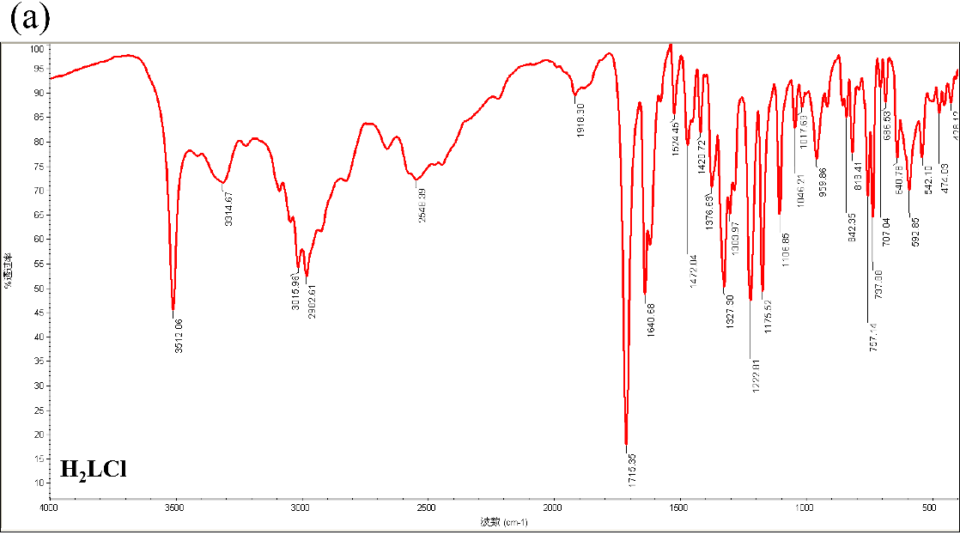

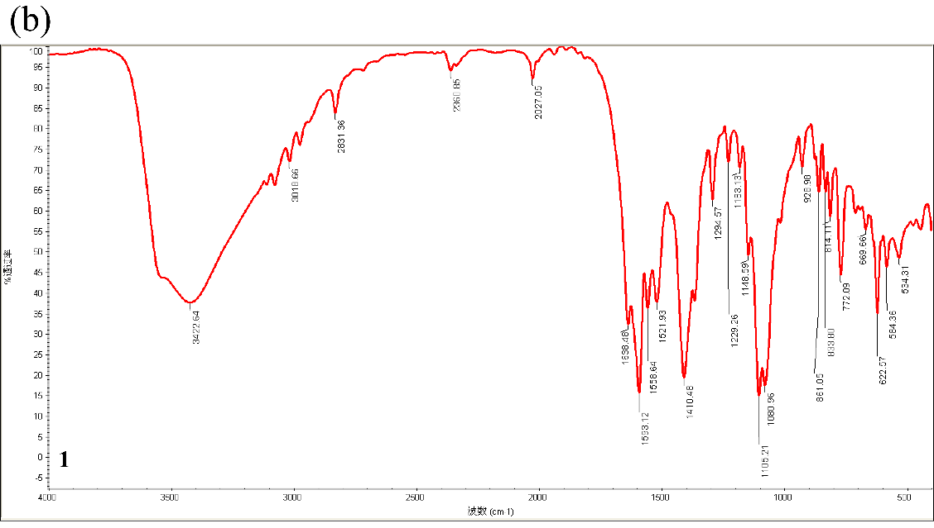

Fig. S1 The Fourier Transform Infrared (FT-IR) spectrum of H2LCl (a) and complex **1** (b).

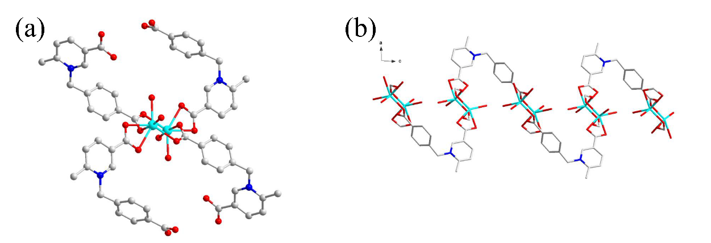

Fig. S2 (a) The connection mode of the [(Cd1)2(μ2-CO2)2] dinuclear subunit. (b) The 1D S-shaped chain in complex **1**.

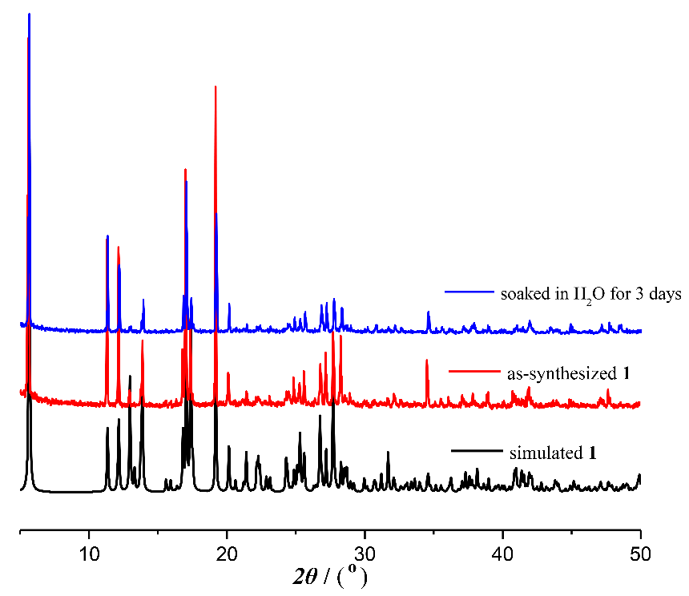

Fig. S3 The PXRD patterns of complex **1** and water-treated of **1**.

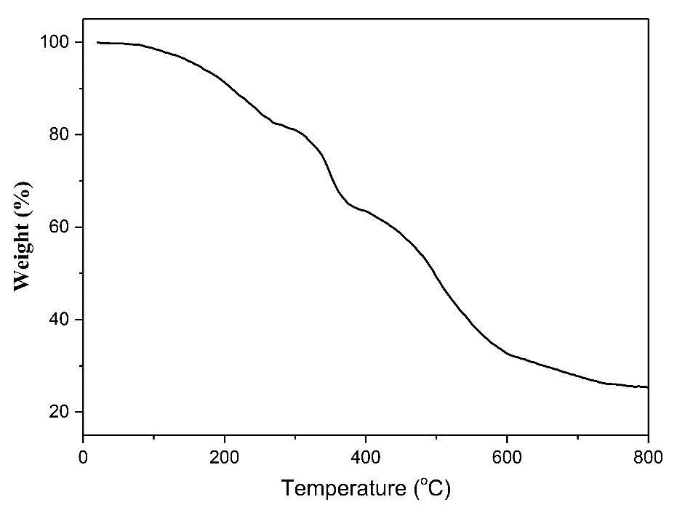

Fig. S4 The TGA curve of complex **1**.

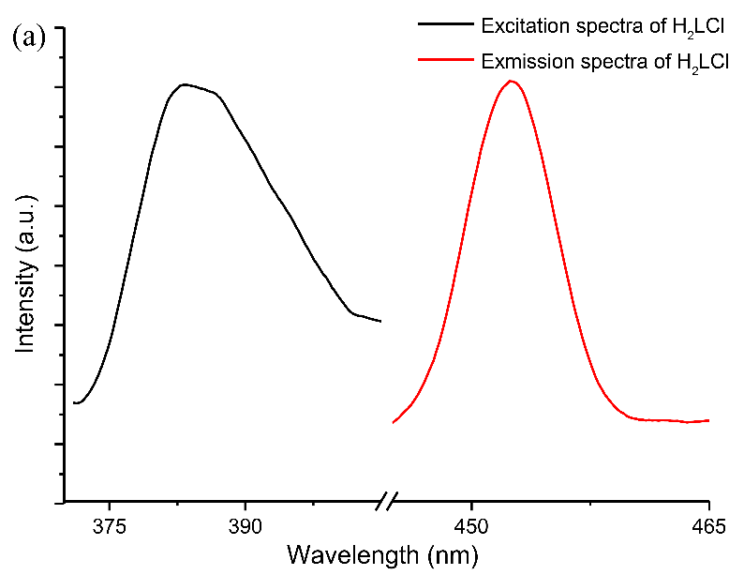

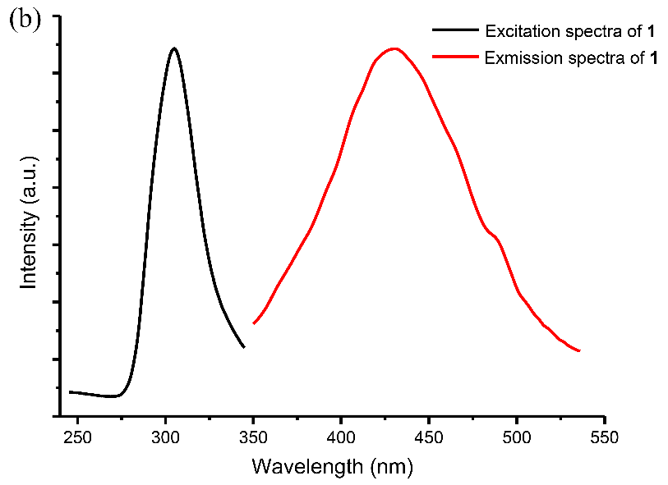

Fig. S5 The solid state luminescent spectrum of the ligand H2LCl (a) and complex **1** (b).

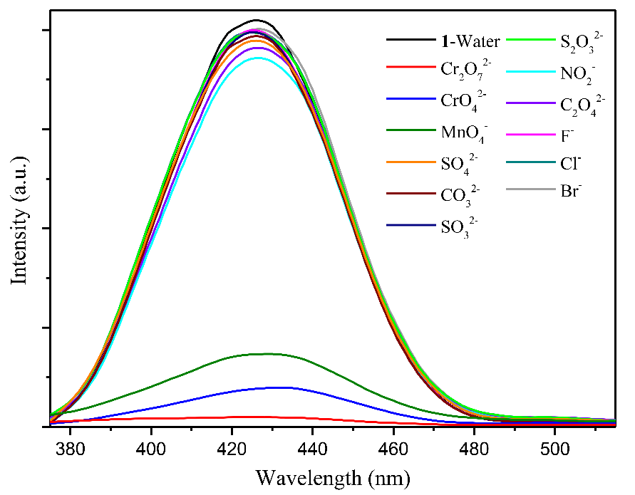

Fig. S6 The luminescence intensity of **1** water suspension in different inorganic anions.

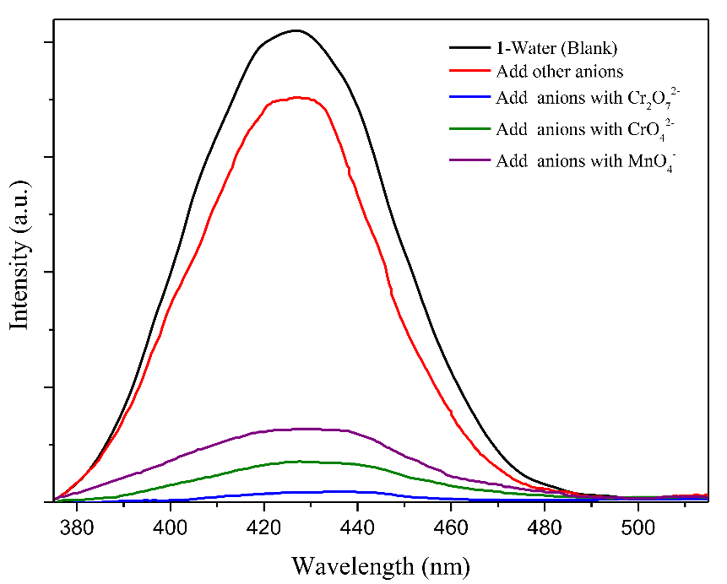

Fig. S7 Competitive analyte test for other inorganic anions in the presence of Cr2O72−, CrO42− or MnO4− toward **1**.

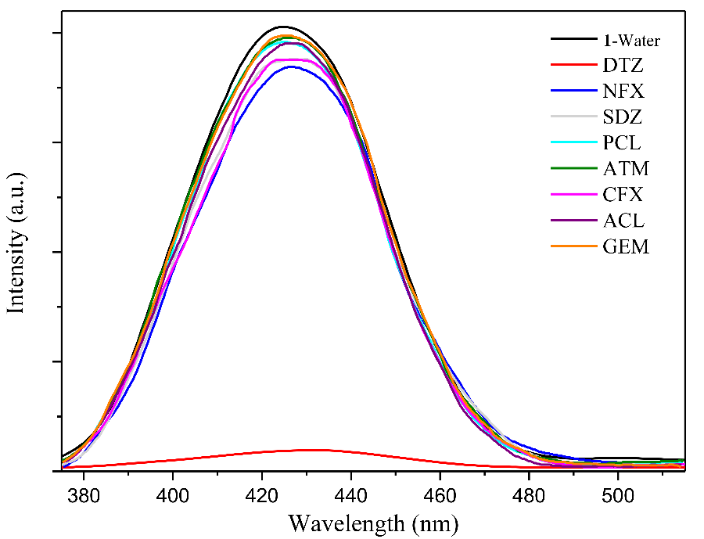

Fig. S8 The luminescence intensity of **1** water suspension in different antibiotics.

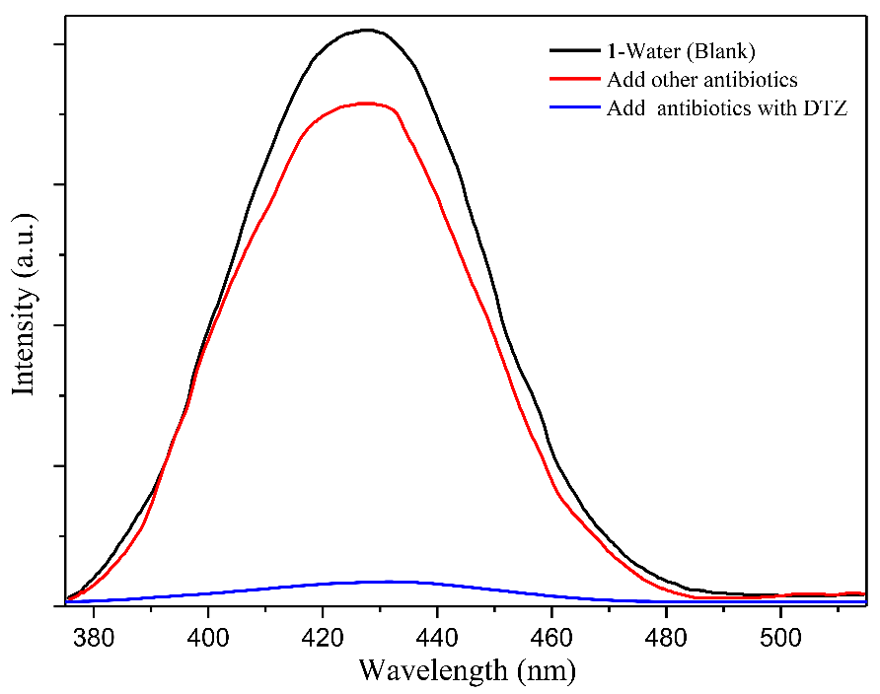

Fig. S9 Competitive analyte test for other inorganic anions in the presence of DTZ toward **1**.

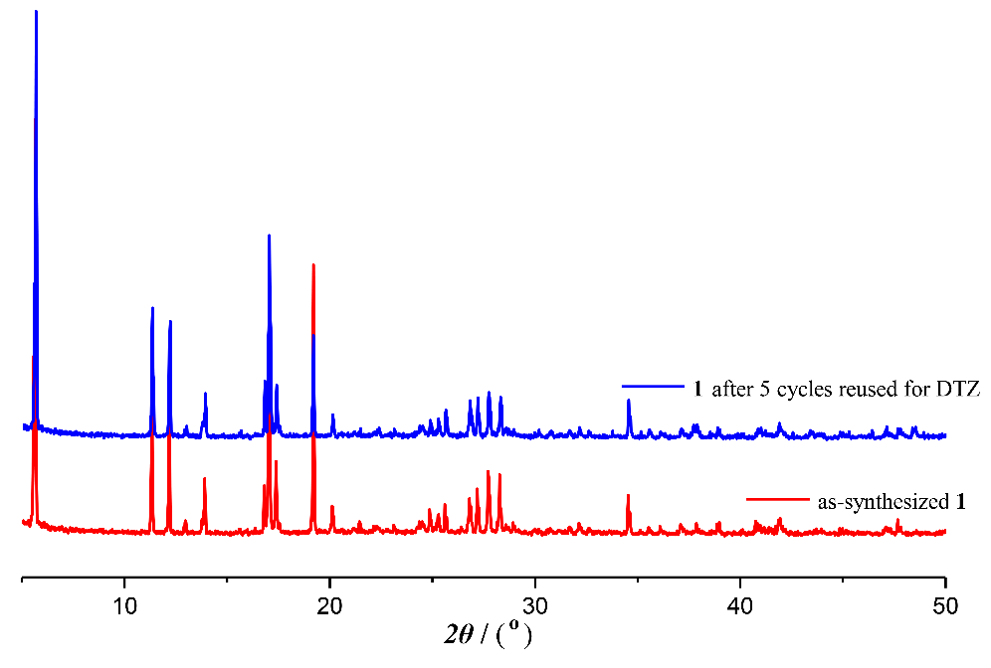

Fig. S10 PXRD curves of **1** after five sensing recovery cycles for DTZ.

Table S2 Comparison of Ksv and LOD values for CPs reported for aqueous phase sensing of Cr2O72−/ CrO42−/ MnO4−.

|  |  |  |  |  |  |
| --- | --- | --- | --- | --- | --- |
|  | CP based sensors oxo-anions *K*sv (M− 1) LOD Ref. | | | | |
| [Cd1.5(NTB)(bipy)0.5]*n* | | Cr2O72− | 2.00 ​× ​103 | 2.23 ​× ​10−6 ​M  H2O | Yang et al., 2022 |
| CrO42− | 1.65 × 104 | 1.60 ​× ​10−6 ​M | Yang et al., 2022 |
| [Cd(L)0.5(bpe)0.5(H2O)]*n* | | Cr2O72− | 1.50 × 104 | 0.60 μM | Lei et al., 2022 |
| [Tb(L)(HCOO)(H2O)]*n* | | Cr2O72− | 2.10 × 104 | 2.10 μM | Sun et al., 2017 |
| [Tb(PMBB)1.5(H2O)2] | | Cr2O72− | 1.06 × 104 | 7.40 × 10−7 M | Zhou et al., 2022 |
| MnO4− | 8.87 × 103 | 8.83 × 10−7 M | Zhou et al., 2022 |
| {[Zn2(TRZ)2(DBTDC-O2)]·DMAc}*n* | | Cr2O72− | 1.24× 104 | 2.55 μM | He et al., 2019 |
| {[Cd(L)(bdc)·2H2O]·2DMF}*n* | | Cr2O72− | 4.25 × 104 | 10.5 μM | Ge et al., 2020 |
| Tb2(TDA)4(OOCCH3)2(H2O)2 | | MnO4− | 1.59 × 104 | 0.612 μM | Yuan et al., 2021 |
| {[Zn6(L1)2(NDC)5(*μ*2-OH)2]·0.5H2O}*n* | | MnO4− | 1.05 × 104 | 0.288 μM | Su et al., 2022 |
| {[Zn(L2)(NDC)]·2H2O}*n* | | MnO4− | 5.48 × 103 | 0.242 μM | Su et al., 2022 |
| [Zn8L6(μ4-O)2⋅DMSO⋅(H2O)3] | | MnO4− | 1.70 × 104 | 0.465 μM | Wang et al., 2021a |
| [Cd(IPA)(L)]n | | Cr2O72− | 2.91 × 103 | 3.4 ​μM  H2O | Parmar et al., 2017 |
| CrO42− | 1.30 × 103 | 3.4 ​μM  H2O | Parmar et al., 2017 |
| [Zn3(L)(OH)(H2O)5]·NMP·2H2O | | Cr2O72− | 6.6 × 104 | 6.05 × 10−5 M | Yan et al., 2018 |
| CrO42− | 1.3 × 104 | 4.29 × 10−4 M | Yan et al., 2018 |
| MnO4− | 1.1 × 104 | 3.38 × 10−4 M | Yan et al., 2018 |
| **CP 1** | | **Cr2O72−** | **8.3191 × 104** | **0.12 μM** | **This work** |
| **CrO42−** | **6.0980 × 104** | **0.16 μM** |
| **MnO4−** | **3.3842 × 104** | **0.29 μM**  **0.3470(10)** |

**Table S3** Comparison of *K*sv and LOD values for CPs reported for aqueous phase sensing of DTZ.

|  |  |  |  |
| --- | --- | --- | --- |
| CP based sensors *K*sv (M− 1) LOD Ref. | | | |
| [Pb1.5(DBPT)]2·(DMA)3(H2O)4 | 1.5 × 104 | 20 ppm  H2O | Sun et al., 2019 |
| [Tb(TATAB)(H2O)]·2H2O  ·CH3OH | 3.42 × 104 | 0.0808  H2O | Wei et al., 2019 |
| [Cd2+ complex] | 0.70 × 104 | 0.73 nM  H2O | Ji et al., 2021 |
| [Tb(H2O)(BTCTB)]**·**2H2O | 1.62 × 104 | 2.9 μM | Yang et al., 2020 |
| [Cd3(DBPT)2(H2O)4]**·**5H2O | 1.70 × 104 | 10 μM | Dong et al., 2018 |
| DMASM@Zn2L(H2O)2]*·*4H2O·3DMF | 3.20 × 104 | – | Wang et al., 2022 |
| [Eu2(dtztp)(OH)2(DMF)(H2O)2.5]·2H2O | 2.45 × 104 | 13.4 ppm | Wang et al., 2021b |
| **CP 1** | **1.1085 × 105** | **0.09 μM**  **0.3470(10)** | **This work** |

**References**

Dong, B.X., Pan, Y.M., Liu, W.L., Teng, Y.L., 2018. An Ultrastable Luminescent Metal–Organic Framework for Selective Sensing of Nitroaromatic Compounds and Nitroimidazole-Based Drug Molecules.Cryst. Growth Des 18, 431–440. https://doi.org/10.1021/acs.cgd.7b01430.

Ge, F.-Y., Sun, G.-H., Meng, L., Ren, S.-S., Zheng, H.-G., 2020. Four New Luminescent Metal–Organic Frameworks as Multifunctional Sensors for Detecting Fe3+, Cr2O72– and Nitromethane. Cryst. Growth Des*.* 20, 1898–1904. https://doi.org/10.1021/acs.cgd.9b01593.

He, H. M., Zhu, Q.-Q., Li, C.-P., Du, M., 2019. Design of a Highly-Stable Pillar-Layer Zinc(II) Porous Framework for Rapid, Reversible, and Multi-Responsive Luminescent Sensor in Water. Cryst. Growth Des. 19, 694–703. https://doi.org/10.1021/acs.cgd.8b01271.

Ji, X., Wu, S., Song, D., Chen, S., Chen, Q., Gao, E., Xu, J., Zhu, X., Zhu, M., 2021. A water-stable luminescent sensor based on Cd2+ coordination polymer for detecting nitroimidazole antibiotics in water. Appl Organomet Chem. 35,. https://doi.org/10.1002/aoc.6359 e6359.

Lei, M., Ge, F., Ren, S., Gao, X., Zheng, H., 2022. A water-stable Cd-MOF and corresponding MOF@melamine foam composite for detection and removal of antibiotics, explosives, and anions. Sep. Purif. Technol. 286,. https://doi.org/10.1016/j.seppur.2021.120433 120433.

Parmar, B., Rachuri, Y., Bisht, K.K., Laiya, R., Suresh, E., 2017. Mechanochemical and Conventional Synthesis of Zn(II)/Cd(II) Luminescent Coordination Polymers: Dual Sensing Probe for Selective Detection of Chromate Anions and TNP in Aqueous Phase. Inorg. Chem. 56, 2627–2638. https://doi.org/10.1021/acs.inorgchem.6b02810.

Su, Y.-Q.,, Wang, R.-T., Blatova, O. A., Shi, Y.-S., Cui, G.-H., 2022. Two robust Zn(II)-organic frameworks as dual-functional fluorescent probes for efficient sensing of enrofloxacin and MnO4− anions.CrystEngComm 24, 182–191. https://doi.org/10.1039/D1CE01447A.

Sun, Y., Dong, B.X., Liu, W.L., 2019. An adjustable dual-emission fluorescent metal-organic framework: Effective detection of multiple metal ions, nitro-based molecules and DMA Spectrochim. Acta A Mol. Biomol. Spectrosc. 223,. https://doi.org/10.1016/j.saa.2019.117283 117283.

Sun, Z., Yang, M., Ma, Y.,Li, L.C., 2017. Multi-Responsive Luminescent Sensors Based on Two-Dimensional Lanthanide–Metal Organic Frameworks for Highly Selective and Sensitive Detection of Cr(III) and Cr(VI) Ions and Benzaldehyde. Cryst. Growth Des. 17, 4326–4335. https://doi.org/10.1021/acs.cgd.7b00638.

Wang, D., Chen, K., Wang, M., You, Y., Zhou, X., 2021a. A two-fold interpenetrated Zn-based coordination polymer for highly selective and sensitive detection of MnO4−. J. Mol. Struct.1239,. https://doi.org/10.1016/j.molstruc.2021.130486 130486.

Wang, G.-D., Li, Y.-Z., Shi, W.-J., Zhang, B., Hou, L., Wang, Y.-Y., 2021b. A robust cluster-based Eu-MOF as multi-functional fluorescence sensor for detection of antibiotics and pesticides in water, Sensors and Actuators: B. Chemical, 331,. https://doi.org/10.1016/j.snb.2020.129377 129377.

Wang, K., Duan, Y., Chen, J., Wang, H., Liu, H., 2022. A dye encapsulated zinc-based metal–organic framework as a dual-emission sensor for highly sensitive detection of antibiotics.Dalton Trans. 51, 685–694. https://doi.org/10.1039/D1DT03950D.

Wei, J.H., Yi, J.W., Han, M.L., Li, B., Liu, S., Wu, Y. P., Ma, L.F., Li, D.S., 2019. A Water-Stable Terbium(III)–Organic Framework as a Chemosensor for Inorganic Ions, Nitro-Containing Compounds and Antibiotics in Aqueous Solutions. Chem. Asian J. 14, 3694. https://doi.org/10.1002/asia.201900706.

Yan, Y.-T., Zhang, W.-Y., Zhang, F., Cao, F., Yang, R.-F., Wang, Y.-Y., Hou, L., 2018. Four new metal–organic frameworks based on diverse secondary building units: sensing and magnetic properties. Dalton Trans. 47, 1682–1692. https://doi.org/10.1039/C7DT04696K.

Yang, H., Qi, D., Si, X., Yan, Z., Guo, L., Shao, C., Zhang, W., Yang, L., 2022. One novel Cd-MOF as a highly effective multi-functional luminescent sensor for the detection of Fe3+, Hg2+, CrⅥ, Aspartic acid and Glutamic acid in aqueous solution. J. Solid State Chem. 310,. https://doi.org/10.1016/j.jssc.2022.123008 123008.

Yang, H.-W., Xu, P.,Wang, X.-G., Zhao, X.-J., Yang, E.-C., 2020. A Highly Stable (4, 8)-Connected Tb-MOF Exhibiting Efficiently Luminescent Sensing towards Nitroimidazole Antibiotics. Z. Anorg. Allg. Chem. 646, 23–29. https://doi.org/10.1002/zaac.201900271.

Yuan, Z.-D.,Hou, G.-Z., Han, L.-J., 2021. A Terbium-Based MOF as fluorescent probe for the detection of Malachite Green, Fe3+ and MnO4−. Z. Anorg. Allg. Chem. 647, 1–9. https://doi.org/10.1002/zaac.202100301.

Zhou, Z.-D., Wang, C.-Y., Zhu, G.-S., Du, B., Yu, B.-Y., Wang, C.-C., 2022. Water-stable europium(III) and terbium(III)-metal organic frameworks as fluorescent sensors to detect ions, antibiotics and pesticides in aqueous solutions.J. Mol. Struct. 1251,. https://doi.org/10.1016/j.molstruc.2021.132009 132009.