**Supplementary materials**

**Sup Fig1** Hierarchal clustering analysis usually provide clustering scores. The distance was calculated by ward, and the tree should be organized by height.

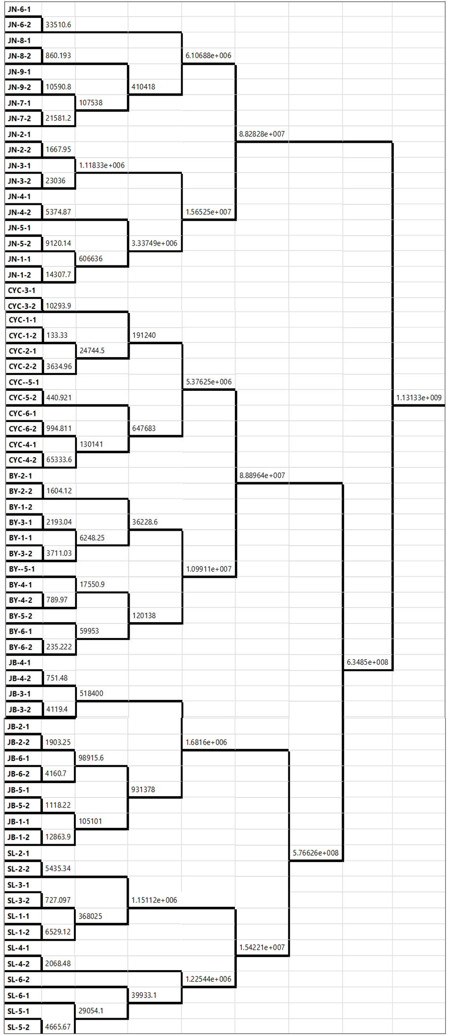

**Sup Fig2** the concentration-response curve of selaginellin and selaginellin A toward HepG2 and SMMC-7721 cell



**Sup Fig3** the inhibition of selaginellin and selaginellin A on thrombase



**SupFig4** the distribution of selaginellin and selaginellin A in *Selaginella pulvinata* sample

