**Electronic Supplementary Information**

**An insight to the filtration mechanism of Pb(II) at the surface of a clay ceramic membrane through its preconcentration at the surface of a graphite/clay composite working electrode.**

Lubna Jaber, Abdelaziz Elgamouz*, Abdel-Nasser Kawde*

Pure and Applied Chemistry Group, Department of Chemistry, College of Sciences, University of Sharjah, P. O. Box 27272, United Arab Emirates.

**Table S1.** Porosity of the incorporated discs.

|  |  |  |  |  |  |  |
| --- | --- | --- | --- | --- | --- | --- |
| Calcination Temperature (oC) | Weight before calcination (g) | Dry Sample Weight (g) | Wet Sample Weight (immersed in D.I Water for 48 hrs.) (g) | Porosity (%) | Average Porosity (%) | Standard deviation  (%) |
| 800 | 4.0026 | 3.2718 | 3.6021 | 10.10 | 10.06 | ±1.56 |
| 4.0044 | 3.2785 | 3.5567 | 8.49 |
| 4.0035 | 3.2761 | 3.6562 | 11.60 |
| 900 | 4.0051 | 3.2424 | 3.4721 | 7.08 | 7.75 | ±1.61 |
| 3.0523 | 2.4843 | 2.6477 | 6.58 |
| 3.0658 | 2.5025 | 2.7423 | 9.58 |
| 1000 | 3.0149 | 2.4644 | 2.5743 | 4.46 | 4.14 | ±0.74 |
| 2.9104 | 2.381 | 2.492 | 4.66 |
| 3.0029 | 2.5632 | 2.6474 | 3.28 |
| 1100 | 4.0018 | 3.2726 | 3.34787 | 2.30 | 2.70 | ±0.40 |
| 4.0012 | 3.2817 | 3.370306 | 2.70 |
| 3.1658 | 4.1138 | 4.241328 | 3.10 |

**Table S2.** FTIR peaks and attributions.

|  |  |  |  |
| --- | --- | --- | --- |
| Raw clay | Calcined clay 700 °C | Calcined clay 1000 °C | Assignments |
| 3686 | **3668** | **-** | Al----O―H stretching |
| 3612 | **-** | **-** | O―H crystalline hydroxyl group |
| 3540 | **-** | **-** | H―O―H stretching of absorbed water |
| 3426 | **3421** | **-** | H―O―H stretching of absorbed water |
| 2978 | **-** | **-** | C―H stretching |
| 2423 | **2358** | **-** | **νassy(CH2)** |
| 1738 | **-** | **-** | **-** |
| 1644 | **-** | **-** | H―O―H bending of water adsorbed at the surface |
| 1434 | **1415** | **-** | C―H stretching |
| 1366 | **-** | **-** | Al―O |
| 1228 | **-** | **-** | **C-O** |
| 1163 | **-** | **1008** | Si―O stretching, clay minerals |
| 979 | **988** | **958** | Si―O stretching |
| 872 | **874** | **885** | OH deformation linked to 2Al3+ |
| 797 | **797** | **796** | Si―O Quartz |
| 778 | **778** | **777** | Si―O Quartz |
| 711 | **712** | **672** | Si―O―Si bending |
| 644 | **-** | **616** | Si―O―Si bending |
| 506 | **439** | **455** | Si―O―Si bending |

**Table S3.** Atomic percentages of raw clay and clay sintered samples obtained by EDS analysis.

|  |  |  |  |  |  |  |  |  |  |  |  |  |  |  |
| --- | --- | --- | --- | --- | --- | --- | --- | --- | --- | --- | --- | --- | --- | --- |
| Material | Elemental content (%) | | | | | | | | | | | | | |
| O | Si | C | Al | Fe | Ca | Mg | K | Cu | Na | Cl | Ti | Ba |
| Raw clay | 47.9 | 16.2 | 10.7 | 6.9 | 6.4 | 3.8 | 3.5 | 1.8 | 1.2 | 0.7 | 0.6 | 0.3 | - |
| 5% raw clay paste | - | 0.1 | 99.6 | 0.1 | - | - | - | - | 0.3 | - | - | - | - |
| 5% clay sintered to 250°C | 52.3 | 13.6 | 14.2 | 5.9 | 5.3 | 1.3 | 4.3 | 1.2 | 0.5 | 0.7 | 0.3 | 0.5 | - |
| 5% clay sintered to 250°C paste | - | 0.3 | 99.2 | - | - | - | - | - | 0.5 | - | - | - | - |
| 5% clay sintered to 1000°C | 44.3 | 19.4 | 5.1 | 6.4 | 6.9 | 9.4 | 4.3 | 1.7 | - | 2.0 | - | - | 0.7 |
| 5% clay sintered to 1000°C paste | - | 0.2 | 99.6 | - | - | - | - | - | 0.2 | - | - | - | - |
| 5% clay sintered to 1100°C | 31.6 | 14.0 | 4.7 | 3.2 | 17.9 | 18.8 | 1.8 | 1.8 | 6.1 | - | - | - | - |
| 5% clay sintered to 1100°C paste | - | - | 96.4 | - | - | - | - | - | 3.6 | - | - | - | - |

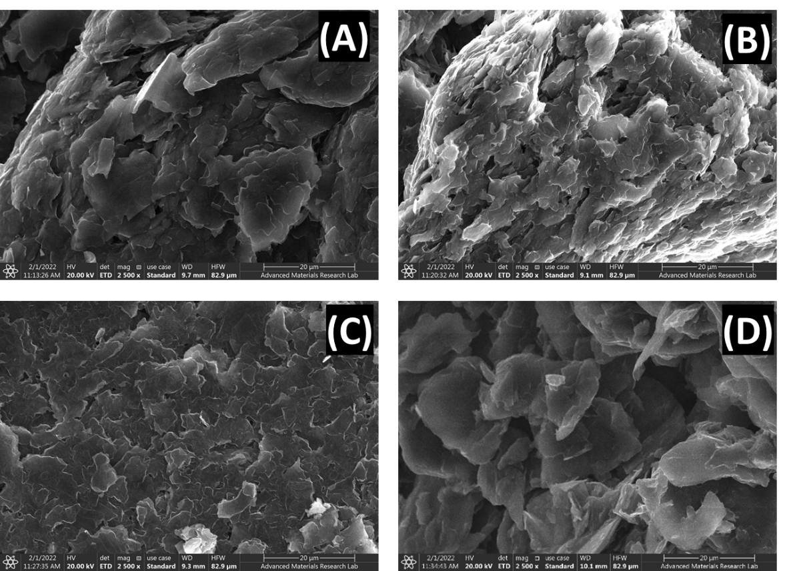

**Fig. S1.** SEM micrographs of 5% raw clay paste (A), 5% clay sintered to 250°C paste (B), 5% clay sintered to 1000°C paste (C) and 5% clay sintered to 1100°C paste (D).

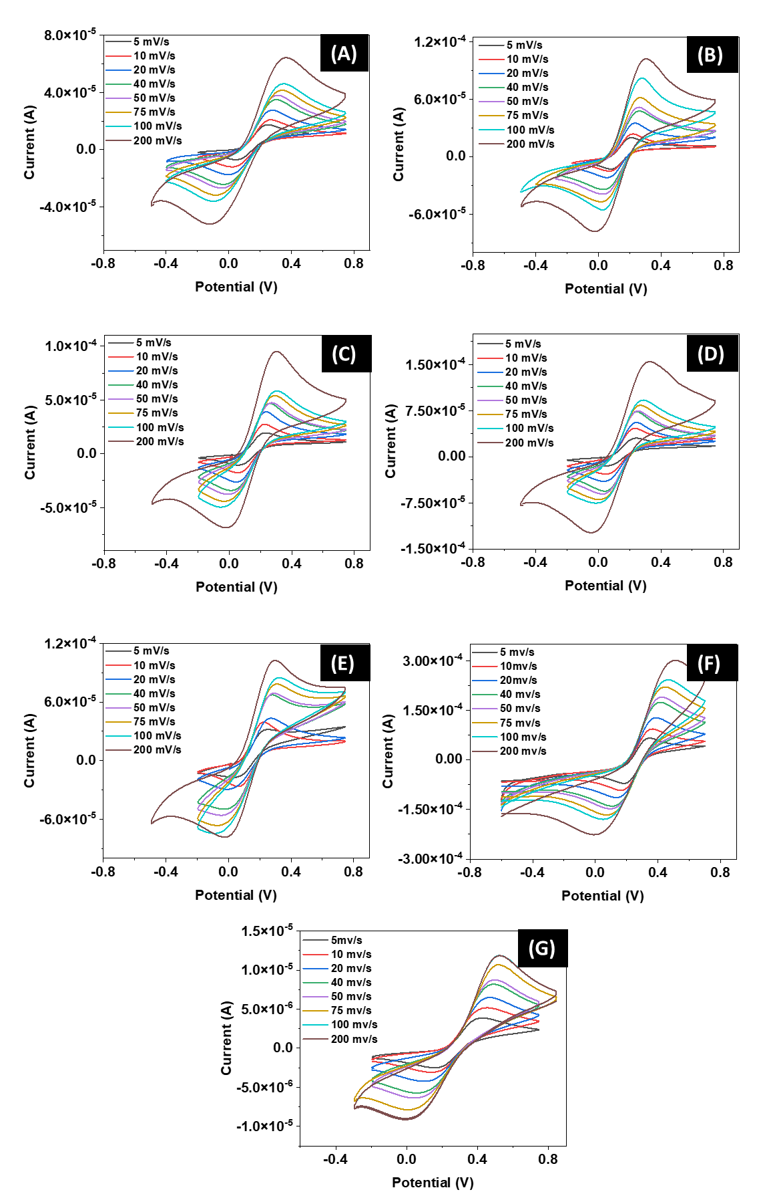

**Fig. S2.** Effect of scan rate used to calculate the electroactive surface area for (A) bare graphite, (B) 5% raw clay, (C) 5% clay sintered to 250°C, (D) 5% clay sintered to 500°C, (E) 5% clay sintered to 700°C, (F) 5% clay sintered to 1000°C, and (G) 5% clay sintered to 1100°C.