Supplementary Material

# Supplementary Data

Supplementary dataset were uploaded in an separate Excel.

# Supplementary Figures and Tables

## Supplementary Figures

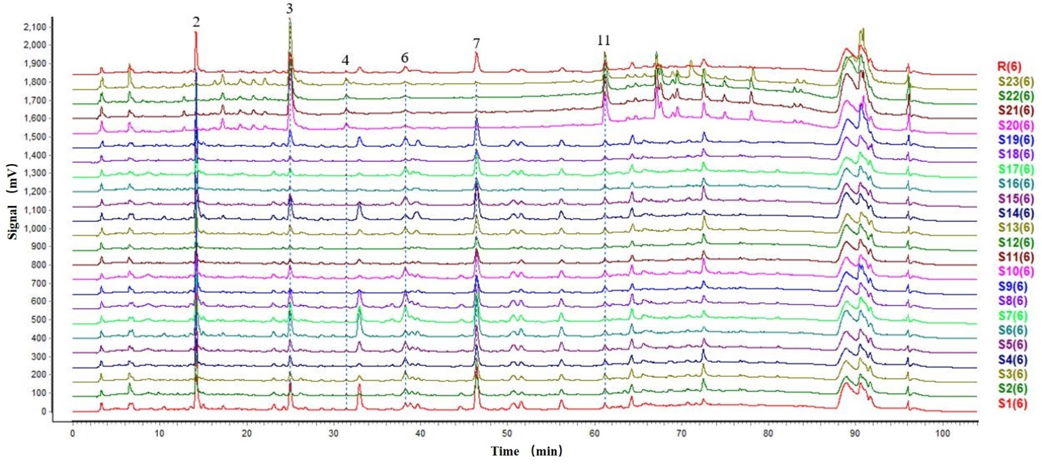

**Supplementary Figure 1.** High-performance liquid chromatography fingerprintings of *Eucommia* cortex and *Eucommiae* folium in different batches. S1–S19 were different batches of *Eucommia* cortex extract samples; S20–S23 were different batches of *Eucommiae* folium extract samples.

|  |  |  |  |  |  |
| --- | --- | --- | --- | --- | --- |
| 1  DMSO | 2  RANKL | 1  Protocatechuic acid | 2  Caffeic acid | 3  Cryptochlorogenic acid | 1Chlorogenic acid |
| 1  Geniposidic acid | 3  PDG | 3  Deacetylasperulosidic acid | 3  Geniposide | 3  Eucommiol | 1  Rutin |

**Supplementary Figure 2.** TRAP-positive osteoclast treated with 10 μM of ten compounds followed by stimulation with 100 ng/ml RANKL and 30 ng/ml M-CSF for 7 days.

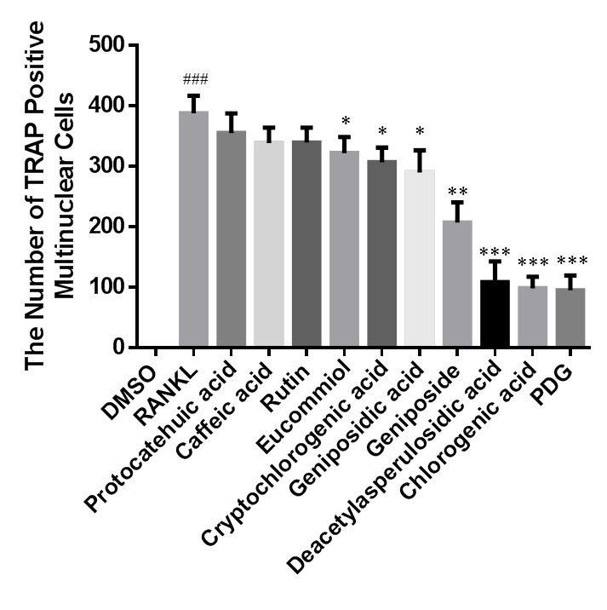 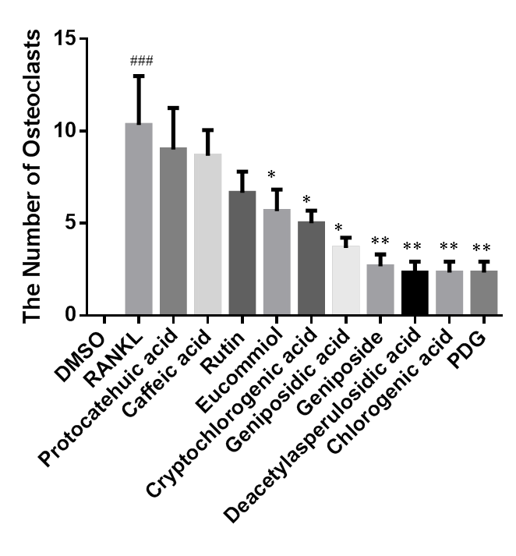

A B

**Supplementary Figure 3.** Quantification of number of TRAP positive multinuclear cells (A) and osteoclasts (B).



**Supplementary Figure 4.** Multivariate analysis based on the high-performance liquid chromatography-quadropole-Exactive-mass spectroscopy (HPLC Q-Exactive MS) proﬁling data for samples in the sham and ovariectomized (OVX) groups in positive and negative ion modes (n = 6). Orthogonal projections to latent structures discriminant analysis (OPLS-DA) score plots in the (A) positive ion mode and (B) negative ion mode. (C) S-plot of the OPLS-DA model in the positive ion mode; (D) S-plot of the OPLS-DA model in the negative ion mode.



**Supplementary Figure 5.** Multivariate analysis based on the high-performance liquid chromatography-quadropole-Exactive-mass spectroscopy (HPLC Q-Exactive MS) proﬁling data for samples in the *Eucommia* cortex treated (EC) and ovariectomized (OVX) groups in positive and negative ion modes (n = 6). Orthogonal projections to latent structures discriminant analysis (OPLS-DA) score plots in the (A) positive ion mode and (B) negative ion mode. (C) S-plot of the OPLS-DA model in the positive ion mode; (D) S-plot of the OPLS-DA model in the negative ion mode.



**Supplementary Figure 6.** Multivariate analysis based on the high-performance liquid chromatography-quadropole-Exactive-mass spectroscopy (HPLC Q-Exactive MS) proﬁling data for samples in the *Eucommia* folium–treated (EF) and ovariectomized (OVX) groups in positive and negative ion modes (n = 6). Orthogonal projections to latent structures discriminant analysis (OPLS-DA) score plots in the (A) positive ion mode and (B) negative ion mode. (C) S-plot of the OPLS-DA model in the positive ion mode; (D) S-plot of the OPLS-DA model in the negative ion mode.

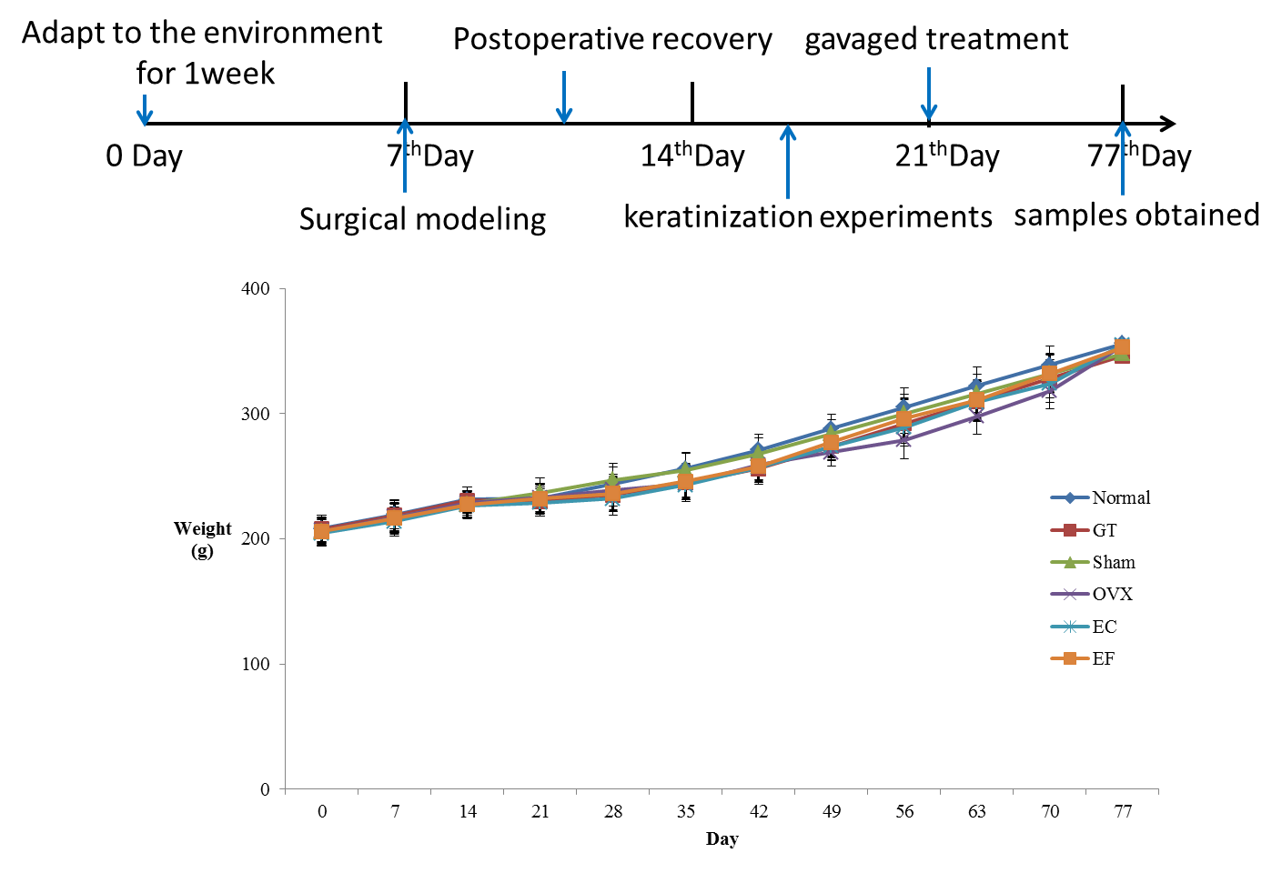

**Supplementary Figure 7.** Rat body weight changes over experiment time.

## Supplementary Tables

**Table S1.** The main components in *Eucommia Cortex* and *Eucommiae Folium* extracts sample.

|  |  |  |  |  |  |  |  |  |
| --- | --- | --- | --- | --- | --- | --- | --- | --- |
| **NO.** | **TR** | **Compounds** | **Formula** | **[M-H]-** | **MS/MS** | **EC** | **EF** | **Reference standard** |
|  |
| 1 | 4.98 | Maleic acid | C4H4O4 | 115.0024 | 115.0024 | + | + |  |  |
| 2 | 5.96 | Deacetylasperulosidic acid | C16H22O11 | 389.1093 | 227.0557, 181.0497, 165.0547, 151.0390 | + | + | Yes |  |
| 3 | 7.41 | Catalpol | C15H22O10 | 361.1144 | 317.1238, 241.0719, 181.0498, 137.0597 | + | + |  |  |
| 4 | 10.42 | Pyrogallic Acid | C6H6O3 | 125.0232 | 123.0078, 108.0207, 97.0282, 94.0285 | + |  |  |  |
| 5 | 10.52 | Rehmannin C | C9H12O5 | 199.0607 | 155.0704, 137.0597 | + | + |  |  |
| 6 | 10.81 | Catechol | C6H6O2 | 109.0282 | 91.0175, 81.0333, 67.0176 | + | + |  |  |
| 7 | 10.92 | Gentianic acid | C7H6O4 | 153.0183 | 109.0283, 91.0176 | + | + |  |  |
| 8 | 11.98 | Aucubin | C15H22O9 | 345.1190 | 311.0773, 183.0656, 165.0547, 121.0647 | + |  |  |  |
| 9 | 12.36 | Geniposidic acid | C16H22O10 | 373.1142 | 211.0608, 193.0500, 167.0704, 149.0599 | + | + | Yes |  |
| 10 | 13.02 | 1,2,3-Propanetriol | C10H14O5 | 213.0765 | 181.0499, 169.0497, 125.0596, 15.0195 | + |  |  |  |
| 11 | 13.38 | 3-(3,4-Dihydroxyphenyl) propionic acid | C9H10O4 | 181.0498 | 163.0390, 135.0441, 119.0490, 151.0390 | + | + |  |  |
| 12 | 14.58 | Protocatechuic acid | C7H6O4 | 153.0183 | 109.0283 | + | + | Yes |  |
| 13 | 19.12 | Asperulosidic acid | C18H24O12 | 431.1196 | 251.0559, 207.0659, 165.0548, 147.0441 | + | + |  |  |
| 14 | 19.96 | Vanillic acid | C8H8O4 | 167.0340 | 152.0105, 123.0439, 108.0204 | + | + |  |  |
| 15 | 20.72 | Chlorogenic acid | C16H18O9 | 353.0889 | 191.0556, 179.0344, 161.0234 | + | + | Yes |  |
| 16 | 21.71 | Caffeic acid | C9H8O4 | 179.0341 | 137.0491, 135.0441 | + | + | Yes |  |
| 17 | 21.79 | Cryptochlorogenic acid | C17H18O9 | 353.0883 | 191.0555, 179.0342, 173.0446, 135.0441 | + | + | Yes |  |
| 18 | 31.32 | Geniposide std | C17H24O10 | 387.1307 | 207.0659, 147.0441, 101.0232, 119.0338 | + | + | Yes |  |
| 19 | 32.09 | Genipin | C11H14O5 | 225.0753 | 175.0392, 147.0441, 123.0440, 101.0233 | + | + |  |  |
| 20 | 35.53 | 3-O-Caffeoylquinic acid methyl ester | C17H20O9 | 367.1038 | 191.0555, 173.0446, 134.0366 | + | + |  |  |
| 21 | 39.29 | Ferulic Acid | C10H10O4 | 193.0501 | 178.0266, 161.0233, 134.0362 | + | + |  |  |
| 22 | 42.79 | Pinoresinol di-O-β-d-glucopyranoside | C32H42O16 | 681.2383 | 357.1333, 342.1091, 311.1279 | + | + | Yes |  |
| 23 | 62.02 | eucommiol | C9H16O4 | 187.0970 | 169.0861, 125.0960 | + | + | Yes |  |
| 24 | 62.15 | Isochlorogenic acid A | C25H24O12 | 515.1162 | 353.0882, 191.0555, 173.0447 | + | + |  |  |
| 25 | 63.56 | Isoquercitrin | C21H20O2 | 463.0913 | 301.0346, 300.0279, 255.0309, 151.00282 | + | + |  |  |
| 26 | 64.35 | Rutin | C27H30O16 | 609.1447 | 301.0336, 300.0267, 277.0324, 178.9972 |  | + | Yes |  |
| 27 | 71.98 | 1－Deoxyeucommiol | C9H16O3 | 171.1018 | 127.1116, 103.0389, 99.0803 | + | + |  |  |

**Table S2.** The contents of main components in *Eucommia Cortex* and *Eucommiae Folium* extracts sample.

|  |  |  |  |  |  |
| --- | --- | --- | --- | --- | --- |
| **No** | **Geniposide acid (mg/g)** | **Geniposide (mg/g)** | **Genipin (mg/g)** | | **PDG (mg/g)** |
| EC Batch NO1 | 0.252 | 0.058 | 0.089 | 0.132 | |
| EC Batch NO2 | 0.255 | 0.047 | 0.088 | 0.093 | |
| EC Batch NO3 | 0.248 | 0.041 | 0.084 | 0.112 | |
| EC Batch NO4 | 0.247 | 0.049 | 0.083 | 0.106 | |
| EC Batch NO5 | 0.243 | 0.055 | 0.082 | 0.224 | |
| Mean | 0.249 | 0.050 | 0.085 | 0.133 | |
| SD | 0.005 | 0.007 | 0.003 | 0.053 | |
| EF Batch NO1 | 0.047 | 0.012 | 0.014 | 0.027 | |
| EF Batch NO2 | 0.055 | 0.009 | 0.019 | 0.023 | |
| EF Batch NO3 | 0.048 | 0.011 | 0.016 | 0.019 | |
| EF Batch NO4 | 0.053 | 0.008 | 0.015 | 0.031 | |
| EF Batch NO5 | 0.046 | 0.011 | 0.017 | 0.026 | |
| Mean | 0.050 | 0.010 | 0.016 | 0.025 | |
| SD | 0.004 | 0.002 | 0.002 | 0.004 | |

**Table S3.** Summary of OPLS-DA model parameters for evaluating model quality by 200 permutation tests of corresponding validation plots

|  |  |  |  |  |  |  |  |  |
| --- | --- | --- | --- | --- | --- | --- | --- | --- |
|  | **Ion mode** | **N** | **A** | **R2X** | **R2Y** | **Q2(cum)** | **R2 intercepts** | **Q2 intercepts** |
| OVX vs Sham | Positive mode | 12 | 1+3+0 | 0.723 | 0.999 | 0.936 | 0.975 | -0.258 |
|  | Negative mode | 12 | 1+5+0 | 0.866 | 1.000 | 0.736 | 0.998 | -0.089 |
| OVX vs EC | Positive mode | 12 | 1+3+0 | 0.727 | 1.000 | 0.954 | 0.981 | -0.126 |
|  | Negative mode | 12 | 1+6+0 | 0.803 | 1.000 | 0.907 | 0.993 | -0.203 |
| OVX vs EF | Positive mode | 12 | 1+3+0 | 0.711 | 1.000 | 0.927 | 0.989 | -0.123 |
|  | Negative mode | 12 | 1+4+0 | 0.809 | 1.000 | 0.879 | 0.997 | -0.230 |

1 A: number of components.