Figure S1: Effect of agitation speed on laccase production

Figure S2: Kinetic plot showing the catalytic behaviour of HRJ16 laccase on ABTS

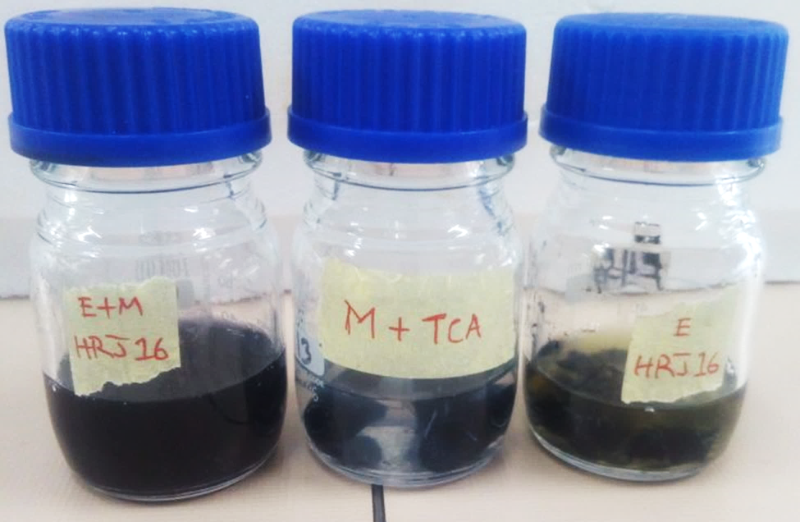

Fig S3: Experiential biobleaching of denim by Hb28a laccase. The control (middle), containing the mediator and TCA, is flanked by Enzyme + Mediator (E+M) treatment on the left, and Enzyme only on the right.