**Supplementary file**



**Fig. S1**. Calibration curve of LEV aqueous solutions

**Calibration curve and validation.**

The maximum absorption wavelength ($λ_{max}$) was 289 nm, and the calibration curve was linear in the concentration range (2.5-40 mg/mL). The obtained regression equation (Y = 0.0769 X + 0.0283) was used to calculate the residual LEV concentration. After equilibrium was established, each solution was filtered through a 0.45µm filter, and the final LEV concentration in each solution was calculated. The validation procedure was carried out in accordance with the ICH guidelines to determine linearity, accuracy, precision, specificity, the limit of detection (LOD), and the limit of quantification (LOQ) (ICH 2005). The used analysis method was validated in accordance with ICH guidelines, and the results of the validation parameters were within acceptable limits. The observed linearity range fits well with the Beer-Lambert law, and the associated regression coefficient (r2 = 0.9996) indicated a high degree of method sensitivity (ICH 2005). The recovery accuracy and precision of the method were both good, as RSD (2%) was within the allowable limit of 5%.

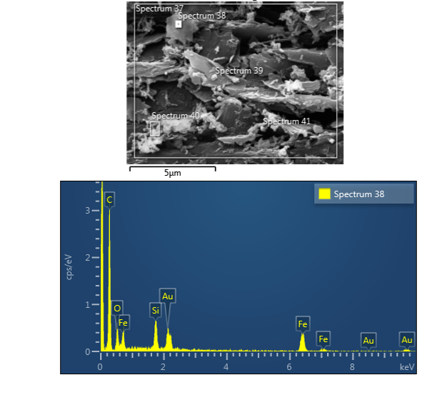

**Fig. S2**. EDS spectrum for a selected area of PG-Fe0 composite.

**Table S1**

Comparison between the removal capacity of PG-Fe0 for LEV with other natural and synthetic adsorbents.

|  |  |  |
| --- | --- | --- |
| **Adsorbent** | **Qm (mg/g)** | **References** |
| UiO-66/CA | 86.43 | (Sun et al., 2019) |
| Charcoal | 87 | (Khalaf and Shqair 2010) |
| Kaolin | 0.26 | (Khalaf and Shqair 2010) |
| Zeolite Y | 45 | (Martucci et al., 2012) |
| Fe3O4@SiO2 | 6.85 | (Al-Jabari et al., 2019) |
| Mordenite | 27 | (Martucci et al., 2012) |
| MgO/CaO NRs | 106.75 | (AbuKhadra et al., 2020) |
| Modified zeolite | 47.68 | (Abukhadra et al., 2020) |
| PG-Fe0 | 66.3 | This study |



**Fig. S3**. Arrhenius plot for the adsorption of LEV at pH = 6.5.



**Fig. S3**. A linear plot for determining thermodynamic parameters at pH = 6.5.

**References**

AbuKhadra, M. R., M. G. Basyouny, A. A. AlHammadi, et al., 2020. Enhanced decontamination of levofloxacin as toxic pharmaceutical residuals from water using CaO/MgO nanorods as a promising adsorbent. Scientific reports. 10, 1-11.

Abukhadra, M. R., A. S. Mohamed, A. M. El-Sherbeeny, et al., 2020. Enhanced Adsorption of Toxic and Biologically Active Levofloxacin Residuals from Wastewater Using Clay Nanotubes as a Novel Fixed Bed: Column Performance and Optimization. ACS omega. 5, 26195-26205.

Al-Jabari, M. H., S. Sulaiman, S. Ali, et al., 2019. Adsorption study of levofloxacin on reusable magnetic nanoparticles: Kinetics and antibacterial activity. Journal of Molecular liquids. 291, 111249.

ICH, 2005. Validation of Analytical Procedures: Text and Methodology. International Conference on Harmonization, of Technical Requirements for registration of Pharmaceuticals for Human Use Topic Q2 (R1), Geneva, Switzerland

Khalaf, S. and I. A. Shqair, 2010. Adsorption of Some Fluoroquinolones on Selected Adsorbents.

Martucci, A., L. Pasti, N. Marchetti, et al., 2012. Adsorption of pharmaceuticals from aqueous solutions on synthetic zeolites. Microporous and Mesoporous Materials. 148, 174-183.

Sun, X., D. Hu, L. Y. Yang, et al., 2019. Efficient adsorption of Levofloxacin from aqueous solution using calcium alginate/metal organic frameworks composite beads. Journal of Sol-Gel Science and Technology. 91, 353-363.