**Blood chemical components analysis of Honeysuckle and formulation of Xanthan gum/starch-based (PVA-co-AA) hydrogels for controlled release**

Zhenzhong Zang1, Shichun Zhao1, Ming Yang1, Chengqun Yu1, Hui Ouyang2, Lihua Chen 1, Weifeng Zhu1, Zheng-gen Liao 1 *, Abid Naeem1*, Yongmei Guan1 *

1 Key Laboratory of Modern Preparation of TCM, Ministry of Education, Jiangxi University of Chinese Medicine, Nanchang 330004, China

2 National Pharmaceutical Engineering Center for Solid Preparation in Chinese Herbal Medicine, Jiangxi University of Chinese Medicine, Nanchang 330006, China

* Correspondence should be addressed to [Lyzlyg@163.com](mailto:Lyzlyg@163.com) (Z.L), [anaeemktk@gmail.com](mailto:anaeemktk@gmail.com) (A.N), and [guanym2008@163.com](mailto:guanym2008@163.com) (Y.G).

**Table S1.** Analysis of chemical components of Honeysuckle (*in vitro*) in both positive and negative ionization modes.

|  |  |  |  |  |  |  |  |  |
| --- | --- | --- | --- | --- | --- | --- | --- | --- |
| **No.** | **tR/min** | **Ion mode** | **Expected** | **Detected** | **δ /ppm** | **Formula** | **MS/MS fragmentation** | **Identification** |
| **1** | 0.9 | [M-H]- | 191.05611 | 191.05563 | -2.51 | C7H12O6 | 191.71199,173.03539,128.03531,115.00371,96.96008 | Quinic acid |
| **2** | 4.07 | [M-H]- | 353.08781 | 353.08615 | -4.70 | C16H18O9 | 191.05554,179.03416,135.04492,9 6.96001 | Neochlorogenic acid |
| **3** | 5.76 | [M-H]- | 358.08781 | 358.08627 | -4.30 | C16H18O9 | 707.17975,191.05548,179.03438,135.04485,96.95994 | Chlorogenic acid |
| **4** | 6.17 | [M-H]- | 358.08781 | 353.08643 | -3.85 | C16H18O9 | 707.18085,191.05550,179.03444,135.04485,96.95992 | Cryptochlorogenic acid |
| **5** | 5.89 | [M-H]- | 389.10893 | 389.10736 | -4.03 | C16H22O11 | 373.11240,358.08624,191.05547,173.04474,116.92834,96.96001 | Secologanoside |
| **6** | 6.26 | [M-H]- | 373.11402 | 373.1123 | -4.61 | C16H22O10 | 747.23145,337.09830,193.05008,149.06041 | Secologanic acid |
| **7** | 7.43 | [M-H]- | 337.09289 | 337.09155 | -3.98 | C16H18O8 | 191.05553,165.05559 | 5-p-coumaroylquinic acid |
| **8** | 6.44 | [M-H]- | 507.17193 | 507.17023 | -3.35 | C21H32O14 | 464.17697,447.14978,401.13867,373.11264,190.92760 | 6'-O-beta-Glucosylaucubin |
| **9** | 10.76 | [M-H]- | 447.09328 | 447.09158 | -3.80 | C21H20O11 | 401.92480, 372.90048,239.07660 | Cynaroside |
| **10** | 9.2 | [M-H]- | 433.13515 | 433.13379 | -3.14 | C18H26O12 | 415.12451,403.12418,387.12845,225.07637 | D-glucitol,hexaacetate |
| **11** | 8.35 | [M-H]- | 367.10346 | 367.10226 | -3.27 | C17H20O9 | 334.93802,192.25473,173.04515,134.04698,93.03442 | 3-O-feruloylquinic acid |
| **12** | 7.98 | [M-H]- | 415.12458 | 415.12241 | -5.23 | C18H24O11 | 397.20807,335.07593,295.11765,265.94949 | 2-Hydroxybenzaldeh yde-O-[Xylosyl-(1→ 6)-Glucoside] |
| **13** | 8.69 | [M-H]- | 533.13006 | 533.12903 | -1.93 | C25H26O13 | 515.10046,489.10471,450.12555 | Ruberythric acid |
| **14** | 8.66 | [M-H]- | 403.12458 | 403.12311 | -3.65 | C17H24O11 | 807.25391,371.09717,223.06064,179.05574,121.02940 | Secoxyloganin |
| **15** | 9.43 | [M-H]- | 417.14023 | 417.13913 | -2.64 | C18H26O11 | 377.18057,341.12320,463.21698 | Secoxyloganin methyl ester |
| **16** | 10.19 | [M-H]- | 609.14611 | 609.14349 | -4.30 | C27H30O16 | 463.08630,301.03375,300.02621,270.92722 | Rutin |
| **17** | 10.6 | [M-H]- | 463.0882 | 463.08618 | -4.36 | C21H20O12 | 301.03378,271.02383 | Hyperoside |
| **18** | 11.76 | [M-H]- | 447.09328 | 447.09177 | -3.38 | C21H20O11 | 895.28003,285.04007 | Kaempferol-7-glucoside |
| **19** | 10.93 | [M-H]- | 593.15119 | 593.14954 | -2.78 | C27H30O15 | 447.09192,285.04047 | Lonicerin |
| **20** | 10.44 | [M-H]- | 593.15119 | 593.14941 | -3.00 | C27H30O15 | 447.09117,285.03897 | Luteolin-7-o-rutinoside |
| **21** | 6.41 | [M-H]- | 179.03498 | 179.03459 | -2.18 | C9H8O4 | 161.04524,135.04495 | Caffeic acid |
| **22** | 11.1 | [M-H]- | 743.2404 | 743.23834 | -2.77 | C33H44O19 | 726.17126 | Strychoside A |
| **23** | 12.12 | [M-H]- | 757.25605 | 757.2536 | -3.24 | C34H46O19 | 740.49084,707.57593,595.20288,559.08124 | (E)-aldosecologanin |
| **24** | 14.66 | [M-H]- | 641.09955 | 641.10077 | 1.90 | C26H26O19 | 513.19556,368.88892,353.08569,191.94563,179.05554 | Methyl-3,5-di-O-Caffeoylquinic acid |
| **25** | 12.43 | [M-H]- | 757.25317 | 757.25360 | 0.568 | C34H46O19 | 595.20721,576.69721,529.09528,525.15869,492.86227 | Centauroside |
| **26** | 12.64 | [M-H]- | 499.12458 | 499.12311 | -2.95 | C25H24O11 | 353.08710,337.09344,191.05540,179.05557,135.04477 | Coumaroylcaffeoyl quinic acid |
| **27** | 13.67 | [M-H]- | 285.04046 | 285.03943 | -3.61 | C15H10O6 | 255.08943,191.03407 | Kaempferol |
| **28** | 10.6 | [M-H]- | 463.0882 | 463.08618 | -4.36 | C21H20O12 | 435.14017,417.20258,285.26077 | Quercetin-7-O-β--glucopyranoside |
| **29** | 13.95 | [M-H]- | 567.17193 | 567.17041 | -2.68 | C26H32O14 | 549.16492,505.16931 | Mulberroside A |
| **30** | 13.52 | [M-H]- | 493.13515 | 493.13342 | -3.51 | C23H26O12 | 475.15778,447.22119,285.10956 | 2'-O-p-hydroxybenz oylgardoside |
| **31** | 13.22 | [M-H]- | 881.49041 | 881.48615 | -4.83 | C46H74O16 | 714.31348 | Araloside D |
| **32** | 15.33 | [M-H]- | 401.08781 | 401.08615 | -4.14 | C20H18O9 | 357.06021,339.17999 | Danthron glucoside |
| **33** | 13.22 | [M-H]- | 881.49041 | 881.48615 | -4.83 | C46H74O16 | 825.29590,633.25177 | Sapindoside B |
| **34** | 15.69 | [M-H]- | 287.22278 | 287.22174 | -3.62 | C16H32O4 | 242.94283 | Diethylene glycol monolaurate |
| **35** | 10.95 | [M-H]- | 593.15119 | 593.14911 | -3.51 | C27H30O15 | 447.08984,116.92838,99.92558 | Luteolin-4'-O-rhamn osy(1→2)-glycoside |
| **36** | 12.47 | [M-H]- | 595.29126 | 595.29413 | 4.82 | C34H44O9 | 565.14587,515.11700,471.18765 | Salannin |
| **37** | 4.49 | [M-H]- | 205.07176 | 205.07091 | -4.14 | C8H14O6 | 191.01903,187.06009,177.01871,137.02405 | Ethylideneglucose |
| **38** | 7.52 | [M-H]- | 403.12458 | 403.12305 | -3.80 | C17H24O11 | 385.18552,367.13690,357.11789,241.11850 | Gardenoside |
| **39** | 8.7 | [M-H]- | 335.07724 | 335.07596 | -3.82 | C16H16O8 | 290.03967 | Dattelic acid |
| **40** | 14.37 | [M-H]- | 771.1778 | 771.18127 | 4.50 | C36H36O19 | 609.25745,593.85394,463.02423 | Quercetin-3-O-alpha-(6'''-caffeoylglucosyl-beta-1,2-rhamnoside) |
| **41** | 11.37 | [M-H]- | 515.1195 | 515.11792 | -3.07 | C25H24O12 | 353.08655,173.04510,179.03467,191.05562,135.04485 | Isochlorogenic acid B |
| **42** | 11.67 | [M-H]- | 515.1195 | 515.11737 | -4.13 | C25H24O12 | 163.03992,319.10071,499.14130,145.05019,117.01926 | Isochlorogenic acid A |
| **43** | 12.19 | [M-H]- | 515.1195 | 515.11719 | -4.48 | C25H24O12 | 497.25662,353.08624,335.07626,191.94528 | Isochlorogenic acid C |
| **44** | 14.72 | [M-H]- | 567.27521 | 567.2771 | 3.33 | C36H40O6 | 405.19391 | Ethyl-2,3,4,6-tetra-O- benzyl-β-D-glucopyran oside |
| **45** | 13.41 | [M-H]- | 549.16136 | 549.15912 | -4.08 | C26H30O13 | 515.11774,387.11417 | Licuroside |
| **46** | 15.14 | [M-H]- | 957.50645 | 957.50653 | 0.08 | C48H78O19 | 795.40009,750.00879 | Madecassol |
| **47** | 14.14 | [M-H]- | 625.29595 | 625.29590 | -0.08 | C42H42O5 | 463.12326 | (1S)-1,5-anhydro- 2,3,4,6-tetra-O-be nzyl-1-(3-vinylphe nyl)-D-glucitol |
| **48** | 27.72 | [M-H]- | 455.35307 | 455.35141 | -3.65 | C30H48O3 | 411.34668,371.86179,116.92822 | Oleanolic acid |
| **49** | 1.36 | [M-H]- | 180.06662 | 180.06592 | -3.89 | C9H11NO3 | 163.03943,119.04985,93.03441,72.05788 | Tyrosine |
| **50** | 6.41 | [M-H]- | 179.03498 | 179.03459 | -2.18 | C9H8O4 | 135.04495 | Caffeic acid |
| **51** | 5.06 | [M-H]- | 375.12967 | 375.12817 | -4.00 | C16H24O10 | 213.07616,169.08652,151.07608 | 8-Epiloganic acid |
| **52** | 5.55 | [M-H]- | 375.12967 | 375.12766 | -5.36 | C16H24O10 | 169.08633,151.07590,95.05007,69.03477 | Loganic acid |
| **53** | 5.66 | [M-H]- | 389.14532 | 389.14386 | -3.75 | C17H26O10 | 435.15060,227.74156,101.02411 | Loganin |
| **54** | 11.97 | [M-H]- | 577.15628 | 577.15363 | -4.59 | C27H30O14 | 269.0437 | Apigenin-7-O-rutinoside |
| **55** | 12.24 | [M-H]- | 607.16684 | 607.15412 | -4.48 | C28H32O15 | 299.02982 | Chrysoeriol-7-O-neohesperidoside |
| **56** | 12.43 | [M-H]- | 757.25605 | 757.25317 | -3.80 | C34H46O19 | 595.20038,525.15930,179.05559,89.02427 | (E)-aldosecolo-ganin |
| **57** | 12.37 | [M-H]- | 491.1195 | 491.11707 | -4.95 | C23H24O12 | 461.10696 | Tricin 7-O-glucoside |
| **58** | 12.67 | [M-H]- | 529.13515 | 529.13312 | -3.84 | C23H24O12 | 353.08578,191.05539,179.03427,135.04486 | Feruloyl caffeoylquinic acid |
| **59** | 12.93 | [M-H]- | 529.13515 | 529.13391 | -2.34 | C23H24O12 | 179.03444,161.02415,135.04488 | Methyl Dicaffeoylquinic acid Isomer |
| **60** | 13.17 | [M-H]- | 529.13515 | 529.13275 | -4.54 | C26H26O12 | 367.10211,353.08615,191.05545,179.03433,173.04478,93.03445 | Methyl Dicaffeoylquinic acid |
| **61** | 13.7 | [M-H]- | 285.04046 | 285.03918 | -4.49 | C15H10O6 | 241.10727,199.09637,133.01405 | Luteolin |
| **62** | 6.26 | [M-H]- | 193.05063 | 193.05008 | -2.85 | C10H10O4 | 134.03685,178.02200,193.05008,149.06041 | Ferulic acid |
| **63** | 7.57 | [M+Na]+ | 381.1156 | 381.11676 | 3.04 | C16H22O9 | 219.17503,149.02365,382.12051,220.05878 | Sweroside |
| **64** | 11.56 | [M+H]+ | 177.05462 | 177.05487 | 1.41 | C10H8O3 | 149.02351,145.03540,134.06010 | 7-methoxycoumarin |
| **65** | 9.29 | [M+Na]+ | 411.12617 | 411.12769 | 3.70 | C17H24O10 | 800.55139,390.89310,338.66925 | Vogeloside |
| **66** | 13.64 | [M+H]+ | 339.07106 | 339.07275 | 4.98 | C15H14O9 | 141.95811 | Quercetin dihydrate |
| **67** | 15.47 | [M+Na]+ | 471.08978 | 471.08765 | -4.52 | C21H20O11 | 287.16422,270.92056 | Quercitrin |
| **68** | 11.48 | [M+H]+ | 595.16575 | 595.16425 | -2.52 | C27H30O15 | 449.10672,287.05466 | Kaempferol-3-rutinoside |
| **69** | 6.36 | [M+H]+ | 359.1184 | 359.11954 | 3.17 | C12H22O12 | 341.06479,325.54489,197.06999,179.03358 | Lactobionic acid |
| **70** | 14.4 | [M+H]+ | 913.51553 | 913.51563 | 0.01 | C47H76O17 | 981.47418,751.46149 | Macranthoside A |
| **71** | 10,98 | [M+H]+ | 595.16575 | 595.16333 | -4.07 | C41H66O12 | 449.10645,287.05414 | 3-O-[α-L-rhamnop yranosyl-(1→2) -α-L-arabinopyran osyl] |
| **72** | 0.86 | [M+H]+ | 175.11895 | 175.11839 | -3.20 | C6H14N4O2 | 158.08055,130.08572,116.07014,70.06467,60.68918 | L-arginine |
| **73** | 1.03 | [M+H]+ | 118.08626 | 118.08585 | -3.47 | C5H11NO2 | 59.10177,58.41454 | Valine |
| **74** | 1.52 | [M+H]+ | 132.10191 | 132.10149 | -3.18 | C6H13NO2 | 86.09599,69.06947 | Isoleucine |
| **75** | 2.68 | [M+H]+ | 166.08626 | 166.08577 | -2.95 | C9H11NO2 | 120.08033,103.05383,77.03815 | Phenylalanine |
| **76** | 5.28 | [M+H]+ | 405.13914 | 405.13791 | -3.04 | C17H24O11 | 243.08563,211.05965,193.04947,167.03346,151.03867,123.04367 | Secologanoside-7-methyl ester |
| **77** | 7.49 | [M+H]+ | 339.10744 | 339.1066 | -2.48 | C16H18O8 | 321.09555,147.04376,119.04882,91.05381 | 5-p-Coumaroylquinic acid |
| **78** | 10.65 | [M+H]+ | 465.10275 | 465.10129 | -3.14 | C21H20O12 | 303.04916 | Quercetin-3-O-glucoside |
| **79** | 12.05 | [M+H]+ | 479.1184 | 479.1167 | -3.55 | C22H22O12 | 317.06448 | Isorhamnetin-3-O-glucoside |
| **80** | 14.41 | [M+H]+ | 913.51553 | 913.51111 | -4.84 | C47H76O17 | 751.45898,935.49072,619.41882,455.35074,437.34024,309.11774 | 3-O-arabinopyran-osyl （2 → 1）- O-rhamnopy- ranosyl-hederagenin-28-O- glucopyran-osyl ester or its isomer |

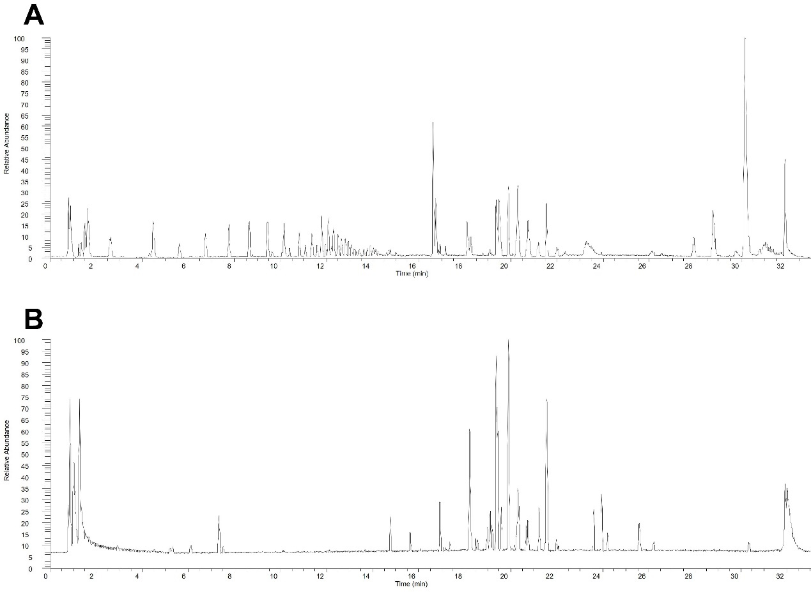

**Figure S1.** Ion chromatograms of blank plasma in positive mode (A) and negative mode (B).

**Table S2.** Analysis of reference substances used in the study

|  |  |  |  |  |  |  |  |  |
| --- | --- | --- | --- | --- | --- | --- | --- | --- |
| **No.** | **tR/min** | **Ion mode** | **Expected** | **Detected** | **δ /ppm** | **Formula** | **MS/MS fragmentation** | **Identification** |
| 1 | 8.68 | [M-H]- | 403.1246 | 403.1232 | -3.47 | C17H24O11 | 807.25330,371.09659,2233.06020,179.05553,121.02919 | Strychnoside |
| 2 | 10.62 | [M+H]+ | 465.1028 | 465.1030 | 0.43 | C21H20O12 | 303.05008,304.05347,305.05533,465.10300 | Isoquercitrin |
| 3 | 10.98 | [M-H]- | 593.1512 | 593.1492 | -3.37 | C27H30O15 | 285.03891,446.90417 | Lonicidin |
| 4 | 4.03 | [M+H]+ | 355.1024 | 355.1024 | 0 | C16H18O9 | 163.03900,135.04408,117.03344,145.02866,89.03838 | Neochlorogenic acid |
| 5 | 11.69 | [M-H]- | 515.1195 | 515.1179 | -3.1 | C25H24O12 | 163.06126,117.01900 | Isochlorogenic acid A |
| 6 | 6.27 | [M-H]- | 373.1140 | 373.1124 | -4.29 | C16H22O10 | 747.23309,193.05328,149.06049 | Strychnic acid |
| 7 | 10.21 | [M-H]- | 609.1461 | 609.1441 | -3.28 | C27H30O16 | 301.03436,300.02655,271.02444 | Rutin |
| 8 | 12.21 | [M-H]- | 515.1195 | 515.1179 | -3.1 | C25H24O12 | 497.25662,353.08679,335.07574,191.94568 | Isochlorogenic acid C |
| 9 | 10.78 | [M+H]+ | 449.1078 | 449.1076 | -0.45 | C21H20O11 | 287.05499,286.04611,288.05832,289.06000,152.99474 | Luteoloside |
| 10 | 5.79 | [M-H]- | 353.0878 | 353.0865 | -3.68 | C16H18O9 | 707.18188,191.05551,179.03442,135.04480,96.95993 | Chlorogrnic acid |

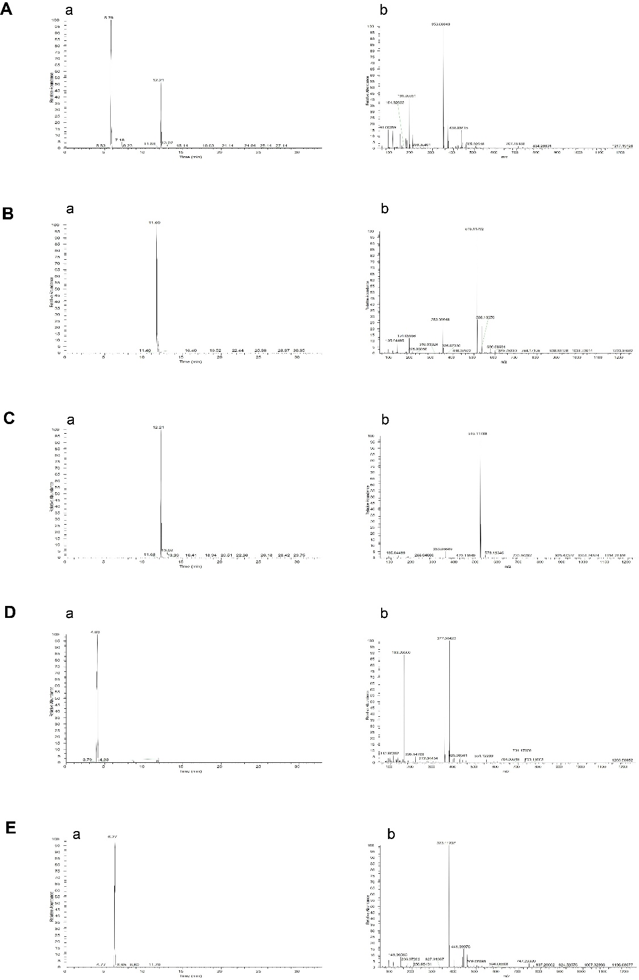

**Figure S2.** Reference compounds chromatograms: chlorogenic acid (A), isochlorogenic acid A (B), isochlorogenic acid C (C), neochlorogenic acid (D), strychnic acid (E). While small letter (a) represents chromatograms and (b) shows its mass spectrum.

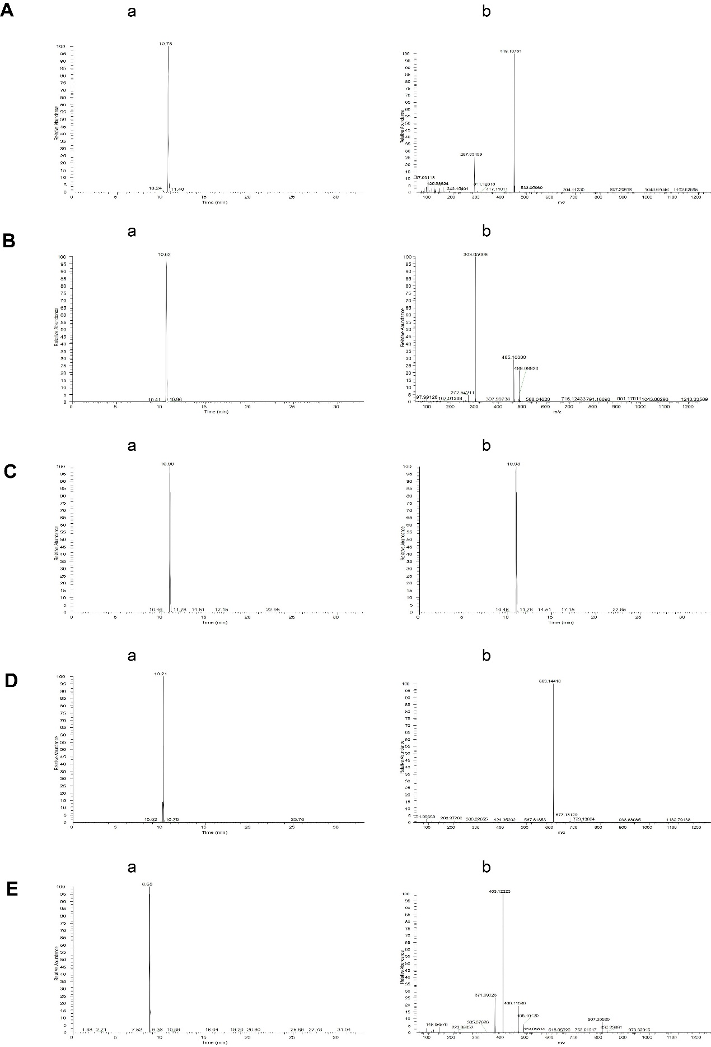

**Figure S3.** Reference compounds chromatograms: luteoloside (A), isoquercitin (B), lonicidin (C), rutin (D), strychnoside (E). While small letter (a) represents chromatograms and (b) shows its mass spectrum.