Supplementary Information

**The use of untargeted and widely targeted metabolomics to distinguish between asphyxia and sudden cardiac death as the cause of death in rats: A preliminary study**

Kai Zhang1, Ya Tuo3, Ruina Liu1, Hui Yan2, Ping Xiang2, Zhenyuan Wang1, * and Ping Huang2, *

*1Department of Forensic Pathology, College of Forensic Medicine, Xi'an Jiaotong University, Xi’an, 710061, China.*

*2Shanghai Key Laboratory of Forensic Medicine, Shanghai Forensic Service Platform, Academy of Forensic Science, Shanghai, 200063, China.*

*3Department of Biochemistry and Physiology, Shanghai University of Medicine and Health Sciences, Shanghai, 201318, China.*

Kai Zhang and Tuo Ya contributed equally to this work.

**Corresponding author:**

Ping Huang\**:*

*E-mail: huangp@ssfjd.cn; Tel: +86-021-52367986*

Zhenyuan Wang*:

*E-mail: wzy218@xjtu.edu.cn; Tel: +86-029-82655472*



**Figure S1** Representative total ion chromatograms (TICs) of the quality control (QC) samples in negative (a) and positive modes (b). A near-perfect overlay with minimal drift in the retention times and similar intensities of all peaks was observed, indicating an excellent signal stability when the same sample was detected at different times by mass spectrometry.



**Figure S2** PCA score plot of the rat pulmonary metabolomics data derived from the asphyxia, sudden cardiac death, control, and QC (quality control) groups. All QC samples clustered together and did not show a trend of separation, and they were distributed in the center of all samples in the score plot, indicating that the QC samples were indeed mixed from these samples and there were good stability and reproducibility during the MS data collection and preprocessing.



**Figure S3** The results from 200 permutation tests for the OPLS-DA model between the asphyxia and control groups (a) and between the asphyxia and sudden cardiac death groups (b).

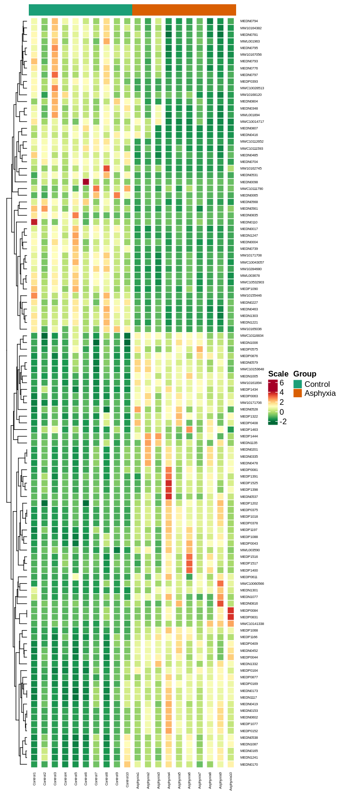

**Figure S4** Heatmap and HCA analysis of differential metabolites between the asphyxia and control groups. Each column represents a sample, and each line represents a metabolite with its index number. Detail information on these metabolites is shown in the Supplementary Material(S2).xlsx.

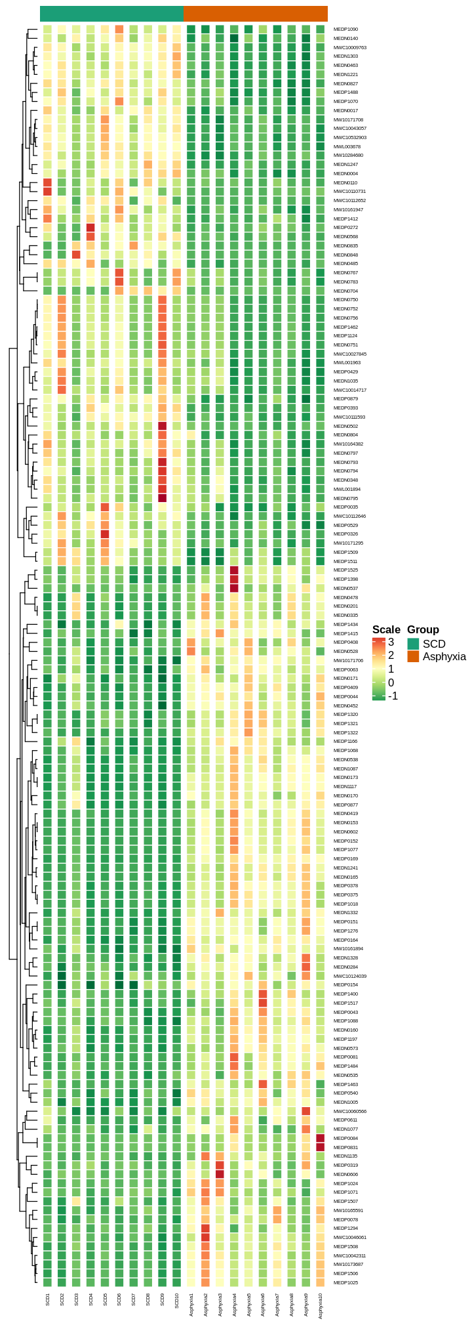

**Figure S5** Heatmap and HCA analysis of differential metabolites between the asphyxia and SCD groups. Each column represents a sample, and each line represents a metabolite with its index number. Detail information on these metabolites is shown in Supplementary Material(S2).xlsx.

**The UHPLC conditions:**

Column: Waters ACQUITY UHPLC HSS T3 C18 (2.1 mm*100 mm, 1.8 μm).

Solvent solution: mobile phase A, water (0.1% formic acid), mobile phase B, acetonitrile (0.1% formic acid).

Gradient program: the column was eluted with 5% mobile phase B at 0 minute followed by a linear gradient to 95% mobile phase B over 10 minutes, held for 1 minute, and then come back to 5% mobile phase B within 0.1 minute, held for 3.9 minutes.

Flow rate, 0.4 mL/min; column temperature, 40 °C; injection volume, 2 μL for QTOF MS/MS detection or 5 μL for QTRAP MS/MS detection.

**The experiment parameters for QTOF and QTRAP scan:**

The electrospray ionization (ESI) source settings: source temperature was 500 °C; ion spray (IS) voltage was 5500 V (positive ion mode), -4500 V (negative ion mode); ion source gas I (GSI), gas II (GSII), and curtain gas (CUR) were set to 50, 50, and 25.0 psi, respectively; collision gas (CAD) was high

The collision energy (CE) voltage was stepped from 15 V to 45 eV in QTOF MS/MS scan to obtain suitable product ions for each metabolite. The declustering potential (DP) and collision energy (CE) were optimized for individual MRM transitions in QTRAP MS/MS scan. The instrument tuning and mass calibration were performed using 10 and 100 μmol/L polypropylene glycol solutions in triple quadrupole and linear ion trap modes, respectively.

**Metabolites have** **two levels of identification in this study:**

**A level:** The match score is greater than 0.8 in the untargeted detection (QTOF);

Or, two ion fragments, Q1, retention time (RT), declustering potential (DP), and collision energy (CE) of the metabolite are consistent with the data in the self-built database MWDB (Wuhan Metware Biotechnology Co., Ltd., China) in the widely-targeted detection (QTRAP).

**B level:** The match score is greater than 0.6 but smaller than 0.8 in the untargeted detection (QTOF);

Or, one ion fragment, Q1, RT, DP, and CE of the metabolite are all consistent with the data in the MWDB in the widely-targeted detection (QTRAP).

The method to match the untargeted QTOF data with public databases (including the Metlin, HMDB, and KEGG databases) is based on the retention time, accurate mass, MS/MS spectra (including forward and reverse scores), and isotope pattern. The match score is calculated by weighting the matching results of these four parameters.

The specific identification levels of the differential metabolites screened are listed in Supplementary Material(S2).xlsx.