**Supporting information**

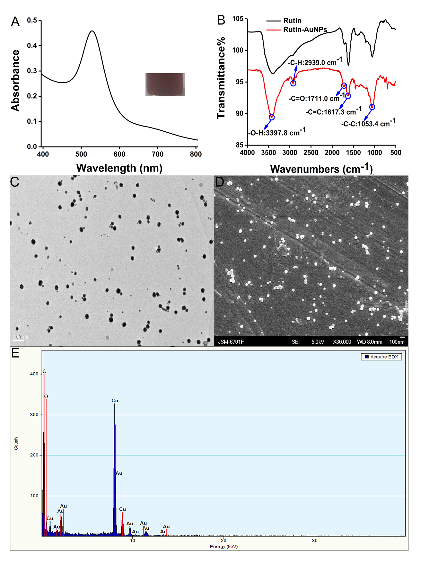

Figure.S1. (A) The UV-Vis absorption and photograph of Rutin-AuNPs. (B) The FT-IR spectrum of Rutin and Rutin-AuNPs. (C) The TEM image of Rutin-AuNPs. (D) The SEM image of Rutin-AuNPs. (E) The EDX image of Rutin-AuNPs.

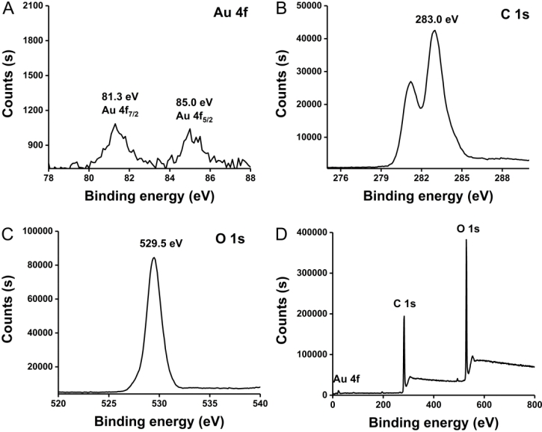

Figure.S2. The XPS image of Au (A), C (B), O (C), and Rutin-AuNPs (D).

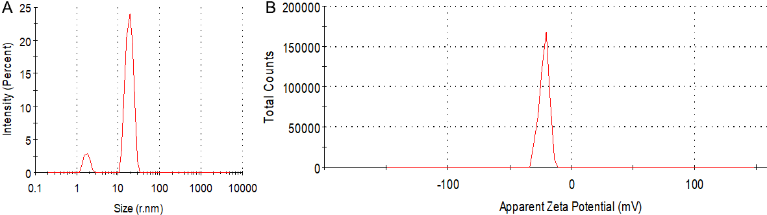

Figure.S3. (A) The particle size distribution of Rutin-AuNPs. (B) The zeta potential of Rutin-AuNPs.

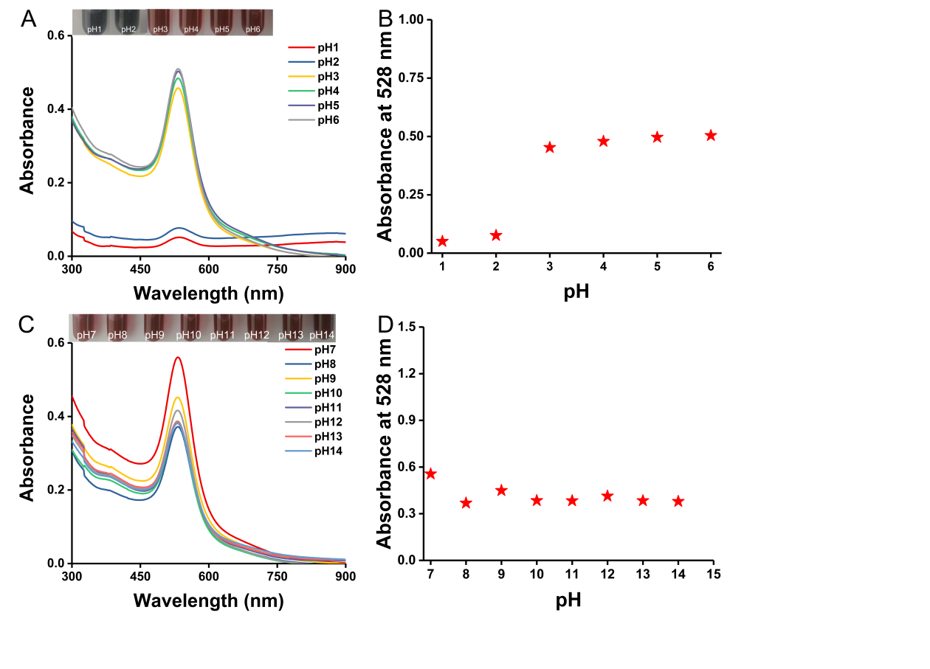

Figure.S4. The UV-Vis absorption spectrum and photograph of Rutin-AuNPs from the pH 1-6 (A), the pH 7-14 (C). The absorbance trend at 528 nm of Rutin-AuNPs from the pH 1-6 (B), the pH7-14 (D).

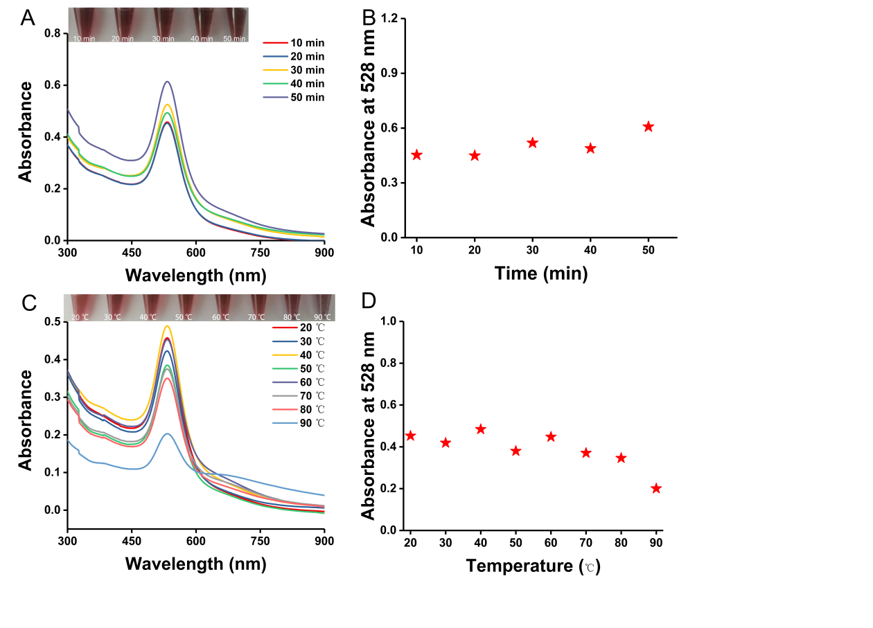

Figure.S5. The UV-Vis absorption spectrum and photograph of Rutin-AuNPs from the time 10 min to 50 min (A), the temperature 20℃ to 90℃ (C). The absorbance trend at 528 nm of Rutin-AuNPs from the time 10 min to 50 min (B), the temperature 20℃ to 90℃ (D).

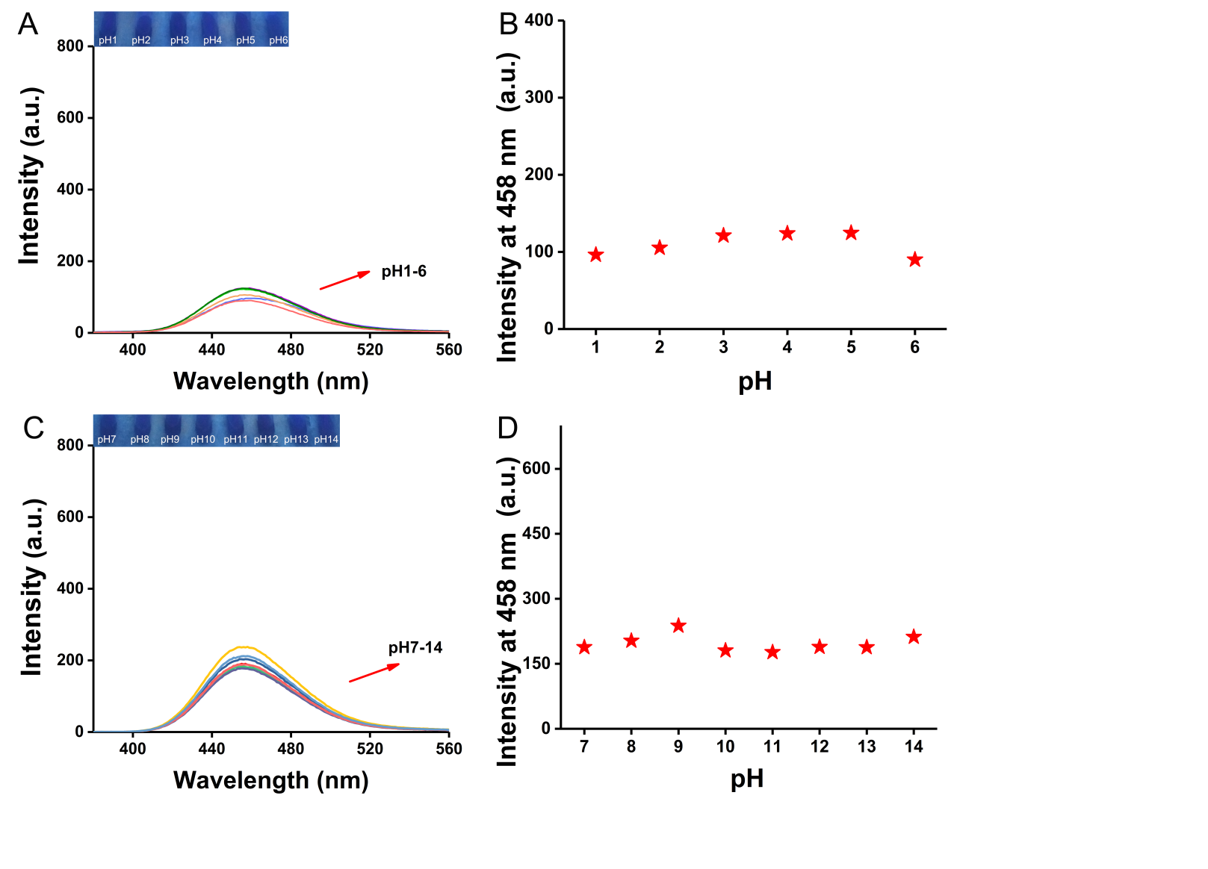

Figure.S6. The fluorescence emission spectrum and photograph of Rutin-AuNPs and 7-Hydroxycumarin mixture from the pH 1-6 (A), the pH 7-14 (C). The fluorescence intensity trend of Rutin-AuNPs and 7-Hydroxycumarin mixture from the pH 1-6 (B), the pH7-14 (D).

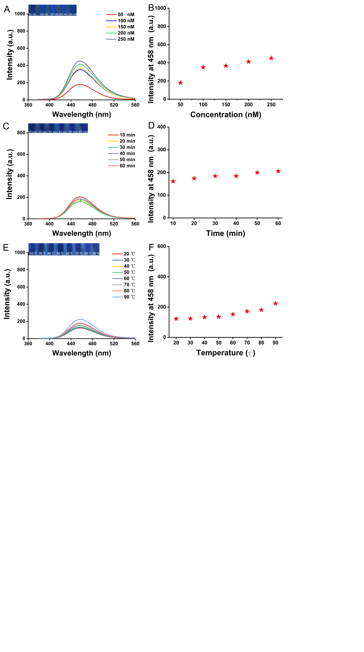

Figure.S7. The fluorescence emission spectrum and photograph of Rutin-AuNPs and 7-Hydroxycumarin mixture under the salt concentration (A), the time (C), and the different temperature (E). The fluorescence intensity trend of Rutin-AuNPs and the 7-Hydroxycumarin mixture under the salt concentration (B), the time (D), and the different temperatures (F).