Novel aromatic carboxamides from dehydroabietylamine as potential fungicides: Design, synthesis and antifungal evaluation

Zihui Yang, Qingsong Liu, Yue Sun, Xuebao Sun, Lu Sun, Linlin Chen and Wen Gu∗

Jiangsu Provincial Key Lab for the Chemistry and Utilization of Agro-forest Biomass, Jiangsu Key Lab of Biomass-based Green Fuels and Chemicals, Co-Innovation Center for Efficient Processing and Utilization of Forest Products, College of Chemical Engineering, Nanjing Forestry University, Nanjing 210037, P. R. China.
∗ Corresponding author. E-mail address: njguwen@163.com

- ¹H NMR, ¹³C NMR and HRMS data of intermediate 1, 2 and compounds 3a-3z, 4a-4f and 5a-5e.
Intermediate 1. white solid, yield 80 %, [α]²⁰_{D} = +28.7° (c 0.50, CH₃OH);¹H NMR (600 MHz, CDCl₃) δ 7.16 (d, J = 8.2 Hz, 1H, benzene), 6.99 (dd, J = 8.1, 1.6 Hz, 1H, benzene), 6.87 (s, 1H, benzene), 5.81 (brs, 1H, CONH₂), 5.53 (brs, 1H, CONH₂), 2.91-2.88 (m, 2H), 2.84-2.79 (m, 1H), 2.32 (d, J = 12.5 Hz, 1H), 2.11 (dd, J = 12.6, 2.1 Hz, 1H), 1.83–1.72 (m, 4H), 1.64 (d, J = 9.6 Hz, 1H), 1.61–1.57 (m, 1H), 1.54–1.49 (m, 1H), 1.29 (s, 3H, CH₃), 1.23 (s, 3H, CH₃), 1.21 (d, J = 6.9 Hz, 6H, 2xCH₃). ¹³C NMR (150 MHz, CDCl₃) δ 181.42 (C=O), 146.86, 145.72, 134.57, 126.85, 123.99, 123.86, 47.26, 45.51, 37.96, 37.30, 36.99, 33.42, 29.90, 25.10, 23.96, 23.94, 21.11, 18.66, 16.64. ESI-HRMS: m/z calcd. for C₂₀H₂₉NONa [M+Na]⁺: 322.2147, found 322.2154.
Intermediate 2. yellow wax, yield 50 %, [α]²⁰_{D} = +30.5° (c 0.50, CH₃OH); ¹H NMR (600 MHz, CDCl₃) δ 7.18 (d, J = 8.2 Hz, 1H, benzene), 6.99 (d, J = 8.1 Hz, 1H, benzene), 6.88 (s, 1H, benzene), 2.93–2.80 (m, 3H), 2.60 (d, J = 13.3 Hz, 1H, CH₂NH), 2.40 (d, J = 13.3 Hz, 1H, CH₂NH), 2.28 (d, J = 12.5 Hz, 1H), 1.79–1.66 (m, 4H), 1.51 (dd, J = 11.8, 3.0 Hz, 1H), 1.41–1.29 (m, 5H), 1.22 (d, J = 6.9 Hz, 6H, 2xCH₃), 1.21 (s, 3H, CH₃), 0.89 (s, 3H, CH₃).¹³C NMR (150 MHz, CDCl₃) δ 147.39, 145.46, 134.62, 126.74, 124.18, 123.77, 53.73, 44.84, 38.48, 37.33, 37.12, 35.16, 33.38, 30.11, 25.19, 23.94, 23.92, 18.70, 18.68, 18.58. ESI-HRMS: m/z calcd. for C₂₀H₃₂N [M+H]⁺: 286.2535, found 286.2539.
Compound 3a. white solid, yield 75 %, m.p. 79–80.5 ℃, [α]²⁰_{D} = −40.7° (c 0.50, CH₃OH); ¹H NMR (400 MHz, CDCl₃) δ: 8.49–8.45 (m, 1H, pyridine), 8.21 (d, J = 4.5 Hz, 1H, pyridine), 7.26–7.23 (m, 1H, pyridine), 7.08 (d, J = 8.2 Hz, 1H, benzene), 6.90 (d, J = 8.1 Hz, 1H, benzene), 6.85–6.79 (m, 1H, benzene, brs, 1H, NH), 3.39 (dd, J₁ = 13.6 Hz, J₂ = 6.1 Hz, 1H, CH₂NH), 3.29 (dd, J₁ =13.6 Hz, J₂ = 6.3 Hz, 1H, CH₂NH), 2.88-2.69 (m, 3H), 2.22 (d, J = 12.8 Hz, 1H), 1.91–1.86 (m, 1H), 1.73–1.60 (m, 3H), 1.43 (t, J = 12.6 Hz, 2H), 1.34–1.23 (m, 2H), 1.15 (s, 3H, CH₃), 1.12 (d, J = 6.9 Hz, 6H, 2xCH₃), 0.93 (s, 3H, CH₃); ¹³C NMR (100 MHz, CDCl₃) δ: 161.70 (C=O), 161.63, 159.88 (d, J = 233.6 Hz), 150.05 (d, J = 4.42 Hz), 146.86, 145.53, 143.44, 134.55, 126.84, 124.15, 123.84, 122.37 (d, J = 4.0 Hz), 116.10 (d, J = 27.3 Hz), 77.00, 50.50, 45.65, 38.21, 37.60, 37.46, 36.28, 33.33, 30.29, 25.34, 23.88, 23.86, 19.07, 18.61, 18,55; ESI-HRMS: m/z calcd. for C₂₆H₃₃FN₂O [M +H]⁺: 409.2655, found 409.2658.
Compound 3b. white solid, yield 80%, m.p. 86–87 ℃, [α]²⁰_{D} = −5.68° (c 0.50, CH₃OH); ¹H NMR (400 MHz, CDCl₃) δ: 8.29 (d, J = 4.3 Hz, 1H, pyridine), 7.93 (d, J = 7.4 Hz, 1H, pyridine), 7.18–7.16 (m, 1H, pyridine), 7.06 (d, J = 8.1 Hz, 1H, benzene), 6.89 (d, J = 8.1 Hz, 1H, benzene), 6.79 (s, 1H, benzene), 6.58 (t, J = 5.4 Hz, brs, 1H, NH), 3.30 (d, J = 9.4 Hz, 2H, CH₂NH), 2.87–2.68 (m, 3H), 2.21 (d, J = 12.8 Hz, 1H), 1.88–1.83 (m, 1H), 1.71–1.60 (m, 3H), 1.46–1.39 (m, 2H), 1.30–1.22 (m, 2H), 1.14 (s, 3H, CH₃), 1.12 (d, J = 6.9 Hz, 6H, 2xCH₃), 0.93 (s, 3H, CH₃); ¹³C NMR (100 MHz, CDCl₃) δ: 164.66 (C=O), 150.61, 146.86, 146.79, 145.55, 139.75, 134.47, 131.40, 126.79, 124.04, 123.79, 122.66, 50.83, 45.66, 38.24, 37.54, 37.40, 36.30, 33.31, 30.11, 25.19, 23.88, 23.86, 19.01, 18.54, 18.51; ESI-HRMS: m/z calcd. for C₂₆H₃₄ClN₂O [M+H]⁺: 425.2360, found 425.2361.
Compound 3c. white solid, yield 54%, m.p. 87–88.5 ℃, [α]²⁰_{D} = −9.09° (c 0.50, CH₃OH); ¹H NMR (400 MHz, CDCl₃) δ: 8.40–8.37 (m, 1H, pyridine), 7.89 (dd, J₁ = 7.6 Hz, J₂ = 2.0 Hz, 1H, pyridine), 7.32 (dd, J₁ = 7.6 Hz, J₂ = 4.7 Hz, 1H, pyridine), 7.16 (d, J = 8.2 Hz, 1H, benzene), 6.99 (dd, J₁ = 8.1 Hz, J₂ = 1.3 Hz, 1H, benzene), 6.88 (s, 1H, benzene), 6.33 (brs, 1H, NH), 3.40 (d, J = 6.4 Hz, 2H, CH₂NH), 2.97–2.78 (m, 3H), 2.31 (d, J = 12.8 Hz, 1H), 1.98–1.64 (m, 1H), 1.84–1.66 (m, 3H), 1.57–1.50 (m, 1H), 1.41–1.33 (m, 2H), 1.24 (s, 3H, CH₃), 1.21 (d, J = 6.9 Hz, 6H, 2xCH₃), 1.04 (s, 3H, CH₃); ¹³C NMR (100 MHz, CDCl₃) δ: 165.70 (C=O), 150.87, 146.91, 145.63, 138.78, 138.11, 134.81, 134.54, 126.83, 124.07, 123.83, 122.84, 50.82, 45.56, 38.28, 37.56, 37.43, 36.32, 33.36, 30.09, 25.18, 23.93, 23.90, 19.02, 18.65, 18.54; ESI-HRMS: m/z calcd. for C₂₆H₃₄BrN₂O [M+H]⁺: 469.1855, found 469.1859.
Compound 3d. white solid, yield 69%, m.p. 96.5–97.5 ℃, [α]²⁰_{D} = −6.52° (c 0.50, CH₃OH); ¹H NMR (400 MHz, CDCl₃) δ: 8.67 (d, J = 3.0 Hz, 1H, pyridine), 7.77 (d, J = 6.2 Hz, 1H, pyridine), 7.47–7.44 (m, 1H, pyridine), 7.16 (d, J = 8.1 Hz, 1H, benzene), 6.99 (d, J = 8.1 Hz, 1H, benzene), 6.89 (s, 1H, benzene), 6.15 (brs, 1H, NH), 3.42–3.23 (m, 2H, CH₂NH) , 2.96–2.78 (m, 3H), 2.30 (d, J = 12.8 Hz, 1H), 1.92–1.63 (m, 4H), 1.49–1.34 (m, 4H), 1.22 (s, 6H, 2xCH₃), 1.20 (s, 3H, CH₃), 0.99 (s, 3H, CH₃), ¹³C NMR (100MHz, CDCl₃) δ: 149.76 (C=O), 146.84, 145.62, 143.69 (d, J = 34.2 Hz), 137.15 (d, J = 1.0 Hz), 134.42, 132.12, 126.80, 126.24, 124.05, 123.84, 121.18 (q, J = 273.8 Hz), 50.91, 45.83, 38.19, 37.27, 37.26 , 35.99, 33.33, 29.98, 25.15, 23.89, 23.86, 18.92, 18.43, 18.37; ESI-HRMS: m/z calcd. for C₃₇H₃₄N₂OF₃ [M+H]⁺: 459.2623, found 459.2626.
Compound 3e. white solid, yield 66%, m.p. 90.2–91.5 ℃, [α]²⁰_{D} = −5.95° (c 0.50, CH₃OH); ¹H NMR (400 MHz, CDCl₃) δ: 8.67 (d, J = 6.3 Hz, 2H, pyridine), 7.45 (d, J = 5.0 Hz, 1H, pyridine), 7.07 (d, J = 8.2 Hz, 1H, benzene), 6.89 (d, J = 8.1 Hz, 1H, benzene), 6.79 (s, 1H, benzene), 5.97 (brs, 1H, NH), 3.40-3.35 (m, 1H, CH₂NH), 3.23–3.18 (m, 1H, CH₂NH), 2.87–2.68 (m, 3H), 2.21 (d, J = 12.9 Hz, 1H), 1.85–1.56 (m, 4H), 1.43–1.20 (m, 4H), 1.14 (s, 3H, CH₃), 1.12 (d, J = 6.9 Hz, 6H, 2xCH₃), 0.92 (s, 3H, CH₃); ¹³C NMR (100 MHz, CDCl₃) δ: 165.17 (C=O), 151.36, 149.30, 146.83, 145.68, 135.06 (q, J = 33.3 Hz), 134.42, 130.42, 126.83, 123.52, 122.16 (q, J = 272.9 Hz), 119.81 (d, J = 4.39 Hz), 50.93, 45.86, 38.26, 37.43, 37.38, 36.09, 33.37, 29.98, 25.16, 23.89, 18.97, 18.47, 18.43; ESI-HRMS: m/z calcd. for C₃₇H₃₄N₂OF₃ [M+H]⁺: 459.2623, found 459.2625.
Compound 3f. white solid, yield 70%, m.p. 83.5–84.5 ℃, [α]²⁰_{D} = −92.1° (c 0.50, CH₃OH); ¹H NMR (400 MHz, CDCl₃) δ: 8.53 (d, J = 7.4 Hz, 1H, pyridine), 8.27 (d, J = 4.6 Hz, 1H, pyridine), 8.06 (s, 1H, pyridine), 7.20 (d, J = 8.1 Hz, 1H, benzene), 7.08–7.00 (m, 2H, benzene), 6.91 (brs, 1H, NH), 4.03 (s, 3H, OCH₃), 3.49–3.37 (m, 2H, CH₂NH), 2.96–2.82 (m, 1H), 2.91–2.79 (m, 2H), 2.33 (d, J = 12.8 Hz, 1H), 2.03–1.98 (m, 1H), 1.85–1.74 (m, 3H), 1.58–1.53 (m, 2H), 1.44–1.37 (m, 2H), 1.27 (s, 3H, CH₃), 1.24 (d, J = 6.9 Hz, 6H, 2xCH₃), 1.04 (s, 3H, CH₃); ¹³C NMR (100 MHz, CDCl₃) δ: 163.74 (C=O), 160.40, 149.17, 147.11, 145.55, 141.56, 134.67, 126.79, 124.18, 123.78, 117.77, 116.20, 54.00, 50.16, 45.52, 38.41, 37.55, 37.46, 36.32, 33.35, 30.30, 25.21, 23.90, 19.00, 18.73, 18.67; ESI-HRMS: m/z calcd. for C₂₇H₃₇N₂O₂ [M+H]⁺: 421.2855, found 421.2852.
Compound 3g. white solid, yield 82%, m.p. 197–198.5 ℃, [α]²⁰_{D} = +23.2° (c 0.50, CH₃OH); ¹H NMR (400 MHz, CDCl₃) δ: 7.70 (d, J = 7.4 Hz, 1H, pyridine), 7.57–7.49 (m, 3H, benzene, pyridine), 7.23 (d, J = 12.1 Hz, 1H, benzene), 7.05 (d, J = 12.1 Hz, 1H, benzene), 6.96 (s, 1H, benzene), 6.04 (brs, 1H, NH), 3.50-3.45 (m, 1H, CH₂NH), 3.34–3.29 (m, 1H, CH₂NH), 3.02–2.85 (m, 3H), 2.36 (d, J = 19.2 Hz, 1H), 2.00–1.96 (m, 1H), 1.88–1.70 (m, 3H), 1.57–1.35 (m, 2H), 1.29 (s, 3H, CH₃), 1.28 1.28 (d, J = 6.9 Hz, 6H, 2xCH₃), 1.06 (s, 3H, CH₃); ¹³C NMR (100 MHz, CDCl₃) δ: 168.00 (C=O), 146.91, 145.52, 136.06 (q, J = 2.2 Hz), 134.51, 131.92, 129.58, 128.51, 127.48 (d, J = 17.9 Hz), 127.07, 126.77 (d, J = 2.7 Hz), 126.18 (q, J = 5.0 Hz), 124.85, 123.49 (t, J = 272.1 Hz), 124.05, 123.77, 50.68, 45.80, 38.21, 37.39, 37.27, 35.95, 33.31, 31.49, 30.04, 25.19, 23.88, 23.84, 22.55, 18.89, 18.46, 18.38; ESI-HRMS: m/z calcd. for C₂₈H₃₅NOF₃ [M+H]⁺: 458.3050, found 458.3053.
Compound 3h. white solid, yield 59%, m.p. 100–101.5 ℃, [α]²⁰_{D} = +18.5° (c 0.50, CH₃OH); ¹H NMR (400 MHz, CDCl₃) δ: 7.91 (s, 1H, pyrazole), 7.16 (d, J = 8.2 Hz, 1H, benzene), 6.98 (dd, J₁ = 8.1 Hz, J₂ =1.7 Hz, 1H, benzene), 6.78 (t, J = 54.2 Hz, 1H, CHF₂), 6.45 (brs, 1H, NH), 3.89 (s, 3H, NCH₃), 3.41–3.27 (m, 2H, NHCH₂), 2.95 –2.75 (m, 3H), 2.28 (d, J = 12.7 Hz, 1H), 1.96–1.91 (m, 1H), 1.79–1.65 (m, 3H), 1.52–1.47 (m, 2H), 1.40–1.33 (m, 2H), 1.22 (s, 6H, 2xCH₃), 1.20 (s, 3H, CH₃), 0.98 (s, 3H, CH₃); ¹³C NMR (100 MHz, CDCl₃) δ: 161.19 (C=O), 147.04, 145.46, 142.25 (t, J = 28.7 Hz), 141.96, 135.47, 134.75, 126.84, 124.17, 123.77, 116.93, 112.00 (t, J = 231.3 Hz), 109.68, 50.23, 45.61, 39.39, 38.25, 37.55, 37.51, 36.04, 33.37, 30.28, 25.38, 23.92, 19.07, 18.63, 18.45; ESI-HRMS: m/z calcd. for C₂₆H₃₆F₂N₃O [M+H]⁺: 444.2826, found 444.2832.
Compound 3i. white wax, yield 69%, [α]²⁰_{D} = +63.2° (c 0.50, CH₃OH); ¹H NMR (600 MHz, CDCl₃) δ: 7.92 (s, 1H, pyrazole), 7.16 (d, J = 8.2 Hz, 1H, benzene), 6.98 (dd, J₁ = 8.1 Hz, J₂ = 1.7 Hz, 1H, benzene), 6.88 (d, J = 1.3 Hz, 1H, benzene), 6.08 (brs, 1H, NH), 3.94 (s, 3H, NCH₃), 3.33 (d, J = 6.3 Hz, 2H, NHCH₂), 2.93–2.89 (m, 1H), 2.83–2.77 (m, 2H), 2.29 (d, J = 12.6 Hz, 1H), 1.95–1.91 (m, 1H), 1.79–1.66 (m, 3H), 1.50–1.43 (m, 2H), 1.38–1.27 (m, 2H), 1.22 (s, 6H, 2xCH₃), 1.21 (s, 3H, CH₃), 0.98 (s, 3H, CH₃);¹³C NMR (100 MHz, CDCl₃) δ: 160.49 (C=O), 146.93, 145.52, 137.67 (q, J = 55 Hz), 135.62, 134.61, 126.83, 124.14, 123.80, 122.38, 120.92 (q, J = 400 Hz), 50.38, 45.75, 39.66, 38.23, 37.48, 37.47 (d, J = 1.3 Hz), 36.07, 33.36, 30.22, 26.86, 25.31, 23.90, 19.06, 18.56, 18.36; ESI-HRMS: m/z calcd. for C₂₄H₃₂F₃N₃O₃Na [M+Na]⁺: 458.2395, found 458.2398.
Compound 3j. white solid, yield 68%, m.p. 131–133 ℃, [α]²⁰_{D} = +79.0° (c 0.50, CH₃OH); ¹H NMR (400 MHz, CDCl₃) δ: 7.16 (brs, 1H, NH), 6.98 (dd, J₁ = 8.1 Hz, J₂ = 1.5 Hz, 1H, benzene), 6.89 (d, J = 5.9 Hz, 2H, benzene), 6.51 (s, 1H, pyrazole), 3.75 (s, 3H, NCH₃), 3.44–3.39 (m, 1H, NHCH₂), 3.22–3.19 (m, 1H, NHCH₂), 2.93–2.78 (m, 3H), 2.28–2.25 (m, 4H, CH, CH₃, pyrazole), 2.00–1.96 (m, 1H), 1.79–1.68 (m, 3H), 1.54–1.47 (m, 2H), 1.42–1.34 (m, 2H), 1.22 (s, 6H, 2xCH₃), 1.20 (s, 3H, CH₃), 0.98 (s, 3H, CH₃); ¹³C NMR (100 MHz, CDCl₃) δ: 162.09 (C=O), 147.18, 145.44, 135.00, 126.87, 124.25, 123.72, 106.05, 49.24, 45.22, 38.24, 37.70, 37.52, 36.40, 36.20, 33.36, 30.42, 25.45, 23.90, 18.99, 18.81, 18.65, 11.17; ESI-HRMS: m/z calcd. for C₂₆H₃₈N₃O [M+H]⁺: 408.3015, found 408.3020.
Compound 3k. white solid, yield 70%, m.p. 179–180.2 ℃, [α]²⁰_{D} = +70.9° (c 0.50, CH₃OH); ¹H NMR (600 MHz, CDCl₃) δ: 7.17 (d, J = 8.2 Hz, 1H, benzene), 7.00 (dd, J₁ = 8.1 Hz, J₂ = 1.5 Hz, 1H, benzene), 6.89 (s, 1H, benzene), 6.21 (brs, 1H, NH), 5.92 (s, 1H, pyrazole), 4.09 (s, 3H, NCH₃), 3.35 (dd, J₁ = 13.7 Hz, J₂ = 6.5 Hz, 1H, NHCH₂), 3.26 (dd, J₁ = 13.7 Hz, J₂ = 6.7 Hz, 1H, NHCH₂), 2.93 (dd, J₁ = 17.1 Hz, J₂ = 6.2 Hz, 1H, CH), 2.86–2.75 (m, 2H), 2.31–2.27 (m, 2H), 2.25 (s, 3H, CH₃), 2.04 (s, 1H), 1.95–1.91 (m, 1H), 1.80–1.73 (m, 2H), 1.70–1.67 (m, 1H), 1.49–1.43 (m, 2H,), 1.38–1.35 (m, 1H), 1.23 (s, 3H, CH₃), 1.22 (d, J = 7.0 Hz, 6H, 2xCH₃), 0.99 (s, 3H, CH₃); ¹³C NMR (150 MHz, CDCl₃) δ: 160.20 (C=O), 146.98, 146.70, 145.70, 136.02, 134.62, 126.94, 124.23, 123.95, 105.33, 49.75, 45.74, 38.76, 38.32, 37.69, 36.41, 33.43, 30.39, 25.42, 23.98, 19.12, 18.72, 18.61, 13.25; ESI-HRMS: m/z calcd. for C₂₆H₃₈N₃O [M+H]⁺: 408.3015, found 408.3013.
Compound 3l. white solid, yield 80%, m.p. 120–121.5 ℃, [α]²⁰_{D} = +11.6° (c 0.50, CH₃OH); ¹H NMR (600 MHz, CDCl₃) δ: 8.67 (s, 1H, benzene), 7.16 (d, J = 8.2 Hz, 1H, benzene), 7.00–6.98 (m, 1H, benzene), 6.89 (brs, 1H, NH), 5.81 (s, 1H, thiazole), 3.41–3.31 (m, 2H, NHCH₂), 2.95–2.91 (m, 1H), 2.85–2.78 (m, 2H), 2.71 (s, 3H, CH₃), 2.31 (d, J = 12.7 Hz, 1H), 1.96–1.93 (m, 1H), 1.80–1.71 (m, 3H), 1.50–1.45 (m, 2H), 1.33–1.28 (m, 2H), 1.23 (s, 3H, CH₃), 1.22 (d, J = 6.9 Hz, 6H, 2xCH₃), 1.00 (s, 3H, CH₃); ¹³C NMR (150 MHz, CDCl₃) δ: 161.78, 155.17, 154.91, 152.23, 146.88, 145.68, 134.59, 126.92, 124.19, 123.90, 50.57, 45.89, 38.31, 37.58, 37.53, 36.48, 33.39, 30.36, 26.89, 25.37, 23.93, 19.10, 18.63, 18.58, 17.27; ESI-HRMS: m/z calcd. for C₂₅H₃₅N₂OS [M+H]⁺: 411.2470, found 411.2469.
Compound 3m. yield 83%, white solid, m.p. 145–146 ℃, [α]²⁰_{D} = +73.8° (c 0.50, CH₃OH); ¹H NMR (600 MHz, CDCl₃) δ: 7.95 (s, 1H, benzene), 7.16 (d, J = 8.2 Hz, 1H), 6.98 (d, J = 8.1 Hz, 1H, benzene), 6.88 (s, 1H, benzene), 6.08 (brs, 1H, NH), 3.39 (dd, J ₁ = 13.7 Hz, J ₂ = 6.6 Hz, 1H, NHCH₂), 3.26 (dd, J ₁ = 13.7 Hz , J₂ = 6.5 Hz, 1H, NHCH₂), 2.93–2.89 (m, 1H), 2.84–2.78 (m, 2H), 2.69 (s, 3H, CH₃), 2.29 (d, J = 12.7 Hz, 1H), 1.95–1.91 (m, 1H), 1.77–1.72 (m, 2H), 1.71–1.66 (m, 1H), 1.49–1.44 (m, 2H), 1.39–1.37 (m, 1H), 1.35–1.32 (m, 1H), 1.22 (s, 6H, 2xCH₃), 1.21 (s, 3H, CH₃), 0.98 (s, 3H, CH₃); ¹³C NMR (150 MHz, CDCl₃) δ: 162.46 (C=O), 159.09, 157.61, 156.08, 146.87, 145.49, 134.63, 126.82, 124.13, 123.79, 118.45, 49.89, 45.31, 38.11, 37.78, 37.44, 36.16, 33.28, 30.29, 26.79, 25.37, 23.84, 19.02, 18.77, 18.52; ESI-HRMS: m/z calcd. for C₂₅H₃₅N₂OS [M+H]⁺: 411.2470, found 411.2475.
Compound 3n. yield 65%, white wax, [α]²⁰_{D} = +84.3° (c 0.50, CH₃OH); ¹H NMR (600 MHz, CDCl₃) δ: 7.16 (d, J = 8.2 Hz, 1H, benzene), 6.99 (d, J = 8.1 Hz, 1H, benzene), 6.88 (s, 1H, benzene), 6.20 (brs, 1H, NH), 3.39–3.29 (m, 2H, NHCH₂), 2.94–2.90 (m, 1H), 2.84–2.78 (m, 2H), 2.70 (s, 3H, CH₃), 2.30 (d, J = 12.8 Hz, 1H), 1.91–1.86 (m, 1H), 1.80–1.73 (m, 2H), 1.71–1.67 (m, 1H), 1.51–1.49 (m, 1H,), 1.39–1.35 (m, 2H), 1.23 (s, 3H, CH₃), 1.22 (d, J = 6.9 Hz, 6H, 2xCH₃), 0.99 (s, 3H, CH₃); ¹³C NMR (150 MHz, CDCl₃) δ: 167.98 (C=O), 158.85, 146.75, 145.63, 140.10, 139.15 (J = 39 Hz), 139.62, 139.38, 136.07, 134.47, 126.84, 124.12, 123.88, 120.29 (J = 270.4 Hz), 51.22, 45.90, 38.22, 37.35, 36.11, 33.30, 30.15, 26.87, 25.25, 23.90, 19.10, 19.05, 18.51, 18.39; ESI-HRMS: m/z calcd. for C₂₆H₃₄N₂OSF₃ [M+H]⁺: 479.2344, found 479.2348.
Compound 3o. yield 75%, white solid, m.p. 125–127 ℃, [α]²⁰_{D} = +20.3° (c 0.50, CH₃OH); ¹H NMR (400 MHz, CDCl₃) δ: 8.28 (s, 1H, benzene), 7.16 (d, J = 8.2 Hz, 1H, benzene), 6.99 (d, J = 7.8 Hz, 1H,benzene), 6.89 (brs, 1H, NH), 5.63 (s, 1H, isoxazole), 3.39–3.24 (m, 2H, NHCH₂), 2.97–2.91 (m, 1H), 2.85–2.76 (m, 2H,), 2.69 (s, 3H, CH₃), 2.31 (d, J = 13.1 Hz, 1H), 1.97-1.91 (m, 1H, CH), 1.82–1.76 (m, 2H,), 1.74–1.70 (m, 1H), 1.47–1.40 (m, 2H), 1.38–1.28 (m, 2H), 1.22 (s, 6H, 2xCH₃), 1.21 (s, 3H, CH₃), 0.99 (s, 3H, CH₃); ¹³C NMR (150 MHz, CDCl₃) δ: 172.17 (C=O), 161.10, 147.74, 146.91, 145.72, 134.57, 126.91, 124.15, 123.93, 111.88, 49.83, 45.70, 38.27, 37.56, 37.48, 36.44, 33.40, 30.29, 25.34, 23.93, 19.07, 18.64, 18.54, 12.49; ESI-HRMS: m/z calcd. for C₂₅H₃₅N₂O₂ [M + H]⁺:395.2699, found 395.2701.
Compound 3p. white wax, yield 75%, [α]²⁰_{D} = +101.1° (c 0.50, CH₃OH); ¹H NMR (600 MHz, CDCl₃) δ: 7.22 (d, J = 2.0 Hz, 1H, benzene), 7.16 (d, J = 8.2 Hz, 1H, benzene), 6.99 (dd, J₁ = 8.1 Hz, J₂=1.5 Hz, 1H, benzene), 6.89 (brs, 1H, NH), 6.36 (s, 1H), 5.67 (s, 1H), 3.35–3.27 (m, 2H, NHCH₂), 2.94–2.90 (m, 1H), 2.85–2.78 (m, 2H), 2.57 (s, 3H, CH₃), 2.29 (d, J = 12.7 Hz, 1H), 2.04 (s, 1H, CH), 1.97–1.94 (m, 1H), 1.80–1.66 (m, 3H), 1.49–1.45 (m, 2H), 1.40–1.35 (m, 2H), 1.23 (s, 6H, 2xCH₃), 1.21 (s, 3H, CH₃), 0.98 (s, 3H, CH₃); ¹³C NMR (150 MHz, CDCl₃) δ: 163.82 (C=O), 156.51, 146.97, 145.50, 140.17, 134.67, 126.84, 124.13, 123.77, 115.60, 108.21, 49.56, 45.64, 38.26, 37.44, 36.32, 33.32, 30.34, 25.34, 23.88, 18.99, 18.60, 18.55, 13.44; ESI-HRMS: m/z calcd. for C₂₆H₃₆NO₂ [M+H]⁺:394.2746, found 394.2750.
Compound 3q. white solid, yield 81%, m.p. 129–130 ℃, [α]²⁰_{D} = +17.8° (c 0.50, CH₃OH); ¹H NMR (600 MHz, CDCl₃) δ: 7.40 (dd, J₁ = 1.7 Hz, J₂ = 0.7 Hz, 1H, isoxazole), 7.16 (d, J = 8.2 Hz, 1H, benzene), 7.08 (dd, J₁ = 3.5 Hz, J₂ = 0.7 Hz, 1H, isoxazole), 6.99 (dd, J₁ = 8.1 Hz, J₂ = 1.7 Hz, 1H, benzene), 6.89 (s, 1H, benzene), 6.47 (dd, J₁ = 3.5 Hz, J₂ = 1.8 Hz, 1H, isoxazole), 6.35 (s, 1H, NH), 3.44-3.40 (m, 1H, NHCH₂), 3.25-3.21 (m, 1H, NHCH₂), 2.94–2.90 (m, 1H), 2.87–2.79 (m, 2H), 2.28 (d, J = 12.6 Hz, 1H), 1.98–1.94 (m, 1H), 1.80–1.66 (m, 3H), 1.51–1.47 (m, 2H), 1.41–1.33 (m, 2H), 1.22 (s, 3H, CH₃), 1.21 (d, J = 7.0 Hz, 6H, 2xCH₃), 0.99 (s, 3H, CH₃); ¹³C NMR (150 MHz, CDCl₃) δ: 158.42 (C=O), 147.98, 147.06, 145.62, 143.66, 134.83, 126.94, 124.21, 123.86, 114.12, 112.13, 49.25, 45.27, 38.25, 37.65, 37.52, 36.20, 33.39, 30.34, 25.42, 23.93, 19.01, 18.84, 18.61; ESI-HRMS: m/z calcd. for C₂₅H₃₄NO₂ [M+H]⁺: 380.2590, found 380.2599.
Compound 3r. white solid, yield 66%, m.p. 198–199.5 ℃, [α]²⁰_{D} = +87.4° (c 0.50, CH₃OH); ¹H NMR (600 MHz, CDCl₃) δ: 9.19 (s, 1H, pyrazine), 8.93 (d, J = 5.0 Hz, 1H), 8.21–8.05 (m, 2H,pyrazine), 7.16 (d, J = 8.2 Hz, 1H, benzene), 6.98 (d, J = 8.1 Hz, 1H, benezene), 6.89 (brs, 1H, NH), 3.51 (dd, J₁ = 13.6 Hz, J₂ = 7.0 Hz, 1H, NHCH₂), 3.28 (dd, J₁ = 13.7 Hz, J₂ = 6.6 Hz, 1H, NHCH₂), 2.95–2.91 (m, 1H, CH), 2.87–2.78 (m, 2H), 2.29 (d, J = 12.8 Hz, 1H), 2.02–1.98 (m, 1H), 1.81–1.76 (m, 2H), 1.71–1.67 (m, 1H), 1.55–1.50 (m, 2H), 1.43–1.39 (m, 2H), 1.23 (s, 3H, CH₃), 1.21 (d, J = 6.9 Hz, 6H, 2xCH₃), 1.02 (s, 3H, CH₃); ¹³C NMR (150 MHz, CDCl₃) δ: 169.94 (C=O), 160.56, 146.92, 145.65, 142.30, 134.65, 134.28, 126.92, 124.16, 123.88, 50.30, 45.68, 38.26, 37.72, 37.50, 36.38, 33.38, 30.33, 25.37, 23.93, 23.92, 19.50, 19.07, 18.67, 18.56; ESI-HRMS: m/z calcd. for C₂₅H₃₄N₃O [M+H]⁺: 392.2702, found 392.2703.
Compound 3s. white solid, yield 80%, m.p. 126–127 ℃, [α]²⁰_{D} = +88.5° (c 0.50, CH₃OH); ¹H NMR (600 MHz, CDCl₃) δ: 8.26 (d, J = 8.8 Hz, 1H, pyridazine), 8.13 (s, 1H, benzene), 7.66 (d, J = 8.8 Hz, 1H, pyridazine), 7.15 (d, J = 8.2 Hz, 1H, benzene), 6.97 (dd, J₁ = 8.1 Hz, J₂ = 1.7 Hz, 1H, benzene), 6.87 (brs, 1H, NH), 3.53 (dd, J₁ = 13.6 Hz, J₂ = 7.0 Hz, 1H, NHCH₂), 3.32 (dd, J₁ =13.7 Hz, J₂ = 6.6 Hz, 1H, NHCH₂), 2.95–2.78 (m, 3H, NHCH₂), 2.28 (d, J = 12.4 Hz, 1H), 2.01–1.98 (m, 1H), 1.80–1.77 (m, 2H), 1.77–1.69 (m, 1H), 1.51–1.48 (m, 2H), 1.43–1.35 (m, 2H), 1.23 (s, 3H, CH₃), 1.21 (d, J = 7.0 Hz, 6H, 2xCH₃), 1.02 (s, 3H, CH₃); ¹³C NMR (150 MHz, CDCl₃) δ 161.83 (C=O), 159.15, 151.86, 147.17, 145.81, 134.87, 129.60, 128.35, 127.11, 124.39, 124.09, 50.41, 45.67, 38.43, 38.15, 37.71, 36.51, 33.61, 30.53, 25.60, 24.15, 24.13, 19.37, 19.00, 18.79; ESI-HRMS: m/z calcd. for C₂₅H₃₃N₃OCl [M + H]⁺: 426.2312, found 426.2320.
Compound 3t. white solid, yield 61%, m.p. 206–207 ℃, [α]²⁰_{D} = +33.3° (c 0.50, CH₃OH); ¹H NMR (600 MHz, CDCl₃) δ: 8.98 (t, J = 6.0 Hz, 1H, coumarin), 8.90 (s, 1H, benzene), 7.70–7.63 (m, 2H, coumarin), 7.40–7.35 (m, 2H, coumarin), 7.16 (d, J = 8.2 Hz, 1H, benzene), 6.97 (dd, J₁= 8.1 Hz, J₂ =1.7 Hz, 1H, benzene), 6.88 (s, 1H,CH=CH), 3.46 (dd, J₁= 13.6 Hz, J₂ = 6.4 Hz, 1H, NHCH₂), 3.34 (dd, J₁= 13.6 Hz, J₂= 6.5 Hz, 1H, NHCH₂), 2.94–2.85 (m, 2H), 2.87–2.82 (m, 1H), 1.99–1,96 (m, 1H), 1.82–1.67 (m, 3H), 1.56–1.51 (m, 2H), 1.42–1.36 (m, 2H), 1.23 (s, 3H, CH₃), 1.20 (d, J = 6.9 Hz, 6H, 2xCH₃), 1.01 (s, 3H, CH₃); ¹³C NMR (150 MHz, CDCl₃) δ: 161.61 (C=O), 154.38, 148.30, 147.10, 145.49, 134.85, 133.96, 129.75, 126.94, 125.25, 124.30, 123.86, 118.70, 118.57, 116.63, 50.45, 45.65, 38.32, 37.84, 37.59, 36.39, 33.42, 30.47, 25.49, 23.98, 23.95, 19.18, 18.79, 18.71; ESI-HRMS: m/z calcd. for C₃₀H₃₆NO₃ [M+H]⁺: 458.2695, found 458.2694.
Compound 3u. white solid, yield 79%, m.p. 157–158 ℃, [α]²⁰_{D} = +46.1° (c 0.50, CH₃OH); ¹H NMR (600 MHz, CDCl₃) δ: 7.50 (d, J = 1.6 Hz, 1H, 1,3-dioxane), 7.44 (dd, J ₁= 8.3 Hz, J₂ = 1.6 Hz, 1H, 1,3-dioxane), 7.16 (d, J = 8.2 Hz, 1H, benzene), 7.07 (d, J = 8.3 Hz, 1H, 1,3-dioxane), 6.99–6.98 (m, 1H, benzene), 6.88 (s, 1H, benzene), 6.00 (brs, 1H, NH), 3.43 (dd, J₁= 13.7 Hz, J₂ = 6.4 Hz, 1H, NHCH₂), 3.30 (d, J₁= 13.7 Hz, J₂ = 6.5 Hz, 1H, NHCH₂), 2.95–2.90 (m, 1H), 2.83–2.77 (m, 2H), 2.30 (d, J = 12.7 Hz, 1H), 2.04-1.94 (m, 1H), 1.81 –1.74 (m, 2H), 1.70–1.66 (m, 1H), 1.52–1.45 (m, 2H), 1.41–1.31 (m, 2H), 1.23 (s, 3H, CH₃), 1.20 (d, J = 6.9 Hz, 6H, 2xCH₃), 1.00 (s, 3H, CH₃);¹³C NMR (150 MHz, CDCl₃) δ: 165.94 (C=O), 146.97, 145.78 (d, J = 17.4 Hz), 144.00, 134.67, 131.32, 126.98, 124.22, 123.96, 122.62, 109.07 (d, J = 40.5 Hz), 108.93, 50.49, 45.80, 38.39, 37.71, 37.48, 36.47, 33.36, 30.38, 25.42, 23.97, 19.13, 18.82, 18.62; ESI-HRMS: m/z calcd. for C₂₈H₃₄NO₃F₂ [M + H]⁺: 470.2507, found 470.2507.
Compound 3v. white solid, yield 82%, m.p. 123–125 ℃, [α]²⁰_{D} = +57.9° (c 0.50, CH₃OH); ¹H NMR (600 MHz, CDCl₃) δ: 9.67 (s, 1H,quinoxazole), 8.19–8.17(m, 1H, quinoxazole), 8.11–8.08 (m, 2H, quinoxazole), 7.87–7.81 (m, 2H, quinoxazole, benzene), 7.16 (d, J = 8.2 Hz, 1H, benzene), 6.97 (d, J = 8.1 Hz, 1H, benzene), 6.89 (brs, 1H, NH), 3.56 (dd, J₁ = 13.7 Hz, J₂ = 7.0 Hz, 1H, NHCH₂), 3.37 (dd, J₁ = 13.7 Hz, J₂= 6.7 Hz, 1H, NHCH₂), 2.98-2.94 (m, 1H), 2.92–2.85 (m, 1H), 2.82–2.78 (m, 1H), 2.30 (d, J = 12.8 Hz, 1H), 2.08–2.04 (m, 1H), 1.86–1.77 (m, 2H), 1.74–1.71 (m, 1H), 1.61–1.55 (m, 2H), 1.49–1.37 (m, 2H), 1.25 (s, 3H, CH₃), 1.20 (d, J = 6.9 Hz, 6H, 2xCH₃), 1.06 (s, 3H, CH₃); ¹³C NMR (150 MHz, CDCl₃) δ: 163.24 (C=O), 147.01, 145.59, 143.98, 143.87, 143.41, 140.15, 134.77, 131.45, 130.67, 129.69, 129.46, 126.92, 124.21, 123.85, 50.01, 45.53, 38.25, 37.97, 37.55, 36.38, 33.37, 30.43, 25.45, 23.91, 19.16, 18.81, 18.65; ESI-HRMS: m/z calcd. for C₂₉H₃₆N₃O [M+H]⁺: 442.2858, found 442.2863.
Compound 3w. white solid, yield 67%, m.p. 221–223 ℃, [α]²⁰_{D} = +52.8° (c 0.50, CH₃OH); ¹H NMR (600 MHz, CDCl₃) δ: 8.41 (d, J = 8.2 Hz, 1H, benzene), 7.50 (d, J = 8.4 Hz, 1H, benzene), 7.42 (d, J = 9.2 Hz, 1H, indazole), 7.30–7.27 (m, 1H, indazole), 7.16 (dd, J₁ = 11.4 Hz, J₂ =7.4 Hz, 2H, indazole), 6.98 (d, J = 8.1 Hz, 1H, benzene), 6.88 (s, 1H, NH, indazole), 3.48 (dd, J₁ =13.7 Hz, J₂ = 6.6 Hz, 1H, NHCH₂), 3.37 (dd, J₁ = 13.7 Hz, J₂ = 6.8 Hz, 1H, NHCH₂), 2.95–2.78 (m, 3H, CH_{2,} CH), 2.28 (d, J = 12.7 Hz, 1H), 2.04–2.00 (m, 1H), 1.81–1.74 (m, 2H), 1.71–1.66 (m, 1H), 1.59–1.54 (m, 2H), 1.47–1.37 (m, 2H), 1.24 (s, 3H, CH₃), 1.20 (d, J = 6.9 Hz, 6H, 2xCH₃), 1.03 (s, 3H, CH₃); ¹³C NMR (150 MHz, CDCl₃) δ: 162.93 (C=O), 147.14, 145.59, 141.43, 139.24, 134.90, 127.26, 126.95, 124.31, 123.87, 122.77, 122.64, 121.93, 109.94, 49.45, 45.58, 38.32, 37.79, 37.60, 36.33, 33.42, 30.46, 25.50, 23.98, 23.95, 19.12, 18.84, 18.70; ESI-HRMS: m/z calcd. for C₂₈H₃₆N₃O [M+H]⁺: 430.2858, found 430.2859.
Compound 3x. white solid, yield 52%, m.p. 258–260.1 ℃, [α]²⁰_{D} = +52.0° (c 0.50, CH₃OH); ¹H NMR (600 MHz, CDCl₃) δ: 9.03 (s, 1H, NH, indole), 7.39 (s, 1H, indole), 7.30 (d, J = 8.5 Hz, 1H, benzene), 7.16 (d, J = 8.2 Hz, 1H, benzene), 7.11–7.09 (m, 1H, indole), 6.98 (dd, J₁ = 8.1 Hz, J₂ = 1.4 Hz, 1H, indole), 6.88 (s, 1H, indole), 6.69 (d, J = 1.1 Hz, 1H, benzene), 6.12 (brs, 1H, NH), 3.42 (dd, J₁ = 13.7 Hz, J₂ = 6.4 Hz, 1H, NHCH₂), 3.35 (dd, J₁ = 13.7 Hz, J₂ = 6.7 Hz, 1H, NHCH₂), 2.94-2.91 (m, 1H), 2.87–2.78 (m, 2H), 2.42 (s, 3H, CH₃), 2.30 (d, J = 13.0 Hz, 1H), 1.99-1.96 (m, 1H), 1.81–1.74 (m, 2H), 1.71–1.68 (s, 1H), 1.52–1.49 (m, 2H), 1.42–1.34 (m, 2H), 1.23 (s, 3H, CH₃), 1.20 (d, J = 6.9 Hz, 6H, 2xCH₃), 1.01 (s, 3H, CH₃); ¹³C NMR (150 MHz, CDCl₃) δ: 161.76 (C=O), 146.97, 145.63, 134.65, 134.62, 130.70, 129.92, 127.86, 126.92, 126.35, 124.21, 123.89, 121.13, 111.57, 101.04, 49.99, 45.82, 38.31, 37.76, 37.55, 36.37, 33.40, 30.39, 25.40, 23.94, 23.93, 21.43, 19.13, 18.70, 18.62; ESI-HRMS: m/z calcd. for C₃₀H₃₉N₂O [M + H]⁺: 443.3062, found 443.3063.
Compound 3y. white solid, yield 70%, m.p. 197–198.8 ℃, [α]²⁰_{D} = −75.6° (c 0.50, CH₃OH); ¹H NMR (600 MHz, CDCl₃) δ: 7.83–7.81 (m, 2H, benzothiophene), 7.73 (s, 1H, benzothiophene), 7.42–7.37 (m, 2H, benzothiophene), 7.17 (d, J = 8.2 Hz, 1H, benzene), 6.99 (dd, J₁ = 8.1 Hz, J₂ =1.1 Hz, 1H, benzene), 6.89 (s, 1H, benzene), 6.10 (brs, 1H, NH), 3.44 (dd, J₁ = 13.7 Hz, J₂ = 6.4 Hz, 1H, NHCH₂), 3.35 (dd, J₁ = 13.7 Hz, J₂ = 6.6 Hz, 1H, NHCH₂), 2.96–2.92 (m, 1H), 2.88–2.79 (m, 2H), 2.31 (d, J = 12.8 Hz, 1H), 1.99–1.95 (m, 1H), 1.84–1.74 (m, 2H), 1.72–1.68 (m, 1H), 1.55–1.49 (m, 2H), 1.42–1.35 (m, 2H), 1.24 (s, 3H, CH₃), 1.20 (d, J = 6.9 Hz, 6H, 2xCH₃), 1.02 (s, 3H, CH₃); ¹³C NMR (150 MHz, CDCl₃) δ: 162.33 , 146.95, 145.64, 140.68, 139.06, 138.48, 134.71, 126.95, 126.26, 124.97, 124.90, 124.21, 123.89, 122.65, 50.43, 45.84, 38.31, 37.74, 37.57, 36.40, 33.39, 30.42, 25.42, 23.94, 23.92, 19.10, 18.74, 18.62; ESI-HRMS: m/z calcd. for C₂₉H₃₆NOS [M+H]⁺: 446.2518, found 446.2520.
Compound 3z. white solid, yield 93% , m.p. 185–186 ℃, [α]²⁰_{D} = +26.5° (c 0.50, CH₃OH); ¹H NMR (600 MHz, CDCl₃) δ: 8.06 (d, J = 8.1 Hz, 1H, benzene), 7.95 (d, J = 7.8 Hz, 1H, benzene), 7.55–7.46 (m, 3H, benzothiazole), 7.17 (d, J = 8.2 Hz, 1H,benzene ), 7.03–6.97 (m, 1H, benzothiazole), 6.89 (brs, 1H, NH), 3.51 (dd, J₁ = 13.7 Hz, J₂ =7.0 Hz, 1H, NHCH₂), 3.32 (dd, J₁ = 13.7 Hz, J₂ = 6.7 Hz, 1H, NHCH₂), 2.96–2.78 (m, 3H), 2.30 (d, J = 12.6 Hz, 1H), 2.02–1.98 (m, 1H), 1.82–1.75 (m, 2H), 1.73–1.69 (m, 1H), 1.59–1.54 (m, 2H), 1.47–1.39 (m, 2H), 1.24 (s, 3H, CH₃), 1.20 (d, J = 7.0 Hz, 6H, 2xCH₃), 1.04 (s, 3H, CH₃); ¹³C NMR (150 MHz, CDCl₃) δ: 163.98 (C=O), 160.01, 152.81, 146.98, 145.62, 137.15, 134.78, 126.93, 126.71, 126.59, 124.29, 124.23, 123.87, 122.34, 50.31, 45.51, 38.22, 37.90, 37.57, 36.30, 33.39, 30.37, 25.45, 23.93, 23.91, 19.12, 18.79, 18.61; ESI-HRMS: m/z calcd. for C₂₈H₃₅N₂OS [M+H]⁺: 447.2470, found 447.2475.
Compound 4a. white solid, yield 89%, m.p. 180–181.5 ℃, [α]²⁰_{D} = +105.6° (c 0.50, CH₃OH); ¹H NMR (600 MHz, CDCl₃) δ: 7.61 (d, J = 7.9 Hz, 2H, benzene, pyrazole), 7.44–7.41 (m, 2H, benzene-pyrazole), 7.38–7.36 (m, 1H, benzene), 7.16 (d, J = 8.2 Hz, 1H, benzene), 7.04 (s, 1H, pyrazole), 6.97 (d, J = 8.1 Hz, 2H, benzene), 6.87 (brs, 1H, NH), 3.44 (dd, J₁ = 13.7 Hz, J₂ = 6.7 Hz, 1H, NHCH₂), 3.30 (dd, J₁ = 13.7 Hz, J₂ = 6.6 Hz, 1H, NHCH₂), 2.92–2.78 (m, 3H), 2.27 (d, J = 12.8 Hz, 1H), 1.99–1.96 (m, 1H), 1.78–1.70 (m, 2H), 1.67–1.65 (m, 1H), 1.53–1.50 (m, 2H), 1.41–1.37(m, 2H),
1.22 (s, 3H, CH₃), 1.20 (d, J = 7.0 Hz, 6H, 2xCH₃), 1.00 (s, 3H, CH₃); ¹³C NMR (150 MHz, CDCl₃) δ: 161.83 (C=O), 147.06, 145.54, 134.82, 129.07, 128.83, 126.90, 125.62, 124.22, 123.80, 117.10, 103.19, 49.73, 45.55, 38.24, 37.74, 37.52, 36.24, 33.38, 30.37, 25.42, 23.93, 23.92, 19.06, 18.69, 18.62; ESI-HRMS: m/z calcd. for C₃₀H₃₈N₃O [M+H]⁺: 456.3015, found 456.3017.
Compound 4b. white wax, yield 32.7%, [α]²⁰_{D} = +13.9° (c 0.50, CH₃OH); ¹H NMR (600 MHz, CDCl₃) δ: 8.05 (s, 1H, thiazole), 7.92–7.90 (m, 2H, benzene-thiazole), 7.57 (t, J = 6.6 Hz, 1H, benzene), 7.45–7.43 (m, 3H, benzene-thiazole), 7.16 (d, J = 8.2 Hz, 1H, benzene), 6.97 (dd, J₁ = 8.1 Hz, J₂ =1.5 Hz, 1H, benzene), 6.89 (brs, 1H, NH), 3.46 (dd, J₁ =13.6 Hz, J₂ =6.9 Hz, 1H, NHCH₂), 3.32 (dd, J₁ = 13.7 Hz, J₂ = 6.8 Hz, 1H, NHCH₂), 2.97–2.86 (m, 2H), 2.83–2.78 (m, 1H), 2.28 (d, J = 12.6 Hz, 1H), 2.05–2.02 (m, 1H), 1.81–1.74 (m, 2H), 1.72–1.69 (m, 1H), 1.57–1.55 (m, 2H), 1.44–1.41 (m, 2H), 1.24 (s, 3H, CH₃), 1.20 (d, J = 7.0 Hz, 6H, 2xCH₃), 1.02 (s, 3H, CH₃); ¹³C NMR (150 MHz, CDCl₃) δ: 167.99 (C=O), 161.14, 150.88, 147.08, 145.50, 134.82, 132.80, 130.52, 128.96, 126.88, 126.60, 124.24, 123.80, 122.72, 49.87, 45.58, 38.29, 37.84 , 37.53, 36.32, 33.37, 30.49, 26.87, 25.42, 23.92, 19.12, 18.69, 18.66; ESI-HRMS: m/z calcd. for C₃₀H₃₇N₂OS [M+H]⁺: 473.2627, found 473.2626.
Compound 4c. white solid, yield 90%, m.p. 240–242.5 ℃, [α]²⁰_{D} = +52.1° (c 0.50, CH₃OH); ¹H NMR (600 MHz, CDCl₃) δ: 7.79–7.77 (m, 2H, benzene-isoxazole), 7.49–7.45 (m, 3H, benzene-isoxazole), 7.16 (d, J = 8.2 Hz, 1H, benzene), 6.98 (dd, J₁ = 8.2 Hz, J₂ = 1.5 Hz, 1H, benzene), 6.94 (s, 1H, benzene), 6.88–6.86 (m, 2H, isoxazole, NH), 3.45 (dd, J₁ =13.7 Hz, J₂ = 6.8 Hz, 1H, NHCH₂), 3.30 (dd, J₁ = 13.7 Hz, J₂ = 6.7 Hz, 1H, NHCH₂), 2.95–2.91 (m, 1H), 2.88–2.78 (m, 2H), 2.29 (d, J = 12.7 Hz, 1H), 1.99–1.95 (m, 1H), 1.82–1.74 (m, 2H), 1.72–1.68 (m, 1H), 1.54–1.50 (m, 2H), 1.42–1.35 (m, 2H), 1.23 (s, 3H, CH₃), 1.21 (d, J = 7.0 Hz, 6H, 2xCH₃), 1.01 (s, 3H, CH₃);¹³C NMR (150 MHz, CDCl₃) δ: 171.62 (C=O), 159.14, 159.07, 146.99, 145.64, 134.72, 130.68, 129.12, 126.93, 126.84, 125.93, 124.24, 123.90, 99.23, 49.92, 45.58, 38.27, 37.79, 37.56, 36.29, 33.36, 30.36, 25.42, 23.96, 19.15, 18.73, 18.61; ESI-HRMS: m/z calcd. for C₃₀H₃₇N₂O₂ [M+H]⁺: 457.2855, found 457.2860.
Compound 4d. white solid, yield 85%, m.p. 233–235 ℃, [α]²⁰_{D} = +36.8° (c 0.50, CH₃OH); ¹H NMR (600 MHz, CDCl₃) δ: 7.97 (d, J = 2.4 Hz, 1H, pyrazole), 7.85–7.83 (m, 2H, pyrazole-benzene), 7.78–7.75 (m, 3H, pyrazole-benzene, pyrazole), 7.17 (d, J = 8.2 Hz, 1H, benzene), 6.99 (dd, J₁ = 8.1 Hz, J₂ = 1.7 Hz, 1H, benzene), 6.89 (s, 1H, benzene), 6.50 (dd, J₁ = 2.4 Hz, J₂ =1.9 Hz, 1H, pyrazole), 6.12 (brs, 1H, NH), 3.46–3.43 (m, 1H, NHCH₂), 3.37 (dd, J₁ =13.7 Hz, J₂ = 6.6 Hz, 1H, NHCH₂), 2.96–2.92 (m, 1H), 2.87–2.79 (m, 2H), 2.31 (d, J = 12.7 Hz, 1H), 2.01–1.97 (m, 1H), 1.82–1.76 (m, 2H), 1.74–1.69 (m, 1H), 1.53–1.50 (m, 2H), 1.42–1.35 (m, 2H), 1.24 (s, 3H, CH₃), 1.21 (d, J = 7.0 Hz, 6H, 2xCH₃), 1.03 (s, 3H, CH₃); ¹³C NMR (150 MHz, CDCl₃) δ: 166.66 (C=O), 146.99, 145.65, 142.21, 141.71, 134.70, 132.42, 128.30, 126.94, 126.78, 124.20, 123.89, 118.63, 108.26, 50.40, 45.85, 38.33, 37.69, 37.55, 36.43, 33.38, 30.40, 25.41, 23.93, 23.91, 19.09, 18.77, 18.62; ESI-HRMS: m/z calcd. for C₃₀H₃₈N₃O [M+H]⁺: 456.3015; found 456.3014.
Compound 4e. white solid, yield 90%, m.p. 183–184.5 ℃, [α]²⁰_{D} = +23.2° (c 0.50, CH₃OH); ¹H NMR (600 MHz, CDCl₃) δ: 8.17 (d, J = 8.5 Hz, 2H, 1,2,4-oxdiazole- benzene), 7.87 (d, J = 8.5 Hz, 2H, 1,2,4-oxdiazole- benzene), 7.17 (d, J = 8.2 Hz, 1H, benzene), 6.99 (d, J = 8.1 Hz, 1H, benzene), 6.89 (s, 1H, benzene), 6.17 (brs, 1H,NH), 3.47 (dd, J ₁= 13.7 Hz, J₂ = 6.4 Hz, 1H, NHCH₂), 3.37 (dd, J₁ =13.7 Hz, J₂ = 6.5 Hz, 1H, NHCH₂), 2.97–2.92 (m, 1H), 2.86–2.79 (m, 2H), 2.32 (d, J = 14.7 Hz, 1H), 2.00–1.97 (m, 1H), 1.83–1.75 (m, 2H), 1.73–1.69 (m, 1H), 1.58–1.55 (m, 1H), 1.53–1.49 (m, 1H), 1.43–1.35 (m, 2H), 1.25 (s, 3H, CH₃), 1.21(d, J = 7.0 Hz, 6H, 2xCH₃), 1.03 (s, 3H, CH₃); ¹³C NMR (150 MHz, CDCl₃) δ: 168.48 (C=O), 166.55, 146.97, 145.74, 141.04, 138.25, 134.68, 128.02, 127.56 (t, J = 32.3 Hz), 127.34, 127.01 (d, J = 8.6 Hz), 125.82, 124.98, 124.23, 123.97, 123.07, 120.85 (q, J = 233.5 Hz), 50.58, 45.85, 38.35 , 37.76, 36.49 , 33.42, 30.41, 25.39, 19.14, 18.84, 18.63; ESI-HRMS: m/z calcd. for C₃₀H₃₅N₃O₂F₃ [M+H]⁺: 526.2681, found 526.2683.
Compound 4f. white solid, yield 86%, m.p. 162–163 ℃, [α]²⁰_{D} = +89.1° (c 0.50, CH₃OH); ¹H NMR (600 MHz, CDCl₃) δ: 7.53 (dd, J₁ = 3.7 Hz, J₂ =1.1 Hz, 1H, thiophene), 7.48 (dd, J₁ = 5.0 Hz, J₂ = 1.1 Hz, 1H, thiophene), 7.16–7.13 (m, 2H,isoxazole, benzene), 6.98 (d, J = 8.1 Hz, 1H,benzene), 6.88 (d, J = 1.3 Hz, 1H, thiophene), 6.83 (d, J = 7.7 Hz, 1H, benzene), 6.80 (s, 1H, NH), 3.44 (dd, J₁ = 13.7 Hz, J₂ = 6.8 Hz, 1H, NHCH₂), 3.29 (dd, J₁ = 13.7 Hz, J₂ = 6.7 Hz, 1H, NHCH₂), 2.95–2.91 (m, 1H), 2.88–2.77 (m, 2H), 2.29 (d, J = 12.6 Hz, 1H), 1.98–1.94 (m, 1H), 1.81–1.74 (m, 2H), 1.71–1.67 (m, 1H), 1.53–1.49 (m, 2H), 1.42–1.33 (m, 2H), 1.23 (s, 3H, CH₃), 1.21 (d, J = 7.0 Hz, 6H, 2xCH₃), 1.01 (s, 3H, CH₃);¹³C NMR (150 MHz, CDCl₃) δ: 166.56 (C=O), 159.05, 158.83, 146.94, 145.61, 134.68, 128.68, 128.43, 128.17, 127.62, 126.90, 124.20, 123.87, 98.89, 49.91, 45.54, 38.23, 37.76, 37.52, 36.24, 33.39, 30.32, 25.38, 23.93, 19.11, 18.68, 18.57; ESI-HRMS: m/z calcd. for C₂₈H₃₅N₂O₂S [M+H]⁺: 463.2419, found 463.2422.
Compound 5a. white solid, yield 82%, m.p. 107–108.5 ℃, [α]²⁰_{D} = +50.5° (c 0.50, CH₃OH); ¹H NMR (600 MHz, CDCl₃) δ: 7.13 (d, J = 8.2 Hz, 1H, benzene), 7.00 (dd, J₁ = 8.1 Hz, J₂ = 1.6 Hz, 1H, benzene), 6.89 (s, 1H, benzene), 6.78-6.77 (m, 4H, 4-F-benzene), 6.50 (brs, 1H, NH), 4.45 (s, 2H, OCH₂), 3.37 (dd, J₁ = 13.7 Hz, J₂ =7.0 Hz, 1H, NHCH₂), 3.08 (dd, J₁ = 13.7 Hz, J₂ = 6.5 Hz, 1H, NHCH₂), 2.92–2.89 (m, 1H), 2.86–2.74 (m, 2H), 2.22 (d, J = 12.7 Hz, 1H), 1.91–1.88 (m, 1H, CH(CH₃)₂), 1.74–1.67 (m, 2H), 1.64–1.59 (m, 2H), 1.37–1.35 (m, 1H), 1.31–1.28 (m, 2H), 1.23 (d, J = 6.9 Hz, 6H, 2xCH₃), 1.19 (s, 3H, CH₃), 0.92 (s, 3H, CH₃); ¹³C NMR (150 MHz, CDCl₃) δ: 167.98 (C=O), 157.83 (d, J = 238.8 Hz), 153.05 (d, J = 2.2 Hz), 147.01, 145.64, 134.57, 126.81, 124.20, 123.89, 116.26, 116.10, 115.55 (d, J = 32.5 Hz), 77.00, 67.85, 49.06, 44.87, 38.16, 37.50, 37.32, 36.13, 33.43, 30.26, 25.26, 23.98, 23.97, 18.97, 18.71, 18.49; ESI-HRMS: m/z calcd. for C₂₈H₃₇NO₂F [M+H]⁺: 438.2808, found 438.2808.
Compound 5b. white wax, yield 73% , [α]²⁰_{D} = +57.3° (c 0.50, CH₃OH); ¹H NMR (600 MHz, CDCl₃) δ: 7.13 (d, J = 8.2 Hz, 1H, benzene), 7.05–6.96 (m, 3H, 4-Cl-benzene), 6.89 (s, 1H, benzene), 6.75 (d, J = 9.0 Hz, 2H, 4-Cl-benzene), 6.47 (brs, 1H, NH), 4.46 (d, J = 4.5 Hz, 2H, OCH₂), 3.39 (dd, J₁ = 13.7 Hz, J₂ =7.1 Hz, 1H, NHCH₂), 3.03 (dd, J₁ =13.7 Hz, J₂ = 6.4 Hz, 1H, NHCH₂), 2.91–2.88 (m, 1H), 2.85–2.75 (m, 2H), 2.21 (d, J = 12.8 Hz, 1H), 1.92–1.89 (m, 1H), 1.75–1.68 (m, 2H), 1.61–1.58 (m, 1H), 1.37–1.32 (m, 1H), 1.28–1.26 (m, 1H), 1.24 (d, J = 6.9 Hz, 6H, 2xCH₃), 1.18 (s, 3H, CH₃), 1.07–1.14 (m, 2H), 0.92 (s, 3H, CH₃); ¹³C NMR (150 MHz, CDCl₃) δ: 167.67 (C=O), 155.45, 146.97, 145.54, 134.47, 129.58, 127.04, 126.72, 124.19, 123.92, 115.65, 77.00, 67.40, 48.95, 44.69, 38.03, 37.44, 37.24, 36.04, 33.38, 30.21, 25.19, 23.97, 23.93, 18.91, 18.68, 18.42; ESI-HRMS: m/z calcd. for C₂₈H₃₇NO₂Cl [M+H]⁺: 454.2513, found 454.2515.
Compound 5c. white wax, yield 83% , [α]²⁰_{D} = +26.1° (c 0.50, CH₃OH); ¹H NMR (600 MHz, CDCl₃) δ: 7.13 (d, J = 8.2 Hz, 1H, benzene), 6.98 (d, J = 8.0 Hz, 1H, benzene), 6.89 (s, 1H, benzene), 6.77 (d, J = 9.0 Hz, 2H, 4-OCH₃-benzene), 6.65 (d, J = 9.0 Hz, 2H, 4-OCH₃-benzene), 6.58 (brs, 1H, NH), 4.44 (s, 2H, OCH₂), 3.67 (s, 3H, OCH₃), 3.34 (dd, J₁ =13.6 Hz, J₂ = 6.8 Hz, 1H, NHCH₂), 3.09 (dd, J₁ = 13.7 Hz, J₂ = 6.5 Hz, 1H, NHCH₂), 2.91–2.88 (m, 1H), 2.87–2.74 (m, 2H), 2.21 (d, J = 12.9 Hz, 1H), 1.92–1.89 (m, 1H), 1.75-1.65 (m, 2H), 1.61–1.58 (m, 1H), 1.37–1.32 (m, 2H), 1.23 (d, J = 7.0 Hz, 6H, 2xCH₃), 1.19 (s, 3H, CH₃), 1.16–1.13 (m, 1H), 0.92 (s, 3H, CH₃); ¹³C NMR (150 MHz, CDCl₃) δ: 168.54 (C=O), 154.71, 151.16, 147.10, 145.58, 134.73, 126.91, 124.30, 123.88, 115.51, 114.85, 68.00, 55.66, 49.18, 45.14, 38.24, 37.57, 37.46, 36.13, 33.49, 30.46, 25.38, 24.07, 19.06, 18.76, 18.60; ESI-HRMS: m/z calcd. for C₂₉H₄₀NO₃ [M+H]⁺:450.3008, found 450.3014.
Compound 5d. white solid, yield 66%, m.p. 127–128 ℃, [α]²⁰_{D} = +48.3° (c 0.50, CH₃OH); ¹H NMR (600 MHz, CDCl₃) δ: 7.33–7.31 (m, 2H, NH, pyridine), 7.08 (d, J = 8.2 Hz, 1H, benzene), 7.04–7.01 (m, 1H, pyridine), 6.95 (dd, J₁ = 8.1 Hz, J₂ =1.7 Hz, 1H, benzene), 6.82 (s, 1H, benzene), 6.37 (d, J = 9.1 Hz, 1H, pyridine), 6.00 (t, J = 6.7 Hz, 1H, pyridine), 4.68 (d, J = 13.6 Hz, 1H, OCH₂), 4.36 (d, J = 13.6 Hz, 1H, OCH₂), 3.36 (dd, J₁ = 13.7 Hz, J₂ = 7.7 Hz, 1H, NHCH₂), 2.85–2.79 (m, 3H), 2.66–2.59 (m, 1H, NHCH₂), 2.20 (d, J = 12.6 Hz, 1H), 1.79–1.59 (m, 6H), 1.33 (d, J = 13.0 Hz, 1H), 1.24 (d, J = 7.0 Hz, 6H, 2xCH₃), 1.14 (s, 3H, CH₃), 1.07–1.05 (m, 1H), 0.87 (s, 3H, CH₃); ¹³C NMR (150 MHz, CDCl₃) δ: 167.50 (C=O), 147.17, 145.33, 140.36, 137.35, 134.75, 126.85, 124.08, 123.55, 120.60, 107.22, 54.62, 49.42, 44.37, 38.24, 37.72, 37.20, 36.07, 33.47, 30.06, 25.21, 24.10, 24.04, 18.95, 18.81, 18.52; ESI-HRMS: m/z calcd. for C₂₇H₃₇N₂O₂ [M+H]⁺:421.2855, found 421.2857.
Compound 5e. white wax, yield 82%, [α]²⁰_{D} = +23.1° (c 0.50, CH₃OH); ¹H NMR (600 MHz, CDCl₃) δ: 7.12–7.09 (m, 3H, benzene), 6.98 (d, J = 8.1 Hz, 1H, benzene), 6.88–6.83(m, 4H, benzene), 6.54 (brs, 1H, NH), 4.50 (s, 2H, OCH₂), 3.33 (dd, J₁ = 13.6 Hz, J₁ = 6.8 Hz, 1H, NHCH₂), 3.11 (dd, J₁ = 13.7 Hz, J₂ = 6.6 Hz, 1H, NHCH₂), 2.91–2.71 (m, 3H), 2.20 (d, J = 12.8 Hz, 1H), 1.89–1.86 (m, 1H), 1.73–1.66 (m, 2H), 1.62–1.58 (m, 1H), 1.36 (d, J = 13.0 Hz), 1.28 (d, J = 12.5 Hz, 1H), 1.23 (d, J = 7.0 Hz, 6H, 2xCH₃), 1.18 (s, 3H, CH₃), 1.17–1.14 (m, 1H), 0.91 (s, 3H, CH₃); ¹³C NMR (150 MHz, CDCl₃) δ: 168.16 (C=O), 156.86, 146.96, 145.49, 134.58, 129.67, 126.81, 124.17, 123.72, 122.00, 114.39, 77.00, 67.10, 49.07, 44.89, 38.08, 37.47, 37.29, 36.05, 33.40, 30.23, 25.26, 23.98, 23.96, 23.95, 18.92, 18.64, 18.47; ESI-HRMS: m/z calcd. for C₂₈H₃₈NO₂ [M+H]⁺: 420.2903, found 420.2903.

- ¹H NMR, ¹³C NMR and HRMS spectra of intermediate 1, 2, compounds 3a-3z, 4a-4f and 5a-5e.
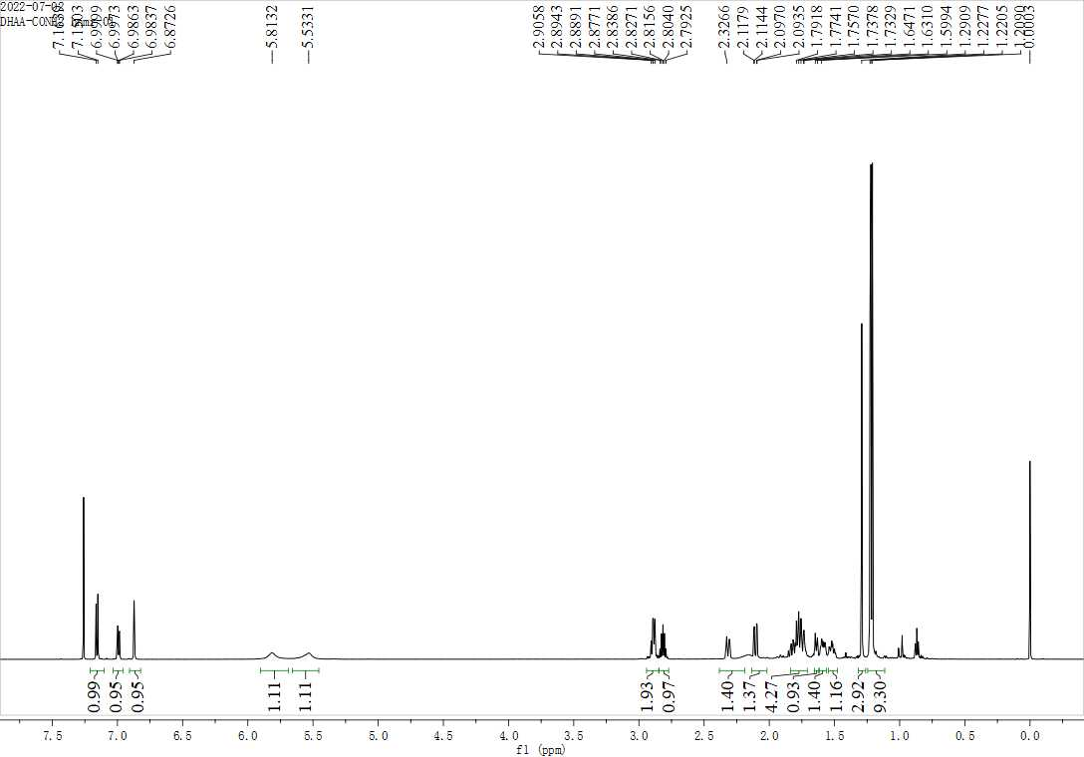
Figure S1. The ¹H NMR spectrum (600 MHz, CDCl₃) of intermediate 1
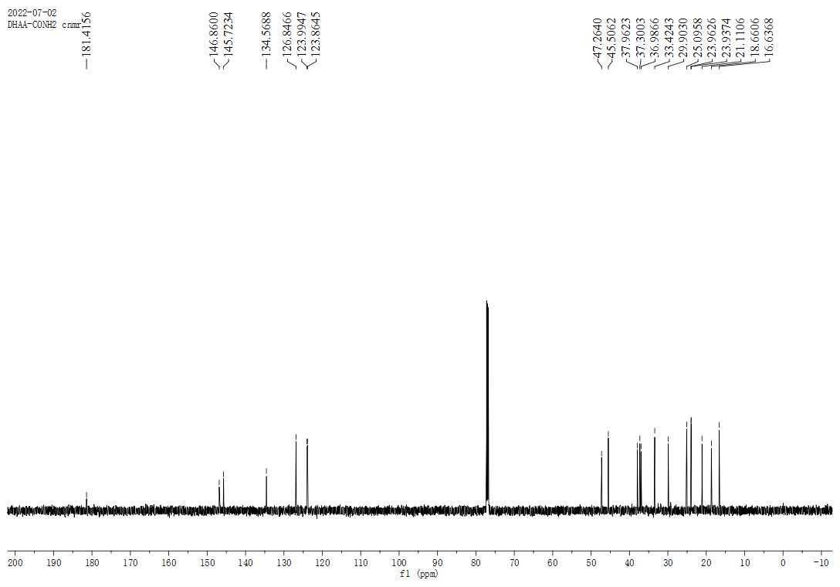
Figure S2. The ¹³C NMR spectrum (150 MHz, CDCl₃) of intermediate 1

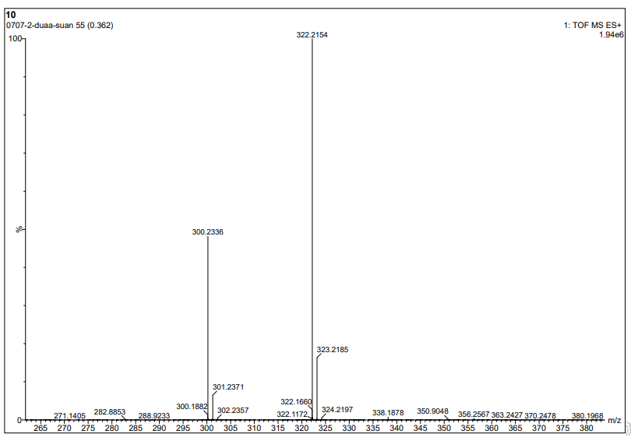
Figure S3. The HRMS spectrum of intermediate 1
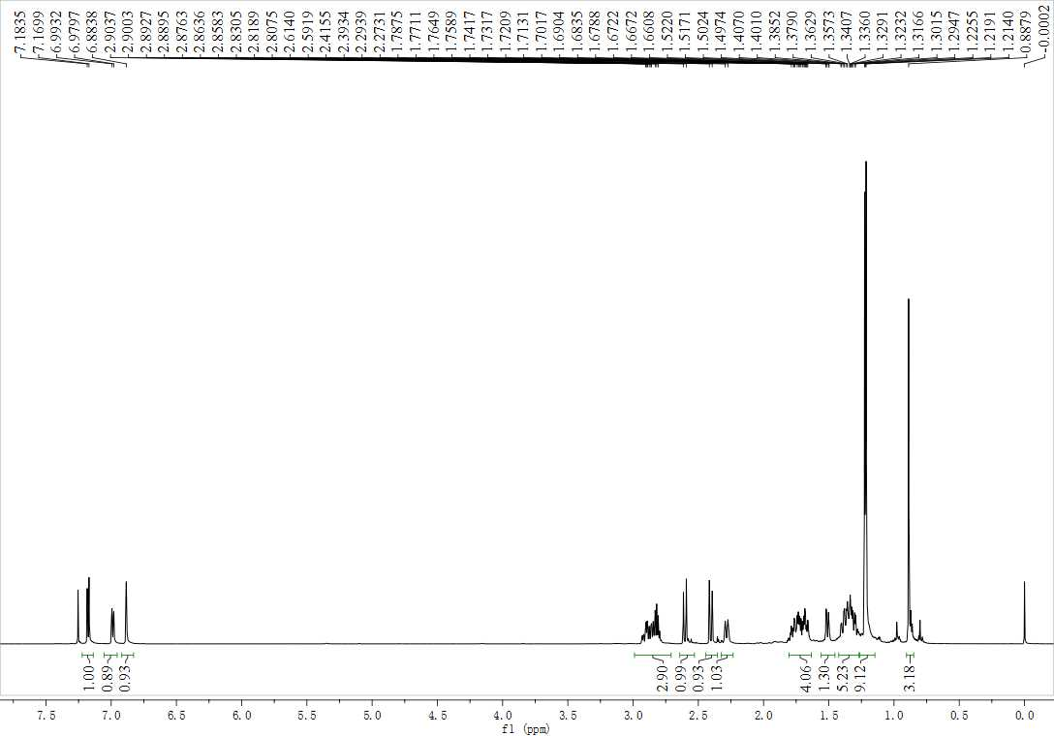
Figure S4. The ¹H NMR spectrum (600 MHz, CDCl₃) of intermediate 1

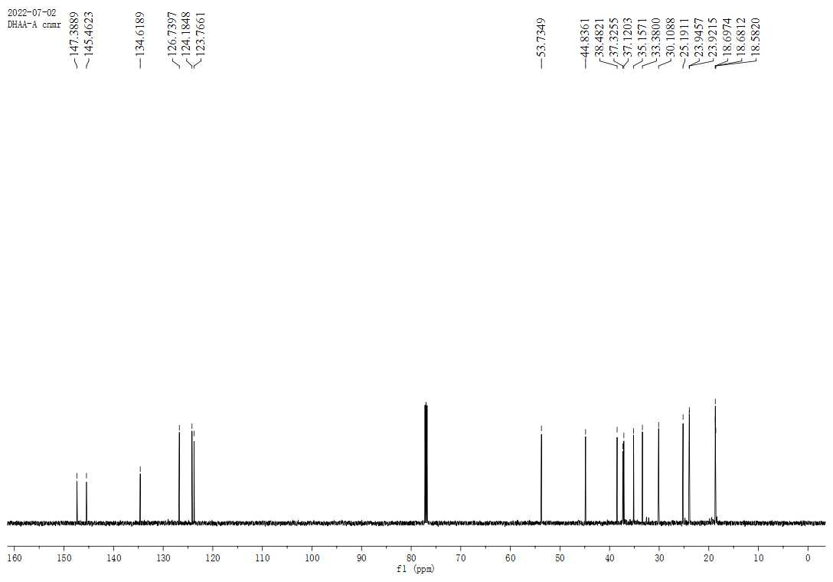
Figure S5. The ¹³C NMR spectrum (150 MHz, CDCl₃) of intermediate 2

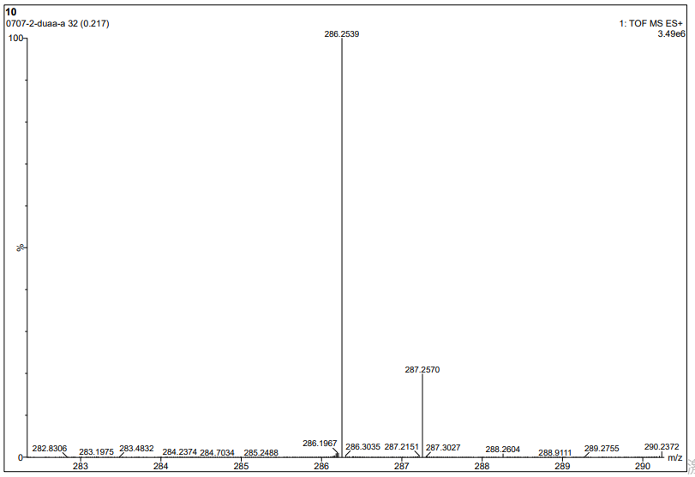

Figure S6. The HRMS spectrum of intermediate 2

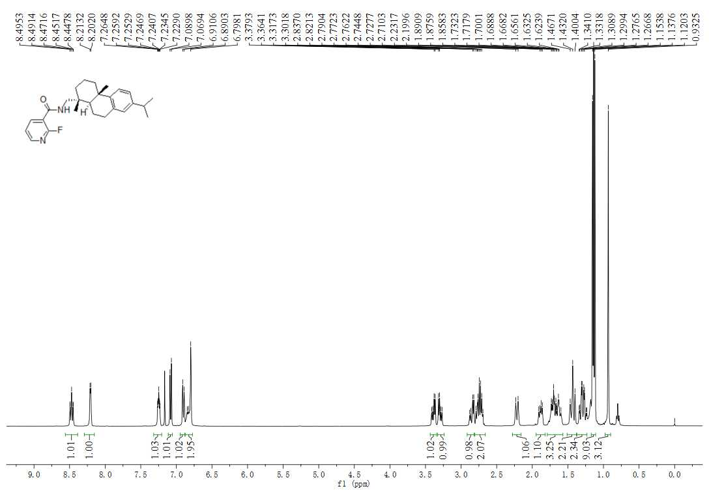
Figure S7. The ¹H NMR spectrum (400 MHz, CDCl₃) of compound 3a

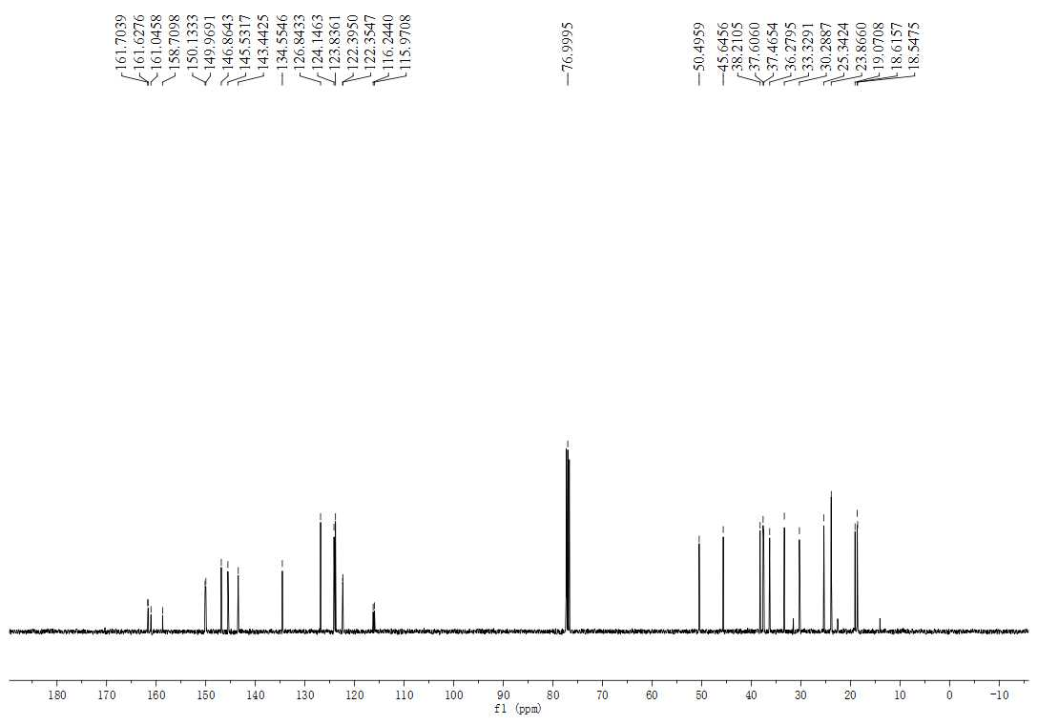
Figure S8. The ¹³C NMR spectrum (100 MHz, CDCl₃) of compound 3a
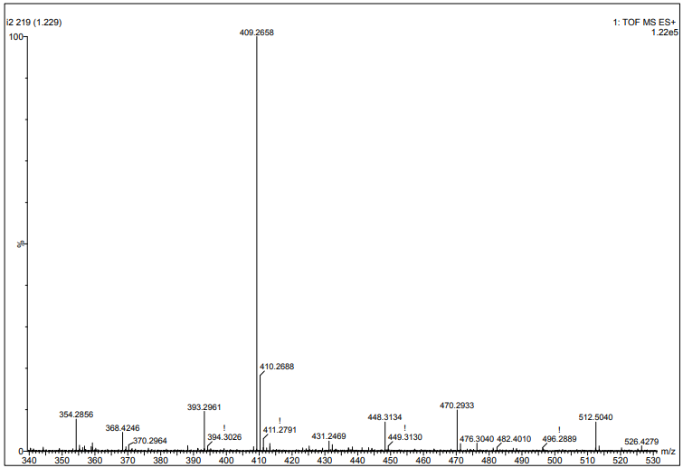
Figure S9. The HRMS spectrum of compound 3a

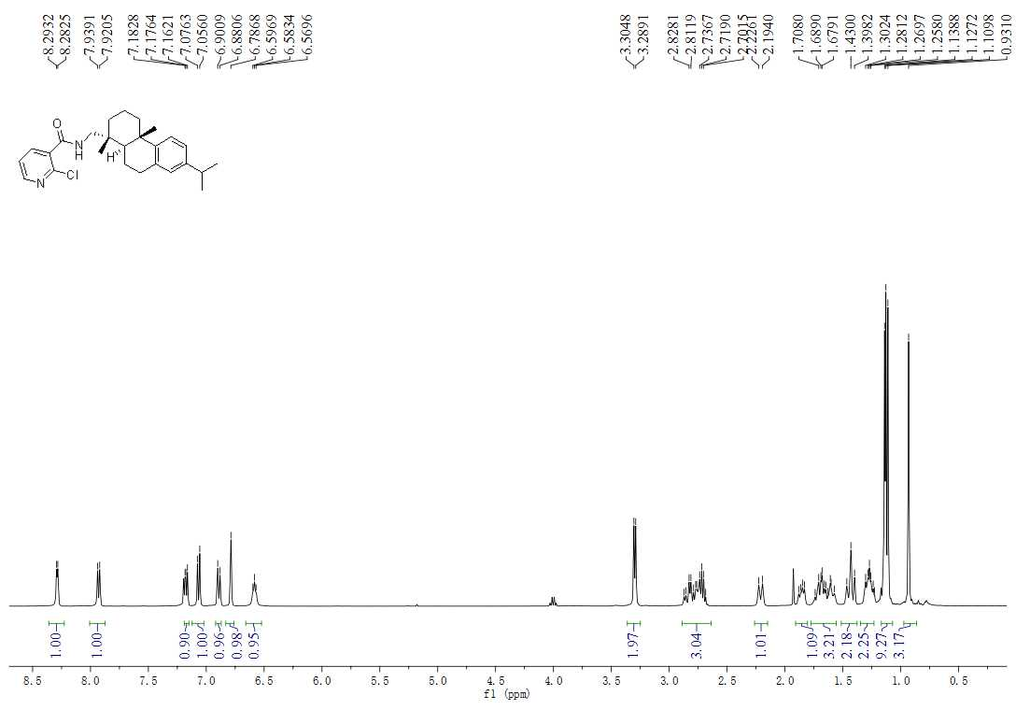
Figure S10. The ¹H NMR spectrum (400 MHz, CDCl₃) of compound 3b

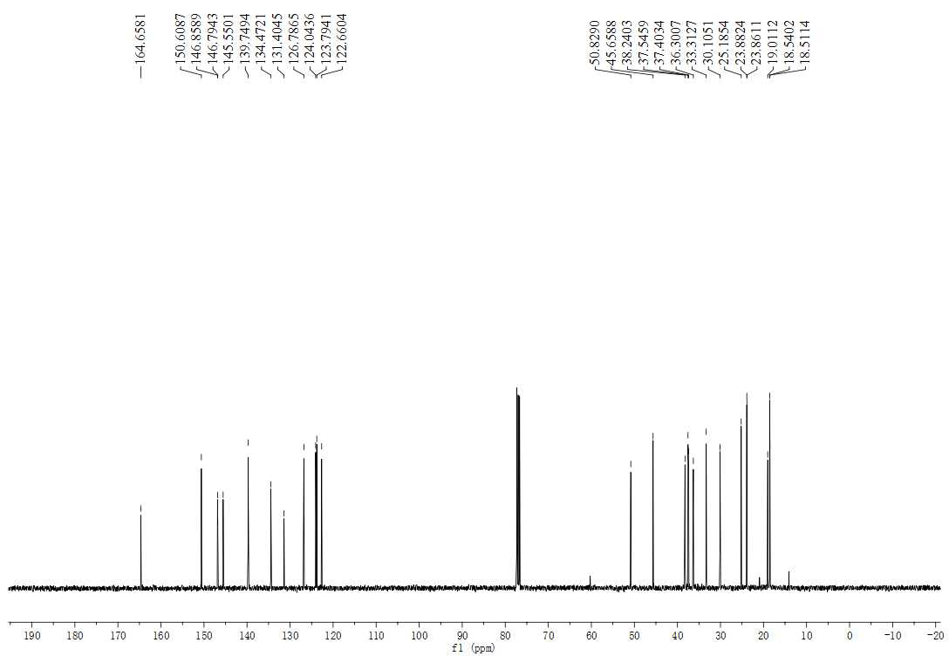
Figure S11. The ¹³C NMR spectrum (100 MHz, CDCl₃) of compound 3b

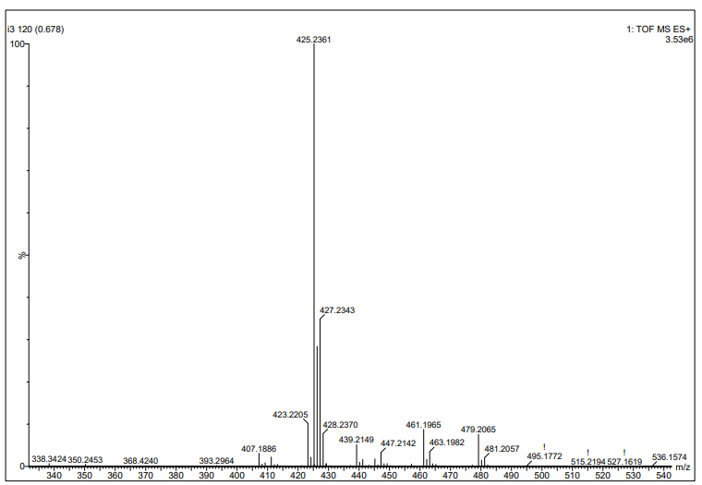
Figure S6. The HRMS spectrum of compound 3b

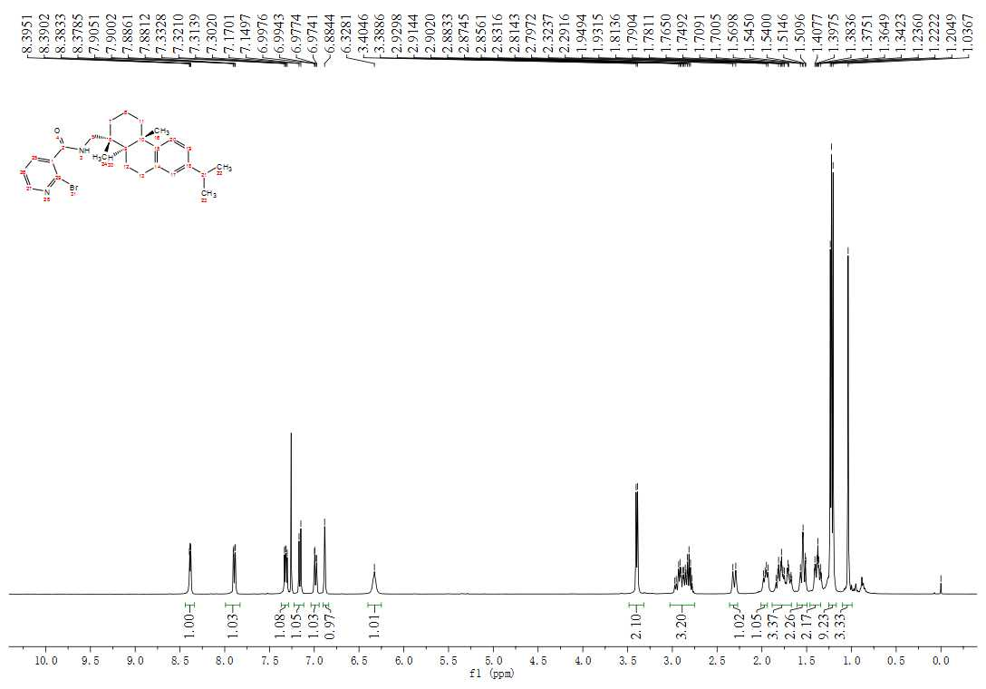
Figure S7. The ¹H NMR spectrum (400 MHz, CDCl₃) of compound 3c

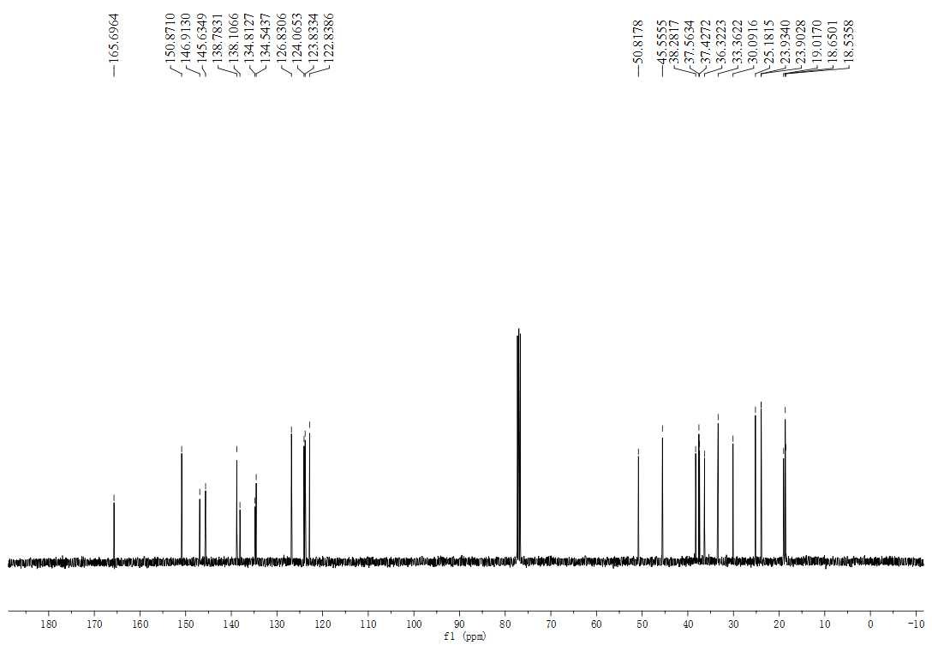
Figure S8. The ¹³C NMR spectrum (100 MHz, CDCl₃) of compound 3c
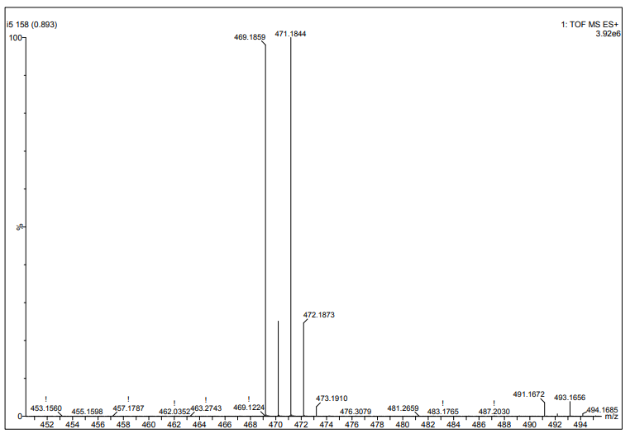
Figure S9. The HRMS spectrum of compound 3c

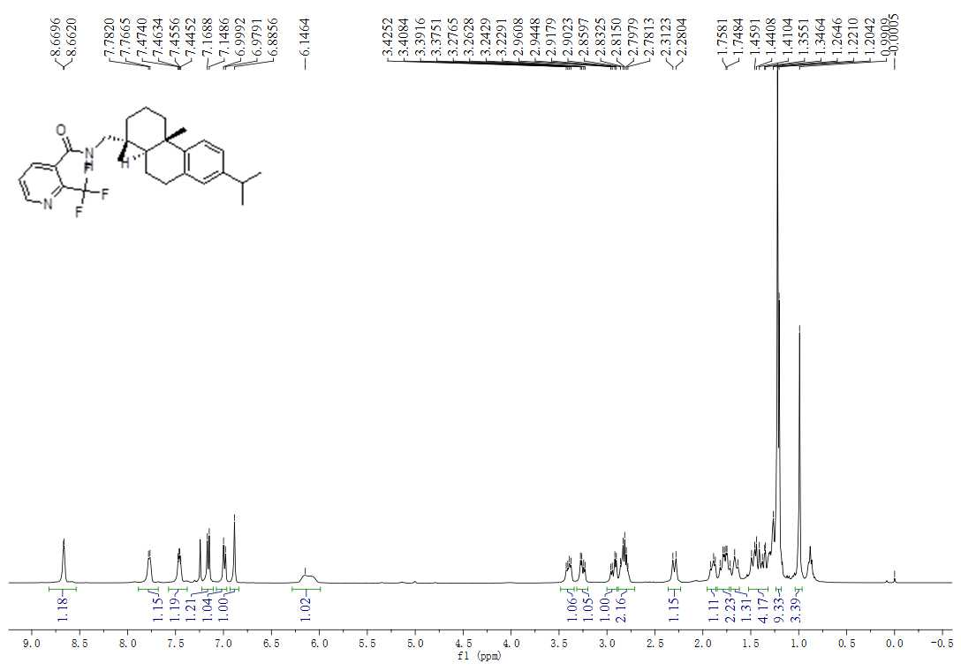

Figure S10. The ¹H NMR spectrum (400 MHz, CDCl₃) of compound 3d
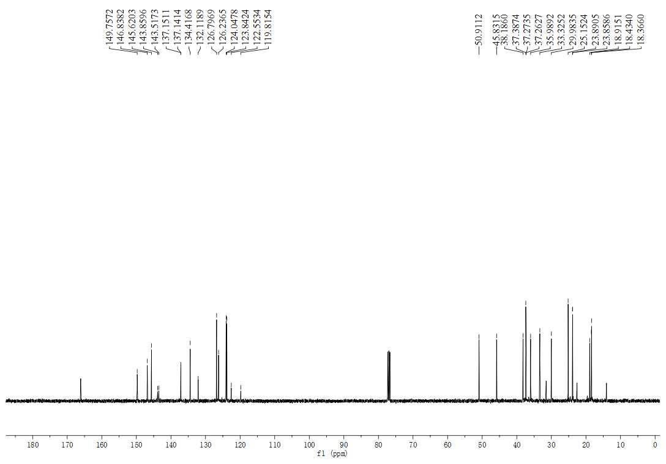
Figure S11. The ¹³C NMR spectrum (100 MHz, CDCl₃) of compound 3d

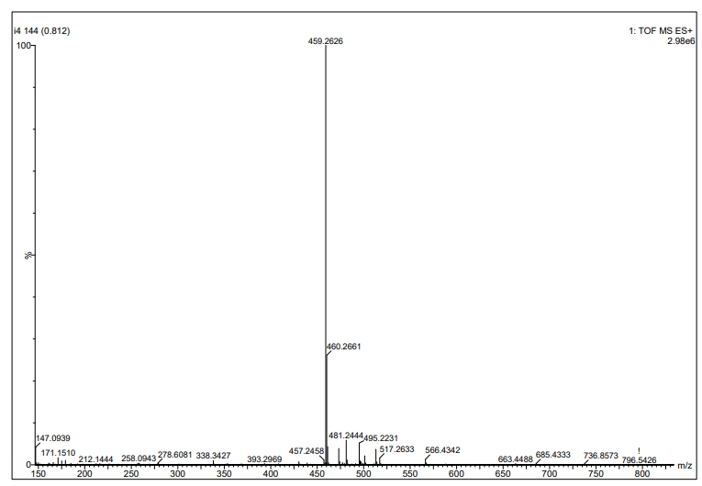
Figure S12. The HRMS spectrum of compound 3d

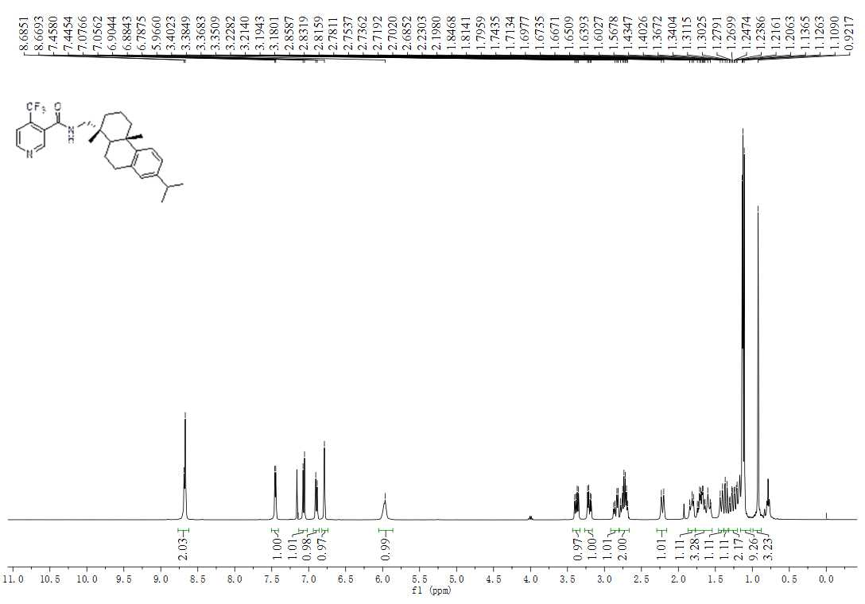
Figure S13. The ¹H NMR spectrum (400 MHz, CDCl₃) of compound 3e

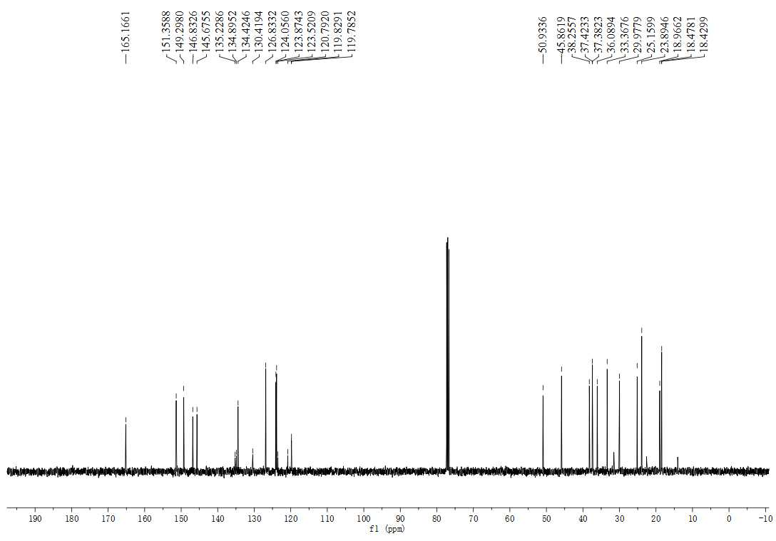
Figure S14. The ¹³C NMR spectrum (100 MHz, CDCl₃) of compound 3e

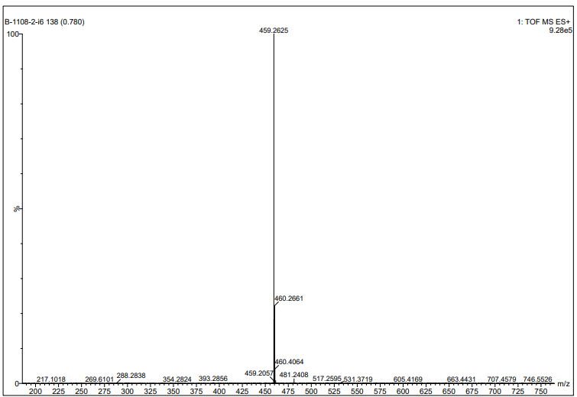
Figure S15. The HRMS spectrum of compound 3e

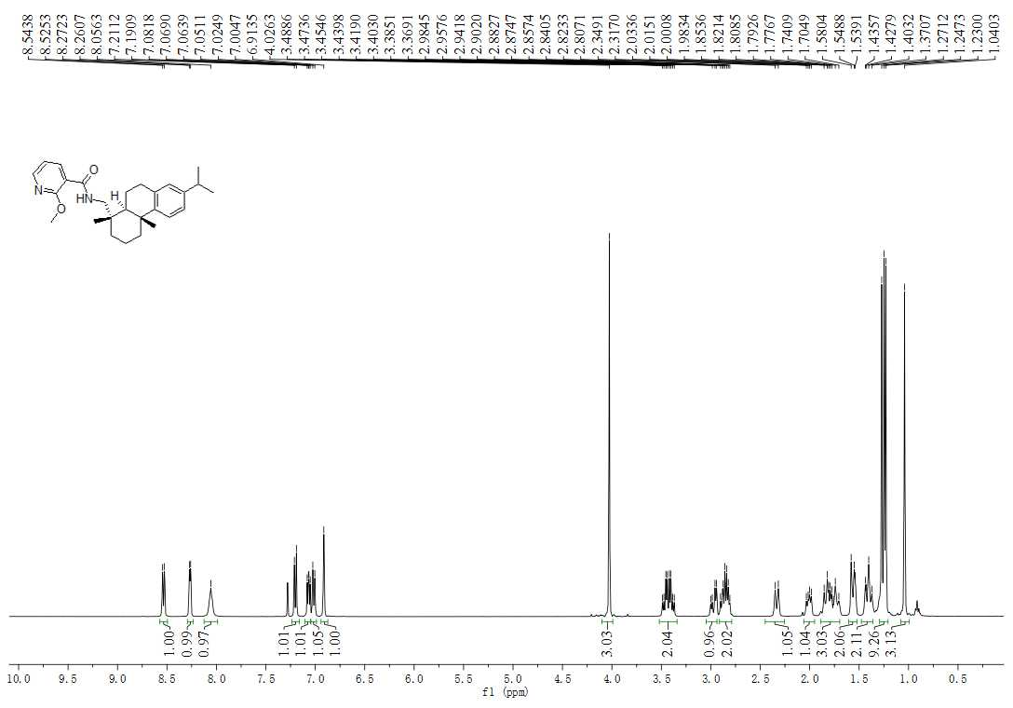
Figure S16. The ¹H NMR spectrum (400 MHz, CDCl₃) of compound 3f

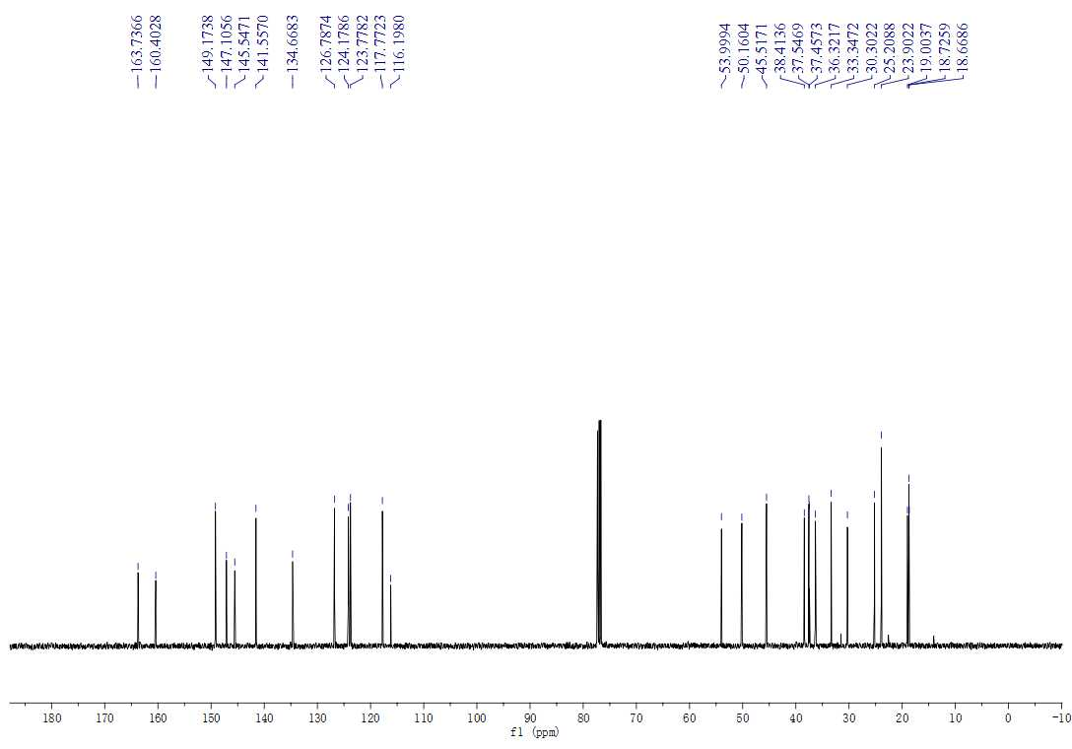
Figure S17. The ¹³C NMR spectrum (100 MHz, CDCL₃) of compound 3f

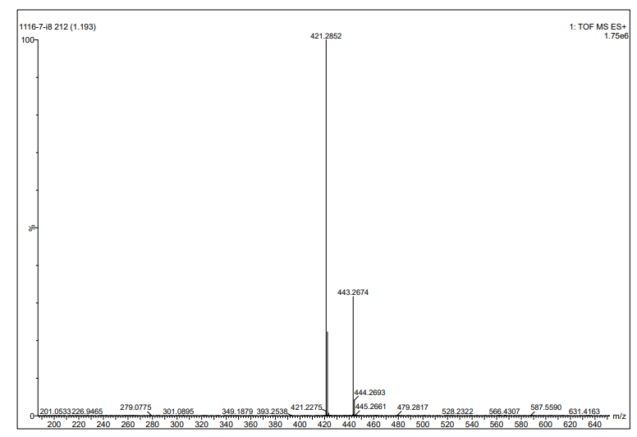
Figure S18. The HRMS spectrum of compound 3f

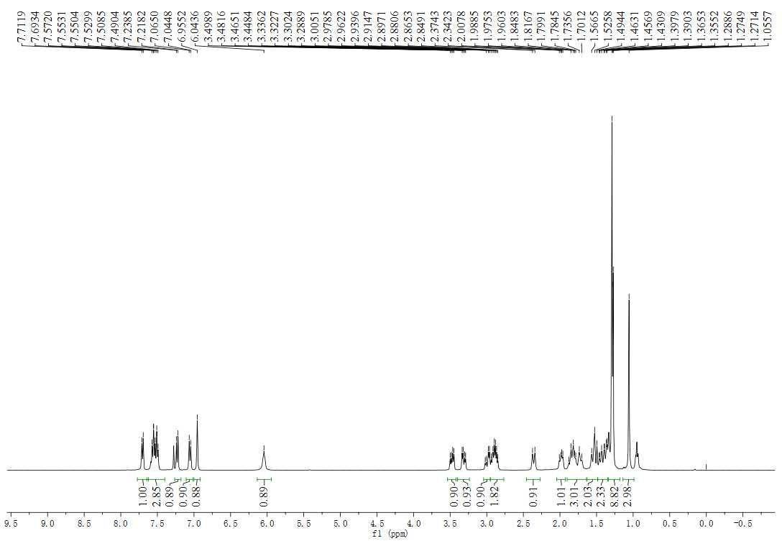
Figure S19. The ¹H NMR spectrum (400 MHz, CDCl₃) of compound 3g

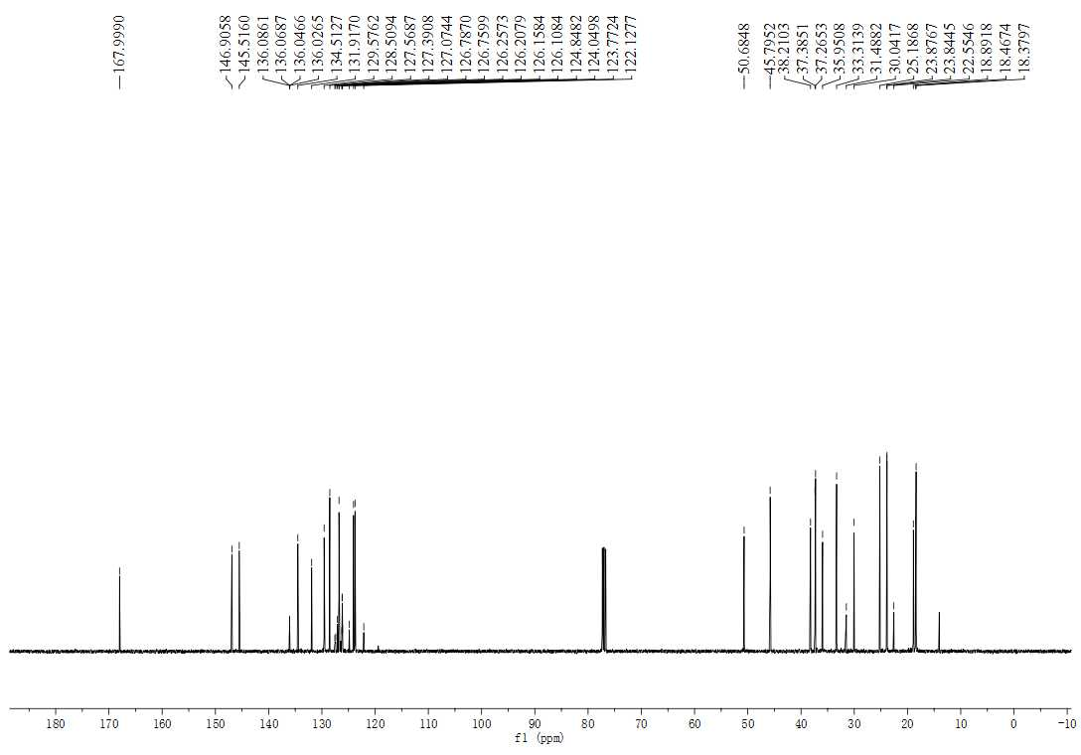
Figure S20. The ¹³C NMR spectrum (100 MHz, CDCl₃) of compound 3g

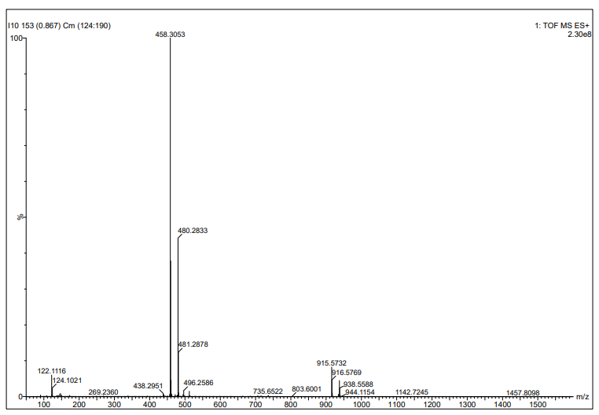
Figure S21. The HRMS spectrum of compound 3g

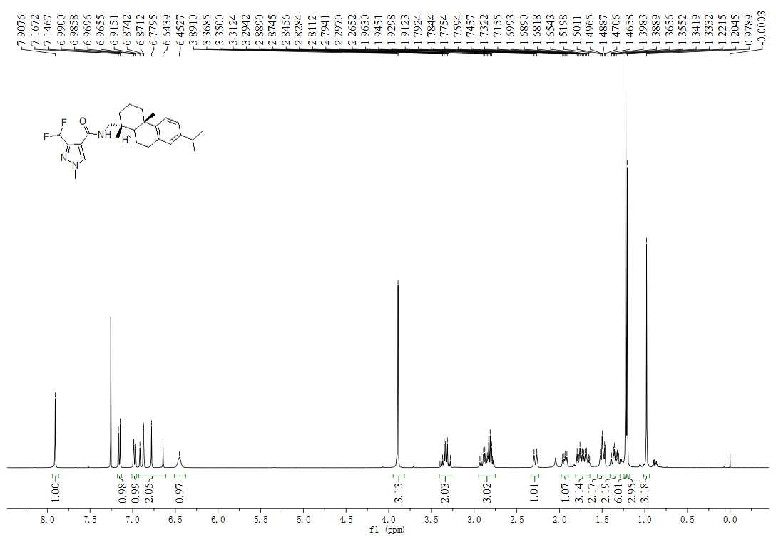
Figure S22. The ¹H NMR spectrum (400 MHz, CDCl₃) of compound 3h
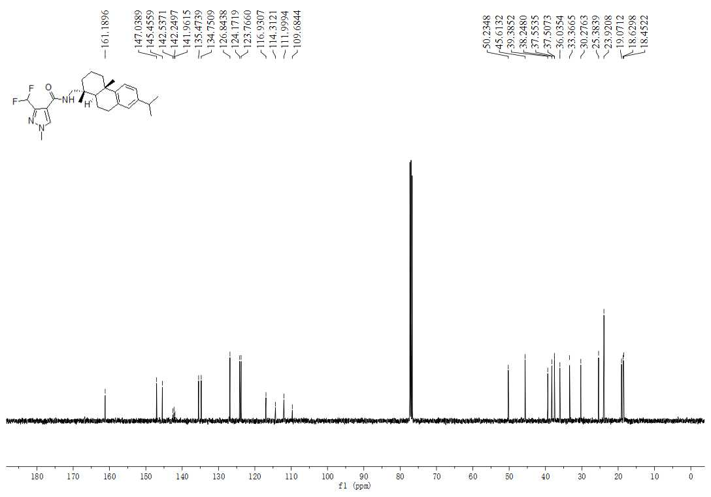
Figure S23. The ¹³C NMR spectrum (100 MHz, CDCl₃) of compound 3h

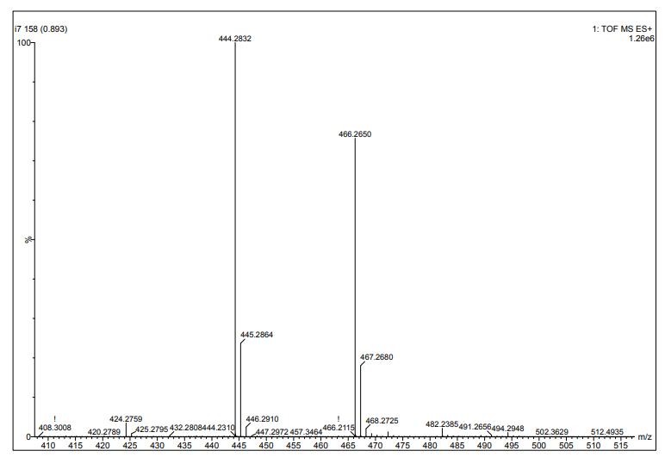
Figure S24. The HRMS spectrum of compound 3h

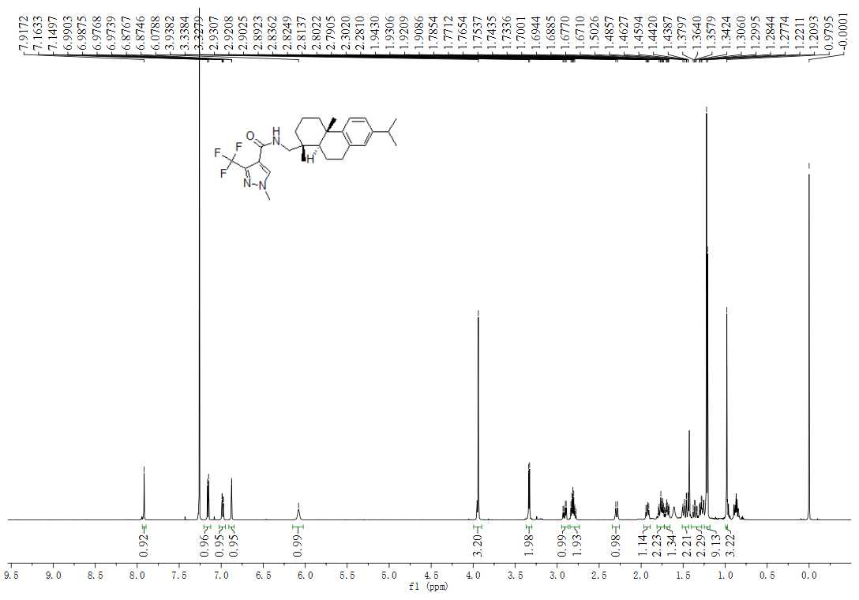
Figure S25. The ¹H NMR spectrum (600 MHz, CDCl₃) of compound 3i

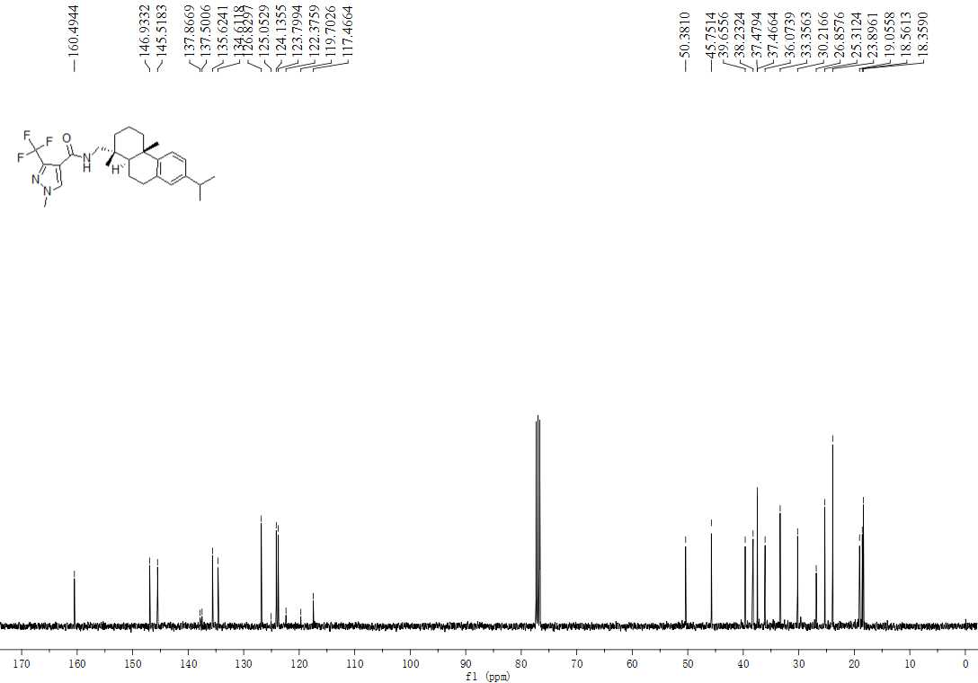
Figure S26. The ¹³C NMR spectrum (150 MHz, CDCl₃) of compound 3i

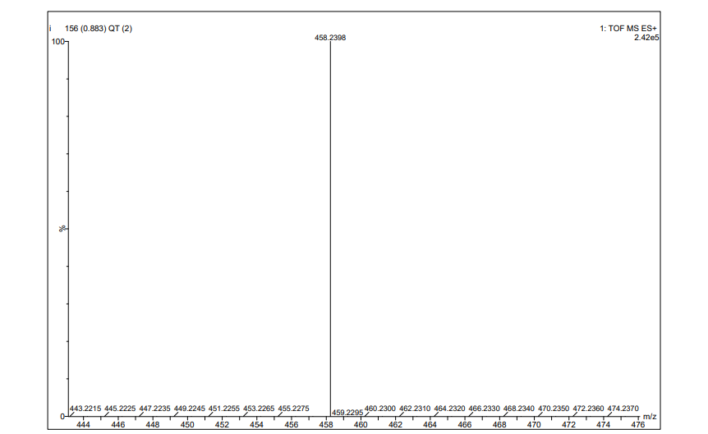
Figure S27. The HRMS spectrum of compound 3i

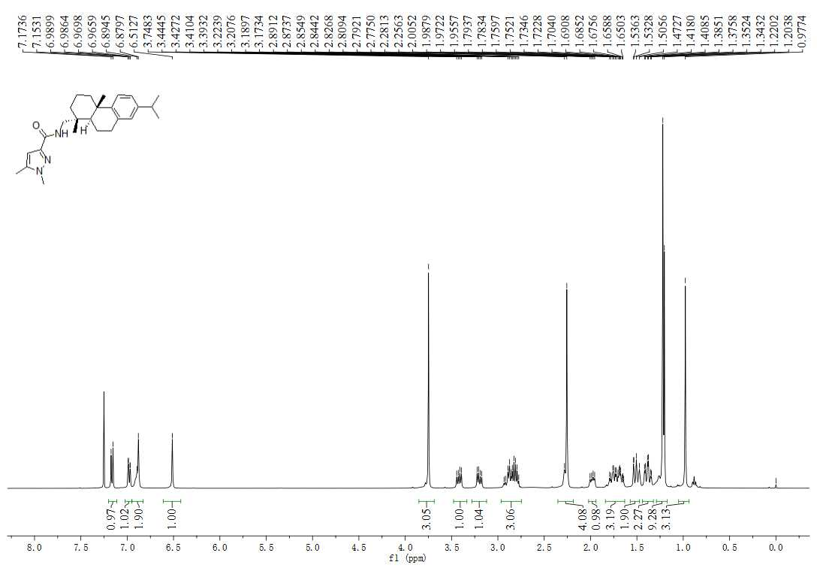
Figure S28. The ¹H NMR spectrum (400 MHz, CDCl₃) of compound 3j
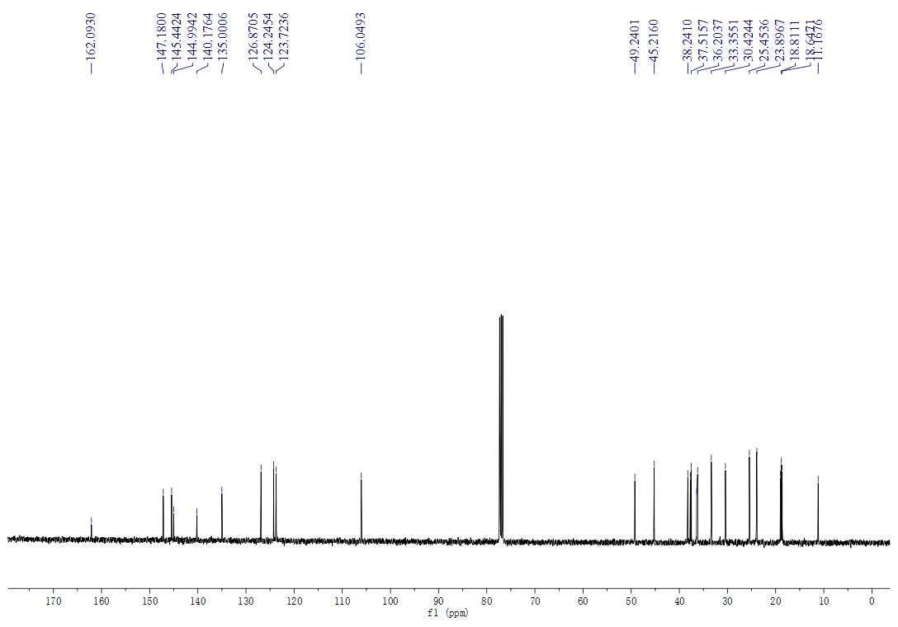
Figure S29. The ¹³C NMR spectrum (100 MHz, CDCl₃) of compound 3j

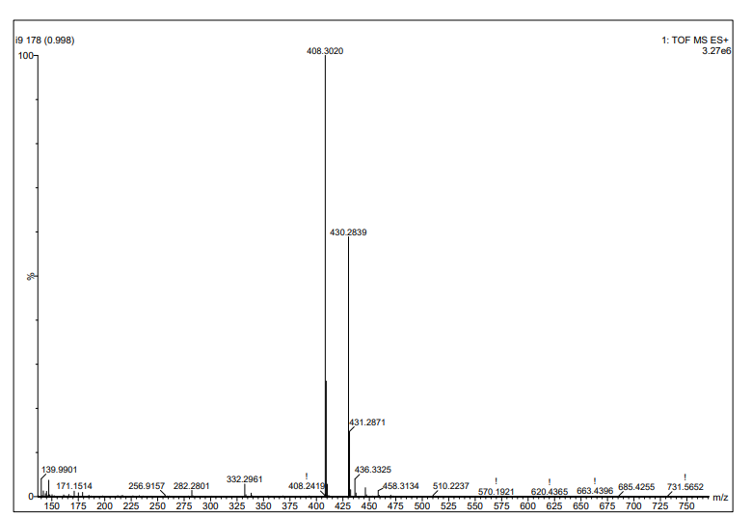
Figure S30. The HRMS spectrum of compound 3j
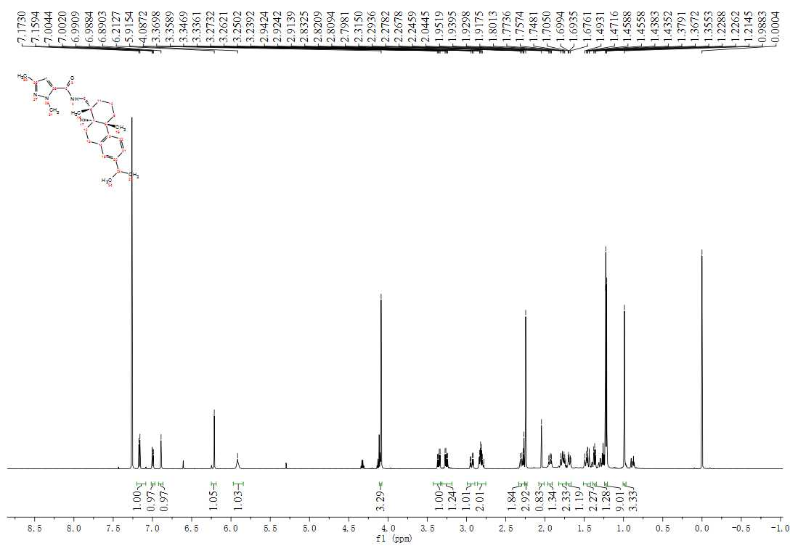Figure S31. The ¹H NMR spectrum (600 MHz, CDCl₃) of compound 3k

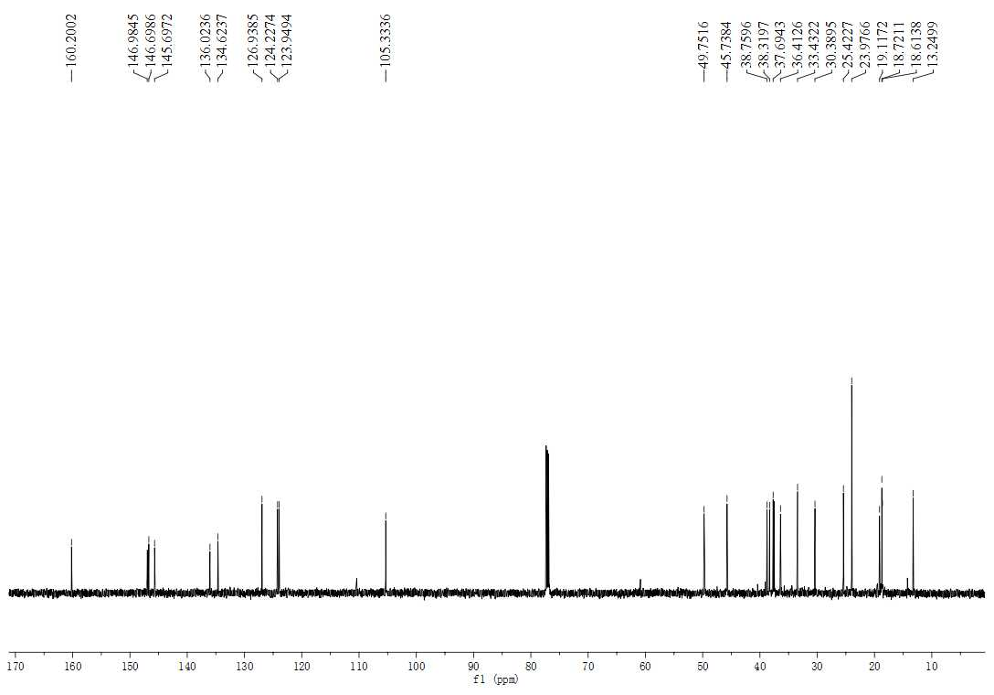
Figure S32. The ¹³C NMR spectrum (150 MHz, CDCl₃) of compound 3k

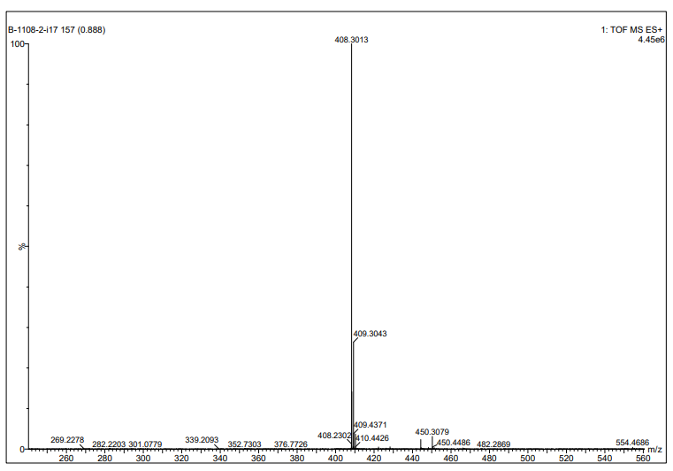
Figure S33. The HRMS spectrum of compound 3k

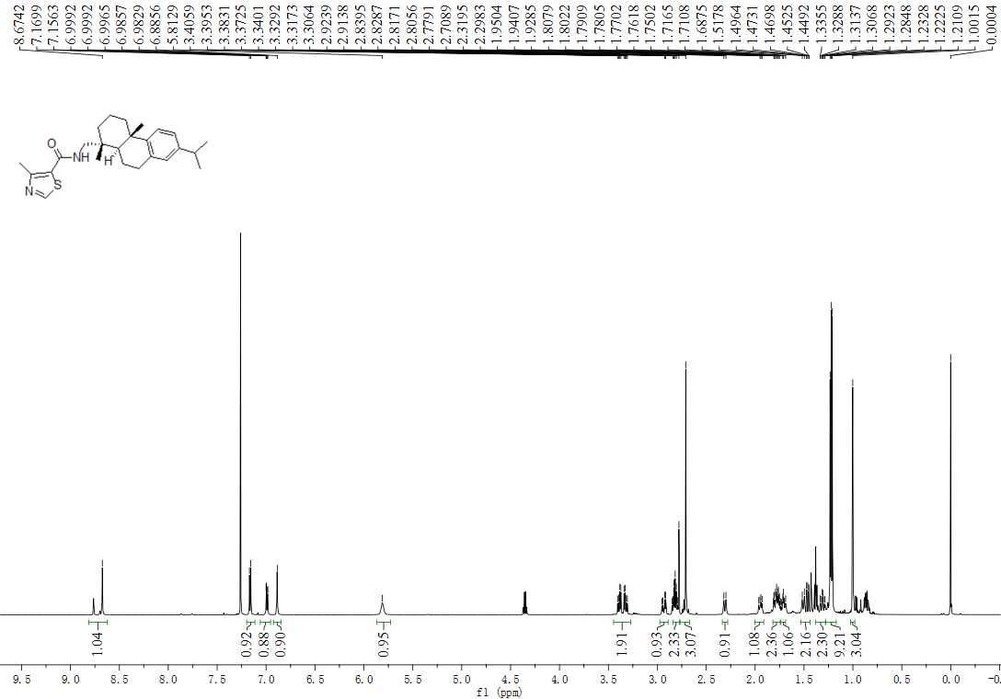
Figure S34. The ¹H NMR spectrum (600 MHz, CDCl₃) of compound 3l

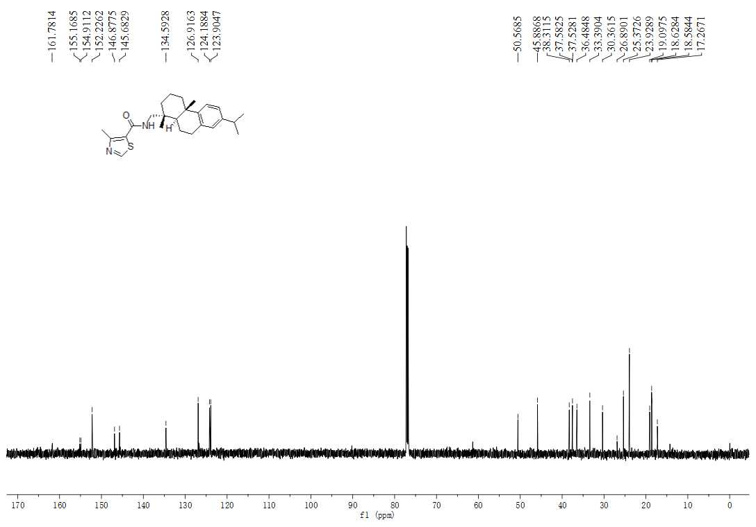
Figure S35. The ¹³C NMR spectrum (150 MHz, CDCl₃) of compound 3l

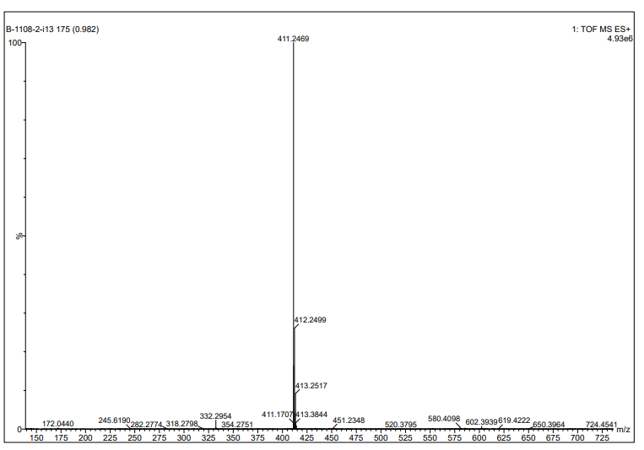
Figure S36. The HRMS spectrum of compound 3l

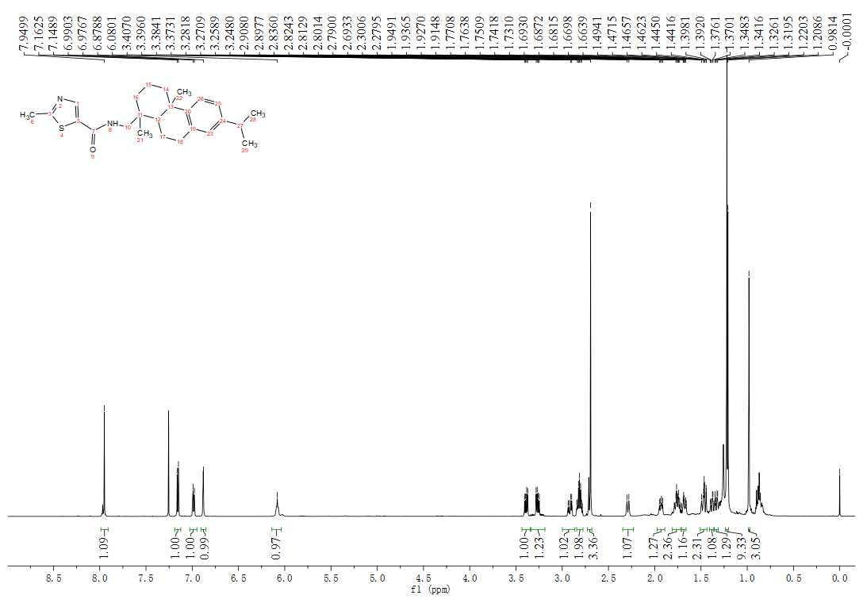
Figure S37. The ¹H NMR spectrum (600 MHz, CDCl₃) of compound 3m
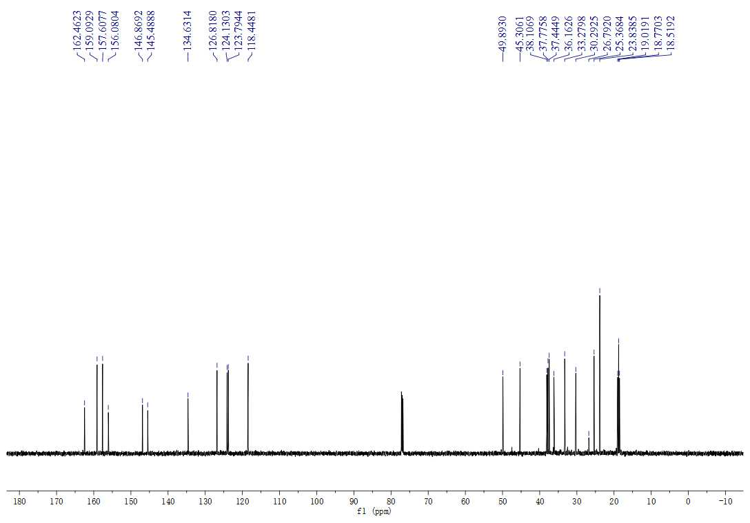
Figure S38. The ¹³C NMR spectrum (150 MHz, CDCl₃) of compound 3m

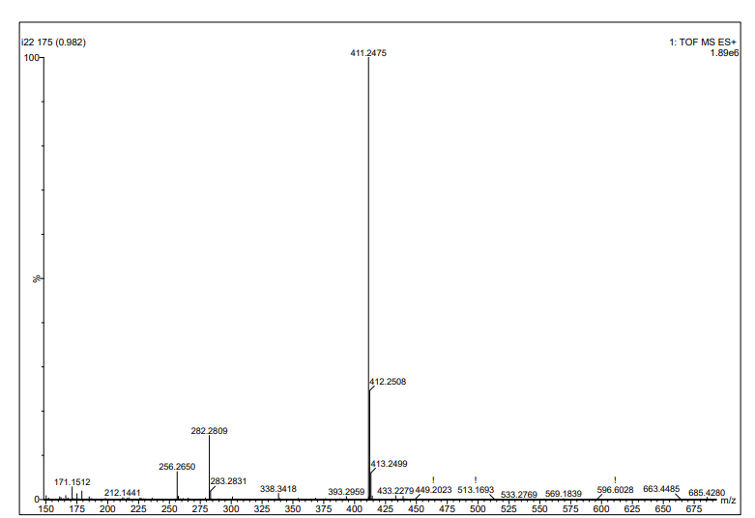
Figure S39. The HRMS spectrum of compound 3m

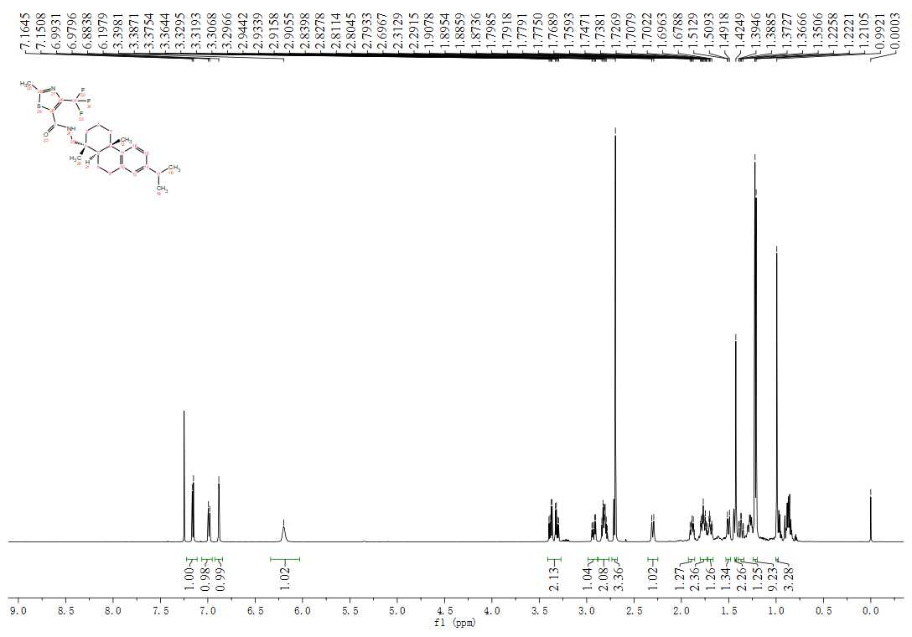
Figure S40. The ¹H NMR spectrum (600 MHz, CDCl₃) of compound 3n
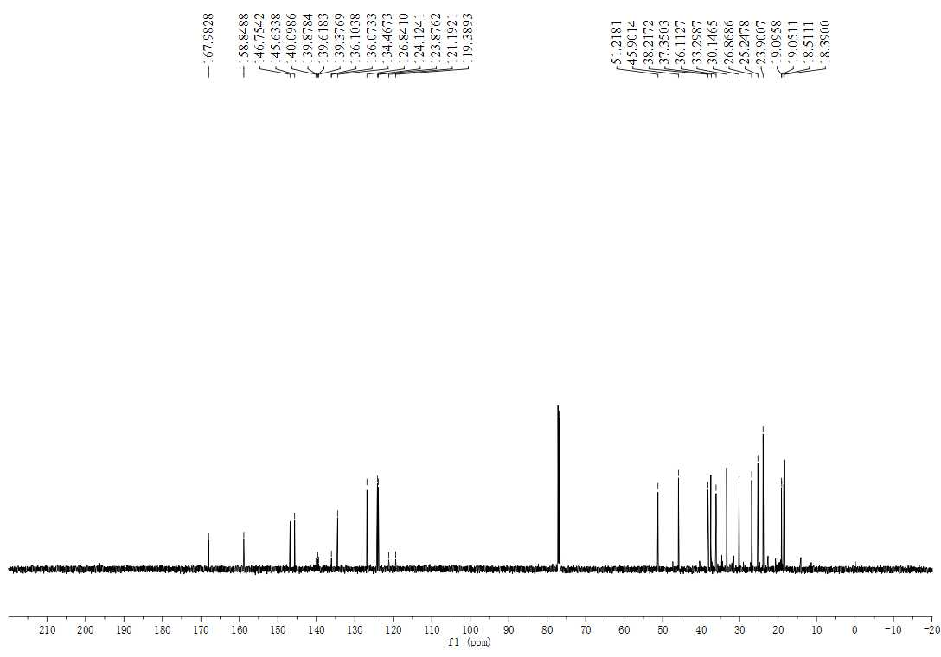
Figure S41. The ¹³C NMR spectrum (150 MHz, CDCl₃) of compound 3n

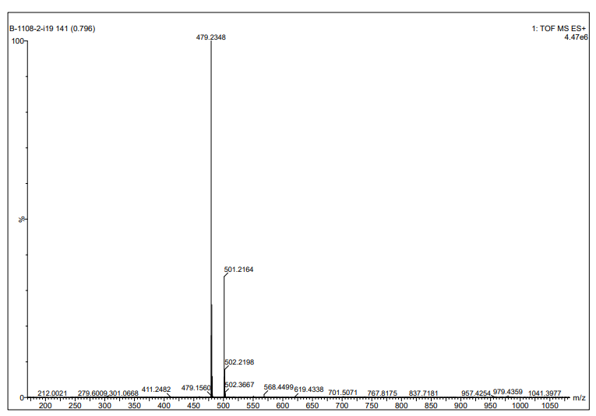
Figure S42. The HRMS spectrum of compound 3n

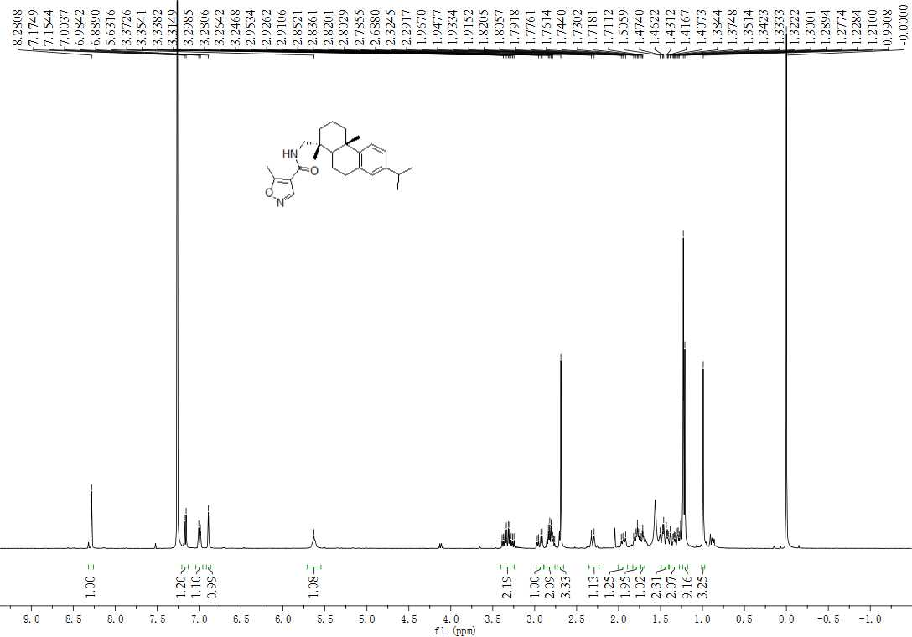
Figure S43. The ¹H NMR spectrum (600 MHz, CDCl₃) of compound 3o

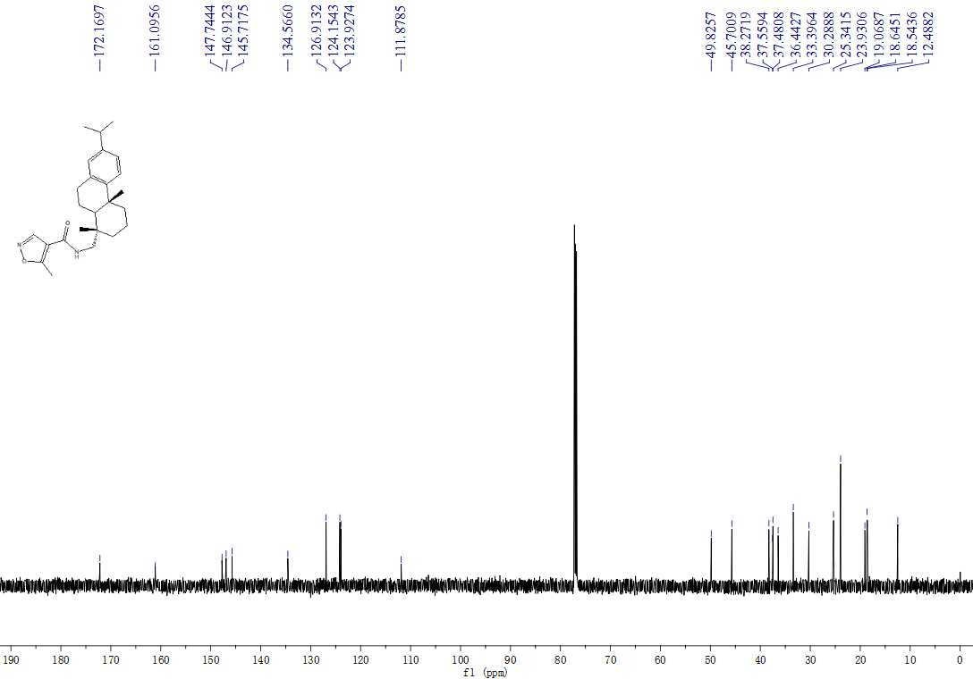
Figure S44. The ¹³C NMR spectrum (150 MHz, CDCl₃) of compound 3o

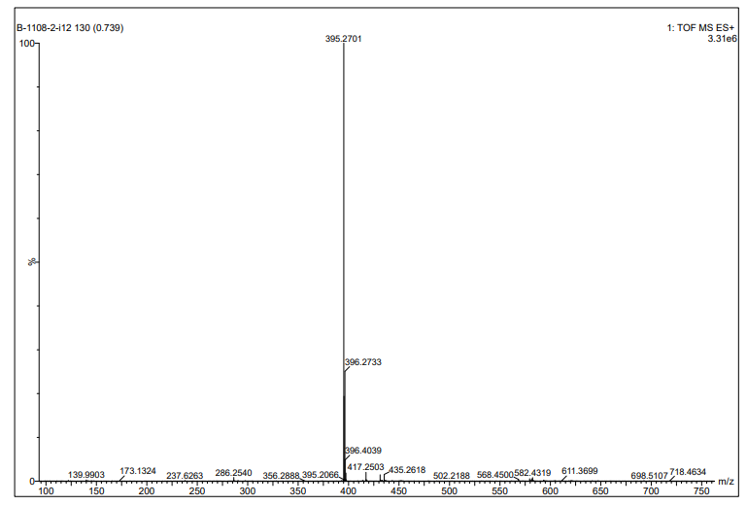
Figure S45. The HRMS spectrum of compound 3o

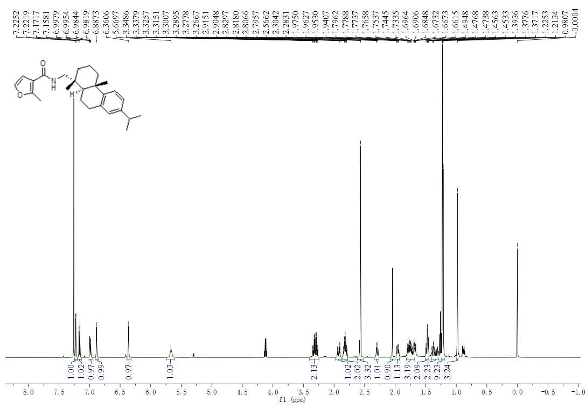
Figure 46. The ¹H NMR Spectrm (600 MHz, CDCl₃) of compound 3p
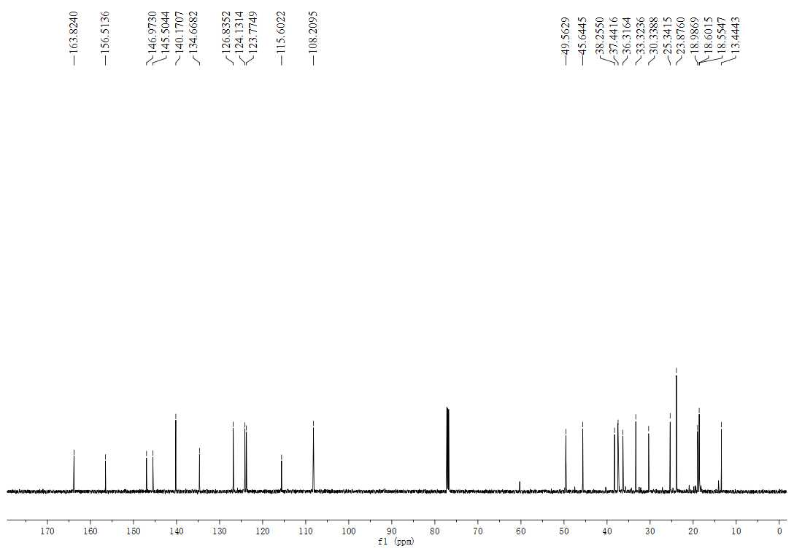
Figure 47. The ¹³C NMR spectrum (150 MHz, CDCl₃) of compound 3p

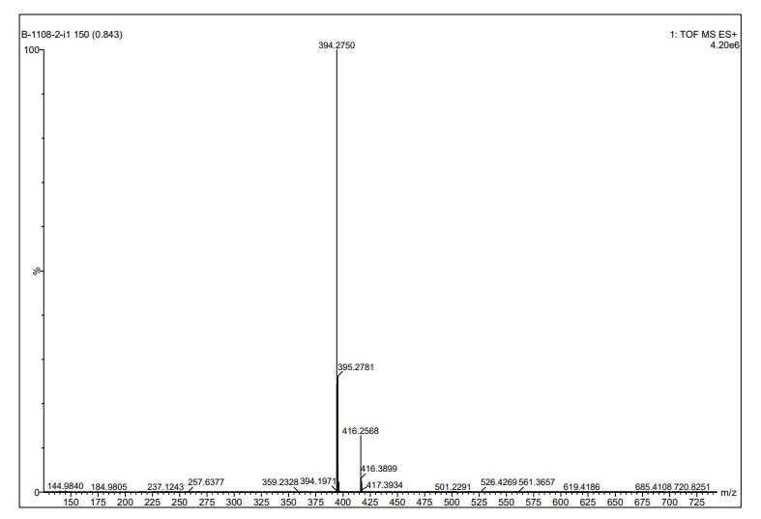
Figure S48. The HRMS spectrum of compound 3p

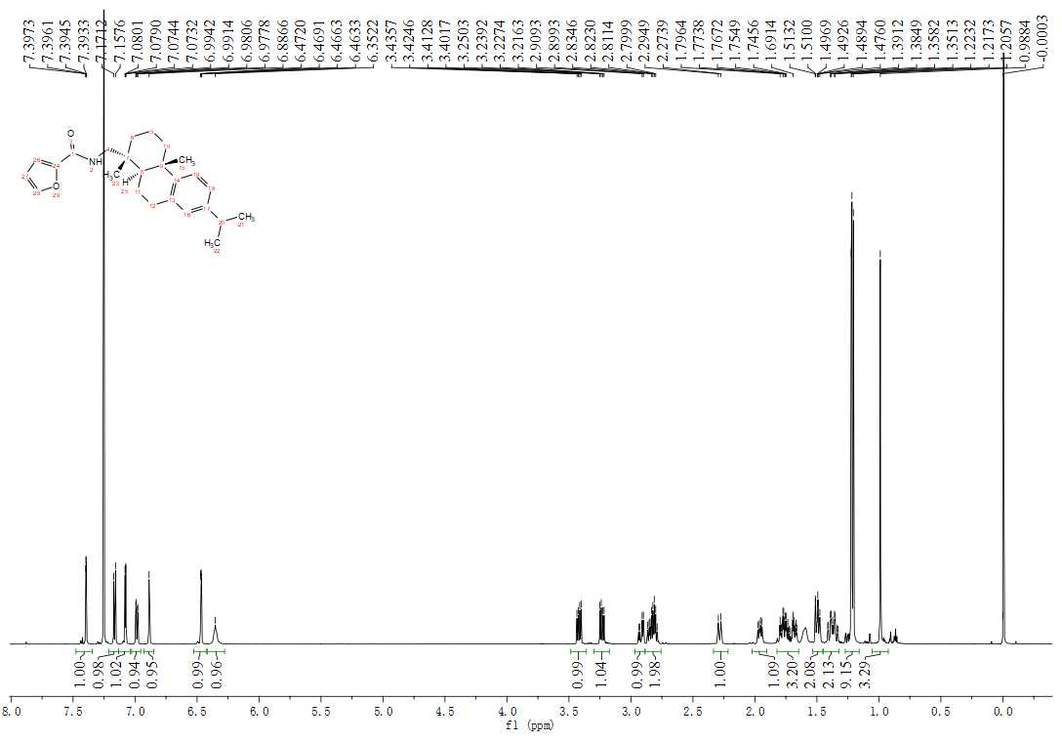
Figure S49. The ¹H NMR spectrum (600 MHz, CDCl₃) of compound 3q

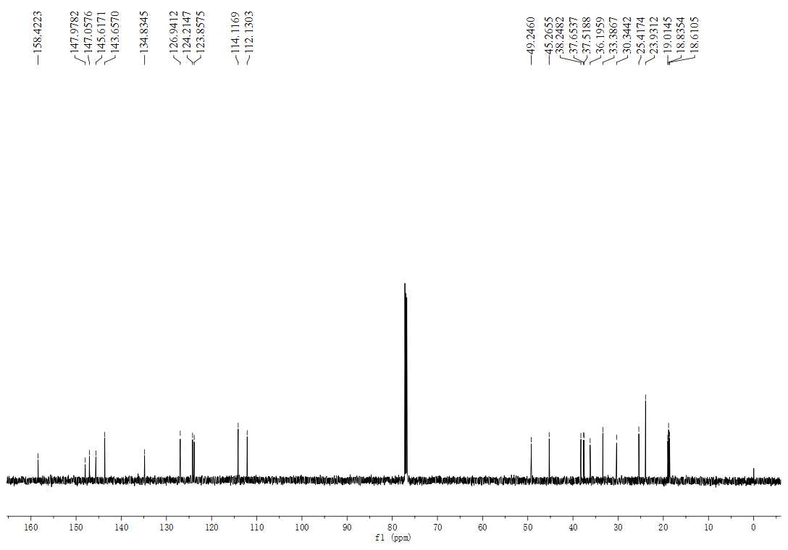
Figure S50 The ¹³C NMR spectrum (150 MHz, CDCl₃) of compound 3q

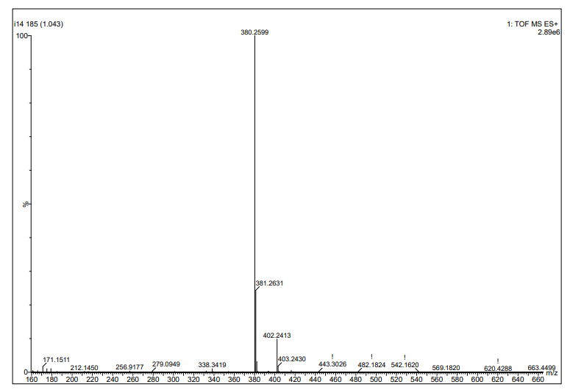
Figure S51. The HRMS spectrum of compound 3q

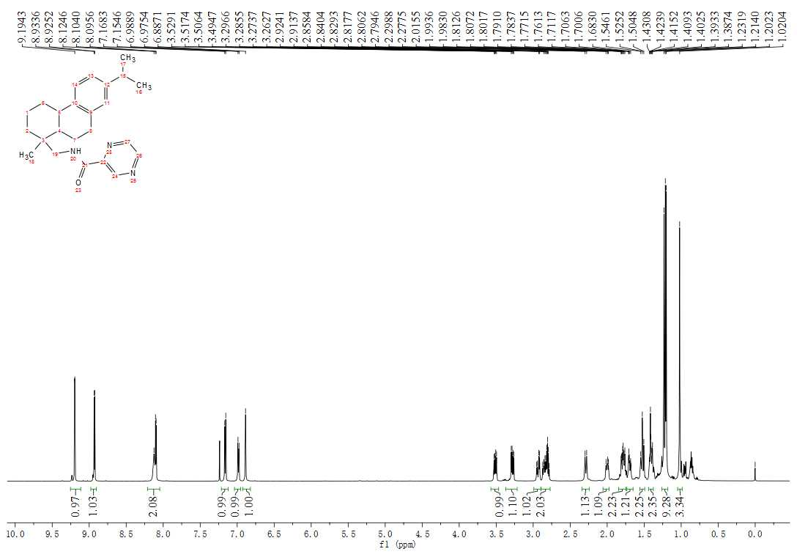
Figure S52. The ¹H NMR spectrum (600 MHz, CDCl₃) of compound 3r

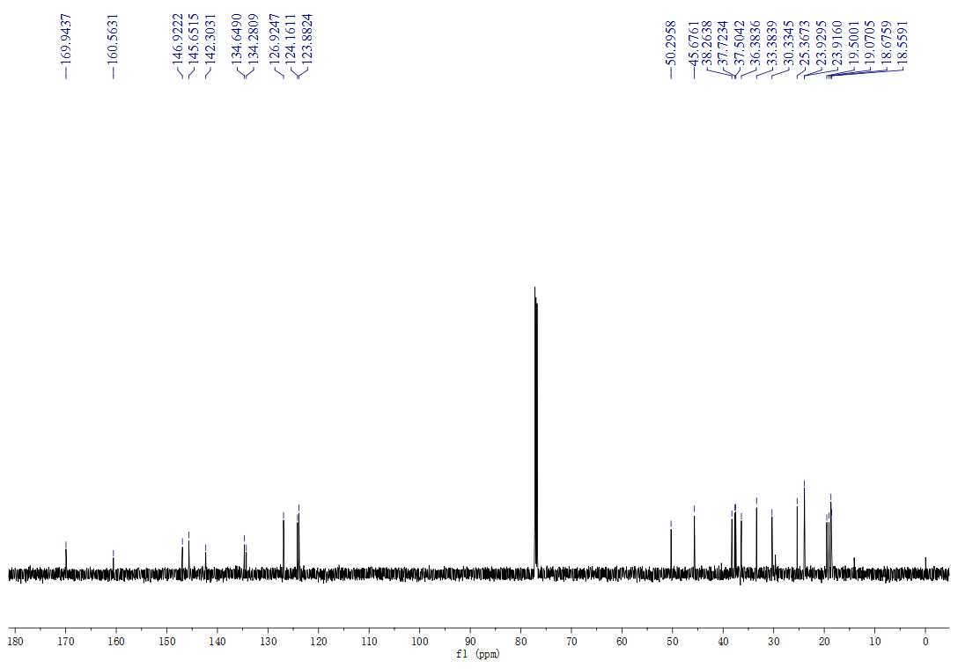
Figure S53. The ¹³C NMR spectrum (150 MHz, CDCl₃) of compound 3r

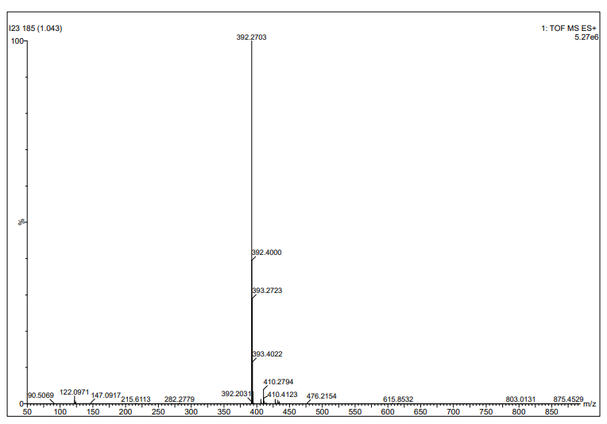
Figure S54.The HRMS spectrum of compound 3r

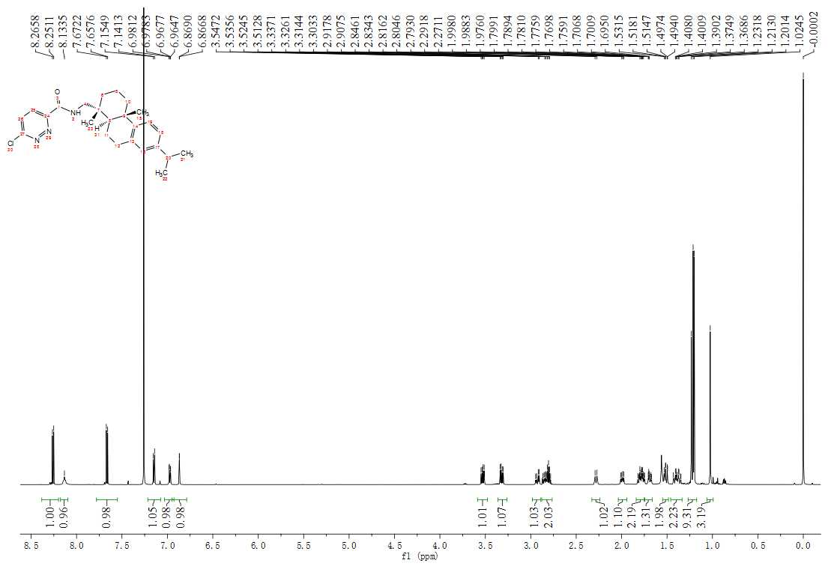
Figure S55. The ¹H NMR spectrum (600 MHz, CDCl₃) of compound 3s

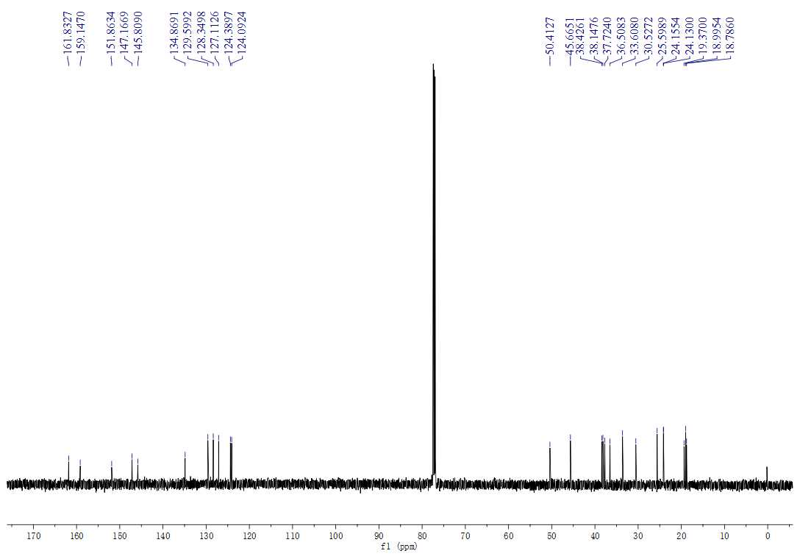
Figure S56. The ¹³C NMR spectrum (150 MHz, CDCl₃) of compound 3s

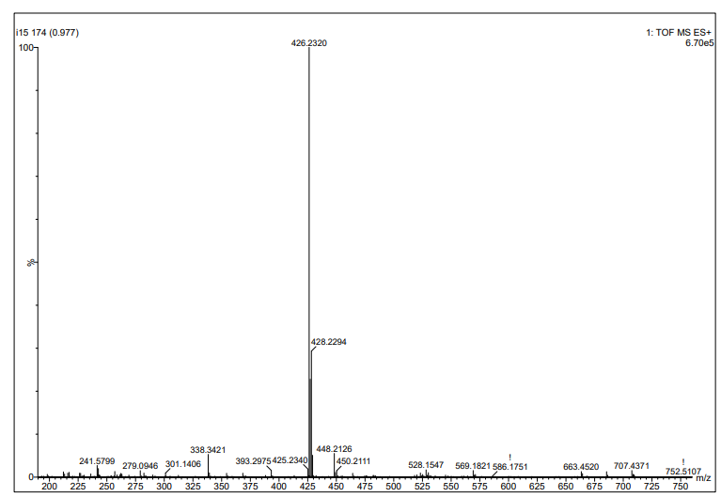
Figure S57. The HRMS spectrum of compound 3s

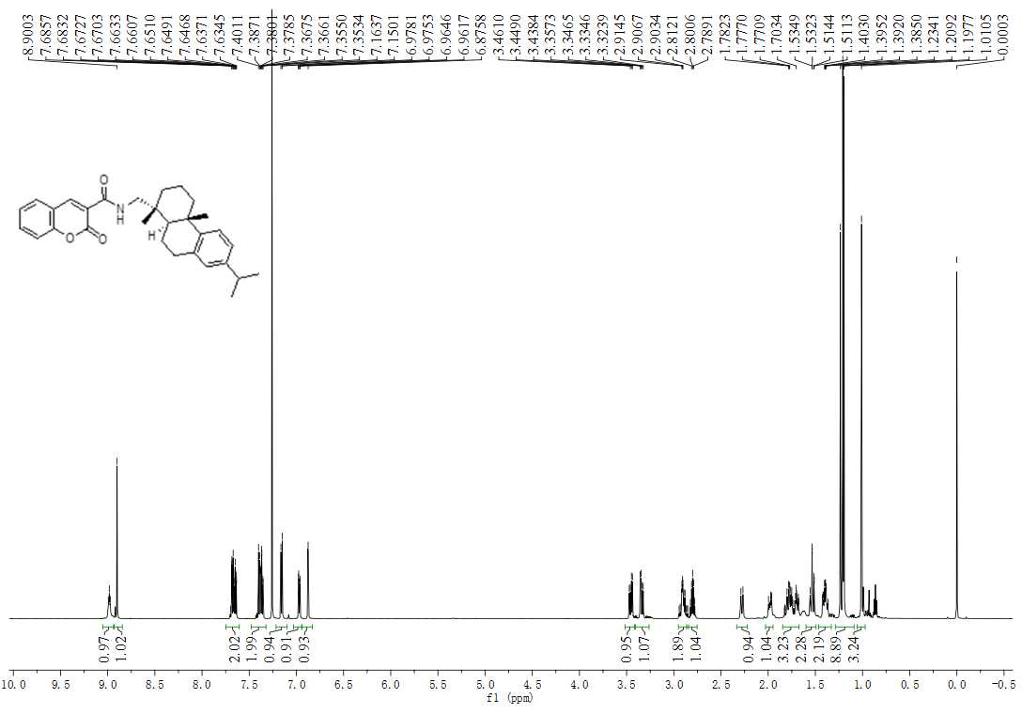
Figure S58. The ¹H NMR spectrum (600 MHz, CDCl₃) of compound 3t
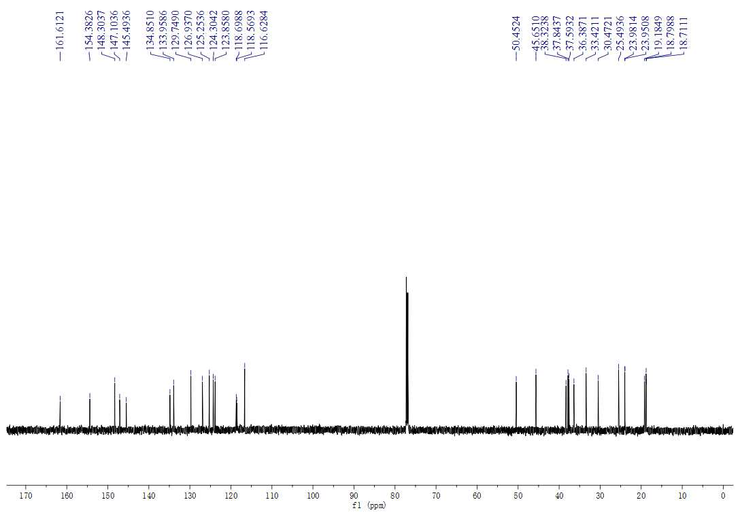
Figure S59. The ¹³C NMR spectrum (150 MHz, CDCl₃) of compound 3t

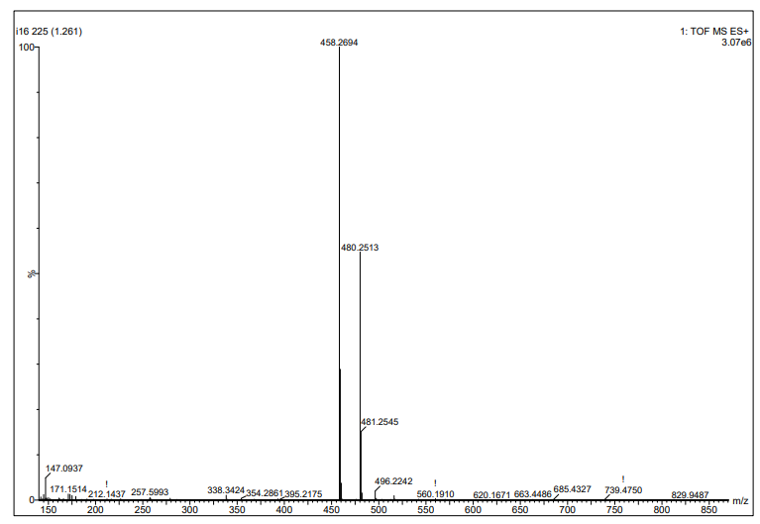
Figure S60. The HRMS spectrum of compound 3t
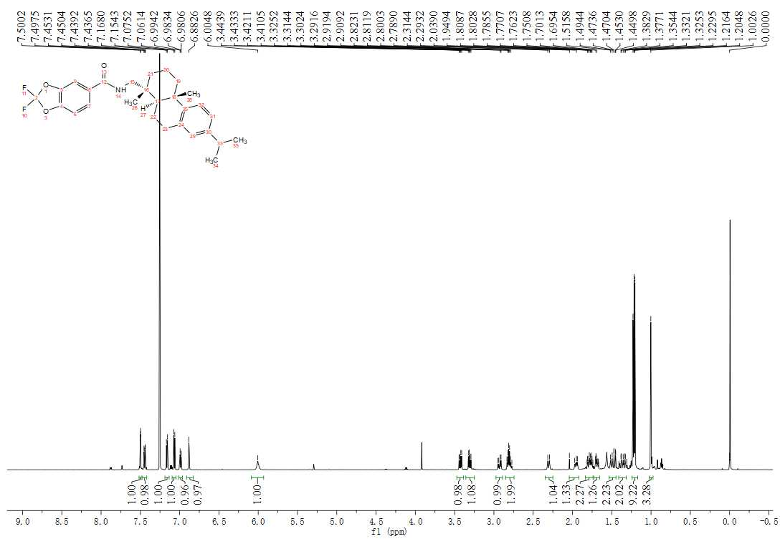
Figure S61. The ¹H NMR spectrum (600 MHz, CDCl₃) of compound 3u

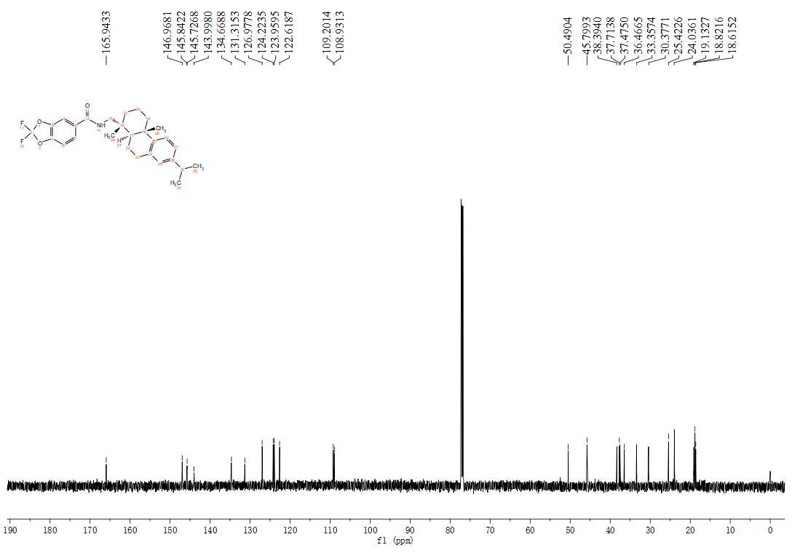
Figure S62. The ¹³C NMR spectrum (150 MHz, CDCl₃) of compound 3u

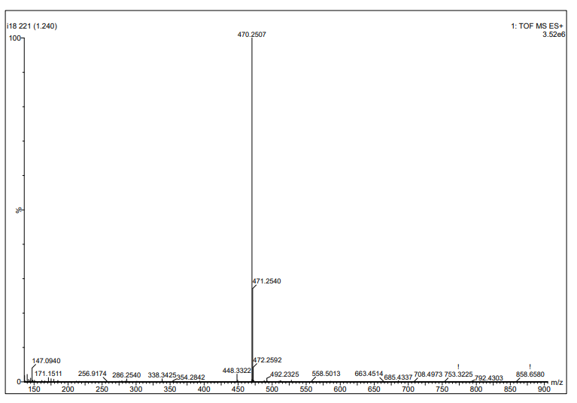
Figure S63. The HRMS spectrum of compound 3u

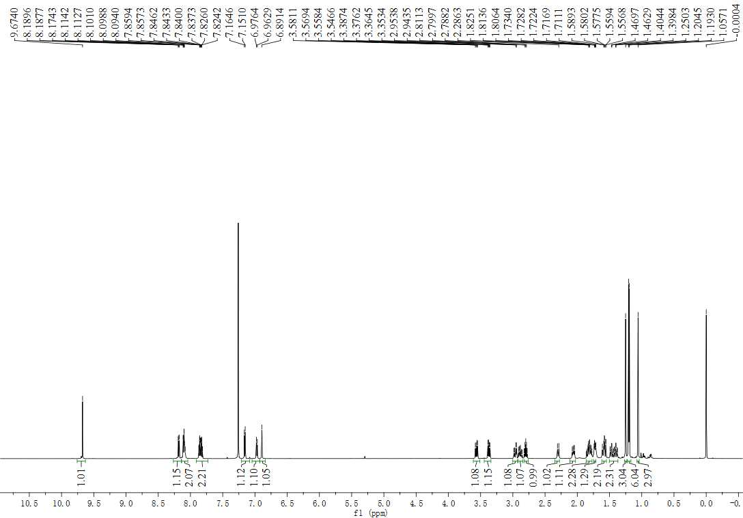
Figure S64. The ¹H NMR spectrum (600 MHz, CDCl₃) of compound 3v

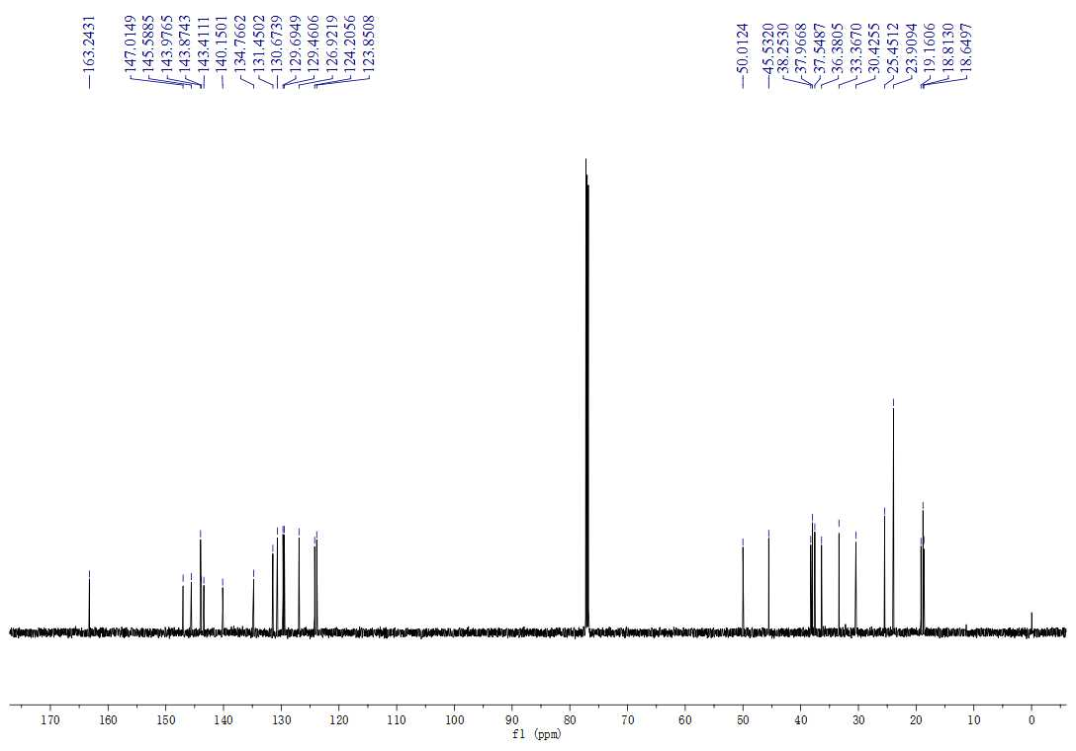
Figure S65. The ¹³C NMR spectrum (150 MHz, CDCl₃) of compound 3v

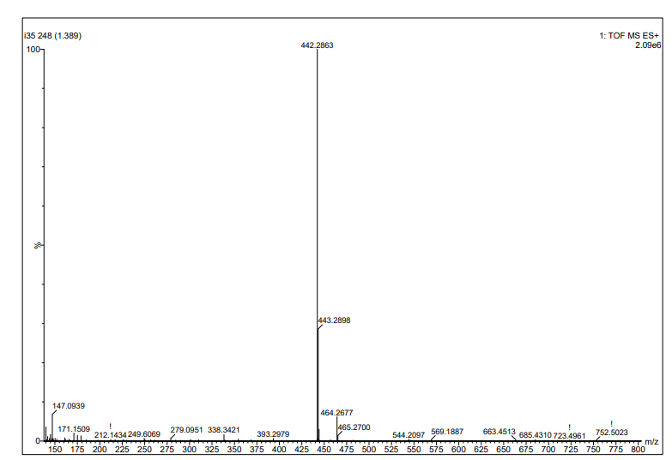
Figure S66. The HRMS spectrum of compound 3v

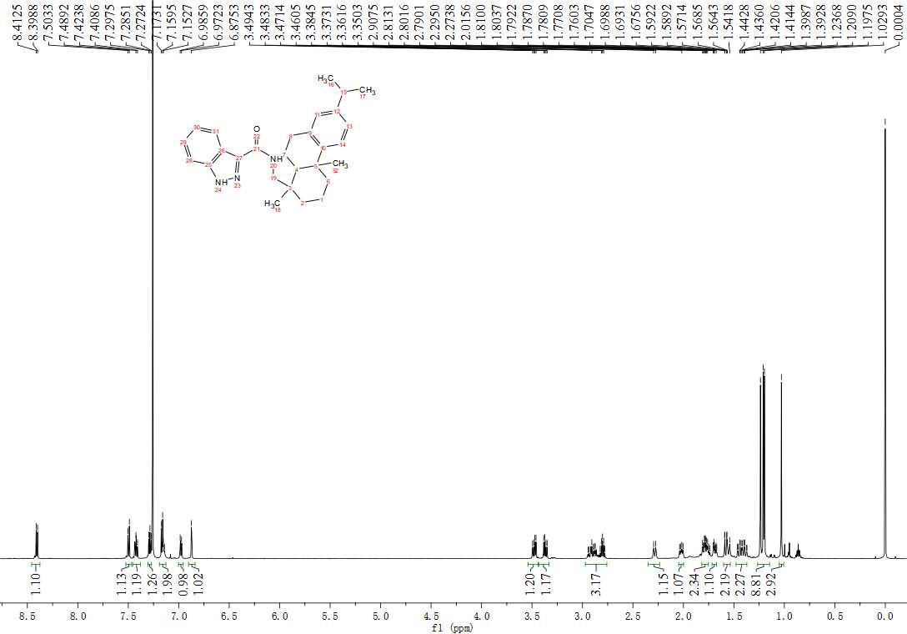
Figure S67. The ¹H NMR spectrum (600 MHz, CDCl₃) of compound 3w

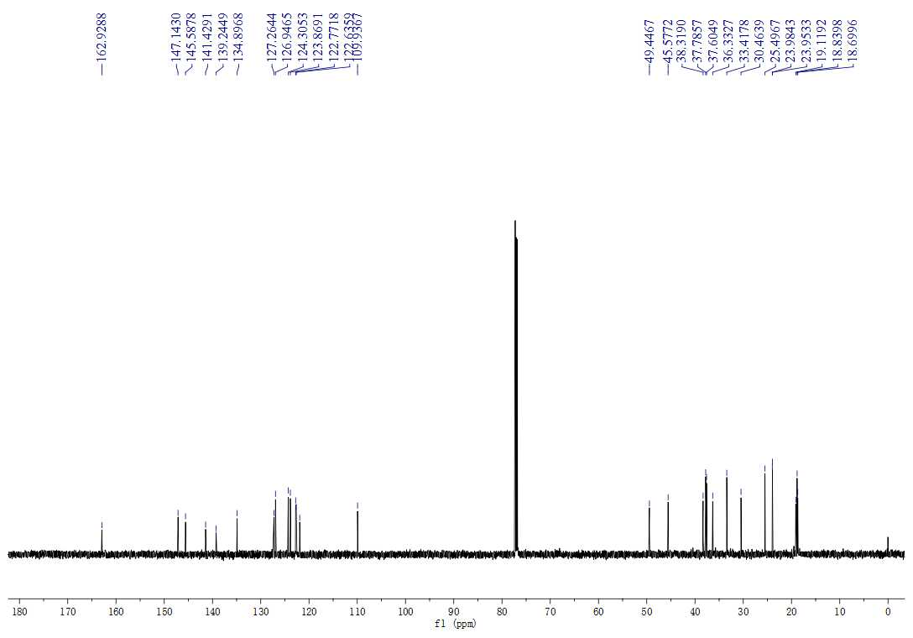
Figure S68. The ¹³C NMR spectrum (150 MHz, CDCl₃) of compound 3w

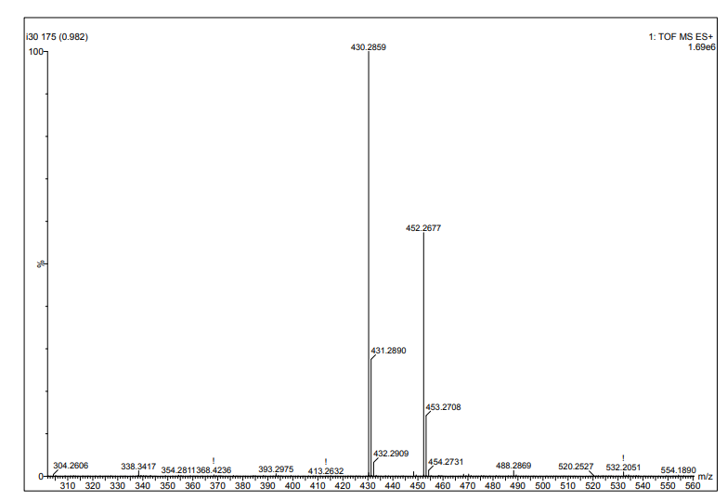
Figure S69. The HRMS spectrum of compound 3w

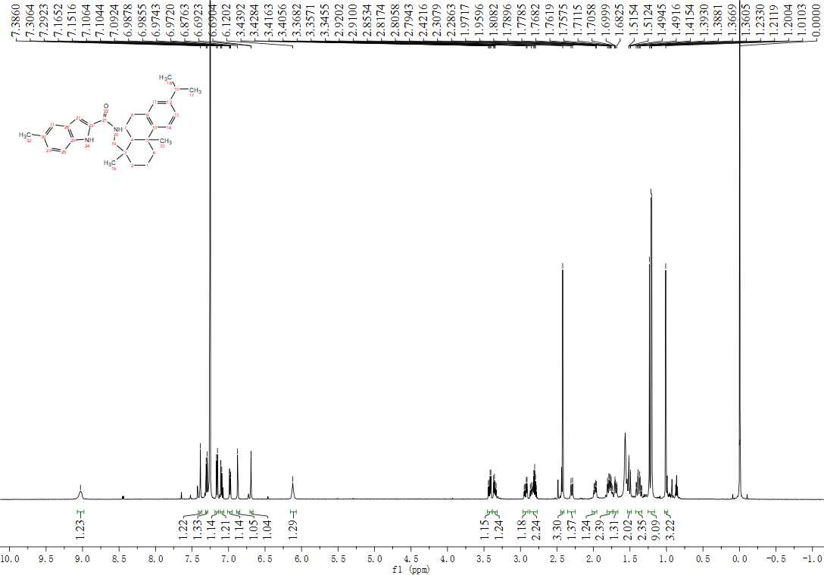
Figure S70. The ¹H NMR spectrum (600 MHz, CDCl₃) of compound 3x

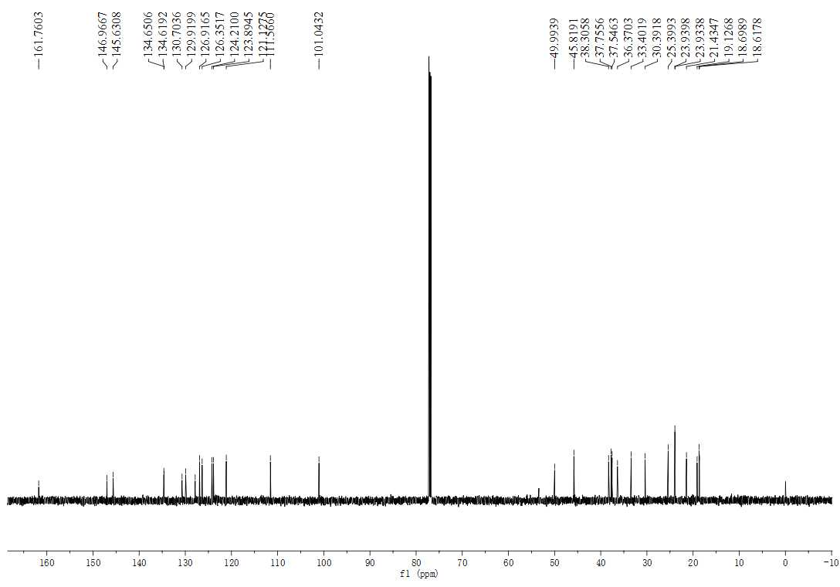
Figure S71. The ¹³CNMR spectrum (150 MHz, CDCl₃) of compound 3x

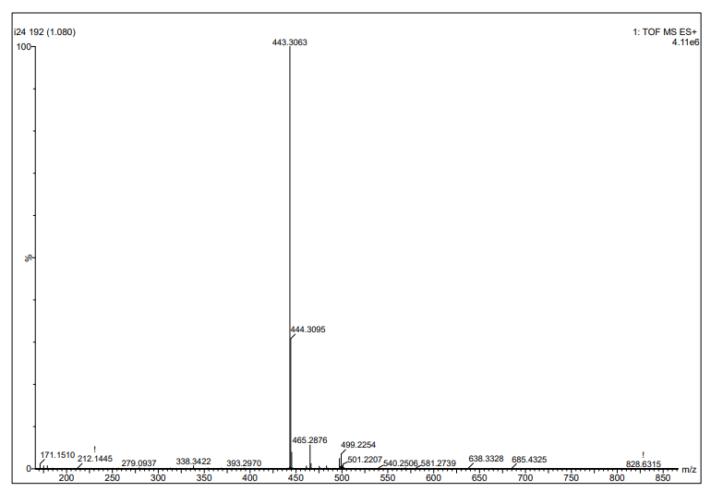
Figure S72. The HRMS spectrum of compound 3x

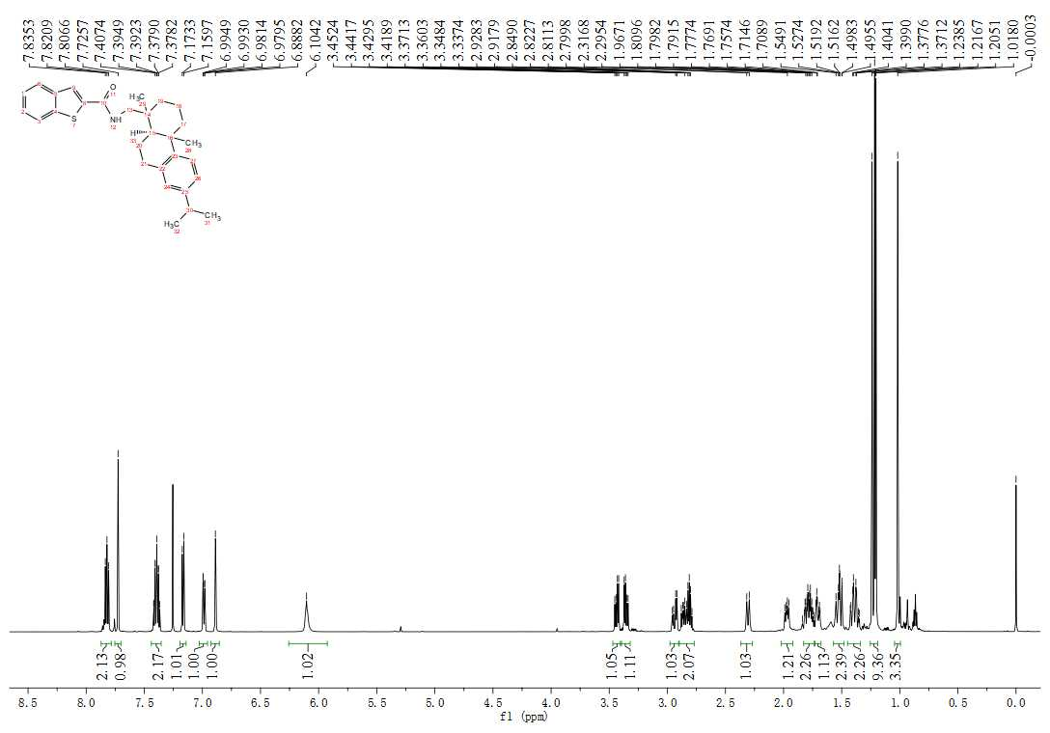
Figure S73. The ¹H NMR spectrum (600 MHz, CDCl₃) of compound 3y

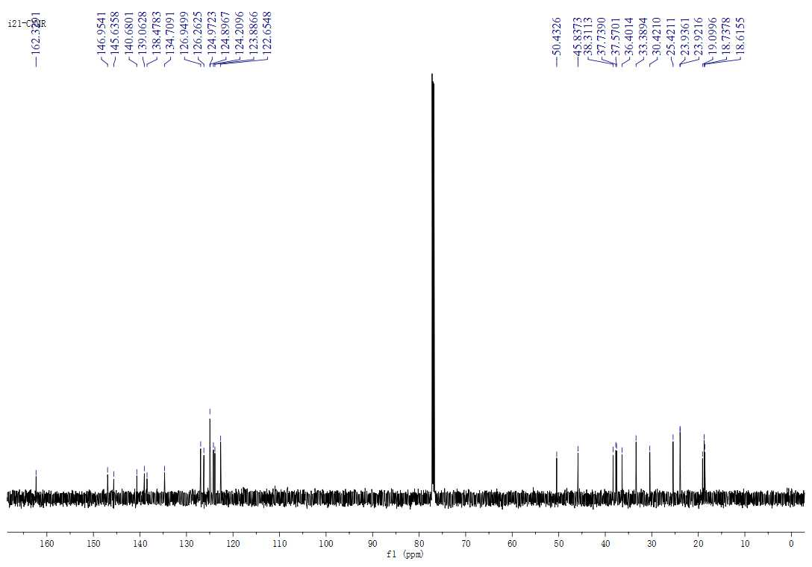
Figure S74. The ¹³C NMR spectrum (150MHz, CDCl₃) of compound 3y

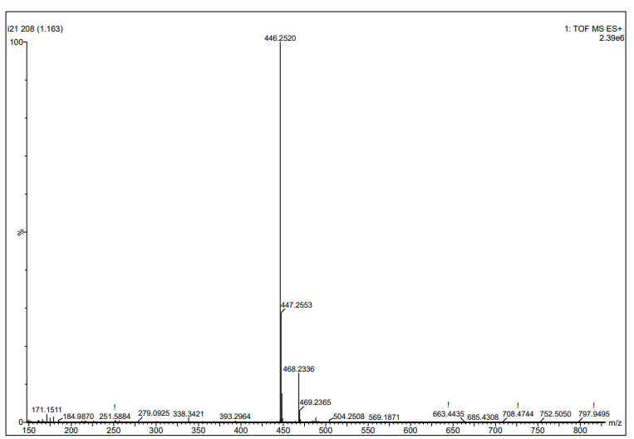
Figure S75. The HRMS spectrum of compound 3y

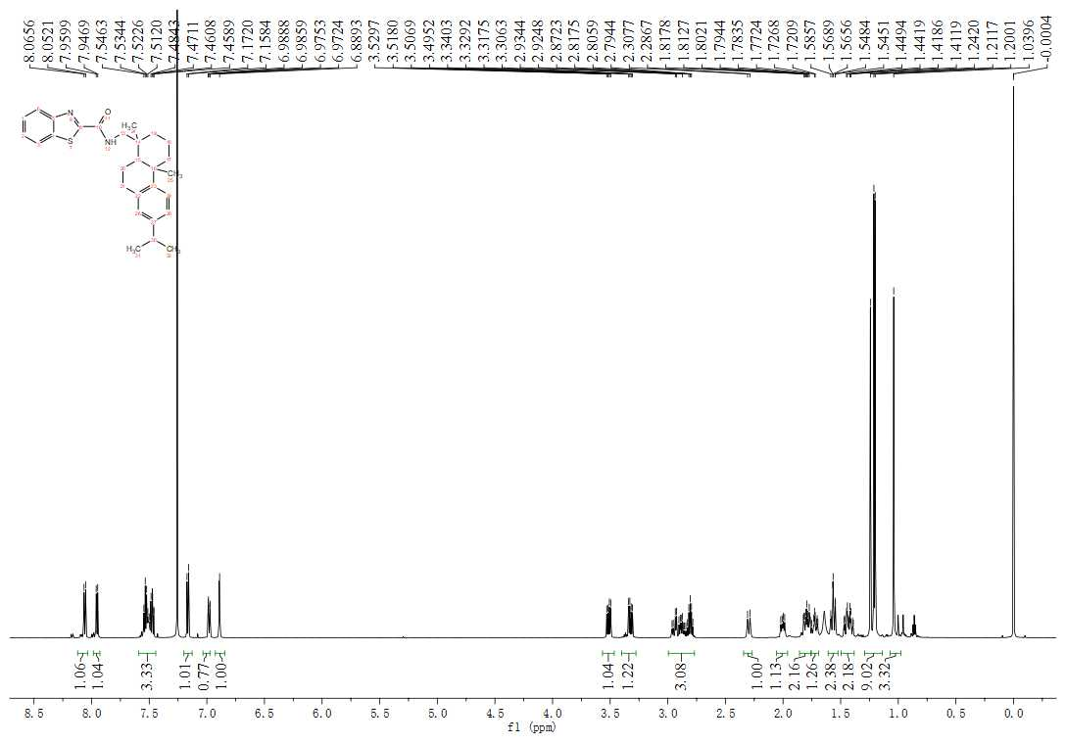
Figure S76. The ¹H NMR spectrum (600 MHz, CDCl₃) of compound 3z

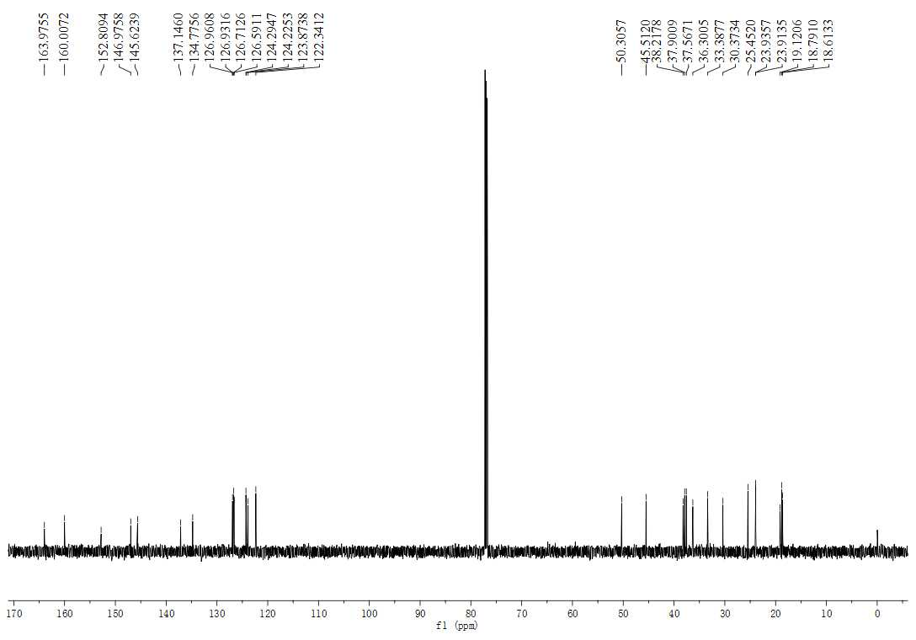
Figure S77. The ¹³C NMR spectrum (150 MHz, CDCl₃) of compound 3z
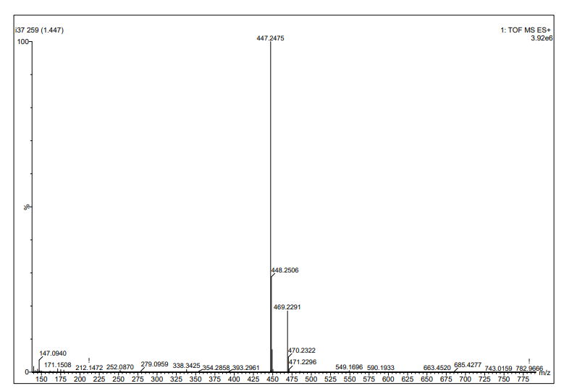
Figure S78. The HRMS spectrum of compound 3z
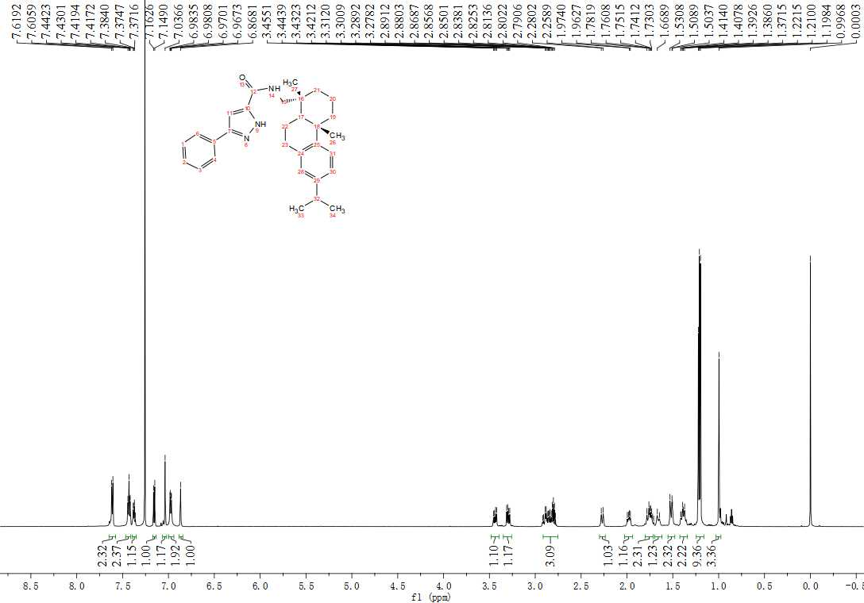
Figure S79. The ¹H NMR spectrum (600 MHz, CDCl₃) of compound 4a

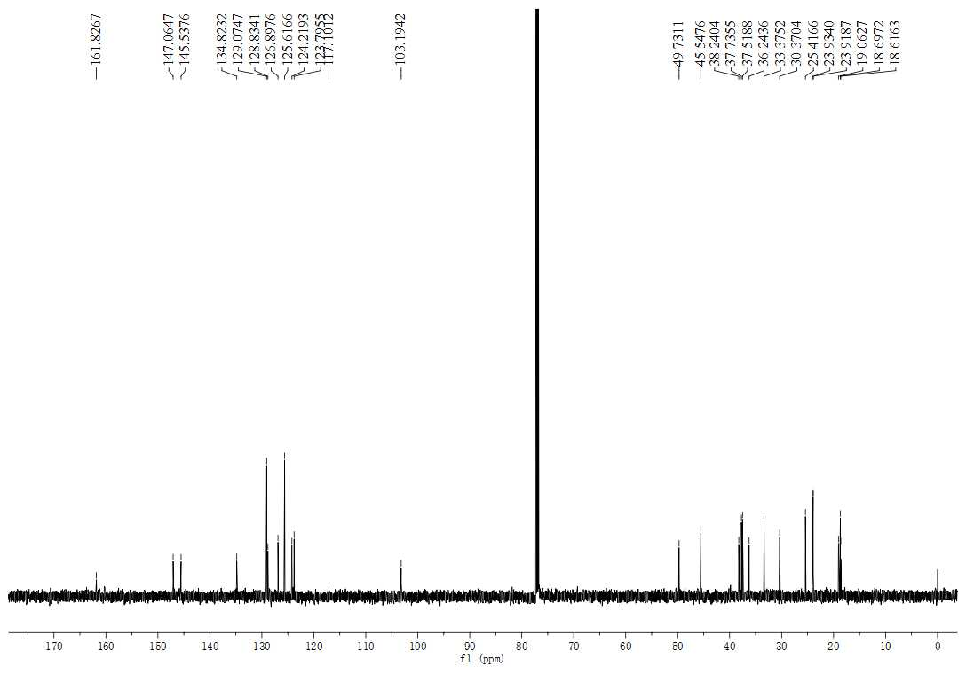
Figure S80. The ¹³CNMR spectrum (150 MHz, CDCl₃) of compound 4a

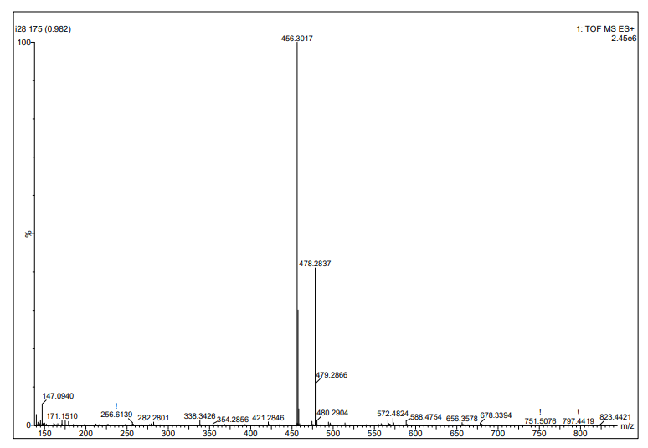
Figure S81. The HRMS spectrum of compound 4a

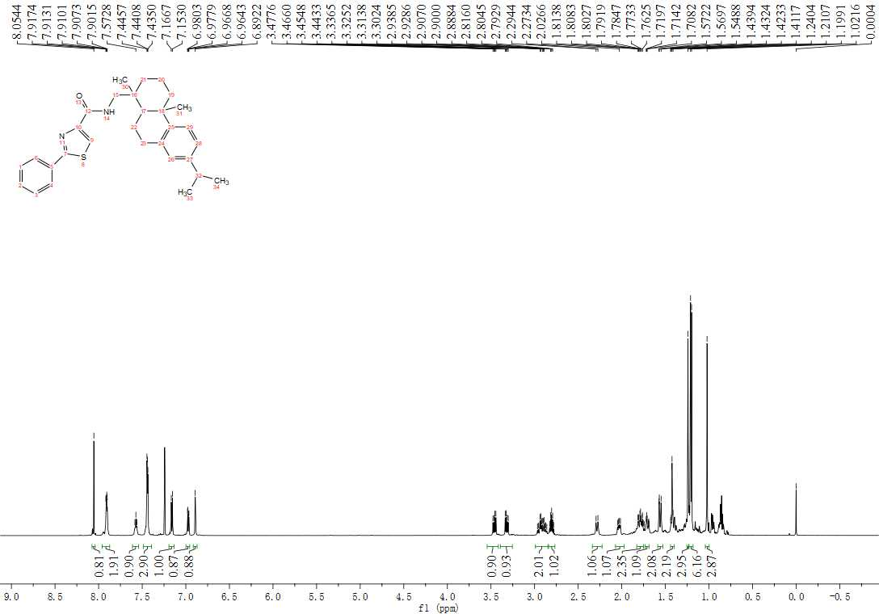
Figure S82. The ¹H NMR spectrum (600 MHz, CDCl₃) of compound 4b

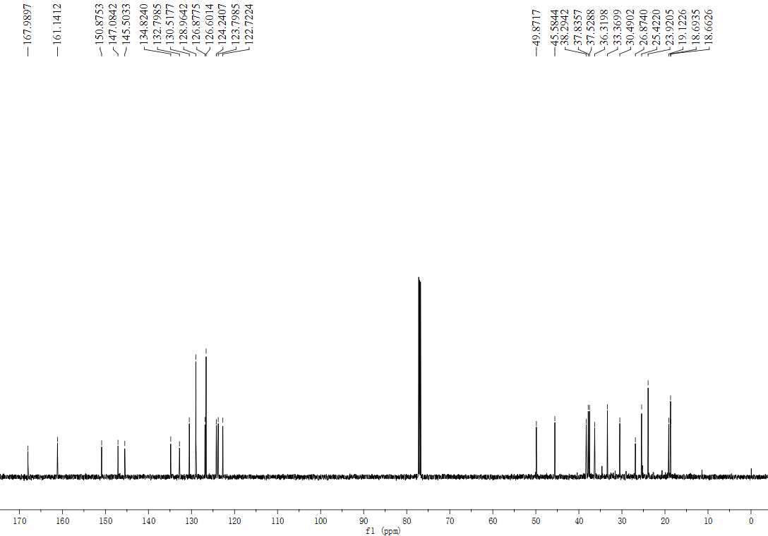
Figure S83. The ¹³CNMR spectrum (150 MHz, CDCl₃) of compound 4b

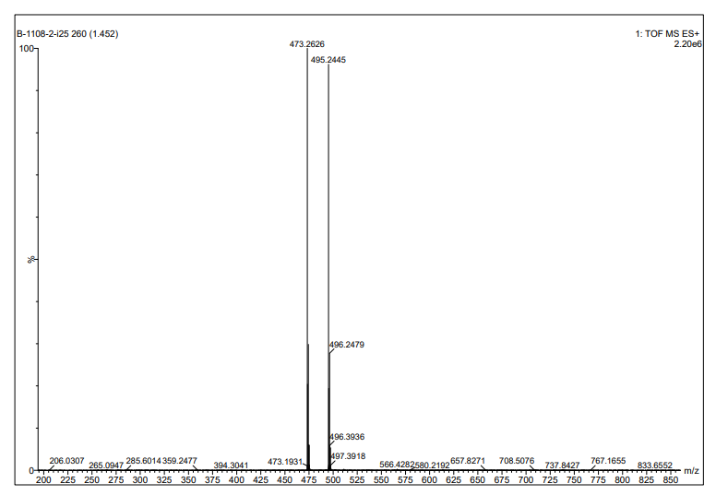
Figure S84. The HRMS spectrum of compound 4b

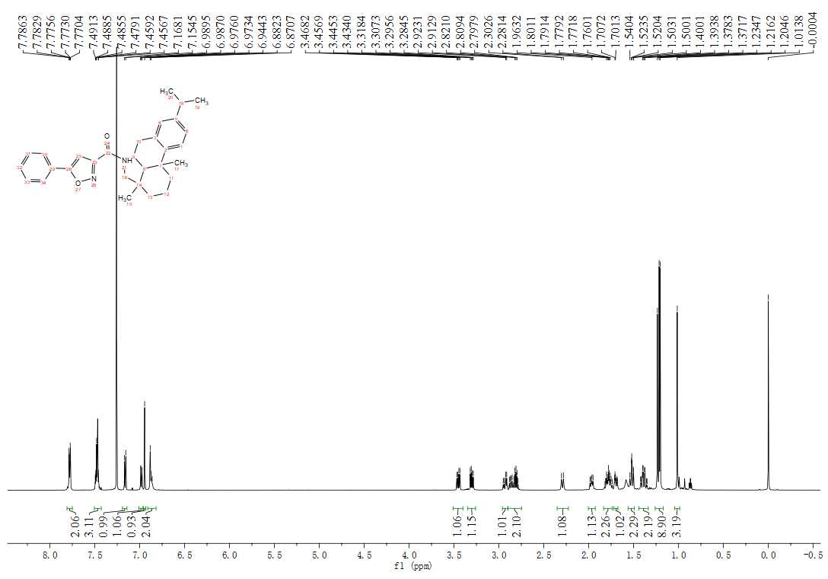
Figure S85. The ¹H NMR spectrum (600 MHz, CDCl₃) of compound 4c

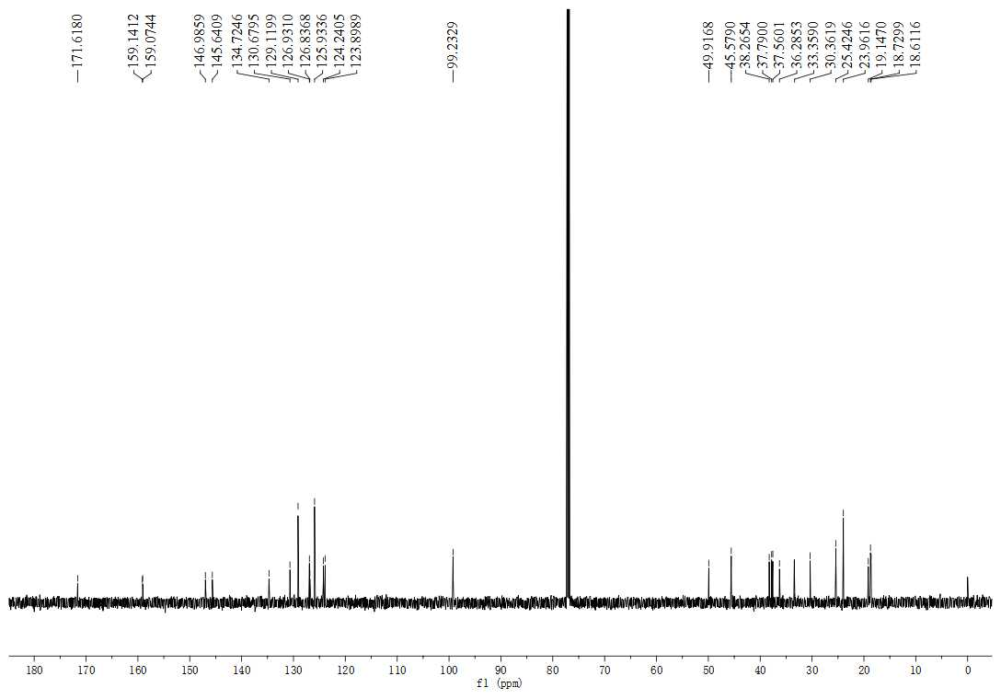
Figure S86. The ¹³C NMR spectrum (150 MHz, CDCl₃) of compound 4c

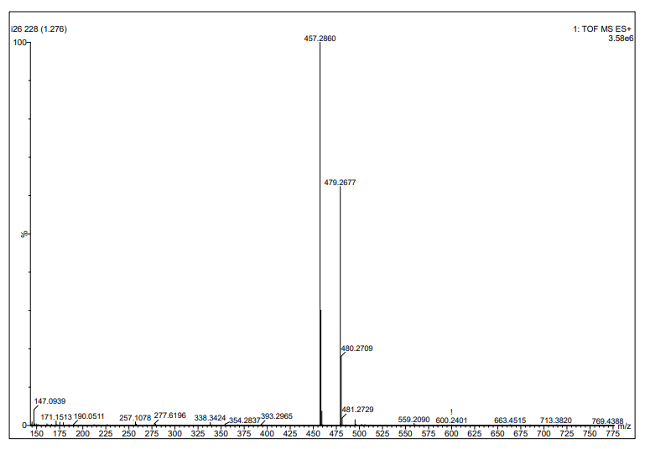
Figure S87. The HRMS spectrum of compound 4c

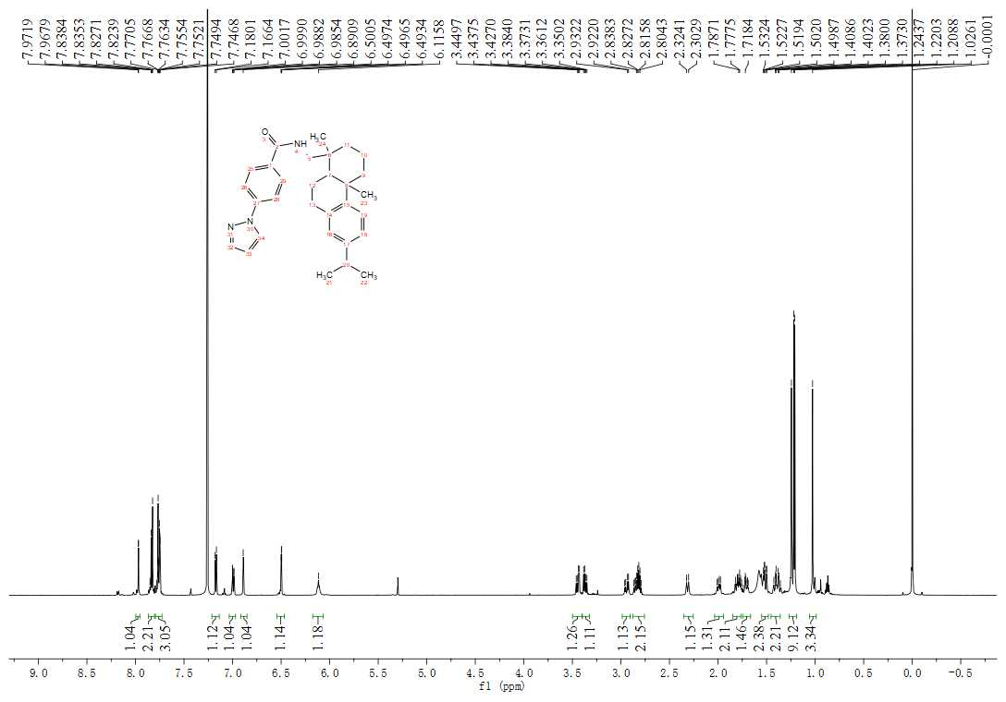
Figure S88. The ¹H NMR spectrum (600 MHz, CDCl₃) of compound 4d
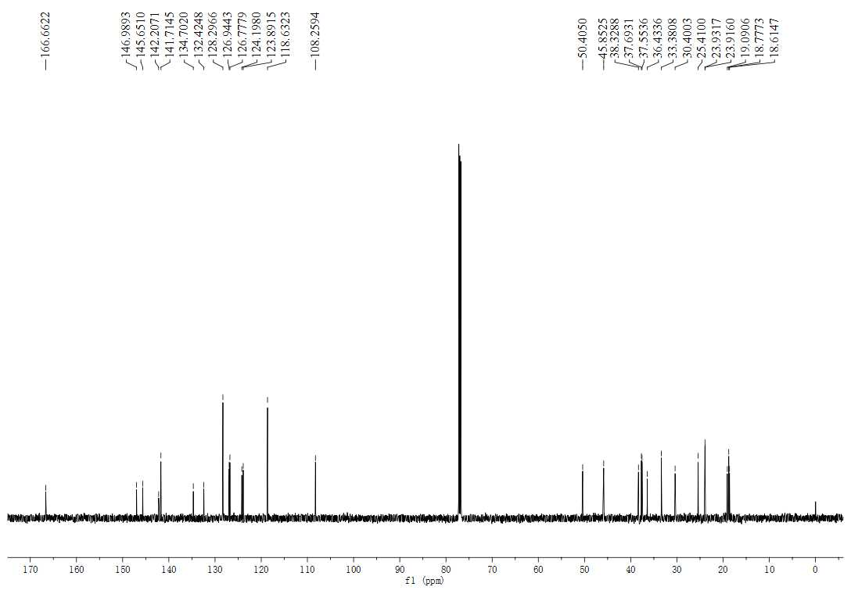
Figure S89. The ¹³C NMR spectrum (150 MHz, CDCl₃) of compound 4d

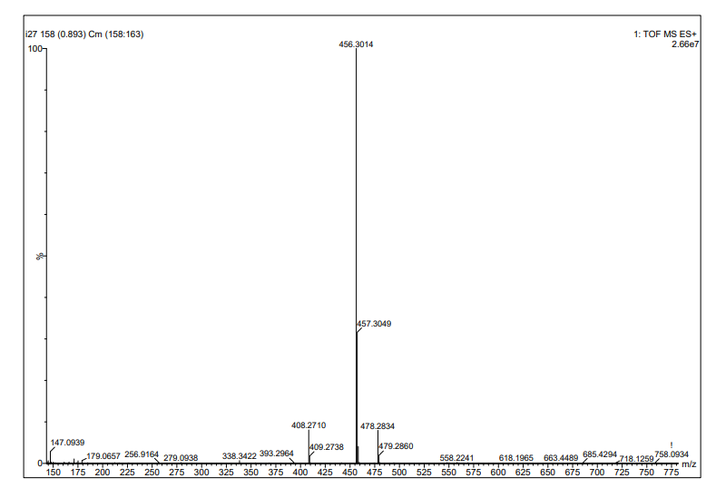
Figure S90. The HRMS spectrum of compound 4d

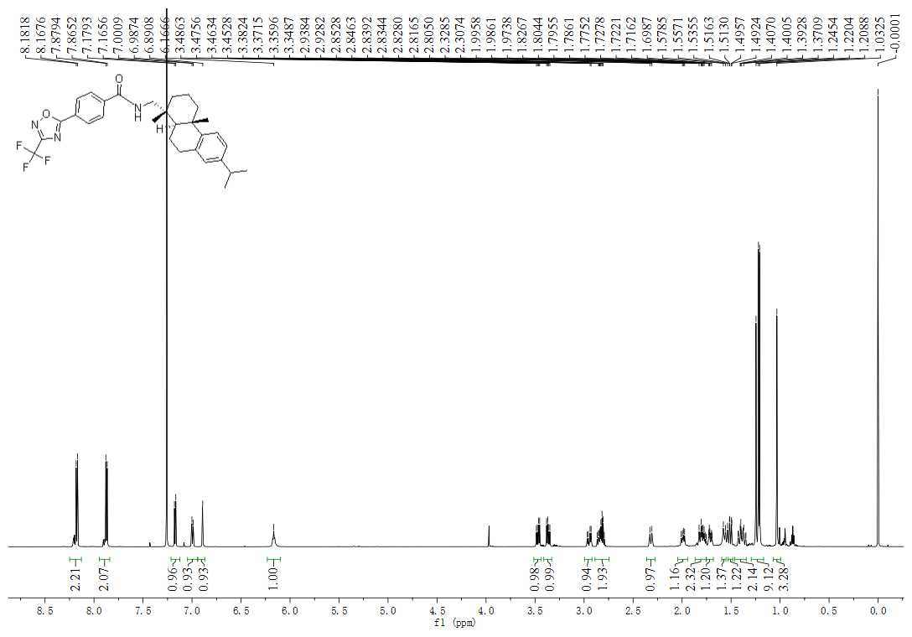
Figure S91. The ¹H NMR spectrum (600 MHz, CDCl₃) of compound 4e

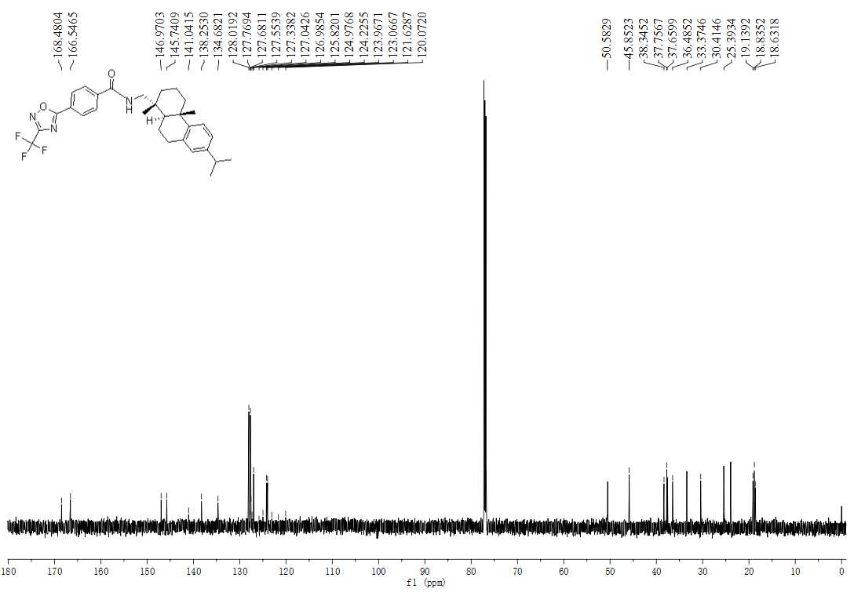
Figure S92. The ¹³C NMR spectrum (150 MHz, CDCl₃) of compound 4e

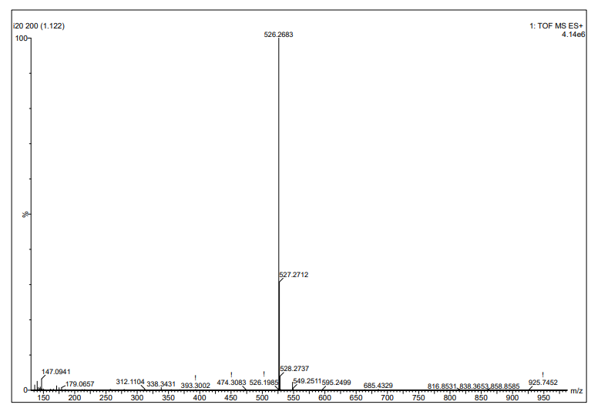
Figure S93. The HRMS spectrum of compound 4e

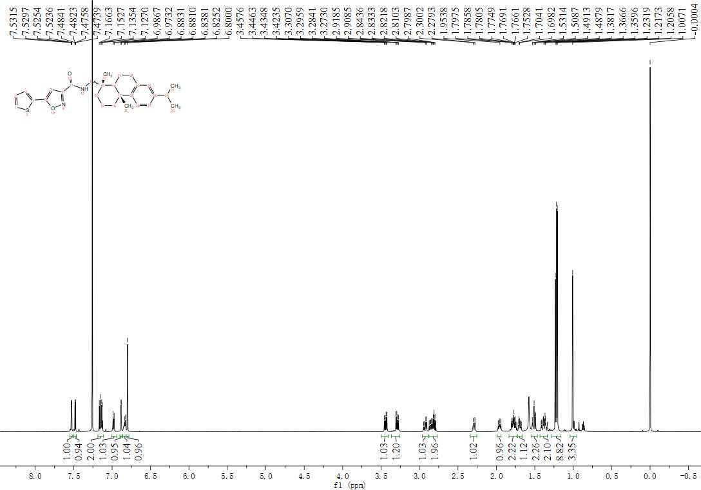
Figure S94. The ¹H NMR spectrum (600 MHz, CDCl₃) of compound 4f
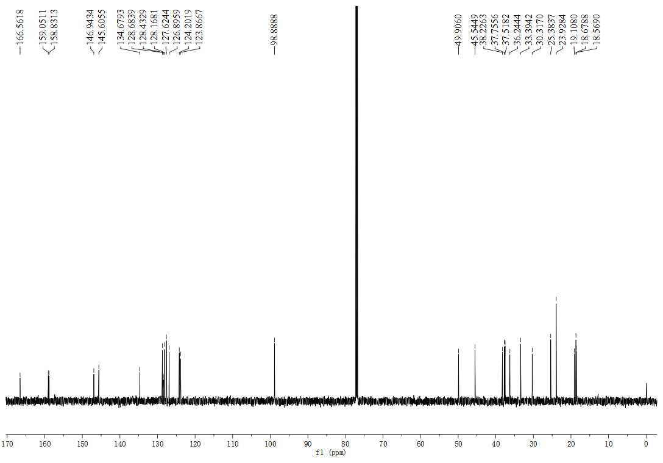
Figure S95. The ¹³CNMR spectrum (150 MHz, CDCl₃) of compound 4f

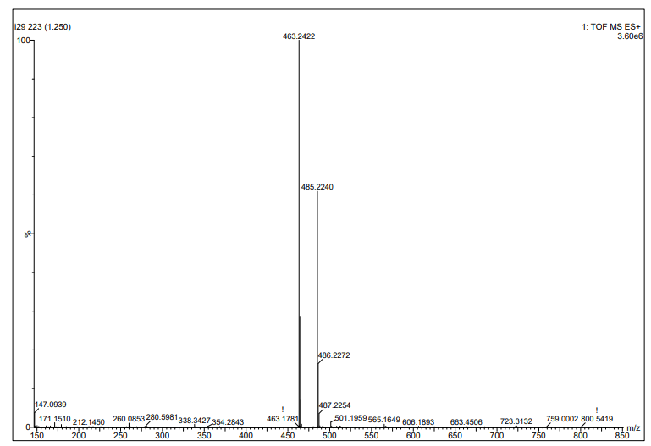
Figure S96. The HRMS spectrum of compound 4f
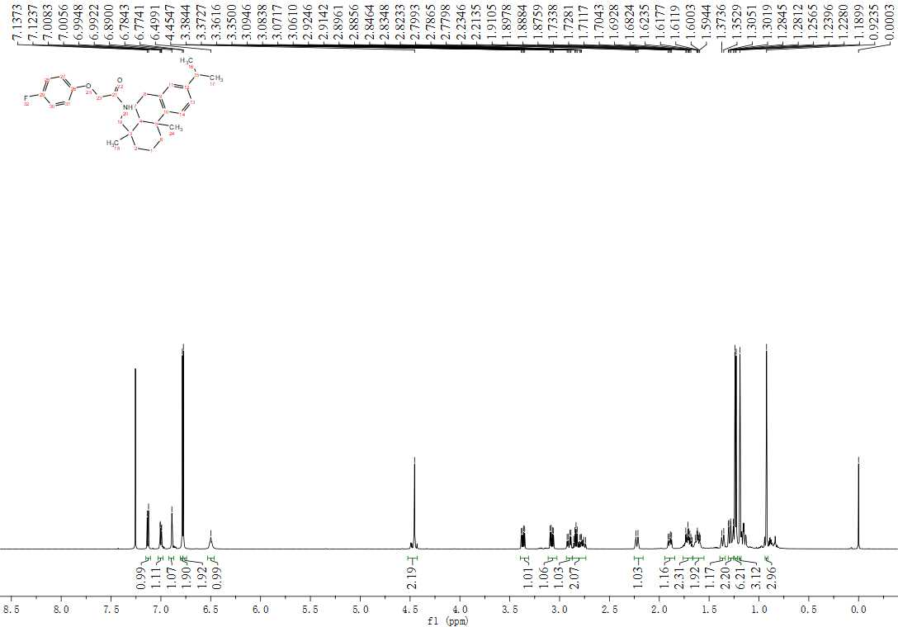
Figure S97. The ¹H NMR spectrum (600 MHz, CDCl₃) of compound 5a

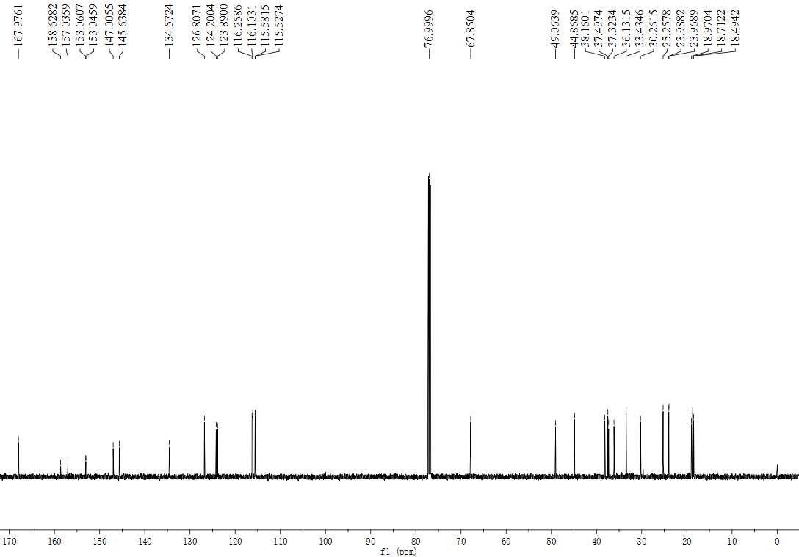
Figure S98. The ¹³ CNMR spectrum (150 MHz, CDCl₃) of compound 5a

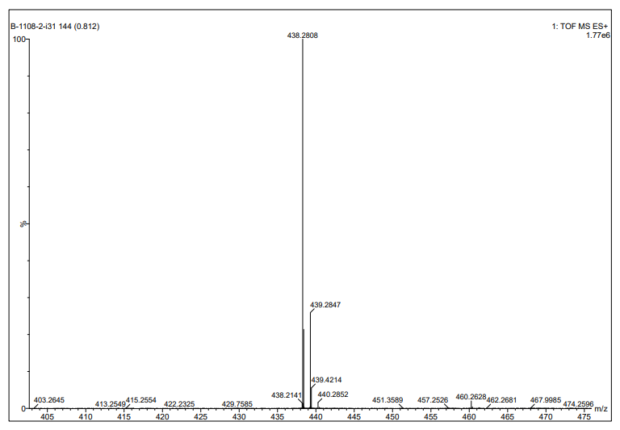
Figure S99. The HRMS spectrum of compound 5a

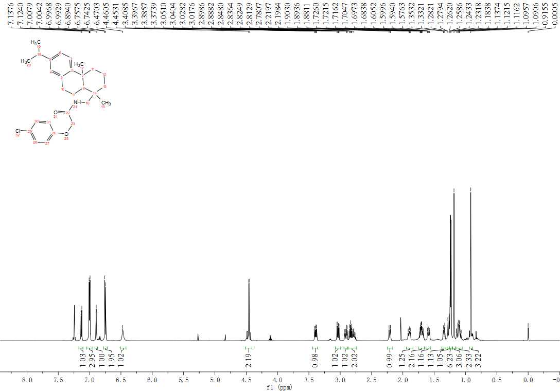
Figure S100. The ¹H NMR spectrum (600 MHz, CDCl₃) of compound 5b

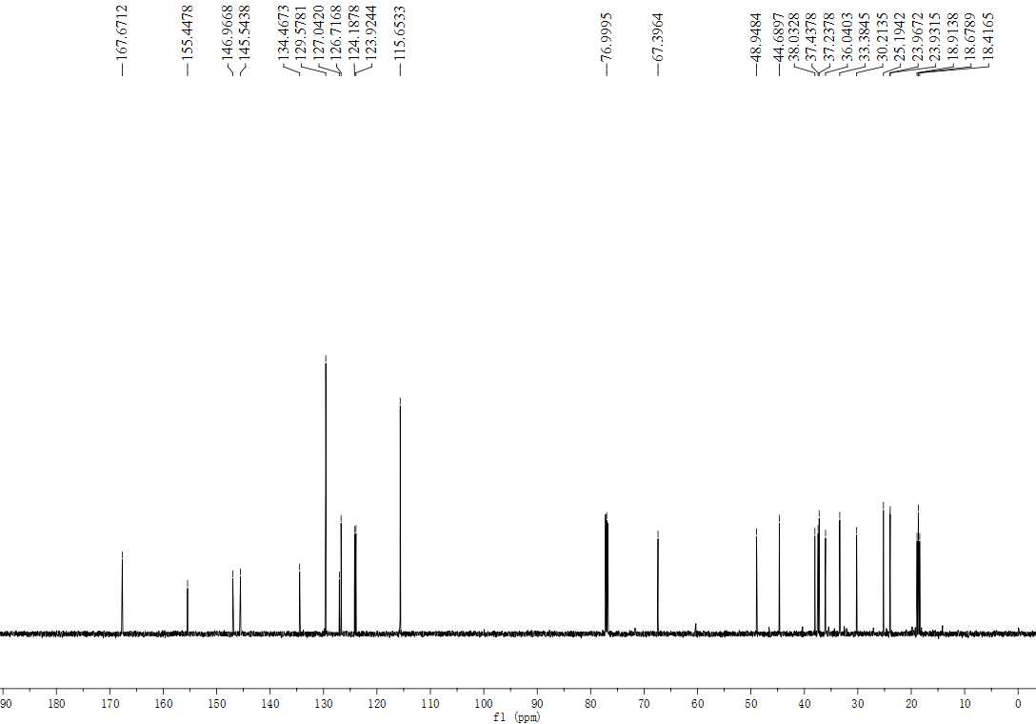
Figure S101. The ¹³C NMR spectrum (150 MHz, CDCl₃) of compound 5b

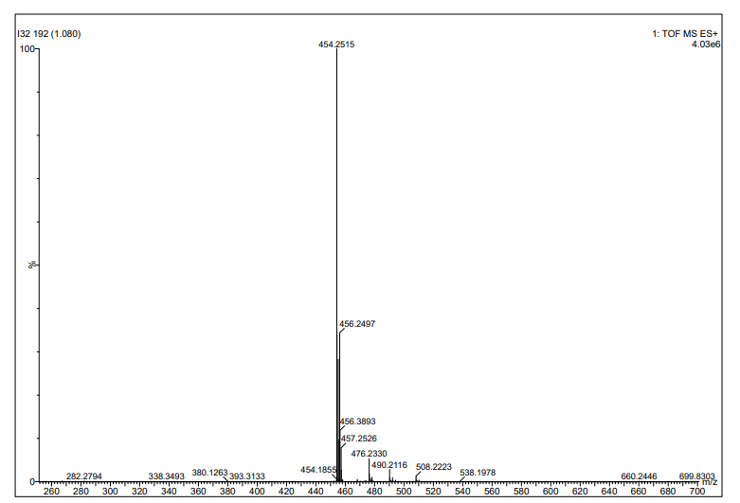
Figure S102. The HRMS spectrum of compound 5b

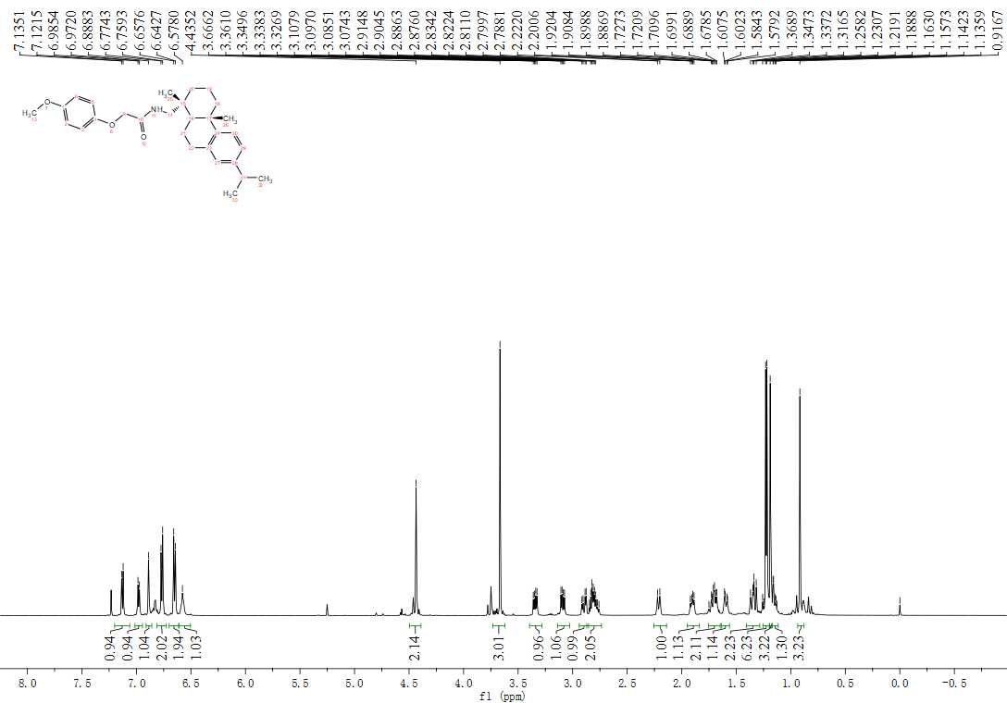
Figure S103. The ¹H NMR spectrum (600 MHz, CDCl₃) of compound 5c

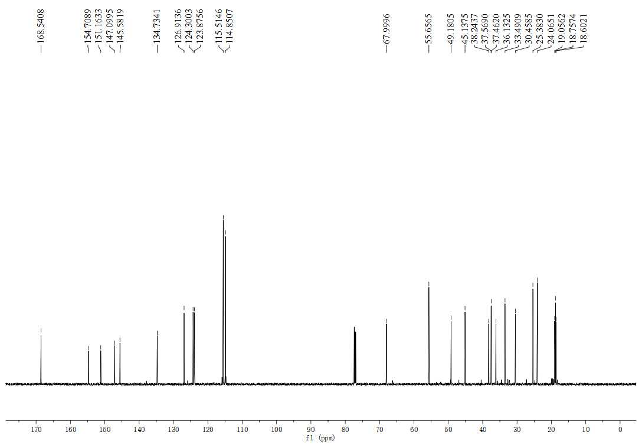
Figure S104. The ¹³C NMR spectrum (150 MHz, CDCl₃) of compound 5c

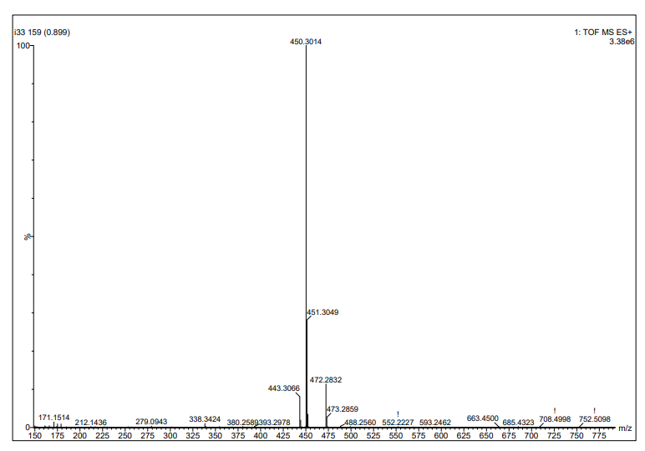
Figure S105. The HRMS spectrum of compound 5c

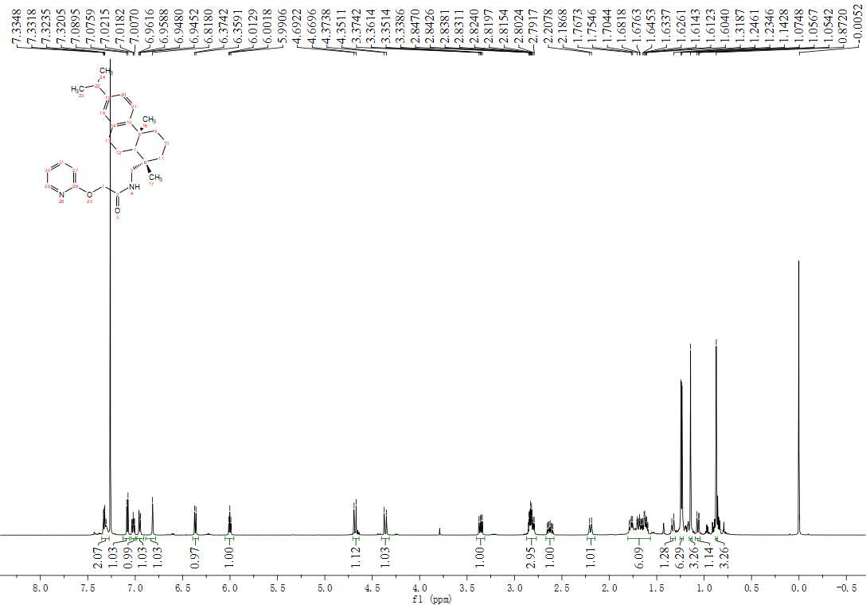
Figure S106. The ¹H NMR spectrum (600 MHz, CDCl₃) of compound 5d

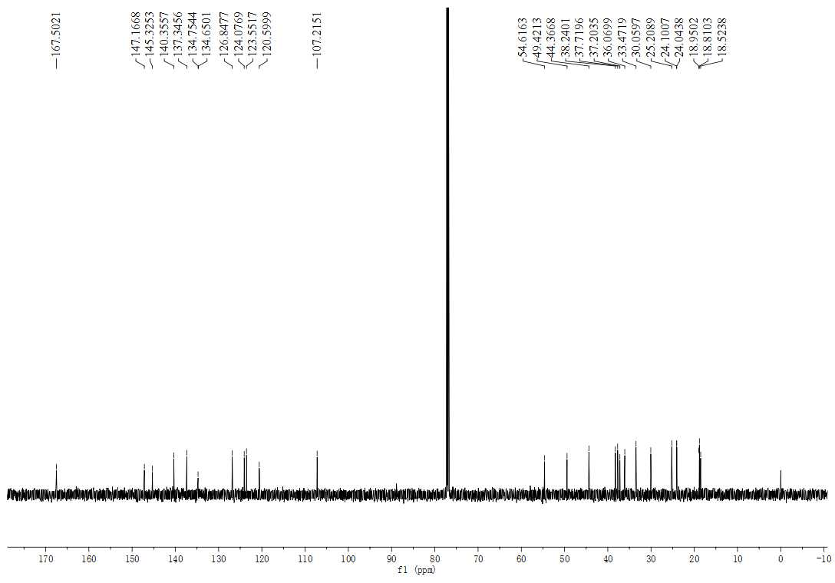
Figure S107. The ¹³C NMR spectrum (150 MHz, CDCl₃) of compound 5d

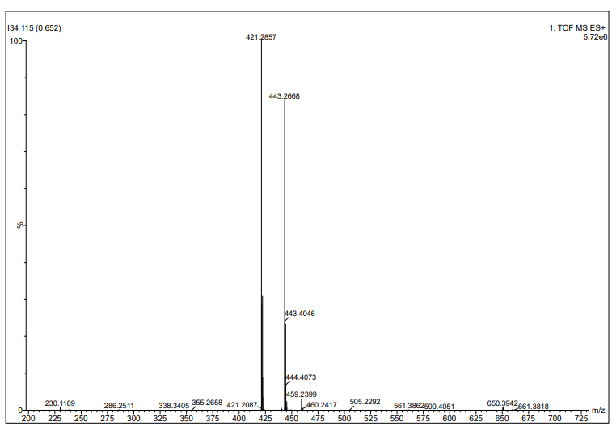
Figure S108. The HRMS spectrum of compound 5d

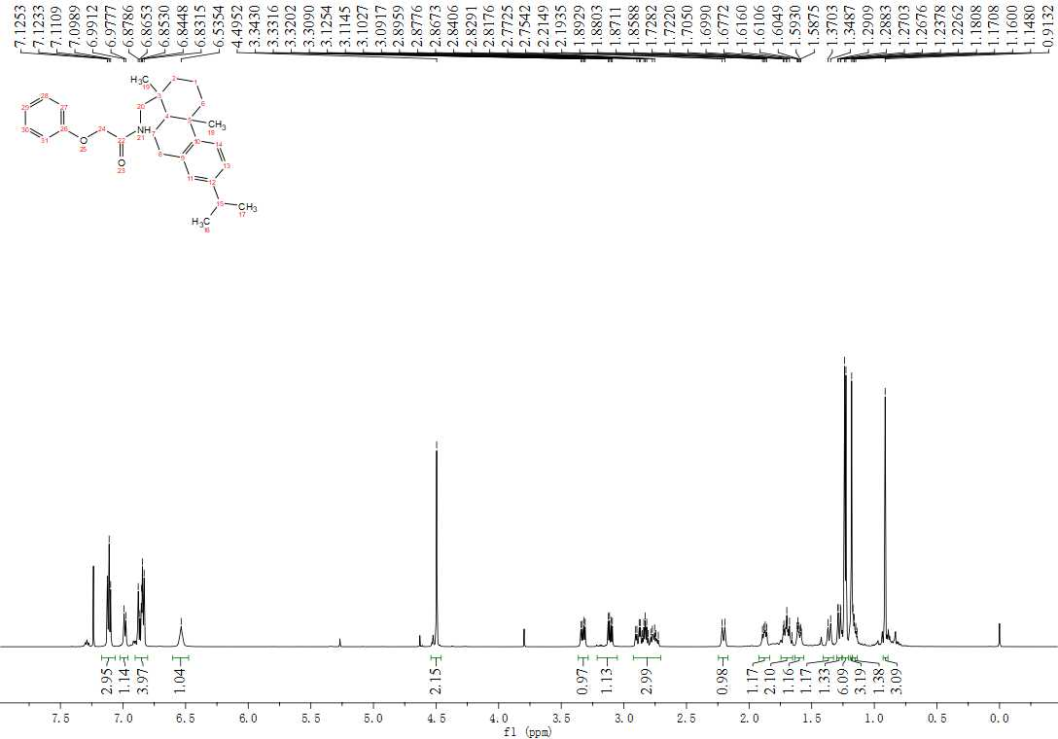
Figure S109. The ¹H NMR spectrum (600 MHz, CDCl₃) of compound 5e

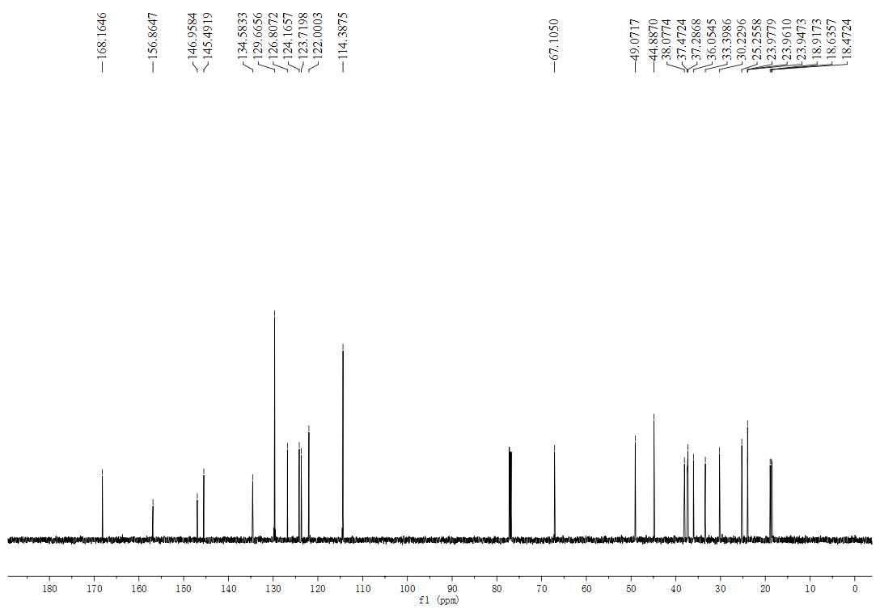
Figure S110. The ¹³C NMR spectrum (150 MHz, CDCl₃) of compound 5e
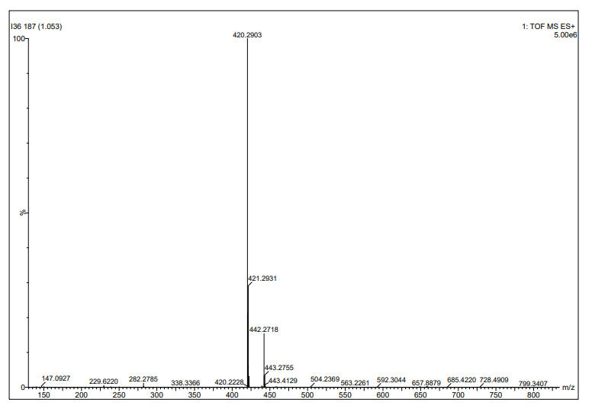
Figure S111. The HRMS spectrum of compound 5e



