**Supporting Information**

**Branched plasticizers derived from eugenol via green polymerization for low/non-migration and externally/ internally plasticized polyvinyl chloride materials**

Yun Hua#, Yufeng Mab#, Jing Zhouc#, Yu Beib,d, Feilong Hue, Zhimin Koua,b, Yonghong Zhoua,d, Puyou Jiaa\*

a Institute of Chemical Industry of Forest Products, Chinese Academy of Forestry (CAF), Jiangsu Key Lab of Biomass Energy and Materials, Jiangsu Province, 16 Suojin North Road, Nanjing 210042, China.

b College of Materials Science and Engineering, Co-Innovation Center of Efficient Processing and Utilization of Forest Resources, Nanjing Forestry University, 159 Longpan Road, Nanjing 210037, China.

c Weifang Vocational College, School of Chemical Engineering, 06588 Haian Road, Weifang 262737, Shandong, P.R. China.

d College of Chemical Engineering, Nanjing Forestry University, Nanjing 210037, P.R. China.

e Key Laboratory of Chemistry and Engineering of Forest Products, State Ethnic Affairs Commission，Guangxi Key Laboratory of Chemistry and Engineering of Forest Products, Guangxi Minzu University, Nanning 530006, China.

(# These authors contributed equally to this work. \*Corresponding author: E-mail: [jiapuyou@icifp.cn](mailto:jiapuyou@icifp.cn) (P.J.))

1 Detailed Description of Experimental Methods and Equipment

1.1 Fourier transform infrared (FT-IR)

FT-IR spectra was investigated using a Nicolet iS10 FTIR (Nicolet Instrument Crop., USA) Fourier transformed infrared spectrophotometer.

1.2 Nuclear magnetic resonance (NMR)

1H NMR was investigated on an AV-300 NMR spectrometer (Bruker Instrument Crop., Germany) at a frequency of 400MHz. CDCl3 was used as solvent and tetrametnylsilane (TMS) was used as internal standard in the process.

1.3 Thermal stability

Thermal stability of PVC films and DPTs was investigated using a TG209F1 thermal gravimetric analyzer (TGA) instruments (Netzsch Instrument Crop., Germany) in N2 atmosphere (50mL/min). The heating rate was 10℃/min.

1.4 Acute oral toxicity test

Acute oral toxicity test was carried out according to Chinese National Standards (GB/T 21603-2008) and OECD 401 guidelines. The temperature of barrier environment was controlled at 20℃-20℃ and the relative humidity was restricted at 40%-70%. The experimental animals(KM mice, SPF grade, 18~22 g) were divided into five groups, each of group contained ten males and ten females. The toxicity of was investigated in the high dose (5000mg/kg) and compared with control group. KM mice were pre reared in the animal room of our laboratory for 3 days to adapt to the environment. The animals were fasted overnight and drinking water was not restricted. After the animals were poisoned, the poisoning performance, the number of deaths and the time of death were observed for 14 consecutive days. The dead animals and the animals executed at the end of the observation period were dissected and observed with naked eyes. Abnormal tissues and organs were found, and further histopathological examination was needed.

1.5 Glass transition temperature

The glass transition temperature (*T*g) of PVC films was investigated using a NETZSCH differential scanning calorimeter (DSC) 200 PC analyzer under N2 atmosphere. The temperature ranged from -40 to 120 °C at a heating of 10°C/min.

1.6 Plasticizing performance

Plasticizing performance of PVC films were evaluated via tensile strength and elongation at break, which were detected according to GB/T 1040.1-2006 (China) at room temperature using an E43.104 Universal Testing Machine (MTS Instrument Crop., China).

1.7 Microstructure

Microstructure of PVC films was investigated using Leica DM750M (Leica Co., Germany).

1.8 Atomic force microscopy(AFM)

AFM observations were carried out in air using SPM-960 AFM (Shimadzu Instrument Crop., Japan) operated in contact mode. Surface of the samples with 2 mm thickness are used for AFM analysis.

1.9 Solvent resistance

Solvent resistance of PVC films was investigated according to American Society for Testing Materials (ASTM D5227. PVC films after weighting were immersed in petroleum ether, respectively. The test condition was controlled at 23 ± 2℃ and the relative humidity was restricted at 50 ± 5%. After 24h, the solvent extracted PVC films were dried and reweighed. The weight loss(*WL*) was calculated according to the Equation (1).

$WL=\frac{W_{1}-W_{2}}{W_{1}}×100$ (1)

where *W*1 was initial weight of PVC films, and *W*2 was final weight of tested PVC films. The extraction loss data was collected using the average value of five test samples.

1.10 Volatility

Volatility was evaluated by placing plasticized PVC samples in a convection oven at 70 °C for 24 h and cooled to room temperature in a desiccator for 2 h. The weight changes were measured before and after the heating.

All figures_30

**Fig. S1** Synthesis scheme of DPE, DDPE, DTPE and DTDPE

untitled

**Fig. S2** Synthesis scheme of internal plasticizer and internally plasticized PVC

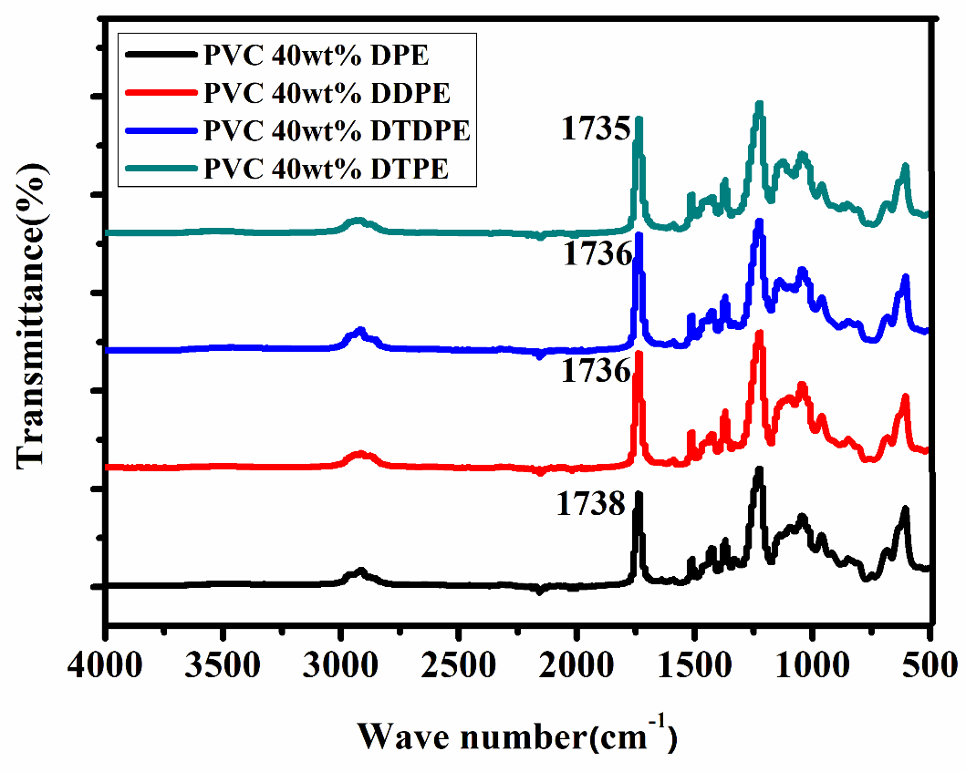

**Fig. S3** FT-IR of PVC plasticized with DPE, DDPE, DTPE and DTDPE

The plasticized PVC compositions were confirmed by the FT IR as shown in Fig.S3. As the number of ester groups linked to DDPE, DTPE, and DTDPE as terminal groups increased, the characteristic absorption peak of the carbonyl group decreased from 1738 cm−1to 1735 cm−1. The phenomenon can be explained by the intermolecular hydrogen-bond of carbanyl group and α-hydrogen of PVC.

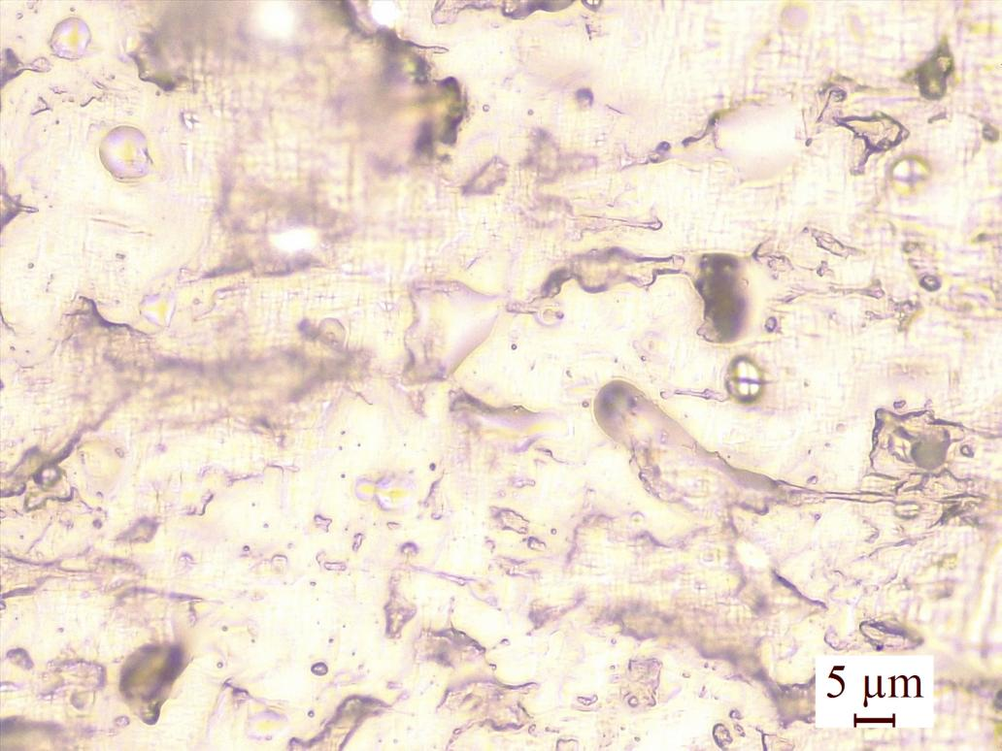

**Fig. S4** Surface morphology of PVC films

C:\Users\mayufeng-njfu\Desktop\untitled.tif

**Fig. S5** The interaction mechanism between plasticizers and PVC chains

**Table S1** Tensile test results of PVC materials

|  |  |  |
| --- | --- | --- |
| Samples | Tensile strength (MPa) | Elongation at break (%) |
| PVC | 32.33±0.28 | 180±5 |
| PVC 40 wt% DPE | 13.22±1.10 | 318±15 |
| PVC 40 wt% DTDPE | 16.24±2.32 | 279±16 |
| PVC 40 wt% DDPE | 17.91±0.98 | 248±9 |
| PVC 40 wt% DTPE | 24.26±1.45 | 230±12 |
| PVC 80 wt% DPE-SNa | 21.40±0.18 | 173±5 |
| PVC 40 wt% DPE-SNa | 22.54±0.24 | 154±8 |