**Supplementary Material**

**Exploring high pressure structural transformations, electronic properties and superconducting properties of** **MH2 (M = Nb, Ta)**

Jinquan Zhang,a Yanqi Wang,a Libiao Tang,a Juyi Duan,a Jingjing Wang,b Song Li,a Meng Ju,c Weiguo Sun,d Yuanyuan Jin,*a Chuanzhao Zhang*a

*a Department of Physics and Optoelectronic Engineering, Yangtze University, Jingzhou 434023, China.*

*b College of Computer and Information Engineering, Hubei Normal University, Huangshi 435002, China.*

*c School of Physical Science and Technology, Southwest University, Chongqing 400715, China.*

*d College of Physics and Electronic Information, Luoyang Normal University, Luoyang 471022, China*

* Corresponding author.

E-mail address: [scujyy@163.com](mailto:scujyy@163.com) (Y. Jin) and [zcz19870517@163.com](mailto:zcz19870517@163.com) (C. Zhang).

**Table S1**. Structural information of the predicted structures for NbH2 and TaH2 at 1 atm and 100 GPa.

|  |  |  |  |  |  |  |
| --- | --- | --- | --- | --- | --- | --- |
| **Phase** | **Space group** | **Lattice parameters (Å, ◦)** | **Atom** | **Atomic coordinates**  **(fractional)** | | |
| NbH2 (1 atm) | *Pm* | *a*=5.639, *b*=3.219, *c*=5.185  *α***=***γ*=90, *β*=90.016 | Nb(1b) | 0.336 | 0.500 | 0.990 |
| Nb(1b) | 0.667 | 0.500 | 0.500 |
| Nb(1a) | 0.835 | 0.000 | 0.006 |
| Nb(1a) | 0.168 | 0.000 | 0.499 |
| H(1b) | -0.002 | 0.500 | 0.467 |
| H(1b) | 0.669 | 0.500 | 0.467 |
| H(1b) | 0.339 | 0.500 | 0.365 |
| H(1b) | 0.005 | 0.500 | 0.100 |
| H(1a) | 0.504 | 0.000 | 0.112 |
| H(1a) | 0.839 | 0.000 | 0.625 |
| H(1a) | 0.166 | 0.000 | 0.869 |
| H(1a) | 0.492 | 0.000 | 0.584 |
| NbH2 (1 atm) | *C*2/*m* | *a*=10.654, *b*=3.139, *c*=12.801  *α***=***γ*=90, *β*=154.317 | Nb(4i) | -0.520 | -0.500 | -0.763 |
| Nb(2a) | 0.000 | -1.000 | 0.000 |
| Nb(2c) | -0.500 | -0.500 | -0.500 |
| H(4i) | 0.068 | -0.500 | -0.044 |
| H(4i) | -0.248 | -0.500 | -0.433 |
| H(4i) | -0.597 | -1.000 | -0.734 |
| H(4i) | -0.243 | -1.000 | -0.311 |
| NbH2 (1 atm) | *Pnma* | *a*=5.238, *b*=3.194, *c*=5.525  *α***=***β*=*γ*=90 | Nb(4c) | -0.238 | 0.250 | 0.427 |
| H(4c) | 0.038 | 0.250 | 0.670 |
| H(4c) | -0.385 | 0.750 | 0.587 |
| NbH2 (1 atm) | *Imma* | *a*=5.238, *b*=3.194, *c*=5.525  *α***=***β*=*γ*=90 | Nb(4e) | 0.000 | 0.750 | 0.268 |
| Nb(4c) | 0.250 | 0.750 | 0.750 |
| H(4e) | 0.000 | 0.750 | 0.679 |
| H(4d) | 0.250 | 0.750 | 0.250 |
| H(8f) | 0.118 | 0.500 | 0.000 |
| NbH2 (1 atm) | *P*4/*nmm* | *a*=3.107, *b*=3.107, *c*=4.704  *α***=***β*=*γ*=90 | Nb(2c) | 0.000 | 0.500 | 0.735 |
| H(2c) | 0.500 | 0.000 | 0.672 |
| H(2a) | 0.000 | 0.000 | 0.000 |
| NbH2 (1 atm) | *Pm*1 | *a*=3.196, *b*=3.196, *c*=5.062  *α***=***β*=90, *γ*=120 | Nb(2d) | 0.667 | 0.333 | 0.243 |
| H(2d) | 0.667 | 0.333 | 0.635 |
| H(1b) | 0.000 | 0.000 | 0.500 |
| H(1a) | 0.000 | 0.000 | 0.000 |
| NbH2 (1 atm) | *P*63*mc* | *a*=3.231, *b*=3.231, *c*=5.196  *α***=***β*=90, *γ*=120 | Nb(2b) | 0.333 | 0.667 | 0.558 |
| H(2b) | 0.667 | 0.333 | 0.425 |
| H(2a) | 0.000 | 0.000 | 0.162 |
| NbH2 (1 atm) | *Fm $\overline{3}$ m* | *a=b=c=*4.556 | Nb(4a) | 0.000 | 0.000 | 0.000 |
| *α***=***β*=*γ*=90 | H(8c) | 0.750 | 0.250 | 0.250 |
| NbH2 (100 GPa) | *Pnma* | *a*=4.682, *b*=2.838, *c*=5.067  *α***=***β*=*γ*=90 | Nb(4c) | 0.264 | 0.250 | 0.410 |
| H(4c) | 0.479 | 0.250 | 0.719 |
| H(4c) | 0.117 | 0.750 | 0.577 |
| TaH2 (1 atm) | *Pm* | *a*=5.161, *b*=3.218, *c*=5.646  *α***=***γ*=90, *β*=89.991 | Ta (1b) | 0.843 | 0.500 | 0.583 |
| Ta (1b) | 0.356 | 0.500 | 0.917 |
| Ta (1a) | 0.839 | 0.000 | 0.082 |
| Ta (1a) | 0.332 | 0.000 | 0.415 |
| H(1b) | 0.977 | 0.500 | 0.912 |
| H(1b) | 0.436 | 0.500 | 0.250 |
| H(1b) | 0.904 | 0.500 | 0.256 |
| H(1b) | 0.211 | 0.500 | 0.586 |
| H(1a) | 0.801 | 0.000 | 0.753 |
| H(1a) | 0.704 | 0.000 | 0.412 |
| H(1a) | 0.212 | 0.000 | 0.083 |
| H(1a) | 0.430 | 0.000 | 0.745 |
| TaH2 (1 atm) | *Pnma* | *a*=5.243, *b*=3.200, *c*=5.505  *α***=***β*=*γ*=90 | Ta(4c) | 0.265 | 0.250 | 0.429 |
| H(4c) | 0.547 | 0.250 | 0.662 |
| H(4c) | 0.110 | 0.750 | 0.586 |
| TaH2 (1 atm) | *P*4/*nmm* | *a*=*b*=3.109, *c*=4.689  *α***=***β*=*γ*=90 | Ta(2c) | 0.500 | 0.000 | 0.269 |
| H(2a) | 0.000 | 0.000 | 0.000 |
| H(2c) | 0.000 | 0.500 | 0.328 |
| TaH2 (1 atm) | *Pm*1 | *a*=*b*=3.196, *c*=5.062  *α***=***β*=90, *γ*=120 | Ta(2d) | 0.667 | 0.333 | 0.238 |
| H(2d) | 0.667 | 0.333 | 0.627 |
| H(1b) | 0.000 | 0.000 | 0.500 |
| H(1a) | 0.000 | 0.000 | 0.000 |
| TaH2 (1 atm) | *P*63*mc* | *a=b=*3.231*, c=*5.162  *α***=***β*=*γ*=90 | Ta(2b) | 0.333 | 0.667 | 0.563 |
| H(2b) | 0.667 | 0.333 | 0.429 |
| H(2a) | 0.000 | 0.000 | 0.152 |
| TaH2 (1 atm) | *P*2*m* | *a=b=*3.231*, c=*5.162  *α***=***β*=90, *γ*=120 | Ta(2d) | 0.333 | 0.667 | 0.500 |
| Ta(1a) | 0.000 | 0.000 | 0.000 |
| H(3g) | 0.259 | 0.000 | 0.500 |
| H(3f) | 0.393 | 0.093 | 0.000 |
| TaH2 (1 atm) | *P*63/*mmc* | *a=b=*3.240*, c=*4.961  *α***=***β*=90, *γ*=120 | Ta(2c) | 0.667 | 0.333 | -0.250 |
| H(2d) | 0.333 | -0.333 | -0.250 |
| H(2a) | 0.000 | 0.000 | 0.000 |
| TaH2 (1 atm) | *Fm $\overline{3}$ m* | *a=b=c=*4.539  *α***=***β*=*γ*=90 | Ta(4a) | 0.000 | 0.000 | 0.000 |
| H(8c) | 0.750 | 0.250 | 0.250 |
| TaH2 (100 GPa) | *Pnma* | *a=*4.709*, b=*2.842, *c=*5.095  *α***=***β*=*γ*=90 | Ta(4c) | 0.265 | 0.250 | 0.716 |
| H(4c) | 0.476 | 0.250 | 0.716 |
| H(4c) | 0.115 | 0.750 | 0.578 |

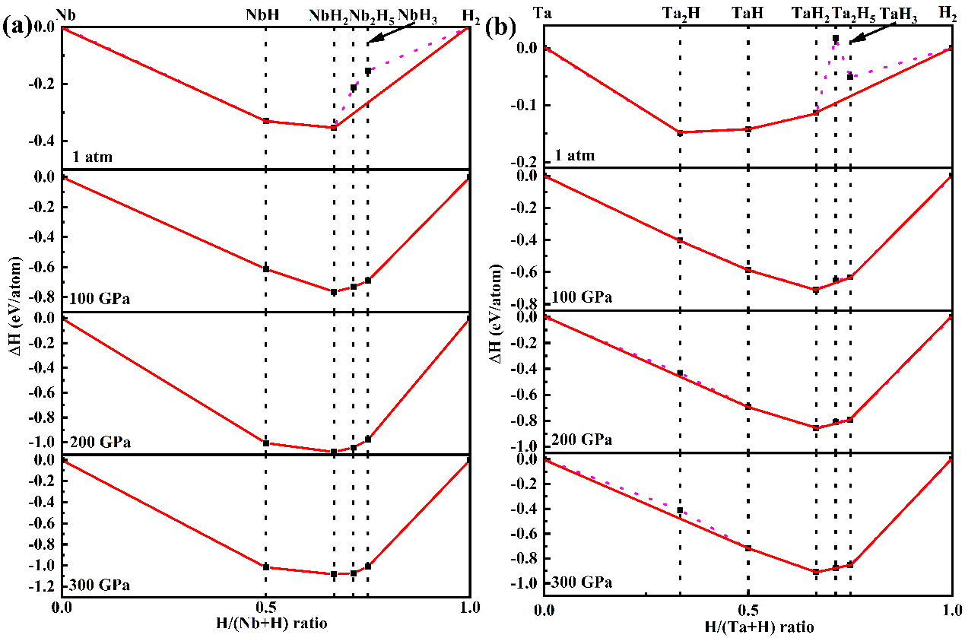

**Fig. S1** (a) Enthalpies of formation of NbH*n* (*n* = 1, 2, 2.5 and 3) with respect to Nb and H2 at given pressures. (b) Enthalpies of formation of TaH*n* (*n* = 0.5, 1, 2, 2.5 and 3) with respect to Ta and H2 at given pressures.

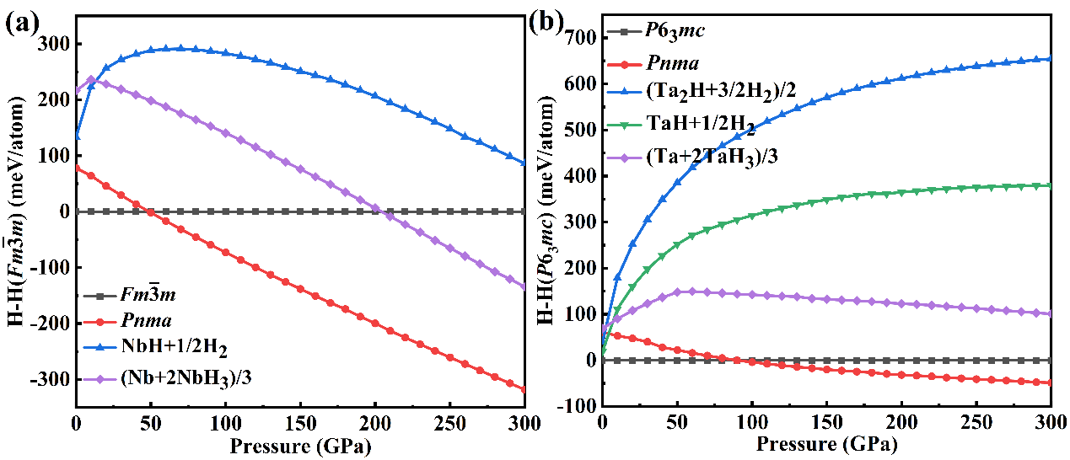

**Fig. S2** Static ground-state enthalpy curves as a function of pressure with respect to (a) *Fmm*-NbH2 and (b) *P*63*mc*-TaH2.

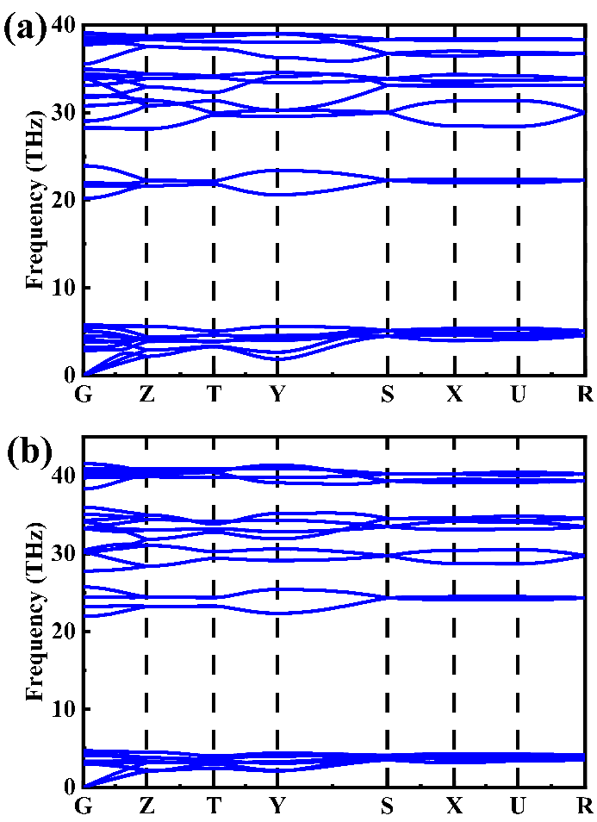

**Fig. S3** Phonon dispersion curves of (a) *Pnma*-NbH2 and (b) *Pnma*-TaH2 at 1 atm.