**Supporting Information file for:**

**Utilization of camellia oleifera shell for production of valuable products by pyrolysis**

Xiao Liu a, Weibo Mengb, Song Cheng b,c*, Baolin Xingb,c*, Yunze Zhengb, Xuanye Renb, Mengya Xueb, Chuanxiang Zhang b, Hongying Xiad

(a. School of Energy Science and Engineering, Henan Polytechnic University, Jiaozuo, 454003, China

b. College of Chemistry and Chemical Engineering, Henan Polytechnic University, Jiaozuo 454003, China；

c. Collaborative Innovation Center of Coal Work Safety and Clean High Efficiency Utilization, Jiaozuo, 454003, China)

d. Faculty of Metallurgical and Energy Engineering, Kunming University of Science and Technology, Kunming 650093, Yunnan, China)

**Corresponding author: Song Cheng, Email address: cskmust@163.com**

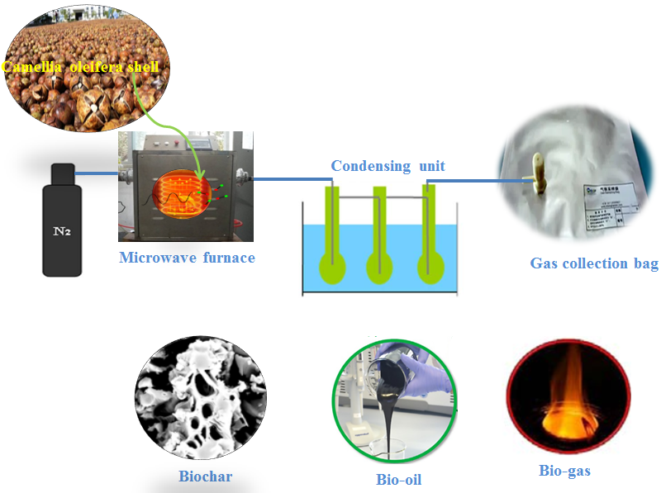

**Fig.S1** The schematic diagram of pyrolysis system.

**Table S1** Pyrolysis products produced from different types of biomass

|  |  |  |  |  |
| --- | --- | --- | --- | --- |
| Precursor | Bio-gas (%) | Bio-oil  (%) | Biochar  (%) | Reference |
| COS | 51.53 | 21.67 | 26.80 | This work |
| Pine dust | 60.00 | 22.70 | 17.30 | (Chen et al., 2008) |
| Corn stover | 41.30 | 32.70 | 26.00 | (Lei et al., 2009) |
| Aspen | 38.90 | 35.90 | 35.20 | (Wan et al., 2009) |
| Peanut shell | 46.20 | 16.60 | 37.20 | (Mamaeva et al., 2016) |

**Table S2** Compositions of bio-oil at 400-800℃

|  |  |  |  |  |  |  |
| --- | --- | --- | --- | --- | --- | --- |
| Item | Components | 400℃ 500℃ 600℃ 700℃ | | | | 800℃ |
| Relative content (%) | | | | |
| 1 | Cyclohexan-1,4,5-triol-3-one-1-  carboxylic acid | 0.63 | 0.44 | 0.71 | 0.36 | 0.56 |
| 2 | 2-Methoxytetrahydrofuran | 0.35 | 0.62 | 2.75 | - | - |
| 3 | 2-Methyl-l-methylmannopyranoside | 0.43 | 2.62 | - | - | - |
| 4 | Cyclobutene, 2-propenylidene- | - | 0.65 | 0.28 | 0.62 | 0.60 |
| 5 | 1,3,5-Cycloheptatriene | 0.76 | 0.54 | 0.62 | - | - |
| 6 | Butanoic acid | 0.45 | 0.96 | 0.57 | 0.73 | 0.82 |
| 7 | Furan, 2-(methoxymethyl)- | 3.77 | 1.26 | 1.02 | 3.03 | 4.46 |
| 8 | Cyclopentanone | 2.81 | 2.5 | 1.02 | 2.62 | 2.24 |
| 9 | Cyclopentanone, 2-methyl- | 0.67 | 0.20 | 0.35 | 0.38 | - |
| 10 | 3-Furaldehyde | - | - | - | 0.63 | 0.34 |
| 11 | Furfural | 10.48 | 7.44 | 7.79 | 7.20 | 3.91 |
| 12 | Cycloheptanone, 3-methyl- | 0.59 | 0.43 | 0.24 | 0.51 | - |
| 13 | Ethylbenzene | 3.53 | 3.30 | 1.59 | 1.84 | 1.92 |
| 14 | Toluene | 0.31 | 0.20 | 0.45 | - | - |
| 15 | p-Xylene | 3.06 | 2.48 | 1.71 | 4.15 | 4.72 |
| 16 | Benzene, 1,3-dimethyl | 6.00 | 5.12 | 3.47 | 2.02 | - |
| 17 | Ethanone, 1-(2-furanyl)- | 1.00 | 0.85 | 1.30 | 1.50 | 1.68 |
| 18 | 2-Furanethanol, á-methoxy-(S)- | 0.49 | 0.25 | 0.30 | 0.67 | - |
| 19 | 2-Furancarboxaldehyde, 5-methyl- | - | - | -0.69 | 0.85 | 0.78 |
| 20 | Phenol | 31.23 | 40.68 | 51.31 | 28.75 | 38.50 |
| 21 | 2-methyl- Phenol | 2.31 | 10.99 | 14.16 | 10.46 | 13.38 |
| 22 | Cresol | - | - | - | - | 0.67 |
| 23 | 3-methyl- Phenol | 16.71 | 9.17 | 11.89 | - | 7.59 |
| 24 | Phenol, 2,5-dimethyl- | 0.47 | 0.32 | 1.37 | - | - |
| 25 | Phenol, 3,4-dimethyl- | - |  | 0.34 | 0.98 | 1.08 |
| 26 | Phenol, 2,3-dimethyl- | 1.03 | 0.99 | 0.27 | 0.41 | - |

**Table S3** Electrochemical performance of various materials applied to lithium ion batteries.

|  |  |  |
| --- | --- | --- |
| Material | Energy storage potential | References |
| Seaweed biochar | <200mAh g−1 | Salimi et al. (2019) |
| Carbonized straw biochar | < 300mAh g−1 | Ryu et al. (2015) |
| MDF/Fe | 307 mAh g−1 | Gomez et al. (2018) |
| ABiochar composite | 340 mAh g−1 | This work |

**Table S4** The detailed information of the cost and income

|  |  |
| --- | --- |
| Item | Value |
| Feedstock | $35,000/year |
| Processing Labor | $12,000/year |
| Electricity purchased | $8,640/year |
| Pyrolysis machinery depreciation | $30,000/year |
| Maintenance | $10,000/year |
| Consumables | $9,150/year |
| Insurance and taxes | $4,000/year |
| Transportation of Bio-oil to Market | $3,000/year |
| Total capital invest and operating cost | $111,790 |
| Sale of bio-oil | $23,850 |
| Sale of bio-char | $134,000 |
| Total annual income | $157,850 |
| Total annual revenue | $46,060 |

Reference

Salimi P, Norouzi O, Pourhoseini S E M., Bartocci, P.,,TavasolI,A., Maria,F.D., Pirbazari, S.M., Bidini,G., Fantozzi,F., 2019. Magnetic biochar obtained through catalytic pyrolysis of macroalgae: A promising anode material for Li-ion batteries. Renewable Energy, 2019, 140: 704-714

Ryu, D. J., Oh, R. G., Seo, Y. D., Oh, S. Y., & Ryu, K. S. (2015). Recovery and electrochemical performance in lithium secondary batteries of biochar derived from rice straw. Environmental Science and Pollution Research, 22(14), 10405-10412.

Gomez-Martin, A., Martinez-Fernandez, J., Ruttert, M., Heckmann, A., Winter, M., Placke, T., & Ramirez‐Rico, J. (2018). Iron-catalyzed graphitic carbon materials from biomass resources as anodes for lithium-ion batteries. ChemSusChem, 11(16), 2776-2787.

Yan, P., Ai, F., Cao, C., & Luo, Z. (2019). Hierarchically porous carbon derived from wheat straw for high rate lithium ion battery anodes. Journal of Materials Science: Materials in Electronics, 30(15), 14120-14129.

Chen, M., Wang, J., Zhang, M., Chen, M., Zhu, X., Min, F., Tan, Z., 2008. Catalytic effects of eight inorganic additives on pyrolysis of pine wood sawdust by microwave heating. J. Anal. Appl. Pyrolysis 82(1), 145-150.

Lei, H., Ren, S., Julson, J., 2009. The Effects of Reaction Temperature and Time and Particle Size of Corn Stover on Microwave Pyrolysis. Energy Fuels 23(3), 3254-3261.

Mamaeva, A., Tahmasebi, A., Tian, L., Yu, J., 2016. Microwave-assisted catalytic pyrolysis of lignocellulosic biomass for production of phenolic-rich bio-oil. Bioresour. Technol. 211, 382-389.

Wan, Y., Chen, P., Zhang, B., Yang, C., Liu, Y., Lin, X., Ruan, R., 2009. Microwave-assisted pyrolysis of biomass: Catalysts to improve product selectivity. J. Anal. Appl. Pyrolysis 86(1), 161-167.