**Supplementary data**

**Efficient synthesis of new azo-sulfonamide derivatives and investigation of their molecular docking and cytotoxicity results**

Nosrat O. Mahmoodi*, a, Ali Ahmadi a, Hadiseh Yazdani Nyakia, Hossein Taherpour Nahzomi b, Esmaeel Panahi Kokhdanc

*(E)-N-((4-((2-hydroxynaphthalen-1-yl)diazenyl)phenyl)sulfonyl)acetamide* ***(1)***



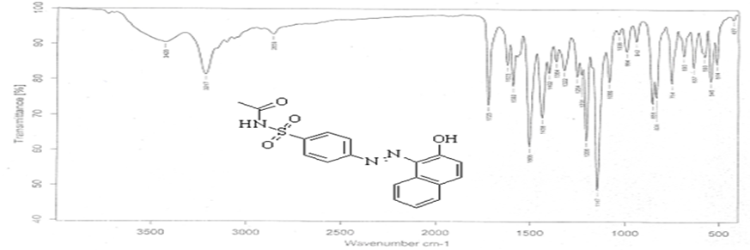

FT-IR (1)

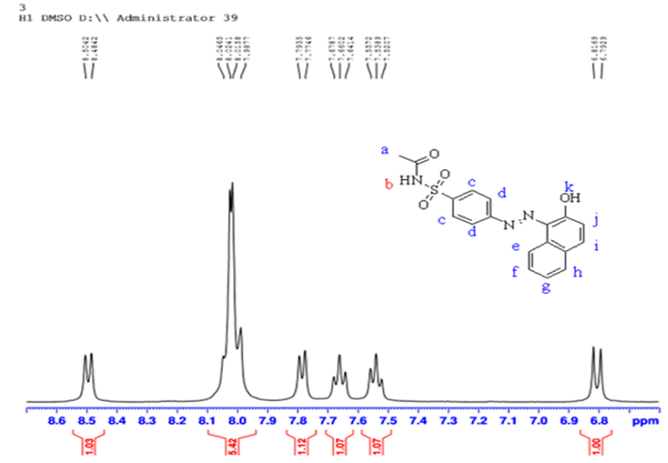

1H NMR (DMSO-d6 400 MHz) (1)

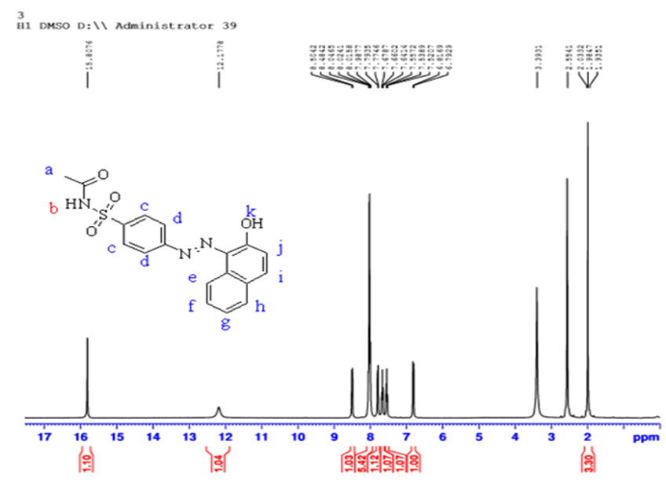

1H NMR (DMSO-d6 400 MHz) (1)

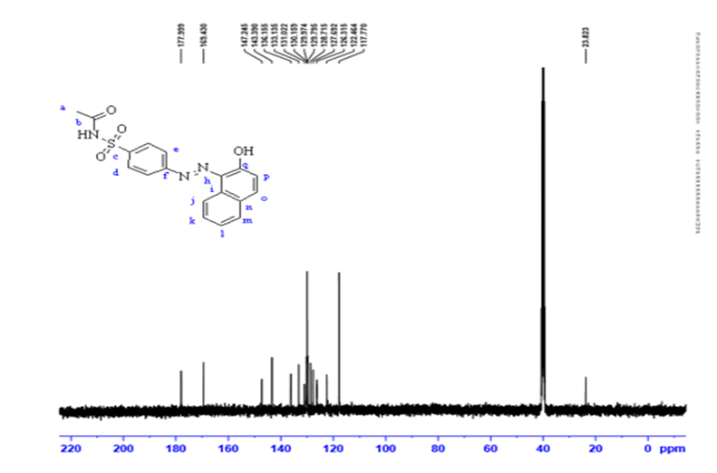

13C NMR (DMSO-d6 100 MHz) (1)

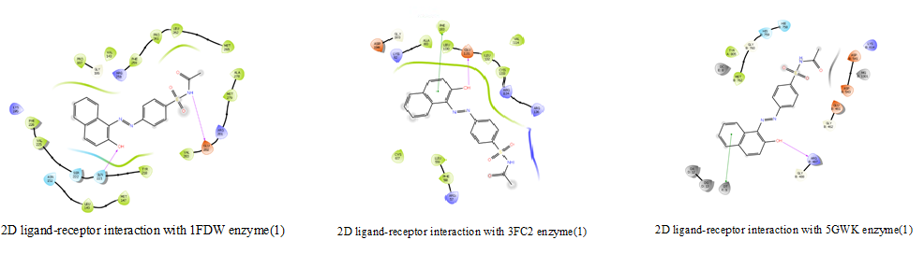

2D ligand-receptor interaction with 1FDW enzyme , 3FC2 enzyme and5GWK enzyme (1)

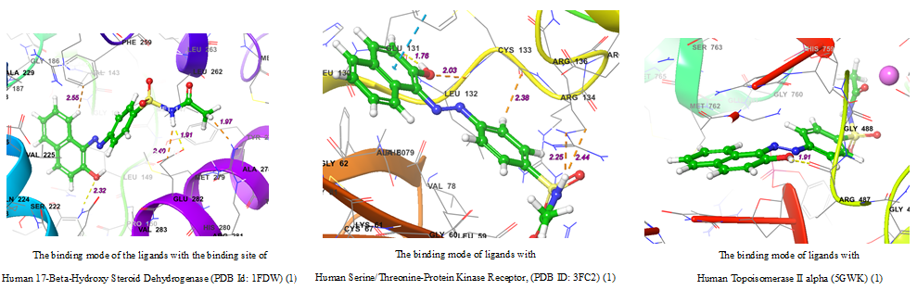

The binding mode of the ligands with the binding site of Human 17-Beta-Hydroxy Steroid Dehydrogenase (PDB Id: 1FDW), Serine/Threonine-Protein Kinase Receptor, (PDB ID: 3FC2) and Topoisomerase II alpha (5GWK) (1)

*MTT assay data* (1)

*(E)-N-((4-((2-hydroxynaphthalen-1-yl)diazenyl)phenyl)sulfonyl)benzamide* ***(2)***



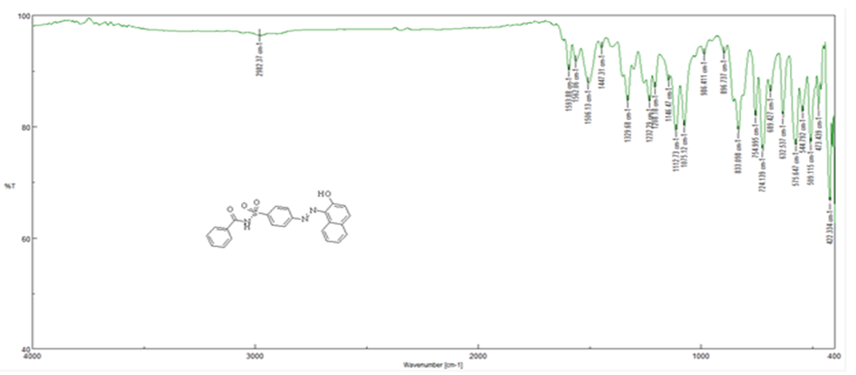

FT-IR (2)

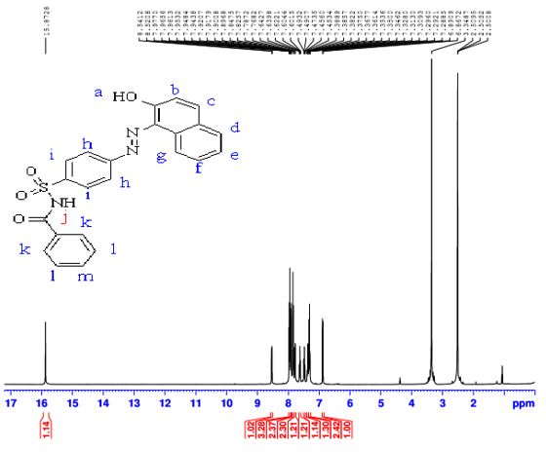

1H NMR (DMSO-d6 400 MHz) (2)

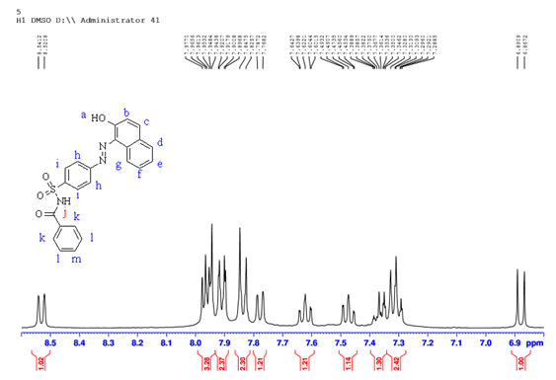

1H NMR (DMSO-d6 400 MHz) (2)

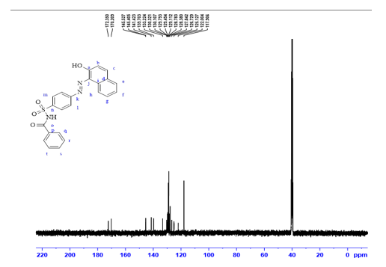

13C NMR (DMSO-d6 100 MHz) (2)

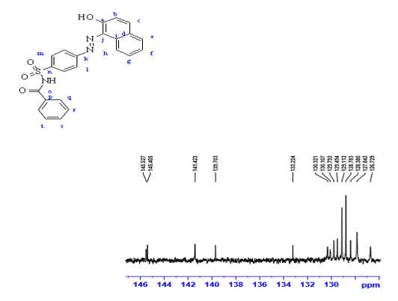

13C NMR (DMSO-d6 100 MHz) (2)

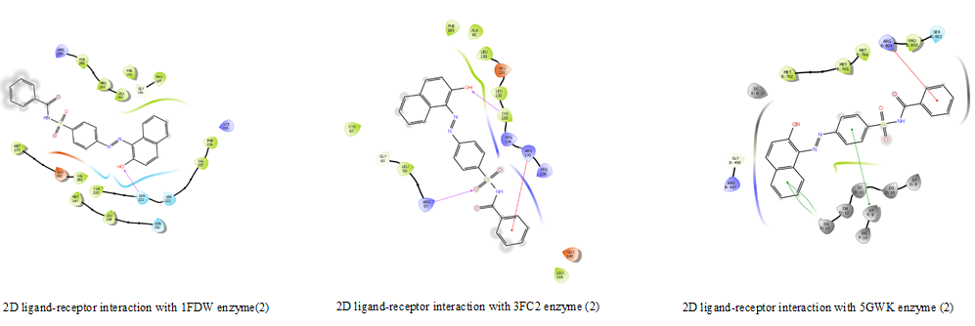

2D ligand-receptor interaction with 1FDW enzyme , 3FC2 enzyme and5GWK enzyme (2)

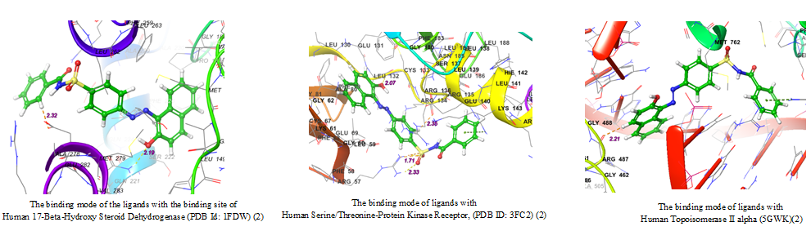

The binding mode of the ligands with the binding site of Human 17-Beta-Hydroxy Steroid Dehydrogenase (PDB Id: 1FDW), Serine/Threonine-Protein Kinase Receptor, (PDB ID: 3FC2) and Topoisomerase II alpha (5GWK) (2)

*MTT assay data* (2)

*(E)-N-((4-((2-hydroxynaphthalen-1-yl)diazenyl)phenyl)sulfonyl)-5-methylisoxazole-3-carboxamide* ***(3)***

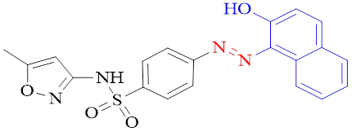

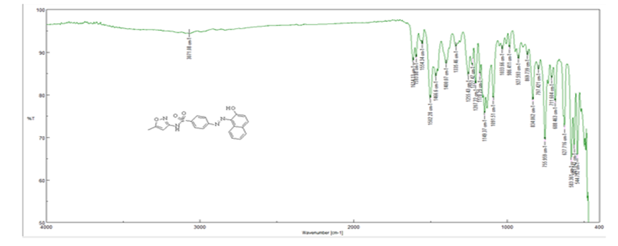

FT-IR (3)

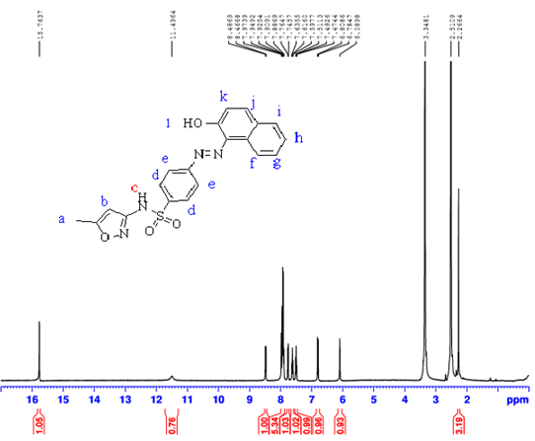

1H NMR (DMSO-d6 400 MHz) (3)

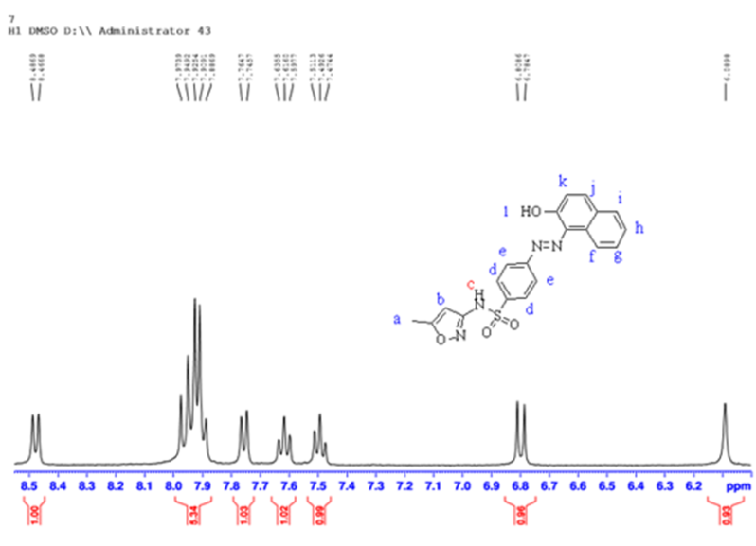

1H NMR (DMSO-d6 400 MHz) (3)

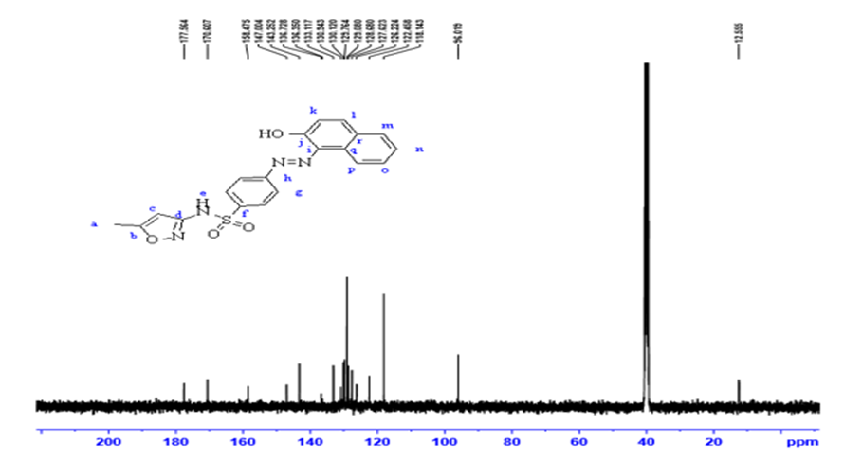

13C NMR (DMSO-d6 100 MHz) (3)

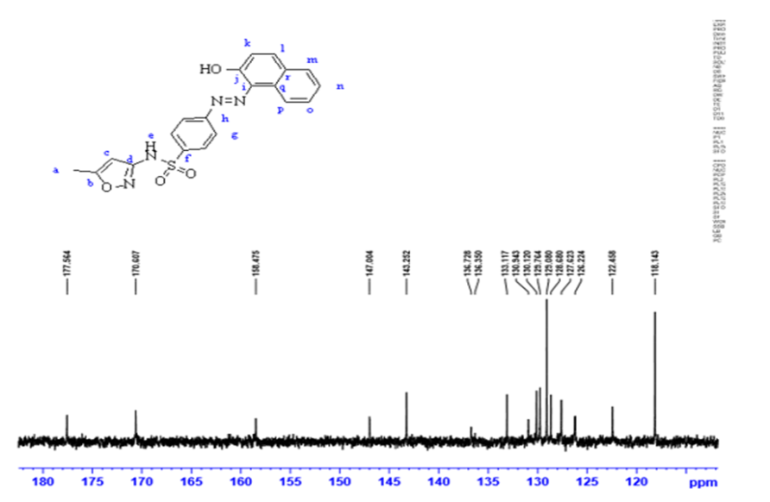

13C NMR (DMSO-d6 100 MHz) (3)

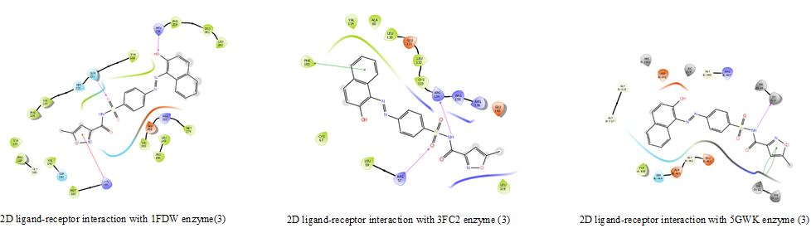

2D ligand-receptor interaction with 1FDW enzyme , 3FC2 enzyme and5GWK enzyme (3)

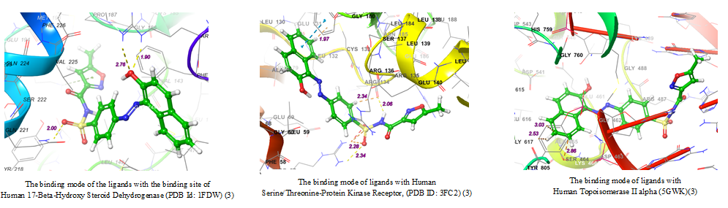

The binding mode of the ligands with the binding site of Human 17-Beta-Hydroxy Steroid Dehydrogenase (PDB Id: 1FDW), Serine/Threonine-Protein Kinase Receptor, (PDB ID: 3FC2) and Topoisomerase II alpha (5GWK) (3)

*MTT assay data* (3)

*(E)-N-((4-((2-hydroxynaphthalen-1-yl)diazenyl)phenyl)sulfonyl)thiazole-2-carboxamide* ***(4)***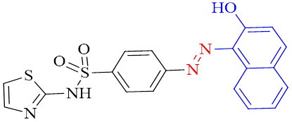

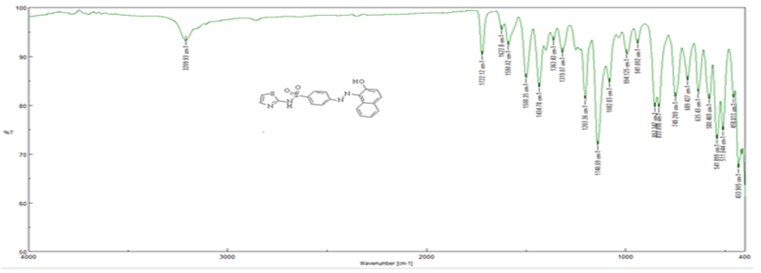

FT-IR (4)

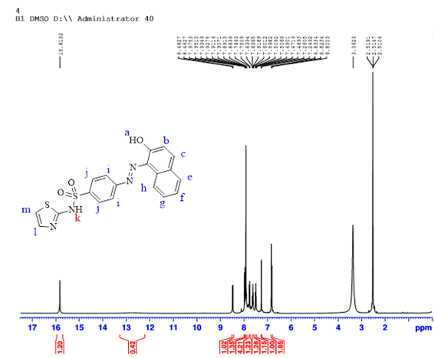

1H NMR (DMSO-d6 400 MHz) (4)

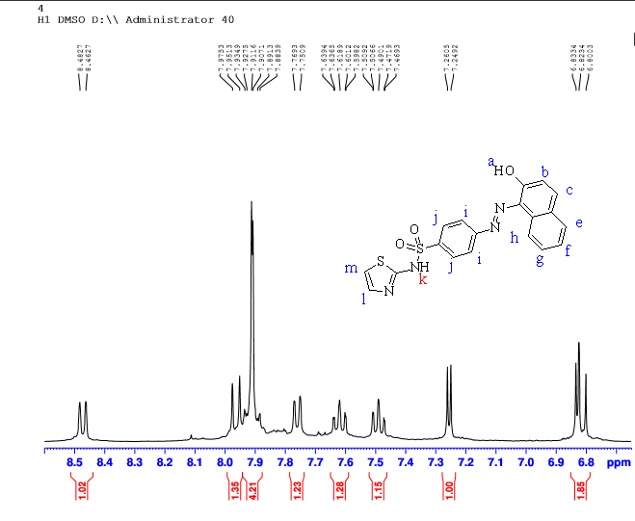

1H NMR (DMSO-d6 400 MHz) (4)

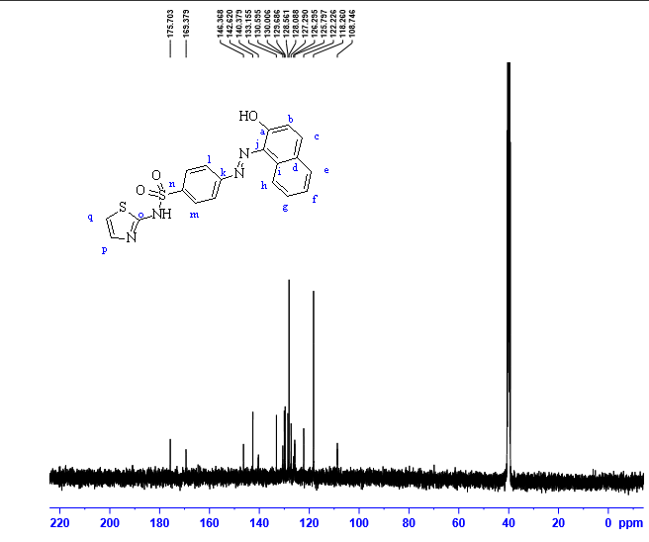

13C NMR (DMSO-d6 100 MHz) (4)

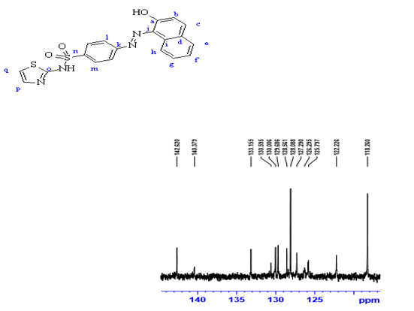

13C NMR (DMSO-d6 100 MHz) (4)

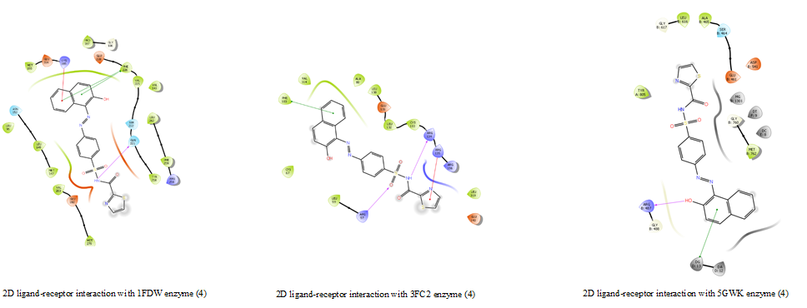

2D ligand-receptor interaction with 1FDW enzyme , 3FC2 enzyme and5GWK enzyme (4)

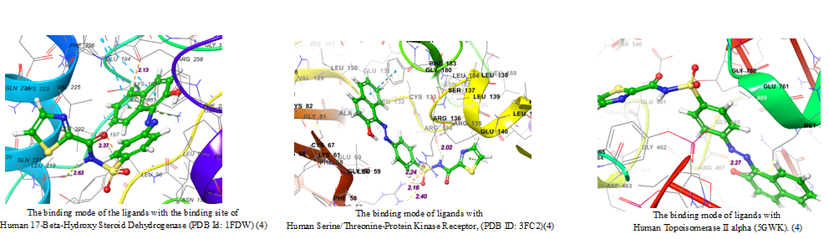

The binding mode of the ligands with the binding site of Human 17-Beta-Hydroxy Steroid Dehydrogenase (PDB Id: 1FDW), Serine/Threonine-Protein Kinase Receptor, (PDB ID: 3FC2) and Topoisomerase II alpha (5GWK) (4)

*MTT assay data* (4)

*(E)-N-((4-((3-formyl-4-hydroxyphenyl)diazenyl)phenyl)sulfonyl)benzamide* ***(5)***



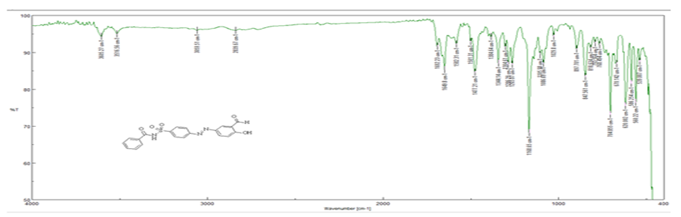

FT-IR (5)

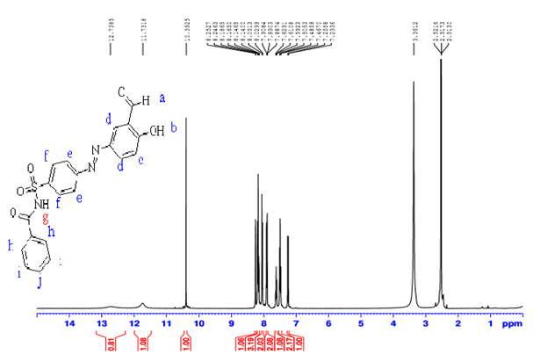

1H NMR (DMSO-d6 400 MHz) (5)

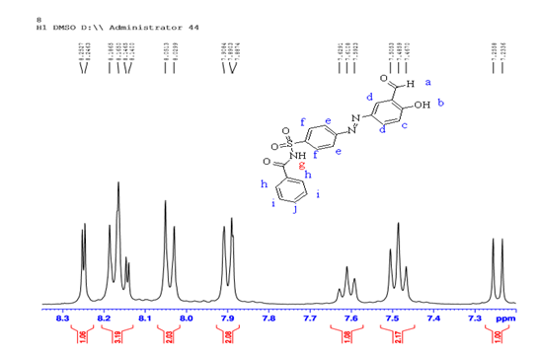

1H NMR (DMSO-d6 400 MHz) (5)

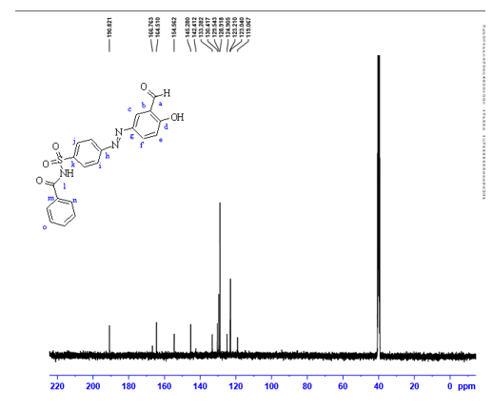

13C NMR (DMSO-d6 100 MHz) (5)

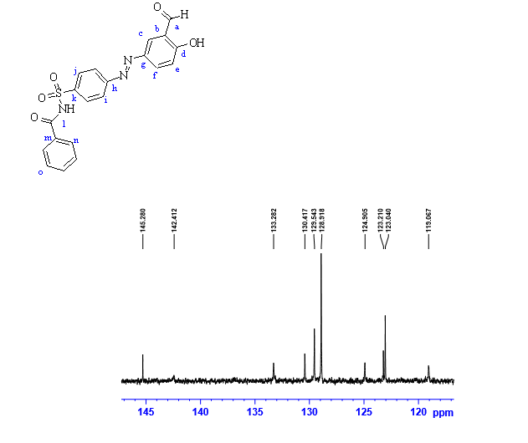

13C NMR (DMSO-d6 100 MHz) (5)

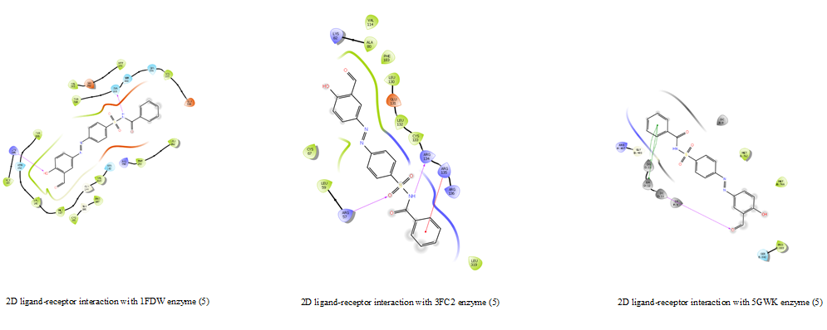

2D ligand-receptor interaction with 1FDW enzyme , 3FC2 enzyme and5GWK enzyme (5)

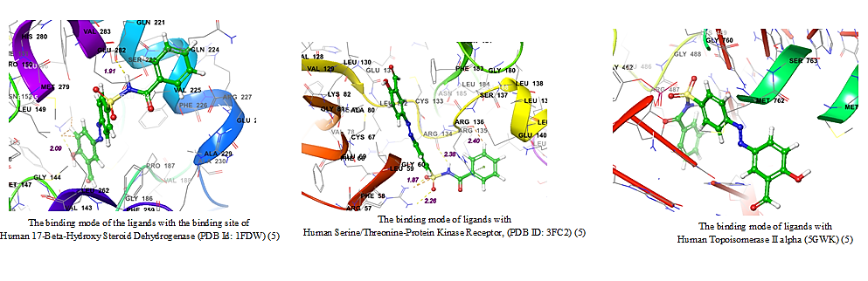

The binding mode of the ligands with the binding site of Human 17-Beta-Hydroxy Steroid Dehydrogenase (PDB Id: 1FDW), Serine/Threonine-Protein Kinase Receptor, (PDB ID: 3FC2) and Topoisomerase II alpha (5GWK) (5)

*MTT assay data* (5)

*(E)-N-((4-((3-formyl-4-hydroxyphenyl)diazenyl)phenyl)sulfonyl)-5-methylisoxazole-3-carboxamide* ***(6)***



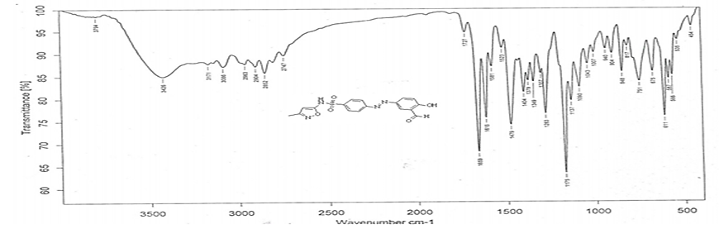

FT-IR (6)

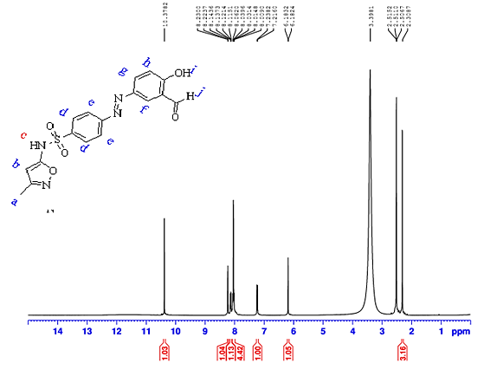

1H NMR (DMSO-d6 400 MHz) (6)

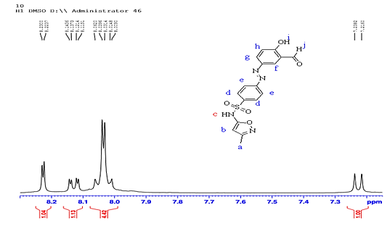

1H NMR (DMSO-d6 400 MHz) (6)

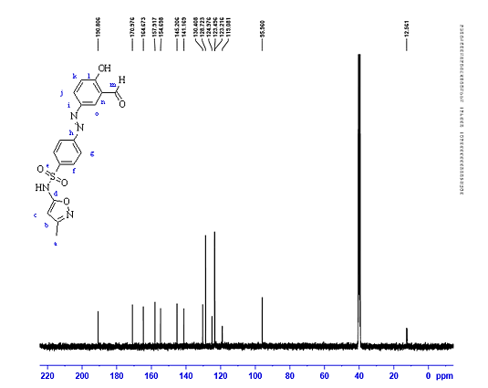

13C NMR (DMSO-d6 125 MHz) (6)

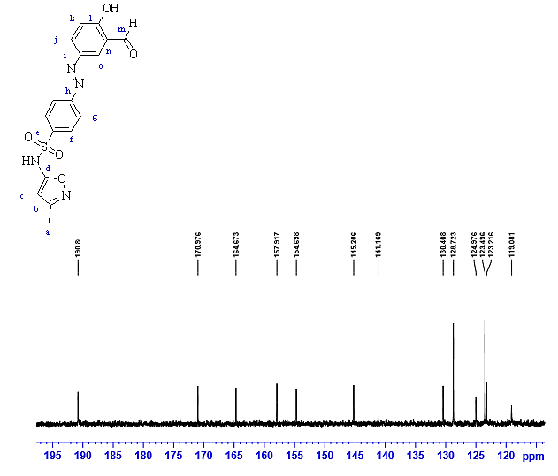

13C NMR (DMSO-d6 100 MHz) (6)

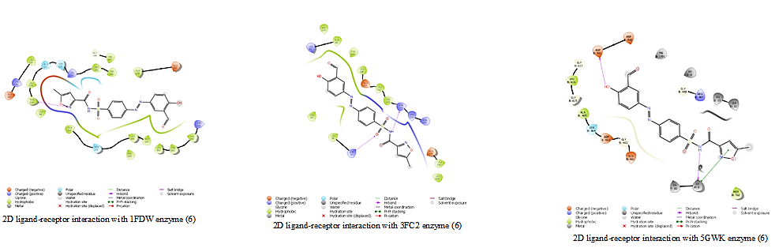

2D ligand-receptor interaction with 1FDW enzyme, 3FC2 enzyme and5GWK enzyme (6)

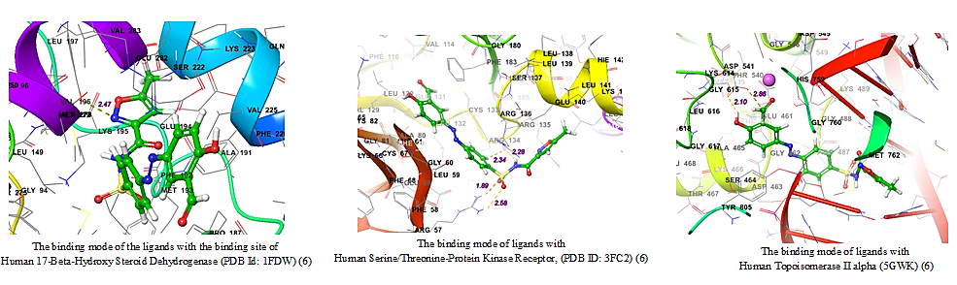

The binding mode of the ligands with the binding site of Human 17-Beta-Hydroxy Steroid Dehydrogenase (PDB Id: 1FDW), Serine/Threonine-Protein Kinase Receptor, (PDB ID: 3FC2) and Topoisomerase II alpha (5GWK) (6)

*MTT assay data* (6)