**(Supporting Information)**

**In-situ Manipulation of Gel Layer Fouling into Gel Layer Membrane Formation on Porous Supports for Water Treatment**

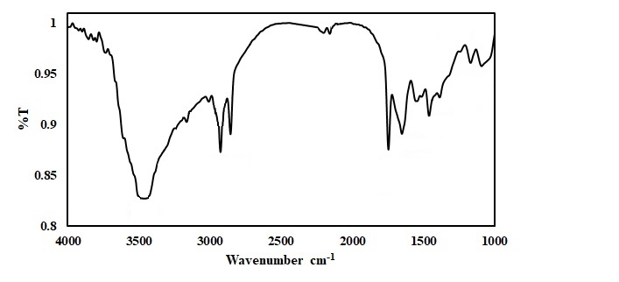

Fig S1. IR spectra of (dried) EPS after ethanol extraction.

Several transmittance peaks are observed. The characteristic peaks of EPS mainly appeared in the region of 1700 cm−1 and 1000 cm−1. The peak at 3413 cm−1 corresponds to O−H stretching while the peak at 2925 cm−1 is attributed to C−H stretching. The peak at 1700 cm−1 belongs to the carbonyl of COOH groups which may be due to the presence of PS and PN. The peaks between 1400 cm−1 to 1650 cm−1 indicate the presence of amide groups from PN. Stretching of C-O-C and C-H at around 1000 cm−1 to 1300 cm−1 is due to the presence of either PS or nucleic acids. Also, there are some minor peaks at around 1300, 1250, and 1150 cm−1, which are attributed to S−O stretching, N−H bending and C−N stretching vibrations, P=O stretching, respectively.

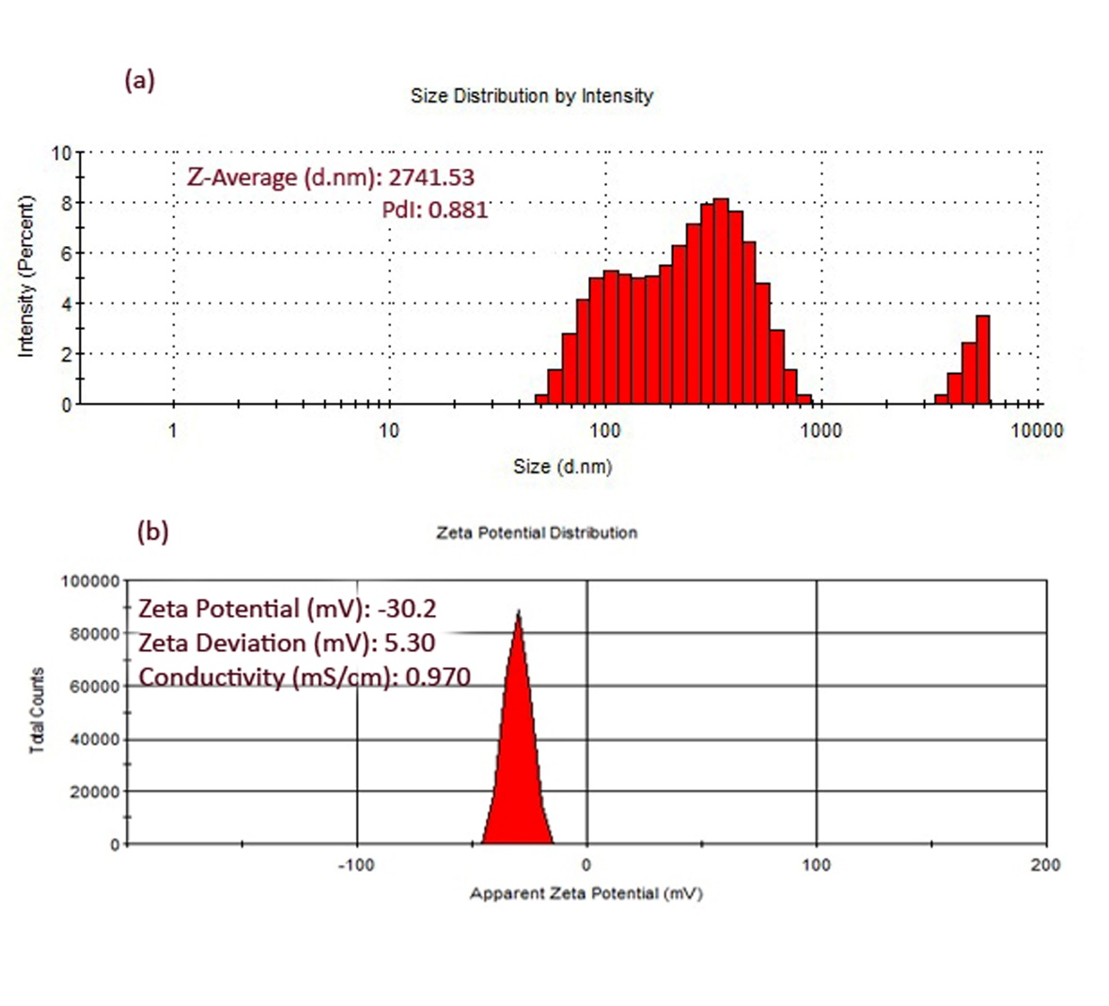

Fig S2. (a) Size distributions in aerobic supernatant (size vs % intensity). (b) Zeta potential distrubution of EPS

The obtained zeta size results indicate that the size of the aerobic supernatant is around 100 to 1000 d.nm. A small peak between 1000 to 10,000 d.nm is raised due to either flocculation or coagulation. This is because of the presence of bivalent metal ions in the feed solution.

Furthermore, the zeta potential of a saturated solution of separated EPS in Milli Q water also reveals that the EPS have a net negative charge. This is interesting as it strongly supports the charge repulsion effect of the GLM to the incomming EPS as an explanation of antifouling behavior.

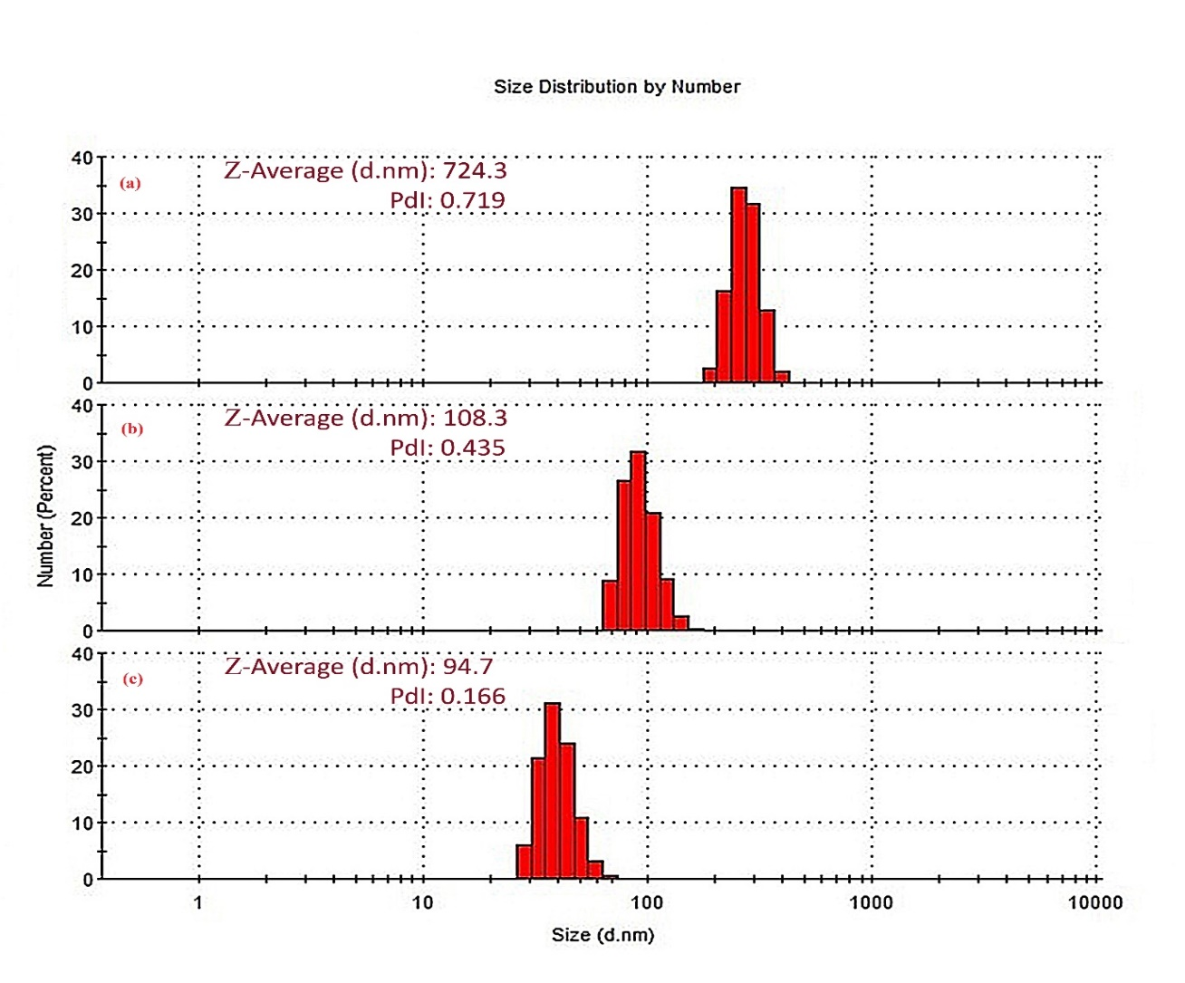

Fig. S3. Particle size distribution (PDS) of; (a) permeate of 0.45 µm MCE filter (the feed), (b) permeate of 0.2 µm PVDF membrane, (c) permeate of GLM.

Fig. S4. (a), (b) AFM pictures (top view) of original PVDF 0.1 µm membrane (left) and after filtration of 0.45 µm supernatant filtrate i.e. (c), (d) top view of the gel layer (right)

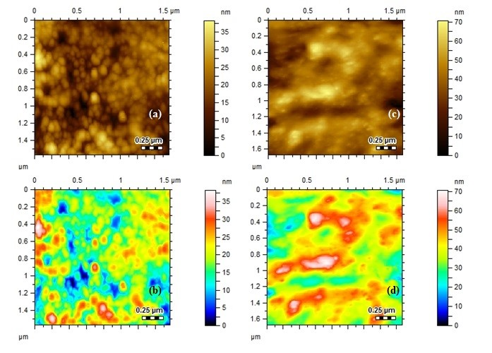

Fig. S4. (a), (b) AFM pictures (top view) of original PVDF 0.1 µm membrane (left) and after filtration of 0.45 µm supernatant filtrate i.e. (c), (d) top view of the gel layer (right)

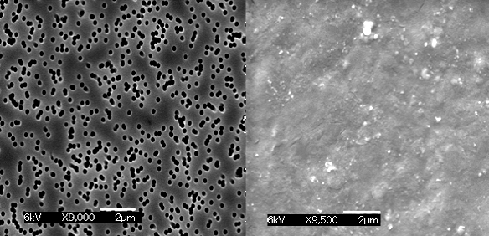

Figure. S5**:** SEM pictures (top view) of original PC 0.2 µm membrane (left) and after filtration of 0.45 µm supernatant filtrate (right), i.e. top view of the gel layer.

Fig. S6. Flux profile of PVDF membrane: (blue squares) pure Milli-Q water flux profile before gel layer coating by the filtrate of 0.45 µm filter, (red squares) flux profile during the gel layer coating by the filtrate of 0.45 µm filter, (green triangles) Milli-Q water flux profile after the gel layer coating by the filtrate of 0.45 µm filter.

**Time (hr)**

**Flux (L/m2.hr)**

Fig. S7. Flux profile of PVDF membrane: (blue squares) pure Milli-Q water flux profile before gel layer coating by the supernatant filtrate of 0.45 µm filter, (red squares) flux profile during the gel layer coating by the supernatant filtrate of 0.45 µm filter, (green triangle) second time filtration of 0.45 µm supernatant filtrate on already formed gel layer (purple cross) Milli-Q water flux profile after the second time filtration of 0.45 µm supernatant filtrate.

Fig. S8. Flux profile of PVDF membrane: (blue squares) pure Milli-Q water flux profile of original 0.2 µm PVDF membrane, (red squares) flux profile during the gel layer coating by the filtrate of 0.45 µm supernatant, (green triangles) Milli-Q water flux profile immediately after the gel layer coating by the filtrate of 0.45 µm supernatant. (Orange circles) Milli-Q water flux after drying the gel layer formed after filtration of 0.45 µm supernatant filtrate.

**Flux (L/m2.hrs)**

**Time (hr)**

Fig. S9. Flux profile of PVDF membrane: (red squares) flux profile during the gel layer coating by the filtrate of 0.45 µm supernatant, (green triangles) Milli-Q water flux profile after the gel layer coating by the filtrate of 0.45 µm supernatant. (Light purple squares) flux profile of whole aerobic supernatant filtration through 0.2 µm PVDF membrane, (black crosses) Milli-Q water flux immediately after filtration of the whole supernatant.

Fig. S10: (vertical lines) flux during the gel layer coating by the filtrate of 0.45 µm supernatant, (dots) the flux of whole aerobic supernatant filtration through 0.2 µm PVDF membrane, (flat lines) Milli-Q water flux immediately after filtration of the whole supernatant.

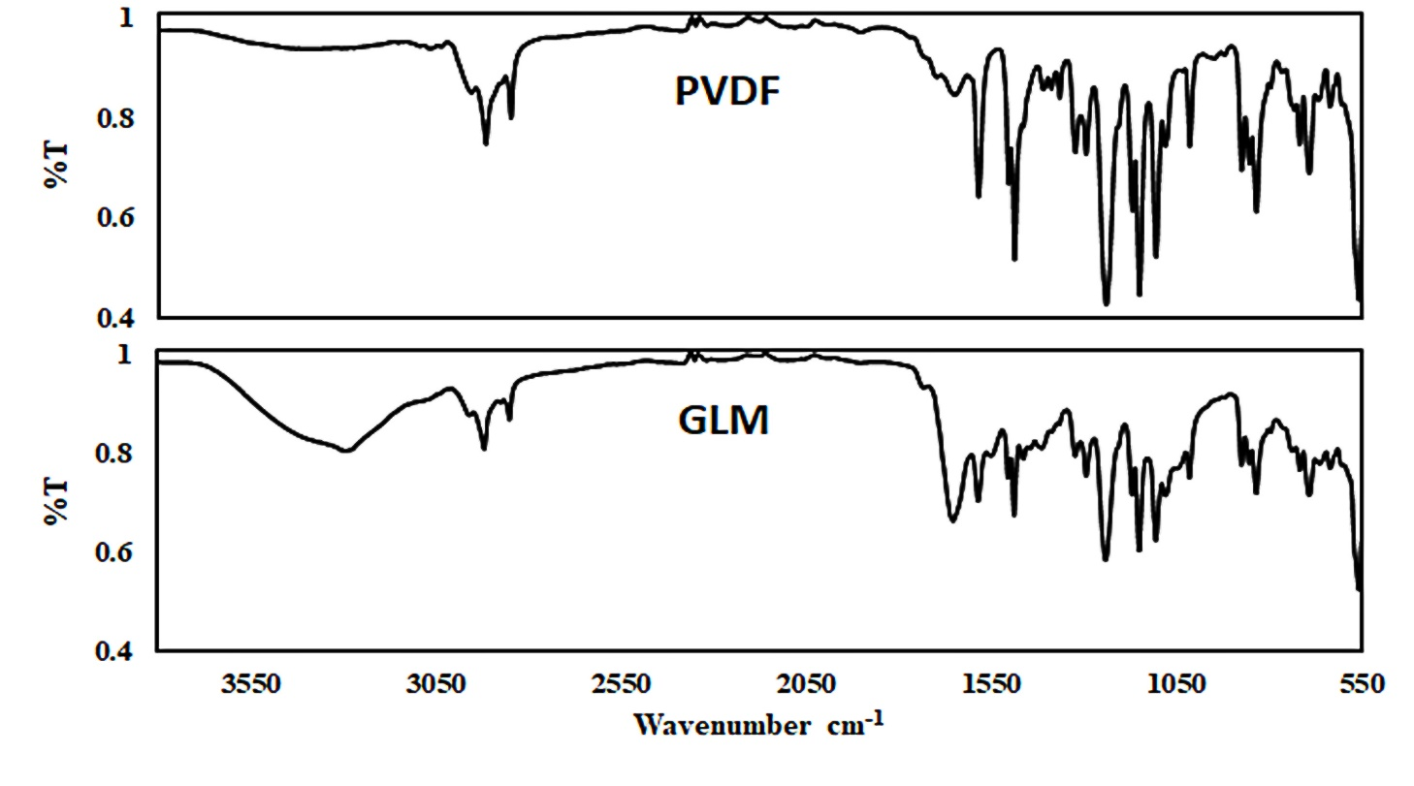

Amide

C-O-C

COOH

-NH

OH

Fig S11. IR spectra Original PVDF filter Vs GLM membrane.

Since the chemistry of the Original PVDF membrane and the support of the GLM are the same, therefore most of the peaks are the same however some additional peaks of the GLM corresponding to the characteristic hydrophilic groups of the EPS/gel layer appear in expected regions i.e. a broad peak at 3550-3150 cm−1 is corresponding to O−H stretching and also may be overlapped with the peak associated with intermolecular H-bonding. Peak around 1600 cm−1 corresponding to the carbonyl of COOH. Peaks around 1000 to 1100 cm−1 may correspond to C-O-C stretchings. Also, there are some minor peaks at around 1300, 1250, and 1150 cm−1, which are attributed to S−O stretching, N−H bending and C−N stretching vibrations, P=O stretching, respectively. All these peaks originate due to the presence of PS, PN, and some nuclic acids in the EPS/gel layer of the GLM as expected.