SUPPORTING INFORMATION
Synthesis, in-vivo anti-diabetic& anticancer activities and molecular modelling studies of tetrahydrobenzo[d]thiazole tethered nicotinohydrazide derivatives
Suri Babu P¹, Visveswara Rao P^{2,3}, Amruthavalli A⁴, Hari babu B^{1*}
1. Detailed Experimental work
Chemistry of Synthesized Compounds
Preparation of 2, 2, 5, 5-tetramethylcyclohexane-1,3-dione (2)
To a solution of 5,5-dimethylcyclohexane-1,3-dione 1 (300 g, 2142 mmol) in acetonitrile (2.4 L) solvent and added K₂CO₃ (888.0 g, 6428.5 mmol) at 0 ºC and stirred 20 min. Then, to the reaction mass added methyl iodide (760 g, 5357.14 mmol) and heated at 50 ºC for l0 h. The reaction progress was monitored by TLC. After completion of the reaction, the reaction mixture was concentrated, diluted with water, and extracted into ethyl acetate. The combined organic layer was backwashed with water, brine solution, dried over Na₂SO₄ and concentrated below 40 ºC under reduced pressure. The crude product was treated with n-hexane and solid thus precipitated was filtrated to give the title compound 2 (Fig. 1) as a white solid (180.0 g, yield: 50 %).
Fig. 1: Structure of compound 2
Analytical data: Molecular formula: C₁₀H₁₆O₂; M.R: 94-95 ºC; ¹H NMR (400 MHz, DMSO-d6, TMS) δ_{H:} 1.21 (s, 6H,-CH₃), 1.34 (s, 6H,-CH₃), 2.4 (s, 4H-CH₃) ; Mass: m/z 169.2 [M+H] +, +ve ion mode.
Preparation of 3-hydroxy-2,2,5,5-tetramethylcyclohexanone (3)
To a solution of 2 (200 g, 1190.4 mmol) in MeOH (2 L) at room temperature and cooled to 0 ºC followed by added NaBH₄ (16.6 g, 440.4 mmol. 0.3 eq). The reaction mixture was stirred under nitrogen for 5 h at 0 ºC-10 ºC. The reaction progress was monitored by TLC. After completion of the reaction, reaction mixture was quenched with saturated NH₄Cl solution. Then, the solvent was evaporated under reduced pressure and the residue was extracted with EtOAc. The combined organic layer was washed with water, brine solution, dried over Na₂SO₄ and concentrated under vacuum. The crude product obtained was purified by silica column chromatography to give the compound 3 (Fig. 2) as a white solid (121 g. yield: 60 %).
Fig. 2: Structure of compound 3
Analytical data: Molecular formula: C₁₀H₁₈O₂; MR:51-51.8 ºC ; ¹H NMR (400 MHz, DMSO-d6, TMS) δ_{H:} 1.2 (s, 6H,-CH₃), 1.3 (s, 6H,-CH₃), 2.0-2.2 (m, 2H-CH₂), 2.1-2.3 (m, 2H-CH₂), 3.5 (m, 1H-CH), 3.8 (m, 1H-OH); Mass: m/z 171.2 [M+H] +, +ve ion mode.
Preparation of 2,2,5,5-tetramethylcyclohex-3-enone (4)
To a solution of 3 (95 g, 558.82 mmol) in pyridine (300 mL) at room temperature and cooled to 0 ºC followed by addition of POCl₃ (427.5 g, 2794.11 mmol) and stirred at 100 ºC for 3 h. The reaction progress was monitored by TLC. After completion of the reaction, the reaction mixture was cooled to room temperature and poured into crushed ice (highly exothermic) and diluted with diethyl ether. The separated ether layer was neutralized with l N HCl and washed with water, brine solution. The ether layer was dried over Na₂SO₄ and concentrated below 30 ºC in vacuum. The crude product was purified by silica column chromatography using 100% hexane as eluent to give the compound 4 (Fig. 3) as a light green liquid (37 g, 42%).
Fig. 3: Structure of compound 4
Analytical data: Molecular formula: C₁₀H₁₆O; ¹H NMR (400 MHz, DMSO-d6, TMS) δ_{H:} 1.2 (s, 6H,-CH₃), 1.3 (s, 6H,-CH₃), 5.4-5.6 (m, 2H-CH-CH); Mass: m/z 153.1 [M+H] +, +ve ion mode.
Preparation of 2,2,5,5-tetramethylcyclohexanone (5)
The solution of compound 4 (35 g, 30.263 mmol) was poured into ethyl acetate (250 mL) and methanol (250 mL) solvent mixture in Parr shaker vessel. The above solution was purged with nitrogen for l0 min. Prior to the addition 10% Pd/C (10 g) to the reaction mixture was kept under hydrogen atmosphere (60 psi pressure) for 16 h. The reaction progress was monitored by TLC. After completion of the reaction, the reaction mixture was filtered through celite pad and dried over anhydrous Na₂SO₄ and concentrated below 30 ºC in vacuum to give a green liquid 5 (Fig. 4). The crude product was used in the next step without further purification (27 g. yield-76 %).
Fig. 4: Structure of compound 5

Analytical data: Molecular formula: C₁₀H₁₈O; ¹H NMR (400 MHz, DMSO-d6, TMS) δ_{H:} 1.2 (s, 6H,-CH₃), 1.3 (s, 6H,-CH₃), 1.73 (m, 4H-CH₂-CH₂), 2.4 (m, 2H-CH₂); Mass: m/z 155.1 [M+H] ⁺, +ve ion mode.
Preparation of 4,4,7,7-tetramethyl-4,5,6,7-tetrahydrobenzo[d]thiazol-2-amine (6)
To a solution of compound 5 (33 g, 213.9 mmol) in ethanol flowed by taken into a sealed tube and added Iodine (65 g, 256.7 rnmol). Then, reaction mixture was maintained at 60 ºC for 2 h. Reaction mixture was cooled to room temperature. Then, added thiourea (40 g, 525.97 mmol) and maintained at 110 ºC for 12 h. Reaction mixture was cooled to room temperature and poured into cold aqueous NaOH solution and extracted with ethyl acetate. Organic layer was washed with water and brine and dried over anhydrous Na₂SO₄ and concentrated under vacuum to get the crude product. The crude product was purified by silica column chromatography (EtOAc / Pet ether) to give the compound 6 (Fig. 5) as a yellow solid (15.5 g, yield: 34.5%).
Fig. 5: Structure of compound 6

Analytical data: Molecular formula: C₁₁H₁₈N₂S; M.R: 220-224 ºC; ¹H NMR (Fig.1) (400 MHz, DMSO-d₆, TMS) δ_{H:} 1.2-1.3 (d, 12H,-CH₃), 1.6 (s, 4H,-CH₂), 6.6 (s, 2H,-NH); ¹³C NMR (Fig.2) (100 MHz, DMSO-d₆, TMS) δ_{C:} 29.0, 32.9, 33.3, 39.2, 117.9, 146.9, 168.5. ESI-MS (Fig.3): m/z 211 [M+H] ⁺, +ve ion mode.
Preparation of ethyl 6-((4,4,7,7-tetramethyl-4,5,6,7-tetrahydrobenzo[d]thiazol-2-yl)amino)nicotinate (7).
To a solution of compound 6 (10 g, 47.61 mmol) in toluene (100 mL) added ethyl 6-chloronicotinate (8.8 g, 47.619 mmol), Na₂CO₃ (10.6 g, 99.9 mrnol) and Xantphos (1 .4 g, 2.38 mmol) under argon over 10 min. Pd₂(dba)₃ (0.87 g, 0.95 mmol) was added to the reaction mixture and stirred at 110 ºC for 8 h. The reaction mixture was cooled to room temperature and concentrated under vacuum and the residue was poured into water and extracted with dichloromethane. The combined extracts were washed with water and brine solution. The organic layer was dried over anhydrous Na₂SO₄ and concentrated under vacuum. The obtained solid was triturated with diethyl ether/hexane to give the title compound 7 (Fig. 6) (88%) as light brown solid.
Fig. 6: Structure of compound 7

Analytical data: Molecular formula: C₁₉H₂₅N₃O₂S; M.R: 220-224 ºC; Anal. Calc. for C₁₉H₂₅N₃O₂S (359): Found C, 63.47; H, 7.02; N, 11.68; O, 8.90; S, 8.93; Calc: C, 63.48; H, 7.01; N, 11.69; O, 8.90; S, 8.92%. FT IR (KBr) (Fig.4): 1708 (s, s, -CO-) cm⁻¹; ¹H NMR (Fig.5) (400 MHz, DMSO-d6, TMS) δH: 1.2-1.3 (d, 12H,-CH₃), 1.4 (t,3H,-CH3), 1.7 (s, 4H,-CH₂),4.3 (qt, 2H,-CH₂), 7.2 (m, 1H,-Ar-H), 8.2 (m, 1H,-Ar-H) , 8.8 (s, 1H,-Ar-H), 11.5-11.7 (s, 2H,-NH); ¹³C NMR (Fig. 6) (100 MHz, DMSO-d6, TMS) δC: 29.0, 31.7, 32.9, 33.3, 34.9, 35.3, 109.9, 120.6, 126.9, 128.7, 129.8, 134.3, 136.9, 146.9, 147.3, 150.4, 153.7, 156.1, 161.5
. ESI-MS (Fig.7): m/z 360 [M+H] ⁺, +ve ion mode.
Preparation of ethyl 6-((cyclopropylmethyl)(4,4,7,7-tetramethyl-4,5,6,7-tetrahydrobenzo[d]-thiazol-2-yl)amino)nicotinate (8)
To a solution of compound 7 (10 g, 27.85 mmol) in DMF (100 mL) followed by added cesium carbonate (27.2 g, 83.56 mmol) and methyl cyclopropyl bromide (5.8 g, 43.17 mmol) at room temperature. The reaction mixture was maintained at 100 ºC for 3 h. The reaction mixture was cooled to room temperature, poured into water and extracted with ethyl acetate. The organic layer was washed with water and brine solution, dried over anhydrous Na₂SO₄ and concentrated under vacuum to get crude compound. The crude product was purified by silica column chromatography to give the title compound 8 (Fig. 7) (87%) as a light yellow Solid.
Fig. 7: Structure of compound 8
Analytical data: Molecular formula: C₂₃H₃₁N₃O₂S; M.R: 79-82 ºC; Anal. Calc. for C₂₃H₃₁N₃O₂S (413): Found C, 66.78; H, 7.57; N, 10.15; O, 7.73; S, 7.74; Calc: C, 66.79; H, 7.56; N, 10.16; O, 7.74; S, 7.75%. FT IR (KBr) (Fig.8): 1708 (s, s, -CO-) cm⁻¹; ¹H NMR (Fig.9) (400 MHz, CDCl₃, TMS) δ_{H:} 0.5-0.6 (d, 4H,-CH₂), 1.2-1.3 (d, 12H,-CH₃), 1.2 (m, 1H,-CH), 1.4 (t,3H,-CH₃), 1.7 (s, 4H,-CH₂), 4.3 (s, 4H,-CH₂), 7.2 (m, 1H,-Ar-H), 8.2 (m, 1H,-Ar-H) 9.0 (s, 1H,-Ar-H); ¹³C NMR (Fig.10) (100 MHz, CDCl₃, TMS) δ_{C:} 3.9,9.4, 14.346, 29.1, 31.9, 33.5, 33.8, 35.4, 36.0, 51.7, 60.7,76.7, 77.0, 77.3, 108.4, 117.8, 132.9, 138.4, 149.1, 150.7, 155.7, 158.5, 165.5. ESI-MS (Fig.11): m/z 414 [M+H] ⁺, +ve ion mode.

Preparation of 6-(4,5,6,7-tetrahydro-4,4,7,7-tetramethylbenzo[d]thiazol-2-ylamino)pyridine-3-carbohydrazide (9)
To a solution of ethyl ester of carboxylic acid 7 (0.01 mol) in ethanol (100 mL) added hydrazine monohydrate (0.011 mol) and then refluxed the reaction mixture for 2 h. After that the solution was cooled to room temperature and the precipitate formed. Then it was filtered off, dried and recrystallized from ethanol to give the title compound 9 (Fig. 8) (87%) as a off white Solid.
Fig. 8: Structure of compound 9
Analytical data: Molecular formula: C₁₇H₂₃N₅OS; M.R: 287-291 ºC; Anal. Calc. for C₁₇H₂₃N₅OS (345): Found C, 59.11; H, 6.72; N, 20.26; O, 4.64; S, 9.27; Calc: C, 59.10; H, 6.71; N, 20.27; O, 4.63; S, 9.28%. FT-IR (KBr) (Fig. S12): 1708 (s, s, -CO-) cm⁻¹; ¹H NMR (Fig. S13) (400 MHz, CDCl3-d6, TMS) δ_{H}: 1.2-1.3 (d, 12H,-CH₃), 1.4 (t,3H,-CH₃), 1.7 (s, 4H,-CH₂), 7.2 (m, 1H,-Ar-H), 8.2 (m, 1H,-Ar-H) , 8.8 (s, 1H,-Ar-H), 11.5-11.7 (m, 2H,-NH); ¹³C NMR (Fig. S14) (100 MHz, DMSO-d6, TMS) δC: 29.0, 31.7, 32.9, 33.3, 34.9, 35.3, 109.9, 120.6, 126.9, 128.7, 129.8, 134.3, 136.9, 146.9, 147.3, 150.4, 153.7, 156.1, 161.5. ESI-MS (Fig. S15): m/z 346 [M+H] ⁺, +ve ion mode.
Preparation of 6-(N-(cyclopropylmethyl)-N-(4,5,6,7-tetrahydro-4,4,7,7-tetramethylbenzo[d]-thiazol-2-yl)amino)pyridine-3-carbohydrazide (10)
To a solution of ethyl ester of carboxylic acid 8 (0.01 mol) in ethanol (100 mL) added hydrazine monohydrate (0.011 mol) then refluxed the reaction mixture for 2 h. After that the solution was cooled to room temperature and the precipitate formed was then filtered off, dried and recrystallized from ethanol to give the title compound 10 (Fig. 9) (89%) as a white Solid.
Fig. 9: Structure of compound 10

Analytical data: Molecular formula: C₂₁H₂₉N₅OS; M.R: 146-150ºC; Anal. Calc. for C₂₁H₂₉N₅OS (399): Found C, 63.14; H, 7.33; N, 17.52; O, 4.01; S, 8.04; Calc: C, 63.13; H, 7.32; N, 17.53; O, 4.00; S, 8.03 %. FT-IR (KBr) (Fig. S16): 1708 (s, s, -CO-) cm⁻¹; ¹H NMR (Fig. S17) (400 MHz, CDCl₃, TMS) δ_{H:} 0.5-0.6 (d, 4H,-CH₂), 1.2-1.3 (d, 12H,-CH₃), 1.2 (m, 1H,-CH), 1.4 (t, 3H,-CH3), 1.7 (s, 4H,-CH₂), 4.0-4.2 (br, 2H,-NH₂), 4.3 (s, 2H,-CH₂), 7.2 (m, 1H,-Ar-H), 7.7.5-7.7 (br, 1H-NH), 8.2 (m, 1H,-Ar-H) 8.8 (s, 1H,-Ar-H); ¹³C NMR (Fig. S18) (100 MHz, CDCl₃, TMS) δ_{C:} 3.9,9.4, 29.1, 31.9, 33.5, 33.8, 35.4, 36.0, 51.7, 60.7,76.7, 77.0, 77.3, 108.4, 119.6, 132.8, 136.5, 145.5, 150.7, 155.7, 158.5, 167.0. ESI-MS (Fig. S19): m/z, 400 [M+H] ⁺, +ve ion mode.

Series-I
General experimental procedure for the synthesis of compounds 11(a-o)
To a solution of carboxylic acid hydrazides (9) were dissolved in 10–20 mL of ethanol and then 0.011 mol of aldehyde (a-o) was added. The mixture was heated under reflux for 3-6 h. After that the solution was allowed to cool at room temperature and filtered off and recrystallized from ethanol (yield: 65-80%).
6-(4,5,6,7-tetrahydro-4,4,7,7-tetramethylbenzo[d]thiazol-2-ylamino)-N'-benzylidenepyridine-3-carbohydrazide (11a)
To a solution of carboxylic acid hydrazide 9 (200 mg, 0.579 mmol) in ethanol (10 mL) benzaldhyde (73.8 mg, 0.69 mmol) was added. The reaction mixture was heated under reflux temperature for 3h. The reaction completion was indicated by TLC analysis. After that the solution was allowed to cool at room temperature and the precipitated solid was filtered, Wet compound recrystallized in ethanol (5 ml) and dried under vacuum to obtain corresponding hydrazone derivative 11a (Fig. 10) (194 mg, 77%) as a off white solid .
Fig. 10: Structure of compound 11a
Analytical data: Molecular formula: C₂₄H₂₇N₅OS; M.R: 240-244 ºC; Anal. Calc. for C₂₄H₂₇N₅OS (433) Found C, 66.45; H, 6.26; N, 16.14; O, 3.67; S, 7.39; Calc: C, 66.48; H, 6.28; N, 16.15; O, 3.69; S, 7.40%. FT-IR (KBr) (Fig. S20):1673.04 (-C=O str), 3229.02 (-NH str) cm-1; ¹H NMR (Fig. S21) (400 MHz, DMSO-d₆, TMS) δ_{H:} 1.2-1.3 (d, 12H,-CH₃), 1.7 (s, 4H,-CH₂), 7.0-8.9 (m, 9H,-Ar-H), 11.5-11.7 (s, 2H,-NH); ¹³C NMR (Fig. S22) (100 MHz, DMSO-d₆, TMS) δ_{C:} 29.0, 31.7, 32.9, 33.3, 34.9, 35.3, 109.9, 120.6, 126.9, 128.7, 129.8, 134.3, 136.9, 146.9, 147.3, 150.4, 153.7, 156.1, 161.5. ESI-MS (Fig. S23): m/z 434.1 [M+H]⁺, +ve ion mode.

N'-(2-fluorobenzylidene)-6-(4,5,6,7-tetrahydro-4,4,7,7-tetramethylbenzo[d]thiazol-2-ylamino)pyridine-3-carbohydrazide (11b)
Following the general procedure, treatment of carboxylic acid hydrazide 9 (200 mg, 0.579 mmol) with 2-fluoro benzaldehyde (86.3 mg, 0.69 mmol) in Ethanol (10 mL) for 3 h, After that the solution was allowed to cool at room temperature and the precipitated solid was filtered, Wet compound recrystallized in ethanol (5 ml) and dried under vacuum to obtain corresponding hydrazone derivative 11b (Fig. 11) (177 mg, 68%) as a Pale brown solid.

Fig. 11: Structure of compound 11b
Analytical data: Molecular formula: C₂₄H₂₆FN₅OS; M.R: 254-258°C; Anal. Calc. for C₂₄H₂₆FN₅OS (451) Found C, 63.84; H, 5.81; F, 4.22; N, 15.51; O, 3.55; S, 7.11; Calc: C, 63.84; H, 5.80; F, 4.21; N, 15.51; O, 3.54; S, 7.10 %. FT-IR (KBr) (Fig. S24):1645.78 (-C=O str), 3268.32 (-NH str) cm⁻¹; ¹H NMR (Fig. S25) (400 MHz, DMSO-d6, TMS) δ_{H:} 1.0-1.3 (d, 12H,-CH₃), 1.7 (s, 4H,-CH₂), 7.0-8.8 (m, 8H,-Ar-H), 11.5-11.9 (s, 2H,-NH); ¹³C NMR (Fig. S26) (100 MHz, DMSO-d₆, TMS) δ_{C:} 28.9, 31.6, 32.9, 33.3, 34.9, 35.3, 109.9, 115.8,116.0, 120.4, 121.7, 121.8, 124.8, 126.2, 129.9, 131.8, 136.9, 146.9, 150.4, 153.7, 156.0, 159.4, 161.4, 161.9; ESI-MS (Fig. S27): m/z 452.1 [M+H]⁺, +ve ion mode.

N'-(3,4-difluorobenzylidene)-6-(4,5,6,7-tetrahydro-4,4,7,7-tetramethylbenzo[d]thiazol-2-ylamino)pyridine-3-carbohydrazide (11c)
Following the general procedure, treatment of carboxylic acid hydrazide 9 (200 mg, 0.579 mmol) with 3,4-Difluoro benzaldehyde (98.8 mg, 0.69 mmol) in ethanol (10 mL) for 4.5 h, After that the solution was allowed to cool at room temperature and the precipitated solid was filtered ,wet compound recrystallized in ethanol (5 ml) and dried under vacuum to obtain corresponding hydrazone derivative 11c (Fig. 12) (182 mg, 67%) as a off white solid.
Fig. 12: Structure of compound 11c
Analytical data: Molecular formula: C₂₄H₂₅F₂N₅OS; M.R: 309-312ºC; Anal. Calc. for C₂₄H₂₅F₂N₅OS (469) Found C, 61.40; H, 5.38; F, 8.10; N, 14.91; O, 3.42; S, 6.84; Calc: C, 61.39; H, 5.37; F, 8.09; N, 14.92; O, 3.41; S, 6.83%. FT IR (KBr) (Fig. S28):1674.83 (-C=O str), 3252.49 (-NH str) cm-1; ¹H NMR (Fig. S29) (400 MHz, DMSO-d₆, TMS) δ_{H:} 1.0-1.3 (d, 12H,-CH₃), 1.7 (s, 4H,-CH₂), 7.0-8.8 (m, 7H,-Ar-H), 11.5-11.9 (s, 2H,-NH); ¹³C NMR (Fig. S30) (100 MHz, DMSO-d₆, TMS) δ_{C:} 28.9, 31.6, 32.9, 33.3, 34.9, 35.3, 109.9, 115.1, 115.1, 117.8, 118.0, 120.4, 124.1, 129.8, 132.1, 136.9, 144.9, 146.9, 148.4, 148.5, 150.4, 150.9, 151.0, 151.5, 153.7, 156.1, 161.5, ESI-MS (Fig. S31): m/z 470.1 [M+H]⁺, +ve ion mode.

6-(4,5,6,7-tetrahydro-4,4,7,7-tetramethylbenzo[d]thiazol-2-ylamino)-N'-(4-fluorobenzylidene)-pyridine-3-carbohydrazide (11d)
Following the general procedure, treatment of carboxylic acid hydrazide 9 (200 mg, 0.579 mmol) with 4-fluoro benzaldehyde (86.3 mg, 0.69 mmol) in ethanol (10 mL) for 4 h, After that the solution was allowed to cool at room temperature and the precipitated solid was filtered ,wet compound recrystallized in ethanol (5 ml) and dried under vacuum to obtain corresponding hydrazone derivative 11d (Fig. 13) (182 mg, 70%) as a Pale yellow solid.
Fig. 13: Structure of compound 11d
Analytical data: Molecular formula: C₂₄H₂₆FN₅OS; M.R: 262-264ºC; Anal. Calc. for C₂₄H₂₆FN₅OS (451): Found C, 63.85; H, 5.81; F, 4.22; N, 15.50; O, 3.55; S, 7.11; Calc: C, 63.84; H, 5.80; F, 4.21; N, 15.51; O, 3.54; S, 7.10 %. FT-IR (KBr) (Fig. S32): 1645.78 (-C=O str), 3268.32 (-NH str) cm-1; ¹H NMR (Fig. S33) (400 MHz, DMSO-d₆, TMS) δ_{H:} 1.2-1.3 (d, 12H,-CH₃), 1.7 (s, 4H,-CH₂), 7.0-8.8 (m, 8H,-Ar-H), 11.5-11.7 (s, 2H,-NH); ¹³C NMR (Fig. S34) (100 MHz, DMSO-d₆, TMS) δ_{C:} 28.9, 31.6, 32.9, 33.3, 34.9, 35.3, 109.9, 115.4, 115.7, 115.9, 120.5, 129.0, 129.8, 130.9, 131.9, 132.0, 136.9, 146.1, 146.8, 150.4, 153.7, 156.1, 161.4, 161.7,164.2,166.3; ESI-MS (Fig. S35): m/z 452.1 [M+H]⁺, +ve ion mode.

N'-(2,5-difluorobenzylidene)-6-(4,5,6,7-tetrahydro-4,4,7,7-tetramethylbenzo[d]thiazol-2-ylamino)-pyridine-3-carbohydrazide (11e)
Following the general procedure, treatment of carboxylic acid hydrazide 9 (200 mg, 0.579 mmol) with 2,5-difluorobenzaldehyde (98.0 mg, 0.69 mmol) in ethanol (10 mL) for 2.5 h , After that the solution was allowed to cool at room temperature and the precipitated solid was filtered, wet compound recrystallized in ethanol (5 ml) and dried under vacuum to obtain corresponding hydrazone derivative 11e (Fig. 14) (182 mg, 69%) as a Pale yellow solid.
Fig. 14: Structure of compound 11e
Analytical data: Molecular formula: C₂₄H₂₅F₂N₅OS; M.R: 324-326ºC; Anal. Calc. for C₂₄H₂₅F₂N₅OS (469): Found C, 61.42; H, 5.39; F, 8.09; N, 14.90; O, 3.41; S, 6.85; Calc: C, 61.39; H, 5.37; F, 8.09; N, 14.92; O, 3.41; S, 6.83%. FT-IR (KBr) (Fig. S36): 1674.83 (-C=O str), 3252.49 (-NH str) cm-1; ¹H NMR (Fig. S37) (400 MHz, DMSO-d₆, TMS) δ_{H:} 1.0-1.3 (d, 12H,-CH₃), 1.7 (s, 4H,-CH₂), 7.0-8.8 (m, 7H,-Ar-H), 11.5-12.0 (s, 2H,-NH); ¹³C NMR (Fig. S38) (100 MHz, DMSO-d₆, TMS) δ_{C:} 29.0, 31.6, 32.9, 33.3, 34.9, 35.3, 109.9, 111.5, 111.5,111.7, 117.6, 117.7,117.9, 18.0,118.2,118.4, 118.4, 120.2, 123.3, 123.3, 123.6, 129.9, 136.9, 138.9, 147.0, 150.4, 153.8, 155.6, 156.1, 157.1, 158.0, 161.5, ESI-MS(Fig. S39): m/z 470.1 [M+H]⁺, +ve ion mode.

6-(4,5,6,7-tetrahydro-4,4,7,7-tetramethylbenzo[d]thiazol-2-ylamino)-N'-(4-fluoro-3-methoxy-benzylidene)pyridine-3-carbohydrazide (11f)
Following the general procedure, treatment of carboxylic acid hydrazide 9 (200 mg, 0.579 mmol) with 4-fluoro-3-methoxy benzaldehyde (106.3 mg, 0.69 mmol) in ethanol (10 mL) for 3.5 h , After that the solution was allowed to cool at room temperature and the precipitated solid was filtered ,wet compound recrystallized in ethanol (5 ml) and dried under vacuum to obtain corresponding hydrazone derivative 11f (Fig. 15) (182 mg, 65%) as a Pale yellow solid.
Fig. 15: Structure of compound 11f
Analytical data: Molecular formula: C₂₅H₂₈FN₅O₂S; M.R: 324-326°C; Anal. Calc. for C₂₅H₂₈FN₅O₂S (481): Found C, 62.37; H, 5.88; F, 3.93; N, 14.55; O, 6.62; S, 6.66; Calc: C, 62.35; H, 5.86; F, 3.94; N, 14.54; O, 6.64; S, 6.66 %. FT-IR (KBr) (Fig. S40):1669.45 (-C=O str), 3242.50 (-NH str) cm-1; ¹H NMR (Fig. S41) (400 MHz, DMSO-d6, TMS) δH: 1.2-1.3 (d, 12H,-CH3), 1.7 (s, 4H,-CH2), 3.9 (s, 3H,-OCH3), 6.7-8.8 (m, 7H,-Ar-H), 11.5-11.9 (s, 2H,-NH); ¹³C NMR (Fig. S42) (100 MHz, DMSO-d6, TMS) δ_{C:} 28.9, 31.6, 32.9, 33.3, 34.9, 35.3, 55.9, 110.1, 110.8, 116.0, 116.2, 120.7, 129.8, 129.9, 131.3, 135.9, 137.0, 146.5, 146.8, 147.4, 147.5, 149.8, 151.4, 153.8, 156.4,161.4, ESI-MS (Fig.43): m/z 482.2 [M+H]⁺, +ve ion mode.

6-(4,5,6,7-tetrahydro-4,4,7,7-tetramethylbenzo[d]thiazol-2-ylamino)-N'-(5-fluoro-2-nitro-benzylidene)pyridine-3-carbohydrazide (11g)
Following the general procedure, treatment of carboxylic acid hydrazide 9 (200 mg, 0.579 mmol) with 5-fluoro-2-nitrobenzaldehyde (116.7 mg, 0.69 mmol) in ethanol (10 mL) for 4 h, After that the solution was allowed to cool at room temperature and the precipitated solid was filtered ,wet compound recrystallized in ethanol (5 ml) and dried under vacuum to obtain corresponding hydrazone derivative 11g (Fig. 16) (198 mg, 69%) as a yellow solid.
Fig. 16: Structure of compound 11g
Analytical data: Molecular formula: C₂₄H₂₅FN₆O₃S; M.R: 333-335ºC; Anal. Calc. for C₂₄H₂₅FN₆O₃S (496): Found C, 58.08; H, 5.05; F, 3.85; N, 16.91; O, 9.66; S, 6.47; Calc: C, 58.05; H, 5.07; F, 3.83; N, 16.92; O, 9.67; S, 6.46 %. FT-IR (KBr) (Fig. S44): 1673.81 (-C=O str), 3266.46 (-NH str) cm-1; ¹H NMR (Fig. S45) (400 MHz, DMSO-d6, TMS) δH: 1.0-1.4 (d, 12H,-CH3), 1.7 (s, 4H,-CH2), 7.0-10.3 (m, 7H,-Ar-H), 11.5-12.2 (s, 2H,-NH); ¹³C NMR (Fig. S46) (100 MHz, DMSO-d6, TMS) δC: 28.9, 31.6, 32.9, 33.3, 34.9, 35.3, 109.7, 109.9, 113.6, 113.9, 117.3, 117.5, 120.0, 121.2,128.2, 128.3, 129.6, 129.9, 132.2, 136.3, 137.1, 141.5, 144.4, 146.2, 147.1, 150.3, 150.4, 153.5, 153.8, 156.0, 156.1, 161.7, 162.6, 164.5, 165.1; ESI-MS (Fig. S47): m/z 497.1 [M+H]⁺, +ve ion mode.

6-(4,5,6,7-tetrahydro-4,4,7,7-tetramethylbenzo[d]thiazol-2-ylamino)-N'-(4-fluoro-3-(trifluoro-methyl)benzylidene)pyridine-3-carbohydrazide (11h)
Following the general procedure, treatment of carboxylic acid hydrazide 9 (200 mg, 0.579 mmol) with 4-fluoro-3-(trifluoromethyl)benzaldehyde (132.5 mg, 0.69 mmol) in ethanol (10 mL) for 3.5 h , After that the solution was allowed to cool at room temperature and the precipitated solid was filtered ,wet compound recrystallized in ethanol (8 ml) and dried under vacuum to obtain corresponding hydrazone derivative 11h (Fig. 17) (210 mg, 70%) as a light brown solid.
Fig. 17: Structure of compound 11h
Analytical data: Molecular formula: C₂₅H₂₅F₄N₅OS; M.R: 229-232ºC; Anal. Calc. for C₂₅H₂₅F₄N₅OS (519): Found C, 57.81; H, 4.86; F, 14.65; N, 13.50; O, 3.09; S, 6.18; Calc: C, 57.79; H, 4.85; F, 14.63; N, 13.48; O, 3.08; S, 6.17%. FT-IR (KBr) (Fig. S48): 1646.81 (-C=O str), 3529.08 (-NH str) cm-1; ¹H- NMR (Fig. S49) (400 MHz, DMSO-d₆, TMS) δ_{H:} 1.2-1.3 (d, 12H,-CH₃), 1.7 (s, 4H,-CH₂), 7.0-8.8 (m, 7H,-Ar-H), 11.5-12.0 (s, 2H,-NH); ¹³C NMR (Fig. S50) (100 MHz, DMSO-d₆, TMS) δ_{C:} 28.9, 31.6, 32.9, 33.3, 34.9, 35.3, 110.0, 116.9, 117.1, 117.3, 117.4, 117.7, 117.9, 120.3, 121.0, 123.7, 125.2, 129.9, 131.6, 133.4, 133.5, 137.0, 144.5, 147.0, 150.4, 153.8, 156.1, 158.1, 160.6, 161.7; ESI-MS (Fig.51): m/z, 520 [M+H]⁺, +ve ion mode.

N'-(3-(trifluoromethyl)benzylidene)-6-(4,5,6,7-tetrahydro-4,4,7,7-tetramethylbenzo[d]
thiazol-2-ylamino)pyridine-3-carbohydrazide (11i)
Following the general procedure, treatment of carboxylic acid hydrazide 9 (200 mg, 0.579 mmol) with 3-(trifluoromethyl)benzaldehyde (120.1 mg, 0.69 mmol) in ethanol (10 mL) for 3.5 h, After that the solution was allowed to cool at room temperature and the precipitated solid was filtered ,wet compound recrystallized in ethanol (5 mL) and dried under vacuum to obtain corresponding hydrazone derivative 11i (Fig. 18) (203 mg, 70%) as a light brown solid.
Fig. 18: Structure of compound 11i
Analytical data: Molecular formula: C₂₅H₂₆F₃N₅OS; M.P:128-132ºC; Anal. Calc. for C₂₅H₂₆F₃N₅OS (501): Found C, 59.89; H, 5.25; F, 11.37; N, 13.98; O, 3.21; S, 6.40; Calc: C, 59.87; H, 5.22; F, 11.36; N, 13.96; O, 3.19; S, 6.39 %. FT-IR (KBr) (Fig. S52): 1646.81 (-C=O str), 3529.08 (-NH str) cm-1; ¹H NMR (Fig. S53) (400 MHz, DMSO-d₆, TMS) δ_{H:} 1.2-1.3 (d, 12H,-CH₃), 1.7 (s, 4H,-CH₂), 7.0-8.8 (m, 8H,-Ar-H), 11.5-11.9 (s, 2H,-NH); ¹³C NMR (Fig. S54) (100 MHz, DMSO-d₆, TMS) δ_{C:} 29.0, 31.7, 32.9, 33.3, 34.9, 35.3, 110.0, 120.3, 122.6, 122.9, 125.3, 125.4, 125.4, 126.1, 128.0, 129.3, 129.4, 129.7, 129.9, 130.0, 130.4, 130.6, 130.9, 131.9, 132.8, 133.1, 133.5, 136.7, 137.0, 145.4, 147.0, 150.4, 153.8, 156.1, 161.6, 165.9; ESI-MS (Fig.55): m/z, 502.1 [M+H]⁺, +ve ion mode.

N'-(2-nitrobenzylidene)-6-(4,5,6,7-tetrahydro-4,4,7,7-tetramethylbenzo[d]thiazol-2-ylamino)-pyridine-3-carbohydrazide (11j)

Following the general procedure, treatment of carboxylic acid hydrazide 9 (200 mg, 0.579 mmol) with 2-nitrobenzaldehyde (104.2 mg, 0.69 mmol) in ethanol (10 mL) for 2.5 h , After that the solution was allowed to cool at room temperature and the precipitated solid was filtered, wet compound recrystallized in ethanol (5 mL) and dried under vacuum to obtain corresponding hydrazone derivative 11j (Fig. 19) (182.7 mg, 66%) as a yellow solid.
Fig. 19: Structure of compound 11j
Analytical data: Molecular formula: C₂₄H₂₆N₆O₃S; M.R: 280-284 ºC; Anal. Calc. for C₂₄H₂₆N₆O₃S (478): Found C, 60.25; H, 5.47; N, 17.57; O, 10.05; S, 6.73; Calc: C, 60.23; H, 5.48; N, 17.56; O, 10.03; S, 6.70%. FT-IR (KBr) (Fig. S56): 1673.81 (-C=O str), 3266.46 (-NH str) cm-1; ¹H NMR (Fig. S57) (400 MHz, DMSO-d₆, TMS) δ_{H:} 1.2-1.3 (d, 12H,-CH₃), 1.7 (s, 4H,-CH₂), 7.0-8.8 (m, 8H,-Ar-H), 11.5-12.1 (s, 2H,-NH); ¹³C NMR (Fig. S58) (100 MHz, DMSO-d₆, TMS) δ_{C:} 29.0, 31.7, 32.9, 33.3, 34.9, 35.3, 109.9, 120.2, 124.6, 127.8, 128.6, 129.9, 130.5, 133.6, 137.0, 142.4, 147.0, 148.1, 150.4, 153.8, 156.0, 161.6; ESI-MS (Fig.59): m/z 479.1 [M+H]⁺, +ve ion mode.

N'-(2-methoxybenzylidene)-6-(4,5,6,7-tetrahydro-4,4,7,7-tetramethylbenzo[d]thiazol-2-ylamino)-pyridine-3-carbohydrazide (11k)
Following the general procedure, treatment of carboxylic acid hydrazide 9 (200 mg, 0.579 mmol) with 2-methoxybenzyaldehyde (94 mg, 0.69 mmol) in ethanol (10 mL) for 2.5 h, After that the solution was allowed to cool at room temperature and the precipitated solid was filtered ,wet compound recrystallized in ethanol (5 mL) and dried under vacuum to obtain corresponding hydrazone derivative 11k (Fig. 20) (179.8 mg, 67%) as a off white solid.
Fig. 20: Structure of compound 11k
Analytical data: Molecular formula: C₂₅H₂₉N₅O₂S; M.P: 245-248 ºC; Anal. Calc. for C₂₅H₂₉N₅O₂S (463): Found C, 64.79; H, 6.33; N, 15.12; O, 6.92; S, 6.95; Calc: C, 64.77; H, 6.31; N, 15.11; O, 6.90; S, 6.92%. FT-IR (KBr) (Fig. S60):1728.38 (-C=O str), 3326.65 (-NH str) cm-1; ¹H NMR (Fig. S61) (400 MHz, DMSO-d₆, TMS) δ_{H:} 1.2-1.3 (d, 12H,-CH₃), 1.7 (s, 4H,-CH₂), 3.8 (s, 3H,-OCH₃), 6.9-8.8 (m, 8H,-Ar-H), 9.2-10.4 (s, 2H,-NH); ¹³C NMR (Fig. S62) (100 MHz, DMSO-d₆, TMS) δ_{C:} 29.0, 29.7, 31.9, 33.5, 33.7, 35.5, 35.9, 55.5, 111.0, 111.6, 120.6, 121.0, 121.0, 121.2, 127.0, 128.6, 131.7, 131.8, 135.9, 150.9, 156.6, 158.1, 189.8; ESI-MS (Fig. S63): m/z 464.1 [M+H]⁺, +ve ion mode.
6-(4,5,6,7-tetrahydro-4,4,7,7-tetramethylbenzo[d]thiazol-2-ylamino)-N'-(4-methoxybenzylidene)-pyridine-3-carbohydrazide (11l)
Following the general procedure, treatment of carboxylic acid hydrazide 9 (200 mg, 0.579 mmol) with 4-methoxybenzyaldehyde (94 mg, 0.69 mmol) in ethanol (10 mL) for 2.5 h. After that the solution was allowed to cool at room temperature and the precipitated solid was filtered ,wet compound recrystallized in ethanol (5 mL) and dried under vacuum to obtain corresponding hydrazone derivative 11l (Fig. 21) (163.6 mg, 61%) as a off white solid.
Fig. 21: Structure of compound 11l

Analytical data: Molecular formula: C₂₅H₂₉N₅O₂S; M.P: 270-274 ºC; Anal. Calc. for C₂₅H₂₉N₅O₂S (463): Found C, 64.77; H, 6.33; N, 15.15; O, 6.91; S, 6.94; Calc: C, 64.77; H, 6.31; N, 15.11; O, 6.90; S, 6.92 %. FT-IR (KBr) (Fig. S64):1728.38 (-C=O str), 3221 (-NH str) cm-1; ¹H- NMR (Fig. S65) (400 MHz, DMSO-d₆, TMS) δ_{H:} 1.2-1.3 (d, 12H,-CH₃), 1.7 (s, 4H,-CH₂), 3.8 (s, 3H,-OCH₃), 7.0-8.8 (m, 8H,-Ar-H), 11.5-11.6 (s, 2H,-NH); ¹³C NMR (Fig. S66) (100 MHz, DMSO-d₆, TMS) δ_{C:} 29.0, 31.7,32.9, 33.5, 33.7, 35.3, 55.5, 109.9, 114.3, 120.7, 126.8, 128.6, 129.8, 136.9, 146.7, 147.2, 150.4, 153.6, 160.7, 161.2; ESI-MS (Fig. S67): m/z 464 [M+H]⁺, +ve ion mode.

6-(4,5,6,7-tetrahydro-4,4,7,7-tetramethylbenzo[d]thiazol-2-ylamino)-N'-((pyridin-3-yl)methylene)-pyridine-3-carbohydrazide (11m)
Following the general procedure, treatment of carboxylic acid hydrazide 9 (200 mg, 0.579 mmol) with 3-Pyridinecarboxaldehyde (74 mg, 0.69 mmol) in ethanol (10 mL) for 6 h. After that the solution was allowed to cool at room temperature and the precipitated solid was filtered, wet compound recrystallized in ethanol (5 mL) and dried under vacuum to obtain corresponding hydrazone derivative 11m (Fig. 22) (163.4 mg, 65%) as a off white solid.
Fig. 22: Structure of compound 11m

Analytical data: Molecular formula: C₂₃H₂₆N₆OS; M.R: 306-310 ºC; Anal. Calc. for C₂₃H₂₆N₆OS (434): Found C, 63.59; H, 6.05; N, 19.36; O, 3.70; S, 7.39; Calc: C, 63.57; H, 6.03; N, 19.34; O, 3.68; S, 7.38%. FT-IR (KBr) (Fig. S68):1679.20(-C=O str), 3233.15 (-NH str) cm-1; ¹H- NMR (Fig. S69) (400 MHz, DMSO-d₆, TMS) δ_{H:} 1.2-1.3 (d, 12H,-CH₃), 1.7 (s, 4H,-CH₂), 7.0-8.8 (m, 8H,-Ar-H), 11.5-11.9 (s, 2H,-NH); ¹³C- NMR (Fig. S70) (100 MHz, DMSO-d₆, TMS) δ_{C:} 29.0, 31.7, 32.9, 33.3, 34.9, 35.3, 109.9, 120.4, 123.9, 129.9, 130.2, 133.3, 137.0, 144.5, 146.9, 148.6, 148.6, 150.4, 150.5, 153.7, 156.0, 161.6; ESI-MS (Fig. S71): m/z 435.1 [M+H]⁺, +ve ion mode.

N'-(2-fluoro-6-methoxybenzylidene)-6-(4,5,6,7-tetrahydro-4,4,7,7-tetramethylbenzo
[d]thiazol-2-ylamino)pyridine-3-carbohydrazide (11n)
Following the general procedure, treatment of carboxylic acid hydrazide 9 (200 mg, 0.579 mmol) with 2-fluoro-6-methoxybenzaldehyde (106.3 mg, 0.69 mmol) in ethanol (10 mL) for 6 h, After that the solution was allowed to cool at room temperature and the precipitated solid was filtered ,wet compound recrystallized in ethanol (8 mL) and dried under vacuum to obtain corresponding hydrazone derivative 11n (Fig. 23) (189.5 mg, 68%) as a off white solid. Yield%:68%.
Fig. 23: Structure of compound 11n

Analytical data: Molecular formula: C₂₅H₂₈FN₅O₂S; M.R: 268-272 ºC; Anal. Calc. for C₂₅H₂₈FN₅O₂S (481): Found C, 62.37; H, 5.88; F, 3.96; N, 14.55; O, 6.66; S, 6.68; Calc: C, 62.35; H, 5.86; F, 3.94; N, 14.54; O, 6.64; S, 6.66%. FT IR (KBr) (Fig. S72):1655.03 (-C=O str), 3266.78 (-NH str) cm-1; ¹H- NMR (Fig. S73) (400 MHz, DMSO-d₆, TMS) δ_{H:} 1.2-1.3 (d, 12H,-CH₃), 1.7 (s, 4H,-CH₂), 3.8 (s, 3H,-OCH₃), 6.8-8.8 (m, 7H,-Ar-H), 11.5-11.7 (s, 2H,-NH); ¹³C NMR (Fig. S74) (100 MHz, DMSO-d₆, TMS) δ_{C:} 29.0, 31.6, 32.9, 33.3, 34.9, 35.3, 56.3, 107.5, 108.3, 108.6, 109.8, 110.9, 110.9, 111.0, 120.5, 129.8, 131.3, 131.4, 136.9, 140.5, 146.8, 150.4, 153.6, 156.1, 158.9, 161.2; ESI-MS (Fig. S75): m/z 482.1 [M+H]⁺, +ve ion mode.

N'-(2,3-dimethoxybenzylidene)-6-(4,5,6,7-tetrahydro-4,4,7,7-tetramethylbenzo[d]thiazol-2-ylamino)pyridine-3-carbohydrazide (11o)

Following the general procedure, treatment of carboxylic acid hydrazide 9 (200 mg, 0.579 mmol) with 2,3-dimethoxybenzaldehyde (114.6 mg, 0.69 mmol) in ethanol (10 mL) for 6 h. After that the solution was allowed to cool at room temperature and the precipitated solid was filtered ,wet compound recrystallized in ethanol (5 mL) and dried under vacuum to obtain corresponding hydrazone derivative 11o (Fig. 24) (188.5 mg, 66%) as a off white solid (Yield%: 66%).
Fig. 24: Structure of compound 11o

Analytical data: Molecular formula: C₂₆H₃₁N₅O₃S; M.P: 271-274 ºC; Anal. Calc. for C₂₆H₃₁N₅O₃S (493): Found C, 63.28; H, 6.35; N, 14.17; O, 9.72; S, 6.52; Calc: C, 63.26; H, 6.33; N, 14.19; O, 9.72; S, 6.50%. FT-IR (KBr) (Fig. S76):1667.61 (-C=O str), 3264.42 (-NH str) cm-1; ¹H- NMR (Fig. S77) (400 MHz, DMSO-d₆, TMS) δ_{H:} 1.2-1.3 (d, 12H,-CH₃), 1.7 (s, 4H,-CH₂), 3.8-3.9 (s, 6H,-OCH₃), 7.0-8.8 (m, 7H,-Ar-H), 11.5-11.8 (s, 2H,-NH); ¹³C NMR (Fig. S78) (100 MHz, DMSO-d₆, TMS) δ_{C:} 29.0, 31.7, 32.9, 33.3, 34.9, 35.3, 55.7, 61.1, 109.8, 114.1,116.9, 120.5, 124.2, 127.7, 129.8, 136.9, 142.9, 146.8, 147.9, 150.4, 152.6, 156.1, 161.2; ESI-MS (Fig. S79): m/z 494.1 [M+H]⁺, +ve ion mode.

General experimental procedure for the synthesis of compounds 12(a-o)
To a solution of carboxylic acid hydrazide (10) was dissolved in 10-20 mL of ethanol and then 0.011 mol of aldehyde (a-o) was added. The mixture was heated under reflux for 3-6 h. After that the solution was allowed to cool at room temperature and filtered off and recrystallized from ethanol to obtain compound 12(a-o) (yield: 65-80%).
Series-II
6-(N-(cyclopropylmethyl)-N-(4,5,6,7-tetrahydro-4,4,7,7-tetramethylbenzo[d]thiazol-2-
yl)amino)-N'-benzylidenepyridine-3-carbohydrazide (12a)

To a solution of carboxylic acid hydrazide 10 (200 mg, 0.5 mmol) in ethanol (10 mL) and then benzaldhyde (63.8 mg, 0.60 mmol) was added. The reaction mixture was heated under reflux temperature for 3h. The reaction was complete as indicated by TLC analysis. After that the solution was allowed to cool at room temperature the precipitated solid were filtered, Wet compound recrystallized in ethanol (5 mL) and dried under vacuum to obtain corresponding hydrazone derivative 12a (Fig. 25) (187.6 mg, 77%) as a off white solid.
Fig. 25: Structure of compound 12a

Analytical data: Molecular formula: C₂₈H₃₃N₅OS; M.P: 149-151ºC; Anal. Calc. for C₂₈H₃₃N₅OS (487): Found C, 68.99; H, 6.83; N, 14.37; O, 3.29; S, 6.59; Calc: C, 68.96; H, 6.82; N, 14.36; O, 3.28; S, 6.58%. FT-IR (KBr) (Fig. S80): 3256-3544 (b, m, -NH-), 1739 (s, s, -CO-) cm⁻¹; ¹H- NMR (Fig. S81) (400 MHz, CDCl₃, TMS) δ_{H:} 0.5-0.6 (d, 4H,-CH₂), 1.2-1.3 (d, 12H,-CH₃), 1.2 (m, 1H,-CH), 1.7 (s, 4H,-CH₂), 4.3 (s, 4H,-CH₂), 7.2-8.9 (m, 9H,-Ar-H), 10.3 (s, 1H,-NH); ¹³C NMR (Fig. S82) (100 MHz, CDCl₃, TMS) δ_{C:} 3.9,9.4, 29.1, 31.9, 33.5, 33.8, 35.4, 36.0, 51.7, 108.4, 119.8, 127.5, 128.3, 128.6, 128.9, 129.7, 129.8, 130.1, 130.3, 132.9, 133.4, 133.6, 150.7, 155.2, 158.5, 171.2. ESI-MS (Fig. S83): m/z 488.2 [M+H]⁺, +ve ion mode.

N'-(2-fluorobenzylidene)-6-(N-(cyclopropylmethyl)-N-(4,5,6,7-tetrahydro-4,4,7,7-tetramethylbenzo[d]thiazol-2-yl)amino)pyridine-3-carbohydrazide (12b)
Following the general procedure, treatment of carboxylic acid hydrazide 10 (200 mg, 0.5 mmol) with 2-fluorobenzaldehyde (74.6 mg, 0.6 mmol) in ethanol (10 mL) for 3 h. After that the solution was allowed to cool at room temperature and the precipitated solid was filtered ,wet compound recrystallized in ethanol (5 mL) and dried under vacuum to obtain corresponding hydrazone derivative 12b (Fig. 26) (174.3 mg, 69%) as a pale yellow solid.

Fig. 26: Structure of compound 12b

Analytical data: Molecular formula: C₂₈H₃₂FN₅OS; M.R: 186-188ºC; Anal. Calc. for C₂₈H₃₂FN₅OS (505): Found C, 66.51; H, 6.40; F, 3.78; N, 13.86; O, 3.15; S, 6.36; Calc: C, 66.51; H, 6.38; F, 3.76; N, 13.85; O, 3.16; S, 6.34%. FT IR (KBr) (Fig.84): 3244-3386 (b, m, -NH-), 1739 (s, s, -CO-) cm⁻¹; ¹H- NMR (Fig.85) (400 MHz, CDCl₃, TMS) δ_{H:} 0.5-0.6 (d, 4H,-CH₂), 1.2-1.3 (d, 12H,-CH₃), 1.2 (m, 1H,-CH), 1.6 (s, 4H,-CH₂), 4.3 (s, 4H,-CH₂), 7.0-8.9 (m, 8H,-Ar-H), 9.6 (s, 1H,-NH); ¹³C- NMR (Fig.86) (100 MHz, CDCl₃, TMS) δ_{C:} 3.9, 9.4, 29.1, 31.9, 33.5, 33.8, 35.4, 36.0, 51.7, 108.4, 108.6, 115.5, 119.9, 121.5, 121.6, 124.4, 127.1, 131.8, 132.9, 150.7, 155.3, 158.5, 162.6. ESI-MS (Fig.87): m/z 506.2 [M+H]⁺, +ve ion mode.

N'-(4-fluorobenzylidene)-6-(N-(cyclopropylmethyl)-N-(4,5,6,7-tetrahydro-4,4,7,7-tetramethylbenzo[d]thiazol-2-yl)amino)pyridine-3-carbohydrazide (12c)
Following the general procedure, treatment of carboxylic acid hydrazide 10 (200 mg, 0.5 mmol) with 4-fluorobenzaldehyde (74.6 mg, 0.6 mmol) in Ethanol (10 mL) for 3.5 h. After that the solution was allowed to cool at room temperature and the precipitated solid was filtered ,wet compound recrystallized in ethanol (5 mL) and dried under vacuum to obtain corresponding hydrazone derivative 12c (Fig. 27) (174.5 mg, 69%) as a pale yellow solid.
Fig. 27: Structure of compound 12c

Analytical data: Molecular formula: C₂₈H₃₂FN₅OS; M.R: 186-188ºC; Anal. Calc. for C₂₈H₃₂FN₅OS (505): Found C, 66.53; H, 6.40; F, 3.77; N, 13.88; O, 3.18; S, 6.35; Calc: C, 66.51; H, 6.38; F, 3.76; N, 13.85; O, 3.16; S, 6.34%. FT IR (KBr) (Fig.88): 3216-3392 (b, m, -NH-), 1739 (s, s, -CO-) cm⁻¹; ¹H- NMR (Fig.89) (400 MHz, CDCl₃, TMS) δ_{H:} 0.5-0.6 (d, 4H,-CH₂), 1.2-1.3 (d, 12H,-CH₃), 1.2 (m, 1H,-CH), 1.6 (s, 4H,-CH₂), 4.3 (s, 4H,-CH₂), 7.0-8.9 (m, 8H,-Ar-H), 9.4 (s, 1H,-NH); ¹³C- NMR (Fig.90) (100 MHz, CDCl₃, TMS δ_{C:} 3.8, 9.4, 29.0, 31.9, 33.5, 33.8, 35.3, 35.9, 51.8, 108.4, 115.6, 115.6, 115.8, 116.2, 116.4, 119.9, 129.3, 129.4, 129.9, 132.2, 132.9, 146.4, 147.6, 150.8, 155.2, 158.5, 162.6, 165.1; ESI-MS (Fig.91): m/z 506.2 [M+H]⁺, +ve ion mode.

N'-(2,5-difluorobenzylidene)-6-(N-(cyclopropylmethyl)-N-(4,5,6,7-tetrahydro-4,4,7,7-tetramethylbenzo[d]thiazol-2-yl)amino)pyridine-3-carbohydrazide (12d)

Following the general procedure, treatment of carboxylic acid hydrazide 10 (200 mg, 0.5 mmol) with 2,5-Difluorobenzaldehyde (74.6 mg, 0.6 mmol) in Ethanol (10 mL) for 3.5 h. After that the solution was allowed to cool at room temperature and the precipitated solid was filtered ,wet compound recrystallized in ethanol (5 mL) and dried under vacuum to obtain corresponding hydrazone derivative 12d (Fig. 28) (174.5 mg, 69%) as a yellow solid.
Fig. 28: Structure of compound 12d

Analytical data: Molecular formula: C₂₈H₃₁F₂N₅OS; M.R:199-203ºC; Anal. Calc. for C₂₈H₃₁F₂N₅OS (523): Found C, 64.25; H, 5.99; F, 7.27; N, 13.38; O, 3.08; S, 6.15; Calc: C, 64.22; H, 5.97; F, 7.26; N, 13.37; O, 3.06; S, 6.12%. FT IR (KBr) (Fig.92): 3216-3392 (b, m, -NH-), 1739 (s, s, -CO-) cm⁻¹; ¹H- NMR (Fig.93) (400 MHz, CDCl₃, TMS) δ_{H:} 0.5-0.6 (d, 4H,-CH₂), 1.2-1.3 (d, 12H,-CH₃), 1.2 (m, 1H,-CH), 1.7 (s, 4H,-CH₂), 4.3 (s, 4H,-CH₂), 7.0-8.9 (m, 7H,-Ar-H), 9.4 (s, 1H,-NH); ¹³C- NMR (Fig.94) (100 MHz, CDCl₃, TMS) δ_{C:} 3.8, 9.3, 29.0, 31.9, 33.5, 33.8, 35.3, 36.0, 51.7, 108.4, 112.6, 112.9, 114.0, 116.6, 116.7, 117.0, 118.0, 118.1, 118.4, 119.6, 122.9, 123.0, 123.1, 133.0, 150.7, 155.3, 156.1, 157.5, 158.6, 159.9; ESI-MS (Fig.95): m/z 524.2 [M+H]⁺, +ve ion mode.

N'-(3,4-difluorobenzylidene)-6-(N-(cyclopropylmethyl)-N-(4,5,6,7-tetrahydro-4,4,7,7-tetramethylbenzo[d]thiazol-2-yl)amino)pyridine-3-carbohydrazide (12e)
Following the general procedure, treatment of carboxylic acid hydrazide 10 (200 mg, 0.5 mmol) with 2,5-Difluorobenzaldehyde (74.6 mg, 0.6 mmol) in Ethanol (10 mL) for 3.5 h. After that the solution was allowed to cool at room temperature and the precipitated solid was filtered, Wet compound recrystallized in ethanol (5 mL) and dried under vacuum to obtain corresponding hydrazone derivative 12e (Fig. 29) (174.5 mg, 69%) as a yellow solid.
Fig. 29: Structure of compound 12e

Analytical data: Molecular formula: C₂₈H₃₁F₂N₅OS; M.R: 174-176 ºC; Anal. Calc. for C₂₈H₃₁F₂N₅OS (523): Found C, 64.25; H, 5.98; F, 7.28; N, 13.39; O, 3.08; S, 6.10; Calc: C, 64.22; H, 5.97; F, 7.26; N, 13.37; O, 3.06; S, 6.12%. FT IR (KBr) (Fig.96) : 3244-3534 (b, m, -NH-), 1739 (s, s, -CO-) cm⁻¹; ¹H- NMR (Fig.97) (400 MHz, CDCl₃, TMS) δ_{H:} 0.5-0.6 (d, 4H,-CH₂), 1.2-1.3 (d, 12H,-CH₃), 1.2 (m, 1H,-CH), 1.7 (s, 4H,-CH₂), 4.3 (s, 4H,-CH₂), 7.1-8.9 (m, 7H,-Ar-H), 9.9 (s, 1H,-NH); ¹³C- NMR (Fig.98) (100 MHz, CDCl₃, TMS) δ_{C:} 3.9, 9.4, 29.1, 31.9, 33.5, 33.8, 35.4, 36.0, 51.9, 108.6, 115.6, 115.7, 115.8, 117.5, 117.7, 118.0, 118.2, 119.7, 124.2, 127.1, 127.2, 130.8, 130.9, 133.1, 133.5, 150.9, 155.4, 158.6; ESI-MS (Fig.99): m/z 524.2 [M+H]⁺, +ve ion mode.

N'-(4-fluoro-3-methoxybenzylidene)-6-(N-(cyclopropylmethyl)-N-(4,5,6,7-tetrahydro-4,4,7,7-tetramethylbenzo[d]thiazol-2-yl)amino)pyridine-3-carbohydrazide (12f)
Following the general procedure, treatment of carboxylic acid hydrazide 10 (200 mg, 0.5 mmol) with 4-fluoro-3-methoxybenzaldehyde (92.5 mg, 0.6 mmol) in ethanol (10 mL) for 2.5 h. After that the solution was allowed to cool at room temperature and the precipitated solid was filtered ,wet compound recrystallized in ethanol (5 mL) and dried under vacuum to obtain corresponding hydrazone derivative 12f (Fig. 30) (184.6 mg, 69%) as a off white solid.
Fig. 30: Structure of compound 12f
Analytical data: Molecular formula: C₂₉H₃₄FN₅O₂S; M.P: 174-178 ºC; Anal. Calc. for C₂₉H₃₄FN₅O₂S (535): Found C, 65.05; H, 6.44; F, 3.56; N, 13.09; O, 5.99; S, 5.97; Calc: C, 65.02; H, 6.40; F, 3.55; N, 13.07; O, 5.97; S, 5.99%. FT IR (KBr) (Fig.100): 3194 (b, m, -NH-), 1651 (s, s, -CO-) cm⁻¹; ¹H- NMR (Fig.101) (400 MHz, CDCl₃, TMS) δ_{H:} 0.5-0.6 (d, 4H,-CH₂), 1.2-1.3 (d, 12H,-CH₃), 1.2 (m, 1H,-CH), 1.7 (s, 4H,-CH₂), 3.9 (s, 3H,-OCH₃), 4.3 (s, 4H,-CH₂), 7.1-8.9 (m, 7H,-Ar-H), 9.2 (s, 1H,-NH); ¹³C- NMR (Fig.102) (100 MHz, CDCl₃, TMS) δ_{C:} 3.9, 9.3, 29.0, 31.9, 33.4, 33.8, 35.3, 35.9, 51.7, 56.1, 108.5, 110.4, 115.8, 116.0, 119.9, 121.8, 130.3, 132.9, 137.1, 146.4, 148.1, 148.2, 150.7, 152.5, 155.0, 158.4; ESI-MS (Fig.103): m/z 536.2 [M+H]⁺, +ve ion mode.

N'-(5-fluoro-2-nitrobenzylidene)-6-(N-(cyclopropylmethyl)-N-(4,5,6,7-tetrahydro-4,4,7,7-tetramethylbenzo[d]thiazol-2-yl)amino)pyridine-3-carbohydrazide (12g)
Following the general procedure, treatment of carboxylic acid hydrazide 10 (200 mg, 0.5 mmol) with 5-fluoro-2-nitrobenzaldehyde (101.5 mg, 0.6 mmol) in Ethanol (10 mL) for 3.5 h. After that the solution was allowed to cool at room temperature and the precipitated solid was filtered ,wet compound recrystallized in ethanol (5 mL) and dried under vacuum to obtain corresponding hydrazone derivative 12g (Fig. 31) (184.6 mg, 68%) as a yellow solid.

Fig. 31: Structure of compound 12g

Analytical data: Molecular formula: C₂₈H₃₁FN₆O₃S; M.R:137-141 ºC; Anal. Calc. for C₂₈H₃₁FN₆O₃S (550): Found C, 61.10; H, 5.69; F, 3.44; N, 15.29; O, 8.70; S, 5.83; Calc: C, 61.07; H, 5.67; F, 3.45; N, 15.26; O, 8.72; S, 5.82 %. FT IR (KBr) (Fig.104): 3194 (b, m, -NH-), 1651 (s, s, -CO-) cm⁻¹; ¹H- NMR (Fig.105) (400 MHz, CDCl₃, TMS) δ_{H:} 0.5-0.6 (d, 4H,-CH₂), 1.2-1.3 (d, 12H,-CH₃), 1.2 (m, 1H,-CH), 1.7 (s, 4H,-CH₂), 4.3 (s, 4H,-CH₂), 7.1-8.9 (m, 7H,-Ar-H), 9.9 (s, 1H,-NH); ¹³C- NMR (Fig.106) (100 MHz, CDCl₃, TMS) δ_{C:} 3.9, 9.3, 29.1, 31.9, 33.5, 33.8, 35.3, 36.0, 51.7, 108.5, 115.2, 115.4, 117.2, 117.4, 119.3, 127.7, 127.8, 132.2, 132.3, 133.1, 143.9, 150.8, 155.4, 158.4, 163.5; ESI-MS (Fig.107): m/z 551.2 [M+H]⁺, +ve ion mode.

N'-(4-fluoro-3-(trifluoromethyl)benzylidene)-6-(N-(cyclopropylmethyl)-N-(4,5,6,7-tetrahydro-4,4,7,7-tetramethylbenzo[d]thiazol-2-yl)amino)pyridine-3-carbohydrazide (12h)
Following the general procedure, treatment of carboxylic acid hydrazide 10 (200 mg, 0.5 mmol) with 5-fluoro-2-nitrobenzaldehyde (115.2 mg, 0.6 mmol) in Ethanol (10 mL) for 3.5 h. After that the solution was allowed to cool at room temperature and the precipitated solid was filtered ,wet compound recrystallized in ethanol (5 mL) and dried under vacuum to obtain corresponding hydrazone derivative 12h (Fig. 32) (200.6 mg, 70%) as a pale yellow solid.
Fig. 32: Structure of compound 12h

Analytical data: Molecular formula: C₂₉H₃₁F4N₅OS; M.R: 190-194ºC; Anal. Calc. for C₂₉H₃₁F4N₅OS (573): Found C, 60.75; H, 5.44; F, 13.28; N, 12.23; O, 2.81; S, 5.58; Calc: C, 60.72; H, 5.45; F, 13.25; N, 12.21; O, 2.79; S, 5.59%. FT IR (KBr) (Fig.108): 3180 (b, m, -NH-), 1740 (s, s, -CO-) cm⁻¹; ¹H- NMR (Fig.109) (400 MHz, CDCl₃, TMS) δ_{H:} 0.5-0.6 (d, 4H,-CH₂), 1.2-1.3 (d, 12H,-CH₃), 1.2 (m, 1H,-CH), 1.7 (s, 4H,-CH₂), 4.3 (s, 4H,-CH₂), 7.2-8.9 (m, 7H,-Ar-H), 9.6 (s, 1H,-NH); ¹³C- NMR (Fig.110) (100 MHz, CDCl₃, TMS) δ_{C:} 3.9, 9.4, 29.1, 31.9, 33.5, 33.8, 35.3, 35.9, 51.8, 108.5, 117.4, 117.6, 118.1, 118.8, 118.9, 119.1, 119.6, 120.8, 123.5, 126.2, 132.5, 133.1, 138.8, 145.7, 150.8, 155.3, 158.4, 158.4, 161.8; ESI-MS (Fig.111): m/z 574.2 [M+H]⁺, +ve ion mode.

N'-(3-(trifluoromethyl)benzylidene)-6-(N-(cyclopropylmethyl)-N-(4,5,6,7-tetrahydro-4,4,7,7-tetramethylbenzo[d]thiazol-2-yl)amino)pyridine-3-carbohydrazide (12i)

Following the general procedure, treatment of carboxylic acid hydrazide 10 (200 mg, 0.5 mmol) with 3-(trifluoromethyl)benzaldehyde (104.4 mg, 0.6 mmol) in Ethanol (10 mL) for 3.5 h. After that the solution was allowed to cool at room temperature and the precipitated solid was filtered ,wet compound recrystallized in ethanol (5 mL) and dried under vacuum to obtain corresponding hydrazone derivative 12i (Fig. 33) (194.3 mg, 70%) as a pale yellow solid.
Fig. 33: Structure of compound 12i
Analytical data: Molecular formula: C₂₉H₃₂F₃N₅OS; M.R: 190-194 ºC; Anal. Calc. for C₂₉H₃₂F₃N₅OS (555): Found C, 62.69; H, 5.83; F, 10.28; N, 12.63; O, 2.89; S, 5.79; Calc: C, 62.68; H, 5.80; F, 10.26; N, 12.60; O, 2.88; S, 5.77 %. FT IR (KBr) (Fig.112): 3190 (b, m, -NH-), 1739 (s, s, -CO-) cm⁻¹; ¹H- NMR (Fig.113) (400 MHz, CDCl₃, TMS) δ_{H:} 0.5-0.6 (d, 4H,-CH₂), 1.2-1.3 (d, 12H,-CH₃), 1.2 (m, 1H,-CH), 1.7 (s, 4H,-CH₂), 4.3 (s, 4H,-CH₂), 7.2-8.9 (m, 8H,-Ar-H), 9.6 (s, 1H,-NH); ¹³C- NMR (Fig.114) (100 MHz, CDCl₃, TMS) δ_{C:} 3.9, 9.4, 29.1, 31.9, 33.5, 33.8, 35.3, 36.0, 51.8, 108.5, 119.6, 122.4, 124.2, 125.1, 126.4, 126.7, 127.8, 129.2, 129.7, 130.3, 130.8, 131.4, 132.6, 133.0, 134.5, 136.7, 137.2, 139.6, 146.3, 150.8, 155.3, 158.5; ESI-MS (Fig.115): m/z 556.2 [M+H]⁺, +ve ion mode.

N'-(2,3-dimethoxybenzylidene)-6-(N-(cyclopropylmethyl)-N-(4,5,6,7-tetrahydro-4,4,7,7-tetramethylbenzo[d]thiazol-2-yl)amino)pyridine-3-carbohydrazide (12j)

Following the general procedure, treatment of carboxylic acid hydrazide 10 (200 mg, 0.5 mmol) with 2,3-dimethoxybenzaldehyde (99.7 mg, 0.6 mmol) in Ethanol (10 mL) for 2 h. After that the solution was allowed to cool at room temperature and the precipitated solid was filtered, wet compound recrystallized in ethanol (5 mL) and dried under vacuum to obtain corresponding hydrazone derivative 12j (Fig. 34) (188.8 mg, 69%) as a pale yellow solid.
Fig. 34: Structure of compound 12j

Analytical data: Molecular formula: C₃₀H₃₇N₅O₃S; M.R: 177-180 ºC; Anal. Calc. for C₃₀H₃₇N₅O₃S (555): Found C, 65.81; H, 6.83; N, 12.75; O, 8.78; S, 5.88; Calc: C, 65.79; H, 6.81; N, 12.79; O, 8.76; S, 5.85%. FT IR (KBr) (Fig.116): 3218 (b, m, -NH-), 1738 (s, s, -CO-) cm⁻¹; ¹H- NMR (Fig.117) (400 MHz, CDCl₃, TMS) δ_{H:} 0.5-0.6 (d, 4H,-CH₂), 1.2-1.3 (d, 12H,-CH₃), 1.2 (m, 1H,-CH), 1.7 (s, 4H,-CH₂), 3.7-3.9 (s, 6H,-OCH₃), 4.3 (s, 4H,-CH₂), 7.2-9.2 (m, 7H,-Ar-H), 9.2 (s, 1H,-NH); ¹³C- NMR (Fig.118) (100 MHz, CDCl₃, TMS) δ_{C:} 3.8, 9.3, 29.0, 29.6, 31.9, 33.4, 33.7, 35.3, 36.0, 51.6, 55.7, 61.5, 108.4, 113.9, 118.3, 120.0, 124.2, 127.4, 132.7, 137.1, 144.2, 148.5, 150.6, 152.5, 155.1, 158.5; ESI-MS (Fig.119): m/z 548 [M+H]⁺, +ve ion mode.

N'-(2-nitrobenzylidene)-6-(N-(cyclopropylmethyl)-N-(4,5,6,7-tetrahydro-4,4,7,7-tetramethylbenzo[d]thiazol-2-yl)amino)pyridine-3-carbohydrazide (12k)
Following the general procedure, treatment of carboxylic acid hydrazide 10 (200 mg, 0.5 mmol) with 2-nitrobenzaldehyde (90.7 mg, 0.6 mmol) in Ethanol (10 mL) for 2.5 h. After that the solution was allowed to cool at room temperature and the precipitated solid was filtered ,wet compound recrystallized in ethanol (8 mL) and dried under vacuum to obtain corresponding hydrazone derivative 12k (Fig. 35) (181.9 mg, 68%) as a yellow solid.
Fig. 35: Structure of compound 12k
Analytical data: Molecular formula: C₂₈H₃₂N₆O₃S; M.R: 222-224 ºC; Anal. Calc. for C₂₈H₃₂N₆O₃S (533): Found C, 63.16; H, 6.06; N, 15.78; O, 9.04; S, 6.03; Calc: C, 63.14; H, 6.06; N, 15.78; O, 9.01; S, 6.02%. FT IR (KBr) (Fig.120): 3242 (b, m, -NH-), 1652 (s, s, -CO-) cm⁻¹; ¹H- NMR (Fig.121) (400 MHz, CDCl₃, TMS) δ_{H:} 0.5-0.6 (d, 4H,-CH₂), 1.2-1.3 (d, 12H,-CH₃), 1.2 (m, 1H,-CH), 1.7 (s, 4H,-CH₂), 4.3 (s, 4H,-CH₂), 7.2-8.9 (m, 8H,-Ar-H), 9.4 (s, 1H,-NH); ¹³C- NMR (Fig.122) (100 MHz, CDCl₃, TMS) δ_{C:} 4.5, 8.4, 27.7, 30.8, 33.4, 33.8, 34.2, 35.0, 57.9, 110.2, 112.4, 113.1, 115.9, 118.8, 124.1, 125.0, 127.9, 129.4, 131.8, 134.2, 140.2, 143.9, 146.5, 148.0, 149.2, 155.2, 160.1, 160.5, 160.9, 161.3, 163.6. 166.6; ESI-MS (Fig.123): m/z 534.2 [M+H]⁺, +ve ion mode.

N'-(4-methoxybenzylidene)-6-(N-(cyclopropylmethyl)-N-(4,5,6,7-tetrahydro-4,4,7,7-tetramethylbenzo[d]thiazol-2-yl)amino)pyridine-3-carbohydrazide (12l)
Following the general procedure, treatment of carboxylic acid hydrazide 10 (200 mg, 0.5 mmol) with 4-methoxybenzaldehyde (81.7 mg, 0.6 mmol) in Ethanol (10 mL) for 2.5 h. After that the solution was allowed to cool at room temperature and the precipitated solid was filtered ,wet compound recrystallized in ethanol (5 mL) and dried under vacuum to obtain corresponding hydrazone derivative 12l (Fig. 36) (168.6 mg, 65%) as a off white solid.
Fig. 36: Structure of compound 12l
Analytical data: Molecular formula: C₂₉H₃₅N₅O₂S; M.P: 228-232 ºC; Anal. Calc. for C₂₉H₃₅N₅O₂S (517): Found C, 67.31; H, 6.83; N, 13.55; O, 6.19; S, 6.17; Calc: C, 67.28; H, 6.81; N, 13.53; O, 6.18; S, 6.19%. FT IR (KBr) (Fig.124): 3236 (b, m, -NH-), 1639 (s, s, -CO-) cm⁻¹; ¹H- NMR (Fig.125) (400 MHz, CDCl₃, TMS) δ_{H:} 0.5-0.6 (d, 4H,-CH₂), 1.2-1.3 (d, 12H,-CH₃), 1.2 (m, 1H,-CH), 1.7 (s, 4H,-CH₂), 3.8 (s, 3H,-OCH₃), 4.3 (s, 4H,-CH₂), 7.2-9.0 (m, 8H,-Ar-H), 9.2 (s, 1H,-NH); ¹³C- NMR (Fig.126) (100 MHz, CDCl₃, TMS) δ_{C:} 4.6, 8.4, 27.7, 30.9, 33.4, 33.9, 34.2, 35.0, 55.8, 56.2, 58.1, 110.1, 112.6, 112.9, 114.9, 115.7, 116.0, 118.6, 124.9, 128.1, 131.8, 134.0, 134.5, 140.4, 140.6, 144.0, 146.6, 155.5, 160.9, 161.4, 161.8, 162.2, 166.6; ESI-MS (Fig.127): m/z 518.2 [M+H]⁺, +ve ion mode.

N'-(2-fluoro-6-methoxybenzylidene)-6-(N-(cyclopropylmethyl)-N-(4,5,6,7-tetrahydro-4,4,7,7-tetramethylbenzo[d]thiazol-2-yl)amino)pyridine-3-carbohydrazide (12m)
Following the general procedure, treatment of carboxylic acid hydrazide 10 (200 mg, 0.5 mmol) with 2-fluoro-6-methoxybenzaldehyde (92.5 mg, 0.6 mmol) in ethanol (10 mL) for 2.5 h. After that the solution was allowed to cool at room temperature and the precipitated solid was filtered ,wet compound recrystallized in ethanol (5 mL) and dried under vacuum to obtain corresponding hydrazone derivative 12m (Fig. 37) (174.0 mg, 65%) as a off white solid.
Fig. 37: Structure of compound 12m
Analytical data: Molecular formula: C₂₉H₃₄FN₅O₂S; M.P: 188-192 ºC; Anal. Calc. for C₂₉H₃₄FN₅O₂S (535): Found C, 65.05; H, 6.44; F, 3.58; N, 13.08; O, 5.99; S, 5.97; Calc: C, 65.02; H, 6.40; F, 3.55; N, 13.07; O, 5.97; S, 5.99%. FT-IR (KBr) (Fig. S128): 3227-3535 (b, m, -NH-), 1648 (s, s, -CO-) cm⁻¹; ¹H NMR (Fig. S129) (400 MHz, CDCl₃, TMS) δ_{H:} 0.5-0.6 (d, 4H,-CH₂), 1.2-1.3 (d, 12H,-CH₃), 1.2 (m, 1H,-CH), 1.7 (s, 4H,-CH₂), 3.9 (s, 3H,-OCH₃), 4.3 (s, 4H,-CH₂), 7.2-9.1 (m, 7H,-Ar-H), 9.4 (s, 1H,-NH); ¹³C NMR (Fig. S130) (100 MHz, CDCl₃, TMS) δ_{C:} 3.9, 9.4, 29.1, 31.9, 33.4, 33.7, 35.4, 36.0, 51.5, 56.2, 106.6, 107.8, 108.3, 108.6, 110.9, 119.9, 131.0, 131.2, 132.5, 136.9, 140.1, 150.5, 154.8, 159.2, 160.4, 162.9, 166.6; ESI-MS(Fig. S131): m/z 536.2 [M+H]⁺, +ve ion mode.
(E)-N'-(2-methoxybenzylidene)-6-(N-(cyclopropylmethyl)-N-(4,5,6,7-tetrahydro-4,4,7,7-tetramethylbenzo[d]thiazol-2-yl)amino)pyridine-3-carbohydrazide (12n)
Following the general procedure, treatment of carboxylic acid hydrazide 10 (200 mg, 0.5 mmol) with 2-methoxybenzaldehyde (81.8 mg, 0.6 mmol) in ethanol (10 mL) for 2.5. After that the solution was allowed to cool at room temperature and the precipitated solid was filtered ,wet compound recrystallized in ethanol (5 mL) and dried under vacuum to obtain corresponding hydrazone derivative 12n (Fig. 38) (168.3 mg, 65%) as off white solid.
Fig. 38: Structure of compound 12n

Analytical data: Molecular formula: C₂₉H₃₅N₅O₂S; M.R: 188-192 ºC; Anal. Calc. for C₂₉H₃₅N₅O₂S (517): Found C, 67.28; H, 6.83; N, 13.55; O, 6.15; S, 6.17; Calc: C, 67.28; H, 6.81; N, 13.53; O, 6.18; S, 6.19 %. FT-IR (KBr) (Fig. S132): 3240 (b, m, -NH-), 1646 (s, s, -CO-) cm⁻¹; ¹H- NMR (Fig. S133) (400 MHz, CDCl₃, TMS) δ_{H:} 0.5-0.6 (d, 4H,-CH₂), 1.2-1.3 (d, 12H,-CH₃), 1.2 (m, 1H,-CH), 1.7 (s, 4H,-CH₂), 3.9 (s, 3H,-OCH₃), 4.3 (s, 4H,-CH₂), 6.9-9.1 (m, 8H,-Ar-H), 9.2 (s, 1H,-NH); ¹³C- NMR (Fig. S134) (100 MHz, CDCl₃, TMS) δ_{C:} 3.8, 9.3, 29.0, 31.9, 33.4, 33.7, 35.4, 36.0, 51.6, 55.4, 108.4, 110.8, 120.2, 120.8,122.1, 126.9, 131.4, 132.6, 146.3, 155.6, 155.8, 158.0, 158.5; ESI-MS (Fig. S135): m/z 518.2 [M+H]⁺, +ve ion mode.
6-(N-(cyclopropylmethyl)-N-(4,5,6,7-tetrahydro-4,4,7,7-tetramethylbenzo[d]thiazol-2-yl)amino)-N'-((pyridin-3-yl)methylene)pyridine-3-carbohydrazide (12o)
Following the general procedure, treatment of carboxylic acid hydrazide 10 (200 mg, 0.5 mmol) with 3-Pyridinecarboxaldehyde (64.3 mg, 0.6 mmol) in Ethanol (10 mL) for 6 h. After that the solution was allowed to cool at room temperature and the precipitated solid was filtered ,wet compound recrystallized in ethanol (5 mL) and dried under vacuum to obtain corresponding hydrazone derivative 12o (Fig. 39) (158.7 mg, 65%) as a off white solid.
Fig. 39: Structure of compound 12o

Analytical data: Molecular formula: C₂₇H₃₂N₆OS; M.R: 214-216 ºC; Anal. Calc. for C₂₇H₃₂N₆OS (485): Found C, 66.36; H, 6.65; N, 17.22; O, 3.25; S, 6.55; Calc: C, 66.36; H, 6.60; N, 17.20; O, 3.27; S, 6.56 %. FT-IR (KBr) (Fig. S136): 3256-3543 (b, m, -NH-), 1739 (s, s, -CO-) cm⁻¹; ¹H NMR (Fig. S137) (400 MHz, CDCl₃, TMS) δ_{H:} 0.5-0.6 (d, 4H,-CH₂), 1.2-1.3 (d, 12H,-CH₃), 1.2 (m, 1H,-CH), 1.7 (s, 4H,-CH₂), 3.9 (s, 3H,-OCH₃), 4.3 (s, 4H,-CH₂), 6.9-9.1 (m, 8H,-Ar-H), 9.4 (s, 1H,-NH); ¹³C NMR (Fig. S138) (100 MHz, CDCl₃, TMS) δ_{C:} 3.9, 9.3, 29.0, 31.9, 33.4, 33.7, 35.4, 36.0, 51.8, 108.5, 110.9, 120.3, 120.9, 122.2, 126.9, 131.4, 132.9, 146.3, 155.8, 155.9, 158.3, 158.9; ESI-MS (Fig. S139): m/z 486.2 [M+H]⁺, +ve ion mode.
SPECTRAS OF SYNTHESIZED COMPOUNDS

Analytical data of Compound 6
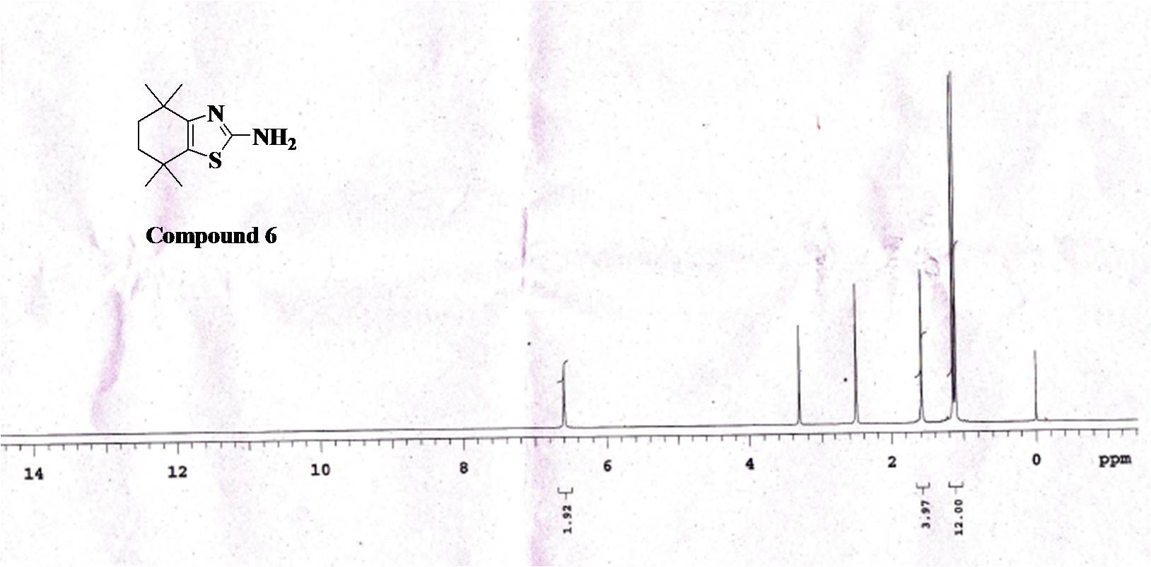
Fig.1.¹H NMR Spectra of Compound 6

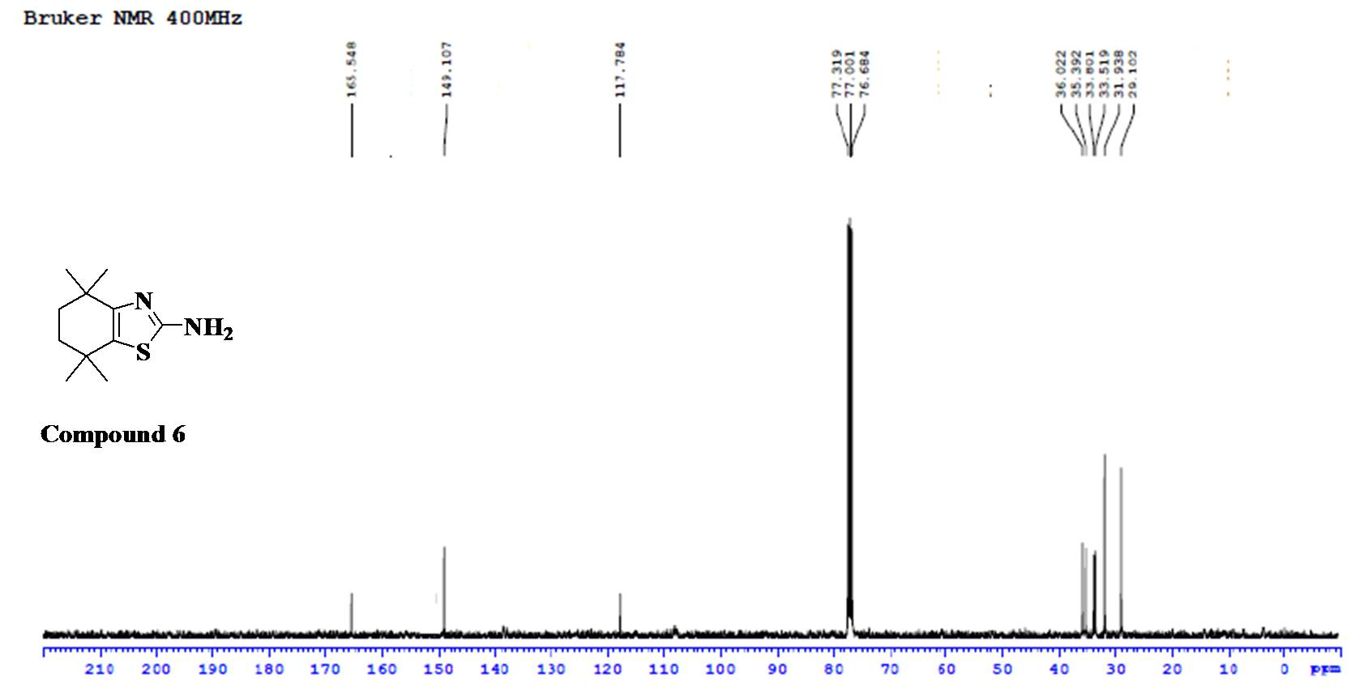

Fig.2. ¹³C NMR Spectra of Compound 6

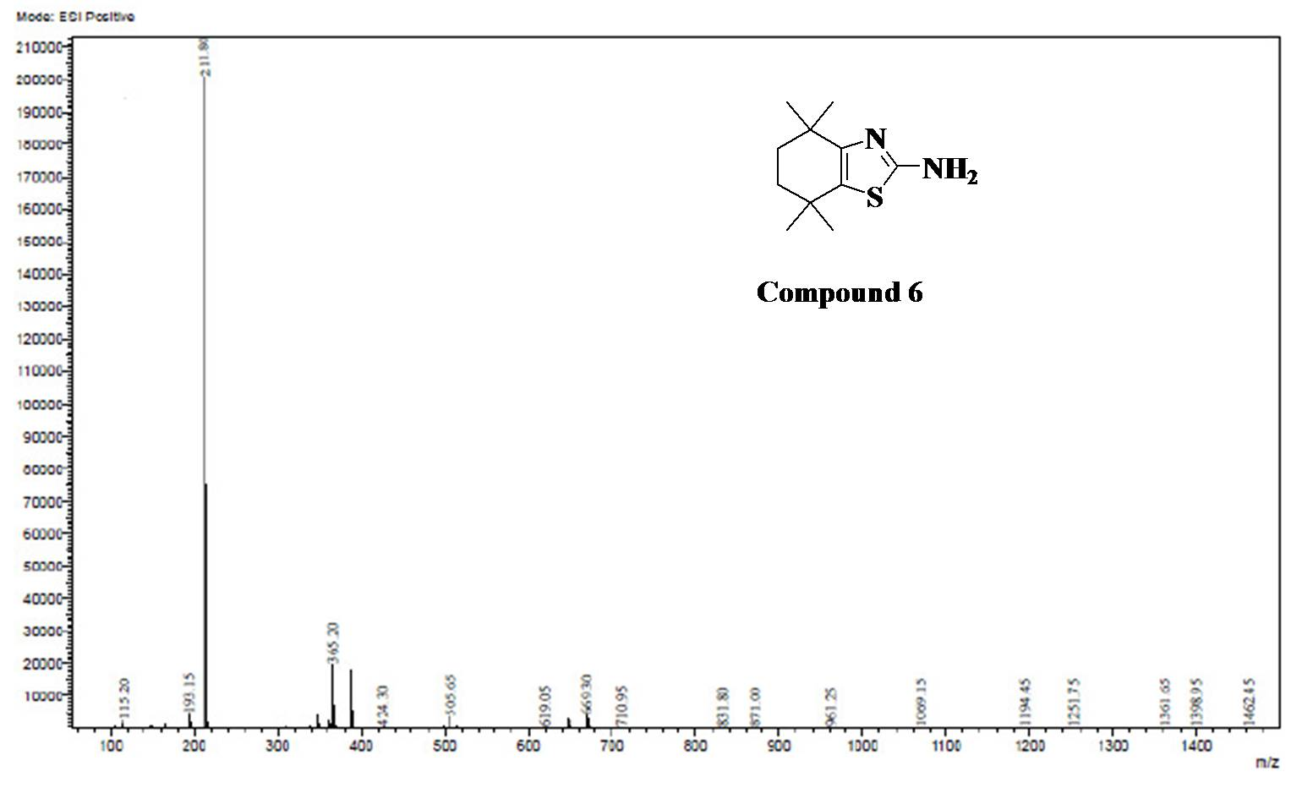
Fig.3. EI-MS Spectra of Compound 6
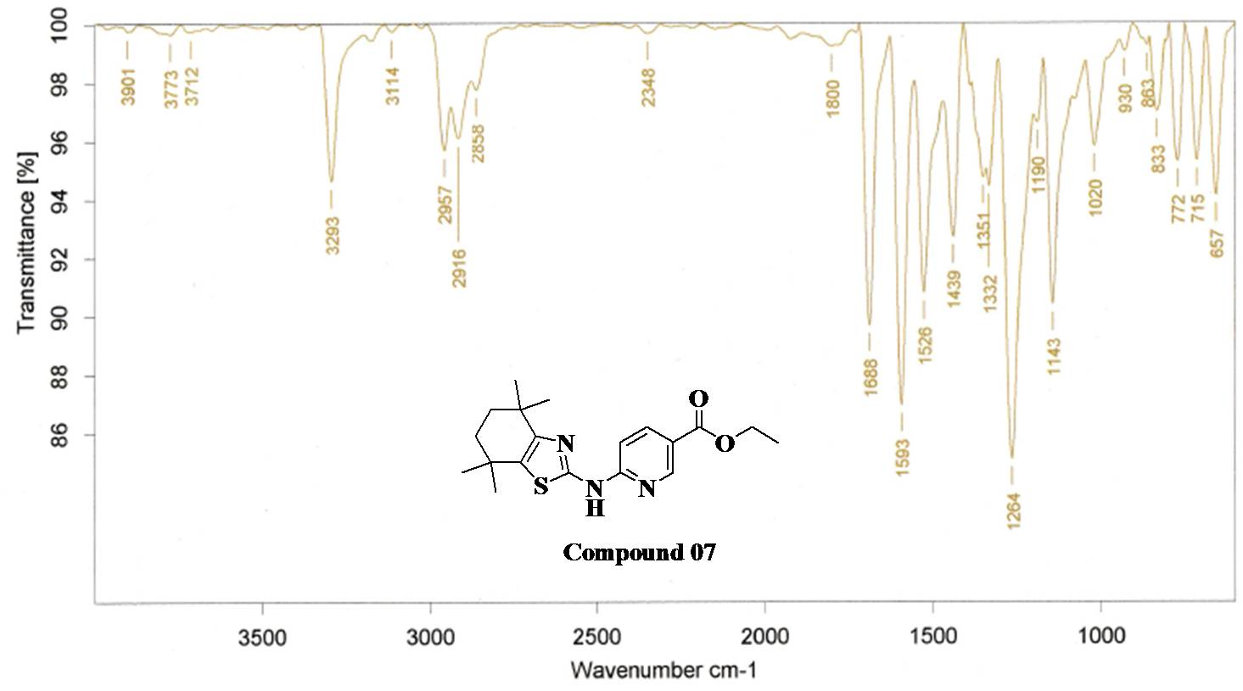
Fig.4. FT-IR Spectra of Compound 7

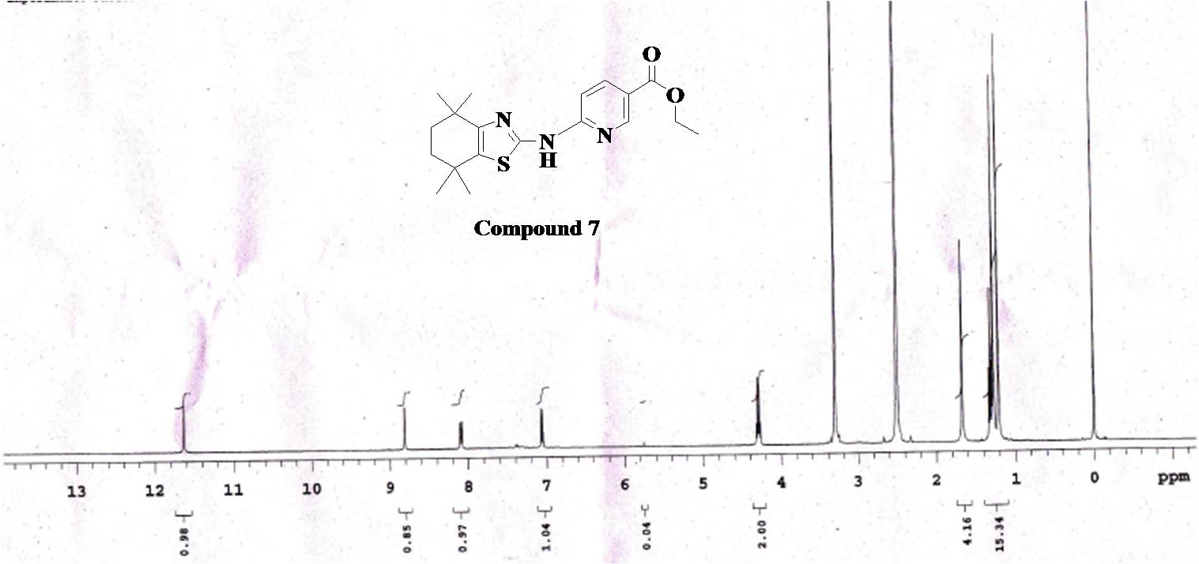
Fig.5. ¹H NMR Spectra of Compound 7

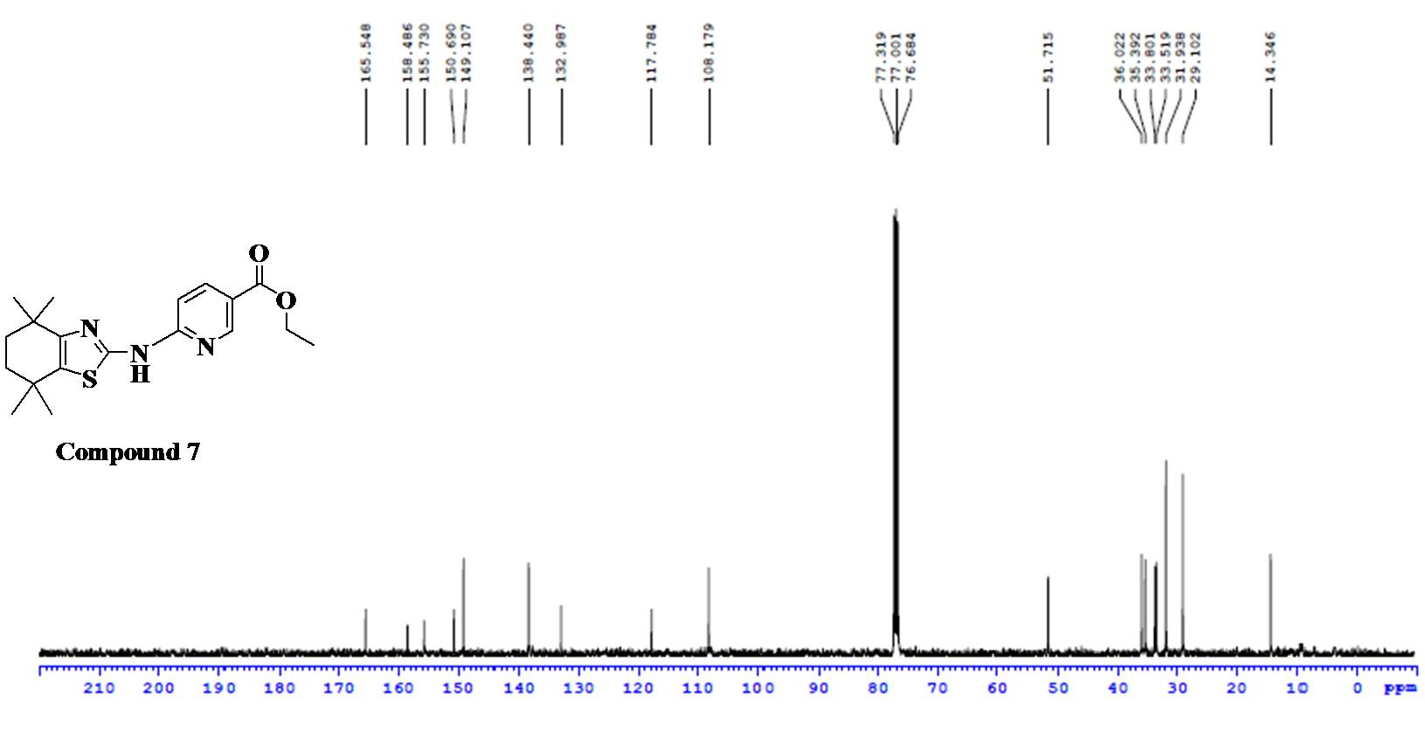

Fig.6. ¹³C NMR Spectra of Compound 7

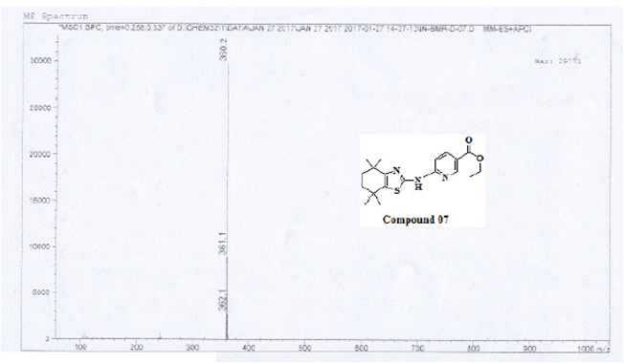
Fig.7. ESI-MS Spectra of Compound 7

Analytical data of Compound 8
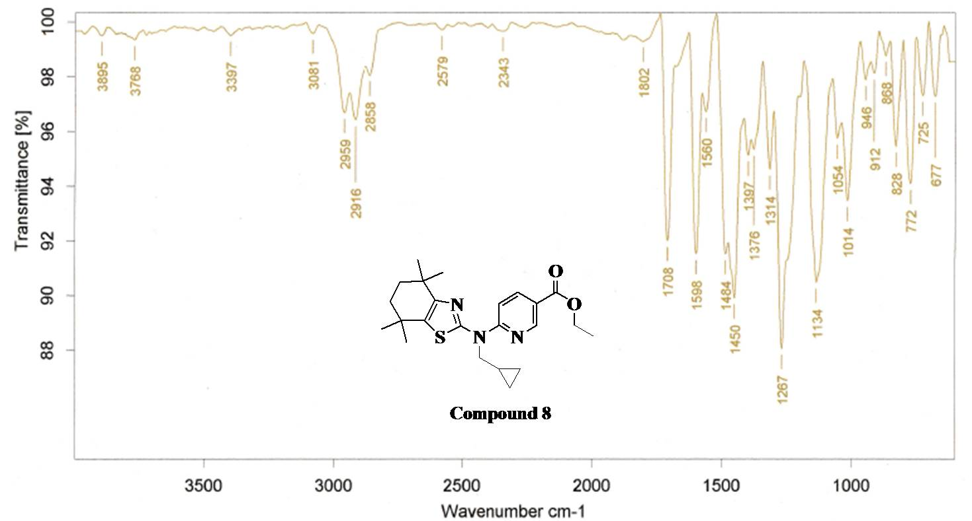
Fig.8. FT-IR Spectra of Compound 8

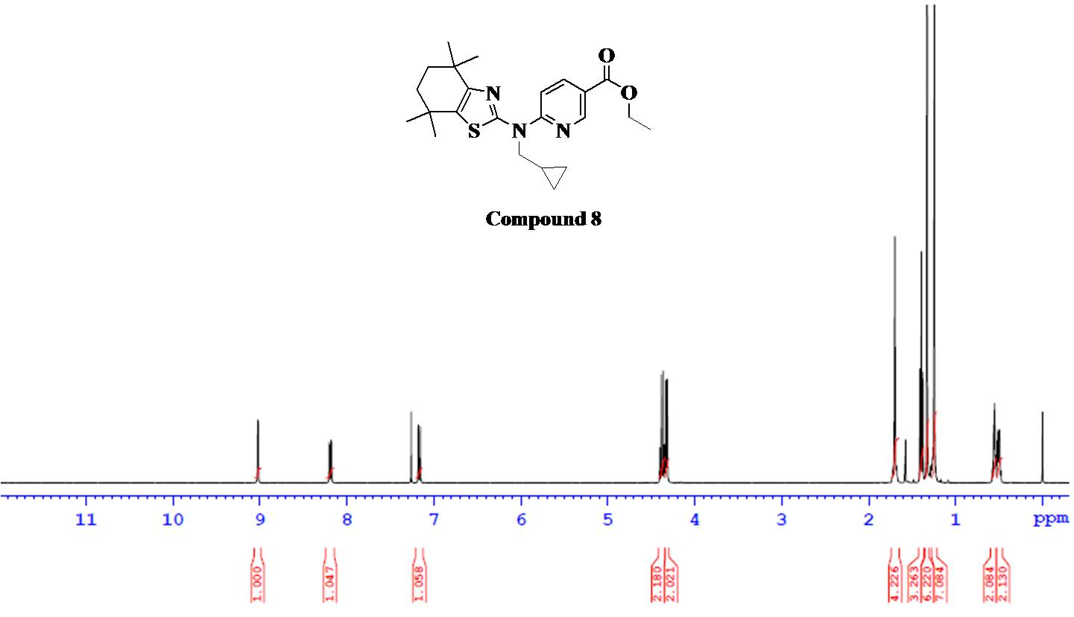
Fig.9. ¹H NMR Spectra of Compound 8
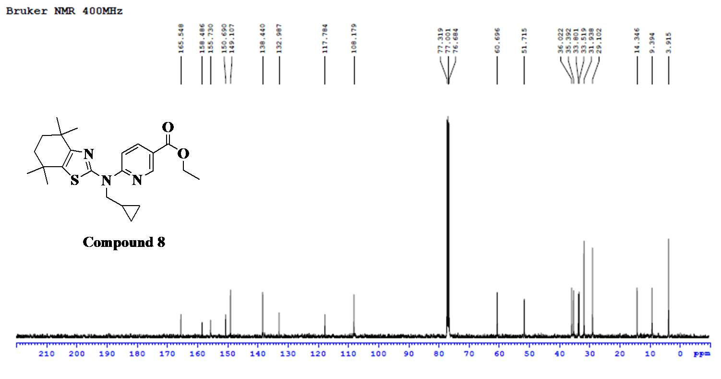
Fig.10. ¹³C NMR Spectra of Compound 8

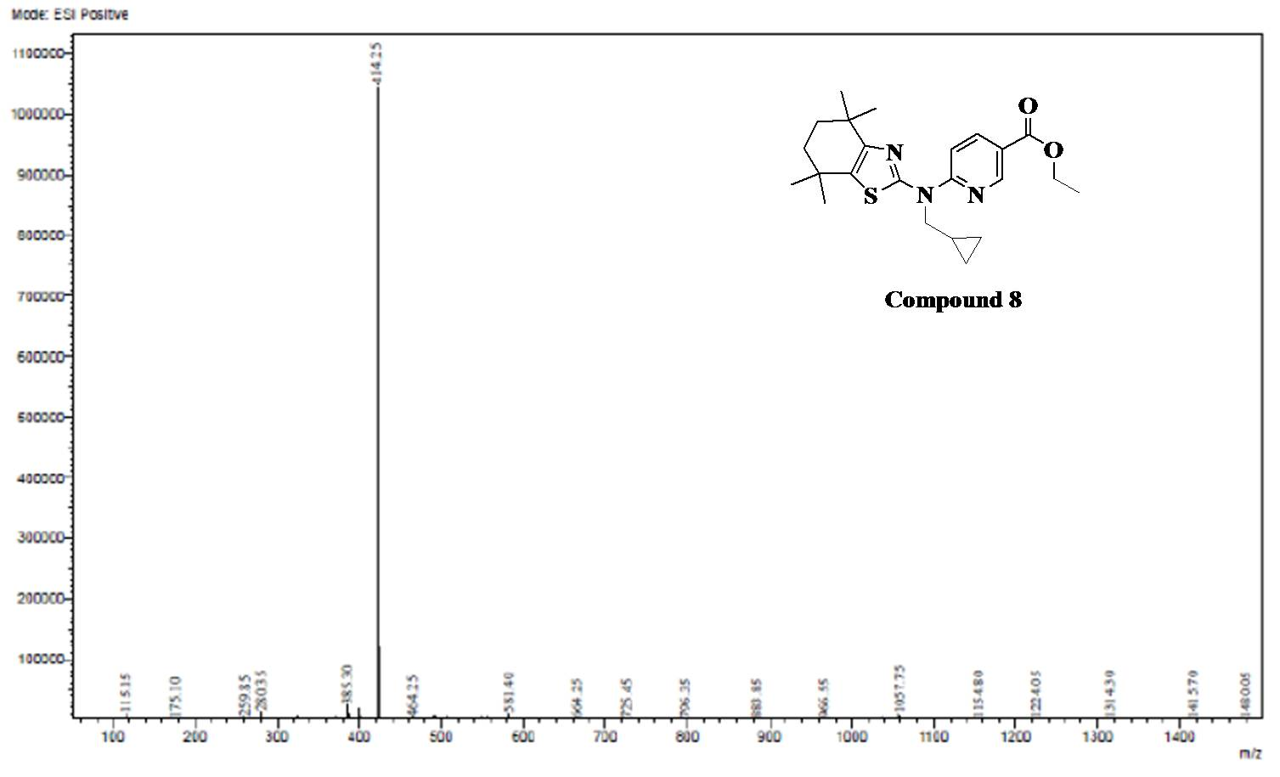
Fig.11. ESI-MS Spectra of Compound 8

Analytical data of Compound 9
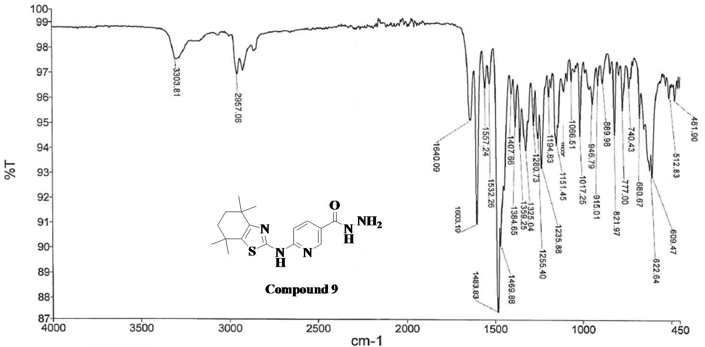
Fig.12. FT-IR Spectra of Compound 9

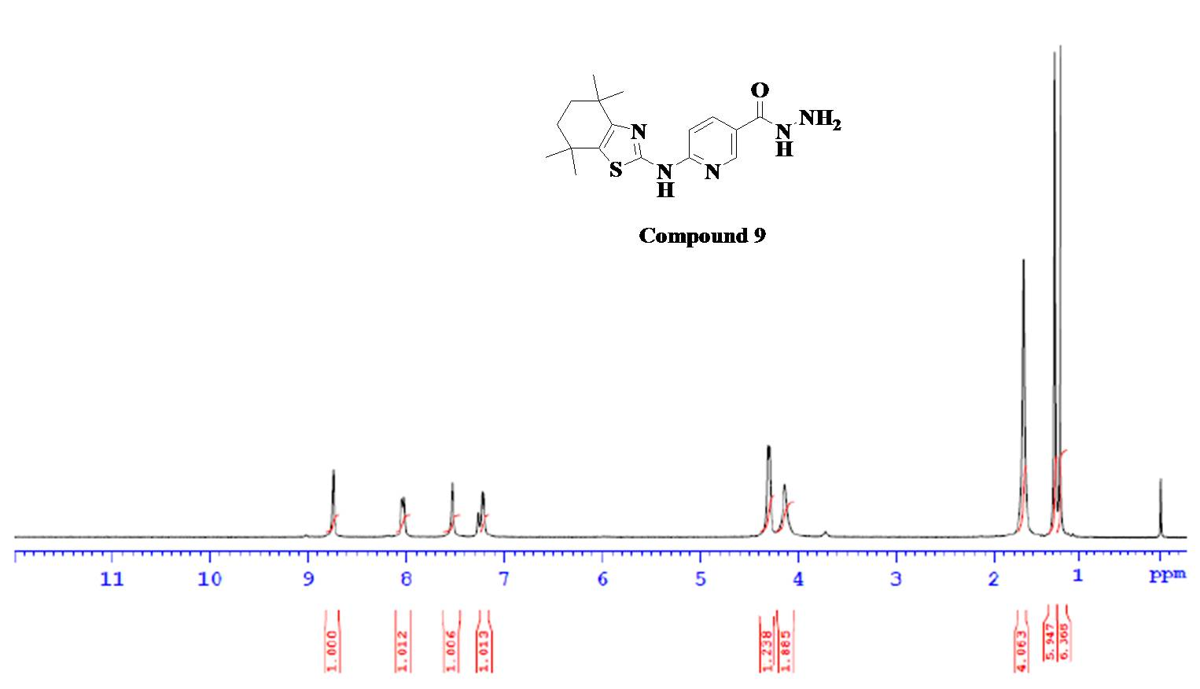
Fig.13. ¹H NMR Spectra of Compound 9

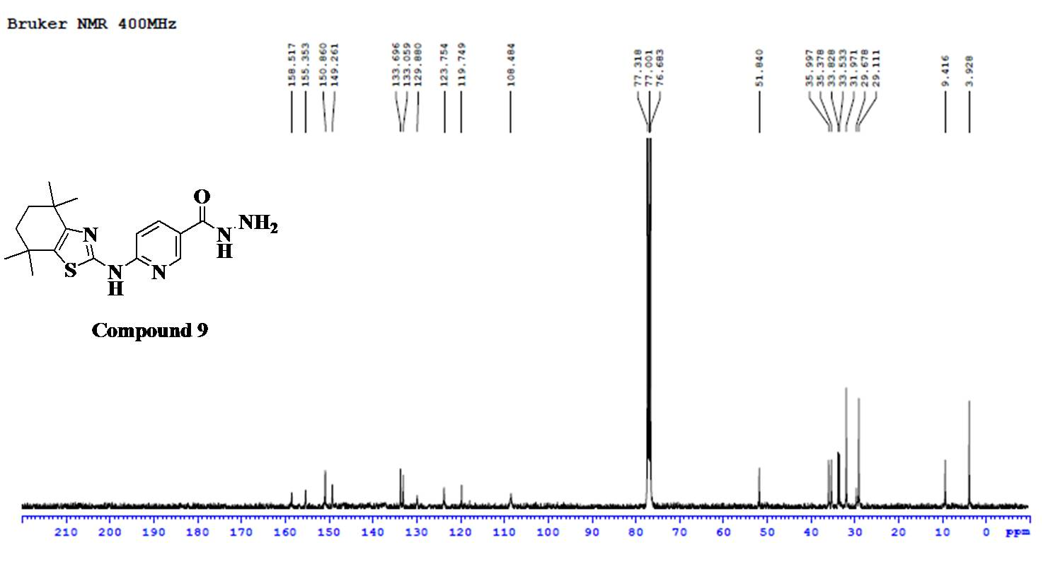
Fig.14. ¹³C NMR Spectra of Compound 9
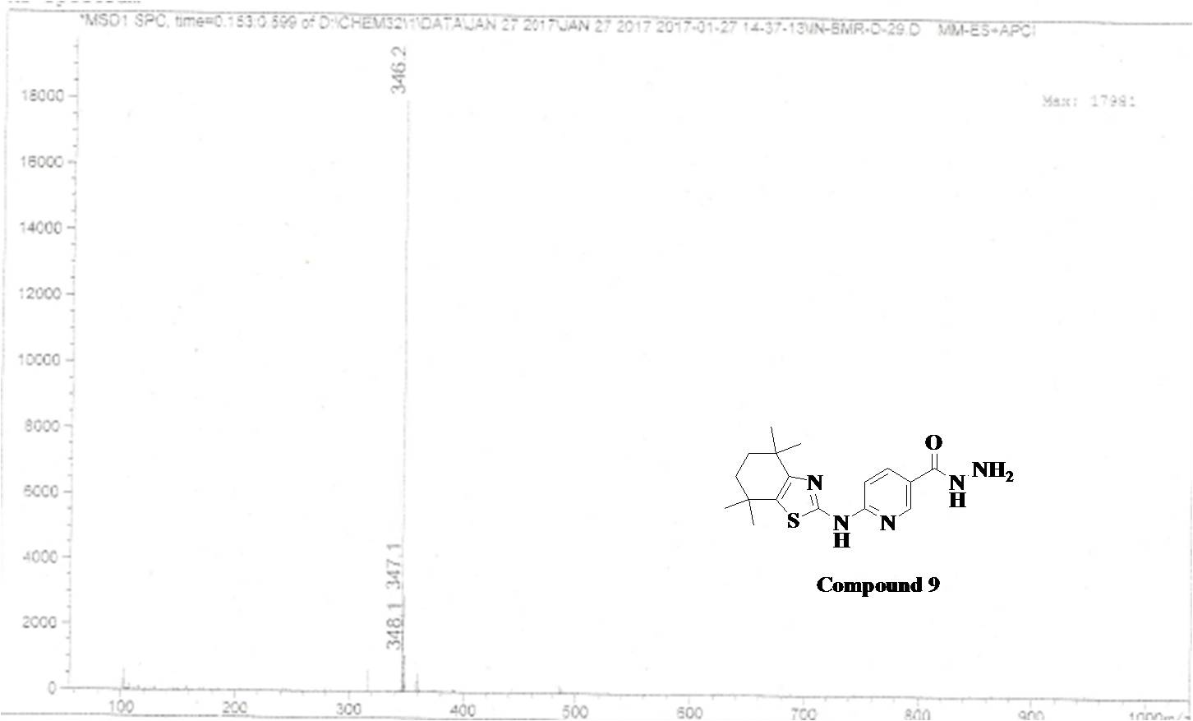
Fig.15. ESI-MS Spectra of Compound 9

Analytical data of Compound 10
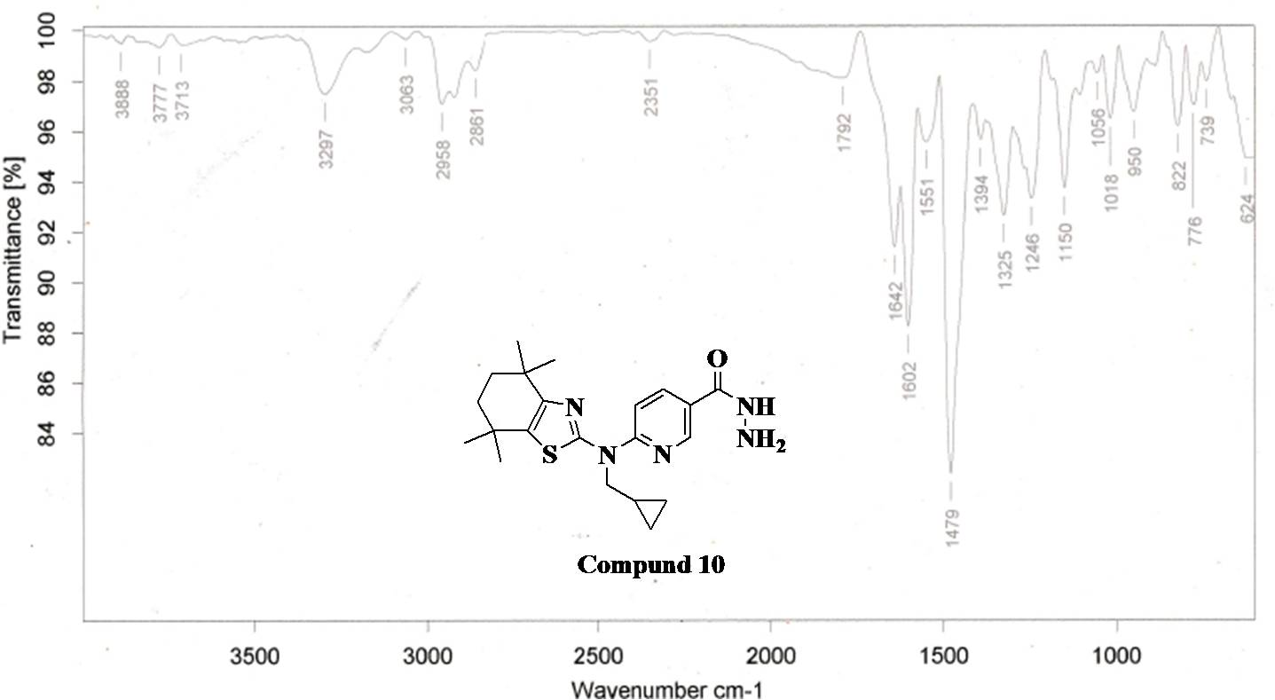
Fig.16. FT-IR Spectra of Compound 10

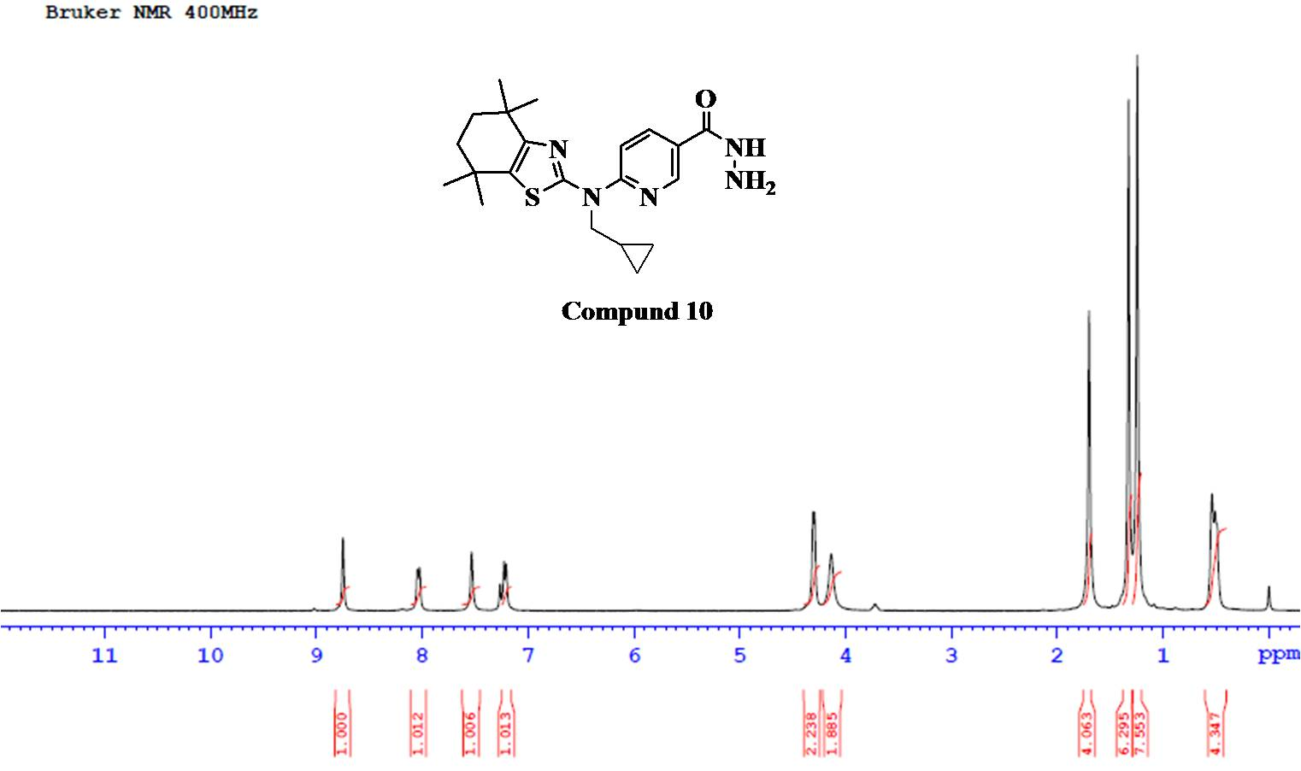
Fig.17. ¹H NMR Spectra of Compound 10

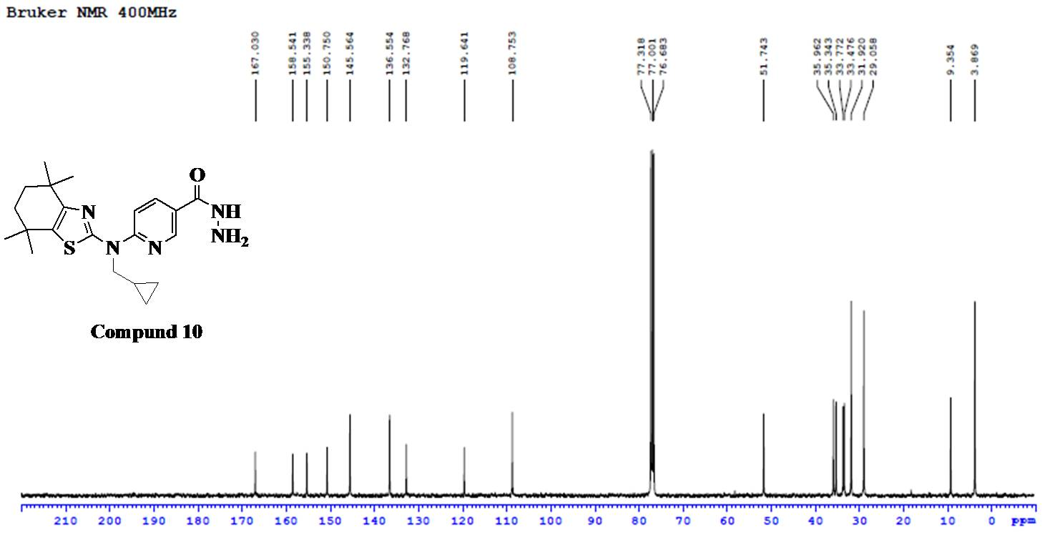
Fig.18. ¹³C NMR Spectra of Compound 10

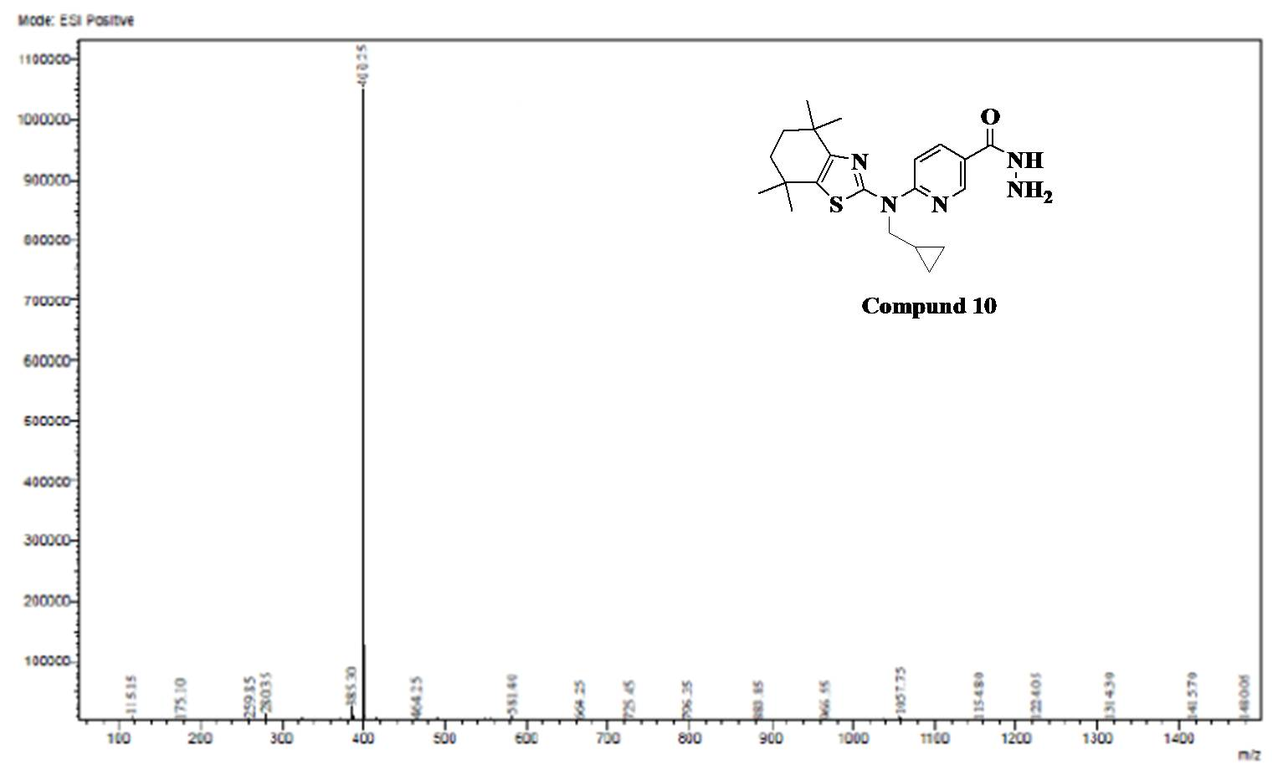
Fig.19. ESI-MS Spectra of Compound 10

Analytical data of Compound 11a
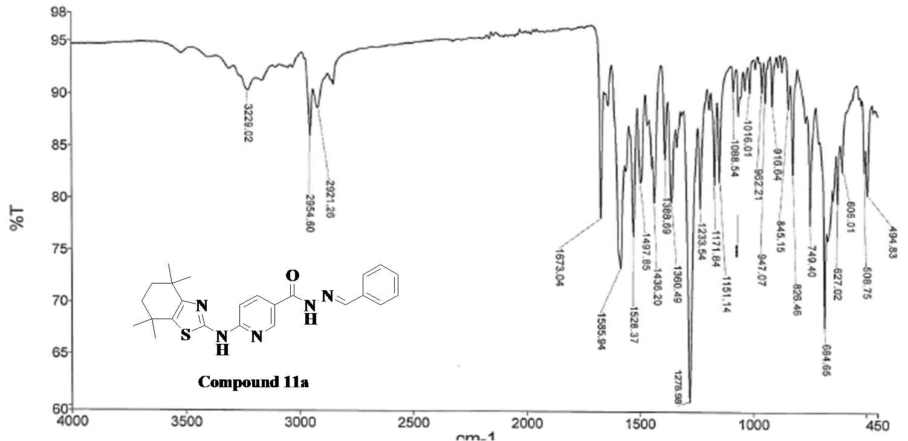
Fig.20. FT-IR Spectra of Compound 11a
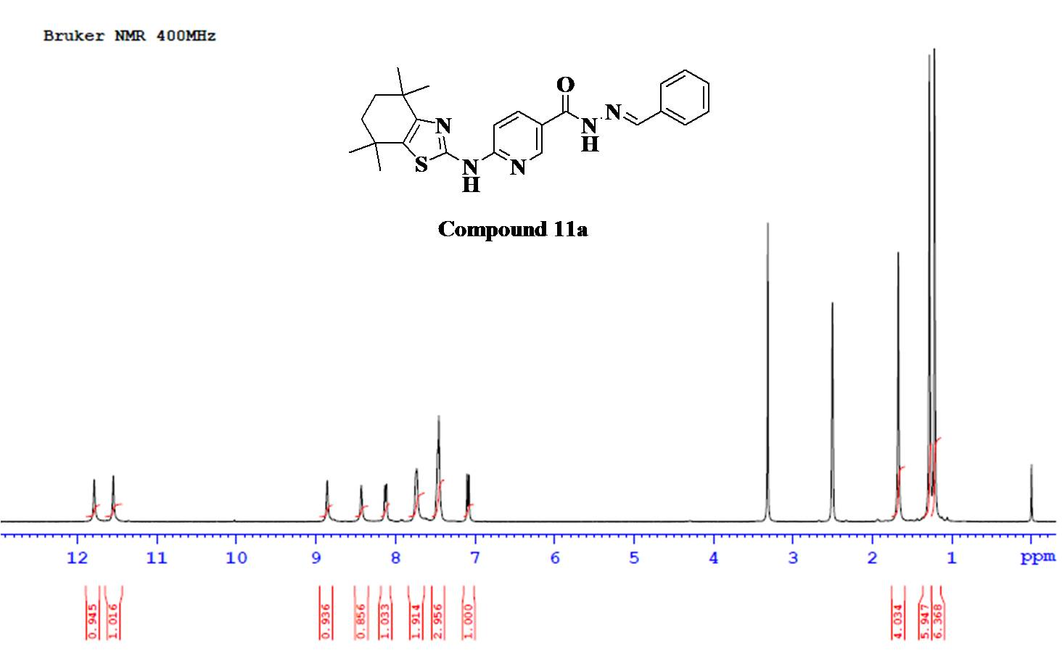 Fig.21. ¹H NMR Spectra of Compound 11a
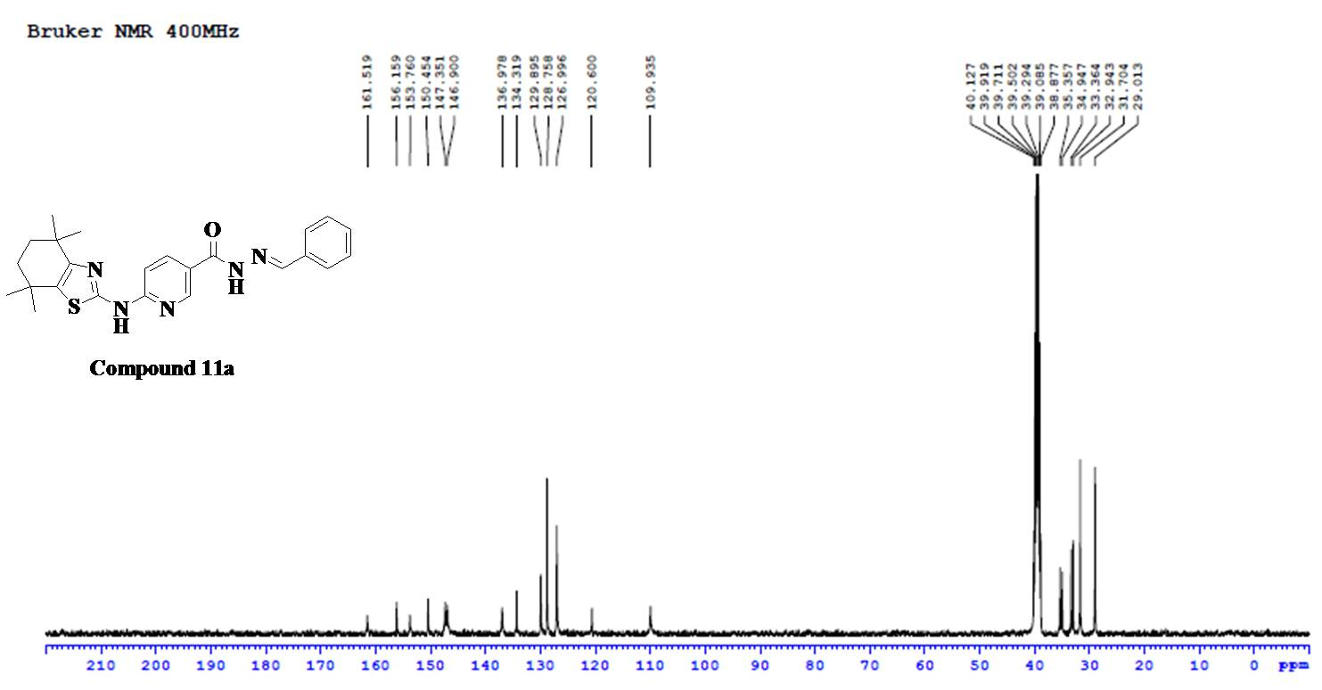
Fig.22. ¹³C NMR Spectra of Compound 11a
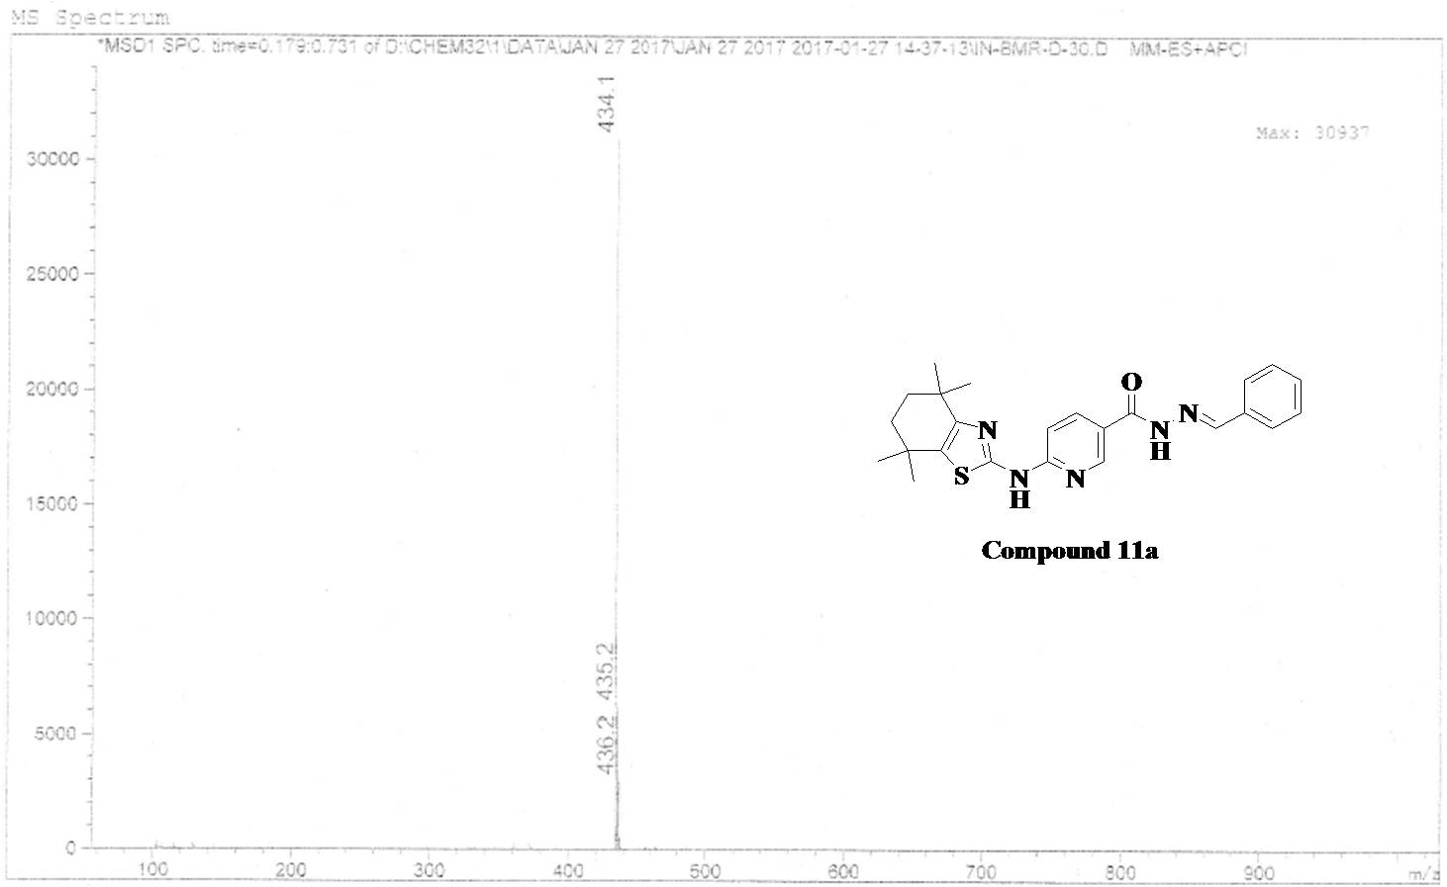
Fig.23. ESI-MS Spectra of Compound 11a

Analytical data of Compound 11b
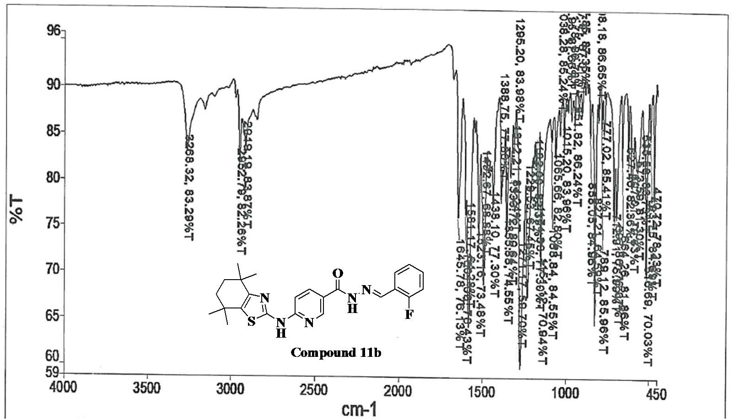
Fig.24. FT-IR Spectra of Compound 11b
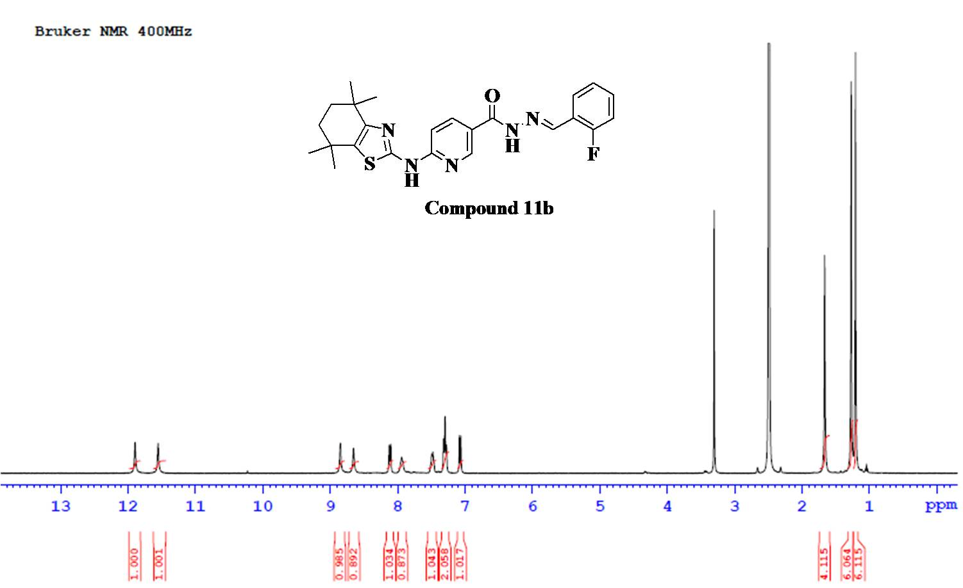
Fig.25. ¹H NMR Spectra of Compound 11b
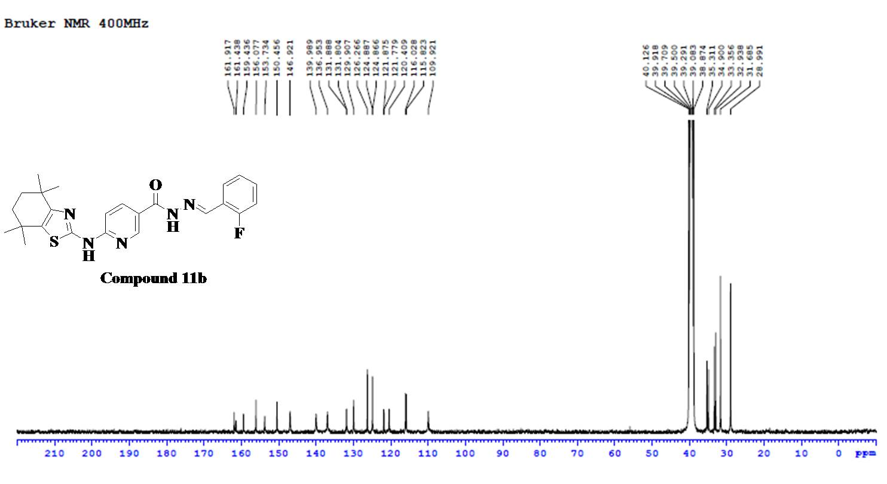Fig.26. ¹³C NMR Spectra of Compound 11b
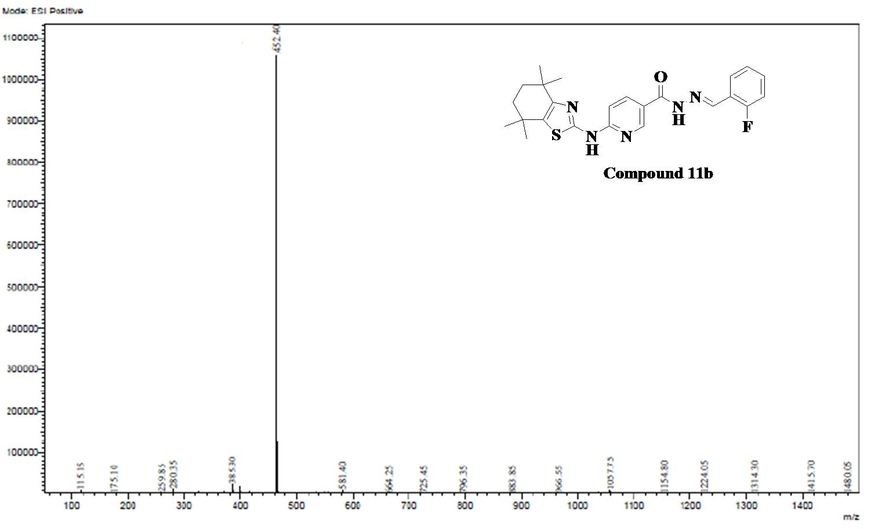
Fig.27. ESI-MS Spectra of Compound 11b

Analytical data of Compound 11c
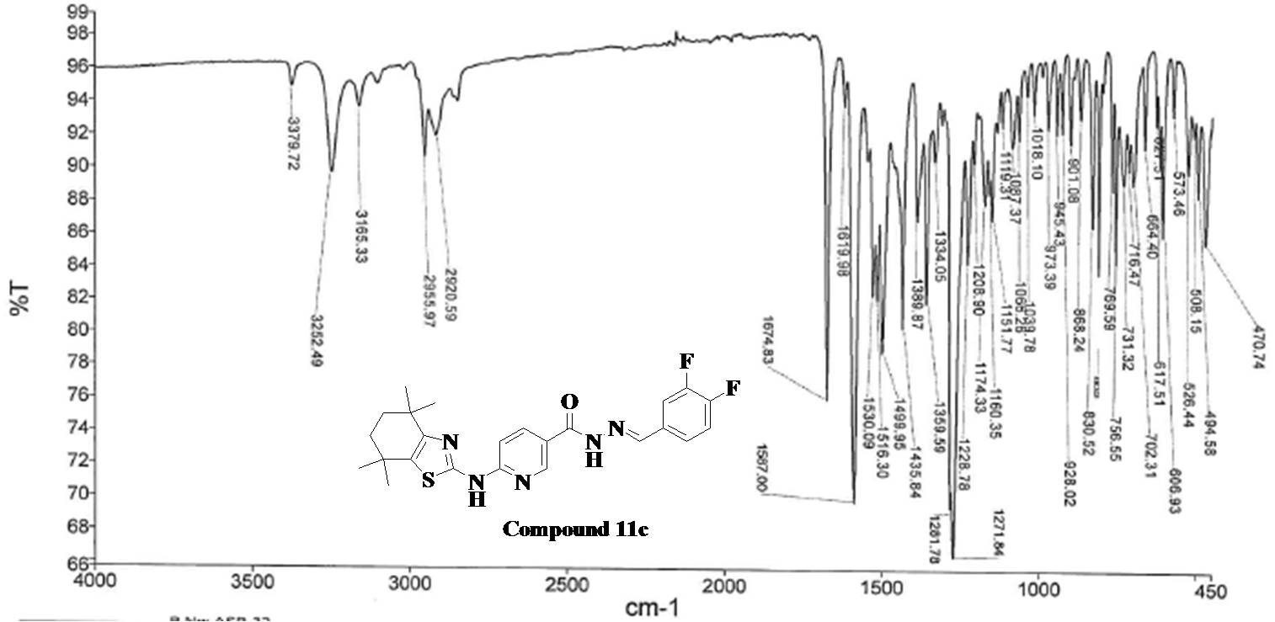
Fig.28. FT-IR Spectra of Compound 11c

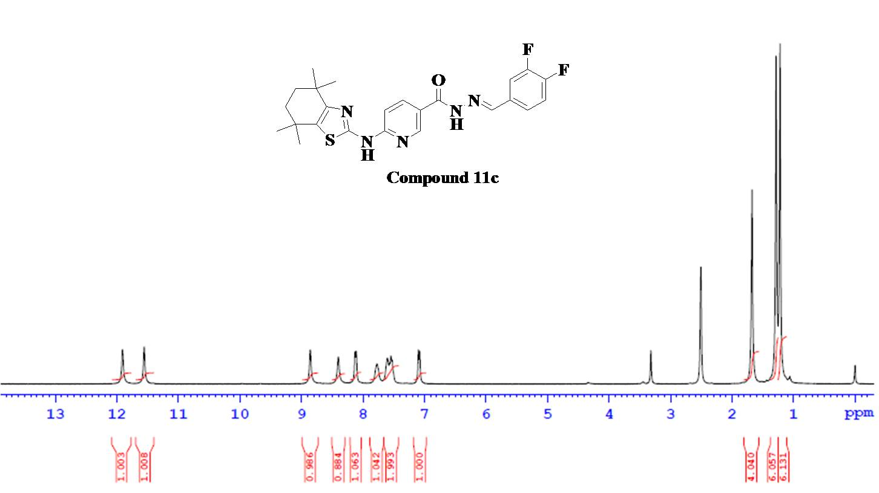
Fig.29. ¹H NMR Spectra of Compound 11c

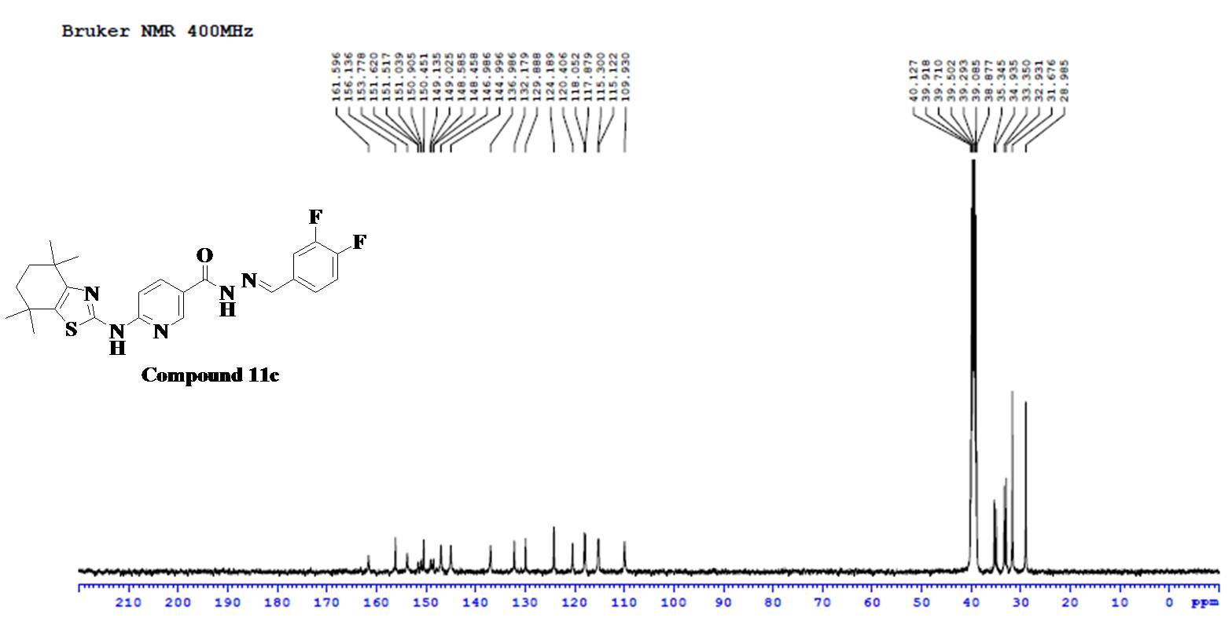
Fig.30. ¹³C NMR Spectra of Compound 11c
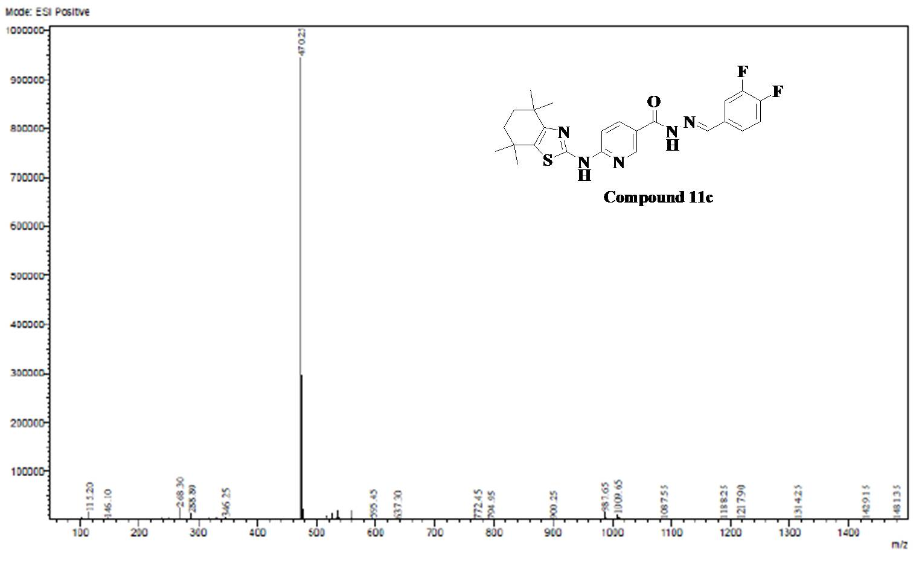
Fig.31. ESI-MS Spectra of Compound 11c

Analytical data of Compound 11d
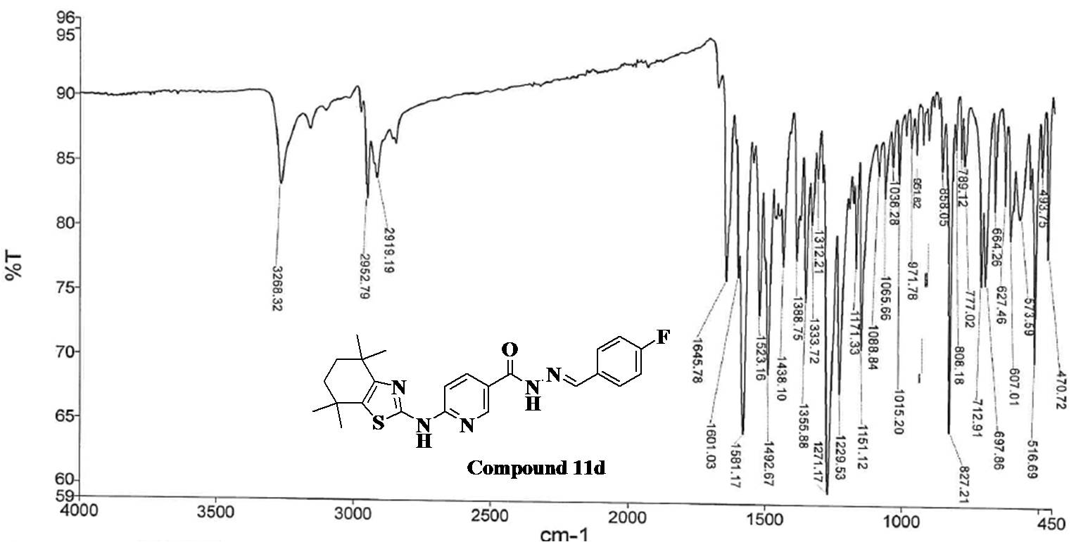
Fig.32. FT-IR Spectra of Compound 11d
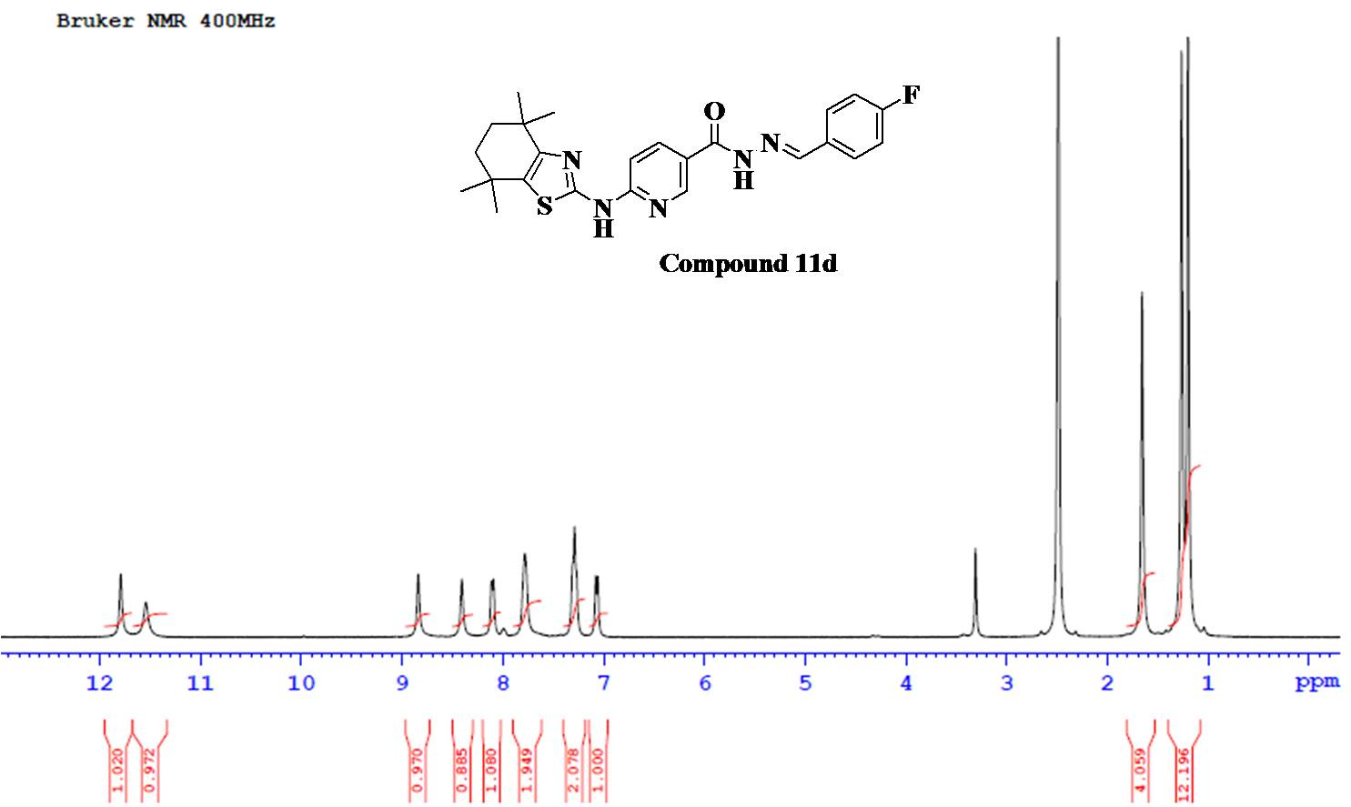
Fig.33. ¹H NMR Spectra of Compound 11d

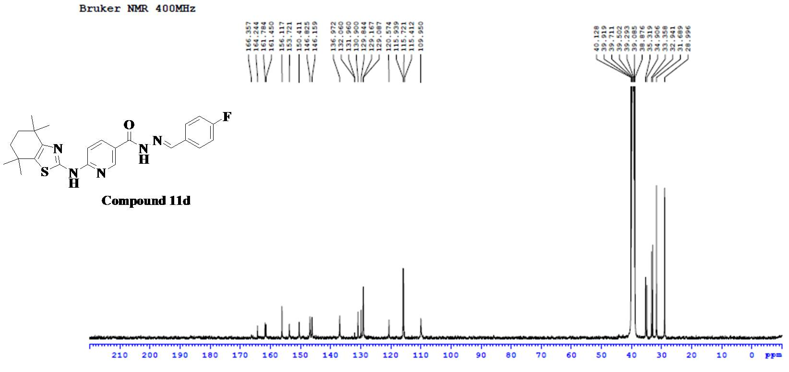
Fig.34. ¹³C NMR Spectra of Compound 11d
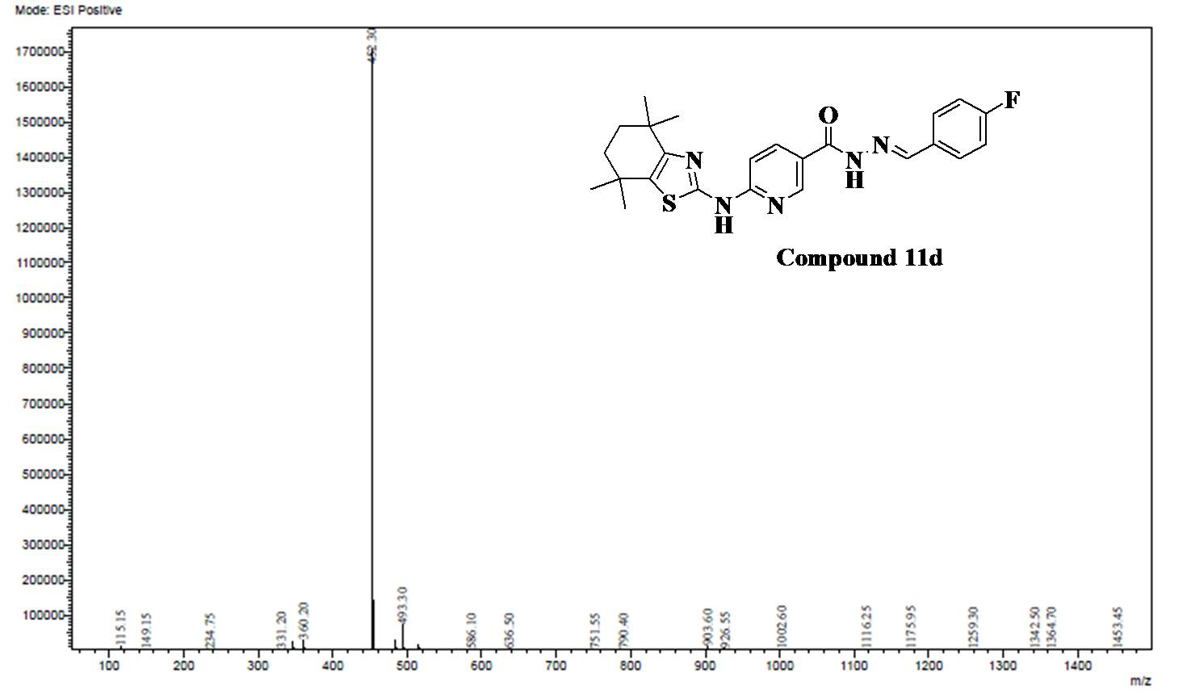
Fig.35. ESI-MS Spectra of Compound 11d

Analytical data of Compound 11e
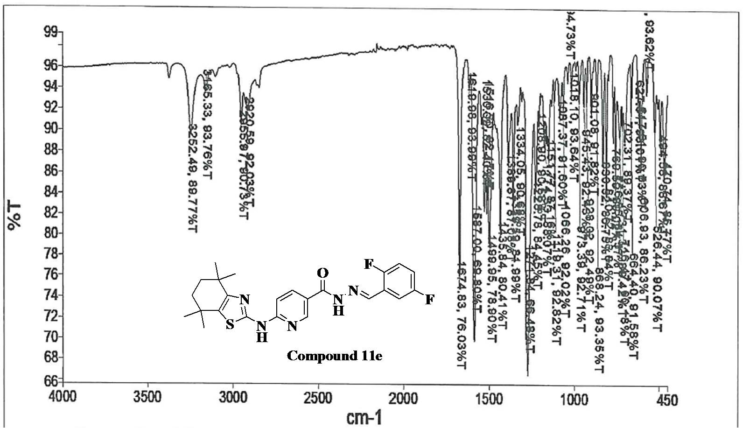
Fig.36. FT-IR Spectra of Compound 11e

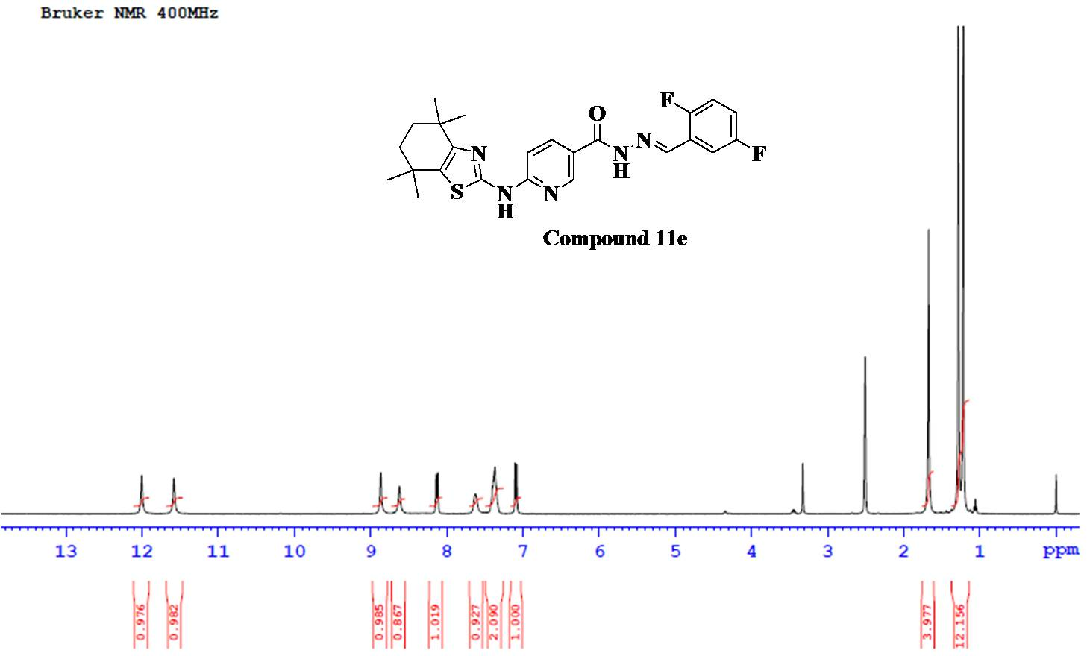
Fig.37. ¹H NMR Spectra of Compound 11e

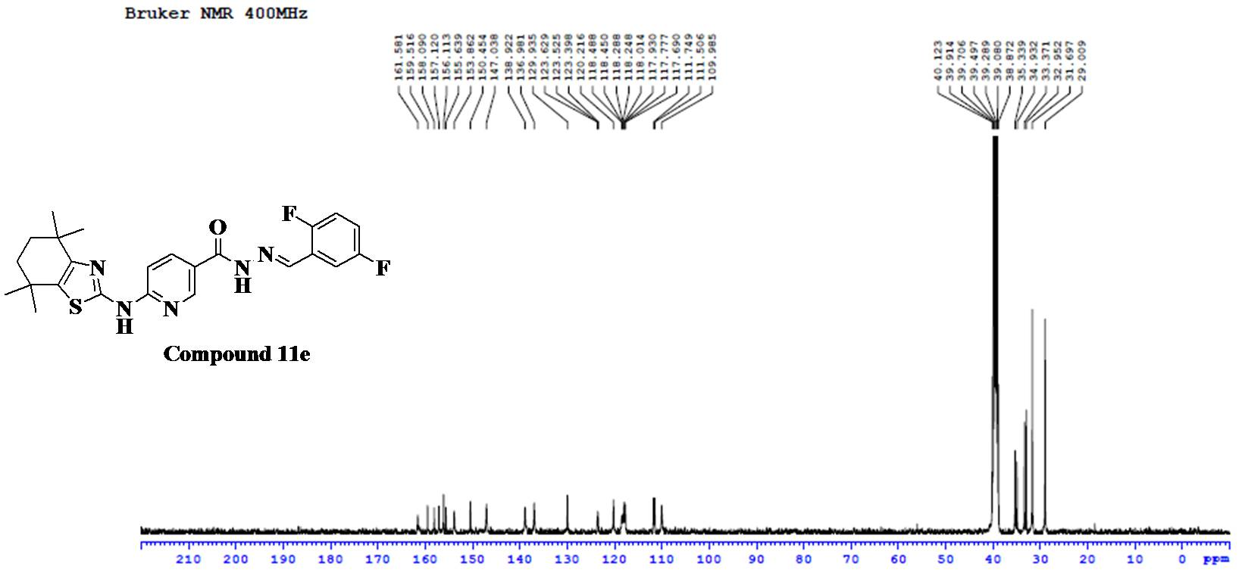
Fig.38. ¹³C NMR Spectra of Compound 11e
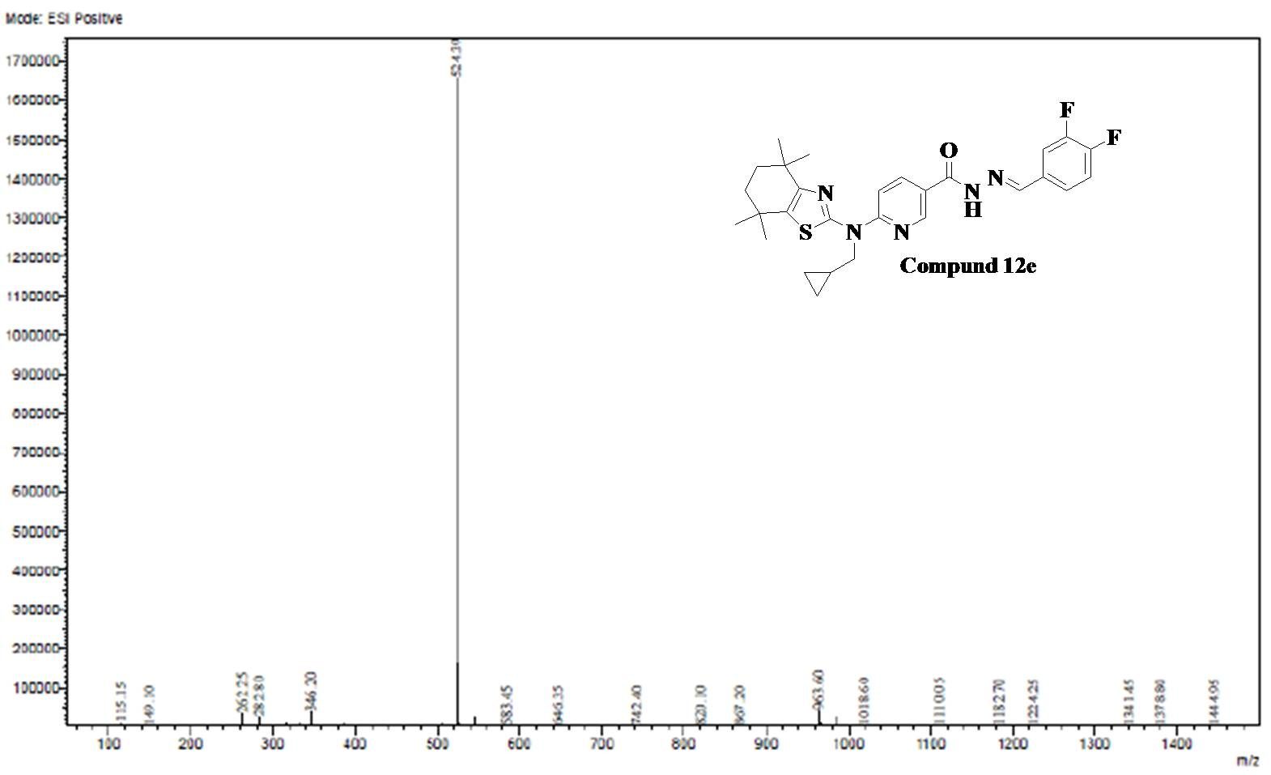
Fig.39. ESI-MS Spectra of Compound 11e
Analytical data of Compound 11f
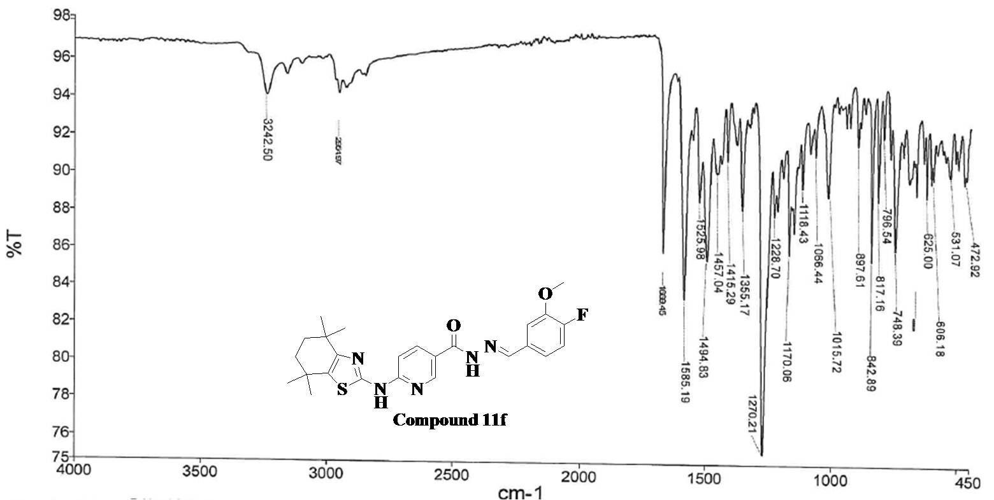

Fig.40. FT-IR Spectra of Compound 11f
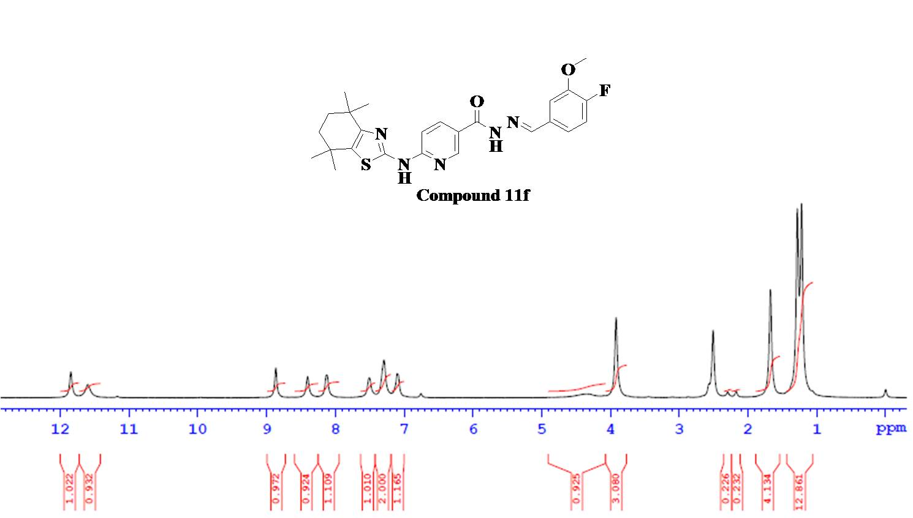
Fig.41. ¹H NMR Spectra of Compound 11f

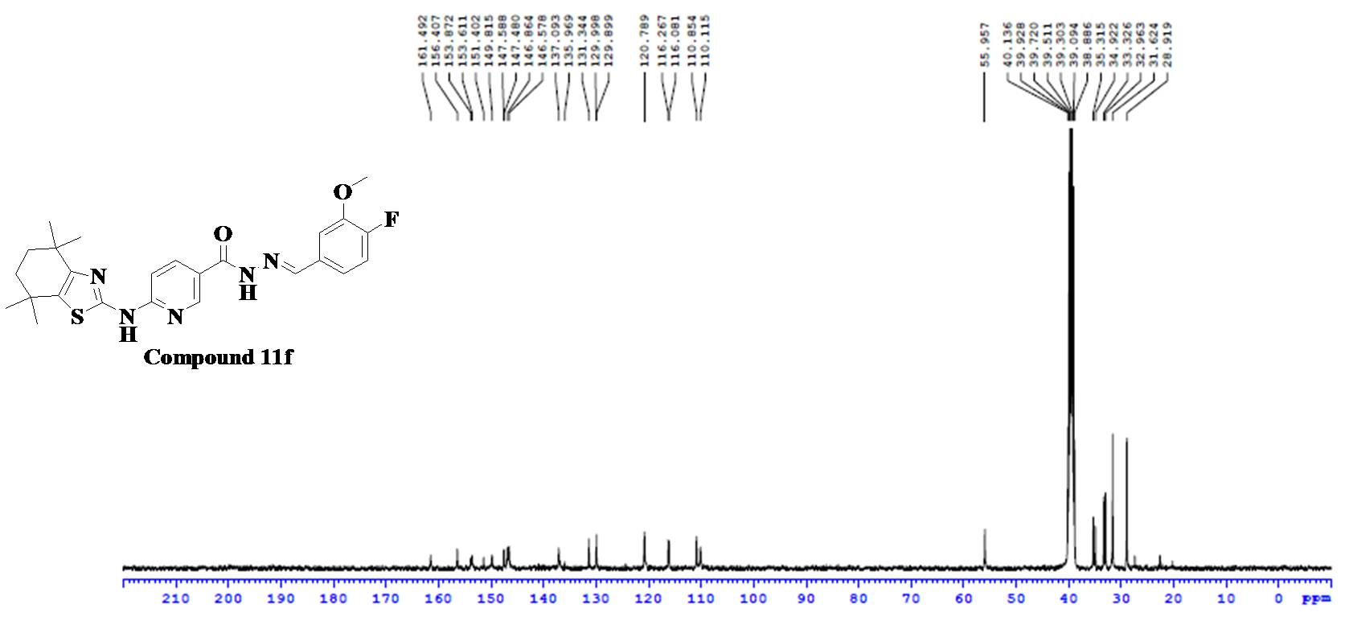
Fig.42. ¹³C NMR Spectra of Compound 11f
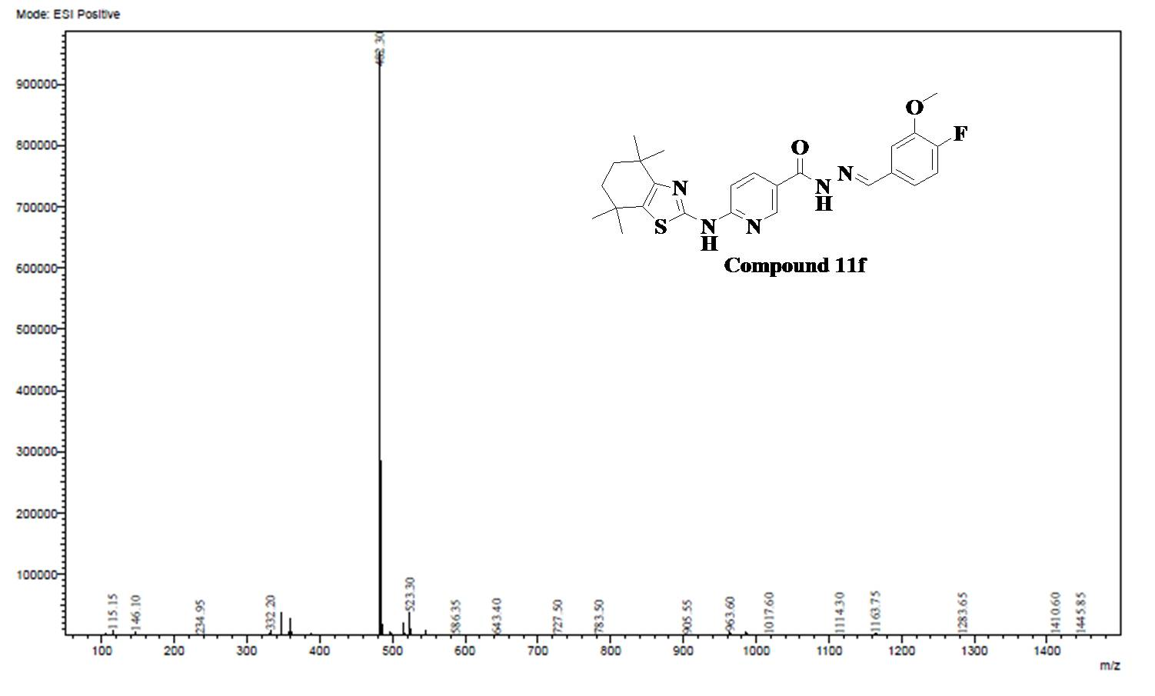
Fig.43. ESI-MS Spectra of Compound 11f

Analytical data of Compound 11g
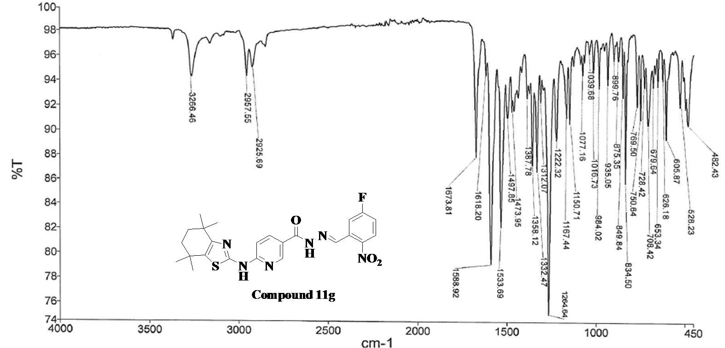Fig.44. FT-IR Spectra of Compound 11g
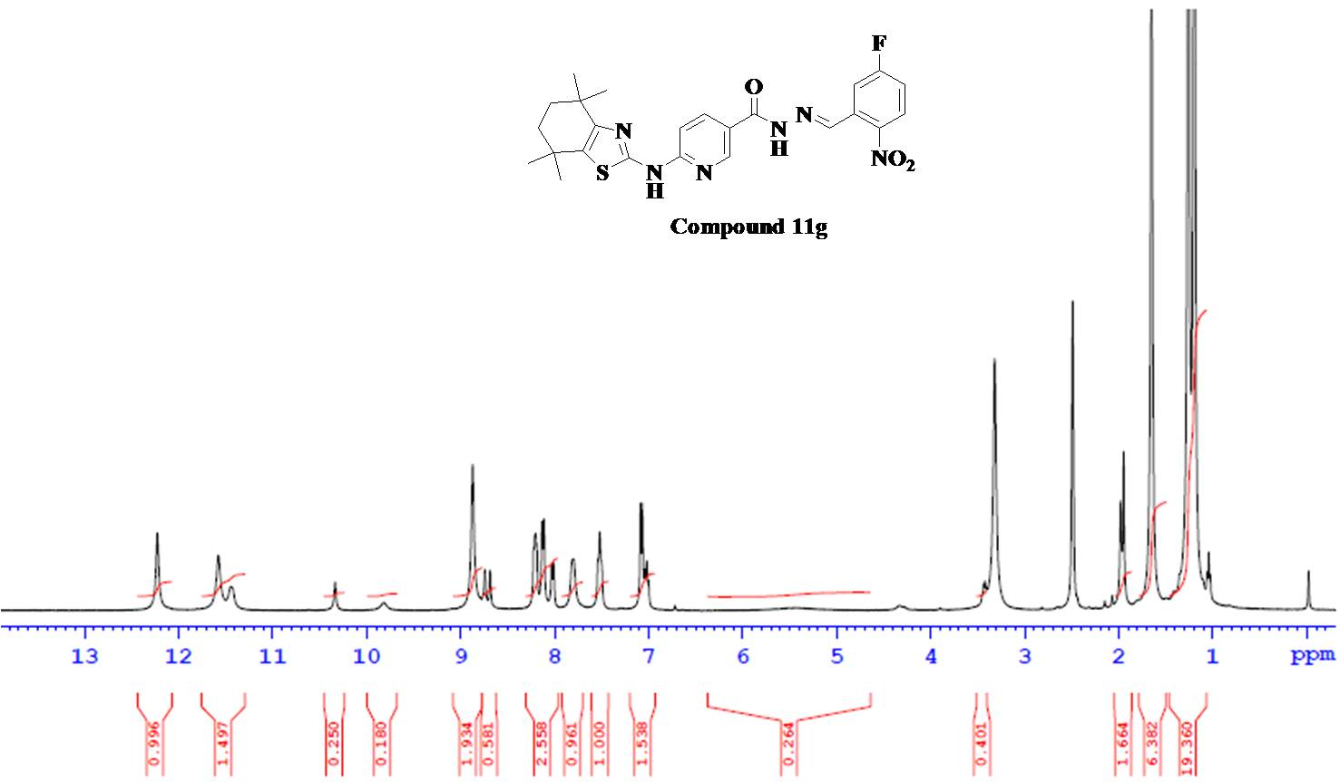
Fig.45. ¹H NMR Spectra of Compound 11g

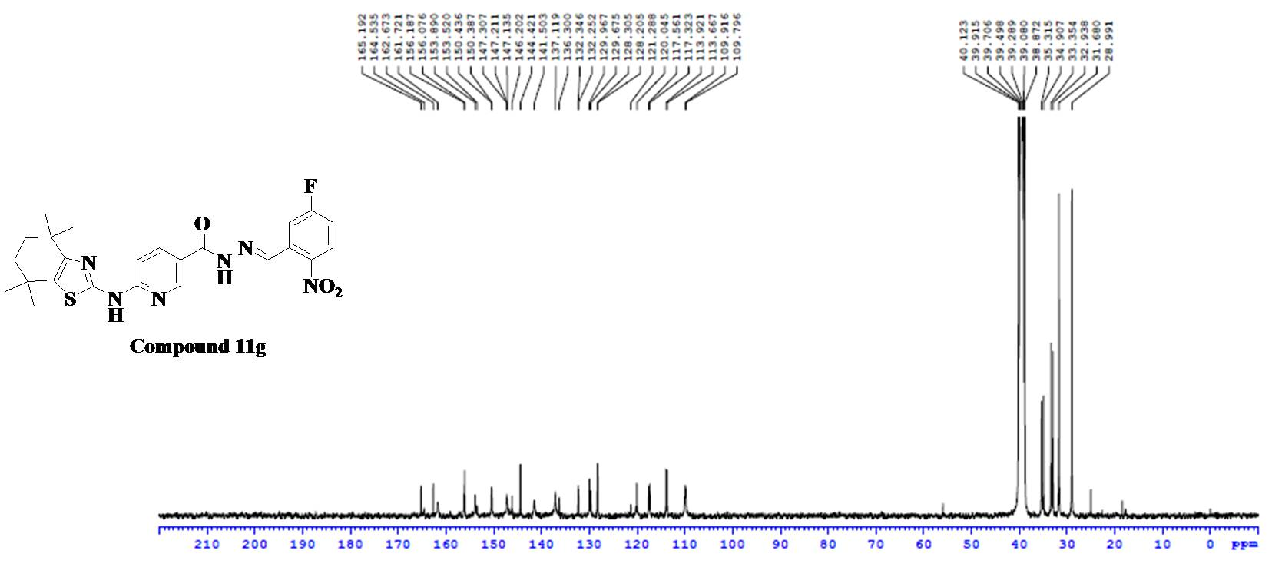
Fig.46. ¹³C NMR Spectra of Compound 11g
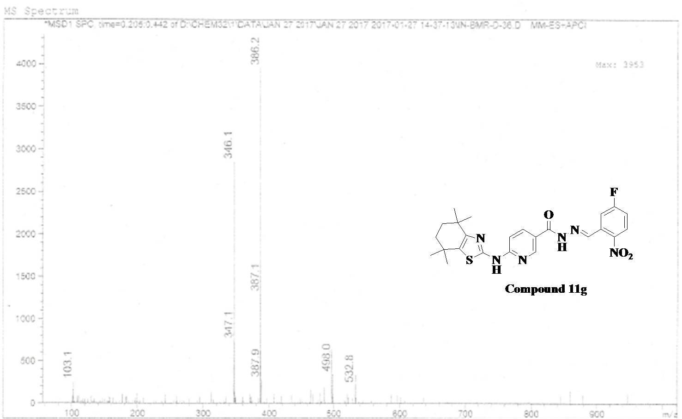
Fig.47. ESI-MS Spectra of Compound 11g

Analytical data of Compound 11h

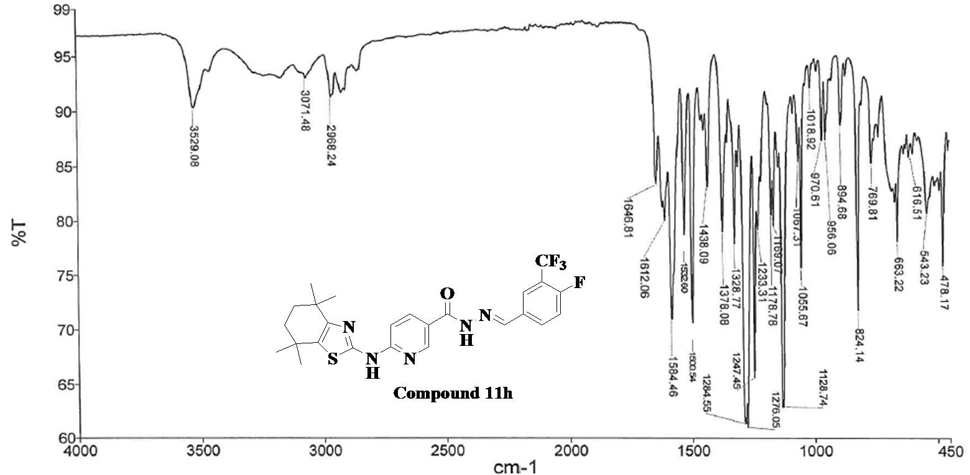
Fig.48. FT-IR Spectra of Compound 11h

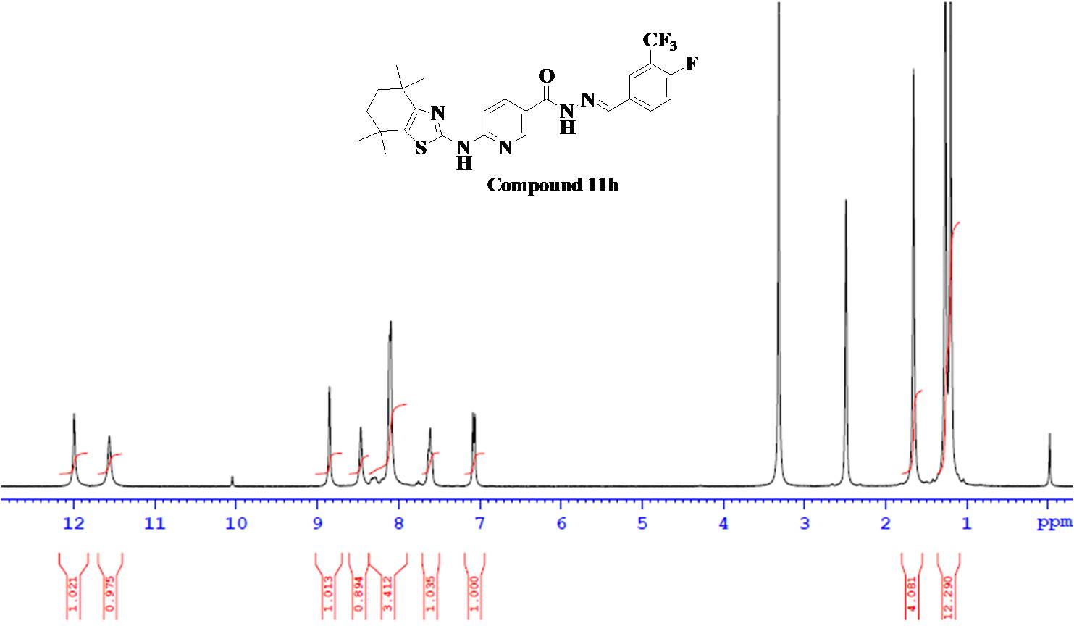Fig.49. ¹H NMR Spectra of Compound 11h
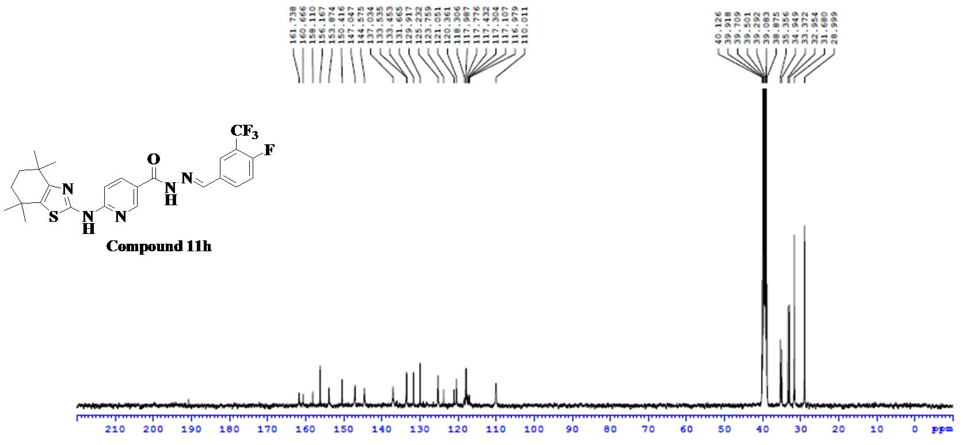
Fig.50. ¹³C NMR Spectra of Compound 11h

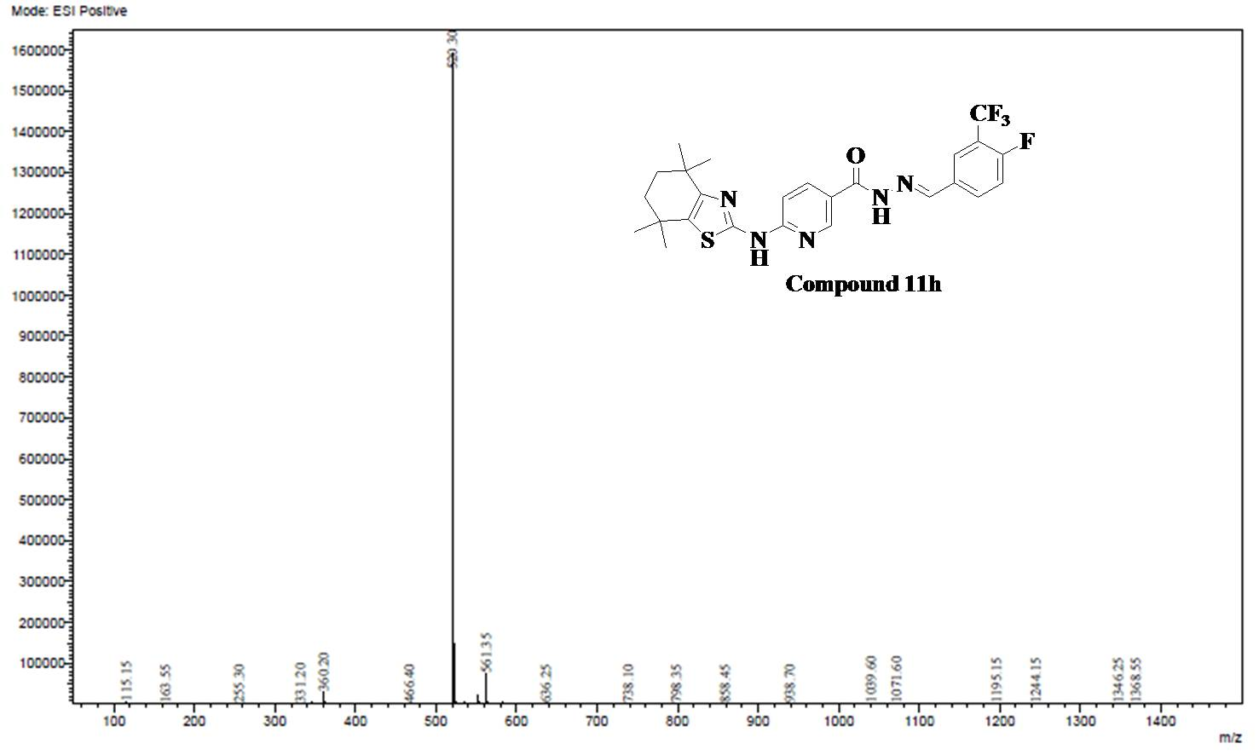
Fig.51. ESI-MS Spectra of Compound 11h
Analytical data of Compound 11h
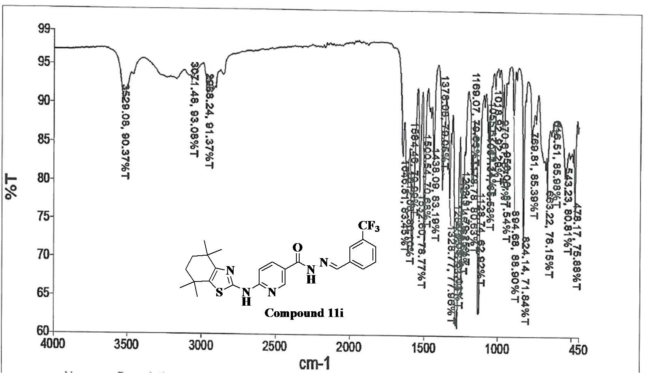
Fig.52. FT-IR Spectra of Compound 11i
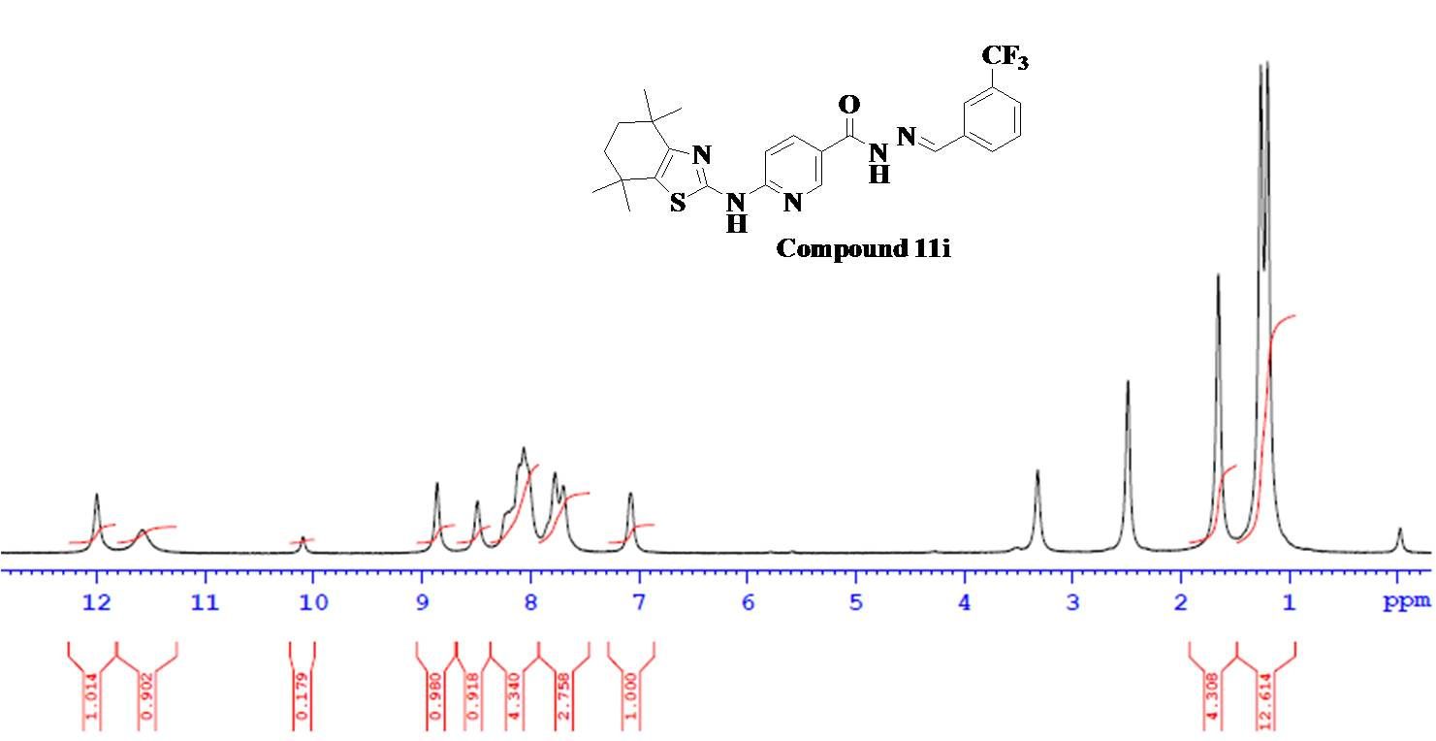
Fig.53. ¹H NMR Spectra of Compound 11i

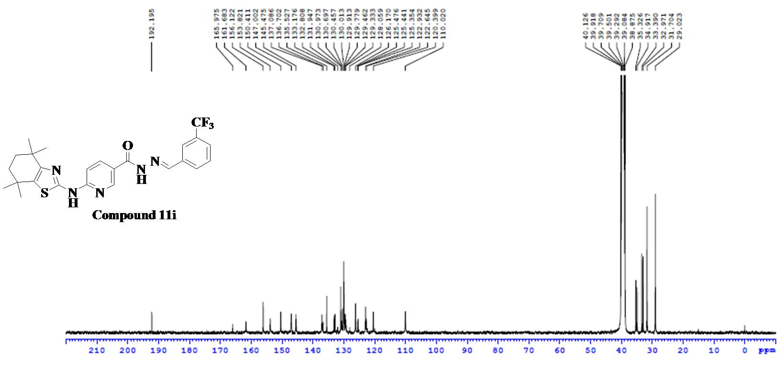
Fig.54. ¹³C NMR Spectra of Compound 11i
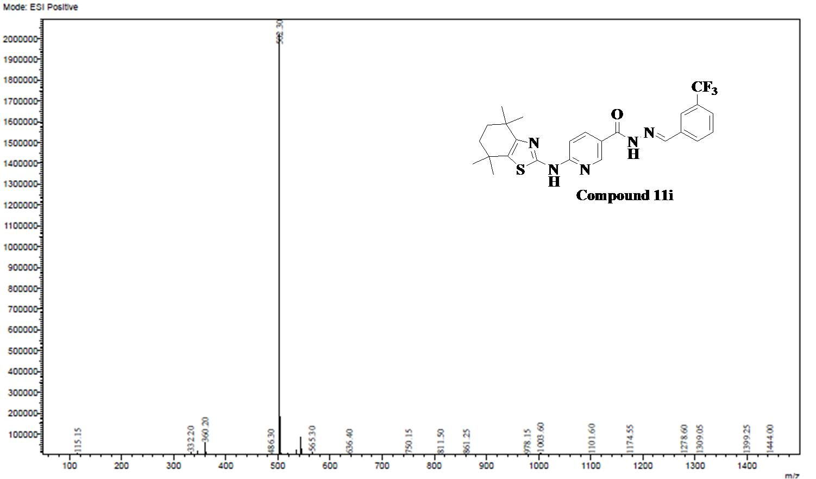
Fig.55. ESI-MS Spectra of Compound 11i
Analytical data of Compound 11j
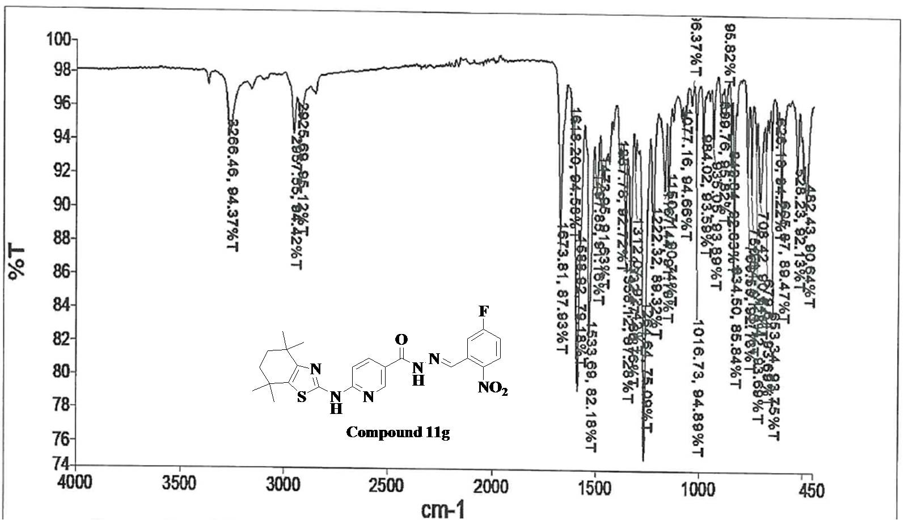
Fig.56. FT-IR Spectra of Compound 11j
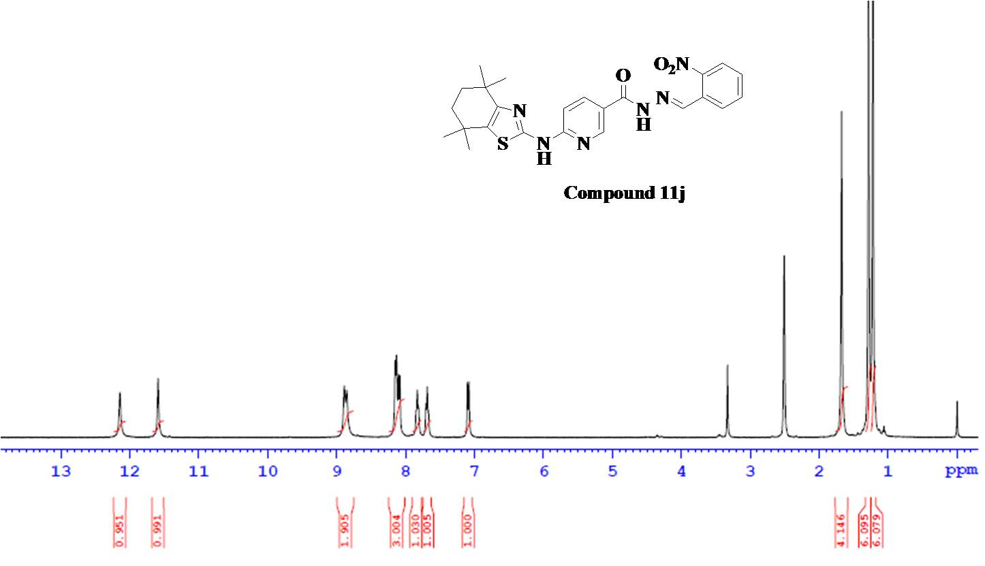
Fig.57. ¹H NMR Spectra of Compound 11j

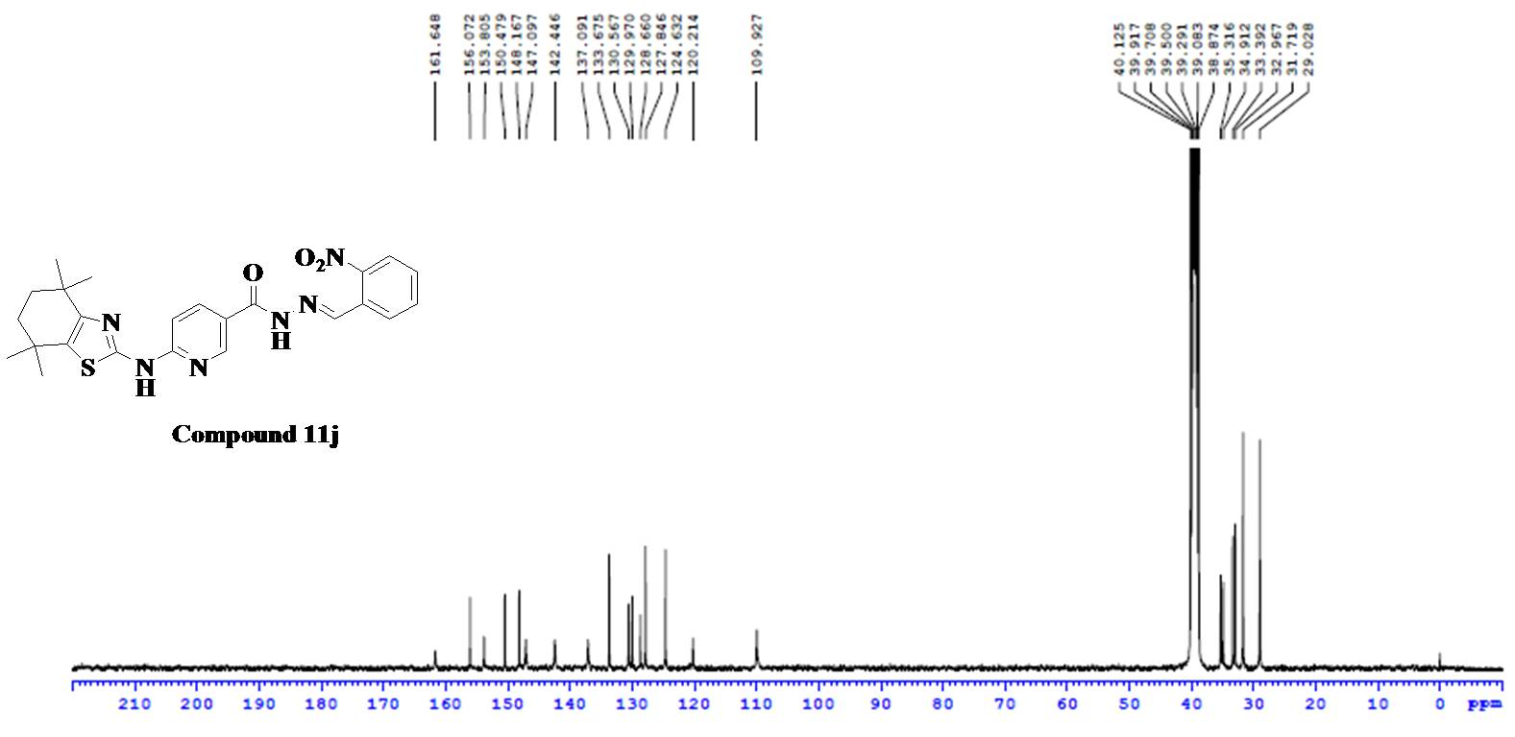
Fig.58. ¹³C NMR Spectra of Compound 11j
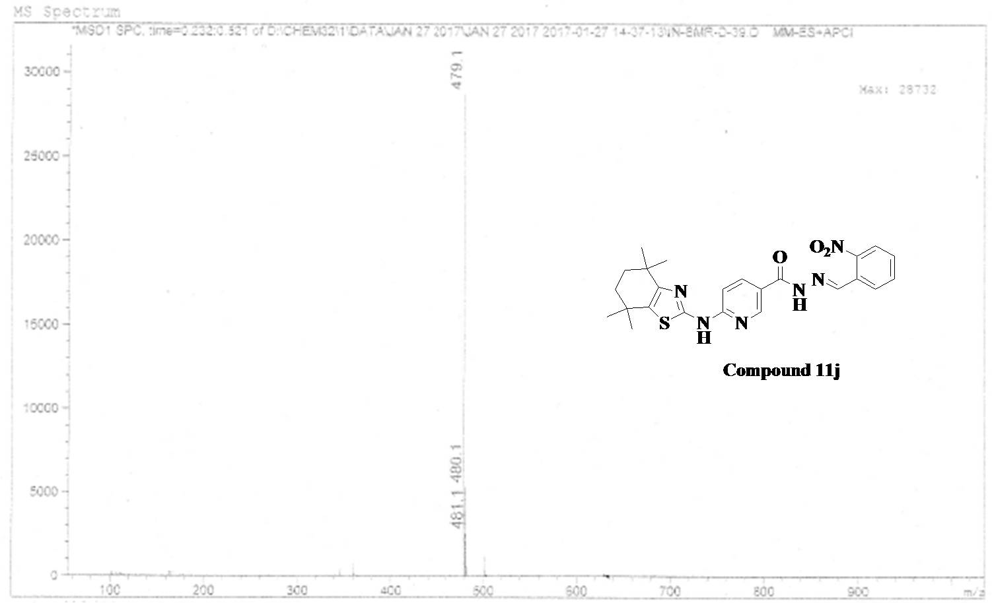
Fig.59. ESI-MS Spectra of Compound 11j

Analytical data of Compound 11k
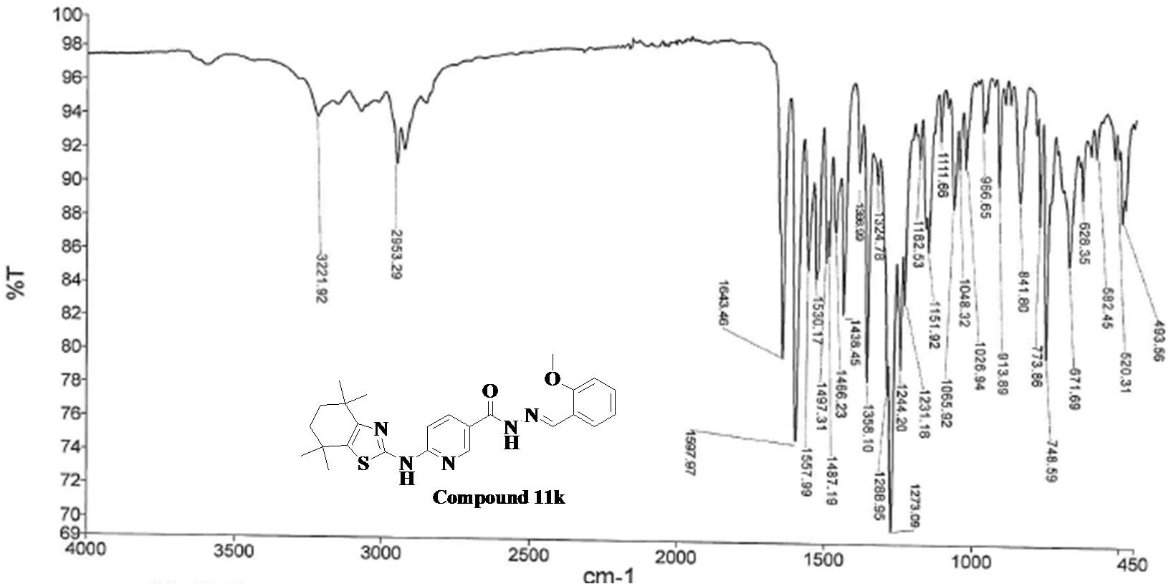
Fig.60. FT-IR Spectra of Compound 11k
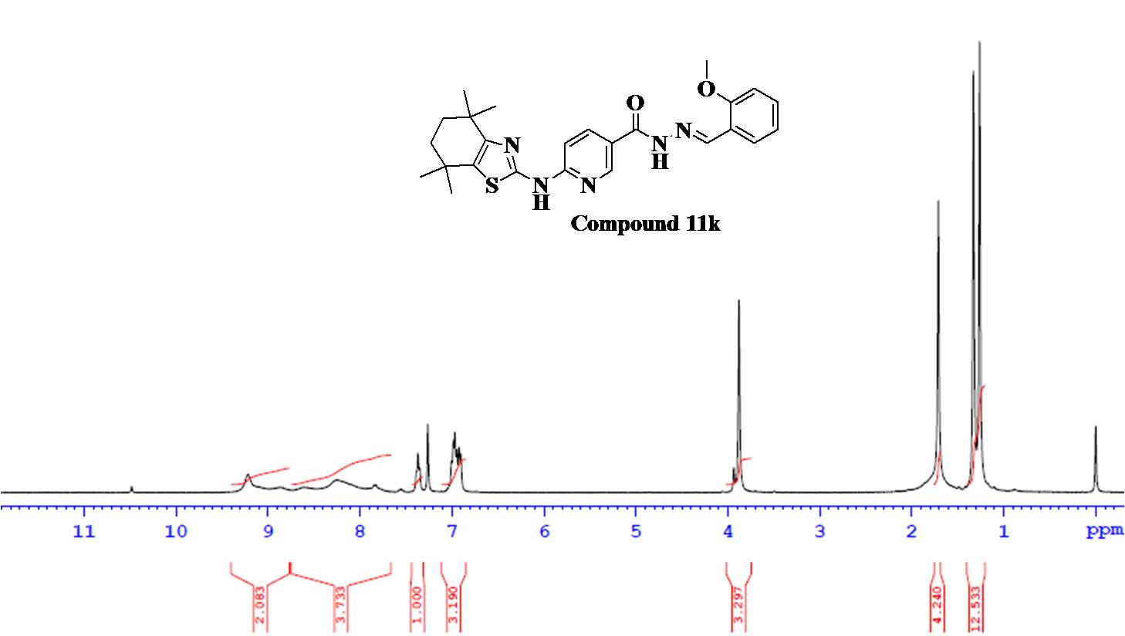
Fig.61. ¹H NMR Spectra of Compound 11k

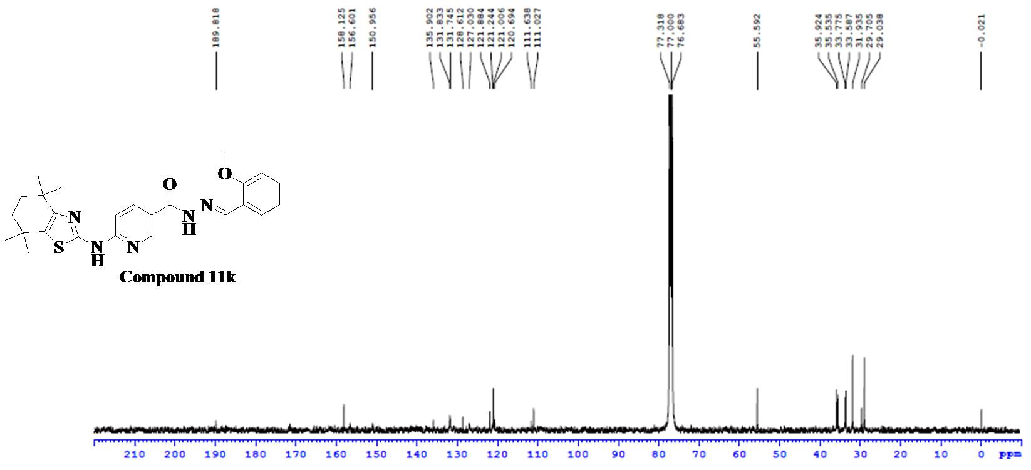
Fig.62. ¹³C NMR Spectra of Compound 11k
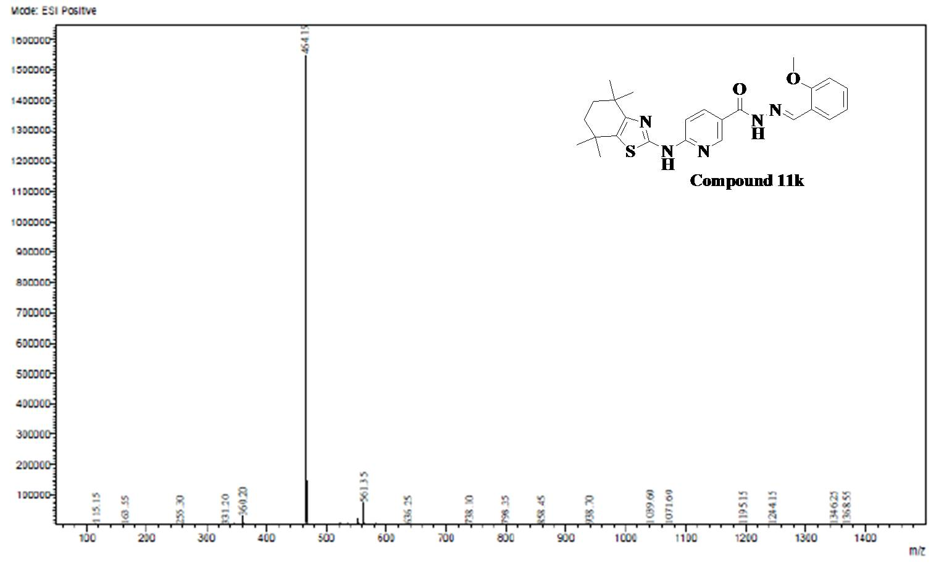
Fig.63. ESI-MS Spectra of Compound 11k
Analytical data of Compound 11l
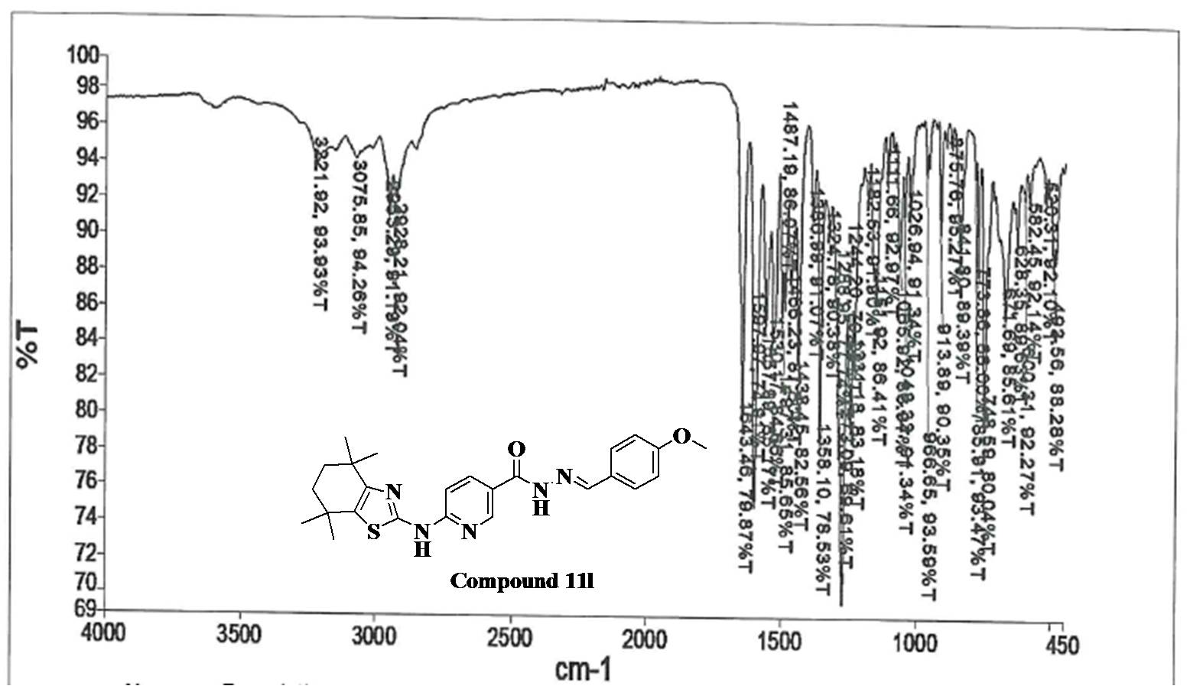
Fig.64. FT-IR Spectra of Compound 11l
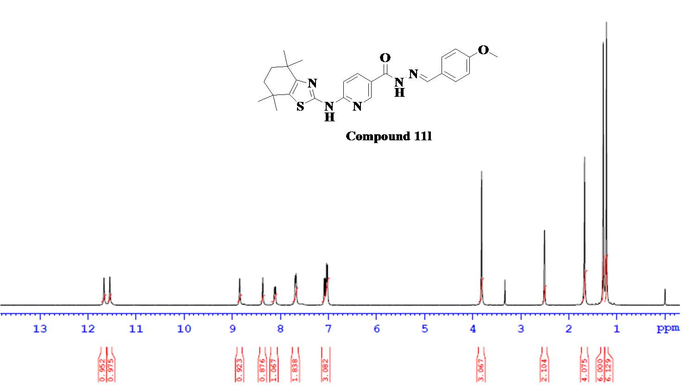

Fig.65. ¹H NMR Spectra of Compound 11l

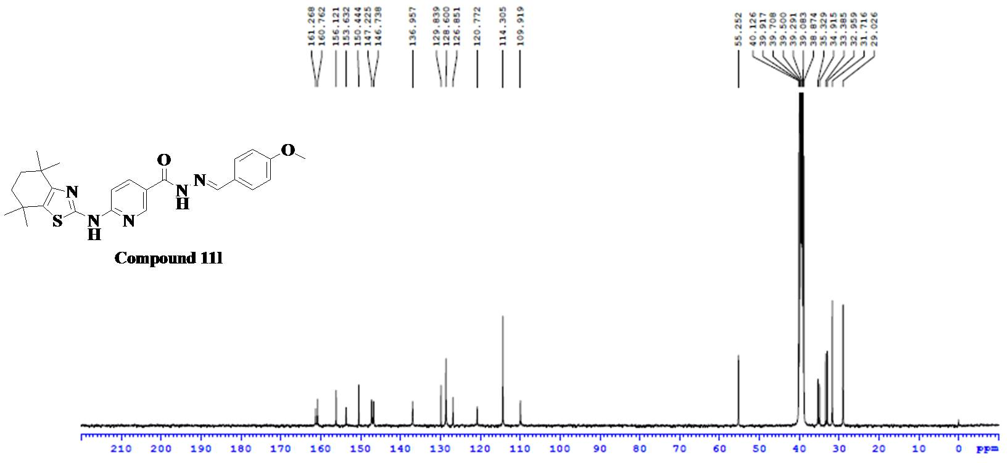
Fig.66. ¹³C NMR Spectra of Compound 11l
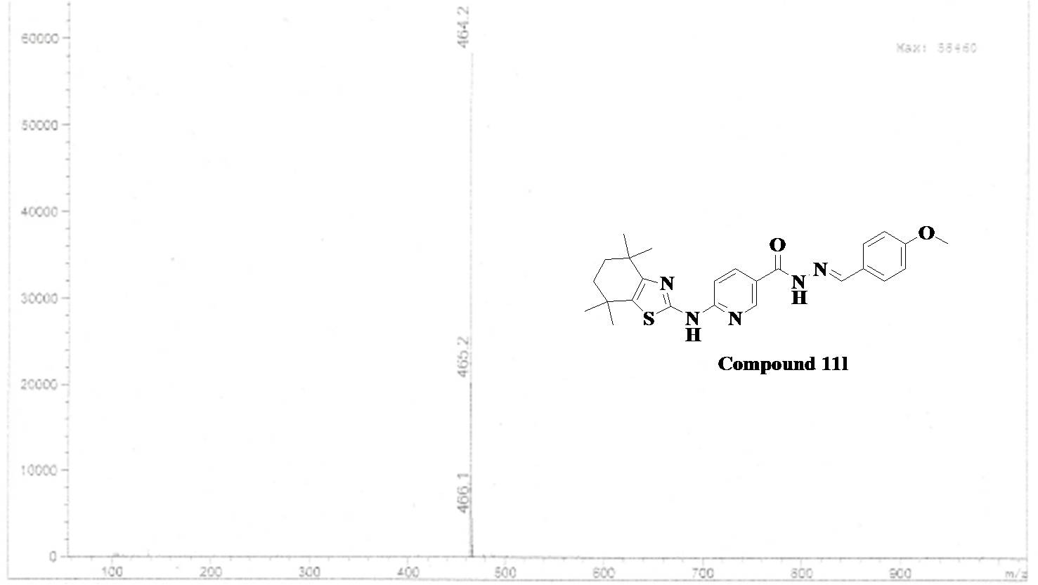
Fig.67. ESI-MS Spectra of Compound 11l

Analytical data of Compound 11m
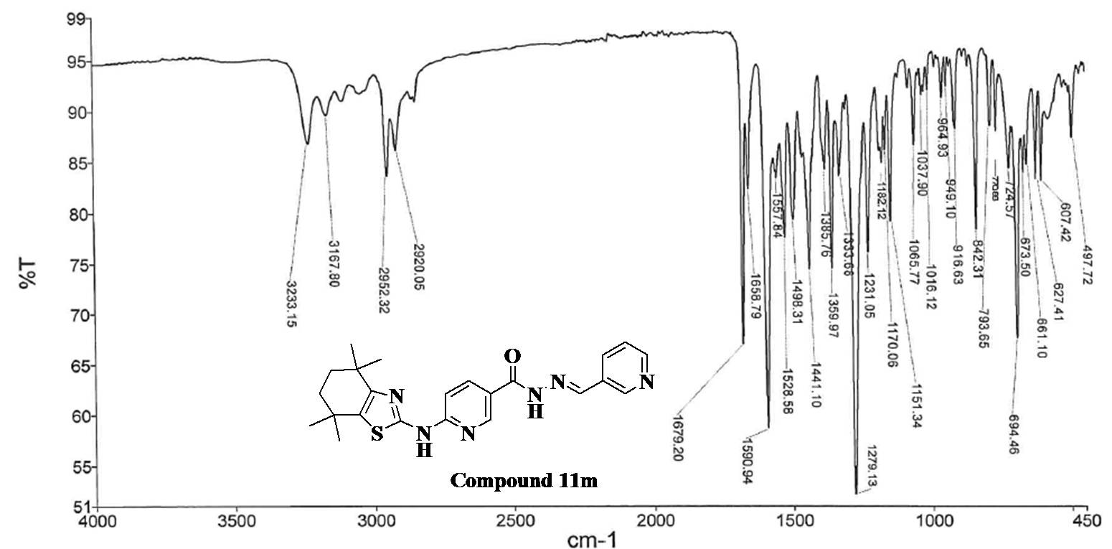
Fig.68. FT-IR Spectra of Compound 11m
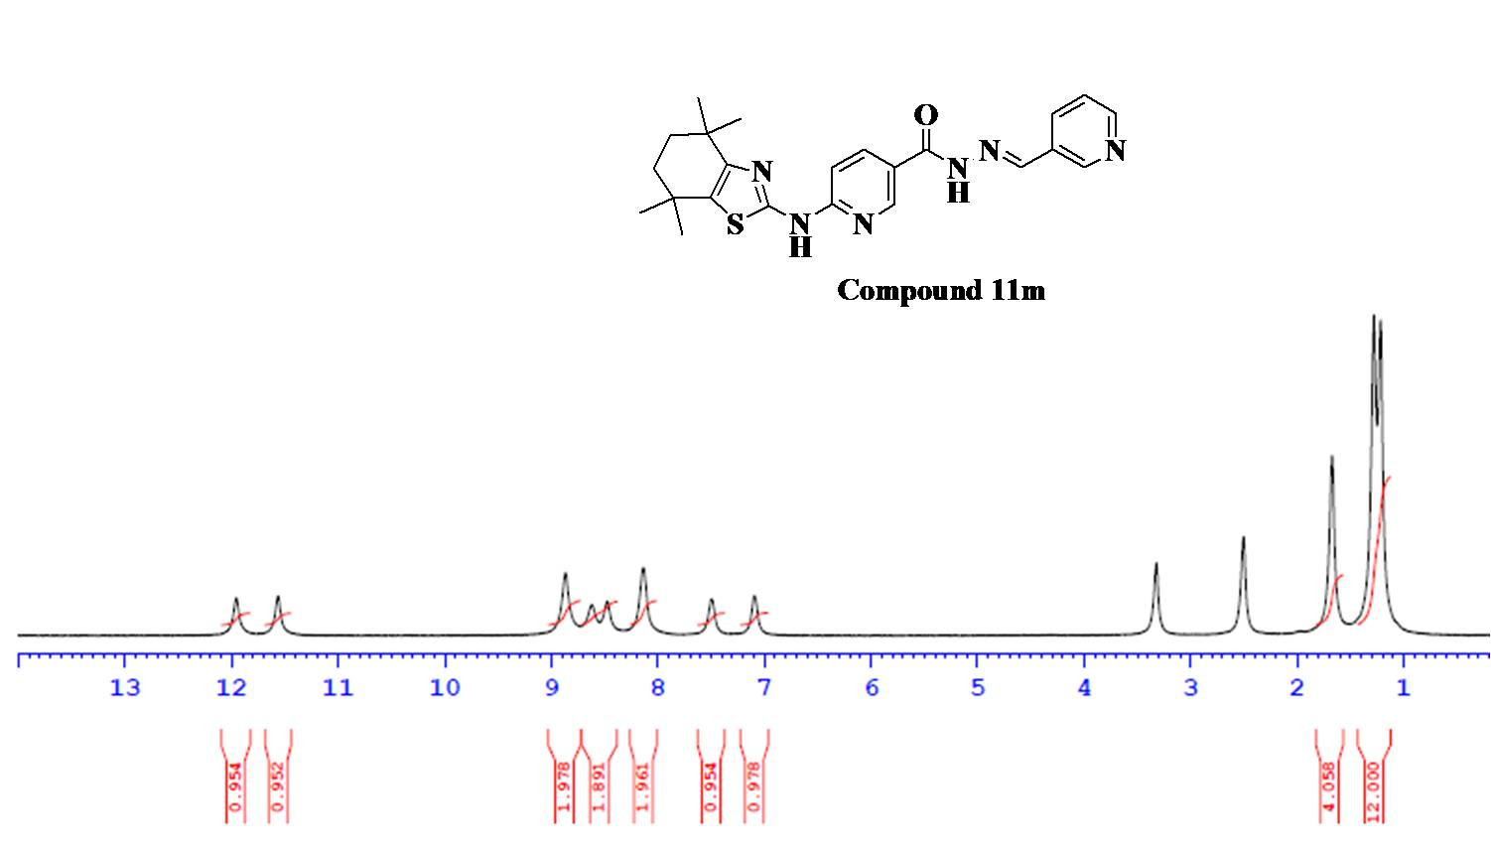
Fig.69. ¹H NMR Spectra of Compound 11m

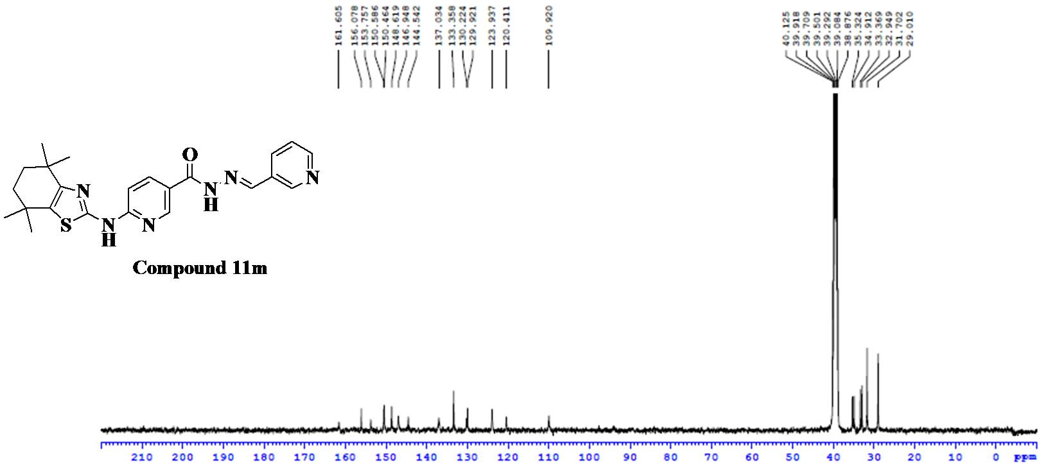
Fig.70. ¹³C NMR Spectra of Compound 11m
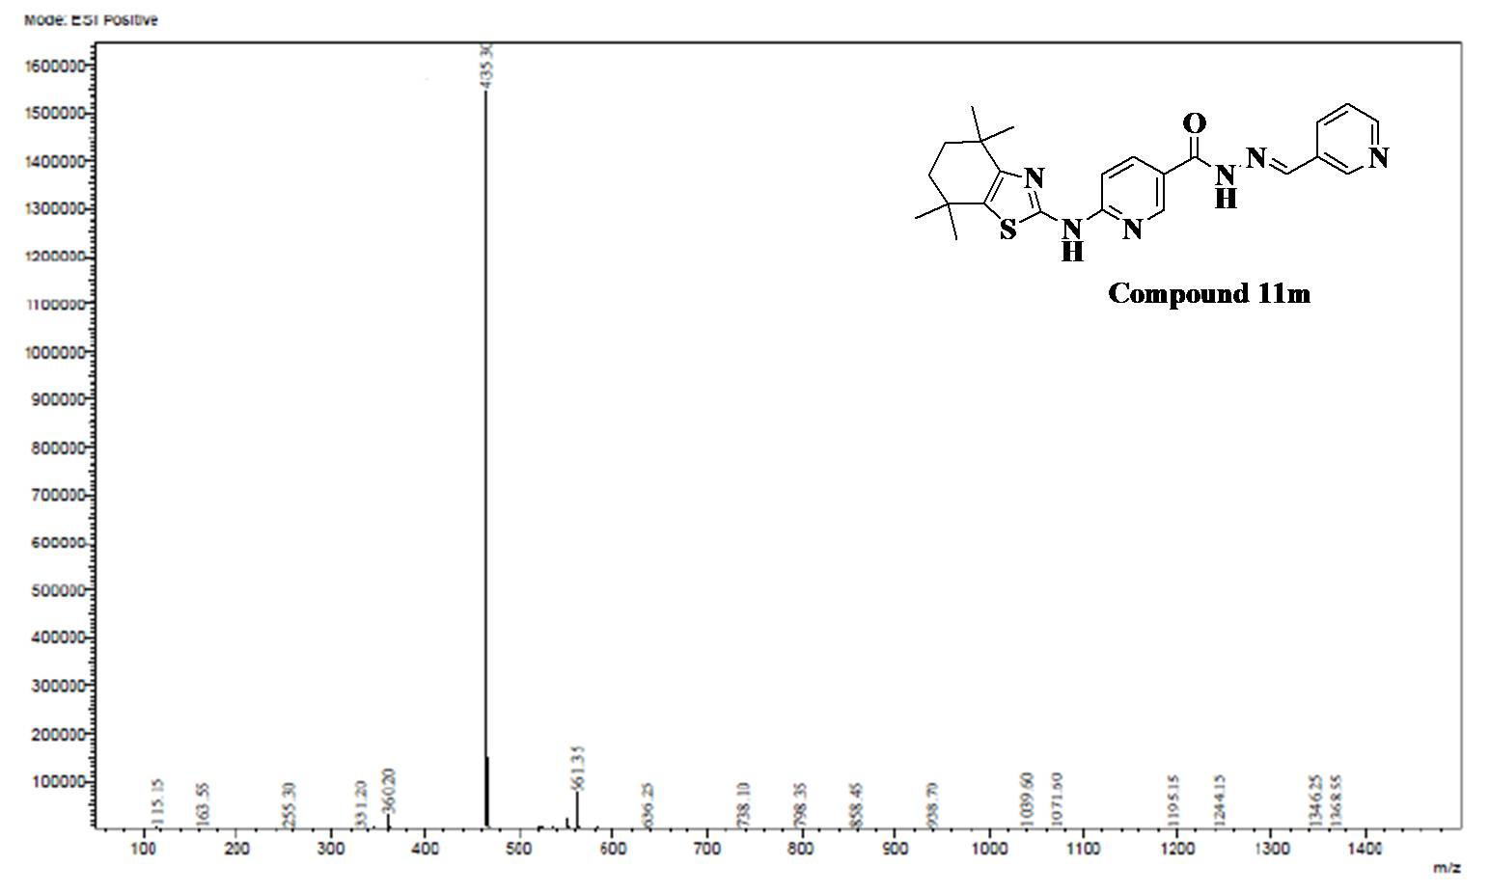
Fig.71. ESI-MS Spectra of Compound 11m

Analytical data of Compound 11n
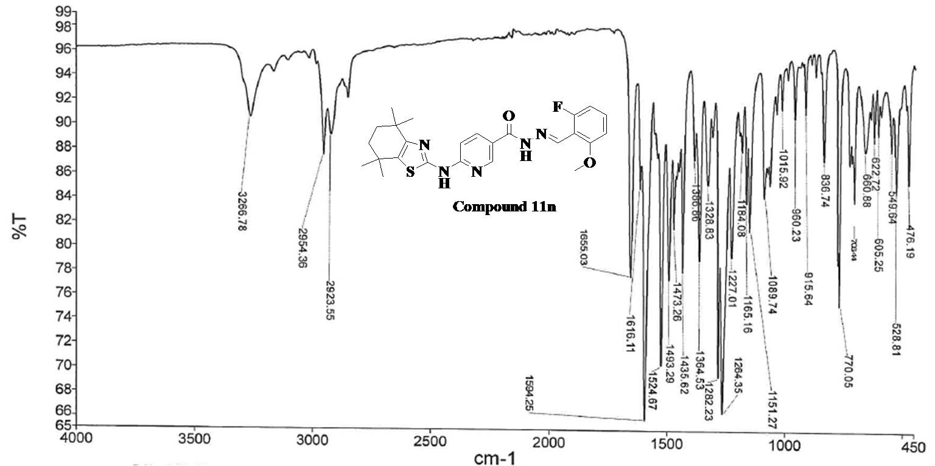
Fig.72. FT-IR Spectra of Compound 11n
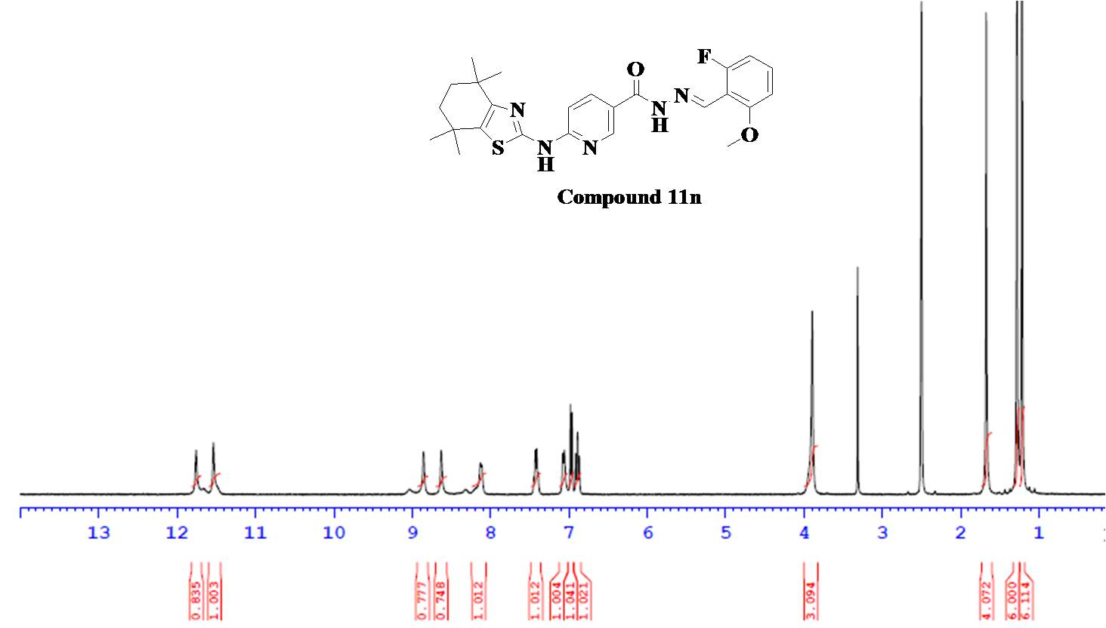
Fig.73. ¹H NMR Spectra of Compound 11m

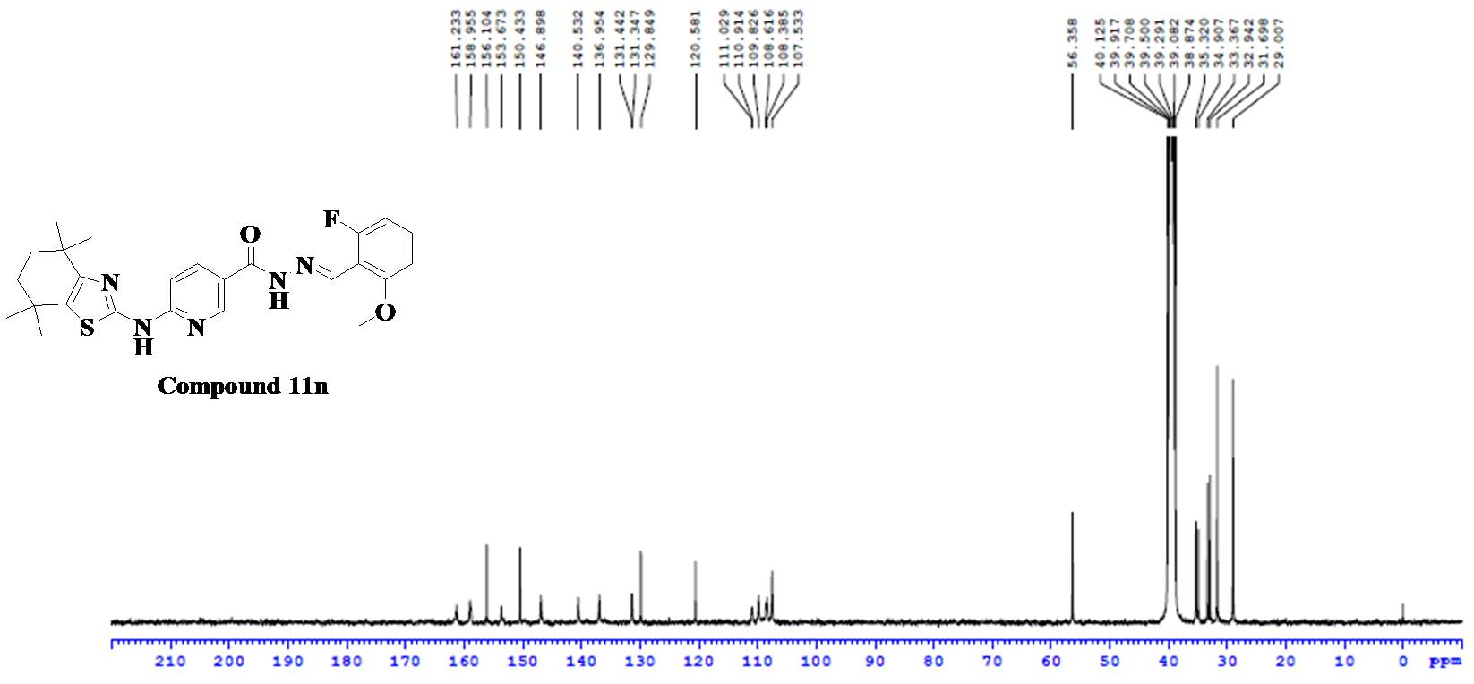
Fig.74. ¹³C NMR Spectra of Compound 11n
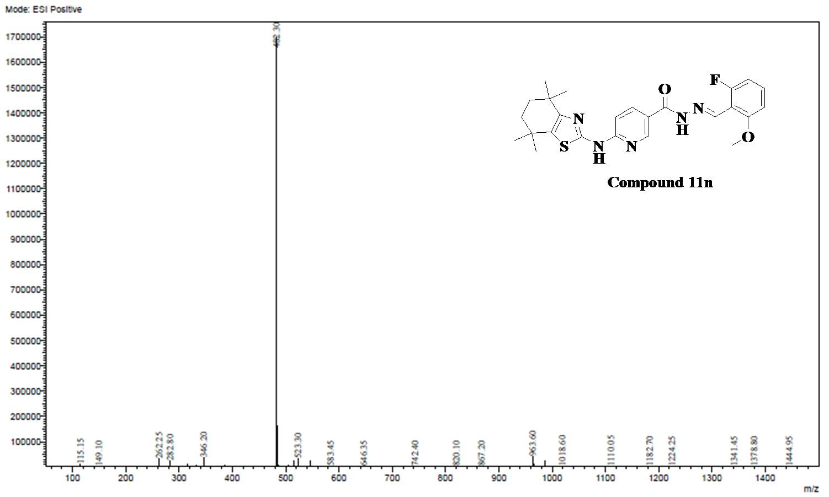
Fig.75. ESI-MS Spectra of Compound 11n

Analytical data of Compound 11o
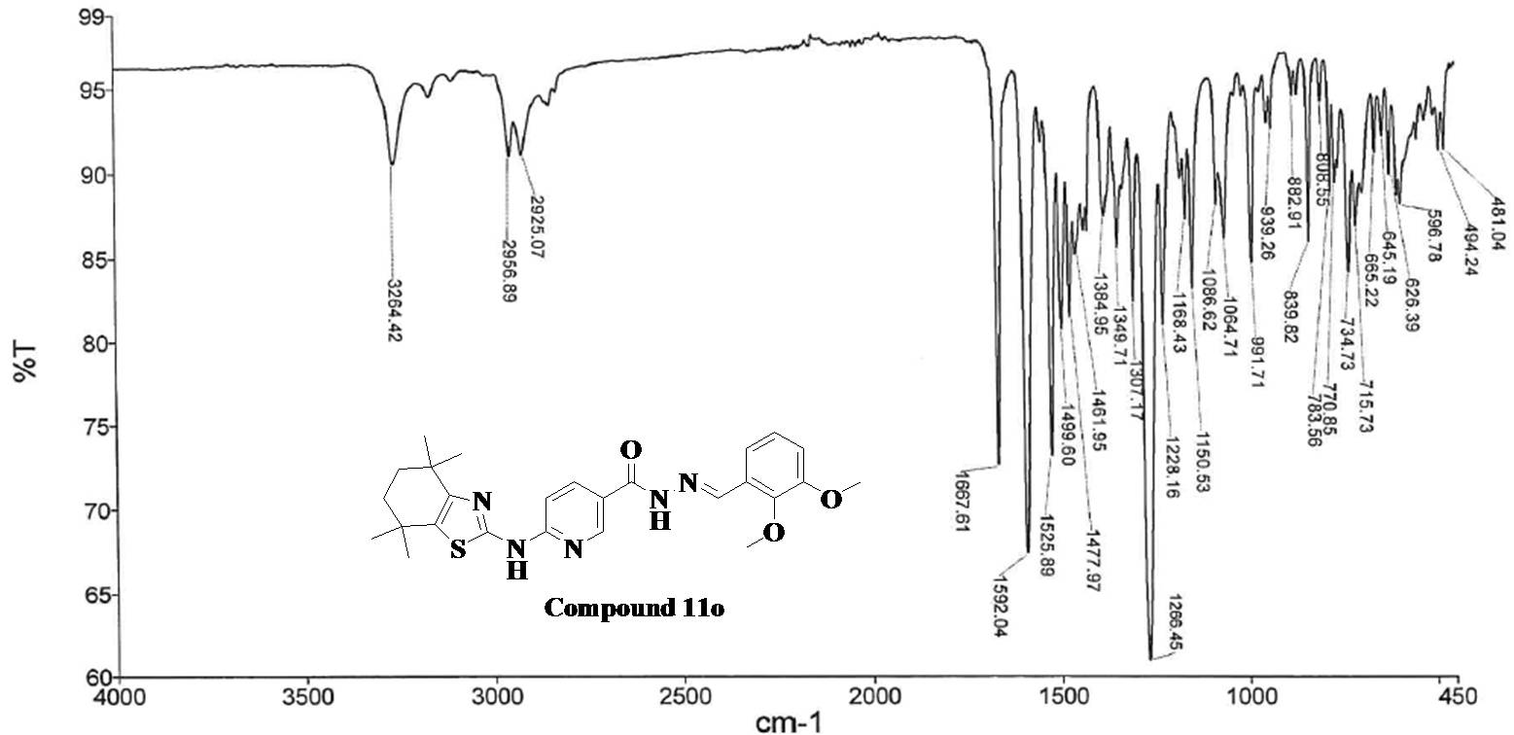
Fig.76. FT-IR Spectra of Compound 11o
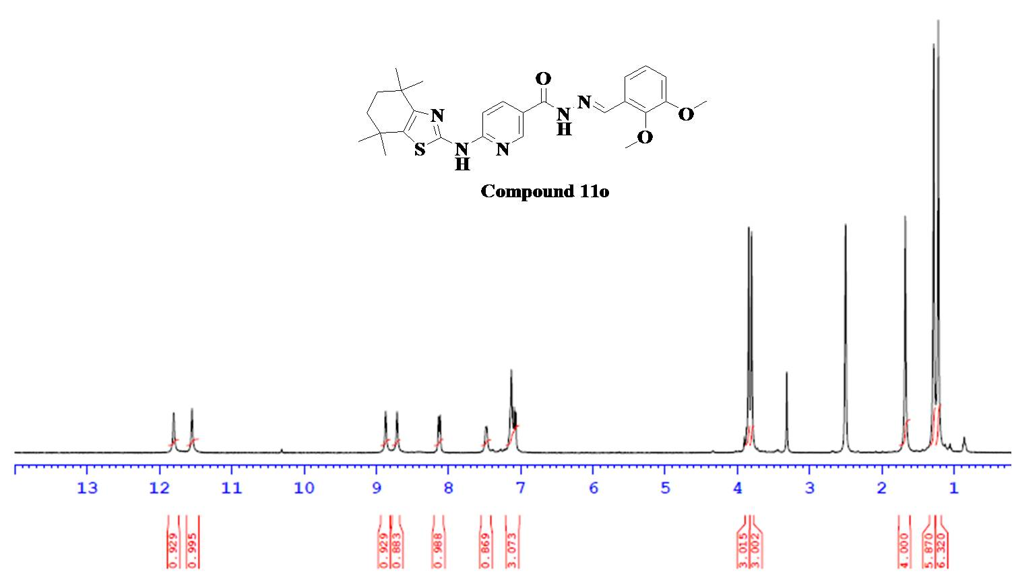
Fig.77. ¹H NMR Spectra of Compound 11o

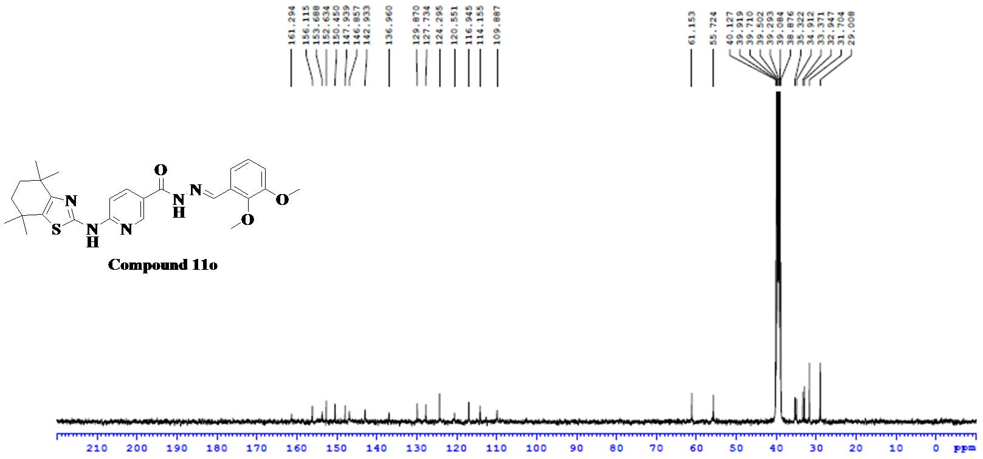
Fig.78. ¹³C NMR Spectra of Compound 11o
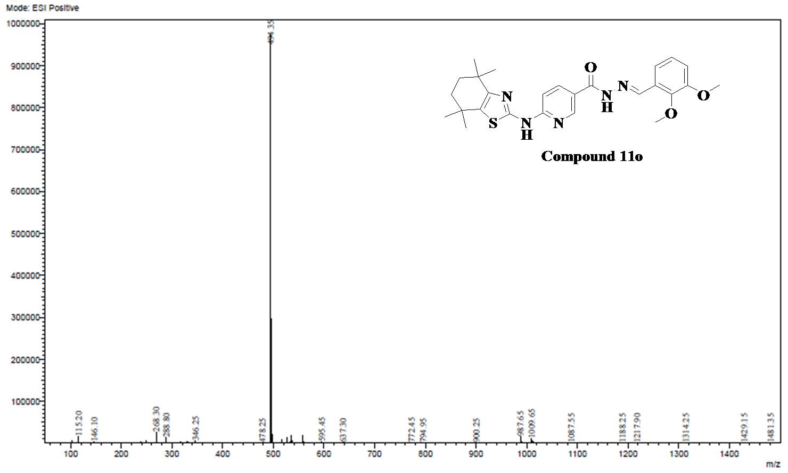
Fig.79. ESI-MS Spectra of Compound 11o
Series-II
Analytical data of Compound 12a
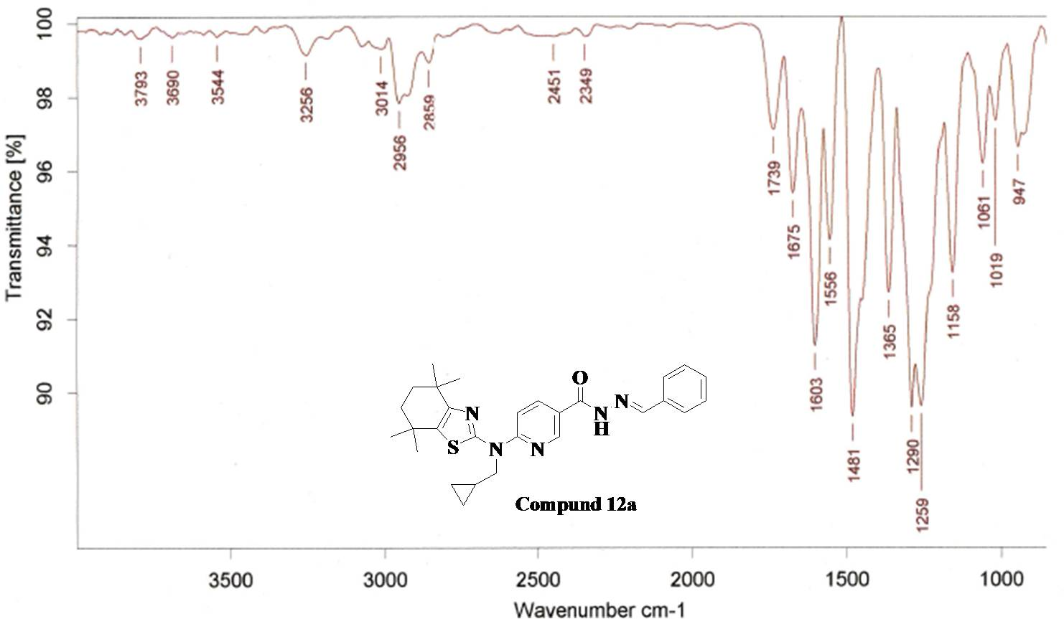
Fig.80. FT-IR Spectra of Compound 12a
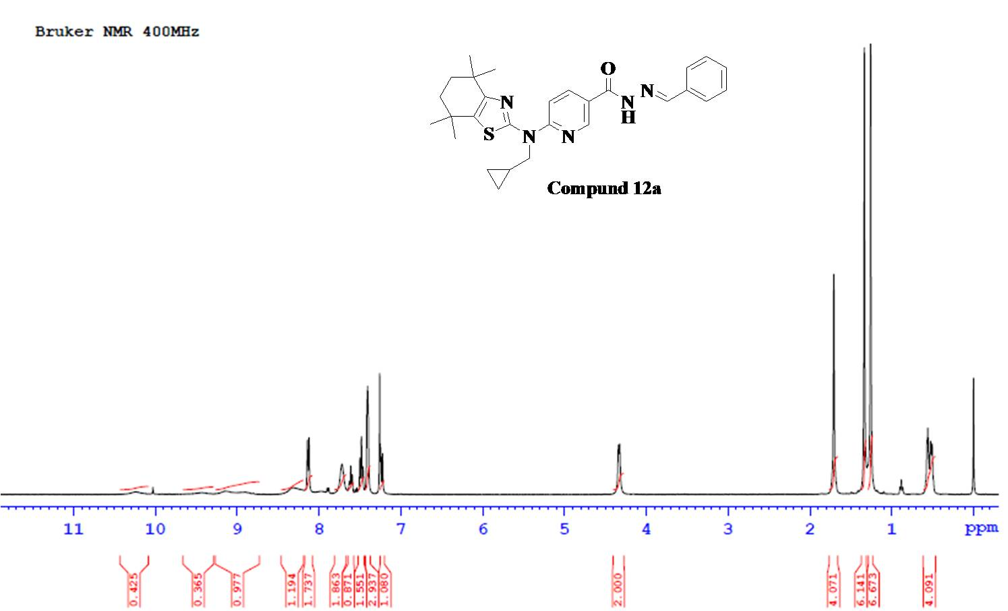
Fig.81. ¹H NMR Spectra of Compound 12a

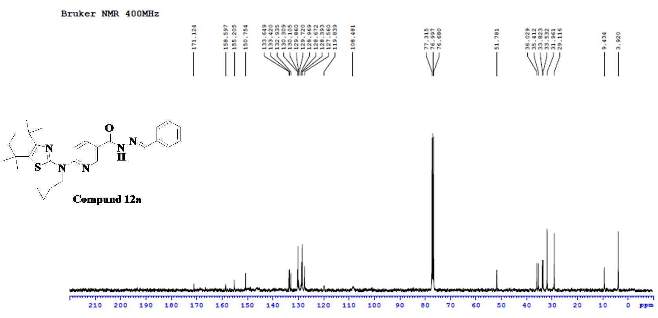
Fig.82. ¹³C NMR Spectra of Compound 12a
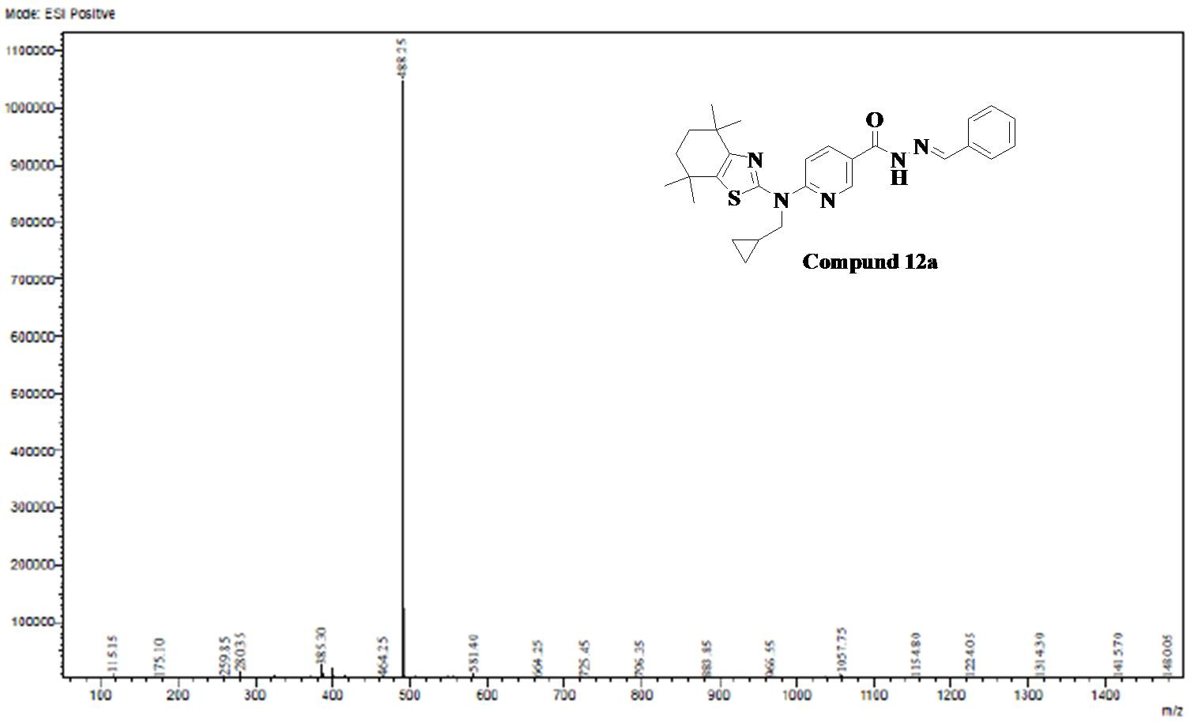
Fig.83. ESI-MS Spectra of Compound 12a
Analytical data of Compound 12b
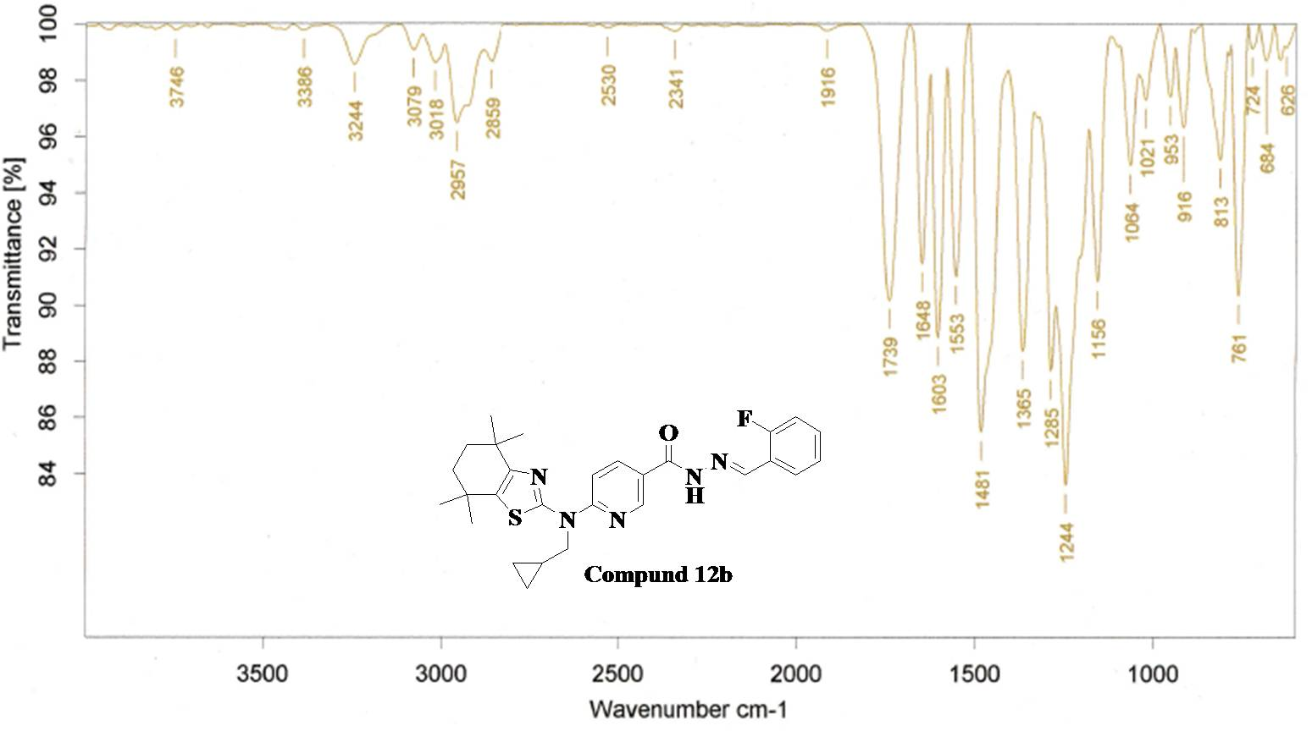
Fig.84. FT-IR Spectra of Compound 12b

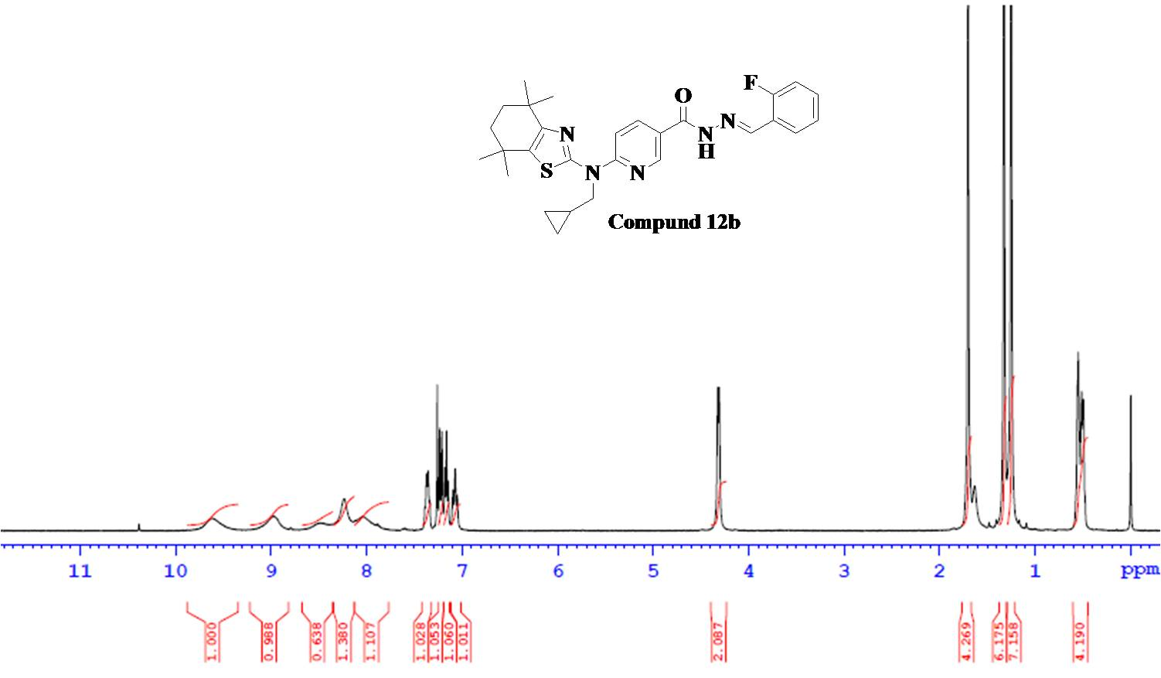
Fig.85. ¹H NMR Spectra of Compound 12b

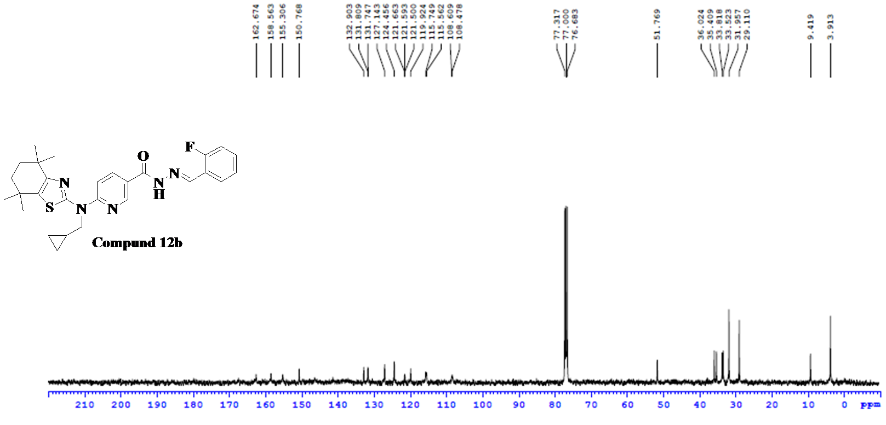
Fig.86. ¹³C NMR Spectra of Compound 12b
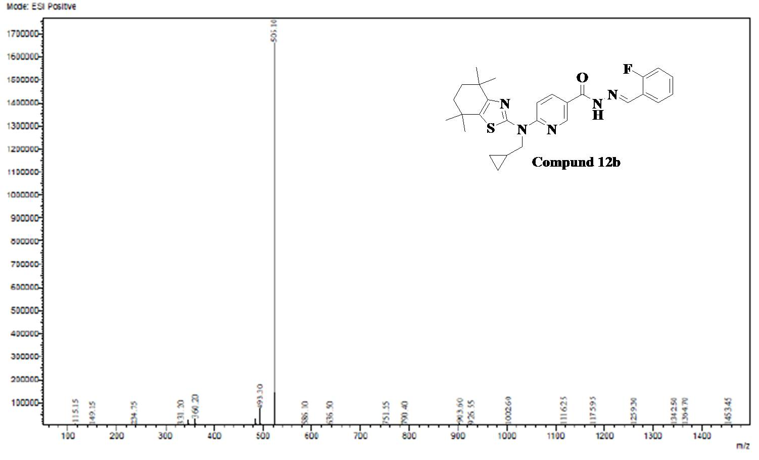
Fig.87. ESI-MS Spectra of Compound 12b

Analytical data of Compound 12c
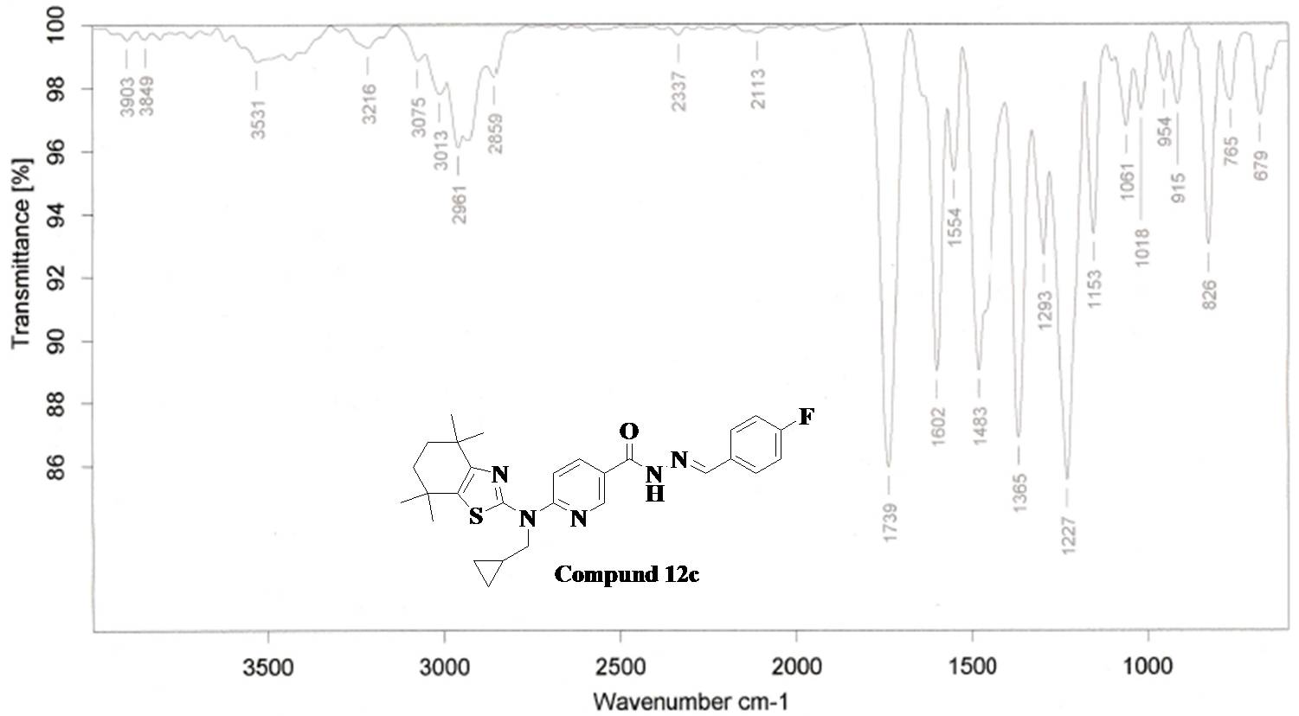
Fig.88. FT-IR Spectra of Compound 12c
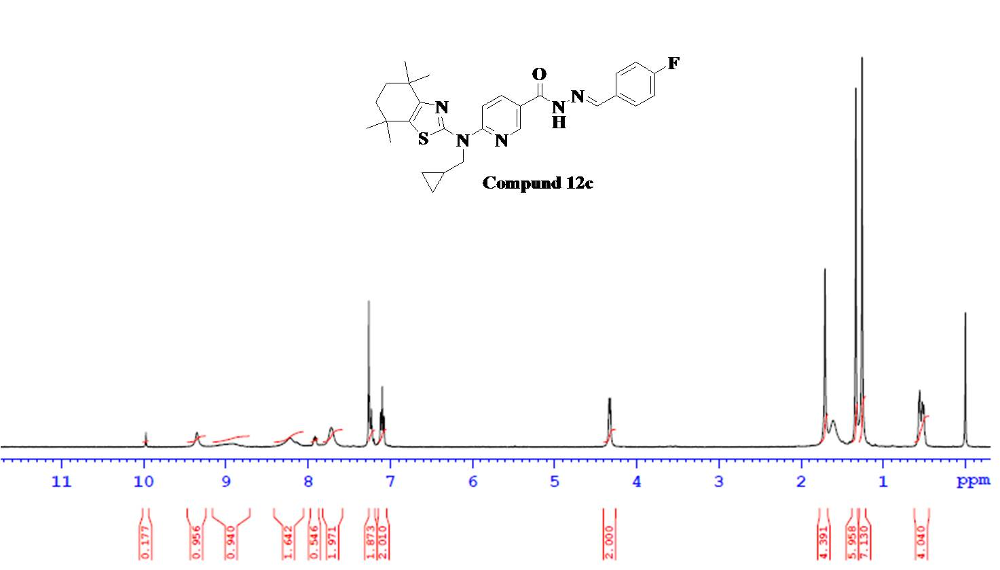
Fig.89. ¹H NMR Spectra of Compound 12c

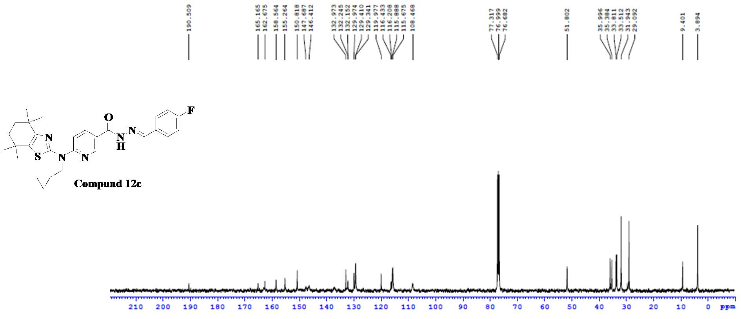
Fig.90. ¹³C NMR Spectra of Compound 12c
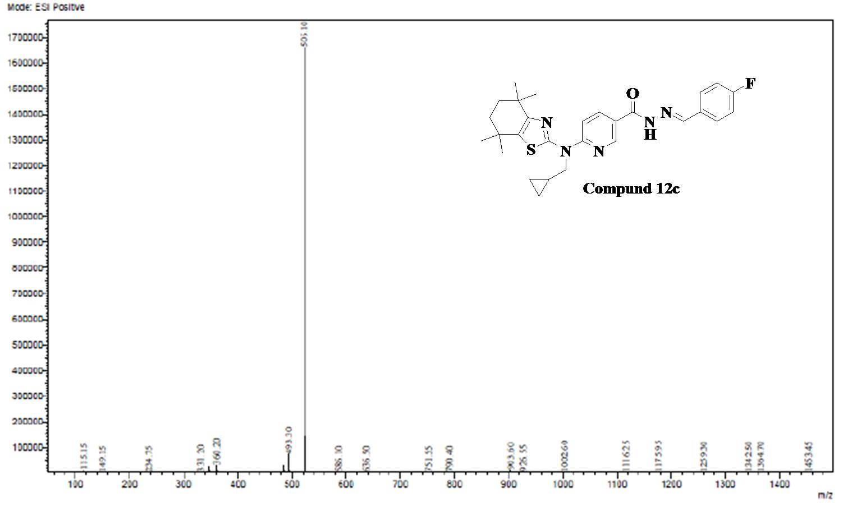
Fig.91. ESI-MS Spectra of Compound 12c

Analytical data of Compound 12d
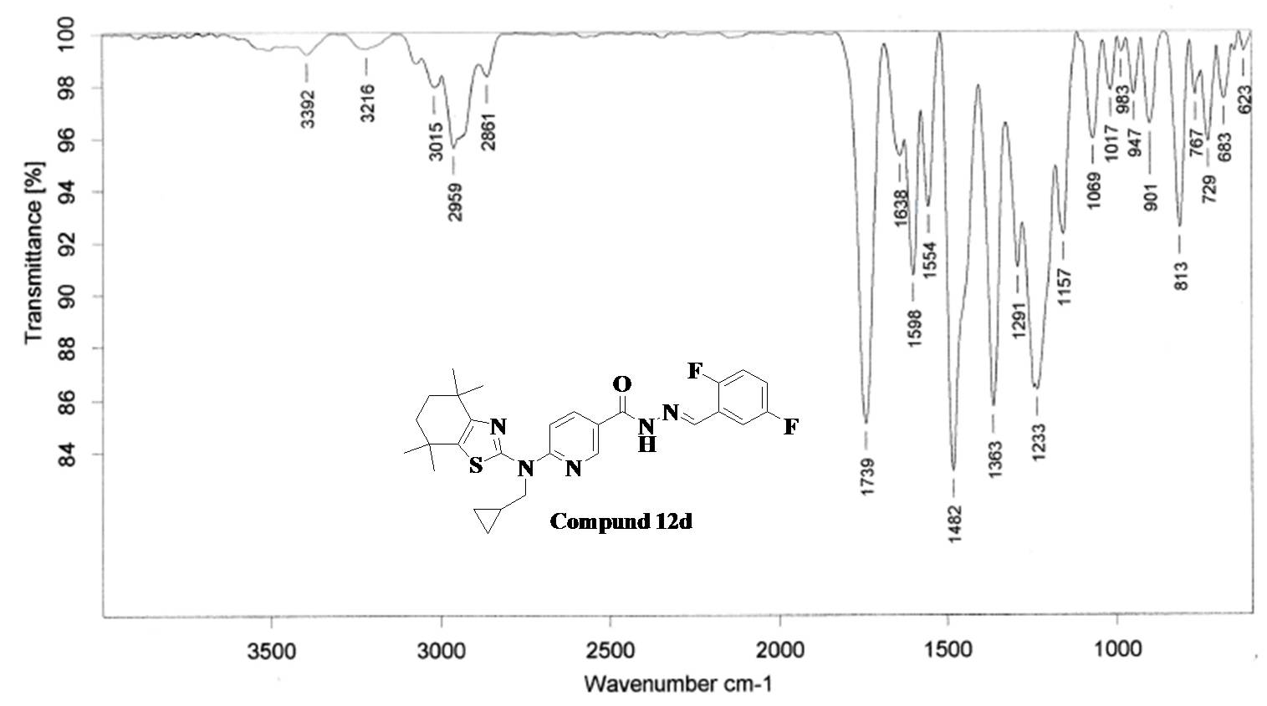
Fig.92. FT-IR Spectra of Compound 12d
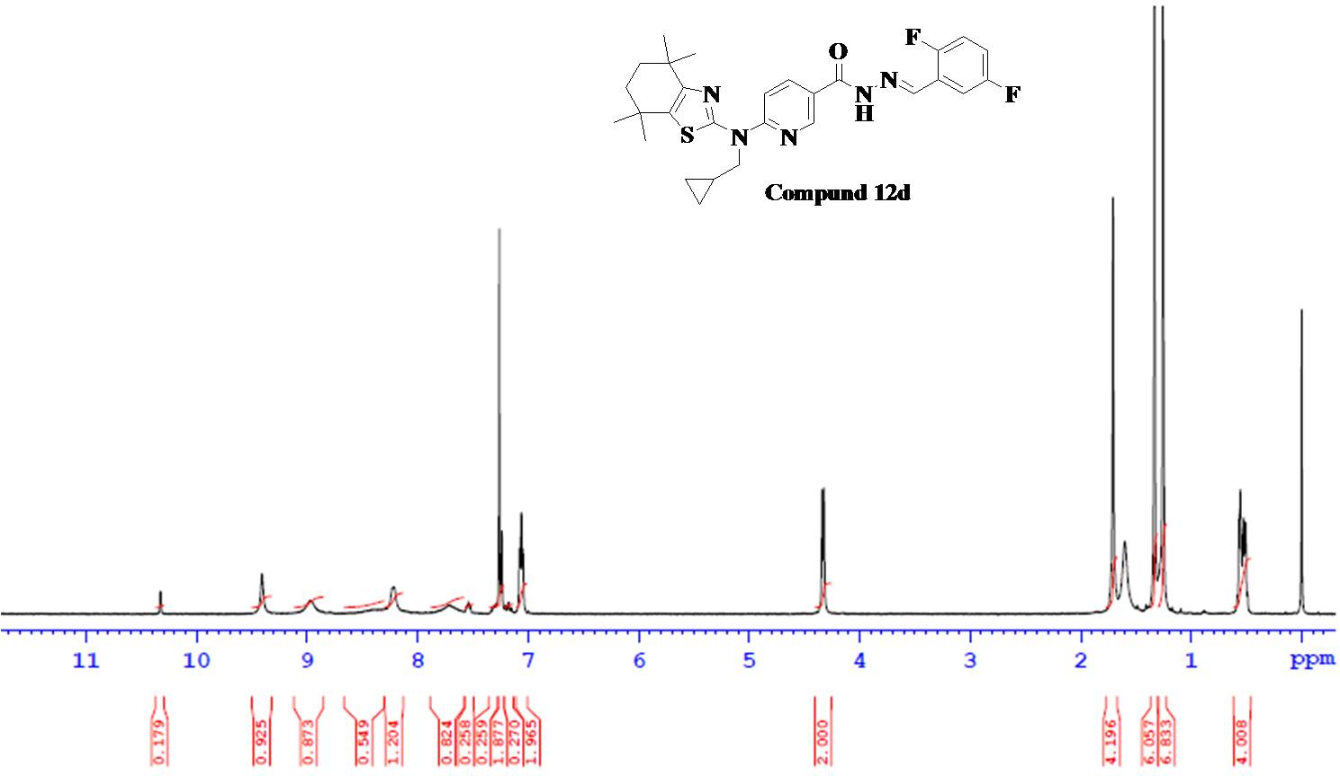
Fig.93. ¹H NMR Spectra of Compound 12d

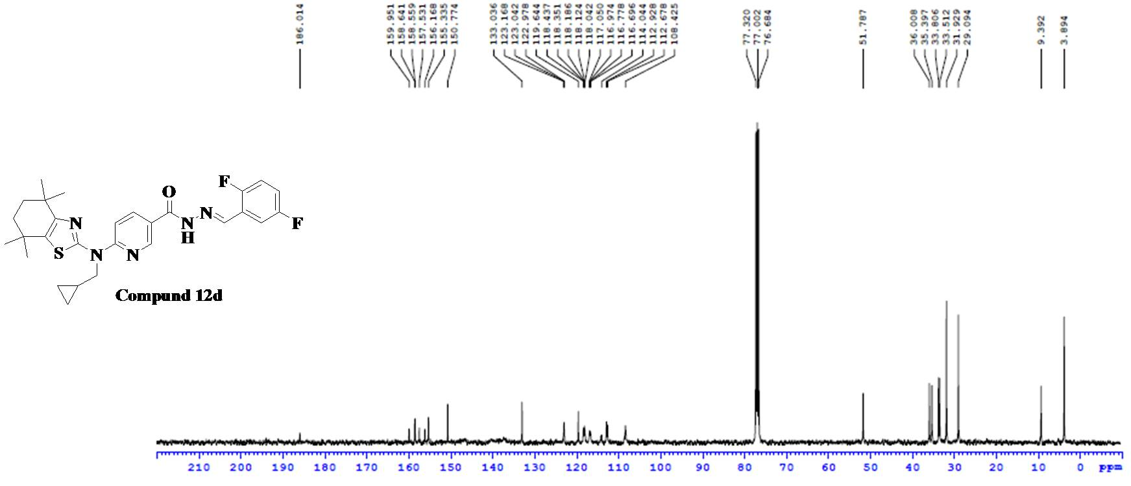
Fig.94. ¹³C NMR Spectra of Compound 12d
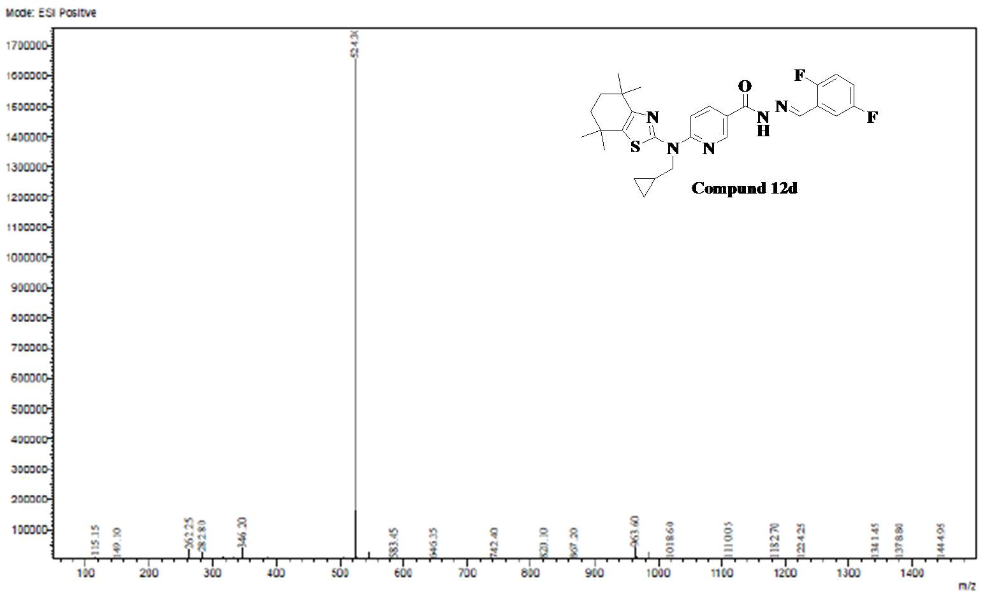
Fig.95. ESI-MS Spectra of Compound 12d
Analytical data of Compound 12e
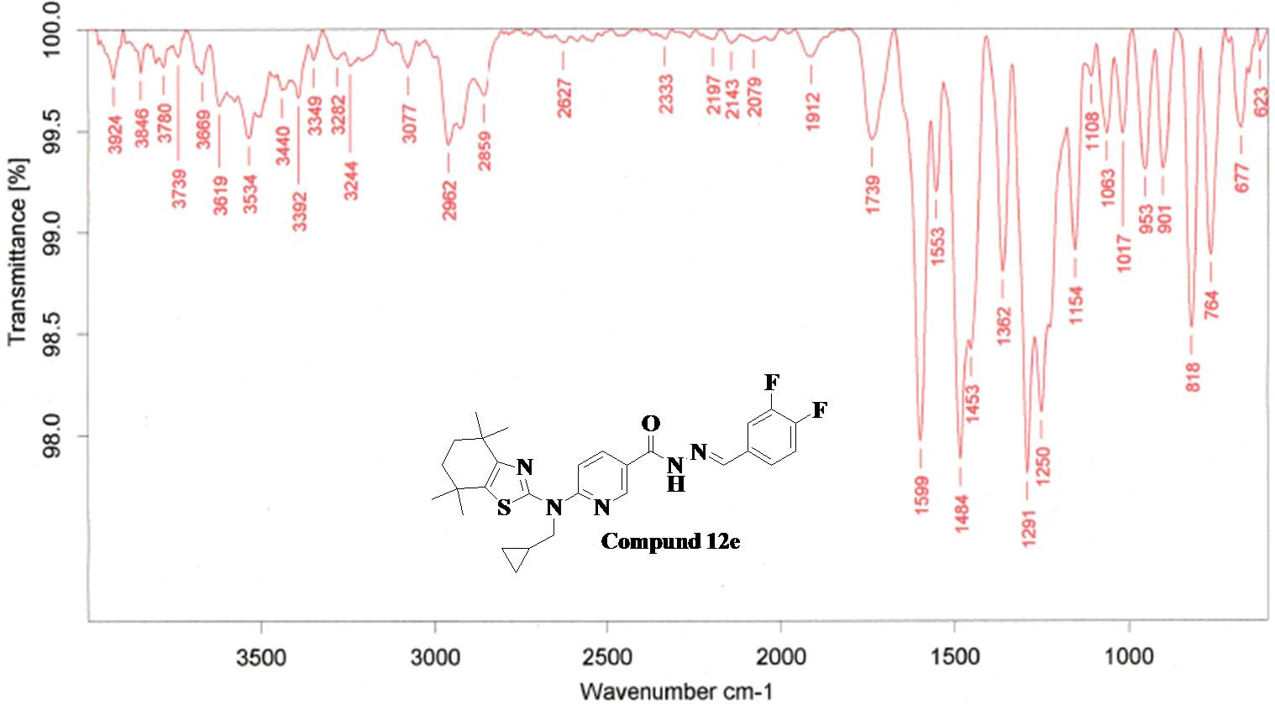
Fig.96. FT-IR Spectra of Compound 12e
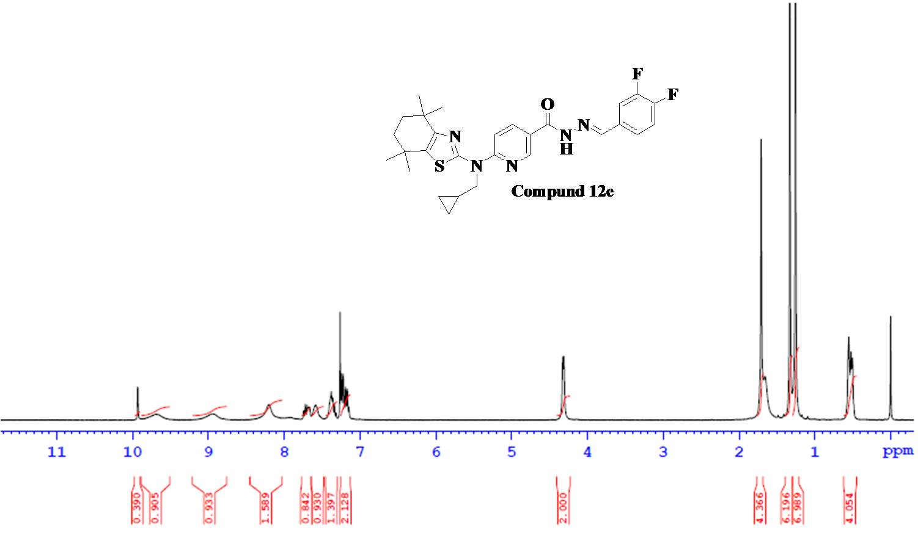

Fig.97. ¹H NMR Spectra of Compound 12e

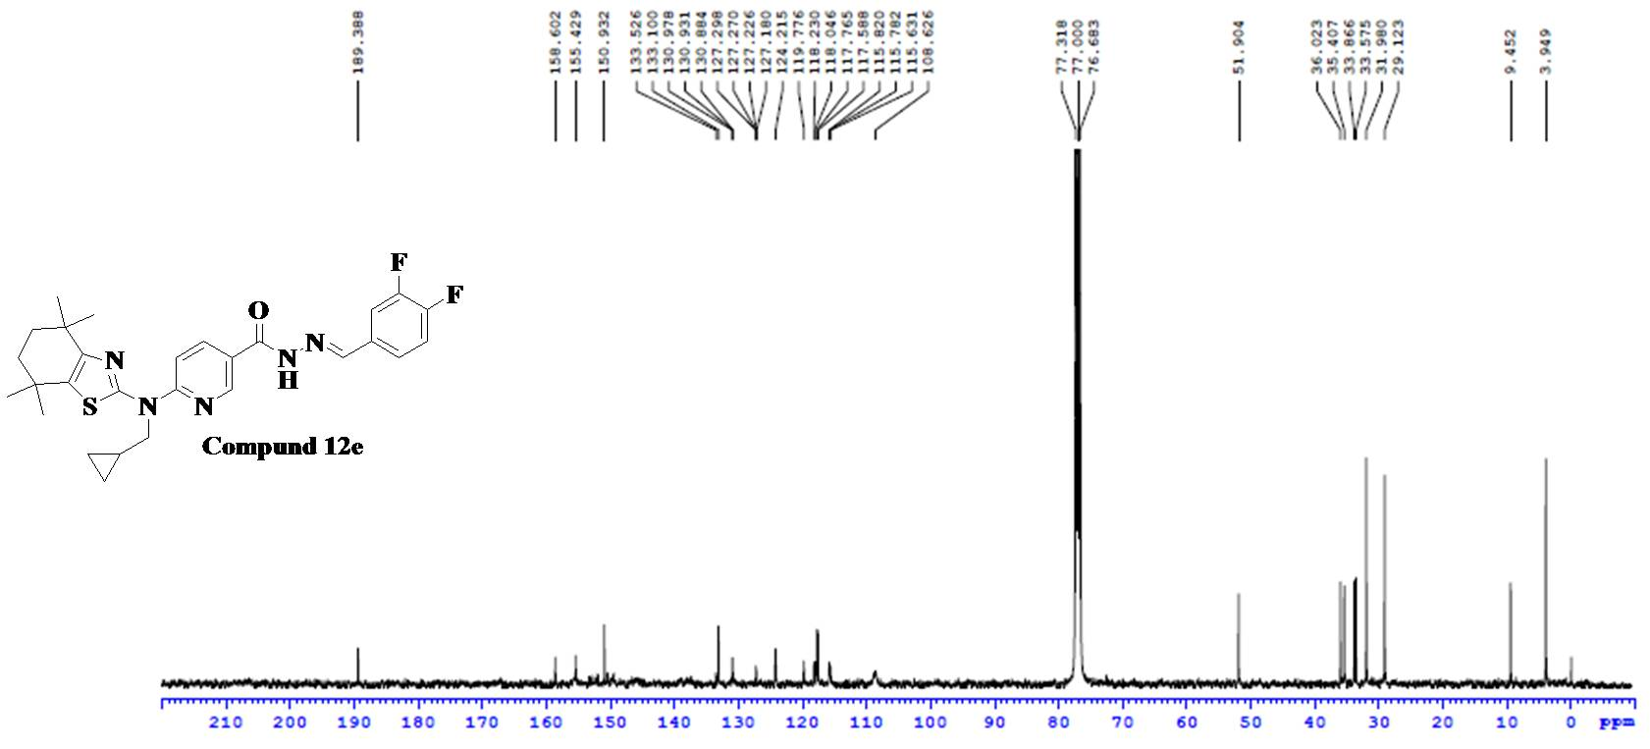
Fig.98. ¹³C NMR Spectra of Compound 12e
Fig.99. ESI-MS Spectra of Compound 12e

Analytical data of Compound 12f
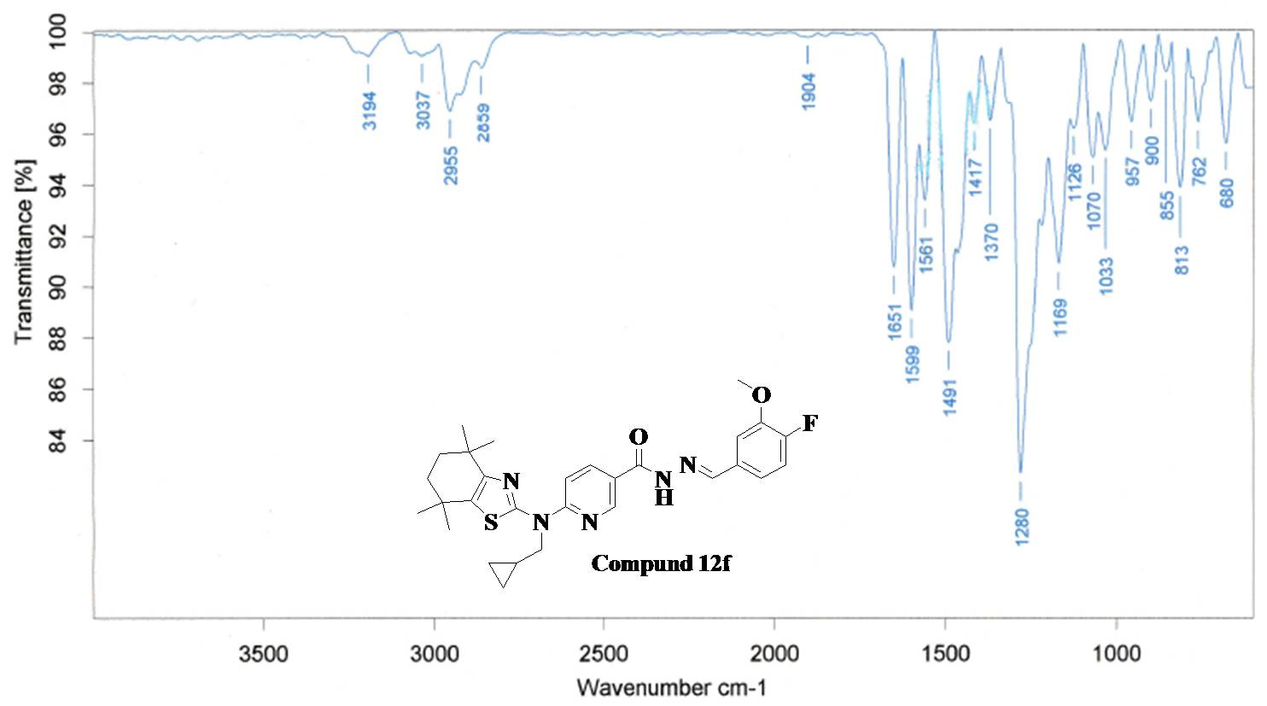
Fig.100. FT-IR Spectra of Compound 12f
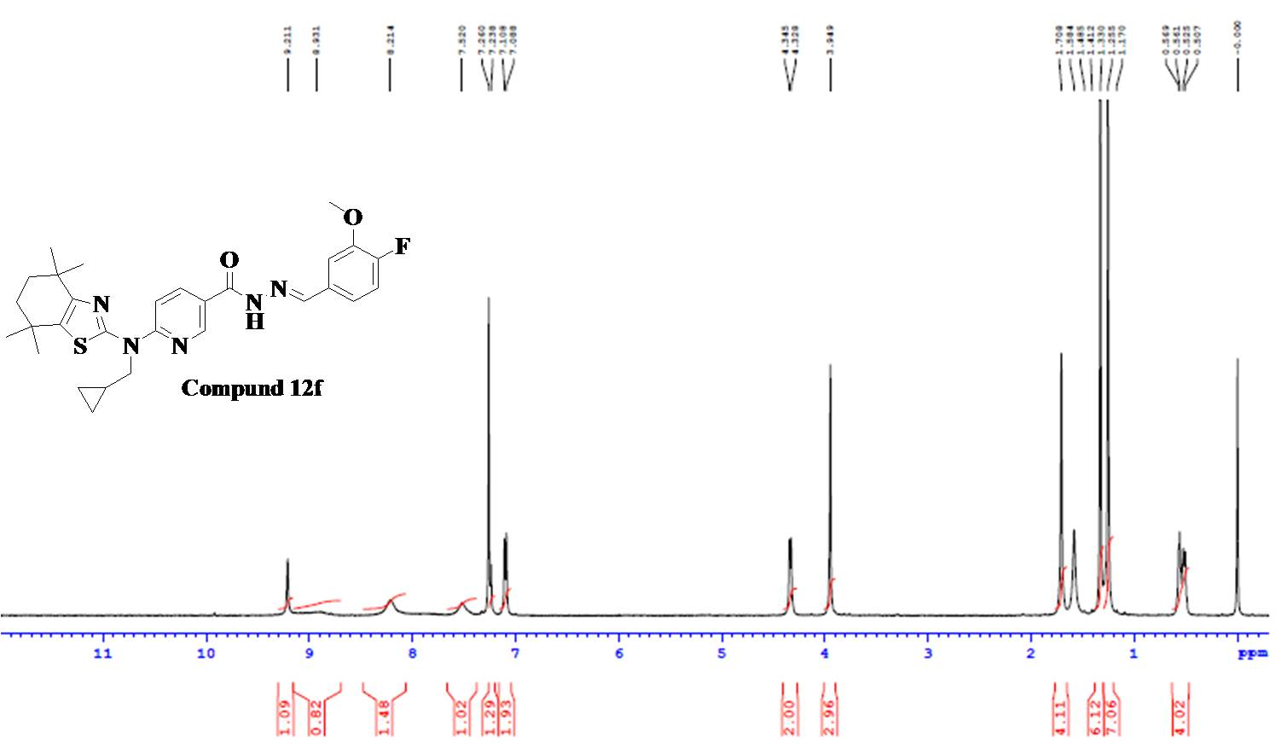
Fig.101. ¹H NMR Spectra of Compound 12f

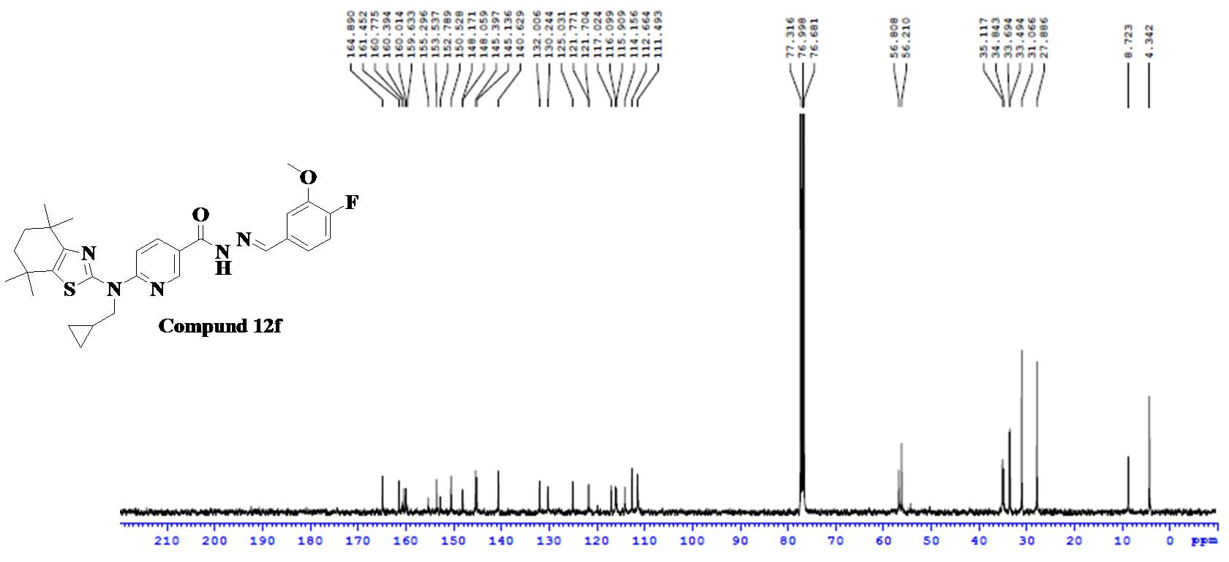
Fig.102. ¹³C NMR Spectra of Compound 12f
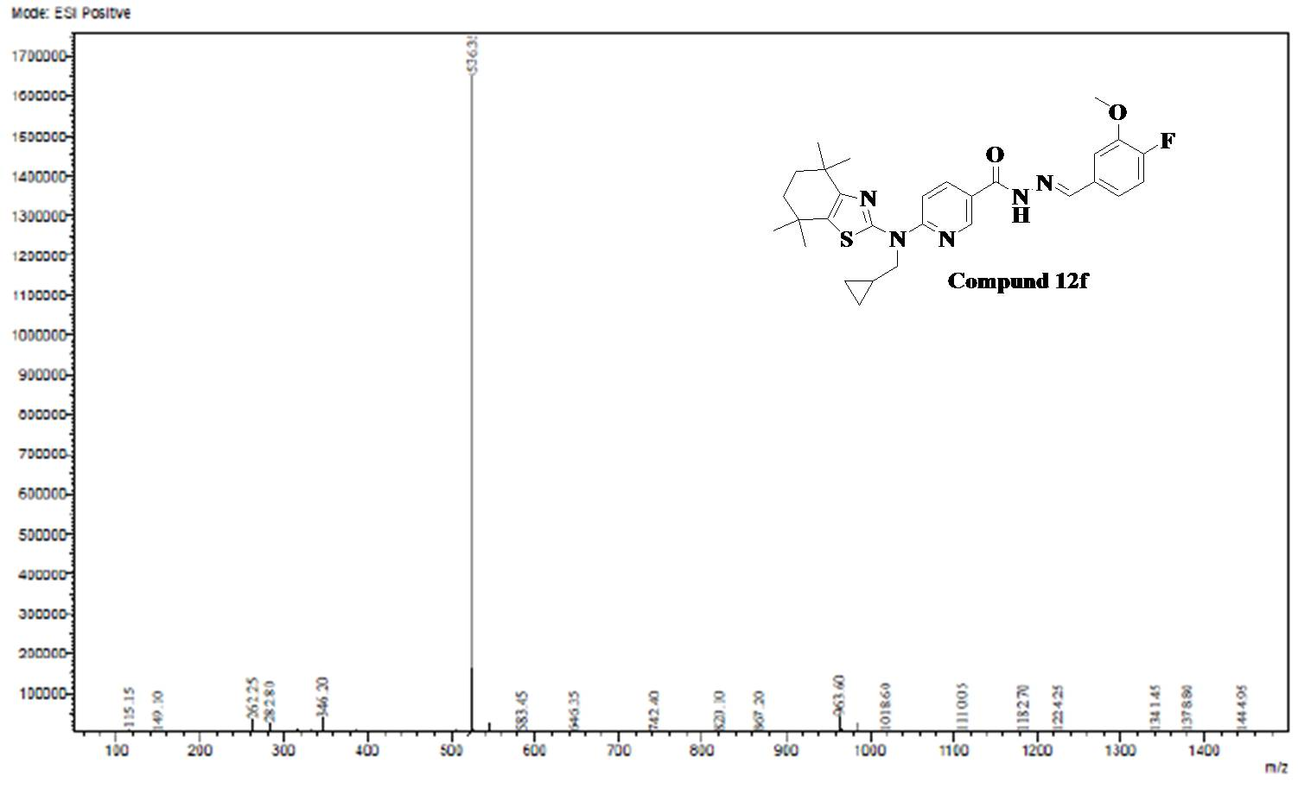
Fig.103. ESI-MS Spectra of Compound 12f

Analytical data of Compound 12g
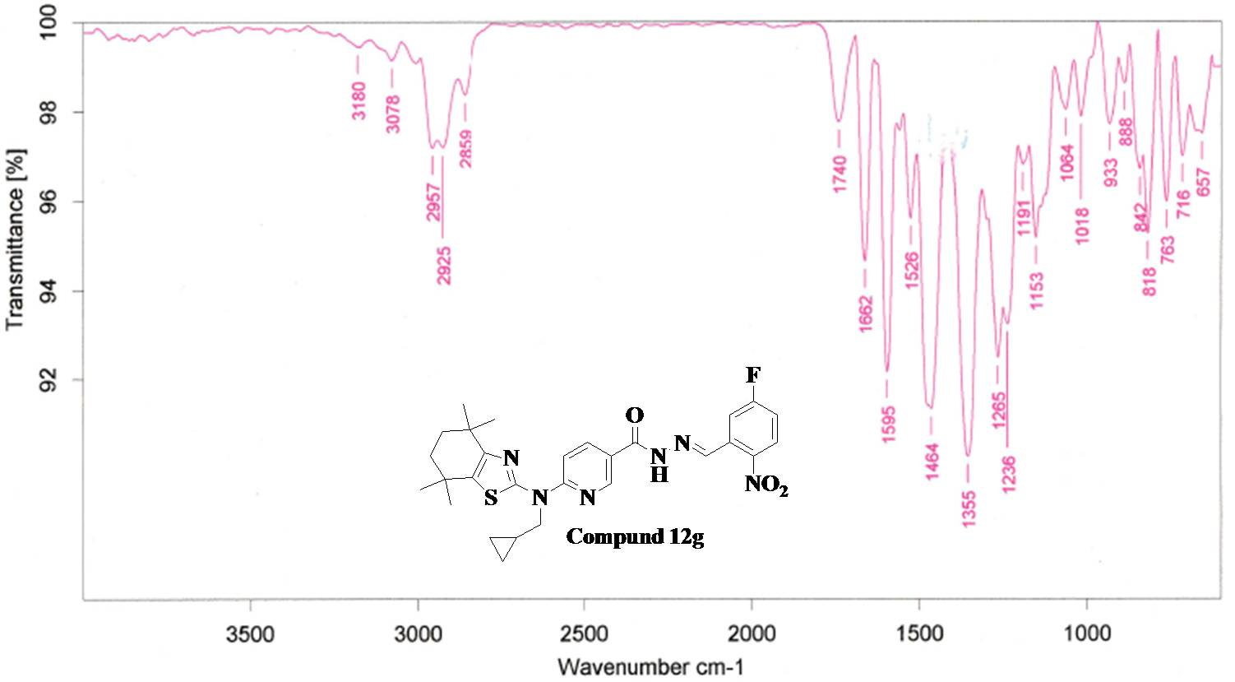
Fig.104. FT-IR Spectra of Compound 12g
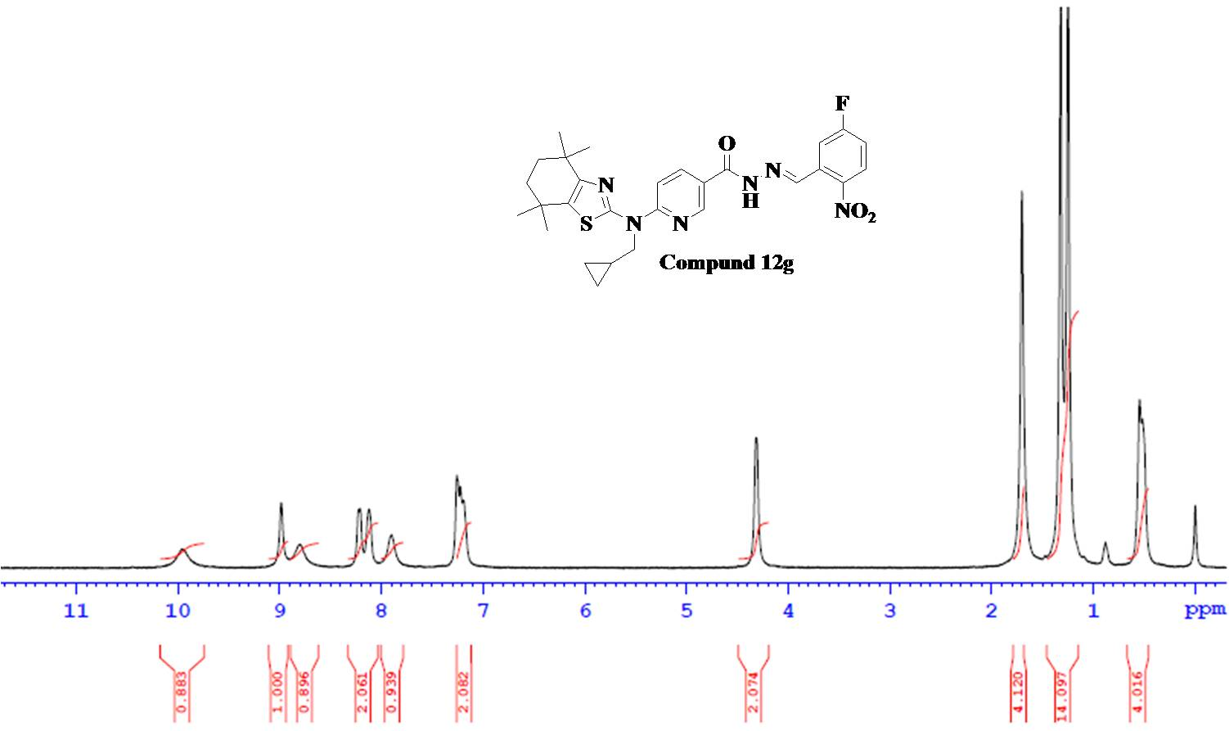
Fig.105. ¹H NMR Spectra of Compound 12g

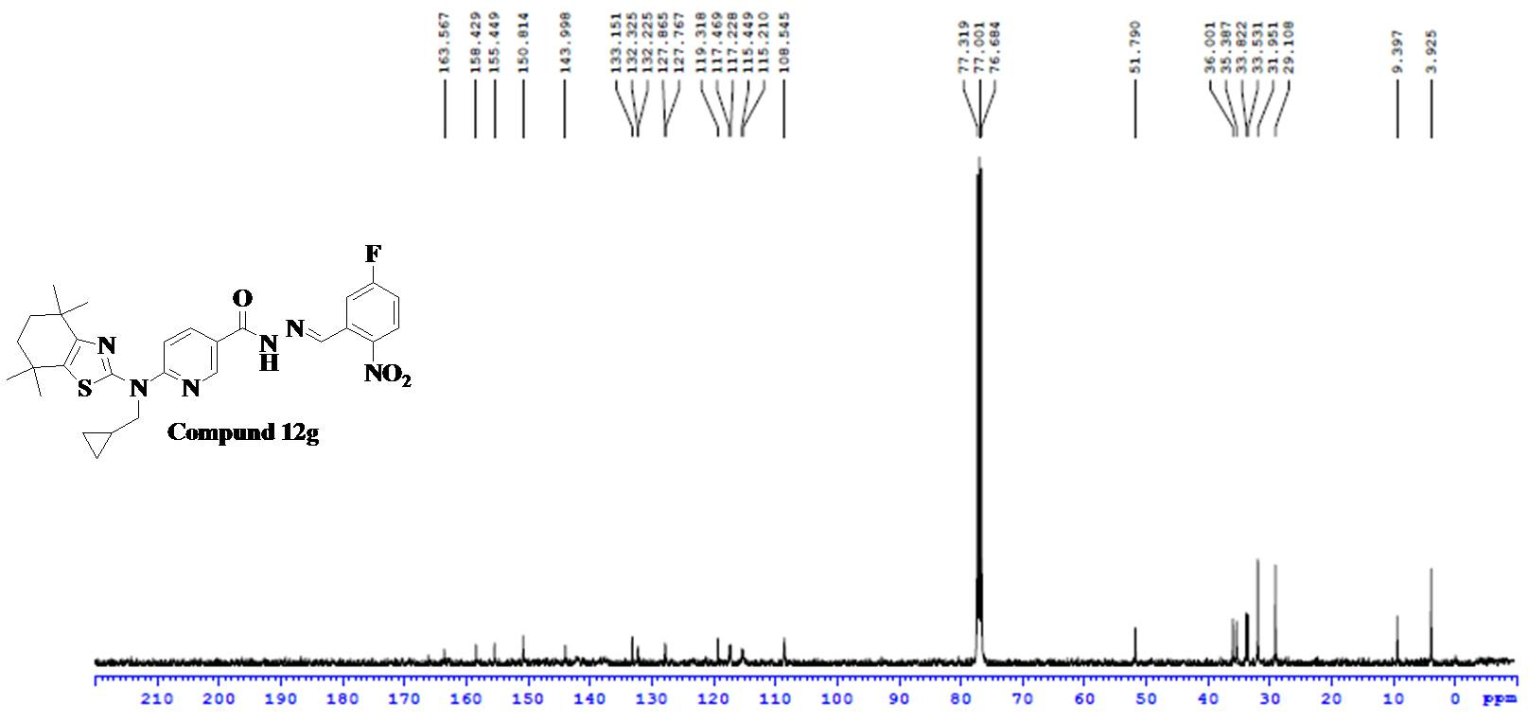
Fig.106. ¹³C NMR Spectra of Compound 12g
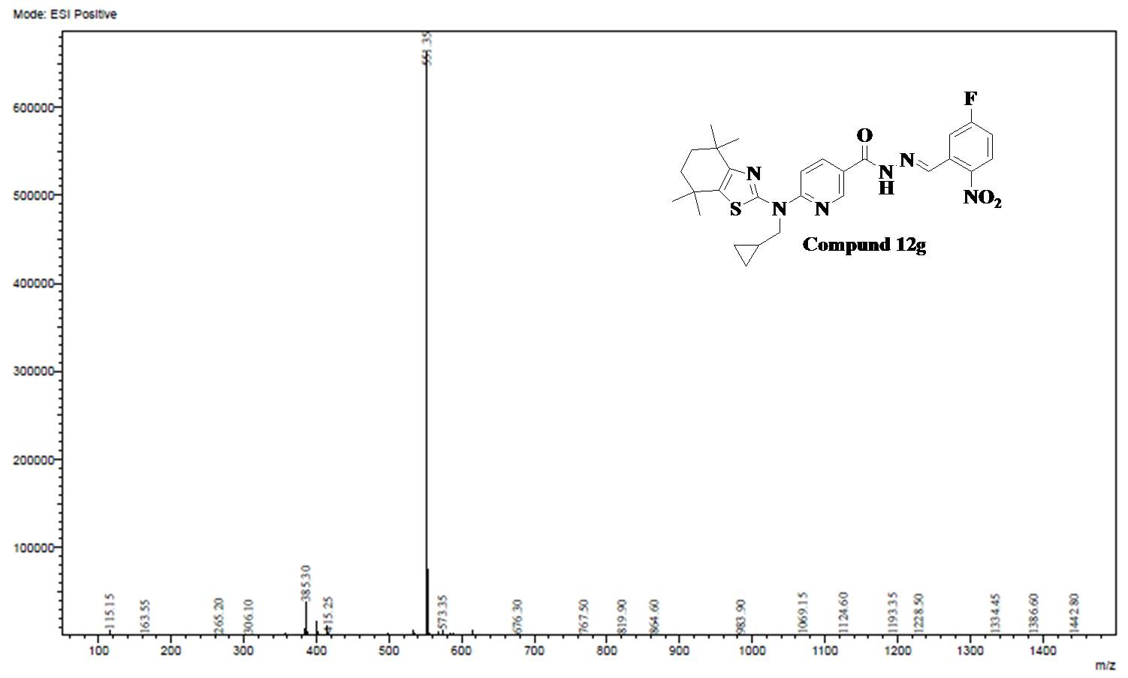
Fig.107. ESI-MS Spectra of Compound 12g

Analytical data of Compound 12h
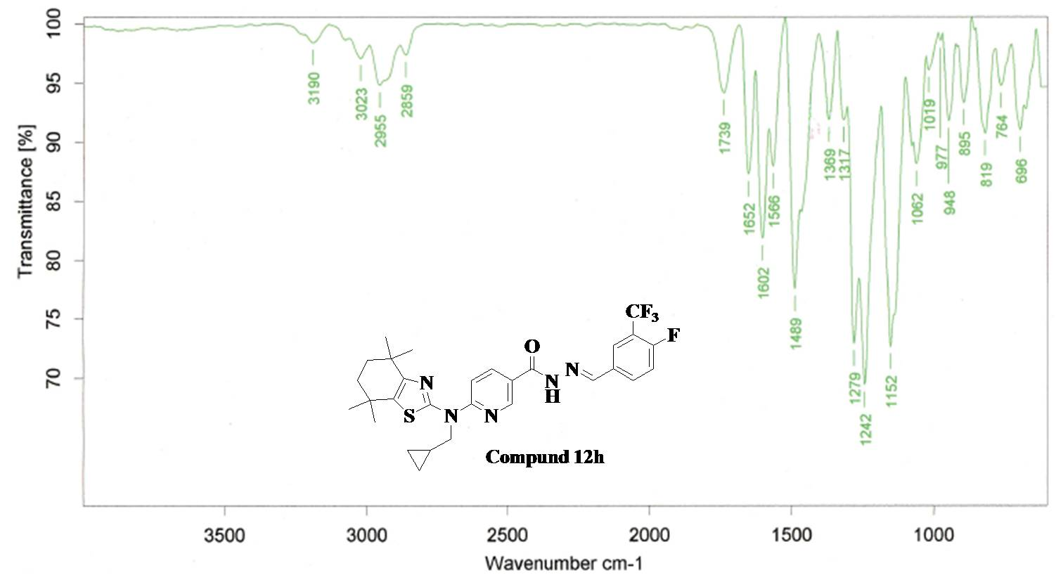

Fig.108. FT-IR Spectra of Compound 12h
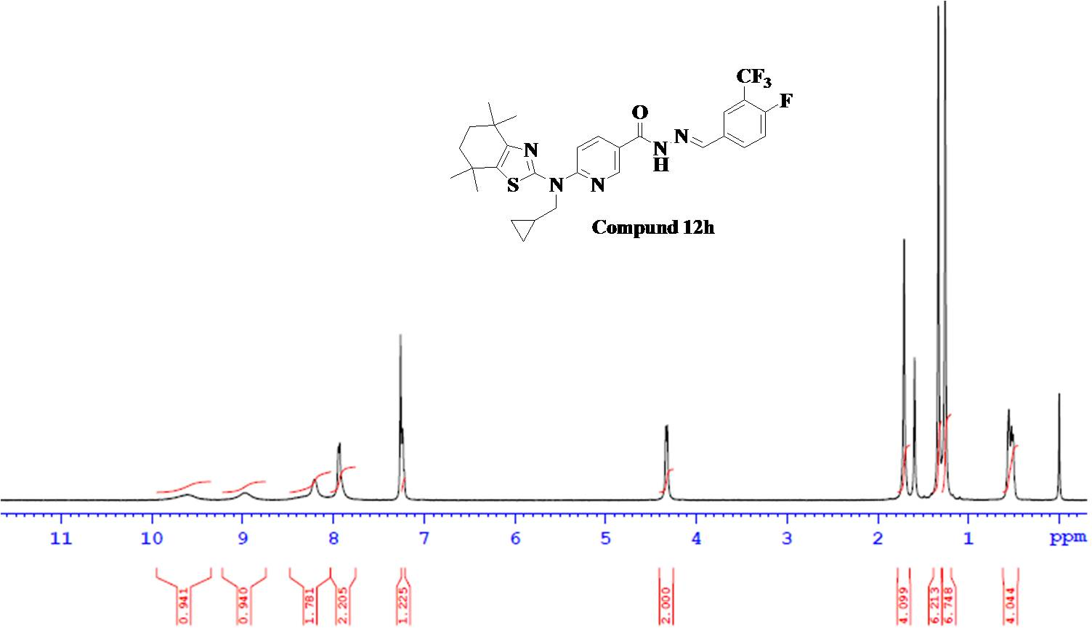
Fig.109. ¹H NMR Spectra of Compound 12h

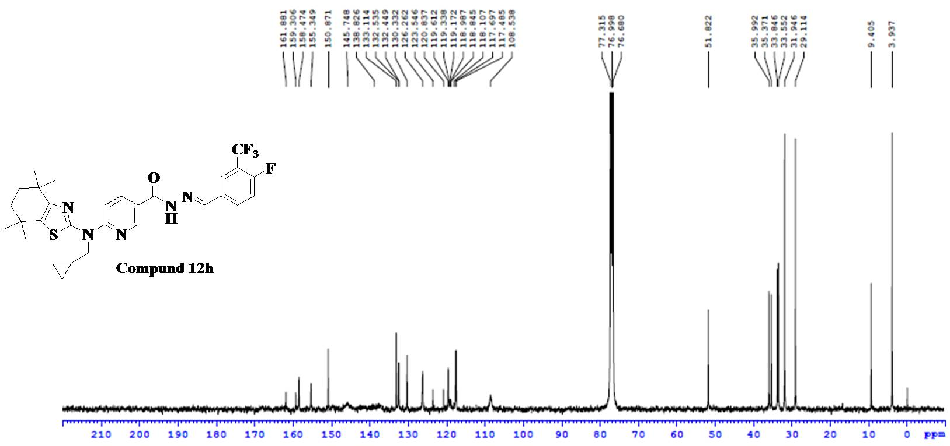
Fig.110. ¹³C NMR Spectra of Compound 12h
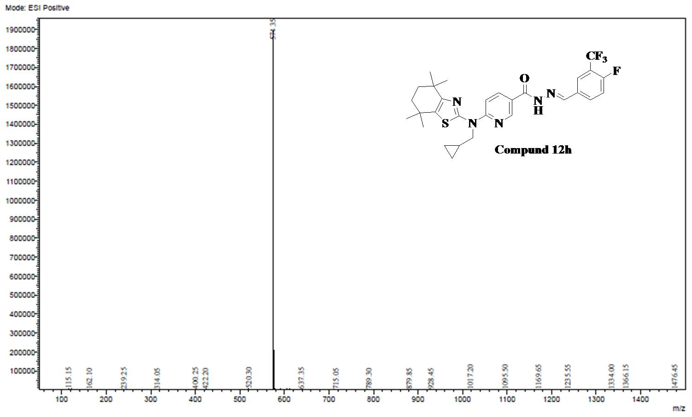
Fig.111. ESI-MS Spectra of Compound 12h

Analytical data of Compound 12i
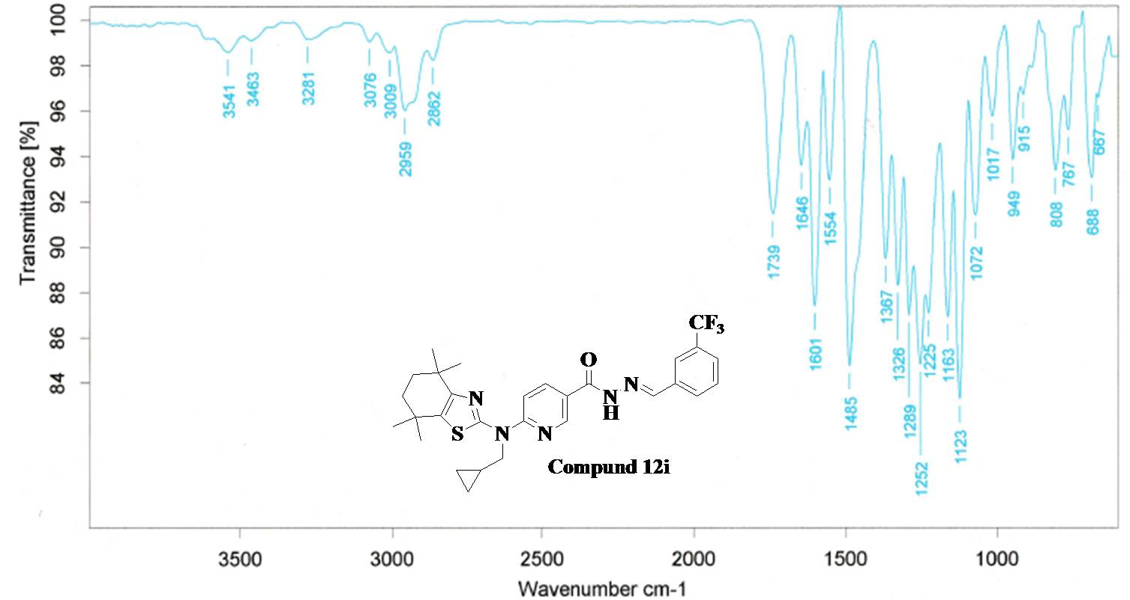
Fig.112. FT-IR Spectra of Compound 12i

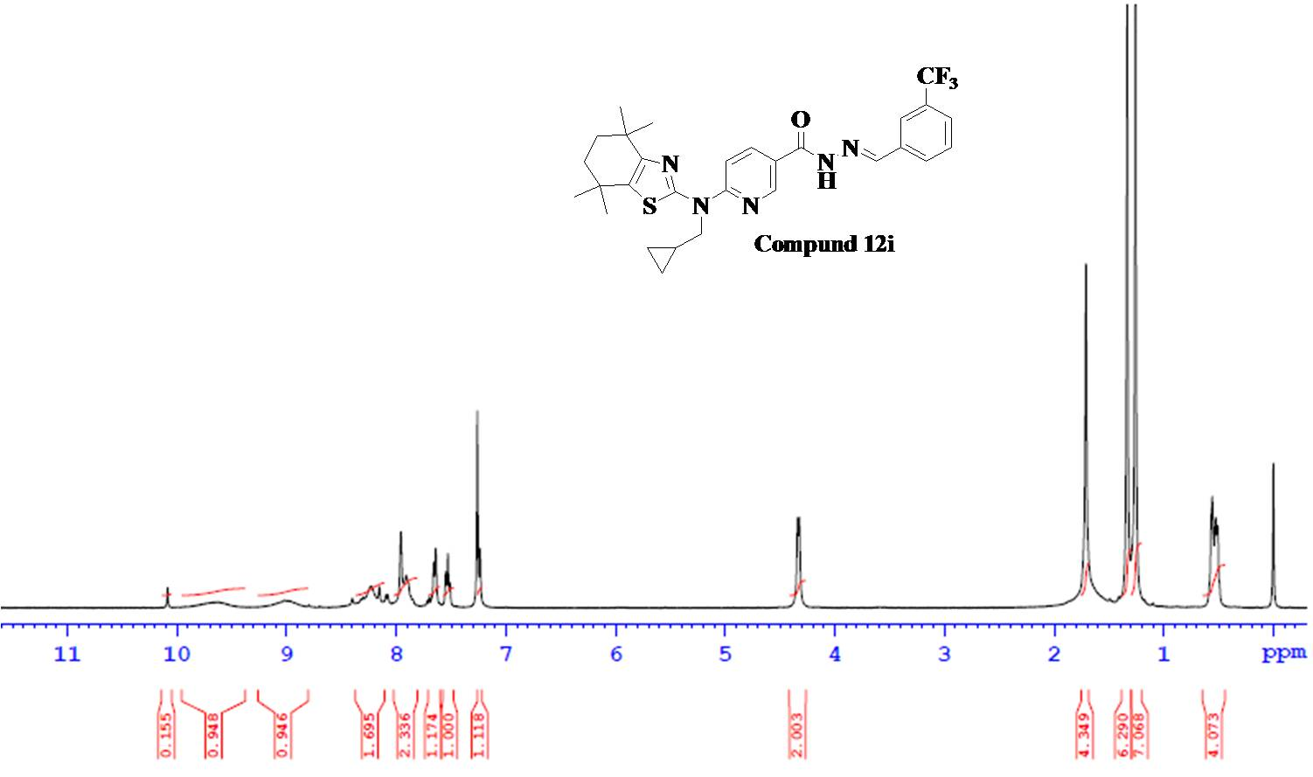
Fig.113. ¹H NMR Spectra of Compound 12i

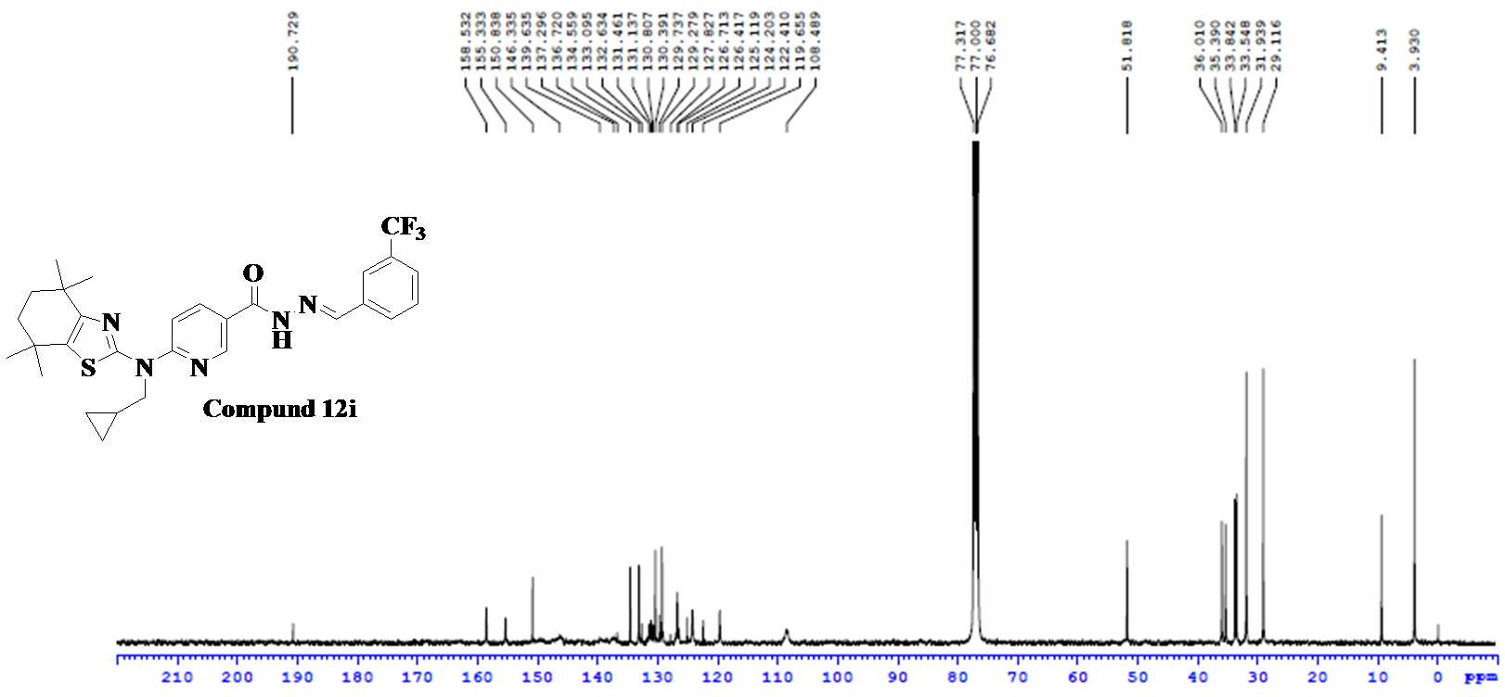
Fig.114. ¹³C NMR Spectra of Compound 12i
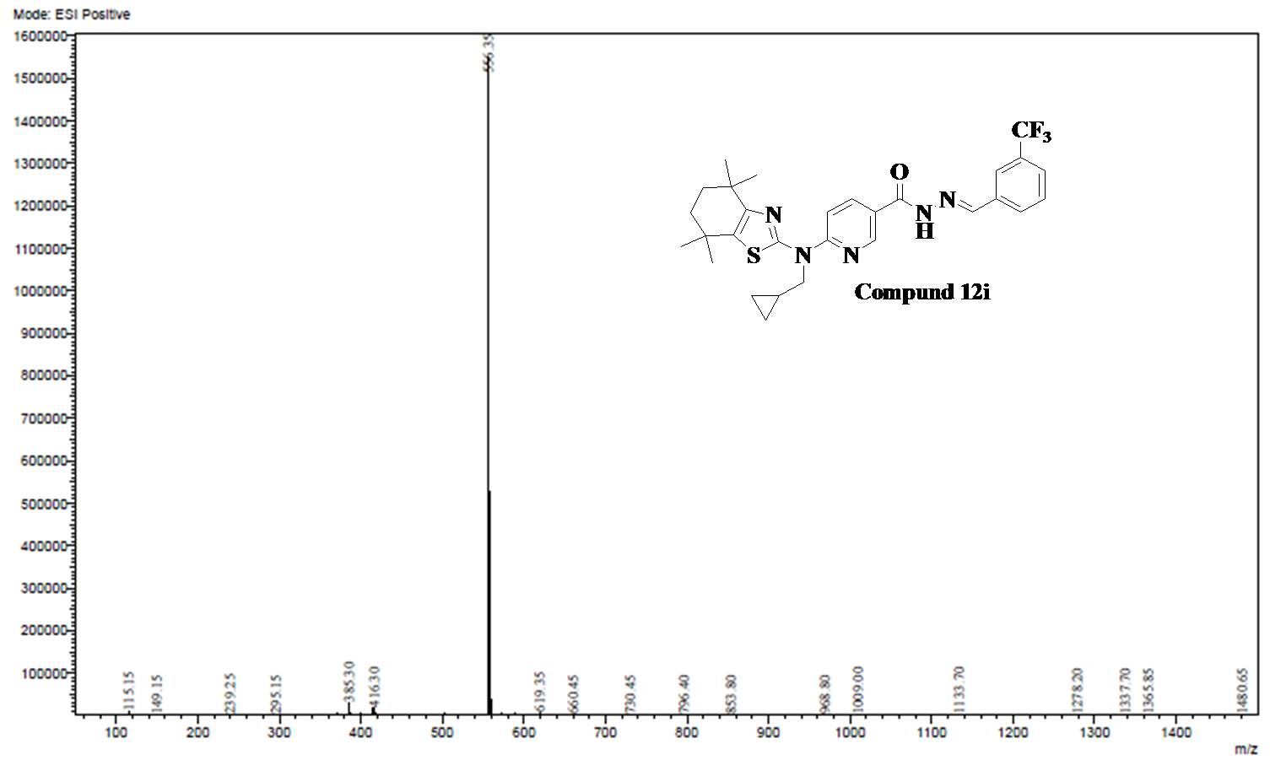
Fig.115. ESI-MS Spectra of Compound 12i

Analytical data of Compound 12j
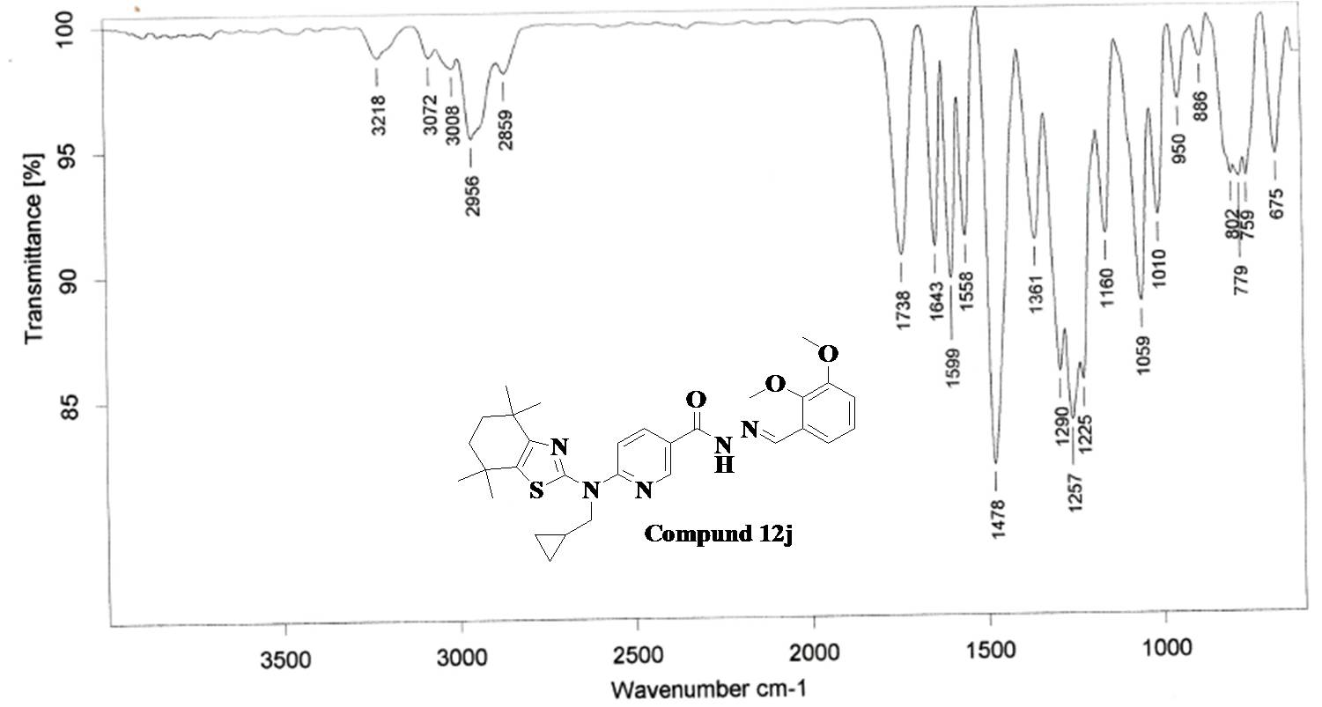
Fig.116. FT-IR Spectra of Compound 12j
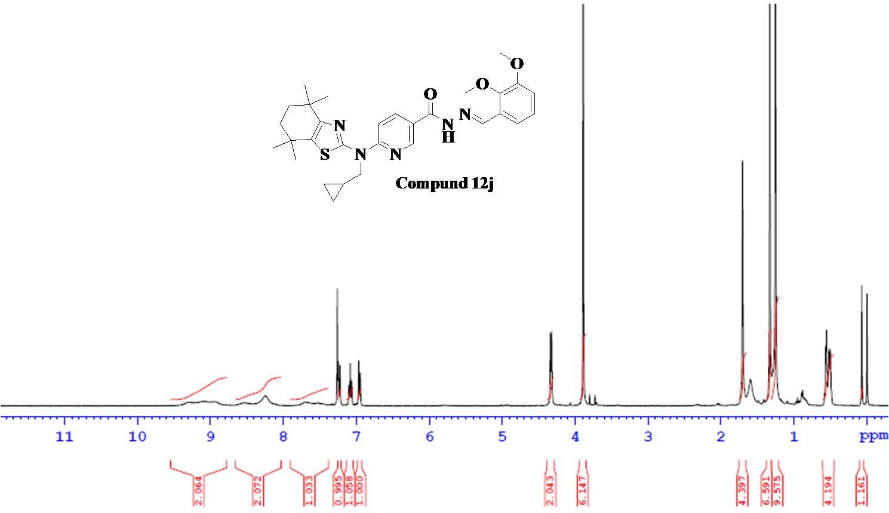
Fig.117. ¹H NMR Spectra of Compound 12j

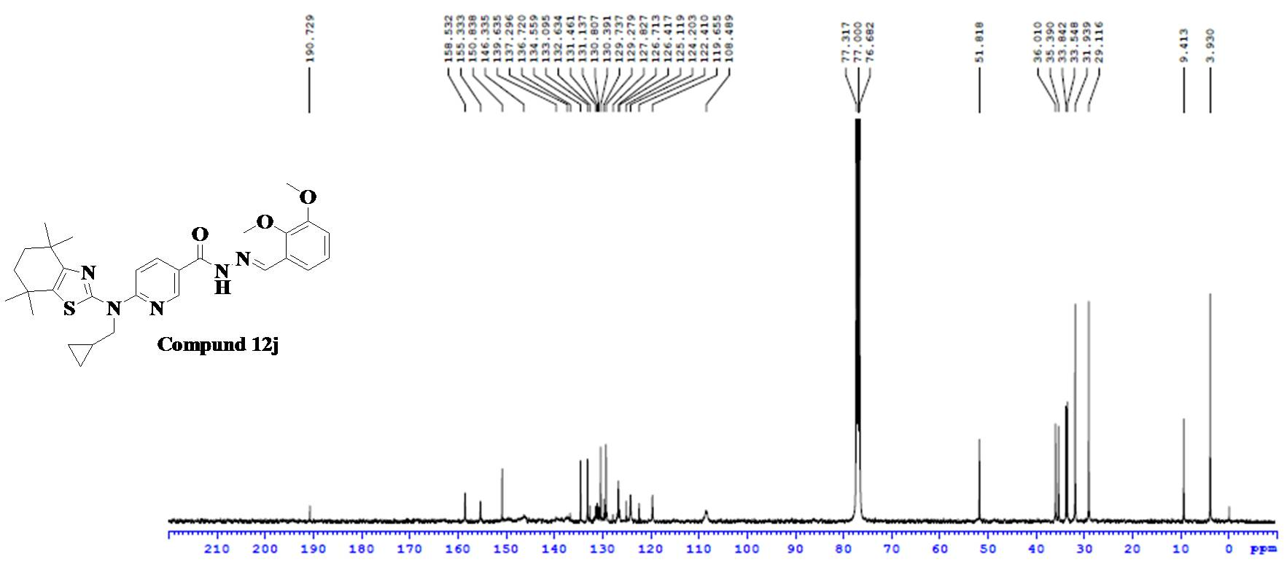
Fig.118. ¹³C NMR Spectra of Compound 12j
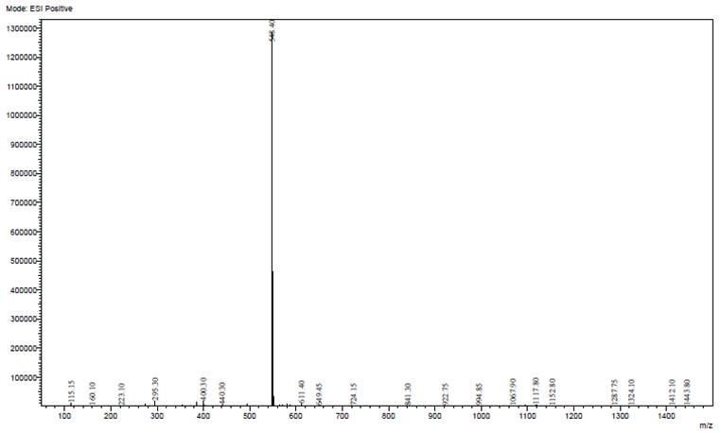
Fig.119. ESI-MS Spectra of Compound 12j

Analytical data of Compound 12k
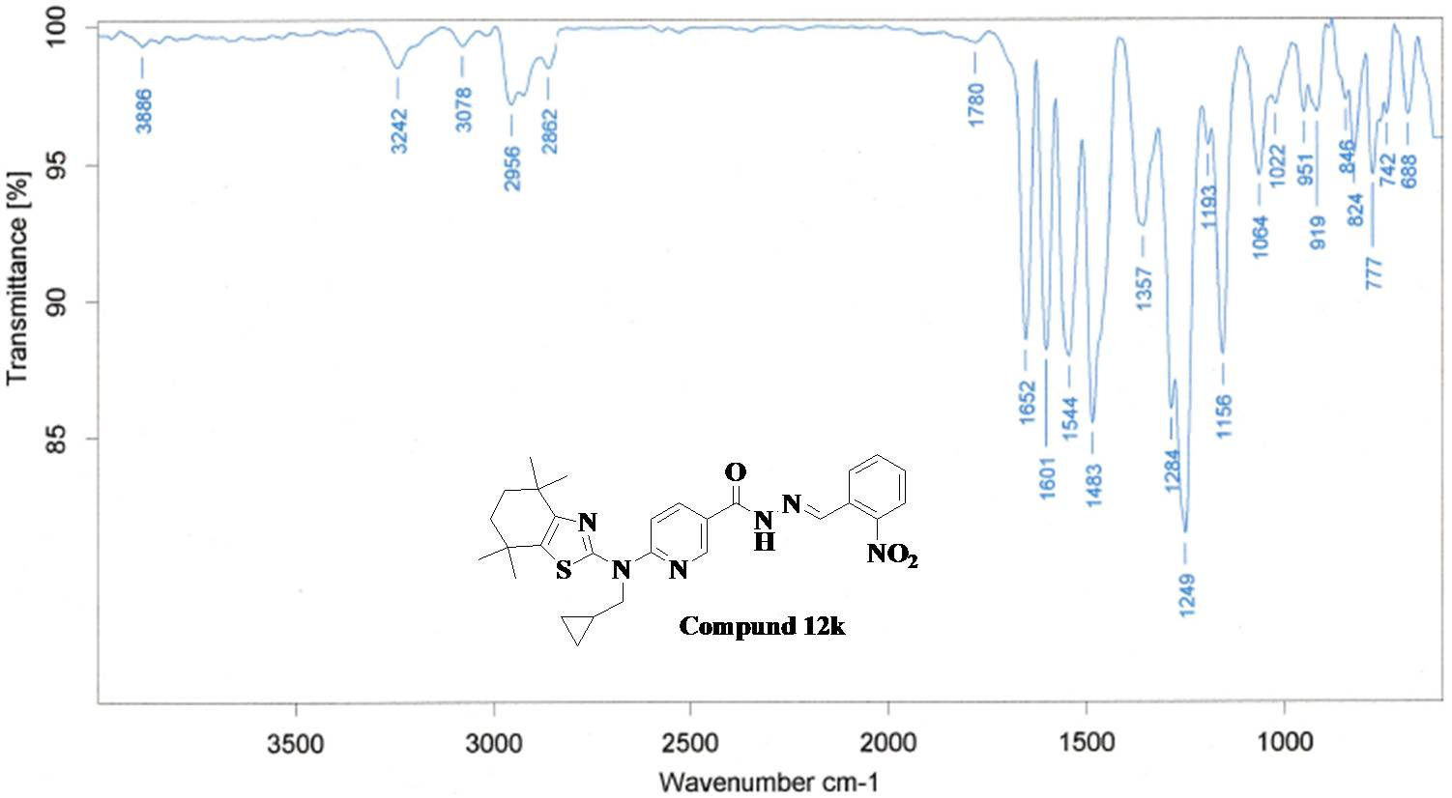
Fig.120. FT-IR Spectra of Compound 12k
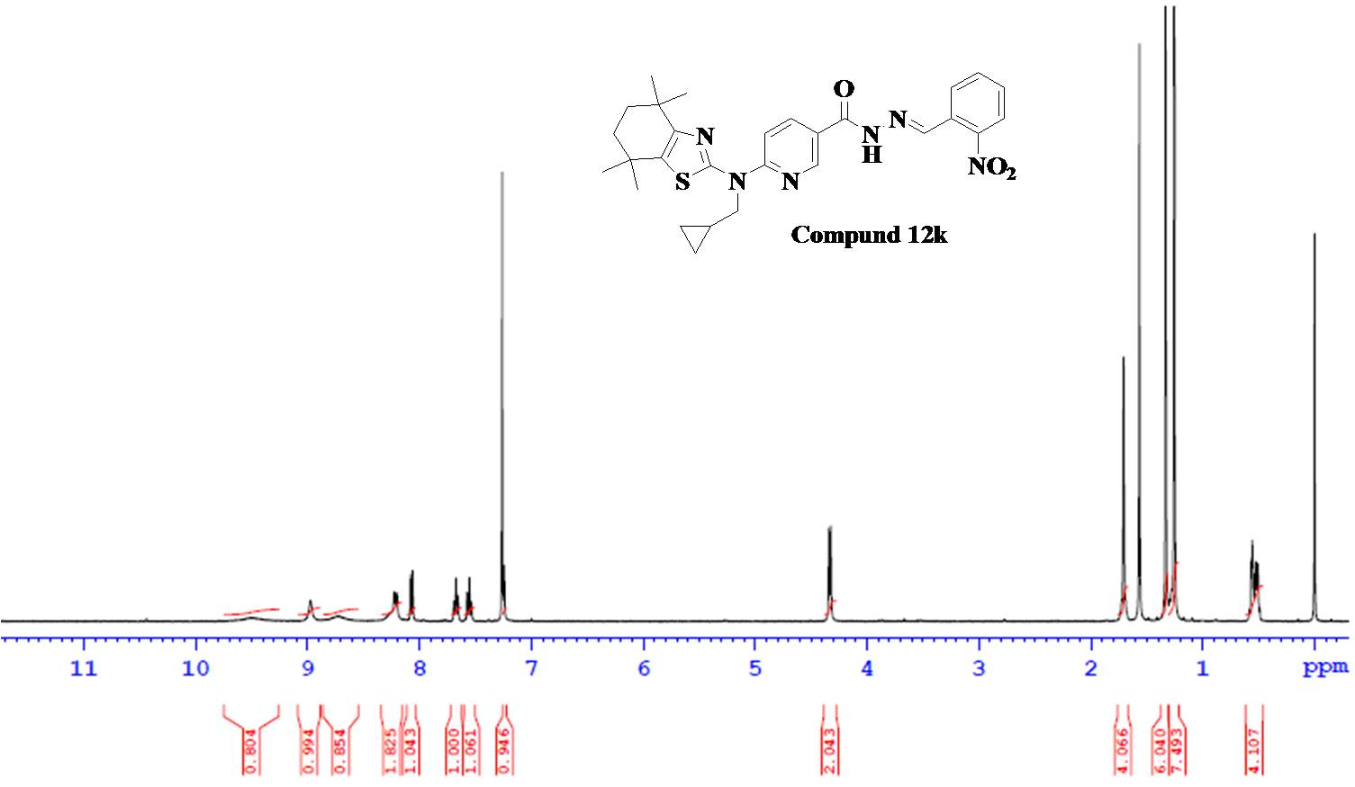
Fig.121. ¹H NMR Spectra of Compound 12k

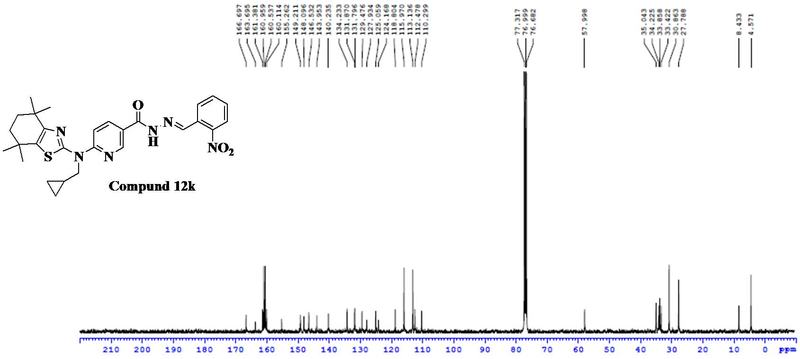
Fig.122. ¹³C NMR Spectra of Compound 12k
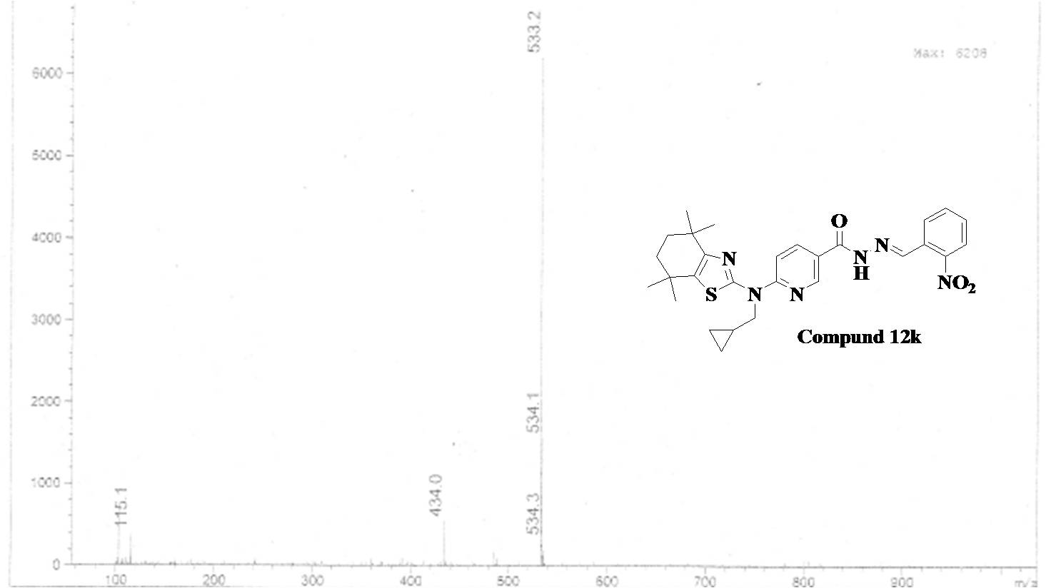
Fig.123. ESI-MS Spectra of Compound 12k

Analytical data of Compound 12l
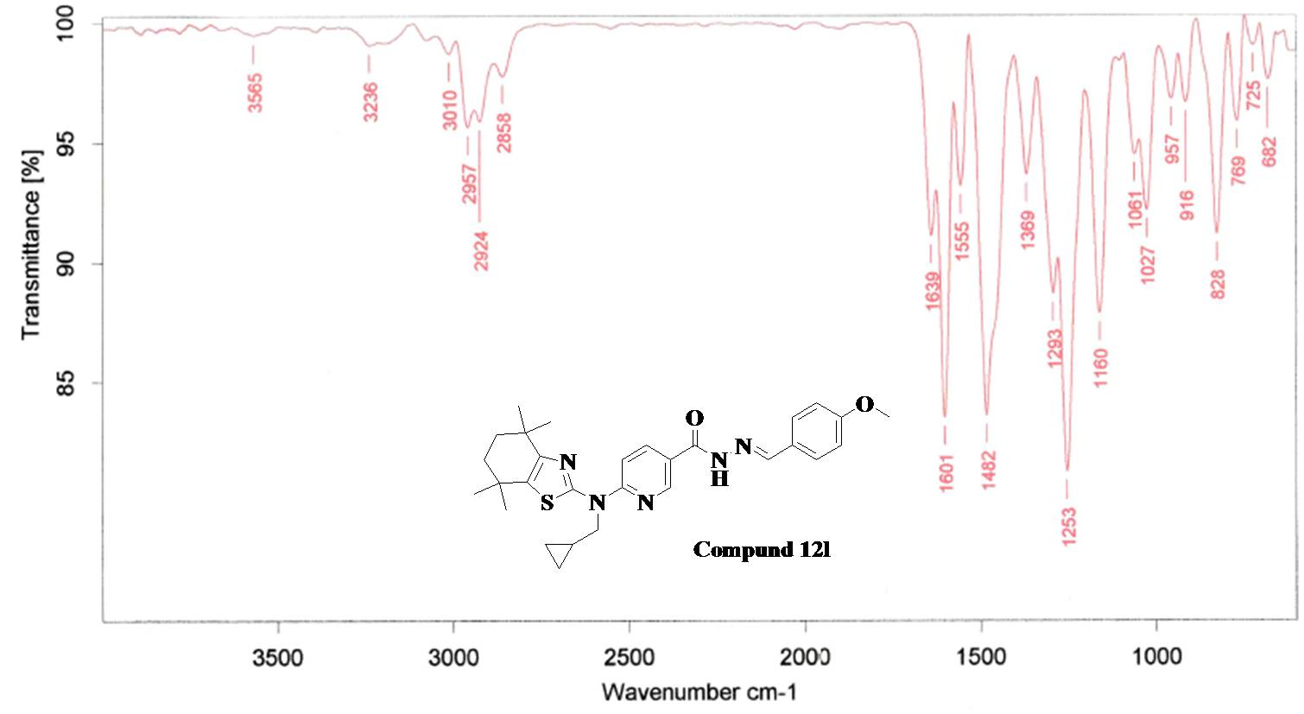
Fig.124. FT-IR Spectra of Compound 12l
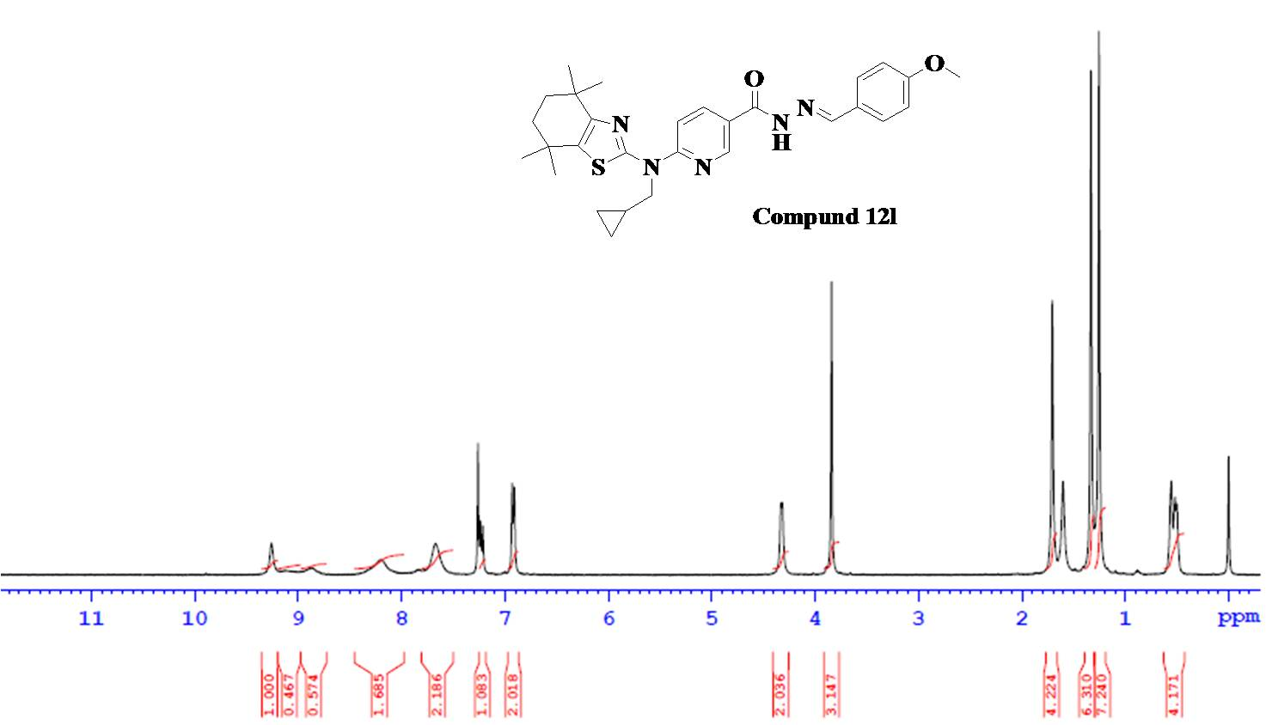
Fig.125. ¹H NMR Spectra of Compound 12l

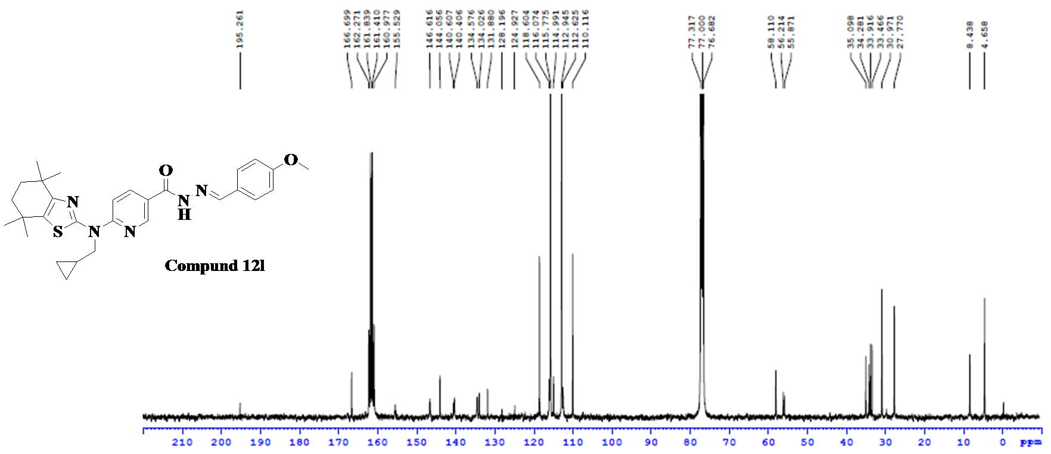
Fig.126. ¹³C NMR Spectra of Compound 12l
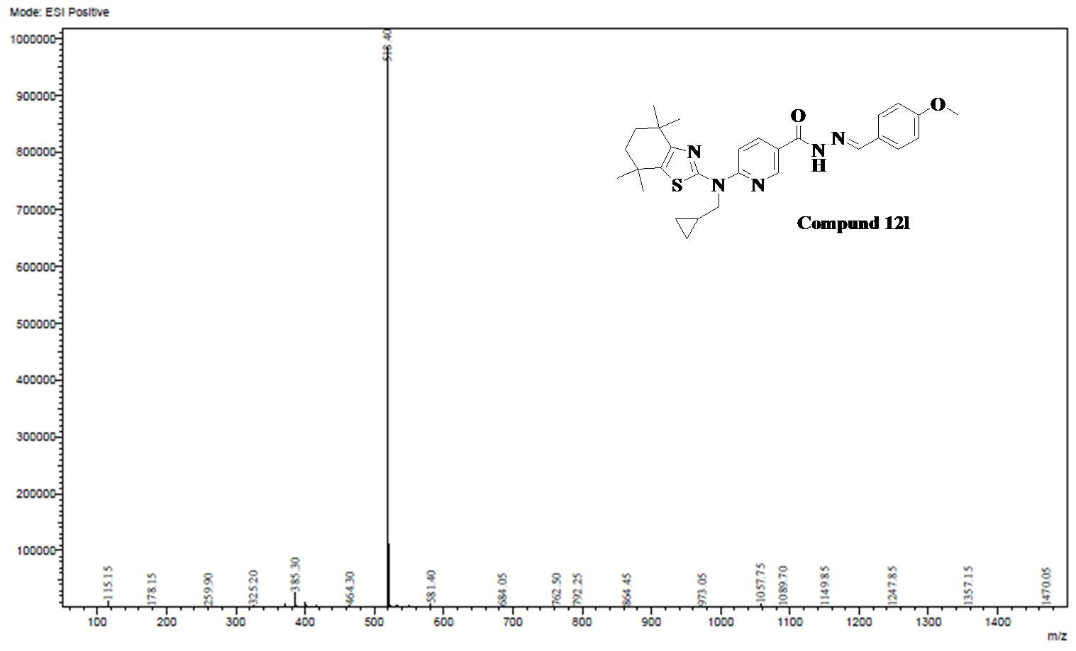
Fig.127. ESI-MS Spectra of Compound 12l

Analytical data of Compound 12m
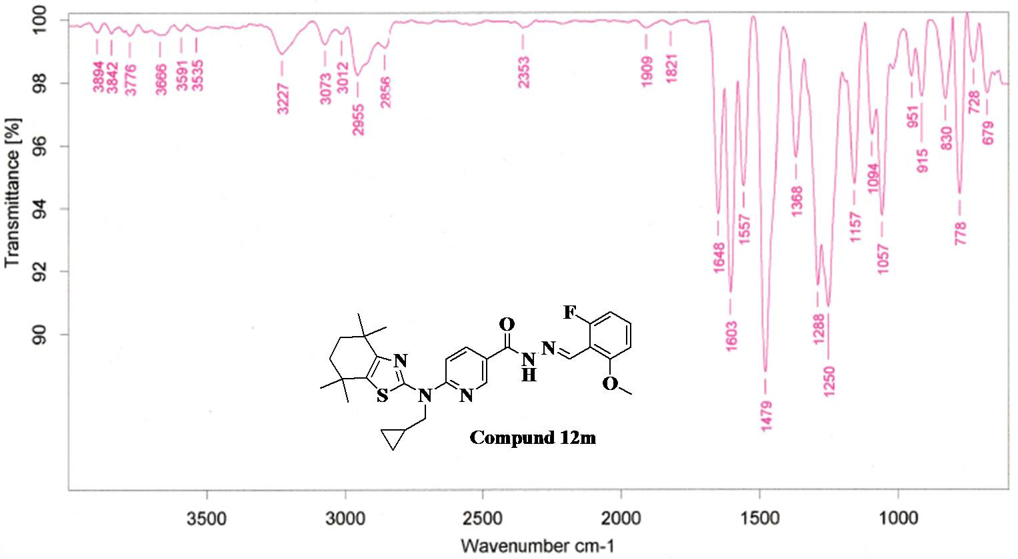
Fig.128. FT-IR Spectra of Compound 12m
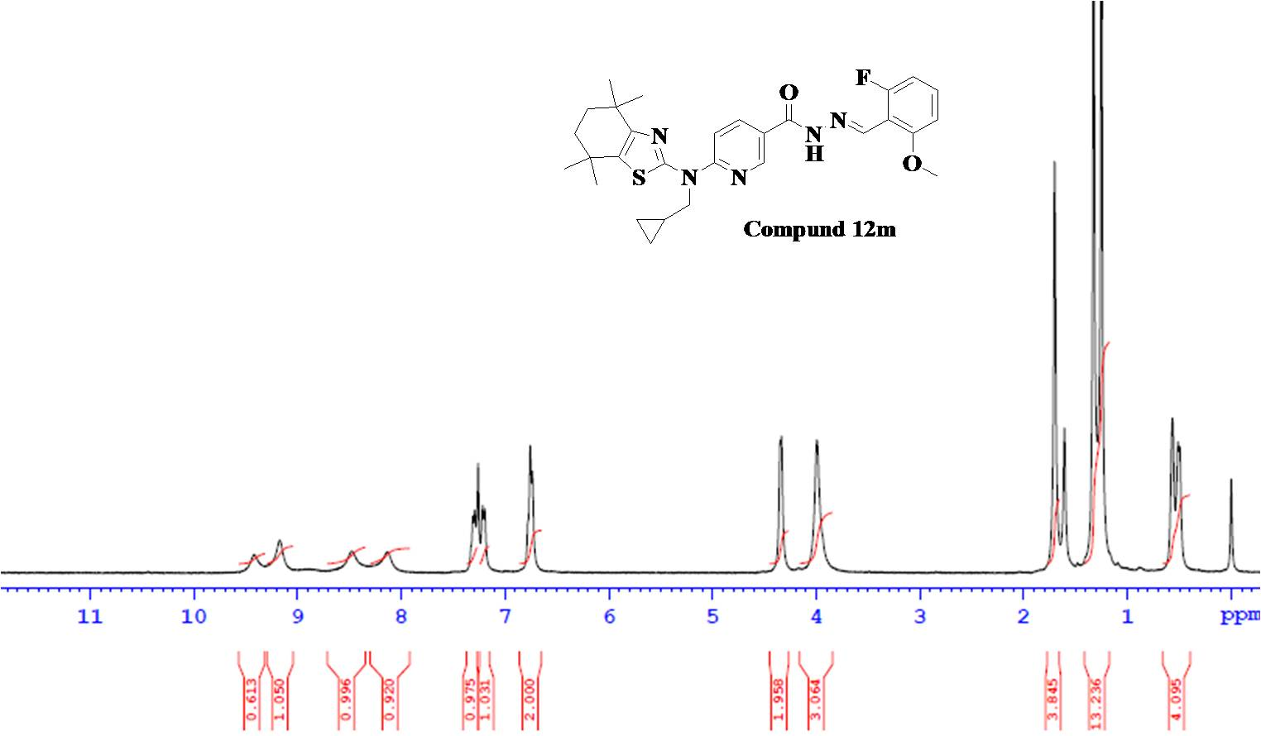
Fig.129. ¹H NMR Spectra of Compound 12l

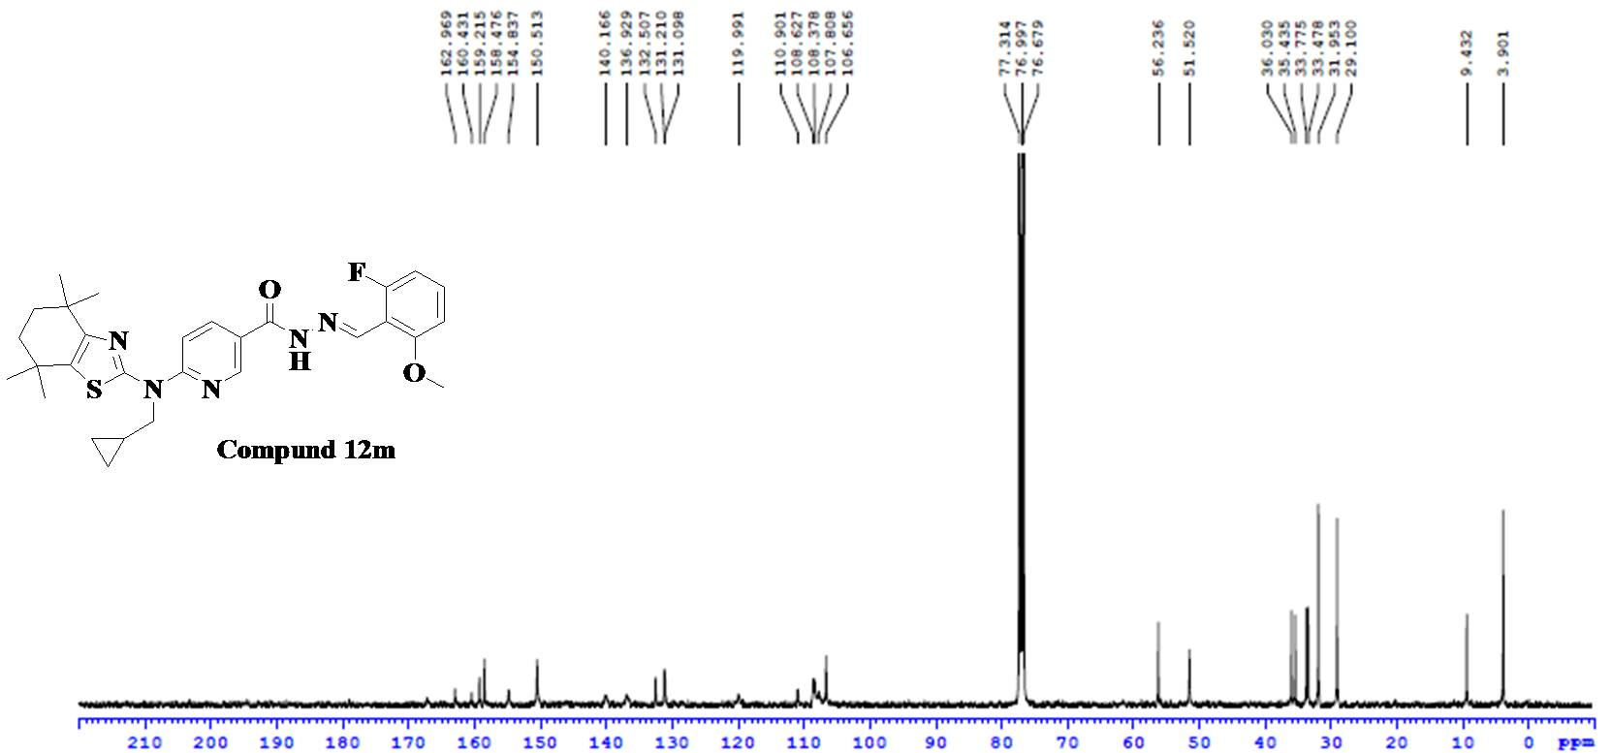
Fig.130. ¹³C NMR Spectra of Compound 12m
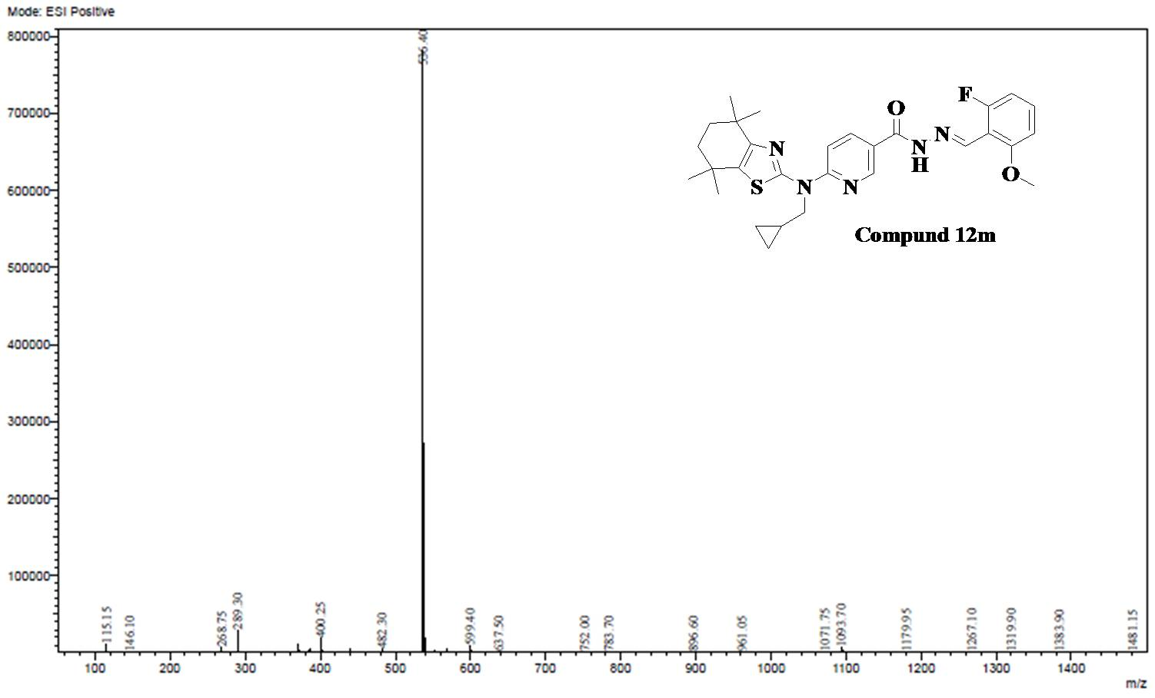
Fig.131. ESI-MS Spectra of Compound 12m

Analytical data of Compound 12n
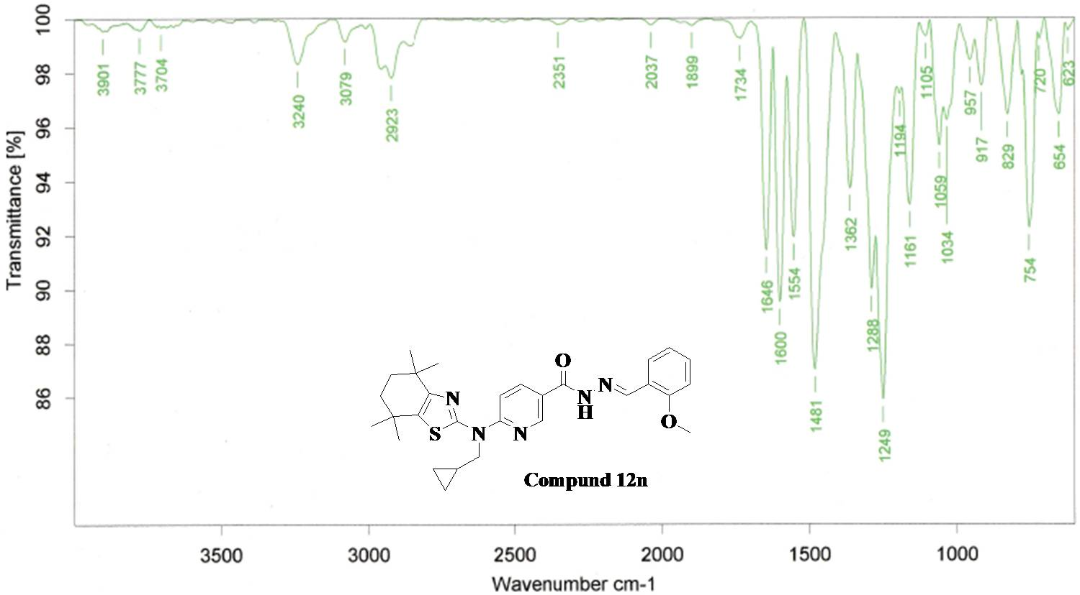
Fig.132. FT-IR Spectra of Compound 12n
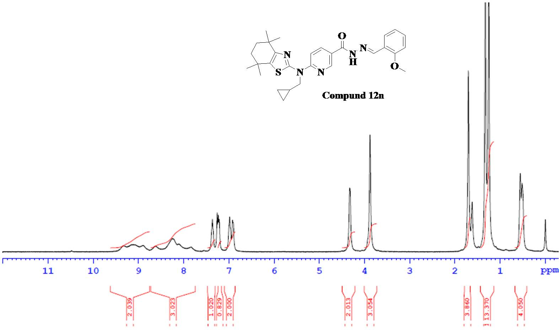
Fig.133. ¹H NMR Spectra of Compound 12n

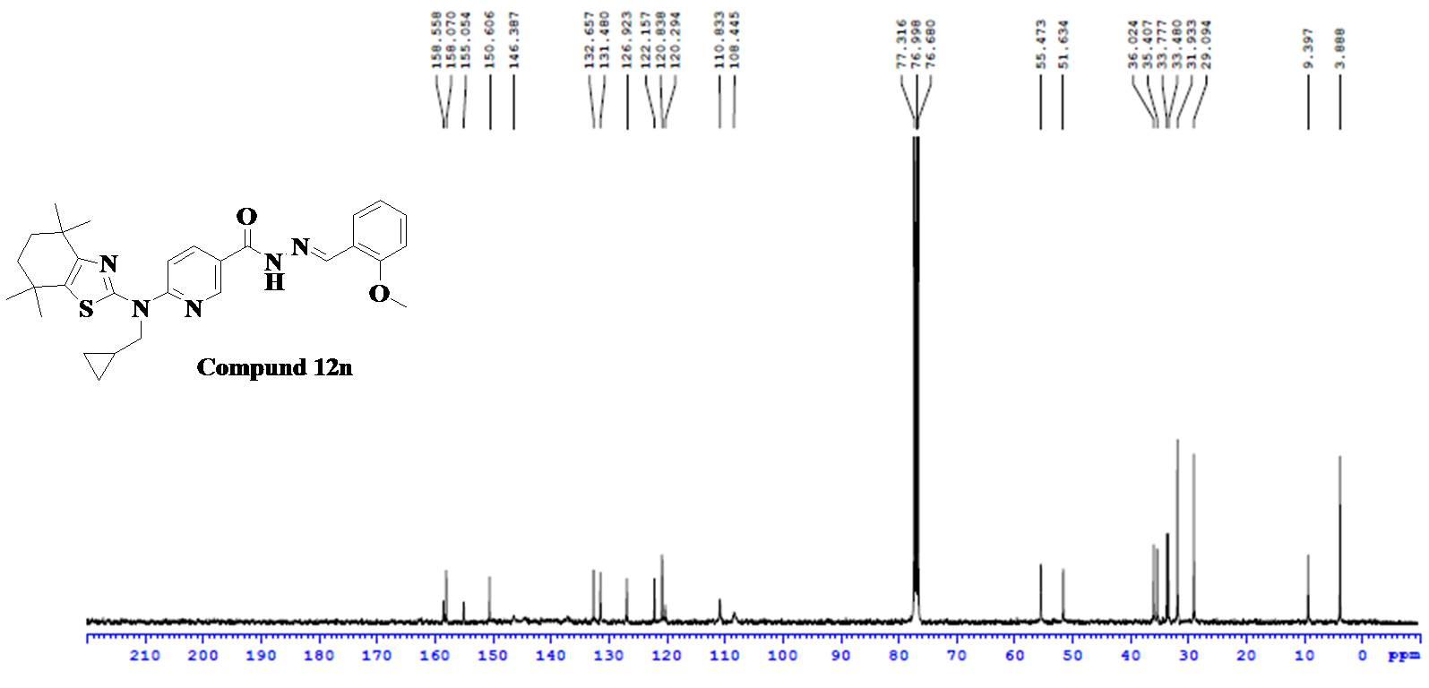
Fig.134. ¹³C NMR Spectra of Compound 12n
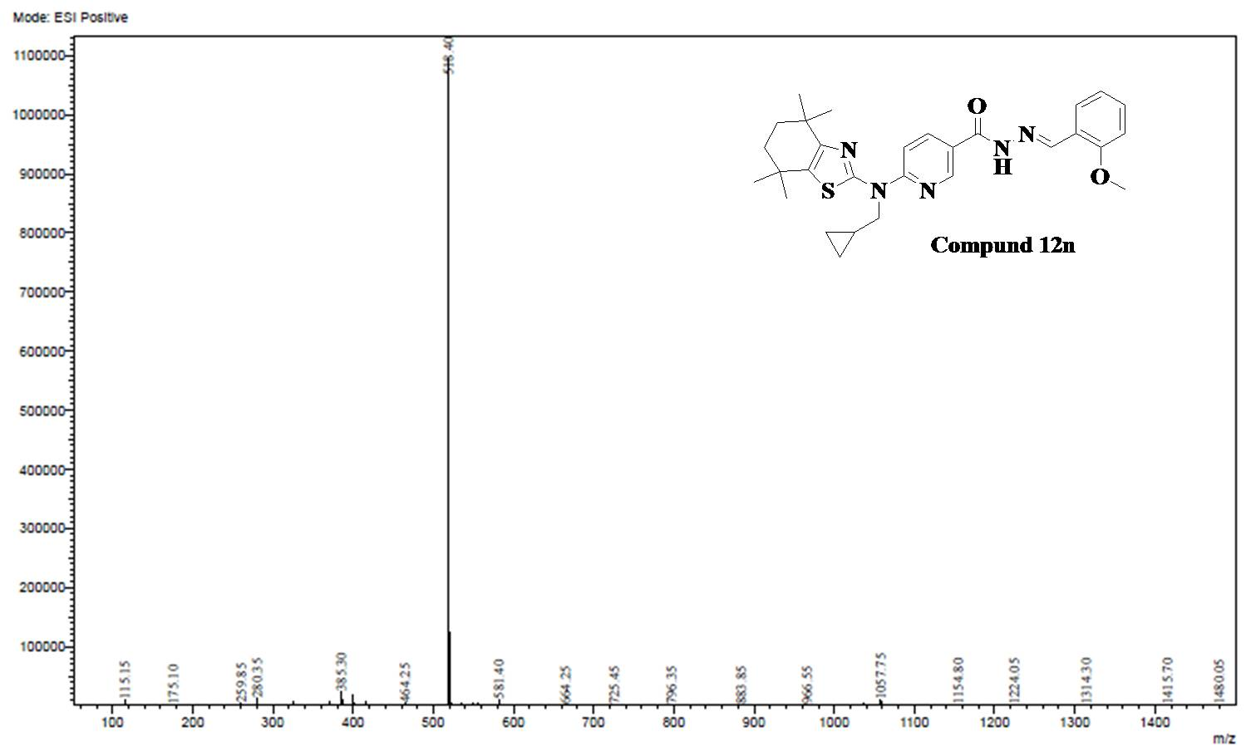
Fig.135. ESI-MS Spectra of Compound 12n

Analytical data of Compound 12o
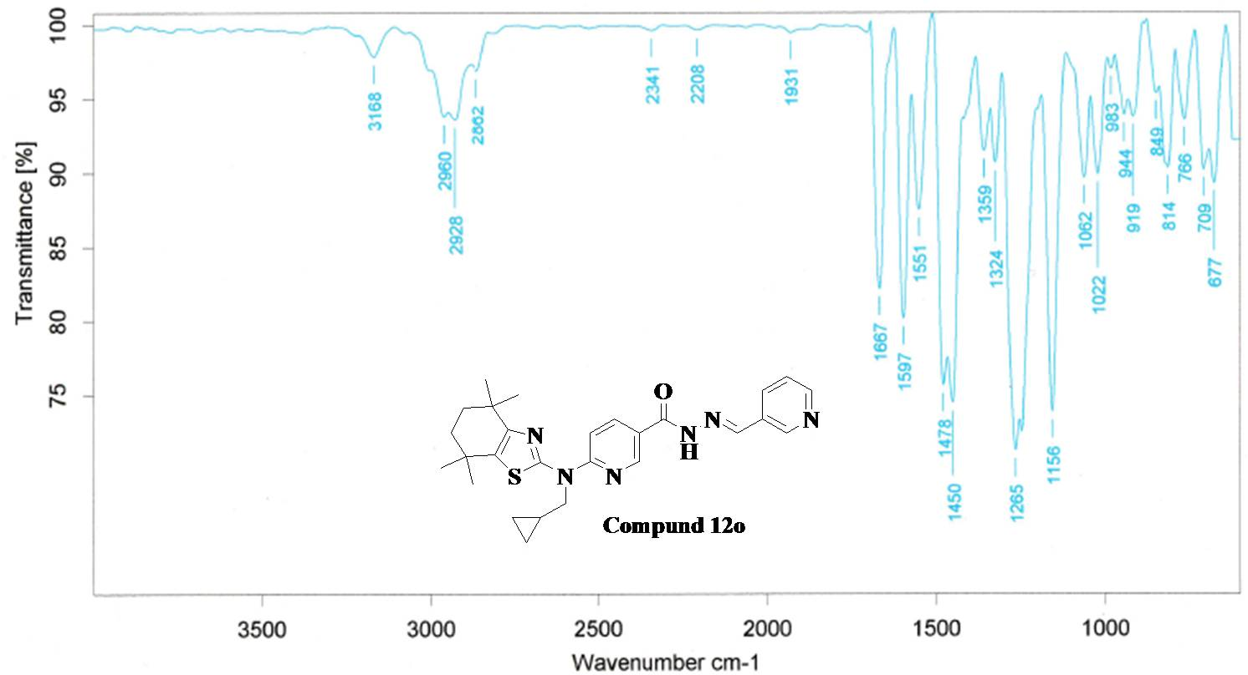
Fig.136. FT-IR Spectra of Compound 12o
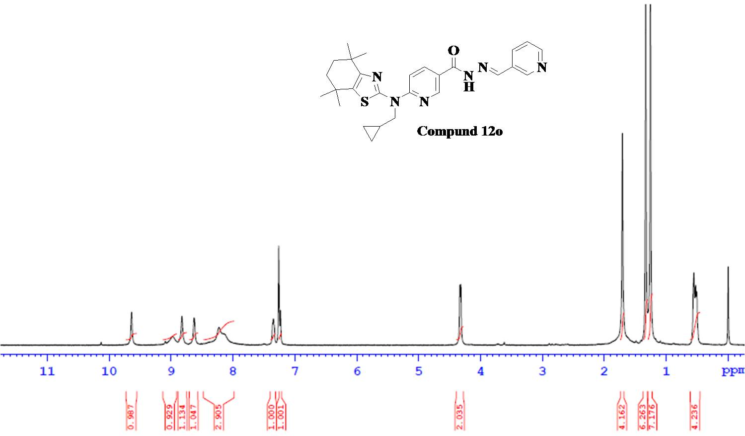
Fig.137. ¹H NMR Spectra of Compound 12o

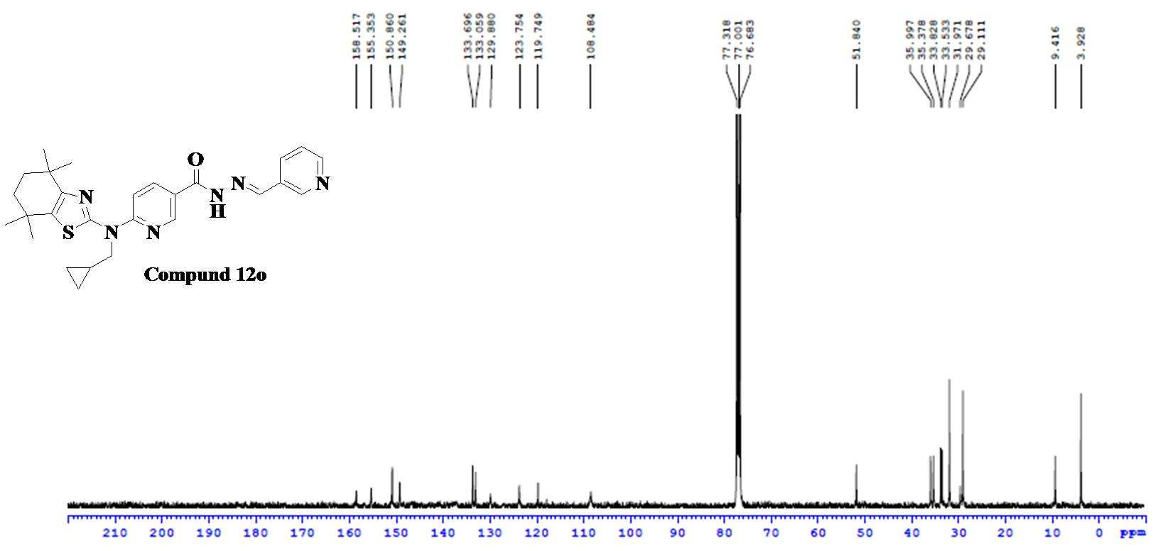
Fig.138. ¹³C NMR Spectra of Compound 12o
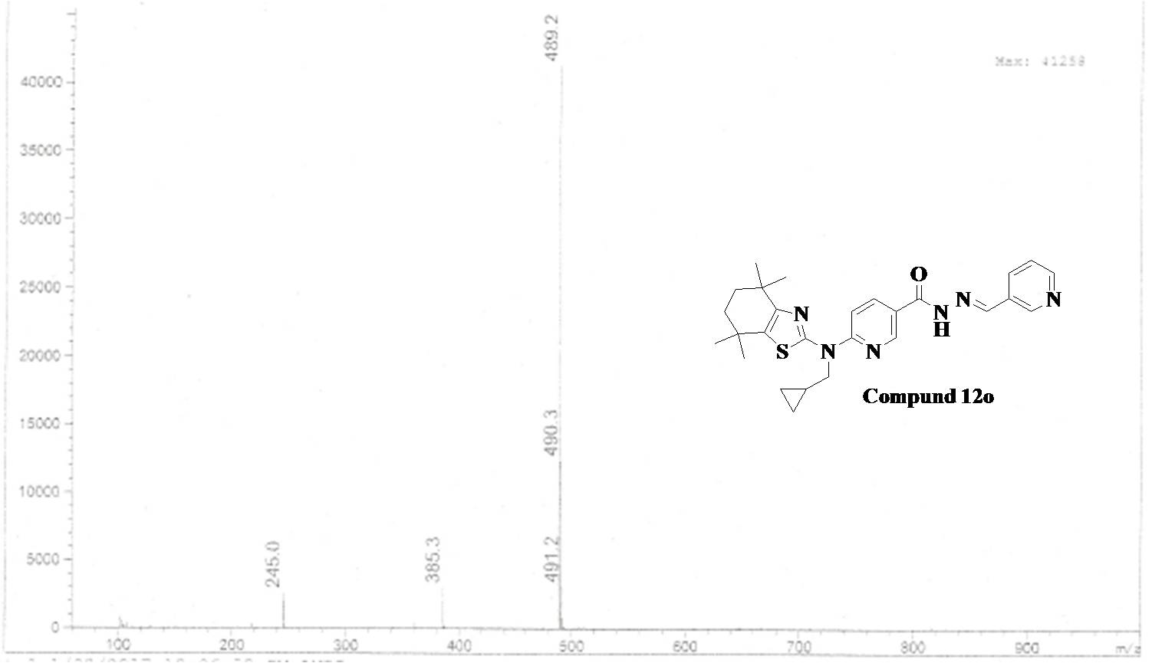
Fig.139. ESI-MS Spectra of Compound 12o

