**Ag nanoparticles immobilized on guanidine modified-KIT-5 mesoporous nanostructure: Evaluation of its catalytic activity for synthesis of propargylamines and investigation of its antioxidant and anti-lung cancer effects**

Xifang Wang,1 Zhihong Liu,*,2 Mutasem Z. Bani-Fwaz,3 Riadh Marzouki,3,4,5 , Ismat H. Ali,3 Attalla F. El-kott,6,7 Fatimah A. Alhomaid8

1Department of Medical Oncology, Shaanxi Provincial People’s Hospital, Shaanxi, Xi’an, 710068, China

2Department of Critical Care Medicine, Xi’an International Medical Center Hospital, Xi’an, 710000, China

3Department of Chemistry, Faculty of Science, King Khalid University, P. O. Box 9004, Abha 61413, Saudi Arabia.

4Laboratory of Materials, Crystallochemistry and Applied Thermodynamics, Faculty of Sciences of Tunis, University of Tunis El Manar, Tunisia.

5Chemistry Department, Faculty of Sciences of Sfax, University of Sfax, 3038, Tunisia.

6Biology Department, College of Science, King Khalid University, Abha 61421, Saudi Arabia

7Zoology Department, College of Science, Damanhour University, Damanhour 22511, Egypt

8Dept.of Biology, Collage of Science and Arts, Qassim University KSA.

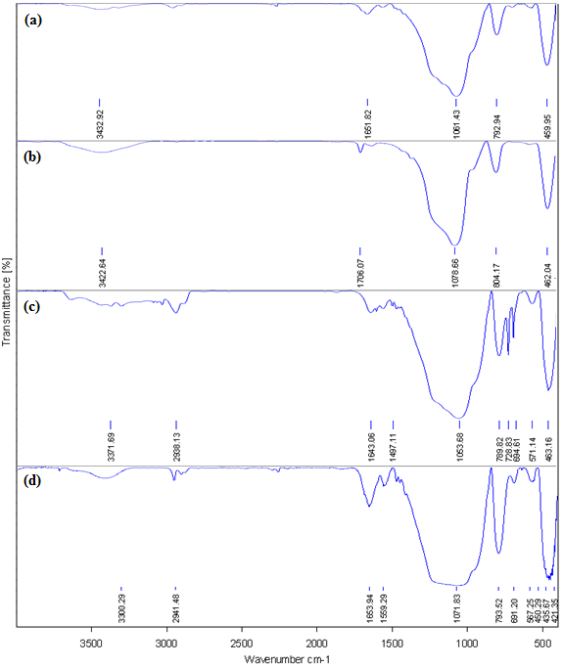

**Fig. S1.** FT-IR spectra of (a) KIT-5, (b) KIT-5-NH2, (c) KIT-5-bigua and (d)KIT-5-bigua-Ag nanocomposite.