**Supplementary Material**

**A novel ratiometric fluorescent aptasensor accurately detects patulin contamination in fruits and fruits products**

Jiankang Denga,b,1,*, Jing Hub,1, Juanjuan Zhaoa,b, Zhang Zhiqianga,b, Qinghua Wangb, Rongrong Wua,b,*

(a. Hebei Technology Innovation Center for Fruits and Vegetables Fermentation, Hengshui053000, China;

b. College of Life Science, Hengshui University, Hengshui053000, China. )

\***Corresponding author**

Email Address

[dengjk1989@163.com](mailto:dengjk1989@163.com) (J. Deng)

[rpkxw@126.com](mailto:rpkxw@126.com) (R. Wu)

1 Equal contribution in this research.

**Table S1.** DNA sequences used in this work

|  |  |
| --- | --- |
| Strand name | DNA sequences (from 5’-terminal to 3’-terminal) |
| AptPAT | GGCCCGCCAACCCGCATCATCTACACTGATATTTTACCTT |
| cDNA | GCGGGTTGGCGGGCCTTTAAA |
| S1 | GGGTTTTGGGTTTTGGGTTTTGGGTTTTCACGCACAGT |
| S2 | CACCTAATGCGTGAAAACCCAAAACCCAAAACCCAAAACCCCGGCCCGCCAACCCGC |

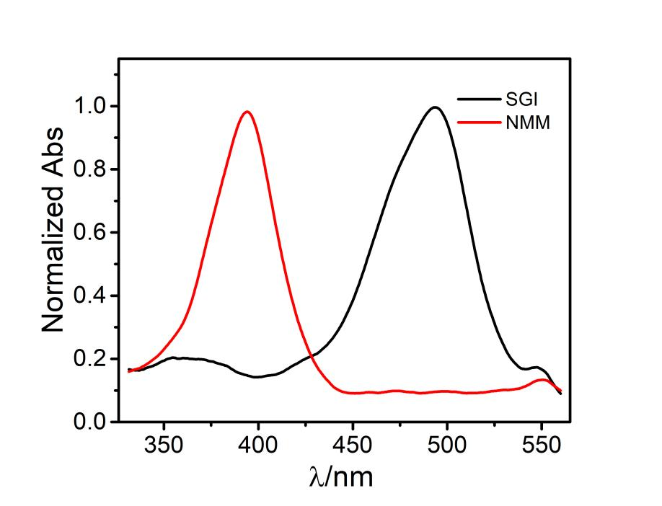

**Figure S1.** Normalized absorption spectra of SGI and NMM.

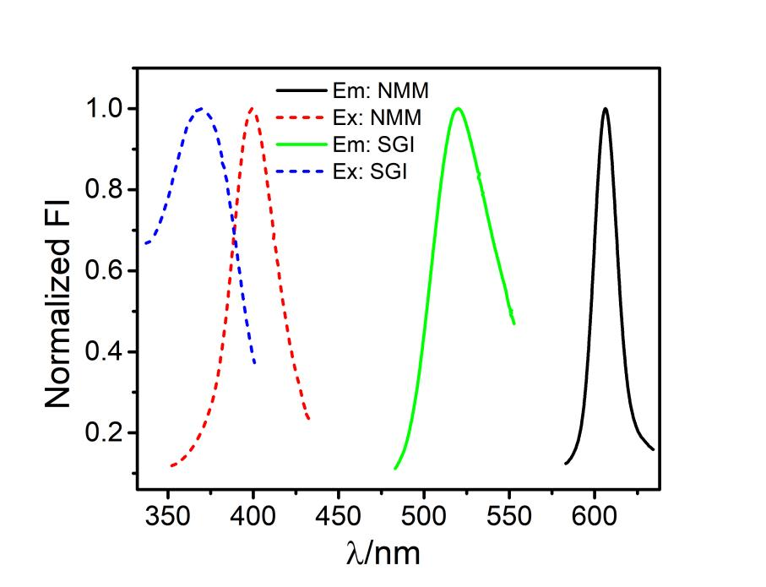

**Figure S2.** Normalized excitation and emission spectra of SGI (with S1-S2) and NMM (with S1).

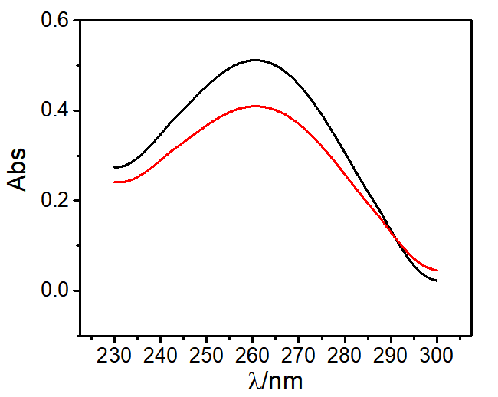

**Figure S3.** Absorption spectra of AptPAT before (black line) and after (red line) the isolation of SA-MB.

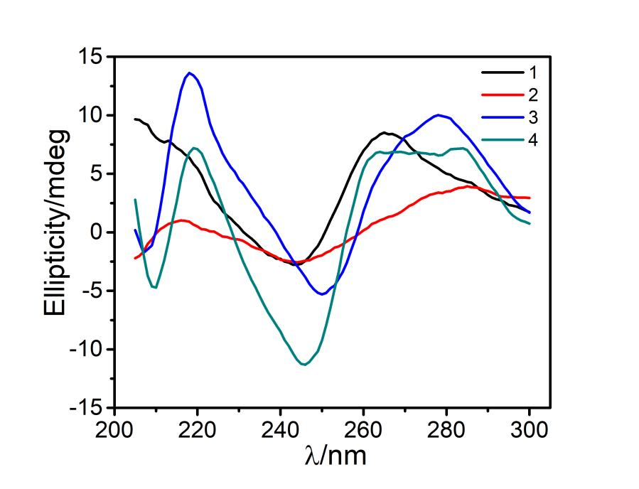

**Figure S4.** Circular dichroism (CD) spectra of the sensing system. Line 1-4: (1) S1; (2) S2; (3) S1-S2; (4) MB-AptPAT-C complex+PAT+S1-S2+Exo III; 10 μM of each probe in NEBuffer 1 with 100 mM K+

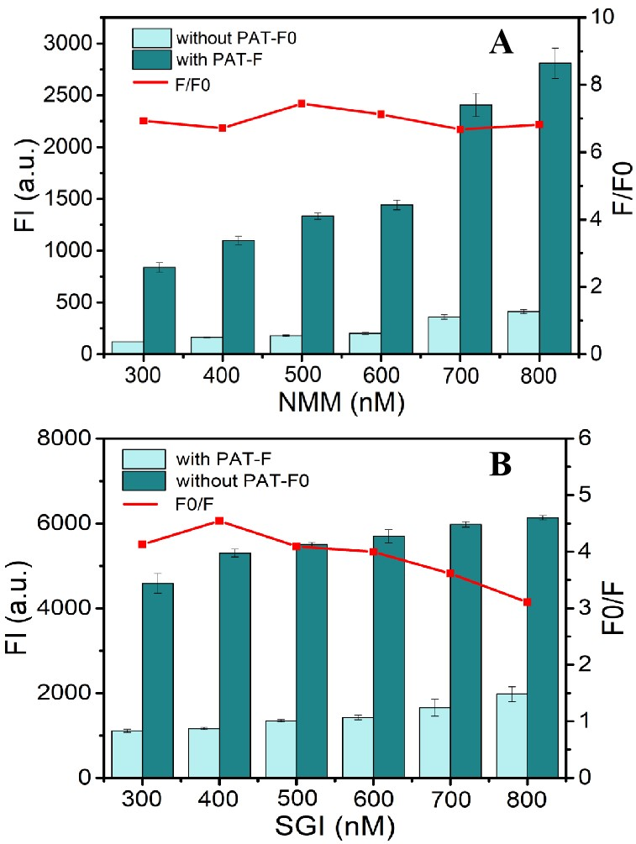

**Figure S5.** Fluorescence intensity as a function of the concentration of NMM (A) and SGI (B) in the absence and presence of PAT respectively.

**Table S2.** The detection limit comparison between our assay and previous’ reports

|  |  |  |  |  |  |
| --- | --- | --- | --- | --- | --- |
| Assay | Indicator or amplification | Limit of detection | Linear range | Recovery | References |
| Colorimetric sensor | Glucose oxidase- squaric acid system | 48 pg/mL | 0.05 ng/mL~25 ng/mL | 93%~108% | [1] |
| Fluorescent aptasensor | Graphene oxide and DNase I | 0.28 μg/L | 6 μg/L~80 μg/L | 77%~104% | [2] |
| Fluorescent aptasensor | Strand displacement amplification-G-quadruplex | 0.042 pg/mL | 0.001 ng/mL~100 ng/mL | 97%~105% | [3] |
| Voltammetric aptasensor | ZnO nanorods-gold nanoparticles | 0.27 pg/mL | 0.5 pg/mL~50 ng/mL | 95~104% | [4] |
| Electrochemical aptasensor | ZnO nano flower-metal organic framework-methylene blue | 14.6 ng/mL | 50 ng/mL~0.5 μg/mL | 92%~96% | [5] |
| Electrochemical aptasensor | Back phosphorus nanosheets | 0.03 nmol/L | 0.1 nmol/L~10 μmol/L | 96%~104% | [6] |
| Fluorescent aptasensor | FAM-TAMRA- fluorescence resonance energy transfer | 6 ng/L | 15 ng/L~ 35 μg/L | 94%~109% | [7] |

**References**

[1] S. Wu, N. Duan, W. Zhang, S. Zhao and Z. Wang, Screening and development of DNA aptamers as capture probes for colorimetric detection of patulin, Anal. Biochem. 508 (2016) 58-64.

[2] L. Ma, T. Guo, S. Pan and Y. Zhang, A fluorometric aptasensor for patulin based on the use of magnetized graphene oxide and DNase I-assisted target recycling amplification, Microchim. Acta 10 (2018) 487.

[3] M. Zhang, Y. Wang, X. Sun, J. Bai, Y. Peng, B. Ning, Z. Gao and B. Liu, Ultrasensitive competitive detection of patulin toxin by using strand displacement amplification and DNA G-quadruplex with aggregation-induced emission, Anal. Chim. Acta. 1106 (2020) 161-167.

[4] B. He and X. Dong, Aptamer based voltammetric patulin assay based on the use of ZnO nanorods, Microchim. Acta 10 (2018) 462.

[5] B. He and X. Dong, Hierarchically porous Zr-MOFs labelled methylene blue as signal tags for electrochemical patulin aptasensor based on ZnO nano flower, Sensor. Actuat. B-chem. 294 (2019) 192-198.

[6] J. Xu, X. Qiao, Y. Wang, Q. Sheng, T. Yue, J. Zheng and M. Zhou, Electrostatic assembly of gold nanoparticles on black phosphorus nanosheets for electrochemical aptasensing of patulin, Microchim. Acta. 4 (2019) 238.

[7] A. Ahmadi, N.M. Danesh, M. Ramezani, M. Alibolandi, P. Lavaee, A.S. Emrani, K. Abnous and S.M. Taghdisi, A rapid and simple ratiometric fluorescent sensor for patulin detection based on a stabilized DNA duplex probe containing less amount of aptamer-involved base pairs, Talanta 204 (2019) 641-646.