**Supporting information for:**

**Synthesis of Na2WO4-MnxOy supported on SiO2 or La2O3 as fiber catalysts by electrospinning for oxidative coupling of methane**

*Kanticha Jaroenpanon1, Worapinit Tiyatha1,2, Thanaphat Chukeaw1,2, Sarannuch Sringam1,2, Thongthai Witoon1,2,3, Chularat Wattanakit4, Metta Chareonpanich1,2,3, Kajornsak Faungnawakij5, Anusorn Seubsai1,2,3\**

*1 Department of Chemical Engineering, Faculty of Engineering, Kasetsart University, Bangkok 10900, Thailand*

*2 Center of Excellence on Petrochemical and Materials Technology, Kasetsart University, Bangkok 10900, Thailand*

*3 Research Network of NANOTEC–KU on NanoCatalysts and NanoMaterials for Sustainable Energy and Environment, Kasetsart University, Bangkok 10900, Thailand*

*4 Department of Chemical and Biomolecular Engineering, School of Energy Science and Engineering, Vidyasirimedhi Institute of Science and Technology, Rayong 21210, Thailand*

*5 National Nanotechnology Center (NANOTEC), National Science and Technology Development Agency, Thailand Science Park, Khlong Luang, Pathum Thani, 12120, Thailand*

**\*Corresponding author**: fengasn@ku.ac.th

**Table S1.** Mn-Na2WO4/SiO2 based catalysts in OCM reaction.

|  |  |  |  |  |  |  |
| --- | --- | --- | --- | --- | --- | --- |
| **No.** | **Catalyst** | **Reaction temperature (˚C)** | **C2+ yield**  **(%)** | **C2+ selectivity**  **(%)** | **CH4 conversion**  **(%)** | **Ref.** |
| 1 | Mn-Na2WO4/SiO2 | 800 | 23.9 | 64.9 | 36.8 | (Jiang et al., 1993) |
| 2 | Mn/Na2WO4/SiO2 | 800 | 26.4 | 80.0 | 33.0 | (Palermo et al., 1998) |
| 3 | Na2WO4/La–Mn/SiO2 | 800 | 25.6 | 55.9 | 45.8 | (Jingjing Wu, 2007) |
| 4 | La/Na2WO4/Mn/SiO2 | 800 | 19.8 | 47.6 | 41.7 | (Jingjing Wu, 2007) |
| 5 | Na2WO4/La/Mn/SiO2 | 800 | 22.1 | 51.7 | 42.8 | (Jingjing Wu, 2007) |
| 6 | Na2WO4/Mn/La/SiO2 | 800 | 22.6 | 52.2 | 43.3 | (Jingjing Wu, 2007) |
| 7 | Mn/Na2WO4/SiO2 | 775 | 16.0 | 80.0 | 20 | (Malekzadeh et al., 2001) |
| 8 | Mn-Na2WO4/SiO2 | 850 | 17.0 | 75 | 22 | (Ji et al., 2002) |
| 9 | Na2WO4/Mn/SiO2 | 850 | 17.2 | 54.0 | 32.0 | (Ji et al., 2003) |
| 10 | Na2WO4/Mn/SiO2 | 800 | 11.2 | 27.4 | 41.0 | (Wu et al., 2007) |
| 11 | La/Na2WO4/Mn/SiO2 | 800 | 10.6 | 25.4 | 41.7 | (Wu et al., 2007) |
| 12 | Na-W-Mn/SiO2 | 850 | 29 | 69 | 42 | (Chua et al., 2008) |
| 13 | W-Na-Mn/SiO2 | 775 | 18.3 | 39.6 | 46.1 | (Mahmoodi et al., 2010) |
| 14 | Na-W-Mn/SiO2 | 800 | 19.1 | 63.2 | 30.2 | (Lee et al., 2013) |
| 15 | Mn-Na2WO4/SiO2 | 800 | 18.5 | 73.3 | 28.5 | (Elkins and Hagelin-Weaver, 2015) |
| 16 | Mn-Na2WO4/SiO2 | 750 | 5.2 | 63.4 | 8.2 | (Hiyoshi and Ikeda, 2015) |

**Table S1.** (Continue)

|  |  |  |  |  |  |  |
| --- | --- | --- | --- | --- | --- | --- |
| **No.** | **Catalyst** | **Reaction temperature (˚C)** | **C2+ yield**  **(%)** | **C2+ selectivity**  **(%)** | **CH4 conversion**  **(%)** | **Ref.** |
| 17 | MnxOy-Na2WO4/SiO2 (grade 923) | 750 | 1.3 | 63.6 | 2.0 | (Yildiz et al., 2016) |
| 18 | Na2WO4/Mn/SiO2  (silica gel) | 770 | 16.9 | 50.8 | 33.4 | (Yildiz et al., 2016) |
| 19 | Na2WO4/Mn/SiO2 | 800 | 2.5 | 67.6 | 3.2 | (Fleischer et al., 2016) |
| 20 | Na2WO4-Mn/SiO2 | 800 | 19.6 | 66.4 | 29.5 | (Fleischer et al., 2016) |
| 21 | Na2WO4/Mn/SiO2 (silica gel) | 800 | 17.1 | 51.0 | 33.5 | (Fleischer et al., 2016) |
| 22 | Na2WO4/Mn/SiO2 (fumed silica) | 800 | 16.5 | 52.7 | 33.3 | (Fleischer et al., 2016) |
| 23 | Mn/Na2WO4/SiO2 | 725 | 16.0 | 64.0 | 25.0 | (Uzunoglu et al., 2017) |
| 24 | Mn-Na-W/SiO2 | 750 | 16.0 | 64.0 | 25.0 | (Hayek et al., 2017) |
| 25 | La-Na2WO4/SiO2 | 800 | 10.9 | 24.0 | 33.5 | (Gu et al., 2018) |
| 26 | MnxOy-Na2WO4/SiO2 | 750 | 4.5 | 61.3 | 7.4 | (Gu et al., 2018) |
| 27 | Na2WO4-Mn/SiO2 | 800 | 20.0 | 67.0 | 30.0 | (Gu et al., 2018) |
| 28 | MnOx-Na2WO4/SiO2 | 770 | 12.4 | 70.4 | 17.6 | (Hayek et al., 2019) |
| 29 | Mn-Na2WO4/SiO2 | 825 | 24.2 | 78.0 | 31.0 | (Godini et al., 2014) |
| 30 | Mn-Na2WO4/SiO2 | 750 | 14.0 | 78.0 | 18.0 | (Liang et al., 2018) |

**Table S2.** La2O3-based catalysts in OCM reaction.

|  |  |  |  |  |  |  |
| --- | --- | --- | --- | --- | --- | --- |
| **No.** | **Catalyst** | **Reaction temperature (˚C)** | **C2+ yield**  **(%)** | **C2+ selectivity**  **(%)** | **CH4 conversion**  **(%)** | **Ref.** |
| 1 | La2O3 | 850 | 10.7 | 85.3 | 12.5 | (V.R Choudhary, 1999) |
| 2 | La2O3–Nd2O3 | 850 | 11.2 | 85.8 | 13.1 | (V.R Choudhary, 1999) |
| 3 | La2O3–Sm2O3 | 850 | 10.0 | 87.6 | 11.4 | (V.R Choudhary, 1999) |
| 4 | La2O3–Gd2O3 | 850 | 8.2 | 85.9 | 9.5 | (V.R Choudhary, 1999) |
| 5 | La2O3–Er2O3 | 850 | 5.6 | 79.3 | 7.1 | (V.R Choudhary, 1999) |
| 6 | La2O3–Yb2O3 | 850 | 8.0 | 83.0 | 9.6 | (V.R Choudhary, 1999) |
| 7 | Mg-La2O3 | 800 | 13.9 | 51.8 | 26.1 | (Vasant R. Choudhary et al., 1998) |
| 8 | Ca-La2O3 | 800 | 13.3 | 51.8 | 25.6 | (Vasant R. Choudhary et al., 1998) |
| 9 | Sr-La2O3 | 800 | 16.2 | 60.7 | 26.7 | (Vasant R. Choudhary et al., 1998) |
| 10 | Ba-La2O3 | 800 | 13.2 | 57.2 | 23.5 | (Vasant R. Choudhary et al., 1998) |
| 11 | La2O3 | 750 | 11.6 | 59.1 | 19.6 | (DeBoy and Hicks, 1988) |
| 12 | Li/ La2O3 | 800 | 16.4 | 75.9 | 21.6 | (DeBoy and Hicks, 1988) |
| 13 | Na/ La2O3 | 800 | 13.8 | 69.2 | 20.0 | (DeBoy and Hicks, 1988) |

**Table S2.** (Continue)

|  |  |  |  |  |  |  |
| --- | --- | --- | --- | --- | --- | --- |
| **No.** | **Catalyst** | **Reaction temperature (˚C)** | **C2+ yield**  **(%)** | **C2+ selectivity**  **(%)** | **CH4 conversion**  **(%)** | **Ref.** |
| 14 | K/ La2O3 | 800 | 13.2 | 64.0 | 20.6 | (DeBoy and Hicks, 1988) |
| 15 | Mg/ La2O3 | 750 | 13.5 | 65.4 | 20.7 | (DeBoy and Hicks, 1988) |
| 16 | Ca/ La2O3 | 750 | 12.5 | 64.3 | 19.4 | (DeBoy and Hicks, 1988) |
| 17 | Na-LaMnO3 | 825 | 19.2 | 60.0 | 32.0 | (Shican Jiang, 2021) |
| 18 | Sr0.8La0.2TiO3 | 800 | 11.0 | 37.1 | 29.6 | (Seoyeon Lim, 2019) |
| 19 | BaCO3/LaOF | 800 | 16.4 | 45.3 | 36.1 | (C.T. Au, 1997) |
| 20 | LaLiO2 | 700 | 17.8 | 39.8 | 44.8 | (Masami Yamamura, 1995) |
| 21 | SrF2/ La2O3 | 700 | 19.6 | 57.3 | 34.2 | (Wei Zheng Weng, 1998) |
| 22 | BaO/ La2O3 | 800 | 12.0 | 47.5 | 25.3 | (Wei Zheng Weng, 1998) |
| 23 | BaF2/ La2O3 | 800 | 14.2 | 53.8 | 26.4 | (Wei Zheng Weng, 1998) |
| 24 | LaOF | 800 | 9.8 | 39.2 | 24.9 | (Wei Zheng Weng, 1998) |
| 25 | BaF2/ LaOF | 800 | 18.7 | 60.2 | 31.0 | (Wei Zheng Weng, 1998) |
| 26 | LiMg7La0.1 | 700 | 23.5 | 97.8 | 23.0 | (Bi Yingli, 1988) |
| 27 | Li4-6LaTi | 750 | 14.2 | 75.0 | 19.0 | (Gerald S. Lane, 1989) |
| 28 | (LiLa)0.9(MgSr)0.1 | 700 | 16.2 | 58.0 | 28.0 | (A. Kiennemann, 1990) |
| 29 | La2Zr2O7 | 750 | 15.1 | 65.6 | 23.0 | (Xiuzhong Fang, 2019) |

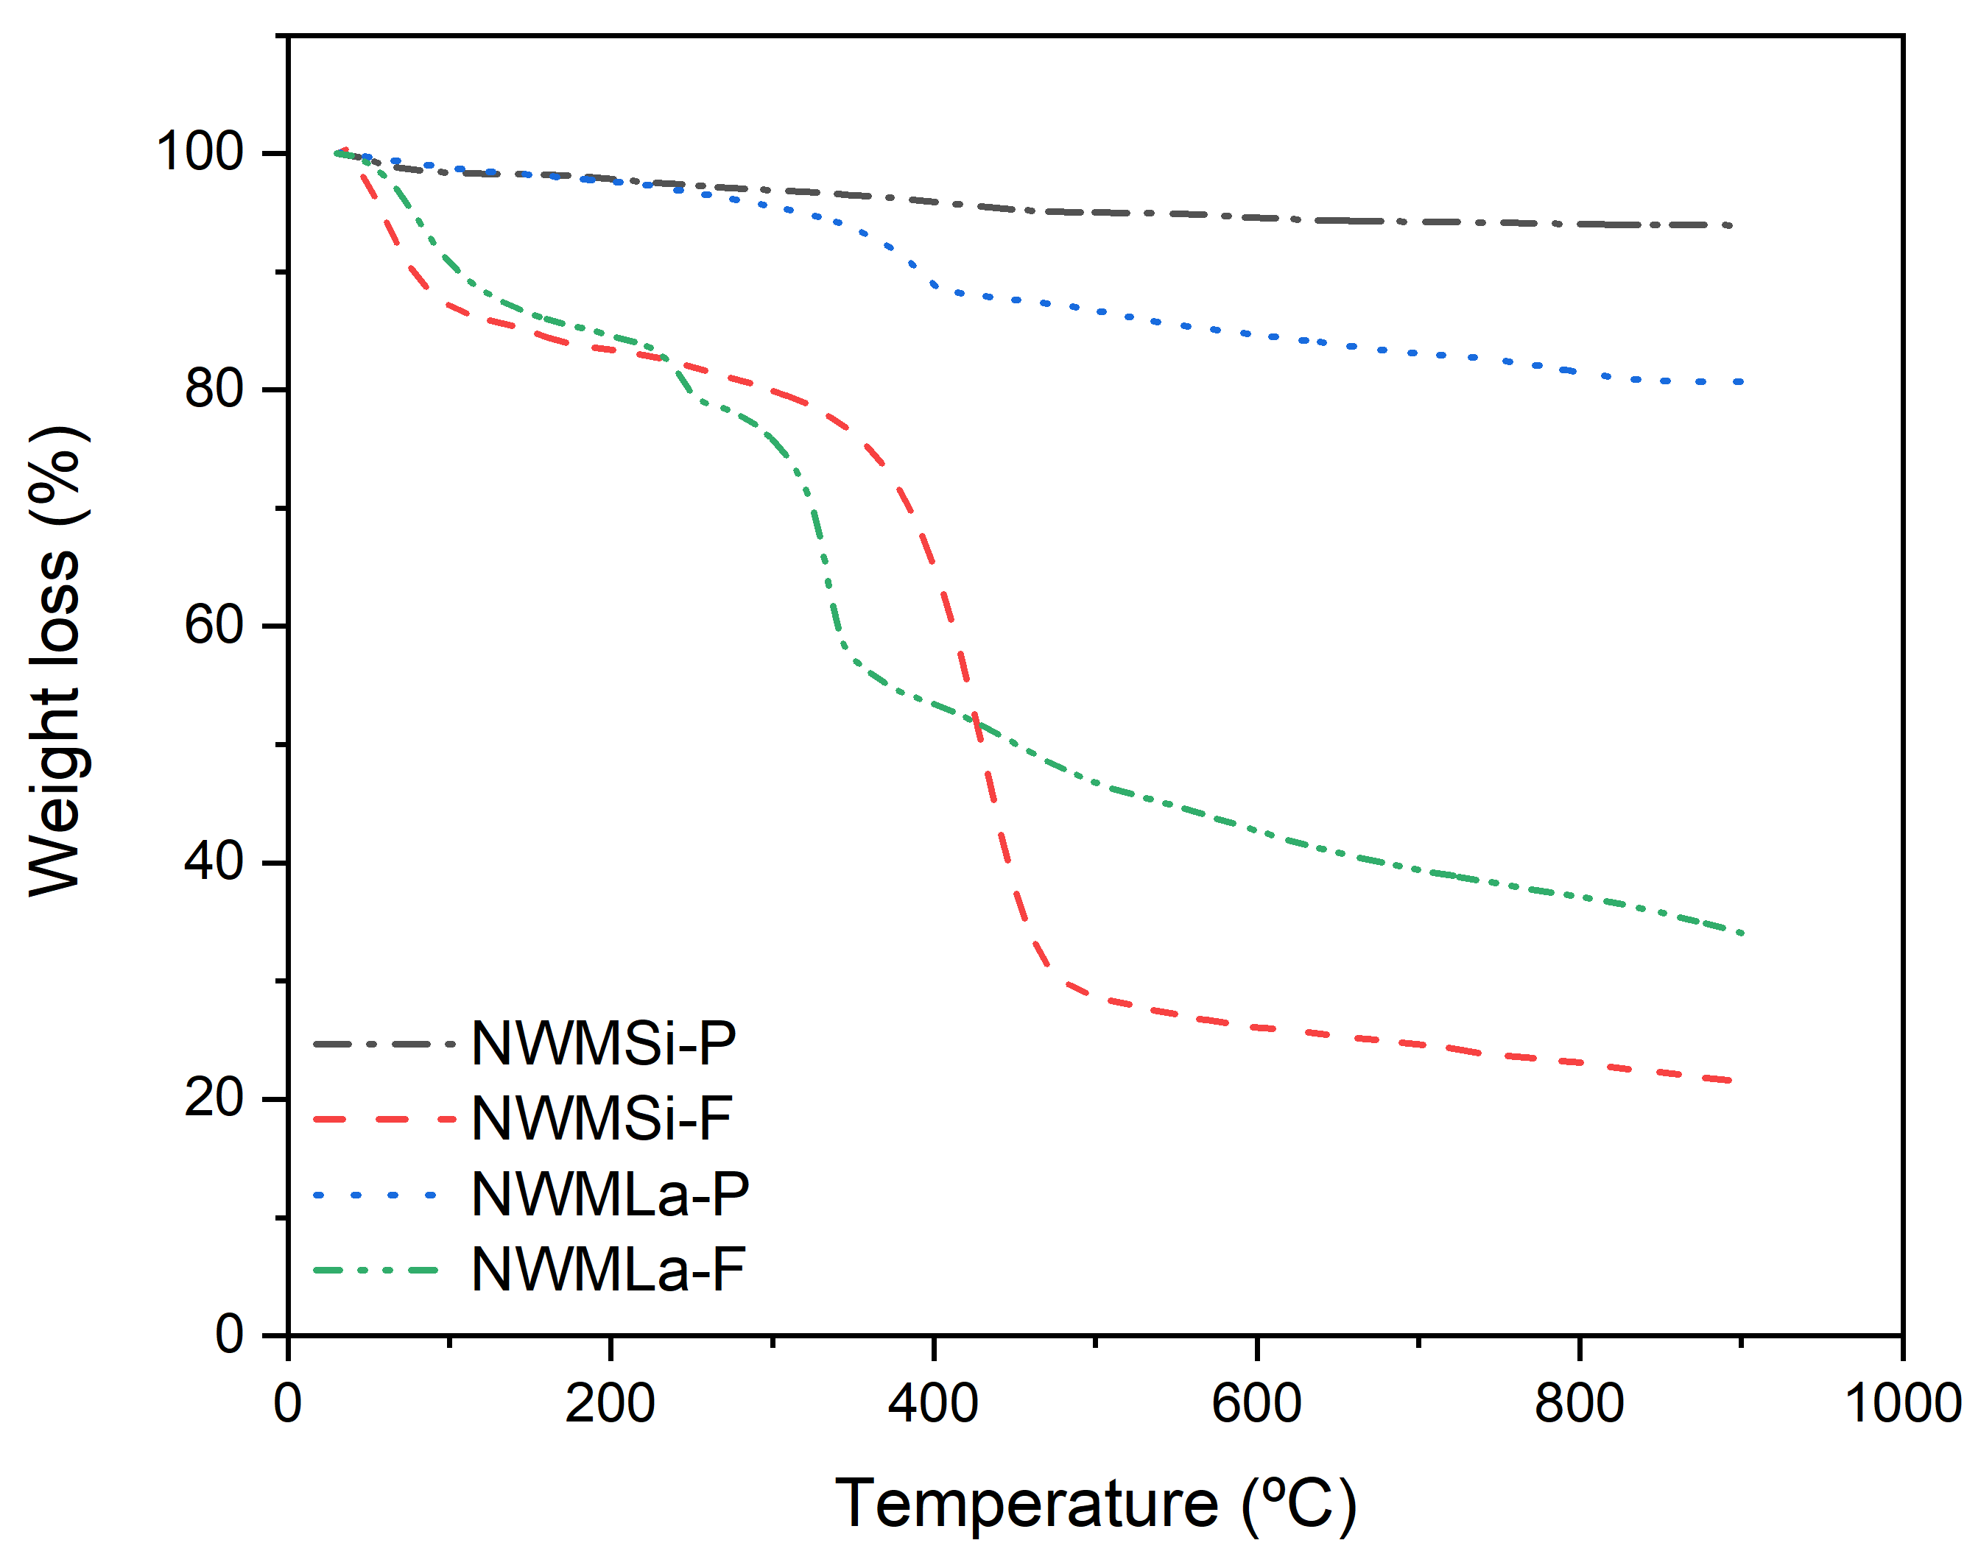

**Figure S1.** TGA of each catalyst. Test condition: 30 to 900 ºC at a heating rate of 10 ºC min-1 in 50 mL min-1 N2 gas.

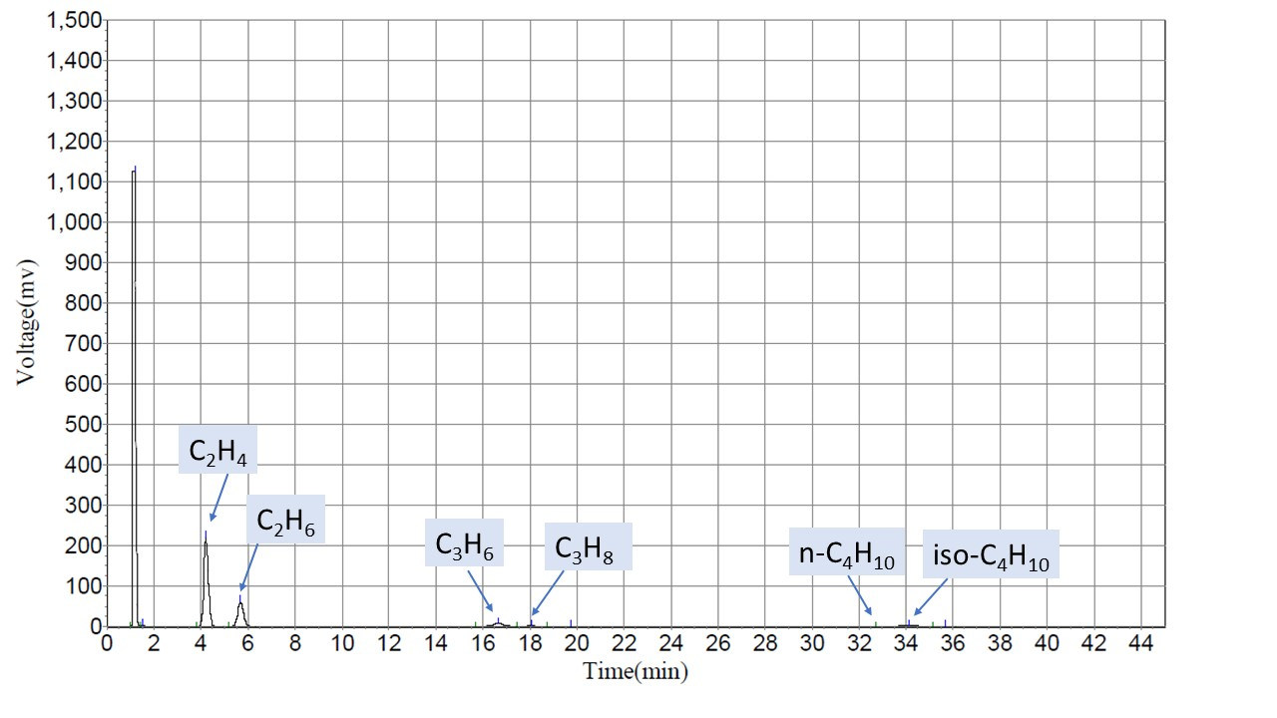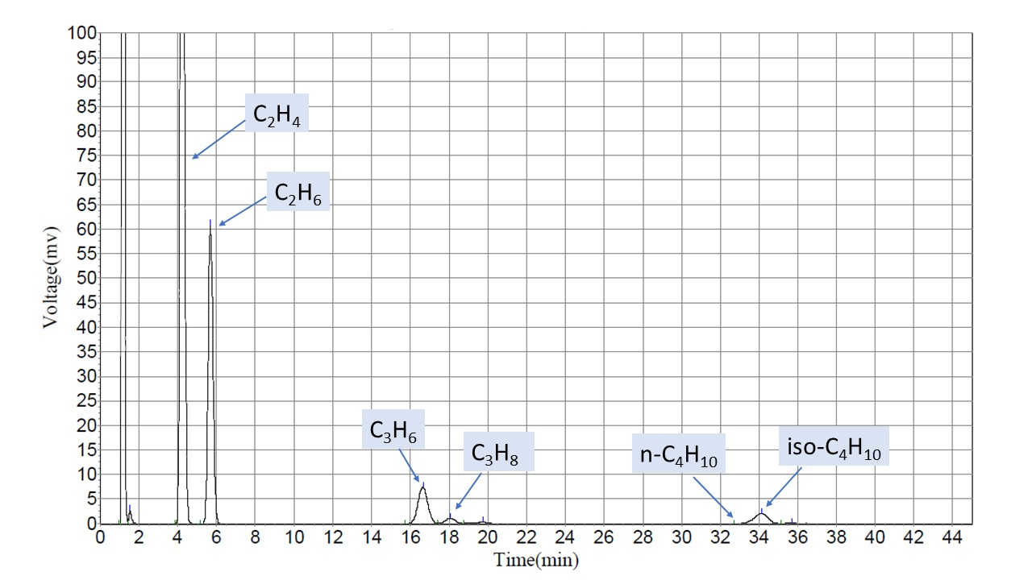

(b)

(a)

**Figure S2.** Example GC chromatograms of NWMSi-F: (a) normal scale, (b) large scale . Reaction conditions: 50 mg catalysts under 35 mL min-1, feed gas ratio of CH4:O2:N2 of 3:1:4 and reactor temperature = 700 ºC.

Carbon balance check

$$n_{2}\text{mol CO}$$

$$n_{\text{3}}\text{mol }{\text{CO}}_{\text{2}}$$

$$n_{\text{4}}\text{mol }{\text{C}}_{\text{2}}{\text{H}}_{\text{4}}$$

$$n_{\text{5}}\text{mol }{\text{C}}_{\text{2}}{\text{H}}_{\text{6}}$$

$$n_{\text{6}}\text{mol }{\text{C}}_{\text{3}}{\text{H}}_{\text{6}}$$

$$n_{\text{7}}\text{mol }{\text{C}}_{\text{3}}{\text{H}}_{\text{8}}$$

$$n_{\text{8}}\text{mol }{\text{n-C}}_{\text{4}}{\text{H}}_{\text{10}}$$

$$n_{\text{9}}\text{mol }{\text{isoC}}_{\text{4}}{\text{H}}_{\text{10}}$$

$${\text{n}}_{\text{10}}\text{mol }{\text{isoC}\text{H}}_{\text{4}}$$

$${\text{n}}_{\text{1}}\text{mol }{\text{CH}}_{\text{4}}$$

$$n_{\text{11}}\text{mol }{\text{O}}_{\text{2}}$$

$$n_{\text{12}}\text{mol }{\text{N}}_{\text{2}}$$

Reactor

35 mL/min

**Figure S3.** Flowchart of oxidative coupling of methane reaction

**Table S3.** An example of the carbon balance for the performance of NWMSi-F catalyst that is shown in Figure 8.

|  |  |  |  |  |
| --- | --- | --- | --- | --- |
| Time  (hr) | CH4-input  (x10-5mol) | Sum of carbon productsa + CH4-out (10-5mol) | | CH4 balance errorb (%) |
| 1 | 2.510 | 2.445 | 2.6 | | |
| 2 | 2.510 | 2.492 | 0.7 | | |
| 3 | 2.510 | 2.472 | 1.5 | | |
| 4 | 2.510 | 2.420 | 3.6 | | |
| 5 | 2.510 | 2.465 | 1.8 | | |
| 6 | 2.510 | 2.507 | 0.1 | | |
| 7 | 2.510 | 2.487 | 0.9 | | |
| 8 | 2.510 | 2.507 | 0.1 | | |
| 9 | 2.510 | 2.510 | 0.0 | | |
| 10 | 2.510 | 2.502 | 0.3 | | |
| 11 | 2.510 | 2.500 | 0.4 | | |
| 12 | 2.510 | 2.435 | 3.0 | | |
| 13 | 2.510 | 2.487 | 0.9 | | |
| 14 | 2.510 | 2.492 | 0.7 | | |
| 15 | 2.510 | 2.497 | 0.5 | | |
| 16 | 2.510 | 2.477 | 1.3 | | |
| 17 | 2.510 | 2.485 | 1.0 | | |
| 18 | 2.510 | 2.452 | 2.3 | | |
| 19 | 2.510 | 2.487 | 0.9 | | |
| 20 | 2.510 | 2.485 | 1.0 | | |
| 21 | 2.510 | 2.485 | 1.0 | | |
| 22 | 2.510 | 2.492 | 0.7 | | |
| 23 | 2.510 | 2.497 | 0.5 | | |
| 24 | 2.510 | 2.507 | 0.1 | | |

aSum of carbon producs=

b

**Table S4.** The characteristic XRD values of crystalline phases from the results in Figures 1 and 9.

|  |  |  |  |
| --- | --- | --- | --- |
| **Crystalline structure** | **Symbol** | **2θ (degree)** | **ICDD No.** |
| Na2WO4 | ⬧ | 16.8, 27.6, 48.8, 57.0 | 01-074-2369 |
| Mn2O3 | ⏶ | 32.9, 38.3, 55.3 | 00-002-0896 |
| $α$-cristobalite | ⦁ | 22.0, 28.5, 31.4, 36.2,42.8, 44.8, 47.0, 48.7, 54.2, 57.2 | 00-001-0438 |
| $α$-tridymite | ■ | 21.8, 30.2, 48.7 | 00-003-0227 |
| La2O3 | 🟊 | 26.1, 29.1, 30.0, 39.5, 46.0, 52.8, 53.4, 55.4, 55.9, 62.2, 72.1, 75.2, 79.1 | 01-073-2141 |
| La(MnO3) | ⦁ | 22.3, 32.3, 58.4, 72.1, 75.5, 79.0 | 01-089-0027 |

**Table S4.** (Continue)

|  |  |  |  |
| --- | --- | --- | --- |
| **Crystalline structure** | **Symbol** | **2θ (degree)** | **ICDD No.** |
| La(OH)3 | ■ | 33.9, 42.5, 56.4 | 00-006-0585 |

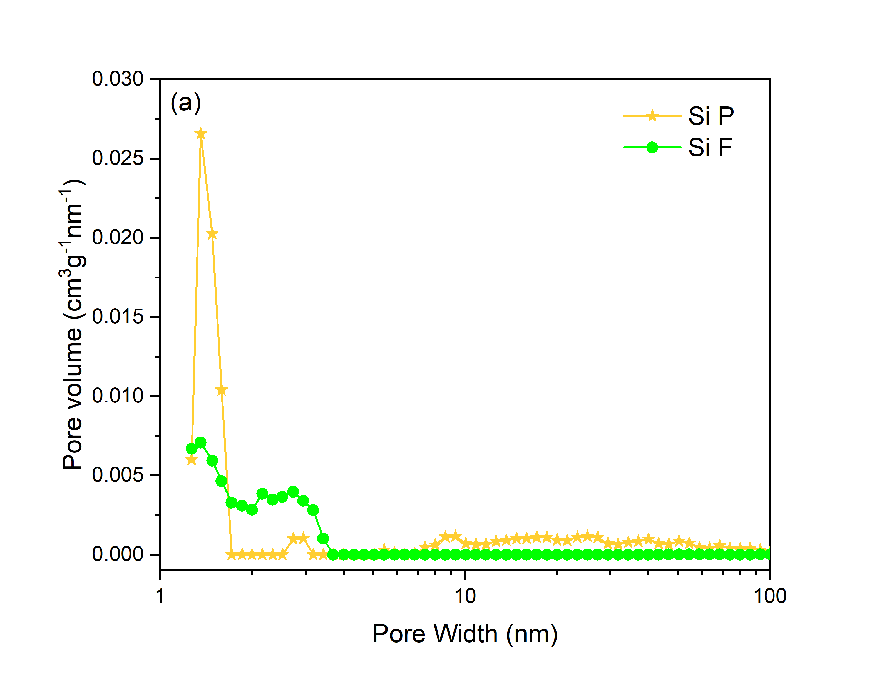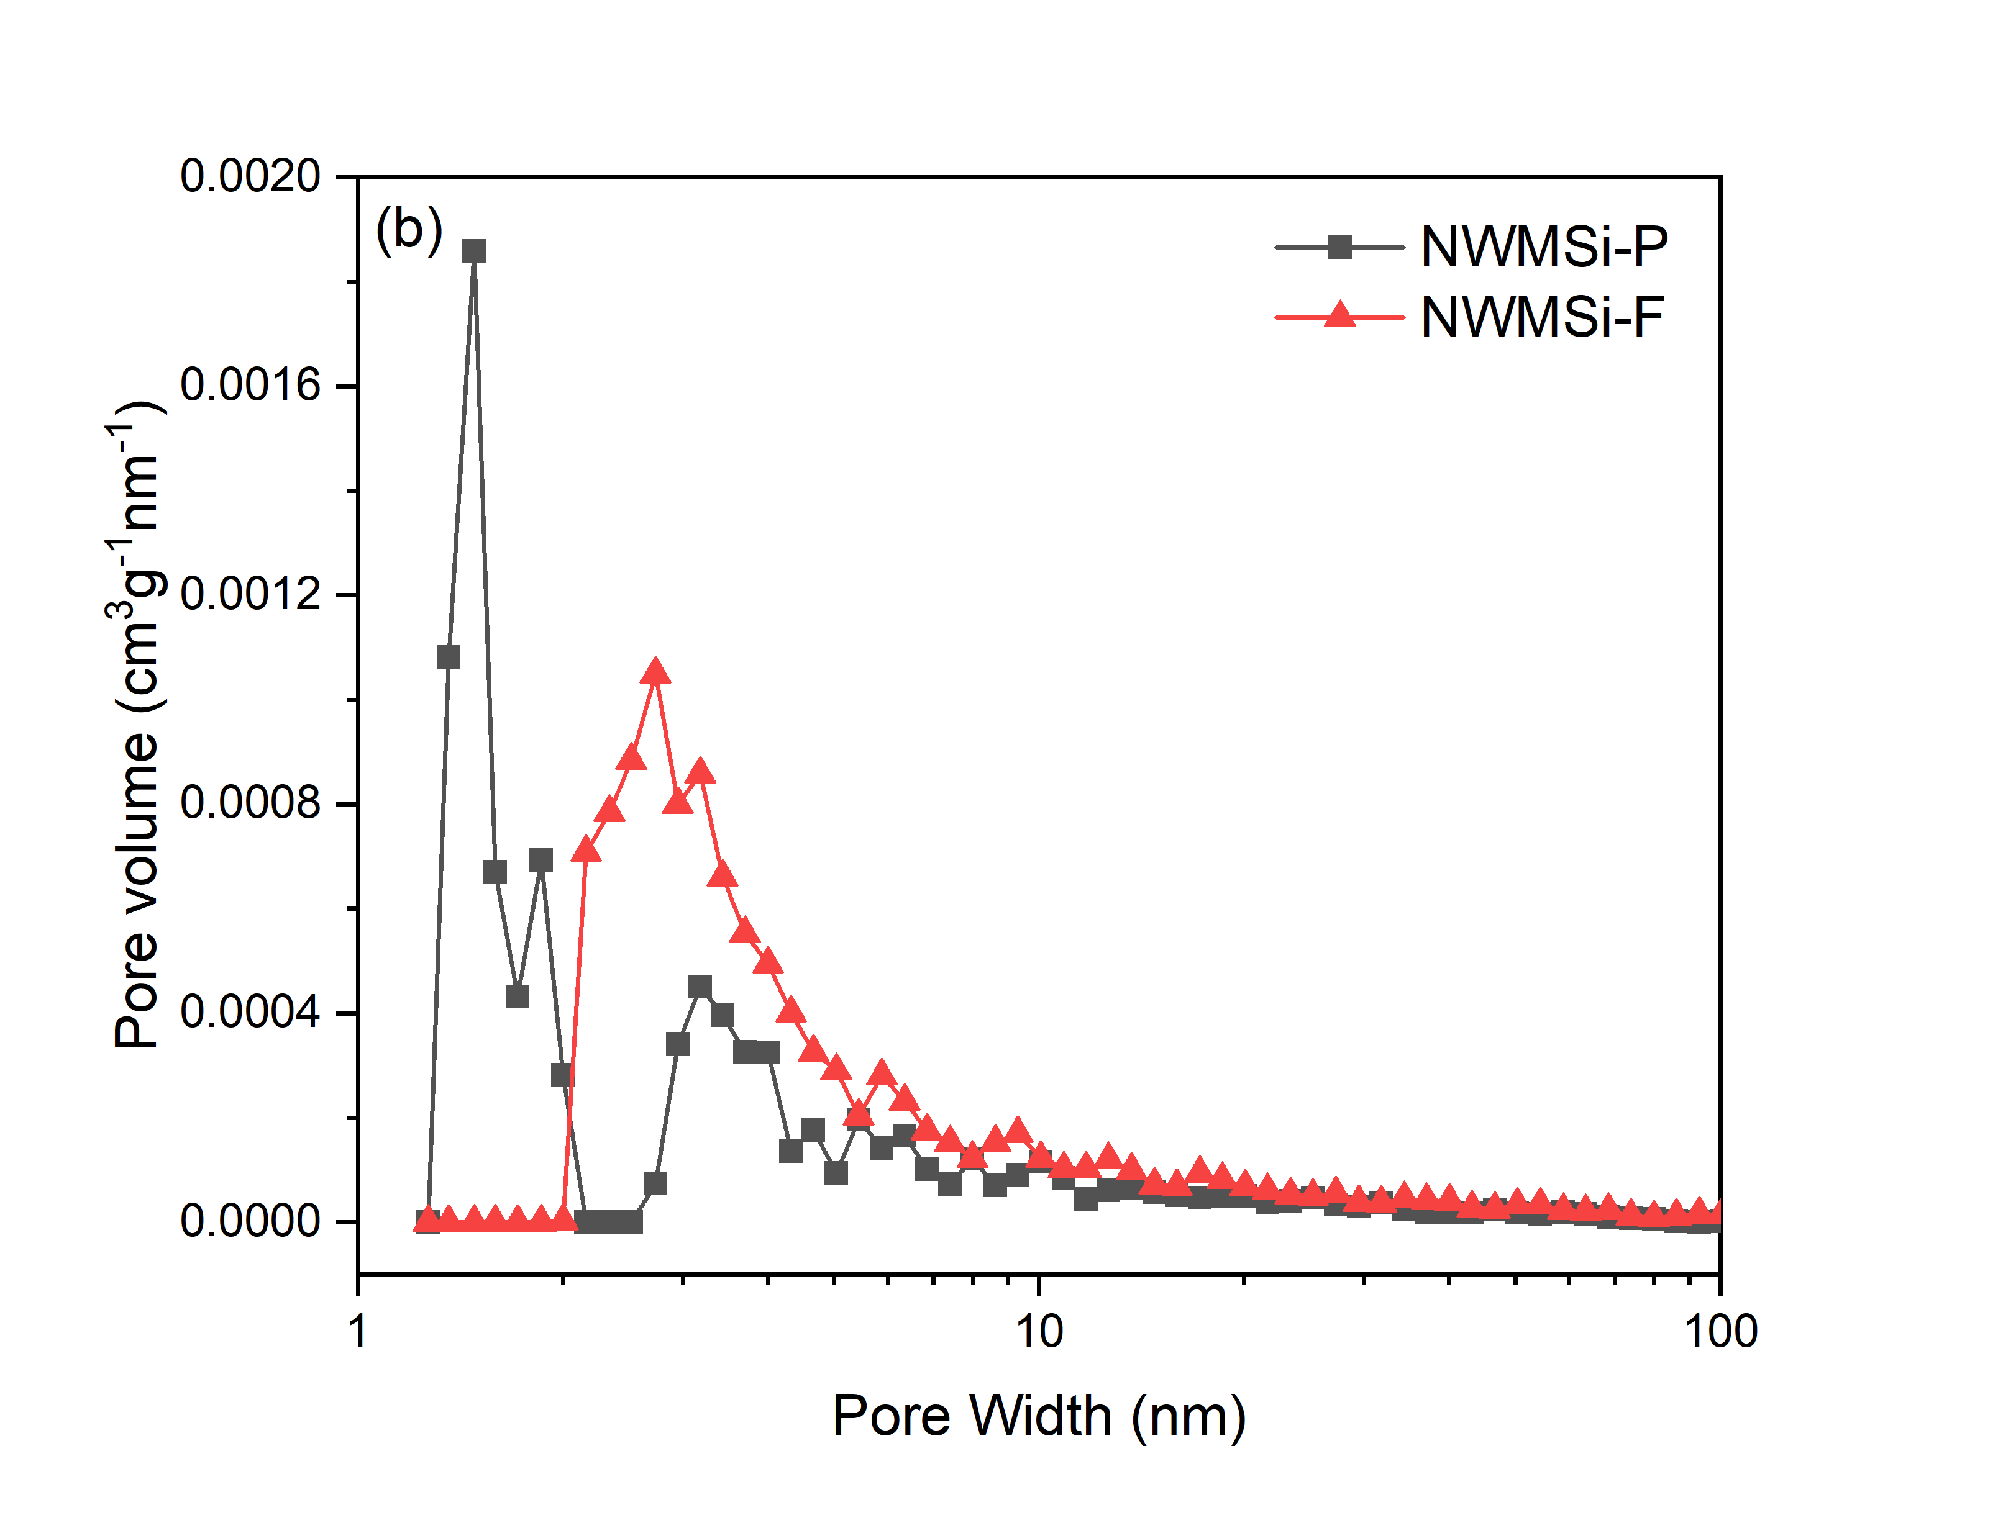

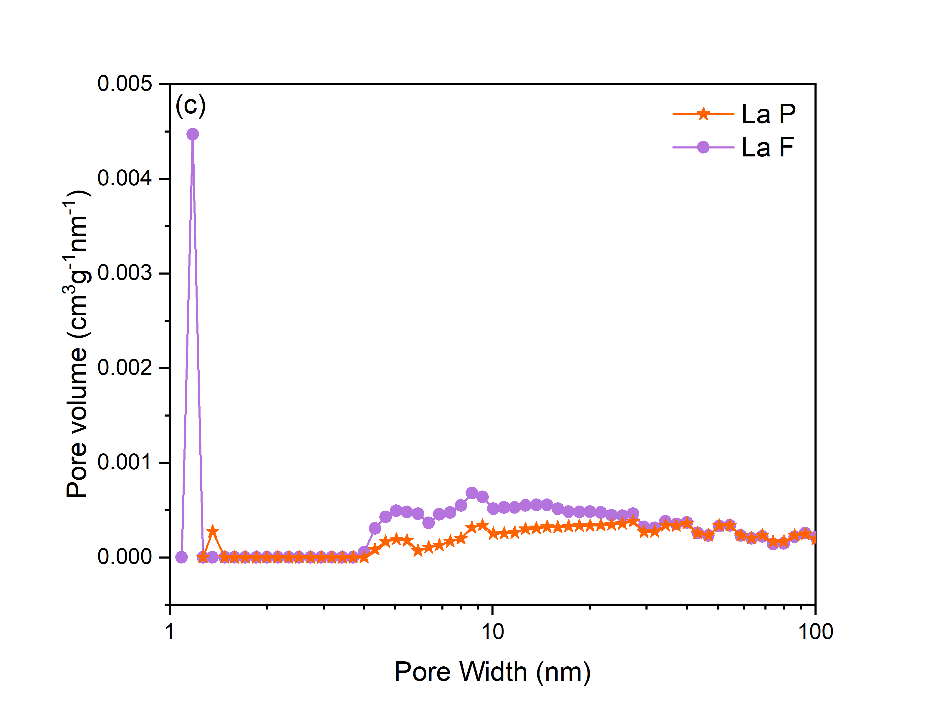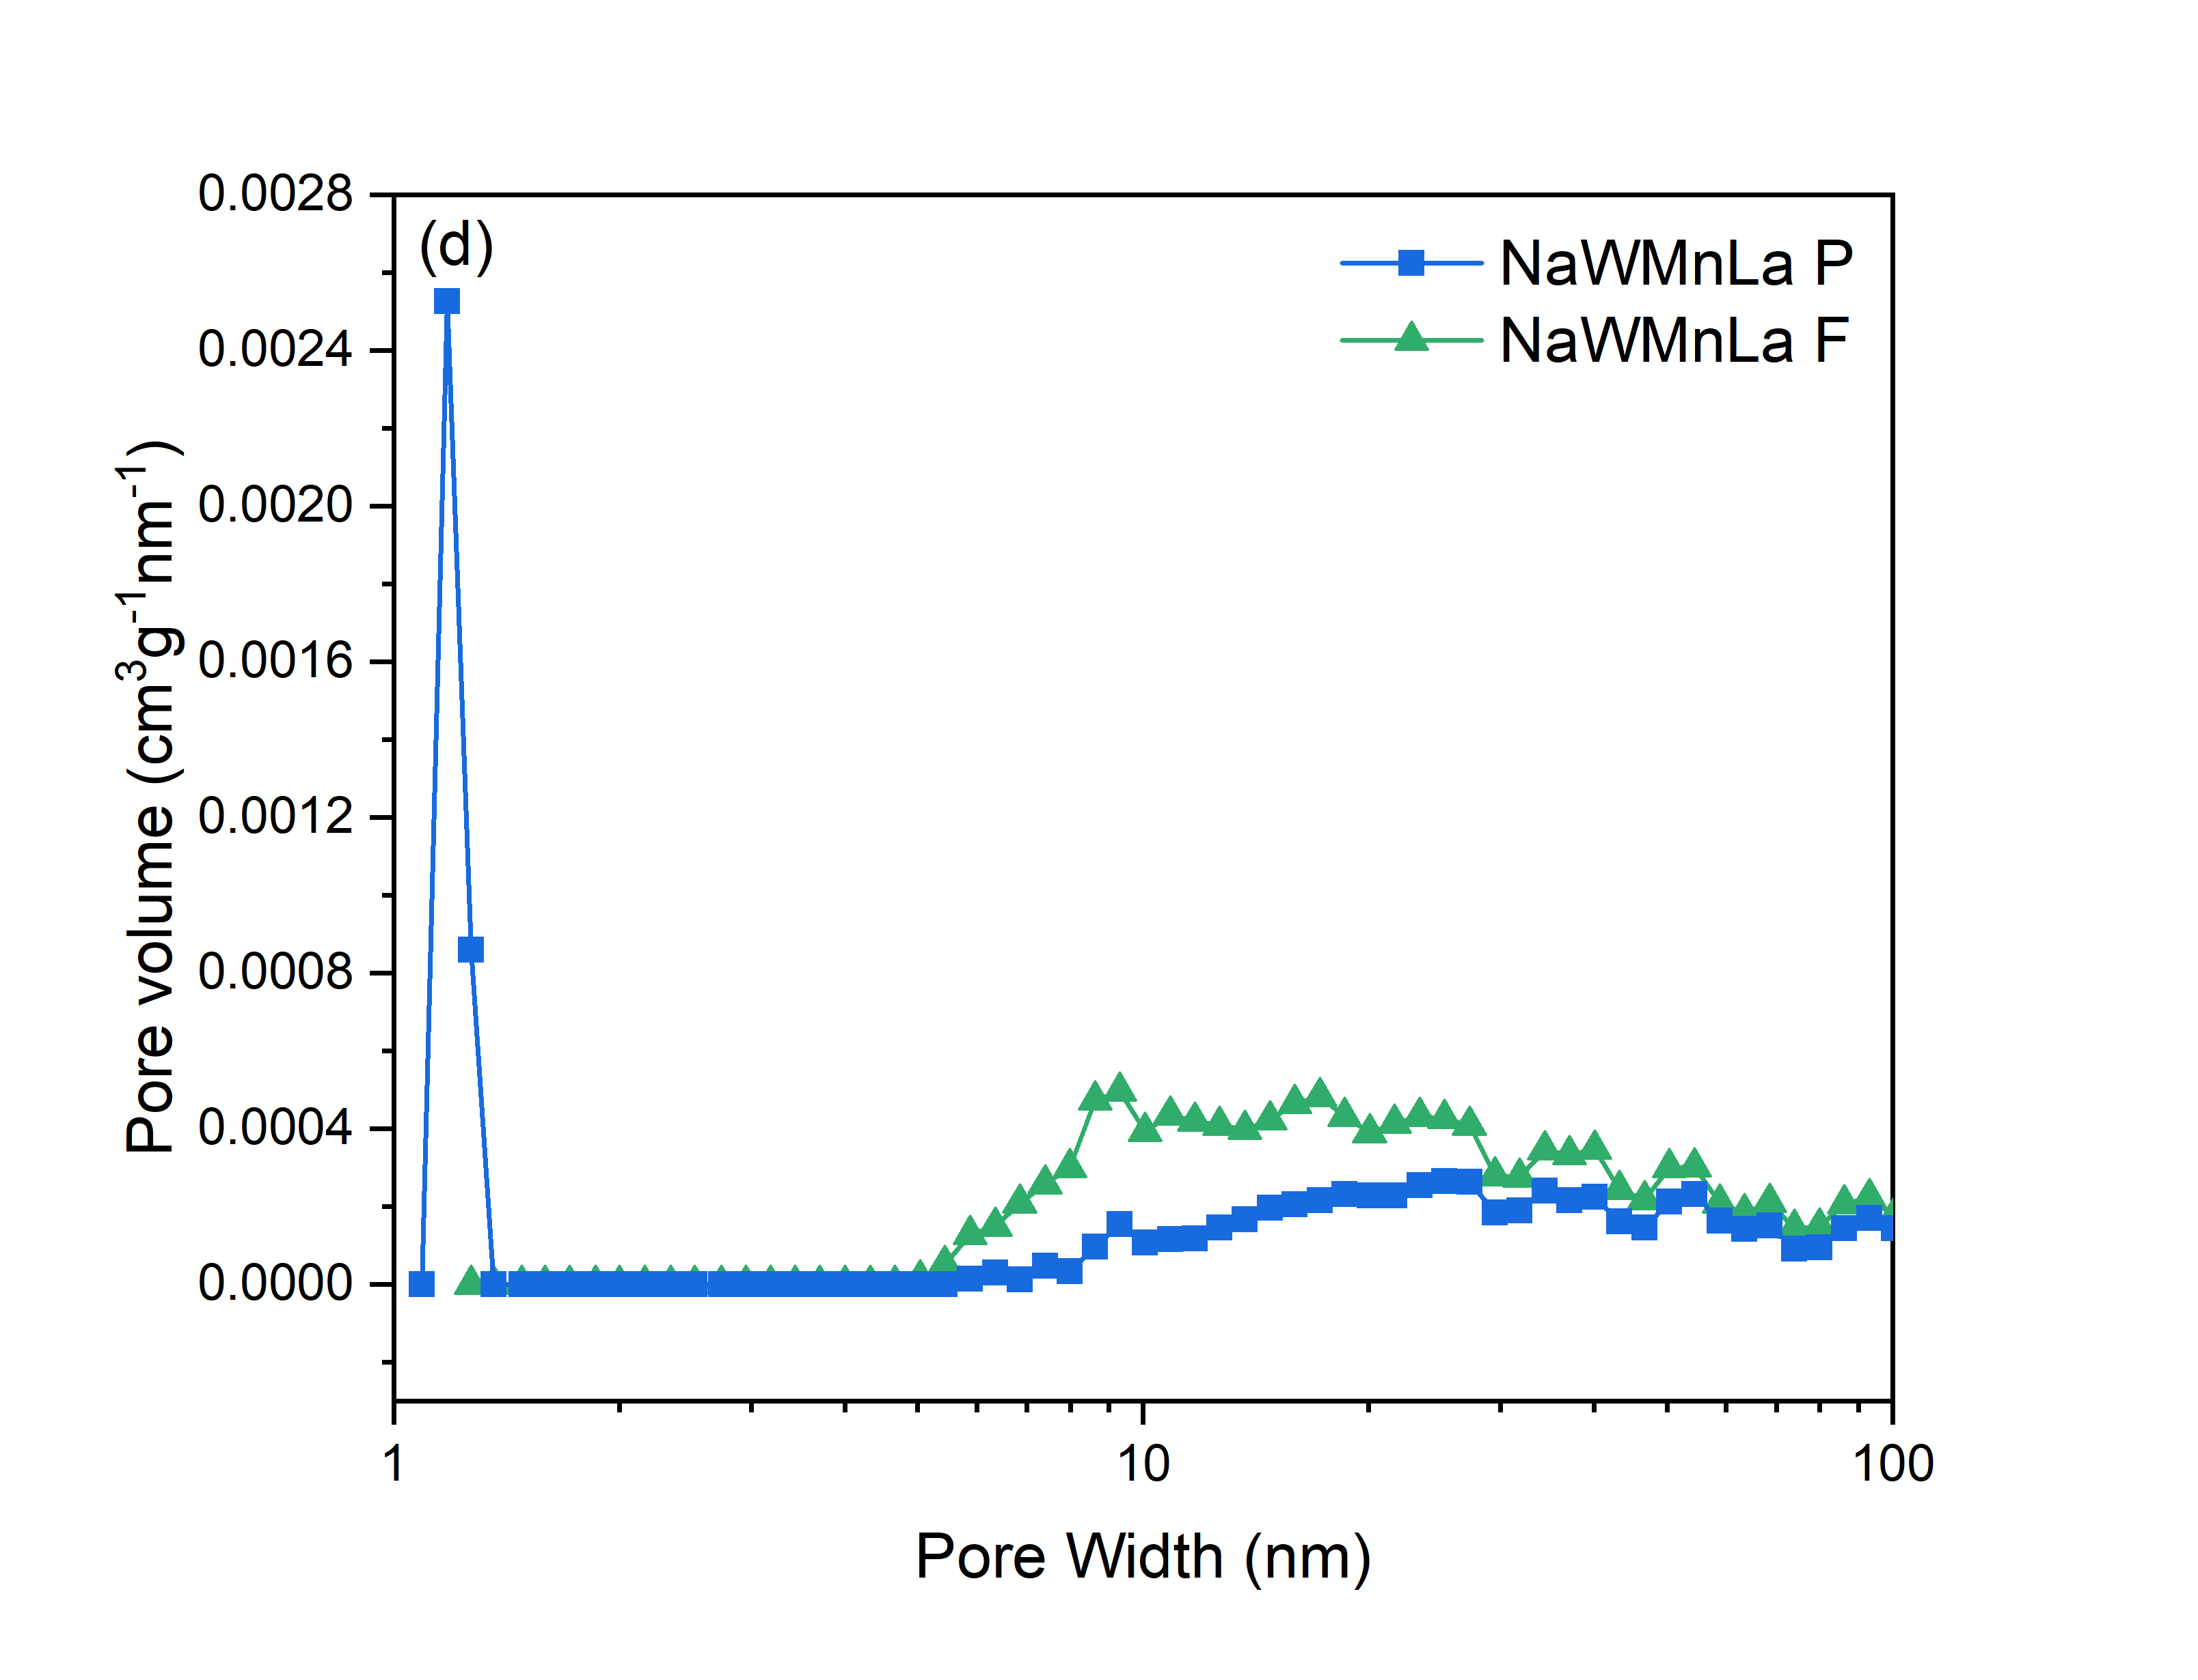

**Figure S4**. Pore size distribution profiles: (a) Si, (b) NWMSi, (c) La, and (d) NWMLa.

**Table S5.** OCM reaction results for the different catalysts. Reaction condition: 50 mg catalysts under 35 mL min-1 and feed gas ratio of CH4:O2:N2 of 3:1:4.

|  |  |  |  |  |  |  |  |
| --- | --- | --- | --- | --- | --- | --- | --- |
| Catalyst | Temperature (ºC) | Olefin selectivity  (%) | C2+  selectivity (%) | Olefin/paraffin (mol/mol) | CH4  conversion (%) | Yield (%) | |
| **Olefin** | **C2+** |
| Si-P | 450 | 0.0 | 0.0 | 0.0 | 0.0 | 0.0 | 0.0 |
| 500 | 0.0 | 0.0 | 0.0 | 0.0 | 0.0 | 0.0 |
| 550 | 0.0 | 0.0 | 0.0 | 0.0 | 0.0 | 0.0 |
| 600 | 6.6 ± 0.3 | 6.6± 0.3 | 0.0 | 0.3 ± 0.0 | 0.0 | 0.0 |
| 650 | 0.7 ±0.0 | 9.7 ± 0.5 | 0.1 ± 0.0 | 1.1 ± 0.1 | 0.0 | 0.1 ± 0.0 |
| 700 | 4.3 ± 0.2 | 16.1 ± 0.8 | 0.4 ± 0.0 | 4.1 ± 0.2 | 0.2 ± 0.0 | 0.7 ± 0.0 |
| 750 | 16.7 ± 0.8 | 27.6 ± 1.4 | 1.6 ± 0.1 | 9.7 ± 0.5 | 1.6 ± 0.1 | 2.7 ± 0.1 |
|  |  |  |  |  |  |  |

**Table S5.** (Continued)

|  |  |  |  |  |  |  |  |
| --- | --- | --- | --- | --- | --- | --- | --- |
| Catalyst | Temperature (ºC) | Olefin selectivity  (%) | C2+  selectivity (%) | Olefin/paraffin (mol/mol) | CH4  conversion (%) | Yield (%) | |
| **Olefin** | **C2+** |
| Si-F | 450 | 0.0 | 0.0 | 0.0 | 0.0 | 0.0 | 0.0 |
| 500 | 0.0 | 0.0 | 0.0 | 0.0 | 0.0 | 0.0 |
| 550 | 0.0 | 0.0 | 0.0 | 0.0 | 0.0 | 0.0 |
| 600 | 0.0 | 1.5 ± 0.1 | 0.0 | 0.7 ± 0.0 | 0.0 | 0.0 |
| 650 | 0.7 ± 0.0 | 6.5 ± 0.3 | 0.1 ± 0.0 | 3.2 ± 0.2 | 0.0 | 0.2 ± 0.0 |
| 700 | 5.8 ± 0.3 | 14.5 ± 0.7 | 0.7 ± 0.0 | 8.2 ± 0.4 | 0.5 ± 0.0 | 1.2 ± 0.1 |
| 750 | 21.1 ± 1.1 | 32.8 ± 1.6 | 1.8 ± 0.1 | 12.2 ± 0.6 | 2.6 ± 0.1 | 4.0 ± 0.2 |

**Table S5.** (Continued)

|  |  |  |  |  |  |  |  |
| --- | --- | --- | --- | --- | --- | --- | --- |
| Catalyst | Temperature (ºC) | Olefin selectivity  (%) | C2+  selectivity (%) | Olefin/paraffin (mol/mol) | CH4  conversion (%) | Yield (%) | |
| **Olefin** | **C2+** |
| NWMSi-P | 450 | 0.0 | 0.0 | 0.0 | 0.0 | 0.0 | 0.0 |
| 500 | 0.0 | 0.0 | 0.0 | 0.0 | 0.0 | 0.0 |
| 550 | 0.0 | 0.0 | 0.0 | 0.0 | 0.0 | 0.0 |
| 600 | 0.1 ± 0.0 | 6.5 ± 0.3 | 0.0 | 0.6 ± 0.0 | 0.0 | 0.1 ± 0.0 |
| 650 | 7.2 ± 0.4 | 24.6 ± 1.2 | 0.5 ± 0.7 | 8.9 ± 0.4 | 0.7 ± 0.0 | 2.1 ± 0.1 |
| 700 | 39.3 ± 2.0 | 54.5 ± 2.7 | 2.8 ± 0.4 | 31.7 ± 1.6 | 12.5 ± 0.6 | 17.3 ± 0.9 |
| 750 | 44.3 ± 2.2 | 53.0 ± 2.7 | 6.1 ± 1.2 | 33.8 ± 1.7 | 15.0 ± 0.8 | 17.9 ± 0.9 |

**Table S5.** (Continued)

|  |  |  |  |  |  |  |  |
| --- | --- | --- | --- | --- | --- | --- | --- |
| Catalyst | Temperature (ºC) | Olefin selectivity  (%) | C2+  selectivity (%) | Olefin/paraffin (mol/mol) | CH4  conversion (%) | Yield (%) | |
| **Olefin** | **C2+** |
| NWMSi-F | 450 | 0.0 | 0.0 | 0.0 | 0.0 | 0.0 | 0.0 |
| 500 | 0.0 | 0.0 | 0.0 | 0.0 | 0.0 | 0.0 |
| 550 | 0.0 | 0.0 | 0.0 | 0.0 | 0.0 | 0.0 |
| 600 | 1.3 ± 0.1 | 15.3 ± 0.7 | 0.1 ± 0.2 | 1.7 ± 0.1 | 0.02 ± 0.0 | 0.3 ± 0.0 |
| 650 | 25.4 ± 1.2 | 50.3 ± 2.5 | 1.1 ± 0.2 | 15.1 ± 0.8 | 4.0 ± 0.2 | 7.6 ± 0.4 |
| 700 | 43.9 ± 2.2 | 60.1 ± 3.0 | 3.0 ± 0.2 | 34.0 ± 1.7 | 14.9 ± 0.7 | 20.4 ± 1.0 |
| 750 | 47.6 ± 2.4 | 56.6 ± 2.8 | 6.4 ± 0.8 | 32.2 ± 1.6 | 15.3 ± 0.8 | 18.2 ± 0.9 |

**Table S5.** (Continued)

|  |  |  |  |  |  |  |  |
| --- | --- | --- | --- | --- | --- | --- | --- |
| Catalyst | Temperature (ºC) | Olefin selectivity  (%) | C2+  selectivity (%) | Olefin/paraffin (mol/mol) | CH4  conversion (%) | Yield (%) | |
| **Olefin** | **C2+** |
| La-P | 450 | 0.0 | 0.0 | 0.0 | 0.0 | 0.0 | 0.0 |
| 500 | 0.0 | 0.0 | 0.0 | 0.0 | 0.0 | 0.0 |
| 550 | 0.0 | 0.0 | 0.0 | 0.0 | 0.0 | 0.0 |
| 600 | 3.6 ± 0.2 | 21.2 ± 1.1 | 0.0 | 5.7 ± 0.3 | 0.2 ± 0.0 | 1.2 ± 0.1 |
| 650 | 21.2 ± 1.1 | 40.7 ± 2.0 | 1.1 ± 0.2 | 22.0 ± 1.1 | 4.8 ± 0.3 | 9.0 ± 0.4 |
| 700 | 26.0 ± 1.3 | 40.8 ± 2.0 | 0.8 ± 0.0 | 25.7 ± 1.3 | 6.7 ± 0.3 | 10.5 ± 0.5 |
| 750 | 26.0 ± 1.3 | 33.6 ± 1.7 | 3.7 ± 0.7 | 26.8 ± 1.3 | 7.0 ± 0.4 | 9.0 ± 0.4 |

**Table S5.** (Continued)

|  |  |  |  |  |  |  |  |
| --- | --- | --- | --- | --- | --- | --- | --- |
| Catalyst | Temperature (ºC) | Olefin selectivity  (%) | C2+  selectivity (%) | Olefin/paraffin (mol/mol) | CH4  conversion (%) | Yield (%) | |
| **Olefin** | **C2+** |
| La-F | 450 | 0.0 | 0.0 | 0.0 | 1.9 ± 0.1 | 0.0 | 0.0 |
| 500 | 0.0 | 0.0 | 0.0 | 5.3 ± 0.3 | 0.0 | 0.0 |
| 550 | 0.8 ± 0.0 | 4.6 ± 0.2 | 0.2 ± 0.1 | 12.7 ± 0.6 | 0.1 ± 0.01 | 0.6 ± 0.0 |
| 600 | 15.9 ± 0.8 | 33.3 ± 1.7 | 0.9 ± 0.1 | 25.3 ± 1.3 | 4.0 ± 0.2 | 8.5 ± 0.4 |
| 650 | 17.8 ± 0.9 | 34.4 ± 1.7 | 1.1 ± 0.0 | 26.7 ± 1.3 | 4.7 ± 0.2 | 9.2 ± 0.5 |
| 700 | 17.5 ± 0.9 | 32.4 ± 1.6 | 1.2 ± 0.0 | 26.9 ± 1.3 | 4.7 ± 0.1 | 8.7 ± 0.4 |
| 750 | 16.8 ± 0.8 | 26.3 ± 1.3 | 1.8 ± 0.1 | 25.8 ± 1.3 | 4.3 ± 0.2 | 6.8 ± 0.3 |

**Table S5.** (Continued)

|  |  |  |  |  |  |  |  |
| --- | --- | --- | --- | --- | --- | --- | --- |
| Catalyst | Temperature (ºC) | Olefin selectivity  (%) | C2+  selectivity (%) | Olefin/paraffin (mol/mol) | CH4  conversion (%) | Yield (%) | |
| **Olefin** | **C2+** |
| NWMLa-P | 450 | 0.0 | 0.0 | 0.0 | 0.6 ± 0.0 | 0.0 | 0.0 |
| 500 | 5.6 ± 0.3 | 14.0 ± 0.7 | 0.3 ± 0.03 | 17.4 ± 0.9 | 1.2 ± 0.1 | 2.6 ± 0.1 |
| 550 | 5.8 ± 0.3 | 18.1 ± 0.9 | 0.1 ± 0.1 | 20.4 ± 1.0 | 1.4 ± 0.1 | 4.1 ± 0.2 |
| 600 | 8.0 ± 0.4 | 23.7 ± 1.2 | 0.5 ± 0.1 | 21.6 ± 1.1 | 1.9 ± 0.1 | 5.5 ± 0.3 |
| 650 | 11.6 ± 0.6 | 34.5 ± 1.7 | 0.7 ± 0.0 | 24.3 ± 1.2 | 2.7 ± 0.1 | 8.4 ± 0.4 |
| 700 | 20.5 ± 1.5 | 36.3 ± 1.8 | 1.4 ± 0.7 | 23.4 ± 1.2 | 4.8 ± 0.2 | 8.5 ± 0.4 |
| 750 | 25.1 ± 1.3 | 33.1 ± 1.7 | 4.2 ± 0.2 | 24.4 ± 1.2 | 6.3 ± 0.3 | 8.2 ± 0.4 |

**Table S5.** (Continued)

|  |  |  |  |  |  |  |  |
| --- | --- | --- | --- | --- | --- | --- | --- |
| Catalyst | Temperature (ºC) | Olefin selectivity  (%) | C2+  selectivity (%) | Olefin/paraffin (mol/mol) | CH4  conversion (%) | Yield (%) | |
| **Olefin** | **C2+** |
| NWMLa-F | 450 | 0.0 | 0.0 | 0.0 | 0.3 ± 0.01 | 0.0 | 0.0 |
| 500 | 3.1 ± 0.2 | 20.0 ± 0.1 | 0.2 ± 0.0 | 23.5 ± 1.2 | 0.7 ± 0.0 | 4.7 ± 0.2 |
| 550 | 6.4 ± 0.3 | 22.8 ± 1.1 | 0.4 ± 0.0 | 28.2 ± 1.4 | 1.8 ± 0.1 | 6.4 ± 0.3 |
| 600 | 13.2 ± 0.7 | 32.7 ± 1.6 | 0.7 ± 0.3 | 26.1 ± 1.3 | 3.4 ± 0.2 | 8.5 ± 0.4 |
| 650 | 16.1 ± 0.8 | 38.9 ± 1.9 | 0.7 ± 0.1 | 24.1 ± 1.2 | 4.0 ± 0.2 | 9.6 ± 0.5 |
| 700 | 17.5 ± 0.9 | 32.4 ± 1.6 | 1.2 ± 0.3 | 26.9 ± 1.3 | 4.7 ± 0.2 | 8.7 ± 0.4 |
| 750 | 16.2 ± 0.8 | 24.9 ± 1.2 | 1.9 ± 0.5 | 26.6 ± 1.3 | 4.3 ± 0.2 | 6.6 ± 0.3 |

**Table S6.** Quantification results of XPS O 1s spectra of the Si-based and La-based catalysts.

|  |  |  |  |  |  |  |
| --- | --- | --- | --- | --- | --- | --- |
| Catalyst | O 1s binding energy (eV) / Percentage fraction | | | | | |
| O2- | Mn—O | OH-, | Si—O | $${\text{O}}_{\text{2}}^{\text{-}}$$ | Na—O—W |
| Si-F | 531.3/1.9 | - | - | 533.3/95.5 | 535.0/2.5 | - |
| NWMSi-F | 531.3/11.2 | 529.7/1.5 | - | 532.8/68.8 | 533.8/13.7 | 534.7/5.0 |
| La-F | 529.2/9.3 | - | 531.6/74.0 | - | 533.0/16.7 | - |
| NWMLa-F | 529.0/8.1 | 529.4/17.6 | 531.4/39.9 | - | 532.2/29.8 | 534.1/4.6 |

**Table S7.** Relative peak area for XPS O 1s spectra of the Si-based and La-based catalysts.

|  |  |  |  |  |  |  |
| --- | --- | --- | --- | --- | --- | --- |
| Catalyst | Relative peak area (a.u.) | | | | | |
| O2- | Mn—O | OH-, | Si—O | $${\text{O}}_{\text{2}}^{\text{-}}$$ | Na—O—W |
| Si-F | 656.9 | - | - | 32,380.6 | 854.0 | - |
| NWMSi-F | 3,957.9 | 538.2 | - | 24,260.8 | 4,751.9 | 1,778.8 |
| La-F | 1,301.3 | - | 10,404.0 | - | 2,347.6 | - |
| NWMLa-F | 1,250.6 | 2,731.3 | 6,183.8 | - | 4,607.5 | 711.4 |

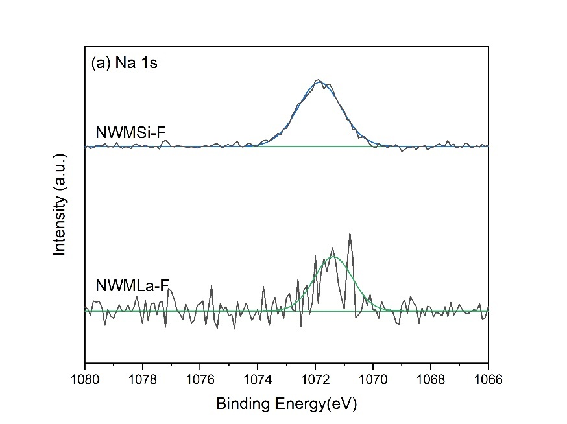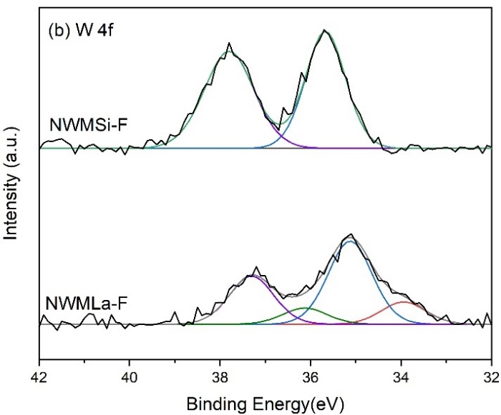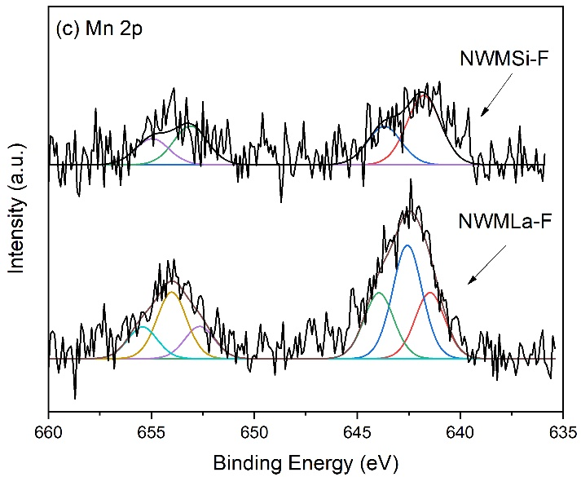

**Figure S5.** XPS spectra of (a) Na 1s, (b) W 4f, and (c) Mn 2p regions obtained from NWMSi-F and NWMLa-F catalysts.

**Reference**

Au, C.T., Zang, Y. Q., He, H., Lai, S. Y., Ng., C.F., 1997. The characterization of BaCO3-modified LaOF catalysts for the OCM reaction. J. Catal. 167, 354-363. <https://doi.org/10.1006/jcat.1997.1577>.

Chua, Y. T., Mohamed, A. R., Bhatia, S., 2008. Oxidative coupling of methane for the production of ethylene over sodium-tungsten-manganese-supported-silica catalyst (Na-W-Mn/SiO2). Appl. Catal. A-Gen. 343, 142-148. <https://doi.org/10.1016/j.apcata.2008.03.032>.

DeBoy, J. M., Hicks, R. F., 1988. Oxidative coupling of methane over alkaline earth promoted La2O3. J. Chem. Soc. 982-984. <https://doi.org/10.1039/C39880000982>.

Elkins, T.W., Hagelin-Weaver, H.E., 2015. Characterization of Mn-Na2WO4/SiO2 and Mn-Na2WO4/MgO catalysts for the oxidative coupling of methane. Appl. Catal. A-Gen. 497, 96-106. <https://doi.org/10.1016/j.apcata.2015.02.040>.

Fleischer, V., Steuer, R., Parishan, S., Schomäcker, R., 2016. Investigation of the surface reaction network of the oxidative coupling of methane over Na2WO4/Mn/SiO2 catalyst by temperature programmed and dynamic experiments. J. Catal. 341, 91-103. <https://doi.org/10.1016/j.jcat.2016.06.014>.

Gerald S. Lane, E.M., Eduardo E. Wolf, 1989. Methane oxidative coupling: II. A study of lithium-titania-catalyzed reactions of methane. J. Catal. 119, 161-178. <https://doi.org/10.1016/0021-9517(89)90143-7>.

Godini, H.R., Gili, A., Görke, O., Arndt, S., Simon, U., Thomas, A., Schomäcker, R., Wozny, G., 2014. Sol–gel method for synthesis of Mn–Na2WO4/SiO2 catalyst for methane oxidative coupling. Catal . Today 236, 12-22. <https://doi.org/10.1016/j.cattod.2014.01.005>.

Gu, S., Oh, H. S., Choi, J. W., Suh, D.J., Jae, J., Choi, J., Ha, J. M., 2018. Effects of metal or metal oxide additives on oxidative coupling of methane using Na2WO4/SiO2 catalysts: Reducibility of metal additives to manipulate the catalytic activity. Appl. Catal. A-Gen. 562, 114-119. <https://doi.org/10.1016/j.apcata.2018.05.031>.

Hayek, N.S., Khlief, G.J., Horani, F., Gazit, O.M., 2019. Effect of reaction conditions on the oxidative coupling of methane over doped MnOx-Na2WO4/SiO2 catalyst. J. Catal. 376, 25-31. <https://doi.org/10.1016/j.jcat.2019.06.042>.

Hayek, N.S., Lucas, N.S., Damouny, C.W., Gazit, O.M., 2017. Critical surface parameters for the oxidative coupling of methane over the Mn-Na-W/SiO2 catalyst. ACS Appl. Mater. Interfaces 9, 40404-40411. <https://doi.org/10.1021/acsami.7b14941>.

Hiyoshi, N., Ikeda, T., 2015. Oxidative coupling of methane over alkali chloride-Mn-Na2WO4/SiO2 catalysts: Promoting effect of molten alkali chloride. Fuel Process. Technol. 133, 29-34. <https://doi.org/10.1016/j.fuproc.2015.01.003>.

Ji, S. F., Xiao, T. C., Li, S. B., Xu, C. Z., Hou, R. L., Coleman, K.S., Green, M.L.H., 2002. The relationship between the structure and the performance of Na-W-Mn/SiO2 catalysts for the oxidative coupling of methane. Appl. Catal. A-Gen. 225, 271-284. <https://doi.org/10.1016/S0926-860X(01)00864-X>.

Ji, S., Xiao, T., Li, S., Chou, L., Zhang, B., Xu, C., Hou, R., York, A.P.E., Green, M.L.H., 2003. Surface WO4 tetrahedron: The essence of the oxidative coupling of methane over M-W-Mn/SiO2 catalysts. J. Catal. 220, 47-56. <https://doi.org/10.1016/s0021-9517(03)00248-3>.

Jiang, Z. C., Yu, C. J., Fang, X. P., Li, S. B., Wang, H. L., 1993. Oxide/support interaction and surface reconstruction in the sodium tungstate (Na2WO4)/silica system. J. Phys. Chem. A 97, 12870-12875. <https://doi.org/10.1021/j100151a038>.

Jingjing Wu, H.Z., Song Qin, Changwei Hu, 2007. La-promoted Na2WO4/Mn/SiO2 catalysts for the oxidative conversion of methane simultaneously to ethylene and carbon monoxide. Appl. Catal. A-Gen. 323, 126-134. <https://doi.org/10.1016/j.apcata.2007.02.009>.

Kiennemann, A., Kieffer, R., Kaddouri, A., Poix, P., Rehspringer, J. L., 1990. Oxidative coupling of methane over LnLiO2, LnNaO2 and LnOX catalysts (Ln = Sm, Nd, La ; X = Cl, Br). Promoting effect of MgO, CaO and SrO. Catal . Today 6, 409-416. <https://doi.org/10.1016/0920-5861(90)85034-L>.

Lee, J.Y., Jeon, W., Choi, J. W., Suh, Y. W., Ha, J. M., Suh, D.J., Park, Y. K., 2013. Scaled-up production of C2 hydrocarbons by the oxidative coupling of methane over pelletized Na2WO4/Mn/SiO2 catalysts: Observing hot spots for the selective process. Fuel 106, 851-857. <https://doi.org/10.1016/j.fuel.2013.01.026>.

Liang, W., Sarsani, S., West, D., Mamedov, A., Lengyel, I., Perez, H., Lowrey, J., 2018. Performance improvement for a fixed-bed reactor with layered loading catalysts of different catalytic properties for oxidative coupling of methane. Catal . Today 299, 60-66. <https://doi.org/10.1016/j.cattod.2017.03.058>.

Mahmoodi, S., Ehsani, M.R., Ghoreishi, S.M., 2010. Effect of promoter in the oxidative coupling of methane over synthesized Mn/SiO2 nanocatalysts via incipient wetness impregnation. Ind. Eng. Chem. Res. 16, 923-928. <https://doi.org/10.1016/j.jiec.2010.09.007>.

Malekzadeh, A., Khodadadi, A., Abedini, M., Amini, M., Bahramian, A., Dalai, A.K., 2001. Correlation of electrical properties and performance of OCM MOx/Na2WO4/SiO2 catalysts. Catal. Commun. 2, 241-247. [https://doi.org/10.1016/S1566-7367(01)00034-6](https://doi.org/https://doi.org/10.1016/S1566-7367(01)00034-6).

Masami Yamamura, H.O., Naohide Tsuzuki, Toshiya Wakatsuki, Kiyoshi Otsuka, 1995. Oxidative coupling of methane over ternary metal oxide catalysts consisting of Groups I, III and V elements in the periodic table. Appl. Catal. A-Gen. 122, 135-149. <https://doi.org/10.1016/0926-860X(94)00229-0>.

Palermo, A., Vazquez, J.P.H., Tikhov, M.S., Lambert, R.M., 1998. Critical influence of the amorphous silica-to-cristobalite phase transition on the performance of Mn/Na2WO4/SiO2 catalysts for the oxidative coupling of methane. J. Catal. 177, 259-266. [https://doi.org/10.1006/jcat.1998.2109](https://doi.org/https://doi.org/10.1006/jcat.1998.2109).

Seoyeon Lim, J.-W.C., Dong Jin Suh, Kwang Ho Song, Hyung Chul Ham, Jeong-Myeong Ha, 2019. Combined experimental and density functional theory (DFT) studies on the catalyst design for the oxidative coupling of methane. J. Catal. 375, 478-492. <https://doi.org/10.1016/j.jcat.2019.04.008>.

Shican Jiang, W.D., Kun Zhao, Zhen Huang, Guoqiang Wei, Yanyan Feng, Yijv Lv, Fang He, 2021. Enhanced chemical looping oxidative coupling of methane by Na-doped LaMnO3 redox catalysts. Fuel 299, <https://doi.org/10.1016/j.fuel.2021.120932>.

Uzunoglu, C., Leba, A., Yildirim, R., 2017. Oxidative coupling of methane over Mn-Na2WO4 catalyst supported by monolithic SiO2. Appl. Catal. A-Gen. 547, 22-29. <https://doi.org/10.1016/j.apcata.2017.08.020>.

V.R Choudhary, S.A.R.M., B.S Uphade, 1999. Oxidative coupling of methane over alkaline earth oxides deposited on commercial support precoated with rare earth oxides. Fuel 78, 427-437. <https://doi.org/10.1016/S0016-2361(98)00168-9>.

Vasant R. Choudhary, Shafeek A. R. Mulla, Rane, V.H., 1998. Surface basicity and acidity of alkaline eart promoted La2O3 catalysts and their performance in oxidative coupling of methane. J. Chem. Technol. Biotechnol 72, 125-130. [https://doi.org/10.1002/(SICI)1097-4660(199806)72:2<125::AID-JCTB880>3.0.CO;2-3](https://doi.org/https://doi.org/10.1002/(SICI)1097-4660(199806)72:2%3c125::AID-JCTB880%3e3.0.CO;2-3).

Wei Zheng Weng, R.L., Mingshu Chen, Xiaoping Zhou, Zisheng Chao, Hui Lin Wan, 1998. Study of the catalytic performance, surface properties and active oxygen species of the fluoride-containing rare earth-alkaline earth oxide based catalysts for the oxidative coupling of methane Stud. Surf. Sci. Catal. 119, 343-348. <https://doi.org/10.1016/S0167-2991(98)80455-2>.

Wu, J., Zhang, H., Qin, S., Hu, C., 2007. La-promoted Na2WO4/Mn/SiO2 catalysts for the oxidative conversion of methane simultaneously to ethylene and carbon monoxide. Appl. Catal. A-Gen. 323, 126-134. <https://doi.org/10.1016/j.apcata.2007.02.009>.

Xiuzhong Fang, L.X., Liang Peng, Yuan Luo, Junwei Xu, Luoji Xu, Xianglan Xu, Wenming Liu, Renyang Zheng, Xiang Wang, 2019. Ln2Zr2O7 compounds (Ln = La, Pr, Sm, Y) with varied rare earth A sites for low temperature oxidative coupling of methane. Chin. Chem. Lett. 30, 1141-1146. <https://doi.org/10.1016/j.cclet.2019.03.031>.

Yildiz, M., Aksu, Y., Simon, U., Otremba, T., Kailasam, K., Göbel, C., Girgsdies, F., Görke, O., Rosowski, F., Thomas, A., Schomäcker, R., Arndt, S., 2016. Silica material variation for the MnxOy-Na2WO4/SiO2. Appl. Catal. A-Gen. 525, 168-179. <https://doi.org/10.1016/j.apcata.2016.06.034>.

Yingli, B., Kaiji, Z., Yutao, Jiang., Chiwen, T., Xiangguong, Y., 1988. Catalytic oxidative coupling of methane over alkali, alkaline earth and rare earth metal oxides. Appl. Catal. A-Gen. 39, 185-190. <https://doi.org/10.1016/S0166-9834(00)80948-3>.