**Supplemental files**

**Controllable synthesis of hierarchical nanoporous carbon@Ni(OH)2 rambutan-like composite microspheres for high-performance hybrid supercapacitor**

Na Li,a Kai Yuana, Tengjia Gaoa, Shun Lib, Jianliang Qinc, Yirong Zhua,Jingjing, Dub, Lijian Xub*, and Jianxiong Xub,c

a HunanKeyLaboratory of Electrochemical Green Metallurgy Technology, College of Materials and Advanced Manufacturing, Hunan University of Technology, Zhuzhou, 412007, P. R. China

b Hunan Key Laboratory of Biomedical Nanomaterials and Devices, College of Life Sciences and Chemistry, Hunan University of Technology, Zhuzhou 412007, P. R. China

c Guangxi Danquan Wine Co., Ltd, Minxing North Road, Chengguan Town, Nandan county, Hechi 530000, P. R. China

* Corresponding author: L. Xu E-mail: [xlj235@](mailto:xlj235@)163.com

Number of pages: 15

Number of figures: 4

Number of schemes: 0

Number of Tables: 5

**Contents**

1. **Table S1. Experimental formulas for synthesis of hierarchical nanoporous carbon materials@nickel hydroxide nanosheets (HNCMs@Ni(OH)2) core-shell composites S3**
2. **Fig. S1. FE-SEM images of (a, b) HNCMs and (c, d) pure Ni(OH)2. S4**
3. **Fig. S2. (A) Adsorption/desorption isotherms of nitrogen, and (B) the pore size distribution curves of the HNCMs@Ni(OH)2-X. S5**
4. **Table S2. Textural properties of HNCMs@Ni(OH)2-X. S5-S6**
5. **Table S3. Estimated Rs and Rct values for HNCMs@Ni(OH)2-X electrodes. S7**
6. **Fig. S3. (a) CV curves of pure Ni(OH)2 at various scan rates. (b) GCD curves of pure Ni(OH)2 at various current densities. (c) EIS file of pure Ni(OH)2. (d) CV curves of HNCMs at various scan rates. (e) GCD curves of HNCMs at various current densities. (f) EIS file of HNCMs. S8-S9**
7. **Fig. S4. Specific capacitance at various current densities of HNCMs, pure Ni(OH)2 and HNCMs@Ni(OH)2-6. S10**
8. **Table S4. Comparison of electrochemical performance between the as-prepared HNMCs@Ni(OH)2-6 and the reported Ni(OH)2-based electrode materials. S11**
9. **Table S5. Comparison of energy densities for HNCMs@Ni(OH)2-6//HNCMs in this work and similar hybrid supercapacitor reported in the literature S12**
10. **References S13-S15**

**Table S1.** Experimental formulas for synthesis of Synthesis of hierarchical nanoporous carbon materials@nickel hydroxide nanosheets (HNCMs@Ni(OH)2) core-shell composites

|  |  |  |  |  |
| --- | --- | --- | --- | --- |
| Sample | HNCMs (mg) | NiSO4•H2O (g) | K2S2O8 (mg) | NH3•H2O (mL) |
| HNCMs@Ni(OH)2-1 | 100 | 0.21 | 6.8 | 0.3 |
| HNCMs@Ni(OH)2-2 | 100 | 0.42 | 13.6 | 0.3 |
| HNCMs@Ni(OH)2-4 | 100 | 0.84 | 27.2 | 0.3 |
| HNCMs@Ni(OH)2-6 | 100 | 1.26 | 40.8 | 0.3 |
| HNCMs@Ni(OH)2-10 | 100 | 2.10 | 68.0 | 0.3 |
| HNCMs@Ni(OH)2-12 | 100 | 2.52 | 81.6 | 0.3 |
| Ni(OH)2 | 0 | 1.26 | 40.8 | 0.3 |

**Fig. S1**.

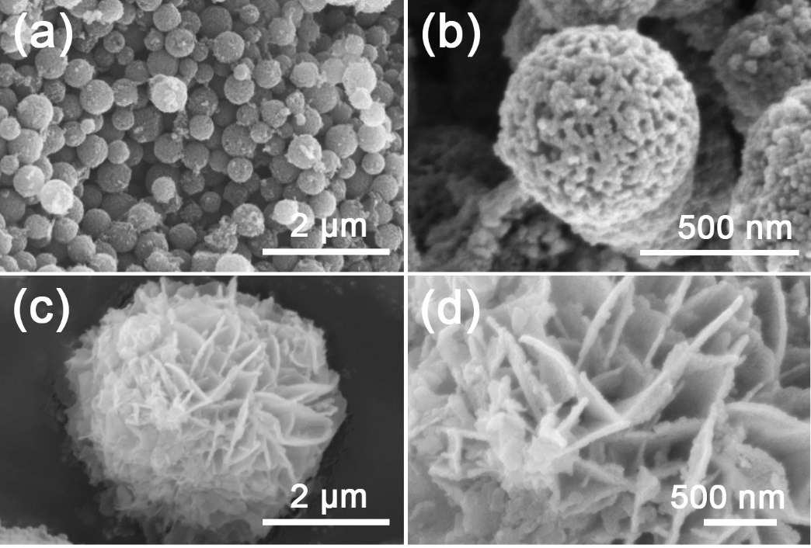

**Fig. S1**. FE-SEM images of (a, b) HNCMs and (c, d) pure Ni(OH)2.

The morphology and microstructure of the as-synthesized HNCMs and pure Ni(OH)2 were characterized by Field Emission Scanning Electron Microscopy (FE-SEM), as demonstrated in **Fig. S1**. The fabricated HNCMs presented as walnut-like microspheres with the diameter ranging from 400 to 900 nm, as shown in **Fig. S1a and Fig S1b**. Moreover, pure Ni(OH)2 sample (**Fig. S1c and d**) at different magnifications reveal that the sample shows a micro flower-like morphology with an average size of 4 μm, and each Ni(OH)2 micro-flower is composed by plenty of nanosheets with an average thickness of 40-50 nm. Also, the serious agglomeration phenomenon could be observed at the center part of the Ni(OH)2 micro-flower.

**Fig. S2**



**Fig.S2** (A)Nitrogen adsorption/desorption isotherms and (B) the pore size distribution curves of the HNCMs@Ni(OH)2-X: (a) HNCMs@Ni(OH)2-1, (b) HNCMs@Ni(OH)2-2, (c) HNCMs@Ni(OH)2-4, (d) HNCMs@Ni(OH)2-6, (e) HNCMs@Ni(OH)2-10, (f) HNCMs@Ni(OH)2-12.

**Table S2.** Textural properties of HNCMs@Ni(OH)2-X

|  |  |  |  |  |  |  |
| --- | --- | --- | --- | --- | --- | --- |
| Sample | Pore structure parameters | | | | | |
| SBET (m 2 g-1) | Smicro (m 2 g-1 ) | Smeso (m 2 g-1) | Vtotal (cm3 g-1) | Vmicro (cm3 g-1) | Vmeso (cm3 g-1) |
| HNCMs@Ni(OH)2-1 | 282.5 | 200.9 | 81.6 | 0.25 | 0.103 | 0.147 |
| HNCMs@Ni(OH)2-2 | 272.6 | 205.5 | 67.1 | 0.23 | 0.105 | 0.125 |
| HNCMs@Ni(OH)2-4 | 277.4 | 194.2 | 83.2 | 0.21 | 0.067 | 0.143 |
| HNCMs@Ni(OH)2-6 | 286.6 | 192.2 | 94.2 | 0.28 | 0.09 | 0.19 |
| HNCMs@Ni(OH)2-10 | 275.6 | 178.5 | 97.1 | 0.25 | 0.089 | 0.161 |
| HNCMs@Ni(OH)2-12 | 264.1 | 203.9 | 61.2 | 0.22 | 0.104 | 0.116 |

**Fig. S2** shows the nitrogen adsorption/desorption isotherms and pore size distribution curves of the HNCMs@Ni(OH)2-X (X=1, 2, 4, 6, 10, 12). As shown, all of samples (**Fig.S2A**) exhibit a typical Ⅳ type isotherm along with a distinct hysteresis loop, implying the mesoporous structure of the samples. Moreover, the pore size distribution curve of all samples (**Fig.S2B**) presented a sharp mesopore peak centered at 4.0 nm. The specific surface area and total pore volume of the HNCMs@Ni(OH)2-X samples are shown in **Table S2**. It is worthwhile noting that HNCMs@Ni(OH)2-6 revealed the highest specific surface area (286.6 m2/g) and the largest pore volume (0.28 cm3/g), which is attributed to the optimal balance between the amount of deposited nickel hydroxide and the hierarchical nanopores retained by HNCMs.

**Table S3.** Estimated Rs and Rct values for HNCMs@Ni(OH)2-X electrodes

|  |  |  |
| --- | --- | --- |
| Material | *Rs* (Ω) | *R*ct (Ω) |
| Pure Ni(OH)2 | 0.92 | 6.4 |
| HNCMs@Ni(OH)2-1 | 0.76 | 0.48 |
| HNCMs@Ni(OH)2-2 | 0.78 | 0.36 |
| HNCMs@Ni(OH)2-4 | 0.81 | 0.45 |
| HNCMs@Ni(OH)2-6 | 0.86 | 0.31 |
| HNCMs@Ni(OH)2-10 | 0.88 | 0.39 |
| HNCMs@Ni(OH)2-12 | 0.87 | 0.69 |

**Fig. S3.**



**Fig. S3.** (a) CV curves of pure Ni(OH)2 at various scan rates. (b) GCD curves of pure Ni(OH)2 at various current densities. (c) EIS file of pure Ni(OH)2. (d) CV curves of HNCMs at various scan rates. (e) GCD curves of HNCMs at various current densities. (f) EIS file of HNCMs.

The electrochemical performance of pure Ni(OH)2 and HNCMs were checked by cyclic voltammetry (CV), galvanostatic charge-discharge (GCD) and electrochemical impedance spectra (EIS). The CV curves of the pure Ni(OH)2 electrode at scan rates ranging from 5 to 100 mV/s (**Fig. S3a**) clearly show obvious faradaic redox peaks, which originated from the reversible redox reaction of Ni2+ and Ni3+, implying the typical characteristic of battery behavior. **Fig. S3b** shows the GCD profiles of pure Ni(OH)2 electrode at different current densities of 1-20 A/g. The GCD curves display the plateau region stemming from the faradaic redox reaction of the electrolyte ions, which coincides with the redox peak in CV curves. Moreover, the electrochemical performance of the HNCMs were also tested. The CV curves of HNCMs (**Fig S3d**) are rectangular-like, indicating its typical double-layer capacitance behavior. **Fig S3e** depicts the isosceles triangle GCD curves at different current densities, further demonstrating the EDLC behaviors. The specific capacitances of the HNCMs electrode calculated based on the GCD curves are 264.5, 239.2, 211.4, 200.3, 296.2, 190.5, 196.4 and 184.2 F/g, respectively. In **Fig. S3(c)**, the EIS curves of pure Ni(OH)2 electrode show an obvious semicircle in the high-frequency region, indicating its large charge transfer resistance. In contrast, The HNCMs electrode exhibited a low internal resistance and a small charge transfer resistance. A higher slope in the low-frequency region represents excellent capacitive control behavior **(Fig. S3(f))**.

**Fig. S4.**



**Fig. S4.** Specific capacitance at various current densities of HNCMs, pure Ni(OH)2 and HNCMs@Ni(OH)2-6.

The specific capacitance of the HNCMs, pure Ni(OH)2, HNCMs@Ni(OH)2-6 electrodes at different current densities are calculated and summarized in **Fig. S4**. As shown, HNCMs@Ni(OH)2-6 electrode displays higher specific capacitance (248.9 mAh/g *vs* 125.7 mAh/g) and better rate performance (62.9% *vs* 51.9%) than that of pure Ni(OH)2.

**Table S4.** Comparison of electrochemical performance between the as-prepared HNMCs@Ni(OH)2-6 and the reported Ni(OH)2-based electrode materials.

|  |  |  |  |  |
| --- | --- | --- | --- | --- |
| Electrode materials | Specific capacitance | Rate performance | Cycling stability | Ref |
| NCSs@Ni(OH)2 | 233.2 mAh/g at 2 A/g | 76% at 20 A/g | 72% (2 A/g, 2000) | S1 |
| CNTF@Ni(OH)2 | 176.4 mAh/g at 2 A/g | 41% at 20 A/g | 83.7% (9 A/g, 3000) | S2 |
| Ag-rGO/Ni(OH)2 | 169.6 mAh/g at 1 A/g | 74% at 5 A/g | 92.6% (2 A/g, 2000) | S3 |
| Ni(OH)2/rGO | 170.3 mAh/g at 2 A/g | 62% at 10 A/g | 72.1% (10 A/g, 1000) | S4 |
| α-Ni(OH)2/RGO | 217.4 mAh/g at 1 A/g | 30% at 10 A/g | 92.4% (1 A/g, 0000) | S5 |
| NCHSs | 238.5 mAh/g at 2 A/g | 63% at 40 A/g | 84% (5 A/g, 5000) | S6 |
| Ni(OH)2-NF | 237.9 mAh/g at 1 A/g | 51.1% at 8 A/g | 75.2% (4 A/g, 2000) | S7 |
| HNCMs@Ni(OH)2-6 | 248.9 mAh/g at 1 A/g | 63% at 20 A/g | 81.1% (10 A/g, 3000) | This work |

**Table S5.** Comparison of energy densities for HNCMs@Ni(OH)2-6//HNCMs in this work and similarhybrid supercapacitor reported in the literature.

|  |  |  |  |
| --- | --- | --- | --- |
| Supercapacitor | Energy density and power density | Stability | Ref |
| NiSi-Ni(OH)2//AC | 21.6 Wh/kg at 431.7 W/kg | 90% after 3000 cycles | S8 |
| Rgo-Ni(OH)2//rGO | 44.3 Wh/kg at 148.5 W/kg | 100% after 2000 cycles | S9 |
| Ni(OH)2/NCDs//3DGE | 34.6 Wh/kg at 700 W/kg | 74.9% after 5000 cycles | S10 |
| Ni-CNFs//Ni-CNFs | 17.8 Wh/kg at 350 W/kg |  | S11 |
| Ni(OH)2/HPCNFs//AC | 31.3 Wh/kg at 300.5 W/kg | 87% after 5000 cycles | S12 |
| Ni(OH)2-6M-6H//AC | 37.8 Wh/kg at 252.67 W/kg | 93% after 15000 cycles | S13 |
| SEP/Ni(OH)2-B//AC | 950 Wh/kg at 24 W/kg | 76% after 5000 cycles | S14 |
| Co(OH)2@Ni(OH)2/  3D-Ni//NW | 27.24 Wh/kg at 4234.9 W/kg | 80% after 3000 cycles | S15 |
| HNCMs@Ni(OH)2-6  //HNCMs | 41.3 Wh/kg at 173.3 W/kg | 85.2 after 20000 cycles | This work |

**References**

[S1] Zhang, L., Li, G.H., Jing, L.L., Li, Z.H., Li, Z.J., Yao, H.C., Wang, J.S., Liu, Q.C., Han, Y., 2020. Controllable and fast growth of ultrathin α-Ni(OH)2 nanosheets on polydopamine based N-doped carbon spheres for supercapacitors application. Synth. Met. 270, 116580.

[S2] Anwer, S., Ari, A.B., Bharath, G., Cao, P., Patole, S.P., Luo, S.H., Masood, H.T., Cantwell, W., Liao, K., Li, Q.W., Zhang, L.X., 2018. Synthesis of joint-welded carbon nanotube foam @ Ni(OH)2 nanosheet-based core–shell 3D architecture for freestanding flexible electrode for supercapacitor applications. Adv. Mater. Interfaces 6, 1900670.

[S3] Cho, E.C., Chang-Jian, C.W., Lee, K.C., Huang, J.H., Ho, B.C., Liu, R.Z., Hsiao, Y.S., 2017. Ternary composite based on homogeneous Ni(OH)2 on graphene with Ag

nanoparticles as nanospacers for efficient supercapacitor. Chem. Eng. J. 334, 2058-2067.

[S4] Liu, J.L., Hu, R.J., Liu, H., Ma, J.Z., 2017. Chips assembled cuboid-like nickel hydroxide/rGO composite material for high performance supercapacitors. J. Alloys Compd. 718, 349-355.

[S5] Bai, J.W., Yan, H.J., Liu, Q., Liu, J.Y., Li, Z.S., Bai, X.F., Li, R.M., Wang, J., 2018. Synthesis of layered a -Ni(OH)2 /RGO composites by exfoliation of α-Ni(OH)2 for high-performance asymmetric supercapacitors. Mater. Chem. Phys. 204, 18-26.

[S6] Qin, Q.Q., Liu, J.Q., Mao, W.P., Xu, C.X., Lan, B.B., Wang, Y., Zhang, Y., Yan, J., Wu, Y.C., 2018. Ni(OH)2/CNTs hierarchical spheres for foldable all-solid-state supercapacitor with high specific energy. Nanoscale, 10, 7377-7381.

[S7] Qiu, H.R., An, S.L., Sun, X.J., Yang, H.M., Zhang, Y.Q., He, W.X., 2019. Excellent performance MWCNTs-GONRs/Ni(OH)2 electrode for outstanding supercapacitors. Ceram. Int. 45, 18422-18429.

[S8] Wang, Q.S., Zhang, Y.F., Xiao, J.Q., Jiang, H.M., Li, X.J., Meng, C.G., 2019. Novel ordered hollow spherical nickel silicate-nickel hydroxide united composite with two types of morphologies for enhanced electrochemical storage performance. Mater. Chem. Front. 3, 2090-2101.

[S9] Zhang, X.Y., Wang, H.S., Shui, L.L., Zhou, G.F, Wang, X., Ma, R.G., Wang, J.C., 2020. Ultrathin Ni(OH)2 layer coupling with graphene for fast electron/ion transport in supercapacitor. Sci. China Mater. 64, 339-348.

[S10] Ji, Z.Y., Li, N., Zhang, Y.F., Xie, M.H., Shen, X.P., Chen, L.Z., Xu, K.Q., Zhu, G.X., 2019. Nitrogen-doped carbon dots decorated ultrathin nickel hydroxide nanosheets for high-performance hybrid supercapacitor. J. Colloid Interface Sci. 542, 392-399.

[S11] Bai, Z.X., Liu, S.C., Chen, P., Cheng, G.J., Wu, G.Y., Li, H., Liu, Y., 2020. Nickel nanoparticles embedded in porous carbon nanofibers and its electrochemical properties. Nanotechnol. 31, 305705.

[S12] Yang, X.X., Fu, K., Mao, L.C., Peng, W., Jin, J.H., Yang, S.L., Li, G., 2019. Bio-mediated synthesis of α-Ni(OH)2 nanobristles on hollow porous carbon nanofibers for rechargeable alkaline batteries. Chem. Eng. Sci. 205, 269-277.

[S13] Zhang, H.B., Xu, B., Xiao, Z.Y., Mei, H., Zhang, L.L., Han, Y.F., Sun, D.F., 2018. Optimizing crystallinity and porosity of hierarchical Ni(OH)2 through conformal transformation of metal–organic framework template for supercapacitor applications. CrystEngComm. 20, 4313.

[S14] Chen, X.Y., Wang, S.C., Qiao, G.Q., Wang, X.H., Lu, G.X., Cui, H.Z., Wang, X.Z., 2021. Sepiolite/amorphous nickel hydroxide hierarchical structure for high capacitive supercapacitor. J. Alloys Compd. 881, 160519.

[S15] Sharifi, A., Arvand, M., Daneshvar, S., 2021. A novel flexible wire-shaped supercapacitor with enhanced electrochemical performance based on hierarchical Co(OH)2@Ni(OH)2 decorated porous dendritic Ni film/Ni wire. J. Alloys Compd. 856, 158101.