**Supporting Information**

**Antitubercular and antioxidant activities of hydroxy and chloro substituted chalcone analogues: Synthesis, biological and computational studies**

Shaik Ammaji, Shaik Masthanamma, Richie R. Bhandare, Sivakumar Annadurai, Afzal Basha Shaik



**Figure 6.** 2D Interactions of selected compounds with Isocitrate Lyase protein amino acid

**Physicochemical and Spectral Data of the target compounds (1-15)**



(*E*)-1-(5'-Chloro-2'-hydroxyphenyl)-3-(2"-fluorophenyl)prop-2-ene-1-one (**1**): Yellow color solid; Yield: 74%; m.p: 160-162 0C (recrystallized from ethanol); **FT-IR** (KBr *v*max cm-1): 668 (C-Cl), 1215 (C-F), 1610 (str, CH=CH, conjugated), 1717 (intense conjugated C=O band), 3344 (Ar-OH); **1H NMR** (CDCl3 400 MHz) *δ* (ppm): 7.17 (d, 1H, Hα, *J =* 16.1 Hz), 7.09 (d, 1H, Hβ, *J* = 16 Hz), 7.24-7.68 (m, 7H, Ar-H), 12.22 (s, Ar-OH); LC-MS: m/z 276.69 (M+, 99.06), 278.69 (M+2, 33.02).



(*E)*-1-(5'-Chloro-2'-hydroxyphenyl)-3-(3"-fluorophenyl)prop-2-ene-1-one (**2**): Yellow color solid; Yield: 84%; m.p: 151-153 0C (recrystallized from ethanol); **FT-IR** (KBr *v*max cm-1): 771 (C-Cl), 1214 (C-F), 1611 (str, CH=CH, conjugated), 1717 (intense conjugated C=O band), 3344 (Ar-OH); 1H NMR (CDCl3 400 MHz) *δ* (ppm): 7.17 (d, 1H, Hα, *J =* 16.3 Hz), 7.10 (d, 1H, Hβ, *J* = 15.8 Hz), 7.24-7.69 (m, 7H, Ar-H), 12.31 (s, Ar-OH); LC-MS: m/z 276.69 (M+, 99.06), 278.69 (M+2, 33.02).



(*E)*-1-(5'-Chloro-2'-hydroxyphenyl)-3-(4"-fluorophenyl)prop-2-ene-1-one (**3**): Yellow color solid, Yield: 85%; m.p: 164-166 oC (recrystallized from ethanol); **FT-IR** (KBr *v*max cm-1): 771 (C-Cl), 1215 (C-F), 1623 (str, CH=CH, conjugated), 1720 (intense conjugated C=O band), 3200 (Ar-OH); **1H NMR** (CDCl3 400 MHz) *δ* (ppm): 7.26 (d, 1H, Hα , *J* = 16 Hz), 7.52 (d, 1H, Hβ, *J* = 16 Hz), 7.24-7.69 (m, 7H, Ar-H), 12.11 (s, Ar-OH); **13C NMR** (CDCl3, 100 MHz) δ (ppm): 116.2 (C-3‘’ and C-5‘’), 119.6 (C-2), 121.8 (C-3’), 125.4 (C-1’), 131.6 (C-2’’ and C-6’’), 132.4 (C-6’), 134.8 (C-5’), 138.7 (C-4’), 147.4 (C-3), 162.6 (C-2’), 164.5 (C-4’’), 192.8 (C-1); **LC-MS**: m/z 276.69 (M+, 99.08), 278.69 (M+2, 33.03).



(*E)*-1-(5'-Chloro-2'-hydroxyphenyl)-3-(2"-chlorophenyl)prop-2-ene-1-one (**4**): Yellow color solid, Yield: 75%. Recrystallized from ethanol (Sawant and Nirwan., 2013). **FT-IR** (KBr *v*max cm-1): 706 (C-Cl), 794 (C-Cl), 1626 (str, CH=CH, conjugated), 1721 (intense conjugated C=O band), 3349 (Ar -OH); **1H NMR** (CDCl3 400 MHz) *δ* (ppm): 7.43 (d, 1H, Hα, *J*=16.1 Hz), 7.92 (d, 1H, Hβ, *J*=16.3 Hz), 7.04-8.93 (m, 7H, Ar-H), 12.36 (s, Ar-OH); LC-MS: m/z 293.14 (M+, 99.06), 295.14 (M+2, 33.01).



(*E)*-1-(5'-Chloro-2'-hydroxyphenyl)-3-(3"-chlorophenyl)prop-2-ene-1-one (**5**): Yellow color solid, Yield: 80%; m.p: 175-177 0C (recrystallized from ethanol); **FT-IR** (KBr *v*max cm-1): 699 (C-Cl), 780 (C-Cl), 1622 (str, CH=CH, conjugated), 1718 (intense conjugated C=O band), 3344 (Ar -OH); **1H NMR** (CDCl3 400 MHz) *δ* (ppm): 7.48 (d, 1H, Hα, *J*=16.2 Hz), 7.98 (d, 1H, Hβ, *J*=16.0 Hz), 7.08-8.98 (m, 7H, Ar H), 12.23 (s, Ar-OH); LC-MS: m/z 293.14 (M+, 99.02), 295.14 (M+2, 33.00).



(*E)*-1-(5'-Chloro-2'-hydroxyphenyl)-3-(4"-chlorophenyl)prop-2-ene-1-one (**6**): Yellow color solid, Yield: 82%, recrystallized from ethanol; **FT-IR** (KBr *v*max cm-1): 786 (C-Cl), 1667 (str, CH=CH conjugated), 1751 (intense conjugated C=O band), 3253 (Ar-OH); **1H NMR** (CDCl3 400 MHz) *δ* (ppm): 7.42 (d, 1H, Hα, *J*=16.2 Hz), 7.86 (d, 1H, Hβ, *J*=16.0 Hz), 7.09-8.91 (m, 7H, Ar H), 12.31 (s, Ar-OH); LC-MS: m/z 293.14 (M+, 99.09), 295.14 (M+2, 33.04). (Hasan et al., 2005).



(*E)*-1-(5'-Chloro-2'-hydroxyphenyl)-3-(2"-hydroxyphenyl)prop-2-ene-1-one (**7**): Yellow color solid, Yield: 80%; m.p: 198-200 oC (recrystallized from chloroform); **FT-IR** (KBr *v*max cm-1): 795 (C-Cl), 1665 (str, CH=CH conjugated), 1756 (intense conjugated C=O band), 3255 (Ar-OH); **1H NMR** (CDCl3 400 MHz) *δ* (ppm): 5.45 (s, Ar-OH), 7.57 (d, 1H, Hα, *J* = 16.5 Hz), 7.84 (d, 1H, Hβ, *J* = 16 Hz), 6.72-8.08 (m, 7H, Ar-H), 12.35 (s, Ar-OH); **13C NMR** (CDCl3, 100 MHz) δ (ppm): 117.3 (C-3’’), 119.8 (C-3’), 122.4 (C-5’’), 123.3 (C-2), 125.8 (C-1’’), 127.5 (C-1’), 133.6 (C-5’), 135.5 (C-6’’), 136.6 (C-4’’), 137.8 (C-6’), 138.6 (C-4’), 143.2 (C-3), 154.3 (C-2’’), 162.4 (C-2’), 191.5 (C-1); **LC-MS**: m/z 274.70 (M+, 99.09), 276.70 (M+2, 33.03).



(*E)*-1-(5'-Chloro-2'-hydroxyphenyl)-3-(3"-hydroxyphenyl)prop-2-ene-1-one (**8**): Yellow color solid, Yield: 75%. Recrystallized from chloroform. **FT-IR** (KBr *v*max cm-1): 795 (C-Cl), 1665 (str, CH=CH conjugated), 1756 (intense conjugated C=O band), 3255 (Ar-OH); **1H NMR** (CDCl3 400 MHz) *δ* (ppm): 5.41 (s, Ar-OH), 7.49 (d, 1H, Hα, *J* = 16.2 Hz), 7.81 (d, 1H, Hβ, *J* = 16.2 Hz), 6.89-8.16 (m, 7H, Ar-H), 12.24 (s, Ar-OH); **LC-MS**: m/z 274.70 (M+, 99.02), 276.70 (M+2, 33.00). (Jung et al., 2006).



(*E)*-1-(5'-Chloro-2'-hydroxyphenyl)-3-(4"-hydroxyphenyl)prop-2-ene-1-one (**9**): Yellow color solid, Yield: 70%. Recrystallized from chloroform. **FT-IR** (KBr *v*max cm-1): 799 (C-Cl), 1672 (str, CH=CH conjugated), 1759 (intense conjugated C=O band), 3258 (Ar-OH); **1H NMR** (CDCl3 400 MHz) *δ* (ppm): 5.34 (s, Ar-OH), 7.53 (d, 1H, Hα, *J* = 16.2 Hz), 7.86 (d, 1H, Hβ, *J* = 16.2 Hz), 6.96-8.33 (m, 7H, Ar-H), 12.30 (s, Ar-OH); **LC-MS**: m/z 274.70 (M+, 99.07), 276.70 (M+2, 33.04). (Saito et al., 2018).



(*E)*-1-(5'-Chloro-2'-hydroxyphenyl)-3-(2"-methoxyphenyl)prop-2-ene-1-one (**10**): Yellow color solid, Yield: 85%. Recrystallized from chloroform. **FT-IR** (KBr *v*max cm-1): 778 (C-Cl), 1681 (str, CH=CH conjugated), 1782 (intense conjugated C=O band), 2831 (-OCH3), 3516 (Ar -OH); **1H NMR** (CDCl3 400 MHz) *δ* (ppm): 2.41 (Ar-OCH3), 7.78 (d, 1H, Hβ, *J* = 16.3 Hz), 7.89 (d, 1H, Hα, *J* = 16.2 Hz), 6.61-8.17 (m, 7H, Ar- H), 12.39 (s, Ar-OH); **LC-MS**: m/z 288.06 (M+, 99.05), 290.06 (M+2, 33.04). (Saito et al., 2018).



(*E)*-(1-(5'-Chloro-2'-hydroxyphenyl)-3-(3"-methoxyphenyl)prop-2-ene-1-one (**11**): Yellow color solid, Yield: 80%; m.p: 122-124 0C (recrystallized from chloroform); **FT-IR** (KBr *v*max cm-1): 775 (C-Cl), 1685 (str, CH=CH conjugated), 1780 (intense conjugated C=O band), 2823 (-OCH3), 3500 (Ar -OH); **1H NMR** (CDCl3 400 MHz) *δ* (ppm): 2.44 (Ar-OCH3), 7.75 (d, 1H, Hβ, *J* = 16 Hz), 7.85 (d, 1H, Hα, *J* = 16.7 Hz), 6.56-8.08 (m, 7H, Ar- H), 12.33 (s, Ar-OH); **LC-MS**: m/z 288.06 (M+, 99.08), 290.06 (M+2, 33.02).



(*E)*-(1-(5'-Chloro-2'-hydroxyphenyl)-3-(4"-methoxyphenyl)prop-2-ene-1-one (12): Yellow color solid; Yield: 85%; recrystallized from chloroform. **FT-IR** (KBr *v*max cm-1): 782 (C-Cl), 1685 (str, CH=CH conjugated), 1786 (intense conjugated C=O band), 2826 (-OCH3), 3521 (Ar -OH); **1H NMR** (CDCl3 400 MHz) *δ* (ppm): 2.45 (Ar-OCH3), 7.72 (d, 1H, Hβ, *J* = 16.4 Hz), 7.85 (d, 1H, Hα, *J* = 16.6 Hz), 6.65-8.22 (m, 7H, Ar- H), 12.34 (s, Ar-OH); **LC-MS**: m/z 288.06 (M+, 99.08), 290.06 (M+2, 33.02). (De Meyer et al., 1991).



(*E)*-(1-(5'-Chloro-2'-hydroxyphenyl)-3-(pyridin-3"-yl)prop-2-ene-1-one (**13**): Cream color solid; Yield 95%; m.p: 112-114 0C (recrystallized from ethanol); **FT-IR** (KBr *v*max cm-1): 775 (C-Cl), 1258 (str, C=N conjugated), 1684 (str, CH=CH conjugated), 1787 (intense conjugated C=O band), 3221 (Ar-OH); **1H NMR** (CDCl3 400 MHz) *δ* (ppm): 6.96 (d, 1H, Hα, *J* = 16 Hz), 8.06 (d, 1H, Hβ, *J* = 16.8 Hz), 7.08-8.84 (m, 7H, Ar- H), 12.28 (s, Ar-OH); **LC-MS**: m/z 259.69 (M+, 99.06), 261.69 (M+2, 33.02).



(*E*)-(1-(5'-Chloro-2'-hydroxyphenyl)-3-(thiophen-2"-yl)prop-2-ene-1-one (**14**): Yellow color solid; Yield: 95%. Recrystallized from ethanol. **FT-IR** (KBr *v*maxcm-1): 856 (C-S), 771 (C-Cl), 1688 (str, CH=CH conjugated), 1779 (intense conjugated C=O band), 3228 (Ar-OH); **1H NMR** (CDCl3 400 MHz) *δ* (ppm): 7.38 (d, 1H, Hα, *J* = 16.3 Hz), 7.59 (d, 1H, Hβ, *J* = 16.0 Hz), 6.94-8.32 (m, 6H, Ar H), 12.46 (s, Ar-OH); LC-MS: m/z 264.72 (M+, 99.09), 266.72 (M+, 33.07). (Gupta and Dhawan 1999).



(*E*)-(1-(5'-Chloro-2'-hydroxyphenyl)-3-(furan-2"-yl)prop-2-ene-1-one (**15**): Yellow color solid; Yield: 95%; m.p: 190-192 0C (recrystallized from ethanol); **FT-IR** (KBr *v*maxcm-1): 744 (C-O), 775 (C-Cl), 1685 (str, CH=CH conjugated), 1776 (intense conjugated C=O band), 3230 (Ar -OH); **1H NMR** (CDCl3 400 MHz) *δ* (ppm): 7.34 (d, 1H, Hα, *J* = 16 Hz), 7.54 (d, 1H, Hβ, *J* = 16.5 Hz), 6.87-8.17 (m, 6H, Ar H), 12.51 (s, Ar-OH); LC-MS: m/z 248.66 (M+, 99.03), 250.66 (M+, 33.01).

**References**

De Meyer, N., Haemers, A., Mishra, L., Pandey, H.K., Pieters, L.A., Vanden Berghe, D.A.,

Vlietinck, A.J., 1991. 4'-Hydroxy-3-methoxyflavones with potent antipicornavirus

activity. J. Med. Chem. 34, 2, 736-46. doi: doi: 10.1021/jm00106a039

Gupta, S., Sharma, S., Saini, A., Dhawan, S., 1999. Photochemistry of chromones:

photoreorganisation of 3-alkoxy-2-thienyl-4-oxo-4 H-1-benzopyrans. J. Chem. Soc.

Perkin Transac. 1. 16, 2391-5. doi: https://doi.org/10.1039/A901090D

Hasan, A., Khan, K.M., Sher, M., Maharvi, G.M., Nawaz, S.A., Choudhary, M.I., Atta-ur-

Rahman., Supuran, C.T., 2005. Synthesis and inhibitory potential towards

acetylcholinesterase, butyrylcholinesterase and lipoxygenase of some variably

substituted chalcones. J. Enzyme. Inhib. Med. Chem. 20, 1, 41-7. doi:

<https://doi.org/10.1080/14756360400015231>

Jung, S.H., Park, S.Y., Kim-Pak, Y., Lee, H.K., Park, K.S., Shin, K.H, Ohuchi, K., Shin,

H.K., Keum, S.R., Lim, S.S., 2006. Synthesis and PPAR-γ ligand-binding activity of

the new series of 2′-hydroxychalcone and thiazolidinedione derivatives. Chem. Pharm.

Bull. 54, 3, 368-71. doi: 10.1248/cpb.54.368

Sawant, A., Nirwan, R., 2013. Synthesis and antibacterial activity of some 1,5-

benzothiazepines. Indian. J. Heterocycl Chem. 23, 51-54.

Saito, Y., Mizokami, A., Tsurimoto, H., Izumi, K., Goto, M., Nakagawa-Goto, K., 2018. 5′-

Chloro-2, 2′-dihydroxychalcone and related flavanoids as treatments for prostate cancer.

Eur. J. Med. Chem. 157, 1143-52. doi: 10.1016/j.ejmech.2018.08.069

**FT-IR, 1H NMR, 13C NMR and Mass Spectra’s**

**of selected compounds**

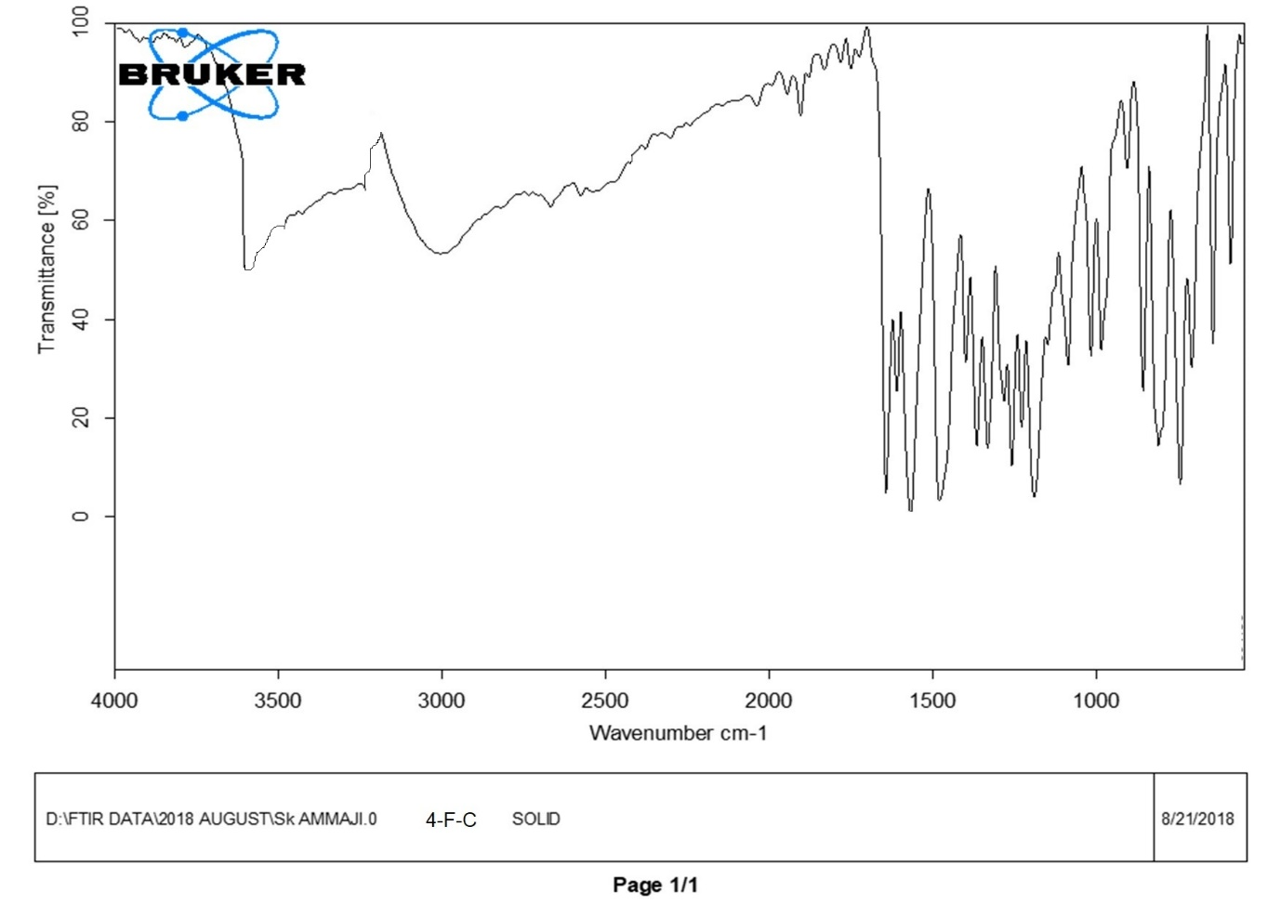

FT-IR Spectrum of compound **3**

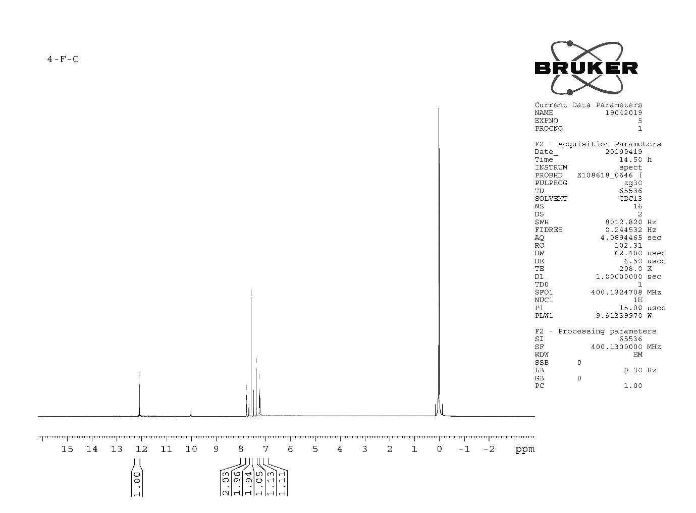

1H NMR Spectrum of compound **3**

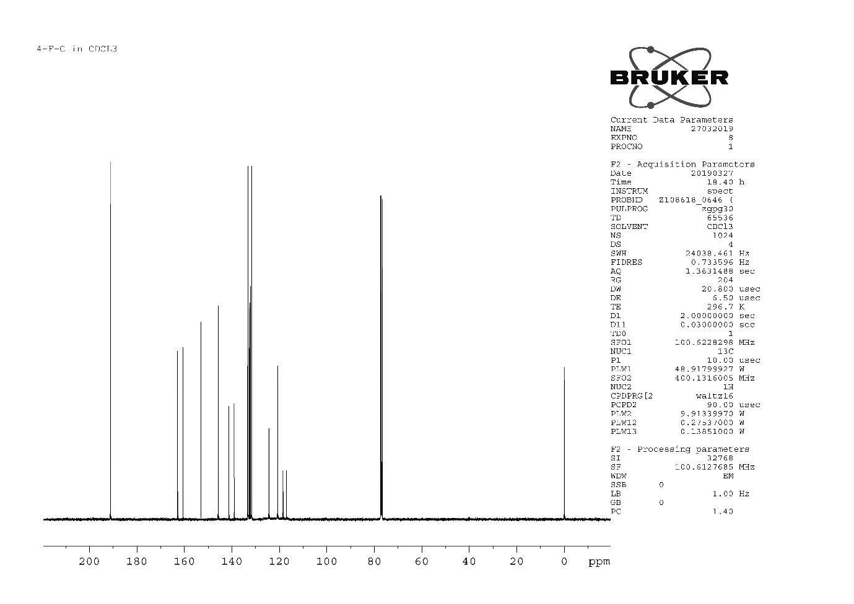

13C NMR Spectrum of compound **3**

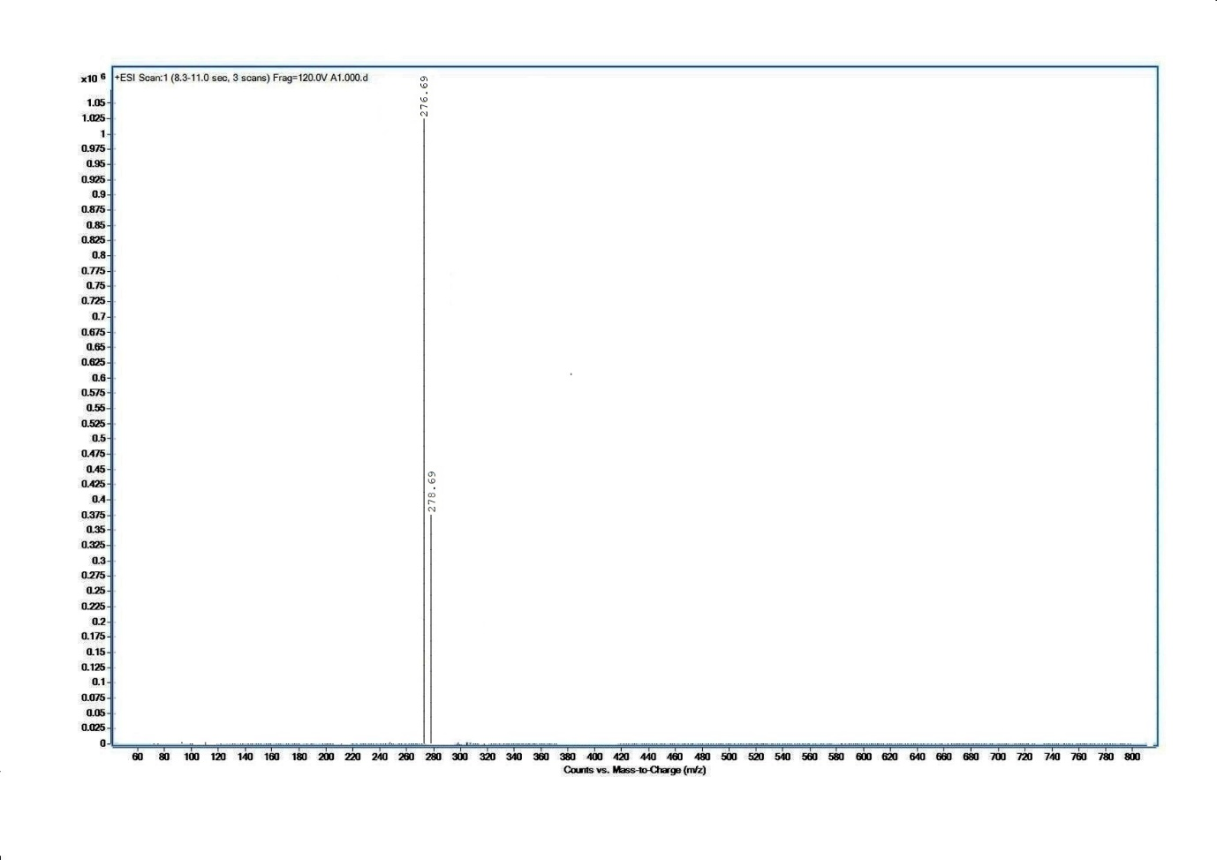

Mass Spectrum of compound **3**

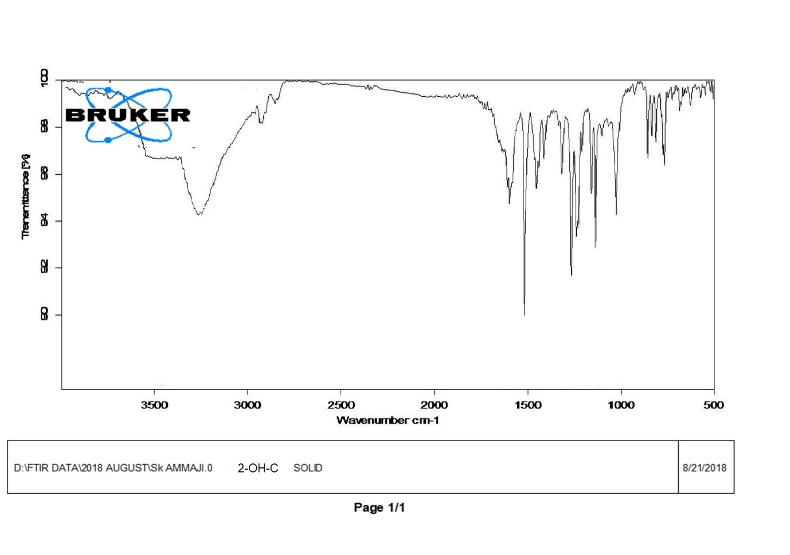 FT-IR Spectrum of compound **7**

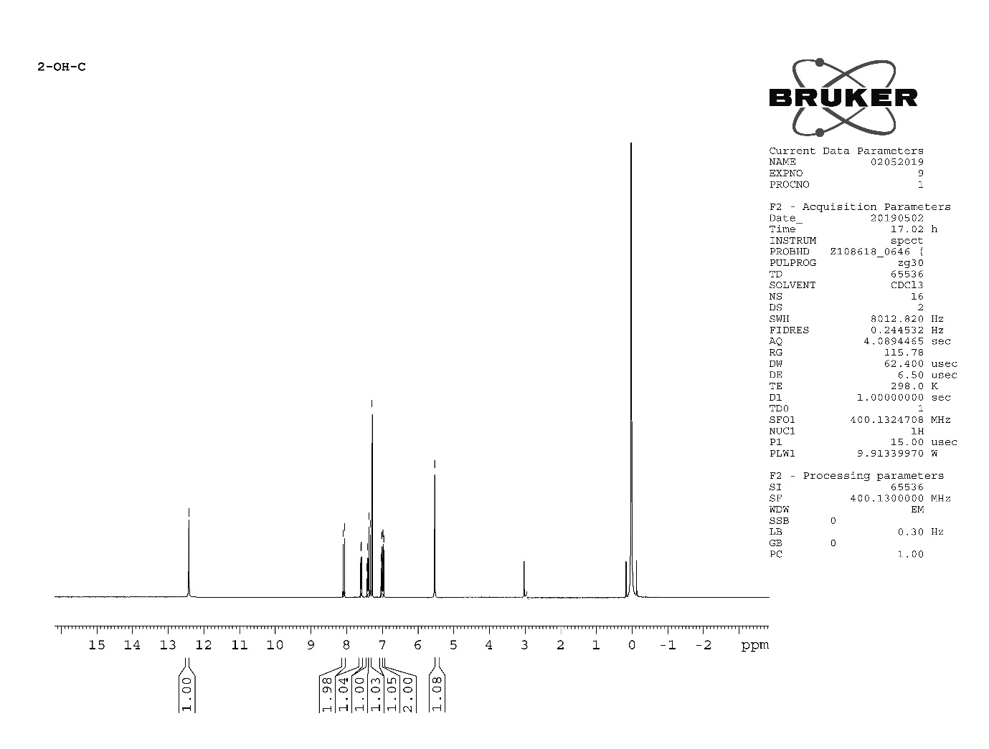1H NMR Spectrum of compound **7**

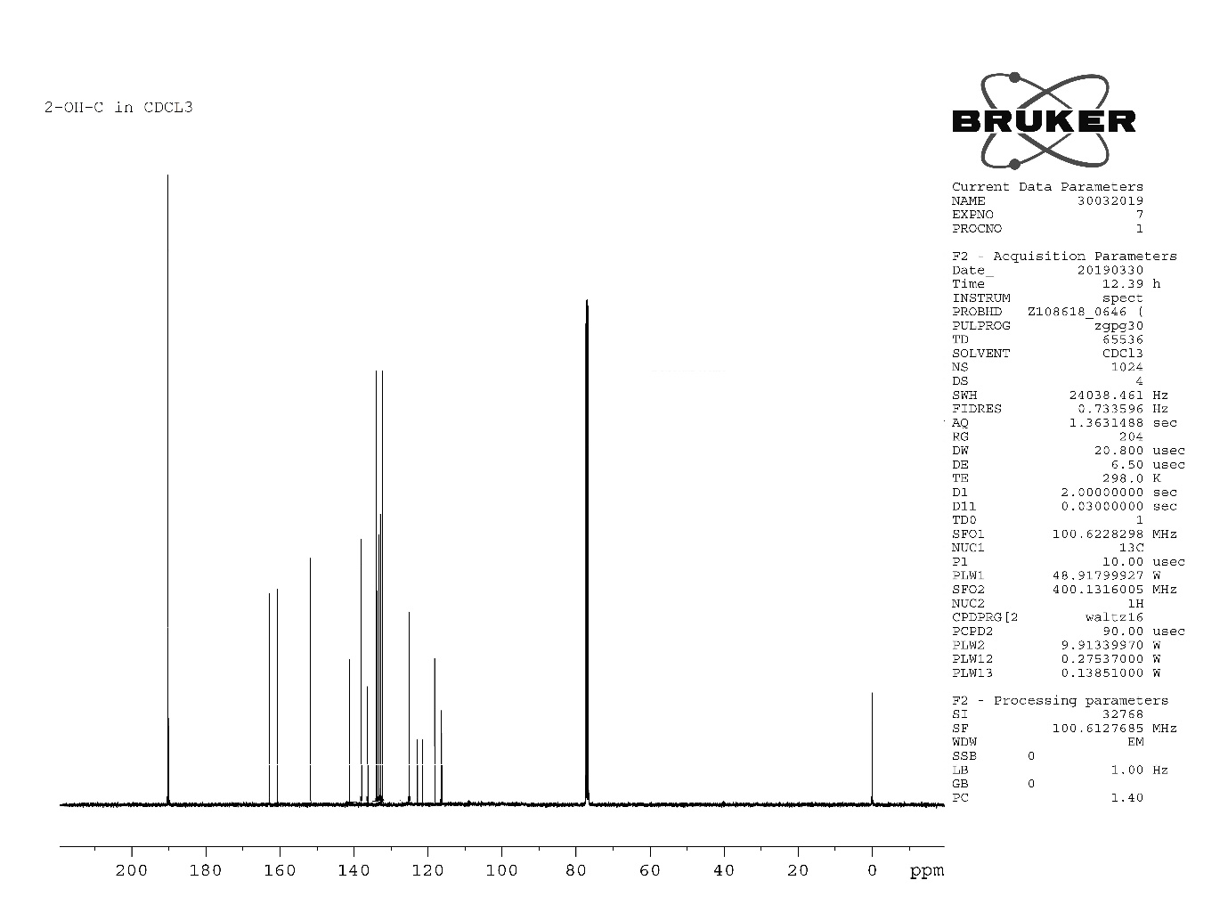13C NMR Spectrum of compound **7**

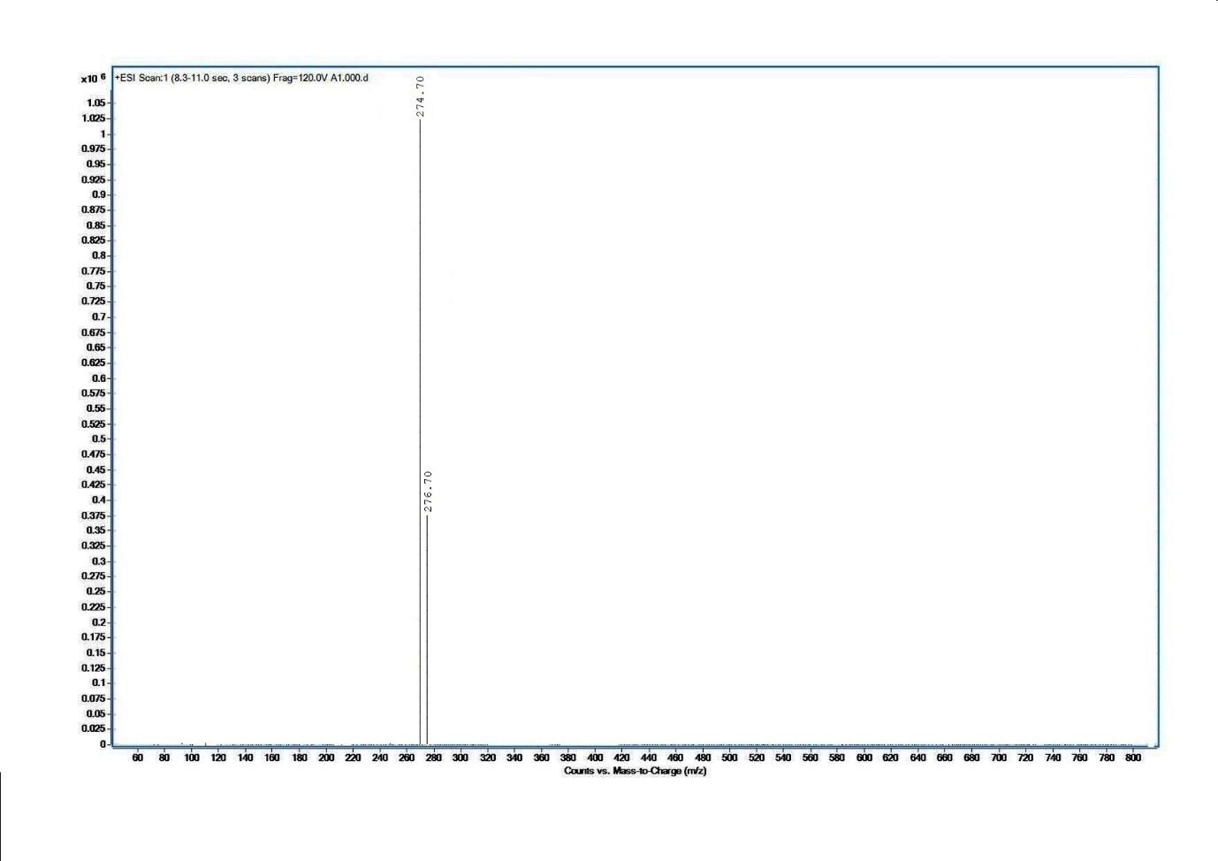Mass Spectrum of compound **7**