

Scheme S1.The equipment used to prepare of illustrate the new compounds

**Part S1: Equations used in Cyclic voltammetry study**

The following equations were implemented to extract several thermodynamic and kinetic characteristics (ipc, ipa, Γ, ks) for CuCl2 in solution *via* its cyclic voltammograms;

1- From Randles-Sevcik equation; ip = 2.69x105 n3/2 D1/2ACν1/2 (**1**), we could estimate the peak current (ip) [1]. In which, n: transferred electrons number, ip: the current of the peak, A: is the surface area of electrode (cm2), D: is the diffusion coefficient (cm2 sec-1), C: is the redox concentration (mol/cm) and ν: is the scan rate (v/s).

2- ΔEp is the potential gap determined by applying this equation; ΔEp= Epa-Epc (**2**) [2]. Where, Epa is the potential of anodic peak, while Epc is the potential of cathodic peak. Several cyclic voltammetric parameters (Γ, αna, Q and ks) can be calculated using the above values (Epc, Epa, and ip).

3- Equation Γ = ip 4RT/n2 F2A ν (**3**) [3] was used to calculate the redox ion's surface concentration in (mol.cm-2). Where, iP, F, T, n, R, A and ν are the peak current, faraday constant (96485.33 coulomb), temperature in K, number of e- in redox processes, gas constant (8.314 J.mol-1.K-1), working electrode surface area in cm2, and scan rate in Vsec-1, respectively.

4- The charge transfer coefficient of electrons was determined using this equation; αna=1.857 RT/(Epc–Epc/2) (**4**) [4], in which Epc/2 is the half-wave potential for the cathodic peak. Also, the amount of charge trapped during the redox reaction was evaluated by this equation; Q = n FA Γ (**5**) [5].

5- The following equation can be used to compute, the rat constant of heterogeneous charge transfer (ks) in cm/sec: ks=2.18* [Dc α na F ν/RT]1/2 *exp [α2 nF (Ep,c–Ep,a)/RT] (**6**). Where, the diffusion coefficient of oxidized particles (DC), the number of electrons transferred in redox reactions (n), the gas constant (R), Faraday constant (F), the temperature (T) in K, charge transfer coefficient (α), the difference potential (ΔEP), scan rate (ν), and transferred electrons number in the slow step (na) were the parameters used.

6- Equation E˚ = (Epa+Epc)/2 (**7**), was used to estimate the formal potential (E˚) [6]. Where Epa is the anodic peak potential and Epc is the cathodic peak potential.

7- The stability constants (βMX) for metal complexes were derived from this equation (**8**) [5]; ΔE˚= E˚C- E˚M =2.303 (RT/nF)* (log βMX +j log Cx) (**8**). Where, E˚C is the formal potential peak of the complex after each addition of ligand, E˚M is the formal potential peak of the metal, Cx is the ligand concentration (mol/cm), j is the complex's coordination number, T and R are the absolute temperature and the gas constant (8.314 J.mol-1.K-1), respectively. Furthermore, the Gibbs free energy [6] was computed using the following equation; ΔG = -2.303 RT log βMX **(9**); where βMX is the stability constant.

**References**

|  |  |
| --- | --- |
| [1] | Matsuki, K., Endo, T., Kamada, H.,1984. SEM studies of electrolytic manganese dioxide, Electrochim. Acta. 29, 983–993. |
| [2] | Ong, W., Kaifer, A. E., 2002. Unusual electrochemical properties of unsymmetric viologen dendrimers. J. Am. Chem. Soc. 124, 9358–9359. |
| [3] | Bamford,C. H., Compton, R. G., Thomas, J. D. R.,1987. Electrode kinetics: principles and methodology (Comprehensive chemical kinetics, vol. 26): Elsevier, Amsterdam, 1986 (ISBN 0-444-42550-0). xviii+ 450 pp. Price US $172.00 (Dfl. 430.00). |
| [4] | Gosser, D. K.,1993. Cyclic voltammetry: simulation and analysis of reaction mechanisms, VCH New York. |
| [5] | El-Shereafy, S. E., Gomaa, E. A., Yousif, A.M., El-Yazed, A.S.A., 2017. Electrochemical and Thermodynamic Estimations of the Interaction Parameters for Bulk and Nano-Silver Nitrate (NSN) with Cefdinir Drug Using a Glassy Carbon Electrode. Iran. J. Mater. Sci. Eng. 14. |
| [6] | Brownson, D. A. C., Banks, C. E., 2014. The Handbook of Graphene Electrochemistry, Springer. |



**Scheme S2.** The microbial screening in terms of MIC for investigated compounds



**Scheme S3.** ABTS method applied to test scavenging activity of new compounds towards free radicals



**Scheme S4.** MTT method used to evaluate cytotoxicity of investigated compounds

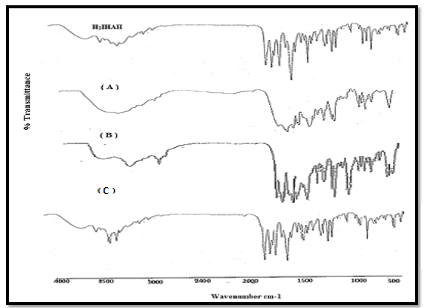

**Fig. S1.** Infrared spectra of H3L, [Hg(H2L)(H2O)Cl] (A), [UO2(H2L)(OAc)] (B) and [Cu(H3L)(OAc)2].H2O (C)

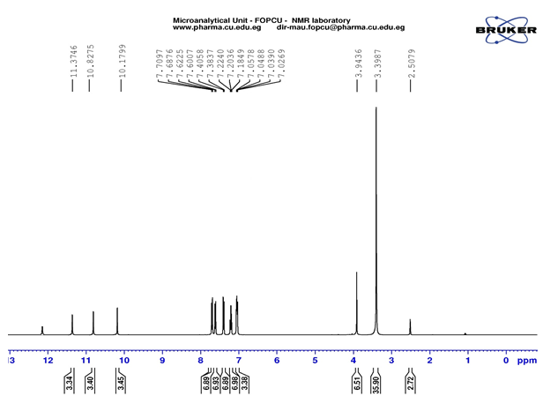

**(A)**

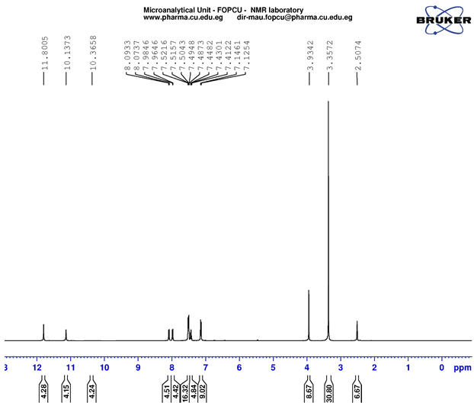

**(B)**

**Fig. S2.** 1H NMR spectra H3L ligand (A) and its Hg(II) complex (B) in d6-DMSO

## 

**Fig. S3.** Mass spectrum of the ligand (H3L)

|  |  |
| --- | --- |
| (A) | (B) |
| **Fig. S4.** Electronic Spectra of (A) [Cu(H3L)(OAc)2].H2O and (B) [UO2(H2L)(OAc)] complexes in nujol | |

|  |  |
| --- | --- |
| (A) | (B) |
| (C) |  |
| **Fig. S5.**  SEM photographs of (A) [UO2(H2L)(OAc)], (B) [Hg(H2L)(H2O)Cl], (C) [Cu(H3L)(OAc)2].H2O complexes | |

## 

**Fig. S6**. The TG curve of [Cu(H3L)(OAc)2].H2O complex

|  |
| --- |
| (A) |
| (B) |
| **Fig. S7.** The mass spectra of UO2(II) (A) and Hg(II) (B) complexes |

|  |  |
| --- | --- |
|  |  |
|  |  |
| **Fig. S8.** The optimized structures of the forms of the ligand(kept/enol) and the complexes | |

|  |  |
| --- | --- |
|  |  |
|  |  |
| **Fig. S9**. MOE for the ligand forms(keto/enol) and their complexes | |



**Fig. S10.** Cyclic voltammogram of different concentrations CuCl2 in absence of H3L

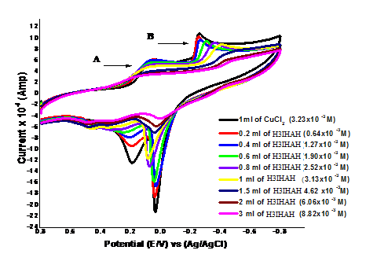

**Fig. S11.** Cyclic voltammogram of CuCl2 in the presence of a different concentration of H3L

## 

**Fig. S12.** Relation (ip vs. ν1/2) for CuCl2 at final adding in absence of H3L at 298.15K and different scan rates

**Table S1.** The behaviour of Cu(II) complex under influence of temperaturechanges

|  |  |  |  |  |
| --- | --- | --- | --- | --- |
| **Complex** | **Temp. range (°C)** | **Decomposition product (Formula wt.)** | **Wt. loss (%) Found Calcd.** | |
| [Cu(H3L)(OAc)2].H2O | 37-125 | H2O (18.015) | 3.44 | 3.46 |
| 125-285 | 2CH3COOH (120.108) | 23.08 | 23.06 |
| 285-430 | C6H5N (91.113) | 17.50 | 17.48 |
| Residue | CuC11H6O3N3 (291.7) | 55.98 | 56.00 |

**Table S2.** Kinetic and thermodynamic parameters of CuCl2 for wave (A) in absence of H3L and at 298.15K and 0.1 scan rate

|  |  |  |  |  |  |  |  |  |  |  |  |  |  |  |  |
| --- | --- | --- | --- | --- | --- | --- | --- | --- | --- | --- | --- | --- | --- | --- | --- |
| **Mx106 (mol/cm3)** | **Epa**  **(volt)** | **Epc**  **(volt)** | **∆Ep**  **(volt)** | **-Ipax105**  **(Amp)** | **Ipcx105**  **(Amp)** | **Ipa/Ipc**  **(Amp)** | **E˚** | **Da x105 (cm2/s)** | **Dc x105**  **(cm2/s)** | **αna** | **Ks x102**  **(cm/sec)** | **Γc x109**  **(mol/ cm2)** | **+ Qc x105** | **Γa x109**  **(mol/cm2)** | **- Qa x105** |
| 0.66 | 0.186 | 0.071 | 0.115 | 2.10 | 1.21 | 1.74 | 0.129 | 2.125 | 4.67 | 1.077 | 8.99 | 4.095 | 1.24 | 7.122 | 2.16 |
| 1.32 | 0.183 | 0.075 | 0.108 | 1.77 | 1.04 | 1.69 | 0.129 | 2.533 | 1.88 | 0.998 | 3.79 | 3.536 | 1.07 | 5.993 | 1.82 |
| 1.96 | 0.182 | 0.069 | 0.113 | 2.86 | 2.12 | 1.35 | 0.125 | 2.984 | 1.64 | 0.787 | 4.65 | 7.179 | 2.17 | 9.691 | 2.94 |
| 2.60 | 0.190 | 0.062 | 0.128 | 4.30 | 4.59 | 0.94 | 0.126 | 3.859 | 4.39 | 0.708 | 4.33 | 15.57 | 3.72 | 14.60 | 4.42 |
| 3.23 | 0.190 | 0.058 | 0.132 | 4.20 | 3.84 | 1.09 | 0.124 | 2.386 | 2.00 | 0.690 | 5.76 | 13.04 | 4.95 | 14.26 | 4.32 |

**Table S3.** Kinetic and thermodynamic parameters of CuCl2 for wave (B) in absence of H3L at 298.15K and 0.1 scan rate

|  |  |  |  |  |  |  |  |  |  |  |  |  |  |  |  |
| --- | --- | --- | --- | --- | --- | --- | --- | --- | --- | --- | --- | --- | --- | --- | --- |
| **Mx106 (mol/cm3)** | **Epa**  **(volt)** | **Epc**  **(volt)** | **∆Ep**  **(volt)** | **-Ipax105**  **(Amp)** | **Ipcx105**  **(Amp)** | **Ipa/Ipc**  **(Amp)** | **E˚** | **Da x105 (cm2/s)** | **Dc x105**  **(cm2/s)** | **αna** | **Ks x102**  **(cm/sec)** | **Γc x109**  **(mol/ cm2)** | **+ Qc x105** | **Γa x109**  **(mol/cm2)** | **- Qa x105** |
| 0.66 | -0.006 | -0.324 | 0.318 | 4.37 | 1.23 | 3.55 | -0.165 | 6.111 | 4.84 | 1.645 | 8.47 | 0.417 | 1.26 | 1.481 | 4.49 |
| 1.32 | -0.008 | -0.322 | 0.314 | 4.28 | 1.15 | 3.73 | -0.165 | 1.490 | 1.07 | 1.908 | 4.13 | 0.390 | 1.18 | 1.453 | 4.40 |
| 1.96 | 0.008 | -0.292 | 0.30 | 8.77 | 1.86 | 4.72 | -0.142 | 2.812 | 1.26 | 2.168 | 4.17 | 0.629 | 1.91 | 2.975 | 9.01 |
| 2.60 | 0.035 | -0.264 | 0.299 | 17.8 | 4.22 | 4.22 | -0.115 | 6.602 | 3.71 | 2.074 | 6.92 | 1.431 | 4.34 | 6.040 | 18.3 |
| 3.23 | 0.037 | -0.255 | 0.292 | 17.7 | 4.01 | 4.41 | -0.109 | 4.236 | 2.18 | 2.168 | 5.06 | 1.362 | 4.13 | 6.007 | 18.2 |

**Table S4.** Kinetic and solvation parameters of CuCl2 for wave (B) in presence of H3L and at 298.15K and 0.1 scan rate

|  |  |  |  |  |  |  |  |  |  |  |  |  |  |  |  |  |
| --- | --- | --- | --- | --- | --- | --- | --- | --- | --- | --- | --- | --- | --- | --- | --- | --- |
| **Mx106 (mol/ cm3)** | **Lx106**  **(mol/cm3)** | **Epa**  **(volt)** | **Epc**  **(volt)** | **∆Ep**  **(volt)** | **-Ipa x105**  **(Amp)** | **Ipc x105**  **(Amp)** | **Ip,a/Ipc**  **(Amp)** | **E˚** | **Da x106 (cm2/s)** | **Dc x106 (cm2/s)** | **αna** | **Ks x102**  **(cm/sec)** | **Γc x109**  **(mol/cm2)** | **+ Qc x105** | **Γa x109**  **(mol/cm2)** | **- Qa x105** |
| 3.21 | 0.64 | 0.041 | -0.25 | 0.29 | 15.1 | 4.66 | 3.239 | -0.104 | 31.1 | 2.97 | 2.38 | 0.61 | 1.579 | 4.78 | 5.117 | 15.5 |
| 3.18 | 1.27 | 0.031 | -0.26 | 0.291 | 12.7 | 4.11 | 3.010 | -0.115 | 22.5 | 2.34 | 2.27 | 0.53 | 1.394 | 4.22 | 4.322 | 13.1 |
| 3.16 | 1.90 | 0.044 | -0.30 | 0.346 | 11.3 | 3.88 | 2.914 | -0.129 | 17.9 | 2.11 | 1.32 | 0.66 | 1.314 | 3.98 | 3.830 | 11.6 |
| 3.14 | 2.52 | 0.076 | -0.35 | 0.429 | 8.88 | 3.76 | 2.364 | -0.139 | 11.2 | 2.00 | 0.94 | 1.21 | 1.274 | 3.86 | 3.011 | 9.12 |
| 3.13 | 3.13 | 0.084 | -0.40 | 0.483 | 7.33 | 3.53 | 2.080 | -0.158 | 7.74 | 1.79 | 0.72 | 1.70 | 1.196 | 3.62 | 2.488 | 7.54 |
| 3.08 | 4.62 | 0.044 | -0.41 | 0.455 | 2.98 | 1.68 | 1.780 | -0.184 | 1.32 | 0.42 | 1.25 | 0.82 | 0.568 | 1.72 | 1.012 | 3.07 |
| 3.03 | 6.06 | 0.035 | -0.44 | 0.471 | 1.50 | 1.32 | 1.131 | -0.201 | 0.34 | 0.27 | 1.14 | 0.74 | 0.449 | 1.36 | 0.508 | 1.54 |
| 2.94 | 8.82 | 0.040 | -0.47 | 0.477 | 0.50 | 1.48 | 0.339 | -0.235 | 0.04 | 0.36 | 0.85 | 0.78 | 0.502 | 1.52 | 0.170 | 0.52 |

**Table S5.** Effect of different scan rate on CuCl2 [3.23x10-6 M] in absence of H3L at 298.15K for wave (A)

|  |  |  |  |  |  |  |  |  |  |  |  |  |  |  |  |
| --- | --- | --- | --- | --- | --- | --- | --- | --- | --- | --- | --- | --- | --- | --- | --- |
| **ʋ (V/sec)** | **Epa**  **(volt)** | **Epc**  **(volt)** | **∆Ep**  **(volt)** | **-Ipa x105**  **(Amp)** | **Ipc x105**  **(Amp)** | **Ipa/Ipc**  **(Amp)** | **E˚** | **Da x105 (cm2/s)** | **Dcx105**  **(cm2/s)** | **αna** | **Ks x102**  **(cm/sec)** | **Γc x108**  **(mol/cm2)** | **+ Qc x105** | **Γa x108**  **(mol/cm2)** | **- Qa x105** |
| 0.1 | 0.190 | 0.058 | 0.132 | 4.20 | 3.84 | 1.093 | 0.124 | 2.39 | 1.99 | 0.690 | 5.76 | 1.304 | 3.95 | 1.426 | 4.32 |
| 0.05 | 0.178 | 0.088 | 0.091 | 2.29 | 2.32 | 0.984 | 0.133 | 1.41 | 1.46 | 1.053 | 2.88 | 1.577 | 4.78 | 1.552 | 4.70 |
| 0.02 | 0.175 | 0.083 | 0.092 | 2.22 | 1.63 | 1.361 | 0.129 | 3.34 | 1.80 | 0.805 | 1.80 | 2.770 | 8.39 | 3.770 | 11.4 |
| 0.01 | 0.167 | 0.086 | 0.081 | 1.84 | 1.17 | 1.579 | 0.126 | 4.60 | 1.84 | 0.825 | 1.16 | 3.962 | 12.0 | 6.258 | 19.0 |

**Table S6**. Effect of different scan rate on Cu- H3L complex for wave (A) and at 298.15K

|  |  |  |  |  |  |  |  |  |  |  |  |  |  |  |  |
| --- | --- | --- | --- | --- | --- | --- | --- | --- | --- | --- | --- | --- | --- | --- | --- |
| **ʋ (V/sec)** | **Epa**  **(volt)** | **Epc**  **(volt)** | **∆Ep**  **(volt)** | **-Ipa x105**  **(Amp)** | **Ipc x105**  **(Amp)** | **Ipa/Ipc**  **(Amp)** | **E˚** | **Da x105 (cm2/s)** | **Dcx105**  **(cm2/s)** | **αna** | **Ks x102**  **(cm/sec)** | **Γc x108**  **(mol/cm2)** | **+ Qc x105** | **Γa x108**  **(mol/cm2)** | **- Qa x105** |
| 0.1 | 0.286 | 0.091 | 0.195 | 8.22 | 1.66 | 0.494 | 0.189 | 0.972 | 3.983 | 0.764 | 5.00 | 0.564 | 1.71 | 0.279 | 0.84 |
| 0.05 | 0.290 | 0.072 | 0.218 | 8.59 | 1.69 | 0.508 | 0.181 | 2.122 | 8.217 | 0.537 | 5.32 | 1.146 | 3.47 | 0.583 | 1.76 |
| 0.02 | 0.277 | 0.118 | 0.158 | 6.42 | 0.844 | 0.760 | 0.197 | 2.963 | 5.127 | 0.761 | 1.77 | 1.432 | 4.34 | 1.088 | 3.30 |
| 0.01 | 0.319 | 0.116 | 0.203 | 7.74 | 0.624 | 1.240 | 0.218 | 8.625 | 5.607 | 0.691 | 1.94 | 2.117 | 6.41 | 2.626 | 7.96 |

**Table S7**. Stability constant for CuCl2 in presence of H3Lby the molar ratio (1:1) at 298.15 K for wave (A)

|  |  |  |  |  |  |  |  |
| --- | --- | --- | --- | --- | --- | --- | --- |
| **M x106**  **(mol/ cm3)** | **Lx106**  **(mol/ cm3)** | **E° M** | **E° C** | **∆E (mv)** | **j** | **Log βMX** | **∆G (kJ/mol)** |
| 3.21 | 0.64 | 0.124 | 0.136 | -0.012 | 0.2 | 1.042 | -5.951 |
| 3.18 | 1.27 | 0.124 | 0.138 | -0.014 | 0.4 | 2.118 | -12.09 |
| 3.16 | 1.90 | 0.124 | 0.162 | -0.038 | 0.6 | 2.793 | -15.78 |
| 3.14 | 2.52 | 0.124 | 0.167 | -0.042 | 0.8 | 3.766 | -21.50 |
| 3.13 | 3.13 | 0.124 | 0.189 | -0.064 | 1 | 4.417 | -25.22 |

**Table S8.**  Stability constant for CuCl2 in presence of H3Lby the molar ratio (1:1) at 298.15 K for wave (B)

|  |  |  |  |  |  |  |  |
| --- | --- | --- | --- | --- | --- | --- | --- |
| **M x106**  **(mol/ cm3)** | **Lx106**  **(mol/ cm3)** | **E° M** | **E° C** | **∆E (mv)** | **j** | **Log βMX** | **∆G (kJ/mol)** |
| 3.21 | 0.64 | -0.109 | -0.104 | -0.005 | 0.2 | 1.154 | -6.589 |
| 3.18 | 1.27 | -0.109 | -0.115 | 0.006 | 0.4 | 2.451 | -13.99 |
| 3.16 | 1.90 | -0.109 | -0.129 | 0.020 | 0.6 | 3.774 | -21.33 |
| 3.14 | 2.52 | -0.109 | -0.139 | 0.030 | 0.8 | 4.978 | -28.42 |
| 3.13 | 3.13 | -0.109 | -0.158 | 0.049 | 1 | 6.325 | -36.17 |

**Table S9.** Effect of scan rate on stability constant of Cu- H3L complex by the molar ratio(1:1) for wave (A)

|  |  |  |  |  |  |  |
| --- | --- | --- | --- | --- | --- | --- |
| ʋ (V/sec) | E° M | E° C | ∆E (mv) | j | Log βMX | ∆G (kJ/mol) |
| 0.1 | 0.124 | 0.189 | -0.064 | 1 | 4.417 | -25.22 |
| 0.05 | 0.133 | 0.181 | -0.048 | 1 | 4.691 | -26.78 |
| 0.02 | 0.129 | 0.197 | -0.068 | 1 | 5.352 | -26.84 |
| 0.01 | 0.126 | 0.218 | -0.091 | 1 | 5.964 | -27.63 |

**Table S10.** Effect of scan rate on stability constant of Cu- H3L complex by the molar ratio(1:1) for wave (B)

|  |  |  |  |  |  |  |
| --- | --- | --- | --- | --- | --- | --- |
| **ʋ (V/sec)** | **E° M** | **E° C** | **∆E (mv)** | **j** | **Log βMX** | **∆G (kJ/mol)** |
| 0.1 | -0.109 | -0.1275 | 0.019 | 1 | 5.818 | -33.21 |
| 0.05 | -0.0985 | -0.1675 | 0.069 | 1 | 6.071 | -34.08 |
| 0.02 | -0.1295 | -0.1675 | 0.038 | 1 | 6.147 | -35.09 |
| 0.01 | -0.101 | -0.1635 | 0.063 | 1 | 6.561 | -37.46 |

**Table S11.** The antioxidant activity of H3L and its metal complexes by ABTS method

|  |  |  |
| --- | --- | --- |
| **Compounds** | **Absorbance** | **% inhibition** |
| Control of ABTS | 0.470 | 0.00 |
| Ascorbic-acid | 0.066 | 85.95 |
| H3L | 0.367 | 21.91 |
| [UO2(H2L)(OAC)] | 0.335 | 28.72 |
| [Cu(H3L)(OAC)2]. H2O | 0.428 | 8.93 |
| [Hg(H2L)(H2O)Cl] | 0.460 | 2.12 |