**Supporting Information**

**CaO nanoparticles incorporated metal organic framework (NH2-MIL-101) for Knoevenagel condensation reaction**

Huda I. Aljaddua1, Mosaed S. Alhumaimess1, Hassan M.A. Hassan1*

1Department of Chemistry, College of Science, Jouf University, PO Box 2014, Sakaka, Saudi Arabia

.

**\*Corresponding author**

e-mail: hmahmed@ju.edu.sa

**Section S1.** Simulated XRD pattern of NH2-MIL-101 (Cr)

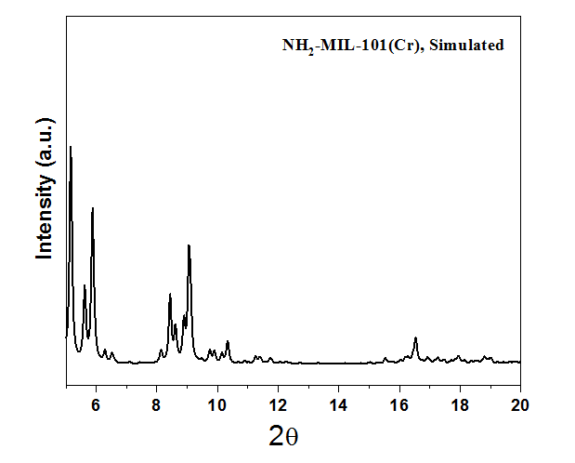

**Fig. S1:** XRD pattern of Simulated NH2-MIL-101(Cr)