**Supplementary Material**

**Antiproliferative, genotoxic activities and quantification of extracts and cucurbitacin B obtained from *Luffa operculata (L.) Cogn*.**

Natasha Costa da Rocha Galucio1, *; Daniele de Araújo Moysés1; Jeferson Rodrigo Souza Pina2; Patrícia Santana Barbosa Marinho2; Paulo Cardoso Gomes Júnior2; Jorddy Neves Cruz3; Valdicley Vieira Vale4; André Salim Khayat1; Andrey Moacir do Rosario Marinho2

1 Programa de Pós-Graduação em Genética e Biologia Molecular, Universidade Federal do Pará, Belém, PA, Brasil

2 Programa de Pós-Graduação em Química, Universidade Federal do Pará, Belém, PA, Brasil

3 Programa de Pós-graduação em Biodiversidade e Biotecnologia (BIONORTE), Universidade Federal do Pará

4 Programa de Pós-graduação em Inovação Farmacêutica, Universidade Federal do Pará, Belém, PA, Brasil

**\* Corresponding author:** Natasha Costa da Rocha Galucio,

**E-mail:** natashagalucio@gmail.com

**Table S1:** Assignment of 1H (400 MHz, CDCl3) and 13C NMR signals to S1.

|  |  |  |
| --- | --- | --- |
|  | S1 | S1 |
|  | H (δ, mult., *J* em Hz) | C (δ) |
| 1a | 2.39 (ddd, 13.0, 6.0, 3.0) | 35.8 |
| 1b | 1.23 (q) |  |
| 2 | 4.41 (dd, 13.1, 6.2) | 71.6 |
| 3 | - | 213.3 |
| 4 | - | 50.2 |
| 5 | - | 140.1 |
| 6 | 5.78 (d, 5.6) | 120.3 |
| 7a | 2.38 (ddd, 15.5, 5.5, 2.5) | 23.7 |
| 7b | 1.96 (dd, 15.5, 7.5) |  |
| 8 | 2.00 (dd, 7.5, 2.5) | 42.2 |
| 9 | - | 48.2 |
| 10 | 2.74 (ddb, 13.2) | 33.4 |
| 11 | - | 212.1 |
| 12a | 3.24 (d, 14.5) | 48.3 |
| 12b | 2.68 (14.5) |  |
| 13 | - | 50.4 |
| 14 | - | 47.9 |
| 15a | 1.87 (dd, 13.0, 8.0) | 45.1 |
| 15b | 1.49 (dd, 13.0, 8.0) |  |
| 16 | 4.36 (q, 7.9) | 71.0 |
| 17 | 2.57 (d, 8.0) | 58.0 |
| 18 | 0.97 (s) | 19.7 |
| 19 | - | 19.9 |
| 20 | 1.35 (s) | 79.1 |
| 21 | - | 23.5 |
| 22 | - | 202.3 |
| 23a | 7.05 (d, 16.0) | 120.1 |
| 23b |  |  |
| 24 | 6.5 (d, 16.2) | 151.8 |
| 25 | - | 78.1 |
| 26 | 1.55 (s) | 25.6 |
| 27 | 1.57 (s) | 26.6 |
| 28 | 1.28 (s) | 29.1 |
| 29 | 1.37 (s) | 21.1 |
| 30 | 1.45 (s) | 18.7 |
| Ac | - | 170.2 |
| Me Ac | 2.01 (s) | 21.8 |

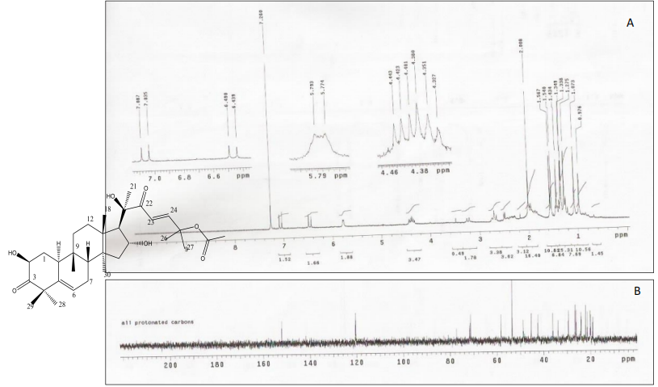

**Figure S1:** NMR spectrum of Cucurbitacin B. (A) 1H 400 MHz, CDCl3, δ; (B): 13C 100 MHz, CDCl3, δ.

~~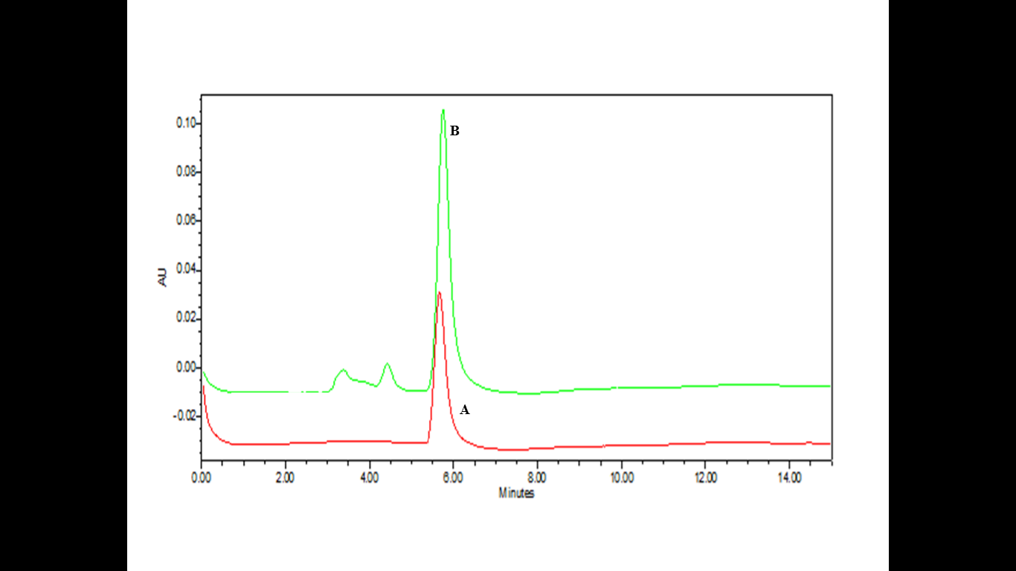~~

**Figure S2:** Overlay of chromatograms (A) CB standard (B) EEF extract.

**Figure S3:** Selectivity Index (SI) values of Methanol Fruit Extracts (EMF), Ethanol Fruit Extracts (EEF) and Cucurbitacin B (CB).



**Figure S4:** Dose-cytotoxicity relationship of EMF, EEF and CB in 48h in ACP02 and MNP01 cells lines.

Legend: EMF- methanol fruit extract; EEF- ethanol fruit extract; CB - cucurbitacin B.



**Figure S5:** Nuclear Division Index (NDI) in MNP01 and ACP02 cell lines. * Statistically significant compared to positive control in both cell lines p < 0.05;

Legend: EEF- ethanol fruit extract; CB- cucurbitacin B. The MNP01cell line was incubated with two concentrations of EEF1 = 0.0022 μg/mL, EE2 = 0.0011 μg/mL, CB1 = 0.0021 μg/mL and CB2 = 0.0011 μg/mL. In the ACP02 cell line, EEF1 = 0.0010 μg/mL, EEF2 = 0.0005 μg/mL, CB1 = 0.0027 μg/mL and CB2 = 0.0014 μg/mL.