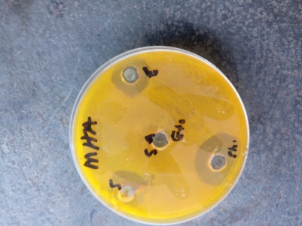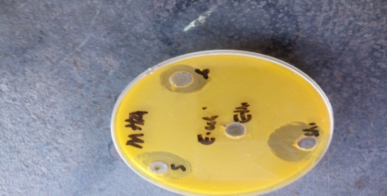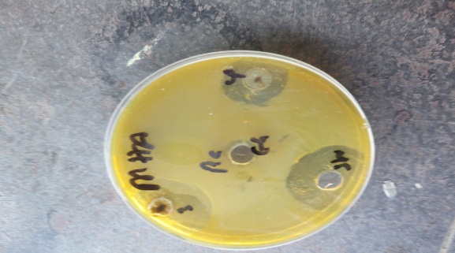

**Figure 1: Representative Image of showing the bacterial inhibition zone of the extract after 24 hs incubation.**

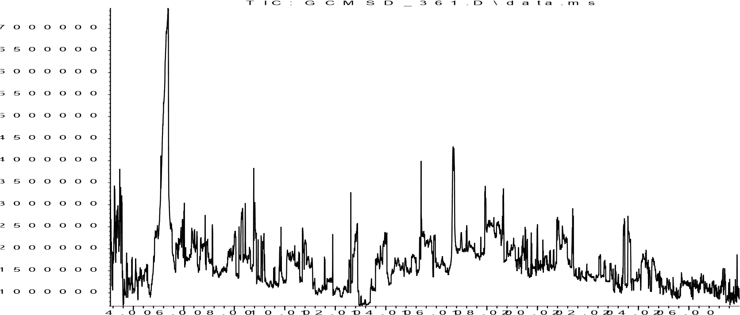

**Figure 2: GC-MS chromatogram of *R. longipes leaf* extract**

Cholest-2-eno[2,3-b]quinoxaline, 5',8'-dichloro-

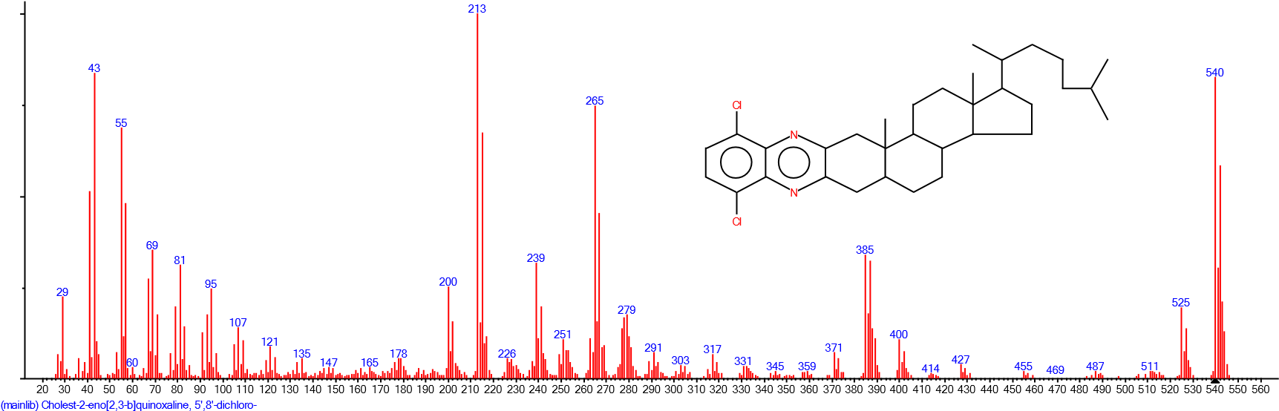

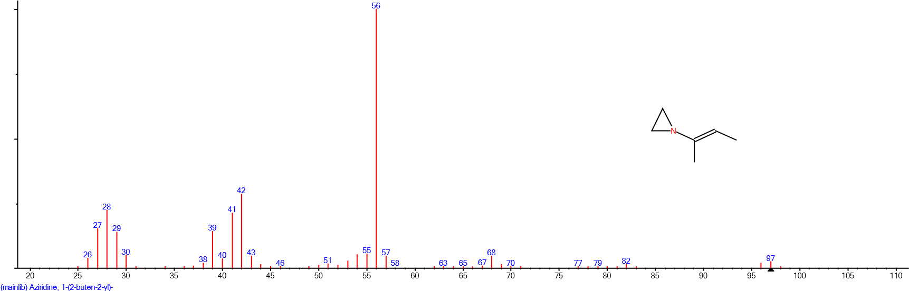

Aziridine, 1-(2-buten-2-yl)-

**Figure 3: Spectra of some compounds identified in the ethanol extracts of *R. longipes***

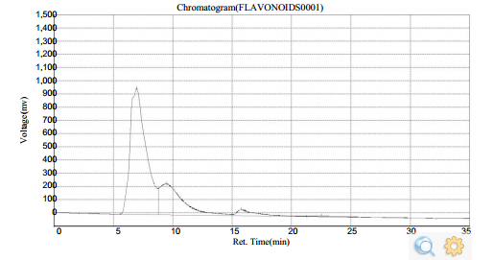

**Figure 4: Chromatogram of Flavonoids in identified in the leaf extract of *R. longipes***

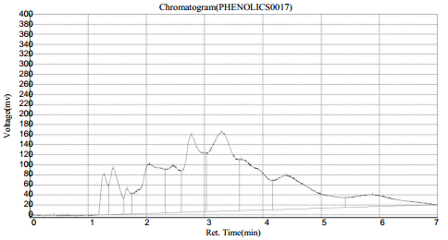

**Figure 5: Chromatogram of Phenolics identified in the leaf extract of *R. longipes***