**Supplementary data**

**Electrochemical degradation of 2,4-Dinitrotoluene (DNT) from aqueous solutions using three-dimensional electrocatalytic reactor (3DER): Degradation pathway, evaluation of toxicity and optimization using RSM-CCD**

Abdollah Dargahi1*, Mehdi Vosoughi1,2*, S. Ahmad Mokhtari2, Yaser Vaziri3*, Mortaza Alighadri2

1. Social Determinants of Health Research Center, Ardabil University of Medical Sciences, Ardabil, Iran.
2. Department of Environmental Health Engineering, School of Public Health, Ardabil University of Medical Sciences, Ardabil, Iran
3. Department of Environmental Health Engineering, School of Public Health, Hamadan University of Medical Sciences, Hamadan, Iran

*Corresponding author E-mail: [a.dargahi29@yahoo.com](mailto:a.dargahi29@yahoo.com), [mvn_20@yahoo.com](mailto:mvn_20@yahoo.com)

**Table S1.** 2,4- DNT chemical structure and its related information

|  |  |
| --- | --- |
| Component | Information/schematic/value |
| Chemical formula | C8H6Cl2O3 |
| structure | 2,4-dinitrotoluene - Kovats Retention Index |
| [Molar mass](https://en.wikipedia.org/wiki/Molar_mass) | 182.14 g/mol |
| [Melting point](https://en.wikipedia.org/wiki/Melting_point) | 70 °C (158 °F; 343 K) |
| [Boiling point](https://en.wikipedia.org/wiki/Boiling_point) | Decomposes at 250–300 °C |
| [Solubility in water](https://en.wikipedia.org/wiki/Aqueous_solution) | 270 mg/L at 22 °C |
| LD50 | 268 to 650 mg/kg (oral, rats)  1,954 mg/kg (oral, mouse)  1250 to 1954 mg/kg (oral, mice) |
| pKa in 298.15 k | 2.8 |
| Vapor pressure | 1.4 x 10-4 mm Hg at 22 ° C |

**Table S2**. Growth inhibition percentage in inlet and outlet solution by 3DER to remove 2,4-DNT under optimal conditions (2,4-DNT concentration = 23.5 mg/L, *j* = 4.8 mA/cm2, pH =4.1, electrolysis time= 50 min, GAC dose = 5 g/250cc))

|  |  |  |  |  |  |  |
| --- | --- | --- | --- | --- | --- | --- |
| Time (h) | Growth inhibition percentage of *Escherichia* | | | Growth inhibition percentage of *Staphylococcus aureus* | | |
| **Inlet** | **Outlet** | | **Inlet** | **Outlet** | |
| 2 | 75.8 | | 12.4 | 62.1 | | 18 |
| 4 | 65.9 | | 21.0.3 | 46.0 | | 14.0 |
| 6 | 47.9 | | 5.7 | 34.3 | | 12.5 |
| 8 | 46.4 | | 13.7 | 30.5 | | 10.6 |
| 10 | 42.4 | | 11.6 | 26.2 | | 7.83 |
| Average | 55.68 | | 10.85 | 39.82 | | 12.58 |

|  |  |
| --- | --- |
|  |  |
|  |  |

**Fig. S1.** FESEM images of the surface morphology at different magnifications of the β-PbO2 electrodeposited on graphite substrates.

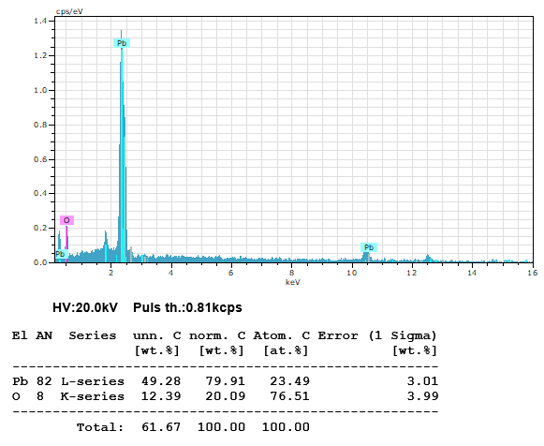

**Fig. S2.** EDS spectrum of the G/β-PbO2 anode

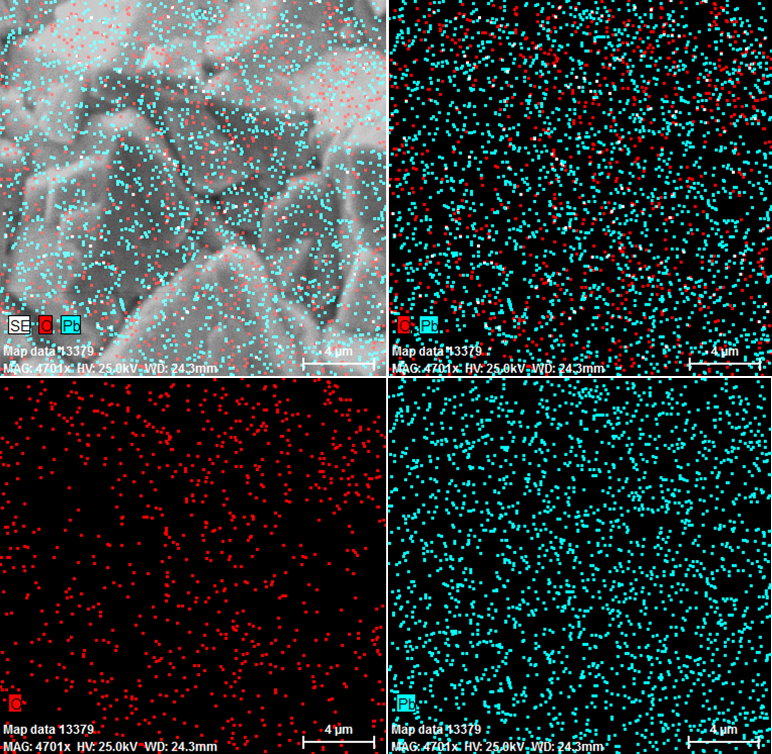

**Fig. S3.** EDS mapping of the G/β-PbO2 anode

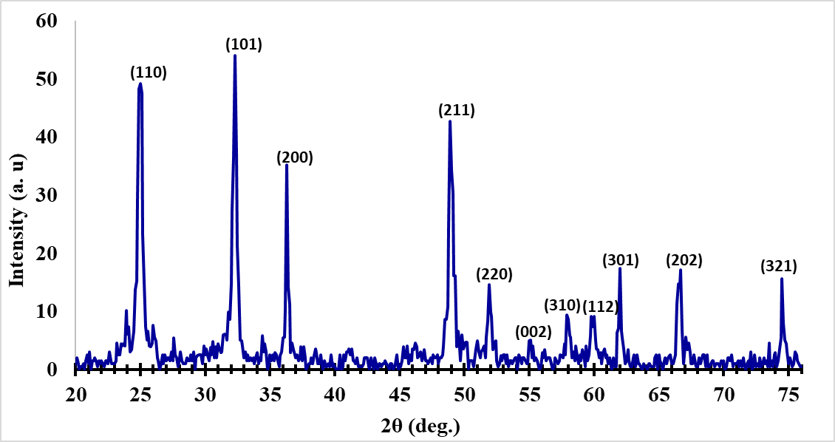

**Fig. S4.** XRD pattern of the G/β-PbO2 anode

|  |
| --- |
| (a) |
| (b) |

**Fig. S5.** (a) SEM image, and (b) XRD of MCZ@Fe3O4 nanoparticles

**Fig. S6.** Pareto chart of the main effects obtained from the screening experiments.

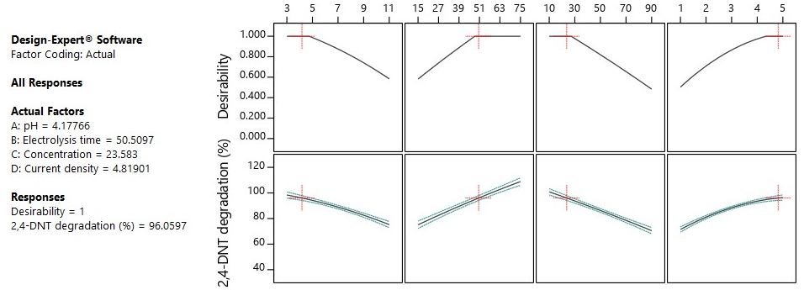

**Fig. S7.** Desirability ramp and the optimal points obtained by CCD for numerical optimization of four selected goals.

|  |
| --- |
|  |

**Fig. S8.** Reusability of G/β-PbO2 anode for electrodegradation of 2,4-DNT by 3DER (2,4-DNT concentration = 10.0 mg/L, Current density = 5.0 mA/cm2, pH =3.0, Electrolysis time = 75 min, GAC dose = 6 g/250cc)