Supporting Information

A surface architectured metal-organic framework for targeting delivery: suppresses cancer growth and metastasis

Wen Xie, Feiya Zhou, Xiang Li, Zhichen Liu, Manyu Zhang, Zhihui Zong, Lili Liang*

Department of Chemistry, Bengbu Medical College, Donghai Avenue, Bengbu 233030, Anhui, P. R. China

**Supporting Information:**

**Figure S1** TGA curves of MIL-101(Fe) and MIL-101(Fe)@FU

**Figure S2** The calibration curve of 5-FU

**Figure S3** Drug release profile for MIL-101(Fe)@FU@FA in PBS buffer solution at pH 7.4 and 6.8

**Figure S4** The particle size of MIL-101(Fe), MIL-101(Fe)@FU and MIL-101(Fe)@FU@FA

**Figure S5** Zata potential of MIL-101(Fe)@FU and MIL-101(Fe)@FU@FA

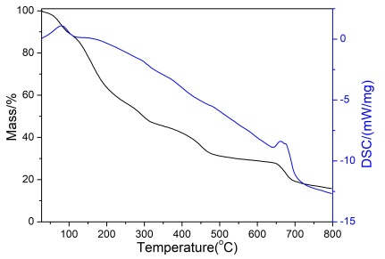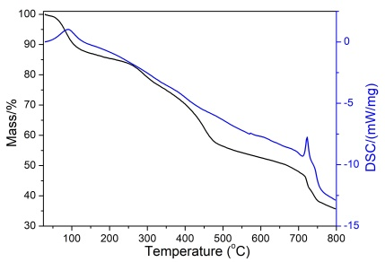

**Figure S1** TGA curves of MIL-101(Fe) and MIL-101(Fe)@FU

**Figure S2** The calibration curve of 5-FU



**Figure S3** Drug release profile for MIL-101(Fe)@FU@FA in PBS buffer solution at (a) pH 7.4 and (b) 6.8

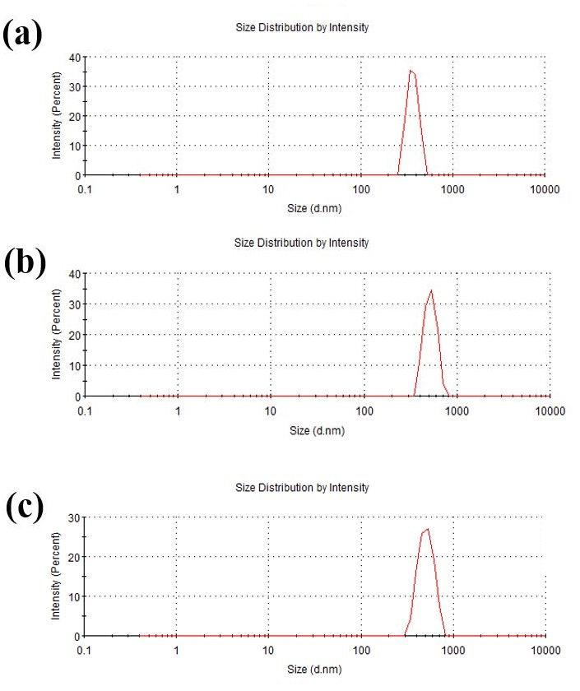

**Figure S4** The particle size of (a) MIL-101(Fe), (b) MIL-101(Fe)@FU, (c) MIL-101(Fe)@FU@FA

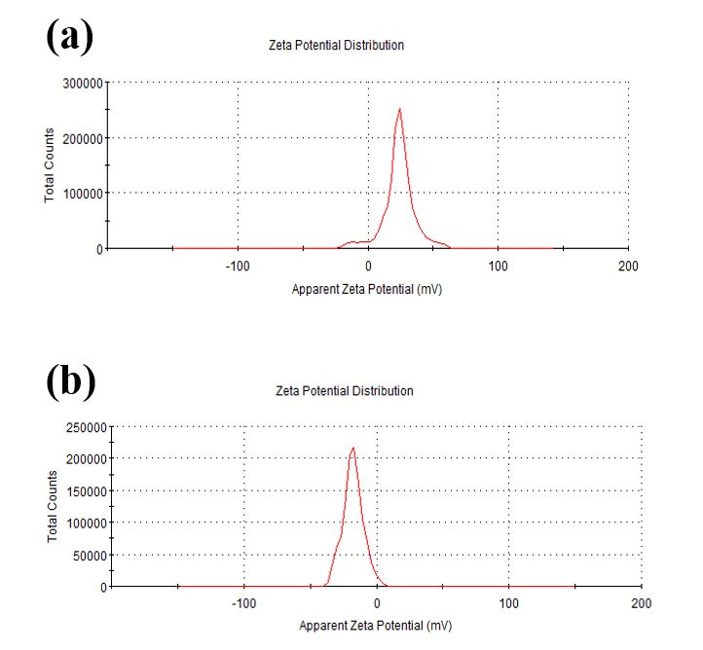

**Figure S5** Zata potential of (a) MIL-101(Fe)@FU and (b) MIL-101(Fe)@FU@FA