Degradation of chemical warfare agents by nickel doped titanium dioxide powders: Enhanced surface activity

Xiao-ming Zhua,c,§, Yong-Chao Zheng*,a,c,§, Li-Kun Chena,c, Ji-Na Wua,c, Sheng-Song Lia,c, Yi Xina,c, Ming-Jun Sun*,b, and Yan Cui*,a,c

a. *State Key Laboratory of NBC Protection for Civilian, Beijing, 102205, P. R. China*

*b. The State Key Laboratory of Refractories and Metallurgy, the Institute of Advanced Materials and Nanotechnology, College of Materials and Metallurgy, Wuhan University of Science and Technology, Wuhan, Hubei, 430081, China.*

c. *Research Institute of Chemical Defense, Beijing, 102205, P. R. China.*

*§. These authors contributed equally to this work.*

**Contents**

|  |  |
| --- | --- |
| 1. High-resolution XPS spectroscopy | Fig. S1 |
| 2. TEM images of TN1 and TN2 | Fig. S2 |
| 3. N2 sorption curves | Fig. S3 |
| 4. Stability test of the catalyst | Fig. S4 |
| 5. Degradation of HD by different ratios of TN2 | Fig. S5 |
| 6. Copies of mass spectra of products | Fig. S6-S11 |
| 7. XRD spectra of the computational model of anatase TiO2 | Fig. S12 |
| 8. Surface structures of TiO2 (101) surface with HD/GD molecule | Fig. S13 |

**High-resolution XPS spectroscopy**



***Fig. S1*** *High-resolution XPS spectroscopy of (c) Ni 2p, and, (d) O 1s and (e) Ti 2p of TN2.*

**TEM images of TN1 and TN2**

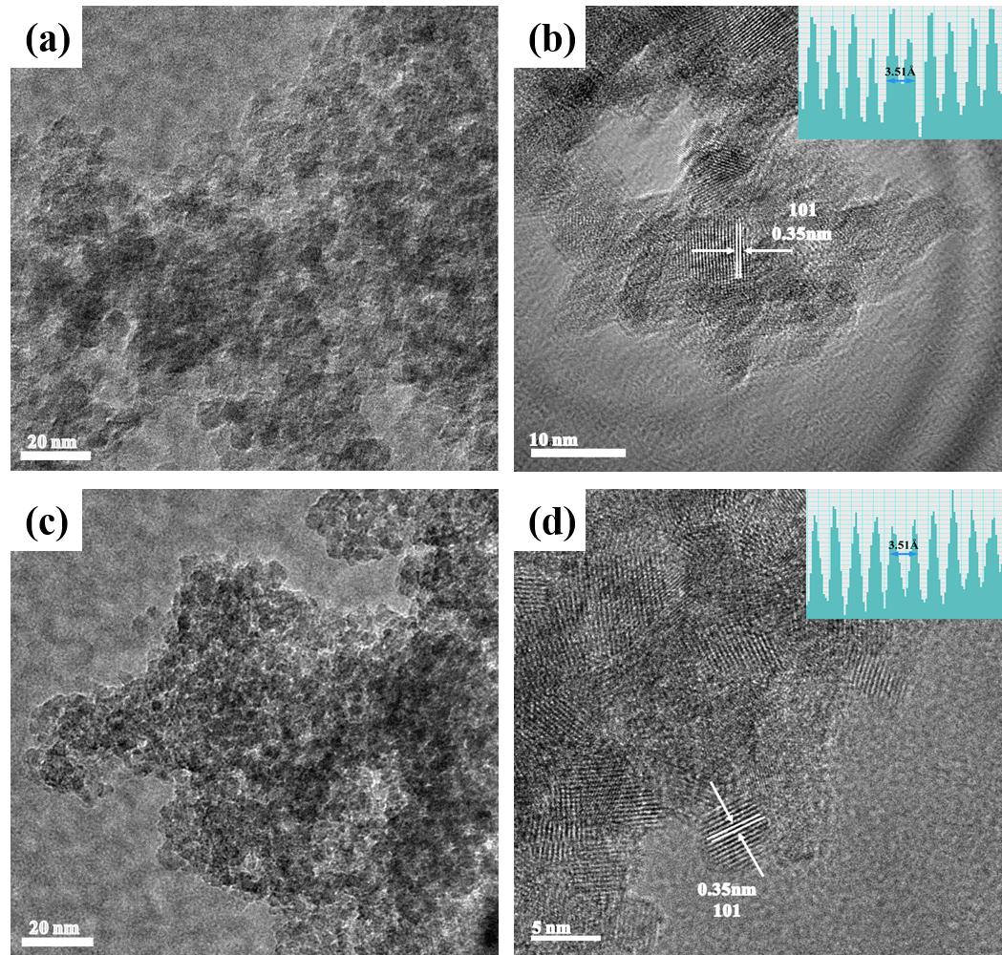

**Fig. S2** Low-resolution TEM images of TN1 (a) and TN3 (c). High-resolution TEM images of TN1 (b) and TN3 (d). The inset on the upper right corner is the corresponding lattice distance of (101) facet.

**N2 sorption curves**





**Fig. S3** Pore size distribution curves of TN1 (a) and TN3 (b) calculated from desorption branch of the nitrogen isotherm. The inset on the upper right corner is the nitrogen adsorption-desorption isotherms.

**Stability test of the catalyst**



**Fig. S4** Recyclability of TN2 for the degradation of (a) HD, (b) GD and (c)VX.

**Degradation of HD by different ratios of TN2**



**Fig. S5** Degradation of HD in 1 hour by different ratios of TN2.

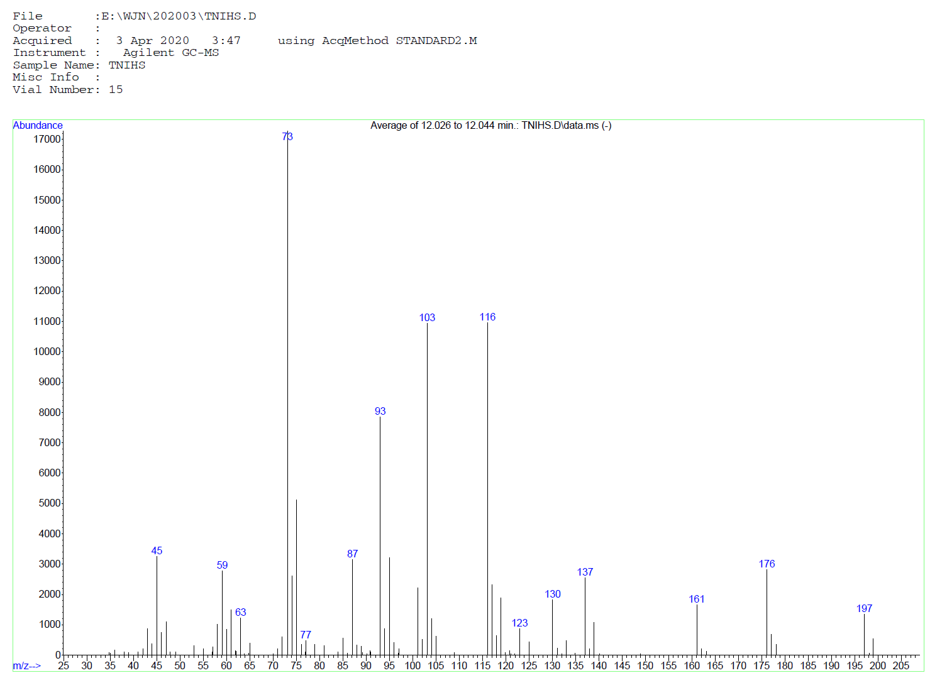

Match level: 91 %

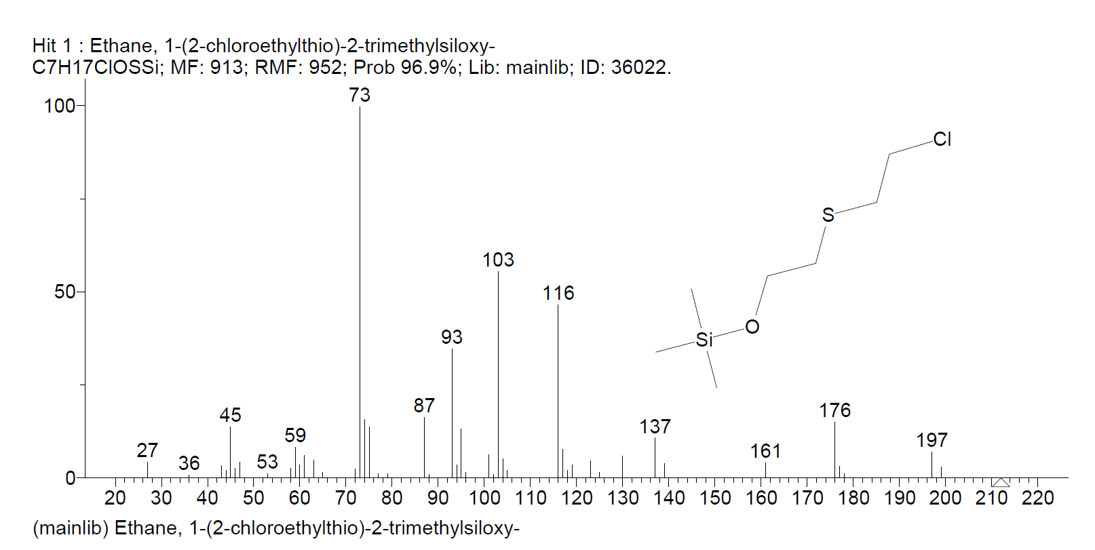

**Fig. S6** Mass spectrometry of silylated product C4H9ClOS **(2)** of HD detected by GC/MS (Agilent 7890A GC & Agilent 5975C MSD) and the corresponding reference spectrum.

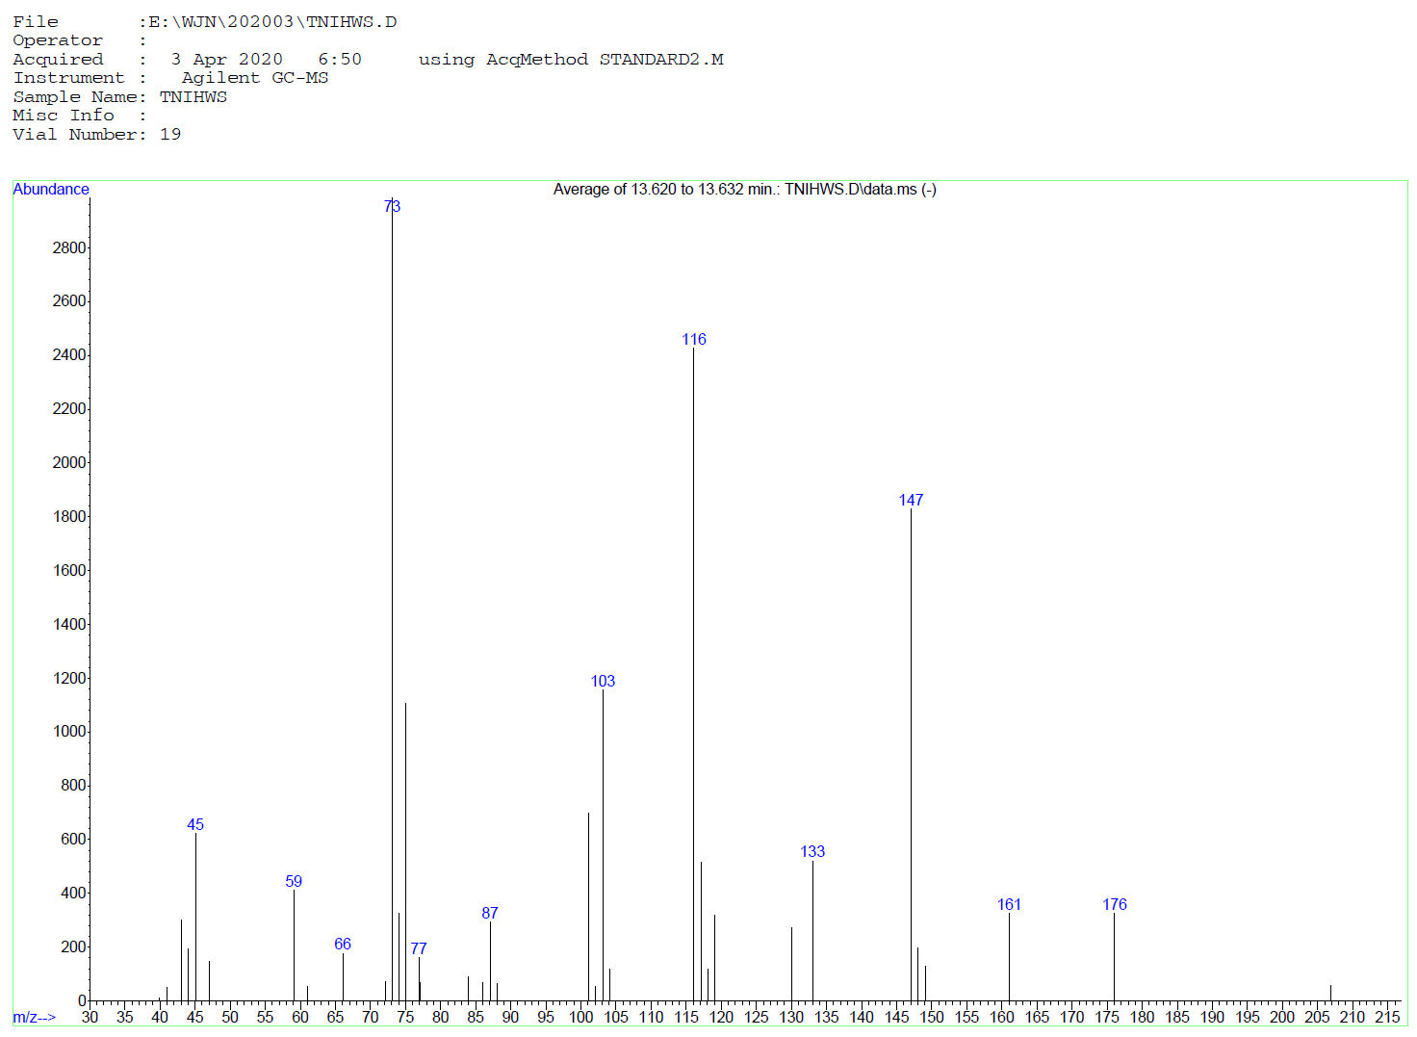

Match level: 88 %

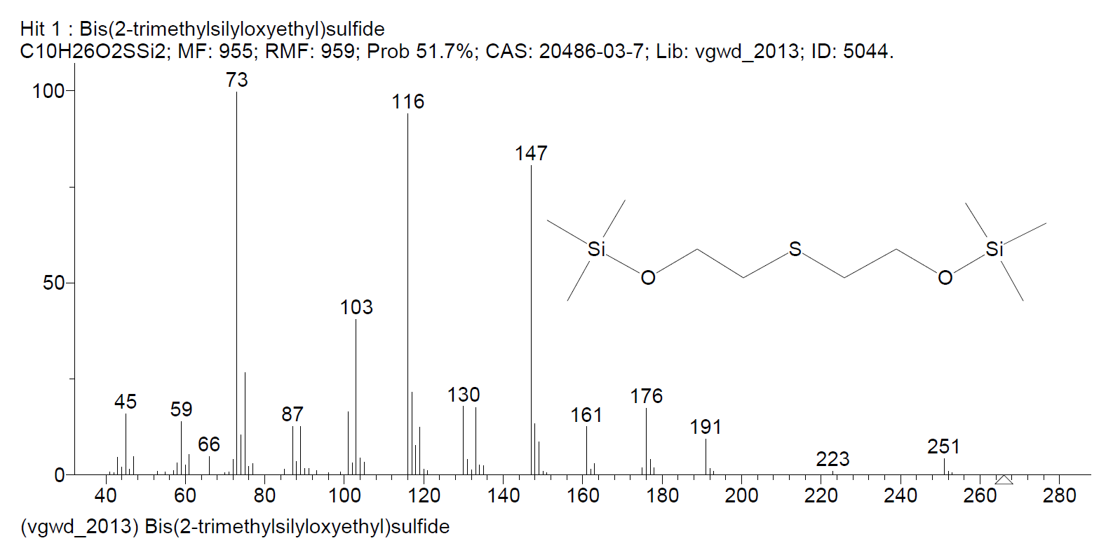

**Fig. S7** Mass spectrometry of silylated product C4H10O2S of HD detected by GC/MS (Agilent 7890A GC & Agilent 5975C MSD) and the corresponding reference spectrum.

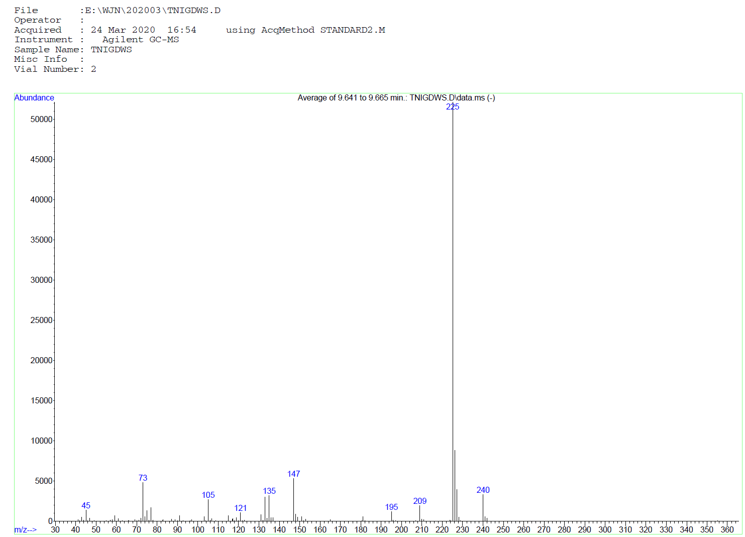

Match level: 96 %

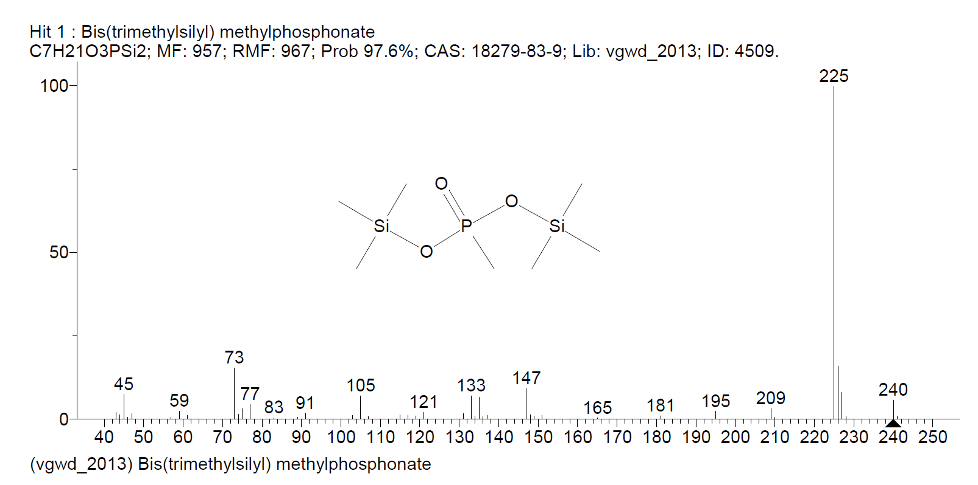

**Fig. S8** Mass spectrometry of silylated product CH5O3P of GD detected by GC/MS (Agilent 7890A GC & Agilent 5975C MSD) and the corresponding reference spectrum.

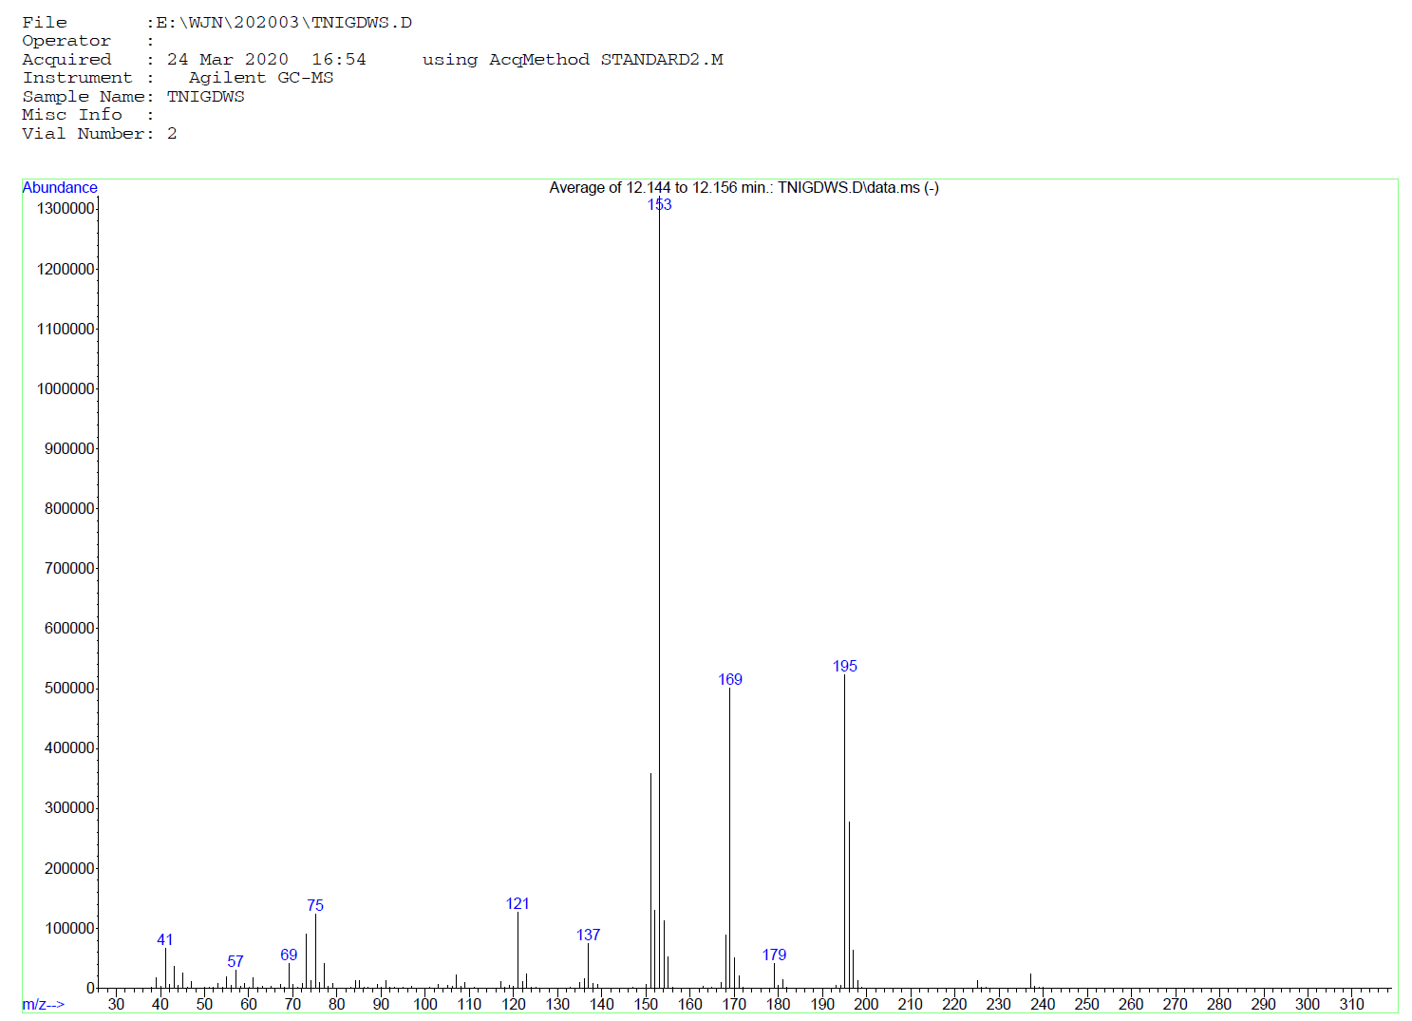

Match level: 97 %

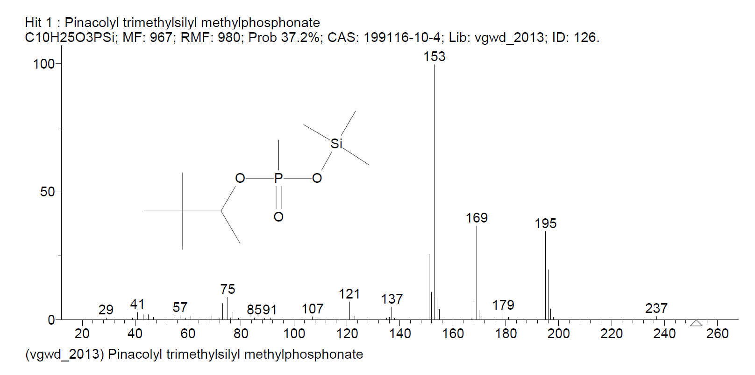

**Fig. S9** Mass spectrometry of silylated product C7H17O3P of GD detected by GC/MS (Agilent 7890A GC & Agilent 5975C MSD) and the corresponding reference spectrum.

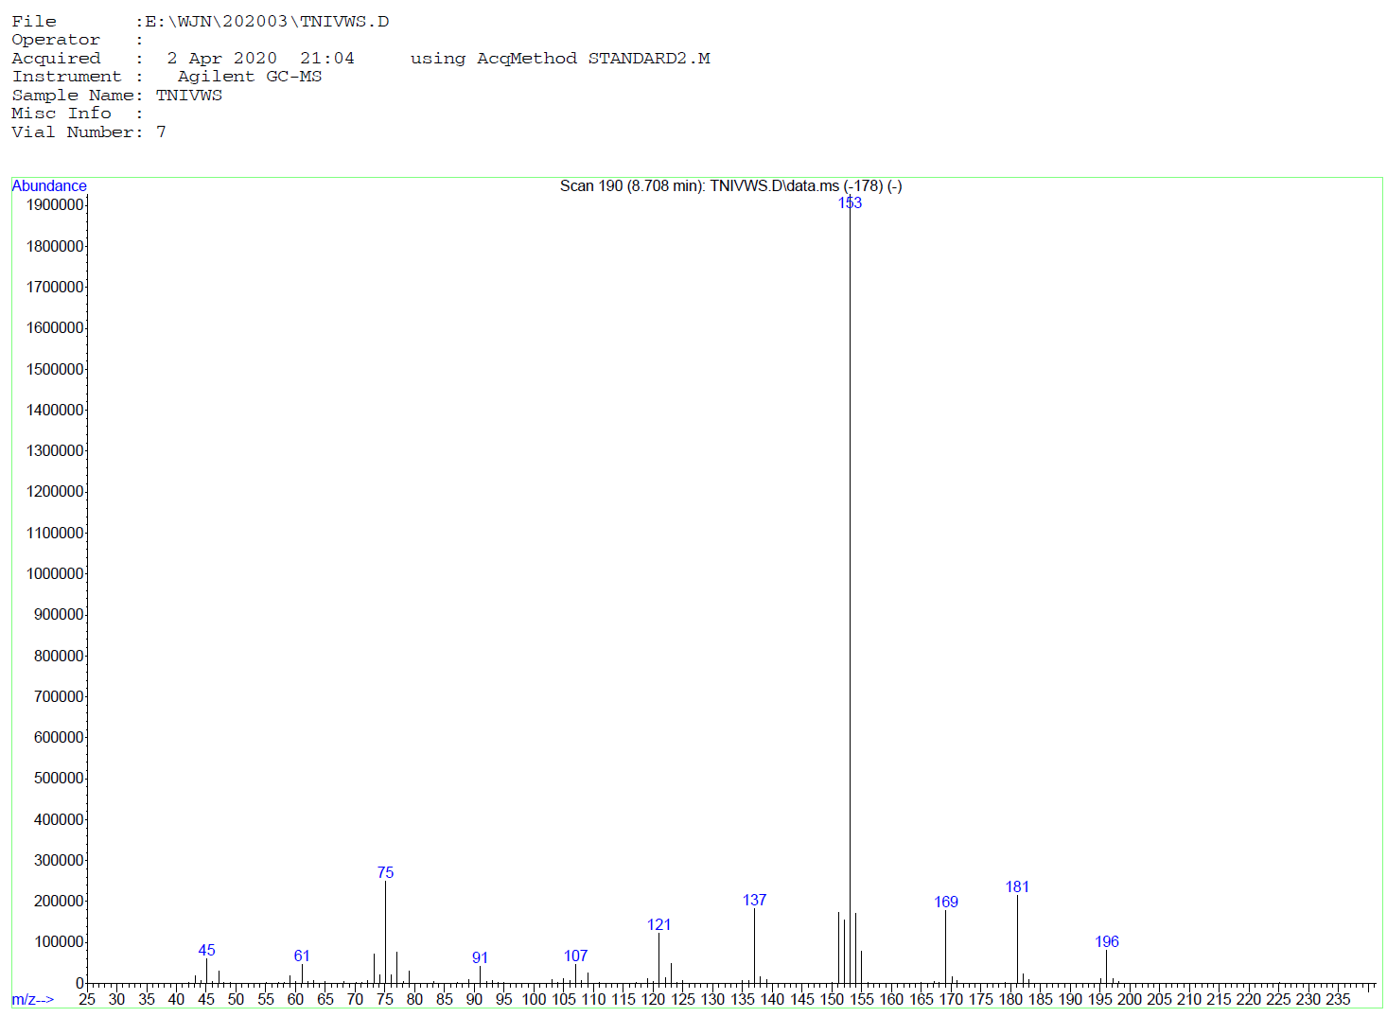

Match level: 98 %

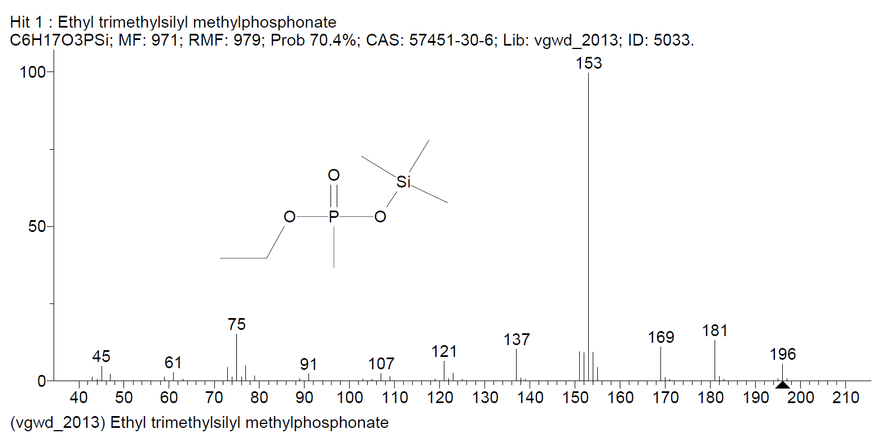

**Fig. S10** Mass spectrometry of silylated product C3H9O3P of VX detected by GC/MS (Agilent 7890A GC & Agilent 5975C MSD) and the corresponding reference spectrum.

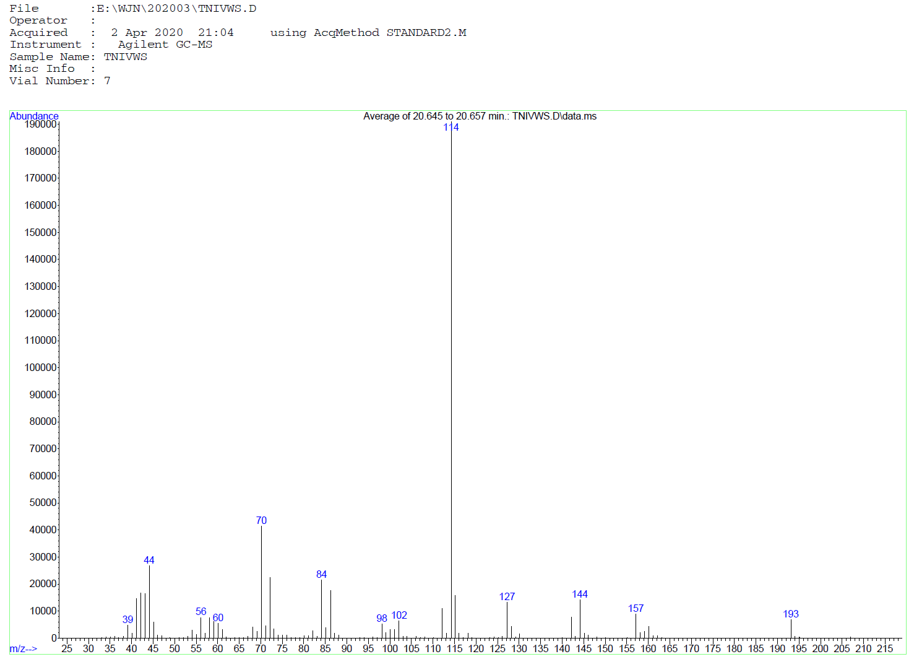

Match level: 87 %

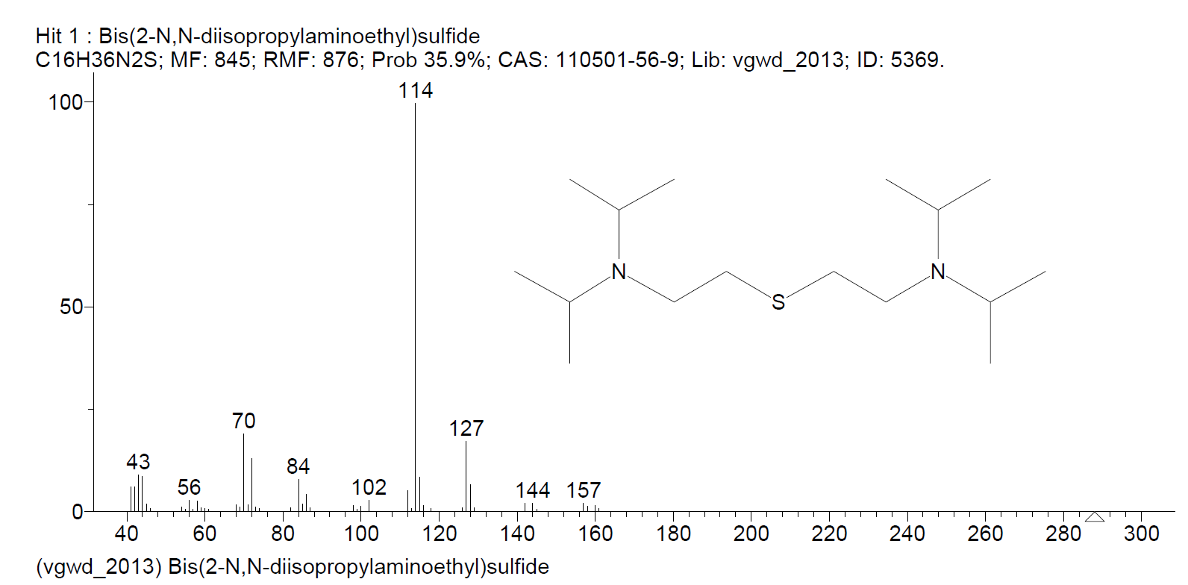

**Fig. S11** Mass spectrometry of silylated product C16H36N2S of VX detected by GC/MS (Agilent 7890A GC & Agilent 5975C MSD) and the corresponding reference spectrum.

**XRD spectra of the computational model of anatase TiO2**

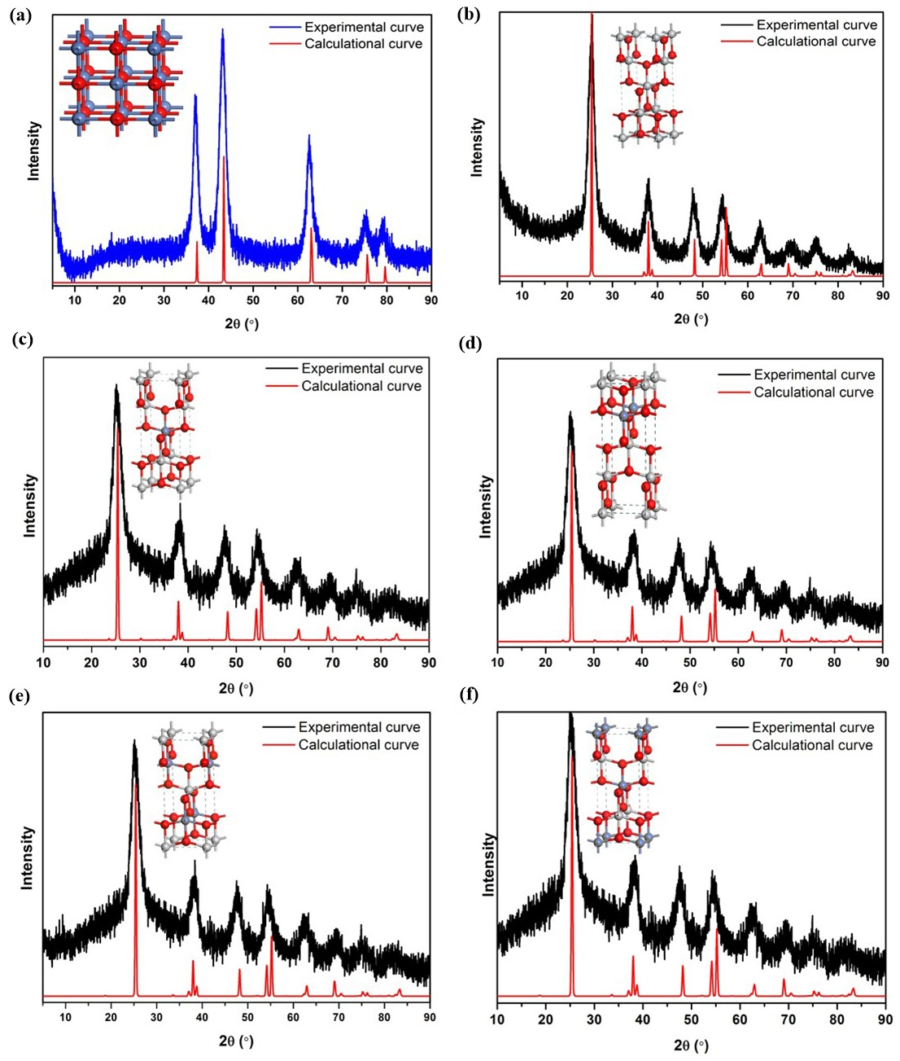

**Fig. S12.** The calculational and experimental XRD spectra of the NiO crystal (a)、anatase TiO2 (b) and the different structures of Ni2+ dopped anatase TiO2 (c-f).

**Surface structures of TiO2 (101) surface with HD/GD molecule**



**Fig. S13.** The optimal surface structures of the anatase TiO2 (101) surface with and without doping of Ni2+ and HD/GD molecule. The calculated interaction energies between the surface structures (TiO2-OH, TiO2-OH-Ni-1) and HD are 6.52, 7.18 kcal/mol, respectively. The calculated interaction energies between the surface structures (TiO2-OH, TiO2-OH-Ni-1) and GD are 7.90, 8.41 kcal/mol, respectively.