Supplementary Information

C-methyl flavonoid from the leaves of Cleistocalyx conspersipunctatus：α-glucosidase inhibitory, molecular docking simulation and biosynthetic pathway
Haifang Du^{a,b,c}, Hanxiang Li^{b}, Ping Wu^{b,c,*}, Jinghua Xue^{b}, Yunshan Wu^{a,d}, Xiaoyi Wei^{b,c}, Bo Liu^{a,d,*}
ª Guangdong Provincial Key Laboratory of Clinical Research on Traditional Chinese Medicine Syndrome, The Second Clinical Medical College, Guangzhou University of Chinese Medicine, Guangzhou 510006, PR China
^{b} Key Laboratory of Plant Resources Conservation and Sustainable Utilization, South China Botanical Garden, Chinese Academy of Sciences, Xingke Road 723, Tianhe District, Guangzhou 510650, PR China
^{c} University of Chinese Academy of Sciences, Yuquanlu 19A, Beijing 100049, PR China
^{d} Guangzhou Key Laboratory of Chirality Research on Active Components of Traditional Chinese Medicine, Guangzhou 510006, PR China

_______________________________________
* Corresponding author. E-mail: doctliu@263.net (B. Liu), wuping@scbg.ac.cn (P. Wu).
Contents of Supplementary Information

Computational Details...................................................................................................................1
Text of Configuration File Used for Docking.............................................................................4
Table 1 Docking results of compounds 1-3, corosolic acid and acarbose with α-glucosidase.....15
Table 2 Inhibition of each sample compounds 13 and corosolic acid α-glucosidase.................16
Extraction and isolation
Figure S1. Extraction and isolation flow chart for compounds 1–12...................................17
NMR spectra and HRESIMS of compound 1
Figure S2. ¹H NMR (500 MHz) spectrum of compound 1 in methanol-d₄ 18
Figure S3. ¹³C NMR (125 MHz) spectrum of compound 1 in methanol-d₄ 18
Figure S4. HSQC spectrum of compound 1 in methanol-d₄ 19
Figure S5. HMBC spectrum of compound 1 in methanol-d₄ 19
Figure S6. HRESI(–)MS of compound 1 20

Computational Details
Molecular Merck force field (MMFF) calculations were done using Spartan'14 program (Wavefunction Inc., Irvine, CA, USA). Density functional theory (DFT) and time–dependent density functional theory (TDDFT) calculations were performed with Gaussian09 RevD.01 [1]. The deduced structure of compound 1 was subjected to theoretical computations of ECD spectra. For conformational analysis, low-energy conformers within a 10 kcal/mol energy window from MMFF conformational search were subjected to geometry optimization using DFT method at the B3LYP-D3(BJ) [2–6]/Def2-SVP [7]/PCM(MeOH) level. Frequency calculations were run at the same level to verify that each optimized conformer was a true minimum and to estimate its relative thermal (E) and free energies (G) at 298.15K. Energies of the low-energy conformers were re-calculated at the M06-2X [8]/Def2-TZVP [7]/PCM(MeOH). The TDDFT calculation was performed using the hybrid PBE0 [9,10] and M06-2X functionals, and Ahlrichs’ basis set TZVP (triple zeta valence plus polarization) [11,12] with the solvation model PCM for MeOH. The number of excited states calculated was 72. The calculated ECD curve of each conformer was visualized and exported by the program SpecDis [13] using a Gaussian band shape. Equilibrium population of each conformer at 298.15K was calculated from its relative free energies using Boltzmann statistics. The calculated spectrum of compound 1 was generated from the low-energy conformers according to the Boltzmann weighting of each conformer in MeOH solution.
References
[1] Frisch, M. J.; Trucks, G. W.; Schlegel, H. B.; Scuseria, G. E.; Robb, M. A.; Cheeseman, J. R.; Scalmani, G.; Barone, V.; Mennucci, B.; Petersson, G. A.; Nakatsuji, H.; Caricato, M.; Li, X.; Hratchian, H. P.; Izmaylov, A. F.; Bloino, J.; Zheng, G.; Sonnenberg, J. L.; Hada, M.; Ehara, M.; Toyota, K.; Fukuda, R.; Hasegawa, J.; Ishida, M.; Nakajima, T.; Honda, Y.; Kitao, O.; Nakai, H.; Vreven, T.; Montgomery, J. A.; Peralta, J. E.; Ogliaro, F.; Bearpark, M.; Heyd, J. J.; Brothers, E.; Kudin, K. N.; Staroverov, V. N.; Keith, T.; Kobayashi, R.; Normand, J.; Raghavachari, K.; Rendell, A.; Burant, J. C.; Iyengar, S. S.; Tomasi, J.; Cossi, M.; Rega, N.; Millam, J. M.; Klene, M.; Knox, J. E.; Cross, J. B.; Bakken, V.; Adamo, C.; Jaramillo, J.; Gomperts, R.; Stratmann, R. E.; Yazyev, O.; Austin, A. J.; Cammi, R.; Pomelli, C.; Ochterski, J. W.; Martin, R. L.; Morokuma, K.; Zakrzewski, V. G.; Voth, G. A.; Salvador, P.; Dannenberg, J. J.; Dapprich, S.; Daniels, A. D.; Farkas, O.; Foresman, J. B.; Ortiz, J. V.; Cioslowski, J.; Fox, D. J. Gaussian 09, revision D.01. Gaussian, Inc.: Wallingford CT, 2013.
[2] A.D. Becke, Density-functional thermochemistry. III. The role of exact exchange, J. Chem. Phys., 98 (1993) 5648–5652.
[3] A.D. Becke, Density-functional exchange-energy approximation with correct asymptotic behavior, Phys. Rev. A 38 (1988) 3098–3100.
[4] C.T. Lee, W.T. Yang, R.G. Parr, Development of the Colle-Salvetti correlation-energy formula into a functional of the electron density, Phys. Rev. B 37 (1988) 785–789.
[5] S. Grimme, J. Antony, S. Ehrlich, et al., A consistent and accurate ab initio parametrization of density functional dispersion correction (DFT-D) for the 94 elements H-Pu, J. Chem. Phys., 132 (2010) 154104–154100.
[6] S. Grimme, S. Ehrlich, L. Goerigk, Effect of the damping function in dispersion corrected density functional theory, J. Comput. Chem. 32 (2011) 1456–1465.
[7] F. Weigend, R. Ahlrichs, Balanced basis sets of split valence, triple zeta valence and quadruple zeta valence quality for H to Rn: Design and assessment of accuracy, Phys. Chem. Chem. Phys. 7 (2005) 3297–3305.
[8] Y. Zhao, D.G. Truhlar, The M06 suite of density functionals for main group thermochemistry, thermochemical kinetics, noncovalent interactions, excited states, and transition elements: two new functionals and systematic testing of four M06-class functionals and 12 other functionals, Theor. Chem. Acc. 120 (2008) 215–241.
[9] J.P. Perdew, K. Burke, M. Ernzerhof, Generalized gradient approximation made simple, Phys. Rev. Lett. 77 (1996) 3865–3868.
[10] C. Adamo, V. Barone, Toward reliable density functional methods without adjustable parameters: The PBE0 model, J. Chem. Phys. 110 (1999) 6158–6169.
[11] D. Schäfer, H.W. Spiess, R. Ahlrichs, Two-dimensional exchange nuclear magnetic resonance of powder samples. IV. Distribution of correlation times and line shapes in the intermediate dynamic range, J. Chem. Phys. 97 (1992) 7944–7954.
[12] A. Schäfer, C. Huber, R. Ahlrichs, Fully optimized contracted Gaussian basis sets of triple zeta valence quality for atoms Li to Kr, J. Chem. Phys. 100 (1994) 5829–5835.
[13] T. Bruhn, A. Schaumloeffel, Y. Hemberger, et al., SpecDis: quantifying the comparison of calculated and experimental electronic circular dichroism spectra, Chirality 25 (2013) 243–249.

Text of Configuration File Used for Docking

Compound 1
MODEL 1
REMARK VINA RESULT: -9.0 0.000 0.000
REMARK 15 active torsions:
REMARK status: ('A' for Active; 'I' for Inactive)
REMARK 1 A between atoms: C_1 and O_18
REMARK 2 A between atoms: C_3 and O_20
REMARK 3 A between atoms: C_9 and C_11
REMARK 4 A between atoms: C_14 and O_22
REMARK 5 A between atoms: O_18 and C_23
REMARK 6 A between atoms: C_25 and C_29
REMARK 7 A between atoms: C_26 and O_43
REMARK 8 A between atoms: C_27 and O_44
REMARK 9 A between atoms: C_28 and O_42
REMARK 10 A between atoms: C_29 and O_30
REMARK 11 A between atoms: O_30 and C_31
REMARK 12 A between atoms: C_31 and C_32
REMARK 13 A between atoms: C_35 and O_40
REMARK 14 A between atoms: C_36 and O_39
REMARK 15 A between atoms: C_37 and O_41
ROOT
ATOM 1 C *** d * 26.054 -3.946 8.956 0.00 0.00 0.298 C
ATOM 2 O *** d * 26.218 -5.179 9.656 0.00 0.00 -0.348 OA
ATOM 3 C *** d * 25.715 -5.111 10.991 0.00 0.00 0.180 C
ATOM 4 C *** d * 26.465 -4.059 11.798 0.00 0.00 0.180 C
ATOM 5 C *** d * 26.404 -2.702 11.105 0.00 0.00 0.183 C
ATOM 6 C *** d * 26.824 -2.827 9.645 0.00 0.00 0.205 C
ENDROOT
BRANCH 1 7
ATOM 7 O *** d * 24.692 -3.614 8.923 0.00 0.00 -0.316 OA
BRANCH 7 8
ATOM 8 C *** d * 24.318 -3.234 7.677 0.00 0.00 0.089 A
ATOM 9 C *** d * 24.044 -1.894 7.409 0.00 0.00 0.006 A
ATOM 10 C *** d * 23.650 -1.504 6.128 0.00 0.00 0.091 A
ATOM 11 C *** d * 24.172 -0.872 8.496 0.00 0.00 0.054 C
ATOM 12 C *** d * 23.525 -2.454 5.105 0.00 0.00 0.077 A
ATOM 13 C *** d * 23.826 -3.793 5.377 0.00 0.00 0.095 A
ATOM 14 C *** d * 23.099 -2.025 3.731 0.00 0.00 0.167 C
ATOM 15 C *** d * 24.207 -4.183 6.661 0.00 0.00 0.007 A
ATOM 16 O *** d * 23.739 -4.795 4.446 0.00 0.00 -0.339 OA
ATOM 17 C *** d * 24.495 -5.623 6.950 0.00 0.00 0.054 C
ATOM 18 C *** d * 23.676 -4.344 3.091 0.00 0.00 0.169 C
ATOM 19 C *** d * 22.661 -3.228 2.907 0.00 0.00 0.121 C
ATOM 20 O *** d * 23.103 -0.886 3.333 0.00 0.00 -0.292 OA
BRANCH 10 21
ATOM 21 O *** d * 23.387 -0.200 5.873 0.00 0.00 -0.359 OA
ATOM 22 H *** d * 23.531 -0.045 4.924 0.00 0.00 0.218 HD
ENDBRANCH 10 21
BRANCH 18 23
ATOM 23 C *** d * 25.027 -3.839 2.687 0.00 0.00 -0.028 A
ATOM 24 C *** d * 25.190 -3.184 1.466 0.00 0.00 0.012 A
ATOM 25 C *** d * 26.449 -2.715 1.090 0.00 0.00 0.037 A
ATOM 26 C *** d * 27.543 -2.900 1.935 0.00 0.00 0.065 A
ATOM 27 C *** d * 27.379 -3.554 3.156 0.00 0.00 0.037 A
ATOM 28 C *** d * 26.121 -4.024 3.532 0.00 0.00 0.012 A
BRANCH 26 29
ATOM 29 O *** d * 28.766 -2.443 1.570 0.00 0.00 -0.361 OA
ATOM 30 H *** d * 29.029 -2.904 0.757 0.00 0.00 0.217 HD
ENDBRANCH 26 29
ENDBRANCH 18 23
ENDBRANCH 7 8
ENDBRANCH 1 7
BRANCH 6 31
ATOM 31 O *** d * 28.196 -3.107 9.583 0.00 0.00 -0.388 OA
ATOM 32 H *** d * 28.387 -3.699 10.289 0.00 0.00 0.210 HD
ENDBRANCH 6 31
BRANCH 3 33
ATOM 33 C *** d * 24.236 -4.747 10.948 0.00 0.00 0.213 C
BRANCH 33 34
ATOM 34 O *** d * 23.559 -5.419 11.974 0.00 0.00 -0.315 OA
BRANCH 34 35
ATOM 35 C *** d * 22.860 -4.544 12.708 0.00 0.00 0.293 C
ATOM 36 O *** d * 23.042 -3.359 12.570 0.00 0.00 -0.259 OA
BRANCH 35 37
ATOM 37 C *** d * 21.952 -4.988 13.605 0.00 0.00 0.045 A
ATOM 38 C *** d * 22.282 -5.051 14.959 0.00 0.00 0.057 A
ATOM 39 C *** d * 21.344 -5.509 15.884 0.00 0.00 0.102 A
ATOM 40 C *** d * 20.076 -5.904 15.455 0.00 0.00 0.132 A
ATOM 41 C *** d * 19.747 -5.842 14.101 0.00 0.00 0.102 A
ATOM 42 C *** d * 20.685 -5.384 13.176 0.00 0.00 0.057 A
BRANCH 39 43
ATOM 43 O *** d * 21.664 -5.570 17.199 0.00 0.00 -0.358 OA
ATOM 44 H *** d * 21.610 -4.672 17.563 0.00 0.00 0.218 HD
ENDBRANCH 39 43
BRANCH 40 45
ATOM 45 O *** d * 19.166 -6.349 16.355 0.00 0.00 -0.356 OA
ATOM 46 H *** d * 18.283 -6.262 15.956 0.00 0.00 0.218 HD
ENDBRANCH 40 45
BRANCH 41 47
ATOM 47 O *** d * 18.516 -6.226 13.686 0.00 0.00 -0.358 OA
ATOM 48 H *** d * 18.267 -5.669 12.930 0.00 0.00 0.218 HD
ENDBRANCH 41 47
ENDBRANCH 35 37
ENDBRANCH 34 35
ENDBRANCH 33 34
ENDBRANCH 3 33
BRANCH 5 49
ATOM 49 O *** d * 25.092 -2.212 11.168 0.00 0.00 -0.390 OA
ATOM 50 H *** d * 24.541 -2.934 11.418 0.00 0.00 0.210 HD
ENDBRANCH 5 49
BRANCH 4 51
ATOM 51 O *** d * 27.805 -4.450 11.928 0.00 0.00 -0.390 OA
ATOM 52 H *** d * 28.319 -3.662 11.959 0.00 0.00 0.210 HD
ENDBRANCH 4 51
TORSDOF 15
ENDMDL

Compound 2
MODEL 1
REMARK VINA RESULT: -9.2 0.000 0.000
REMARK 10 active torsions:
REMARK status: ('A' for Active; 'I' for Inactive)
REMARK 1 A between atoms: C_1 and O_18
REMARK 2 A between atoms: C_3 and O_20
REMARK 3 A between atoms: C_9 and C_11
REMARK 4 A between atoms: C_14 and O_22
REMARK 5 A between atoms: O_18 and C_23
REMARK 6 A between atoms: C_25 and C_29
REMARK 7 A between atoms: C_26 and O_31
REMARK 8 A between atoms: C_27 and O_32
REMARK 9 A between atoms: C_28 and O_30
REMARK 10 A between atoms: C_29 and O_33
ROOT
ATOM 1 C *** d * 23.865 -3.299 6.710 0.00 0.00 0.089 A
ATOM 2 C *** d * 23.570 -2.029 6.352 0.00 0.00 0.006 A
ATOM 3 C *** d * 23.462 -1.665 5.054 0.00 0.00 0.091 A
ATOM 4 C *** d * 23.610 -2.596 4.085 0.00 0.00 0.077 A
ATOM 5 C *** d * 23.807 -3.889 4.421 0.00 0.00 0.095 A
ATOM 6 C *** d * 23.927 -4.220 5.723 0.00 0.00 0.007 A
ATOM 7 C *** d * 23.507 -2.278 2.758 0.00 0.00 0.167 C
ATOM 8 C *** d * 23.685 -3.391 1.734 0.00 0.00 0.121 C
ATOM 9 C *** d * 24.559 -4.500 2.296 0.00 0.00 0.169 C
ATOM 10 O *** d * 23.948 -4.894 3.494 0.00 0.00 -0.339 OA
ATOM 11 C *** d * 24.132 -5.695 6.049 0.00 0.00 0.054 C
ATOM 12 C *** d * 23.311 -0.956 7.398 0.00 0.00 0.054 C
ATOM 13 O *** d * 23.282 -1.179 2.298 0.00 0.00 -0.292 OA
ENDROOT
BRANCH 1 14
ATOM 14 O *** d * 24.096 -3.716 8.002 0.00 0.00 -0.316 OA
BRANCH 14 15
ATOM 15 C *** d * 25.413 -3.819 8.508 0.00 0.00 0.298 C
ATOM 16 O *** d * 25.668 -5.071 9.106 0.00 0.00 -0.348 OA
ATOM 17 C *** d * 25.405 -5.249 10.470 0.00 0.00 0.179 C
ATOM 18 C *** d * 25.839 -4.079 11.338 0.00 0.00 0.180 C
ATOM 19 C *** d * 25.361 -2.743 10.807 0.00 0.00 0.183 C
ATOM 20 C *** d * 25.768 -2.613 9.356 0.00 0.00 0.205 C
BRANCH 17 21
ATOM 21 C *** d * 23.990 -5.737 10.734 0.00 0.00 0.198 C
BRANCH 21 22
ATOM 22 O *** d * 23.353 -6.080 9.518 0.00 0.00 -0.398 OA
ATOM 23 H *** d * 23.304 -7.038 9.433 0.00 0.00 0.209 HD
ENDBRANCH 21 22
ENDBRANCH 17 21
BRANCH 18 24
ATOM 24 O *** d * 27.249 -4.058 11.385 0.00 0.00 -0.390 OA
ATOM 25 H *** d * 27.588 -4.890 11.720 0.00 0.00 0.210 HD
ENDBRANCH 18 24
BRANCH 19 26
ATOM 26 O *** d * 23.964 -2.645 10.924 0.00 0.00 -0.390 OA
ATOM 27 H *** d * 23.543 -3.413 10.533 0.00 0.00 0.210 HD
ENDBRANCH 19 26
BRANCH 20 28
ATOM 28 O *** d * 27.161 -2.385 9.300 0.00 0.00 -0.388 OA
ATOM 29 H *** d * 27.537 -2.802 8.522 0.00 0.00 0.210 HD
ENDBRANCH 20 28
ENDBRANCH 14 15
ENDBRANCH 1 14
BRANCH 3 30
ATOM 30 O *** d * 23.236 -0.343 4.792 0.00 0.00 -0.359 OA
ATOM 31 H *** d * 22.943 0.176 5.550 0.00 0.00 0.218 HD
ENDBRANCH 3 30
BRANCH 9 32
ATOM 32 C *** d * 26.030 -4.185 2.529 0.00 0.00 -0.028 A
ATOM 33 C *** d * 26.476 -3.368 3.498 0.00 0.00 0.012 A
ATOM 34 C *** d * 27.789 -3.137 3.664 0.00 0.00 0.037 A
ATOM 35 C *** d * 28.707 -3.710 2.871 0.00 0.00 0.065 A
ATOM 36 C *** d * 28.263 -4.522 1.898 0.00 0.00 0.037 A
ATOM 37 C *** d * 26.953 -4.753 1.730 0.00 0.00 0.012 A
BRANCH 35 38
ATOM 38 O *** d * 30.038 -3.485 3.038 0.00 0.00 -0.361 OA
ATOM 39 H *** d * 30.481 -4.332 3.209 0.00 0.00 0.217 HD
ENDBRANCH 35 38
ENDBRANCH 9 32
TORSDOF 10
ENDMDL

Compound 3
MODEL 1
REMARK VINA RESULT: -8.4 0.000 0.000
REMARK 4 active torsions:
REMARK status: ('A' for Active; 'I' for Inactive)
REMARK 1 A between atoms: C_1 and O_18
REMARK 2 A between atoms: C_3 and O_20
REMARK 3 A between atoms: C_9 and C_11
REMARK 4 A between atoms: C_14 and O_22
ROOT
ATOM 1 C *** d * 24.255 -4.251 6.918 0.00 0.00 0.083 A
ATOM 2 C *** d * 24.280 -2.907 6.918 0.00 0.00 0.006 A
ATOM 3 C *** d * 23.865 -2.199 5.846 0.00 0.00 0.091 A
ATOM 4 C *** d * 23.423 -2.864 4.750 0.00 0.00 0.077 A
ATOM 5 C *** d * 23.394 -4.217 4.734 0.00 0.00 0.095 A
ATOM 6 C *** d * 23.822 -4.894 5.821 0.00 0.00 0.006 A
ATOM 7 C *** d * 22.968 -2.197 3.646 0.00 0.00 0.167 C
ATOM 8 C *** d * 22.426 -3.021 2.488 0.00 0.00 0.121 C
ATOM 9 C *** d * 23.158 -4.348 2.391 0.00 0.00 0.169 C
ATOM 10 O *** d * 23.024 -4.966 3.641 0.00 0.00 -0.339 OA
ATOM 11 C *** d * 23.806 -6.412 5.797 0.00 0.00 0.054 C
ATOM 12 C *** d * 24.784 -2.203 8.167 0.00 0.00 0.054 C
ATOM 13 O *** d * 22.925 -0.995 3.499 0.00 0.00 -0.292 OA
ENDROOT
BRANCH 9 14
ATOM 14 C *** d * 24.591 -4.202 1.892 0.00 0.00 -0.028 A
ATOM 15 C *** d * 24.879 -3.255 0.981 0.00 0.00 0.012 A
ATOM 16 C *** d * 26.123 -3.086 0.508 0.00 0.00 0.037 A
ATOM 17 C *** d * 27.137 -3.863 0.920 0.00 0.00 0.065 A
ATOM 18 C *** d * 26.852 -4.819 1.819 0.00 0.00 0.037 A
ATOM 19 C *** d * 25.607 -4.989 2.293 0.00 0.00 0.012 A
BRANCH 17 20
ATOM 20 O *** d * 28.400 -3.701 0.445 0.00 0.00 -0.361 OA
ATOM 21 H *** d * 29.035 -3.963 1.131 0.00 0.00 0.217 HD
ENDBRANCH 17 20
ENDBRANCH 9 14
BRANCH 3 22
ATOM 22 O *** d * 23.941 -0.838 5.937 0.00 0.00 -0.359 OA
ATOM 23 H *** d * 23.384 -0.345 5.325 0.00 0.00 0.218 HD
ENDBRANCH 3 22
BRANCH 1 24
ATOM 24 O *** d * 24.691 -4.946 8.006 0.00 0.00 -0.359 OA
ATOM 25 H *** d * 24.595 -4.409 8.808 0.00 0.00 0.217 HD
ENDBRANCH 1 24
TORSDOF 4
ENDMDL

Crosolic acid
MODEL 1
REMARK VINA RESULT: -9.0 0.000 0.000
REMARK 4 active torsions:
REMARK status: ('A' for Active; 'I' for Inactive)
REMARK 1 A between atoms: C_1 and O_26
REMARK 2 A between atoms: C_2 and O_25
REMARK 3 A between atoms: C_17 and C_32
REMARK 4 A between atoms: C_32 and O_33
ROOT
ATOM 1 C *** d * 17.205 17.147 5.074 0.00 0.00 0.148 C
ATOM 2 C *** d * 17.235 17.758 3.686 0.00 0.00 0.155 C
ATOM 3 C *** d * 17.367 16.738 2.534 0.00 0.00 -0.015 C
ATOM 4 C *** d * 16.346 15.562 2.693 0.00 0.00 0.004 C
ATOM 5 C *** d * 16.065 14.975 4.112 0.00 0.00 -0.033 C
ATOM 6 C *** d * 16.101 16.106 5.183 0.00 0.00 0.044 C
ATOM 7 C *** d * 16.480 14.421 1.663 0.00 0.00 0.007 C
ATOM 8 C *** d * 17.518 13.342 2.003 0.00 0.00 0.011 C
ATOM 9 C *** d * 17.389 12.711 3.409 0.00 0.00 -0.028 C
ATOM 10 C *** d * 17.070 13.822 4.452 0.00 0.00 0.007 C
ATOM 11 C *** d * 18.732 11.967 3.832 0.00 0.00 -0.013 C
ATOM 12 C *** d * 18.552 11.342 5.219 0.00 0.00 -0.069 C
ATOM 13 C *** d * 17.749 11.960 6.102 0.00 0.00 -0.022 C
ATOM 14 C *** d * 16.891 13.171 5.836 0.00 0.00 0.033 C
ATOM 15 C *** d * 19.142 10.914 2.769 0.00 0.00 0.016 C
ATOM 16 C *** d * 20.181 9.885 3.230 0.00 0.00 0.022 C
ATOM 17 C *** d * 19.778 9.168 4.537 0.00 0.00 0.053 C
ATOM 18 C *** d * 19.497 10.214 5.643 0.00 0.00 0.038 C
ATOM 19 C *** d * 20.988 8.298 4.967 0.00 0.00 0.021 C
ATOM 20 C *** d * 20.790 7.633 6.335 0.00 0.00 0.006 C
ATOM 21 C *** d * 20.502 8.665 7.438 0.00 0.00 -0.014 C
ATOM 22 C *** d * 19.318 9.586 7.052 0.00 0.00 -0.005 C
ATOM 23 C *** d * 18.848 16.311 2.424 0.00 0.00 0.018 C
ATOM 24 C *** d * 17.091 17.505 1.207 0.00 0.00 0.018 C
ATOM 25 C *** d * 14.581 14.501 4.169 0.00 0.00 0.016 C
ATOM 26 C *** d * 16.224 11.686 3.339 0.00 0.00 0.016 C
ATOM 27 C *** d * 17.989 8.841 7.292 0.00 0.00 0.011 C
ATOM 28 C *** d * 21.768 9.452 7.830 0.00 0.00 0.010 C
ATOM 29 C *** d * 19.961 12.913 3.996 0.00 0.00 0.021 C
ENDROOT
BRANCH 17 30
ATOM 30 C *** d * 18.598 8.250 4.210 0.00 0.00 0.149 C
ATOM 31 O *** d * 17.557 8.570 3.688 0.00 0.00 -0.649 OA
BRANCH 30 32
ATOM 32 O *** d * 18.794 6.973 4.586 0.00 0.00 -0.776 OA
ATOM 33 H *** d * 17.957 6.492 4.475 0.00 0.00 0.167 HD
ENDBRANCH 30 32
ENDBRANCH 17 30
BRANCH 1 34
ATOM 34 O *** d * 18.455 16.621 5.440 0.00 0.00 -0.393 OA
ATOM 35 H *** d * 18.784 16.061 4.732 0.00 0.00 0.210 HD
ENDBRANCH 1 34
BRANCH 2 36
ATOM 36 O *** d * 16.054 18.514 3.530 0.00 0.00 -0.392 OA
ATOM 37 H *** d * 15.652 18.669 4.388 0.00 0.00 0.210 HD
ENDBRANCH 2 36
TORSDOF 4
ENDMDL

Acarbose
MODEL 1
REMARK VINA RESULT: -8.2 0.000 0.000
REMARK 22 active torsions:
REMARK status: ('A' for Active; 'I' for Inactive)
REMARK 1 A between atoms: C_2 and C_11
REMARK 2 A between atoms: C_3 and O_10
REMARK 3 A between atoms: C_4 and O_9
REMARK 4 A between atoms: C_5 and O_8
REMARK 5 A between atoms: C_6 and O_7
REMARK 6 A between atoms: O_10 and C_13
REMARK 7 A between atoms: C_11 and O_12
REMARK 8 A between atoms: C_15 and C_19
REMARK 9 A between atoms: C_16 and O_21
REMARK 10 A between atoms: C_17 and O_22
REMARK 11 A between atoms: C_18 and O_23
REMARK 12 A between atoms: C_19 and O_20
REMARK 13 A between atoms: O_21 and C_24
REMARK 14 A between atoms: C_25 and O_30
REMARK 15 A between atoms: C_26 and O_33
REMARK 16 A between atoms: C_27 and N_31
REMARK 17 A between atoms: N_31 and C_34
REMARK 18 A between atoms: C_35 and O_42
REMARK 19 A between atoms: C_36 and O_44
REMARK 20 A between atoms: C_37 and O_43
REMARK 21 A between atoms: C_38 and C_40
REMARK 22 A between atoms: C_40 and O_41
ROOT
ATOM 1 C *** d * 16.544 9.831 4.674 0.00 0.00 0.292 C
ATOM 2 O *** d * 15.222 9.359 4.542 0.00 0.00 -0.348 OA
ATOM 3 C *** d * 14.822 8.478 5.557 0.00 0.00 0.180 C
ATOM 4 C *** d * 15.698 7.226 5.530 0.00 0.00 0.187 C
ATOM 5 C *** d * 17.154 7.628 5.740 0.00 0.00 0.183 C
ATOM 6 C *** d * 17.545 8.690 4.721 0.00 0.00 0.204 C
ENDROOT
BRANCH 4 7
ATOM 7 O *** d * 15.664 6.568 4.289 0.00 0.00 -0.348 OA
BRANCH 7 8
ATOM 8 C *** d * 14.809 5.451 4.152 0.00 0.00 0.292 C
ATOM 9 C *** d * 15.258 4.413 5.166 0.00 0.00 0.204 C
ATOM 10 C *** d * 14.644 3.049 4.906 0.00 0.00 0.187 C
ATOM 11 C *** d * 14.817 2.674 3.435 0.00 0.00 0.281 C
ATOM 12 C *** d * 14.333 3.805 2.521 0.00 0.00 0.156 C
ATOM 13 O *** d * 15.012 4.988 2.834 0.00 0.00 -0.351 OA
ATOM 14 C *** d * 12.822 4.011 2.402 0.00 0.00 0.042 C
BRANCH 9 15
ATOM 15 O *** d * 16.665 4.287 5.116 0.00 0.00 -0.388 OA
ATOM 16 H *** d * 16.977 3.756 5.853 0.00 0.00 0.210 HD
ENDBRANCH 9 15
BRANCH 10 17
ATOM 17 O *** d * 13.287 3.050 5.271 0.00 0.00 -0.391 OA
ATOM 18 H *** d * 13.018 2.164 5.520 0.00 0.00 0.210 HD
ENDBRANCH 10 17
BRANCH 11 19
ATOM 19 N *** d * 16.260 2.495 3.220 0.00 0.00 0.104 N
ATOM 20 H *** d * 16.661 3.449 3.033 0.00 0.00 0.317 HD
BRANCH 19 21
ATOM 21 C *** d * 16.663 1.615 2.119 0.00 0.00 0.275 C
ATOM 22 C *** d * 17.993 0.958 2.498 0.00 0.00 0.186 C
ATOM 23 C *** d * 18.252 -0.259 1.637 0.00 0.00 0.182 C
ATOM 24 C *** d * 17.171 -1.296 1.866 0.00 0.00 0.180 C
ATOM 25 C *** d * 15.782 -0.722 1.737 0.00 0.00 -0.027 C
ATOM 26 C *** d * 15.575 0.600 1.861 0.00 0.00 0.018 C
BRANCH 22 27
ATOM 27 O *** d * 19.023 1.897 2.299 0.00 0.00 -0.390 OA
ATOM 28 H *** d * 18.688 2.789 2.390 0.00 0.00 0.210 HD
ENDBRANCH 22 27
BRANCH 23 29
ATOM 29 O *** d * 19.487 -0.840 1.978 0.00 0.00 -0.390 OA
ATOM 30 H *** d * 20.165 -0.169 1.864 0.00 0.00 0.210 HD
ENDBRANCH 23 29
BRANCH 24 31
ATOM 31 O *** d * 17.396 -2.351 0.951 0.00 0.00 -0.388 OA
ATOM 32 H *** d * 16.561 -2.772 0.742 0.00 0.00 0.210 HD
ENDBRANCH 24 31
BRANCH 25 33
ATOM 33 C *** d * 14.657 -1.706 1.514 0.00 0.00 0.201 C
BRANCH 33 34
ATOM 34 O *** d * 13.954 -1.505 0.294 0.00 0.00 -0.397 OA
ATOM 35 H *** d * 13.061 -1.844 0.381 0.00 0.00 0.209 HD
ENDBRANCH 33 34
ENDBRANCH 25 33
ENDBRANCH 19 21
ENDBRANCH 11 19
ENDBRANCH 7 8
ENDBRANCH 4 7
BRANCH 3 36
ATOM 36 C *** d * 14.657 9.181 6.904 0.00 0.00 0.198 C
BRANCH 36 37
ATOM 37 O *** d * 14.444 8.224 7.921 0.00 0.00 -0.398 OA
ATOM 38 H *** d * 13.802 8.564 8.548 0.00 0.00 0.209 HD
ENDBRANCH 36 37
ENDBRANCH 3 36
BRANCH 5 39
ATOM 39 O *** d * 17.336 8.121 7.047 0.00 0.00 -0.390 OA
ATOM 40 H *** d * 16.855 8.947 7.156 0.00 0.00 0.210 HD
ENDBRANCH 5 39
BRANCH 6 41
ATOM 41 O *** d * 17.650 8.091 3.447 0.00 0.00 -0.388 OA
ATOM 42 H *** d * 16.806 7.708 3.195 0.00 0.00 0.210 HD
ENDBRANCH 6 41
BRANCH 1 43
ATOM 43 O *** d * 16.809 10.629 3.541 0.00 0.00 -0.348 OA
BRANCH 43 44
ATOM 44 C *** d * 17.241 11.949 3.758 0.00 0.00 0.187 C
ATOM 45 C *** d * 16.382 12.830 2.833 0.00 0.00 0.180 C
ATOM 46 O *** d * 16.752 14.181 2.896 0.00 0.00 -0.349 OA
ATOM 47 C *** d * 18.090 14.371 2.519 0.00 0.00 0.288 C
ATOM 48 C *** d * 19.004 13.662 3.472 0.00 0.00 0.204 C
ATOM 49 C *** d * 18.719 12.174 3.445 0.00 0.00 0.183 C
BRANCH 45 50
ATOM 50 C *** d * 14.886 12.746 3.116 0.00 0.00 0.198 C
BRANCH 50 51
ATOM 51 O *** d * 14.320 11.633 2.458 0.00 0.00 -0.398 OA
ATOM 52 H *** d * 15.009 11.081 2.080 0.00 0.00 0.209 HD
ENDBRANCH 50 51
ENDBRANCH 45 50
BRANCH 47 53
ATOM 53 O *** d * 18.202 15.771 2.692 0.00 0.00 -0.369 OA
ATOM 54 H *** d * 18.048 15.956 3.622 0.00 0.00 0.212 HD
ENDBRANCH 47 53
BRANCH 48 55
ATOM 55 O *** d * 20.340 13.888 3.104 0.00 0.00 -0.388 OA
ATOM 56 H *** d * 20.367 14.148 2.179 0.00 0.00 0.210 HD
ENDBRANCH 48 55
BRANCH 49 57
ATOM 57 O *** d * 19.585 11.608 4.400 0.00 0.00 -0.390 OA
ATOM 58 H *** d * 20.480 11.877 4.172 0.00 0.00 0.210 HD
ENDBRANCH 49 57
ENDBRANCH 43 44
ENDBRANCH 1 43
TORSDOF 22
ENDMDL

Table 1 Docking results of compounds 1-3, corosolic acid and acarbose with α-glucosidase
(The top 20 with the lowest binding energy)
Mode | Affinity(kcal/mol)
Mode | 1 | 2 | 3 | Corosolic  acid | Acarbose
1 | -9.0 | -9.2 | -8.4 | -9.0 | -8.2
2 | -8.4 | -9.2 | -7.2 | -8.3 | -7.7
3 | -8.3 | -8.5 | -6.6 | -8.0 | -7.6
4 | -8.2 | -8.3 | -6.4 | -7.7 | -7.5
5 | -8.2 | -8.2 | -6.4 | -7.7 | -7.5
6 | -8.2 | -8.1 | -6.3 | -7.6 | -7.5
7 | -7.8 | -8.0 | -6.2 | -7.6 | -7.4
8 | -7.8 | -7.9 | -6.2 | -7.4 | -7.4
9 | -7.7 | -7.9 | -6.2 | -7.4 | -7.4
10 | -7.7 | -7.9 | -6.1 | -7.4 | -7.4
11 | -7.6 | -7.9 | -6.1 | -7.3 | -7.3
12 | -7.6 | -7.7 | -6.0 | -7.3 | -7.3
13 | -7.5 | -7.6 | -6.0 | -7.3 | -7.3
14 | -7.5 | -7.6 | -5.9 | -7.2 | -7.3
15 | -7.5 | -7.6 | -5.9 | -7.2 | -7.3
16 | -7.4 | -7.5 | -5.9 | -7.2 | -7.2
17 | -7.4 | -7.5 | -5.8 | -7.1 | -7.2
18 | -7.4 | -7.4 | -5.8 | -7.1 | -7.0
19 | -7.3 | -7.4 | -5.7 | -7.0 | -7.0
20 | -7.3 | -7.4 | -5.7 | -6.9 | -6.9

Table 2 Inhibition of each sample compounds 13 and corosolic acid α-glucosidase
Compound 1 |  |  |  | Compound 3 |  |  |  | Corosolic  acid
concentration （μM） | Inhibition (%) |  |  | concentration （μM） | Inhibition (%) |  |  | concentration （μM） | Inhibition (%)
0.156 | 10.23 | 9.29 | 9.38 | 0.781 | 13.38 | 13.40 | 12.41 | 0.781 | 13.38 | 13.44 | 12.35
0.313 | 12.34 | 11.43 | 11.50 | 1.563 | 17.50 | 17.55 | 16.59 | 1.563 | 20.50 | 20.59 | 19.53
0.625 | 19.73 | 18.82 | 18.92 | 3.125 | 18.92 | 18.94 | 19.99 | 3.125 | 29.92 | 28.87 | 27.86
1.25 | 27.56 | 26.62 | 26.67 | 6.25 | 26.67 | 26.69 | 25.71 | 6.25 | 38.67 | 38.49 | 38.47
2.5 | 38.63 | 37.6 | 37.69 | 12.5 | 43.07 | 43.10 | 41.09 | 12.5 | 46.88 | 47.32 | 43.23
5.0 | 49.66 | 48.59 | 48.55 | 25.0 | 57.55 | 57.61 | 57.58 | 25.0 | 64.55 | 66.03 | 65.03
10.0 | 70.21 | 73.11 | 73.28 | 50.0 | 68.28 | 68.4 | 68.71 | 50.0 | 78.28 | 77.92 | 76.88

Figure S1. Extraction and isolation flow chart for compounds 1–12

NMR spectra and HRESIMS of compound 1
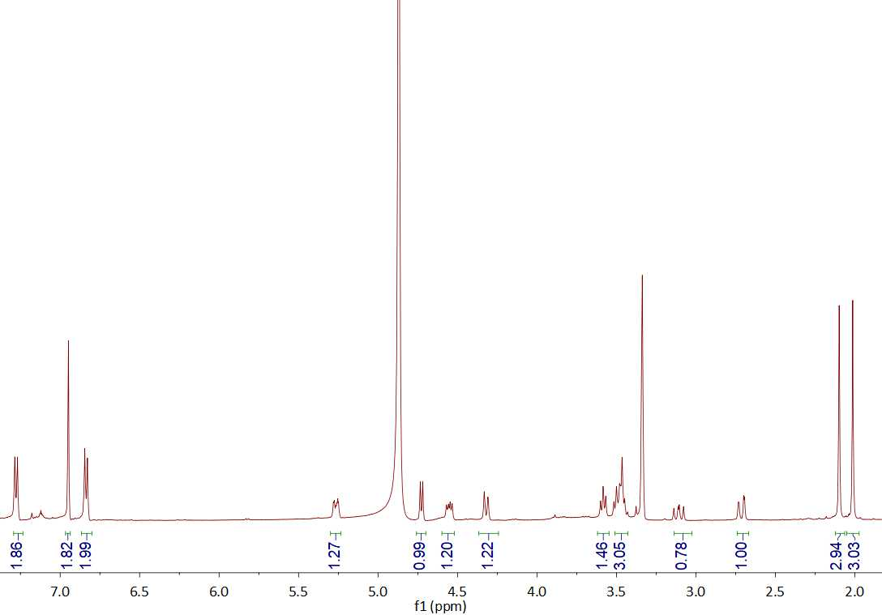

Figure S2. ¹H NMR (500 MHz) spectrum of compound 1 in methanol-d₄

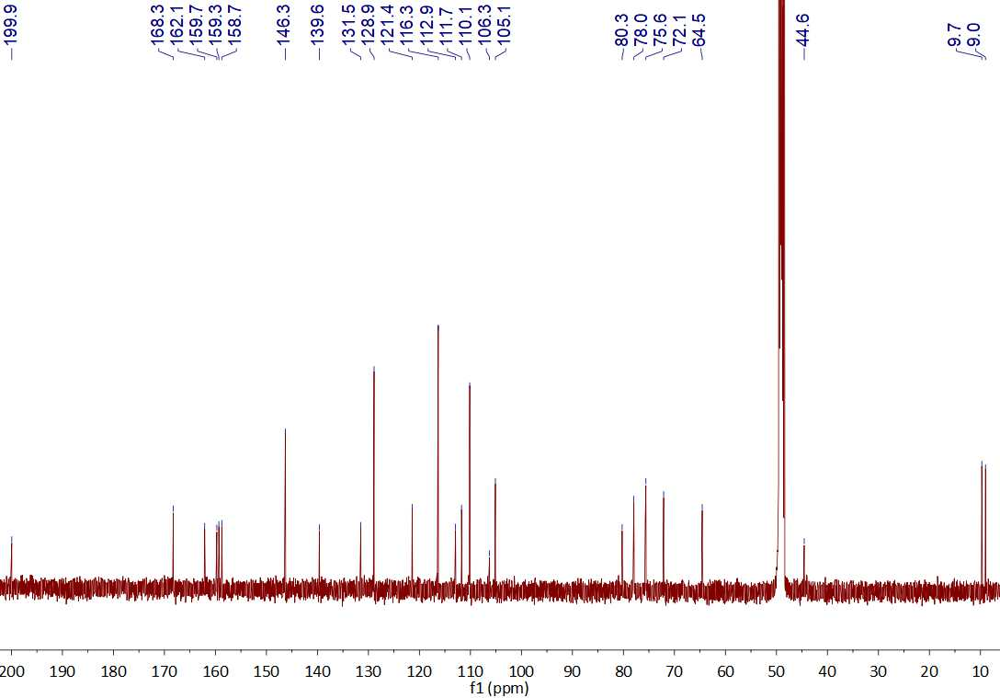

Figure S3. ¹³C NMR (125 MHz) spectrum of compound 1 in methanol-d₄

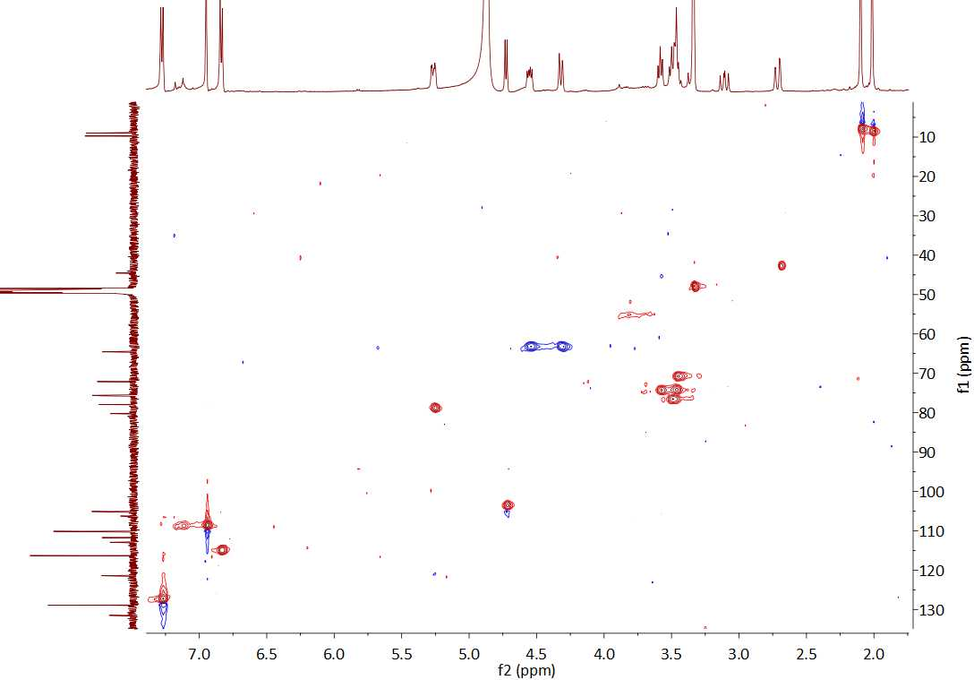
Figure S4. HSQC spectrum of compound 1 in methanol-d₄

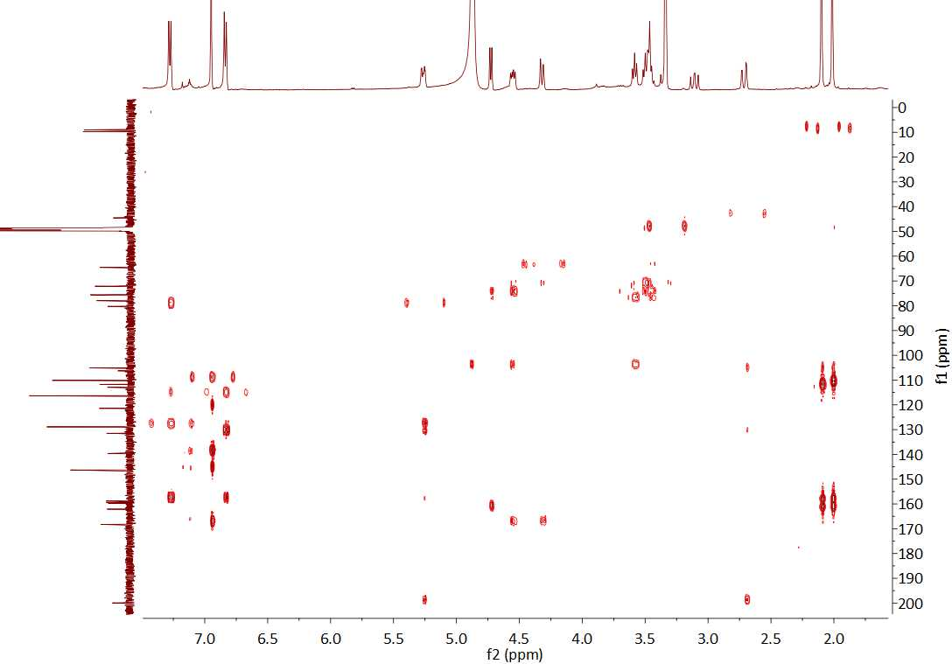
Figure S5. HMBC spectrum of compound 1 in methanol-d₄

Figure S6. HRESI(–)MS of compound 1

