Supplementary Materials

**Development of [(2E,6E)-2,6-bis(4-(dimethylamino)benzylidene)cyclohexanone] as fluorescence-on probe for Hg2+ ion detection: Computational aided Experimental Studies**

**Table of contents**

**Fig. S1** FTIR spectrum of the probe

**Fig. S2** 1H-NMR spectrum of the probe

**Table S1** DFT detail of probe and its Hg2+ complexes

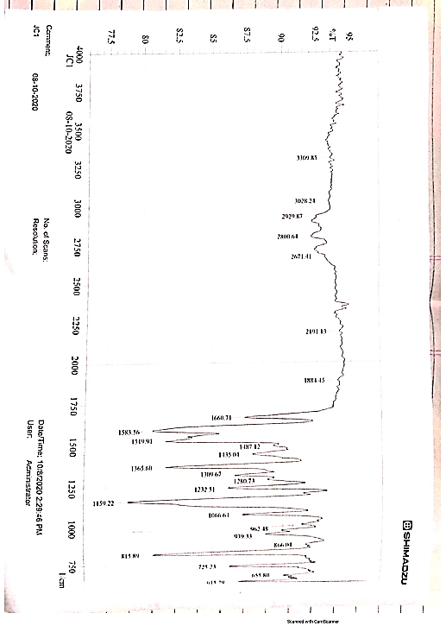

**Fig. S1** FTIR spectrum of the probe

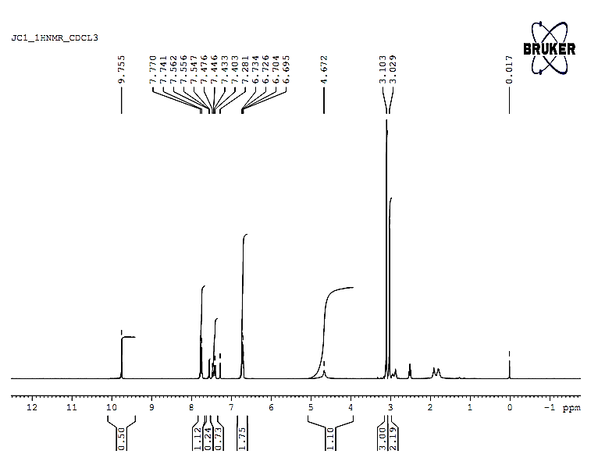

**Fig. S2** 1H-NMR spectrum of the probe

**Table S1** DFT detail of probe and probe-Hg2+ complexes

|  |  |  |  |  |  |  |  |  |
| --- | --- | --- | --- | --- | --- | --- | --- | --- |
| |  | | --- | | **Gas Phase** | |  | | Ene au | Ebindng au | Ebindng Kcal/mol |  |  |  |
| Hg(II) | -41.7935 |  |  |  |  |  |
| Probe | -1116.16 |  |  |  |  |  |
|  |  |  |  |  |  |  |
| Complex-1 | -2274.59 | -0.48508 | -305.597 |  |  |  |
| Complex-2 | -2274.23 | -0.11874 | -74.8037 |  |  |  |
|  |  |  |  |  |  |  |
| Species | H au | delH au | delH Kcal/ G au | delG au | delG Kcal/mol |  |
| Hg(II) | -41.7911 |  | -41.811 |  |  |  |
| Probe | -1115.66 |  | -1115.75 |  |  |  |
|  |  |  |  |  |  |  |
| Complex-1 | -2273.59 | -0.48053 | -302.733 | -2273.75 | -281.898 |  |
|  |  |  |  |  |  |  |
| Solvent Phase | Ene au | Ebinding au | Ebinding Kcal/mol |  |  |  |
| Hg(II) | -42.2161 |  |  |  |  |  |
| Probe | -1116.17 |  |  |  |  |  |
|  |  |  |  |  |  |  |
| Complex-1 | -2274.9 | -0.33846 | -213.232 |  |  |  |
|  |  |  |  |  |  |  |
| Species | H au | delH au | del HKcal/mol | G au | delG au | delG Kcal/mol |
| Hg(II) | -41.7138 |  |  | -41.5336 |  |  |
| Probe | -111.63 |  |  | -1115.76 |  |  |
|  |  |  |  |  |  |  |
| complex-1 | -2273.28 | -0.31333 | -197.398 | -2273.32 | -0.26165 | -164.841 |
|  |  |  |  |  |  |  |