**Supplementary material**

Table of contents

|  |  |
| --- | --- |
| Subject | Page |
| General informations (instruments & materials) | S2 |

*Antimicrobial activity assay* S3

*In vitro anticancer screening* S4

*In vitro EGFR kinase assay* S5

*Molecular docking study* S5

1H-NMR,13C-NMR, and mass spectral data of the new compounds. S6–S27

**General informations** (instruments & materials)

All melting points are uncorrected and were taken in open capillary tubes using an Electrothermal IA9100 digital melting point apparatus. Elemental microanalyses were carried out at the Micro Analytical Unit at Cairo University. Mass spectra (MS) were performed at 70 e.v by GCMS-QP1000 EX spectrometer using the Electron Ionization Technique (EI) at Al-Azhar University, Cairo, Egypt. Infrared spectra were recorded in National Research Centre, by using the KBr disc technique on a Jasco FT/IR-360 plus Infrared spectrometer at the range (400- 4000 cm-1), made in Japan. 1H NMR and 13C NMR spectra were recorded on a Bruker High-Performance Digital FT-NMR Spectrometer Advance III (400/100 MHz) and in the presence of TMS as the internal standard. Ain Shams University, Cairo, Egypt. Follow up of the reactions and checking the purity of the compounds were made by TLC on silica gel-precoated aluminum sheets (Type 60, F 254, Merck, Darmstadt, Germany) using chloroform/methanol (3:1, v/v) and the spots were detected by exposure to UV lamp at δ 254 nanometer for few seconds and by iodine vapor. The chemical names given for the prepared compounds are according to the IUPAC system.

***Antimicrobial activity assay***

The biological potential of the newly prepared target structures was inspected toward the examined organisms and expressed as the diameter of the inhibition zones due to the agar plate diffusion technique. Also, the pathological strains (100µl) were outgrowing in 10 mL of fresh media till they reached a count of nearly 108 cells/ml and 105 cells/mL for bacteria and fungi, respectively poured into 10cm diameter Petri-dishes. Also, (100µl) of each sample (200 µg) hold on a filter paper disc (1.0 cm diameter). Prior to incubation, all prepared discs were deposited onto the surface of inoculated agar plates and kept at 4°C for two hours. The latter condition favors diffusion over microbial growth to clearly detect the inhibition zone. Whoever, incubation of plates was done for 24 h at 37 ˚C for bacteria, yeast and for 48 h at 30˚C for fungi activity. The plates were done in triplicate and the average inhibition zone diameters were recorded in mm and used as a criterion for the microbial activity. Amoxicillin trihydrate was inspected as the antibacterial reference drug and clotrimazole was utilized as a standard antifungal drug. DMSO (solvent controls) was used for dissolving the examined compounds and illustrated no inhibition zone, indicating that it has no effect on the growth of the tested biological strains.

**Minimum Inhibitory Concentration (MIC) Measurement**

The Minimum Inhibitory Concentration activity of the compounds was then evaluated using the broth dilution method. Whereas, two-fold serial dilution at the concentrations (0.25, 0.5, 1, 2, 4, 8, 16, 32, 64, 128 µg/ml) was used to investigate the Minimum Inhibitory Concentration (MIC) values (expressed in μg/mL) for the target compounds and the reference drugs. The tubes were then inoculated with the test organisms, grown in their suitable broth for 24 h at 37 ˚C for bacteria, yeast and for 48 h at 30˚C for fungi activity (1×108 CFU/mL for bacteria and 1 x106 CFU/mL of yeast and fungi), each 2 mL received 0.1 mL of the above inoculums Positive controls were prepared separately for either bacteria, yeast or fungi with respective organisms in the same culture media without the target compounds. After incubation, the tube with the lowest concentration of extract that shows no growth was taken as the MIC value for the respective organism.

***In vitro anticancer screening***

The cell lines were purchased from the American Type Culture collection as follows: breast carcinoma cell line (MCF-7) and the liver carcinoma cell line (HepG2). Cytotoxic activity screening was performed using MTT assay at Regional Center for Mycology and Biotechnology, Al- Azhar University. Exponentially, cells were placed in 104 cells/ well for 24 h, and then add fresh medium containing different concentrations of the tested sample. Serial two-fold dilutions of the tested sample were added using a multichannel pipette. Moreover, all cells were cultivated at 37 °C, 5% CO2 and 95% humidity. Also, incubation of control cells occurred at 37 °C. However, after incubation for 24 h different concentrations of the sample (50, 25, 12.5, 6.25, 3.125, 1.56, and 0 μg L−1) were added and continued the incubation for 48 h, then, add the crystal violet solution 1% to each well for 0.5 h to examine viable cells. Rinse the wells using water until no stain. After that, add 30% glacial acetic acid to all wells with shaking plates on a Microplate reader (TECAN, Inc.) to measure the absorbance, using a test wavelength of 490 nm. Besides, compare the treated samples with the control cell. The cytotoxicity was estimated by IC50 (the concentration that inhibits 50% of the growth of cancer cells) in μM for the tested compounds and the reference drugs doxorubicin and cisplatin.

***In vitro EGFR kinase assay***

EGFR kinase inhibitory assay was performed for the target compounds **2b**, **4a**, **6a**, **7b**, **7c,** and **9a** with erlotinib as a reference inhibitor, by using the EGFR kinase assay kit (Cat. # 40321). The assay kit is designed to measure EGFR Kinase activity for screening applications using Kinase-Glo® MAX as a detection reagent using Kinase-Glo® MAX as a detection reagent. Thaw 5x Kinase Buffer 1: ATP and PTK substrate Poly (Glu: Tyr 4:1) (10 mg/ml) kinase was provided. Then the master mixture was prepared: N wells x (6 μl 5x Kinase Buffer 1 + 1 µl ATP (500 µM) + 1 µl PTK substrate Poly (Glu: Tyr 4:1) (10 mg/ml)+ 17 μl water) and 25 μl of the mixture was added to every well. The tested compounds were dissolved in DMSO, then 5 μl of their solution was added to each well labeled as “Test Inhibitor”. For the well-labeled as “Positive Control", 5 μl of the same solution of the reference drug erlotinib and “Blank”, 5 μl of the same solution without inhibitor (Inhibitor buffer). (3 ml of 1x Kinase Buffer 1) was prepared by mixing 600 µl of 5x Kinase Buffer 1 with 2400 µl water. To the wells designated as "Blank", add 20 μl of 1x Kinase Buffer 1. The reaction was initiated by adding 20 µl of diluted EGFR enzyme to the wells designated “Positive Control” and "Test Inhibitor Control". Incubate at 30°C for 40 minutes. Thaw Kinase-G lo Max reagent. After the 40 minute reaction, 50 µl of Kinase-Glo Max reagent was added to each well. The plate was covered with aluminum foil and incubated at room temperature for 15 minutes. Then the luminescence was measured using the microplate reader (Infinite M200 microplate reader, Tecan, Männedorf, Switzerland). All assays were performed in triplicate. The relative inhibition (%) of inhibitors was then calculated compared to the control with no inhibitor. Then the IC50 values and their standard deviation (SD) for the tested compounds and the reference drug were determined in (μM).

***Molecular docking study***

The molecular modeling studies were carried out using Molecular Operating Environment (MOE, 2019.0102) software. All minimizations were performed with MOE until an RMSD gradient of 0.1 kcal∙mol−1Å−1 with MMFF94x force field and the partial charges were automatically calculated. The X-ray crystallographic structure of Epidermal Growth Factor Receptor (**EGFR**)kinase domain complexed with a quinazoline inhibitor erlotinib(**ERL**) (**PDB ID: 1M17**) was downloaded from the protein data bank(**https://www.rcsb.org/structure/1M17**). For each co-crystallized enzyme; water molecules and ligands which are not involved in the binding were removed, the protein was prepared for the docking study using *Protonate 3D* protocol in MOE with default options. The co-crystalized ligand (**ERL**) was used to define the binding site for docking. Triangle Matcher placement method and London dG scoring function were used for docking.

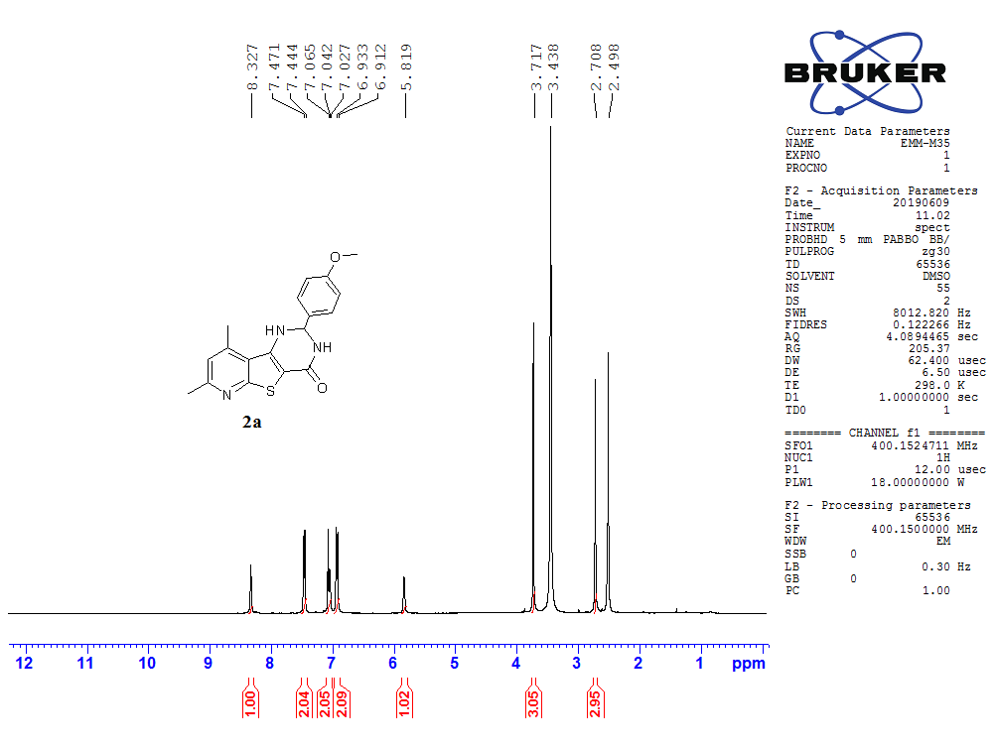

**Fig.1** 1H NMR (400 MHz) in DMSO-*d*6 of compound **2a**

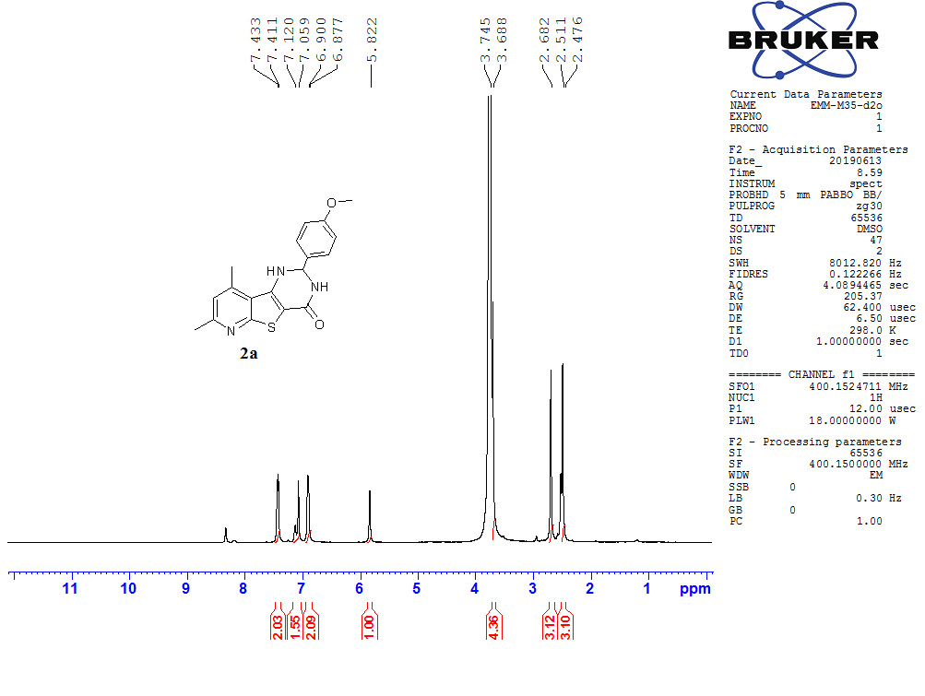

**Fig.2** 1H NMR (400 MHz) in DMSO-*d*6 + D2O of compound **2a**

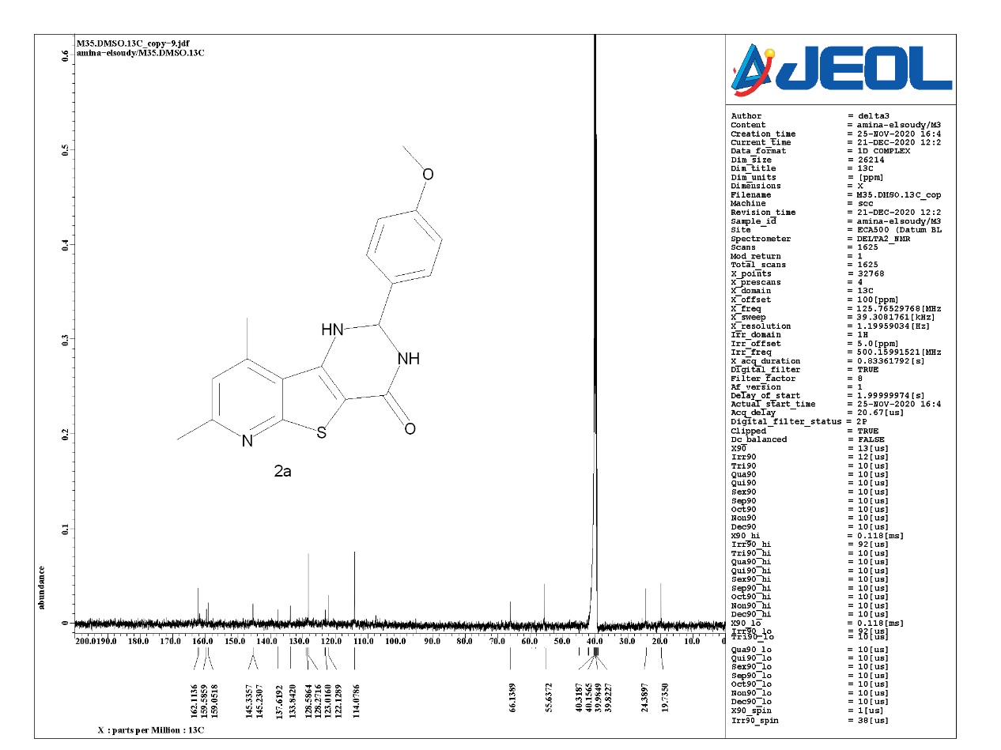

**Fig. 3** 13C NMR (100 MHz) in DMSO-*d*6 of compound **2a**

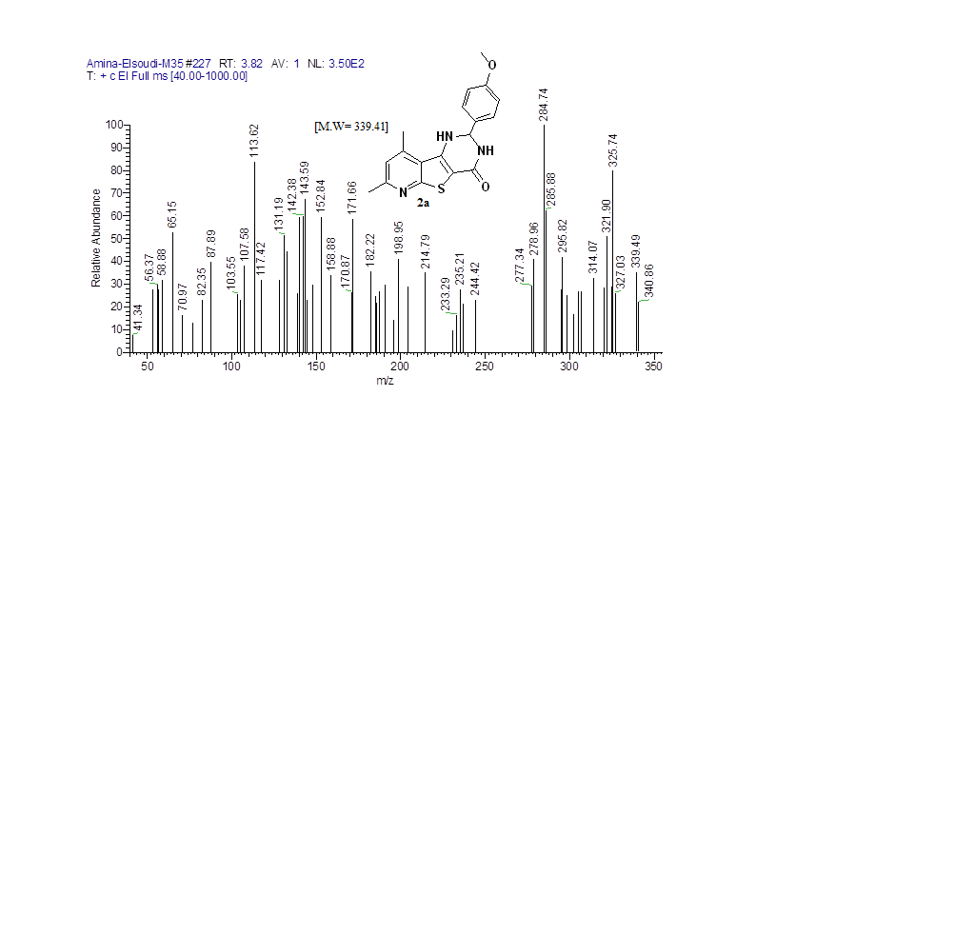

**Fig. 4** Mass spectrum of compound **2a**

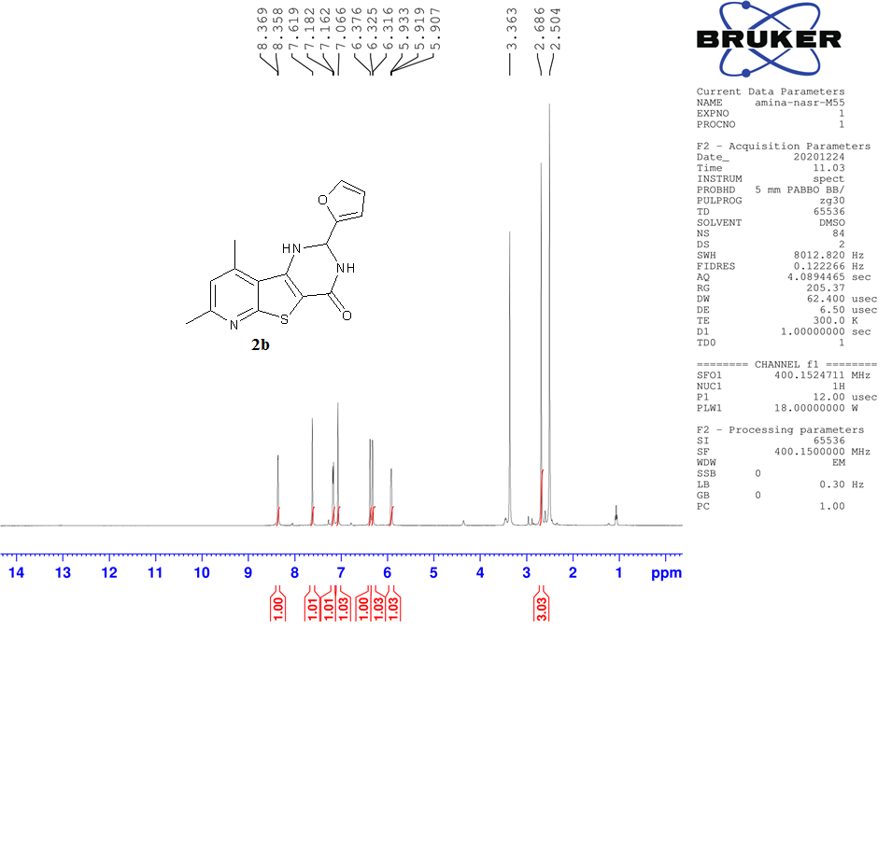

**Fig. 5** 1H NMR (400 MHz) in DMSO-*d*6 of compound **2b**

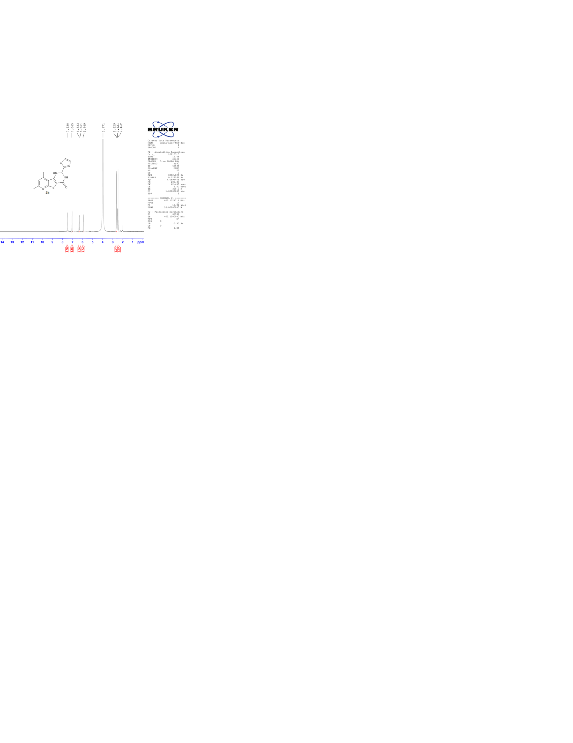

**Fig. 6** 1H NMR (400 MHz) in DMSO-*d*6 + D2O of compound **2b**

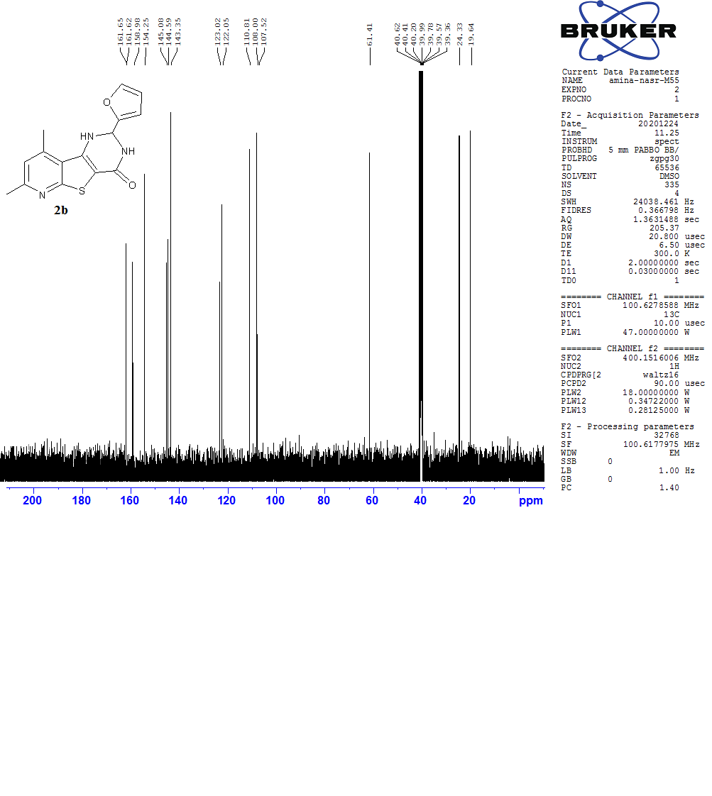

**Fig. 7** 13C NMR (100 MHz) in DMSO-*d*6 of compound **2b**

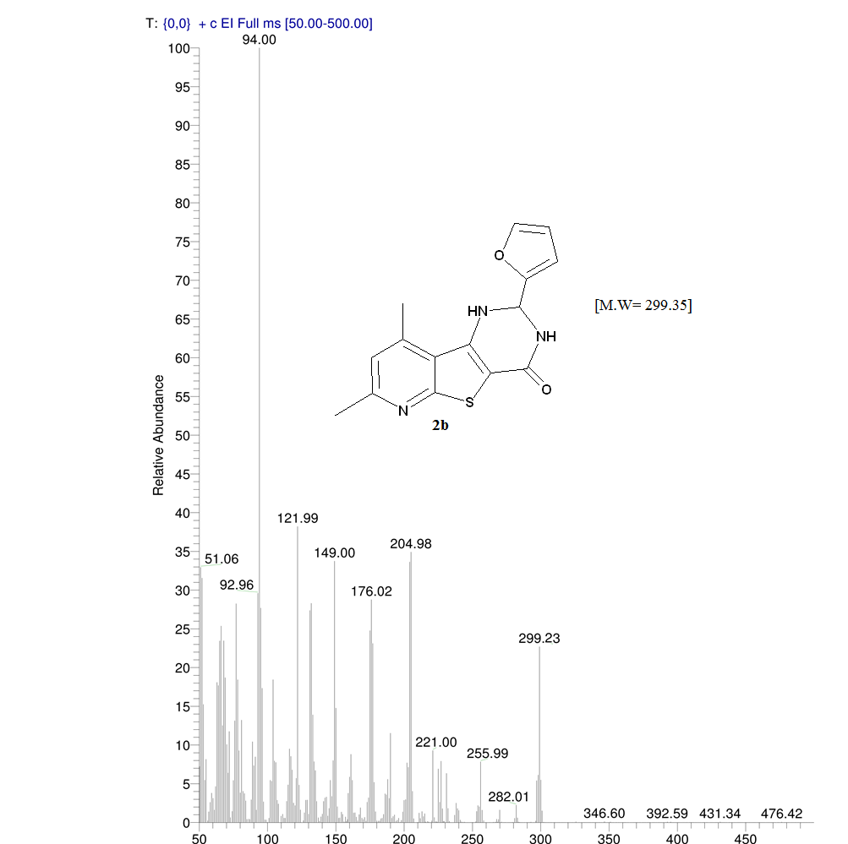



**Fig. 8** Mass spectrum of compound **2b**

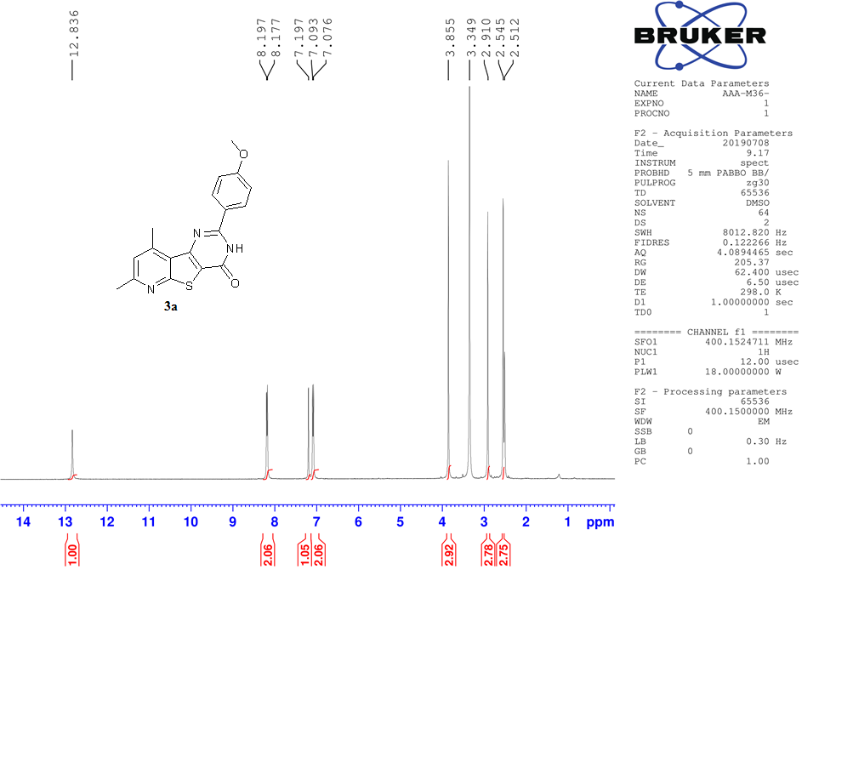

**Fig. 9** 1H NMR (400 MHz) in DMSO-*d*6 of compound **3a**

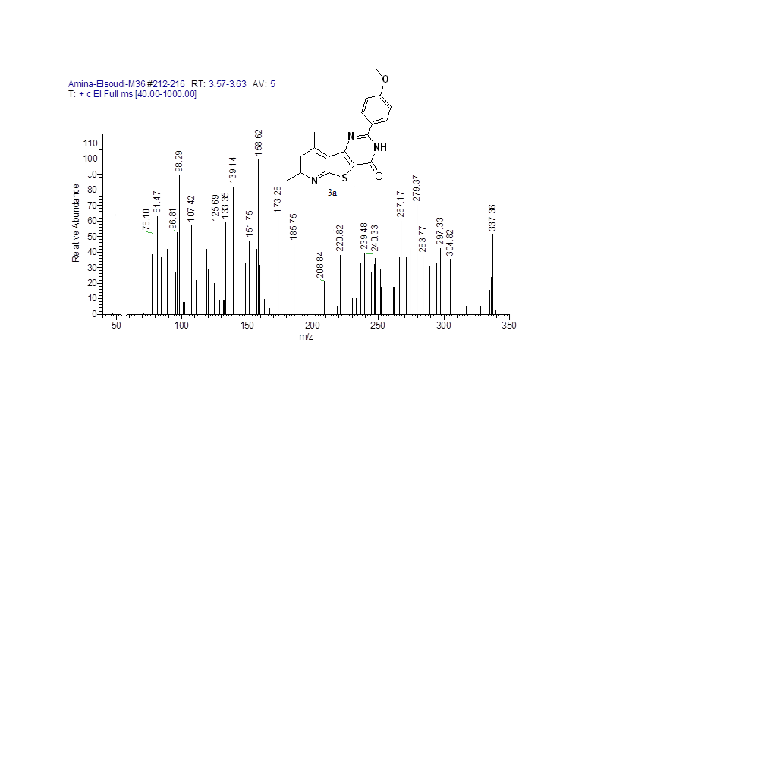

**Fig. 10** Mass spectrum of compound **3a**

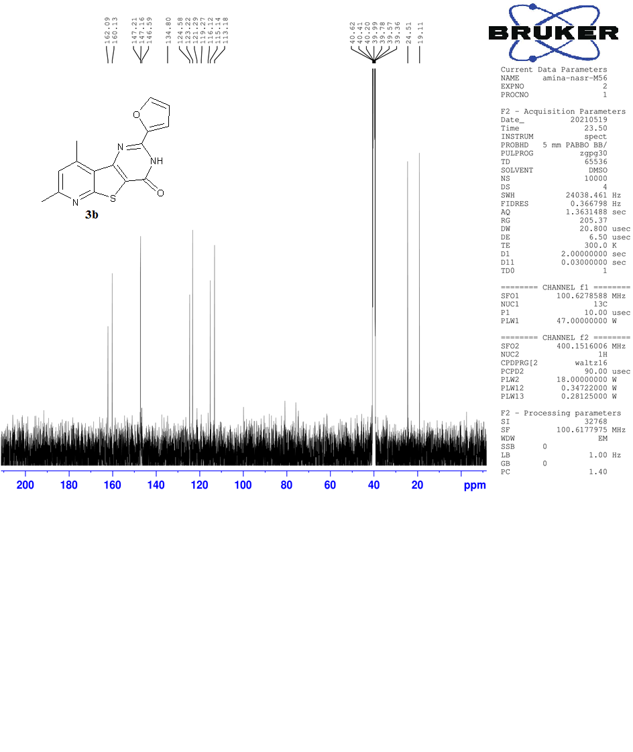

**Fig. 11** 13C NMR (100 MHz) in DMSO-*d*6 of compound **3b**

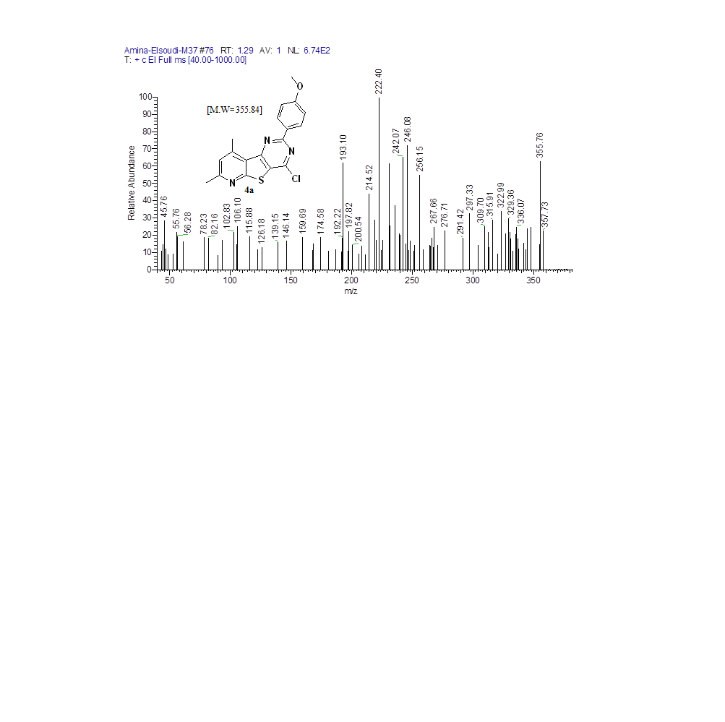

**Fig. 12** Mass spectrum of compound **4a**

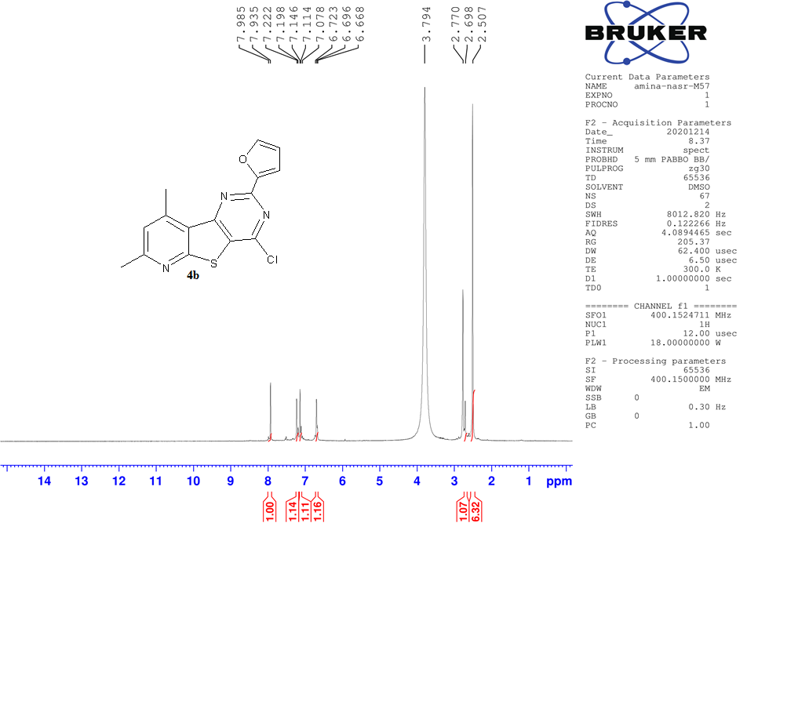

**Fig. 13** 1H NMR (400 MHz) in DMSO-*d*6 of compound **4b**

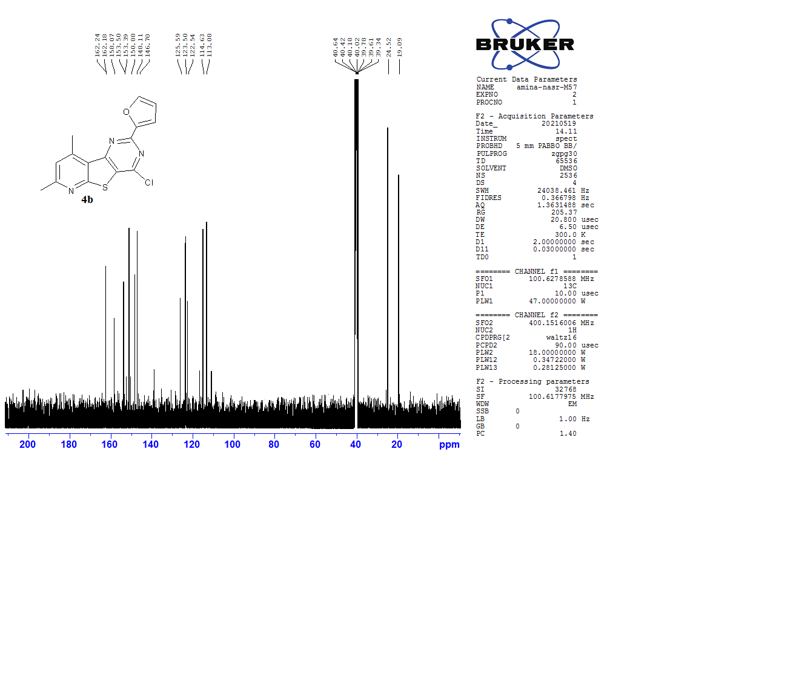

**Fig. 14** 13C NMR (100 MHz) in DMSO-*d*6 of compound **4b**

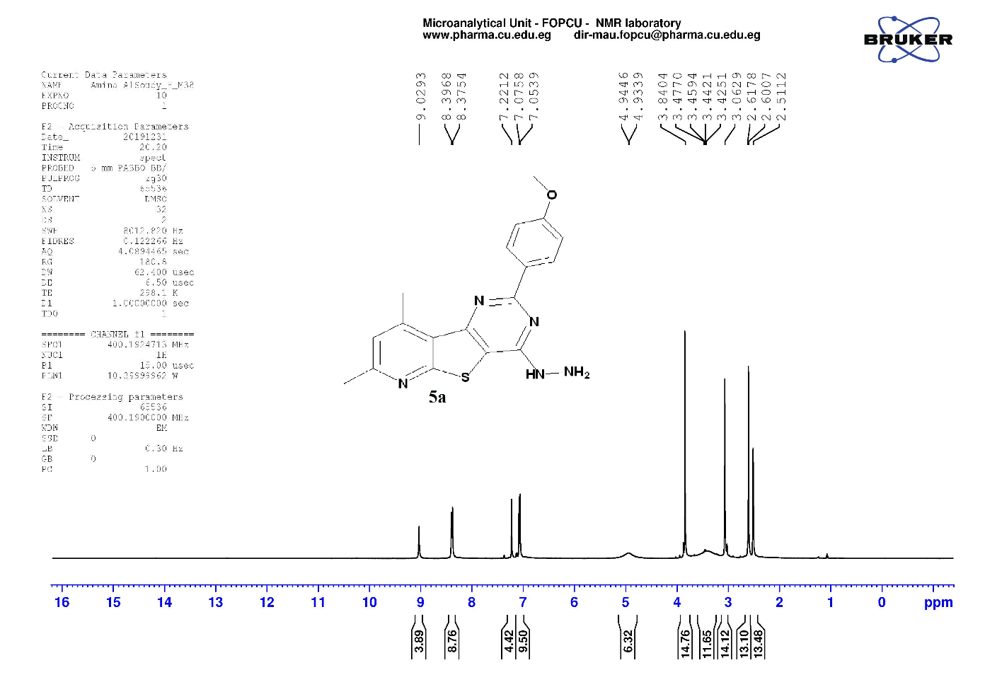

**Fig. 15** 1H NMR (400 MHz) in DMSO-*d*6 of compound **5a**

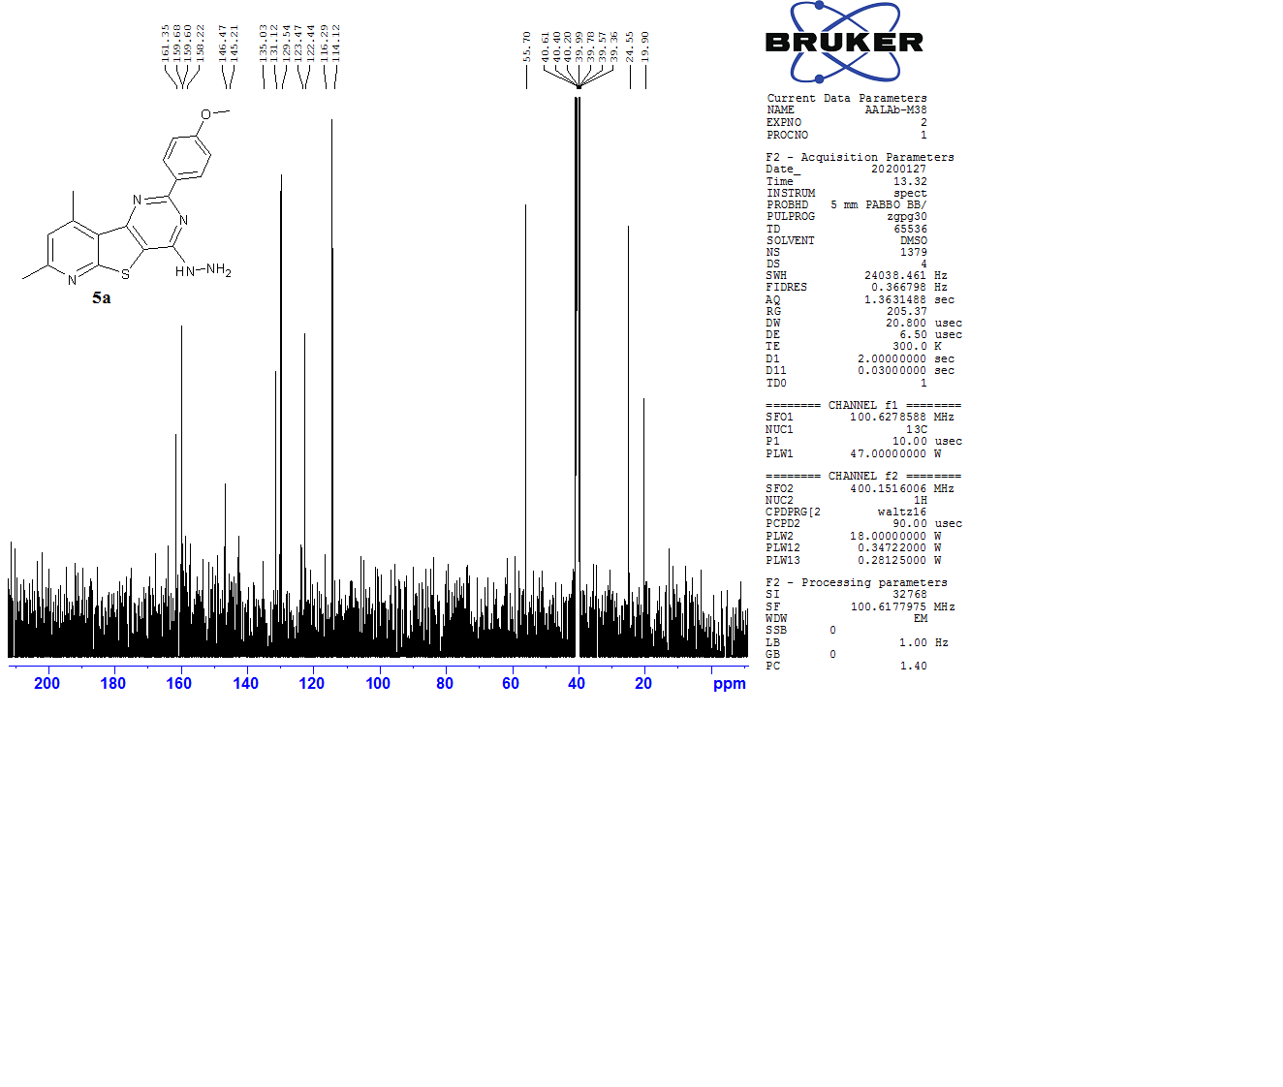

**Fig. 16** 13C NMR (100 MHz) in DMSO-*d*6 of compound **5a**

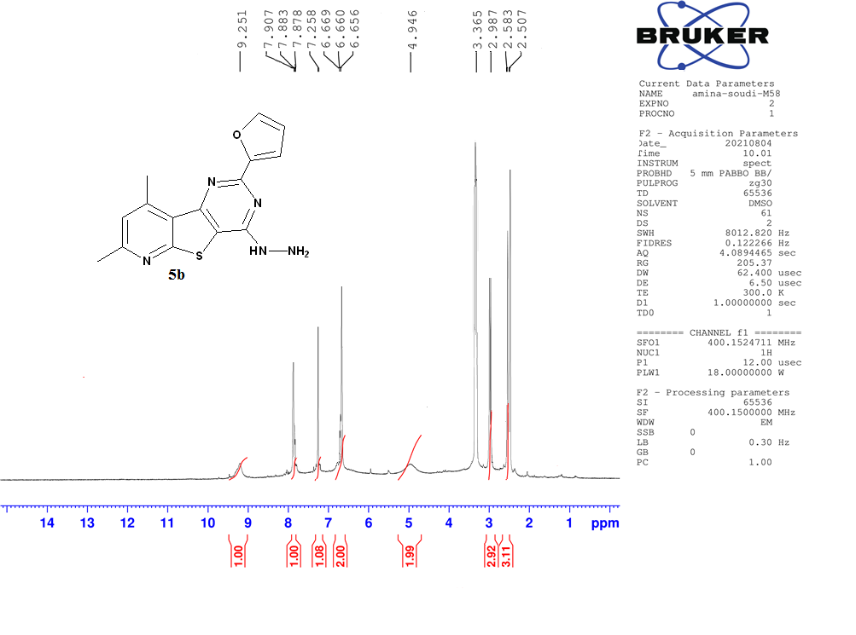

**Fig. 17** 1H NMR (400 MHz) in DMSO-*d*6 of compound **5b**

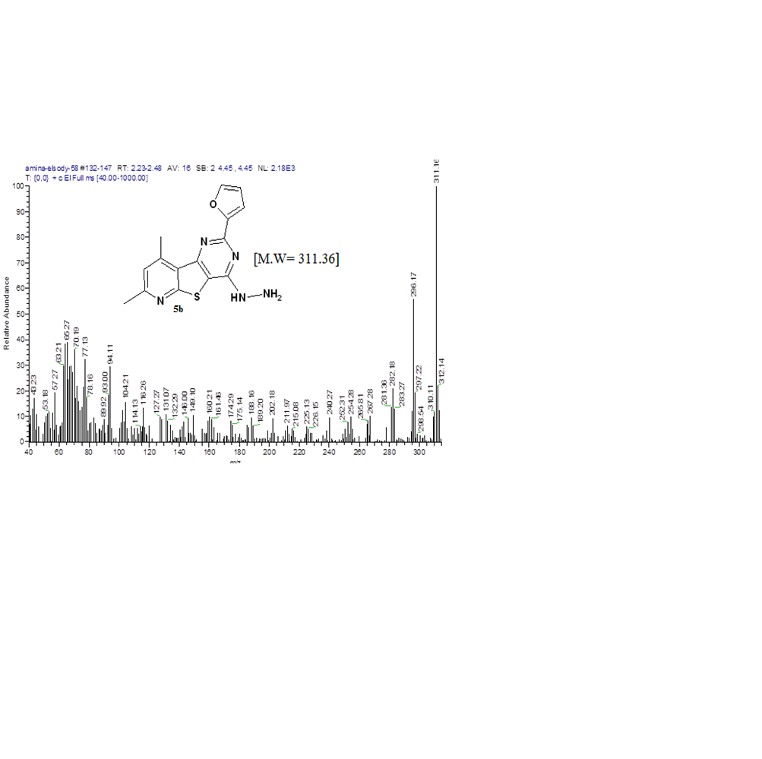



**Fig. 18** Mass spectrum of compound **5b**

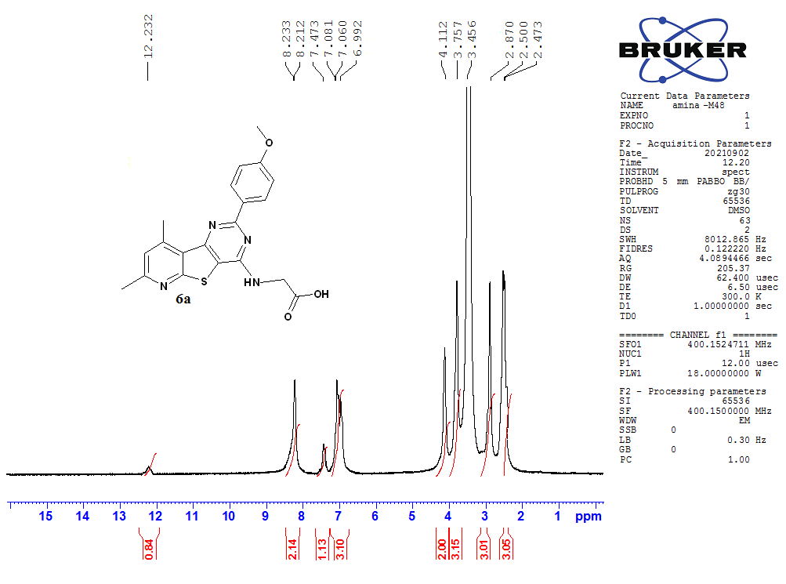

**Fig. 19** 1H NMR (400 MHz) in DMSO-*d*6 of compound **6a**

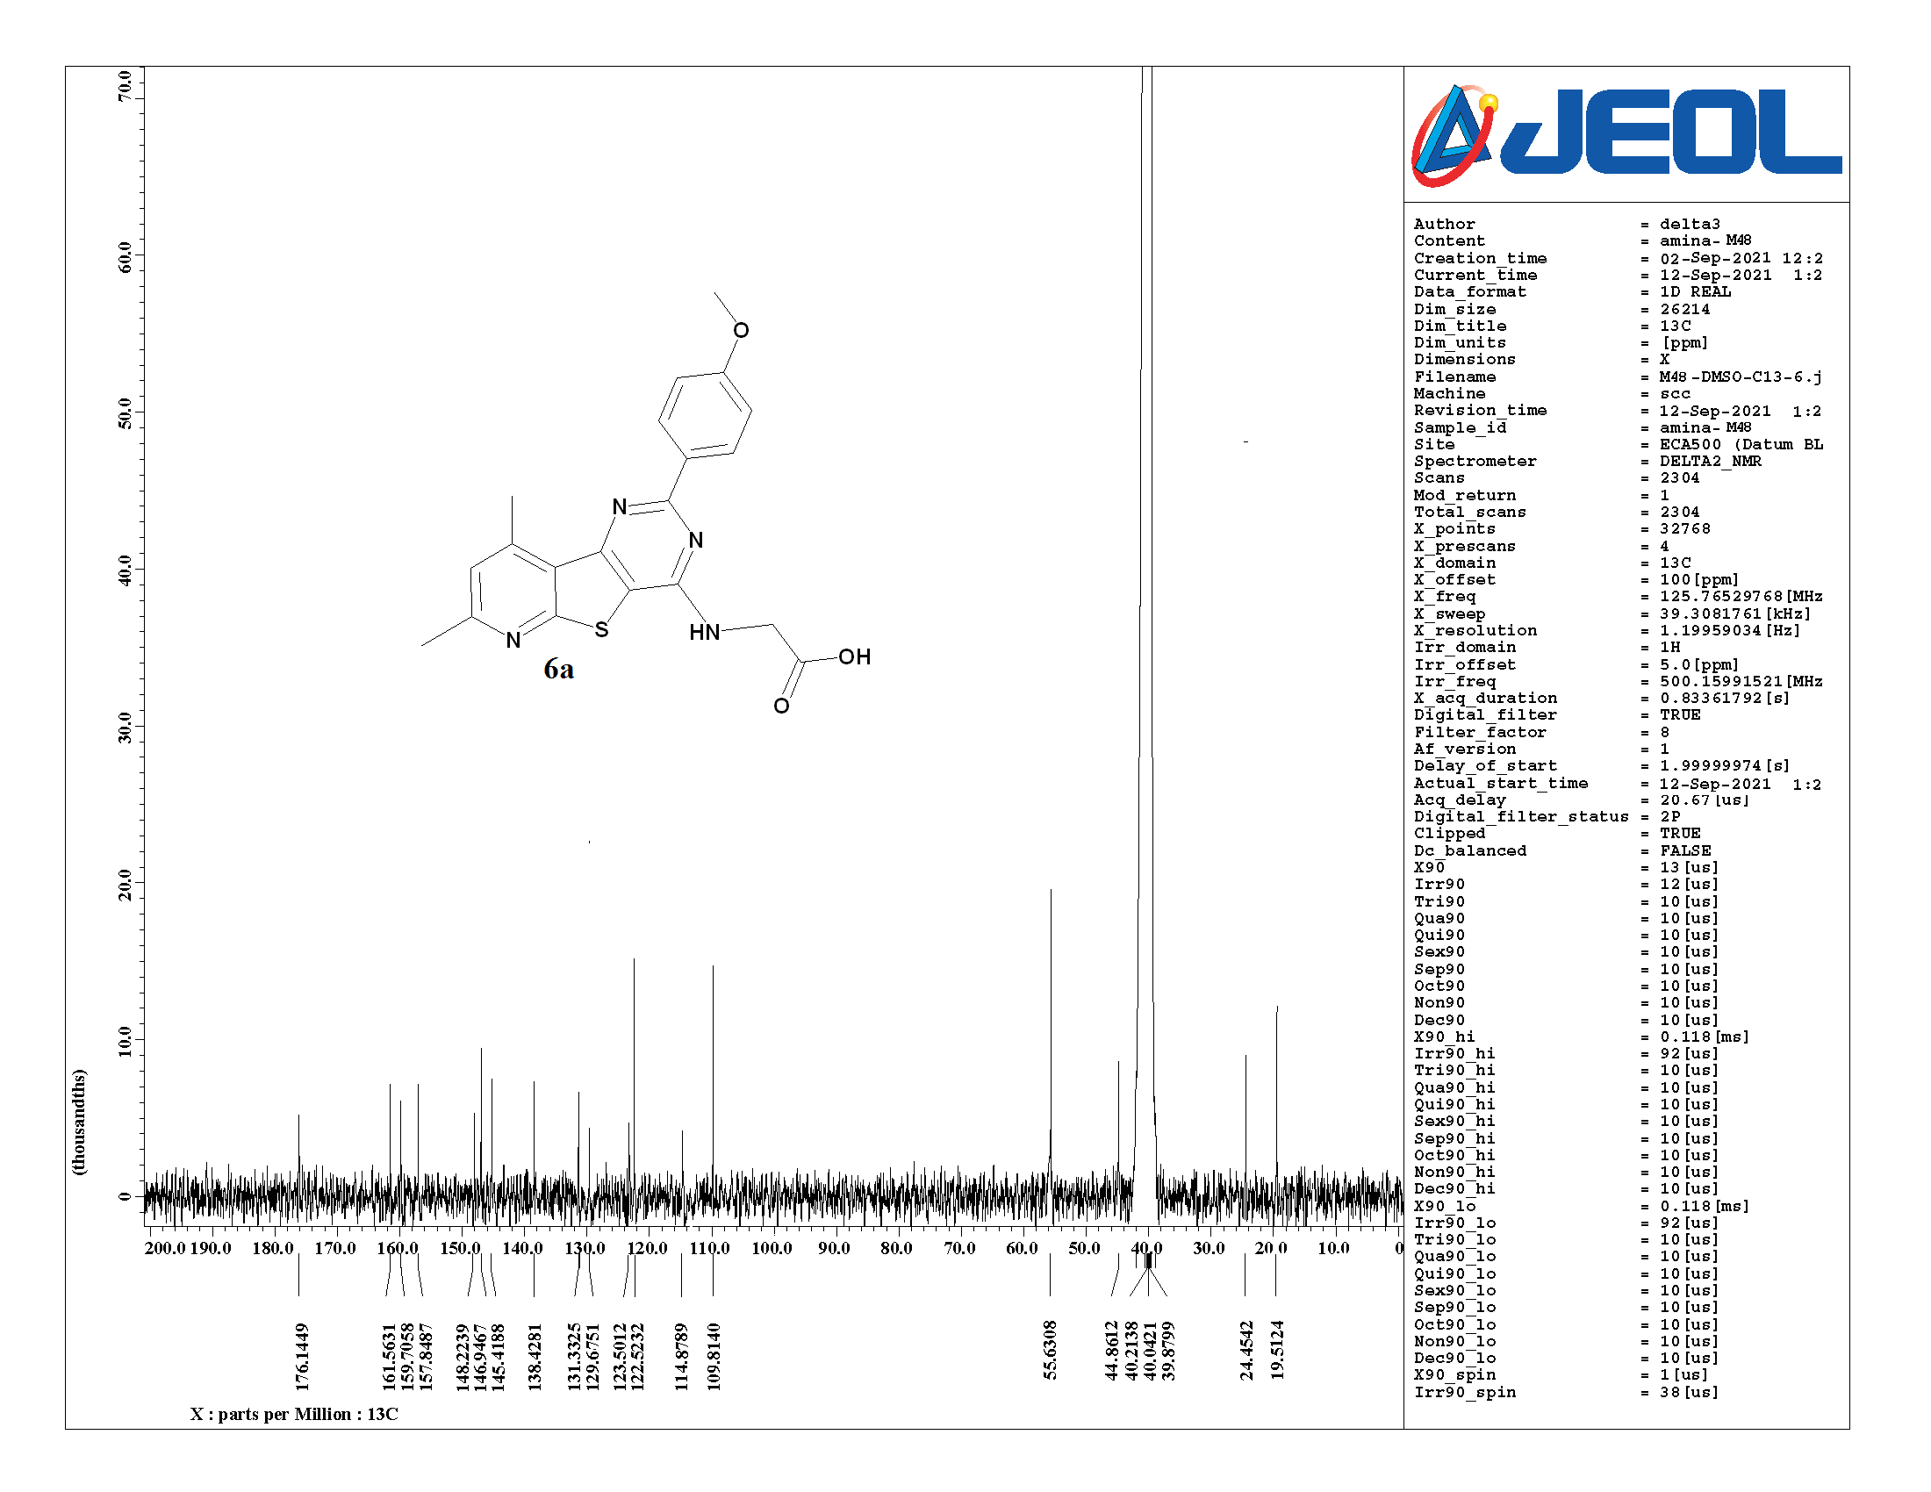

**Fig. 20** 13C NMR (100 MHz) in DMSO-*d*6 of compound **6a**

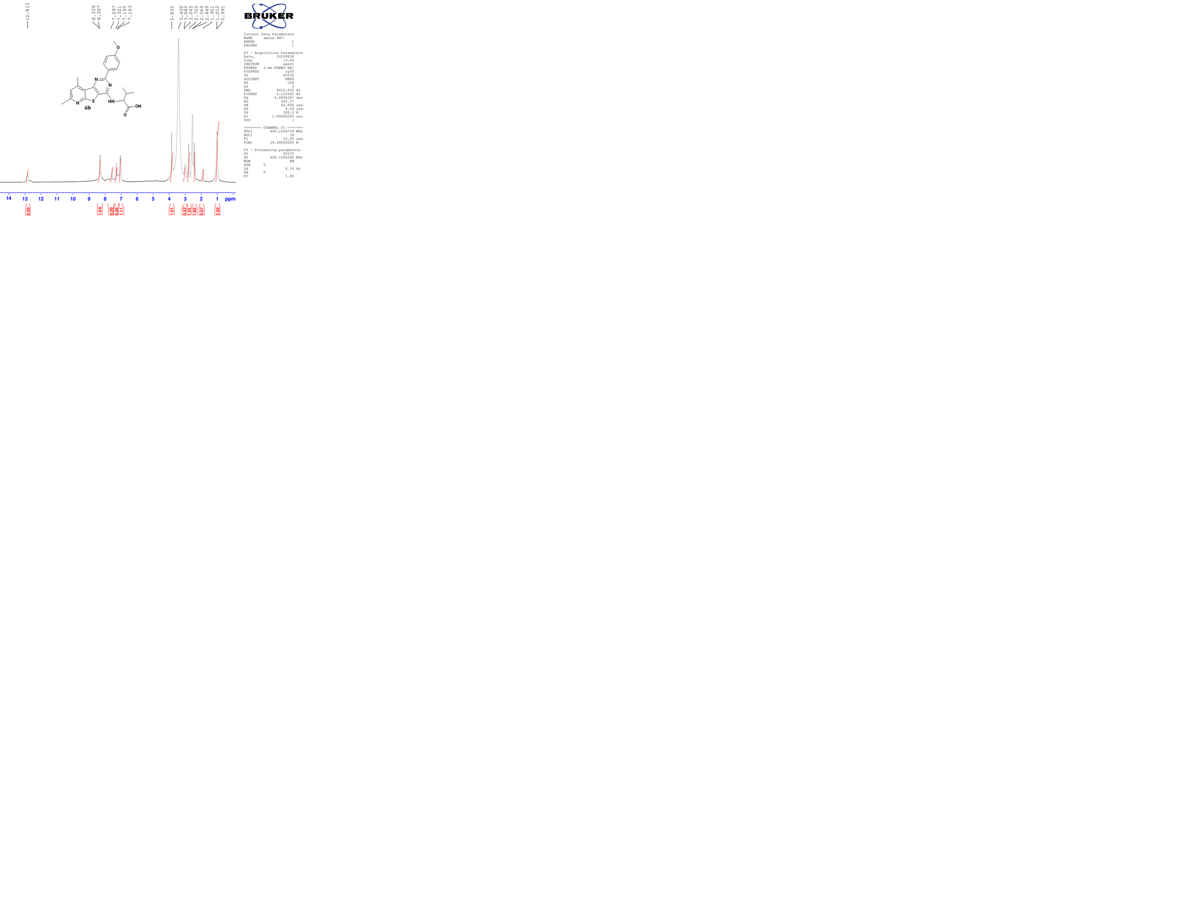

**Fig. 21** 1H NMR (400 MHz) in DMSO-*d*6 of compound **6b**

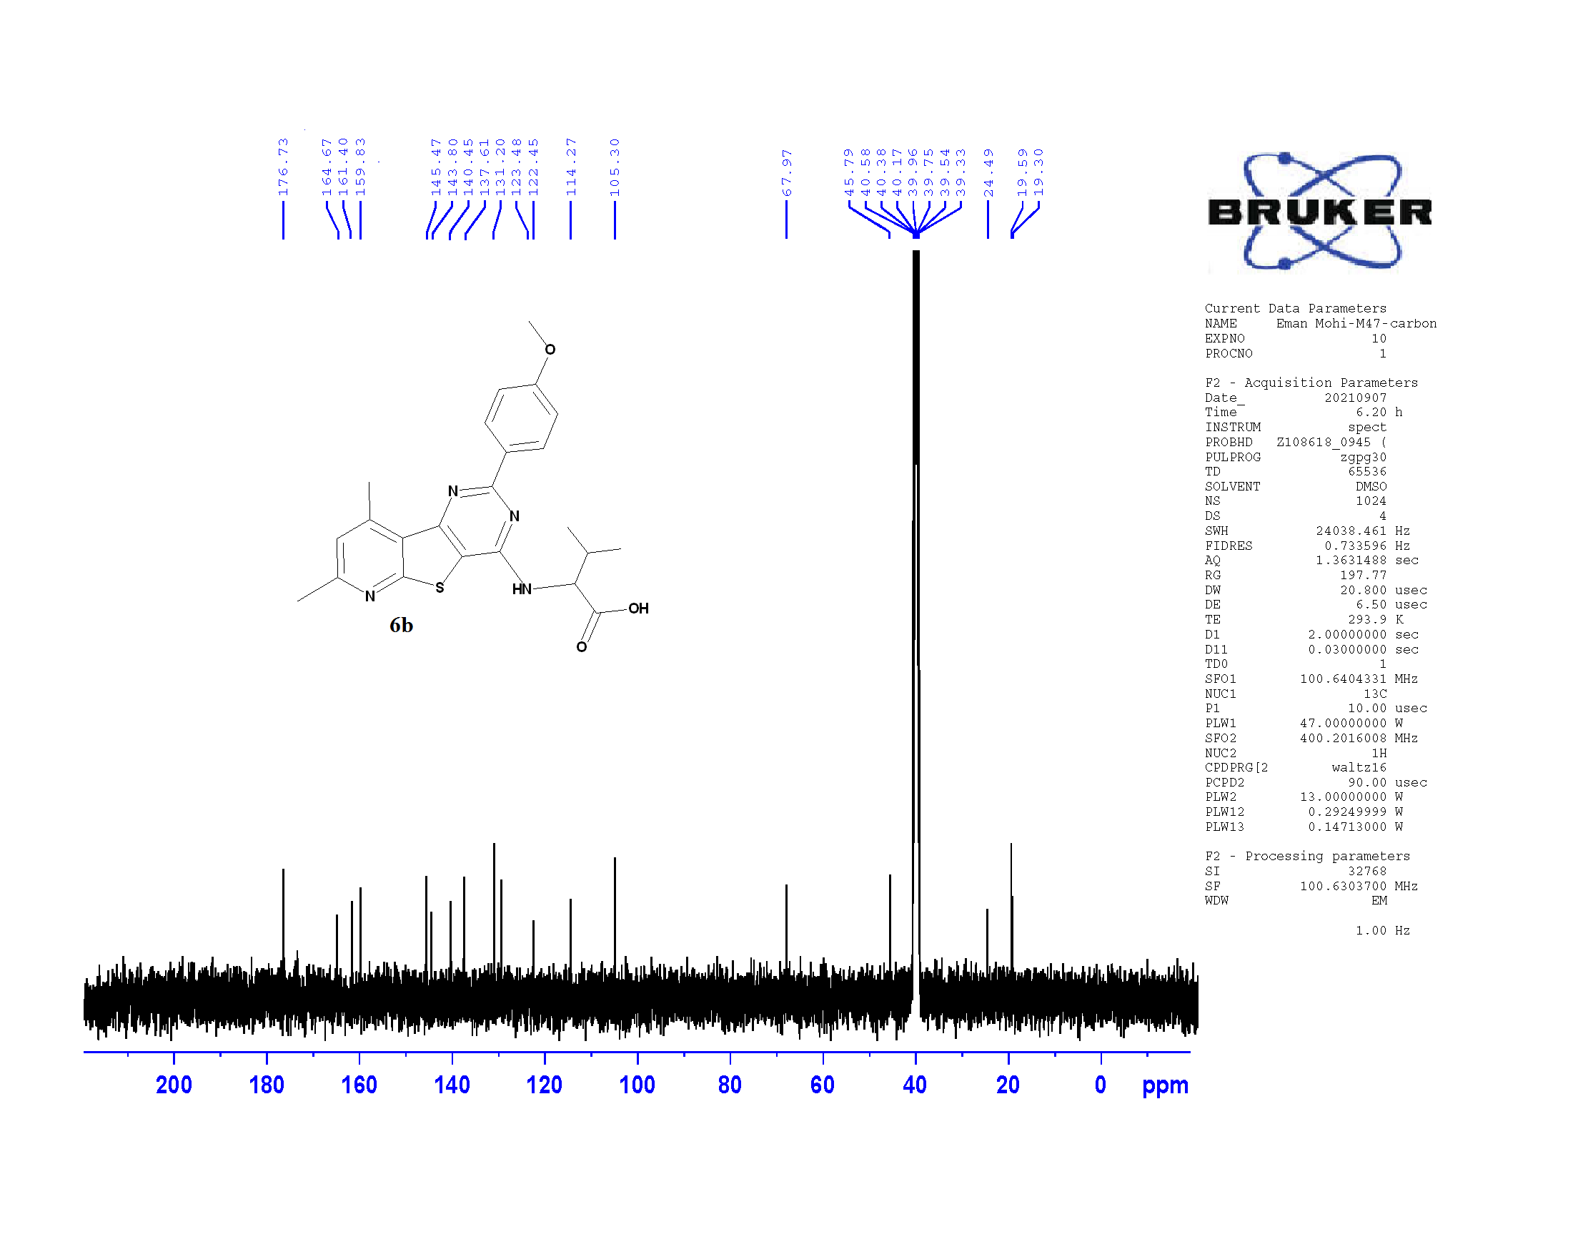

**Fig. 22** 13C NMR (100 MHz) in DMSO-*d*6 of compound **6b**

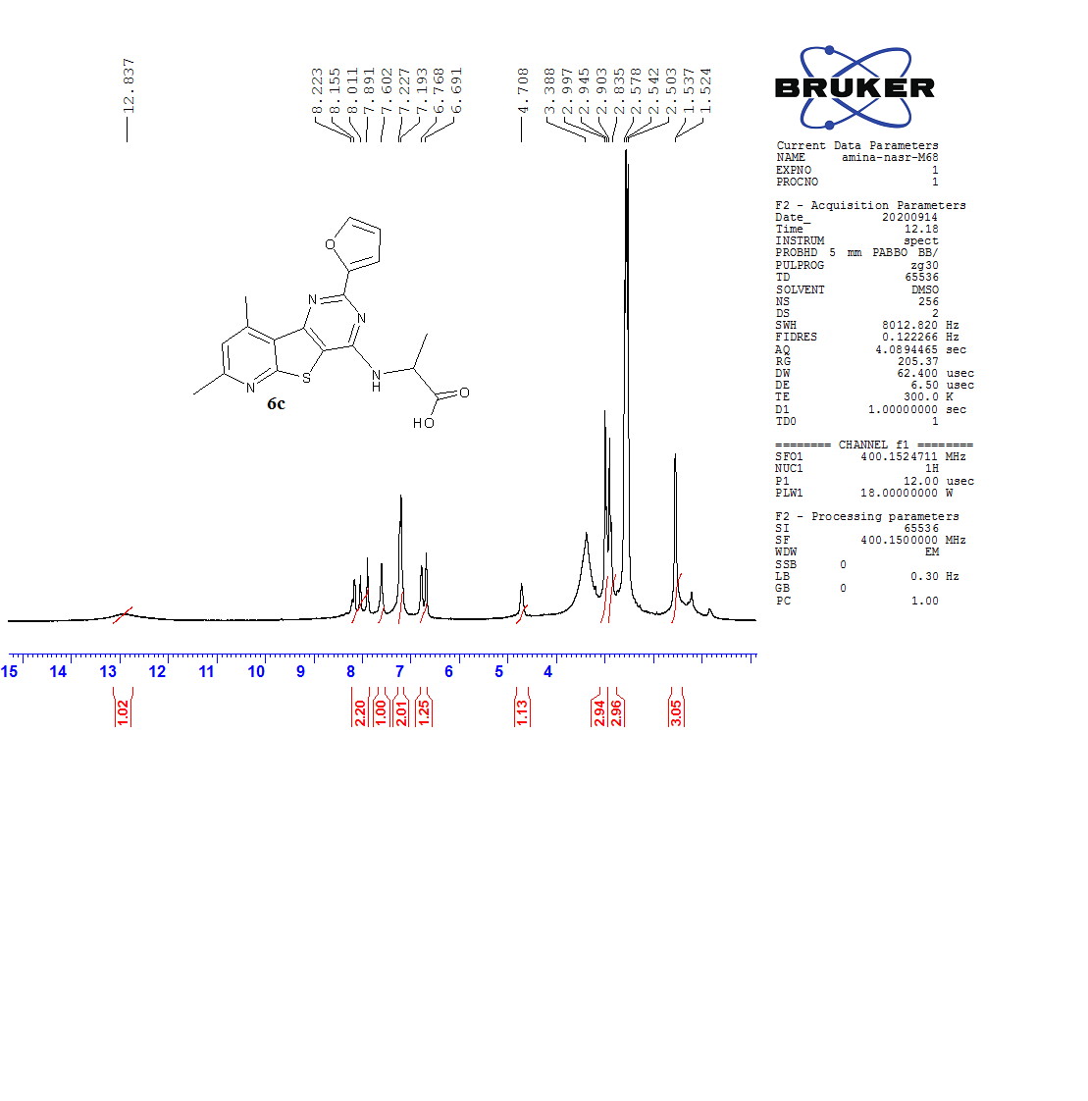

**Fig. 23** 1H NMR (400 MHz) in DMSO-*d*6 of compound **6c**

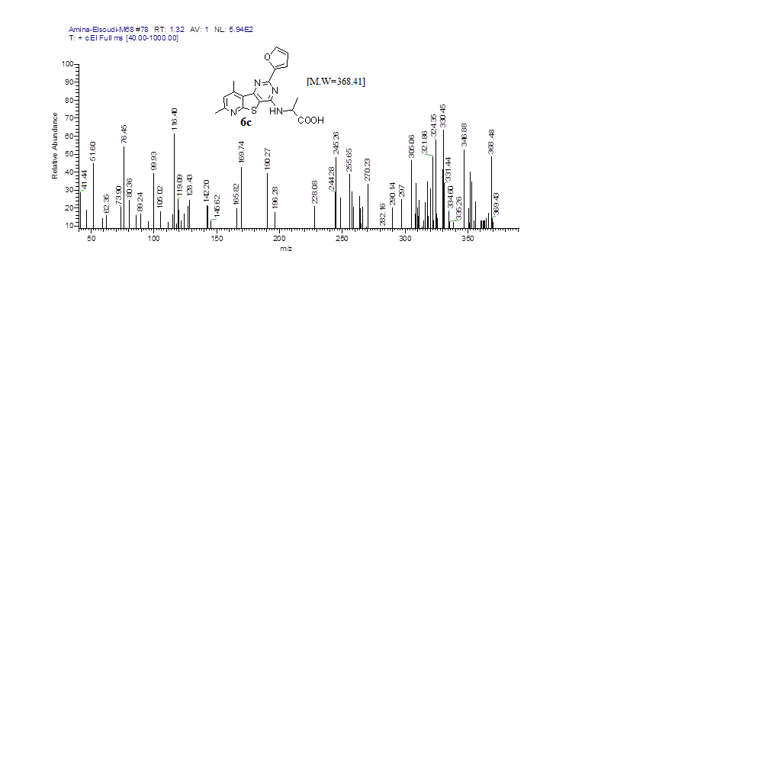

**Fig. 24** Mass spectrum of compound **6c**

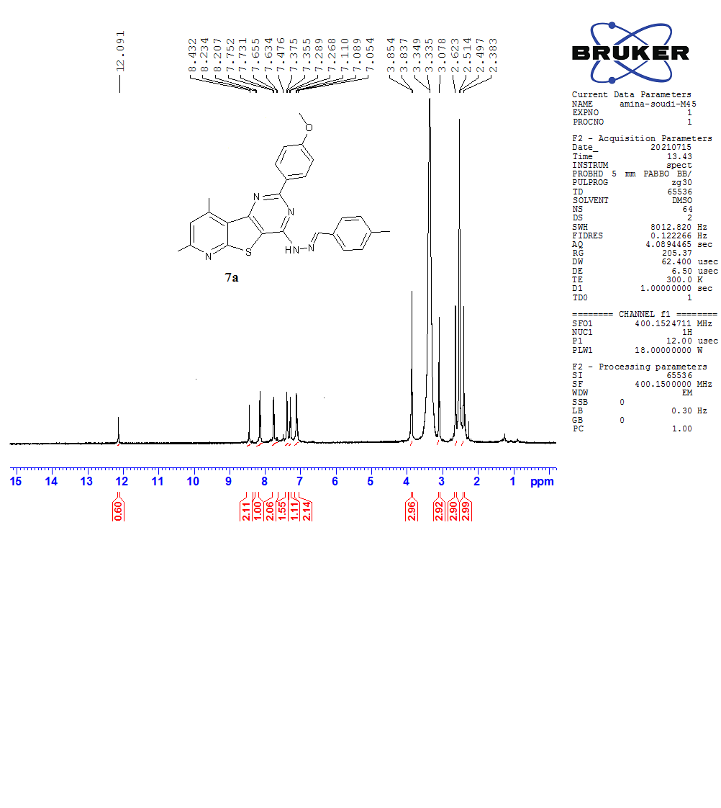

**Fig. 25** 1H NMR (400 MHz) in DMSO-*d*6 of compound **7a**

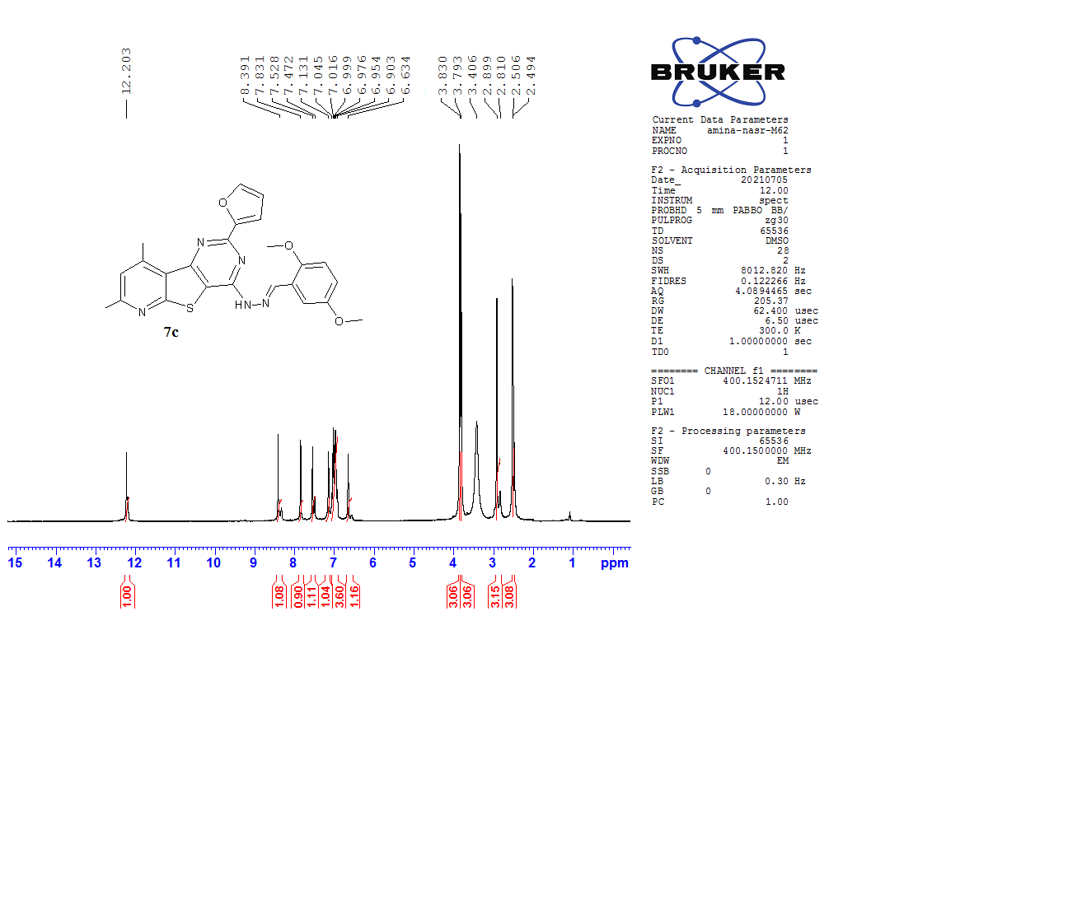

**Fig. 26** 1H NMR (400 MHz) in DMSO-*d*6 of compound **7c**

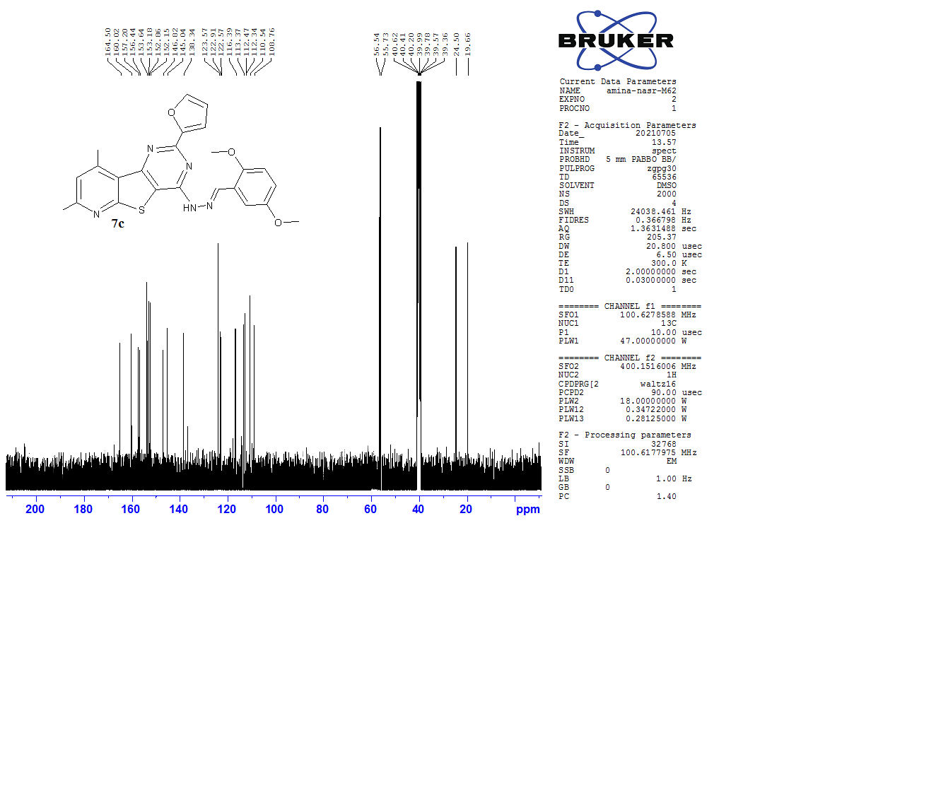

**Fig. 27** 13C NMR (100 MHz) in DMSO-*d*6 of compound **7c**

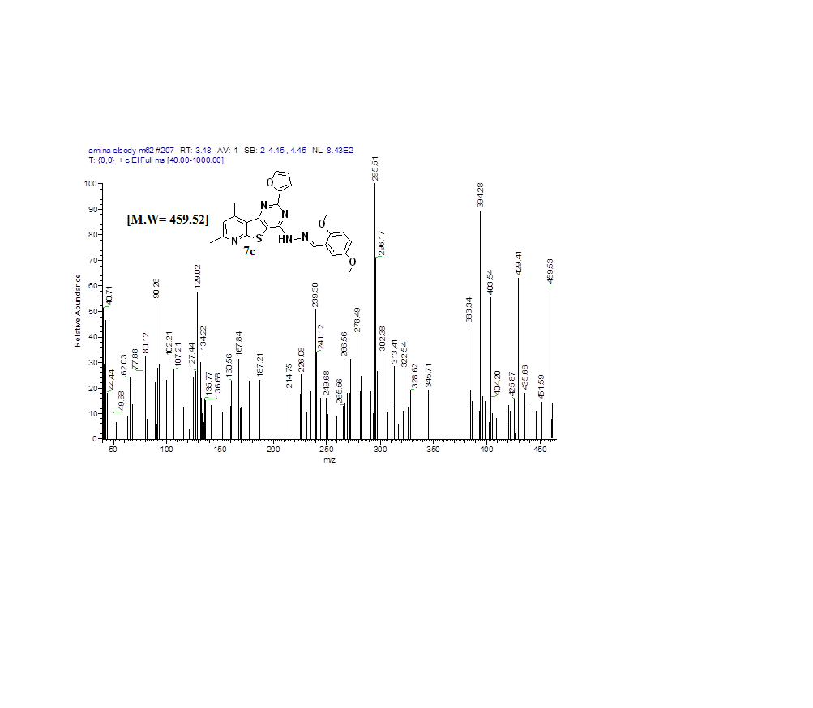

**Fig. 28** Mass spectrum of compound **7c**

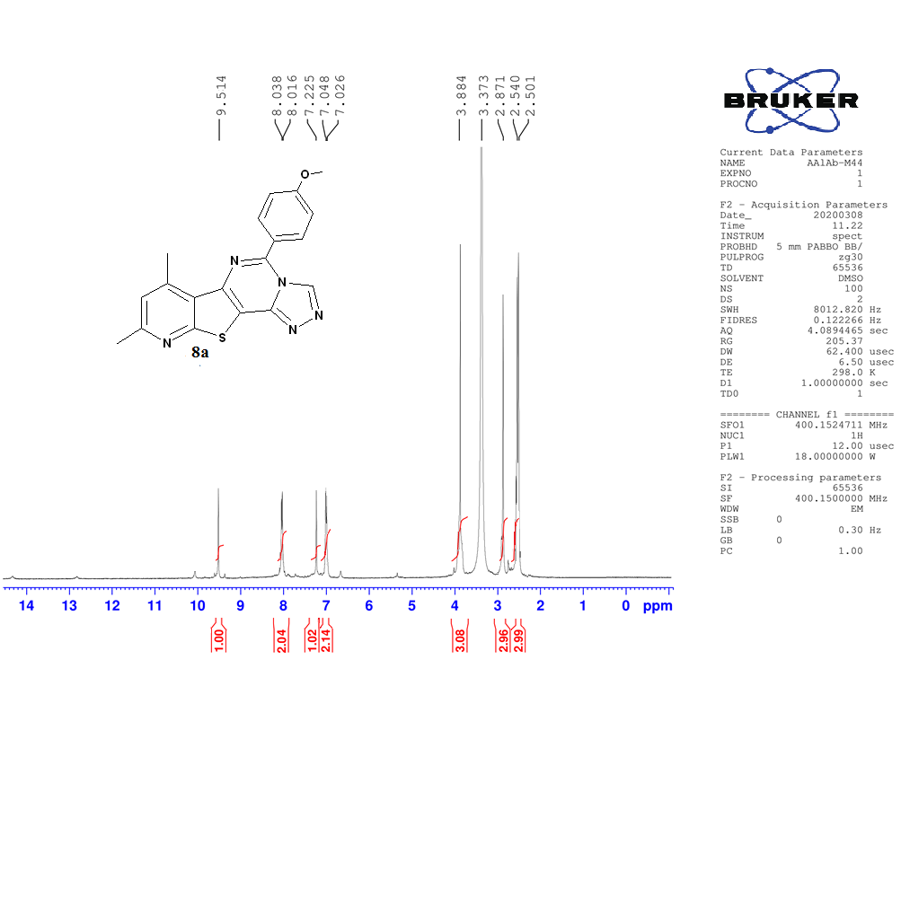

**Fig. 29** 1H NMR (400 MHz) in DMSO-*d*6 of compound **8a**

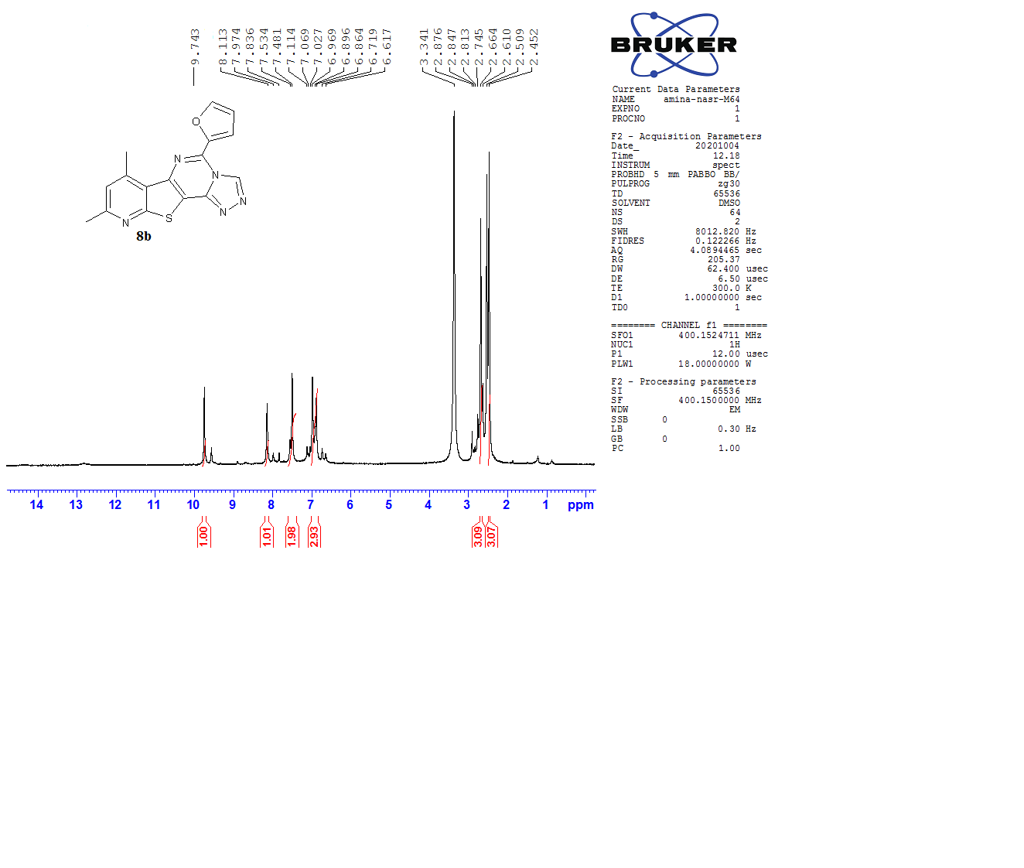

**Fig. 30** 1H NMR (400 MHz) in DMSO-*d*6 of compound **8b**

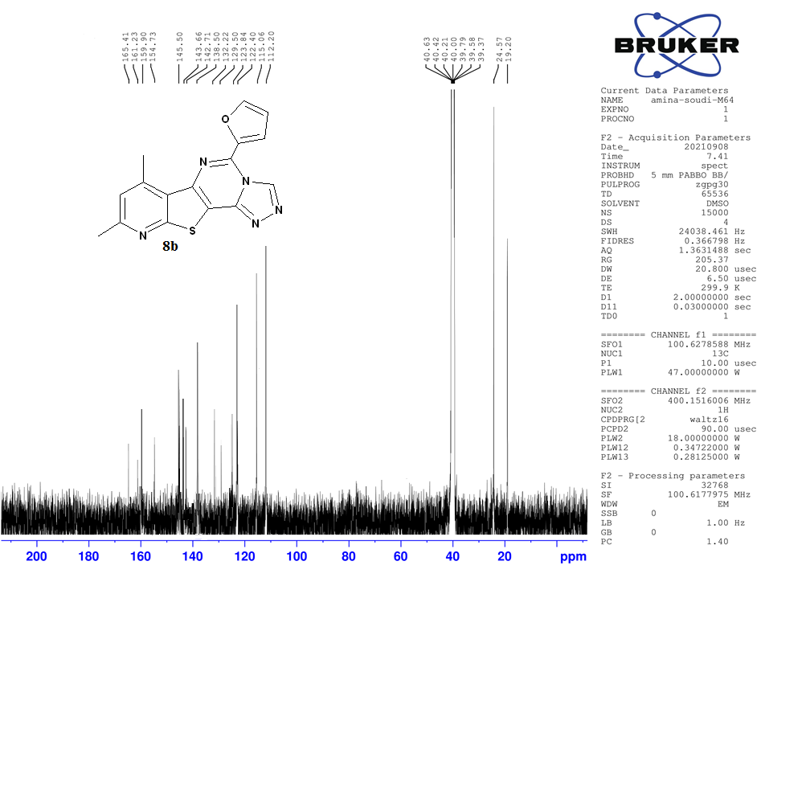

**Fig. 31** 13C NMR (100 MHz) in DMSO-*d*6 of compound **8b**

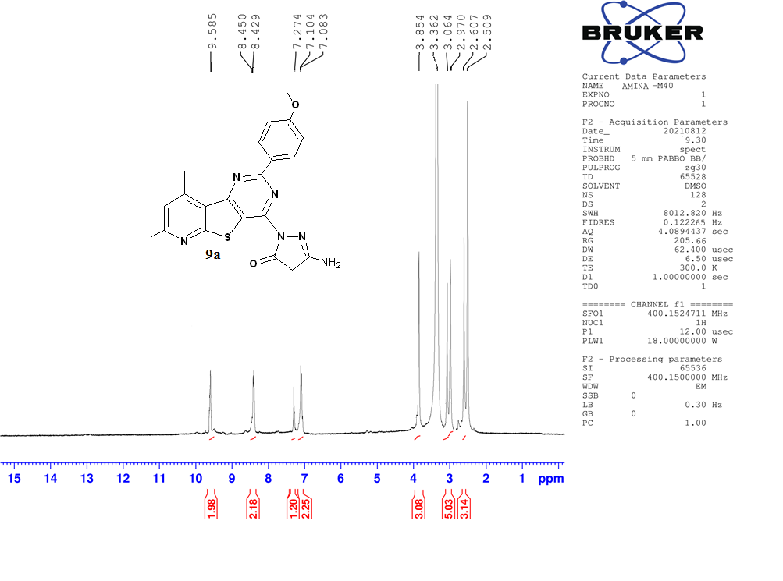

**Fig. 32** 1H NMR (400 MHz) in DMSO-*d*6 of compound **9a**

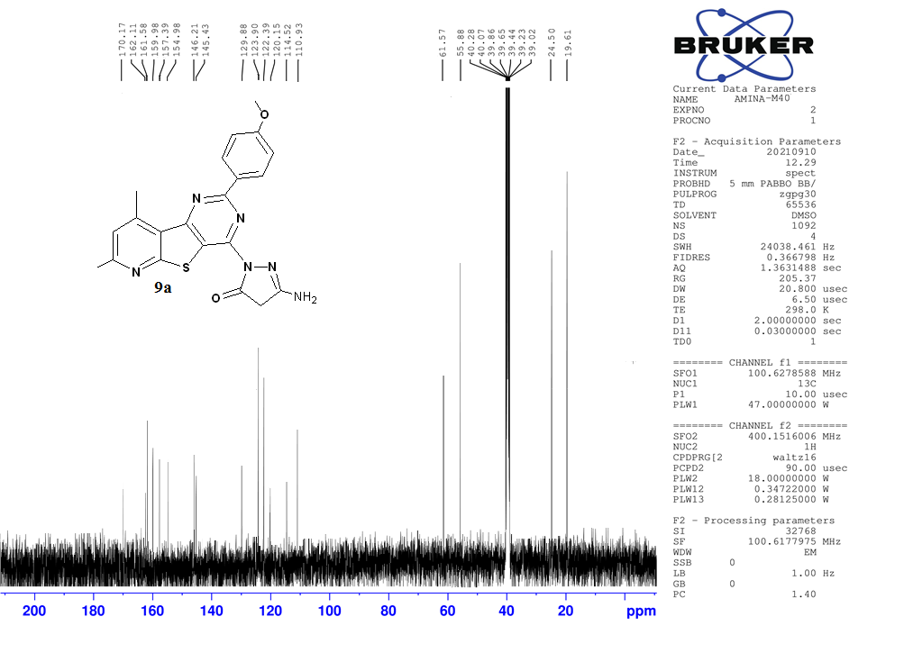

**Fig. 33** 13C NMR (100 MHz) in DMSO-*d*6 of compound **9a**

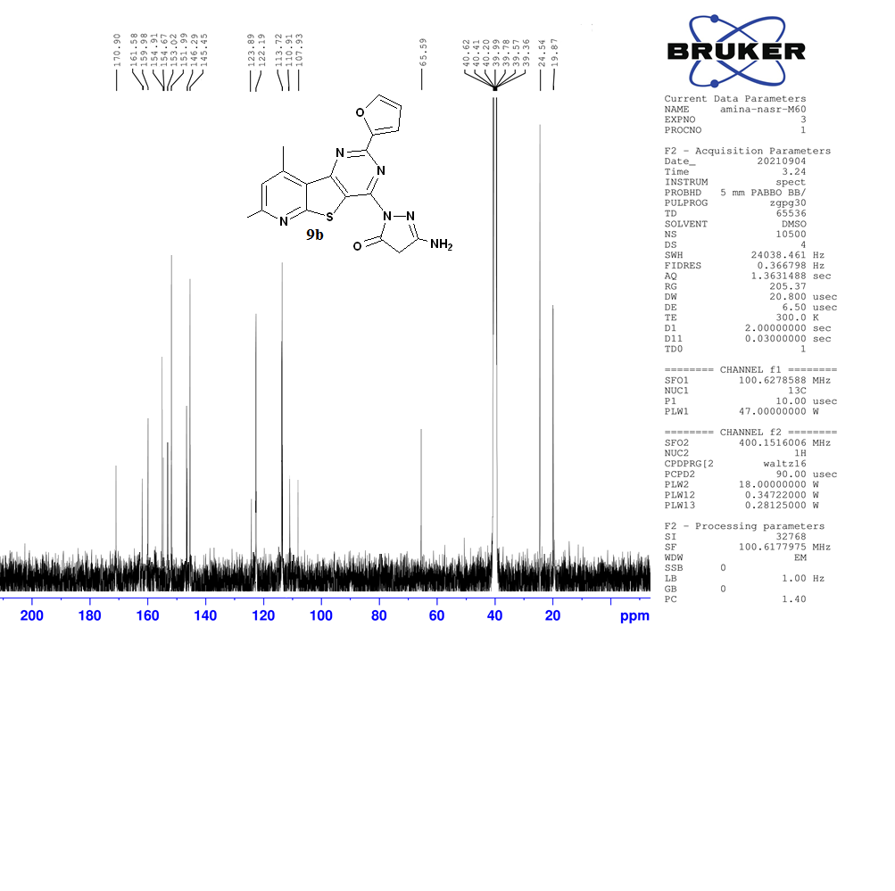

**Fig. 34** 13C NMR (100 MHz) in DMSO-*d*6 of compound **9b**

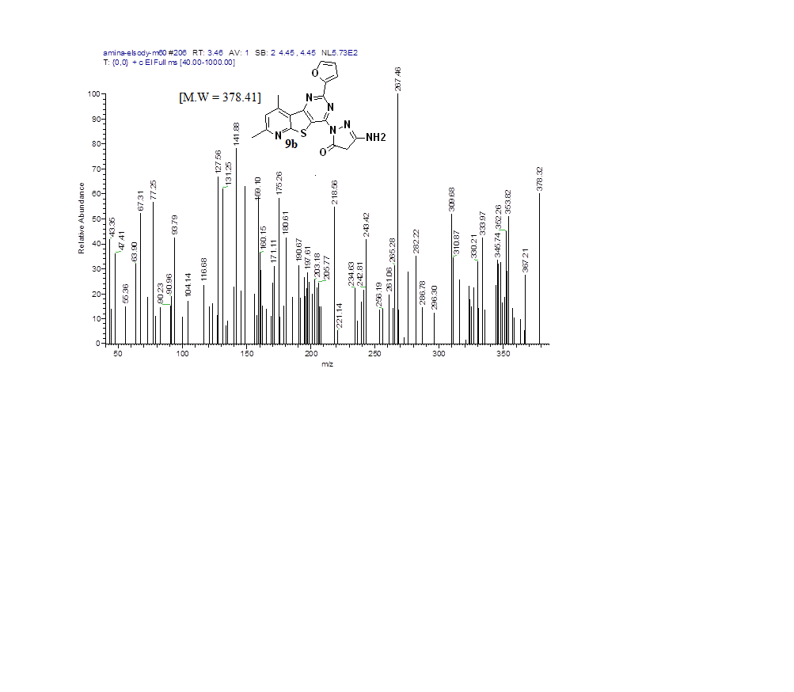

**Fig. 35** Mass spectrum of compound **9b**

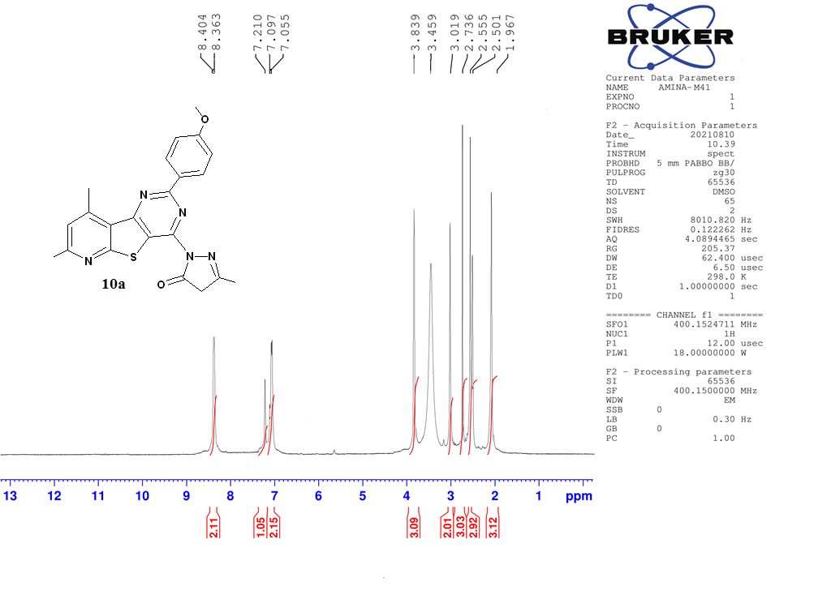

**Fig. 36** 1H NMR (400 MHz) in DMSO-*d*6 of compound **10a**

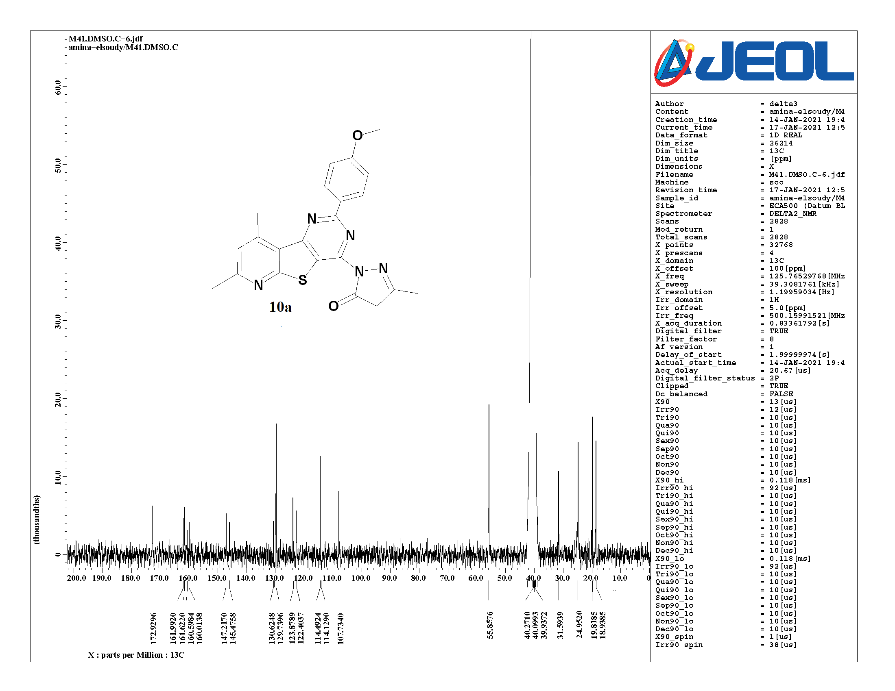

**Fig. 37** 13C NMR (100 MHz) in DMSO-*d*6 of compound **10a**

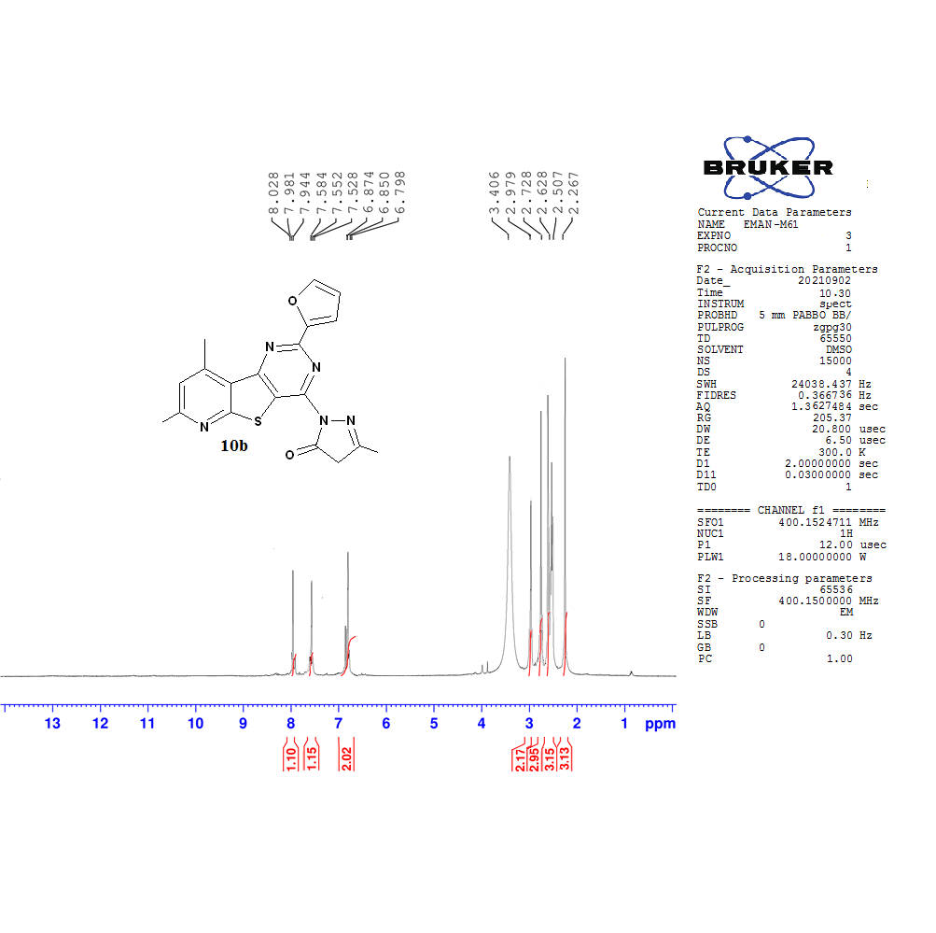

**Fig. 38** 1H NMR (400 MHz) in DMSO-*d*6 of compound **10b**

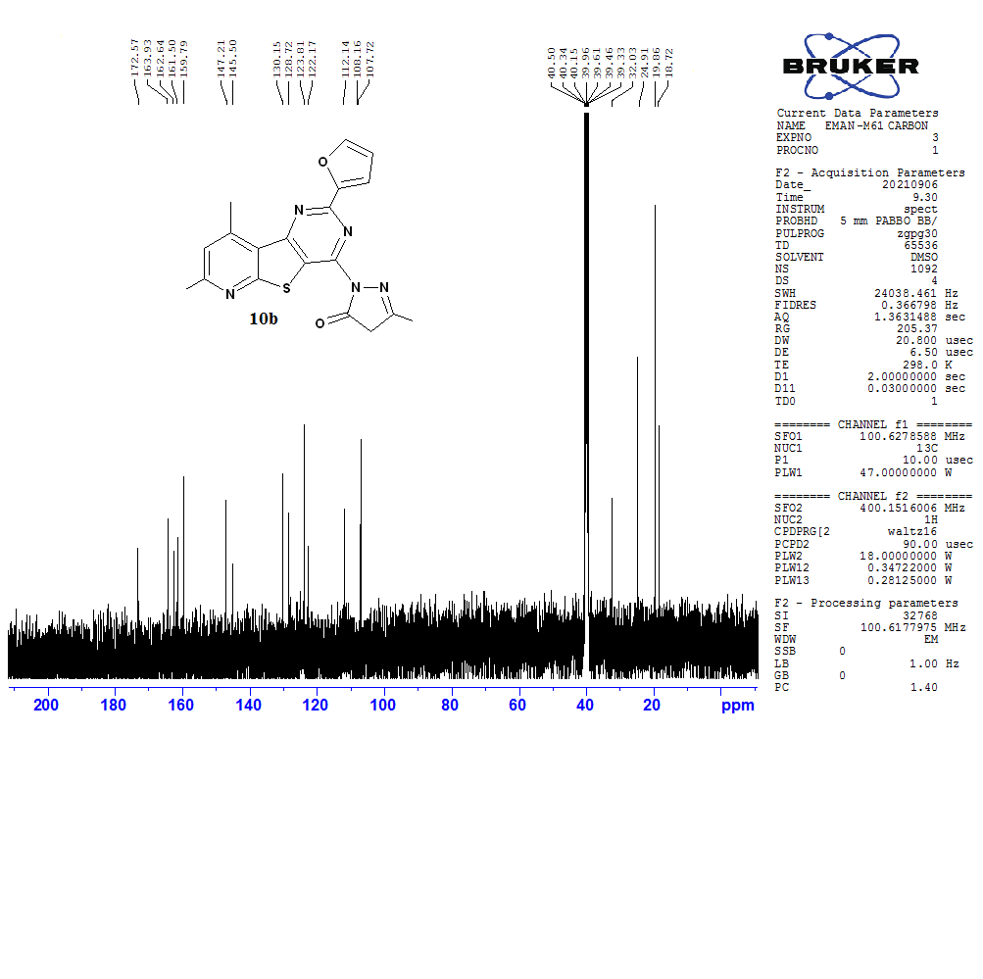

**Fig. 39** 13C NMR (100 MHz) in DMSO-*d*6 of compound **10b**

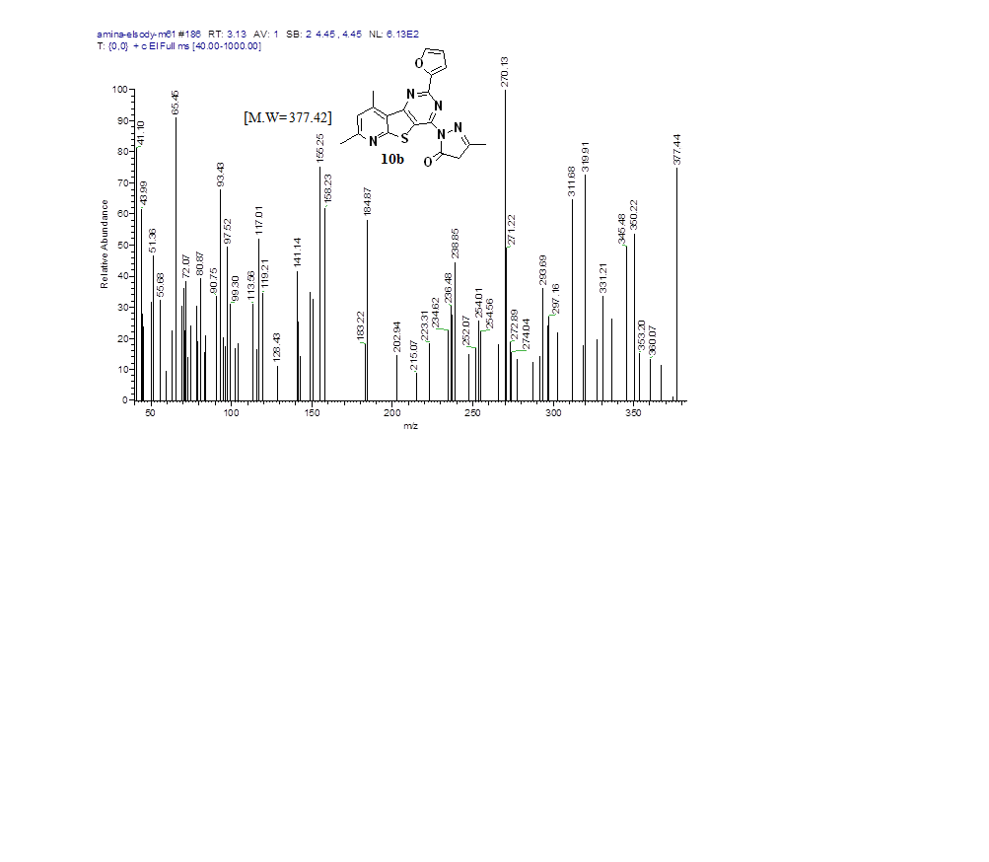



**Fig. 40** Mass spectrum of compound **10b**

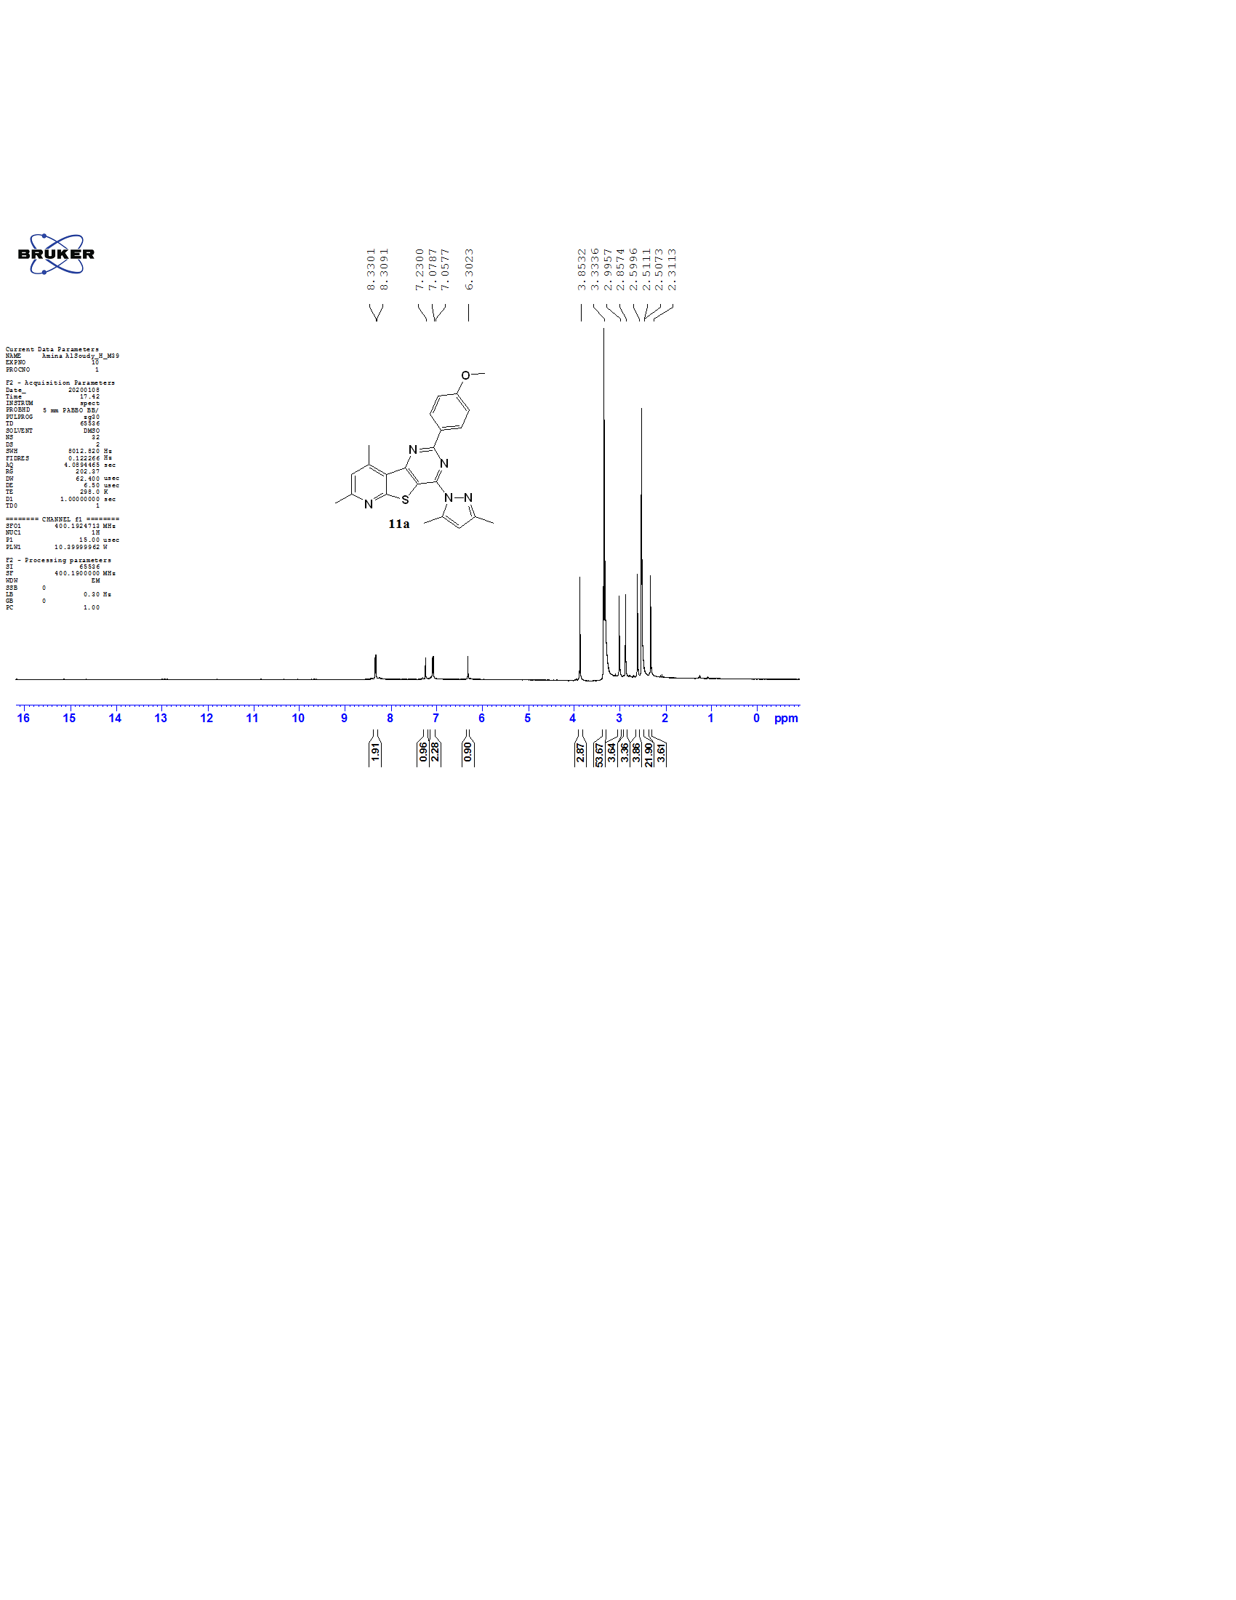

**Fig. 41** 1H NMR (400 MHz) in DMSO-*d*6 of compound **11a**

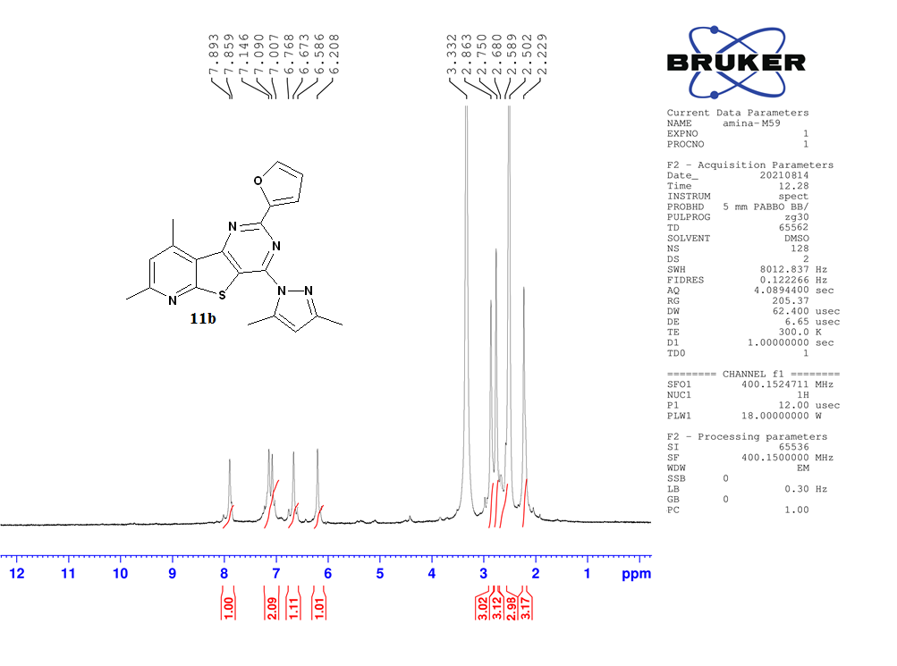

**Fig. 42** 1H NMR (400 MHz) in DMSO-*d*6 of compound **11b**

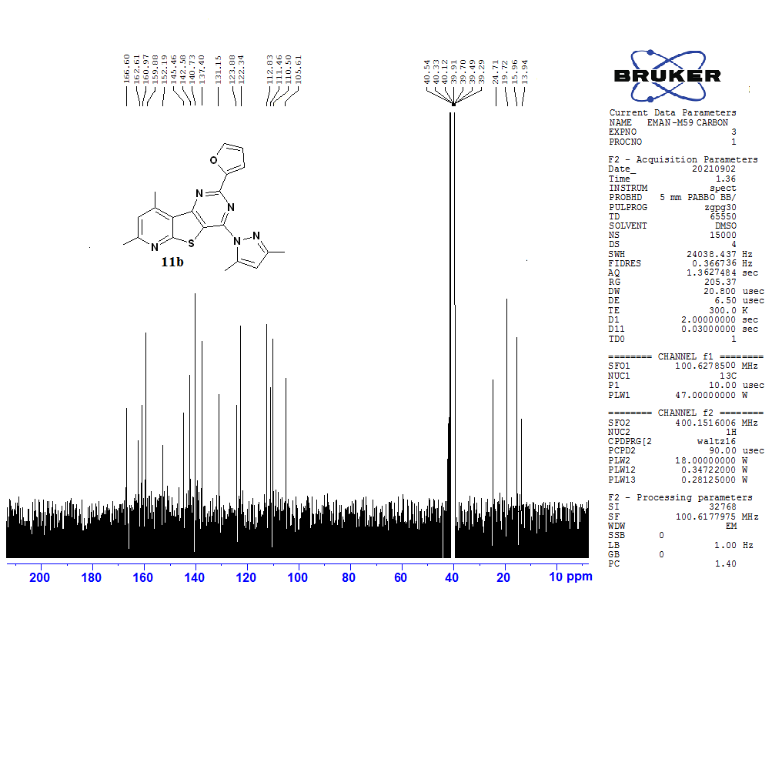

**Fig. 43** 13C NMR (100 MHz) in DMSO-*d*6 of compound **11b**

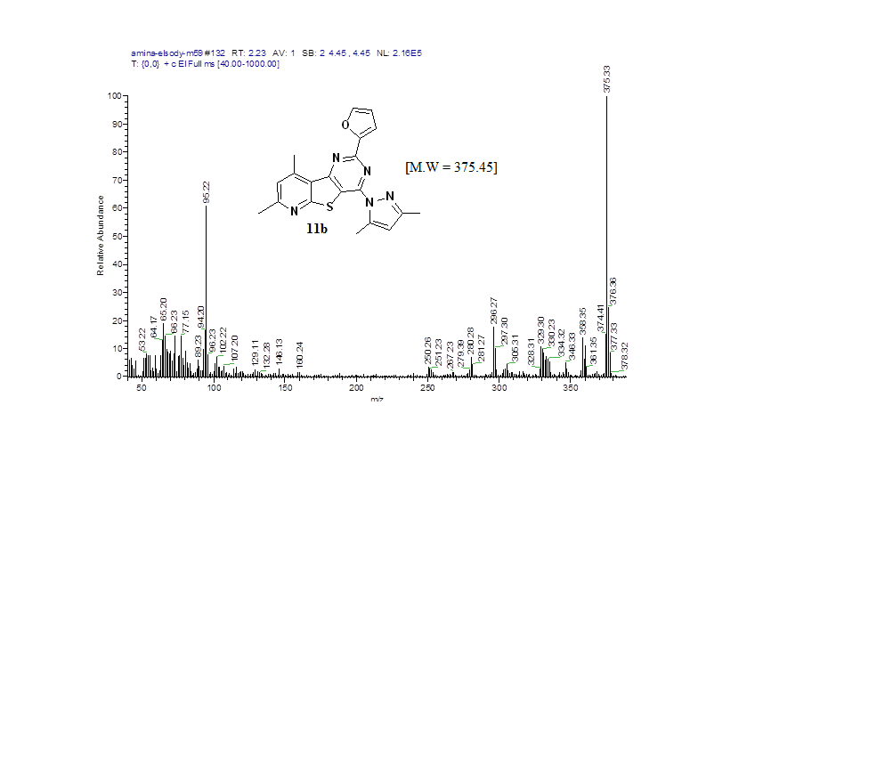



**Fig. 44** Mass spectrum of compound **11b**