Immobilization of bismuth oxychloride on cellulose nanocrystal for photocatalytic sulfonylation of arylacetylenic acids with sodium sulfinates under visible light

**Xiaoxia Wanga,b,** **Xueting Lia, Baoqiang Tiana, He Xiaoa, Wenwen Chena,*, Haishun Wua, Jianfeng Jiaa,\***

a *Key Laboratory of Magnetic Molecules & Magnetic Information Materials Ministry of Education* *School of Chemical and Material Science, Shanxi Normal University, Taiyuan 030006, P. R. China. E-mail:**[chenww@sxnu.edu.cn](mailto:chenww@sxnu.edu.cn);*[*jiajf@dns.sxnu.edu.cn*](mailto:jiajf@dns.sxnu.edu.cn)

b *Department of Chemistry, Changzhi University, Changzhi 046011, P. R. China.*

**Experimental Section**

*Characterization*

XRD pattern was obtained on an Ultima IV-185, Rigaku. Morphology of the materials were studied by SEM (JEOL JSM-7500F, Japan) and TEM (Titan G260-300). XPS analysis was performed with K-Alpha X-ray photoelectron spectrometer. The diffuse reflectance UV-Visible spectra (UV-vis-DRS) of the samples were examined by employing a Cary 5000 spectrometer (Evolution 220, Thermo Scientific, US) equipped with an integrating sphere with BaSO4 as the reference. The transient photocurrent was measured under irradiation at initial voltage is 0.14 V. EIS was studied in frequency range of 0.1~106 Hz with an ac voltage amplitude of 10 mV. NMR was recorded on Bruker Avance III DM 600 MHz. High resolution mass spectrometry (HRMS) data were collected on High Resolution Mass Spectrometer (Bruker ImpactⅡ, Germany).

*Photoelectrochemical measurements*

In order to verify the relationship between the photoelectric charge behavior and photocatalytic activity in the photocatalytic reaction, the transient photocurrent and electrochemical impedance (EIS) measurements of the prepared photocatalyst materials were performed, respectively. The photochemical properties of the samples were tested using CHI660E electrochemical workstation system with a standard three-electrode cell. Pt sheet and Ag/AgCl electrode were used as counter electrode and reference electrode respectively, and conductive glass (FTO) coated with catalyst was used as working electrode. Aqueous solution of Na2SO4 (0.1 M) was used as electrolyte and a 300 W Xe lamp was used as the light source.

*Synthesis of Arylpropiolic Acids[1]*

Pd(PPh3)4 (0.25 mmol) and dppb (0.5 mmol) were added into 50 mL schlenk bottle and remove oxygen. The solution of DBU (50 mmol) and aryl iodide (10 mmol) in DMSO (8 mL) was poured into the above bottle. Under nitrogen atmosphere, the solution of propiolic acid (10 mmol) in DMSO (2 mL) was added to the system drop by drop. The mixture was stirred at 50°C for 14 h. After reaction finished, EtOAc (10 mL) was addedd into the reaction mixture. Then, the mixture was extracted with saturated aqueous NaHCO3 solution and the aqueous layer was acidified to pH 2.0, and extracted with EtOAc. Then, the aqueous phase was extracted with CH2Cl2 and acidified to pH 2.0. The solid was filtered under reduced pressure to obtain the product.

*General Procedure for the Preparation of Sodium Aryl Sulfinates*

Compounds were synthesized according to literature procedures.[2] Sodium sulfite (10 mmol), sodium bicarbonate (10 mmol) and corresponding aryl sulfonyl chloride (5 mmol) were dissolved in 5 mL distilled water. The mixture was stirred at 80°C for 4 hours. After cooling to room temperature, a white solid can be obtained by vacuum dehydration. Then 15 mL of ethanol was poured to the white solid and filtered. The filtrate was concentrated to obtain the corresponding sodium aryl sulfonate.

*Catalytic activity measurements*

The photocatalytic performance of the prepared BiOCl/CNC nanocomposite sample for the sulfonylation reaction was evaluated with 30 W LED light (λ: 400-760 nm) and the distance between the light source and the reaction solution was 2 cm. The intensity density was maintained at 10 mw/cm2.In a typical reaction, arylacetylenic acid (0.5 mmol), sodium sulfinate (1.0 mmol) and iodine (0.25 mmol) were mixed in THF (4.5 mL), then BiOCl/CNC (20 mg) was added to the solution. The resulting mixture was irradiated with 30 W LED light for 20 h in the presence of molecular oxygen. After the reaction is over, 2 mL of saturated aqueous Na2SO3 was poured to quench the reaction, and extracted with EtOAc. The organic phase was washed with H2O and brine, dried with anhydrous sodium sulfate, filtered and concentrated. Finally, the filtrate was purified by column chromatography to afford the corresponding products.



**Fig. S1** (a) XRD patterns and (b) FTIR spectra of as-prepared samples.



**Fig. S2** TGA tests of CNC, BiOCl and BiOCl/CNC.



**Fig. S3** XPS spectra of BiOCl and BiOCl/CNC: (a) C 1s, (b) Bi 4f and (c) Cl 2p.



**Fig. S4** (a) transient photocurrent response (b) EIS Nyquist curves and (c) PL spectra of CNC, BiOCl and BiOCl/CNC.

**

**Fig. S5** (a) XRD and (b) IR comparison of BiOCl/CNC before and after used.



**Fig. S6** (a) TEM image of BiOCl/CNC after used; (b-e) Element mapping of Bi, O and Cl for BiOCl/CNC after used.

**Characterization of the isolated compounds (1H, 13C, NMR spectra, IR data and HRMS data of new compounds)**

*1-Methyl-4-(2-phenyl-ethynesulfonyl)-benzene (****3a****)*3: white solid (113.6 mg, 89%); **m.p.** = 94-95℃. **1H NMR** (600 MHz, CDCl3) δ 7.96 (d, *J* = 8.3 Hz, 2H), 7.51 (dd, *J* = 5.1, 3.3 Hz, 2H), 7.48 – 7.44 (m, 1H), 7.41 – 7.34 (m, 4H), 2.47 (s, 3H). **13C NMR** (151 MHz, CDCl3) δ 145.40, 138.96, 132.74, 131.48, 130.02, 128.68, 127.52, 118.03, 92.99, 85.61, 21.77.**IR (cm-1)**: 2183, 1593, 1445, 1328, 1154, 1084, 850, 682, 551.

*1-Methyl-4-((**p-tolylethynyl)sulfonyl)benzene* *(****3b****)*3: white solid (114.9 mg, 85%); **m.p.** = 113-115℃. **1H NMR** (600 MHz, CDCl3) δ 7.95 (d, *J* = 8.3 Hz, 2H), 7.39 (dd, *J* = 13.2, 8.1 Hz, 4H), 7.16 (d, *J* = 8.0 Hz, 2H), 2.46 (s, 3H), 2.37 (s, 3H). **13C NMR** (151 MHz, CDCl3) δ 145.26, 142.33, 139.14, 132.69, 129.98, 129.47, 127.45, 114.88, 93.71, 85.22, 21.79, 21.74. **IR (cm-1)**: 2180, 1330, 1158, 1084, 859, 820, 813, 774, 672, 607, 549, 514.

*1-Methoxy-4-(tosylethynyl)benzene (****3c****)*4: pale yellow solid (137.3 mg, 96%); **m.p.** = 87-89℃. **1H NMR** (600 MHz, CDCl3) δ 7.95 (d, *J* = 8.4 Hz, 2H), 7.48 – 7.43 (m, 2H), 7.38 (d, *J* = 8.1 Hz, 2H), 6.88 – 6.84 (m, 2H), 3.82 (s, 3H), 2.46 (s, 3H). **13C NMR** (151 MHz, CDCl3) δ 162.12, 145.15, 139.29, 134.66, 129.95, 127.38, 114.43, 109.65, 94.14, 84.89, 55.46, 21.73. **IR (cm-1)**: 2174, 1604, 1508, 1333, 1261, 1166, 1085, 1030, 860,772, 665, 547.

*4-(Toluene-4-sulfonylethynyl)-biphenyl (****3d****)*5: *y*ellow solid (125.2 mg, 75%); **m.p.** = 138-140℃. **1H NMR** (600 MHz, CDCl3) δ 7.98 (d, *J* = 8.3 Hz, 2H), 7.63 – 7.54 (m, 6H), 7.45 (t, *J* = 7.6 Hz, 2H), 7.40 (d, *J* = 8.2 Hz, 3H), 2.47 (s, 3H). **13C NMR** (151 MHz, CDCl3) δ 145.38, 144.28, 139.51, 139.04, 133.22, 130.03, 129.03, 128.39, 127.53, 127.30, 127.15, 116.66, 93.14, 86.18, 21.77. **IR (cm-1)**: 2179, 1593, 1484, 1340, 1164, 1085, 840, 764, 736, 666, 627, 556.

*1-Methyl-2-(tosylethynyl)benzene (****3e****)*: *p*ale yellow solid (93.3 mg, 69%); **m.p.** = 75-77℃. **1H NMR** (600 MHz, CDCl3) δ 7.96 (d, *J* = 8.3 Hz, 2H), 7.45 (d, *J* = 7.6 Hz, 1H), 7.39 (d, *J* = 8.1 Hz, 2H), 7.34 (td, *J* = 7.6, 1.0 Hz, 1H), 7.21 (d, *J* = 7.7 Hz, 1H), 7.17 (t, *J* = 7.6 Hz, 1H), 2.47 (s, 3H), 2.38 (s, 3H). **13C NMR** (151 MHz, CDCl3) δ 145.28, 142.39, 139.32, 133.02, 131.48, 129.99, 129.91, 127.38, 125.90, 117.87, 92.64, 89.31, 21.74, 20.40. **IR (cm-1)**: 2175, 1592, 1333, 1304, 1157, 1083, 865, 678, 555. **HRMS (ESI+)**: calcd for C16H14O2SNa+[M+Na] 293.0607, found 293.0605.

*1-Methoxy-3-(tosylethynyl)benzene (****3f****)*: white solid (116.2 mg, 81%); **m.p.** = 85-87℃. **1H NMR** (600 MHz, CDCl3) δ 7.96 (d, *J* = 8.3 Hz, 2H), 7.39 (d, *J* = 8.1 Hz, 2H), 7.28 – 7.24 (m, 1H), 7.13 – 7.08 (m, 1H), 7.05 – 6.94 (m, 2H), 3.79 (s, 3H), 2.47 (s, 3H). **13C NMR** (151 MHz, CDCl3) δ 159.39, 145.41, 138.94, 130.02, 129.84, 127.53, 125.24, 118.91, 118.37, 117.10, 92.90, 85.29, 55.46, 21.75. **IR (cm-1)**: 2167, 1576, 1338, 1294, 1199, 1165, 1083, 1054, 767, 678, 538. **HRMS (ESI+)**: calcd for C16H14O3SNa+ [M+Na] 309.0556, found 309.0554.

*1-Trifluoromethyl-4-(tosylethynyl)benzene (****3g****)*:white solid (50.5 mg, 36%); **m.p.** = 120-122℃. **1H NMR** (600 MHz, CDCl3) δ 7.96 (d, *J* = 8.4 Hz, 2H), 7.64 (s, 4H), 7.41 (d, *J* = 8.1 Hz, 2H), 2.49 (s, 3H). **13C NMR** (151 MHz, CDCl3) δ 145.81, 138.49, 133.02, 130.13, 127.70, 125.64 (d, J = 3.6 Hz), 124.25, 122.44, 121.90, 90.35, 87.40, 21.77. **IR (cm-1)**: 2192, 1346, 1323, 1158, 1118, 1067, 686, 539. **HRMS (ESI+)**: calcd for C16H11F3O2SNa+ [M+Na] 347.0324, found 347.0323.

*2-(Toluene-4-sulfonylethynyl)-thiophene (****3h****)*3: yellow solid (71.3 mg, 54%); **m.p.** = 92-94℃. **1H NMR** (600 MHz, CDCl3) δ 7.95 (d, *J* = 8.3 Hz, 2H), 7.50 (dd, *J* = 5.1, 1.1 Hz, 1H), 7.46 (dd, *J* = 3.7, 1.1 Hz, 1H), 7.39 (d, *J* = 8.1 Hz, 2H), 7.05 (dd, *J* = 5.0, 3.8 Hz, 1H), 2.47 (s, 3H). **13C NMR** (151 MHz, CDCl3) δ 145.47, 138.86, 137.06, 132.16, 130.05, 127.71, 127.55, 117.53, 89.29, 87.13, 21.76. **IR (cm-1)**: 2162, 1593, 1412, 1334, 1179, 1163, 1084, 776, 726, 668, 554, 539.

*2-(Toluene-4-sulfonylethynyl)-naphthalene (****3i****)*4: white solid (133.1 mg, 87%); **m.p.** = 116-119℃. **1H NMR** (600 MHz, CDCl3) δ 8.09 (d, *J* = 8.3 Hz, 1H), 8.03 (d, *J* = 8.3 Hz, 2H), 7.95 (d, *J* = 8.3 Hz, 1H), 7.86 (d, *J* = 8.1 Hz, 1H), 7.79 – 7.74 (m, 1H), 7.61 – 7.57 (m, 1H), 7.56 – 7.53 (m, 1H), 7.45 – 7.38 (m, 3H), 2.47 (s, 3H). **13C NMR** (151 MHz, CDCl3) δ 145.42, 139.24, 133.24, 132.23,132.90, 132.23, 130.08, 128.65, 128.04, 127.51, 127.15, 125.36, 125.00, 115.49, 92.01, 90.17, 21.77. **IR (cm-1)**: 2178, 1327, 1160, 1087, 770, 755, 674, 555, 542.

*((Phenylethynyl)sulfonyl)benzene (****3j****)*4:white solid (88.3 mg, 73%); **m.p.** = 85-87℃. **1H NMR** (600 MHz, CDCl3) δ 8.15 – 8.01 (m, 2H), 7.69 (t, *J* = 7.5 Hz, 1H), 7.60 (t, *J* = 7.8 Hz, 2H), 7.56 – 7.50 (m, 2H), 7.48 (t, *J* = 7.6 Hz, 1H), 7.37 (t, *J* = 7.8 Hz, 2H). **13C NMR** (151 MHz, CDCl3) δ 141.83, 134.21, 132.78, 131.62, 129.41, 128.72, 127.42, 117.88, 93.52, 85.36. **IR (cm-1)**: 2185, 1325, 1158, 1085, 855, 728, 687, 658, 575, 541.

*1-Fluoro-4-(2-phenyl-ethynesulfonyl)-benzene (****3k****)*: pale yellow solid (90.2 mg, 69%); **m.p.** = 87-88℃. **1H NMR** (600 MHz, CDCl3) δ 8.19 – 8.03 (m, 2H), 7.56 – 7.51 (m, 2H), 7.51 – 7.46 (m, 1H), 7.38 (t, *J* = 7.8 Hz, 2H), 7.31 – 7.25 (m, 2H). **13C NMR** (151 MHz, CDCl3) δ 166.09 (d, *J* = 257.4 Hz), 137.93 (d, *J* = 2.9 Hz), 132.79, 131.72, 130.46 (d, *J* = 9.8 Hz), 128.76, 117.73, 116.78 (d, *J* = 22.8 Hz), 93.72, 85.23. **IR (cm-1)**: 2183, 1589, 1488, 1333, 1236, 1152, 1083, 683, 550. **HRMS (ESI+)**: calcd for C14H9FO2SNa+ [M+Na] 283.0199, found 283.0195.

*1-Chloro-4-(2-phenyl-ethynesulfonyl)-benzene (****3l****)*3:white solid (113.3 mg, 82%); **m.p.** = 114-116℃. **1H NMR** (600 MHz, CDCl3) δ 8.05 – 7.98 (m, 2H), 7.60 – 7.56 (m, 2H), 7.55 – 7.51 (m, 2H), 7.49 (t, *J* = 7.6 Hz, 1H), 7.38 (t, *J* = 7.8 Hz, 2H). **13C NMR** (151 MHz, CDCl3) δ 141.00, 140.30, 132.82, 131.78, 129.77, 128.96, 128.77, 117.66, 94.03, 85.08. **IR (cm-1)**: 2183, 1331, 1155, 1086, 853, 757, 663, 533.

*1-Methoxy-4-(2-phenyl-ethynesulfonyl)-benzene (****3m****)*4:white solid (117.8 mg, 86%); **m.p.** = 94-96℃. **1H NMR** (600 MHz, CDCl3) δ 8.04 – 7.97 (m, 2H), 7.53 – 7.49 (m, 2H), 7.46 (t, *J* = 7.6 Hz, 1H), 7.36 (t, *J* = 7.8 Hz, 2H), 7.07 – 7.02 (m, 2H), 3.90 (s, 3H). **13C NMR** (151 MHz, CDCl3) δ 164.24, 133.41, 132.67, 131.42, 129.84, 128.68, 118.09, 114.63, 92.52, 85.91, 55.84. **IR (cm-1)**: 2186, 1333, 1260, 1152, 1085, 832, 687, 561, 544.

*1-Bromo-4-(2-phenyl-ethynesulfonyl)-benzene (****3n****)*3:white solid (110.4 mg, 69%); **m.p.** = 116-117℃. **1H NMR** (600 MHz, CDCl3) δ 7.94 (d, *J* = 8.6 Hz, 2H), 7.74 (d, *J* = 8.6 Hz, 2H), 7.55 – 7.51 (m, 2H), 7.49 (t, *J* = 7.6 Hz, 1H), 7.38 (t, *J* = 7.8 Hz, 2H). **13C NMR** (151 MHz, CDCl3) δ 140.81, 132.79, 132.74, 131.77, 129.59, 128.95, 128.75, 117.61, 94.07, 85.02. **IR (cm-1)**: 2184, 1572, 1337, 1165, 1084, 1063, 854, 758, 742, 588.

*1-Bromo-2-(2-phenyl-ethynesulfonyl)-benzene (****3o****)*:white solid (109.6 mg, 68%); **m.p.** = 120-122℃. **1H NMR** (600 MHz, CDCl3) δ 8.25 (dd, *J* = 7.9, 1.7 Hz, 1H), 7.81 (dd, *J* = 7.8, 1.0 Hz, 1H), 7.61 – 7.57 (m, 2H), 7.55 (td, *J* = 7.7, 1.1 Hz, 1H), 7.52 – 7.48 (m, 2H), 7.40 (t, *J* = 7.8 Hz, 2H). **13C NMR** (151 MHz, CDCl3) δ 140.45, 135.73, 134.95, 132.98, 131.78, 130.53, 128.78, 127.93, 121.42, 117.83, 93.44, 83.98. **IR (cm-1)**: 2184, 1331, 1162, 856, 756, 665, 575. **HRMS (ESI+)**: calcd for C14H9BrO2SNa+ [M+Na] 342.9399, found 342.9396.

*1-Bromo-3-(2-phenyl-ethynesulfonyl)-benzene (****3p****)*:white solid (102 mg, 64%); **m.p.** = 85-87℃. **1H NMR** (600 MHz, CDCl3) δ 8.22 (t, *J* = 1.8 Hz, 1H), 8.02 (ddd, *J* = 7.9, 1.6, 1.0 Hz, 1H), 7.81 (ddd, *J* = 8.0, 1.8, 0.9 Hz, 1H), 7.57 – 7.53 (m, 2H), 7.52 – 7.46 (m, 2H), 7.39 (dd, *J* = 10.9, 4.7 Hz, 2H). **13C NMR** (151 MHz, CDCl3) δ 143.53, 137.26, 132.88, 131.89, 130.98, 130.32, 128.80, 126.02, 123.29, 117.55, 94.43, 84.87. **IR (cm-1)**: 2180, 1572, 1443, 1331, 1161, 857, 762, 676, 575. **HRMS (ESI+)**: calcd for C14H9BrO2SNa+ [M+Na] 342.9399, found 342.9397.

*1-tert-Butyl-4-(2-phenyl-ethynesulfonyl)-benzene (****3q****)*:yellow solid (97.8 mg, 66%); **m.p.** = 86-89℃. **1H NMR** (600 MHz, CDCl3) δ 8.02 – 7.98 (m, 2H), 7.62 – 7.59 (m, 2H), 7.52 (dd, *J* = 5.1, 3.3 Hz, 2H), 7.48 – 7.44 (m, 1H), 7.36 (dd, *J* = 10.8, 4.7 Hz, 2H), 1.36 (s, 9H). **13C NMR** (151 MHz, CDCl3) δ 158.30, 138.79, 132.76, 131.49, 128.69, 127.34, 126.44, 118.05, 92.97, 85.62, 35.39, 31.06. **IR (cm-1)**: 2184, 1726, 1594, 1335, 1161, 1111, 1086, 840, 757, 667, 613, 564. **HRMS (ESI+)**: calcd for C18H18O2SNa+ [M+Na] 321.0920, found 321.0913.

*2-(2-Phenyl-ethynesulfonyl)-naphthalene (****3s****)*:white solid (90.8 mg, 62%); **m.p.** = 116-117℃. **1H NMR** (600 MHz, CDCl3) δ 8.65 (s, 1H), 8.07 – 8.01 (m, 3H), 7.94 (d, *J* = 8.2 Hz, 1H), 7.71 – 7.67 (m, 1H), 7.66 – 7.63 (m, 1H), 7.51 (dd, *J* = 5.1, 3.3 Hz, 2H), 7.48 – 7.43 (m, 1H), 7.35 (dd, *J* = 10.9, 4.7 Hz, 2H). **13C NMR** (151 MHz, CDCl3) δ 138.60, 135.56, 132.77, 132.10, 131.60, 129.87, 129.68, 129.66, 129.24, 128.71, 128.08, 127.90, 122.13, 117.89, 93.77, 85.53. **IR (cm-1)**: 2181, 1443, 1334, 1157, 1127, 1072, 865, 758, 684. **HRMS (ESI+)**: calcd for C18H12O2SNa+ [M+Na] 315.0450, found 315.0447.

*2-(2-Phenyl-ethynesulfonyl)-thiophene (****3t****)*:pale yellow solid (32.3 mg, 26%); **m.p.** = 89-92℃. **1H NMR** (600 MHz, CDCl3) δ 7.87 (dd, *J* = 3.8, 1.3 Hz, 1H), 7.77 (dd, *J* = 5.0, 1.3 Hz, 1H), 7.57 – 7.54 (m, 2H), 7.49 (t, *J* = 7.6 Hz, 1H), 7.39 (t, *J* = 7.8 Hz, 2H), 7.18 (dd, *J* = 4.9, 3.9 Hz, 1H). **13C NMR** (151 MHz, CDCl3) δ 142.97, 134.88, 134.30, 132.81, 131.67, 128.74, 127.98, 117.82, 93.26, 85.68. **IR (cm-1)**: 2181, 1399, 1335, 1154, 1015, 850, 682, 577, 534. **HRMS (ESI+)**: calcd for C12H8O2S2Na+ [M+Na] 270.9858, found 270.9857.

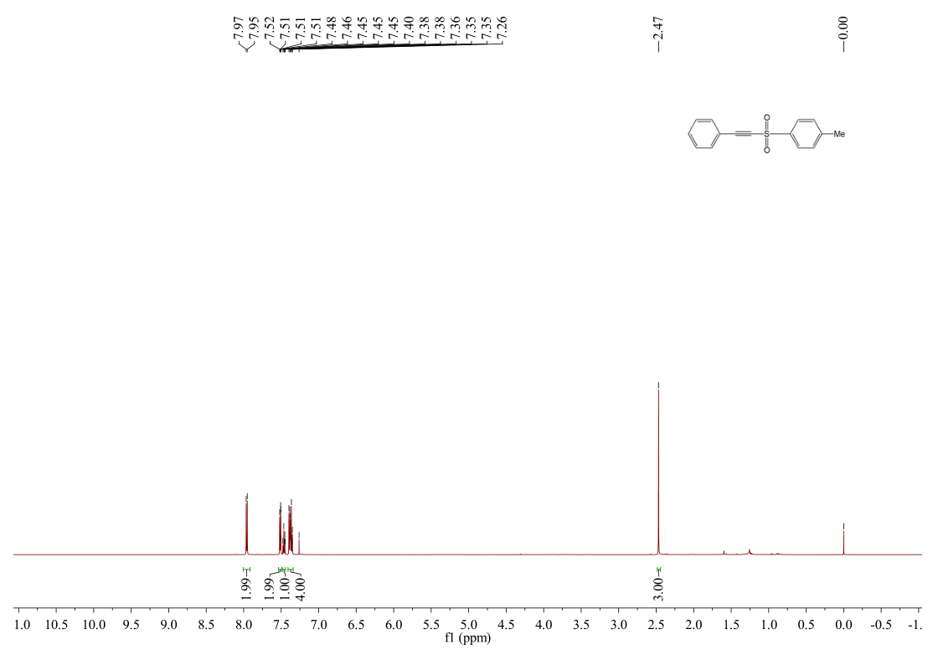

**Fig. S7** 1H NMR spectrum of **3a** (600 MHz, CDCl3, 25 ℃).

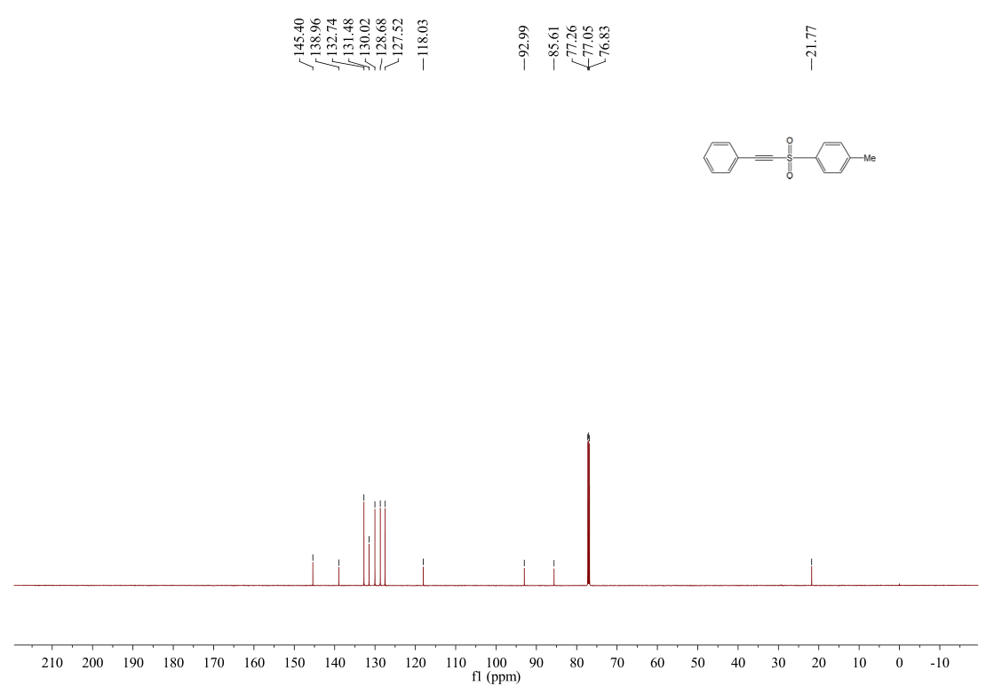

**Fig. S8** 13C NMR spectrum of **3a** (600 MHz, CDCl3, 25 ℃).

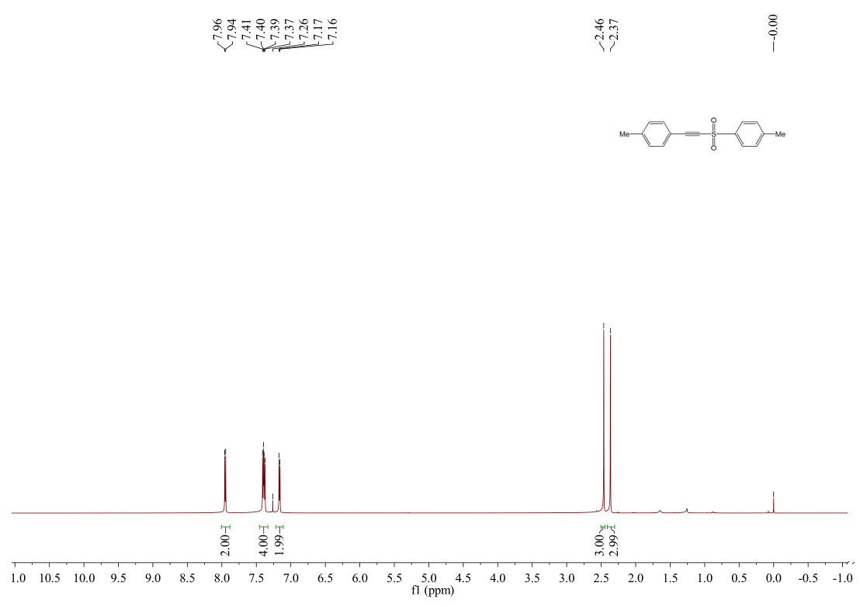

**Fig. S9** 1H NMR spectrum of **3b** (600 MHz, CDCl3, 25 ℃).

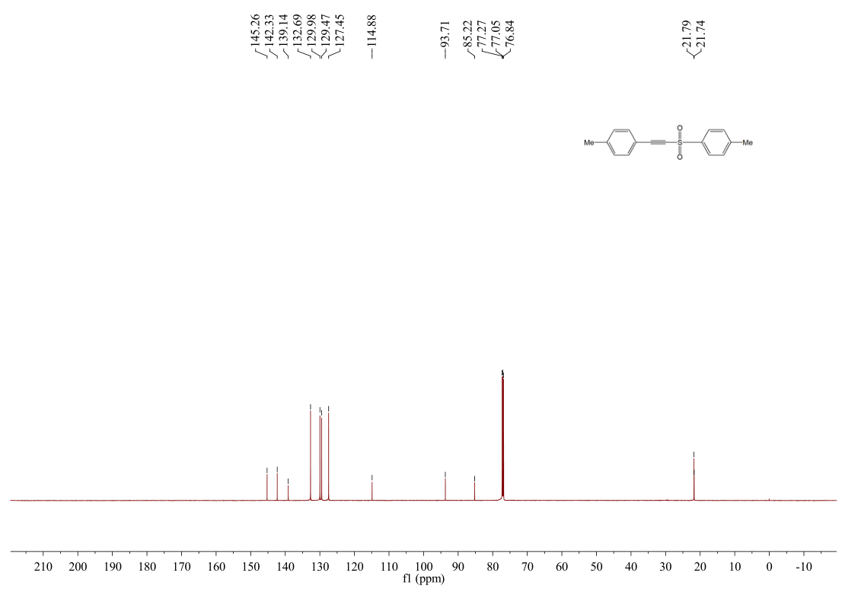

**Fig. S10** 13C NMR spectrum of **3b** (600 MHz, CDCl3, 25 ℃).

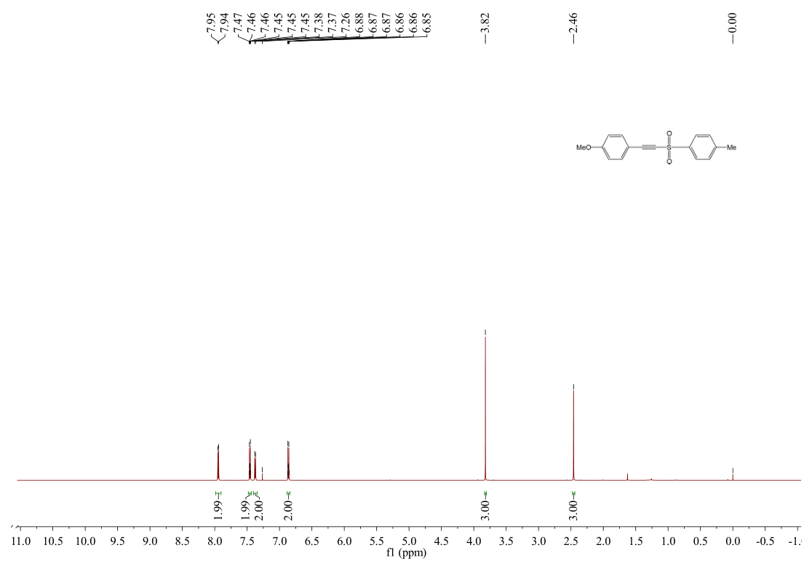**Fig. S11** 1H NMR spectrum of 3c (600 MHz, CDCl3, 25 ℃).

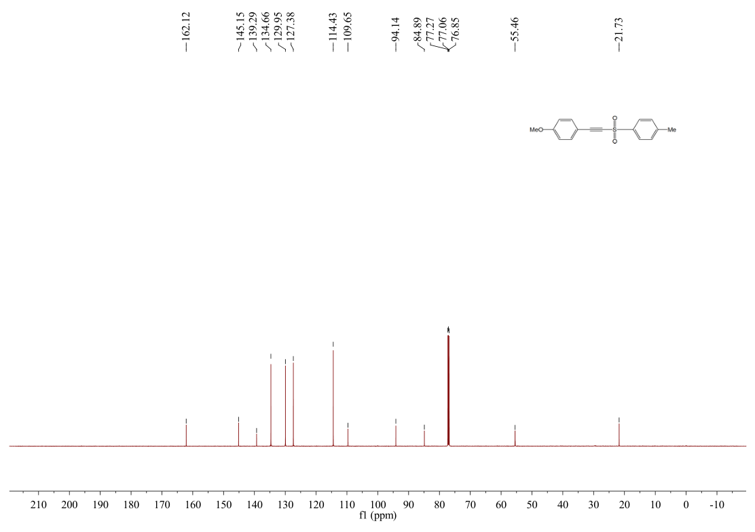**Fig. S12** 13C NMR spectrum of 3c (600 MHz, CDCl3, 25 ℃).

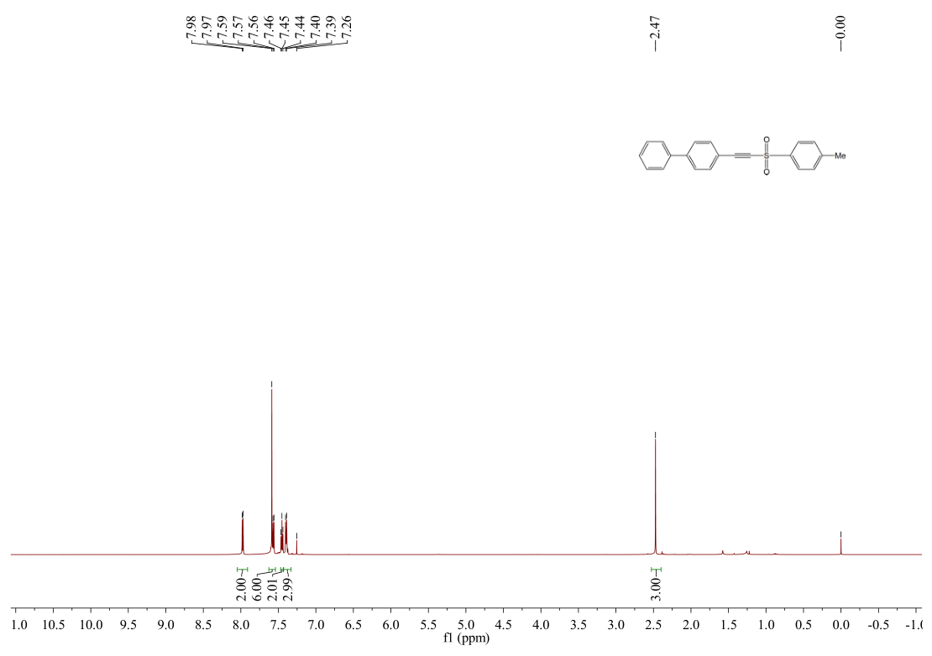 **Fig. S13** 1H NMR spectrum of 3d (600 MHz, CDCl3, 25 ℃).

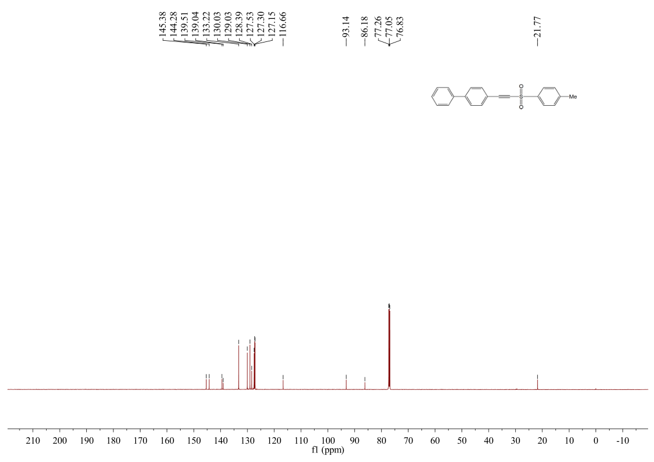 **Fig. S14** 13C NMR spectrum of 3d (600 MHz, CDCl3, 25 ℃).

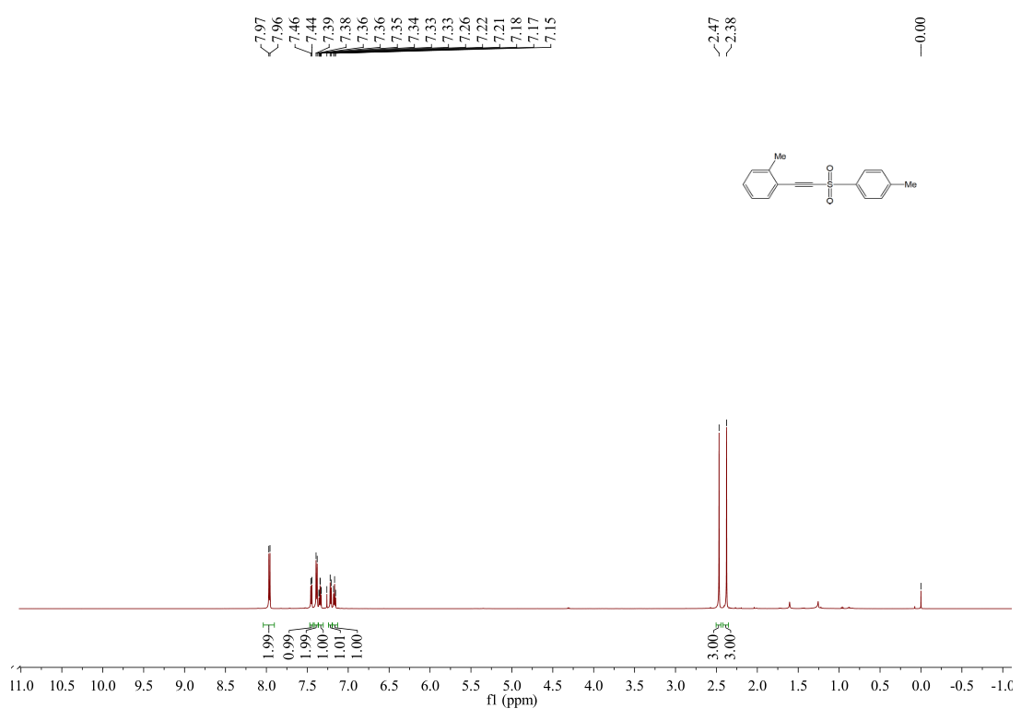

**Fig. S15** 1H NMR spectrum of 3e (600 MHz, CDCl3, 25 ℃).

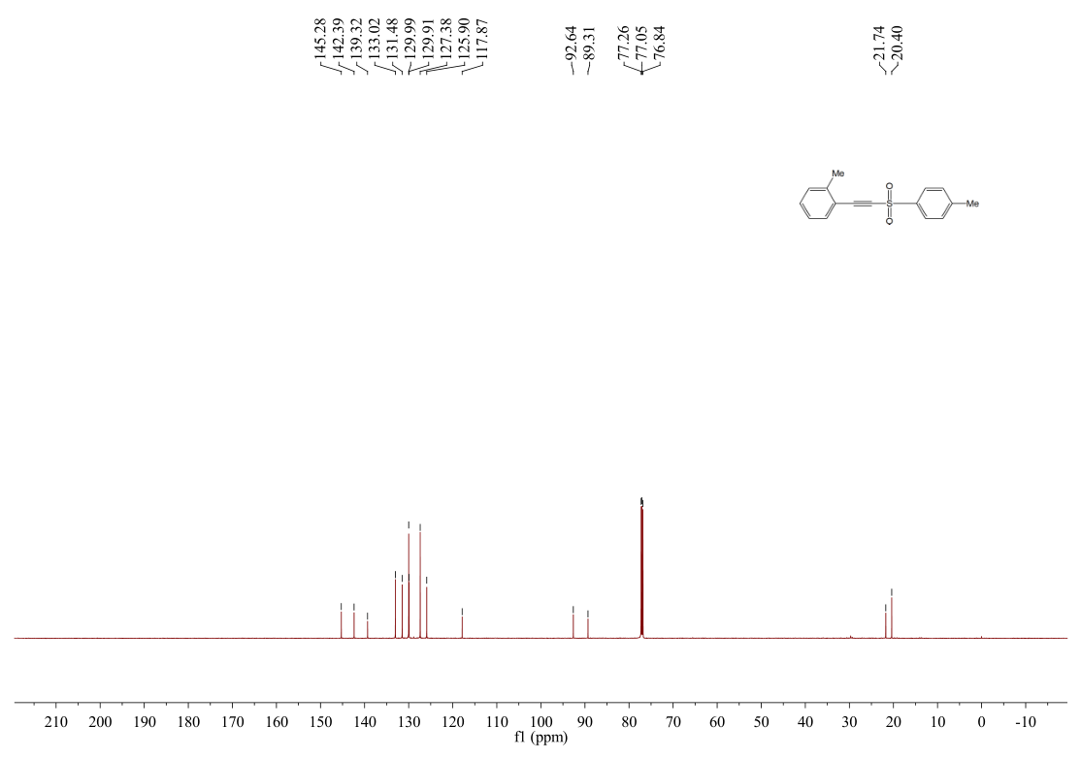

**Fig. S16** 13C NMR spectrum of 3e (600 MHz, CDCl3, 25 ℃).

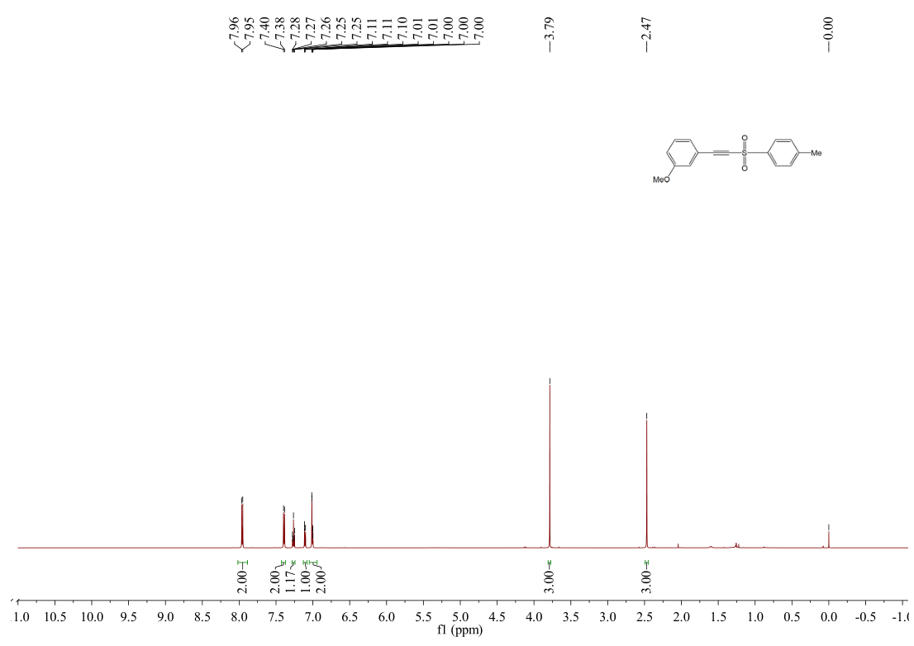

**Fig. S17** 1H NMR spectrum of 3f (600 MHz, CDCl3, 25 ℃).

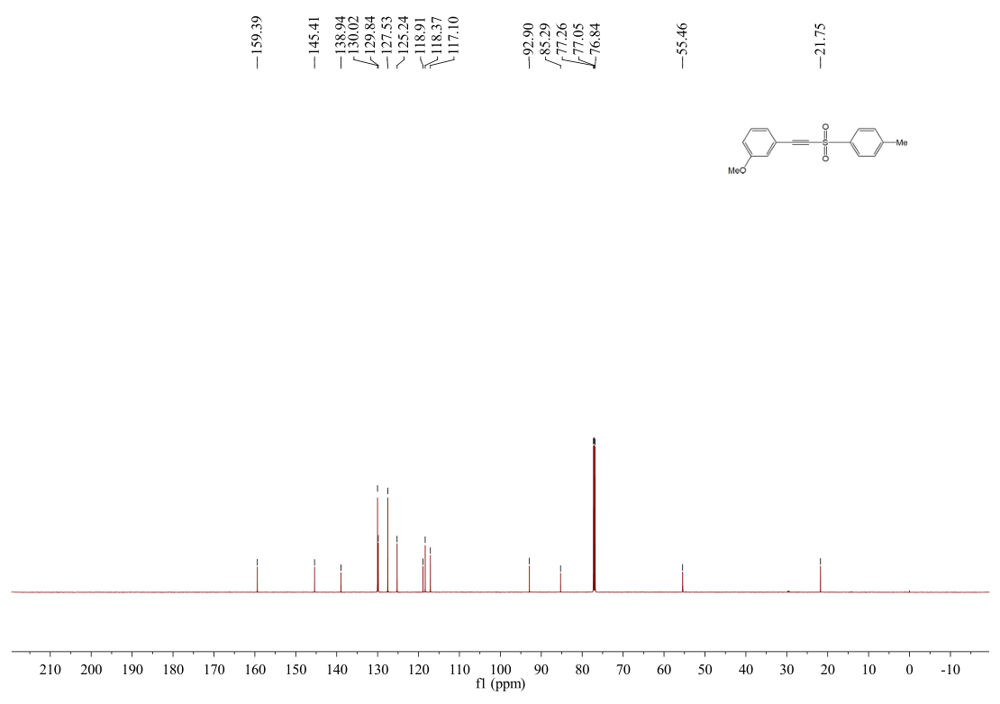

**Fig. S18** 13C NMR spectrum of 3f (600 MHz, CDCl3, 25 ℃).

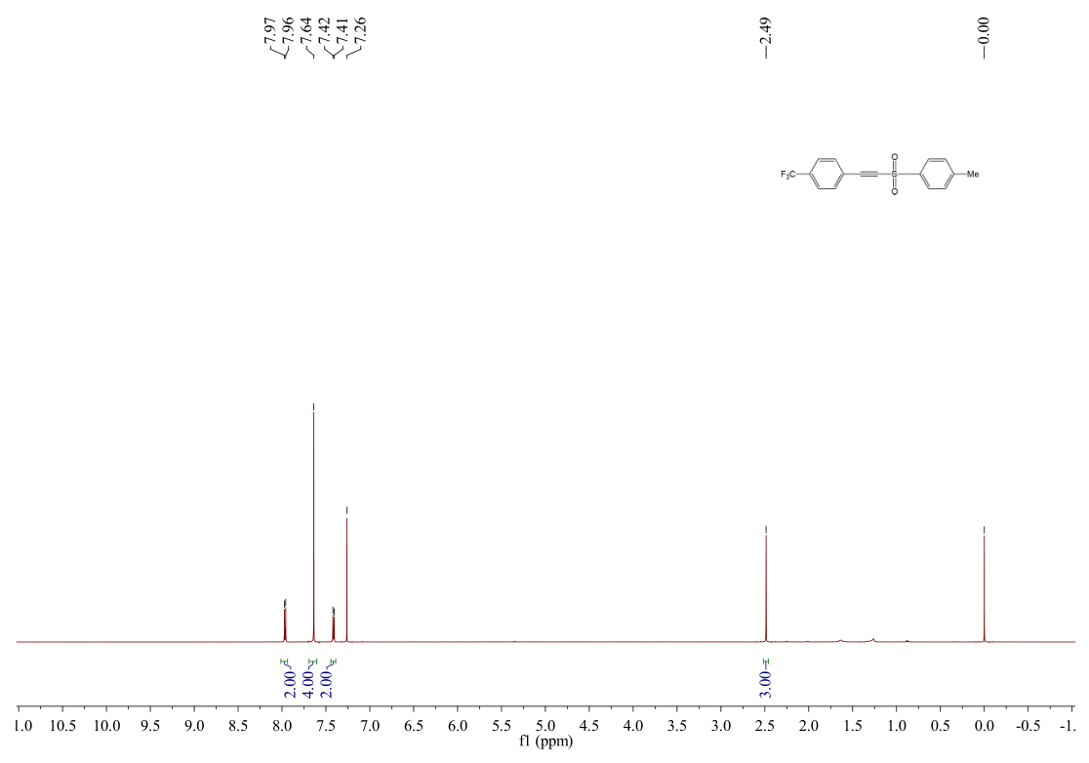

**Fig. S19** 1H NMR spectrum of **3g** (600 MHz, CDCl3, 25 ℃).

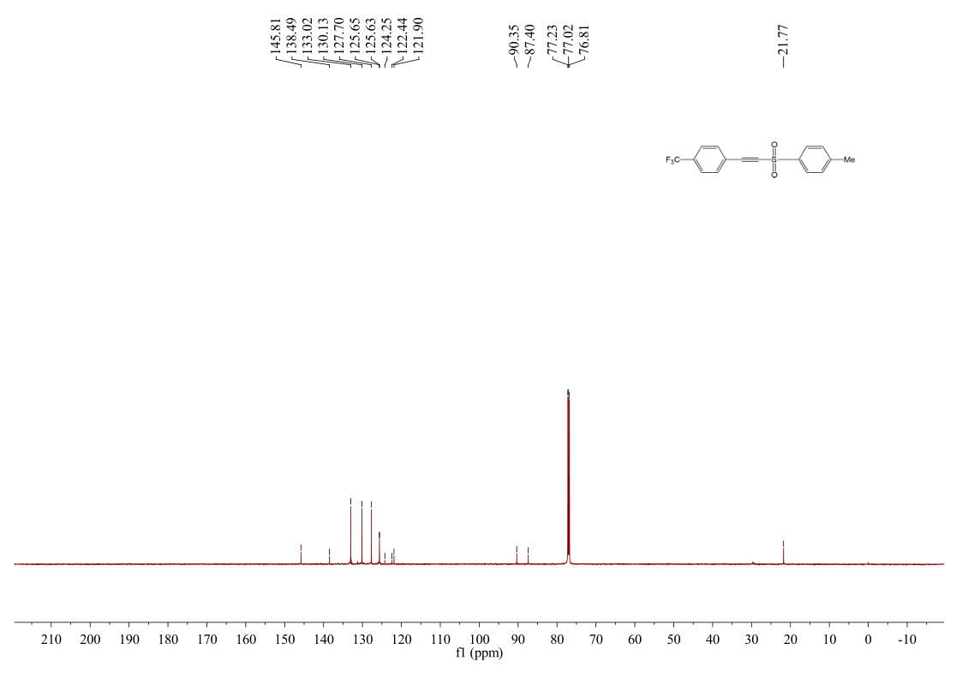

**Fig. S20** 13C NMR spectrum of **3g** (600 MHz, CDCl3, 25 ℃).

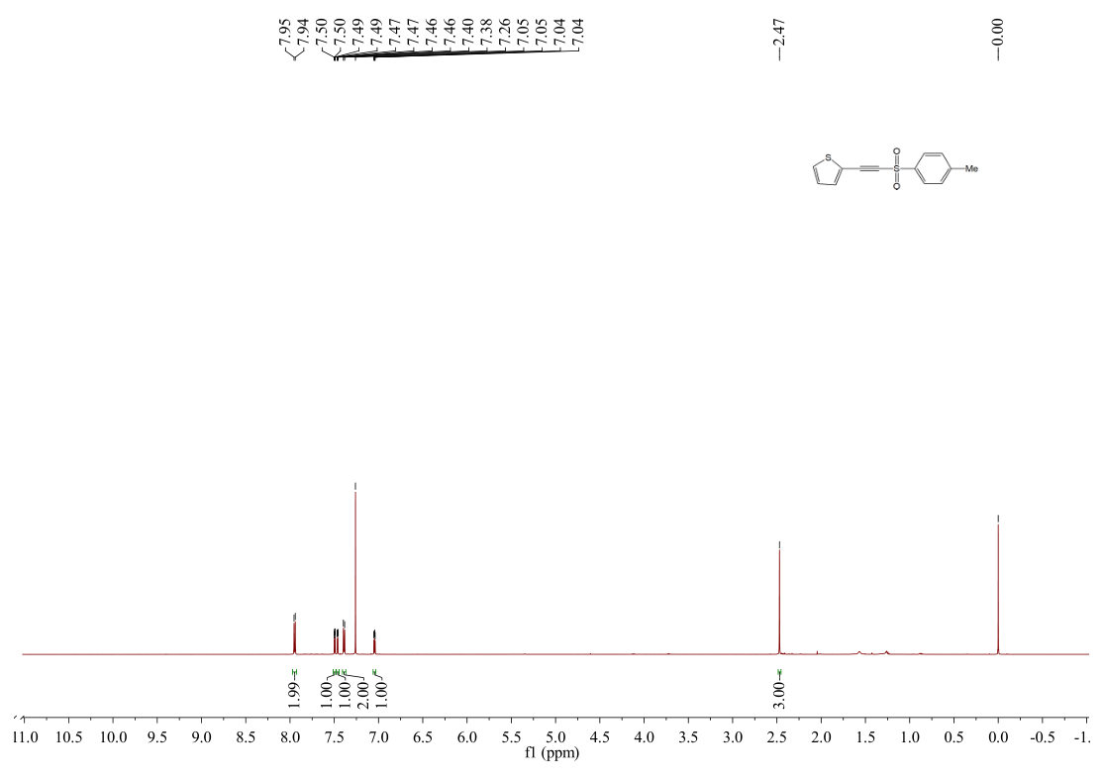

**Fig. S21** 1H NMR spectrum of **3h** (600 MHz, CDCl3, 25 ℃).

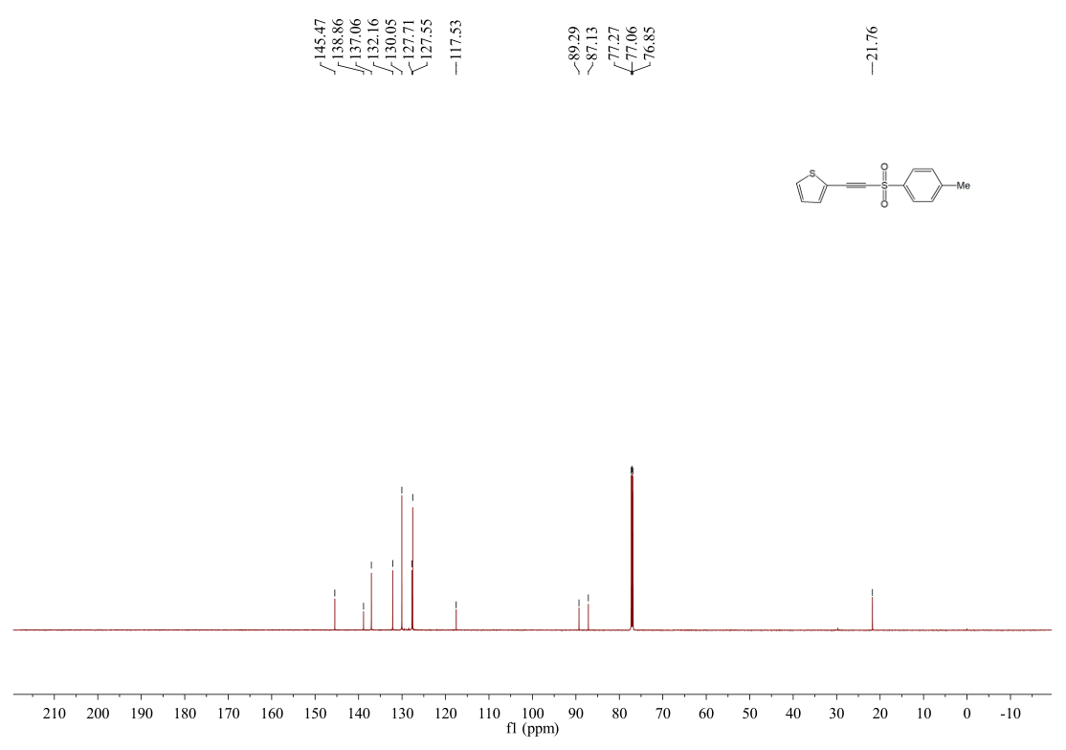

**Fig. S22** 13C NMR spectrum of **3h** (600 MHz, CDCl3, 25 ℃).

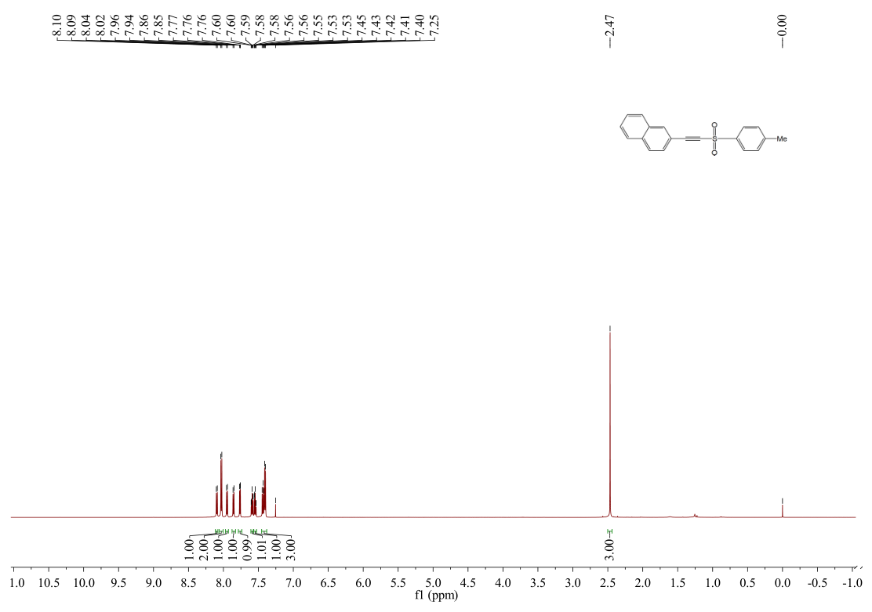

**Fig. S23** 1H NMR spectrum of **3i** (600 MHz, CDCl3, 25 ℃).

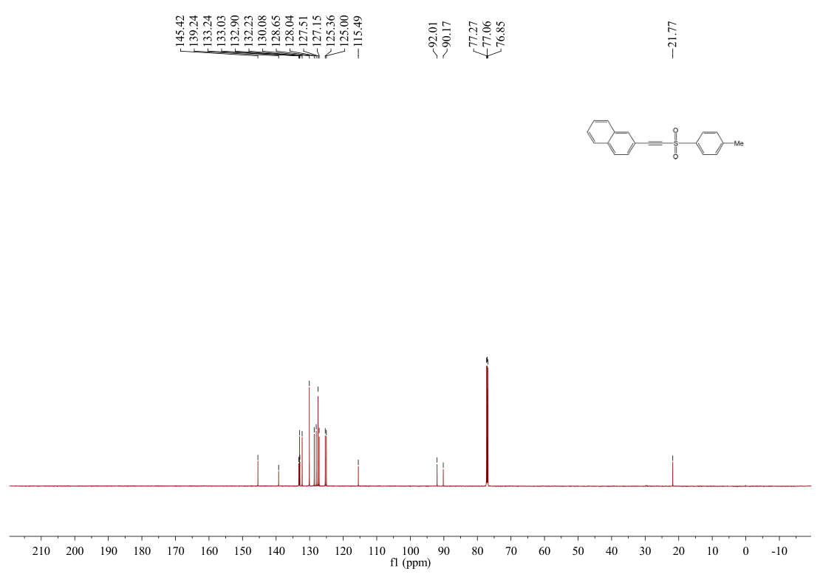

**Fig. S24** 13C NMR spectrum of **3i** (600 MHz, CDCl3, 25 ℃).

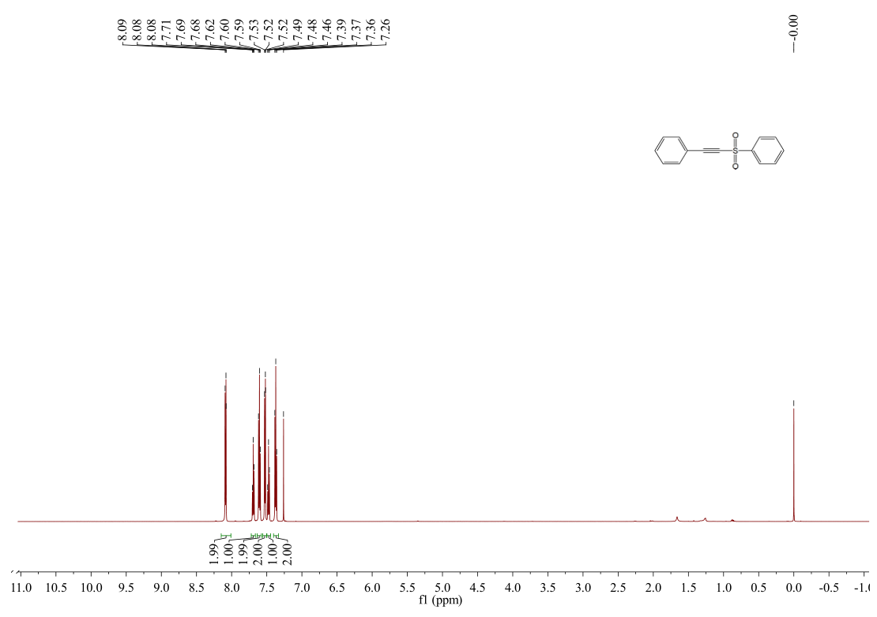

**Fig. S25** 1H NMR spectrum of **3j** (600 MHz, CDCl3, 25 ℃).

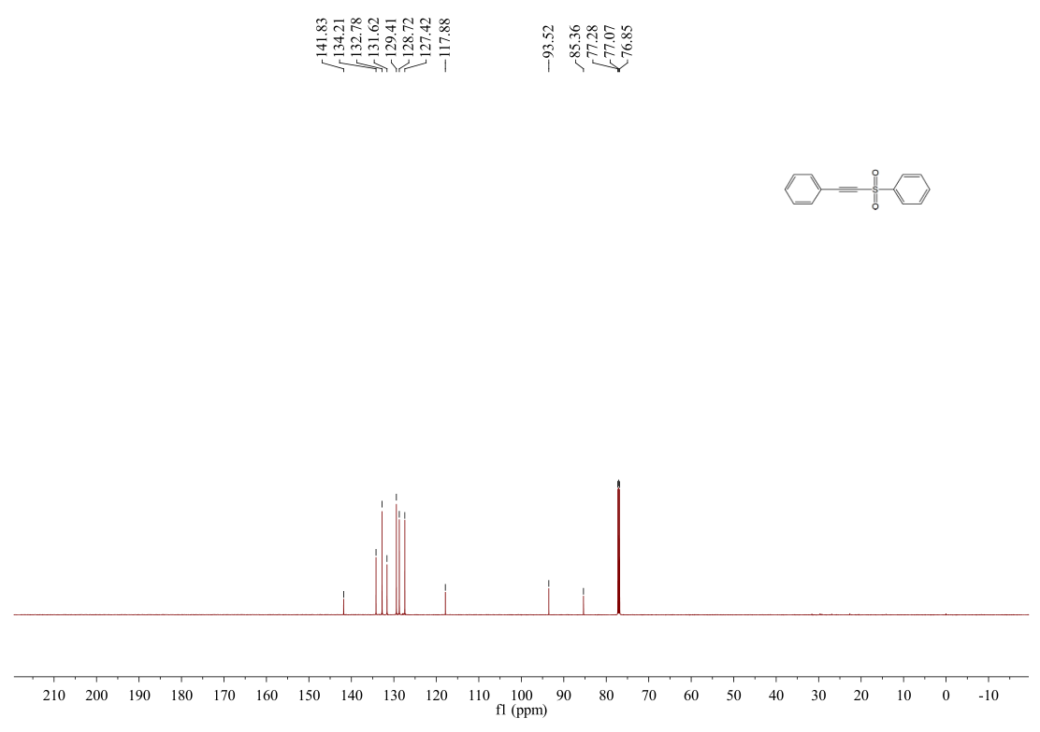

**Fig. S26** 13C NMR spectrum of **3j** (600 MHz, CDCl3, 25 ℃).

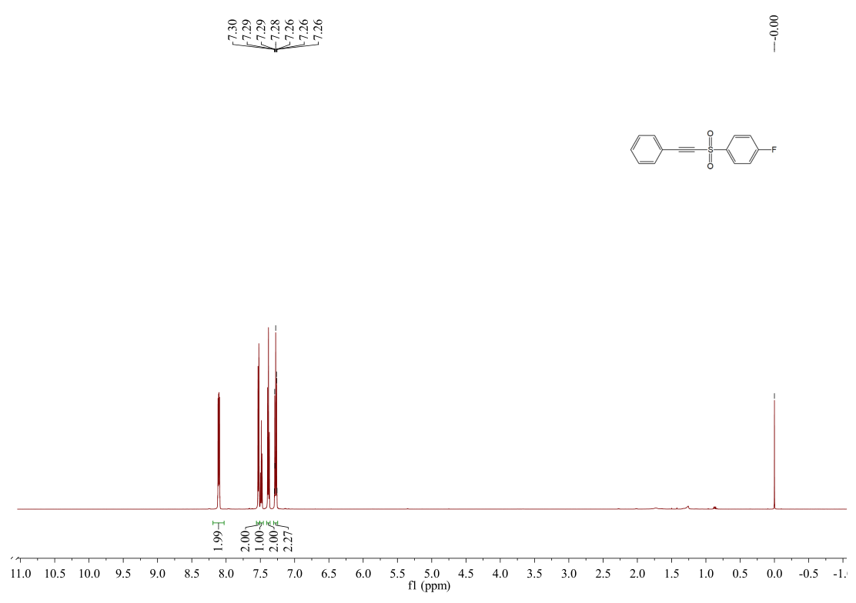

**Fig. S27** 1H NMR spectrum of **3k** (600 MHz, CDCl3, 25 ℃).

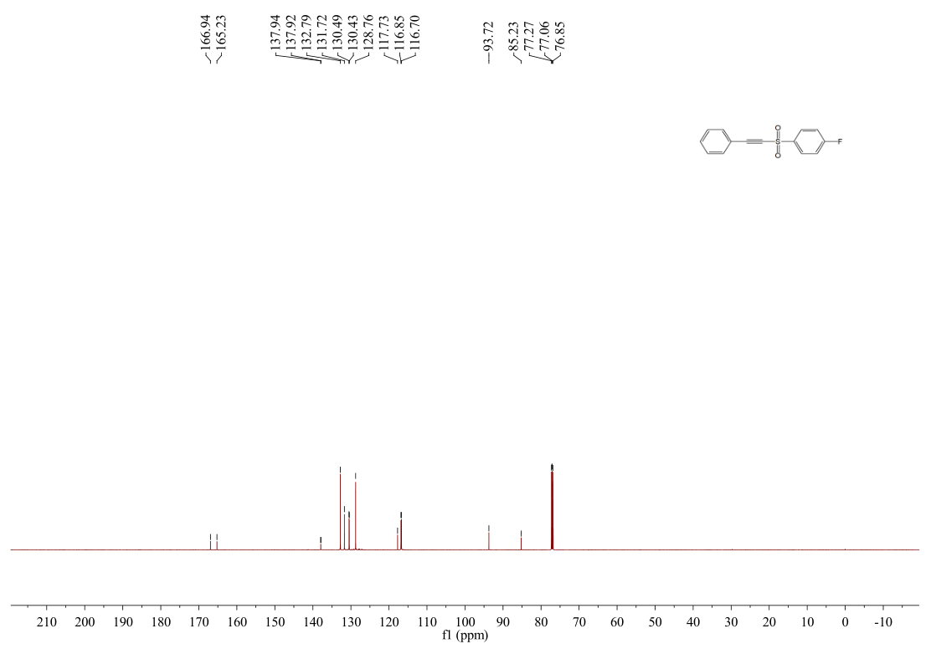

**Fig. S28** 13C NMR spectrum of **3k** (600 MHz, CDCl3, 25 ℃).

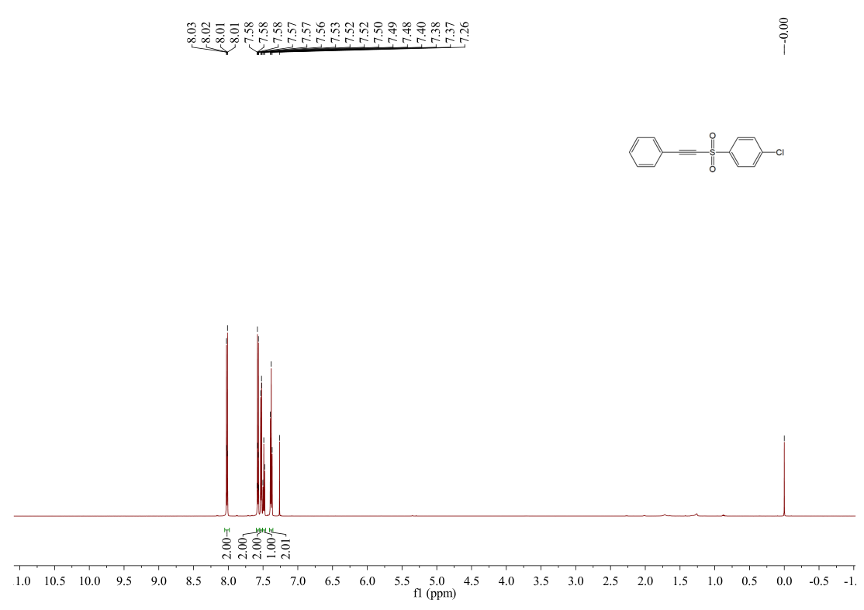

**Fig. S29** 1H NMR spectrum of **3l** (600 MHz, CDCl3, 25 ℃).

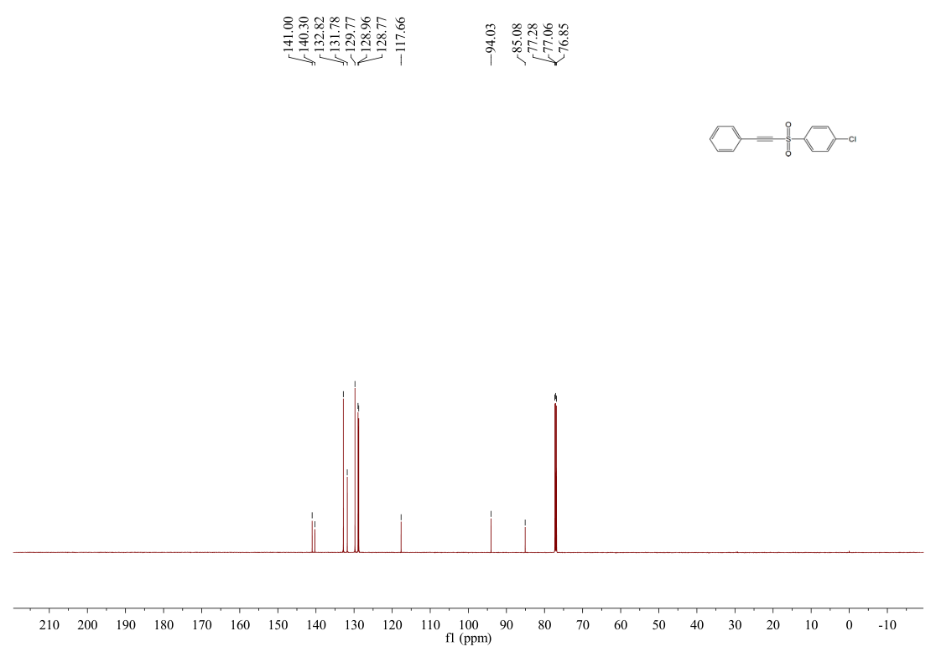

**Fig. S30** 13C NMR spectrum of **3l** (600 MHz, CDCl3, 25 ℃).

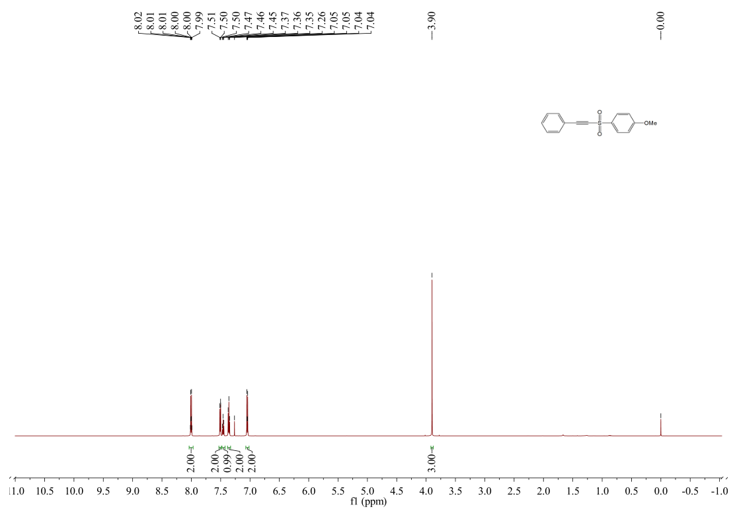**Fig. S31** 1H NMR spectrum of 3m (600 MHz, CDCl3, 25 ℃).

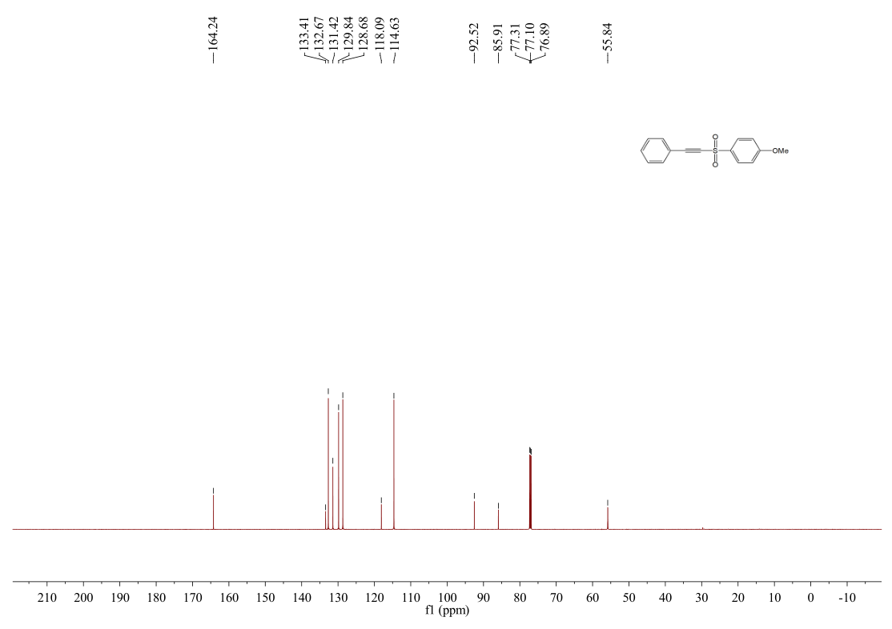 **Fig. S32** 13C NMR spectrum of 3m (600 MHz, CDCl3, 25 ℃).

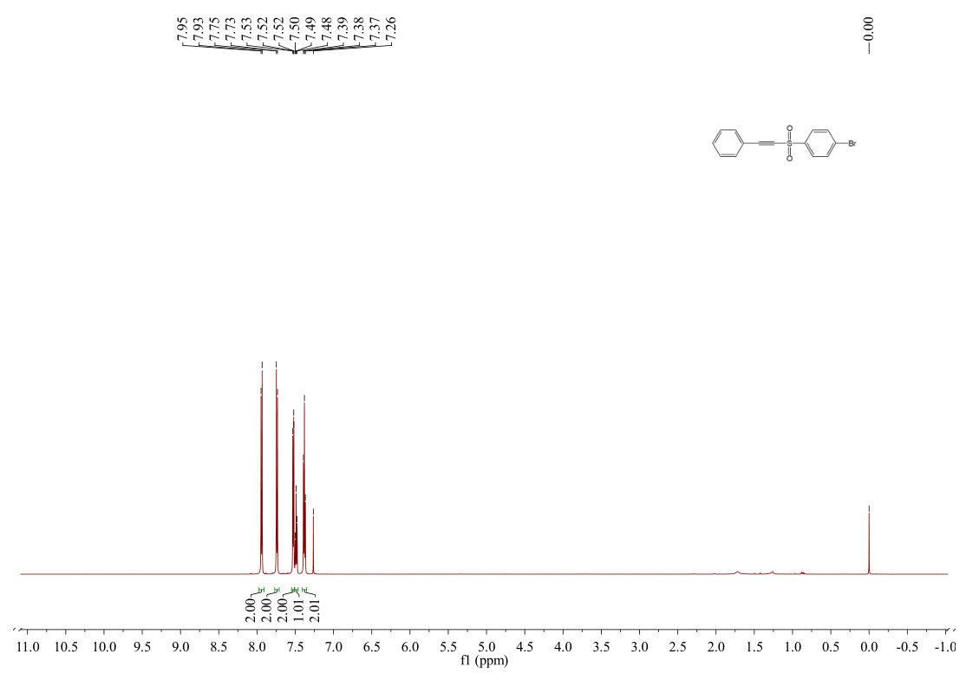

**Fig. S33** 1H NMR spectrum of 3n (600 MHz, CDCl3, 25 ℃).

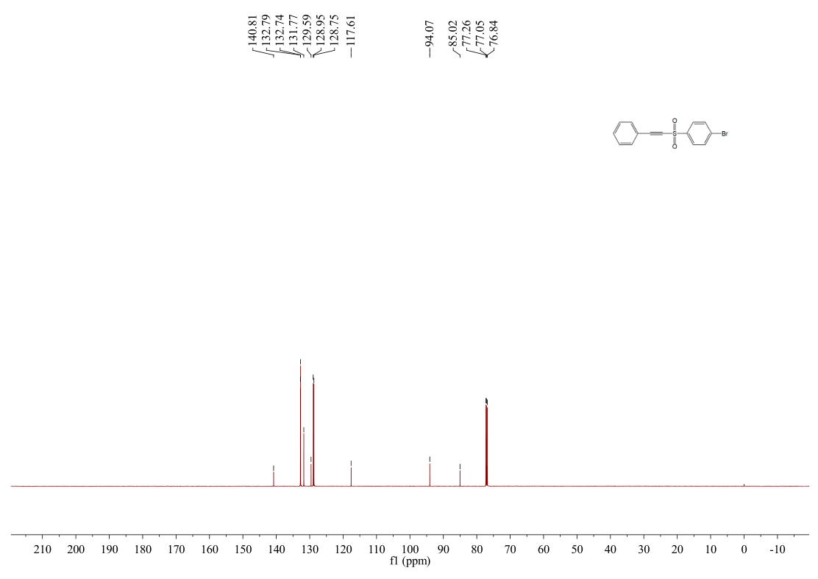

**Fig. S34** 13C NMR spectrum of 3n (600 MHz, CDCl3, 25 ℃).

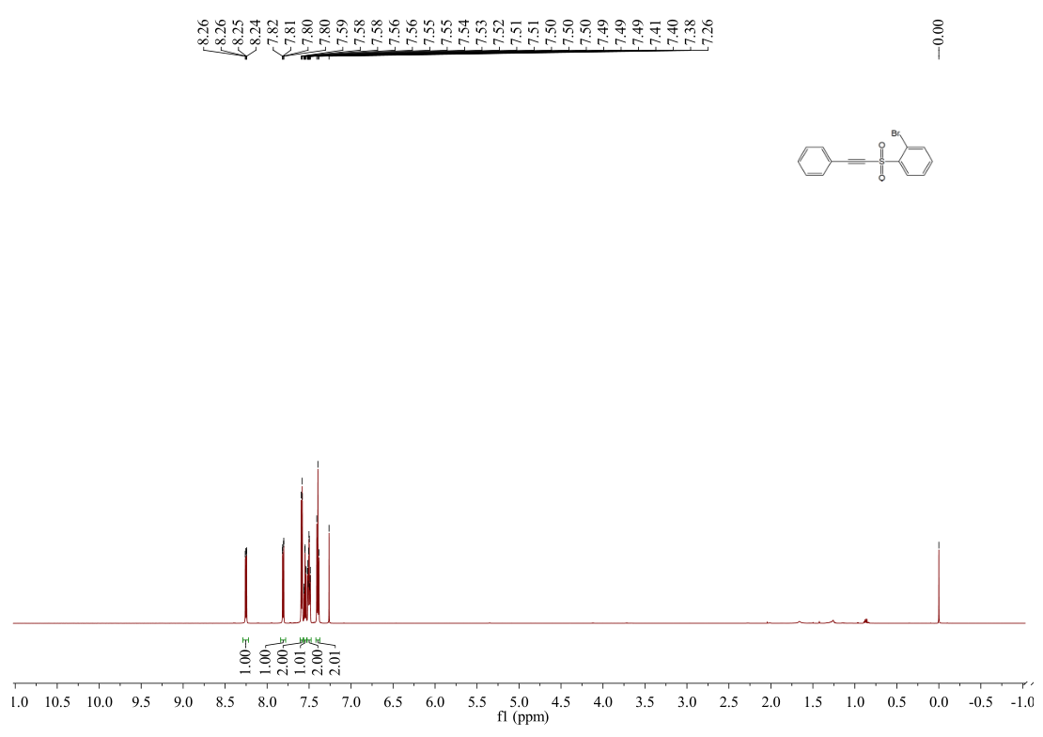

**Fig. S35** 1H NMR spectrum of **3o** (600 MHz, CDCl3, 25 ℃).

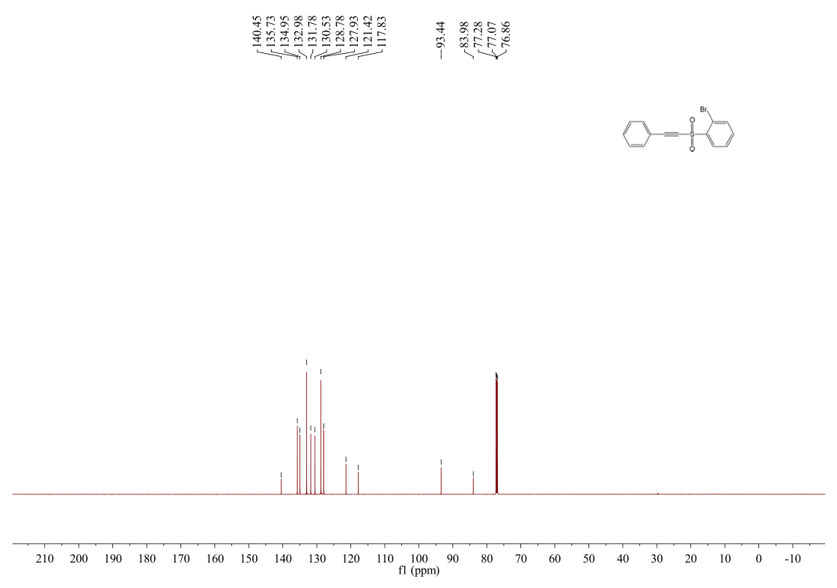

**Fig. S36** 13C NMR spectrum of **3o** (600 MHz, CDCl3, 25 ℃).

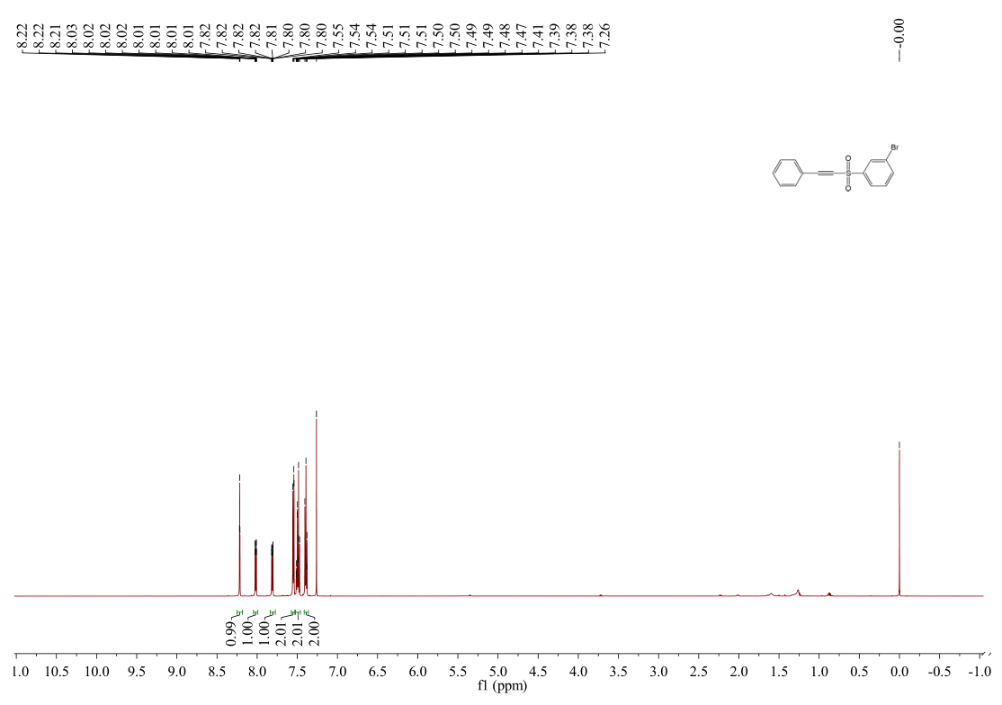

**Fig. S37** 1H NMR spectrum of 3p (600 MHz, CDCl3, 25 ℃).

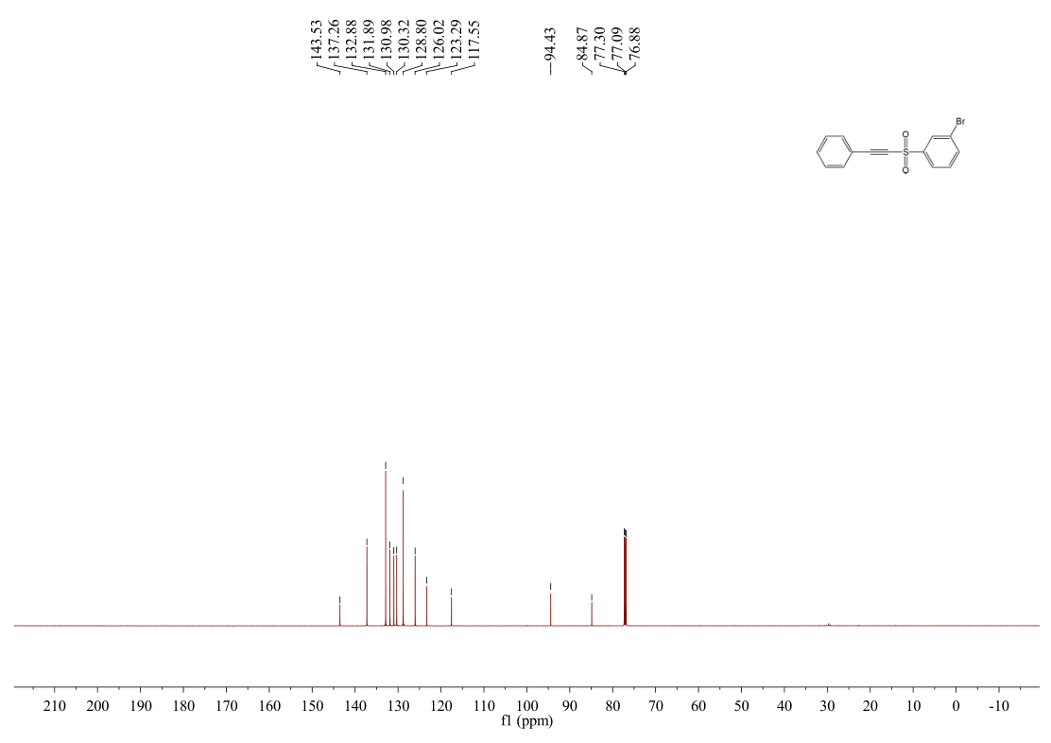 **Fig. S38** 13C NMR spectrum of 3p (600 MHz, CDCl3, 25 ℃).

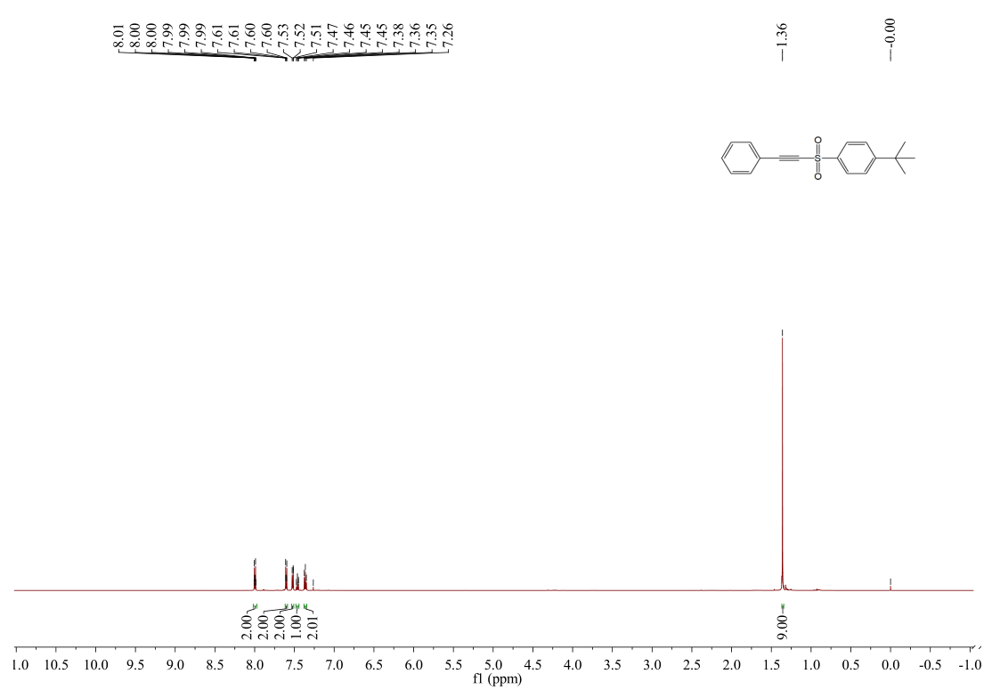

**Fig. S39** 1H NMR spectrum of **3q** (600 MHz, CDCl3, 25 ℃).

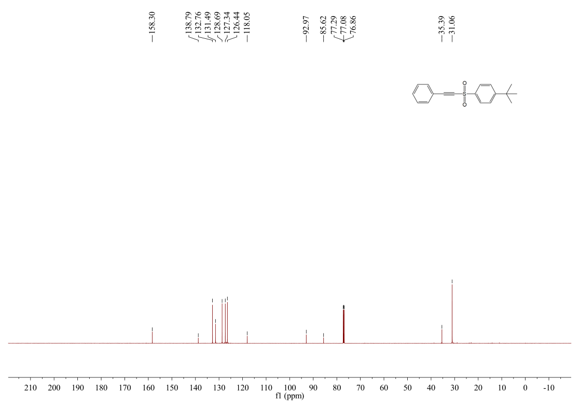

**Fig. S40** 13C NMR spectrum of **3q** (600 MHz, CDCl3, 25 ℃).

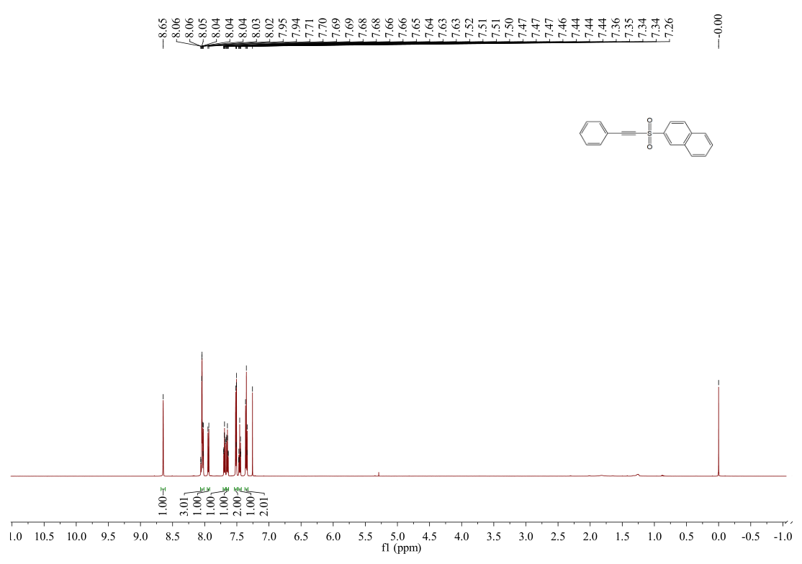

**Fig. S41** 1H NMR spectrum of **3s** (600 MHz, CDCl3, 25 ℃).

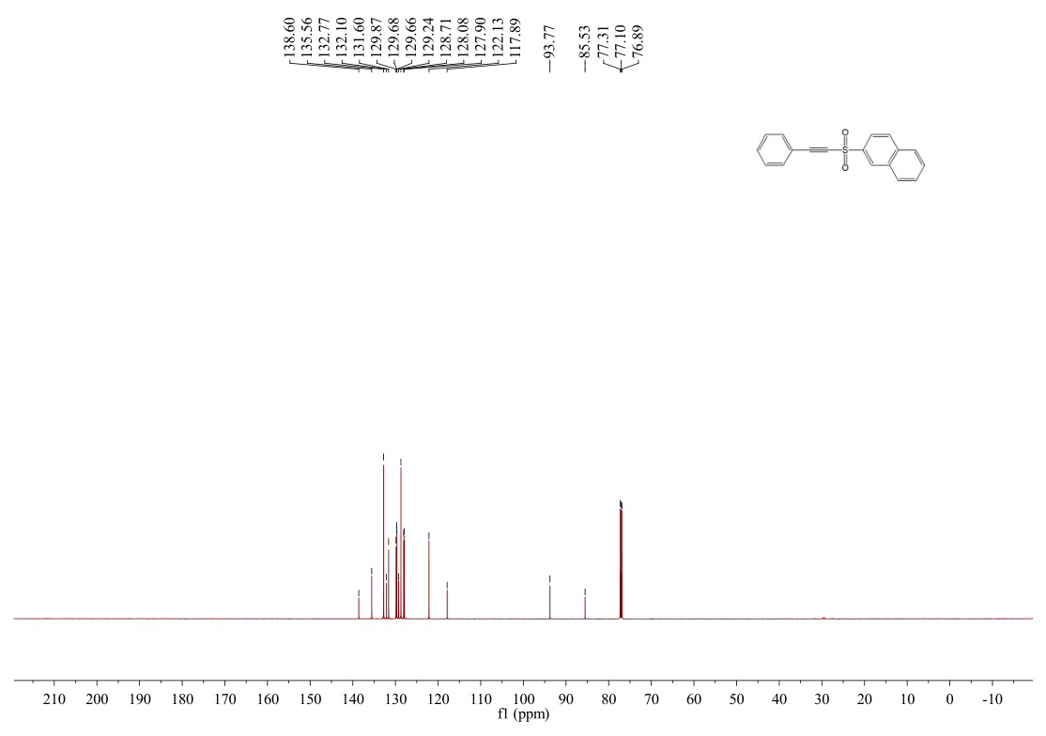

**Fig. S42** 13C NMR spectrum of **3s** (600 MHz, CDCl3, 25 ℃).

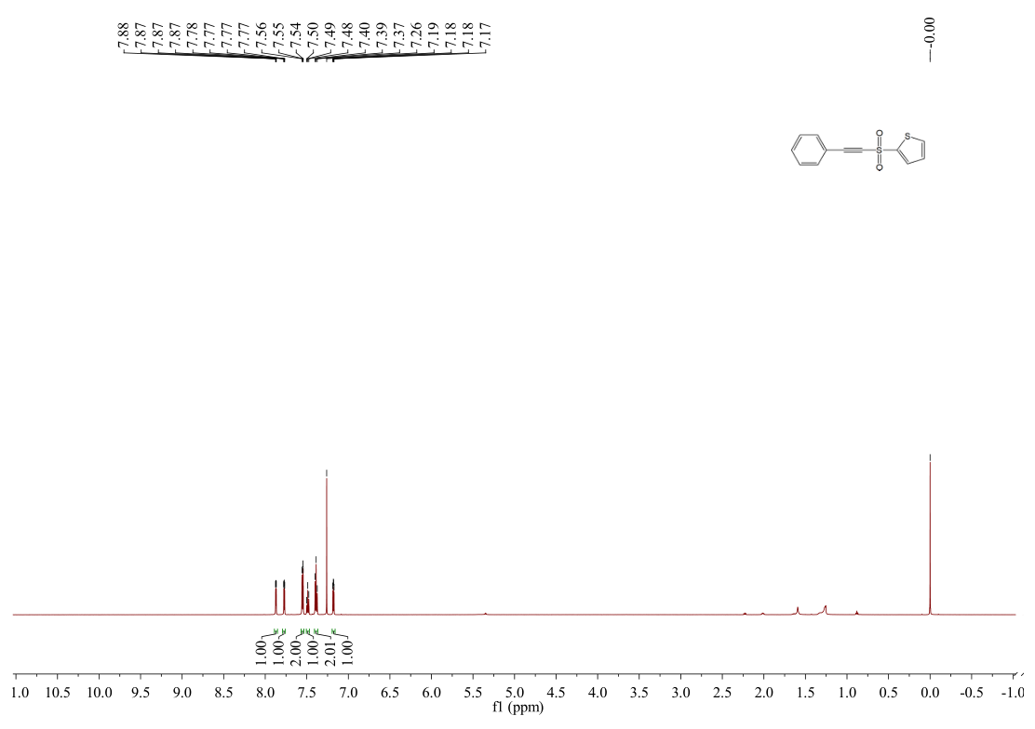

**Fig. S43** 1H NMR spectrum of **3t** (600 MHz, CDCl3, 25 ℃).

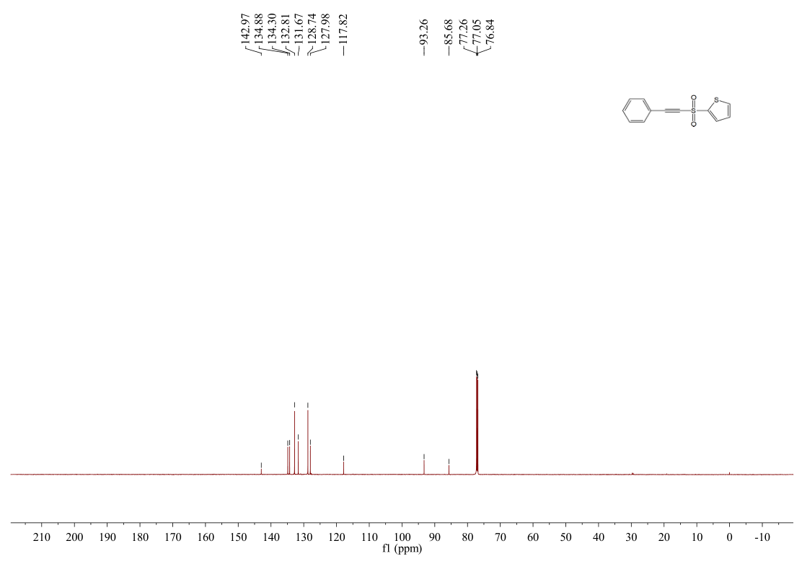

**Fig. S44** 13C NMR spectrum of **3t** (600 MHz, CDCl3, 25 ℃).

References

1 K. Park, T. Palani, A. Pyo, S. Lee, *Tetrahedron Lett.* **2012**, *53*, 733-737.

2 A. U. Meyer, S. Jäger, D. Prasad Hari, B. König, *Adv. Synth. Catal.* **2015**, *357*, 2050-2054.

3 P. Chen, C. Zhu, R. Zhu, W. Wu, H. Jiang, *Chem-Asian J.* **2017**, *12*, 1875-1878.

4 J. Meesin, P. Katrun, C. Pareseecharoen, M. Pohmakotr, V. Reutrakul, D. Soorukram, C. Kuhakarn, *J. Org. Chem.* **2016**, *81*, 2744-2752.

5 L. Wang, W. Wei, D. Yang, H. Cui, H. Yue, *Tetrahedron Lett.* **2017**, *58*, 4799-4802.