**Figure (S1):** The effect of different concentrations of chemical compounds (100, 50, 25, 15 and 10 mg/ml) on mycelium growth of *F. oxysporium* for 7 days at 27°C in dark.

2

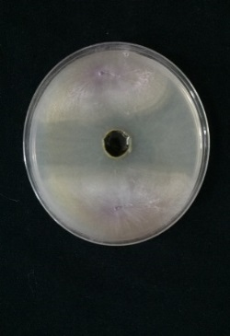

333

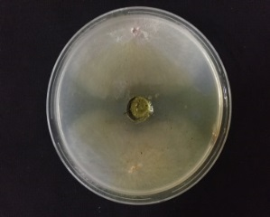

1

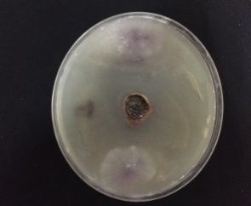

5

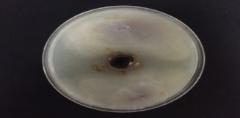

4

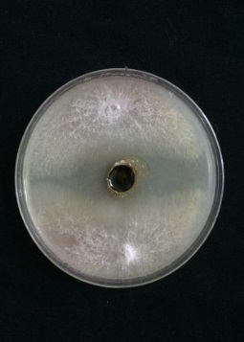

**Fig. (S2).** Effect of compound **1** with different concentration on the mycelium growth of *Fusarium oxysporum* cultivated in PDA medium after 6 days at 28˚C in the dark. Inhibition zones represent the influence. (1) Well embedded with 1 (100mg/ml), (2) well embedded with 1 (50 mg/ml), (3) well embedded with 1 (25 mg/ml), (4) well embedded with 1 (15 mg/ml), (5) well embedded with 1 (10 mg/ml).

**Fig. (S3).** Diameter of mycelium growth (DCM) and inhibition (%) of *F. oxysporum* exposed to different chemical compounds.

|  |  |
| --- | --- |
| **A** | **B** |
| **C** | **D** |

**Fig. S4**: Scanning Electron micrograph of *Fusarium oxysporum* from the inhibition zone treated with "4" compound (25mg/ml). (A&B) showing abnormal structure: perforation on mycelium, lysis of cell and destruction of both the mycelium and conidia of *F. oxysporum*; (C &D) control showing healthy intact mycelia and conidia of *F. oxysporum*.

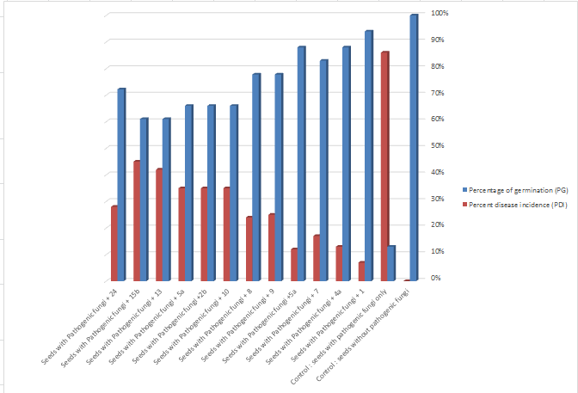

**Fig. (S5):** Effect of tested chemical compounds on germination (%) and disease incidence (%) of tomato seeds, which were incubated in growth cabinet at 25ₒC with 12h photoperiod (91µmol m-2S-1.

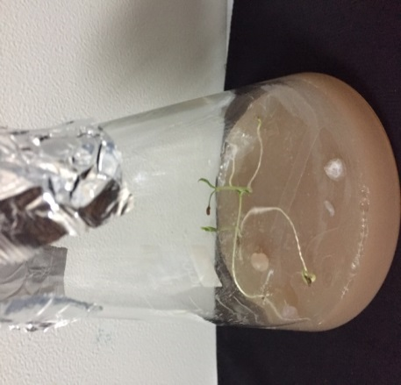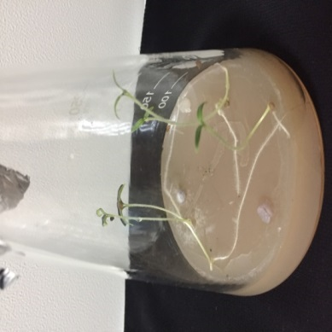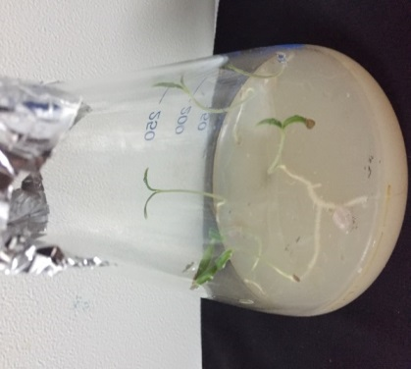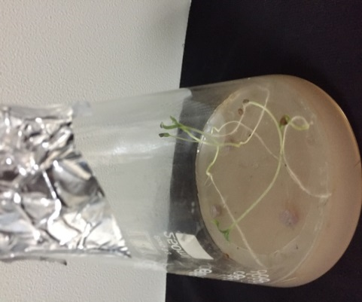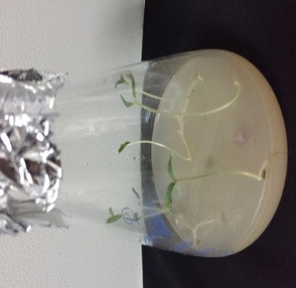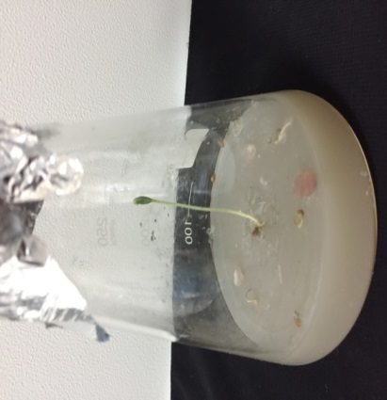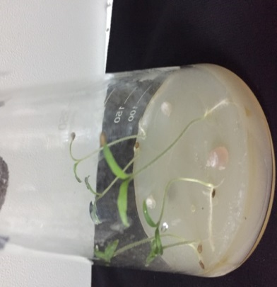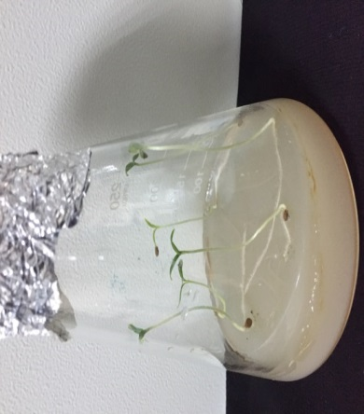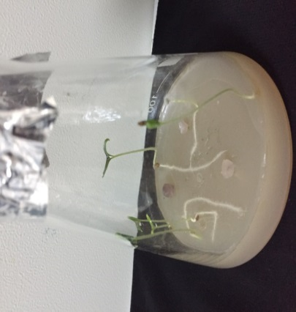

4

5

7

1

2

3

6

8

9

**Fig (S6):** Effect of tested chemical compounds (**25** mg/ml) against *F. oxysporum* on Erlenmeyer flasks containing 2% water agar medium cultivated with tomato seeds. (1) Healthy seedling, grown in water agar medium. (2) damping-off tomato germinating seeds caused by *F. oxysporum*. (3) Seedling grown in water agar medium infested with both *F. oxysporum* and **1**. (4) Seedling grown in water agar medium infested with both *F. oxysporum* and **7**.(5) Seedling grown in water agar medium infested with both *F. oxysporum* and **4a**. (6) Seedling grown in water agar medium infested with both *F. oxysporum* and **5a**.(7) Seedling grown in water agar medium infested with both *F. oxysporum* and **9**.(8) Seedling grown in water agar medium infested with both *F. oxysporum* and **12**. (9) Seedling grown in water agar medium infested with both *F. oxysporum* and **3**.

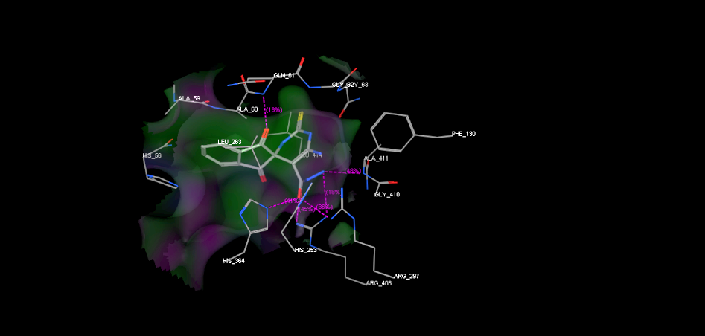

(**A**)

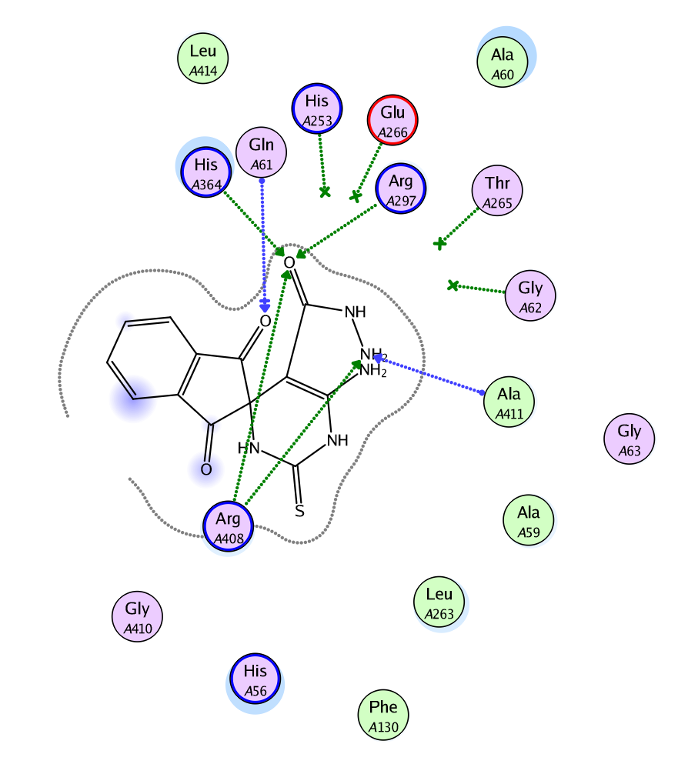

(**B**)

**Fig.S7.** The suggested binding of compound **7** within SDH active site. A) 3D, B) 2D binding interaction.

).

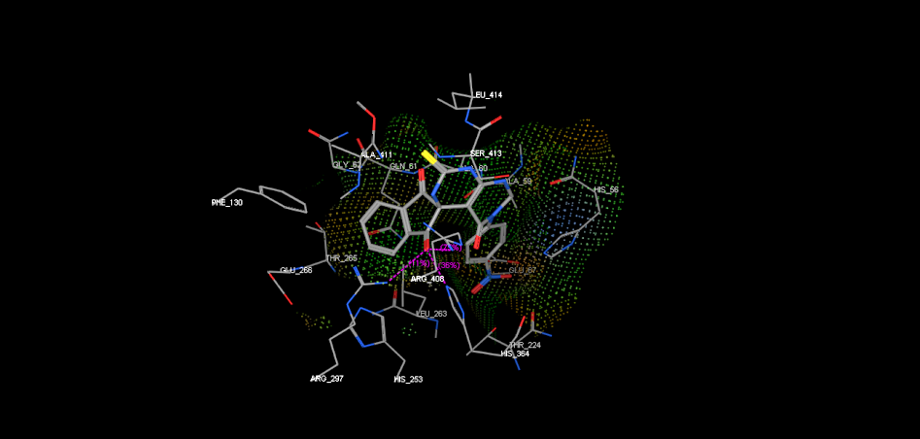

(A)

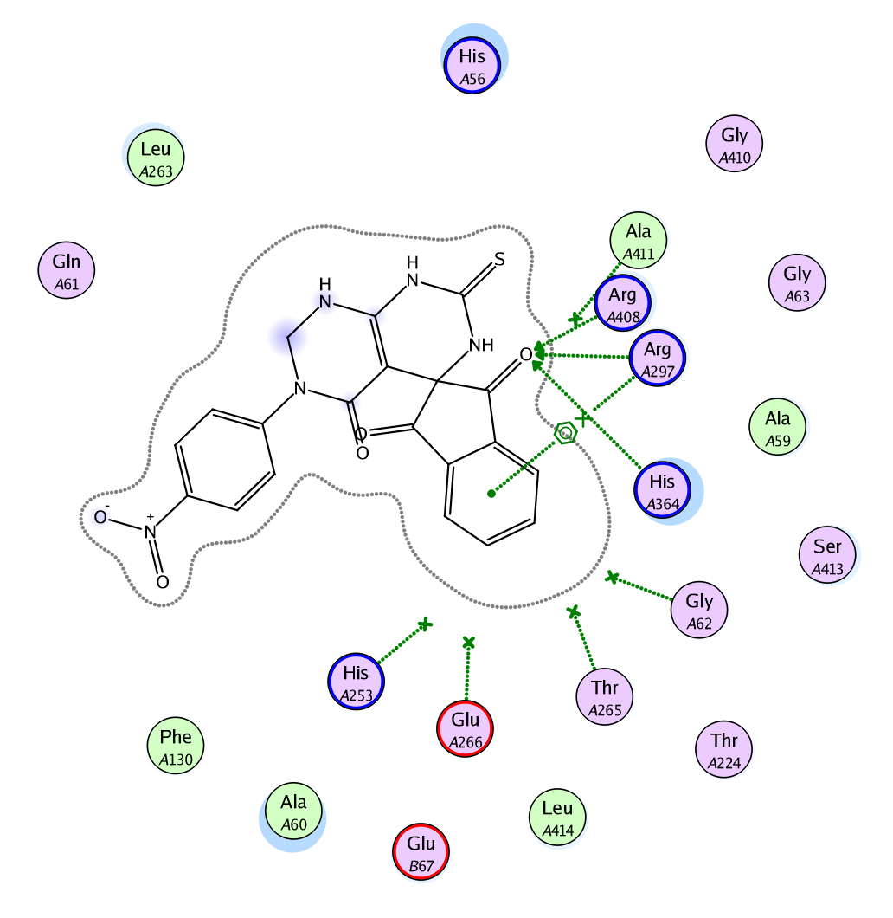

(B)

**Fig.S8.** The suggested binding of compound **5a** within SDH active site. A) 3D, B) 2D binding interaction.

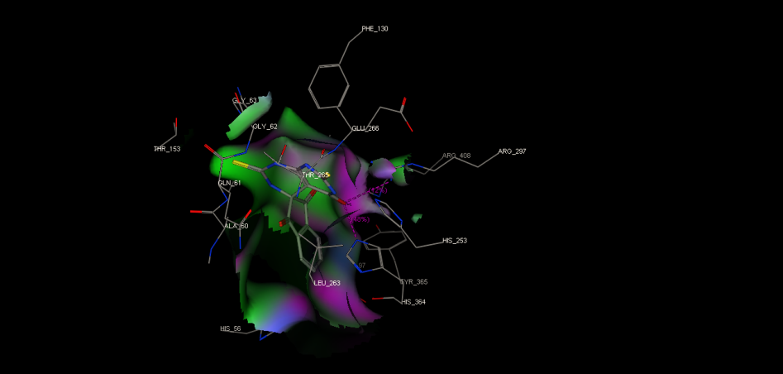

**(A)**

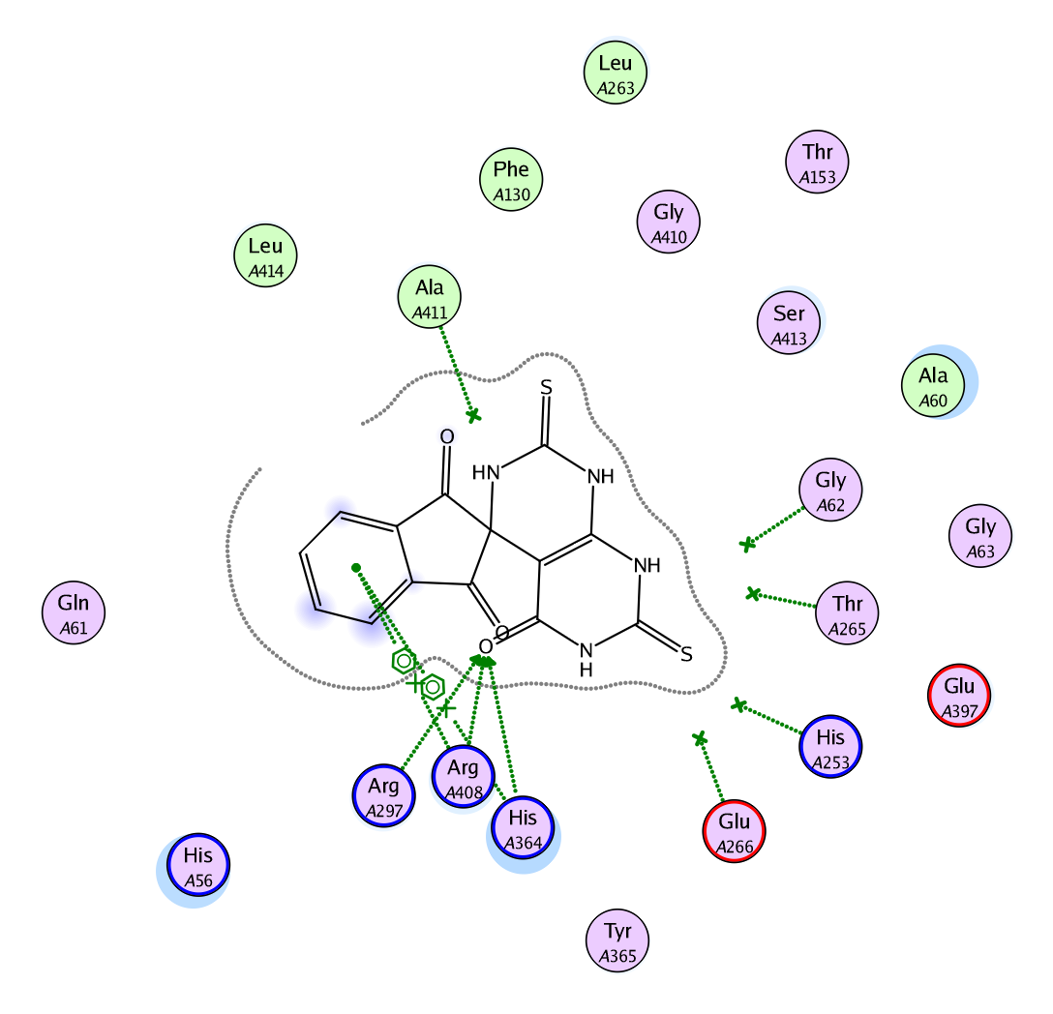

**(B)**

**Fig.S9.** The suggested binding of compound **2b** within SDH active site. A) 3D, B) 2D binding interaction.

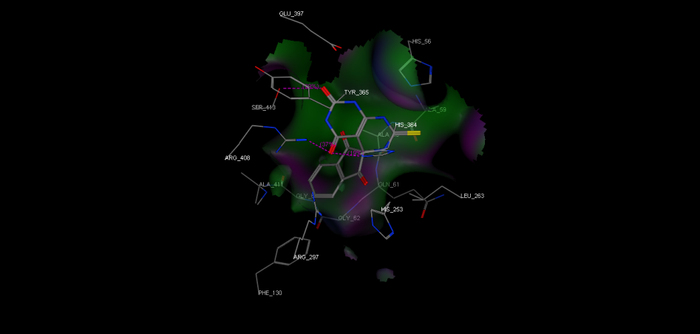

(**A**)

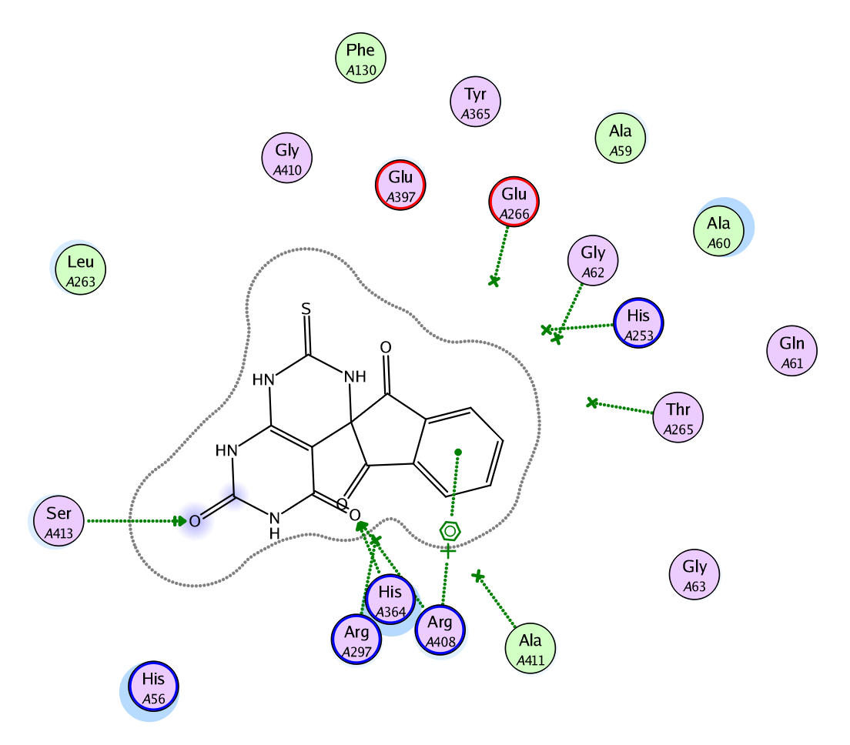(**B**)

**Fig.S10.** The suggested binding of compound **2a** within SDH active site. A) 3D, B) 2D binding interaction.

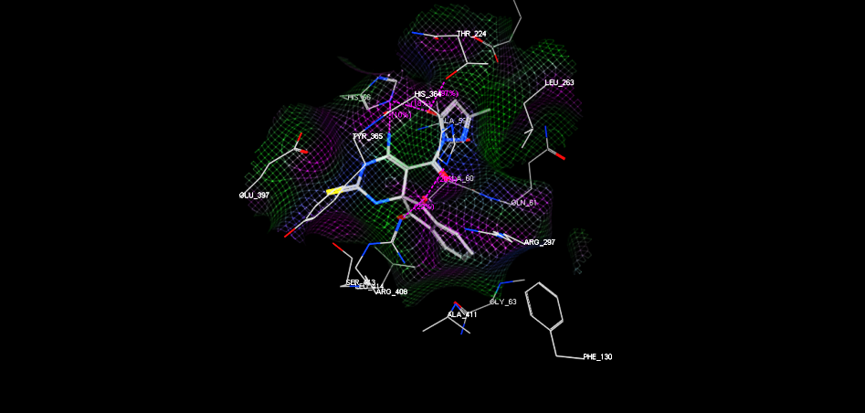

(A)

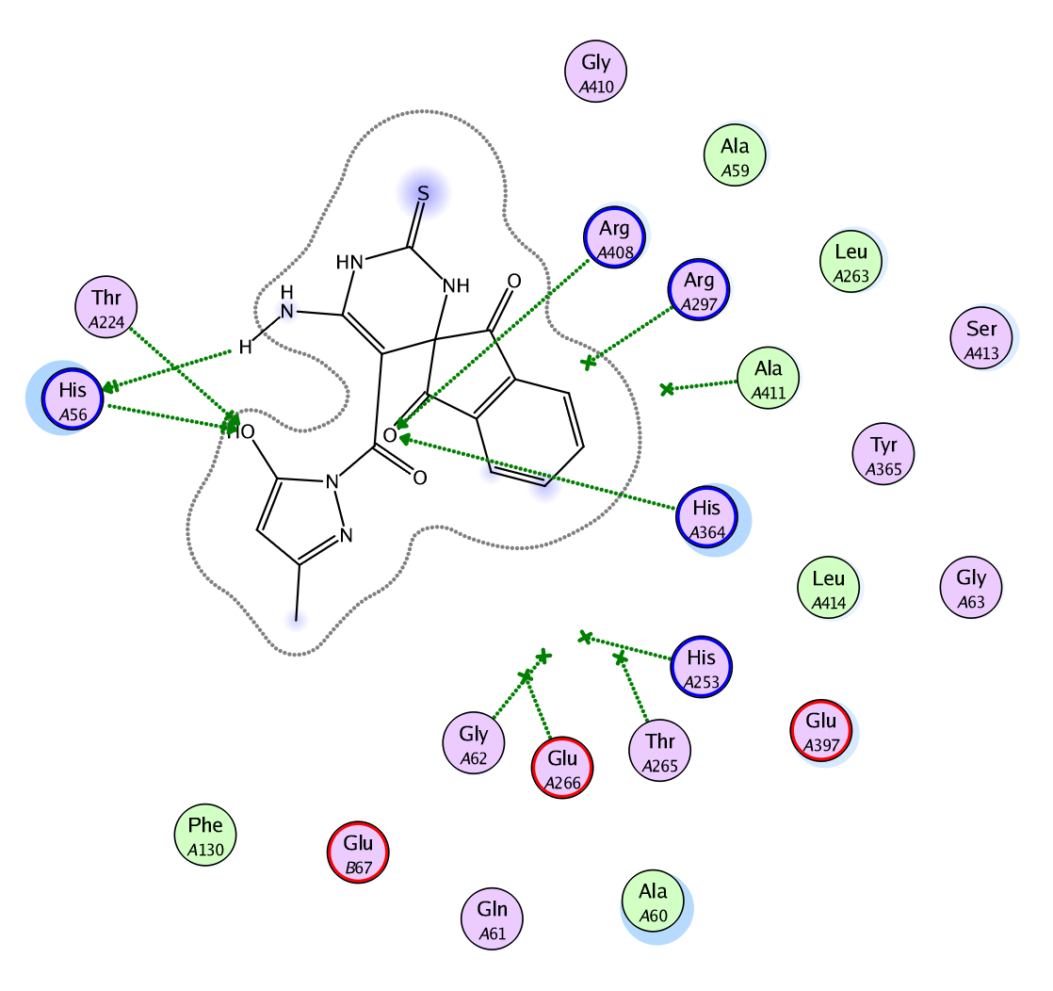

**(B)**

**Fig.S11.** The suggested binding of compound **8** within SDH active site. A) 3D, B) 2D binding interaction.

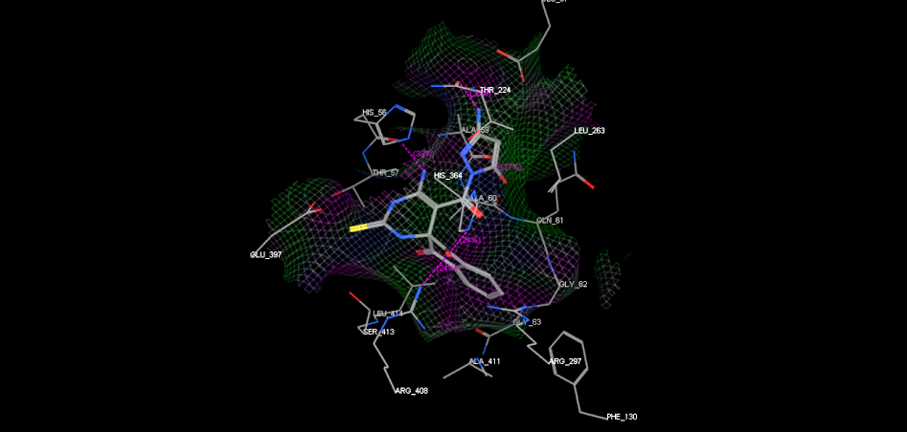

(**A**)

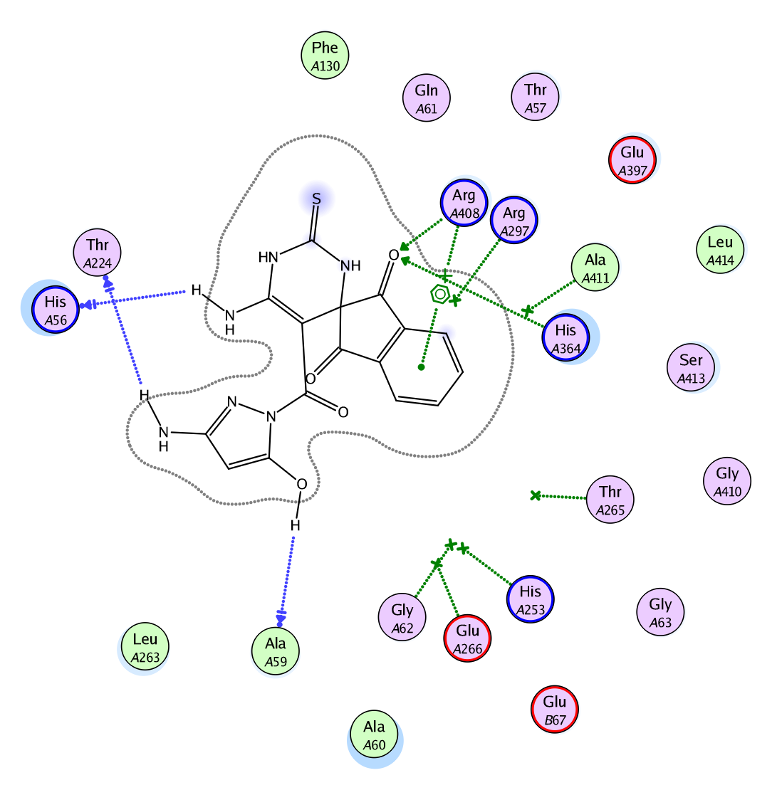

(**B**)

**Fig.S12.** The suggested binding of compound **9** within SDH active site. A) 3D, B) 2D binding interaction.

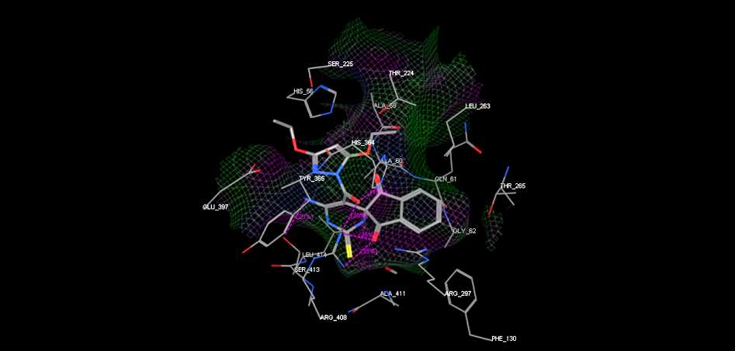

(A)

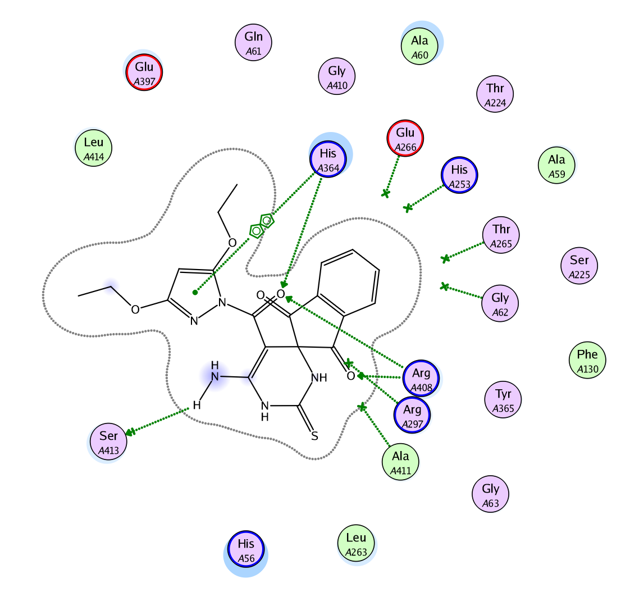

(**B**)

**Fig.S13.** The suggested binding of compound **10** within SDH active site. A) 3D, B) 2D binding interaction.

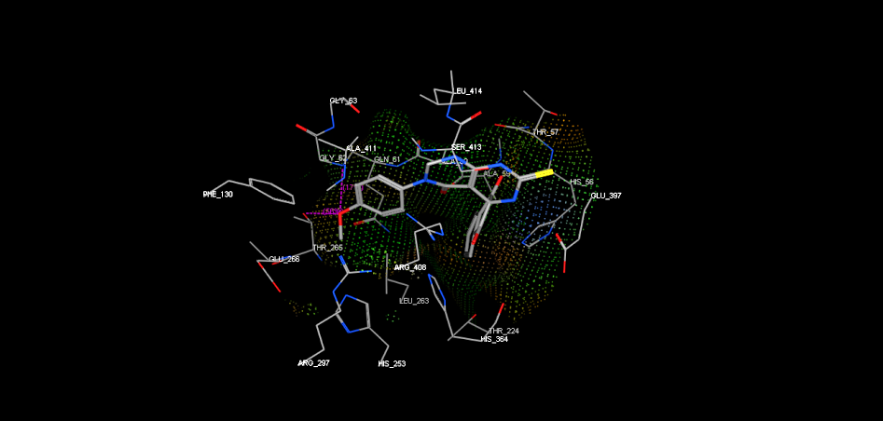

(A)

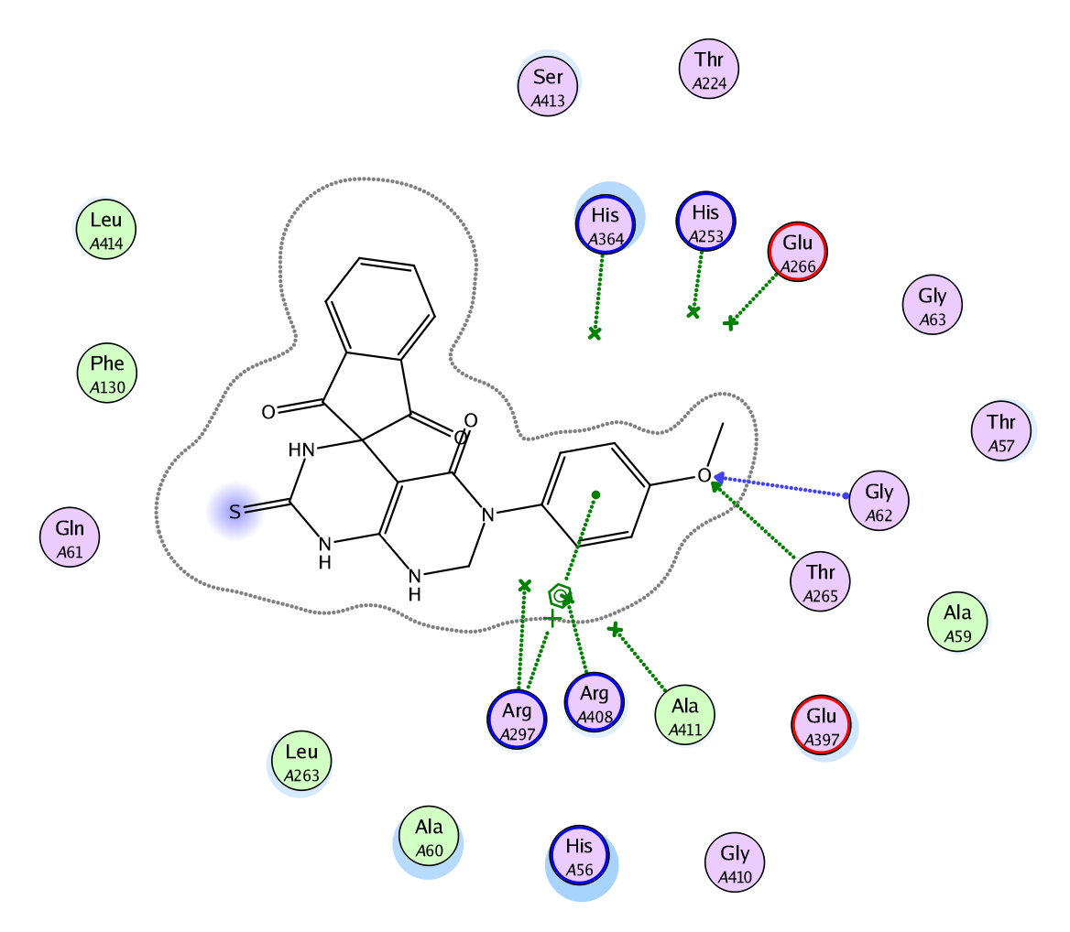

(B)

**Fig.S14.** The suggested binding of compound **5b** within SDH active site. A) 3D, B) 2D binding interaction.

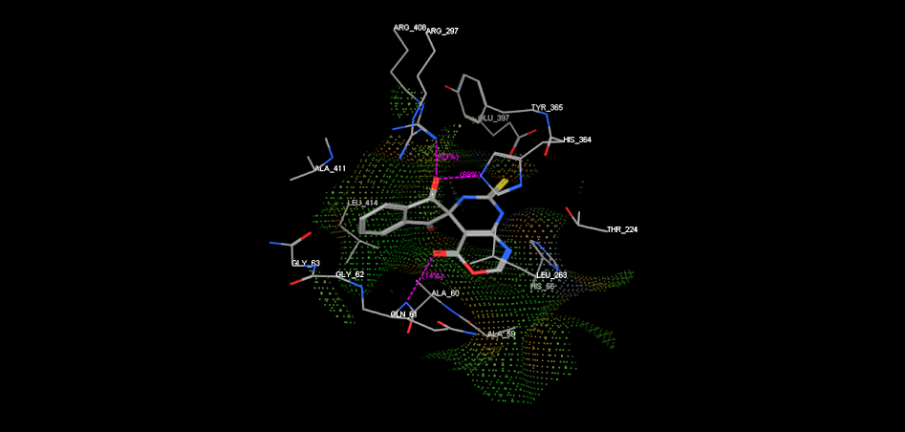

(A)

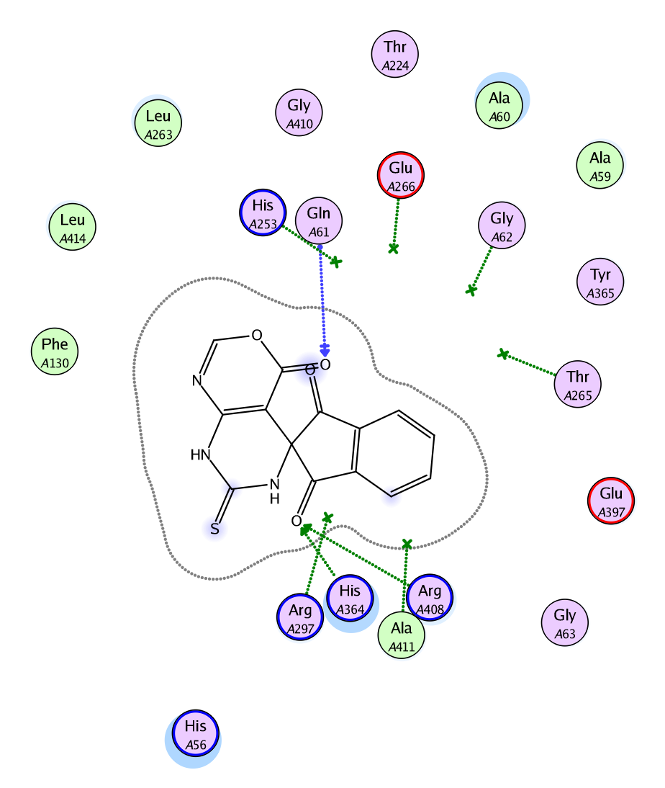

(B)

**Fig.S15.** The suggested binding of compound **3** within SDH active site. A) 3D, B) 2D binding interaction.

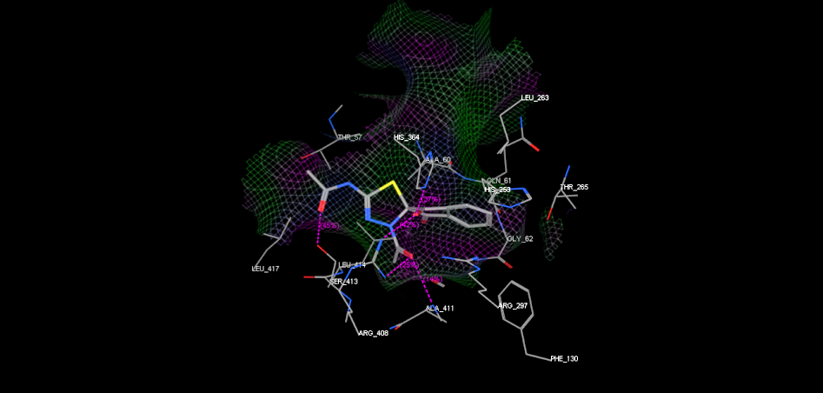

(A)

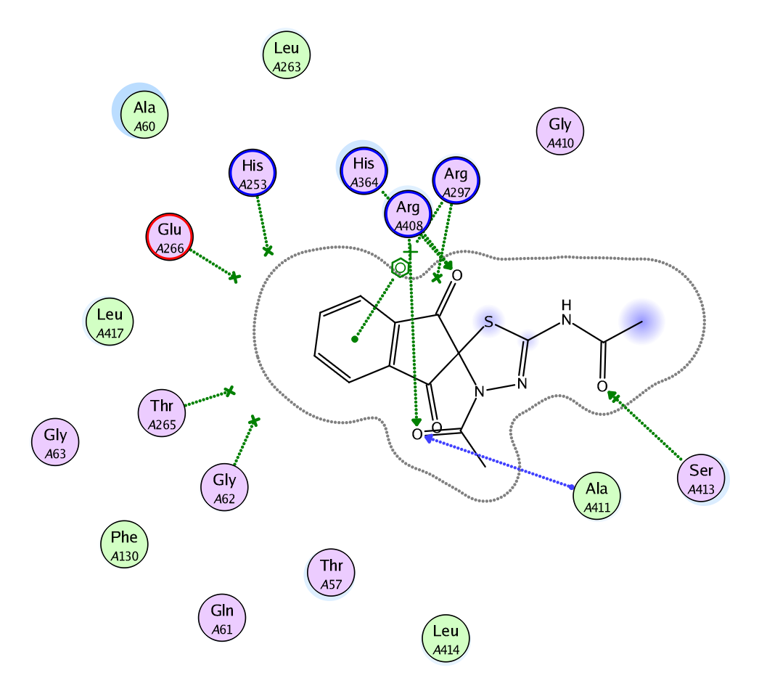

**Fig.S16.** The suggested binding of compound **12** within SDH active site. A) 3D, B) 2D binding interaction.