**Synthesis, characterization, biological and docking studies of ZrO(II), VO(II) and Zn(II) complexes of halogenated tetra-dentate Schiff base**

Laila H. Abdel-Rahman1*, Mohamed Shaker S. Adam1, Nabil Al-Zaqri2 , Mohamed R. Shehata3, Hanan El-Sayed Ahmed1 and Shaaban K. Mohamed 4,5

1Department of Chemistry, Faculty of Science, Sohag University, Sohag 82534, Egypt

2Department of Chemistry, College of Science, King Saud University, Riyadh 11451, Saudi Arabia

3 Department of Chemistry, Faculty of Science, Cairo University, Giza, 12613, Egypt

4 Chemistry and Environmental Division, Manchester Metropolitan University, Manchester M1 6GD, England

5Chemistry Department, Faculty of Science, Minia University, 61519 El-Minia, Egypt.

Correspondence: [Laila.abdelrahman@science.sohag.edu.eg](mailto:Laila.abdelrahman@science.sohag.edu.eg), lailakenawy@hotmail.com

Starting reagents and solvents that were utilized in this research are commonly available in pure form and used without further purification.Organic compounds, 4-chloro-o-phynelendiamine and 5-bromo-salicyaldehyde and metal salts Zirconium(IV) oxychloride octahydrate (ZrOCl2⋅8H2O), vanadyl acetylacetonate (VO(C5H7O2)2) and zinc(II) acetate dehydrate (Zn(acac)2⋅2H2O) were obtained from Sigma‐Aldrich. Ethanol, N,N\-dimethylforamide (DMF) and N,N\-dimethylsulfoxide (DMSO) were used without distillation. DPPH (1,1-diphenyl-2-picryl-hydrazyl) radical scavenging activity evaluation and ascorbic acid were used in antioxidant activity studies and purchased from Sigma–Aldrich. The studied compounds were examined against human colorectal colon cancer (HCT-116 adenocarcinoma cell lines), normal cell line (HEK-293), breast cancer (MCF-7 adenocarcinoma cell lines) and hepatic cancer (HepG-2 adenocarcinoma cell lines) at Cairo University, Pharmacology Department, Cancer Biology Department and the National Cancer Institute. The absorbance for each well was determined with an ELISA microplate reader (Σ960, Meter Tech, USA) at 564 nm. To estimate antimicrobial activity, selected strains of bacteria (*Escherichia coli (-ve), Serratia marcescensas (-ve) and Micrococcus luteus (+ve))* and fungi *(Geotrichum candidum, Aspergillus flavus, and Fusarium oxysporum*) were used. These strains are grown in nutrient agar and Muller-Hinton medium. Ofloxacin and Fluconazole are used as standard drug for comparison. The important reagents for DNA interaction studies, Calf-thymus DNA (CT-DNA), 2-amino-2-hydroxyl methyl-propane-1,3- diol (Tris) and ethylenediaminetetraacetic acid (EDTA) were purchased from Sigma–Aldrich. CT-DNA dissolved in Tris-HCl buffer (pH=7.2) which was prepared using deionized water. Tris-HCl buffer (pH=7.2) is used to control the pH of the reaction system. TBE Buffer (Tris-borate-EDTA) (50X), Top Vision Agarose, ethidium bromide solution (10 mg/mL), 6X DNA Loading Dye and 100 bp DNA Ladder are utilized in gel electrophoresis and purchased from Thermo Fisher Scientific.

1H and 13C NMR spectra of the ligand were scanned by utilizing a Bruker Advance DPX‐500 spectrometer. PXRD, UV–visible, FT-IR, mass spectra and elemental analyses of the prepared compounds were determined using  [Bruker](https://www.bruker.com/products/x-ray-diffraction-and-elemental-analysis/x-ray-diffraction.html) D8 Advance, UV-Vis spectrophotometer Q5000, a Shimadzu FTIR‐8300 spectrophotometer, DI analysis Shimadzu Qp-2010 plus and an elemental analyzer (PerkinElmer 240c), respectively. Thermogravimetric analysis was conducted with a heating rate 10 min-1 with DTG 60H Detector. Magnetic and conductivity measurement was measured utilizing a Gouy’s balance and a Jenway 4510 conductivity meter, respectively. An Elico digital pH meter (model LI‐127) equipped with a CL‐51B combined electrode was used for pH measurements and calibrated against standard buffers (pH 4.02 and 9.18) before measurements.

Figures S



Figure S1: Continuous variation plots for the prepared chelates 10-2 M and 298 K.



Figure S2: molar ratio plots for the prepared chelates 10-2 M and 298 K.

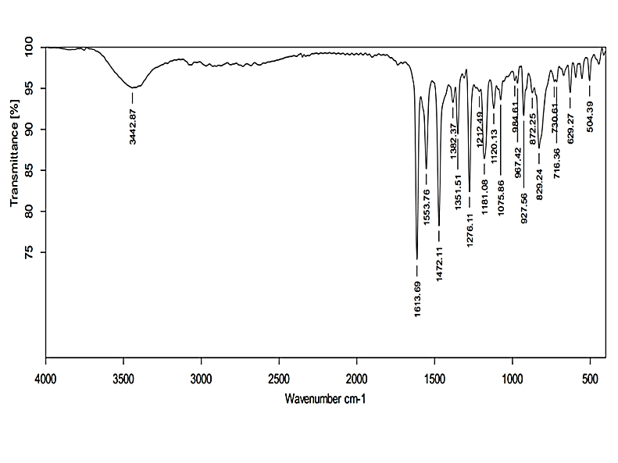

Figure S3: IR spectrum of the H2L ligand.

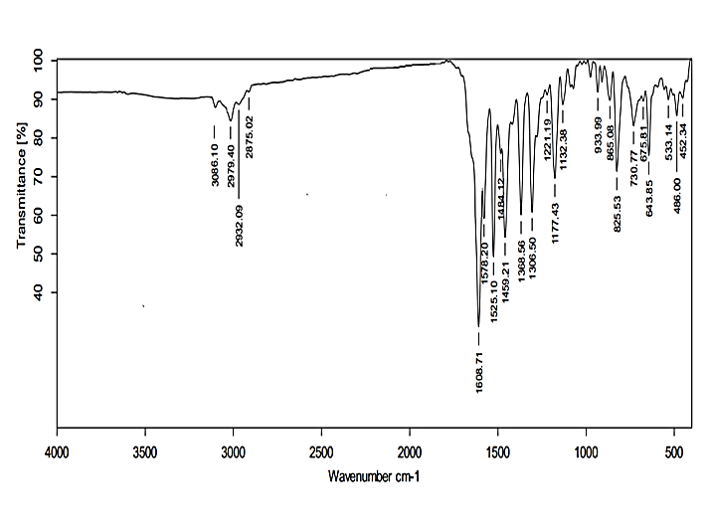

Figure S4: IR spectrum of the ZrOL complex.

`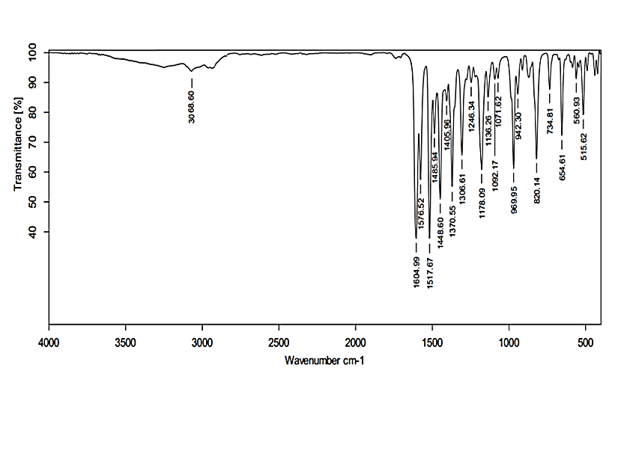

Figure S5: IR spectrum of the VOL complex.

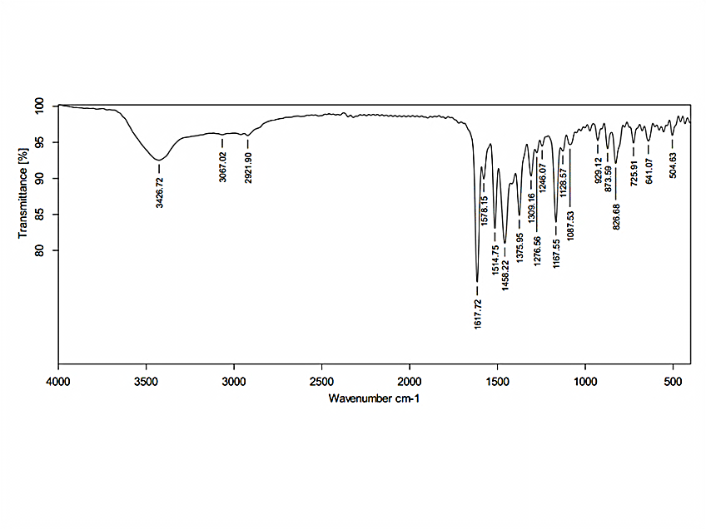

Figure S6: IR spectrum of the ZnL(H2O)2 complex.



Figure S7: The 1HNMR spectrum of the ZnL(H2O)2 complex.

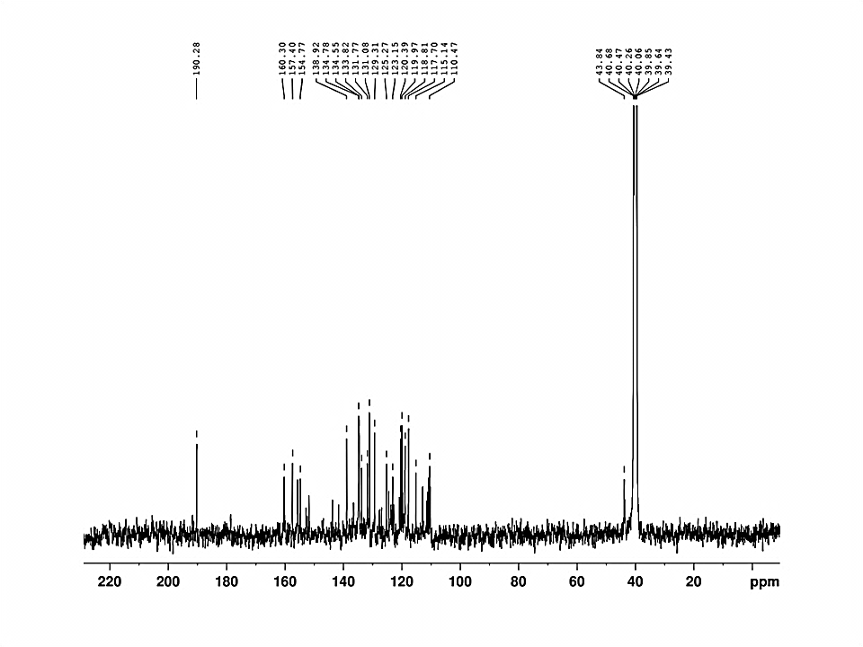

Figure S8: The 13C{1H} NMR spectrum of the prepared H2L imine ligand.

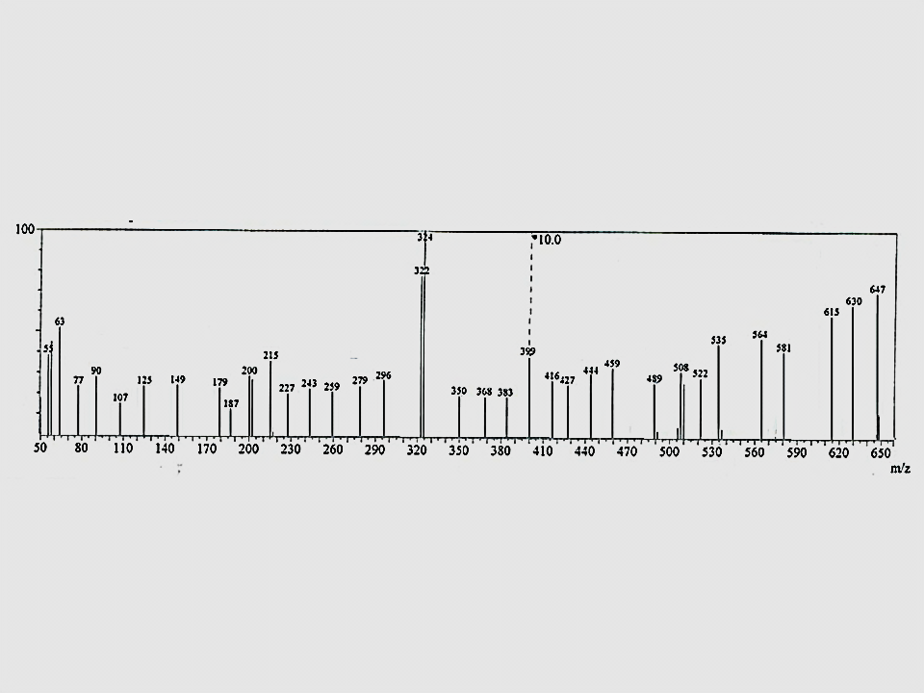

Figure S9:ESI-mass spectrum of ZrOL complex.

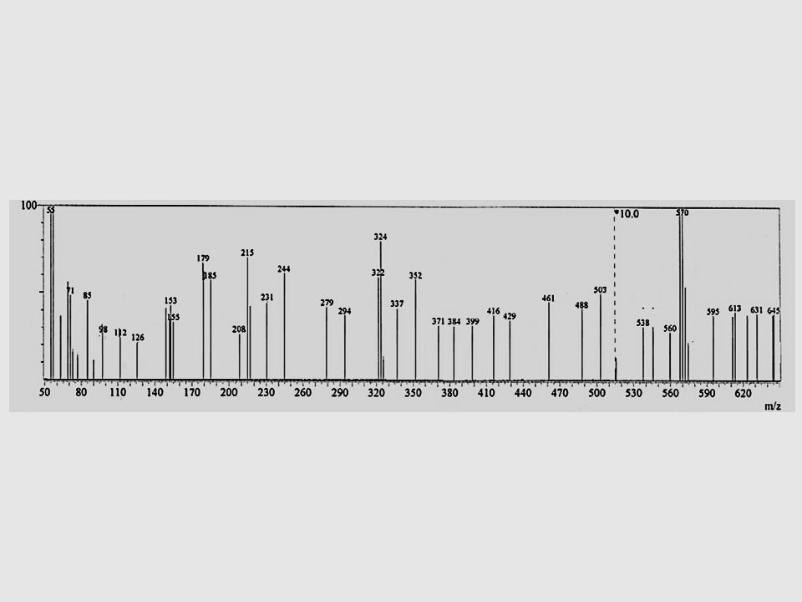

Figure S10:ESI-mass spectrum of ZnL(H2O)2 complex.

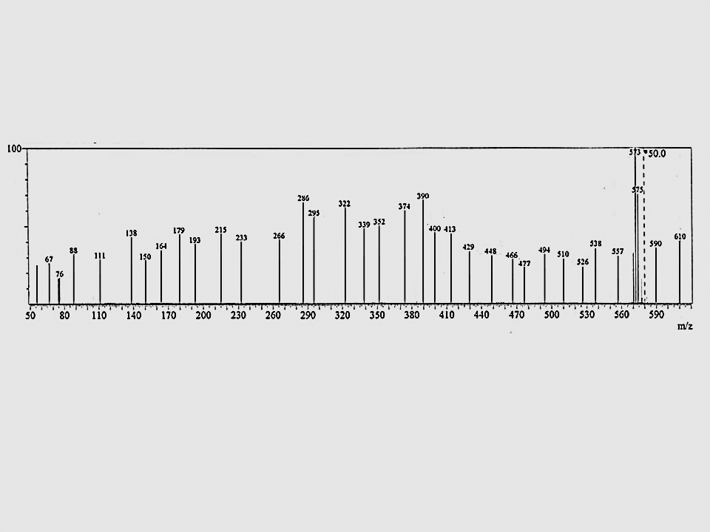

**Figure 11:ESI-mass spectrum of VOL complex.**

|  |  |  |
| --- | --- | --- |
|  |  |  |
| ZrOL | VOL | ZnL(H2O)2 |

Figure S12:Thermogravimetric data for the titled complexes.

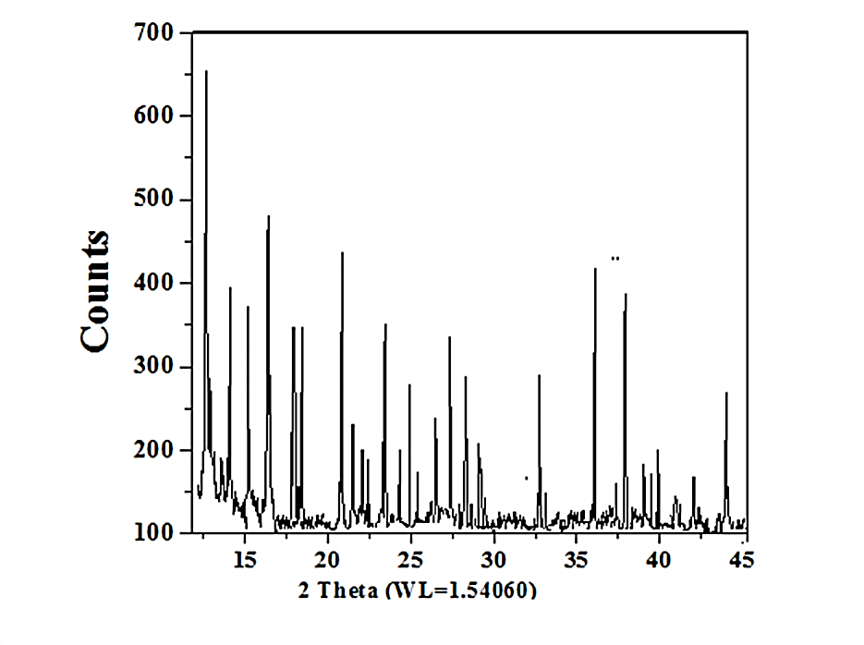

Figure S13:Powder X-ray diffraction (PXRD) of ZrOL complex.



Figure S14:Powder X-ray diffraction (PXRD) of ZnL(H2O)2 complex.

|  |
| --- |
|  |

**Figure S15:** The change of electronic absorption spectra of VOL and ZrOL complex (10-2 M) upon addition of various amounts of CT-DNA (10-100 $μ$ M).



**Figure S16:** Plot of [DNA] / (εa– εf) versus [DNA]for the interaction the studied complexes with CT-DNA.

**Tables S**

**Table S1:** Molecular electronic spectra, λ max (nm), ε max (dm3 mol-1 mm-1) of the synthesized ligand and its complexes in DMF at 298 K against DMF as a blank with 10−2 M.

|  |  |  |  |  |
| --- | --- | --- | --- | --- |
| **Assignment** | **Ε**  **(dm3 mol-1 mm-1)** | **λ max**  **(nm)** | **Color** | **Imine ligand**  **and its complexes** |
| π→π*  π→π*  n→π*  n→π*  Intraligand band | 197  165  173  170  171 | 288  334  360  386  396 | deep orange | **H2L** |
| π→π*  π→π*  n→π*  n→π*  Intraligand band LMCT band | 192  159  166  164  165  170 | 288  334  360  387  397  418 | Dark green | **ZrOL** |
| π→π*  π→π*  n→π*  n→π*  Intraligand band  Intraligand band LMCT band  d-d band | 182  149  157  158  158  168  167  182 | 289  335  360  387  397  431  451  481 | brown | **VOL** |
| π→π*  π→π*  n→π*  n→π*  Intraligand band  Intraligand band LMCT band | 186  154  162  161  162  172  171 | 287  334  360  387  397  431  451 | green | **ZnL(H2O)2** |

**Table S2:** Important optimized bond lengths (Å) and bond angles (°) of VOL.

|  |  |  |  |  |  |  |  |
| --- | --- | --- | --- | --- | --- | --- | --- |
| Type of bond | Bond length(Å)  Complex | | Type of bond | Bond length(Å)  H2L Complex | | | |
| V=O3 | 1.909 | | N1••••N2 | | 2.985 | | 2.753 |
| V-N1 | 2.018 | | N1••••O1 | | 4.065 | | 3.016 |
| V-N2 | 2.131 | | N2••••O2 | | 4.023 | | 2.935 |
| V-O1 | 1.944 | |  | |  | |  |
| V-O2 | 2.005 | |  | |  | |  |
| Type of Angle | | Angle (°)  Complex | Type of Angle | | | Angle (°)  Complex | |
| N1-V- N2 | | 83.12 | O3-V-O1 | | | 101.7 | |
| N1-V-O1 | | 99.15 | O3-V-O2 | | | 89.98 | |
| N2-V-O2 | | 90.38 | N1-V-O2 | | | 166.8 | |
| O1-V-O2 | | 84.92 | N2-V-O1 | | | 168.0 | |
| O3-V-N1 | | 101.4 |  | | |  | |
| O3-V-N2 | | 89.22 | N1-N2-O2-O1 | | | 0.404* | |

*dihedral angle

**Table S3.** Important optimized bond lengths (Å) and bond angles (°) of ZrOL.

|  |  |  |  |  |  |  |  |
| --- | --- | --- | --- | --- | --- | --- | --- |
| Type of bond | Bond length(Å)  Complex | | Type of bond | Bond length(Å)  H2L Complex | | | |
| Zr=O3 | 1.812 | | N1••••N2 | | 2.985 | | 2.751 |
| Zr-N1 | 2.123 | | N1••••O1 | | 4.065 | | 3.026 |
| Zr-N2 | 2.196 | | N2••••O2 | | 4.023 | | 2.937 |
| Zr-O1 | 2.031 | |  | |  | |  |
| Zr-O2 | 2.053 | |  | |  | |  |
| Type of Angle | | Angle (°)  Complex | Type of Angle | | | Angle (°)  Complex | |
| N1-Zr- N2 | | 79.12 | O3-Zr-O1 | | | 102.6 | |
| N1-Zr-O1 | | 93.52 | O3-Zr-O2 | | | 92.91 | |
| N2-Zr-O2 | | 87.38 | N1-Zr-O2 | | | 161.6 | |
| O1-Zr-O2 | | 96.63 | N2-Zr-O1 | | | 165.1 | |
| O3-Zr-N1 | | 99.82 |  | | |  | |
| O3-Zr-N2 | | 91.44 | N1-N2-O2-O1 | | | -0.055* | |

*dihedral angle

**Table S4:** Important optimized bond lengths (Å) and bond angles (°) of ZnL(H2O)2.

|  |  |  |  |  |  |  |  |
| --- | --- | --- | --- | --- | --- | --- | --- |
| Type of bond | Bond length(Å)  Complex | | Type of bond | Bond length(Å)  H2L Complex | | | |
| Zn-N1 | 2.203 | | Zn-O4 | | - | | 2.135 |
| Zn-N2 | 2.243 | |  | |  | |  |
| Zn-O1 | 2.060 | | N1••••N2 | | 2.985 | | 2.931 |
| Zn-O2 | 2.053 | | N1••••O1 | | 4.065 | | 2.891 |
| Zn-O3 | 2.145 | | N2••••O2 | | 4.023 | | 2.854 |
| Type of Angle | | Angle (°)  Complex | Type of Angle | | | Angle (°)  Complex | |
| N1-Zn- N2 | | 82.45 | O1-Zn-O4 | | | 80.11 | |
| N1-Zn-O1 | | 85.34 | O2-Zn-O4 | | | 99.81 | |
| N1-Zn-O2 | | 96.73 | O3-Zn-O4 | | | 93.29 | |
| N1-Zn-O3 | | 95.26 | O2-Zn-O3 | | | 81.21 | |
| N2-Zn-O1 | | 97.71 | N1-Zn-O4 | | | 168.1 | |
| N2-Zn-O2 | | 83.11 | N2-Zn-O3 | | | 166.9 | |
| N2-Zn-O4 | | 96.50 | O1-Zn-O2 | | | 177.8 | |
| O1-Zn-O3 | | 104.1 | N1-O1-O4-O2 | | | 3.285* | |

*dihedral angle

**Table S5:** Calculated energies of H2L, VOL, ZrOL and ZnL(H2O)2.

|  |  |  |  |  |  |
| --- | --- | --- | --- | --- | --- |
|  | Ea | HOMOb | LUMOc | Egd | Dipole momente |
| H2L | -6638.65 | -5.9057 | -2.3584 | 3.5473 | 7.5052 |
| VOL | -6784.10 | -5.8502 | -3.4972 | 2.3530 | 3.2991 |
| ZrOL | -6759.46 | -6.0736 | -3.2090 | 2.8646 | 6.4651 |
| ZnL(H2O)2 | -6855.98 | -5.6510 | -2.9263 | 2.7247 | 7.2917 |

aE: the total energy (a.u.). bHOMO: highest occupied molecular orbital (eV).

cLUMO: lowest unoccupied molecular orbital (eV).

dEg=ELUMO- EHOMO (eV). e dipole moment (Debye).

**Table S6**: The IC50 values (µM) of the synthesized ligands and their complexes against different tumor cell lines.

|  |  |  |  |  |
| --- | --- | --- | --- | --- |
| Comp. | HCT-116 cell line | Hep-G2 cell line | MCF‐7 cell line | HEK-293 cell line |
| H2L | 106.3 | 80.5 | 65.5 | 83 |
| ZrOL | 40.4 | 33.5 | 26.5 | 87 |
| VOL | 30.5 | 22.4 | 17.5 | 90 |
| ZnL(H2O)2 | 48.6 | 40.8 | 32.5 | 85 |
| Vinblastine | 14.6 | 6.7 | 5.73 | 95 |

**Table S7: Results of antibacterial bioassay of the synthesized ligand and its complexes against the selected strains of bacteria in DMSO.**

|  |  |  |  |  |  |  |
| --- | --- | --- | --- | --- | --- | --- |
| ***Compounds*** | **Inhibition zone (mm)** | | | | | |
| ***Escherichiacoli***  ***(-ve)*** | | ***Micrococcus luteus*  *(+ve)*** | | ***Serratia marcescensas (-ve)*** | |
| **Conc.($μ$ M)** | **15** | **30** | **15** | **30** | **15** | **30** |
| H2L | 8±0.43 | 15±0.45 | 11±0.19 | 20±0.40 | 9±0.55 | 18±0.72 |
| ZrOL | 19±0.11 | 35±0.51 | 25±0.12 | 49±0.49 | 21±0.71 | 43±0.22 |
| VOL | 22±0.26 | 38±0.19 | 28±0.39 | 53±0.53 | 24±0.47 | 46±0.61 |
| ZnL(H2O)2 | 18±0.24 | 32±0.26 | 23±0.13 | 45±0.12 | 20±0.71 | 40±0.19 |
| **Ofloxacin** | **23±0.66** | **40±0.33** | **30±0.35** | **55±0.42** | **27±0.53** | **47±0.33** |

**Table S8: Results of antifungal bioassay of the synthesized ligand and its complexes against the selected strains of fungi in DMSO.**

|  |  |  |  |  |  |  |
| --- | --- | --- | --- | --- | --- | --- |
| ***Compounds*** | **Inhibition zone (mm)** | | | | | |
| ***Geotrichum candidum*** | | ***Aspergillus flavus*** | | ***Fusarium oxysporum*** | |
| **Conc. ($μ$ M)** | **15** | **30** | **15** | **30** | **15** | **30** |
| **H2L** | 10±0.35 | 16±0.10 | 8±0.28 | 13±0.22 | 9±0.15 | 15±0.19 |
| **ZrOL** | 23±0.32 | 43±0.18 | 20±0.32 | 31±0.31 | 24±0.41 | 35±0.50 |
| **VOL** | 27±0.45 | 46±0.35 | 21±0.65 | 34±0.27 | 25±0.22 | 37±0.40 |
| **ZnL(H2O)2** | 21±0.13 | 40±0.34 | 18±0.18 | 29±0.17 | 21±0.42 | 32±0.51 |
| **Fluconazole** | **29±0.30** | **48±0.55** | **23**±0.24 | 36±0.77 | **26±0.41** | **39±0.73** |

Table S9: The minimum inhibitory concentrations values of the prepared H2L ligand and its complexes against the selected bacteria and fungi strains.

|  |  |  |  |  |  |  |
| --- | --- | --- | --- | --- | --- | --- |
| Comp. | Minimum Inhibition concentration (MIC) $μ$ M | | | | | |
| E. coli | M. luteus | S. marcescensas | A. flavus | F. oxysporum | G. candidum |
| H2L | 4.75 | 4.00 | 3.75 | 5.25 | 4.75 | 4.50 |
| ZrOL | 1.75 | 1.50 | 1.25 | 2.50 | 2.00 | 1.75 |
| VOL | 1.25 | 1.00 | 0.75 | 2.00 | 1.50 | 1.00 |
| ZnL(H2O)2 | 2.00 | 1.75 | 1.50 | 3.00 | 2.50 | 2.00 |
| Ofloxacin | 1.00 | 0.75 | 0.50 | -- | -- | -- |
| Fluconazole | -- | -- | -- | 1.25 | 1.00 | 0.75 |
| Control (DMSO) | 00 | 00 | 00 | 00 | 00 | 00 |