Supporting Informtion

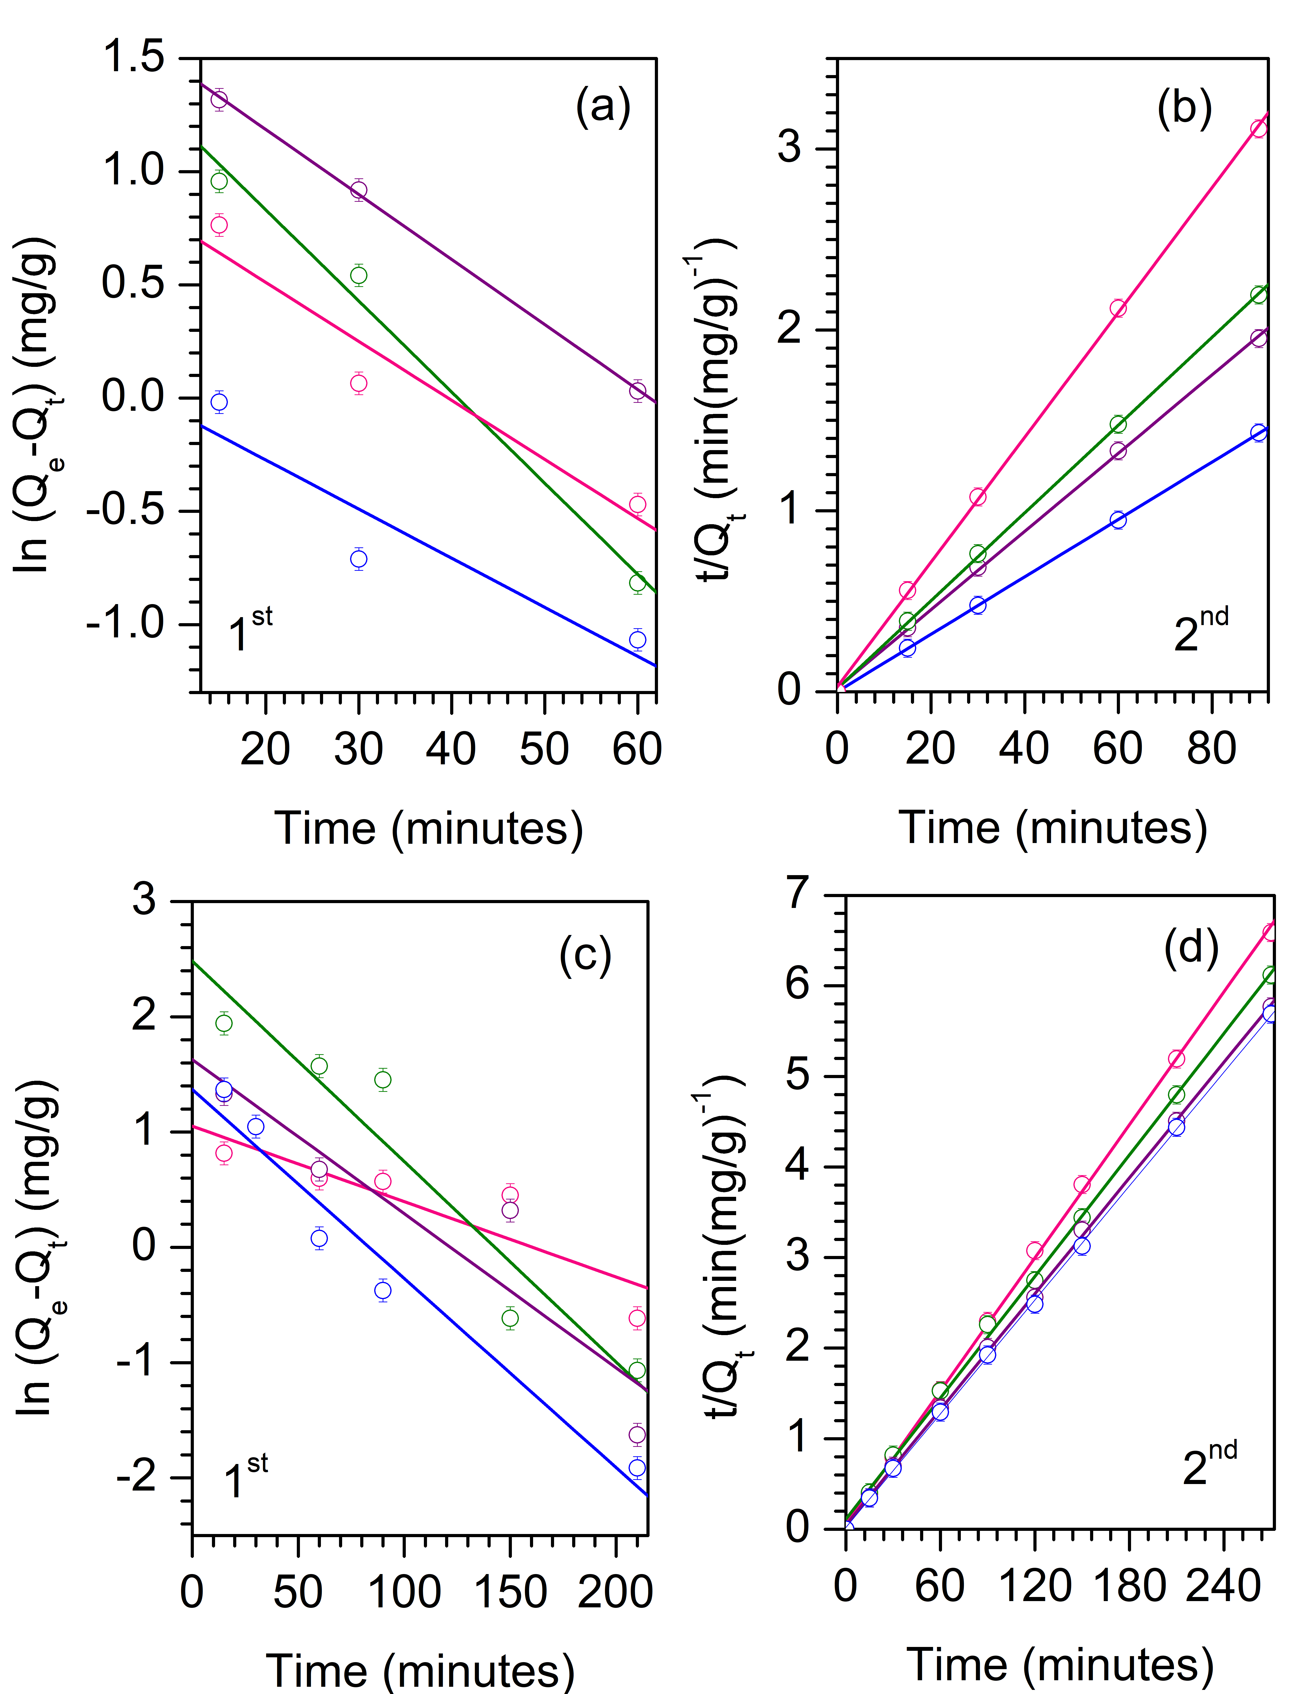
Fig. S1. The confirmation of adsorption kinetic. (a,b) the effect of TiO₂ loading (blue – ZSM-5, purple – 5% TiO₂/ZSM-5, green – 10% TiO₂/ZSM-5, pink – 20% TiO₂/ZSM-5) and (c,d) the effect of MB concentration using 10% TiO₂/ZSM-5 (pink – 100 mg L⁻¹, green – 110 mg L⁻¹, purple – 120 mg L⁻¹, blue – 130 mg L⁻¹)

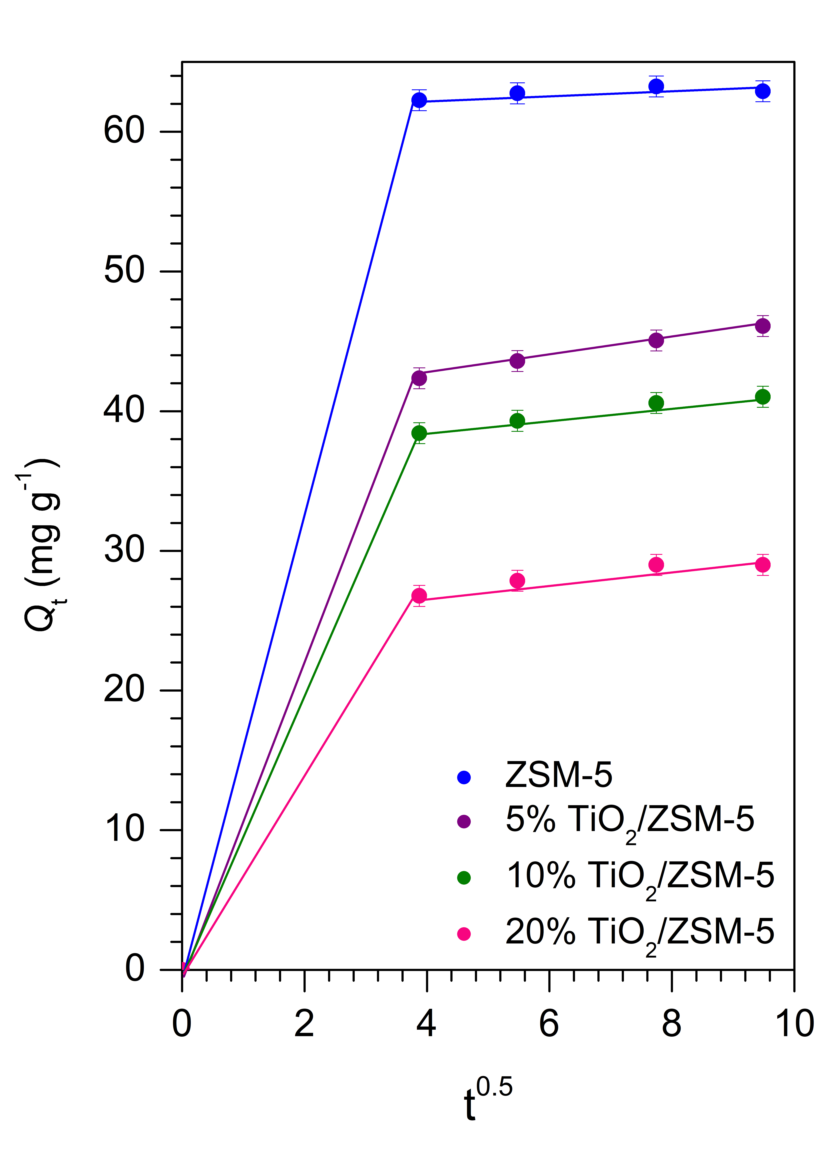
Fig. S2 The intraparticle diffusion model of MB adsorption at different TiO₂ loading.

Table S1 MB adsorption kinetic parameter at different TiO₂ loading
%TiO₂ | Q_{e, exp}  (mg g⁻¹) | Pseudo first order |  |  | Pseudo second order |  |  | Intraparticle diffusion
 |  | k₁  (min⁻¹) | q_{e}  (mg g⁻¹) | R² | k₂  (g mg⁻¹ min⁻¹) | q_{e}  (mg g⁻¹) | R² | k_{p1}  (mg g⁻¹ min^{0.5}) | C₁  (mg g⁻¹) | R² | k_{p2}  (mg g⁻¹ min^{0.5}) | C₂  (mg g⁻¹) | R²
0 | 62.899 | 0.022 | 1.177 | 0.87 | 0.025 | 62.893 | 1 | 16.08 | 8 × 10⁻⁵ | 1 | 0.253 | 61.32 | 0.99
5 | 46.093 | 0.029 | 5.938 | 0.99 | 0.021 | 46.296 | 0.99 | 10.94 | - | 1 | 0.695 | 39.71 | 0.99
10 | 41.032 | 0.040 | 5.136 | 0.98 | 0.032 | 41.152 | 0.99 | 9.922 | - | 1 | 0.559 | 36.26 | 1
20 | 28.304 | 0.026 | 2.808 | 0.93 | 0.078 | 28.409 | 0.99 | 6.915 | - | 1 | 0.435 | 25.24 | 0.94

Table S2 MB adsorption kinetic parameter and Langmuir equilibrium parameter at different concentration of MB using 10% TiO₂/ZSM-5
C_{e}  (mg L⁻¹) | Q_{e, exp}  (mg g⁻¹) | R_{L} | Pseudo first order |  |  | Pseudo second order
 |  |  | k₁  (min⁻¹) | q_{e}  (mg g⁻¹) | R² | k₂  (g mg⁻¹ min⁻¹) | q_{e}  (mg g⁻¹) | R²
100 | 62.8993 | 0.85 | 0.0217 | 1.1768 | 0.8671 | 0.2528 | 62.8931 | 1
110 | 46.0934 | 0.84 | 0.0287 | 5.9376 | 0.9993 | 0.0211 | 46.2963 | 0.9995
120 | 41.0319 | 0.83 | 0.0402 | 5.1361 | 0.9884 | 0.0317 | 41.1522 | 0.9997
130 | 28.3045 | 0.82 | 0.0261 | 2.8075 | 09304 | 0.0779 | 28.4091 | 0.9999

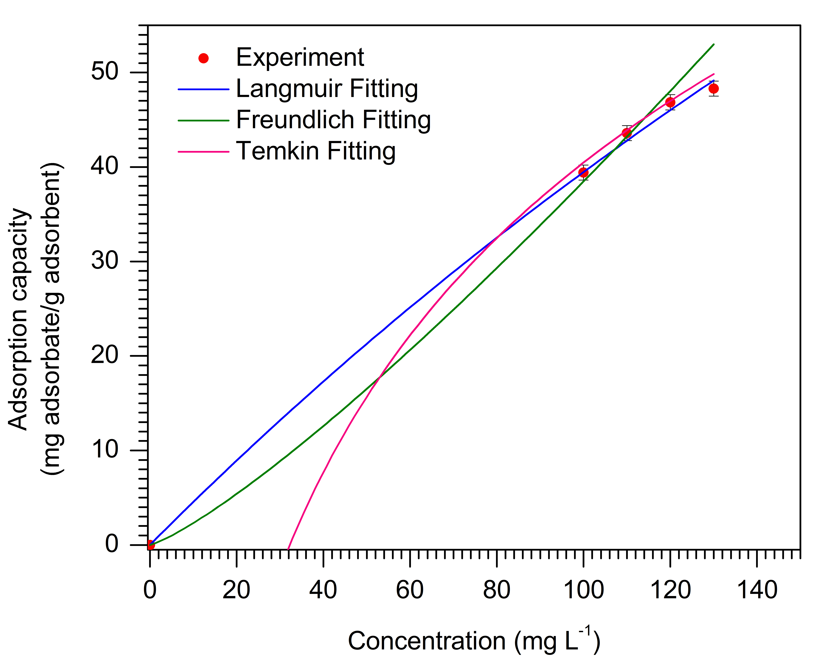
Fig. S3 Non-linear fitting of adsorption isotherm of 10% TiO₂/ZSM-5

Table S3 MB adsorption isotherm model parameter of 10% TiO₂/ZSM-5
Adsorption isotherm model | Parameter | Value
Langmuir | Q_{max} (mg g⁻¹) | 2.7 × 10²
 | K_{L} (L mg⁻¹) | 1.7 × 10⁻³
 | RMSE | 1.5 × 10⁻⁷
Freundlich | n (mg g⁻¹)(L mg⁻¹)^{1/n} | 8.2 × 10⁻¹
 | K_{F} ((mg g⁻¹)(L mg⁻¹)^{-1/n} | 1.4 × 10⁻¹
 | RMSE | 3.1 × 10⁻³
Temkin | B (L mol⁻¹) | 3.6 × 10¹
 | K_{T} (L mg⁻¹) | 3.1 × 10⁻²
 | RMSE | 4.5 × 10⁻¹

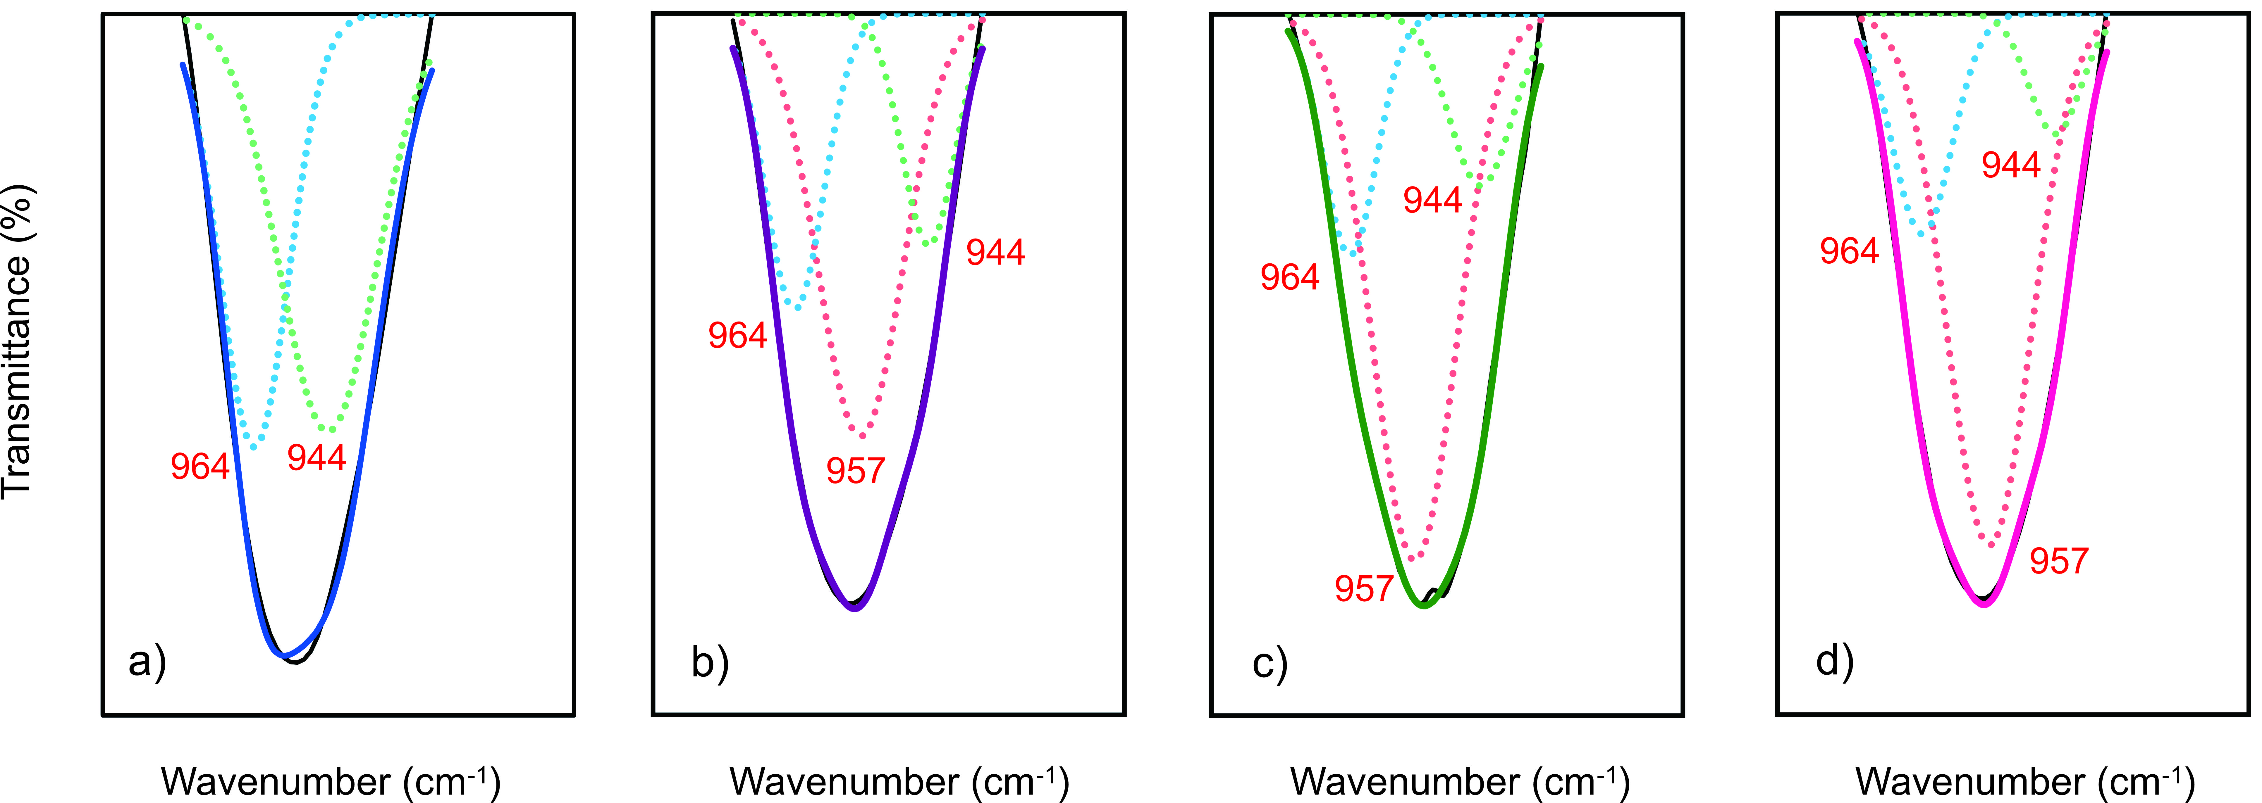
Fig. S4 FTIR spectra of a) ZSM-5, b) 5% TiO₂/ZSM-5, c) 10% TiO₂/ZSM-5, d) 20% TiO₂/ZSM-5 in region 1000–900 cm⁻¹

Fig. S5 FTIR spectra of a) ZSM-5, b) 5% TiO₂/ZSM-5, c) 10% TiO₂/ZSM-5, d) 20% TiO₂/ZSM-5 in region 500–400 cm⁻¹

Table S4 Crystallite size of 10% TiO₂/ZSM-5 measured by Scherer equation using X’Pert HighScore softaware
2θ (°) | FWHM | Crystallite size (nm)
25.21 | 0.234 | 36
37.72 | 0.401 | 21.4
47.947 | 0.28 | 33.4
53.843 | 0.535 | 16.9
54.974 | 0.811 | 11.1

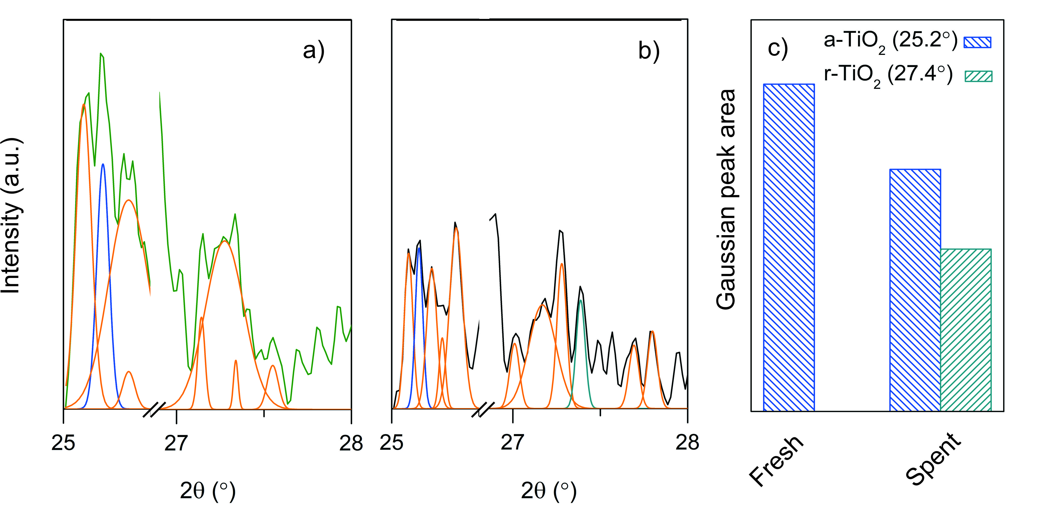
Fig. S6 Evacuated system of (a) fresh and (b) spent 10% TiO₂/ZSM-5; (c) the gaussian peak area of anatase phase (a-TiO₂) and rutile phase (r-TiO₂).

