Catechin mediated green synthesis of Au nanoparticles: Experimental and theoretical approaches to the Determination HOMO-LUMO energy gap and reactivity indexes for the (+)-epicatechin (2S, 3S)
Javad Ebrahimianª, Maryam Khayatkashani**^{,b}, Nasrin Soltani^{c}, Qahtan A. Yousif^{d}, Masoud Salavati-Niasari^{*,e}
ªAlumni Association of Sharif University of Technology, 11365-11155 Tehran, Iran
^{b}School of Traditional Medicine, Tehran University of Medical Sciences, Tehran, Iran
^{c}Department of Chemistry, Payame Noor University, P.O. Box 19395-3697 Tehran, Iran
^{d}Department of Chemistry, College of Education, University of Al-Qadisiyah, Al Diwaniyah, Iraq
^{e}Institute of Nano Science and Nano Technology, University of Kashan, Kashan, P. O. Box.
87317-51167, Iran
**Corresponding author: School of Traditional Medicine, Tehran University of Medical Sciences, Tehran, Iran; E-mail address: maryamkhaiiat@yahoo.com (M. Khayatkashani)
*Corresponding author: Institute of Nano Science and Nano Technology, University of Kashan, Kashan, P. O. Box. 87317-51167, I. R. Iran; Tel.: +98 31 55912383; Fax: +98314455923, +98 31 55913201; E-mail address: salavati@kashanu.ac.ir (M. Salavati-Niasari).

Fig. S1: UV-vis absorption spectrum of 30 mL HAuCl₄ 1×10⁻³ M with 8, 10, 12, 14, 16, 18, and 20 mL salix aegyptiaca extract (a), an investigation of the stability of AuNPs using UV-vis absorption spectrum (b).

Fig. S2: The structure of the most stable conformer of (+)-epicatechin (2S,3S) and the optimization diagram and RMS Gradient Norm calculation by PM3MM.

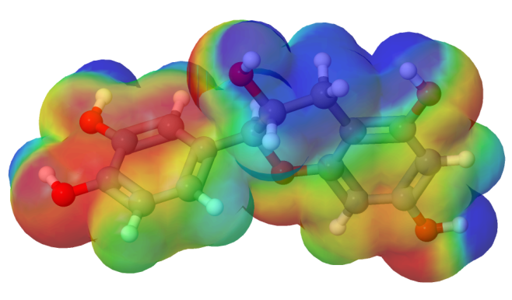
Fig. S3: The molecular electrostatic potential (MEP) map of (+)-epicatechin (2S,3S).
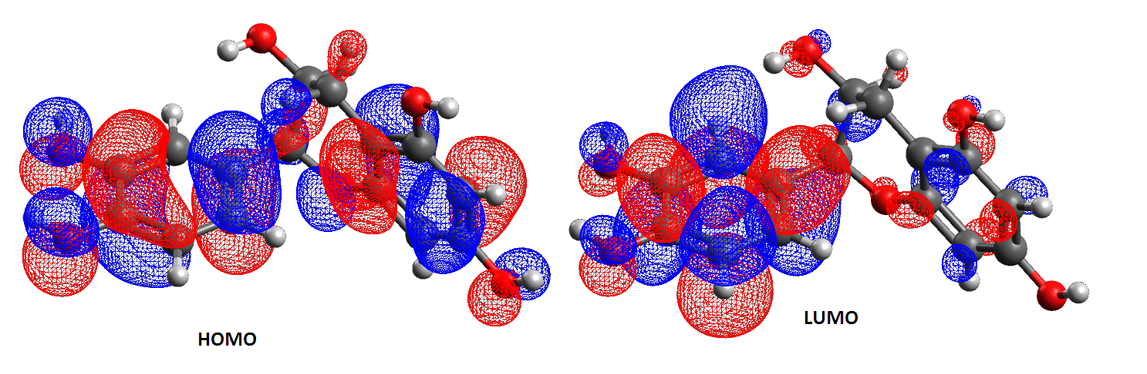
Fig. S4: The distribution pattern of frontier molecular orbital of (+)-epicatechin (2S,3S) calculated by DFT-B3LYP/6-31g (d, p) scrf= (iefpcm, solvent = water).

