Supplementary Information
Figure S1
(a)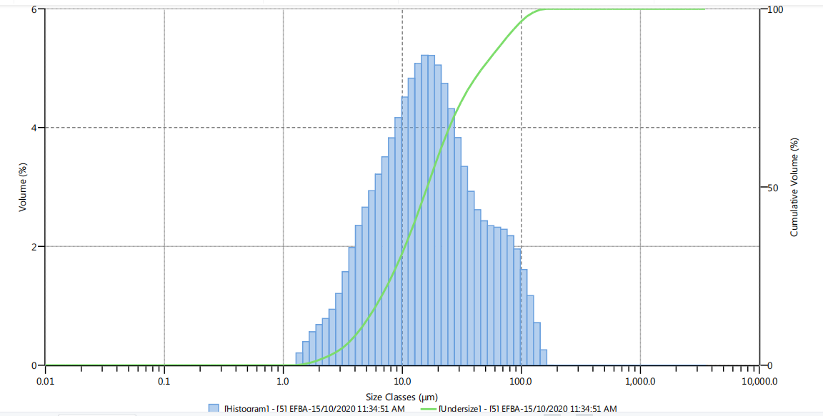
(b)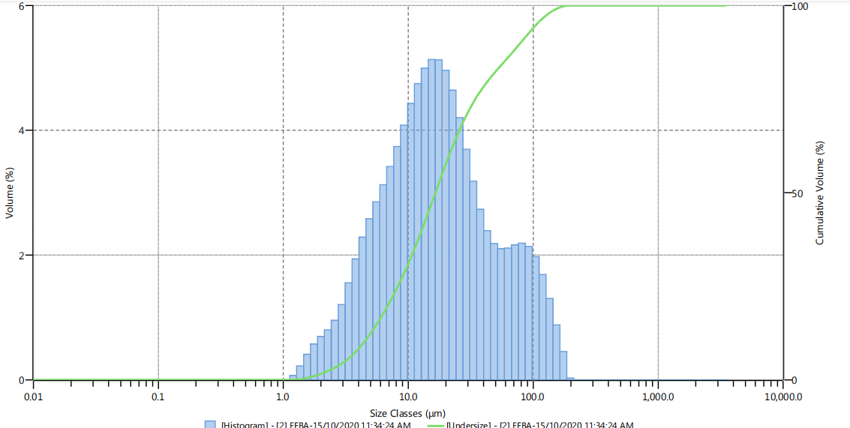
(c)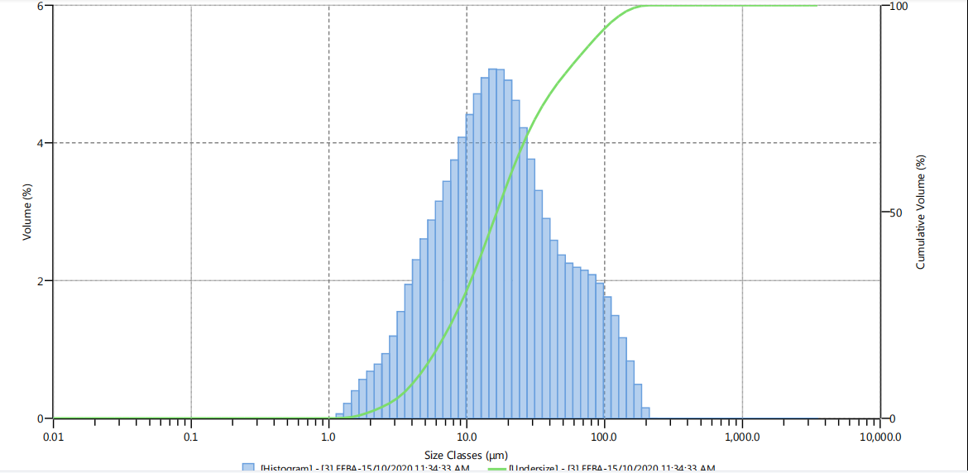
Figure S1 Size distribution of EFBA at different concentration (a) 0.05 wt%, (b) 0.1 wt% and (c) 0.2 wt%

Figure S2
(a)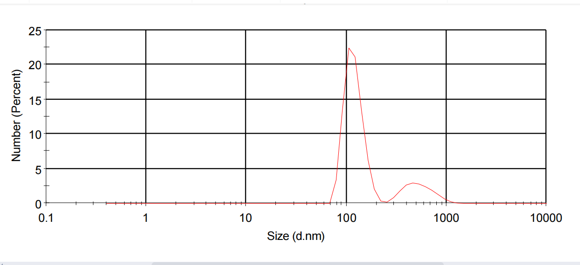
(b)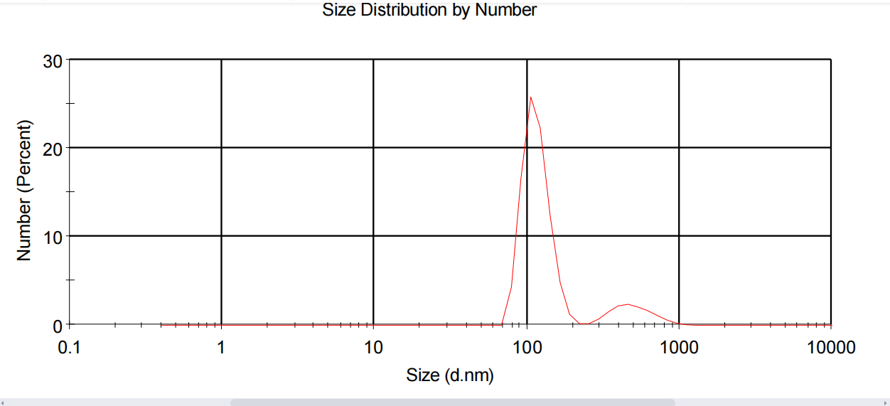
(c)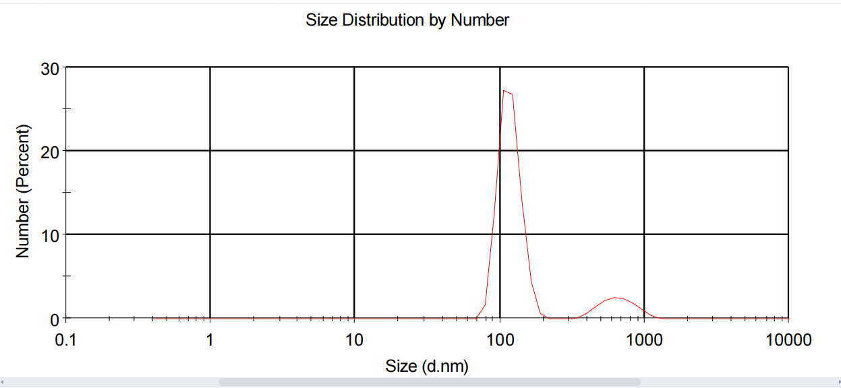
Figure S2 Size distribution of EFBSNP at different concentration (a) 0.05 wt%, (b) 0.1 wt% and (c) 0.2 wt%
Figure S3
(a)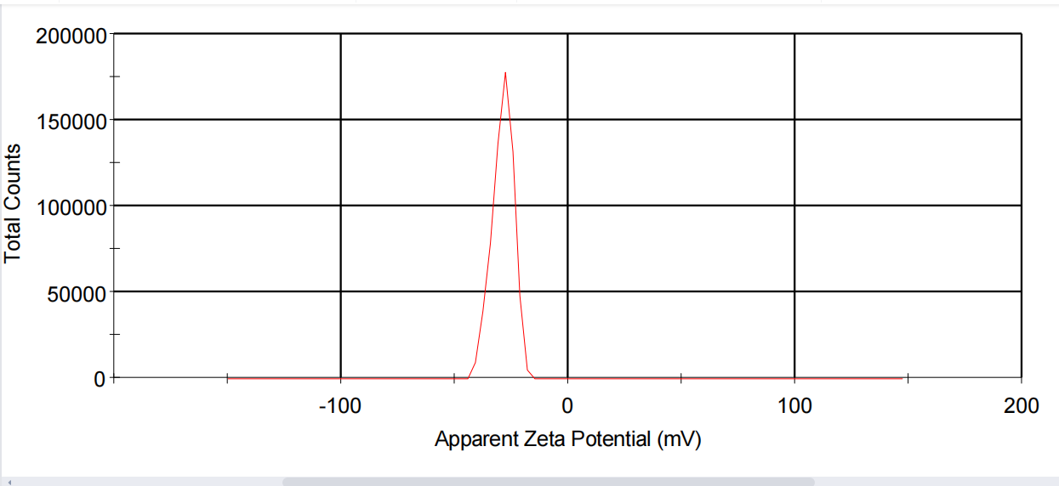
(b)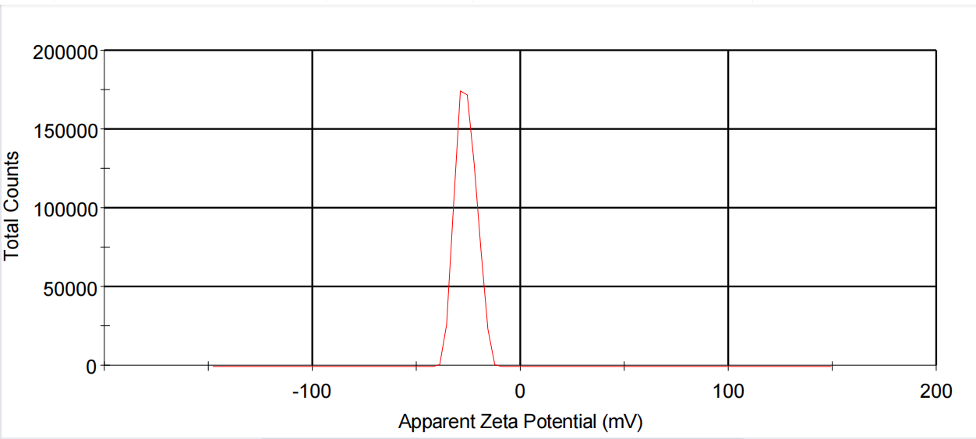
(c)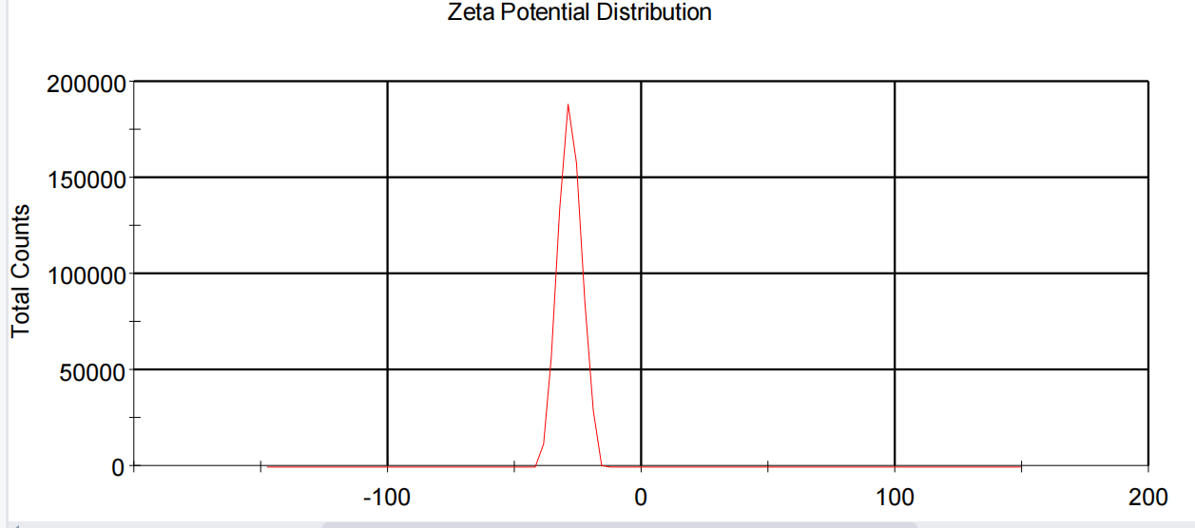
Figure S3 Zeta potential of EFBA at different concentration (a) 0.05 wt%, (b) 0.1 wt% and (c) 0.2 wt%
Figure S4
(a)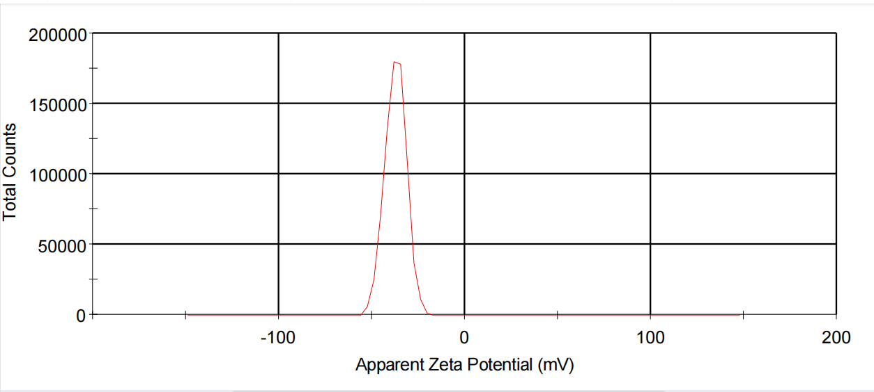
(b)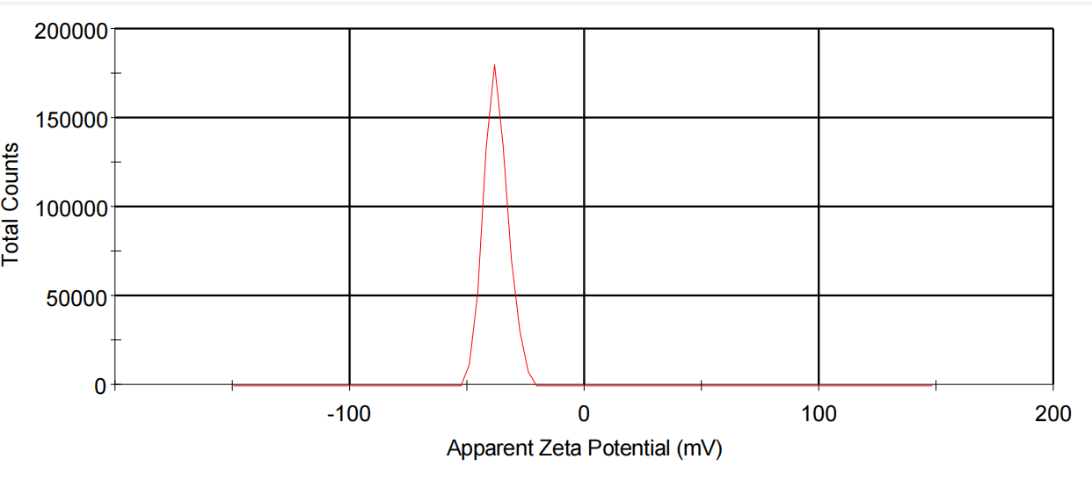
(c)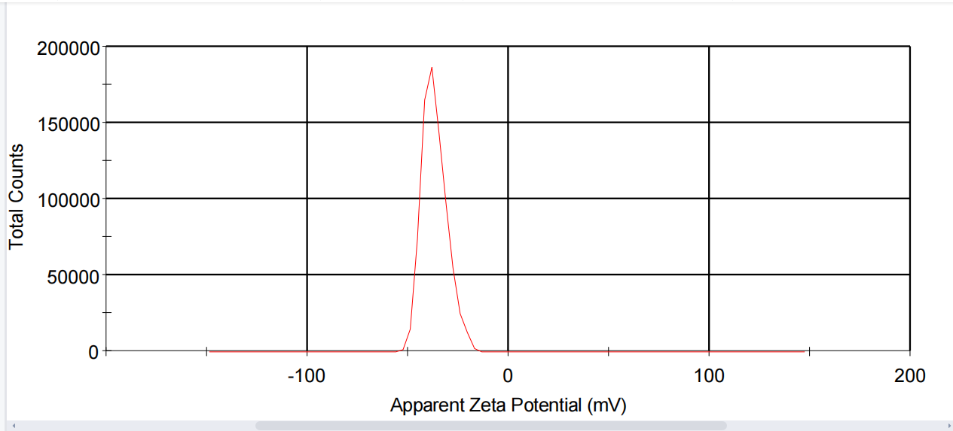
Figure S4 Zeta potential of EFBSNP at different concentration (a) 0.05 wt%, (b) 0.1 wt% and (c) 0.2 wt%

