**Supporting Information**

**Iron Oxide Nanoparticles-loaded Hyaluronic Acid Nanogels for MRI-aided Alzheimer's disease Theranostics**

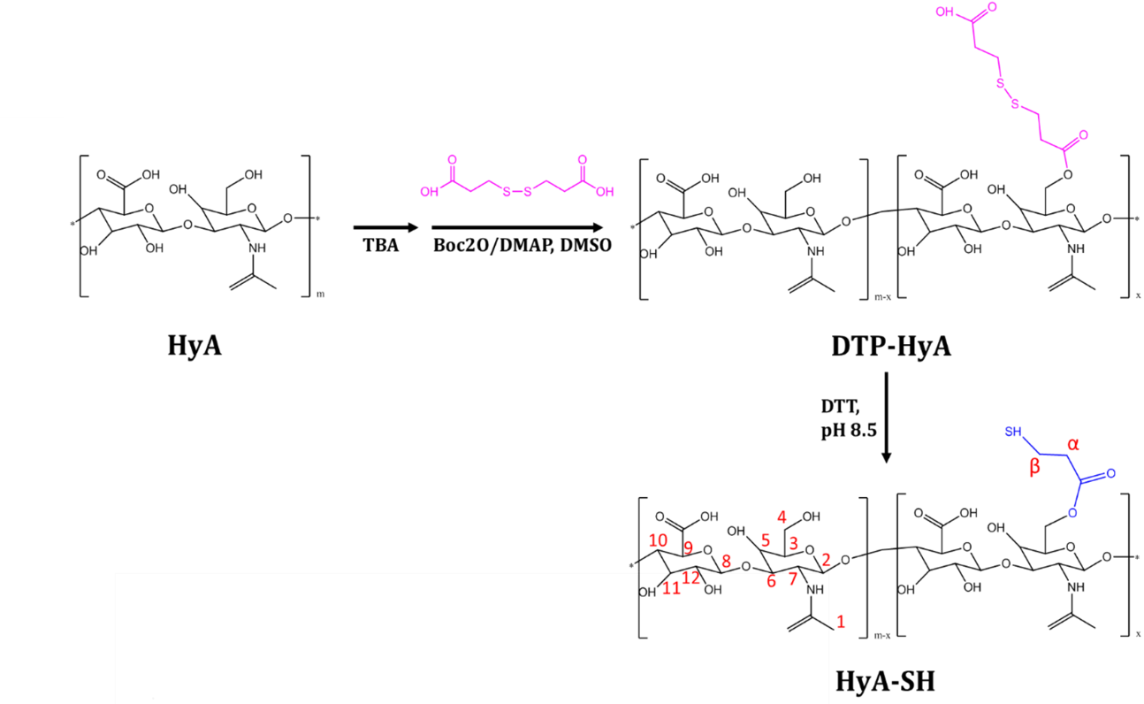

**Fig. 1S.** Schematic representation of the synthesis procedure of HyA-SH.

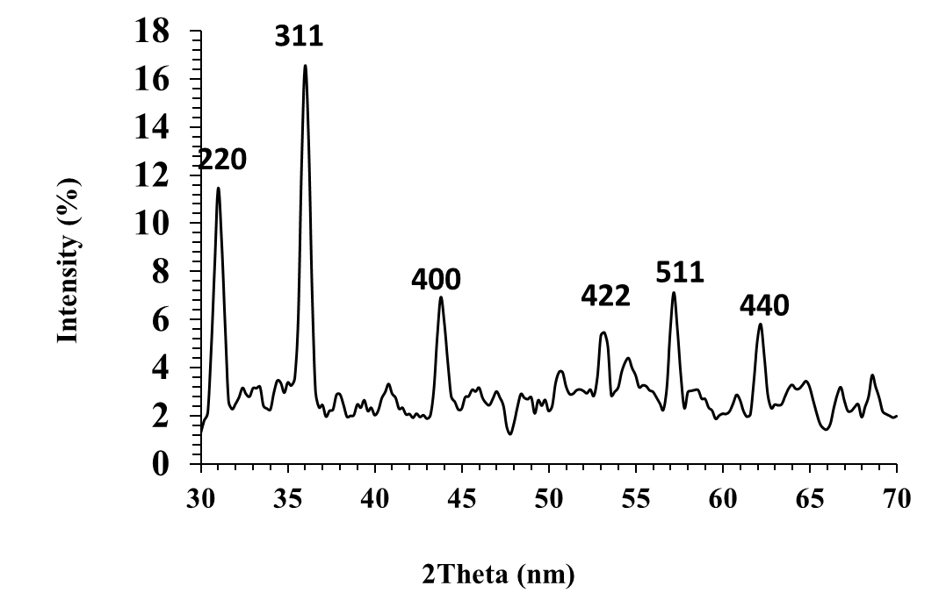

**Fig. 2S.** XRD pattern of Fe3O4 NPs.

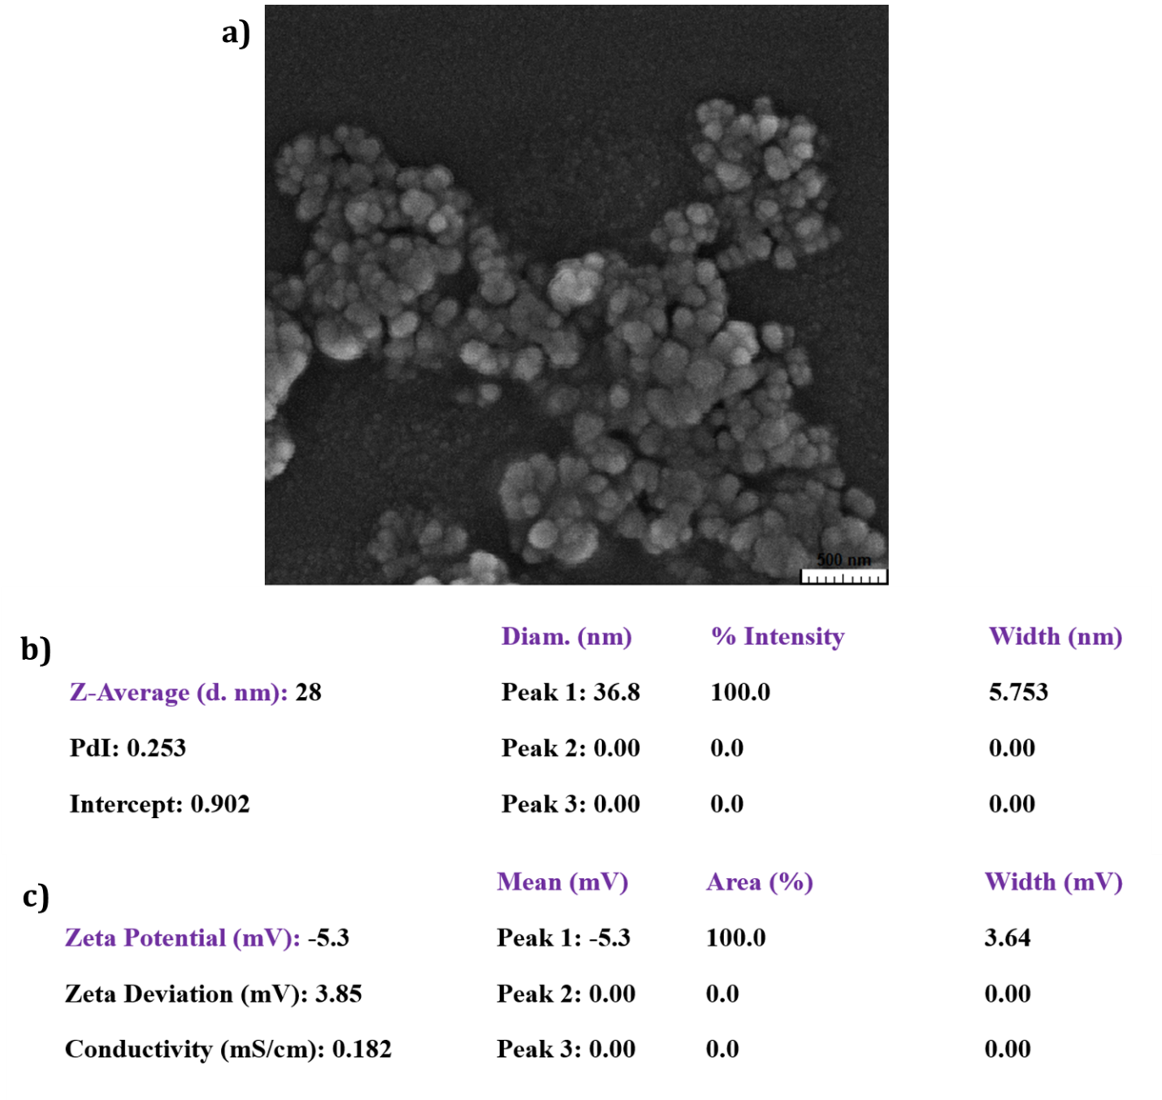

**Fig. 3S.** SEM image (a), DLS data (b), and Zeta potential data (c) of Fe3O4 NPs.

**Fig. 4S.** Hydrodynamic size stability of Fe3O4-HyA NGs over 7 days. The size analysis was done by dynamic light scattering (DLS) method.