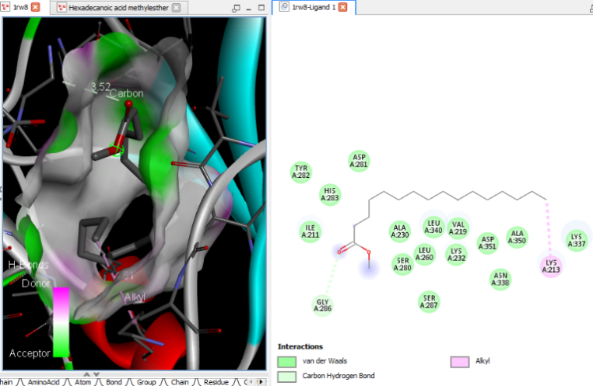Hexadecanoic acid, methyl ester | 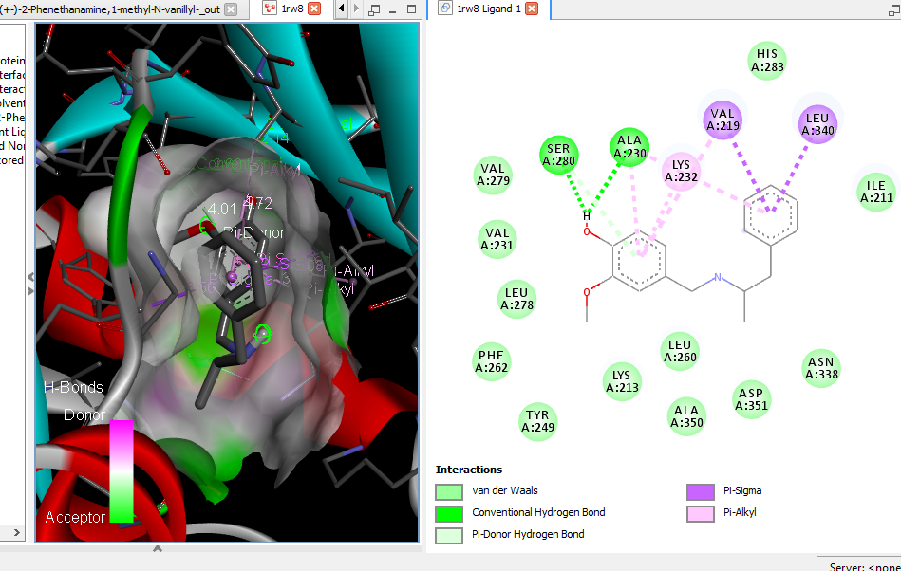  (+-)-2-Phenethanamine, 1-methyl-N-vanillyl-
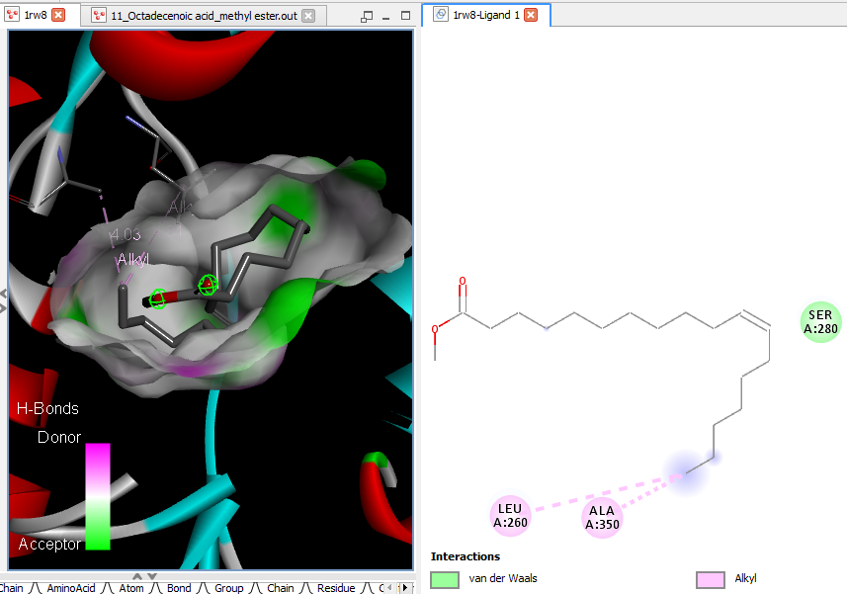11-Octadecenoic acid, methyl ester | 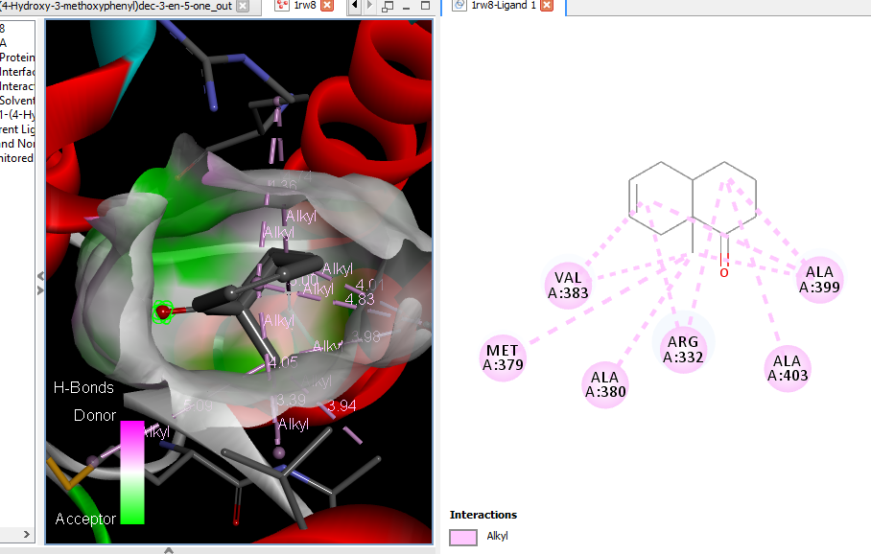 (E)-1-(4-Hydroxy-3-methoxyphenyl)dec-3-en-5-one
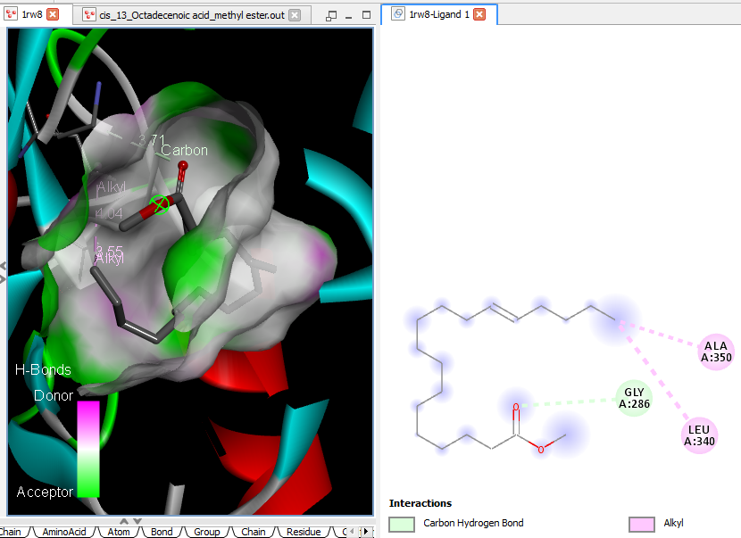cis-13-Octadecenoic acid, methyl ester | 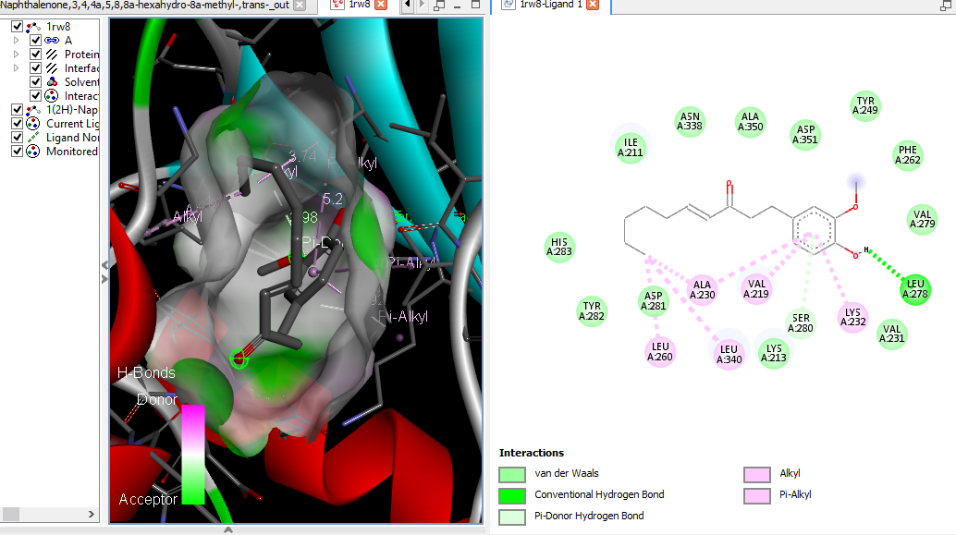1(2H)-Naphthalenone, 3,4,4a,5,8,8a-hexahydro-8a-methyl-,trans-

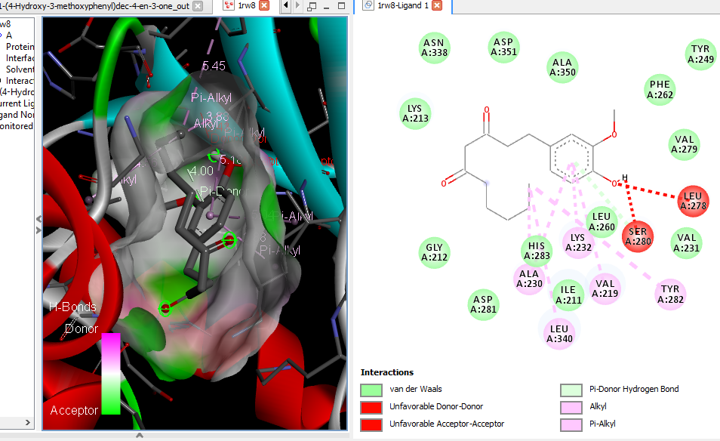  1-(4-Hydroxy-3-methoxyphenyl)dec-4-en-3-one (6-Shogoal) | 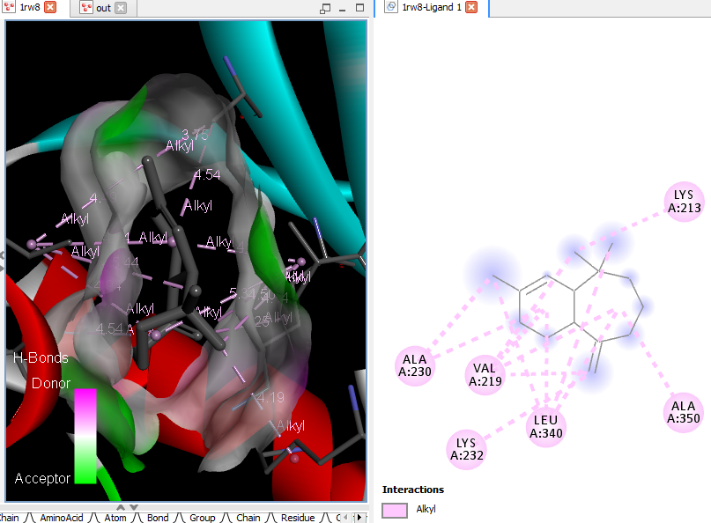1H-Benzocycloheptene, 2,4a,5,6,7,8,9,9a-octahydro-3,5,5-trimethyl-9-methylene-,(4aS-cis)- (alpha-Himachalene)
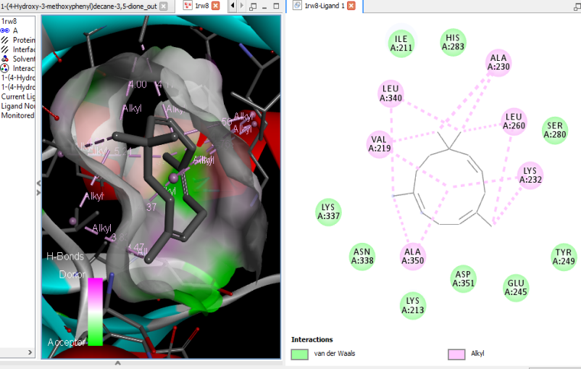  1-(4-Hydroxy-3-methoxyphenyl)decane-3,5-dione (gingerdione) | 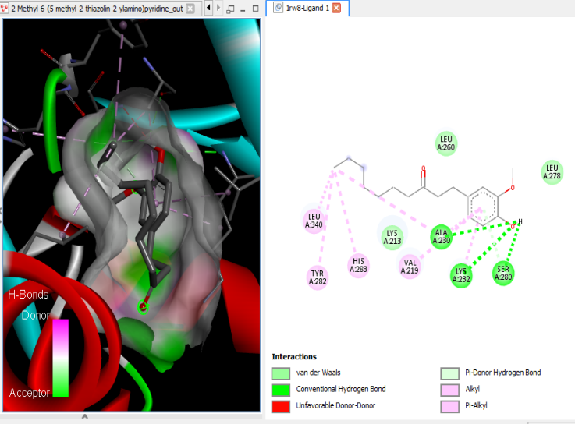2-Methyl-6-(5-methyl-2-thiazolin-2-ylamino)pyridine
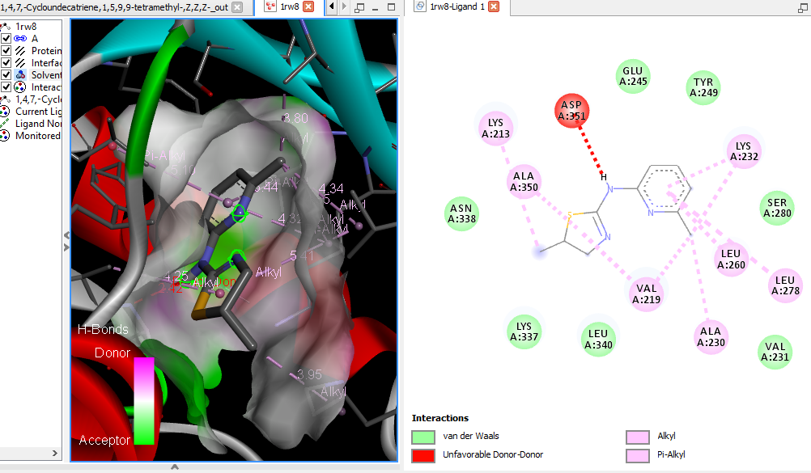1,4,7,-Cycloundecatriene, 1,5,9,9-tetramethyl-, Z,Z,Z- | 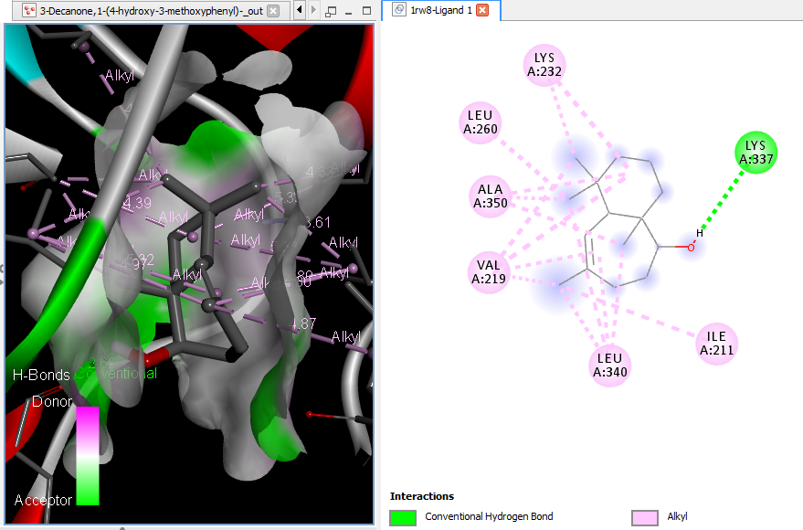3-Decanone, 1-(4-hydroxy-3-methoxy phenyl)- (Paradol)

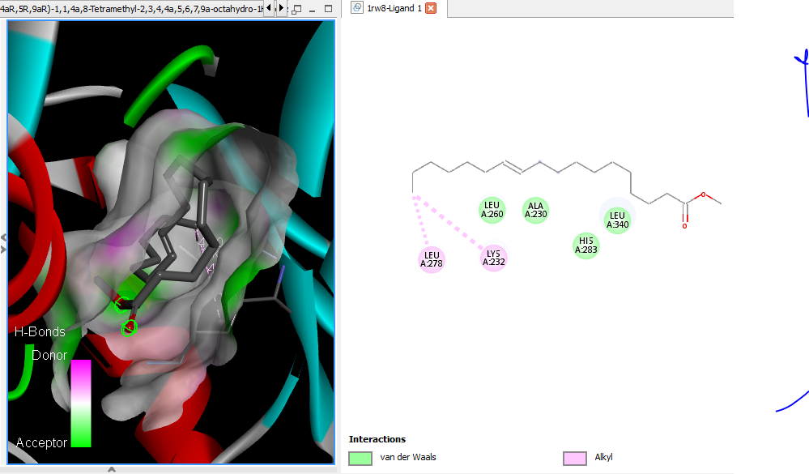4aR,5R,9aR)-1,1,4a,8-Tetramethyl-2,3,4,4a,5,6,7,9a-octahydro-1Hbenzo[7]annulen-5-ol (Allohimachalol) | 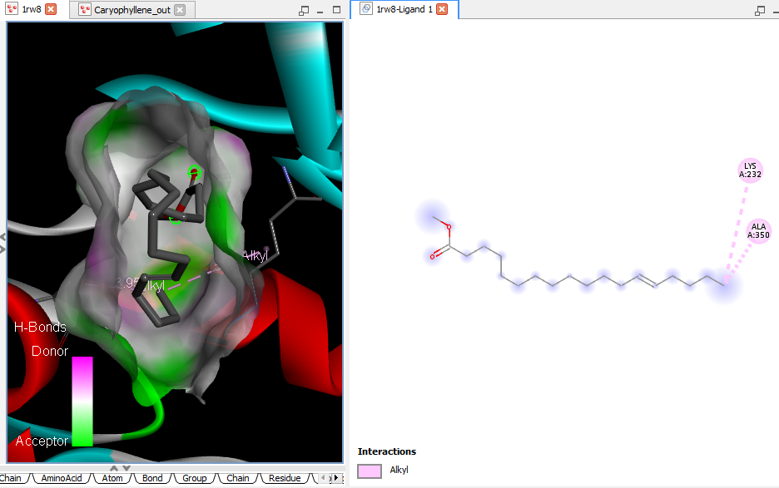Caryophyllene
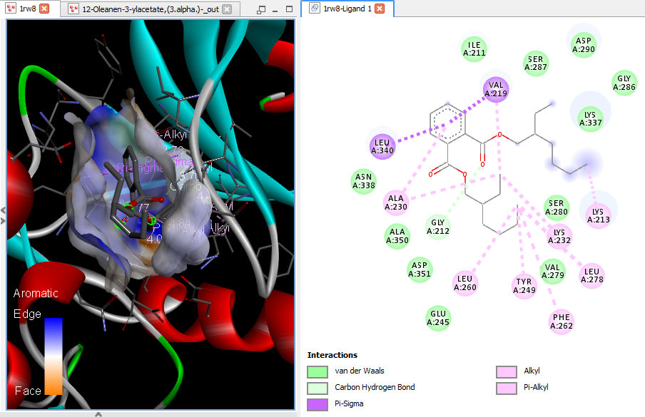  12-Oleanen-3-yl acetate, (3.alpha.)- (beta-Amyrenyl acetate) | 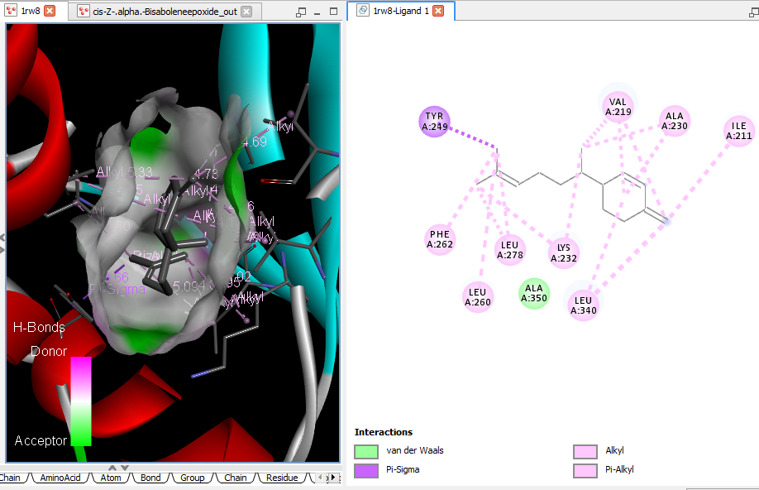cis-Z-.alpha.-Bisabolene epoxide
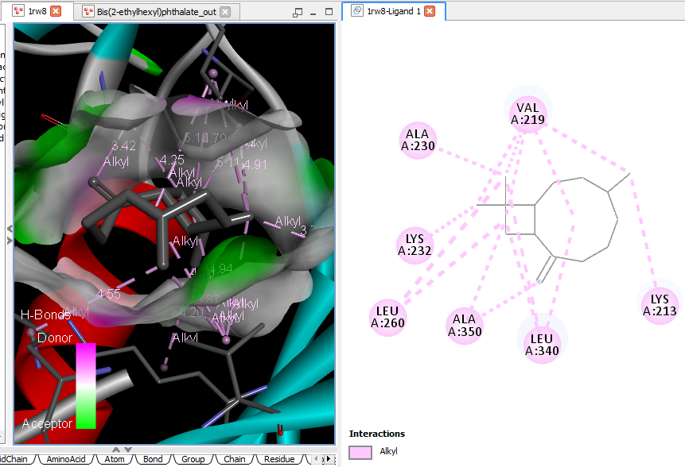Bis(2-ethylhexyl) phthalate | 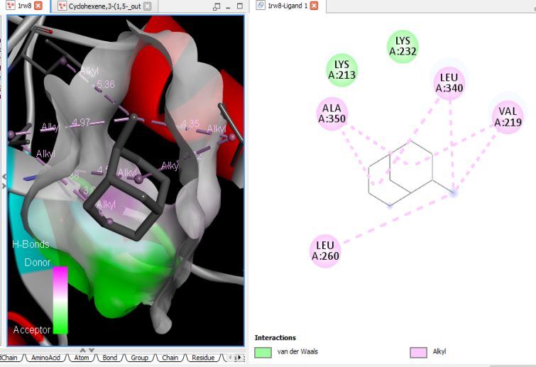Cyclohexene, 3-(1,5-dimethyl-4-hexenyl)-6-methylene-, [S-(R*,S*)]-

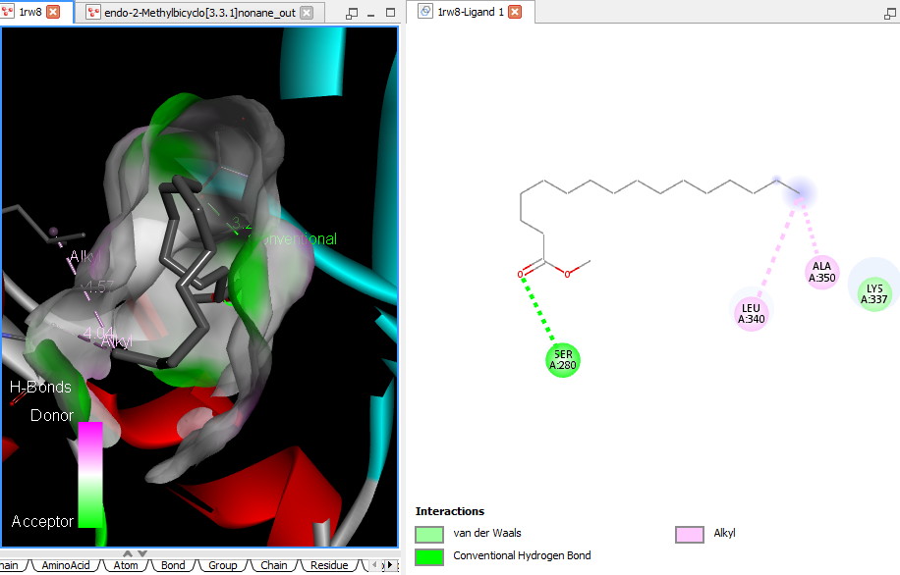  endo-2-Methylbicyclo[3.3.1]nonane | 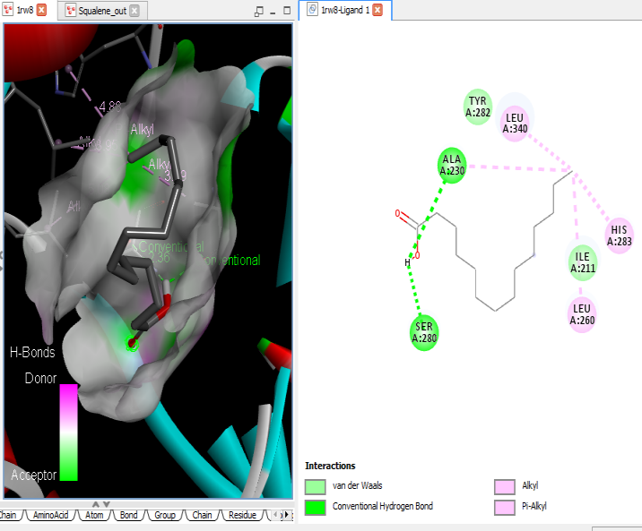  Squalene
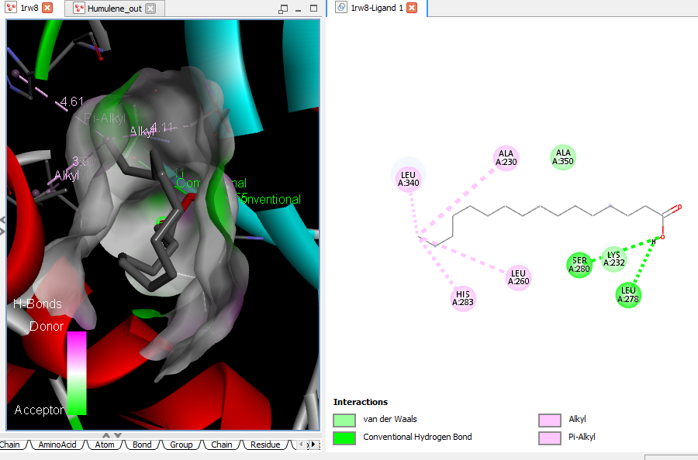 Humulene | 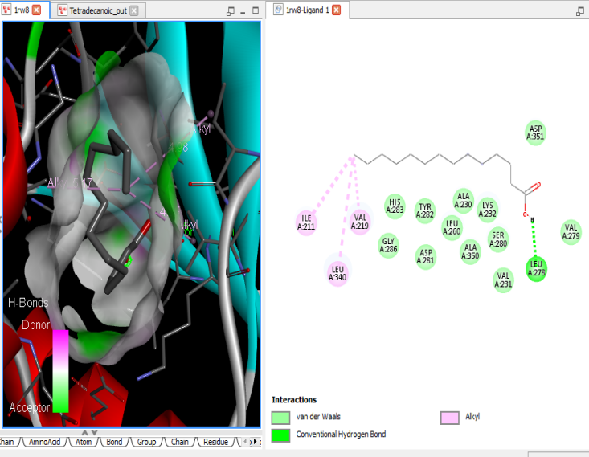Tetradecanoic acid (myristic acid)
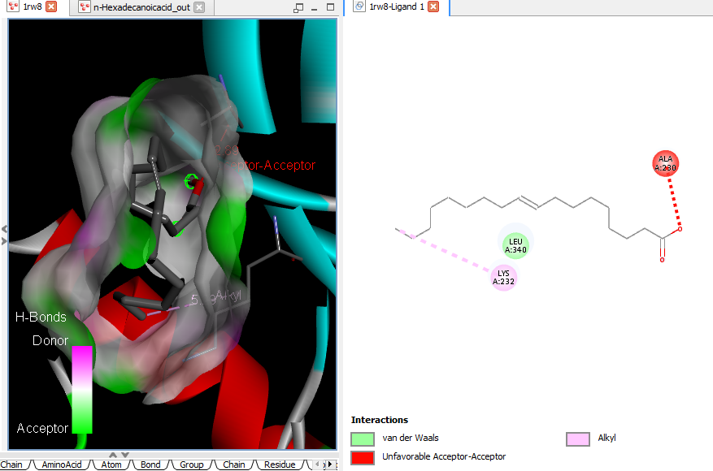
n-Hexadecanoic acid
Supplementary Figure 9A: 3D and 2D complex structure of binding Interaction between ligand and protein (PDB: 1RW8)
No interaction. Hexadecanoic acid, methyl ester | 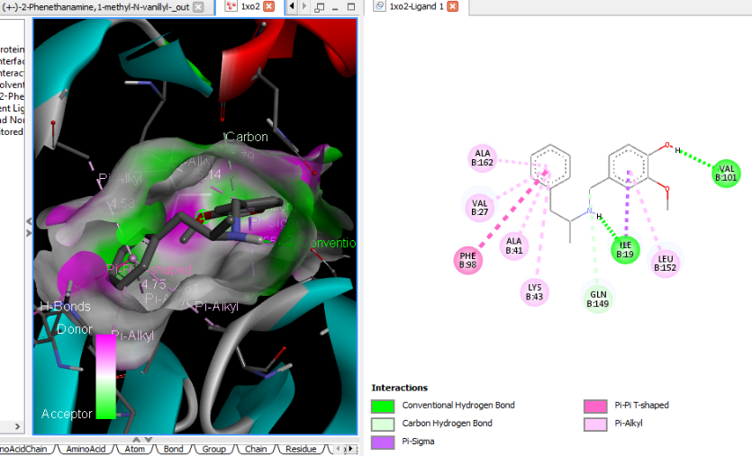 (+-)-2-Phenethanamine, 1-methyl-N-vanillyl-
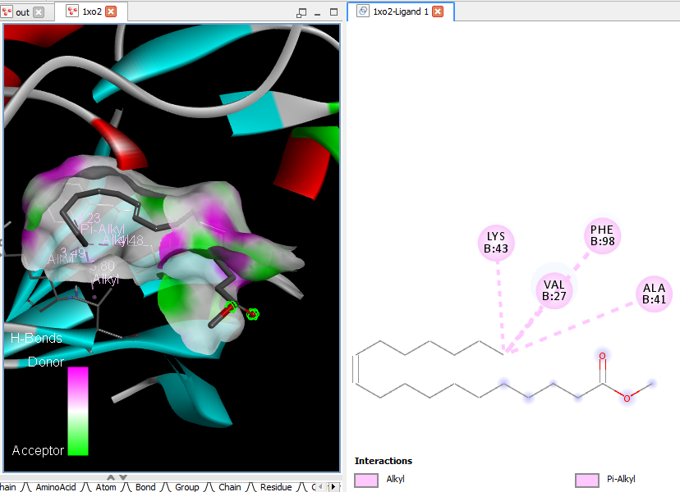11-Octadecenoic acid, methyl ester | 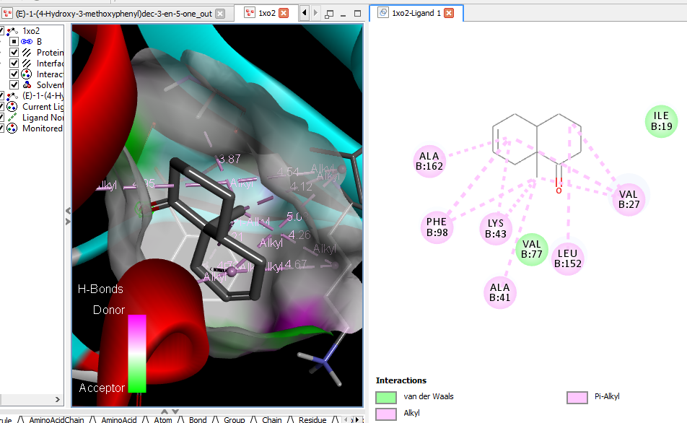 (E)-1-(4-Hydroxy-3-methoxyphenyl)dec-3-en-5-one
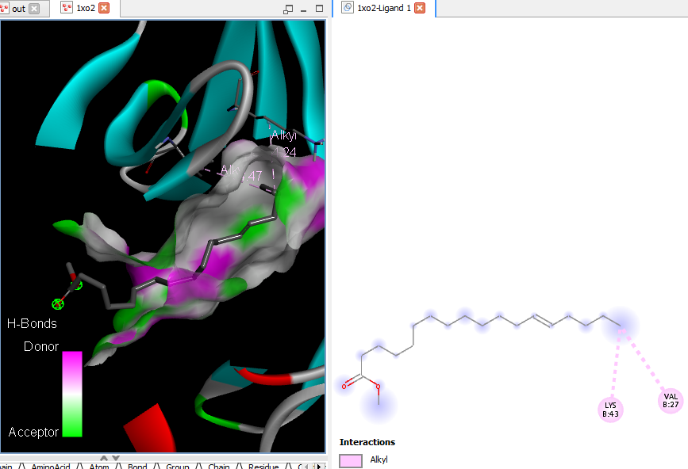cis-13-Octadecenoic acid, methyl ester | 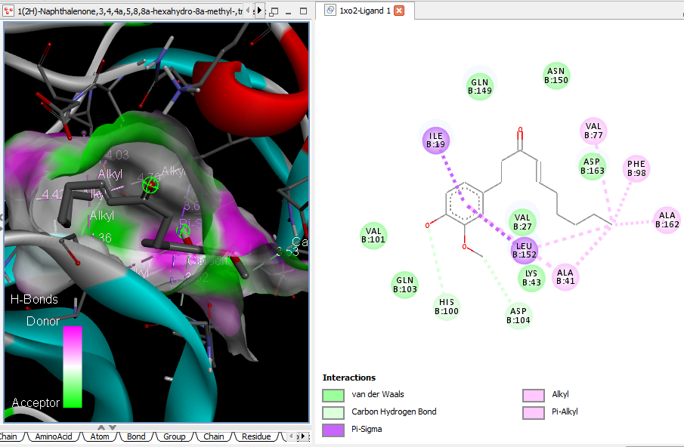  1(2H)-Naphthalenone, 3,4,4a,5,8,8a-hexahydro-8a-methyl-,trans-

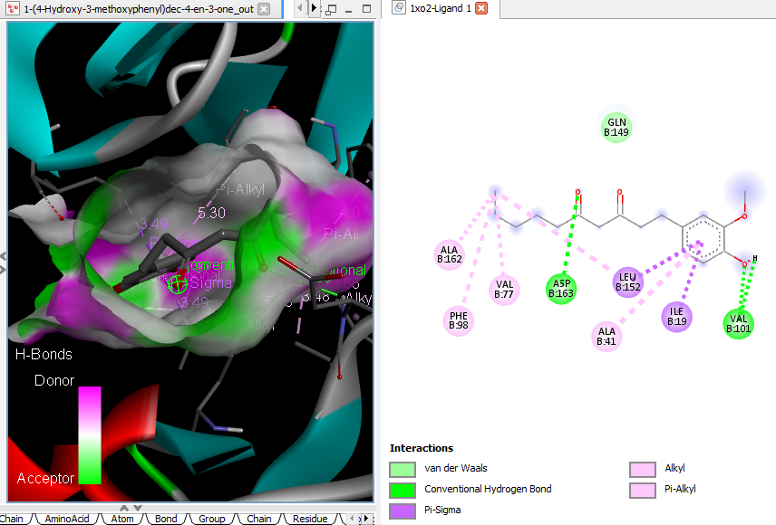  1-(4-Hydroxy-3-methoxyphenyl)dec-4-en-3-one (6-Shogoal) | 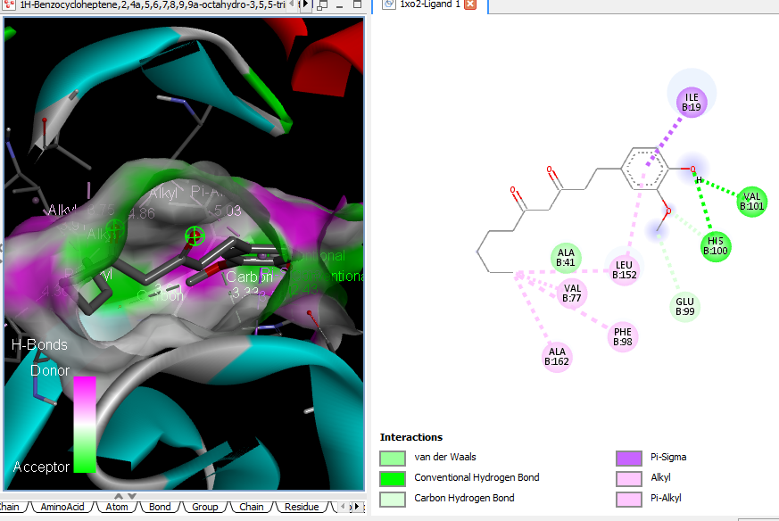  1H-Benzocycloheptene, 2,4a,5,6,7,8,9,9a-octahydro-3,5,5-trimethyl-9-methylene-,(4aS-cis)- (alpha-Himachalene)
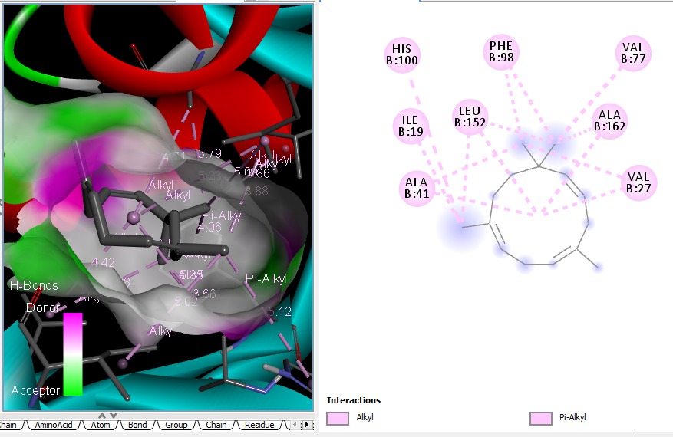  1-(4-Hydroxy-3-methoxyphenyl)decane-3,5-dione (gingerdione) | 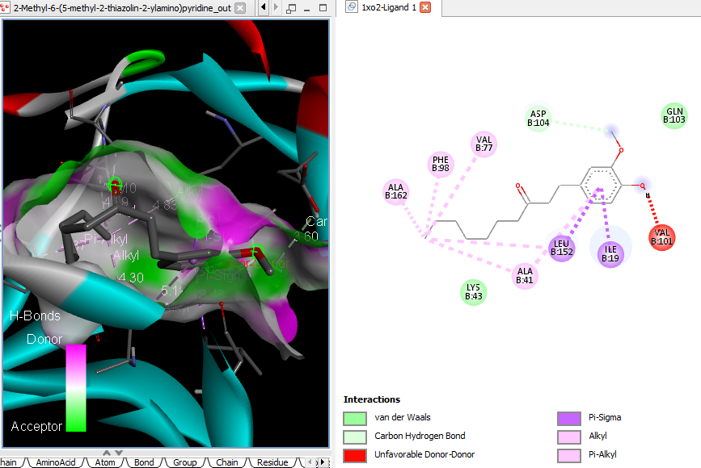  2-M ethyl-6-(5-methyl-2-thiazolin-2-ylamino)pyridine
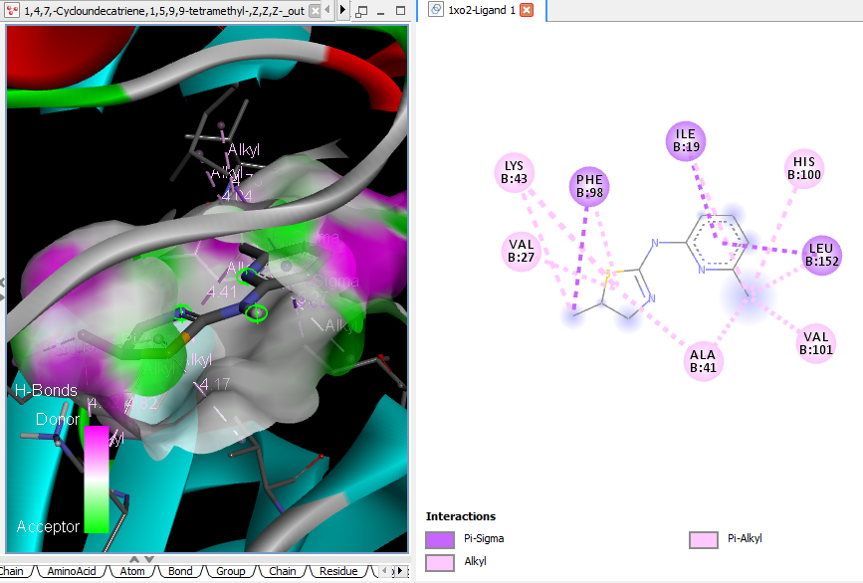  1,4,7,-Cycloundecatriene, 1,5,9,9-tetramethyl-, Z,Z,Z- | 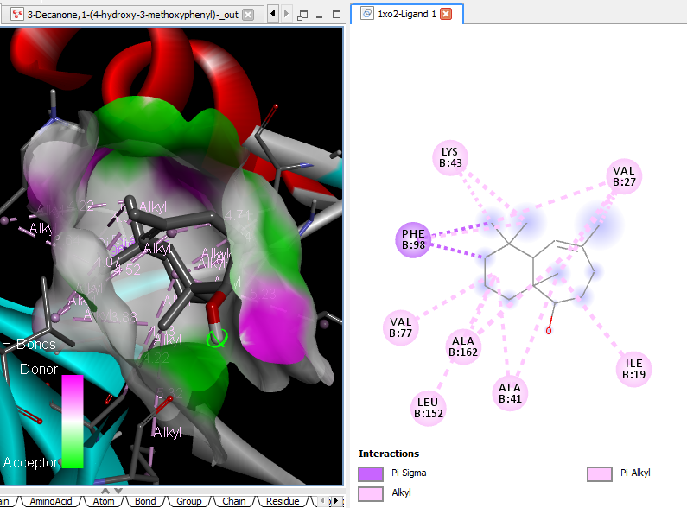  3-Decanone, 1-(4-hydroxy-3-methoxy phenyl)- (Paradol)

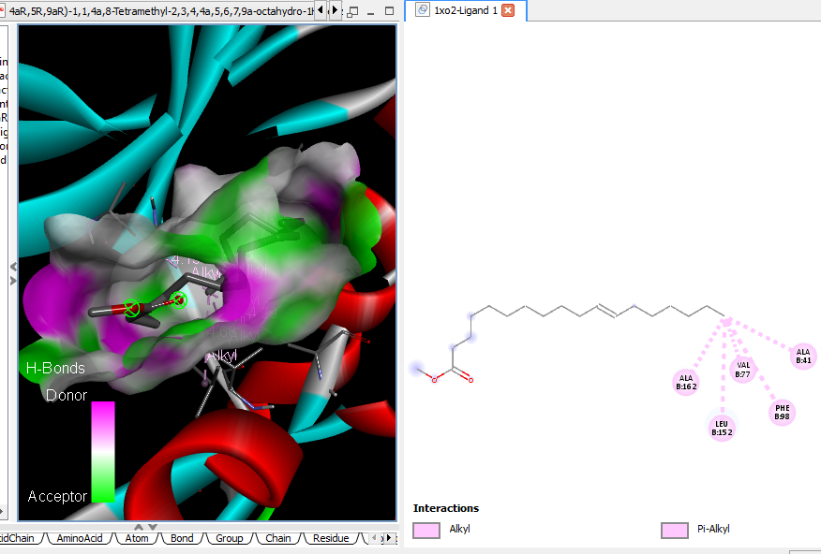 4aR,5R,9aR)-1,1,4a,8-Tetramethyl-2,3,4,4a,5,6,7,9a-octahydro-1H-benzo[7]annulen-5-ol (Allohimachalol) |  |  |  | 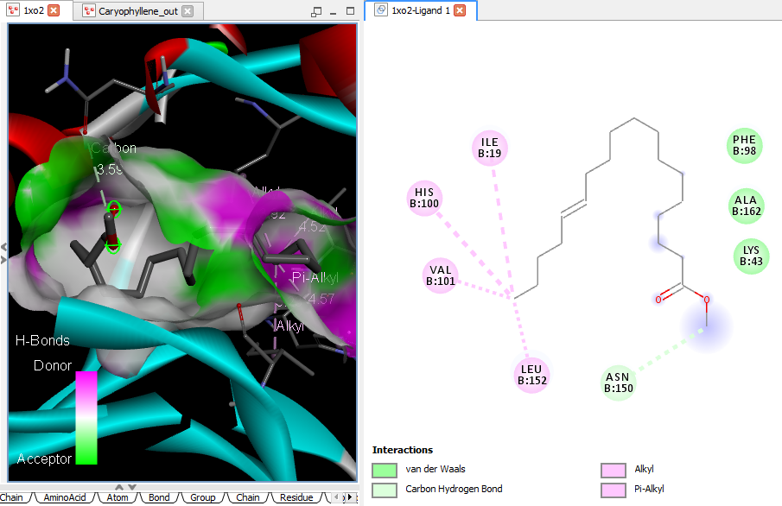 Caryophyllene
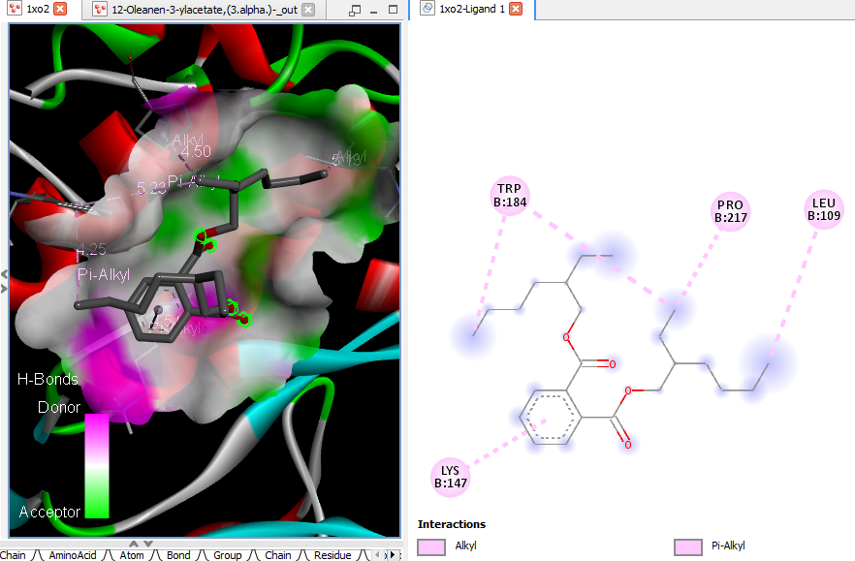  12-Oleanen-3-yl acetate, (3.alpha.)- (beta-Amyrenyl acetate) |  |  |  | 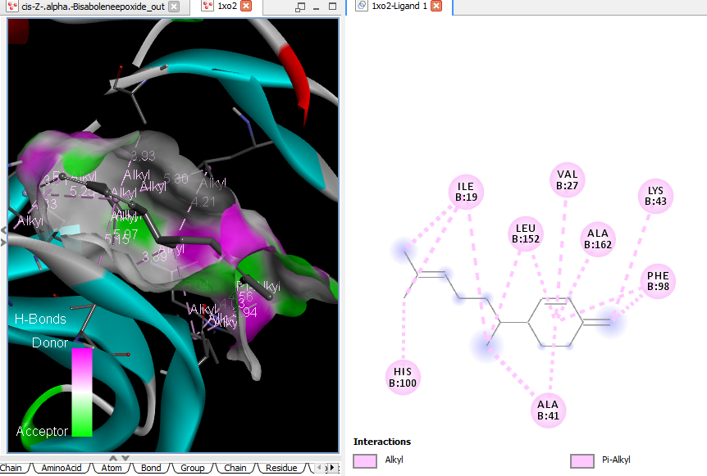 cis-Z-.alpha.-Bisabolene epoxide
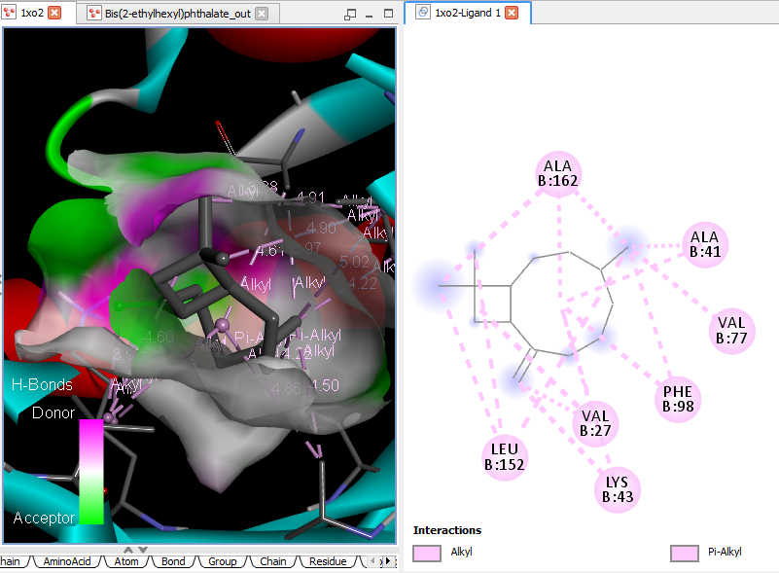  Bis(2-ethylhexyl) phthalate |  |  |  | 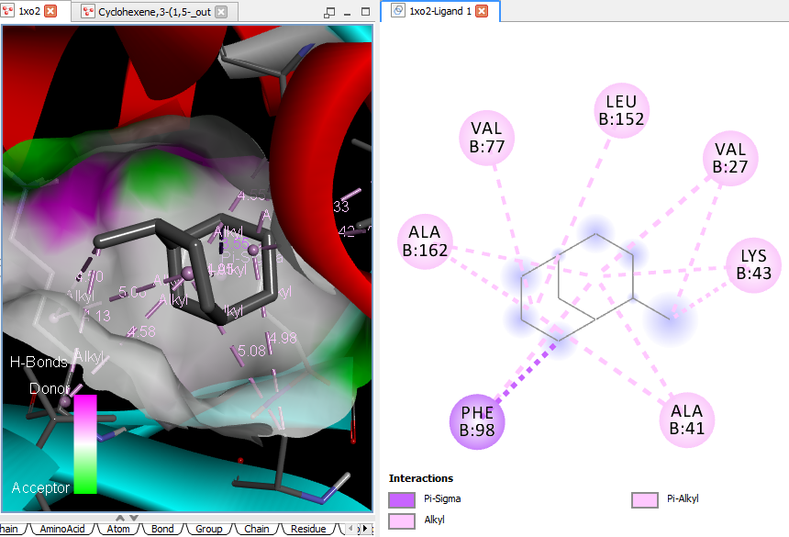 Cyclohexene, 3-(1,5-dimethyl-4-hexenyl)-6-methylene-, [S-(R*,S*)]-
 |  | 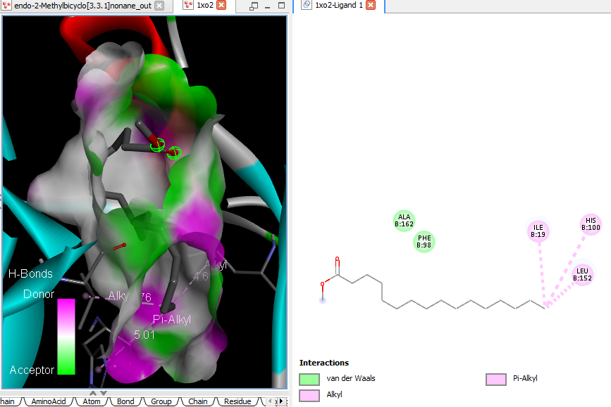  endo-2-Methylbicyclo[3.3.1]nonane |  |  | 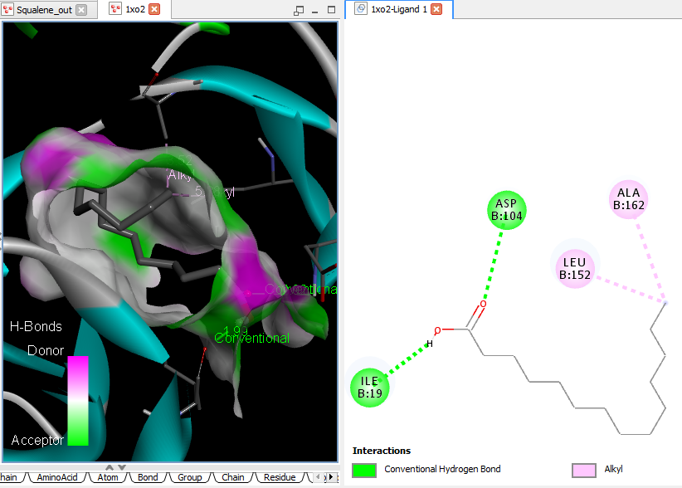 Squalene
 |  | 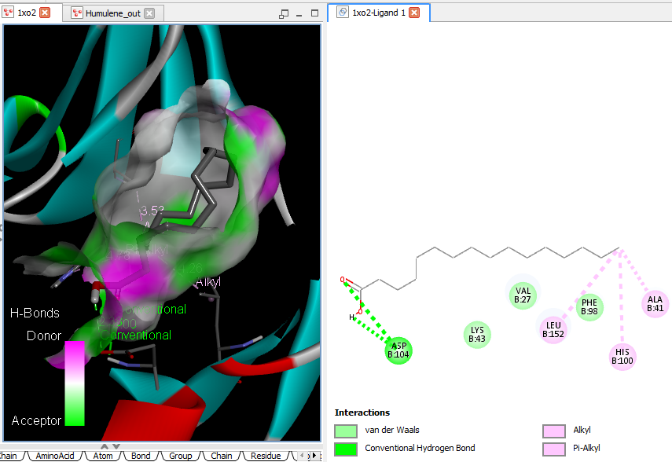  Humulene |  |  | 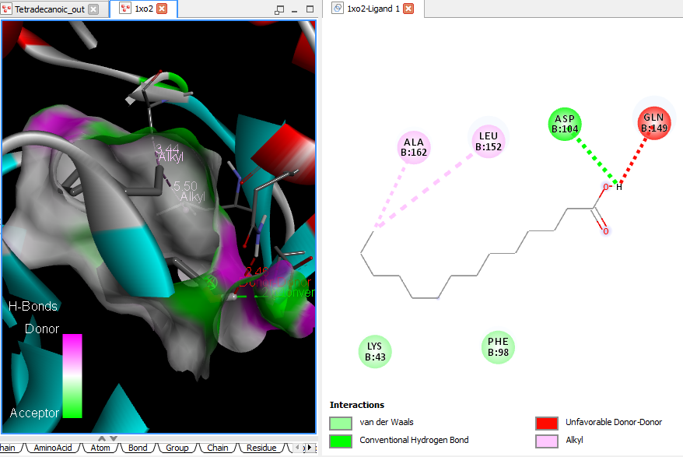 Tetradecanoic acid (myristic acid)
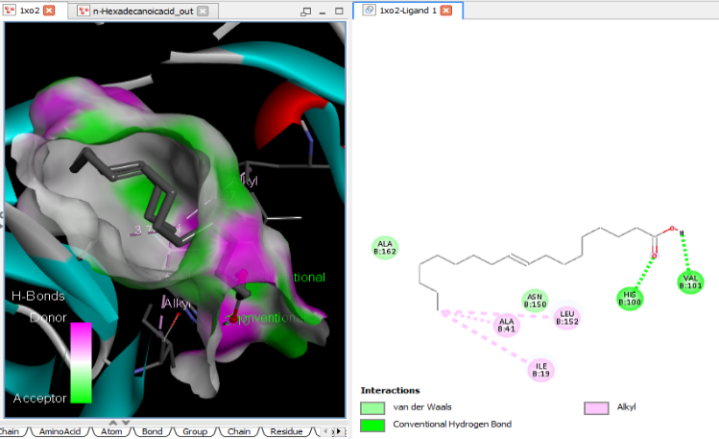
n-Hexadecanoic acid
Supplementary Figure 9B: 3D and 2D complex structure of binding Interaction between ligand and protein (PDB: 1XO2)

 | 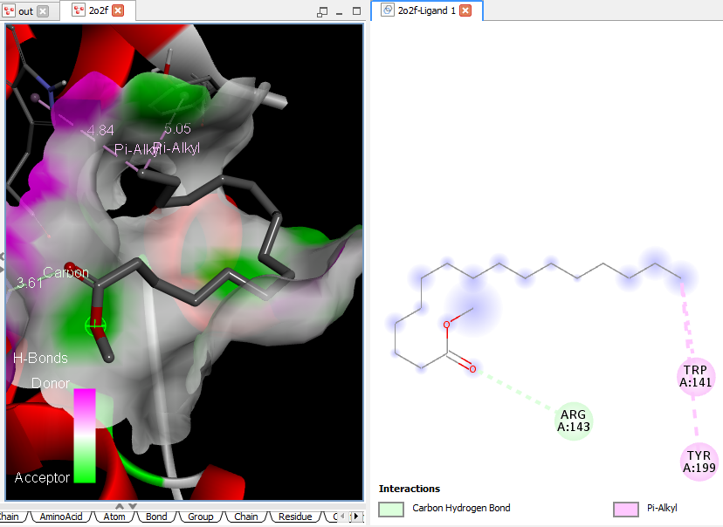Hexadecanoic acid, methyl ester |  | 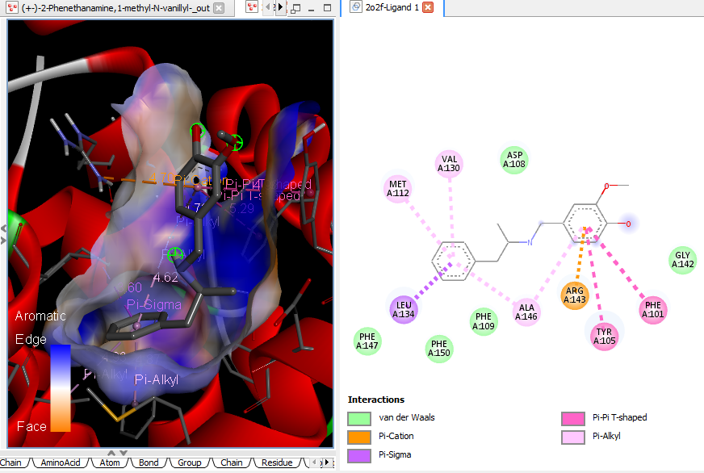  (+-)-2-Phenethanamine, 1-methyl-N-vanillyl-
 | 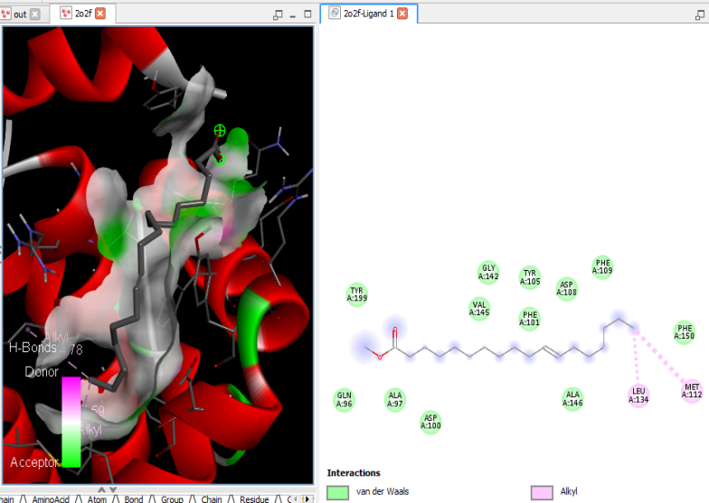11-Octadecenoic acid, methyl ester |  | 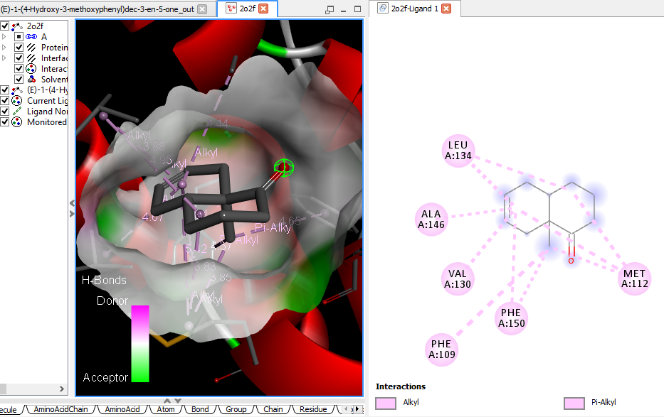 (E)-1-(4-Hydroxy-3-methoxyphenyl)dec-3-en-5-one
 | NI cis-13-Octadecenoic acid, methyl ester |  | 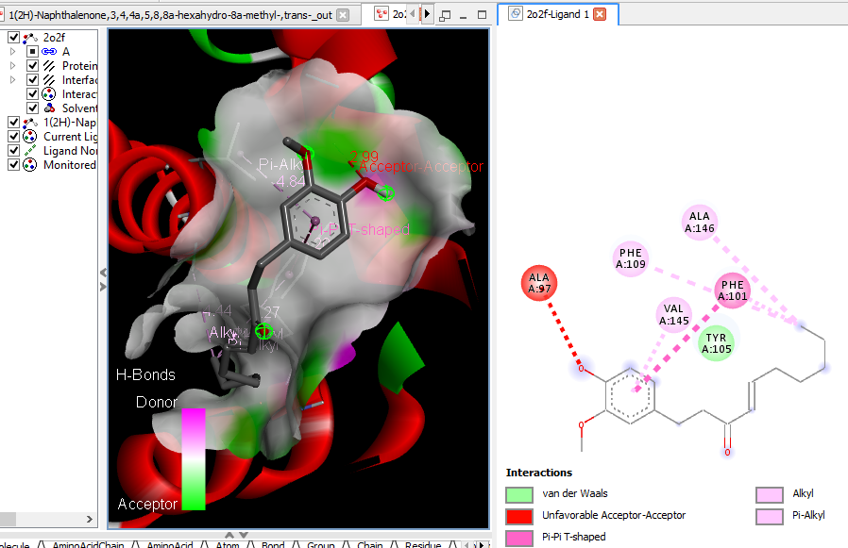 1(2H)-Naphthalenone, 3,4,4a,5,8,8a-hexahydro-8a-methyl-,trans-

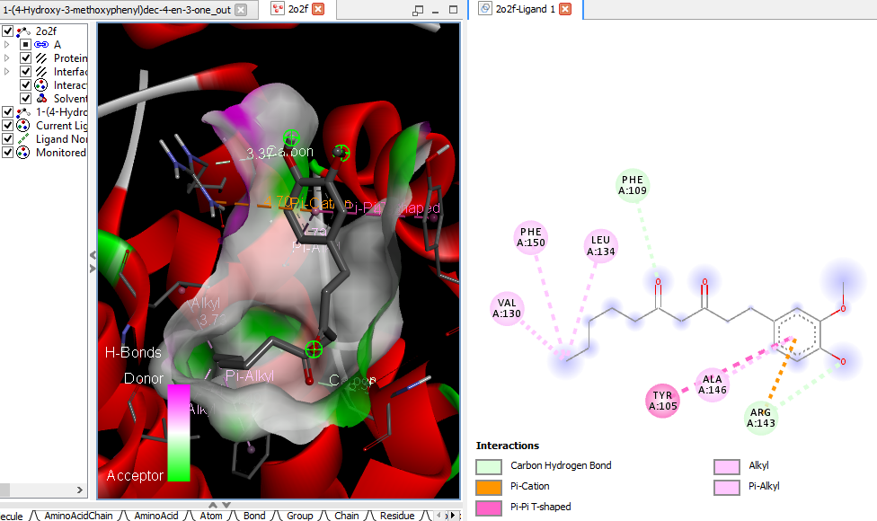  1-(4-Hydroxy-3-methoxyphenyl)dec-4-en-3-one (6-Shogoal) | 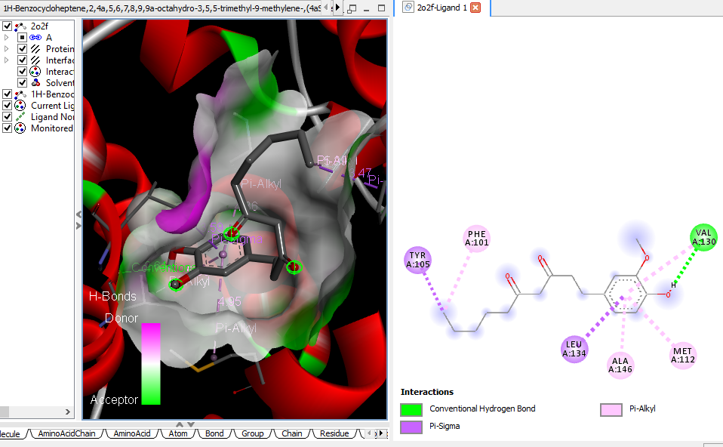 1H-Benzocycloheptene, 2,4a,5,6,7,8,9,9a-octahydro-3,5,5-trimethyl-9-methylene-,(4aS-cis)- (alpha-Himachalene)
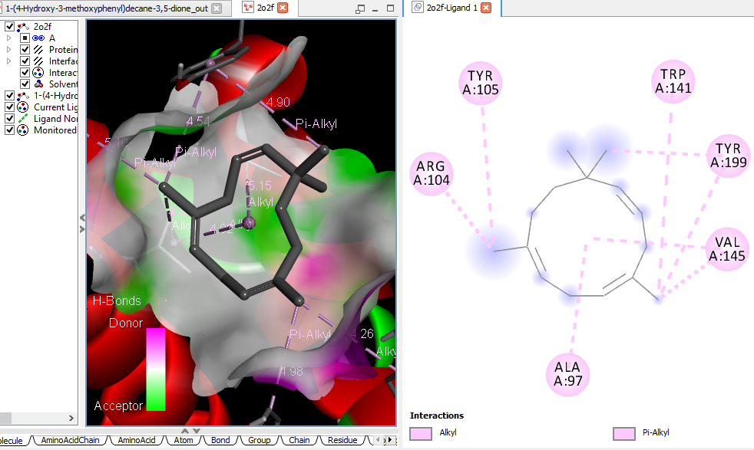 1-(4-Hydroxy-3-methoxyphenyl)decane-3,5-dione (gingerdione) | 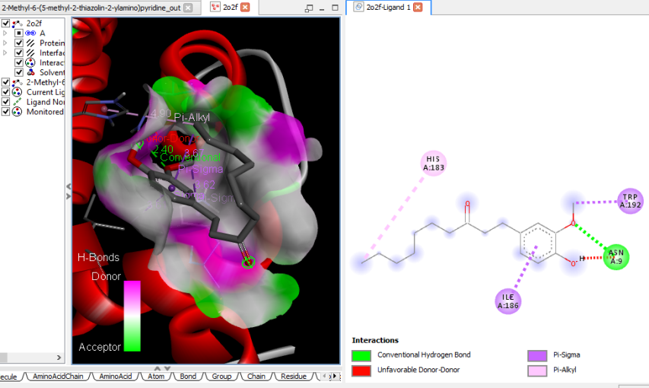 2-Methyl-6-(5-methyl-2-thiazolin-2-ylamino)pyridine
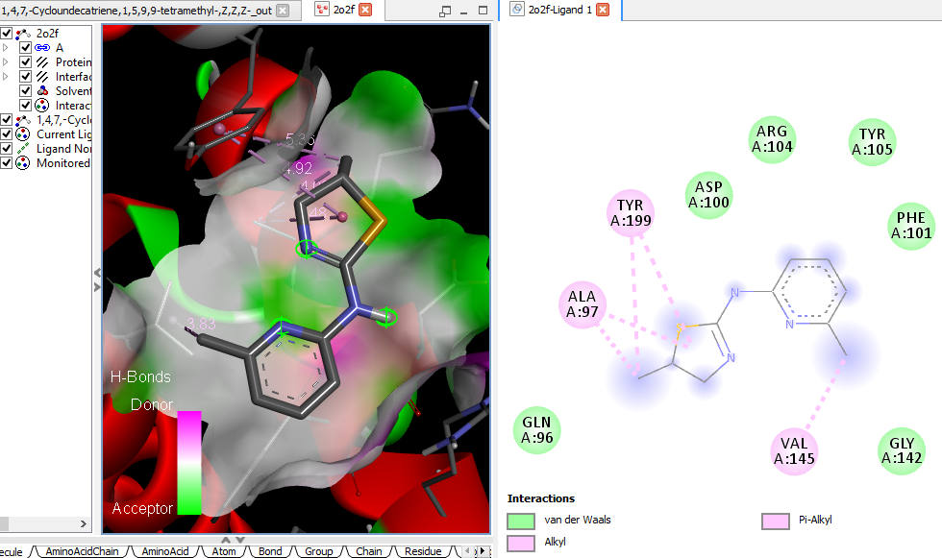 1,4,7,-Cycloundecatriene, 1,5,9,9-tetramethyl-, Z,Z,Z- | 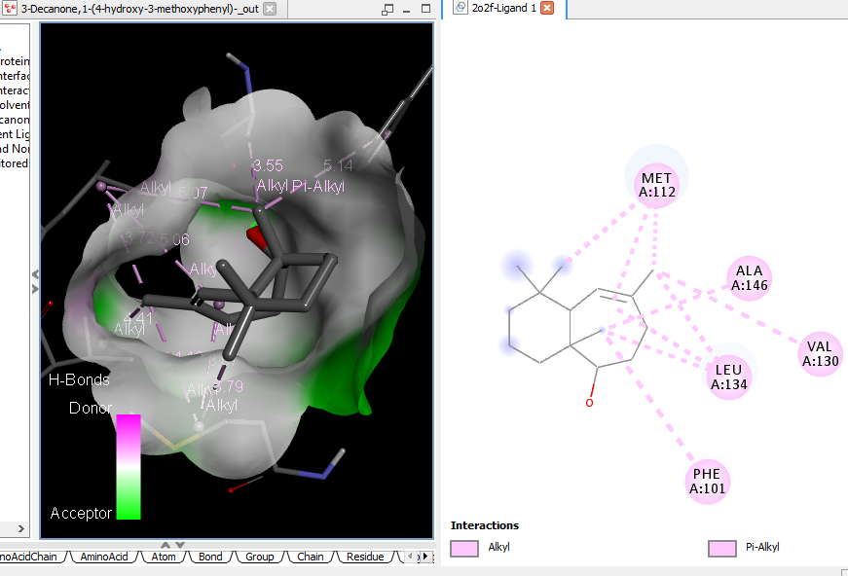 3-Decanone, 1-(4-hydroxy-3-methoxy phenyl)- (Paradol)

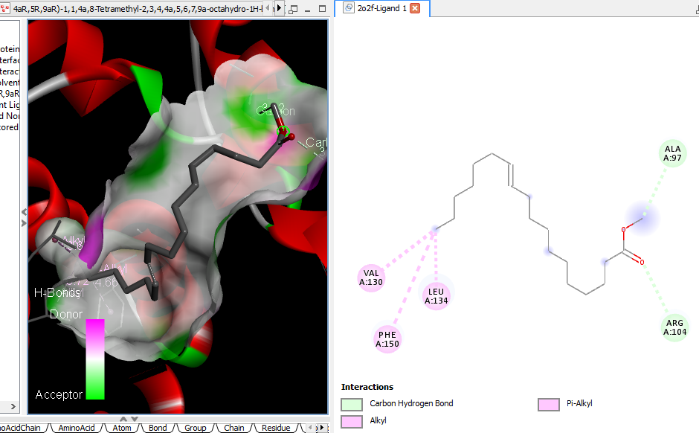  4aR,5R,9aR)-1,1,4a,8-Tetramethyl-2,3,4,4a,5,6,7,9a-octahydro-1H-benzo[7]annulen-5-ol (Allohimachalol) | 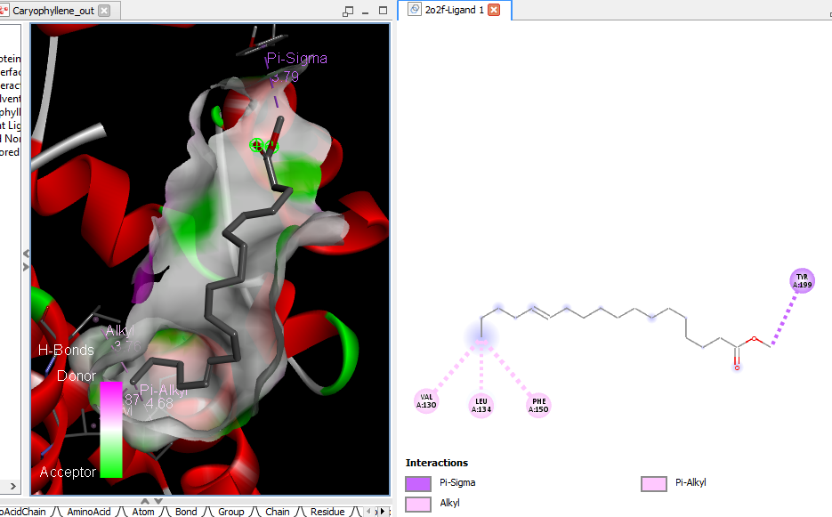 Caryophyllene
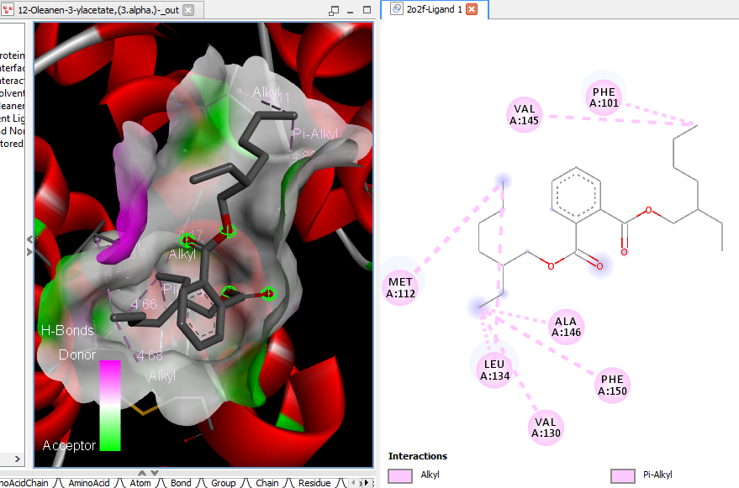  12-Oleanen-3-yl acetate, (3.alpha.)- (beta-Amyrenyl acetate) | 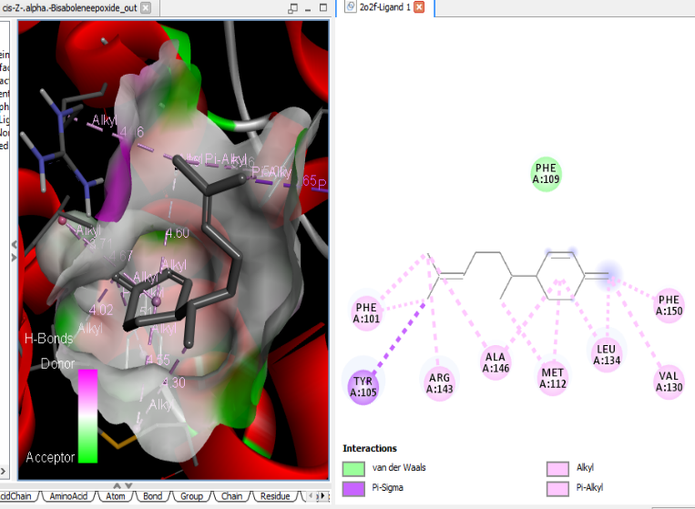  cis-Z-.alpha.-Bisabolene epoxide
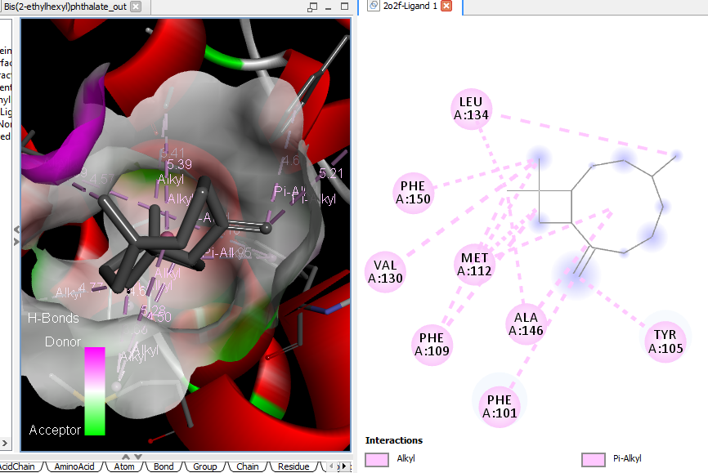 Bis(2-ethylhexyl) phthalate | 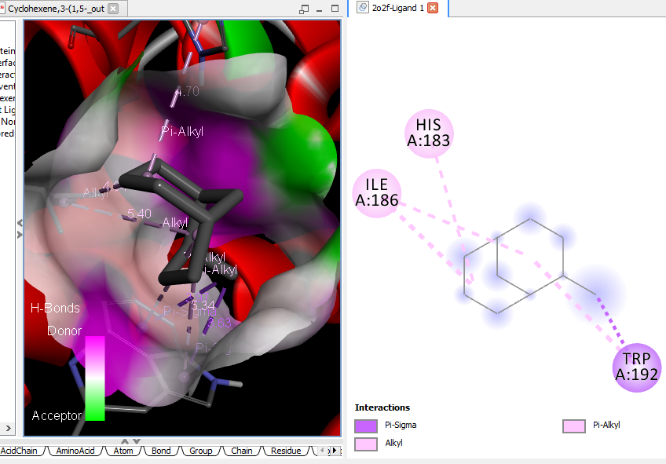 Cyclohexene, 3-(1,5-dimethyl-4-hexenyl)-6-methylene-, [S-(R*,S*)]-

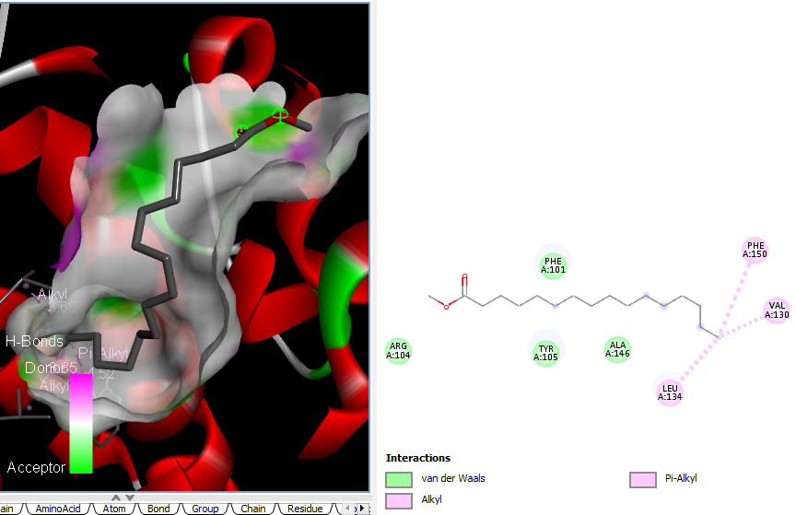 endo-2-Methylbicyclo[3.3.1]nonane |  |  |  |  |  |  | 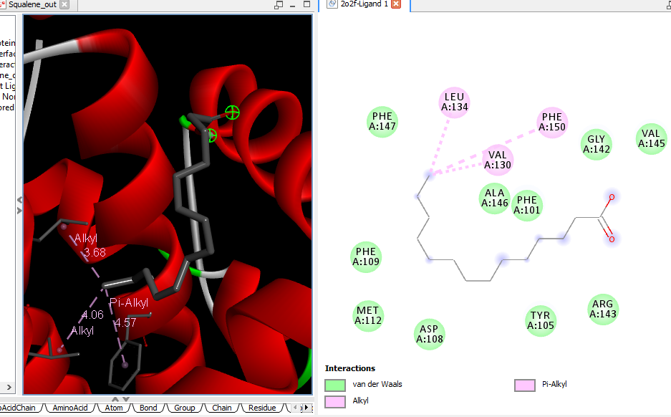 Squalene
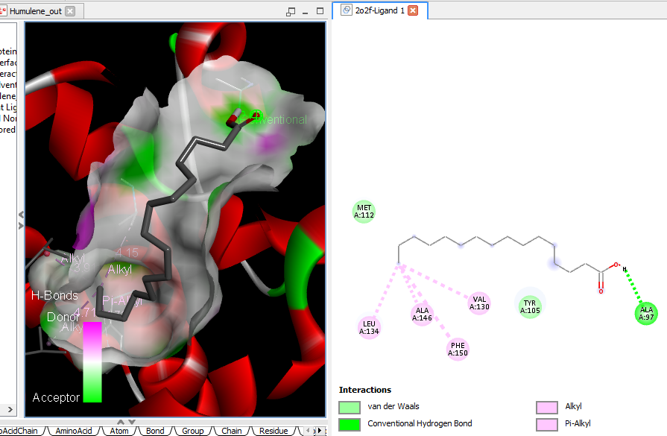 Humulene |  |  |  |  |  |  | 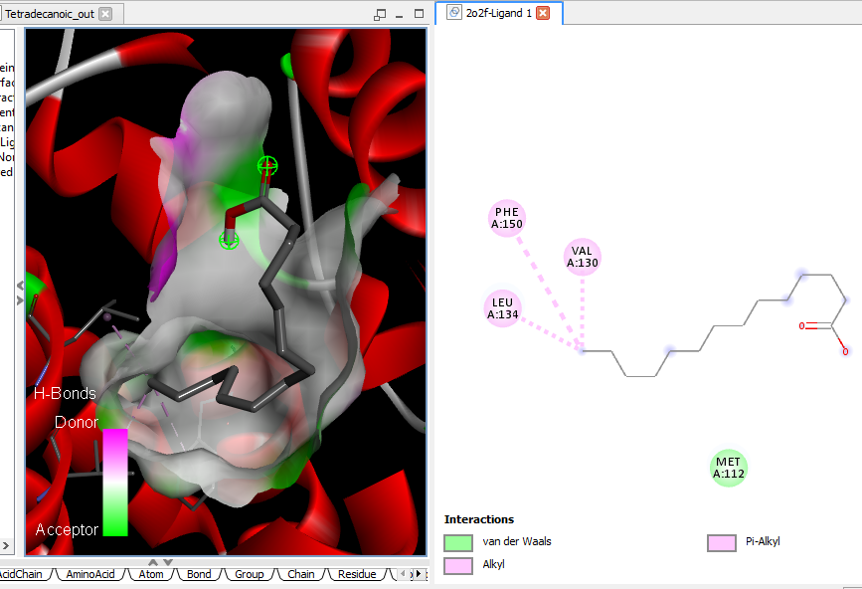 Tetradecanoic acid (myristic acid)
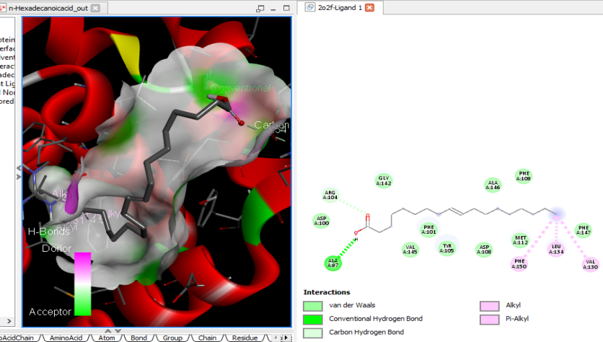
n-Hexadecanoic acid

Supplementary Figure 9C: 3D and 2D complex structure of binding Interaction between ligand and protein (PDB: 2O2F)

 |  |  |  | 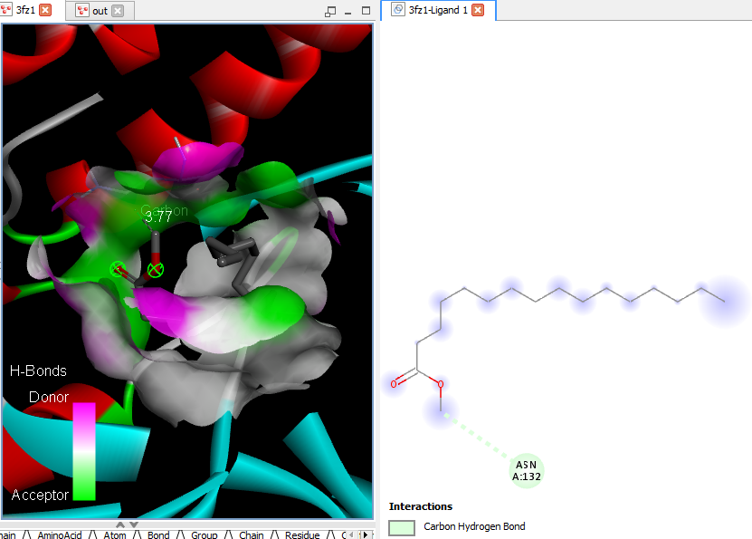Hexadecanoic acid, methyl ester | 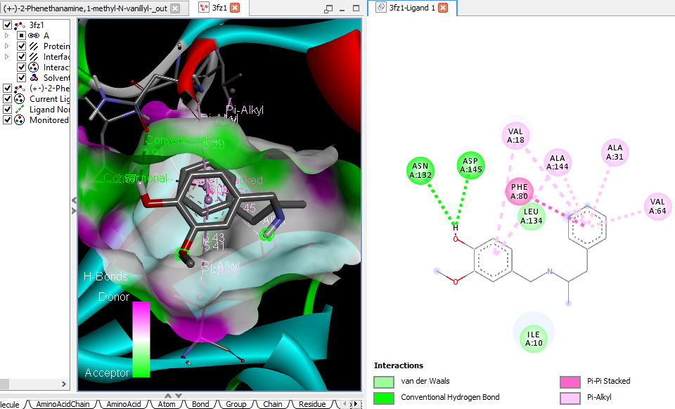  (+-)-2-Phenethanamine, 1-methyl-N-vanillyl-
 |  |  |  | 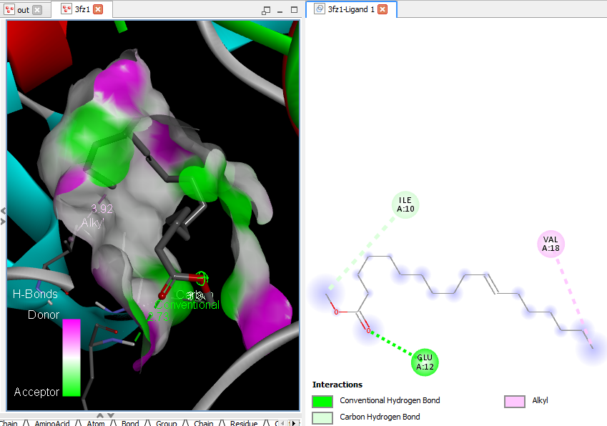11-Octadecenoic acid, methyl ester | 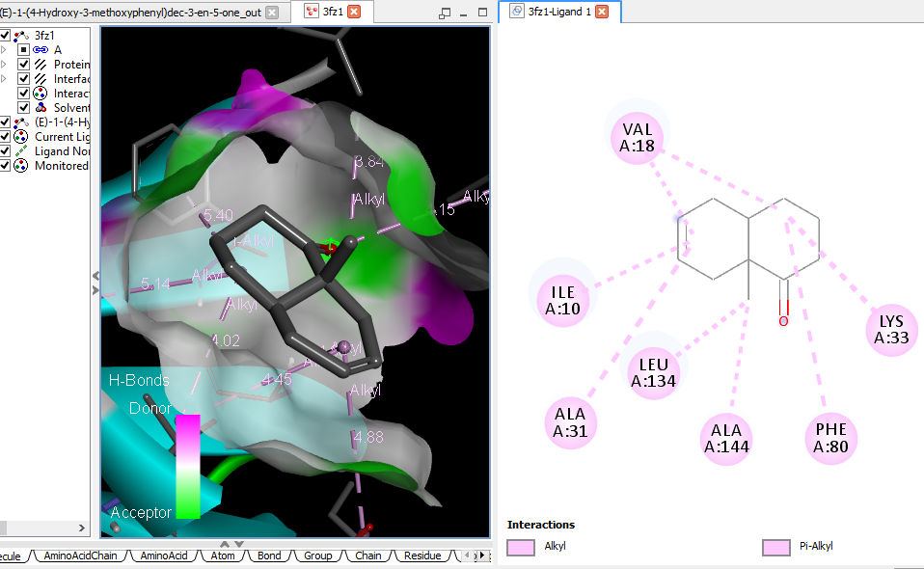 (E)-1-(4-Hydroxy-3-methoxyphenyl)dec-3-en-5-one
 |  |  |  | NI Cis-13-Octadecenoic acid, methyl ester | 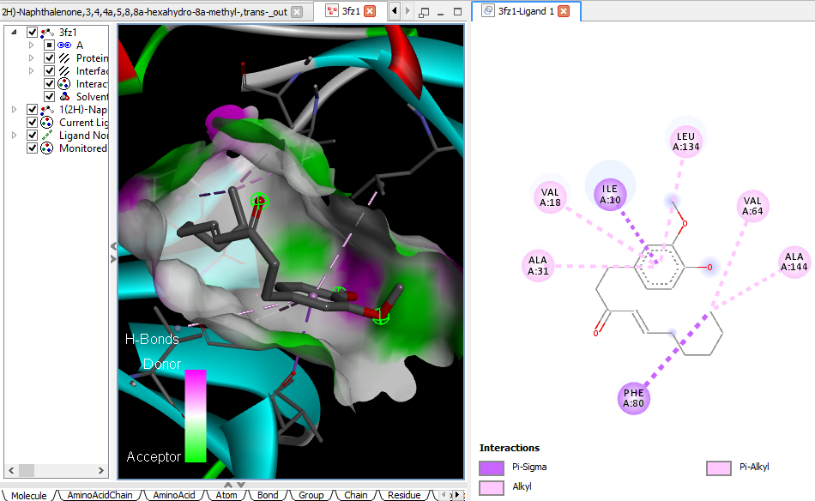 1(2H)-Naphthalenone, 3,4,4a,5,8,8a-hexahydro-8a-methyl-,trans-
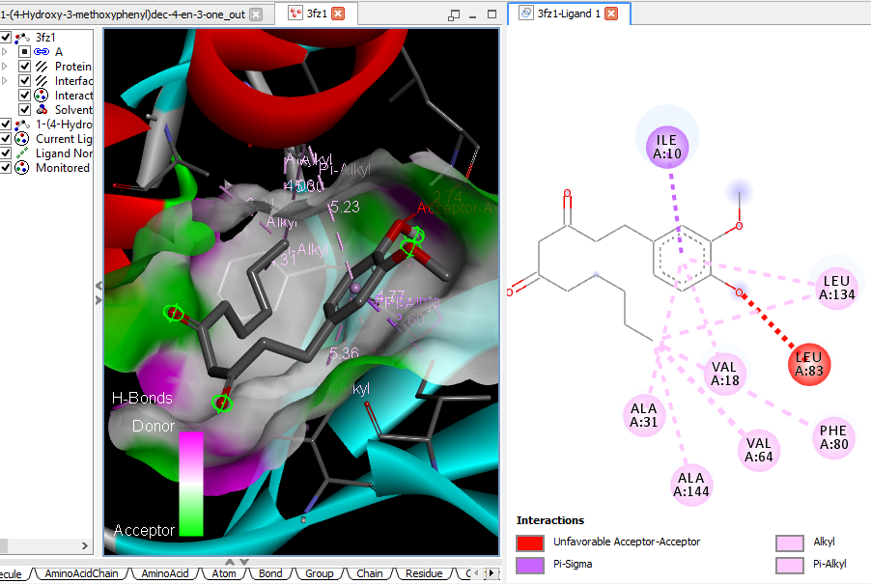 1-(4-Hydroxy-3-methoxyphenyl)dec-4-en-3-one (6-Shogoal) |  |  |  |  | 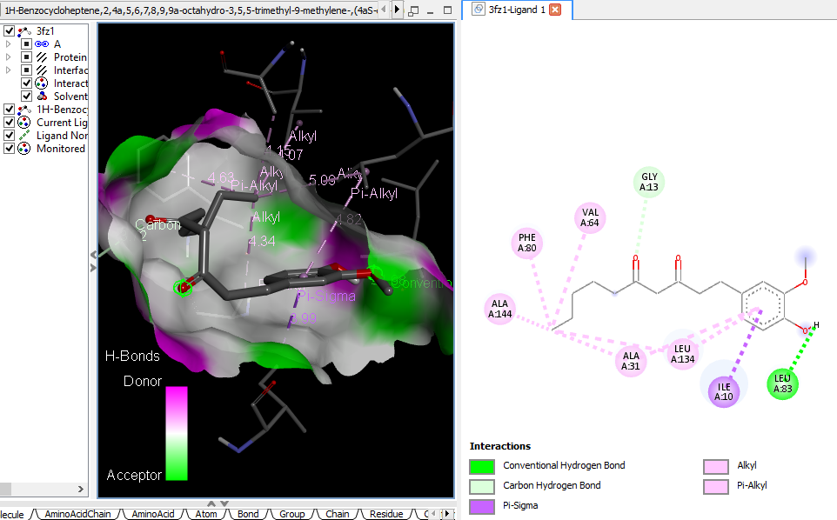  \1H-Benzocycloheptene, 2,4a,5,6,7,8,9,9a-octahydro-3,5,5-trimethyl-9-methylene-,(4aS-cis)- (alpha-Himachalene)
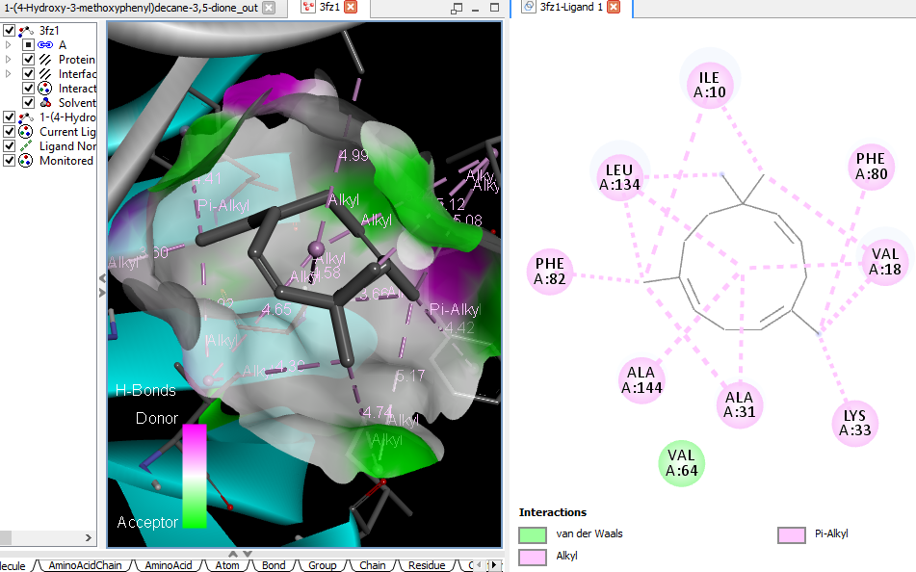  1-(4-Hydroxy-3-methoxyphenyl)decane-3,5-dione (gingerdione) |  |  |  |  | 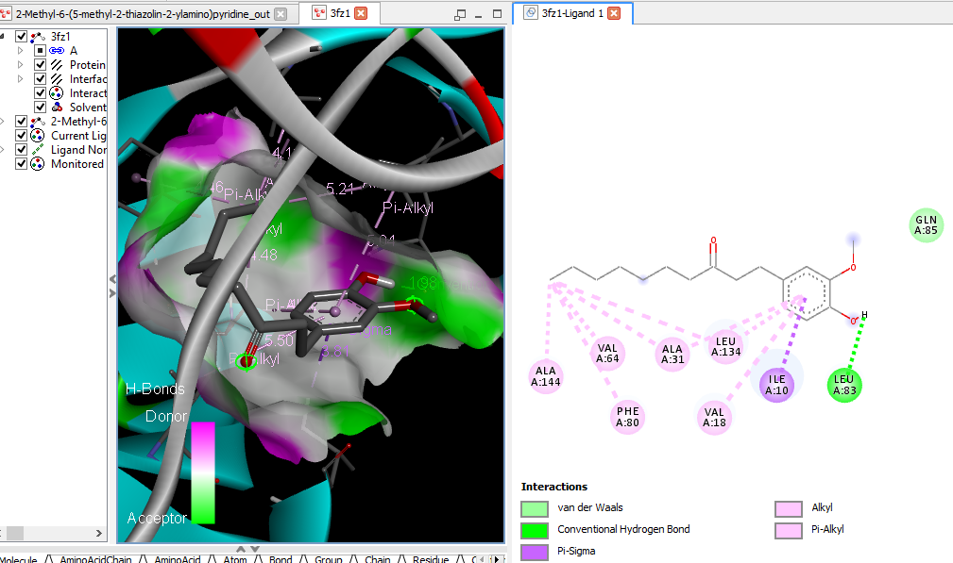  2-Methyl-6-(5-methyl-2-thiazolin-2-ylamino)pyridine
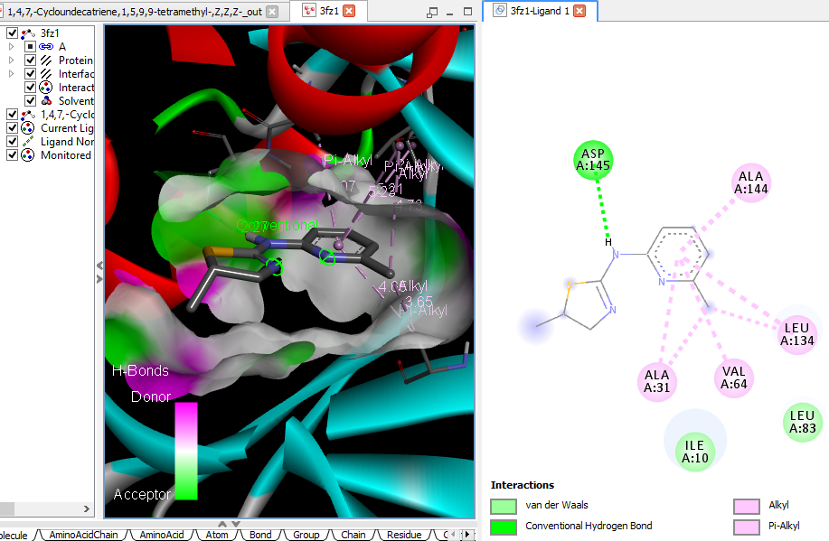  1,4,7,-Cycloundecatriene, 1,5,9,9-tetramethyl-, Z,Z,Z- |  |  |  |  | 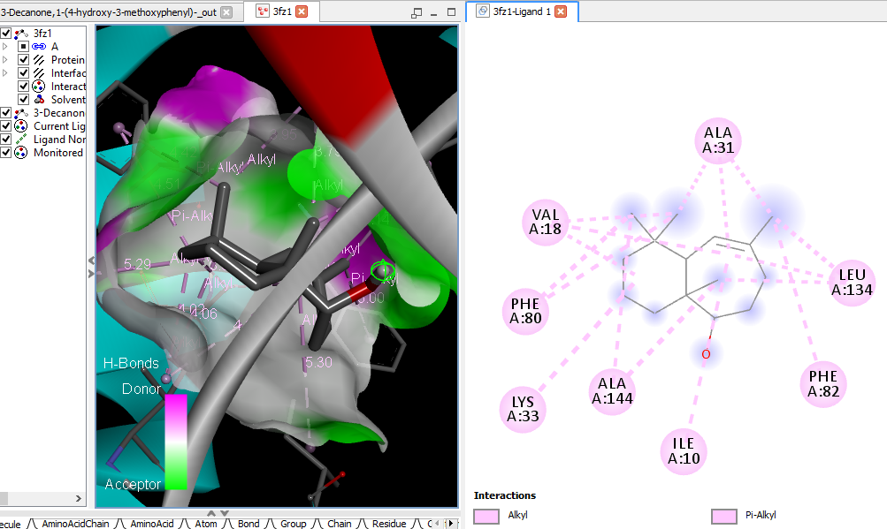  3-Decanone, 1-(4-hydroxy-3-methoxy phenyl)- (Paradol)
 | 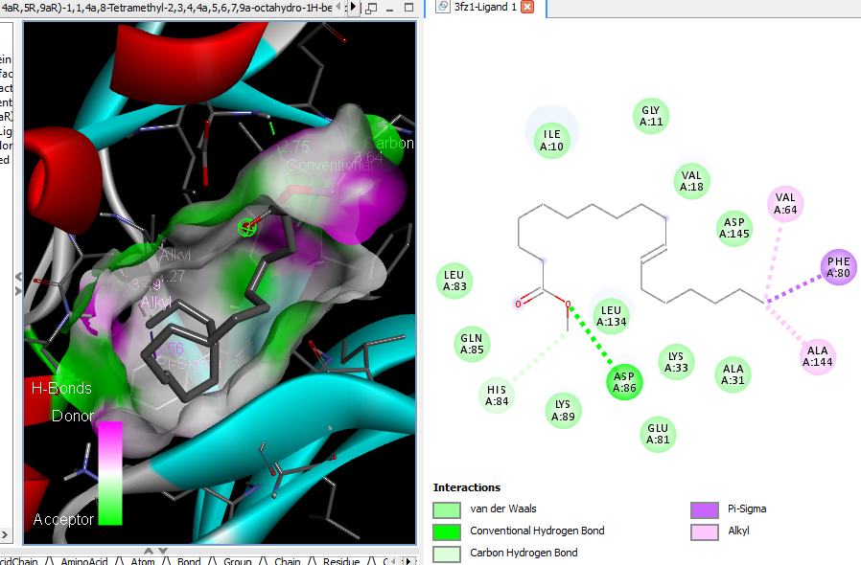  4aR,5R,9aR)-1,1,4a,8-Tetramethyl-2,3,4,4a,5,6,7,9a-octahydro-1H-benzo[7]annulen-5-ol (Allohimachalol) |  |  |  |  |  | 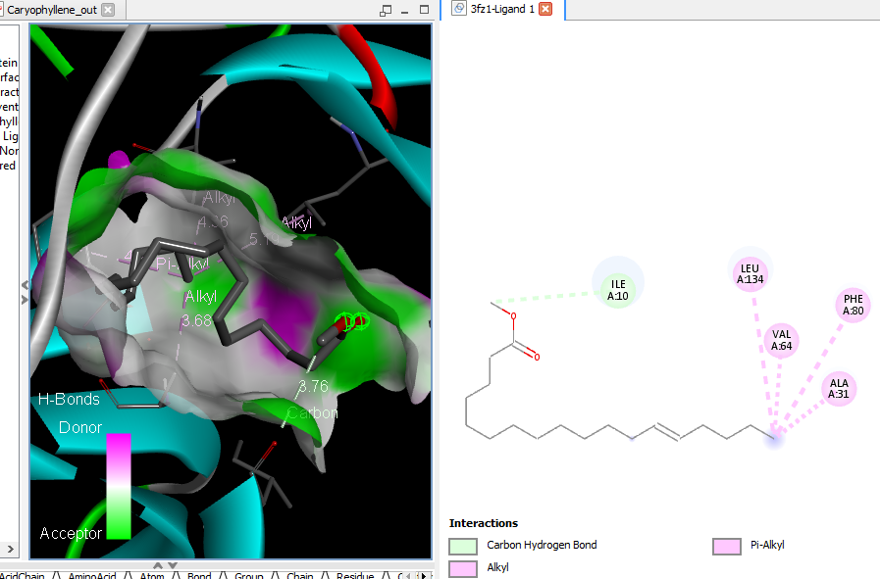 Caryophyllene
 | 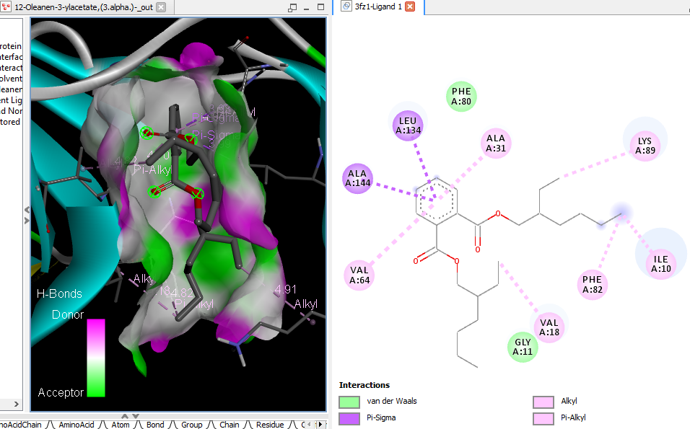  12-Oleanen-3-yl acetate, (3.alpha.)- (beta-Amyrenyl acetate) |  |  |  |  |  | 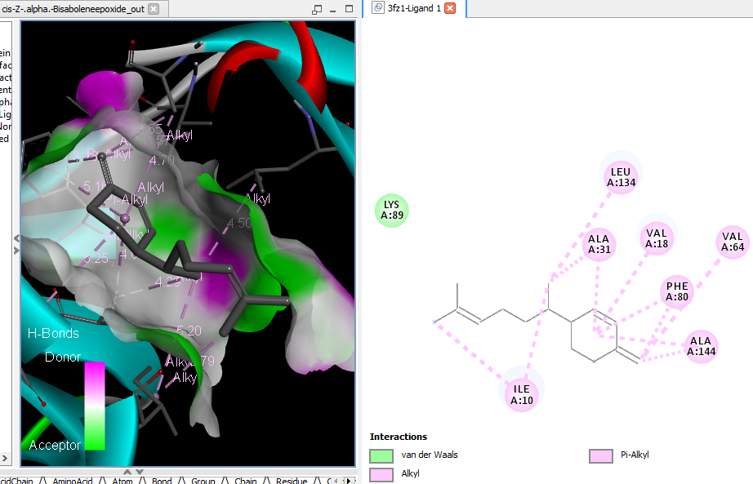  cis-Z-.alpha.-Bisabolene epoxide
 | 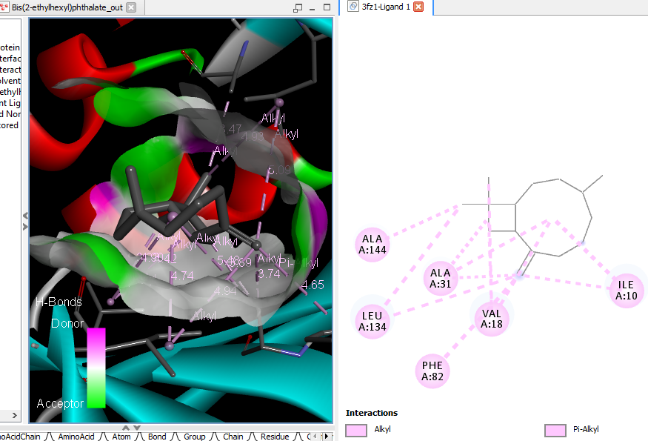 Bis(2-ethylhexyl) phthalate |  |  |  |  |  | 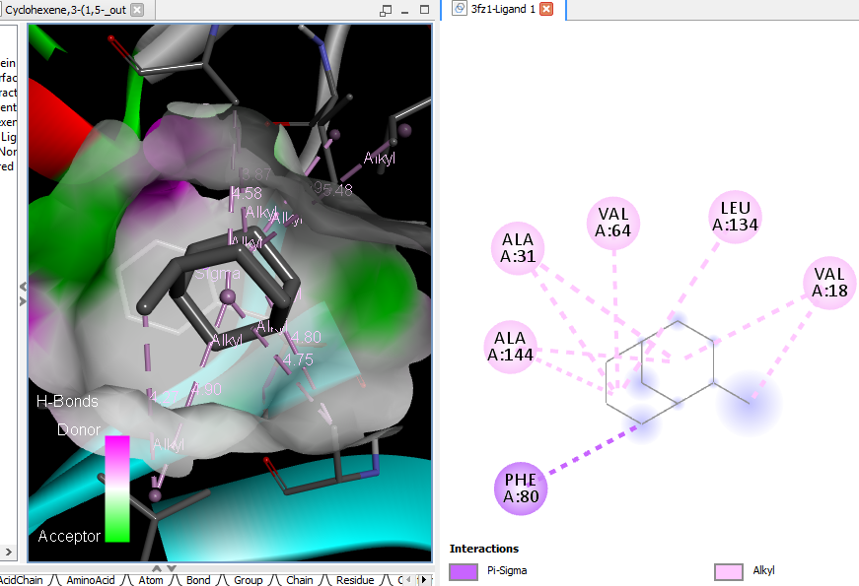 Cyclohexene, 3-(1,5-dimethyl-4-hexenyl)-6-methylene-, [S-(R*,S*)]-
 | 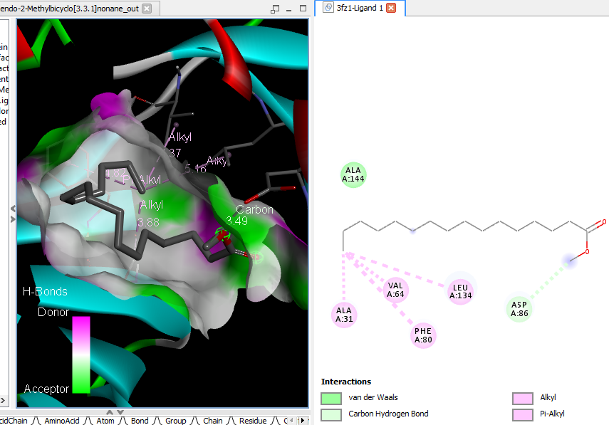 endo-2-Methylbicyclo[3.3.1]nonane |  |  |  | 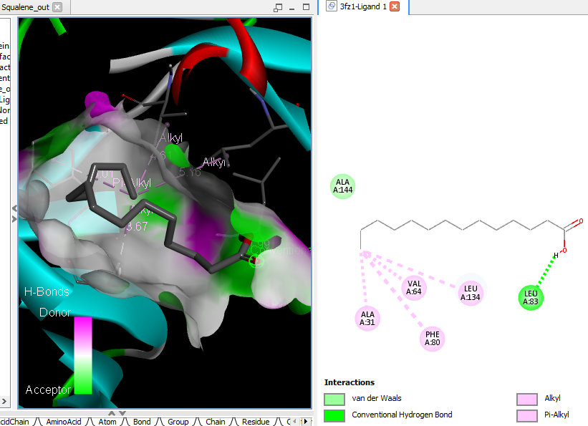 Squalene
 | 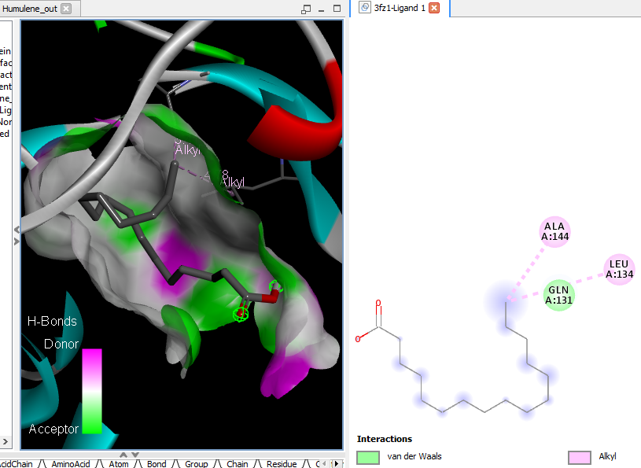  Humulene |  |  |  | 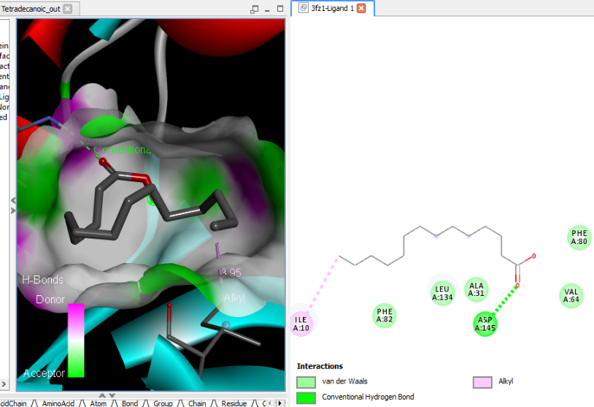Tetradecanoic acid (myristic acid)
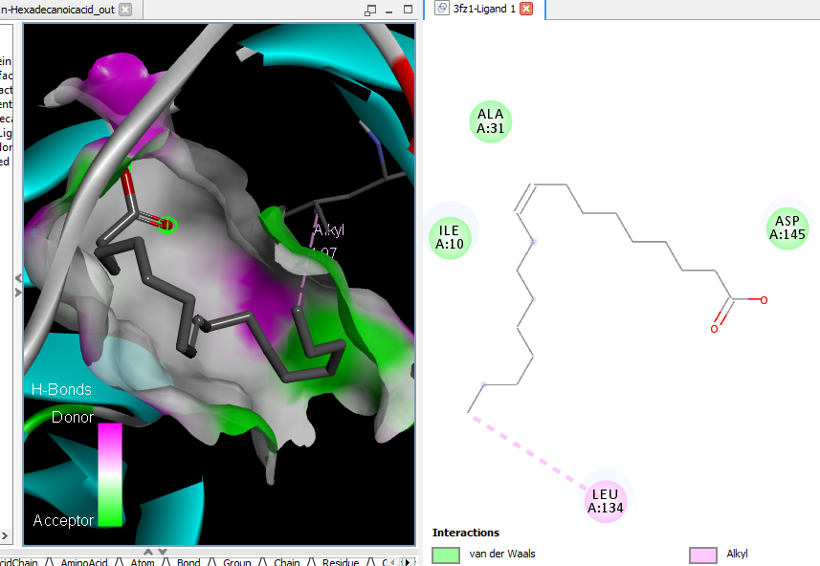
n-Hexadecanoic acid
Supplementary Figure 9D: 3D and 2D complex structure of binding Interaction between ligand and protein (PDB: 3FZ1)
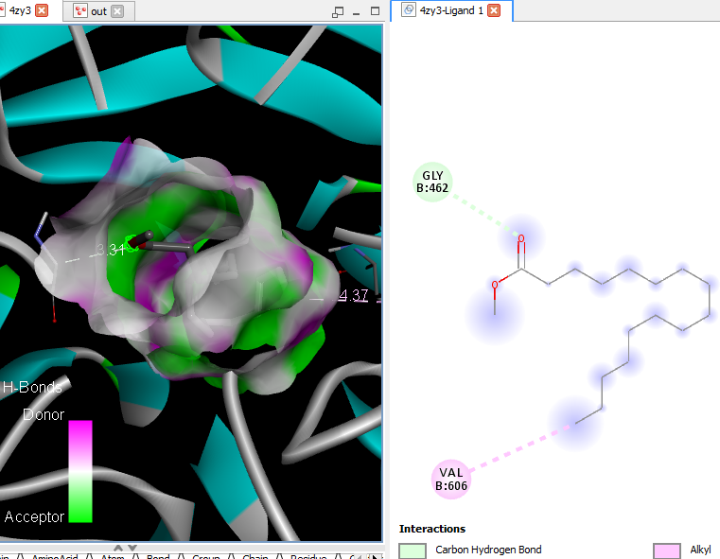Hexadecanoic acid, methyl ester |  |  |  |  | 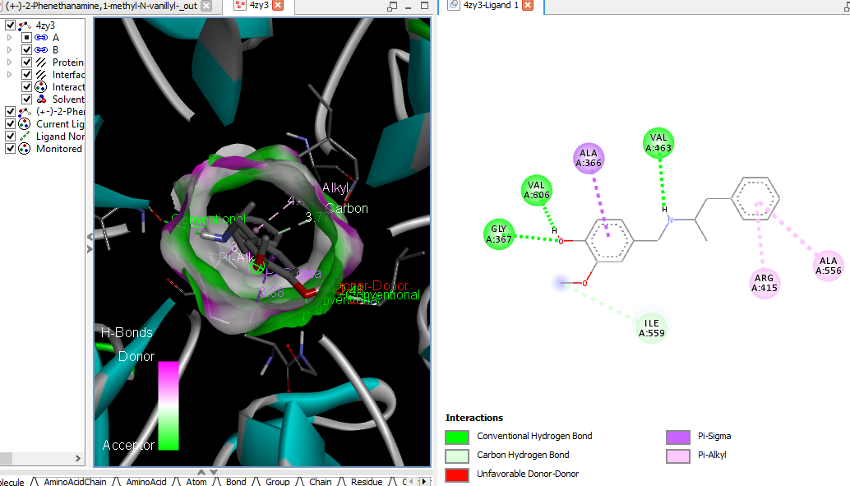  (+-)-2-Phenethanamine, 1-methyl-N-vanillyl-
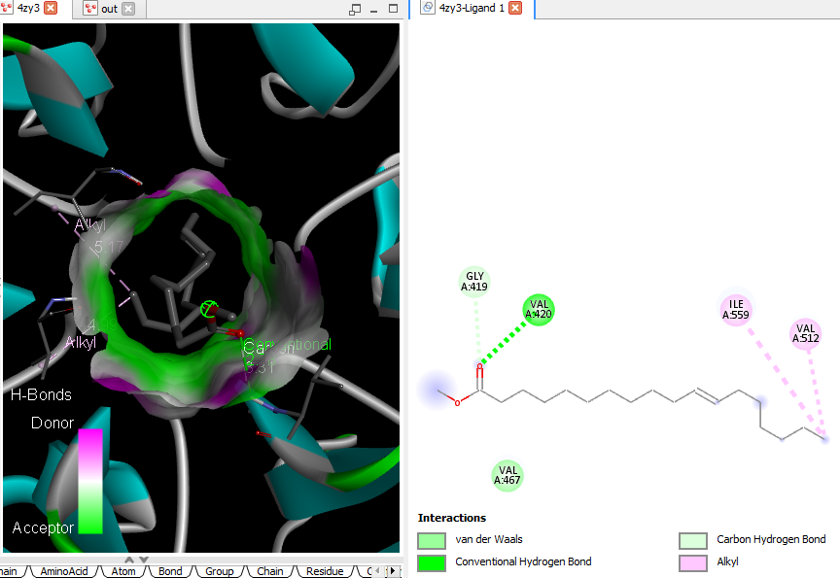11-Octadecenoic acid, methyl ester |  |  |  |  | 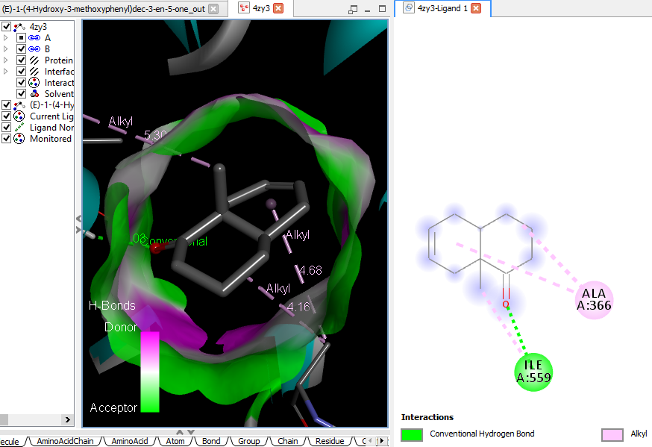  (E)-1-(4-Hydroxy-3-methoxyphenyl)dec-3-en-5-one
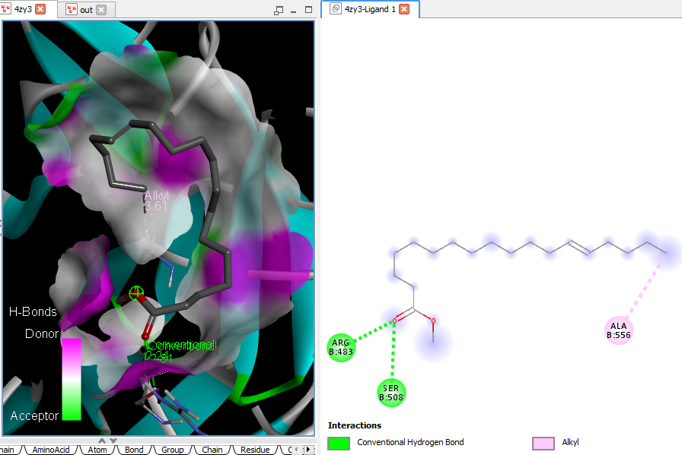cis-13-Octadecenoic acid, methyl ester |  |  |  |  | 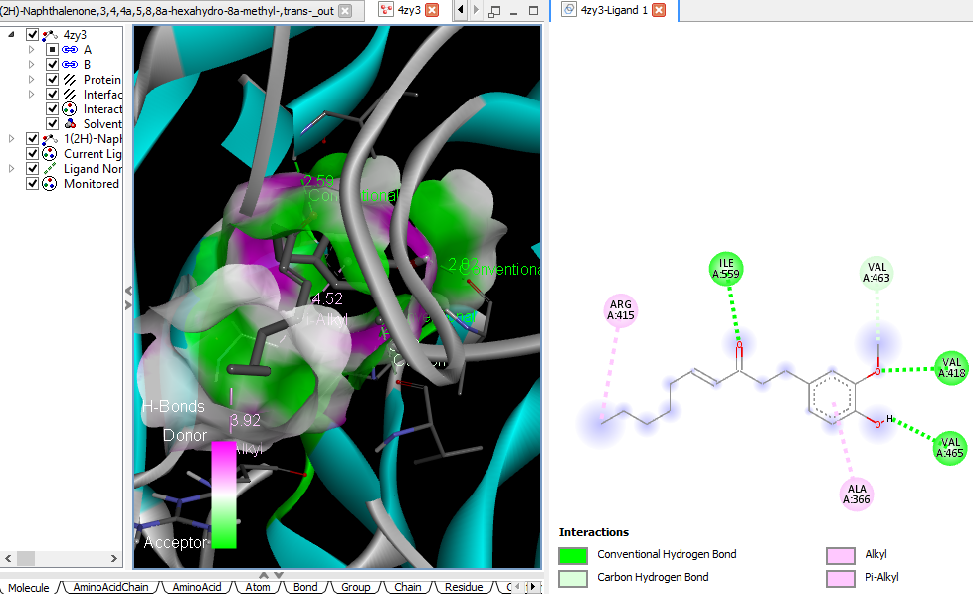 1(2H)-Naphthalenone, 3,4,4a,5,8,8a-hexahydro-8a-methyl-,trans-
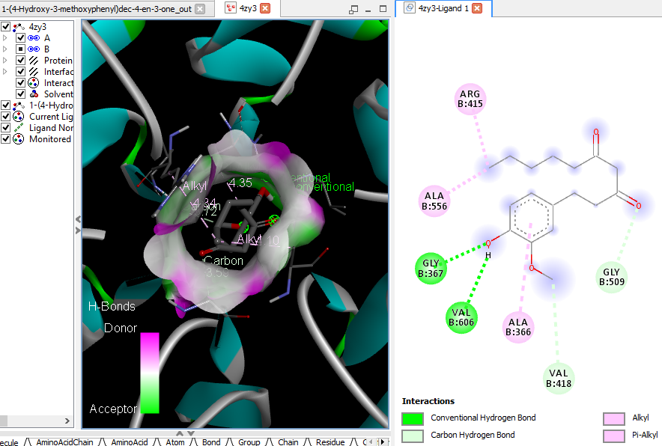  1-(4-Hydroxy-3-methoxyphenyl)dec-4-en-3-one (6-Shogoal) |  |  |  |  |  | 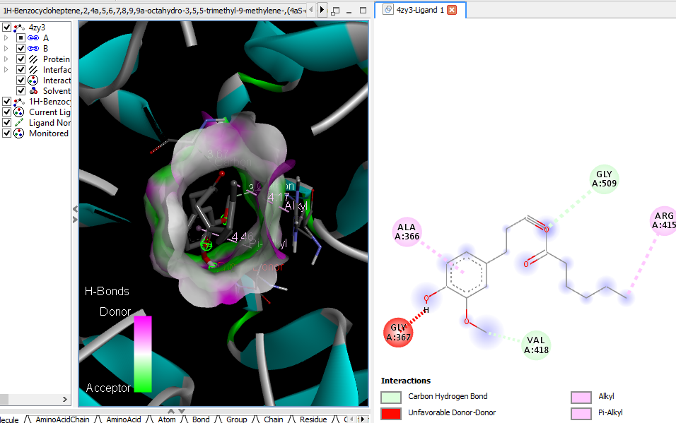 1H-Benzocycloheptene, 2,4a,5,6,7,8,9,9a-octahydro-3,5,5-trimethyl-9-methylene-,(4aS-cis)- (alpha-Himachalene)
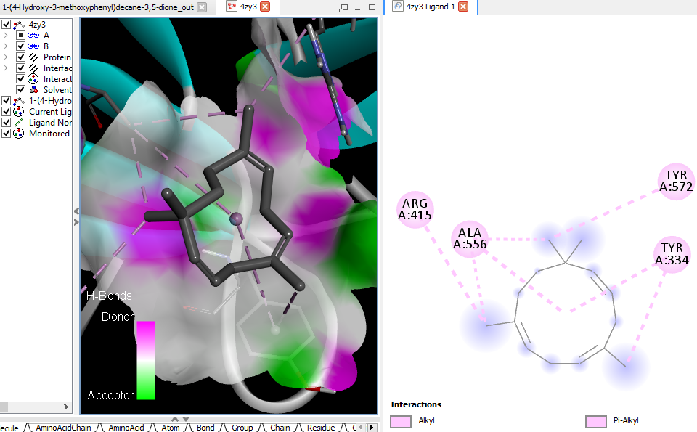  1-(4-Hydroxy-3-methoxyphenyl)decane-3,5-dione (gingerdione) |  |  |  |  |  | 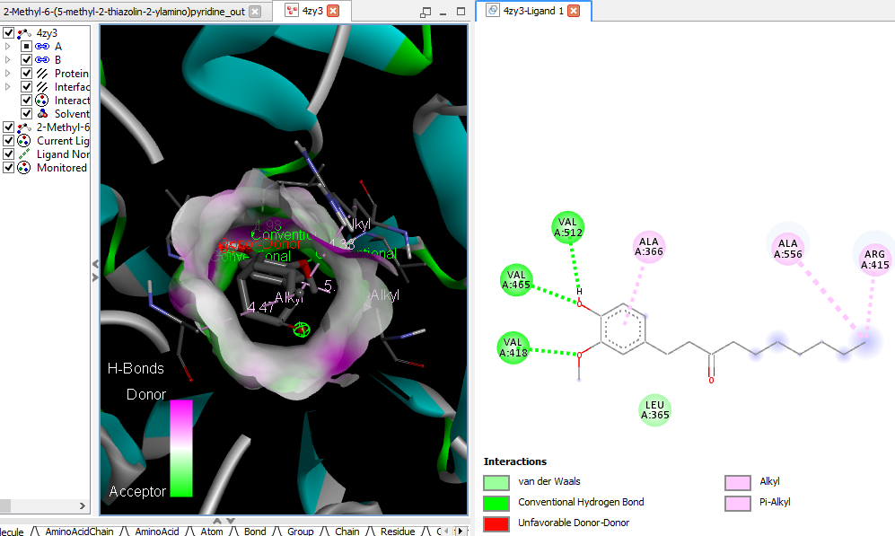 2-Methyl-6-(5-methyl-2-thiazolin-2-ylamino)pyridine
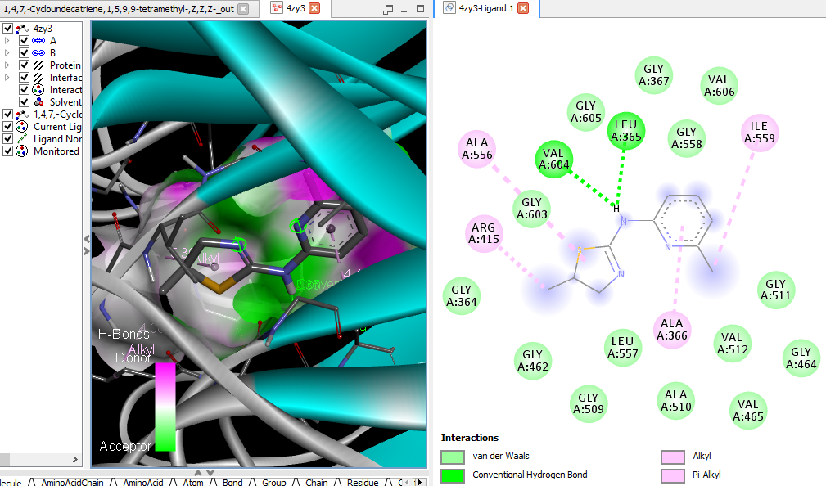  1,4,7,-Cycloundecatriene, 1,5,9,9-tetramethyl-, Z,Z,Z- |  |  |  |  |  | 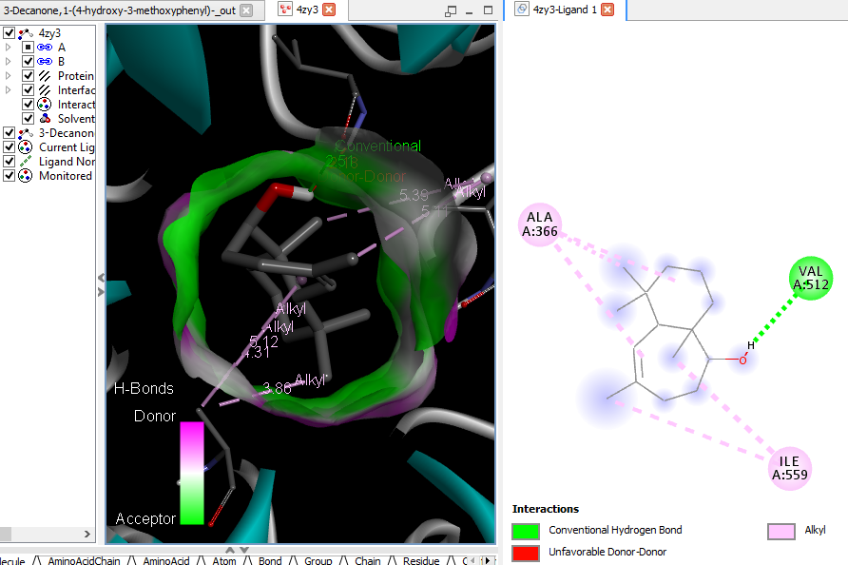 3-Decanone, 1-(4-hydroxy-3-methoxy phenyl)- (Paradol)
 |  | 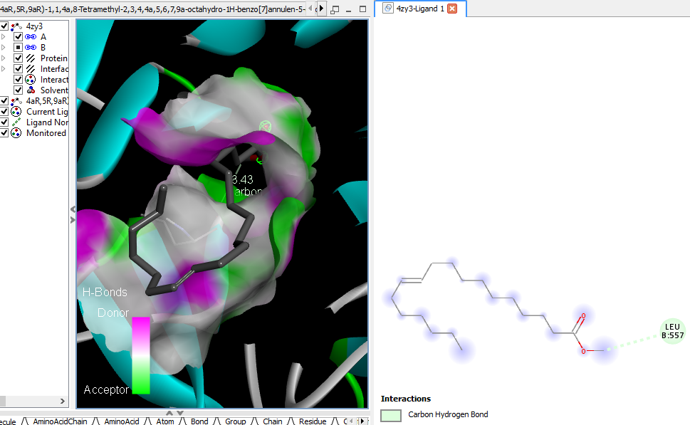 4aR,5R,9aR)-1,1,4a,8-Tetramethyl-2,3,4,4a,5,6,7,9a-octahydro-1H-benzo[7]annulen-5-ol (Allohimachalol) |  |  | 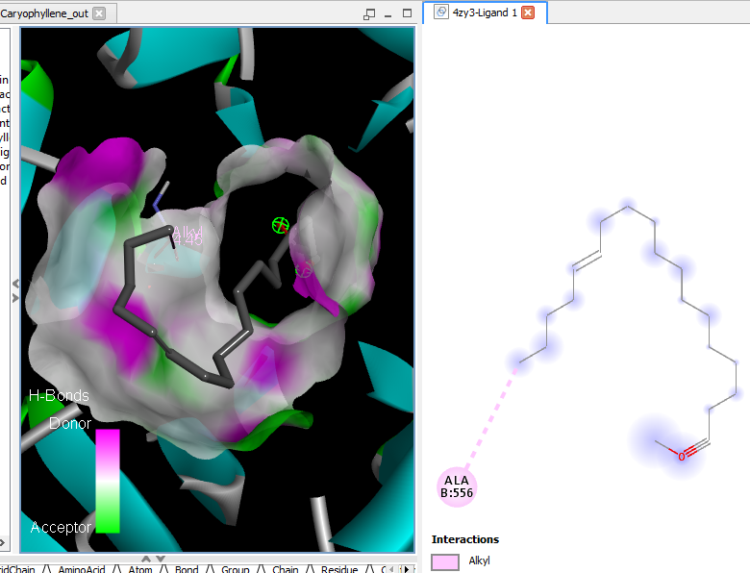Caryophyllene
 |  | 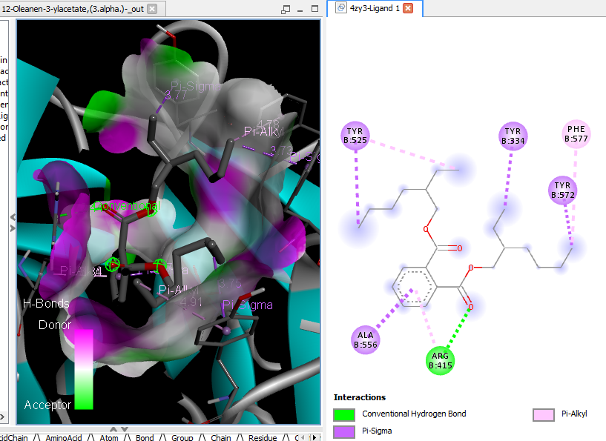  12-Oleanen-3-yl acetate, (3.alpha.)- (beta-Amyrenyl acetate) |  |  | 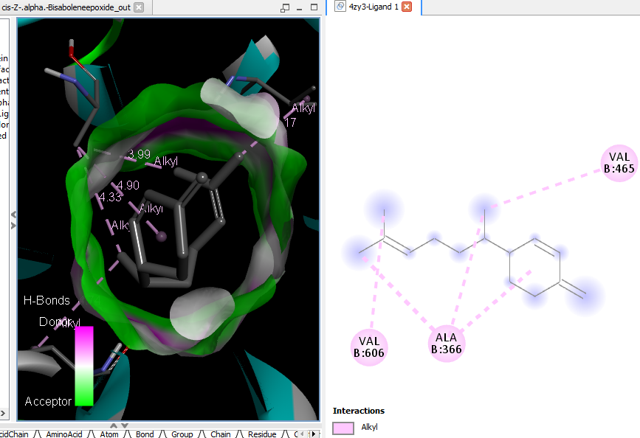cis-Z-.alpha.-Bisabolene epoxide
 |  | 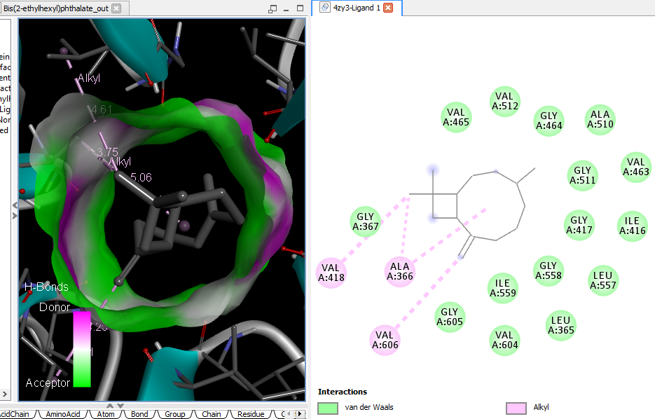Bis(2-ethylhexyl) phthalate |  |  | 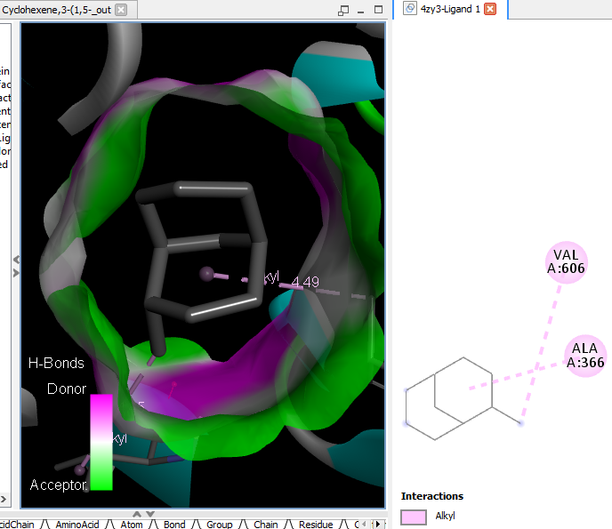Cyclohexene, 3-(1,5-dimethyl-4-hexenyl)-6-methylene-, [S-(R*,S*)]-
 |  |  | 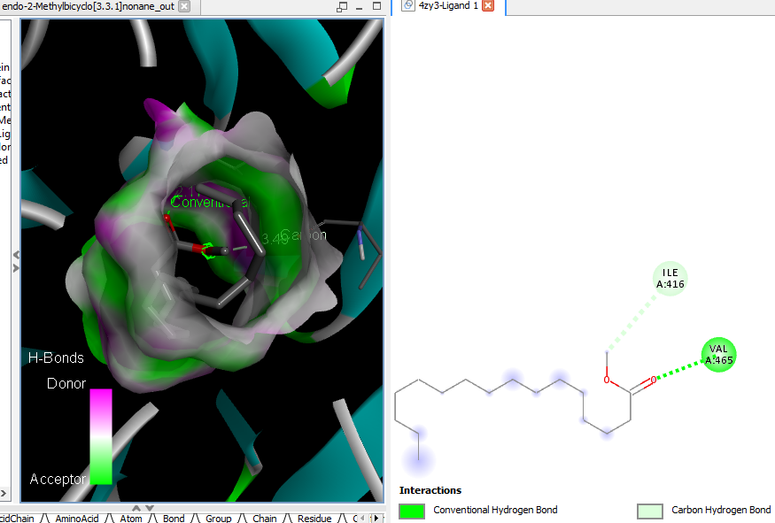endo-2-Methylbicyclo[3.3.1]nonane |  |  | 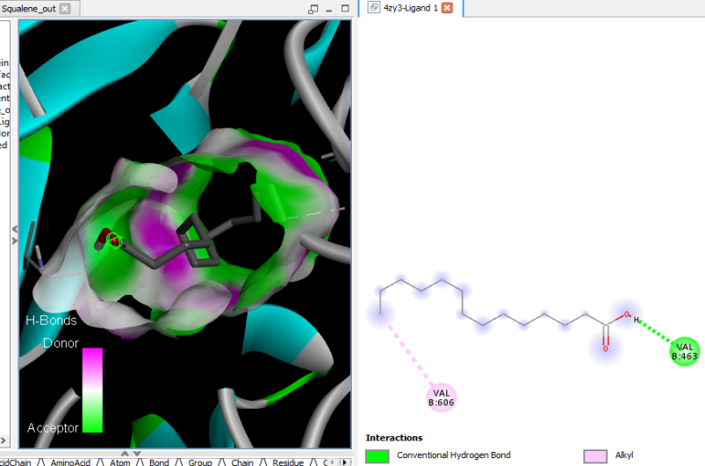Squalene
 |  |  | 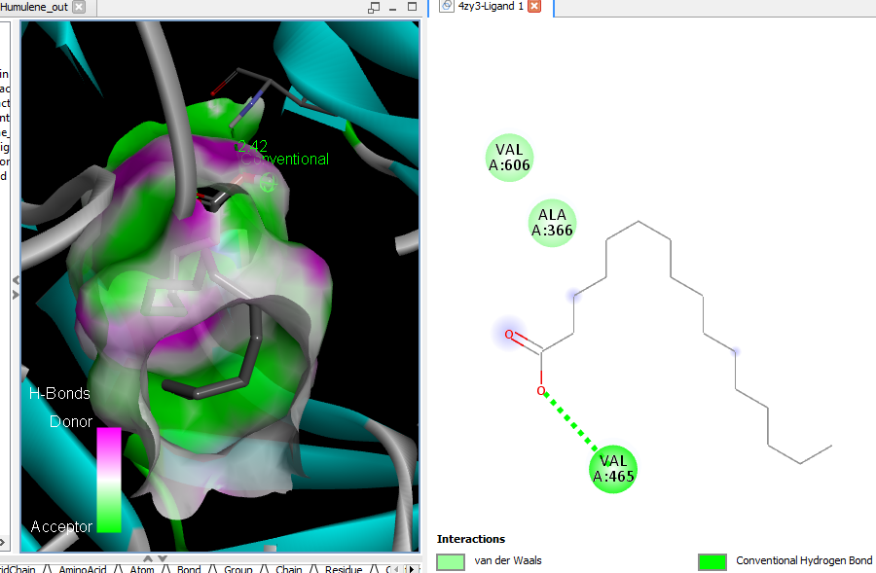Humulene |  |  | 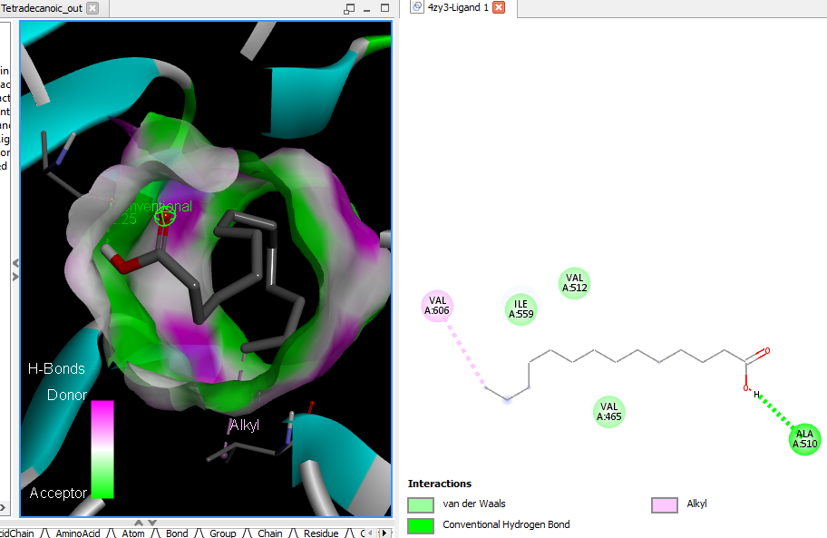Tetradecanoic acid (myristic acid)
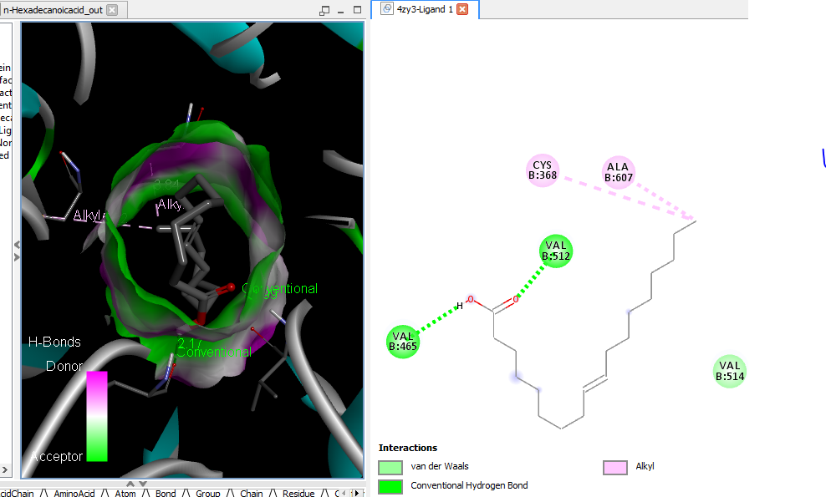
n-Hexadecanoic acid
Supplementary Figure 9E: 3D and 2D complex structure of binding Interaction between ligand and protein (PDB: 4ZY3)

