**Figure-1**



**Figure-2**



**Figure-2:** General structure of synthetic compounds **1-20**

**Structure-activity relationship:**

**Figure-3**



**Figure-3:** SAR of nitrofurazone and compound **1**.

**Figure-4**



**Figure-4:** SAR of compounds **2-4**.

**Figure-5**



**Figure-5:** SAR of compounds **5-7**.

**Figure-6**



**Figure-6:** SARof compounds **8-9***.*

**Figure-7**



**Figure-7:** SARof compounds **10-12***.*

**Figure-8**



**Figure-8:** SAR (Structure-activity relationship) of compounds **15** and **19**.

**Figure-9**

**Figure-9:** Lineweaver-Burk plots of inhibition kinetics of *α*-glucosidase by compounds **7** (left) and **19** (right) indicating competitive and uncompetitive mode of inhibitions, respectively.

**Figure-10**

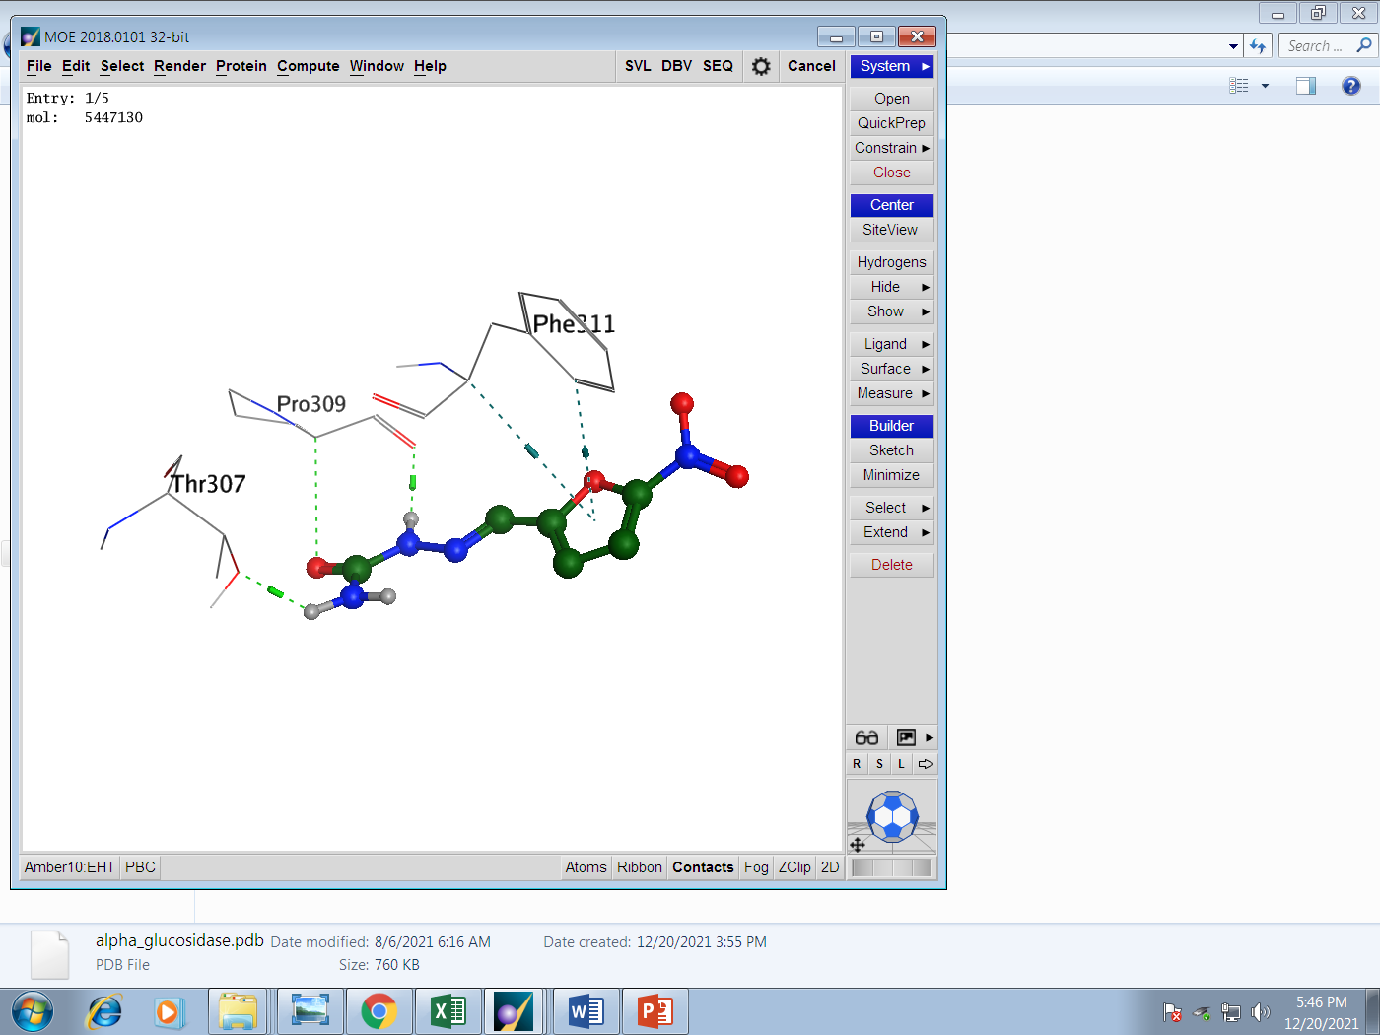

**Figure-10:** Docking conformation of *nitrofurazone* in the active site of alpha-glucosidase enzyme. The dark green color indicate the phi-stacking interactions while the light green indicate the h-bond.

**Figure-11**

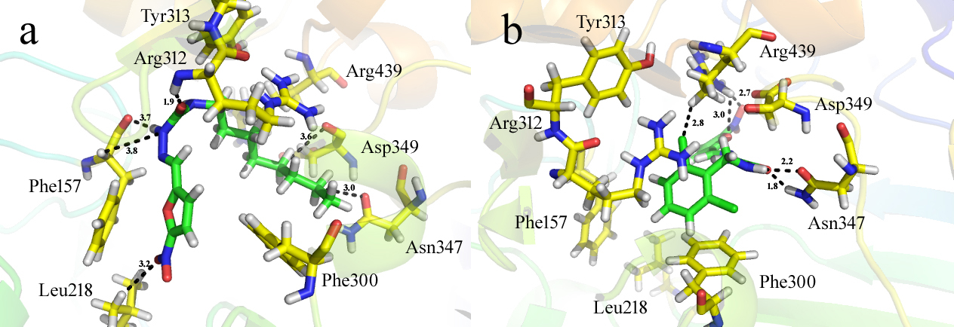

**Figure-11:** Docking conformation of compound **19** (**a**) and **6** (**b**) within the active site of α-glucosidase.

**Figure-12**

**Figure-12:** The dynamics results. (**A-B**) represent the RMSD graph and the RMSF for the c**19** in complex with *α*-glucosidase enzyme.

**Spectroscopic characterization of *N*-(Benzyl)-2-((5-nitrofuran-4-yl)methylene)hydrazine carboxamide (1)**

The 1H-NMR spectra of representative molecule **1** was recorded on 400 MHz instruments in deuterated DMSO. The most downfield signal of the spectra corresponds to the protons of furan ring. Furan ring has two methine (CH) protons which appeared as doublets, the proton adjacent to NO2 group appeared at *δ* 7.74, while other protons of furan ring resonated at *δ* 7.40, both protons have shown the coupling constant value of 4.0 Hz. The methine proton H-5 adjacent to electronegative nitrogen atom resonated at *δ* 7.52 as a sharp singlet. Compound **1** possess two NH protons, the NH adjacent to carbonyl and another nitrogen atom resonated at *δ* 7.26 due to extended conjugation, however, another NH adjacent to benzyl group resonated at *δ* 3.16. The methylene protons (CH2) of benzylic part appeared at *δ* 5.18 as a sharp singlet. H-2ʹ and H-6ʹ resonated at *δ* 7.36 as doublet with coupling constant 7.0 Hz. However, H-4ʹ, H-5ʹ, and H-6ʹ appeared as multiplet at *δ*   (Figure-13).



**Figure-13:** Representative 1H-NMR signals for compound **1**

13C-NMR broad band spectrum of compound **1** was recorded on a 75 MHz instrument in deuterated DMSO. Compound **1** possess fourteen carbons including three quaternary, eight methine (CH), and one methylene (CH2) carbons (Figure-14). The most downfield signal corresponds to the quaternary carbon of carbonyl group at *δ* 155.9. The quaternary carbon (C-1) directly attached to NO2 resonated at *δ* 153.4. Quaternary carbons C-4 and C-1ʹ resonated at *δ* 151.0 and *δ* 135.2, respectively. The signals of aromatic carbons appeared in the usual range of *δ* 111.3-128.6. Nevertheless, the methylene carbon resonated at *δ* 43.6.



**Figure-14:** Representative 13C-NMR signals for compound **1**

The EI-MS spectrum of compound **1** exhibited a fragment at *m/z* 243 showing possible fragmentation of molecule by a loss of NO2 group and a base peak at *m/z* 91 was also observed (Figure-15). The molecular formula was confirmed by HREI-MS calculated for molecular formula C13H11N4O4 [288.2588], Found 288.0859.



**Figure-15:** Mass fragmentation pattern of compound **1**