Corrosion protection of carbon steel using a combination of Zr conversion coating and subsequent zinc-rich silicate coating with a flake ZnAl alloy

^{Supplementary Data}

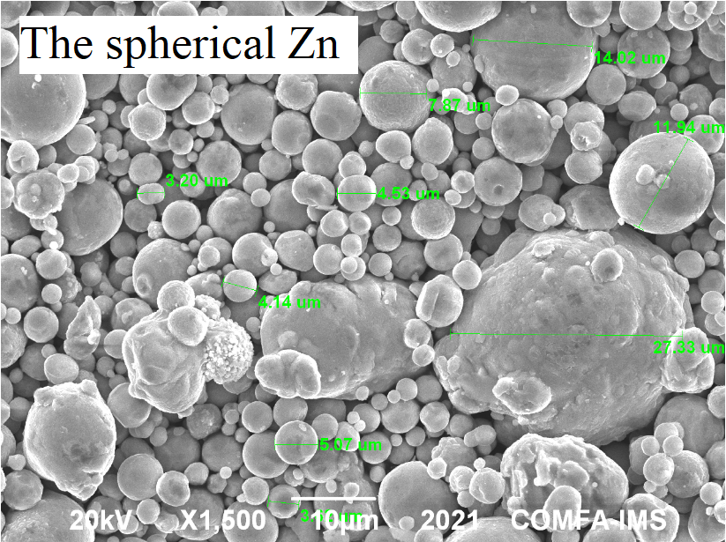 | 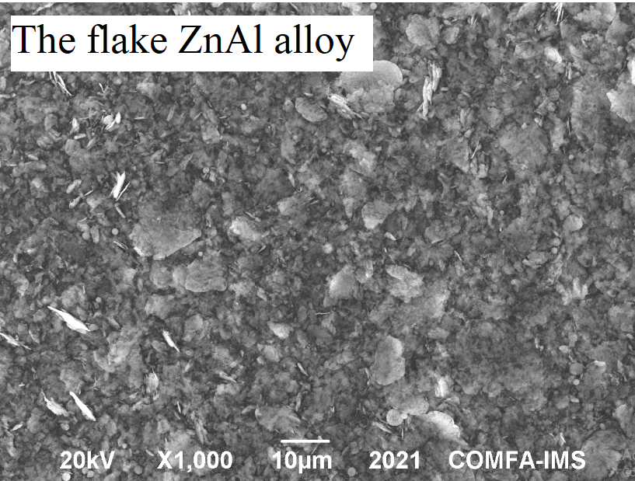
Figure S1. The surface morphology of spherical Zn and flake ZnAl alloy.

Figure S2. Polarization curve of zinc-rich coating containing flake ZnAl pigment after immersion in NaCl solution (3.5 wt%) for 48h.

Table S1. Comparison of the DC polarization of zirconium conversion pretreated steel after immersion in NaCl (3.5% w/w) for 30 min.
Sub. | Reaction conditions for pretreatment |  |  |  |  | Obtained data from DC polarization
 | C_{Zr4+} (ppm) | pH | Time  (s) | T  (⁰C) | Additives  (%, v/v) | i_{corr}  (μA/cm²) | E_{corr}  (mV) | R_{p}  (Ω.cm²) | β_{a}  (V/dec) | - β_{c}  (V/dec)
Bare  carbon  steel | - | - | - | - | - | 27.7 | - 599 | 933 | 0.1763 | 0.0899
Carbon  steel | 50 | 4 | 240 | 30 | APTES  0.025 | 3.2 | - 637 | 2475 | 0.0342 | 0.0404

Table S2. EIS data fitted of zinc-rich coating containing flake ZnAl pigment after immersion in NaCl solution (3.5 wt%) for 2 days
Electrical element | M1 | M2 | M3
R_{s} (Ω.cm²) | 84.05 | 83.90 | 94.72
R_{c} (Ω.cm²) | 879.88 | 472.71 | 851.85
Q_{c}, Y₀ | 1.47E-03 | 1.61E-03 | 1.06E-03
Q_{c}, n | 0.3782 | 0.4240 | 0.3246
R_{ct} (Ω.cm²) | 426.83 | 2541.47 | 1127.13
C_{dl} (F) | 4.61E-04 | 1.04E-04 | 7.78E-06
χ2 | 0.02522 | 0.075248 | 0.027841

Table S3. EIS data fitted of zinc-rich coating containing flake ZnAl pigment with and without pretreatment after immersion in NaCl solution (3.5 wt%) for 2 days, 30 days and 60 days.
Parameters | M1 |  |  | M2 |  |  | M4
 | 2 d | 30 d | 60 d | 2 d | 30 d | 60 d | 2 d | 30 d | 60 d
R_{s} (Ω) | 24.292 | 18.516 | 11.499 | 24.249 | 22.87 | 11.604 | 59.822 | 8.7539 | 11.163
R_{c} (Ω) | 254.3 | 304.22 | 718.85 | 136.62 | 215.08 | 14.38 | 17.194 | 3485.5 | 494.94
Q_{c}, Y₀ | 0.00147 | 0.00083 | 0.00078 | 0.00161 | 4.59E-05 | - | - | 0.00075 | 2.37E-05
Q_{c}, n | 0.37821 | 0.32099 | 0.29747 | 0.42397 | 0.5246 | - | - | 0.30425 | 0.48104
R_{ct} (Ω) | 123.36 | 1430.2 | 1879 | 734.53 | 2112.6 | 3953.5 | 1094.5 | 298.75 | 5995
C_{dl} (F) | 0.00046 | 5.26E-06 | 1.06E-05 | 0.0001 | - | 3.75E-07 | 6.48E-07 | - | -
Qdl, Y₀ | - | - | - | - | 0.0008 | 0.00061 | 0.00116 | 3.60E-05 | 0.00052
Q_{dl}, n | - | - | - | - | 0.34008 | 0.31317 | 0.48182 | 0.60285 | 0.22832
χ² | 0.02522 | 0.07475 | 0.05185 | 0.07525 | 0.02895 | 0.04676 | 0.08485 | 0.07171 | 0.011008

