Supplementary materials
for
Performance and mechanisms of NaOH and ball-milling co-modified biochar for enhanced the removal of Cd²⁺ in synthetic water: A combined experimental and DFT study
Hua Duª, Cunxian Xi^{b}, Bobin Tang^{b}, Wenli Chenª, Wei Deng^{d}, Shurui Cao^{c,*}, Guihua Jiang^{a,d,e,*}

ªCollege of Pharmacy, Chengdu University of TCM, Sichuan 611137, China
^{b}The Inspection Technical Center of Chongqing Customs, Chongqing 400020, China
^{c}Forensic Identification Center, Southwest University of Political Science and Law, Chongqing 401120, China
^{d}College of Ethnic medicine, Chengdu University of TCM, Sichuan 611137, China
^{e}State Key Laboratory of Southwestern Chinese Medicine Resources, Sichuan 611137, China

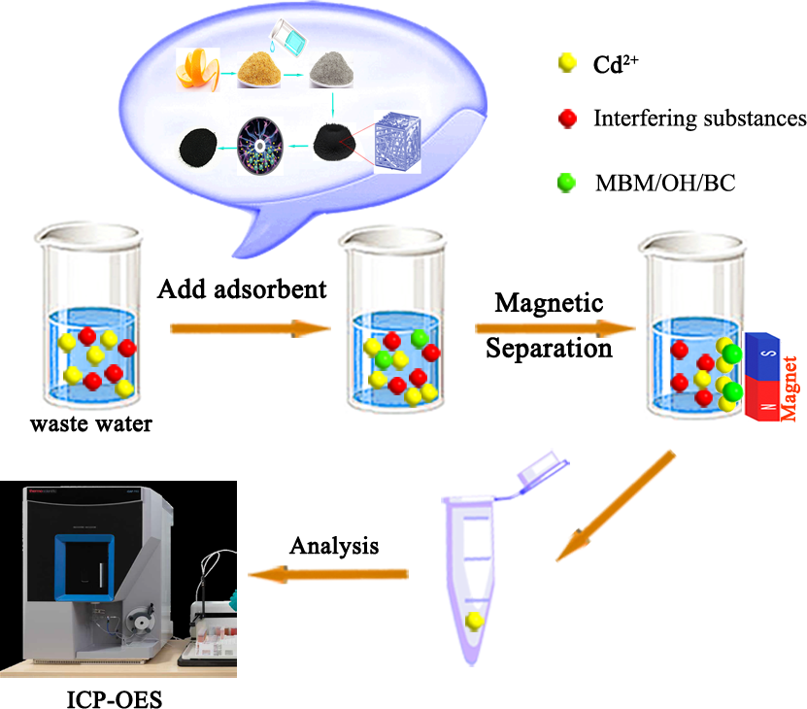

Fig. S1 The schematic illustration of batch adsorption experiment.

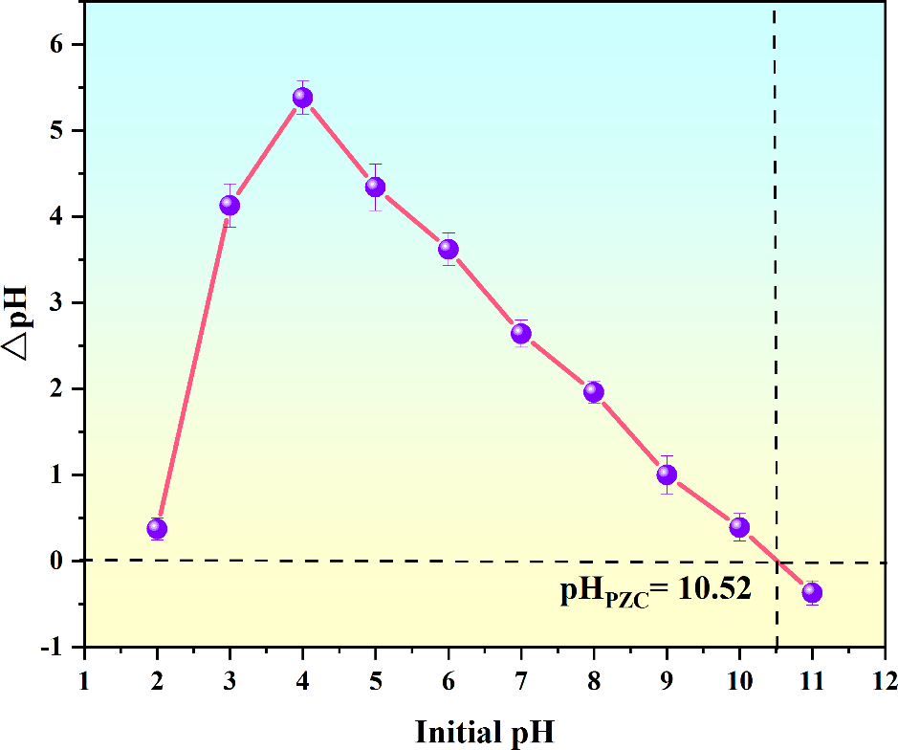

Fig. S2 The pH_{PZC} of the MBM/OH/BC.

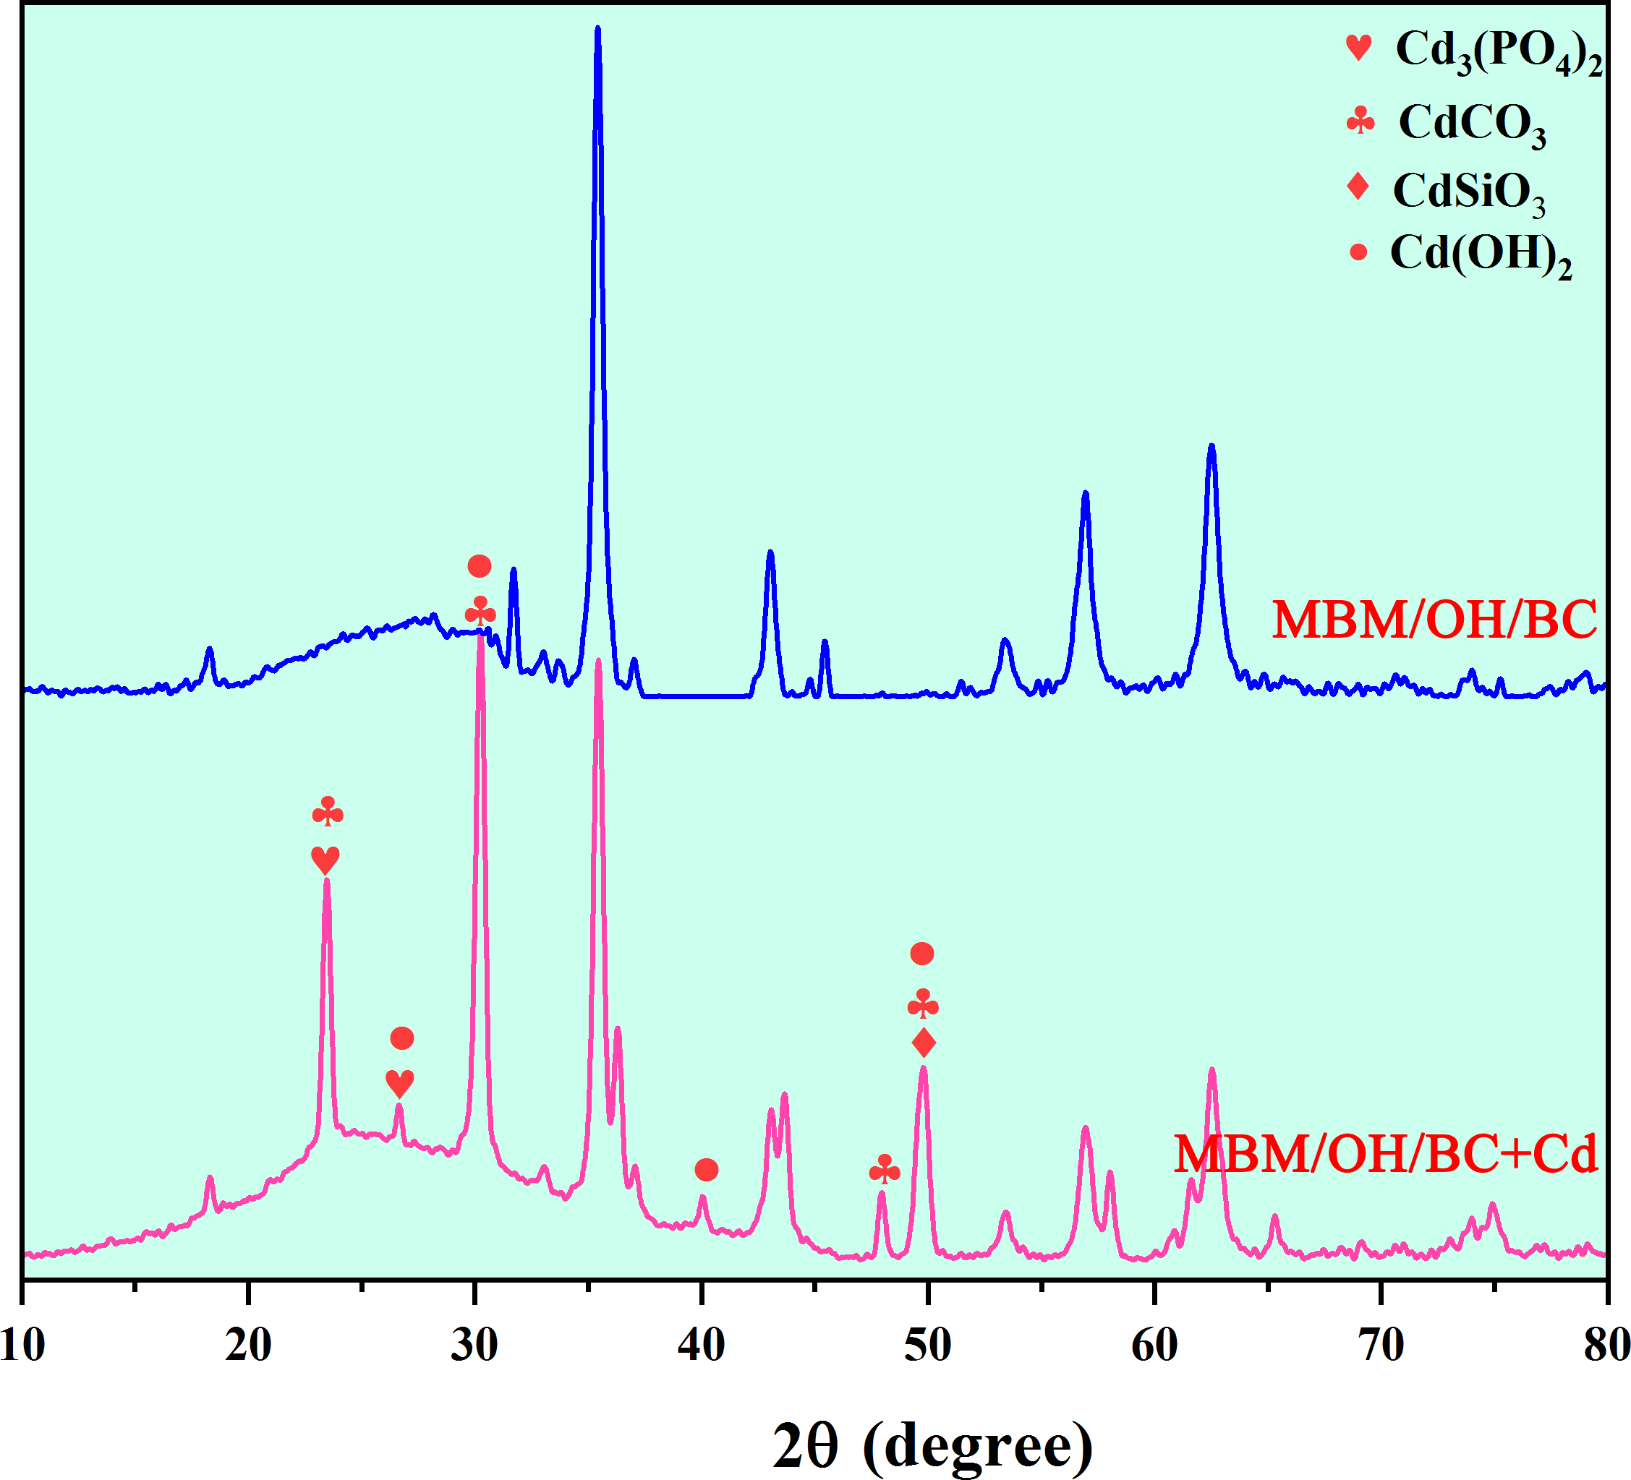
Fig. S3 XRD patterns of MBM/OH/BC before and after Cd²⁺ adsorption.

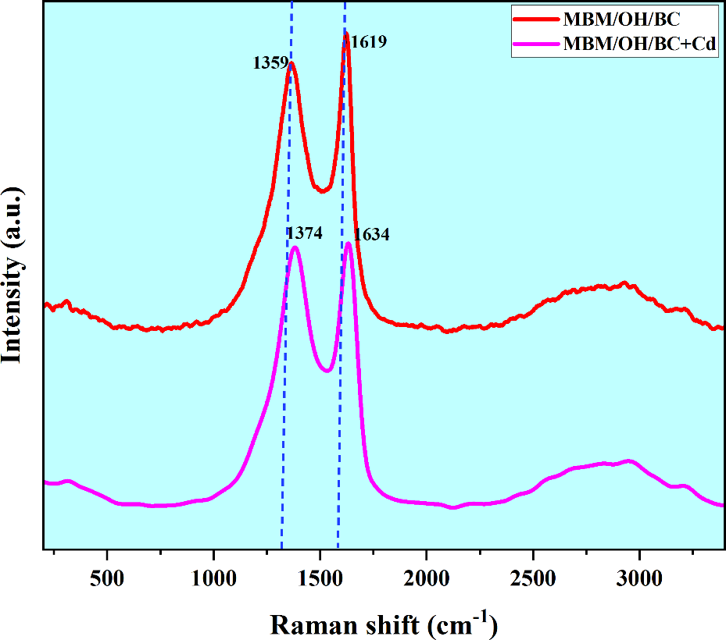
Fig. S4 The Raman spectroscopy of MBM/OH/BC before and after Cd²⁺ adsorption.

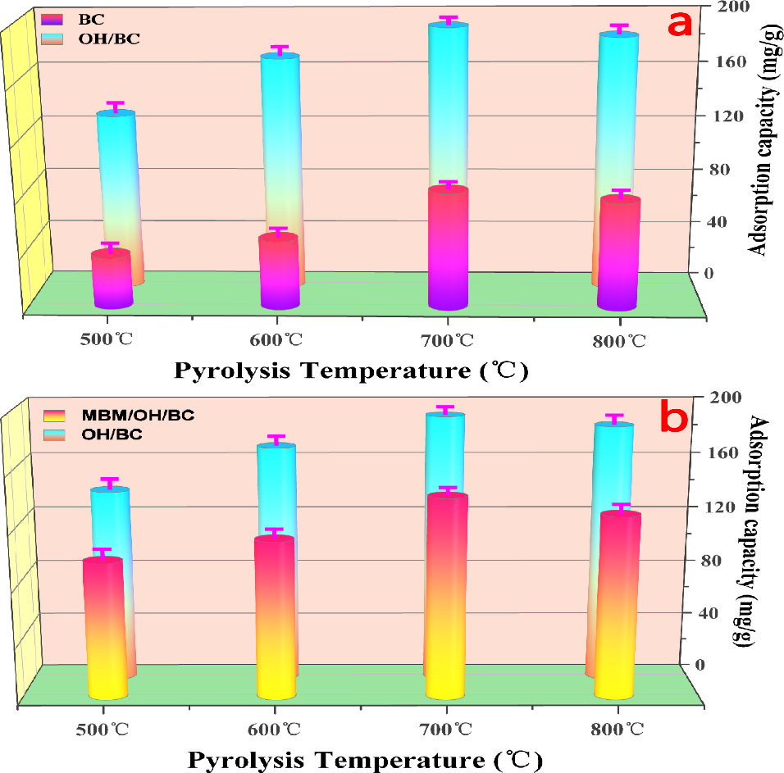
Fig. S5 (a) The adsorption capacity of BC and OH/BC pyrolyzed at different temperatures (500, 600, 700 and 800 ℃). (b) The adsorption capacity of OH/BC and MBM/OH/BC pyrolyzed at different temperatures (500, 600, 700 and 800 ℃).

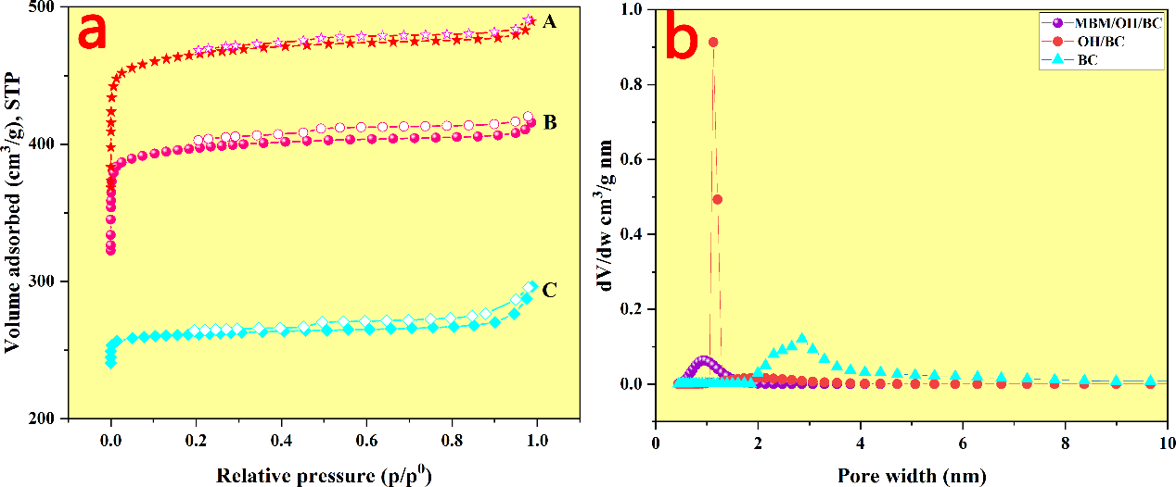
Fig. S6 (a) N₂ adsorption (closed symbols) and desorption (opened symbols) isotherms, and (b) pore size distribution obtained from the Horvath-Kawazoe method for three biochar.

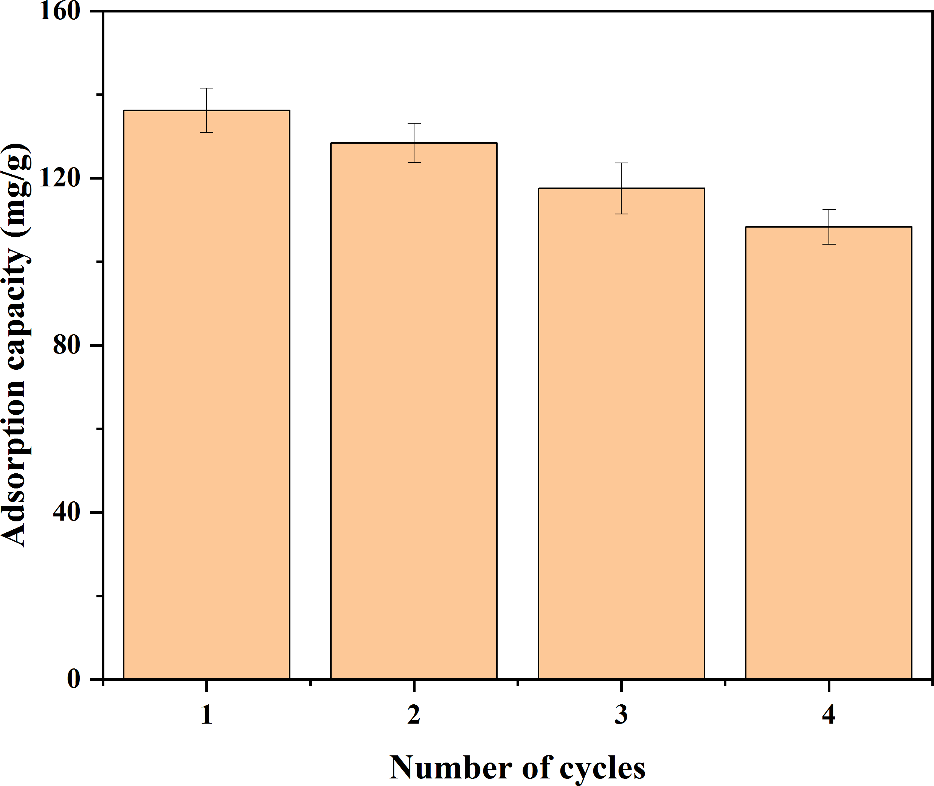

Fig. S7 The adsorption capacity of MBM/OH/BC to Cd²⁺ after a continuous regeneration cycle.

Table S1
Summary of the literature data on adsorption of Cd²⁺ by different absorbent.
Raw material | Q_{m} (mg·g⁻¹) | Adsorption  Condition  (pH) | Adsorption  Condition  T (°C) | References
MBM/OH/BC | 183.59 | 7.0 | 25 | Current  study
Magnetic oak  bark char | 7.40 | 5.0 | 25 | [1]
Magnetic oak  wood char | 2.87 | 6.0 | 25 | [1]
Chicken | 69.62 | 6.0 | 25 | [2]
Pine bark char | 0.34 | 5.0 | 25 | [3]
Biochar treated  by KMnO4 | 28.1 | 7.0 | 22 ± 0.5 | [4]
Hydrochars via hydrothermal | 13.92 | 8.0 | 30± 1 | [5]
Synthesized azide cancrinite | 2.87 | - | - | [6]
Magnetic biochar prepared by CO2 atmosphere (MC) | 45.24 | 6.0 | 25 | [7]

2.3 Characterization of sorbents
The Brunauer-Emmett-Teller (BET) specific surface area, pore volume and pore size distribution of biochar were determined on the basis of the N₂ adsorption-desorption method at 77K using ASAP2460 (Micromeritics Company, USA). The specific surface areas (S_{BET}) and pore volume were calculated based on the theory of BET and Barrett-Joyner-Halenda (BJH), respectively. The S_{BET} was based on the data of adsorption data corresponding to N₂ vapor pressures from 0.01-0.3 and the pore volume was based on the data of N₂ desorption data. The pore size was based on the data of adsorption isotherm. The morphologies of adsorbent were characterized by scanning electron microscope (SEM) (Quanta Q400, FEI Company, USA). The surface functional group characteristics of adsorbent are analyzed by Fourier transform infrared spectrum (FTIR) (IRTracer-100, Shimadzu, Japan). XRD patterns of samples were identified by an X-ray powder diffractometer (Bruker D8 ADVANCE, Germany) equipped with Cu K_{α} radiation (40 Kv, 40 mA) in a scanning range of 10-80° (2θ). The surface elemental compositions and the bonding situations were determined using an ESCALAB 250Xi X-ray photoelectron spectroscopy (XPS) (Thermo Fisher Scientific, USA). The magnetic property of the adsorbent was analyzed by a vibrating sample magnetometer (VSM) (MPMS (SQUID) XL-7, Quantum Design Co., USA) with the field cycling from -20 to 20 kOe at room temperature. The content of K, Ca, Mg and Na were determined by ICP-OES (V8rtical, 5100DV, Agilent Technologies, Mulgrave, Australia), and water-soluble PO₄³⁻ and CO₃²⁻ were determined by ion chromatography (940 Professional IC Vario, Metrohm GmbH Co., Ltd., Switzerland).

[1] Mohan D, Sarswat A, Ok Y S and Pittman C U, Jr. Organic and inorganic contaminants removal from water with biochar, a renewable, low cost and sustainable adsorbent--a critical review. Bioresour Technol 2014; 160: 191-202.
[2] Huang F, Gao L Y, Deng J H, Chen S H and Cai K Z. Quantitative contribution of Cd(2+) adsorption mechanisms by chicken-manure-derived biochars. Environ Sci Pollut Res Int 2018; 25: 28322-28334.
[3] Mohan D, Pittman C U, Jr., Bricka M, Smith F, Yancey B, Mohammad J, et al. Sorption of arsenic, cadmium, and lead by chars produced from fast pyrolysis of wood and bark during bio-oil production. J Colloid Interface Sci 2007; 310: 57-73.
[4] Wang H, Gao B, Wang S, Fang J, Xue Y and Yang K. Removal of Pb(II), Cu(II), and Cd(II) from aqueous solutions by biochar derived from KMnO4 treated hickory wood. Bioresour Technol 2015; 197: 356-62.
[5] Sun K, Tang J, Gong Y and Zhang H. Characterization of potassium hydroxide (KOH) modified hydrochars from different feedstocks for enhanced removal of heavy metals from water. Environ Sci Pollut Res Int 2015; 22: 16640-51.
[6] Borhade A V, Kshirsagar T A, Dholi A G and Agashe J A. Removal of Heavy Metals Cd2+, Pb2+, and Ni2+ From Aqueous Solutions Using Synthesized Azide Cancrinite, Na8[AlSiO4]6(N3)2.4(H2O)4.6. Journal of Chemical & Engineering Data 2015; 60: 586-593.
[7] Tan Z, Wang Y, Kasiulienė A, Huang C and Ai P. Cadmium removal potential by rice straw-derived magnetic biochar. Clean Technologies and Environmental Policy 2016; 19: 761-774.

