Supplementary material
Anti-inflammatory, analgesic and molecular docking studies of lignoceric acid, lanost-5- en-3β-ol- 26-oic acid and lanost-5-en-26-oic acid-3β-olyl palmitate isolated from Helichrysum stoechas collected from Mediterranean Sea bank: Misurata- Libya
Md. Sarfaraj Hussain*^{a,b}, Faizul Azam^{c}, Anzarul Haque^{d} , Mohd. Zaheen Hassan^{e}, Hanan Ahmed Eldarratª, Mohammed Ali^{f}, Muhammad Arif^{g}
ªDepartment of Pharmacognosy, Faculty of Pharmacy, Misurata University, Misurata, Libya.
^{b}Institute of Pharmacy, Sansriti University, Chhata, Mathura, U.P. India.
^{c}Department of Pharmaceutical Chemistry and Pharmacognosy, Unaizah College of Pharmacy, Qassim University, Unaizah, 51911, Saudi Arabia.
^{d}College of Pharmacy, Department of Pharmacognosy, Prince Sattam Bin Abdul Aziz University, Al Kharj, Kingdom of Saudi Arab.
^{e}Department of Pharmaceutical Chemistry, College of Pharmacy, King Khalid University, Abha, Saudi Arabia.
^{f}Department of Pharmacognosy & Phytochemistry, Faculty of Pharmacy, Hamdard University, New Delhi, India.
^{g}Faculty of Pharmacy, Integral University, Kursi Road, Lucknow, India.
Corresponding author present address
Md. Sarfaraj Hussain, Department of Pharmacognosy, Faculty of Pharmacy, Misurata University, Misurata, Libya. E-mail: sarfarajpharma@gmail.com

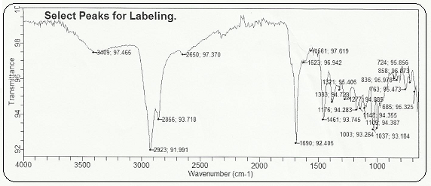
Spectrum 1. IR spectrum of HS-02

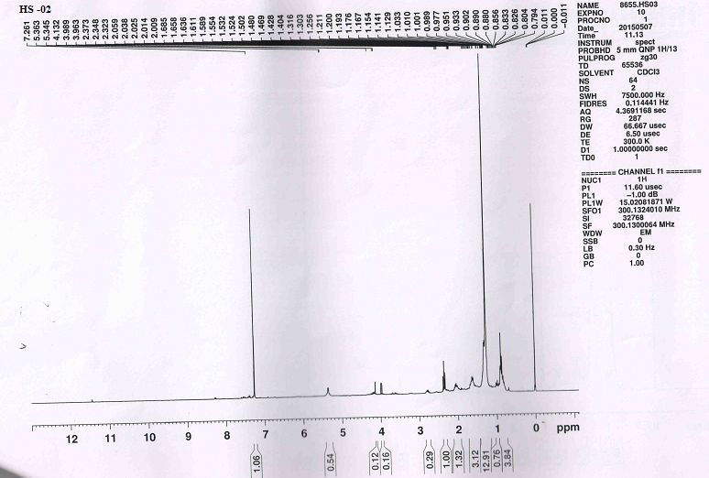
Spectrum 2. ¹H NMR spectrum of HS-02

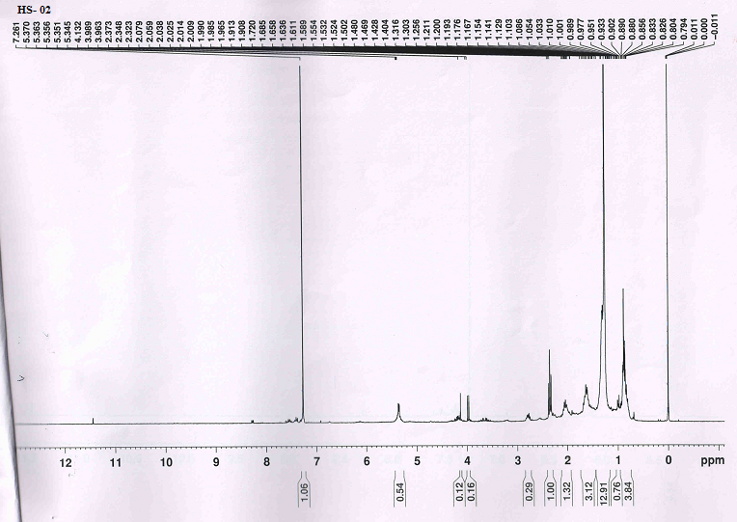
Spectrum 3. ¹H NMR spectrum of HS-02 extended form.
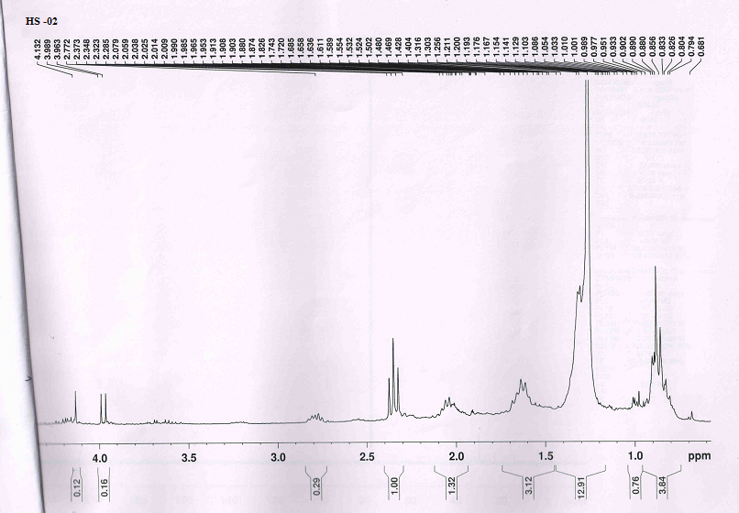
Spectrum 4. ¹H NMR spectrum of HS-02 extended form.
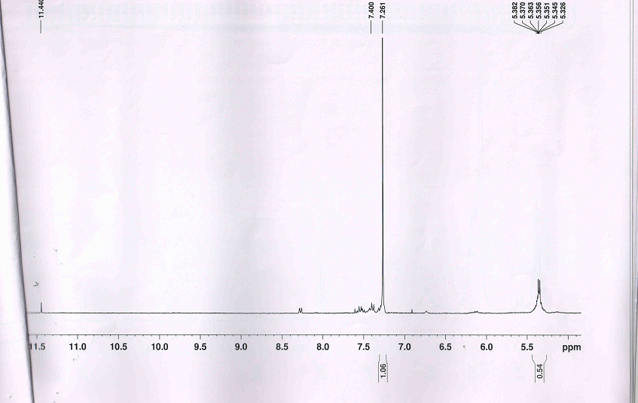
Spectrum 5. ¹H NMR spectrum of HS-02 extended form

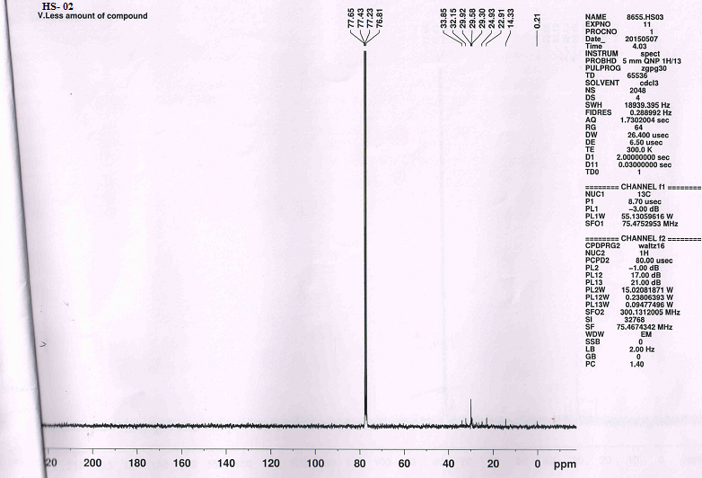
Spectrum 6. ¹³C NMR spectrum of HS-02

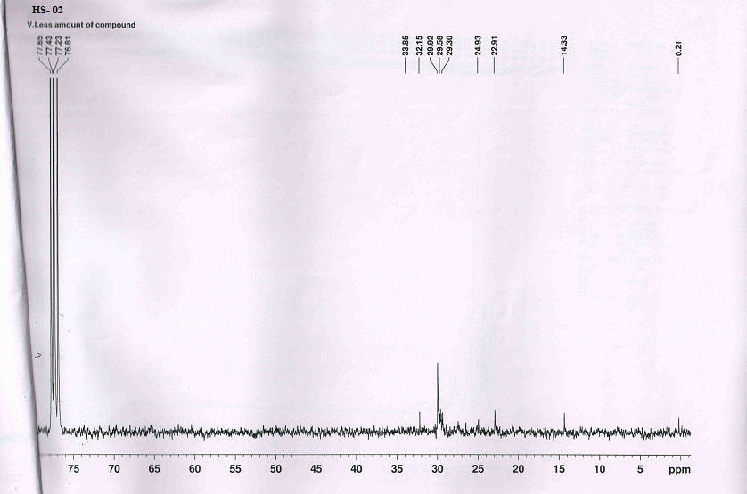
Spectrum 7. ¹³C NMR spectrum of HS-02 extended form

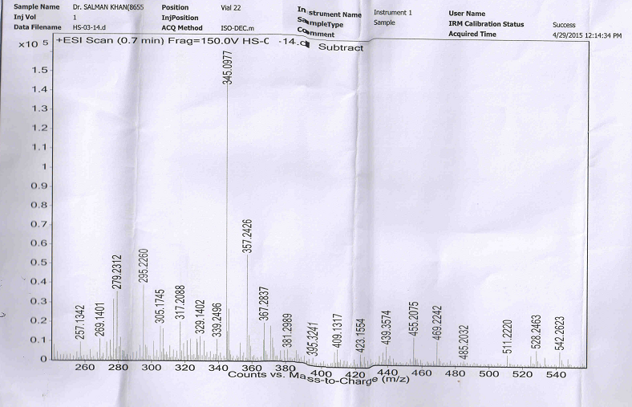
Spectrum 8.Mass spectrum of HS-02 extended form

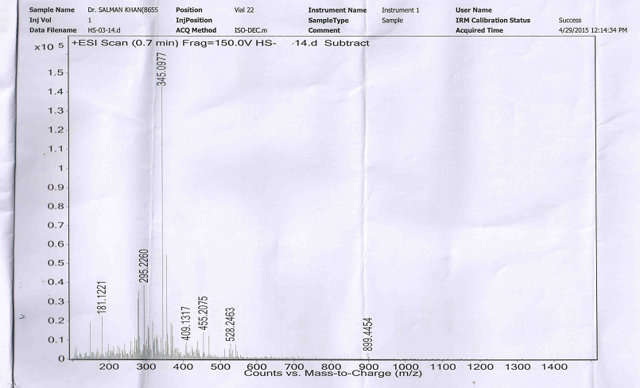
Spectrum 9.Mass spectrum of HS-02 extended form
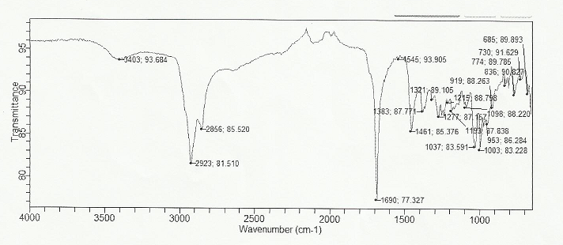

Spectrum 10. .IR spectrum of HS-03

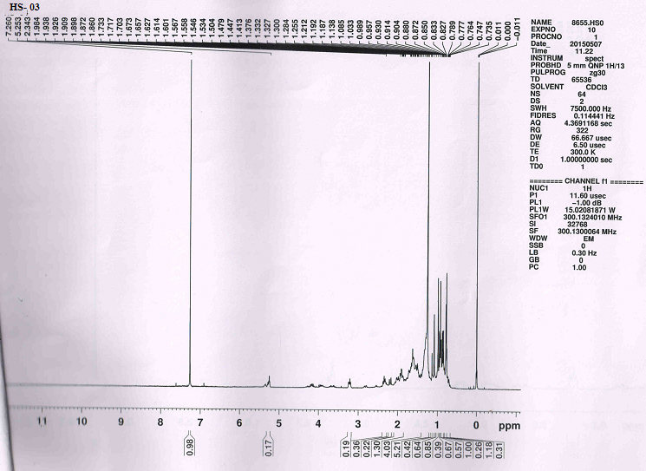
Spectrum 11. ¹H NMR spectrum of HS-03

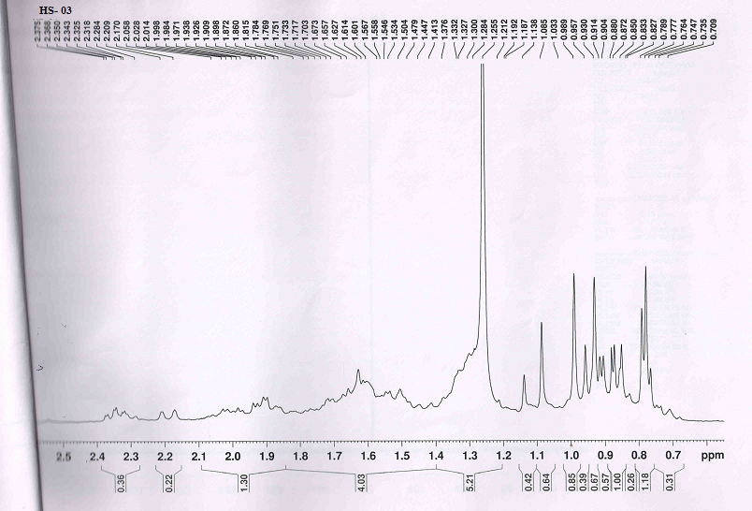

Spectrum 12. ¹H NMR spectrum of HS-03 extended form

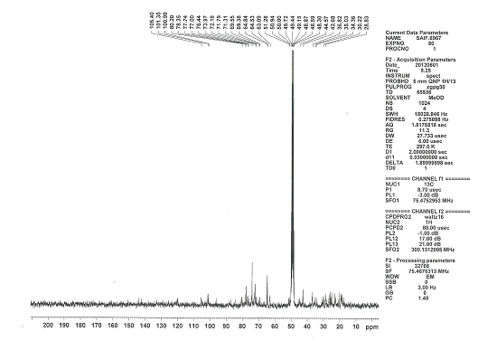
Spectrum 13. ¹³C NMR spectrum of HS-03 extended form
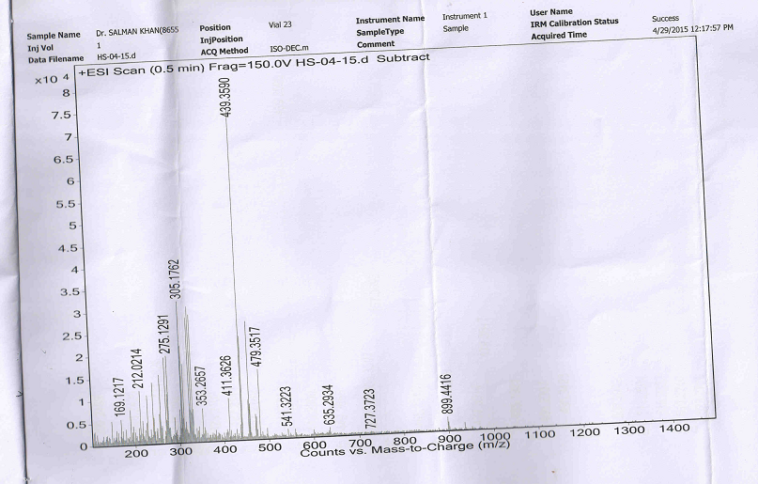

Spectrum 14. Mass spectrum of HS-03

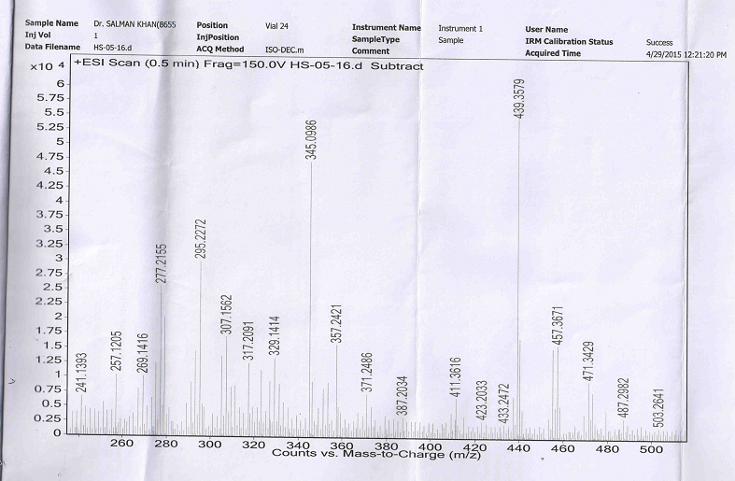
Spectrum 15. Mass spectrum of HS-03

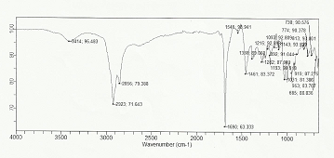
Spectrum 16. IR spectrum of HS-04

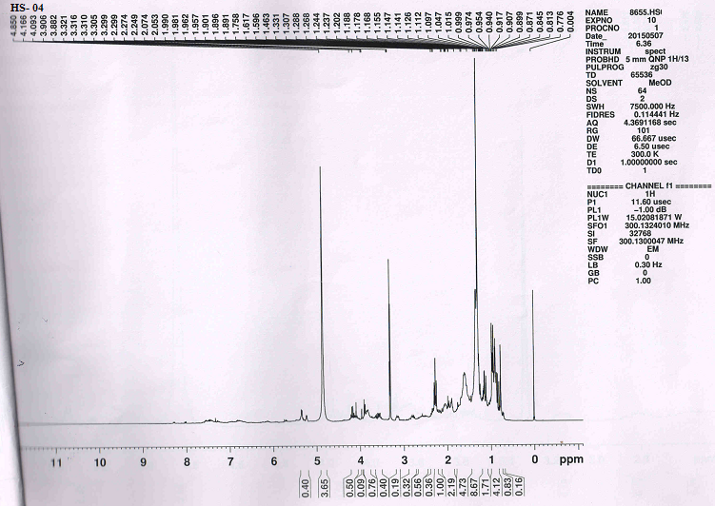
Spectrum 17. ¹H NMR spectrum of HS-04

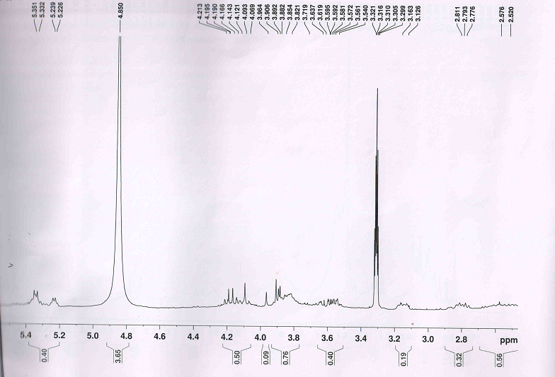
Spectrum 18. ¹H NMR spectrum of HS-04 extended form

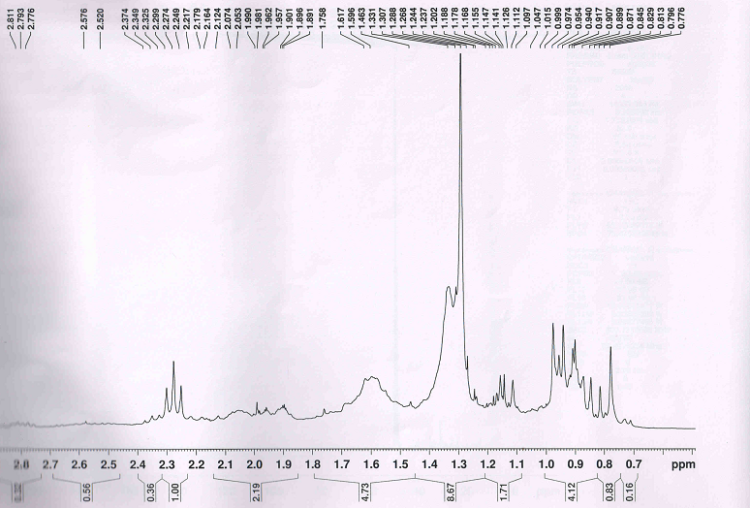
Spectrum 19. ¹H NMR spectrum of HS-04 extended form

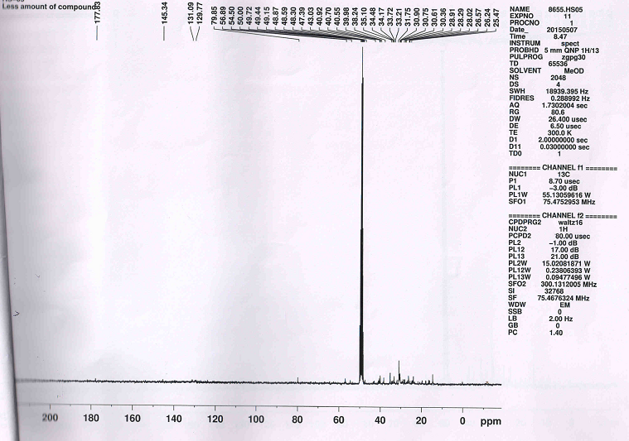
Spectrum 20. ¹³C NMR spectrum of HS-04

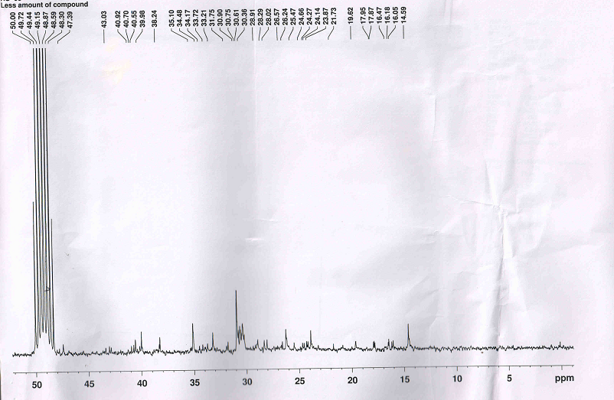
Spectrum 21. ¹³C NMR spectrum of HS-04 extended form

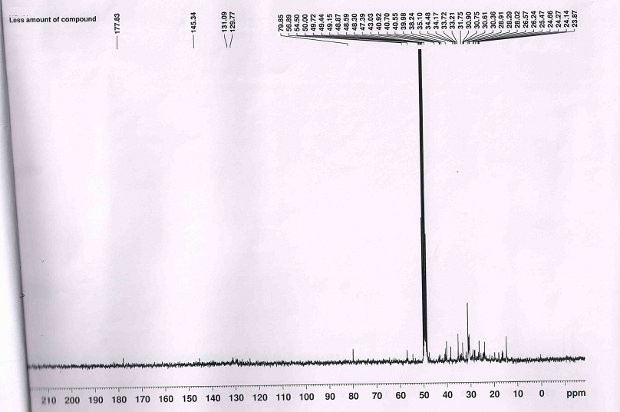
Spectrum 22. ¹³C NMR spectrum of HS-04 extended form

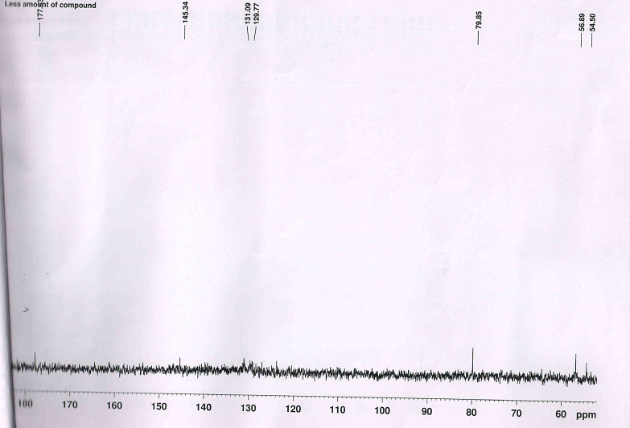 Spectrum 23. ¹³C NMR spectrum of HS-04 extended form

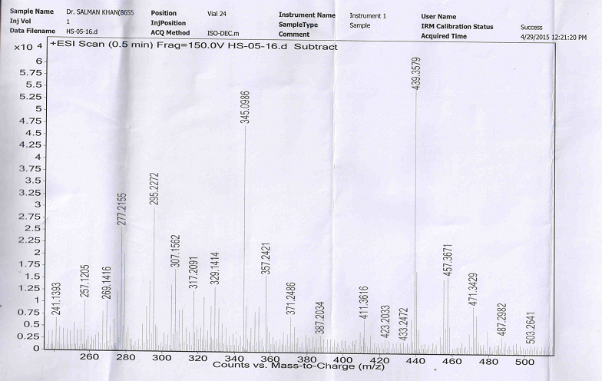
Spectrum 24. Mass spectrum of HS-04 extended form

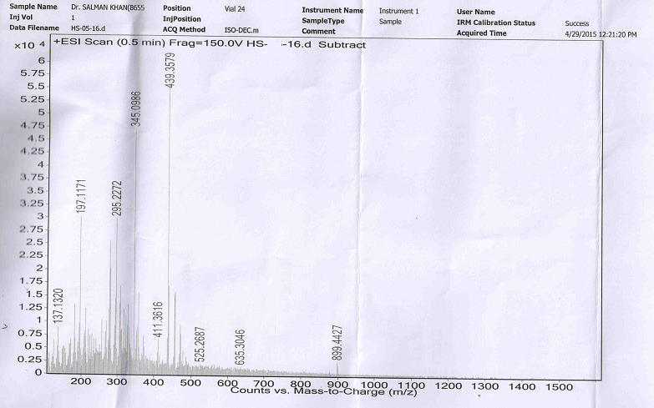
Spectrum 24. Mass spectrum of HS-04

