**Electronic Supplementary Material**

**Vitamin B3 as a high acid-alkali tolerant peroxidase mimic for colorimetric detection of hydrogen peroxide and glutathione**

Chun-Yan Zhang a, Wei-Yi Zhang a, Guo-Ying Chen a, Tong-Qing Chai a, Hao Zhang a, Yi Xu b,c,*, Feng-Qing Yang a,*

a School of Chemistry and Chemical Engineering, Chongqing University, Chongqing 401331, China

b Key Disciplines Lab of Novel Micro-Nano Devices and System Technology, Key Laboratory of Optoelectronic Technology and Systems, Ministry of Education, Chongqing University, Chongqing 400044, China

c School of Optoelectronic Engineering, Chongqing University, Chongqing 400044, China

**\***Corresponding authors:

Prof. Dr. Feng-Qing Yang, School of Chemistry and Chemical Engineering, Chongqing University, Chongqing 401331, China.

Tel: +8613617650637. E-mail: fengqingyang@cqu.edu.cn.

Prof. Dr. Yi Xu, School of Optoelectronic Engineering, Chongqing University, Chongqing 400044, China.

E-mail: xuyibbd@cqu.edu.cn.

**Table of contents**

**Supplementary Figures**

**Figure S1.** UV-Vis absorption spectra and digital photographs of (**A**)TMB-VB3-H2O2 (1), TMB-VB3 (2), TMB-H2O2 (3), and VB3-H2O2 (4); (**B**)ABTS-VB3-H2O2 (1), ABTS-VB3 (2), ABTS-H2O2 (3), and VB3-H2O2 (4); (**C**)OPD-VB3-H2O2 (1), OPD-VB3 (2), OPD-H2O2 (3), and VB3-H2O2 (4).

**Fig. S2.** The storage stability of the peroxidase-like activity of VB3.

**Figure S3.** (**A**) Reaction velocity under 4.0 mM of TMB with varied concentrations of H2O2 and (**B**) the corresponding double-reciprocal plots of VB3-catalyzed activity; (**C**) Reaction velocity under 0.1 mM H2O2 with varied concentrations of TMB and (**D**) the corresponding double-reciprocal plots of VB3-catalyzed activity. Error bars represent the standard deviation of three measurements.

**Figure S4.** Effects of various active scavengers during the catalysis of TMB by VB3.

**Supplementary Tables**

**Table S1.** Kinetic parameters (*Km* and *vmax*) of different small-molecule peroxidase mimics.

**Table S2.** H2O2 detection in disinfectant samples.

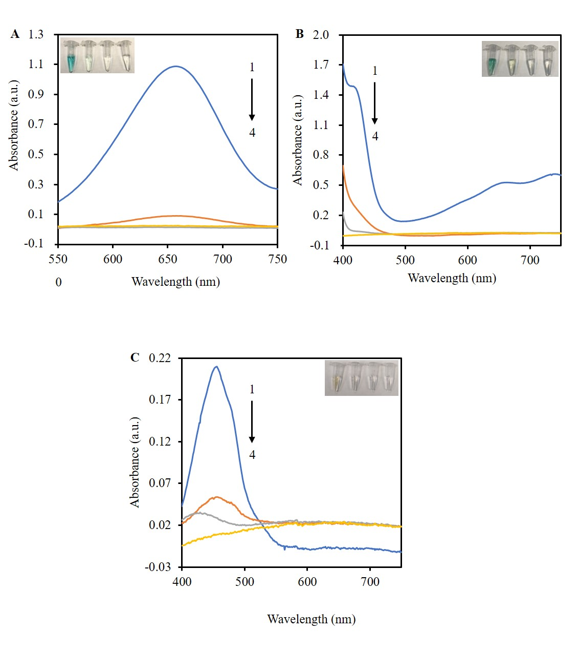

**Figure S1.** UV-Vis absorption spectra and digital photographs of (**A**)TMB-VB3-H2O2 (1), TMB-VB3 (2), TMB-H2O2 (3), and VB3-H2O2 (4); (**B**) ABTS-VB3-H2O2 (1), ABTS-VB3 (2), ABTS-H2O2 (3), and VB3-H2O2 (4); (**C**)OPD-VB3-H2O2 (1), OPD-VB3 (2), OPD-H2O2 (3), and VB3-H2O2 (4).

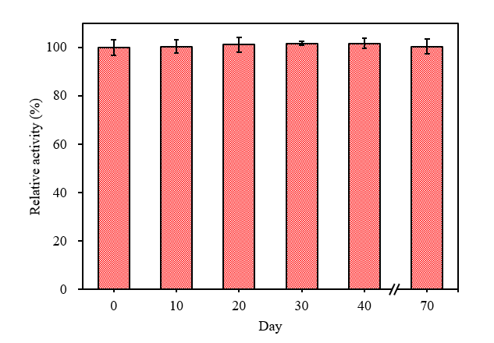

**Fig. S2.** The storage stability of the peroxidase-like activity of VB3.

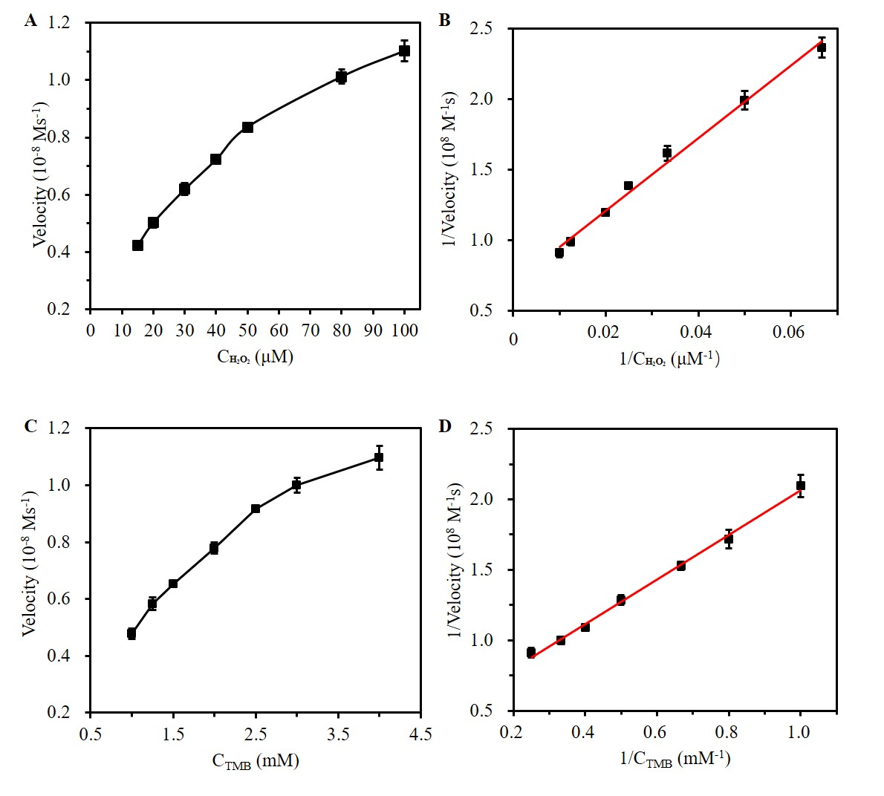

R2=0.9964

R2=0.9934

**Figure S3.** (**A**) Reaction velocity under 4.0 mM of TMB with varied concentrations of H2O2 and (**B**) the corresponding double-reciprocal plots of VB3-catalyzed activity; (**C**) Reaction velocity under 0.1 mM H2O2 with varied concentrations of TMB and (**D**) the corresponding double-reciprocal plots of VB3-catalyzed activity. Error bars represent the standard deviation of three measurements.

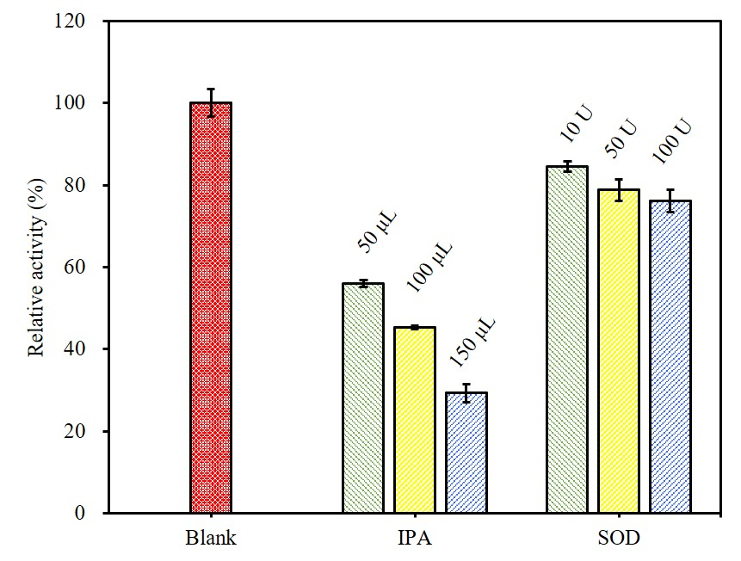

**Figure S4.** Effects of various active scavengers during the catalysis of TMB by VB3.

**Table S1.** Kinetic parameters (*Km* and *vmax*) of different small-molecule peroxidase mimics.

|  |  |  |  |  |  |  |  |  |  |  |  |
| --- | --- | --- | --- | --- | --- | --- | --- | --- | --- | --- | --- |
| **Catalyst** | ***Km* (mM)** | |  | ***v*max (10-8 M s-1)** | | |  | | **Kcat (s-1)** | | **Ref.** |
| **TMB** | **H2O2** |  | **TMB** | | **H2O2** | |  | **TMB** | **H2O2** |
| AF | 1.90 ± 0.126 | 1.86 ± 0.232 |  | 0.384 ± 0.16 | 0.217 ± 0.02 | | |  | 3.84 × 10-5 | 2.17 × 10-5 | (Liu et al., 2017) |
| DFF | 1.78 | 2.97 |  | 0.404 | 0.983 | | |  | 4.04 × 10-5 | 9.83 × 10-5 | (Li et al., 2018) |
| L-Glu | 0.6268 ± 0.219 | 0.0144 ± 0.002 |  | 0.2287 ± 0.052 | 0.1927 ± 0.006 | | |  | 2.29 × 10-7 | 1.93 × 10-7 | (Shi et al., 2018) |
| L-Asp | 0.4370 ± 0.083 | 0.0115 ± 0.001 |  | 0.3560 ± 0.040 | 0.2713 ± 0.003 | | |  | 3.56 × 10-7 | 2.71 × 10-7 | (Shi et al., 2018) |
| HRP | 0.179 ± 0.020 | 1.18 ± 0.147 |  | 3.895 ± 0.218 | 7.307 ± 0.824 | | |  | 1.69 × 103 | 3.18 × 103 | (Shi et al., 2018) |
| VB3 | 3.28 | 0.037 |  | 2.07 | 1.44 | | |  | 4.1 × 10-7 | 2.9 × 10-7 | This work |

*Km*: Michaelis constant; *vmax*: the maximal reaction rate; Kcat: turnover number; AF: Aminofluorescein; DFF: 2′, 7′-difluorofluorescein; L-Glu: L-glutamic acid; L-Asp: L-aspartic acid; HRP: Horseradish peroxidase; VB3: Vitamin B3, nicotinic acid.

**Table S2.** H2O2 detection in disinfectant samples.

|  |  |  |  |  |  |  |
| --- | --- | --- | --- | --- | --- | --- |
| **Samples** | **Detected (μM)** | | **Added (μM)** | **Found (μM)** | **Recovery (%)** | **RSD (%)** |
|  | |  | 10.0 | 44.0 | 94.3 | 5.5 |
| 1 | | 34.6 | 20.0 | 54.2 | 98.1 | 4.2 |
|  | |  | 40.0 | 75.5 | 102.3 | 4.8 |
|  | |  | 10.0 | 43.6 | 96.9 | 4.3 |
| 2 | | 34.0 | 20.0 | 53.8 | 99.0 | 6.1 |
|  | |  | 40.0 | 74.5 | 101.4 | 5.0 |
|  | |  | 10.0 | 21.3 | 95.0 | 3.7 |
| 3 | | 11.8 | 20.0 | 31.8 | 100.4 | 4.3 |
|  | |  | 40.0 | 54.2 | 106.0 | 1.0 |

**References**

Li, M. L., Yang, J., Ou, Y. N., Shi, Y., Liu, L., Sun, C. Q., Zheng, H. Z., Long, Y. J., 2018. Peroxidase-like activity of 2′,7′-difluorofluorescein and its application for galactose detection. *Talanta* 182, 422-427.

Liu, L., Shi, Y., Li, M. L., Sun, C. Q., Long, Y. J., Zheng, H. Z., 2017. Effect of carboxyl and amino groups in fluorescein molecules on their peroxidase-like activity. *Mol. Catal.* 439, 186-192.

Shi, Y., Liu, L., Yu, Y. Y., Long, Y. J., Zheng, H. Z., 2018a. Acidic amino acids: A new-type of enzyme mimics with application to biosensing and evaluating of antioxidant behaviour. *Spectrochim. Acta, Part A* 201, 367-375.