Supplementary material for
Development of a Novel Unified Quality Control Strategy for Proprietary Chinese Medicines
Ze-Yan Chen ^{a, b, 1}, Xu-Ya Wei ^{b, d, 1}, Ting Tan ^{c, d}, Yu-Lin Feng ^{c, d}, Juan Guo ^{b}, Guang-Hong Cui ^{b}, Chang-Jiang-Sheng Lai ^{b, *}, Lu-Qi Huang ^{a, b, *}
ª School of Traditional Chinese Medicine, Guangdong Pharmaceutical University, Guangzhou, 510006, PR China
^{b} State Key Laboratory Breeding Base of Dao-di Herbs, National Resource Center for Chinese Materia Medica, China Academy of Chinese Medical Sciences, Beijing, 100700, PR China
^{c} The National Pharmaceutical Engineering Center for Solid Preparation in Chinese Herbal Medicine, Jiangxi University of Traditional Chinese Medicine, Nanchang, 330006, PR China
^{d} Jiangxi University of Traditional Chinese Medicine, Nanchang, 330006, PR China

* Corresponding authors.
E-mail addresses: laichangjiang44@126.com (C. J. S. Lai), huangluqi01@126.com (L. Q. Huang).
¹ These authors contributed equally to this work.
1. The prescriptions of Ginseng-Fuzi proprietary Chinese medicines
Name | Ingredient
Jianbuqiangshen Pill (JBP) | Anemarrhenae Rhizoma, Phellodendri Chinensis Cortex, Testudinis Carapax et Plastrum (Vinegar quenching), Rehmanniae Radix Praeparata, Paeoniae Radix Alba, Angelicae Sinensis Radix, Astragali Radix Praeparata Cum Melle, Ginseng Radix et Rhizoma, Atractylodis Macrocephalae Rhizoma (Stir-baked in bran), Poria, Lycii Fructus, Cuscutae Semen, Cynomorii Herba, Psoraleae Fructus (Stir-bake with saltwater), Eucommiae Cortex, Dipsaci Radix, Aconiti Lateralis Radix Praeparata (Processed, Fuzi), Notopterygii Rhizoma et Radix, Angelicae Pubescentis Radix, Gentianae Macrophyllae Radix, Saposhnikoviae Radix, Chaenomelis Fructus, Achyranthis Bidentatae Radix, Panthera Pardus Bone (Processed with oil)
Nanbao Capsule (NAC) | Cervi Cornu Pantotrichum, Hippocampus, Asini Corii Colla, Moutan Cortex, Astragali Radix, Equus Asinus (Penis and testes), Canis Familiaris (Penis and testes), Ginseng Radix et Rhizoma, Angelicae Sinensis Radix, Eucommiae Cortex, Cinnamomi Cortex, Lycii Fructus, Cuscutae Semen, Aconiti Lateralis Radix Praeparata (Processed, Fuzi), Morindae Officinalis Radix, Cistanches Herba, Rehmanniae Radix Praeparata, Poria, Atractylodis Macrocephalae Rhizoma, Corni Fructus, Epimedii Folium, Psoraleae Fructus, Rubifructus, Trigonella Foenum-graecum, Ophiopogonis Radix, Cynomorii Herba, Curculiginis Rhizoma, Dipsaci Radix, Achyranthis Bidentatae Radix, Scrophulariae Radix, Glycyrrhizae Radix et Rhizoma
Nvbao Capsule (NVC) | Ginseng Radix et RHizoma 58g, Chuanxiong Rhizoma 82g, Deer Fetus 2.5g, Stellariae Radix 65g, Moutan Cortex 65g, Aquilariae Lignum Resinatum 32g, Euodiae Fructus (Processed) 15g, Cinnamomi Cortex 50g, Corydalis Rhizoma (Processing with rice vinegar) 32g, Aucklandiae Radix 50g, Cyperi Rhizoma (Processing with rice vinegar) 82g, Angelicae Sinensis Radix 100g, Sepiae Endoconcha 50g, Citri Reticulatae Pericarpium Viride 50g, Schizonepetae Spica Carbonisata 82g, Zingiberis Rhizoma Praeparatum 50g, Sal Viae Miltiorrhizae Radix et Rhizoma 65g, Asini Corii Colla 25g, Alismatis Rhizoma (stir-fried with salt) 50g, Aconiti Lateralis Radix Praeparata (Processed, Fuzi) 50g, Glycyrrhizae Radix et Rhizoma 32g, Persicae Semen (Stir-fried) 65g, Eucommiae Cortex 15g, Achyranthis Bidentatae Radix 50g, Carthami Flos 125g, Amomi Fructus Rotundus 25g, Cervi Cornu Pantotrichum 15g, Poria 65g, Lactic Cervi 80g, Amomi Fructus 25g, Atractylodis Macrocephalae Rhizoma (Stir-fried) 65g, Citri Reticulatae Pericarpium 82g, Testudinis Carapax et Plastrum (Processed with rice vinegar) 15g, Dried Lacquer 15g, Areca 50g, Trionycis Carapax (Processed with rice vinegar) 15g, Rehmanniae Radix Praeparata 82g, Curcumae Rhizoma 32g, Magnoliae Officinalis Cortex (Processing with ginger) 50g, Foeniculi Fructus (Processing with salt) 65g, Paeoniae Radix Alba (Processed with wine) 82g, Typhae Pollen 50g, Paeoniae Radix Rubra 50g, Petiolus Trachycarpi 15g, Sparganii Rhizoma 32g
Pingfengshengmai Capsule (PFC) | Astragali Radix 90g, Atractylodis Macrocephalae Rhizoma 30g, Saposhnikoviae Radix 30g, Schisandrae Chinensis Fructus 60g, Ginseng Radix et Rhizoma 60g, Ophiopogonis Radix 97.5g, Aconiti Lateralis Radix Praeparata (Processed, Fuzi) 45g
Qiliqiangxin Capsule (QLC) | Astragali Radix 450g, Ginseng Radix et Rhizoma 225g, Aconiti Lateralis Radix Praeparata (Processed, Fuzi) 112.5g, Sal Viae Miltiorrhizae Radix et Rhizoma 225g, Descurainiae Semen 150g, Alismatis Rhizoma 225g. Polygonati Odorati Rhizoma 75g, Cinnamomi Ramulus 90g, Carthami Flos 90g, Periplocae Cortex 180g, Citri Reticulatae Pericarpium 75g
Renshenzaizao Pill (RSP) | Ginseng Radix et Rhizoma 100g, Agkistrodon (Processed with wine) 100g, Pogostemonis Herba 100g, Santali Albi Lignum 50g, Caryophylli Fructus 50g, Scrophulariae Radix 100g, Asari Radix et Rhizoma 50g, Cyperi Rhizoma (Processed with rice vinegar) 50g, Pheretima 25g, Rehmanniae Radix Praeparata 100g, Notoginseng Radix et Rhizoma 25g, Olibanum (Processed with rice vinegar) 50g, Citri Reticulatae Pericarpium Viride 50g, Amomi Fructus Rotundus 50g, Saposhnikoviae Radix 100g, Polygoni Multiflori Radix (Processed) 100g, Chuanxiong Rhizoma 100g, Wenyujin Rhizoma Concisum 12.5g, Astragali Radix 100g, Glycyrrhizae Radix et Rhizoma 100g, Coptidis Rhizoma 100g, Poria 50g, Paeoniae Radix Rubra 100g, Rhei Radix et Rhizoma 100g, Taxilli Herba 100g, Puerariae Lobatae Radix 75g, Ephedrae Herba 100g, Drynariae Rhizoma (Stir-fried) 50g, Scorpio 75g, Panthera Pardus Bone (Processed) 50g, Bombyx Batryticatus (Processed) 50g, Aconiti Lateralis Radix Praeparata (Processed, Fuzi) 50, Amber 25g, Testudinis Carapax et Plastrum (Processed) 50g, Dioscoreae Collettii Rhizoma 100g, Atractylodis Macrocephalae Rhizoma (Stir-baked in bran) 50g, Aquilariae Lignum Resinatum 50g, Gastrodiae Rhizoma 100g, Cinnamomi Cortex 100g, Angelicae Dahuricae Radix 100g, Myrrha (Processed with rice vinegar) 50g, Angelicae Sinensis Radix 50g, Alpiniae Katsumadai Semen 100g, Clematidis Radix et Rhizoma 75g, Linderae Radix 50g, Notopterygii Rhizoma et Radix 100g, Citri Exocarpium Rubrum 200g, Massa Medicata Fermentat (Processed with rice vinegar) 200g, Cinnabaris 20g, Draconis Sanguis 15g, Moschus 5g, Borneolum Syntheticum 5g, Bovis Calculus 5g, Bambusae Concretio Silicea 50g, Arisaema Cum Bile 50g, Powerdered Buffalo Horn Extract 30g
Shenfuqiangxin Pill (SFP) | Ginseng Radix et Rhizoma 200g, Aconiti Lateralis Radix Praeparata (Processed, Fuzi) 160g, Mori Cortex 200g, Polyporus 300g, Descurainiae Semen 240g, Rhei Radix et Rhizoma 120g
Shenguilizhong Pill (SGP) | Ginseng Radix et Rhizoma 60g, Cinnamomi Cortex 60g, Aconiti Lateralis Radix Praeparata (Processed, Fuzi) 120g, Zingiberis Rhizoma 240g, Atractylodis Macrocephalae Rhizoma (Stir-baked in bran) 240g, Glycyrrhizae Radix et Rhizoma 60g
Wumei Pill (WMP) | Mume Fructus (Softened and pitted) 120g, Zanthoxyli Pericarpium (Removed seed) 12g, Asari Radix et Rhizoma 18g, Coptidis Rhizoma 48g, Phellodendri Chinensis Cortex 18g, Zingiberis Rhizoma 30g, Aconiti Lateralis Radix Praeparata (Processed, Fuzi) 18g, Cinnamomi Ramulus 18g, Ginseng Radix et Rhizoma 18g, Angelicae Sinensis Radix 12g
Xinbao Pill (XBP) | Daturae Flos, Ginseng Radix et Rhizoma, Cinnamomi Cortex, Aconiti Lateralis Radix Praeparata (Processed, Fuzi), Cervi Cornu Pantotrichum, Borneolum Syntheticum, Moschus, Notoginseng Radix et Rhizoma, Bufonis Venenum

2. Precision and repeatability of target compounds
Compounds | Concentration | Precision (RSD, %) |  | Stability
 |  | Inter-day | Intra-day | (RSD, %)
AT | 2 | 4.20 | 10.03 | 4.47
 | 20 | 3.89 | 5.59 | 2.10
 | 200 | 1.89 | 2.31 | 0.61
HAT | 2 | 3.31 | 7.94 | 7.55
 | 20 | 2.47 | 6.56 | 1.05
 | 200 | 1.47 | 2.58 | 1.07
MAT | 2 | 4.46 | 7.73 | 9.72
 | 20 | 4.11 | 9.41 | 4.08
 | 200 | 0.97 | 2.36 | 3.05
BAC | 2 | 4.61 | 2.05 | 2.37
 | 20 | 4.31 | 7.93 | 4.00
 | 200 | 2.01 | 1.71 | 1.00
BMA | 2 | 8.61 | 10.41 | 9.91
 | 20 | 6.61 | 0.73 | 5.83
 | 200 | 1.43 | 3.10 | 3.39
BHA | 2 | 2.28 | 3.82 | 8.78
 | 20 | 0.46 | 1.63 | 2.61
 | 200 | 2.91 | 2.85 | 2.22
AC | 2 | 6.63 | 3.70 | 2.70
 | 20 | 5.28 | 3.60 | 5.18
 | 200 | 5.90 | 3.76 | 3.51
MA | 2 | 3.20 | 5.72 | 4.00
 | 20 | 1.41 | 0.51 | 3.17
 | 200 | 0.92 | 2.41 | 4.11
HA | 2 | 6.58 | 3.59 | 5.99
 | 20 | 4.79 | 3.32 | 1.17
 | 200 | 1.23 | 2.78 | 3.78
SGR | 2 | 11.37 | 5.51 | 8.23
 | 20 | 7.22 | 4.77 | 0.06
 | 200 | 2.71 | 3.18 | 2.85
INAT | 2 | 9.44 | 8.65 | 2.47
 | 20 | 6.30 | 5.76 | 4.99
 | 200 | 3.50 | 3.18 | 2.74
YUAT | 2 | 8.90 | 8.73 | 9.74
 | 20 | 6.92 | 0.37 | 8.24
 | 200 | 2.34 | 1.92 | 0.22
CK | 2 | 7.74 | 6.15 | 9.39
 | 20 | 0.89 | 1.44 | 2.29
 | 200 | 2.86 | 6.16 | 5.05
F3 | 80 | 2.47 | 6.23 | 8.54
 | 200 | 2.27 | 9.43 | 4.58
 | 1000 | 3.02 | 3.01 | 4.96
F4 | 2 | 8.13 | 10.43 | 6.70
 | 20 | 0.33 | 8.48 | 4.52
 | 200 | 2.53 | 2.19 | 1.64
F5 | 50 | 7.06 | 1.65 | 5.88
 | 200 | 2.27 | 8.30 | 9.10
 | 1000 | 3.91 | 3.23 | 7.39
Rb1 | 5 | 0.04 | 10.87 | 2.77
 | 20 | 4.16 | 8.50 | 0.78
 | 200 | 7.15 | 9.93 | 7.43
Rb2 | 2 | 2.86 | 2.53 | 7.36
 | 20 | 9.68 | 4.28 | 0.38
 | 200 | 3.62 | 7.31 | 7.93
Rc | 2 | 5.41 | 3.19 | 3.79
 | 20 | 2.40 | 4.21 | 5.72
 | 200 | 4.78 | 8.67 | 5.73
Rd | 2 | 3.53 | 9.19 | 6.22
 | 20 | 9.26 | 4.71 | 7.74
 | 200 | 5.76 | 8.57 | 9.74
Rd2 | 50 | 6.97 | 8.30 | 3.78
 | 200 | 2.28 | 7.88 | 3.76
 | 1000 | 8.94 | 0.99 | 4.27
De-Rd | 2 | 9.73 | 8.51 | 5.95
 | 20 | 7.95 | 3.72 | 9.08
 | 200 | 3.13 | 8.11 | 5.17
Re | 2 | 9.13 | 9.76 | 6.52
 | 20 | 8.20 | 7.97 | 0.59
 | 200 | 5.71 | 6.93 | 9.23
Rf | 2 | 1.92 | 4.55 | 3.10
 | 20 | 5.02 | 8.04 | 4.72
 | 200 | 1.90 | 5.74 | 9.97
Rg1 | 5 | 8.93 | 3.42 | 8.91
 | 20 | 3.03 | 2.70 | 7.29
 | 200 | 2.68 | 4.58 | 6.21
Rg2 | 2 | 6.48 | 1.49 | 9.86
 | 20 | 4.74 | 2.14 | 11.41
 | 200 | 2.68 | 7.62 | 3.51
Rg3 | 2 | 9.59 | 3.21 | 4.74
 | 20 | 6.91 | 9.53 | 1.88
 | 200 | 6.12 | 7.19 | 6.49
Rg5 | 2 | 6.19 | 9.50 | 5.47
 | 20 | 6.30 | 4.67 | 4.11
 | 200 | 4.33 | 3.78 | 4.99
Rg6 | 2 | 1.64 | 9.27 | 2.50
 | 20 | 1.29 | 2.02 | 2.40
 | 200 | 2.54 | 8.91 | 4.56
Rh1 | 50 | 7.56 | 8.60 | 7.53
 | 200 | 9.82 | 8.36 | 4.04
 | 1000 | 4.50 | 3.85 | 2.84
Rh2 | 2 | 9.00 | 3.61 | 4.96
 | 20 | 8.02 | 2.51 | 5.91
 | 200 | 2.86 | 3.95 | 5.68
Rk1 | 2 | 9.22 | 2.34 | 4.18
 | 20 | 6.69 | 6.91 | 4.89
 | 200 | 2.46 | 6.50 | 2.13
Ro | 10 | 7.85 | 7.55 | 8.76
 | 200 | 1.98 | 5.28 | 6.39
 | 1000 | 7.60 | 2.79 | 0.29
PD | 10 | 6.04 | 4.80 | 9.07
 | 200 | 6.76 | 7.21 | 1.97
 | 1000 | 1.49 | 8.68 | 6.72
PPD | 2 | 0.63 | 9.75 | 3.91
 | 20 | 6.38 | 7.96 | 9.73
 | 200 | 0.57 | 3.40 | 0.60
PT | 2 | 1.57 | 7.80 | 3.79
 | 20 | 8.79 | 4.96 | 4.35
 | 200 | 6.21 | 4.98 | 1.98
PPT | 2 | 7.12 | 5.99 | 4.40
 | 20 | 5.79 | 1.53 | 9.52
 | 200 | 6.07 | 4.14 | 1.54

3. Supplementary figures
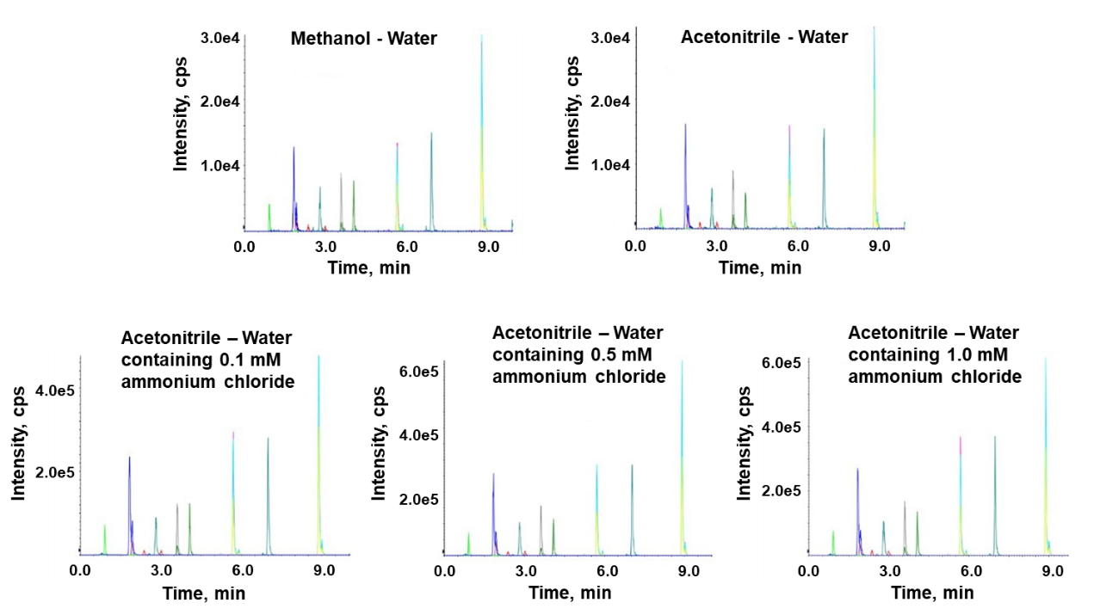
Fig. S1 LC-MS spectrums of mobile phase optimization

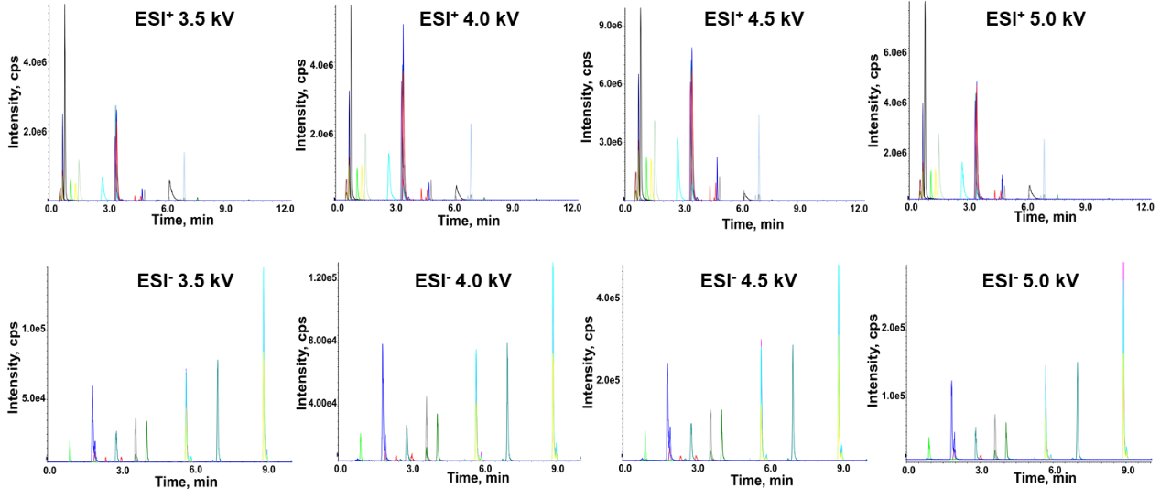
Fig. S2 LC-MS spectrums of ion spray voltage optimization

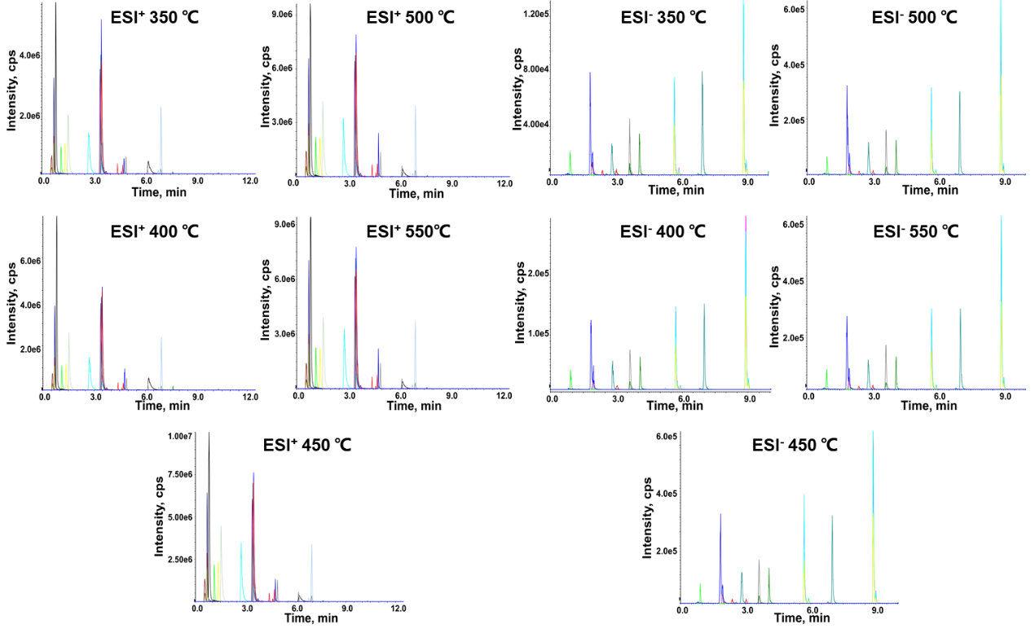
Fig. S3 LC-MS spectrums of ion source temperature optimization

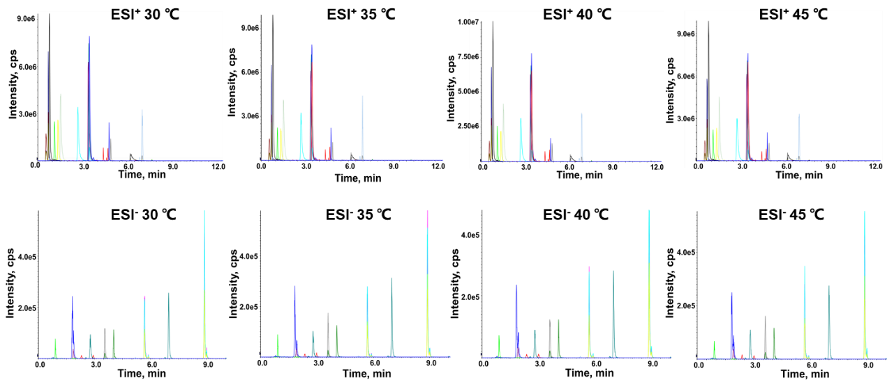
Fig. S4 LC-MS spectrums of column temperature optimization

