CS@Cu2O and Magnetic Fe3O4@SiO2-pAMBA-CS-Cu2O as Heterogeneous Catalysts for CuAAC

Click Reaction

Fatemeh Jafarzadeh1, Zahra Dolatkhah1, Shiva Molaei1, Shahrzad Javanshir1*

*1Pharmaceutical and Heterocyclic Chemistry Research Laboratory, Department of Chemistry, Iran university of Science and Technology, Tehran 16846-13114, Iran*

*Email: [shjavan@iust.ac.ir](mailto:shjavan@iust.ac.ir)

Contents:

**Fig S1**. XPS analysis of Fe3O4@SiO2-pAMBA-CS-Cu2O ……………………………………………………………....S2

**Fig S2**. TGA-DTG analysis of Fe3O4@SiO2-pAMBA-CS-Cu2O ……………………………………………………….S3

**Fig S3**. 1H-NMR spectrum of 3j in CDCl3 ………………………………………………………………………………….S4

c

b

a





**Fig S1**. XPS analysis of Fe3O4@SiO2-pAMBA-CS-Cu2O

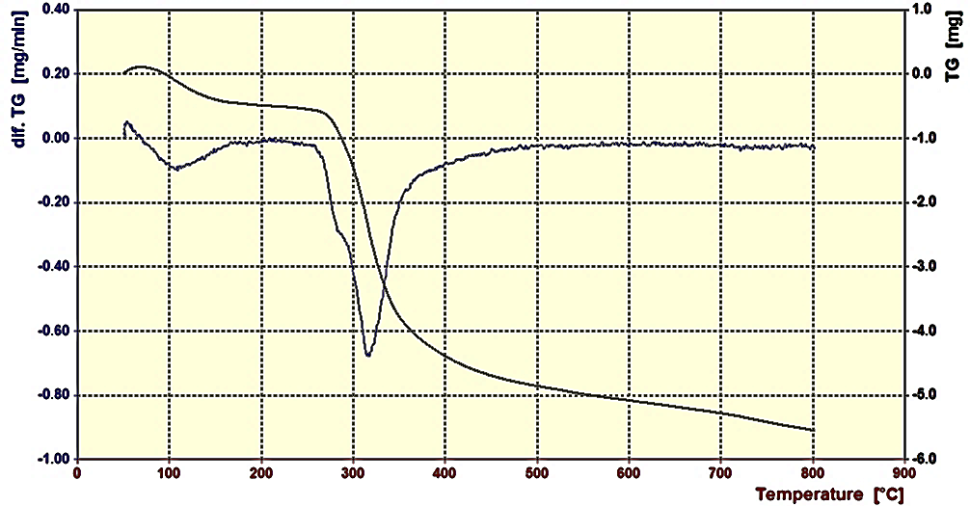

**Fig S2**. TGA-DTG analysis of Fe3O4@SiO2-pAMBA-CS-Cu2O

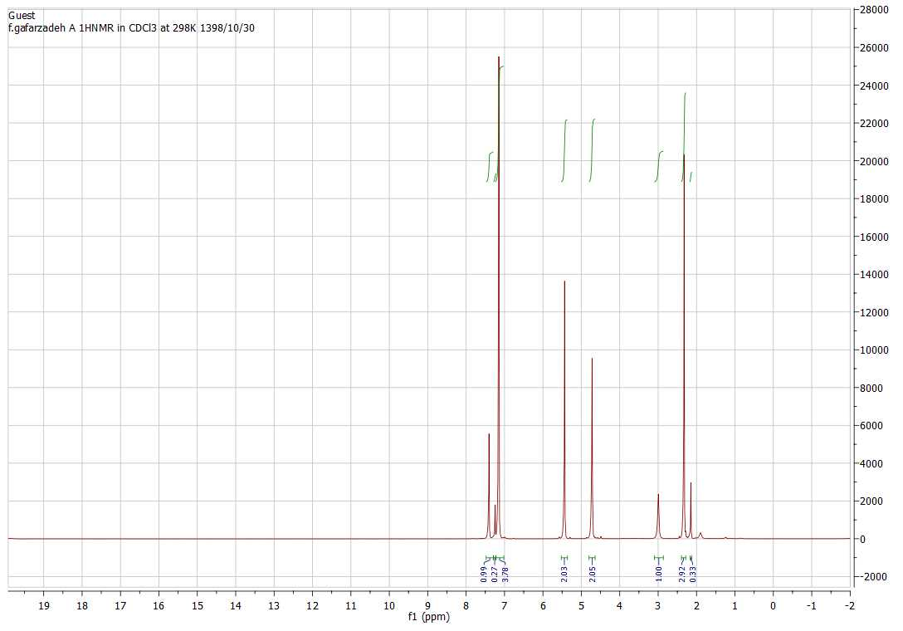

**Fig S3**. 1H-NMR spectrum of **3j** in CDCl3