**Greener Pastures in Evaluating Antidiabetic Drug for a Quinoxaline Derivative: Synthesis, Characterization, Molecular Docking, *in Vitro* and HSA/DFT/XRD Studies**

Mohcine Missioui 1, Salma Mortada 2, Walid Guerrab 1, Güneş Demirtaş 3, Joel T. Mague 4, M’hammed Ansar 1, My El Abbes Faouzi 2, E.M. Essassi 5, Yassin T.H. Mehdar 6, Faizah S. Aljohani 6, Musa A. Said 6 and Youssef Ramli 1,*

*1 Laboratory of Medicinal Chemistry, Drug Sciences Research Center, Faculty of Medicine and Pharmacy, Mohammed V University in Rabat, Morocco*

*2 Laboratories of Pharmacology and Toxicology, Faculty of Medicine and Pharmacy, Mohammed V University in Rabat, Morocco*

*3 Ondokuz Mayıs University, Faculty of Arts and Sciences, Department of Physics, 55139, Samsun, Turkey*

*4 Department of Chemistry, Tulane University, New Orleans, LA 70118, USA*

*5 Laboratory of Heterocyclic Organic Chemistry, Faculty of Sciences, Mohammed V University, Rabat, Morocco*

*6 Department of Chemistry, Taibah University, Madinah, King Saudi Arabia*

*\* Correspondence:* [*y.ramli@um5s.net.ma*](mailto:y.ramli@um5s.net.ma)*, https://orcid.org/0000-0002-6885-5692*

**SUPPLEMENTARY MATERIALS: Table of Contents**

**Figure S1** SM (ESI+) spectrum for **MOQTA**, recorded on an API 3200 LC/MS/MS mass spectrometer using electrospray ionization (ESI) in positive polarity.

**Figure S2** IR spectrum for **MOQTA**, recorded on an IR VERTEX 70 FT-IR (Bruker Optics) spectrophotometer

**Figure S3** 1H NMR spectrum for **MOQTA**, recorded on a BrukerAvance (300 MHz) spectrometer, using TMS as the internal standard and DMSO-d6 as solvent.

**Figure S4** 13C{1H} NMR spectrum for **MOQTA**, recorded on a BrukerAvance (300 MHz) spectrometer, using TMS as internal standard and DMSO-d6 as solvent.

**Figure S5** SM (ESI+) spectrum for **MPQ**, recorded on an API 3200 LC/MS/MS mass spectrometer using electrospray ionization (ESI) in positive polarity.

**Figure S6** IR spectrum for **MPQ**, recorded on an IR VERTEX 70 FT-IR (Bruker Optics) spectrophotometer

**Figure S7** 1H NMR spectrum for **MPQ**, recorded on a « JNM-ECZ500R/S1 FT NMR System de JEOL » spectrometer, using TMS as the internal standard and CHLOROFORM-D as solvent.

**Figure S8** 13C{1H} NMR spectrum for **MPQ**, recorded on a « JNM-ECZ500R/S1 FT NMR System de JEOL » spectrometer, using TMS as the internal standard and CHLOROFORM-D as solvent.

C:\Users\USER\Desktop\Revisio\FR 164  MS;.tif **Figure S1** SM (ESI+) spectrum for **MOQTA**, recorded on an API 3200 LC/MS/MS mass spectrometer using electrospray ionization (ESI) in positive polarity.

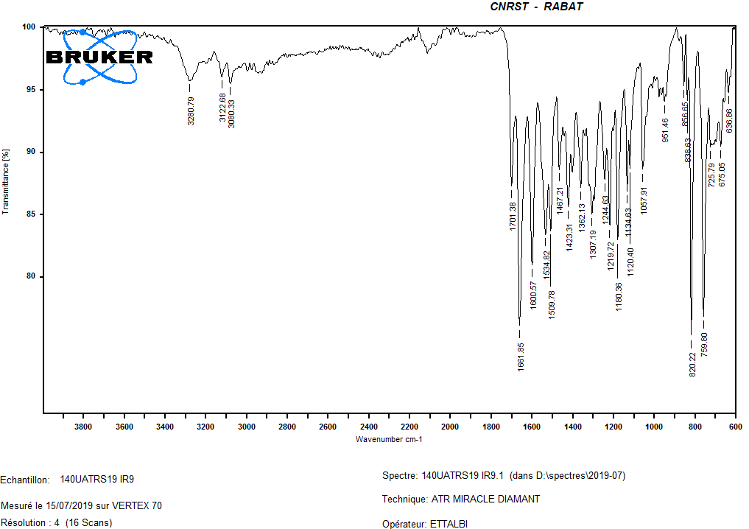

**Figure S2** IR spectrum for **MOQTA**, recorded on an IR VERTEX 70 FT-IR (Bruker Optics) spectrophotometer

C:\Users\USER\Desktop\Revisio\1H RMN; FR164.tiff

**Figure S3** 1H NMR spectrum for **MOQTA**, recorded on a BrukerAvance (300 MHz) spectrometer, using TMS as the internal standard and DMSO-d6 as solvent.

C:\Users\USER\Desktop\Revisio\13C RMN FR164.tiff

**Figure S4** 13C{1H} NMR spectrum for **MOQTA**, recorded on a BrukerAvance (300 MHz) spectrometer, using TMS as internal standard and DMSO-d6 as solvent.



**Figure S5** SM (ESI+) spectrum for **MPQ**, recorded on an API 3200 LC/MS/MS mass spectrometer using electrospray ionization (ESI) in positive polarity.

C:\Users\USER\Desktop\Revisio\IR.tif

**Figure S6** IR spectrum for **MPQ**, recorded on an IR VERTEX 70 FT-IR (Bruker Optics) spectrophotometer

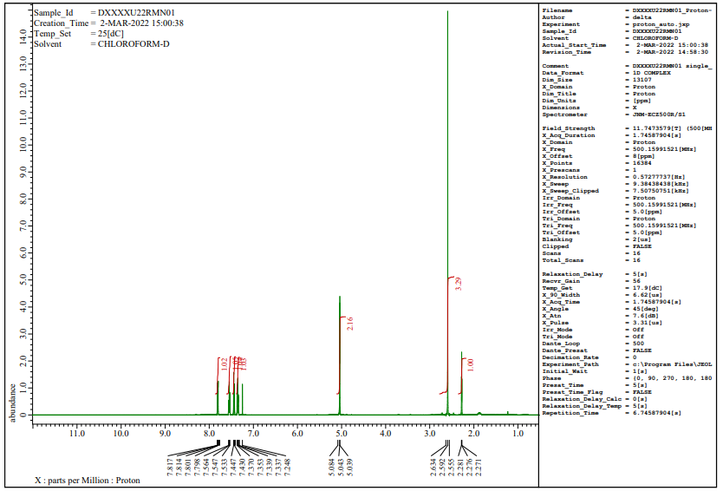

**Figure S7** 1H NMR spectrum for **MPQ**, recorded on a « JNM-ECZ500R/S1 FT NMR System de JEOL » spectrometer, using TMS as the internal standard and CHLOROFORM-D as solvent.

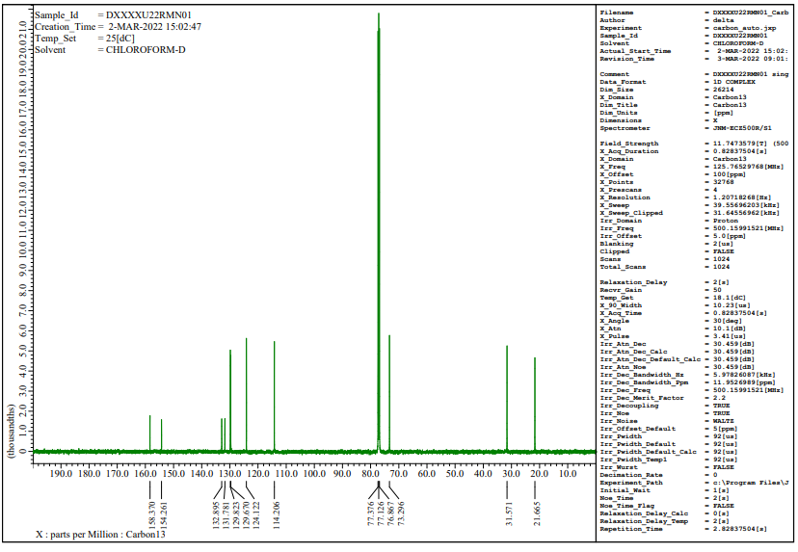

**Figure S8** 13C{1H} NMR spectrum for **MPQ**, recorded on a « JNM-ECZ500R/S1 FT NMR System de JEOL » spectrometer, using TMS as the internal standard and CHLOROFORM-D as solvent.