Supplementary Material for

Regio- and stereoselectivity of the 1,3-dipolar cycloaddition of azomethine ylides to (E)-3-(2-oxo-2-(pyren-1-yl)ethylidene)indolin-2-ones: A combined experimental and theoretical study
Essam M. Hussein*^{a,b}, Ziad Moussa^{c}, Uttam Pal^{d}, Reem I. Alsantali^{e}, Abdullah Y. A. Alzahrani^{f}, Rami J. Obaidª, Fawaz M. Alzahrani^{a,g} , Munirah M. Al-Rooqiª, Meshari A. Alsharifª, Nizar El Guesmi^{a,h}, Rabab S. Jassas^{i}, M. Shaheer Malikª, Hatem M. Altassª, Samir K. Pal^{j}, Tanusri Saha Dasgupta^{k}, Saleh A. Ahmed*^{a,b}

ª Department of Chemistry, Faculty of Applied Science, Umm Al-Qura University, 21955 Makkah, Saudi Arabia
^{b} Department of Chemistry, Faculty of Science, Assiut University, 71516 Assiut, Egypt
^{c} Department of Chemistry, College of Science, United Arab Emirates University, P.O. Box 15551, Al Ain, United Arab Emirates
^{d} Technical Research Centre, S.N.Bose National Centre for Basic Sciences, Block JD, Sector III, Salt Lake, Kolkata: 700106, India
^{e}Department of Pharmaceutical Chemistry, College of Pharmacy, Taif University, P.O.Box 11099,Taif 21944, Saudi Arabia
^{f} Department of Chemistry, Faculty of Science and Arts, King Khalid University, Mohail, Assir, Saudi Arabia
^{g}esearch laboratories unit, Faculty of Applied Science, Umm Al-Qura University, 21955 Makkah, Saudi Arabia

^{h} Département de chimie, Faculté des Sciences de Monastir, Avenue de l’Environnement,
5019 Monastir, Tunisia
^{i} Department of Chemistry, Jamoum University College, Umm Al-Qura University, 21955 Makkah, Saudi Arabia

^{j} Department of Chemical, Biological & Macromolecular Sciences, S.N.Bose National Centre for Basic Sciences, JD Block, Sector III, Salt Lake, Kolkata (Calcutta) 700 106. India
^{k}Department of Condensed Matter Physics and Material Sciences, S.N.Bose, National Centre for Basic Sciences, Block JD, Sector III, Salt Lake, Kolkata: 700106, India

Correspondence may be addressed to:
Saleh A. Ahmed, https://orcid.org/0000-0002-2364-0380; E-mail: saahmed@uqu.edu.sa, saleh_63@hotmail.com; Essam M. Hussein, https://orcid.org/0000-0003-4778-540X; E-mail: amhfarghaly@uqu.edu.sa, essam.hussein78@yahoo.com.

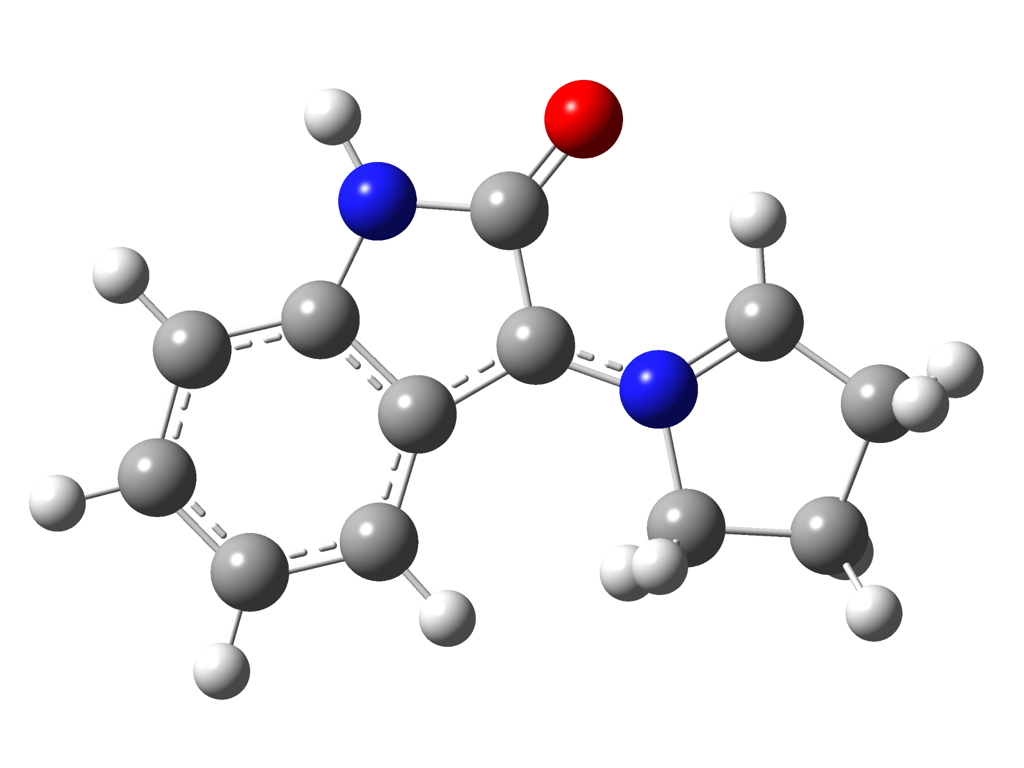

3a
Standard orientation:
---------------------------------------------------------------------
Center Atomic Atomic Coordinates (Angstroms)
Number Number Type X Y Z
---------------------------------------------------------------------
1 6 0 -2.021166 0.677307 -0.032004
2 6 0 -3.374295 0.362034 -0.042547
3 6 0 -3.744265 -0.988324 -0.000902
4 6 0 -2.765368 -1.986952 0.056612
5 6 0 -1.402782 -1.666636 0.067676
6 6 0 -0.998362 -0.321079 0.014434
7 6 0 0.251256 0.406245 0.016264
8 7 0 -1.418164 1.927883 -0.053340
9 6 0 2.663194 0.650852 0.086011
10 7 0 1.547606 -0.056974 0.031081
11 6 0 -0.027054 1.827396 -0.014253
12 8 0 0.755974 2.793584 -0.015015
13 6 0 3.884239 -0.208331 0.140128
14 6 0 1.838763 -1.520225 0.018172
15 6 0 3.346147 -1.599990 -0.265256
16 1 0 2.594673 1.730209 0.127971
17 1 0 4.675351 0.150972 -0.527245
18 1 0 4.312947 -0.212802 1.154656
19 1 0 -4.125710 1.145935 -0.079664
20 1 0 -4.795975 -1.257570 -0.008761
21 1 0 -3.062883 -3.030729 0.096859
22 1 0 -0.681614 -2.473528 0.127290
23 1 0 -1.890926 2.818339 -0.077640
24 1 0 1.558323 -1.926698 0.995046
25 1 0 1.226278 -1.995019 -0.748233
26 1 0 3.514767 -1.769556 -1.332782
27 1 0 3.819036 -2.418375 0.282426
---------------------------------------------------------------------

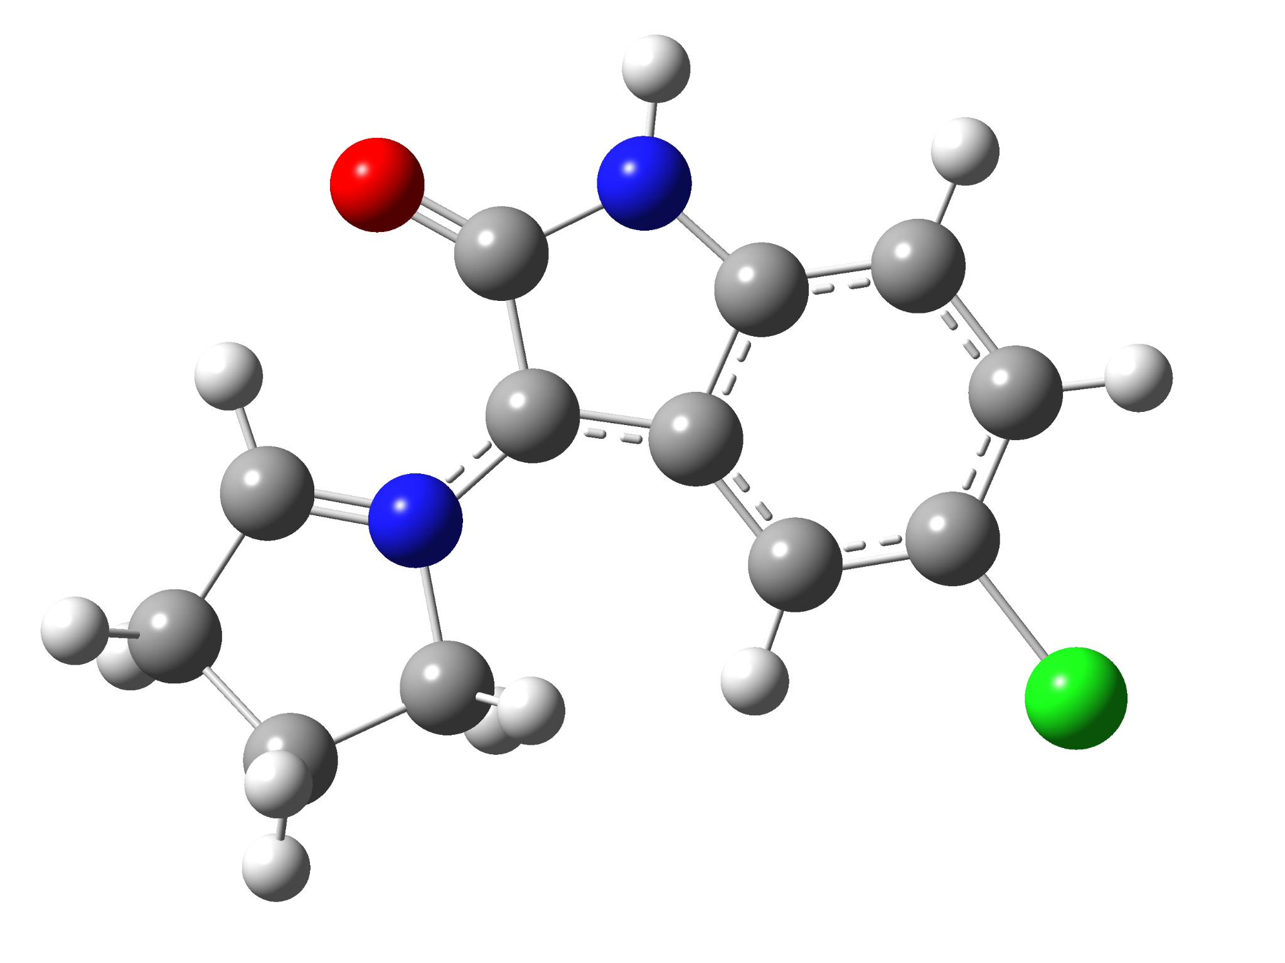

3b
Standard orientation:
---------------------------------------------------------------------
Center Atomic Atomic Coordinates (Angstroms)
Number Number Type X Y Z
---------------------------------------------------------------------
1 6 0 1.042996 1.680606 0.040292
2 6 0 2.415136 1.888047 0.060495
3 6 0 3.268779 0.777048 0.037853
4 6 0 2.716763 -0.503533 -0.011084
5 6 0 1.339029 -0.731036 -0.032943
6 6 0 0.467870 0.371292 0.001914
7 6 0 -0.960506 0.575150 -0.014947
8 7 0 0.016204 2.613646 0.043197
9 6 0 -3.284991 -0.104577 -0.103063
10 7 0 -1.988169 -0.343399 -0.029557
11 6 0 -1.235666 1.997663 -0.001580
12 8 0 -2.323252 2.598582 -0.017140
13 6 0 -4.096763 -1.357653 -0.147318
14 6 0 -1.710261 -1.809565 0.007255
15 6 0 -3.082494 -2.443599 0.280139
16 1 0 -3.624072 0.921867 -0.162160
17 1 0 -4.970452 -1.309203 0.511718
18 1 0 -4.484099 -1.531851 -1.163277
19 1 0 2.826634 2.892676 0.091448
20 1 0 4.344413 0.907578 0.053885
21 1 0 0.983719 -1.751350 -0.086134
22 1 0 0.120339 3.616663 0.057586
23 1 0 -1.284711 -2.094765 -0.959994
24 1 0 -0.976558 -2.010484 0.787882
25 1 0 -3.188143 -2.654572 1.348247
26 1 0 -3.208832 -3.384008 -0.260776
27 17 0 3.798363 -1.901294 -0.051699
---------------------------------------------------------------------

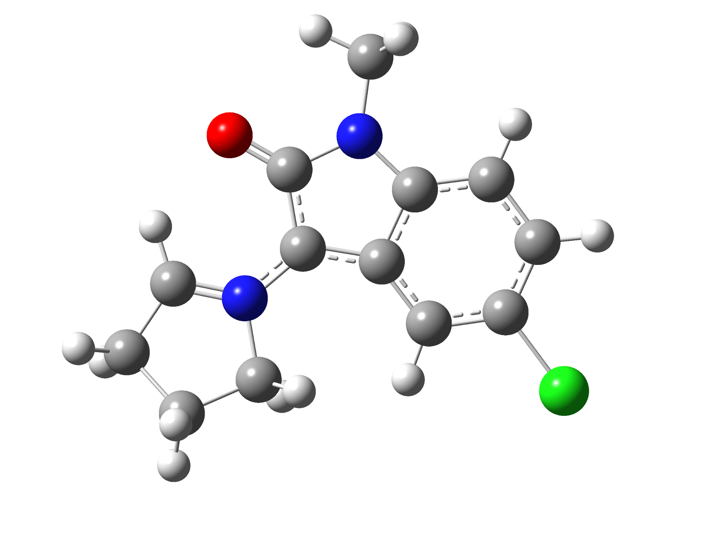

3c
Standard orientation:
---------------------------------------------------------------------
Center Atomic Atomic Coordinates (Angstroms)
Number Number Type X Y Z
---------------------------------------------------------------------
1 6 0 1.053194 1.398273 0.028257
2 6 0 2.430487 1.579065 0.047459
3 6 0 3.263074 0.450990 0.030450
4 6 0 2.687518 -0.818429 -0.012037
5 6 0 1.304868 -1.019947 -0.032737
6 6 0 0.455509 0.097851 -0.003408
7 6 0 -0.966258 0.330763 -0.021026
8 7 0 0.055094 2.362280 0.026038
9 6 0 -3.305386 -0.301879 -0.104054
10 7 0 -2.012951 -0.565265 -0.031054
11 6 0 -1.207742 1.757973 -0.014073
12 8 0 -2.286526 2.377769 -0.031515
13 6 0 -4.141226 -1.539327 -0.143194
14 6 0 -1.763944 -2.036465 0.010884
15 6 0 -3.147729 -2.642726 0.288133
16 1 0 -3.624711 0.730423 -0.166932
17 1 0 -5.013401 -1.471894 0.516275
18 1 0 -4.532617 -1.710770 -1.158116
19 1 0 2.863504 2.573816 0.073344
20 1 0 4.341047 0.561364 0.045884
21 1 0 0.930436 -2.033712 -0.080864
22 1 0 -1.345449 -2.333571 -0.955852
23 1 0 -1.033051 -2.248700 0.791118
24 1 0 -3.256263 -2.846844 1.357303
25 1 0 -3.292749 -3.582998 -0.248380
26 17 0 3.741671 -2.237655 -0.045613
27 6 0 0.251773 3.795262 0.047244
28 1 0 0.819405 4.128198 -0.829769
29 1 0 -0.735974 4.258933 0.033248
30 1 0 0.783798 4.106198 0.954013
---------------------------------------------------------------------

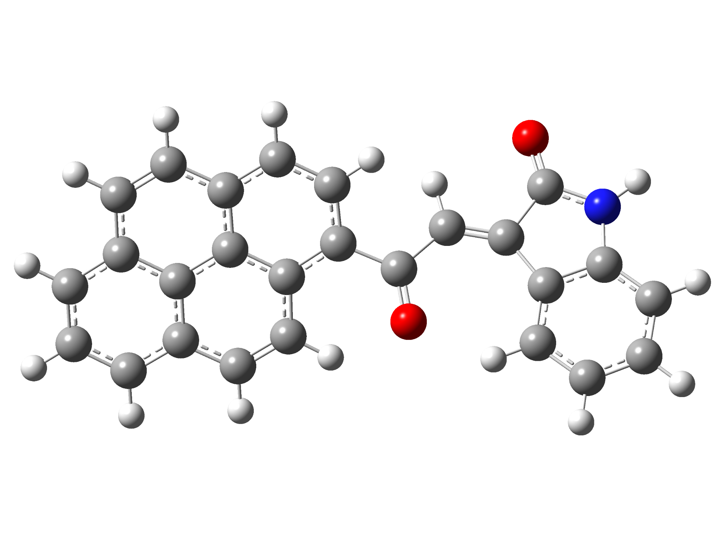

4a
Standard orientation:
---------------------------------------------------------------------
Center Atomic Atomic Coordinates (Angstroms)
Number Number Type X Y Z
---------------------------------------------------------------------
1 6 0 3.378297 0.645542 -0.315182
2 6 0 2.042019 0.874462 -0.304137
3 6 0 0.955830 -0.029516 0.144255
4 8 0 1.175056 -1.214715 0.412133
5 6 0 -5.217037 -2.379815 -0.690908
6 6 0 -4.021084 -1.674950 -0.464978
7 6 0 -4.079794 -0.307140 -0.063663
8 6 0 -5.352896 0.322863 0.100296
9 6 0 -6.522631 -0.419901 -0.134814
10 6 0 -6.453672 -1.757343 -0.526847
11 6 0 -2.873811 0.426048 0.169901
12 6 0 -2.959064 1.798322 0.563734
13 6 0 -4.250748 2.405833 0.724588
14 6 0 -5.395953 1.701156 0.503221
15 6 0 -2.731379 -2.279115 -0.627258
16 6 0 -1.577556 -1.588576 -0.396821
17 6 0 -1.596693 -0.208682 0.015556
18 6 0 -0.416697 0.561495 0.236571
19 6 0 -0.537603 1.914821 0.602394
20 6 0 -1.773452 2.519738 0.778324
21 6 0 4.291183 -0.420405 0.098087
22 6 0 5.609519 0.031216 -0.172031
23 7 0 5.561845 1.311154 -0.735785
24 6 0 4.113528 -1.688933 0.663538
25 6 0 5.237984 -2.470186 0.954934
26 6 0 6.526487 -2.000541 0.681076
27 6 0 6.730534 -0.736350 0.109265
28 6 0 4.263416 1.761606 -0.862936
29 8 0 3.919089 2.840277 -1.318572
30 1 0 1.751195 1.838474 -0.712407
31 1 0 -5.166537 -3.421466 -0.996601
32 1 0 -7.488675 0.061280 -0.007060
33 1 0 -7.367963 -2.315733 -0.704668
34 1 0 -4.295174 3.448569 1.027070
35 1 0 -6.366110 2.174977 0.627910
36 1 0 -2.683408 -3.318894 -0.940577
37 1 0 -0.622494 -2.081989 -0.508085
38 1 0 0.357284 2.499684 0.786842
39 1 0 -1.829712 3.561113 1.082579
40 1 0 6.357495 1.859964 -1.026462
41 1 0 3.112094 -2.048420 0.857226
42 1 0 5.105143 -3.454007 1.393605
43 1 0 7.387103 -2.622261 0.910328
44 1 0 7.731316 -0.373759 -0.104700
---------------------------------------------------------------------

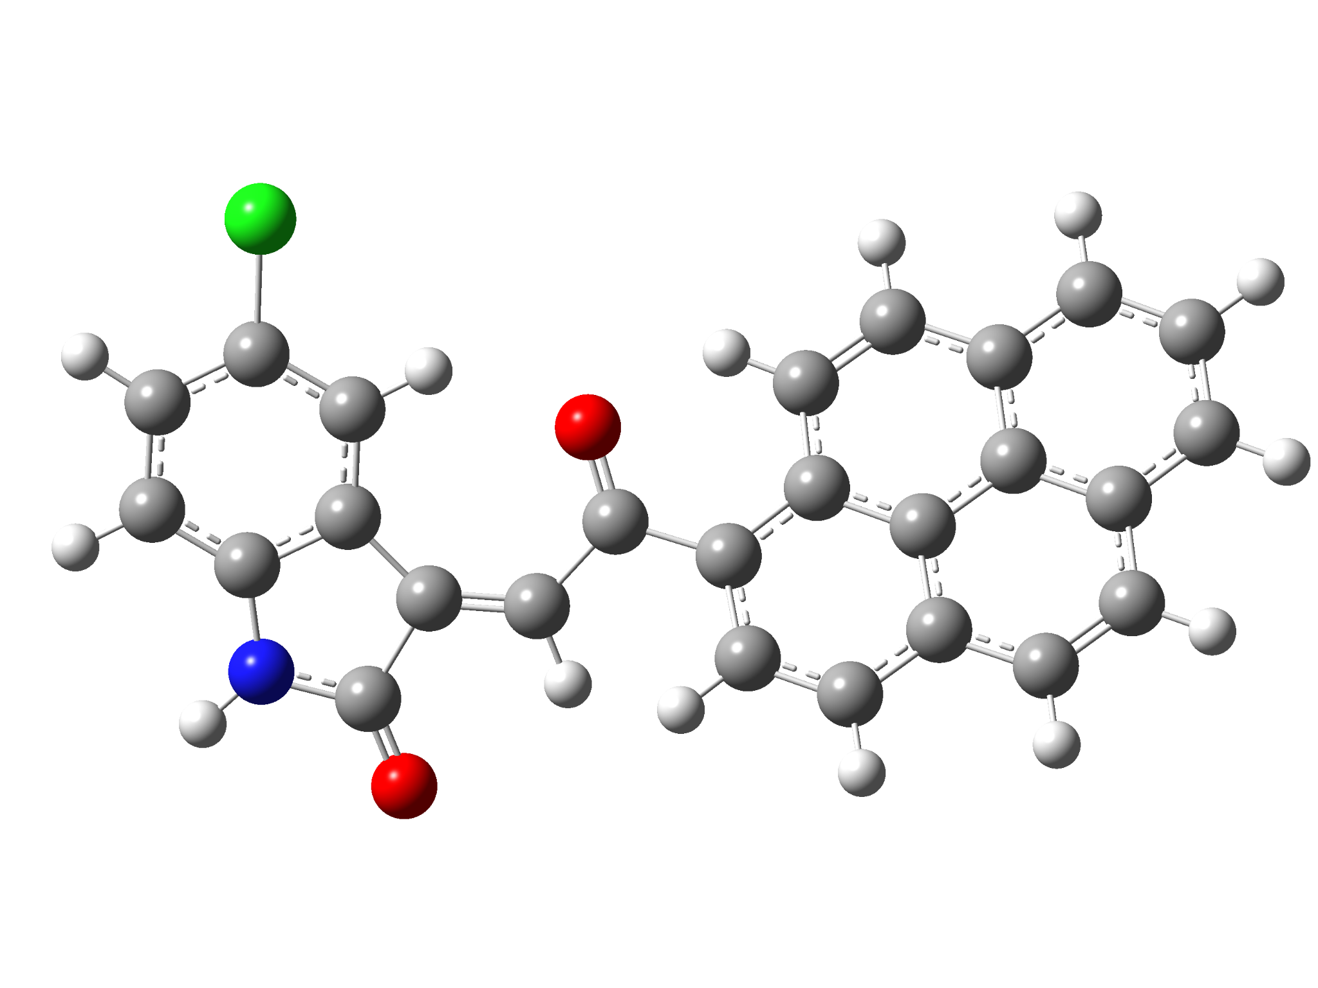

4c
Standard orientation:
---------------------------------------------------------------------
Center Atomic Atomic Coordinates (Angstroms)
Number Number Type X Y Z
---------------------------------------------------------------------
1 6 0 -2.879745 -1.309080 -0.366771
2 6 0 -1.529926 -1.406056 -0.302967
3 6 0 -0.545220 -0.346028 0.030146
4 8 0 -0.889990 0.835957 0.121465
5 6 0 5.393736 2.504183 -0.935053
6 6 0 4.264872 1.713346 -0.654527
7 6 0 4.442085 0.415188 -0.090253
8 6 0 5.763836 -0.059209 0.178671
9 6 0 6.863259 0.765097 -0.116298
10 6 0 6.678460 2.033495 -0.667933
11 6 0 3.305748 -0.403364 0.201273
12 6 0 3.510752 -1.703884 0.760153
13 6 0 4.848673 -2.154765 1.023501
14 6 0 5.926879 -1.368887 0.745689
15 6 0 2.929384 2.160927 -0.918719
16 6 0 1.840492 1.389333 -0.634445
17 6 0 1.979063 0.076564 -0.058916
18 6 0 0.872402 -0.778495 0.225933
19 6 0 1.112810 -2.059971 0.756789
20 6 0 2.394436 -2.511311 1.033390
21 6 0 -3.898091 -0.285086 -0.122971
22 6 0 -5.160872 -0.892238 -0.344007
23 7 0 -4.982755 -2.227584 -0.718435
24 6 0 -3.842111 1.060389 0.256333
25 6 0 -5.044410 1.754511 0.413564
26 6 0 -6.283481 1.148712 0.196583
27 6 0 -6.351014 -0.196343 -0.189831
28 6 0 -3.645022 -2.568185 -0.761945
29 8 0 -3.192311 -3.662745 -1.053862
30 1 0 -1.141329 -2.385625 -0.567317
31 1 0 5.252756 3.492359 -1.364697
32 1 0 7.866378 0.402329 0.091563
33 1 0 7.539719 2.656641 -0.889697
34 1 0 4.983721 -3.144636 1.450808
35 1 0 6.933536 -1.724242 0.949596
36 1 0 2.791154 3.146713 -1.355337
37 1 0 0.846970 1.768299 -0.826603
38 1 0 0.274576 -2.706873 0.992328
39 1 0 2.541472 -3.497981 1.463425
40 1 0 -5.717418 -2.884461 -0.936632
41 1 0 -2.886430 1.541314 0.411070
42 1 0 -7.194268 1.723136 0.325067
43 1 0 -7.312094 -0.670535 -0.361626
44 17 0 -4.995472 3.448112 0.891879
---------------------------------------------------------------------

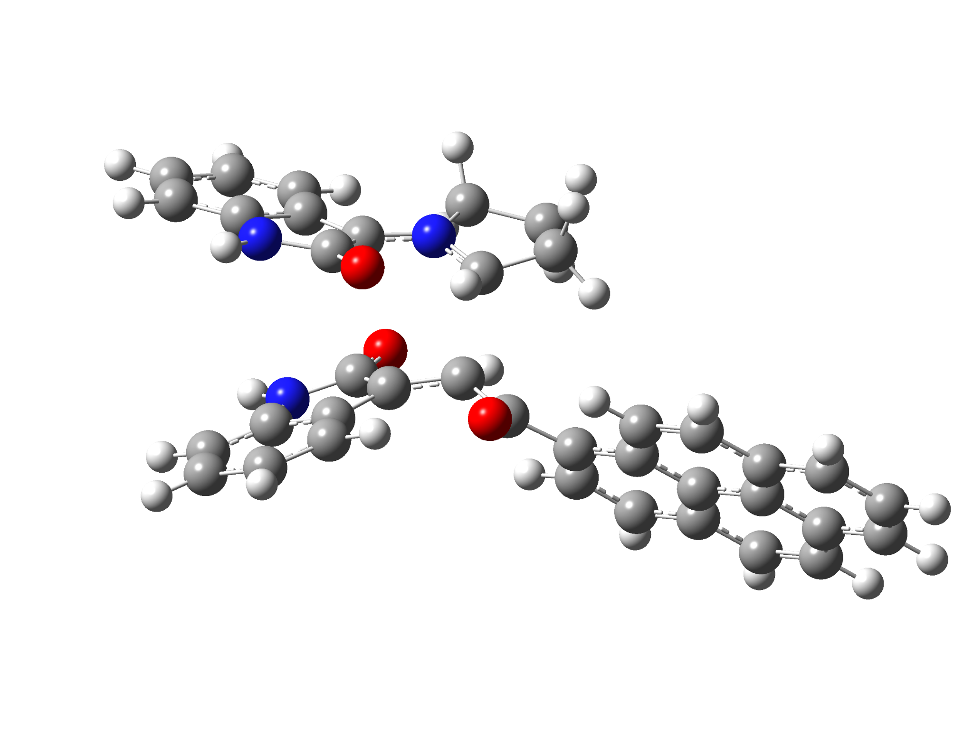

5a-exo-TS
Standard orientation:
---------------------------------------------------------------------
Center Atomic Atomic Coordinates (Angstroms)
Number Number Type X Y Z
---------------------------------------------------------------------
1 6 0 -5.343566 -0.441259 -0.965686
2 6 0 -6.687917 -0.419708 -0.617874
3 6 0 -7.157130 -1.406714 0.259223
4 6 0 -6.289747 -2.378015 0.772949
5 6 0 -4.934910 -2.390331 0.424774
6 6 0 -4.438496 -1.419102 -0.458979
7 6 0 -3.136261 -1.081545 -0.997866
8 7 0 -4.652350 0.415603 -1.813219
9 6 0 -1.613038 0.626426 0.761200
10 6 0 -0.408720 -0.022277 0.433977
11 6 0 -0.759979 -1.250706 -1.263623
12 7 0 -1.973788 -1.783894 -0.958650
13 6 0 -3.309212 0.076140 -1.908961
14 8 0 -2.494801 0.634606 -2.643739
15 6 0 0.807789 0.689054 -0.068825
16 8 0 0.740387 1.513837 -0.978696
17 6 0 7.114504 0.352533 -2.185120
18 6 0 5.873083 0.358010 -1.524444
19 6 0 5.818817 0.045877 -0.133199
20 6 0 7.027516 -0.266742 0.564221
21 6 0 8.246235 -0.259732 -0.135714
22 6 0 8.287533 0.046426 -1.496432
23 6 0 4.564628 0.045646 0.555648
24 6 0 4.536407 -0.274114 1.949380
25 6 0 5.766236 -0.579999 2.626722
26 6 0 6.957437 -0.577282 1.965385
27 6 0 4.645844 0.667266 -2.198279
28 6 0 3.447906 0.677638 -1.546024
29 6 0 3.352668 0.369112 -0.141273
30 6 0 2.119117 0.332455 0.573726
31 6 0 2.126486 -0.000899 1.940093
32 6 0 3.303213 -0.283345 2.620132
33 6 0 -2.186349 1.937351 0.501711
34 6 0 -3.330317 2.064479 1.339912
35 7 0 -3.476681 0.893733 2.086378
36 6 0 -1.862796 2.992220 -0.362891
37 6 0 -2.654329 4.147347 -0.353997
38 6 0 -3.764100 4.255480 0.491861
39 6 0 -4.120772 3.205160 1.351741
40 6 0 -2.485787 -0.023953 1.782456
41 8 0 -2.364861 -1.138895 2.299026
42 6 0 0.263144 -2.356606 -1.305083
43 6 0 -1.854025 -3.139870 -0.356006
44 6 0 -0.341111 -3.433182 -0.375982
45 1 0 -0.754172 -0.407587 -1.944689
46 1 0 0.364331 -2.721991 -2.336551
47 1 0 -0.212275 -0.863550 1.092619
48 1 0 1.254933 -2.027903 -0.984929
49 1 0 -7.355529 0.337720 -1.017829
50 1 0 -8.206003 -1.415574 0.540195
51 1 0 -6.669034 -3.132923 1.454640
52 1 0 -4.288491 -3.143565 0.854664
53 1 0 -5.032929 1.218211 -2.291764
54 1 0 7.150132 0.592263 -3.244516
55 1 0 9.163244 -0.495530 0.397796
56 1 0 9.238442 0.047507 -2.021018
57 1 0 5.724889 -0.816488 3.686559
58 1 0 7.879334 -0.811604 2.491226
59 1 0 4.683810 0.905177 -3.258295
60 1 0 2.546074 0.943841 -2.079279
61 1 0 1.191905 -0.007179 2.490818
62 1 0 3.274149 -0.515041 3.681230
63 1 0 -4.232889 0.683628 2.720494
64 1 0 -1.017675 2.898799 -1.031533
65 1 0 -2.404536 4.967643 -1.020076
66 1 0 -4.363861 5.161213 0.483240
67 1 0 -4.985574 3.284231 2.004252
68 1 0 -2.250072 -3.117397 0.658389
69 1 0 -2.440499 -3.834388 -0.966336
70 1 0 -0.130530 -4.448324 -0.720197
71 1 0 0.066753 -3.335116 0.633494
---------------------------------------------------------------------

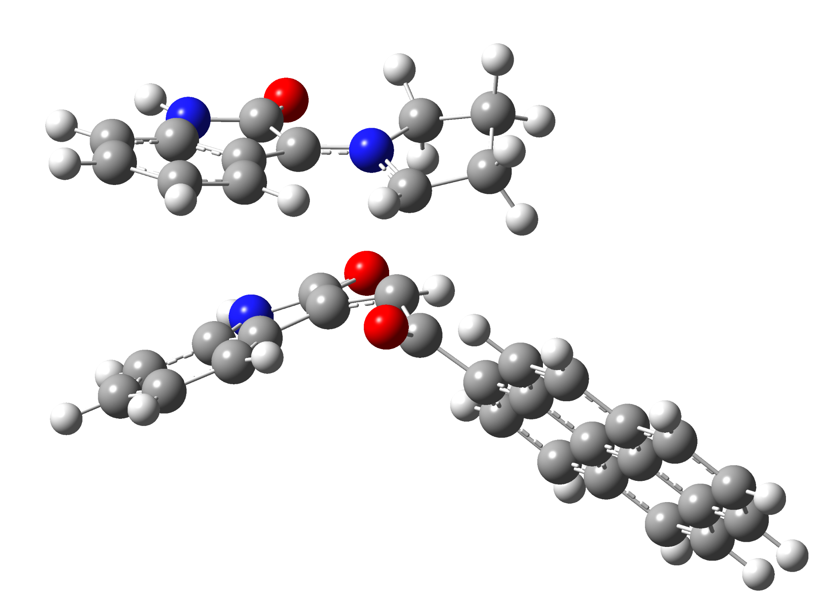

5a-endo-TS
Standard orientation:
---------------------------------------------------------------------
Center Atomic Atomic Coordinates (Angstroms)
Number Number Type X Y Z
---------------------------------------------------------------------
1 6 0 5.108467 -0.270986 -1.190133
2 6 0 5.810544 -1.396876 -1.594418
3 6 0 5.122110 -2.375157 -2.325086
4 6 0 3.765506 -2.218609 -2.622973
5 6 0 3.058521 -1.089105 -2.194353
6 6 0 3.727561 -0.081978 -1.481734
7 6 0 3.372421 1.220154 -0.946550
8 7 0 5.579684 0.840976 -0.498302
9 6 0 1.614340 0.072157 1.160730
10 6 0 0.487171 0.592419 0.500129
11 6 0 1.006982 1.417944 -1.358105
12 7 0 2.242308 1.943975 -1.133820
13 6 0 4.602753 1.819172 -0.362380
14 8 0 4.783726 2.925460 0.141793
15 6 0 -0.633358 -0.284320 0.020667
16 8 0 -0.420689 -1.180381 -0.799818
17 6 0 -6.850214 -1.111918 -2.244453
18 6 0 -5.643531 -0.851185 -1.570700
19 6 0 -5.680131 -0.310232 -0.251128
20 6 0 -6.943747 -0.042550 0.362510
21 6 0 -8.124938 -0.318842 -0.347162
22 6 0 -8.077165 -0.847643 -1.637579
23 6 0 -4.462410 -0.037993 0.449386
24 6 0 -4.527810 0.508261 1.769688
25 6 0 -5.810450 0.764138 2.364035
26 6 0 -6.966212 0.501558 1.691916
27 6 0 -4.363313 -1.107944 -2.161650
28 6 0 -3.198580 -0.858920 -1.496204
29 6 0 -3.193934 -0.315573 -0.161790
30 6 0 -2.001965 -0.007875 0.561519
31 6 0 -2.104941 0.542994 1.852806
32 6 0 -3.332248 0.784196 2.452278
33 6 0 2.188912 -1.250169 1.328169
34 6 0 3.213417 -1.140521 2.312311
35 7 0 3.290389 0.183969 2.739604
36 6 0 1.940311 -2.505446 0.754677
37 6 0 2.686049 -3.611638 1.176592
38 6 0 3.684184 -3.478222 2.148472
39 6 0 3.963023 -2.232151 2.729092
40 6 0 2.337052 0.972491 2.108080
41 8 0 2.125575 2.160871 2.348167
42 6 0 0.019481 2.527600 -1.664779
43 6 0 2.136507 3.403773 -0.812982
44 6 0 0.869863 3.819015 -1.571058
45 1 0 0.945561 0.460866 -1.854908
46 1 0 -0.428187 2.398435 -2.655684
47 1 0 0.184107 1.550529 0.916444
48 1 0 -0.807456 2.531426 -0.945768
49 1 0 6.864314 -1.512565 -1.358480
50 1 0 5.649639 -3.265362 -2.653945
51 1 0 3.241491 -2.992001 -3.175716
52 1 0 1.999351 -1.027788 -2.408708
53 1 0 6.534078 1.003322 -0.214468
54 1 0 -6.815768 -1.524845 -3.249131
55 1 0 -9.083392 -0.115881 0.123215
56 1 0 -9.000206 -1.055037 -2.170779
57 1 0 -5.838673 1.176301 3.369037
58 1 0 -7.929267 0.701528 2.154279
59 1 0 -4.331543 -1.518219 -3.167858
60 1 0 -2.251434 -1.089905 -1.962107
61 1 0 -1.200897 0.759149 2.411298
62 1 0 -3.373286 1.191527 3.458540
63 1 0 3.908911 0.548309 3.448541
64 1 0 1.177467 -2.612263 -0.005746
65 1 0 2.492212 -4.584745 0.735761
66 1 0 4.255010 -4.348496 2.459270
67 1 0 4.737617 -2.127329 3.483370
68 1 0 2.051775 3.508871 0.271330
69 1 0 3.042348 3.912839 -1.134098
70 1 0 1.131775 4.169892 -2.574405
71 1 0 0.347530 4.631291 -1.059844
---------------------------------------------------------------------

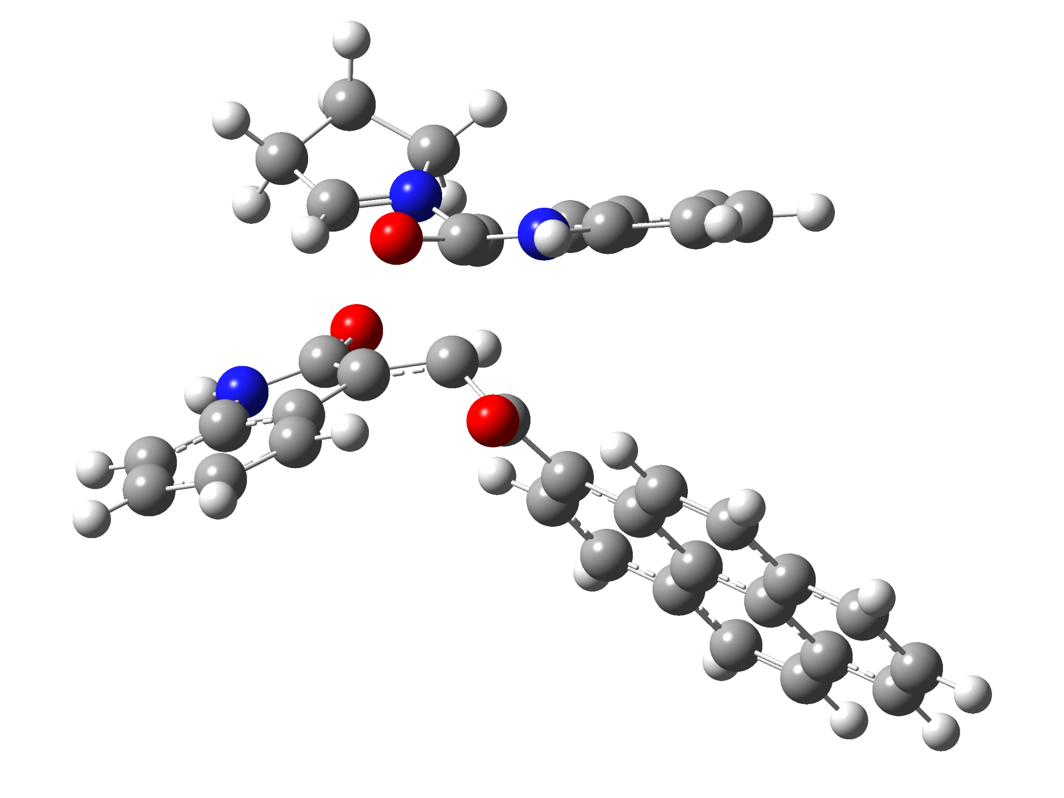

6a-exo-TS
Standard orientation:
---------------------------------------------------------------------
Center Atomic Atomic Coordinates (Angstroms)
Number Number Type X Y Z
---------------------------------------------------------------------
1 7 0 -3.225989 1.759163 -0.369929
2 6 0 -1.978060 1.727471 0.269440
3 6 0 -1.365810 -0.151485 -0.336722
4 6 0 -2.450671 -1.058224 -0.331407
5 6 0 -4.233216 0.973562 -0.029115
6 7 0 -0.977119 2.498169 2.204978
7 6 0 -0.260248 3.040201 1.138784
8 6 0 -0.877473 2.655189 -0.074892
9 6 0 0.879810 3.834955 1.170464
10 6 0 1.416790 4.260179 -0.051662
11 6 0 0.831179 3.881975 -1.263815
12 6 0 -0.309305 3.067334 -1.282171
13 6 0 -2.047057 1.732809 1.778816
14 8 0 -2.900166 1.234945 2.503048
15 6 0 -0.125608 -0.441514 0.473841
16 8 0 -0.167303 -0.459711 1.701799
17 6 0 1.133581 -0.734960 -0.288849
18 6 0 2.433838 -0.546246 0.270232
19 6 0 3.582918 -0.876874 -0.524044
20 6 0 3.425458 -1.412228 -1.840616
21 6 0 2.130028 -1.597571 -2.347744
22 6 0 1.018738 -1.254589 -1.591834
23 6 0 4.903632 -0.682580 -0.007787
24 6 0 6.047462 -1.019512 -0.797507
25 6 0 5.845520 -1.557390 -2.114322
26 6 0 4.591112 -1.745684 -2.611437
27 6 0 2.665479 -0.009689 1.587403
28 6 0 3.926866 0.177726 2.071471
29 6 0 5.090889 -0.150823 1.302731
30 6 0 6.395653 0.033130 1.794368
31 6 0 7.504224 -0.297550 1.016299
32 6 0 7.333286 -0.819079 -0.266590
33 7 0 -4.021189 -2.375904 -1.360089
34 6 0 -3.868653 -2.872217 -0.061740
35 6 0 -2.911154 -2.073043 0.617378
36 6 0 -3.181054 -1.292910 -1.592429
37 8 0 -3.101211 -0.692061 -2.676314
38 6 0 -4.516112 -3.941763 0.544360
39 6 0 -4.198272 -4.225032 1.880174
40 6 0 -3.268428 -3.442452 2.574920
41 6 0 -2.626594 -2.361767 1.957273
42 6 0 -3.466591 2.417503 -1.686642
43 6 0 -5.383406 1.104189 -0.975012
44 6 0 -4.991957 2.325974 -1.839186
45 1 0 -4.217735 0.456344 0.918834
46 1 0 -1.153645 0.205305 -1.341724
47 1 0 -0.741012 2.581304 3.182746
48 1 0 1.341249 4.117376 2.111935
49 1 0 2.305697 4.883632 -0.053453
50 1 0 1.269425 4.209593 -2.201190
51 1 0 -0.729925 2.758465 -2.233386
52 1 0 2.000172 -2.013480 -3.343025
53 1 0 0.034885 -1.422032 -2.015260
54 1 0 6.718141 -1.813485 -2.709573
55 1 0 4.448677 -2.153846 -3.608461
56 1 0 1.809947 0.226514 2.202698
57 1 0 4.065882 0.583118 3.070702
58 1 0 6.531225 0.437023 2.794240
59 1 0 8.505409 -0.150310 1.410587
60 1 0 8.199724 -1.078099 -0.869425
61 1 0 -4.573397 -2.794952 -2.093411
62 1 0 -5.244168 -4.539554 0.002893
63 1 0 -4.687041 -5.056614 2.379460
64 1 0 -3.045596 -3.669237 3.613295
65 1 0 -1.924825 -1.746819 2.506803
66 1 0 -3.082505 3.437707 -1.656711
67 1 0 -2.946536 1.838402 -2.454686
68 1 0 -6.334356 1.229398 -0.447542
69 1 0 -5.463561 0.192338 -1.581537
70 1 0 -5.282975 2.212086 -2.885137
71 1 0 -5.464390 3.232360 -1.447242
---------------------------------------------------------------------

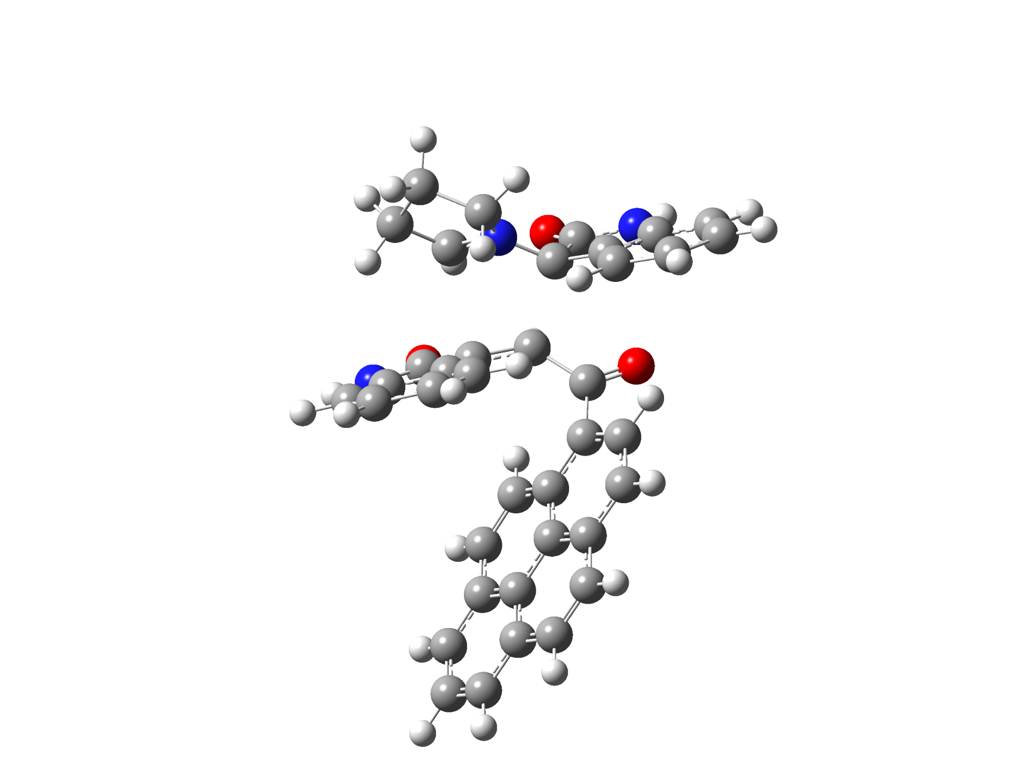

6a-endo-TS
Standard orientation:
---------------------------------------------------------------------
Center Atomic Atomic Coordinates (Angstroms)
Number Number Type X Y Z
---------------------------------------------------------------------
1 7 0 -3.366714 -1.107810 0.220938
2 6 0 -3.120045 0.098493 -0.465136
3 6 0 -1.197847 -0.214329 -1.125271
4 6 0 -0.649389 -1.358672 -0.476063
5 6 0 -3.043406 -2.283471 -0.297582
6 7 0 -4.354973 1.489851 -1.860246
7 6 0 -4.076088 2.219685 -0.705521
8 6 0 -3.376547 1.397815 0.205446
9 6 0 -4.413564 3.535229 -0.411070
10 6 0 -4.043210 4.040971 0.840948
11 6 0 -3.348724 3.247582 1.760084
12 6 0 -3.002584 1.927466 1.440780
13 6 0 -3.858100 0.204691 -1.795081
14 8 0 -4.017925 -0.670608 -2.633175
15 6 0 -0.605237 1.175653 -1.137925
16 8 0 -1.213069 2.074799 -1.709647
17 6 0 0.716206 1.495242 -0.490472
18 6 0 1.931458 0.845378 -0.816018
19 6 0 3.127160 1.238207 -0.130919
20 6 0 3.087674 2.275177 0.851900
21 6 0 1.869602 2.928944 1.102313
22 6 0 0.713630 2.555739 0.427771
23 6 0 4.371460 0.600503 -0.430564
24 6 0 5.560455 0.975557 0.269279
25 6 0 5.479020 2.009308 1.264751
26 6 0 4.298630 2.632812 1.538751
27 6 0 2.040941 -0.151691 -1.850224
28 6 0 3.230911 -0.749156 -2.141185
29 6 0 4.435225 -0.411275 -1.436076
30 6 0 5.667636 -1.027544 -1.714157
31 6 0 6.820649 -0.662404 -1.019000
32 6 0 6.769974 0.328487 -0.038254
33 7 0 0.223041 -3.479145 -0.327846
34 6 0 0.449026 -2.868895 0.901871
35 6 0 -0.074049 -1.546745 0.848005
36 6 0 -0.408530 -2.607693 -1.224766
37 8 0 -0.673705 -2.892821 -2.395622
38 6 0 1.057652 -3.383021 2.042873
39 6 0 1.153831 -2.553981 3.168715
40 6 0 0.648940 -1.247456 3.140711
41 6 0 0.036100 -0.740960 1.988281
42 6 0 -3.669315 -1.220597 1.676118
43 6 0 -3.253918 -3.396692 0.677457
44 6 0 -4.016546 -2.708845 1.834359
45 1 0 -2.887587 -2.390818 -1.362957
46 1 0 -1.488865 -0.468492 -2.147800
47 1 0 -4.785224 1.852524 -2.698460
48 1 0 -4.944510 4.153070 -1.128673
49 1 0 -4.296446 5.065473 1.096582
50 1 0 -3.066804 3.657631 2.724868
51 1 0 -2.440772 1.335258 2.155352
52 1 0 1.838493 3.737307 1.828220
53 1 0 -0.219529 3.076440 0.618078
54 1 0 6.385726 2.291256 1.793800
55 1 0 4.253052 3.419976 2.286877
56 1 0 1.161833 -0.426520 -2.420897
57 1 0 3.281704 -1.495682 -2.929319
58 1 0 5.713439 -1.794703 -2.482611
59 1 0 7.764558 -1.149810 -1.245258
60 1 0 7.672209 0.611669 0.497582
61 1 0 0.583681 -4.374864 -0.621349
62 1 0 1.455306 -4.393942 2.059072
63 1 0 1.632061 -2.929512 4.068435
64 1 0 0.745843 -0.614334 4.017768
65 1 0 -0.321761 0.282992 1.975112
66 1 0 -2.779670 -0.948373 2.248976
67 1 0 -4.483277 -0.541579 1.932956
68 1 0 -2.276688 -3.784474 0.998942
69 1 0 -3.798721 -4.234331 0.231675
70 1 0 -5.093964 -2.857031 1.711976
71 1 0 -3.730461 -3.087444 2.817918
---------------------------------------------------------------------

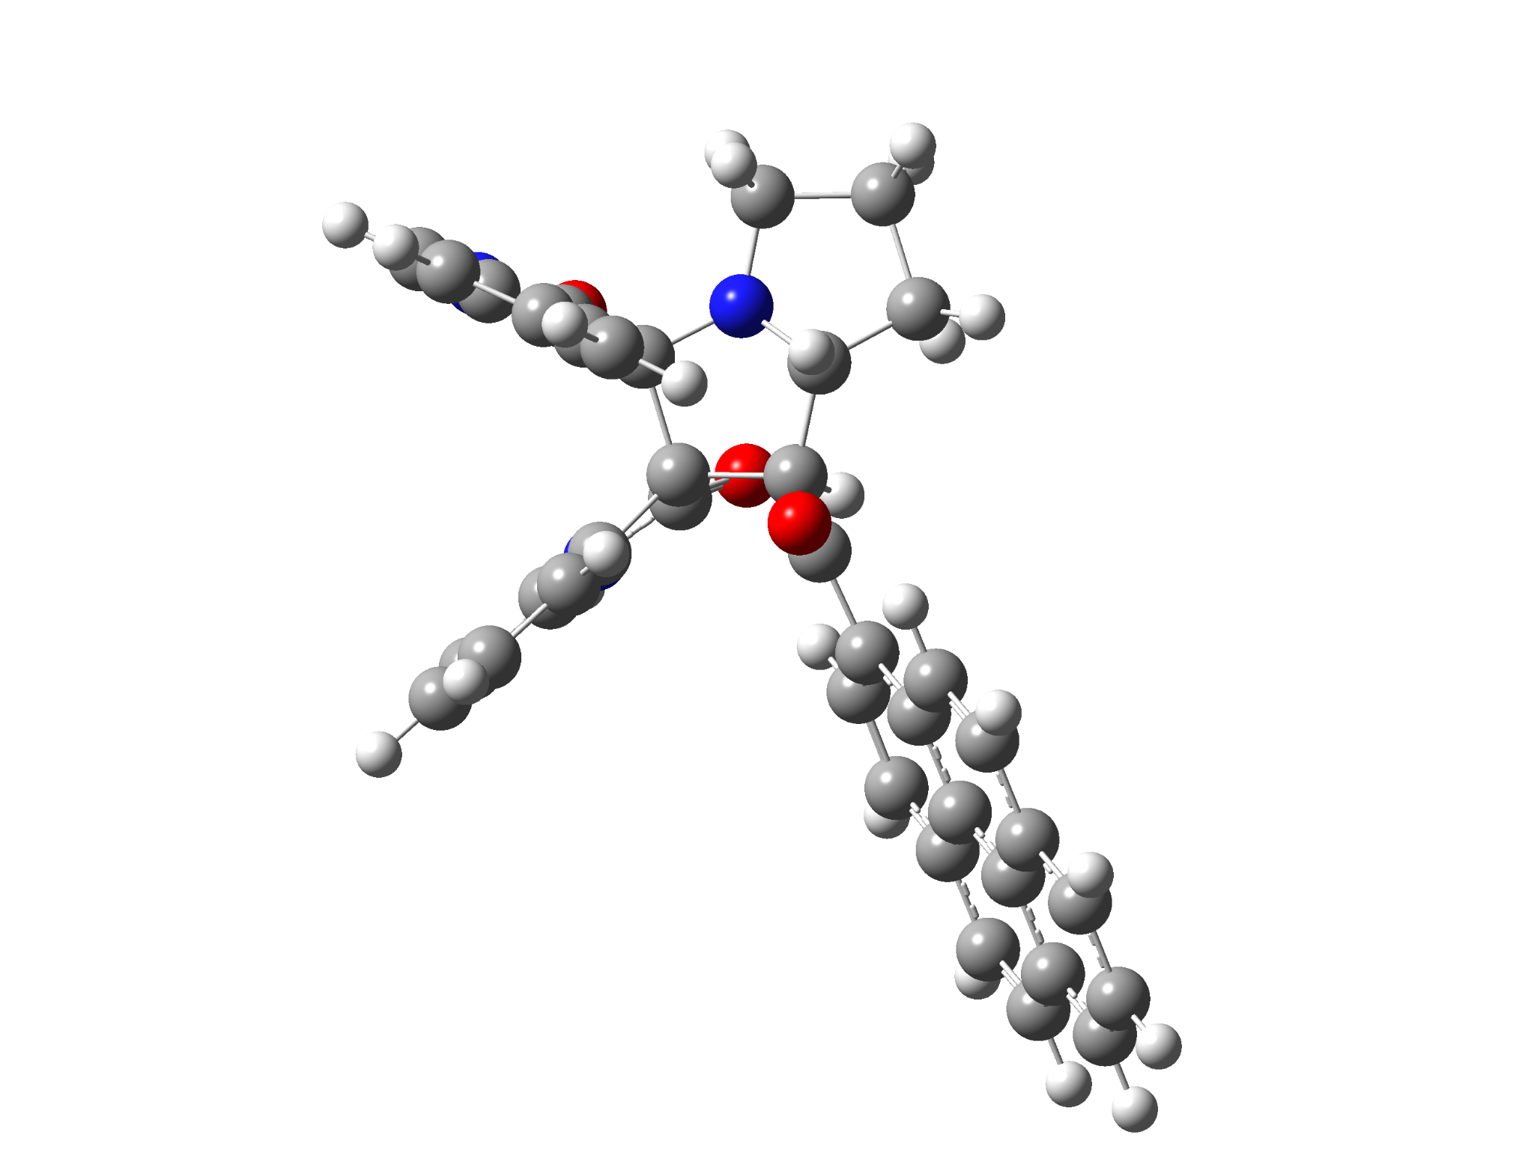

5a-1’R
Standard orientation:
---------------------------------------------------------------------
Center Atomic Atomic Coordinates (Angstroms)
Number Number Type X Y Z
---------------------------------------------------------------------
1 6 0 4.834408 0.494968 -1.241835
2 6 0 5.453711 1.025282 -2.367596
3 6 0 4.781988 2.040326 -3.061365
4 6 0 3.534657 2.494360 -2.627898
5 6 0 2.924657 1.937915 -1.491915
6 6 0 3.575746 0.925654 -0.790248
7 6 0 3.229484 0.178031 0.508284
8 7 0 5.327471 -0.496350 -0.382467
9 6 0 1.846131 -0.657218 0.500021
10 6 0 0.808443 0.332410 1.193913
11 6 0 1.664372 1.542021 1.630561
12 7 0 3.007098 0.990526 1.678381
13 6 0 4.501916 -0.726343 0.693478
14 8 0 4.745595 -1.481924 1.614489
15 6 0 -0.392351 0.737222 0.329064
16 8 0 -0.242980 1.633180 -0.502282
17 6 0 -6.744044 2.120912 -1.191648
18 6 0 -5.493024 1.629635 -0.776283
19 6 0 -5.413121 0.349840 -0.152116
20 6 0 -6.609086 -0.410195 0.041162
21 6 0 -7.837708 0.117996 -0.390431
22 6 0 -7.903456 1.371450 -1.000493
23 6 0 -4.148225 -0.164845 0.276665
24 6 0 -4.102969 -1.447539 0.907954
25 6 0 -5.318321 -2.191460 1.088523
26 6 0 -6.517888 -1.696539 0.673764
27 6 0 -4.280861 2.371739 -0.950750
28 6 0 -3.070153 1.883634 -0.552429
29 6 0 -2.944817 0.591989 0.073704
30 6 0 -1.701932 0.046783 0.529688
31 6 0 -1.705946 -1.208334 1.168687
32 6 0 -2.866035 -1.946172 1.344114
33 6 0 1.555751 -1.331745 -0.835841
34 6 0 1.776629 -2.716852 -0.699053
35 7 0 2.087856 -3.014718 0.632559
36 6 0 1.182440 -0.834633 -2.081650
37 6 0 1.042677 -1.714872 -3.165814
38 6 0 1.284999 -3.080905 -3.008619
39 6 0 1.657274 -3.603786 -1.763507
40 6 0 1.969042 -1.907404 1.446405
41 8 0 1.874369 -1.932528 2.657154
42 6 0 1.543259 2.157412 3.029990
43 6 0 3.893432 2.008195 2.216496
44 6 0 2.991658 2.678114 3.300597
45 1 0 1.565260 2.342740 0.879033
46 1 0 0.796034 2.954932 3.080948
47 1 0 0.473430 -0.166607 2.102557
48 1 0 1.274645 1.381638 3.753407
49 1 0 6.425607 0.669129 -2.696659
50 1 0 5.240365 2.475296 -3.944702
51 1 0 3.023949 3.279639 -3.176786
52 1 0 1.939446 2.276381 -1.192603
53 1 0 6.232927 -0.938327 -0.456135
54 1 0 -6.796712 3.097227 -1.666093
55 1 0 -8.743483 -0.464211 -0.243079
56 1 0 -8.861892 1.763934 -1.327051
57 1 0 -5.259098 -3.164324 1.568808
58 1 0 -7.429813 -2.270074 0.817650
59 1 0 -4.337400 3.352277 -1.416803
60 1 0 -2.175483 2.465208 -0.715511
61 1 0 -0.777762 -1.635031 1.527068
62 1 0 -2.821375 -2.917696 1.827982
63 1 0 2.136172 -3.944734 1.024113
64 1 0 0.985376 0.220243 -2.219795
65 1 0 0.743261 -1.325146 -4.133580
66 1 0 1.178778 -3.750841 -3.856919
67 1 0 1.837092 -4.666660 -1.632040
68 1 0 4.796836 1.553735 2.635494
69 1 0 4.197702 2.749234 1.456033
70 1 0 3.047490 3.767925 3.221978
71 1 0 3.319379 2.405806 4.307021
---------------------------------------------------------------------

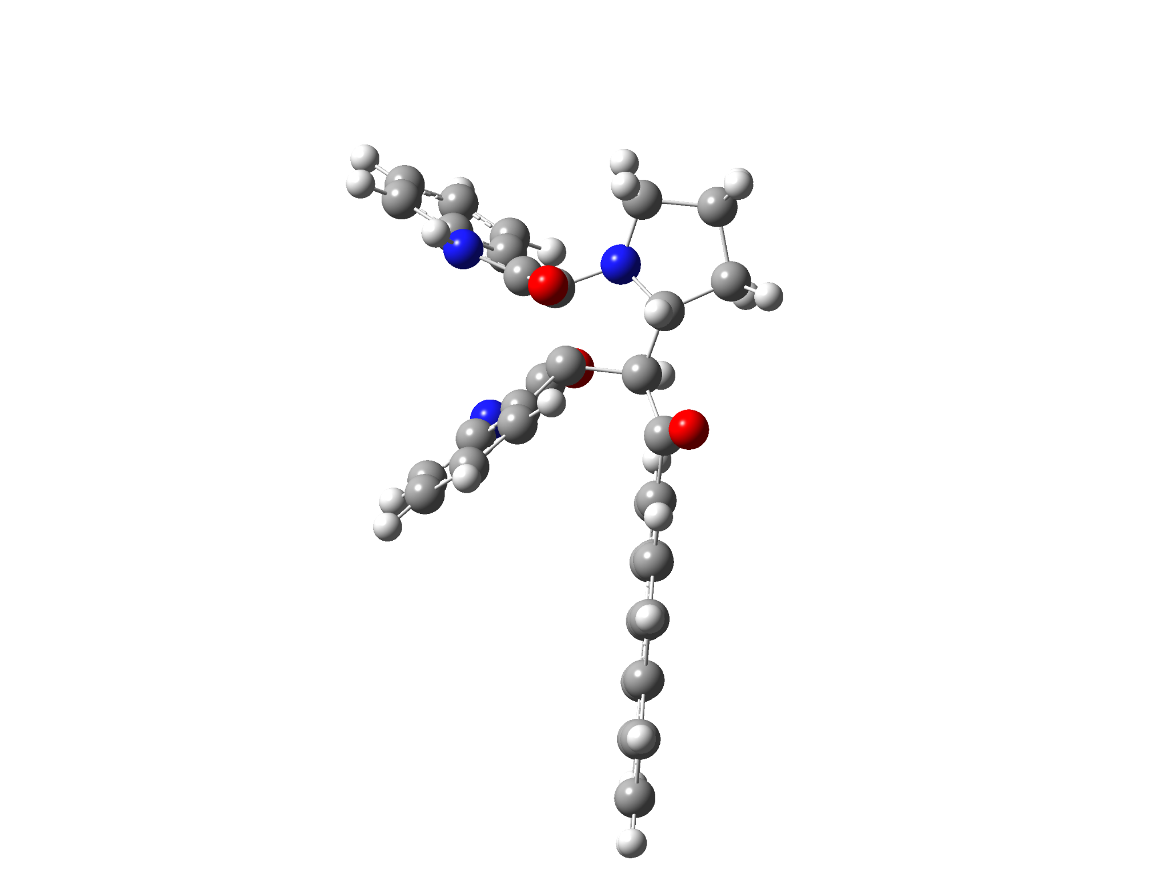

5a-1’S
Standard orientation:
---------------------------------------------------------------------
Center Atomic Atomic Coordinates (Angstroms)
Number Number Type X Y Z
---------------------------------------------------------------------
1 6 0 -4.771641 -1.353004 0.747795
2 6 0 -5.765307 -2.308814 0.570884
3 6 0 -6.205999 -2.550741 -0.737991
4 6 0 -5.672529 -1.843658 -1.818912
5 6 0 -4.664392 -0.887629 -1.618315
6 6 0 -4.196073 -0.659393 -0.329210
7 6 0 -3.152868 0.317593 0.197672
8 7 0 -4.226540 -0.882016 1.953462
9 6 0 -1.590685 0.021574 -0.198538
10 6 0 -1.020613 1.462418 -0.531561
11 6 0 -2.086078 2.423728 -0.001584
12 7 0 -3.307341 1.669909 -0.276922
13 6 0 -3.366714 0.174244 1.751626
14 8 0 -2.917895 0.892184 2.630033
15 6 0 0.397961 1.754306 -0.023105
16 8 0 0.544665 2.566050 0.884903
17 6 0 6.591673 0.238877 1.919274
18 6 0 5.346044 0.452543 1.301603
19 6 0 5.153128 0.039074 -0.049775
20 6 0 6.231011 -0.586095 -0.751797
21 6 0 7.458832 -0.779649 -0.096358
22 6 0 7.635955 -0.371126 1.226308
23 6 0 3.892510 0.250248 -0.694134
24 6 0 3.727943 -0.178428 -2.048830
25 6 0 4.827864 -0.801194 -2.732436
26 6 0 6.025133 -0.997164 -2.113088
27 6 0 4.248183 1.072742 1.981490
28 6 0 3.046684 1.283856 1.370885
29 6 0 2.813505 0.888209 0.005161
30 6 0 1.565158 1.068783 -0.669237
31 6 0 1.438401 0.618959 -1.996571
32 6 0 2.490229 0.021512 -2.677147
33 6 0 -0.844952 -0.857079 0.799431
34 6 0 -0.603111 -2.110169 0.208464
35 7 0 -1.077092 -2.099099 -1.112347
36 6 0 -0.392453 -0.625046 2.095759
37 6 0 0.270514 -1.652086 2.784891
38 6 0 0.478601 -2.895860 2.184523
39 6 0 0.043509 -3.143102 0.875591
40 6 0 -1.537373 -0.859288 -1.480679
41 8 0 -1.819766 -0.520455 -2.619267
42 6 0 -2.387005 3.755811 -0.693809
43 6 0 -4.438917 2.539926 0.023548
44 6 0 -3.924340 3.927182 -0.469267
45 1 0 -1.933005 2.591522 1.073466
46 1 0 -1.806007 4.582841 -0.278385
47 1 0 -1.041411 1.537224 -1.622914
48 1 0 -2.164586 3.682320 -1.764116
49 1 0 -6.197235 -2.838197 1.414988
50 1 0 -6.983319 -3.290245 -0.907400
51 1 0 -6.040919 -2.032042 -2.822559
52 1 0 -4.246518 -0.337273 -2.453014
53 1 0 -4.582065 -1.102551 2.874043
54 1 0 6.731793 0.557310 2.948877
55 1 0 8.275838 -1.253129 -0.634435
56 1 0 8.592045 -0.528350 1.716850
57 1 0 4.681690 -1.114855 -3.762592
58 1 0 6.848395 -1.469905 -2.642390
59 1 0 4.388226 1.383248 3.013867
60 1 0 2.249078 1.773319 1.909340
61 1 0 0.504808 0.752989 -2.528420
62 1 0 2.355909 -0.293546 -3.708271
63 1 0 -0.901759 -2.819936 -1.798420
64 1 0 -0.558006 0.332678 2.573859
65 1 0 0.626315 -1.472596 3.794503
66 1 0 0.992290 -3.681182 2.731219
67 1 0 0.217924 -4.102350 0.397513
68 1 0 -5.338888 2.204344 -0.501007
69 1 0 -4.661696 2.577974 1.103488
70 1 0 -4.136481 4.697773 0.277452
71 1 0 -4.422380 4.226447 -1.395592
---------------------------------------------------------------------

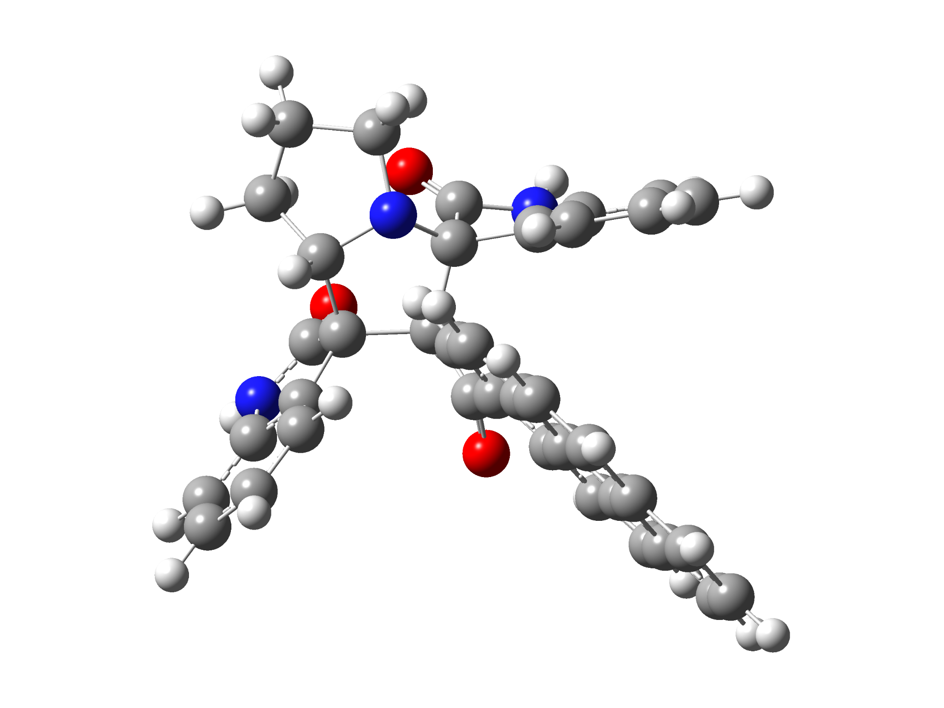

6a-2’R
Standard orientation:
---------------------------------------------------------------------
Center Atomic Atomic Coordinates (Angstroms)
Number Number Type X Y Z
---------------------------------------------------------------------
1 7 0 2.410979 -0.859063 1.403251
2 6 0 2.080043 -1.424050 0.111995
3 6 0 1.722575 -0.155198 -0.769968
4 6 0 2.606078 1.027030 -0.166328
5 6 0 3.007060 0.493890 1.256552
6 7 0 2.678703 -3.120786 -1.458442
7 6 0 1.408761 -3.458094 -0.952153
8 6 0 1.034376 -2.546912 0.054268
9 6 0 0.636151 -4.565332 -1.283995
10 6 0 -0.529947 -4.794513 -0.542015
11 6 0 -0.881374 -3.947681 0.511021
12 6 0 -0.097274 -2.823339 0.812744
13 6 0 3.271542 -2.187123 -0.614227
14 8 0 4.463260 -2.067514 -0.438593
15 6 0 0.254120 0.249869 -1.095870
16 8 0 0.106220 0.674989 -2.238668
17 6 0 -0.897011 0.205960 -0.143205
18 6 0 -2.254723 0.219322 -0.595927
19 6 0 -3.307331 0.298007 0.378843
20 6 0 -3.002562 0.372046 1.774401
21 6 0 -1.658831 0.325391 2.177024
22 6 0 -0.642873 0.227040 1.238193
23 6 0 -4.679350 0.311254 -0.029471
24 6 0 -5.724992 0.411680 0.941135
25 6 0 -5.374060 0.495348 2.331360
26 6 0 -4.071041 0.475124 2.728837
27 6 0 -2.640253 0.115656 -1.980619
28 6 0 -3.950317 0.112371 -2.361287
29 6 0 -5.017189 0.222410 -1.412101
30 6 0 -6.369992 0.237162 -1.796713
31 6 0 -7.381684 0.338643 -0.843106
32 6 0 -7.063498 0.425409 0.512720
33 7 0 3.909237 2.595450 -1.401093
34 6 0 2.871265 3.324140 -0.818993
35 6 0 2.044276 2.455607 -0.084658
36 6 0 3.804700 1.244943 -1.157142
37 8 0 4.497177 0.400148 -1.691401
38 6 0 2.660704 4.697133 -0.887776
39 6 0 1.577948 5.227871 -0.178035
40 6 0 0.759780 4.396144 0.588174
41 6 0 0.998578 3.014645 0.645504
42 6 0 3.224294 -1.639592 2.363377
43 6 0 4.484066 0.334288 1.653222
44 6 0 4.381591 -0.698943 2.791422
45 1 0 2.535198 1.157997 1.993318
46 1 0 2.093162 -0.347308 -1.777169
47 1 0 3.272304 -3.808108 -1.907231
48 1 0 0.942065 -5.245988 -2.073004
49 1 0 -1.150952 -5.654055 -0.776685
50 1 0 -1.766845 -4.156574 1.103125
51 1 0 -0.373569 -2.185756 1.641551
52 1 0 -1.417239 0.358314 3.236318
53 1 0 0.379679 0.138613 1.587374
54 1 0 -6.172581 0.572758 3.064659
55 1 0 -3.814801 0.534592 3.783248
56 1 0 -1.865880 0.050130 -2.729645
57 1 0 -4.202519 0.026085 -3.415157
58 1 0 -6.619263 0.168295 -2.852254
59 1 0 -8.421521 0.350090 -1.156064
60 1 0 -7.854250 0.504988 1.254027
61 1 0 4.557625 2.947303 -2.091338
62 1 0 3.319849 5.335992 -1.467954
63 1 0 1.383413 6.295524 -0.217563
64 1 0 -0.071443 4.815894 1.145972
65 1 0 0.351506 2.400775 1.256884
66 1 0 2.614408 -1.943874 3.222095
67 1 0 3.613458 -2.547743 1.894044
68 1 0 4.931667 1.278768 1.980146
69 1 0 5.061530 -0.072801 0.821227
70 1 0 5.314811 -1.248365 2.943584
71 1 0 4.132863 -0.201359 3.736561
---------------------------------------------------------------------

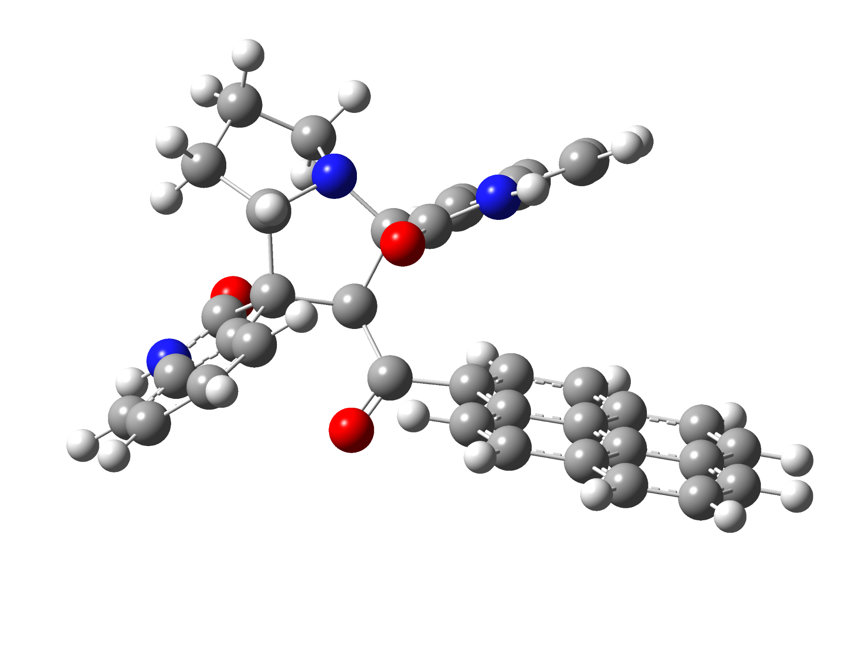

6a-2’S
Standard orientation:
---------------------------------------------------------------------
Center Atomic Atomic Coordinates (Angstroms)
Number Number Type X Y Z
---------------------------------------------------------------------
1 7 0 -3.838055 0.676557 -0.261060
2 6 0 -2.951270 -0.494006 -0.342437
3 6 0 -1.605121 -0.014549 0.295335
4 6 0 -1.541326 1.538560 0.079875
5 6 0 -3.011897 1.864800 -0.496089
6 7 0 -3.465605 -2.090886 -2.017226
7 6 0 -3.792640 -2.677821 -0.792495
8 6 0 -3.508792 -1.777476 0.248133
9 6 0 -4.306817 -3.947470 -0.551655
10 6 0 -4.531965 -4.317825 0.781019
11 6 0 -4.241388 -3.443060 1.831001
12 6 0 -3.721763 -2.166270 1.564885
13 6 0 -2.878882 -0.855252 -1.866051
14 8 0 -2.482132 -0.151431 -2.780061
15 6 0 -0.380171 -0.841324 -0.109524
16 8 0 -0.503604 -1.701284 -0.974673
17 6 0 0.921355 -0.616591 0.595567
18 6 0 2.176172 -0.845589 -0.045705
19 6 0 3.381122 -0.664688 0.710659
20 6 0 3.323093 -0.285455 2.088637
21 6 0 2.069629 -0.075517 2.682710
22 6 0 0.902401 -0.225243 1.945923
23 6 0 4.658659 -0.868705 0.099239
24 6 0 5.859422 -0.701432 0.857508
25 6 0 5.757821 -0.326005 2.240869
26 6 0 4.544883 -0.127864 2.828641
27 6 0 2.303726 -1.213823 -1.432322
28 6 0 3.524598 -1.398522 -2.011414
29 6 0 4.744137 -1.242207 -1.274850
30 6 0 6.008217 -1.439438 -1.859168
31 6 0 7.173202 -1.274499 -1.111492
32 6 0 7.101234 -0.909754 0.233621
33 7 0 -0.277096 3.156641 1.242632
34 6 0 0.244307 3.108710 -0.061430
35 6 0 -0.452958 2.135364 -0.796694
36 6 0 -1.267656 2.227253 1.437289
37 8 0 -1.817491 1.994768 2.507975
38 6 0 1.268459 3.870629 -0.609452
39 6 0 1.598337 3.638618 -1.952349
40 6 0 0.910234 2.683573 -2.704805
41 6 0 -0.127007 1.928995 -2.133460
42 6 0 -4.639811 0.914148 0.954979
43 6 0 -3.808244 3.041607 0.118415
44 6 0 -5.046735 2.380995 0.777745
45 1 0 -2.864510 1.992964 -1.569353
46 1 0 -1.748689 -0.147769 1.373360
47 1 0 -3.509949 -2.547727 -2.916755
48 1 0 -4.519579 -4.633616 -1.365864
49 1 0 -4.931825 -5.304285 0.996867
50 1 0 -4.414454 -3.750914 2.857324
51 1 0 -3.494493 -1.494948 2.387717
52 1 0 2.014233 0.204876 3.730957
53 1 0 -0.042289 -0.057625 2.449699
54 1 0 6.673562 -0.202498 2.813194
55 1 0 4.479308 0.155696 3.875679
56 1 0 1.406163 -1.356536 -2.016321
57 1 0 3.586187 -1.673166 -3.061356
58 1 0 6.067259 -1.724128 -2.906328
59 1 0 8.141593 -1.431398 -1.577379
60 1 0 8.011716 -0.784098 0.813632
61 1 0 0.094510 3.707156 2.003949
62 1 0 1.796224 4.616893 -0.022955
63 1 0 2.398227 4.213638 -2.409540
64 1 0 1.177880 2.521521 -3.744408
65 1 0 -0.672875 1.196533 -2.719076
66 1 0 -5.493966 0.233110 0.982594
67 1 0 -4.059429 0.793942 1.881740
68 1 0 -4.096241 3.758450 -0.655035
69 1 0 -3.220345 3.588928 0.858615
70 1 0 -5.314942 2.849157 1.729013
71 1 0 -5.911558 2.446051 0.109738
---------------------------------------------------------------------

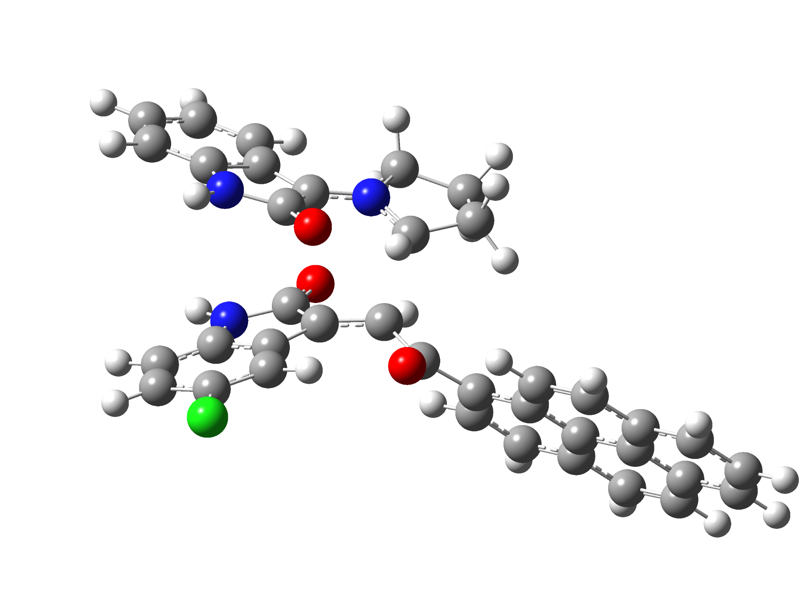

5c-exo-TS
Standard orientation:
---------------------------------------------------------------------
Center Atomic Atomic Coordinates (Angstroms)
Number Number Type X Y Z
---------------------------------------------------------------------
1 6 0 -5.188387 -0.771187 -1.021065
2 6 0 -6.535038 -0.866444 -0.695036
3 6 0 -6.967302 -2.010269 -0.010846
4 6 0 -6.062690 -3.019817 0.338937
5 6 0 -4.706190 -2.915169 0.014144
6 6 0 -4.246015 -1.784591 -0.679288
7 6 0 -2.955832 -1.305884 -1.134046
8 7 0 -4.528807 0.249721 -1.694637
9 6 0 -1.508887 0.128932 0.910307
10 6 0 -0.275702 -0.394357 0.485138
11 6 0 -0.574620 -1.333437 -1.408991
12 7 0 -1.766385 -1.956367 -1.204318
13 6 0 -3.172606 -0.013248 -1.831563
14 8 0 -2.377539 0.696275 -2.446209
15 6 0 0.903314 0.448233 0.111305
16 8 0 0.783812 1.424063 -0.627733
17 6 0 7.176035 0.796786 -2.098566
18 6 0 5.948205 0.622462 -1.435444
19 6 0 5.932916 0.047663 -0.129654
20 6 0 7.166152 -0.340604 0.481304
21 6 0 8.370071 -0.147545 -0.217637
22 6 0 8.373241 0.414975 -1.494568
23 6 0 4.693132 -0.138096 0.560115
24 6 0 4.704388 -0.719579 1.866783
25 6 0 5.958044 -1.096271 2.459261
26 6 0 7.135323 -0.916054 1.797460
27 6 0 4.697196 1.002582 -2.023569
28 6 0 3.512313 0.836738 -1.368371
29 6 0 3.456210 0.260611 -0.048462
30 6 0 2.238814 0.033836 0.659824
31 6 0 2.285845 -0.553861 1.937023
32 6 0 3.485613 -0.909879 2.537194
33 6 0 -2.146478 1.436064 0.876114
34 6 0 -3.294467 1.361361 1.714295
35 7 0 -3.384226 0.074945 2.245978
36 6 0 -1.867003 2.634698 0.206192
37 6 0 -2.720686 3.720421 0.416043
38 6 0 -3.836293 3.646497 1.252996
39 6 0 -4.136027 2.446014 1.913188
40 6 0 -2.350041 -0.728612 1.794637
41 8 0 -2.178014 -1.909691 2.109046
42 6 0 0.491774 -2.374898 -1.628971
43 6 0 -1.593111 -3.391254 -0.844303
44 6 0 -0.069824 -3.616676 -0.901089
45 1 0 -0.602503 -0.385766 -1.934138
46 1 0 0.608877 -2.555075 -2.706723
47 1 0 -0.039179 -1.328804 0.985605
48 1 0 1.469024 -2.066210 -1.249786
49 1 0 -7.232054 -0.079449 -0.967192
50 1 0 -8.016949 -2.111738 0.248057
51 1 0 -6.414273 -3.897363 0.872446
52 1 0 -4.031092 -3.705030 0.314912
53 1 0 -4.943373 1.100394 -2.045158
54 1 0 7.181855 1.236556 -3.092329
55 1 0 9.305755 -0.441472 0.250570
56 1 0 9.313178 0.557393 -2.019539
57 1 0 5.946497 -1.532354 3.454524
58 1 0 8.075715 -1.206701 2.258410
59 1 0 4.705352 1.441348 -3.018058
60 1 0 2.591084 1.162501 -1.830591
61 1 0 1.363459 -0.704752 2.487659
62 1 0 3.486320 -1.340581 3.534634
63 1 0 -4.130385 -0.277932 2.826362
64 1 0 -1.019996 2.706192 -0.461690
65 1 0 -4.469869 4.516146 1.387437
66 1 0 -5.004349 2.377483 2.561550
67 1 0 -1.992410 -3.560308 0.154745
68 1 0 -2.149797 -3.990932 -1.571749
69 1 0 0.181865 -4.549392 -1.410896
70 1 0 0.332115 -3.675681 0.113755
71 17 0 -2.383137 5.241612 -0.412798
---------------------------------------------------------------------

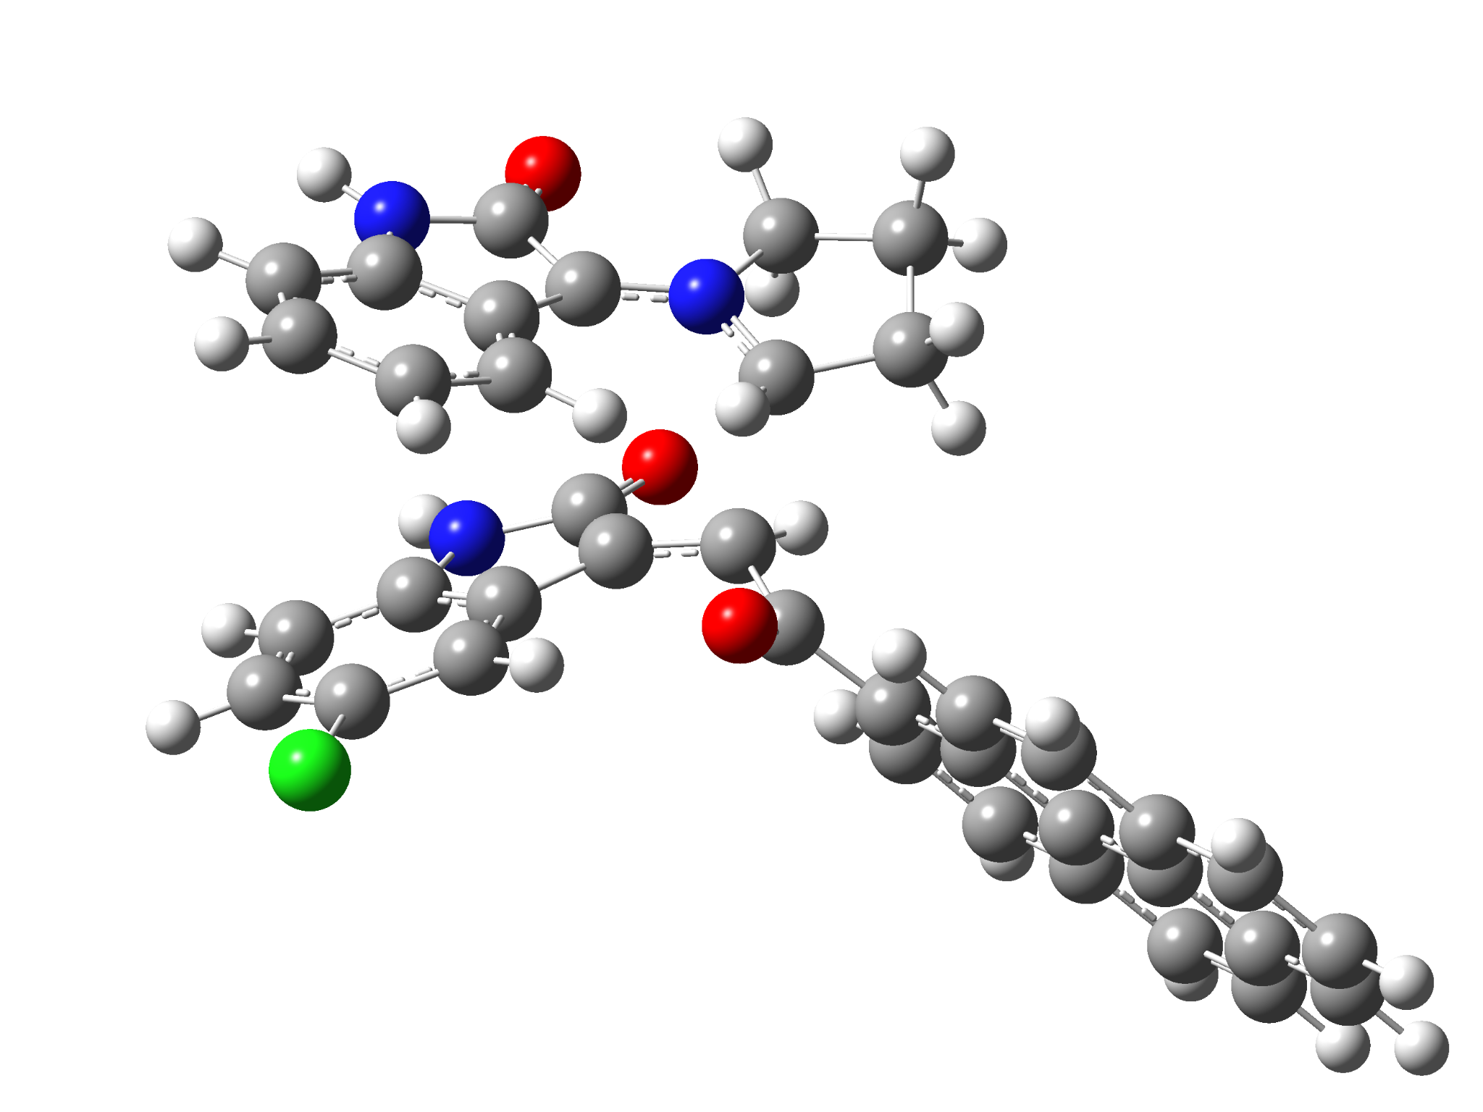

5c-endo-TS
Standard orientation:
---------------------------------------------------------------------
Center Atomic Atomic Coordinates (Angstroms)
Number Number Type X Y Z
---------------------------------------------------------------------
1 6 0 -4.963155 -0.282736 -1.243674
2 6 0 -5.705583 0.795059 -1.702725
3 6 0 -5.044721 1.778176 -2.452104
4 6 0 -3.676126 1.673606 -2.715865
5 6 0 -2.929663 0.592224 -2.233828
6 6 0 -3.569311 -0.419013 -1.499671
7 6 0 -3.167442 -1.681266 -0.904831
8 7 0 -5.399622 -1.387374 -0.516815
9 6 0 -1.486725 -0.348476 1.170943
10 6 0 -0.328401 -0.845328 0.550502
11 6 0 -0.789915 -1.794113 -1.279714
12 7 0 -2.003616 -2.359873 -1.035897
13 6 0 -4.383145 -2.311052 -0.317223
14 8 0 -4.522507 -3.400629 0.233512
15 6 0 0.752892 0.056225 0.028023
16 8 0 0.495500 0.906081 -0.828373
17 6 0 6.916353 1.104900 -2.290236
18 6 0 5.725332 0.808656 -1.603364
19 6 0 5.791266 0.309649 -0.268599
20 6 0 7.067937 0.119443 0.346780
21 6 0 8.232675 0.428863 -0.376261
22 6 0 8.156234 0.916025 -1.681616
23 6 0 4.589814 0.002534 0.445352
24 6 0 4.685173 -0.499619 1.781289
25 6 0 5.980114 -0.677746 2.377056
26 6 0 7.120181 -0.382459 1.691750
27 6 0 4.432833 0.988790 -2.195379
28 6 0 3.282906 0.706260 -1.517498
29 6 0 3.307758 0.202531 -0.168006
30 6 0 2.133577 -0.138733 0.570204
31 6 0 2.267061 -0.643936 1.877704
32 6 0 3.506109 -0.809482 2.478085
33 6 0 -2.130262 0.949693 1.257539
34 6 0 -3.167500 0.840758 2.227559
35 7 0 -3.185964 -0.459604 2.725496
36 6 0 -1.927508 2.178501 0.614683
37 6 0 -2.744484 3.254006 0.967871
38 6 0 -3.757750 3.141841 1.921845
39 6 0 -3.978419 1.915268 2.564244
40 6 0 -2.182911 -1.232333 2.151278
41 8 0 -1.920941 -2.395252 2.455772
42 6 0 0.249318 -2.872954 -1.513832
43 6 0 -1.837707 -3.796236 -0.638609
44 6 0 -0.545124 -4.193752 -1.361186
45 1 0 -0.764662 -0.861628 -1.823869
46 1 0 0.705207 -2.776578 -2.504699
47 1 0 0.011993 -1.769190 1.011954
48 1 0 1.065312 -2.801633 -0.785876
49 1 0 -6.768299 0.871567 -1.492445
50 1 0 -5.602497 2.633658 -2.820353
51 1 0 -3.174322 2.453463 -3.279413
52 1 0 -1.863911 0.573427 -2.421676
53 1 0 -6.351752 -1.580867 -0.244927
54 1 0 6.859346 1.486017 -3.306366
55 1 0 9.201034 0.284944 0.095560
56 1 0 9.066856 1.150196 -2.224925
57 1 0 6.030776 -1.057225 3.393952
58 1 0 8.092997 -0.523351 2.155420
59 1 0 4.378553 1.368323 -3.212592
60 1 0 2.324911 0.881117 -1.985420
61 1 0 1.376697 -0.883640 2.448347
62 1 0 3.569606 -1.182797 3.496271
63 1 0 -3.800400 -0.817203 3.441421
64 1 0 -1.156532 2.291416 -0.135087
65 1 0 -4.371622 4.002468 2.162768
66 1 0 -4.763780 1.819551 3.307960
67 1 0 -1.762071 -3.839946 0.450576
68 1 0 -2.716620 -4.360450 -0.941329
69 1 0 -0.779403 -4.607275 -2.347312
70 1 0 0.005458 -4.954739 -0.802984
71 17 0 -2.493822 4.809652 0.171608
---------------------------------------------------------------------

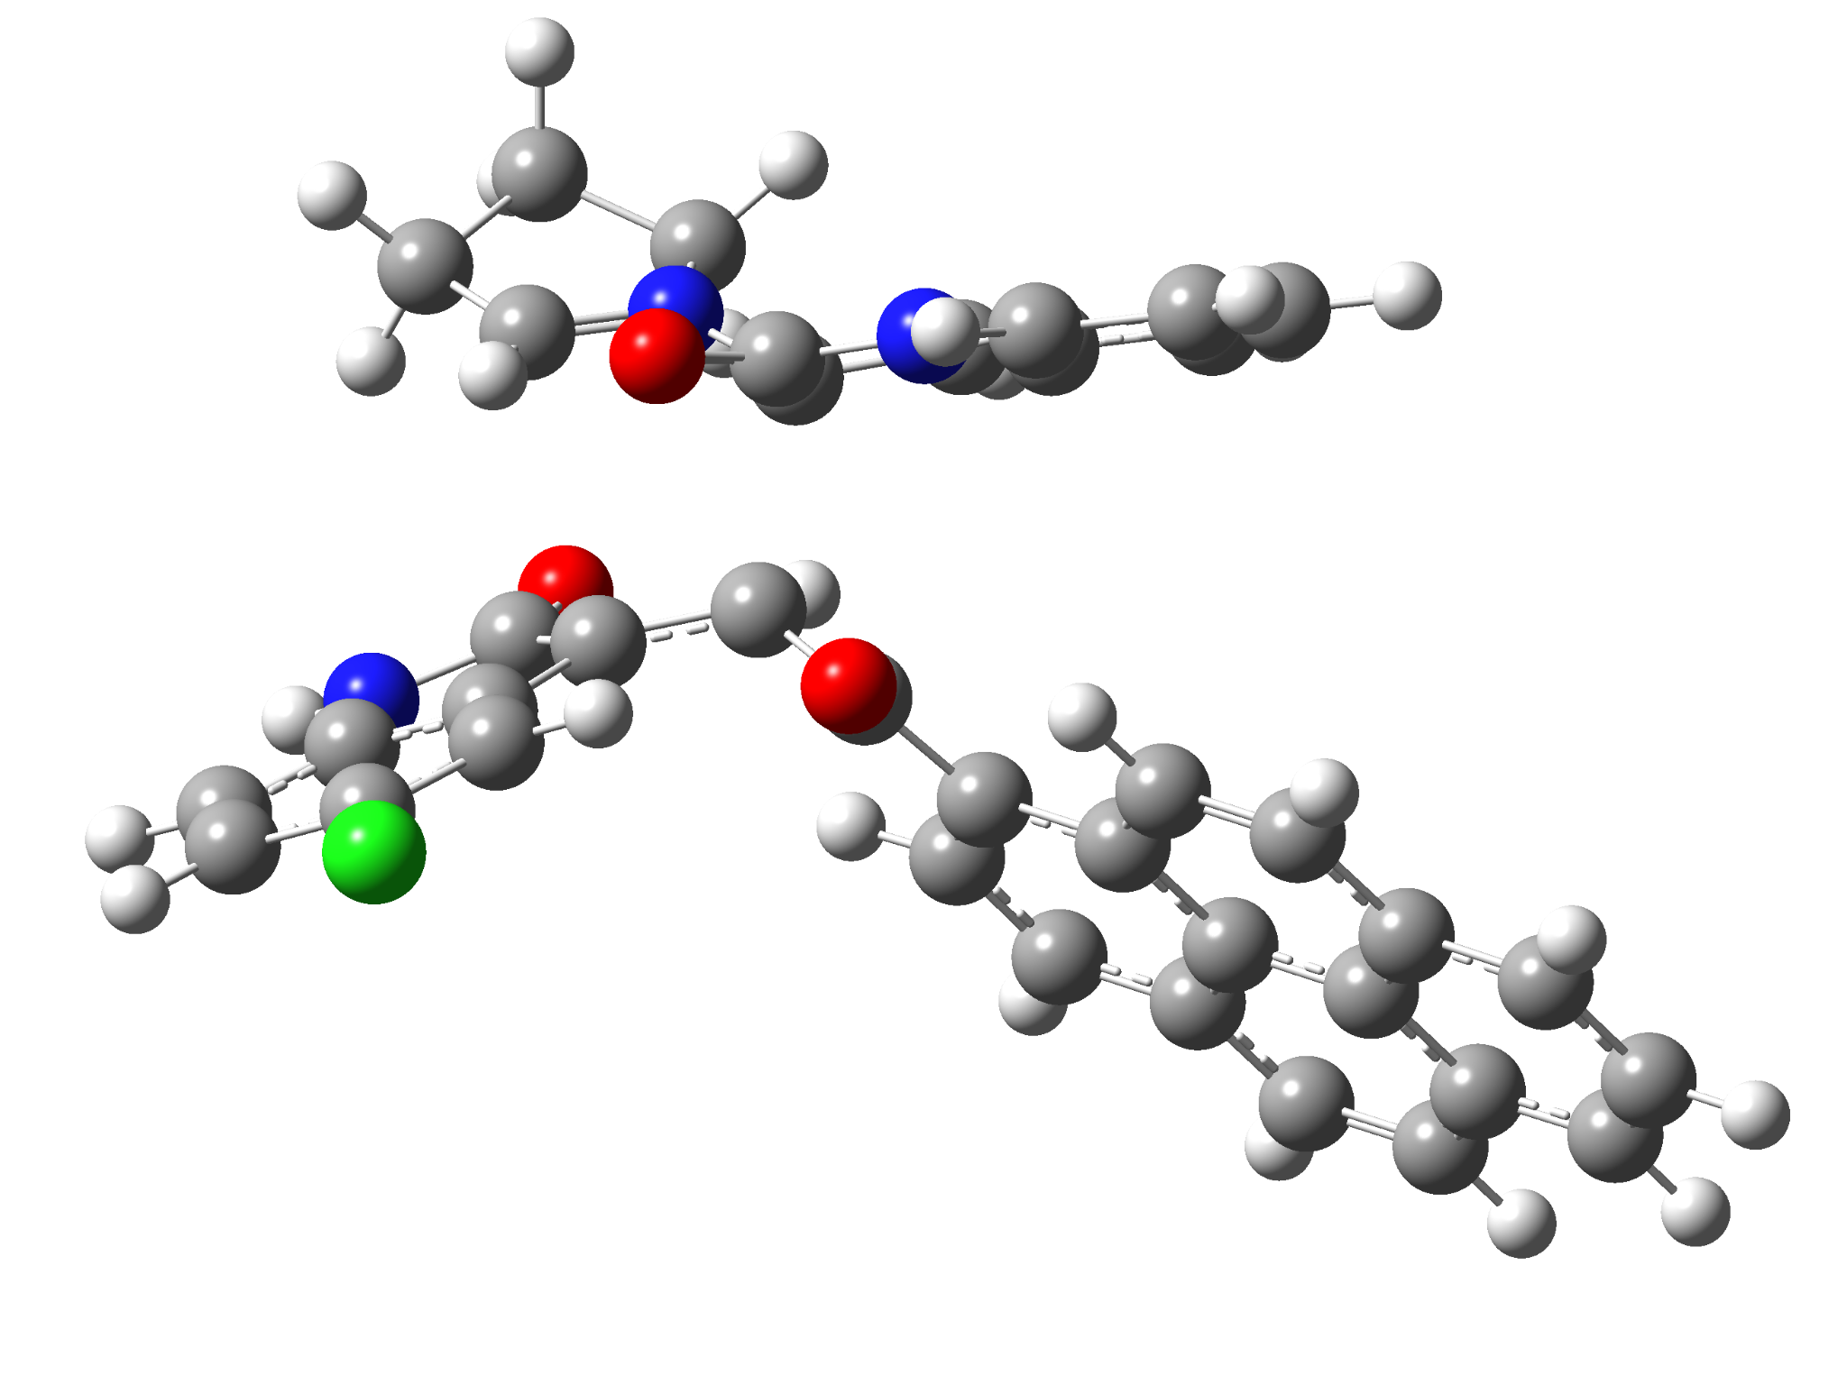

6c-exo-TS
Standard orientation:
---------------------------------------------------------------------
Center Atomic Atomic Coordinates (Angstroms)
Number Number Type X Y Z
---------------------------------------------------------------------
1 7 0 2.875603 2.311266 -0.063197
2 6 0 1.681613 1.922347 -0.686970
3 6 0 1.185139 0.330466 0.561894
4 6 0 2.337971 -0.407431 0.909139
5 6 0 3.973639 1.576991 -0.069531
6 7 0 0.747175 1.802652 -2.795415
7 6 0 -0.082786 2.624862 -2.033720
8 6 0 0.484566 2.788948 -0.747524
9 6 0 -1.283570 3.224395 -2.395440
10 6 0 -1.935134 4.015723 -1.440597
11 6 0 -1.399545 4.182710 -0.159726
12 6 0 -0.195603 3.560441 0.197435
13 6 0 1.849029 1.369959 -2.081699
14 8 0 2.787496 0.727353 -2.536721
15 6 0 0.018840 -0.342204 -0.121222
16 8 0 0.145798 -0.821637 -1.245714
17 6 0 -1.268175 -0.423017 0.644884
18 6 0 -2.535838 -0.581139 0.005880
19 6 0 -3.713985 -0.674267 0.820783
20 6 0 -3.615168 -0.638248 2.246906
21 6 0 -2.349118 -0.499657 2.836629
22 6 0 -1.212132 -0.383692 2.051006
23 6 0 -5.005043 -0.812510 0.218683
24 6 0 -6.177237 -0.912556 1.031901
25 6 0 -6.033938 -0.874011 2.460816
26 6 0 -4.807926 -0.743992 3.040618
27 6 0 -2.708803 -0.624545 -1.423911
28 6 0 -3.942711 -0.752193 -1.991311
29 6 0 -5.133957 -0.853703 -1.201412
30 6 0 -6.410133 -0.991071 -1.776333
31 6 0 -7.546844 -1.086642 -0.974905
32 6 0 -7.432892 -1.048338 0.415267
33 7 0 3.966200 -1.098899 2.371126
34 6 0 3.920604 -2.044286 1.344043
35 6 0 2.932480 -1.644949 0.405332
36 6 0 3.024274 -0.093497 2.177663
37 8 0 2.840044 0.848861 2.963886
38 6 0 4.682932 -3.192697 1.177365
39 6 0 4.460131 -3.976135 0.037082
40 6 0 3.498579 -3.580541 -0.895523
41 6 0 2.732406 -2.422884 -0.741017
42 6 0 2.966754 3.424544 0.926187
43 6 0 5.039099 2.162696 0.799425
44 6 0 4.480144 3.562317 1.146910
45 1 0 4.066211 0.751873 -0.760430
46 1 0 0.894460 1.011639 1.357351
47 1 0 0.567396 1.485423 -3.736674
48 1 0 -1.704994 3.083783 -3.386185
49 1 0 -2.873564 4.496369 -1.699629
50 1 0 -1.925564 4.788591 0.571189
51 1 0 0.186497 3.676484 1.206201
52 1 0 -2.262863 -0.483222 3.919520
53 1 0 -0.252017 -0.289549 2.545546
54 1 0 -6.927789 -0.952283 3.074208
55 1 0 -4.709696 -0.717051 4.122521
56 1 0 -1.829531 -0.575329 -2.048841
57 1 0 -4.036899 -0.784865 -3.073954
58 1 0 -6.500898 -1.024005 -2.858860
59 1 0 -8.525250 -1.193339 -1.434016
60 1 0 -8.320871 -1.125947 1.037081
61 1 0 4.514473 -1.167180 3.215526
62 1 0 5.433366 -3.485014 1.906082
63 1 0 5.034017 -4.881236 -0.126377
64 1 0 2.009823 -2.128882 -1.490522
65 1 0 2.494226 4.315524 0.511563
66 1 0 2.449780 3.109955 1.836910
67 1 0 6.009184 2.192504 0.293386
68 1 0 5.157538 1.543783 1.698859
69 1 0 4.709046 3.864426 2.170577
70 1 0 4.892936 4.313388 0.465958
71 17 0 3.251498 -4.577691 -2.332133
---------------------------------------------------------------------

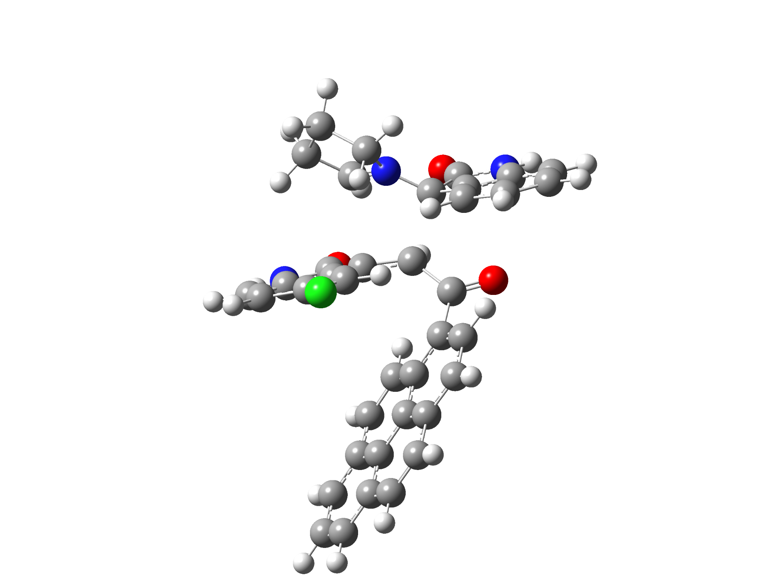

6c-endo-TS
Standard orientation:
---------------------------------------------------------------------
Center Atomic Atomic Coordinates (Angstroms)
Number Number Type X Y Z
---------------------------------------------------------------------
1 7 0 -3.408713 -1.101301 -0.014457
2 6 0 -3.172097 0.140377 -0.638632
3 6 0 -1.238844 -0.135518 -1.342312
4 6 0 -0.677458 -1.304227 -0.756769
5 6 0 -3.116439 -2.250520 -0.597853
6 7 0 -4.408536 1.601429 -1.954569
7 6 0 -4.119974 2.272183 -0.766355
8 6 0 -3.418700 1.403253 0.098750
9 6 0 -4.450245 3.572697 -0.405266
10 6 0 -4.070931 4.014121 0.868173
11 6 0 -3.374860 3.173400 1.743052
12 6 0 -3.035770 1.869569 1.357189
13 6 0 -3.917877 0.312965 -1.955484
14 8 0 -4.087578 -0.521920 -2.832626
15 6 0 -0.654555 1.257739 -1.288683
16 8 0 -1.278159 2.184046 -1.795349
17 6 0 0.679940 1.541082 -0.652729
18 6 0 1.887023 0.910985 -1.042340
19 6 0 3.097003 1.260372 -0.359063
20 6 0 3.078979 2.234322 0.686929
21 6 0 1.867889 2.872801 1.001564
22 6 0 0.697850 2.543507 0.328460
23 6 0 4.333866 0.641732 -0.722770
24 6 0 5.537018 0.971728 -0.024520
25 6 0 5.476915 1.940255 1.035998
26 6 0 4.303537 2.546257 1.371874
27 6 0 1.973874 -0.020656 -2.137986
28 6 0 3.156859 -0.598969 -2.490070
29 6 0 4.375892 -0.305493 -1.790389
30 6 0 5.601469 -0.903667 -2.131256
31 6 0 6.768636 -0.582933 -1.437866
32 6 0 6.738993 0.344587 -0.396112
33 7 0 0.188179 -3.433379 -0.711055
34 6 0 0.426544 -2.879826 0.541372
35 6 0 -0.094973 -1.555465 0.551059
36 6 0 -0.455688 -2.521856 -1.560128
37 8 0 -0.740430 -2.756556 -2.736907
38 6 0 1.038309 -3.441317 1.656397
39 6 0 1.137021 -2.672342 2.824386
40 6 0 0.622433 -1.373910 2.841099
41 6 0 0.009858 -0.799448 1.724956
42 6 0 -3.708261 -1.286154 1.435162
43 6 0 -3.330921 -3.411869 0.317306
44 6 0 -4.068006 -2.777562 1.520467
45 1 0 -2.948275 -2.300457 -1.665567
46 1 0 -1.548246 -0.339807 -2.370379
47 1 0 -4.842410 2.006874 -2.771045
48 1 0 -4.982447 4.227431 -1.088378
49 1 0 -4.318323 5.025650 1.175771
50 1 0 -3.085710 3.533442 2.725380
51 1 0 -2.473685 1.242018 2.040745
52 1 0 1.852188 3.631393 1.779471
53 1 0 -0.230329 3.051455 0.570713
54 1 0 6.393951 2.186279 1.565065
55 1 0 4.273384 3.282584 2.170616
56 1 0 1.083069 -0.259427 -2.706890
57 1 0 3.190452 -1.294954 -3.324066
58 1 0 5.630765 -1.621241 -2.946976
59 1 0 7.707129 -1.055420 -1.712977
60 1 0 7.652096 0.592991 0.138508
61 1 0 0.542016 -4.316477 -1.047880
62 1 0 1.438235 -4.450737 1.631756
63 1 0 1.611215 -3.079257 3.710164
64 1 0 -0.346425 0.222151 1.771513
65 1 0 -2.814490 -1.047506 2.016306
66 1 0 -4.514914 -0.613364 1.728212
67 1 0 -2.355292 -3.831998 0.601129
68 1 0 -3.894189 -4.215352 -0.166831
69 1 0 -5.148513 -2.909023 1.407808
70 1 0 -3.771345 -3.209741 2.478350
71 17 0 0.748651 -0.422500 4.324908
---------------------------------------------------------------------

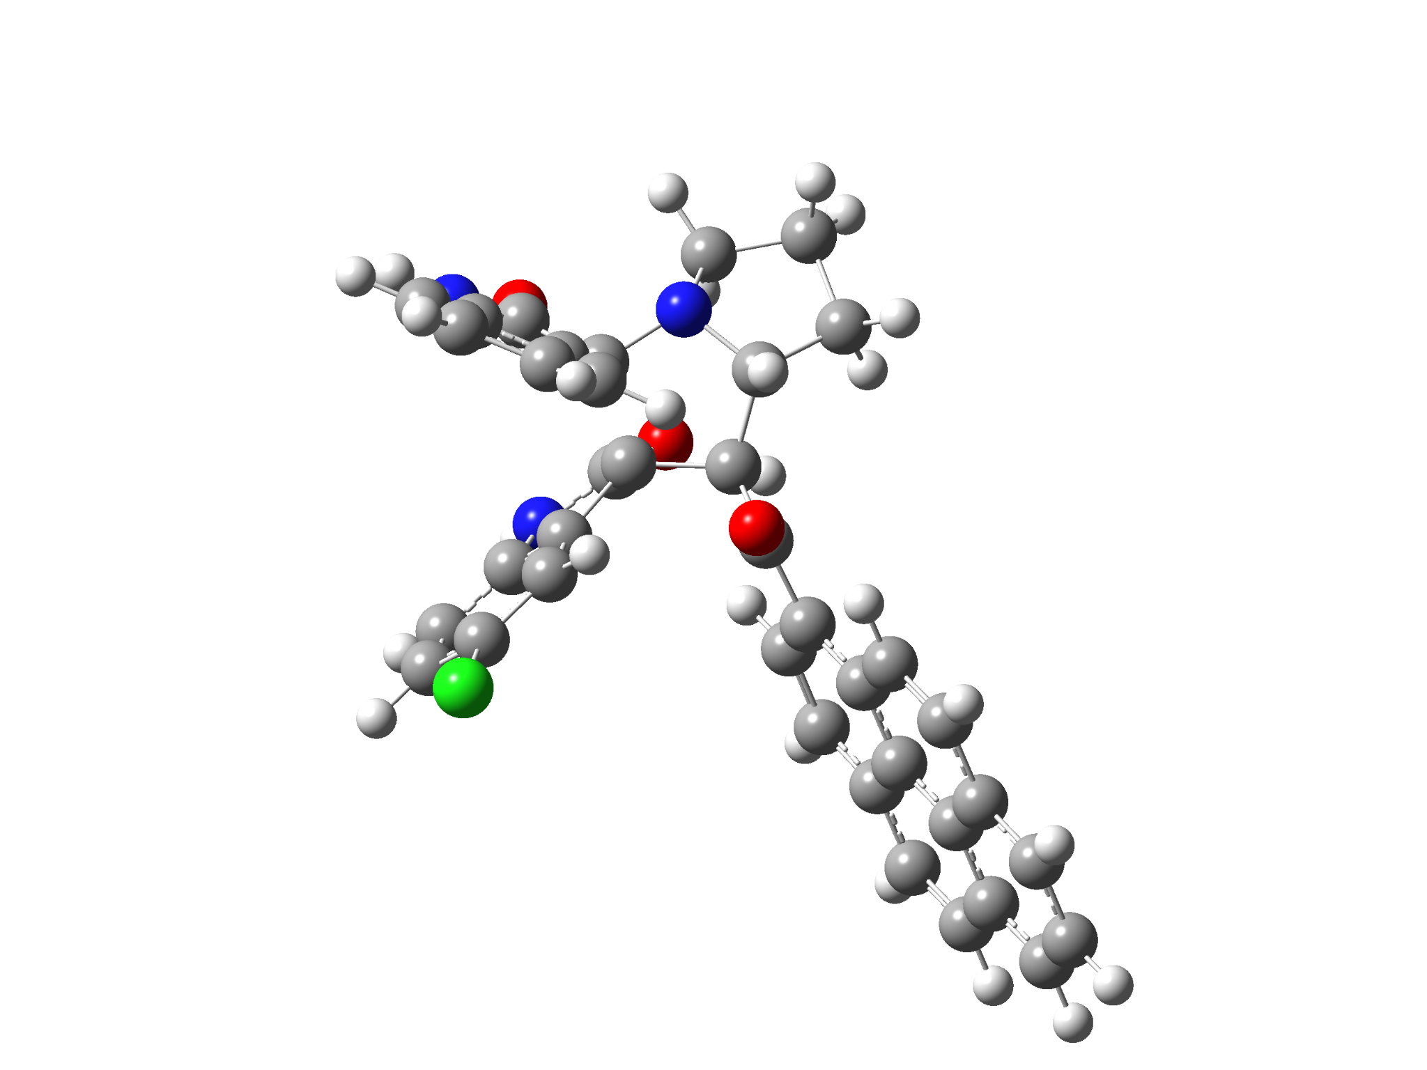

5c-1’R
Standard orientation:
---------------------------------------------------------------------
Center Atomic Atomic Coordinates (Angstroms)
Number Number Type X Y Z
---------------------------------------------------------------------
1 6 0 -4.793238 0.838124 -0.861484
2 6 0 -5.402137 1.875035 -1.557994
3 6 0 -4.703759 2.427626 -2.639037
4 6 0 -3.445149 1.939386 -2.996310
5 6 0 -2.849740 0.892729 -2.275225
6 6 0 -3.523248 0.340947 -1.189822
7 6 0 -3.196204 -0.843187 -0.267224
8 7 0 -5.314598 0.108460 0.216990
9 6 0 -1.841919 -0.647027 0.630834
10 6 0 -0.761944 -1.429211 -0.205698
11 6 0 -1.543676 -2.100134 -1.394649
12 7 0 -2.972235 -2.047852 -1.043424
13 6 0 -4.489191 -0.910647 0.617196
14 8 0 -4.734545 -1.702557 1.510138
15 6 0 0.432521 -0.601196 -0.697042
16 8 0 0.286983 0.104336 -1.695593
17 6 0 6.791881 0.725658 -2.227214
18 6 0 5.537233 0.381839 -1.692036
19 6 0 5.446184 -0.045187 -0.334437
20 6 0 6.634613 -0.117343 0.457721
21 6 0 7.867283 0.236760 -0.116678
22 6 0 7.944028 0.653725 -1.446250
23 6 0 4.177437 -0.398255 0.225942
24 6 0 4.120518 -0.831035 1.588064
25 6 0 5.328462 -0.893072 2.362579
26 6 0 6.531856 -0.551278 1.823027
27 6 0 4.332372 0.438798 -2.463743
28 6 0 3.117910 0.112188 -1.933734
29 6 0 2.981550 -0.315424 -0.564734
30 6 0 1.734613 -0.691748 0.029659
31 6 0 1.726847 -1.134350 1.366828
32 6 0 2.879389 -1.192403 2.134399
33 6 0 -1.625507 0.787959 1.100353
34 6 0 -1.885062 0.856876 2.483346
35 7 0 -2.149515 -0.426196 2.973850
36 6 0 -1.277121 1.953048 0.422495
37 6 0 -1.211013 3.154203 1.140011
38 6 0 -1.492282 3.217005 2.503355
39 6 0 -1.835188 2.049138 3.195160
40 6 0 -1.982769 -1.388694 2.005203
41 8 0 -1.876389 -2.583738 2.215106
42 6 0 -1.239079 -3.599430 -1.631198
43 6 0 -3.411955 -3.392089 -0.600572
44 6 0 -2.618731 -4.290084 -1.554123
45 1 0 -1.359066 -1.509852 -2.295852
46 1 0 -0.736944 -3.770033 -2.587766
47 1 0 -0.409010 -2.236580 0.434148
48 1 0 -0.581346 -3.982710 -0.843836
49 1 0 -6.386664 2.239530 -1.279895
50 1 0 -5.150063 3.241532 -3.202611
51 1 0 -2.913867 2.376928 -3.835811
52 1 0 -1.860564 0.546912 -2.550564
53 1 0 -6.222118 0.247536 0.638459
54 1 0 6.853123 1.050396 -3.262484
55 1 0 8.767368 0.182455 0.489932
56 1 0 8.905320 0.923312 -1.873422
57 1 0 5.260656 -1.222656 3.395740
58 1 0 7.438104 -0.603557 2.420701
59 1 0 4.397456 0.755447 -3.501632
60 1 0 2.228859 0.185679 -2.541615
61 1 0 0.793973 -1.425798 1.833108
62 1 0 2.825991 -1.524290 3.167369
63 1 0 -2.236912 -0.673728 3.949354
64 1 0 -1.045570 1.945431 -0.633169
65 1 0 -1.437159 4.165818 3.025260
66 1 0 -2.044025 2.081016 4.260009
67 1 0 -3.160940 -3.604202 0.444079
68 1 0 -4.493375 -3.492229 -0.725780
69 1 0 -3.095115 -4.301631 -2.540628
70 1 0 -2.553959 -5.320999 -1.193771
71 17 0 -0.757225 4.628564 0.289397
---------------------------------------------------------------------

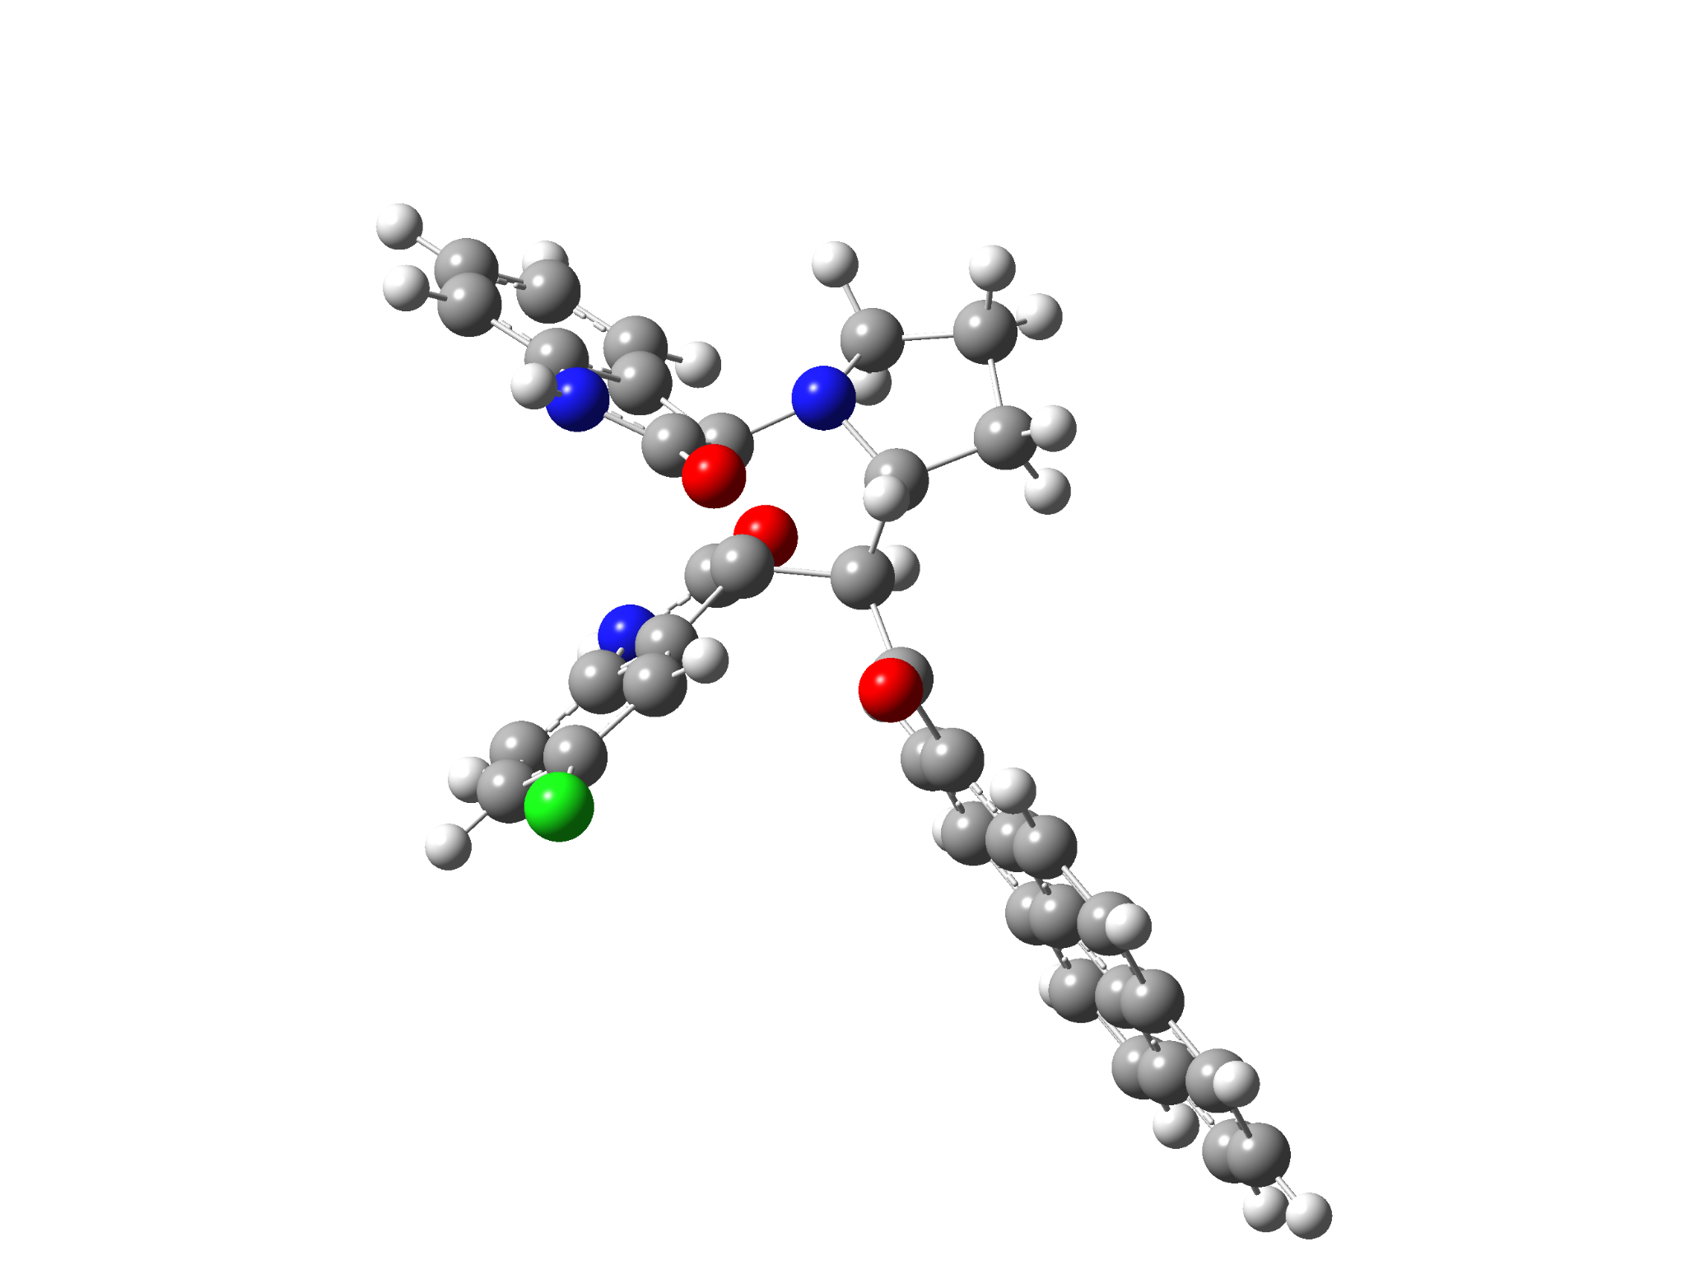

5c-1’S
Standard orientation:
---------------------------------------------------------------------
Center Atomic Atomic Coordinates (Angstroms)
Number Number Type X Y Z
---------------------------------------------------------------------
1 6 0 -5.325895 0.101377 -0.222884
2 6 0 -6.598116 0.161879 0.335200
3 6 0 -6.943824 -0.815612 1.276287
4 6 0 -6.035158 -1.813548 1.635387
5 6 0 -4.753498 -1.852513 1.065135
6 6 0 -4.387480 -0.885950 0.130488
7 6 0 -3.103995 -0.654662 -0.662407
8 7 0 -4.780061 0.945036 -1.194786
9 6 0 -1.752909 -0.247819 0.216161
10 6 0 -0.621995 -1.007218 -0.561046
11 6 0 -1.277641 -1.475615 -1.904091
12 7 0 -2.688400 -1.714130 -1.559603
13 6 0 -3.519680 0.552363 -1.580470
14 8 0 -2.886375 1.042014 -2.496682
15 6 0 0.679951 -0.233081 -0.809140
16 8 0 0.686152 0.619635 -1.692547
17 6 0 7.235478 0.741398 -1.587710
18 6 0 5.914429 0.430776 -1.217233
19 6 0 5.667291 -0.199869 0.037829
20 6 0 6.769344 -0.505876 0.896461
21 6 0 8.072840 -0.176885 0.487378
22 6 0 8.302447 0.440479 -0.742977
23 6 0 4.329207 -0.523021 0.430112
24 6 0 4.114969 -1.162654 1.691440
25 6 0 5.238892 -1.457261 2.536231
26 6 0 6.509147 -1.143131 2.157244
27 6 0 4.793094 0.720283 -2.059551
28 6 0 3.513842 0.422825 -1.688861
29 6 0 3.220536 -0.207304 -0.426493
30 6 0 1.898980 -0.559915 -0.003204
31 6 0 1.734747 -1.210069 1.235287
32 6 0 2.805326 -1.494379 2.069754
33 6 0 -1.629237 1.240244 0.529572
34 6 0 -1.838809 1.431339 1.907722
35 7 0 -2.014620 0.185437 2.526363
36 6 0 -1.369617 2.348169 -0.274579
37 6 0 -1.351006 3.614327 0.323854
38 6 0 -1.580914 3.795992 1.686942
39 6 0 -1.827649 2.685557 2.503059
40 6 0 -1.868170 -0.849854 1.641640
41 8 0 -1.816498 -2.034621 1.948656
42 6 0 -0.758014 -2.827936 -2.443668
43 6 0 -2.823112 -3.138781 -1.197431
44 6 0 -1.945076 -3.809011 -2.260988
45 1 0 -1.198520 -0.663964 -2.627944
46 1 0 -0.453029 -2.751195 -3.490495
47 1 0 -0.419146 -1.909942 0.016865
48 1 0 0.118909 -3.159083 -1.876891
49 1 0 -7.302247 0.935987 0.045429
50 1 0 -7.932148 -0.795544 1.726146
51 1 0 -6.318277 -2.568431 2.362205
52 1 0 -4.056365 -2.624302 1.365414
53 1 0 -5.282993 1.664558 -1.695379
54 1 0 7.415733 1.222039 -2.545572
55 1 0 8.906874 -0.409647 1.144166
56 1 0 9.316599 0.687298 -1.042820
57 1 0 5.051725 -1.941625 3.490788
58 1 0 7.350322 -1.372585 2.806172
59 1 0 4.976630 1.193997 -3.020600
60 1 0 2.691938 0.673890 -2.342217
61 1 0 0.745180 -1.493388 1.571882
62 1 0 2.631904 -1.983927 3.024022
63 1 0 -2.083665 0.028872 3.522070
64 1 0 -1.181717 2.238114 -1.333538
65 1 0 -1.559796 4.793228 2.112055
66 1 0 -1.994541 2.809914 3.568520
67 1 0 -2.445363 -3.358947 -0.187931
68 1 0 -3.870039 -3.447255 -1.252589
69 1 0 -2.506028 -3.899818 -3.196624
70 1 0 -1.626670 -4.811153 -1.959224
71 17 0 -1.023075 5.023649 -0.680344
---------------------------------------------------------------------

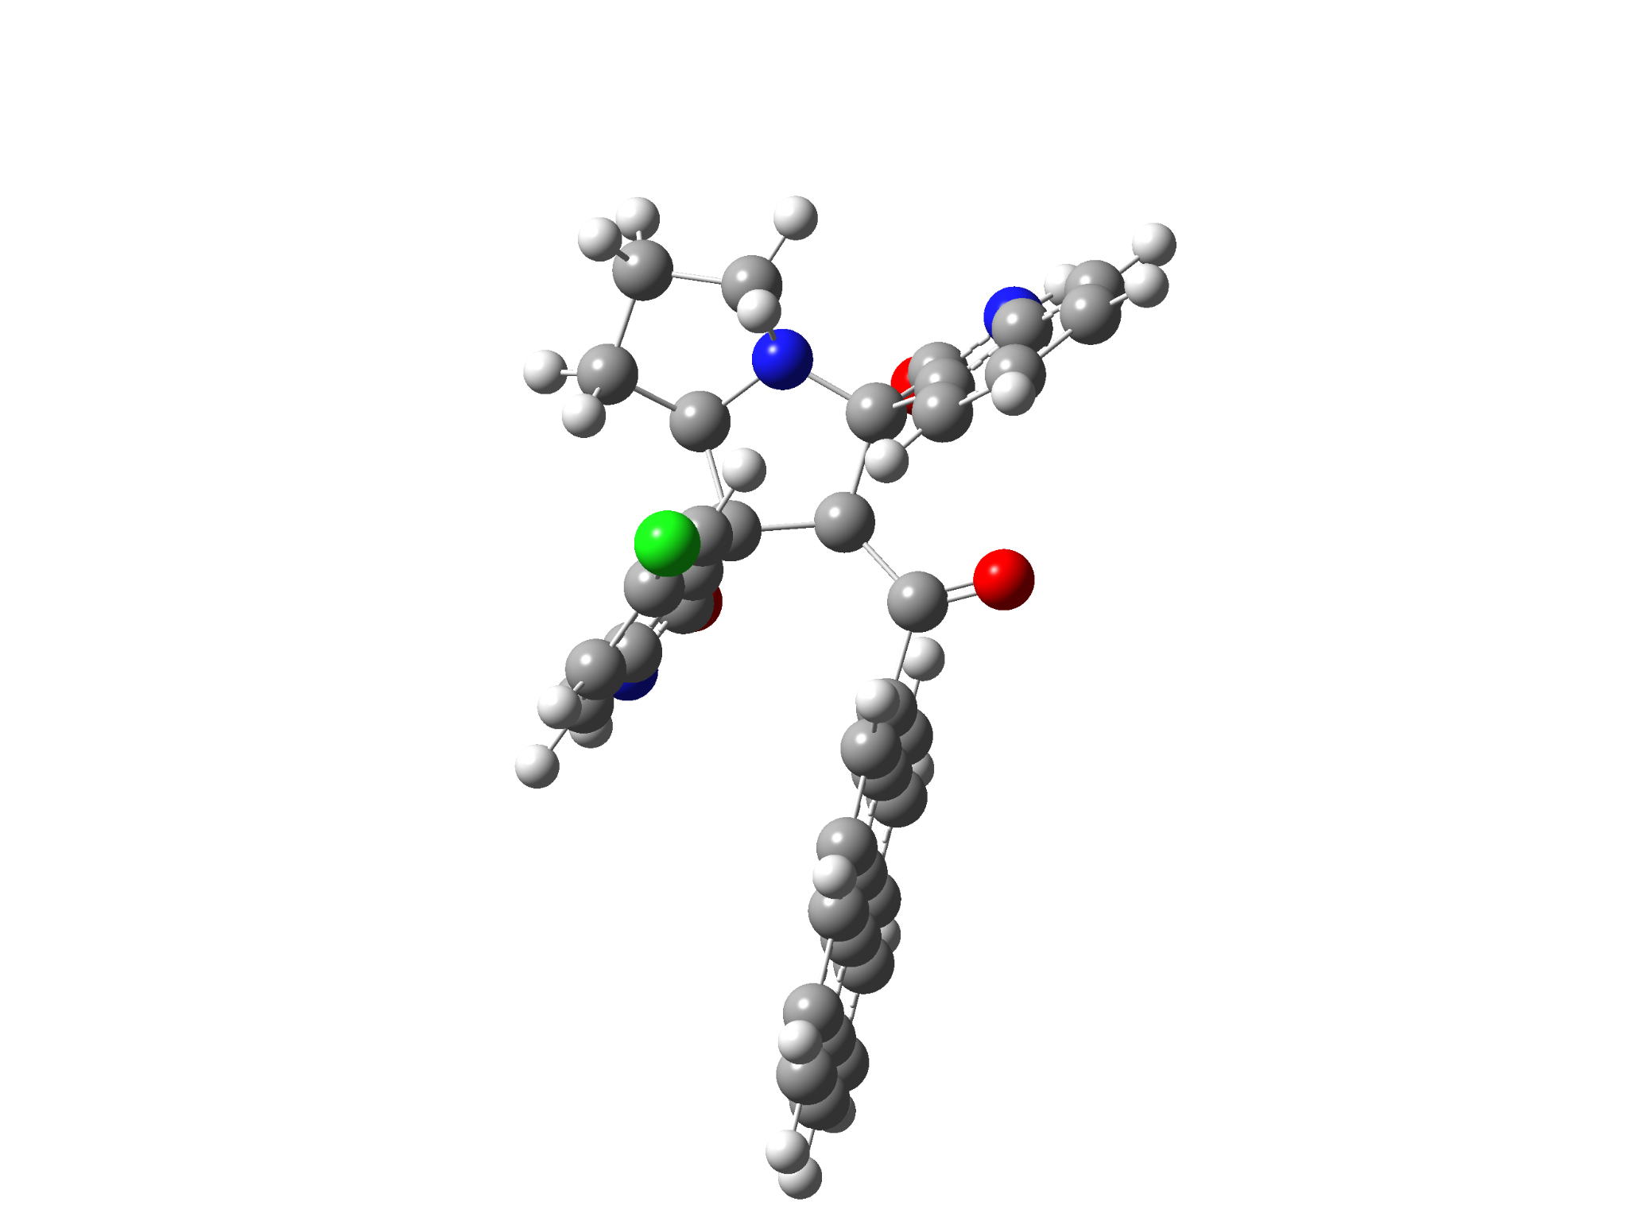

6c-2’R
Standard orientation:
---------------------------------------------------------------------
Center Atomic Atomic Coordinates (Angstroms)
Number Number Type X Y Z
---------------------------------------------------------------------
1 7 0 -3.077214 -0.879530 1.471469
2 6 0 -2.458336 -1.478278 0.286374
3 6 0 -0.957677 -1.014460 0.392971
4 6 0 -0.903438 0.191663 1.392229
5 6 0 -2.092684 -0.238630 2.344325
6 7 0 -3.437243 -3.535348 -0.391103
7 6 0 -3.855502 -2.563338 -1.311882
8 6 0 -3.269179 -1.322930 -1.001848
9 6 0 -4.697419 -2.742823 -2.402840
10 6 0 -4.949984 -1.636381 -3.223687
11 6 0 -4.361347 -0.400148 -2.952536
12 6 0 -3.518015 -0.244607 -1.841825
13 6 0 -2.503998 -3.038341 0.485124
14 8 0 -1.856488 -3.682853 1.290353
15 6 0 -0.176666 -1.029575 -0.918228
16 8 0 -0.572055 -1.718795 -1.843933
17 6 0 1.124723 -0.272947 -1.060033
18 6 0 2.346205 -0.807082 -0.587359
19 6 0 3.553113 -0.069821 -0.816115
20 6 0 3.515155 1.172953 -1.521014
21 6 0 2.282451 1.646547 -1.998299
22 6 0 1.110731 0.930327 -1.775096
23 6 0 4.804199 -0.579141 -0.348844
24 6 0 6.008763 0.159380 -0.568651
25 6 0 5.932591 1.411185 -1.272288
26 6 0 4.742696 1.892983 -1.729682
27 6 0 2.439731 -2.073849 0.091224
28 6 0 3.634524 -2.558137 0.530673
29 6 0 4.857716 -1.831203 0.336385
30 6 0 6.098145 -2.312234 0.790007
31 6 0 7.267461 -1.582111 0.576823
32 6 0 7.226060 -0.360228 -0.095603
33 7 0 0.991983 1.414514 2.106880
34 6 0 0.216165 2.292379 1.347987
35 6 0 -0.931762 1.621316 0.882118
36 6 0 0.425364 0.160546 2.188533
37 8 0 0.881864 -0.788325 2.800930
38 6 0 0.457082 3.633844 1.075590
39 6 0 -0.488913 4.338934 0.322051
40 6 0 -1.643474 3.692101 -0.114925
41 6 0 -1.882203 2.340696 0.166972
42 6 0 -4.369398 -0.197106 1.506380
43 6 0 -2.885942 0.827159 3.124894
44 6 0 -4.360561 0.413432 2.915581
45 1 0 -1.653872 -0.978911 3.025636
46 1 0 -0.481625 -1.822704 0.976029
47 1 0 -3.612502 -4.526807 -0.477116
48 1 0 -5.134695 -3.712640 -2.620948
49 1 0 -5.601244 -1.749033 -4.085325
50 1 0 -4.547296 0.445902 -3.606488
51 1 0 -3.045438 0.714804 -1.674482
52 1 0 2.247167 2.581687 -2.550476
53 1 0 0.170056 1.310723 -2.160842
54 1 0 6.851346 1.967408 -1.439502
55 1 0 4.701452 2.836433 -2.267829
56 1 0 1.541281 -2.658481 0.255822
57 1 0 3.674997 -3.514192 1.045077
58 1 0 6.137101 -3.264885 1.311325
59 1 0 8.217311 -1.968594 0.934596
60 1 0 8.141458 0.201643 -0.261742
61 1 0 1.881489 1.630243 2.534442
62 1 0 1.352409 4.130995 1.435518
63 1 0 -0.332789 5.386273 0.088980
64 1 0 -2.811309 1.888957 -0.152341
65 1 0 -4.475588 0.587696 0.739039
66 1 0 -5.192732 -0.904774 1.361267
67 1 0 -2.715288 1.825039 2.711348
68 1 0 -2.602553 0.853587 4.180518
69 1 0 -4.649787 -0.347607 3.648068
70 1 0 -5.052489 1.255736 3.008814
71 17 0 -2.846728 4.595375 -1.031872
---------------------------------------------------------------------

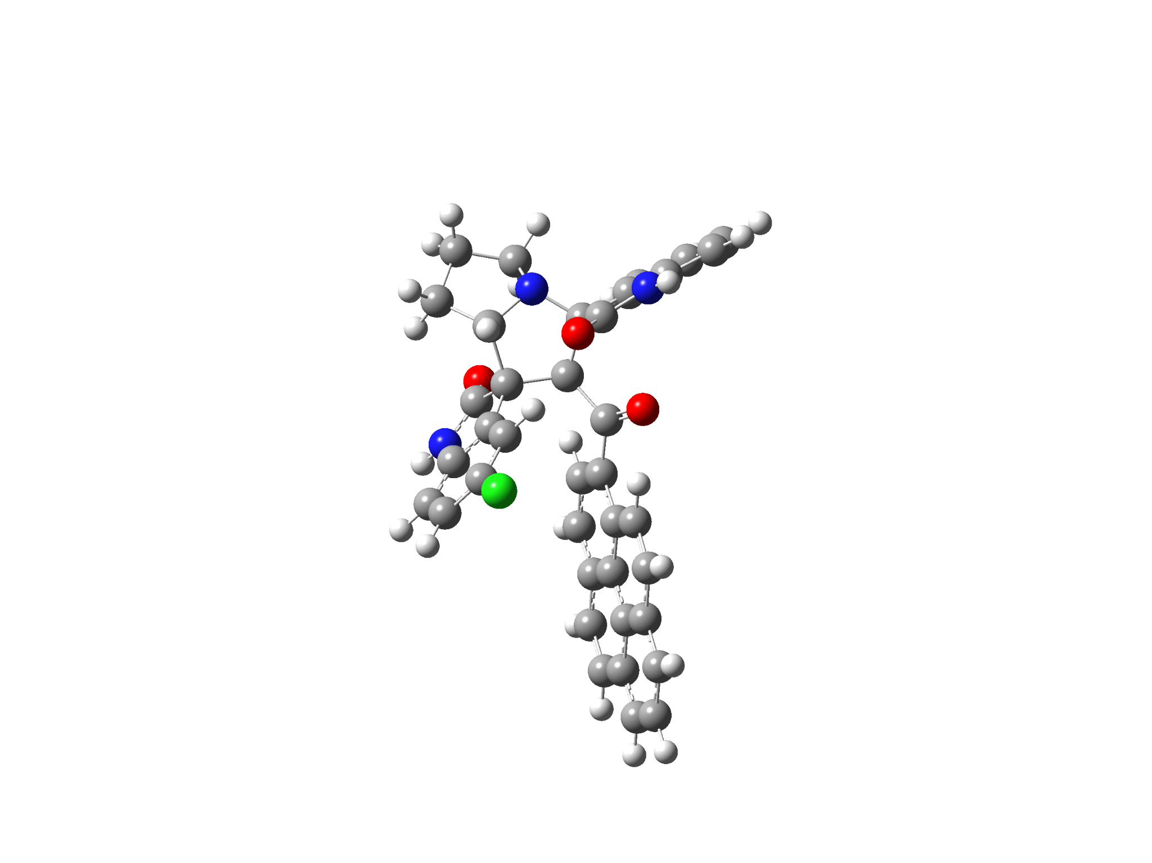

6c-2’S
Standard orientation:
---------------------------------------------------------------------
Center Atomic Atomic Coordinates (Angstroms)
Number Number Type X Y Z
---------------------------------------------------------------------
1 7 0 -3.882334 0.682619 0.112662
2 6 0 -3.034515 -0.400907 -0.407480
3 6 0 -1.696372 -0.272177 0.392609
4 6 0 -1.570038 1.237374 0.801470
5 6 0 -3.009972 1.830143 0.376613
6 7 0 -3.540198 -1.181804 -2.587221
7 6 0 -3.932322 -2.188633 -1.701322
8 6 0 -3.656611 -1.786009 -0.383716
9 6 0 -4.498016 -3.425169 -1.993041
10 6 0 -4.784665 -4.280328 -0.920497
11 6 0 -4.503601 -3.905082 0.395700
12 6 0 -3.931395 -2.652206 0.667270
13 6 0 -2.917670 -0.135557 -1.947323
14 8 0 -2.461210 0.852896 -2.497942
15 6 0 -0.484993 -0.928728 -0.278908
16 8 0 -0.603796 -1.372824 -1.415194
17 6 0 0.796078 -1.051925 0.485075
18 6 0 2.065996 -1.039646 -0.167020
19 6 0 3.249010 -1.217717 0.623967
20 6 0 3.153479 -1.430852 2.035200
21 6 0 1.885611 -1.441618 2.636279
22 6 0 0.740338 -1.241491 1.877343
23 6 0 4.541362 -1.191041 0.010567
24 6 0 5.720097 -1.382546 0.797035
25 6 0 5.580945 -1.602394 2.210219
26 6 0 4.353625 -1.625528 2.801312
27 6 0 2.230496 -0.813988 -1.579848
28 6 0 3.465826 -0.778554 -2.156632
29 6 0 4.663647 -0.971614 -1.393640
30 6 0 5.942065 -0.947116 -1.979446
31 6 0 7.085433 -1.135833 -1.204504
32 6 0 6.977290 -1.352293 0.169902
33 7 0 -0.278134 2.211522 2.521271
34 6 0 0.280562 2.648501 1.310208
35 6 0 -0.432343 2.075901 0.243517
36 6 0 -1.312259 1.329609 2.323560
37 8 0 -1.905304 0.727555 3.210178
38 6 0 1.351174 3.509914 1.110966
39 6 0 1.716348 3.807033 -0.208729
40 6 0 1.003106 3.249892 -1.269558
41 6 0 -0.081348 2.386215 -1.066083
42 6 0 -4.715773 0.460158 1.310146
43 6 0 -3.784095 2.705584 1.391984
44 6 0 -5.066043 1.895602 1.716654
45 1 0 -2.823910 2.362529 -0.557199
46 1 0 -1.882528 -0.806588 1.330661
47 1 0 -3.565417 -1.244539 -3.594902
48 1 0 -4.703771 -3.724028 -3.016399
49 1 0 -5.225515 -5.252461 -1.120809
50 1 0 -4.724926 -4.584586 1.212587
51 1 0 -3.712303 -2.371094 1.693136
52 1 0 1.801890 -1.610545 3.706297
53 1 0 -0.217144 -1.262682 2.384608
54 1 0 6.479966 -1.750549 2.802847
55 1 0 4.259938 -1.792324 3.871076
56 1 0 1.350291 -0.680210 -2.191880
57 1 0 3.555614 -0.598246 -3.224617
58 1 0 6.029266 -0.778196 -3.049383
59 1 0 8.065248 -1.114786 -1.672376
60 1 0 7.871058 -1.500763 0.770160
61 1 0 0.093026 2.400503 3.441762
62 1 0 1.896168 3.944226 1.943392
63 1 0 2.549968 4.471289 -0.407264
64 1 0 -0.635637 1.973129 -1.901900
65 1 0 -5.593002 -0.138424 1.052957
66 1 0 -4.171032 -0.039818 2.124758
67 1 0 -4.020849 3.680809 0.958610
68 1 0 -3.202601 2.890711 2.297917
69 1 0 -5.349952 1.965072 2.770440
70 1 0 -5.904896 2.256001 1.112783
71 17 0 1.476791 3.649197 -2.918805
---------------------------------------------------------------------

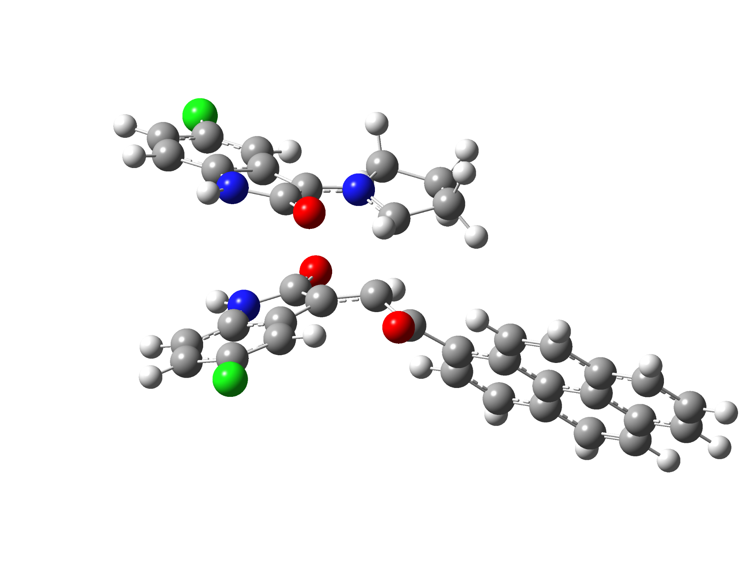

5g-exo-TS
Standard orientation:
---------------------------------------------------------------------
Center Atomic Atomic Coordinates (Angstroms)
Number Number Type X Y Z
---------------------------------------------------------------------
1 6 0 -4.900343 0.005286 -1.164641
2 6 0 -6.251079 0.013532 -0.845459
3 6 0 -6.804123 -1.127599 -0.250227
4 6 0 -5.992060 -2.232452 0.015680
5 6 0 -4.630427 -2.250002 -0.292428
6 6 0 -4.064743 -1.118356 -0.899176
7 6 0 -2.730641 -0.738929 -1.316406
8 7 0 -4.138880 1.002954 -1.758272
9 6 0 -1.162175 0.385207 0.830449
10 6 0 0.011105 -0.233643 0.365744
11 6 0 -0.362342 -0.980837 -1.582519
12 7 0 -1.611134 -1.499075 -1.434347
13 6 0 -2.813285 0.617000 -1.913982
14 8 0 -1.947563 1.289175 -2.471644
15 6 0 1.277225 0.511119 0.066853
16 8 0 1.266787 1.531603 -0.619295
17 6 0 7.630393 0.442211 -1.931526
18 6 0 6.369278 0.334561 -1.318527
19 6 0 6.256884 -0.325281 -0.058594
20 6 0 7.428549 -0.865171 0.558305
21 6 0 8.668768 -0.734370 -0.089700
22 6 0 8.766983 -0.087519 -1.322155
23 6 0 4.981937 -0.444894 0.579739
24 6 0 4.895925 -1.113861 1.841020
25 6 0 6.089444 -1.642908 2.440916
26 6 0 7.300632 -1.525098 1.828036
27 6 0 5.178520 0.866286 -1.913744
28 6 0 3.961003 0.763774 -1.306979
29 6 0 3.807325 0.105557 -0.034181
30 6 0 2.550312 -0.057914 0.621374
31 6 0 2.500905 -0.734270 1.854244
32 6 0 3.642408 -1.238536 2.461052
33 6 0 -1.653979 1.752008 0.898217
34 6 0 -2.806371 1.738961 1.733691
35 7 0 -3.040259 0.432522 2.163449
36 6 0 -1.242535 2.960227 0.319649
37 6 0 -1.972348 4.113825 0.616212
38 6 0 -3.092005 4.098136 1.451163
39 6 0 -3.524395 2.891001 2.019149
40 6 0 -2.097183 -0.441831 1.648838
41 8 0 -2.055075 -1.654845 1.869141
42 6 0 0.600076 -2.100975 -1.882833
43 6 0 -1.583079 -2.968497 -1.190891
44 6 0 -0.088411 -3.337171 -1.262305
45 1 0 -0.291281 0.002791 -2.032525
46 1 0 0.711550 -2.202111 -2.971234
47 1 0 0.143404 -1.221793 0.796953
48 1 0 1.598168 -1.921405 -1.475847
49 1 0 -6.871892 0.879027 -1.055309
50 1 0 -7.857998 -1.157248 0.002007
51 1 0 -4.046700 -3.124790 -0.045466
52 1 0 -4.464927 1.913608 -2.045998
53 1 0 7.710200 0.947261 -2.890447
54 1 0 9.557586 -1.143726 0.383062
55 1 0 9.733807 0.004893 -1.807970
56 1 0 6.004143 -2.143921 3.401375
57 1 0 8.194732 -1.931149 2.293818
58 1 0 5.260585 1.370091 -2.873446
59 1 0 3.089351 1.202805 -1.771418
60 1 0 1.550695 -0.838313 2.366941
61 1 0 3.570078 -1.735451 3.424449
62 1 0 -3.813463 0.122431 2.732986
63 1 0 -0.390786 2.989501 -0.345536
64 1 0 -3.626768 5.019137 1.655054
65 1 0 -4.397162 2.869034 2.664725
66 1 0 -2.005581 -3.178125 -0.209173
67 1 0 -2.188284 -3.450823 -1.965268
68 1 0 0.075938 -4.244670 -1.847477
69 1 0 0.294756 -3.519648 -0.254949
70 17 0 -6.708063 -3.657746 0.767107
71 17 0 -1.468309 5.647091 -0.096230
---------------------------------------------------------------------

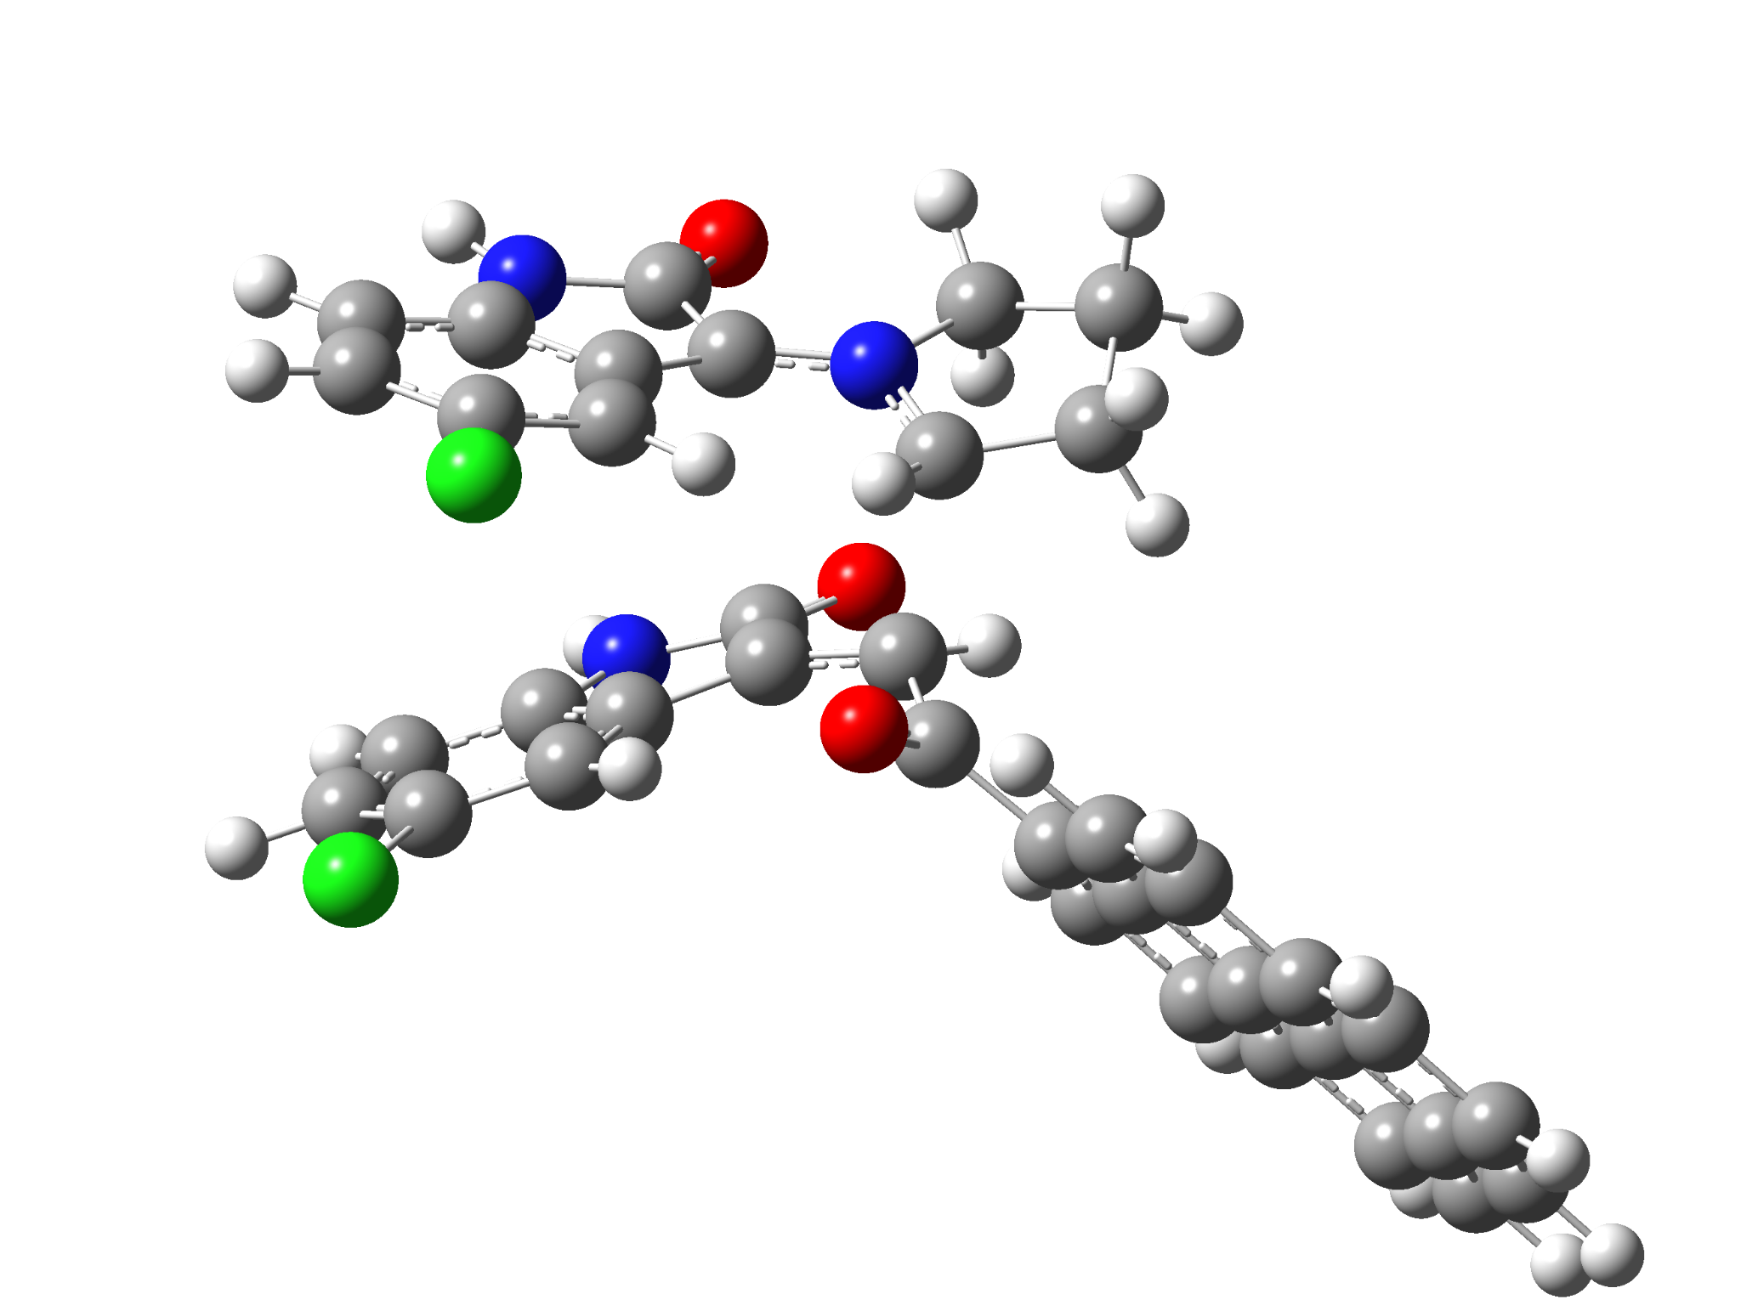

5g-endo-TS
Standard orientation:
---------------------------------------------------------------------
Center Atomic Atomic Coordinates (Angstroms)
Number Number Type X Y Z
---------------------------------------------------------------------
1 6 0 -4.839389 -0.213660 -0.948544
2 6 0 -5.619647 0.931404 -0.998848
3 6 0 -5.036197 2.118225 -1.461337
4 6 0 -3.695718 2.124038 -1.848005
5 6 0 -2.893271 0.982281 -1.774424
6 6 0 -3.469000 -0.218097 -1.332550
7 6 0 -3.010305 -1.588317 -1.193796
8 7 0 -5.209079 -1.502749 -0.577757
9 6 0 -1.282942 -0.976239 1.116923
10 6 0 -0.139686 -1.197766 0.329464
11 6 0 -0.654688 -1.494382 -1.680909
12 7 0 -1.846486 -2.147202 -1.604012
13 6 0 -4.173623 -2.411141 -0.764305
14 8 0 -4.264100 -3.623843 -0.592880
15 6 0 0.896853 -0.130555 0.112295
16 8 0 0.579461 0.940330 -0.410606
17 6 0 6.937585 1.938665 -1.807473
18 6 0 5.781342 1.369064 -1.244570
19 6 0 5.909151 0.442438 -0.167648
20 6 0 7.211455 0.109302 0.319950
21 6 0 8.339788 0.702385 -0.271867
22 6 0 8.202857 1.607341 -1.325164
23 6 0 4.743753 -0.146965 0.417083
24 6 0 4.901512 -1.074946 1.494130
25 6 0 6.220846 -1.389233 1.967220
26 6 0 7.326267 -0.823861 1.405905
27 6 0 4.464565 1.684247 -1.713329
28 6 0 3.348300 1.132402 -1.155314
29 6 0 3.435711 0.194097 -0.065697
30 6 0 2.299527 -0.434799 0.530343
31 6 0 2.494968 -1.352959 1.580210
32 6 0 3.758185 -1.659302 2.062721
33 6 0 -1.945390 0.195155 1.663367
34 6 0 -2.925399 -0.270055 2.586131
35 7 0 -2.894839 -1.662298 2.617241
36 6 0 -1.798366 1.575302 1.465593
37 6 0 -2.610153 2.440605 2.202150
38 6 0 -3.566655 1.977017 3.108266
39 6 0 -3.733606 0.599289 3.304865
40 6 0 -1.909240 -2.161995 1.775353
41 8 0 -1.606720 -3.348413 1.660798
42 6 0 0.391623 -2.397331 -2.304820
43 6 0 -1.640440 -3.627088 -1.724742
44 6 0 -0.372592 -3.715812 -2.583014
45 1 0 -0.666921 -0.432493 -1.878037
46 1 0 0.801875 -1.955865 -3.218830
47 1 0 0.241621 -2.209005 0.449758
48 1 0 1.236766 -2.550931 -1.624645
49 1 0 -6.663135 0.913606 -0.699727
50 1 0 -5.619346 3.030249 -1.516330
51 1 0 -1.851059 1.062924 -2.050431
52 1 0 -6.139545 -1.805076 -0.331081
53 1 0 6.833248 2.645114 -2.626623
54 1 0 9.327710 0.448202 0.102886
55 1 0 9.085981 2.056325 -1.769820
56 1 0 6.318674 -2.094057 2.788364
57 1 0 8.318307 -1.072086 1.773937
58 1 0 4.362772 2.390170 -2.533657
59 1 0 2.370106 1.415613 -1.515937
60 1 0 1.633893 -1.814691 2.050309
61 1 0 3.868925 -2.357513 2.887520
62 1 0 -3.460411 -2.259827 3.201325
63 1 0 -1.072672 1.961851 0.762782
64 1 0 -4.177756 2.684623 3.657324
65 1 0 -4.474056 0.231322 4.008713
66 1 0 -1.518752 -4.037460 -0.719559
67 1 0 -2.521848 -4.080201 -2.172986
68 1 0 -0.640776 -3.777732 -3.642451
69 1 0 0.214658 -4.603248 -2.335442
70 17 0 -2.981627 3.621176 -2.438213
71 17 0 -2.424986 4.179930 1.978929
---------------------------------------------------------------------

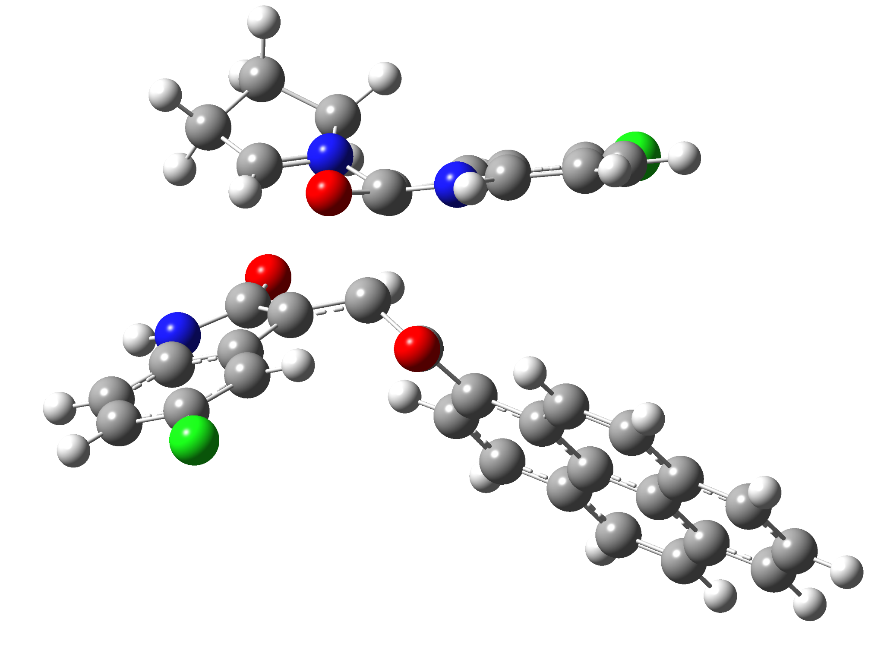

6g-exo-TS
Standard orientation:
---------------------------------------------------------------------
Center Atomic Atomic Coordinates (Angstroms)
Number Number Type X Y Z
---------------------------------------------------------------------
1 7 0 2.844184 2.256783 -0.226973
2 6 0 1.687517 1.740435 -0.832794
3 6 0 1.276725 0.223400 0.503530
4 6 0 2.467122 -0.418159 0.915109
5 6 0 3.986903 1.597360 -0.169478
6 7 0 0.801135 1.429547 -2.946420
7 6 0 -0.093689 2.238871 -2.249904
8 6 0 0.439168 2.522052 -0.970057
9 6 0 -1.324950 2.735423 -2.659334
10 6 0 -2.045398 3.544029 -1.771342
11 6 0 -1.528524 3.818804 -0.504849
12 6 0 -0.297653 3.306025 -0.080864
13 6 0 1.915107 1.114529 -2.189488
14 8 0 2.900753 0.508474 -2.588619
15 6 0 0.165634 -0.571931 -0.143175
16 8 0 0.337869 -1.096952 -1.241249
17 6 0 -1.115723 -0.705753 0.622122
18 6 0 -2.362472 -1.004485 -0.009106
19 6 0 -3.537350 -1.129663 0.806351
20 6 0 -3.454152 -0.987296 2.226819
21 6 0 -2.207212 -0.713700 2.810235
22 6 0 -1.075551 -0.566306 2.022850
23 6 0 -4.809319 -1.405618 0.211073
24 6 0 -5.977708 -1.536013 1.025352
25 6 0 -5.850224 -1.387239 2.448398
26 6 0 -4.642367 -1.126016 3.021929
27 6 0 -2.519658 -1.161269 -1.432768
28 6 0 -3.735928 -1.420379 -1.993848
29 6 0 -4.922978 -1.554993 -1.202943
30 6 0 -6.180420 -1.827025 -1.771220
31 6 0 -7.313653 -1.950976 -0.968880
32 6 0 -7.214496 -1.807546 0.415540
33 7 0 4.105788 -0.912746 2.443156
34 6 0 4.134373 -1.925139 1.481249
35 6 0 3.141779 -1.648629 0.503813
36 6 0 3.110080 0.019307 2.169337
37 8 0 2.856644 0.999994 2.886386
38 6 0 4.965508 -3.034597 1.402949
39 6 0 4.809734 -3.903711 0.314901
40 6 0 3.843597 -3.629153 -0.655747
41 6 0 3.008104 -2.511719 -0.590089
42 6 0 2.846392 3.438548 0.684837
43 6 0 4.997294 2.309020 0.670212
44 6 0 4.344026 3.689564 0.913537
45 1 0 4.144434 0.734159 -0.799412
46 1 0 0.930383 0.930754 1.252944
47 1 0 0.656192 1.036910 -3.865021
48 1 0 -1.726097 2.509051 -3.642187
49 1 0 -3.006711 3.951797 -2.062418
50 1 0 0.050405 3.516879 0.923097
51 1 0 -2.132268 -0.614919 3.889492
52 1 0 -0.130235 -0.365714 2.513992
53 1 0 -6.741228 -1.488110 3.062560
54 1 0 -4.555879 -1.015284 4.099418
55 1 0 -1.641120 -1.091886 -2.056742
56 1 0 -3.817824 -1.536778 -3.071740
57 1 0 -6.259257 -1.941869 -2.849077
58 1 0 -8.277587 -2.161712 -1.422530
59 1 0 -8.099584 -1.907093 1.038300
60 1 0 4.641344 -0.892504 3.298216
61 1 0 5.718325 -3.232813 2.160289
62 1 0 5.438586 -4.781749 0.220880
63 1 0 2.282735 -2.312865 -1.367726
64 1 0 2.325257 4.267537 0.204982
65 1 0 2.336741 3.152648 1.609149
66 1 0 5.972324 2.366527 0.176372
67 1 0 5.138036 1.761001 1.611437
68 1 0 4.535736 4.074730 1.916656
69 1 0 4.718717 4.418057 0.187620
70 17 0 -2.451703 4.831979 0.600731
71 17 0 3.681166 -4.732230 -2.025116
---------------------------------------------------------------------

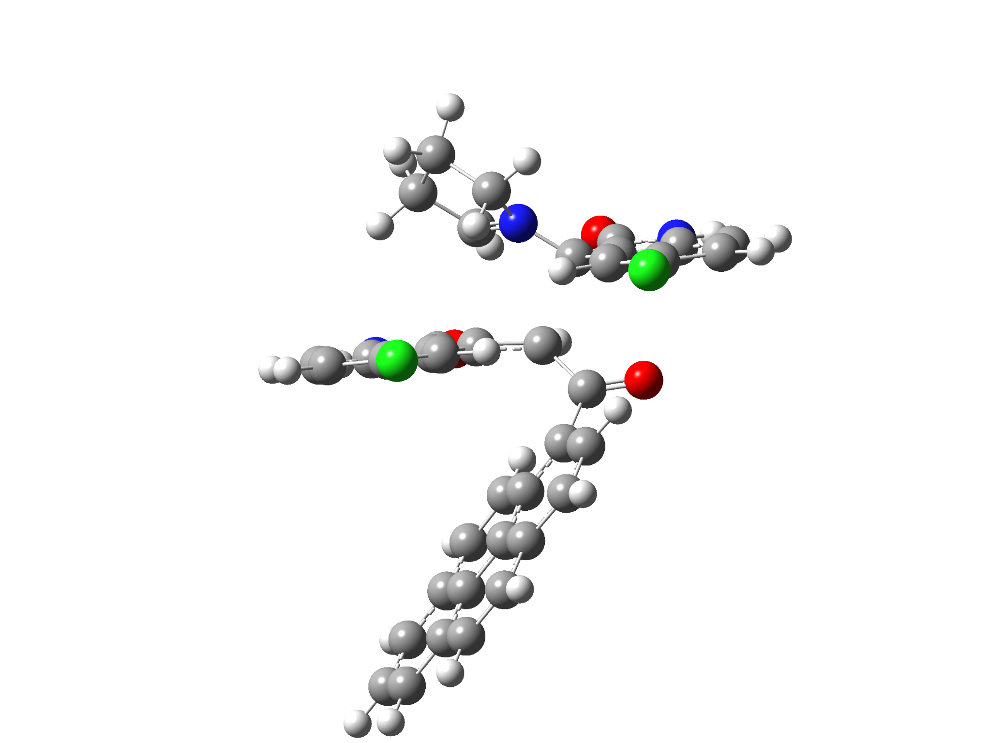

6g-endo-TS
Standard orientation:
---------------------------------------------------------------------
Center Atomic Atomic Coordinates (Angstroms)
Number Number Type X Y Z
---------------------------------------------------------------------
1 7 0 -3.106350 -1.607458 0.248356
2 6 0 -2.949532 -0.683784 -0.806277
3 6 0 -0.967672 -0.956938 -1.286093
4 6 0 -0.335747 -1.756253 -0.290728
5 6 0 -2.646677 -2.845204 0.166009
6 7 0 -4.239934 -0.008308 -2.620232
7 6 0 -4.112116 1.096544 -1.780985
8 6 0 -3.385753 0.723636 -0.629064
9 6 0 -4.600218 2.384089 -1.960667
10 6 0 -4.364510 3.329391 -0.955626
11 6 0 -3.647043 2.968246 0.185427
12 6 0 -3.140503 1.675651 0.359919
13 6 0 -3.616640 -1.125698 -2.104619
14 8 0 -3.634008 -2.246825 -2.590005
15 6 0 -0.522284 0.417910 -1.736858
16 8 0 -1.204505 1.023675 -2.556240
17 6 0 0.740479 1.055053 -1.224939
18 6 0 2.021331 0.459159 -1.327826
19 6 0 3.150666 1.160490 -0.793615
20 6 0 2.980495 2.439956 -0.179337
21 6 0 1.699537 3.015759 -0.148744
22 6 0 0.607669 2.341421 -0.681025
23 6 0 4.458489 0.588165 -0.876038
24 6 0 5.581932 1.276033 -0.320468
25 6 0 5.369564 2.551080 0.308454
26 6 0 4.127663 3.108378 0.371313
27 6 0 2.258896 -0.791679 -2.002012
28 6 0 3.508861 -1.328275 -2.089692
29 6 0 4.651358 -0.671885 -1.519312
30 6 0 5.944756 -1.218269 -1.588115
31 6 0 7.033580 -0.544534 -1.034623
32 6 0 6.856331 0.689223 -0.407750
33 7 0 0.750191 -3.597633 0.554371
34 6 0 0.846885 -2.600624 1.518458
35 6 0 0.186798 -1.438868 1.028743
36 6 0 0.070391 -3.144747 -0.584256
37 8 0 -0.111118 -3.823160 -1.597749
38 6 0 1.445035 -2.637586 2.772955
39 6 0 1.388505 -1.489829 3.575309
40 6 0 0.738617 -0.347376 3.102077
41 6 0 0.138470 -0.299681 1.841450
42 6 0 -3.480943 -1.256590 1.648978
43 6 0 -2.794912 -3.581111 1.457845
44 6 0 -3.680211 -2.633422 2.301331
45 1 0 -2.412240 -3.282929 -0.795503
46 1 0 -1.169466 -1.560214 -2.175147
47 1 0 -4.661594 -0.008343 -3.537586
48 1 0 -5.149511 2.660365 -2.854975
49 1 0 -4.734362 4.342934 -1.061949
50 1 0 -2.566648 1.445295 1.249449
51 1 0 1.566247 3.997681 0.296854
52 1 0 -0.375097 2.801797 -0.662762
53 1 0 6.226551 3.068998 0.731170
54 1 0 3.981978 4.076491 0.842982
55 1 0 1.430140 -1.314981 -2.464183
56 1 0 3.656046 -2.271903 -2.608311
57 1 0 6.088742 -2.175608 -2.082017
58 1 0 8.026190 -0.981269 -1.095092
59 1 0 7.708881 1.211035 0.018999
60 1 0 1.218172 -4.491577 0.575041
61 1 0 1.951881 -3.529298 3.129886
62 1 0 1.847757 -1.484308 4.557193
63 1 0 -0.324053 0.618447 1.500483
64 1 0 -2.660212 -0.702520 2.110583
65 1 0 -4.375047 -0.632163 1.642039
66 1 0 -1.800892 -3.727679 1.904321
67 1 0 -3.229519 -4.575006 1.315176
68 1 0 -4.729170 -2.935475 2.224911
69 1 0 -3.406037 -2.621779 3.358152
70 17 0 0.672354 1.086718 4.129990
71 17 0 -3.361078 4.170299 1.440432
---------------------------------------------------------------------

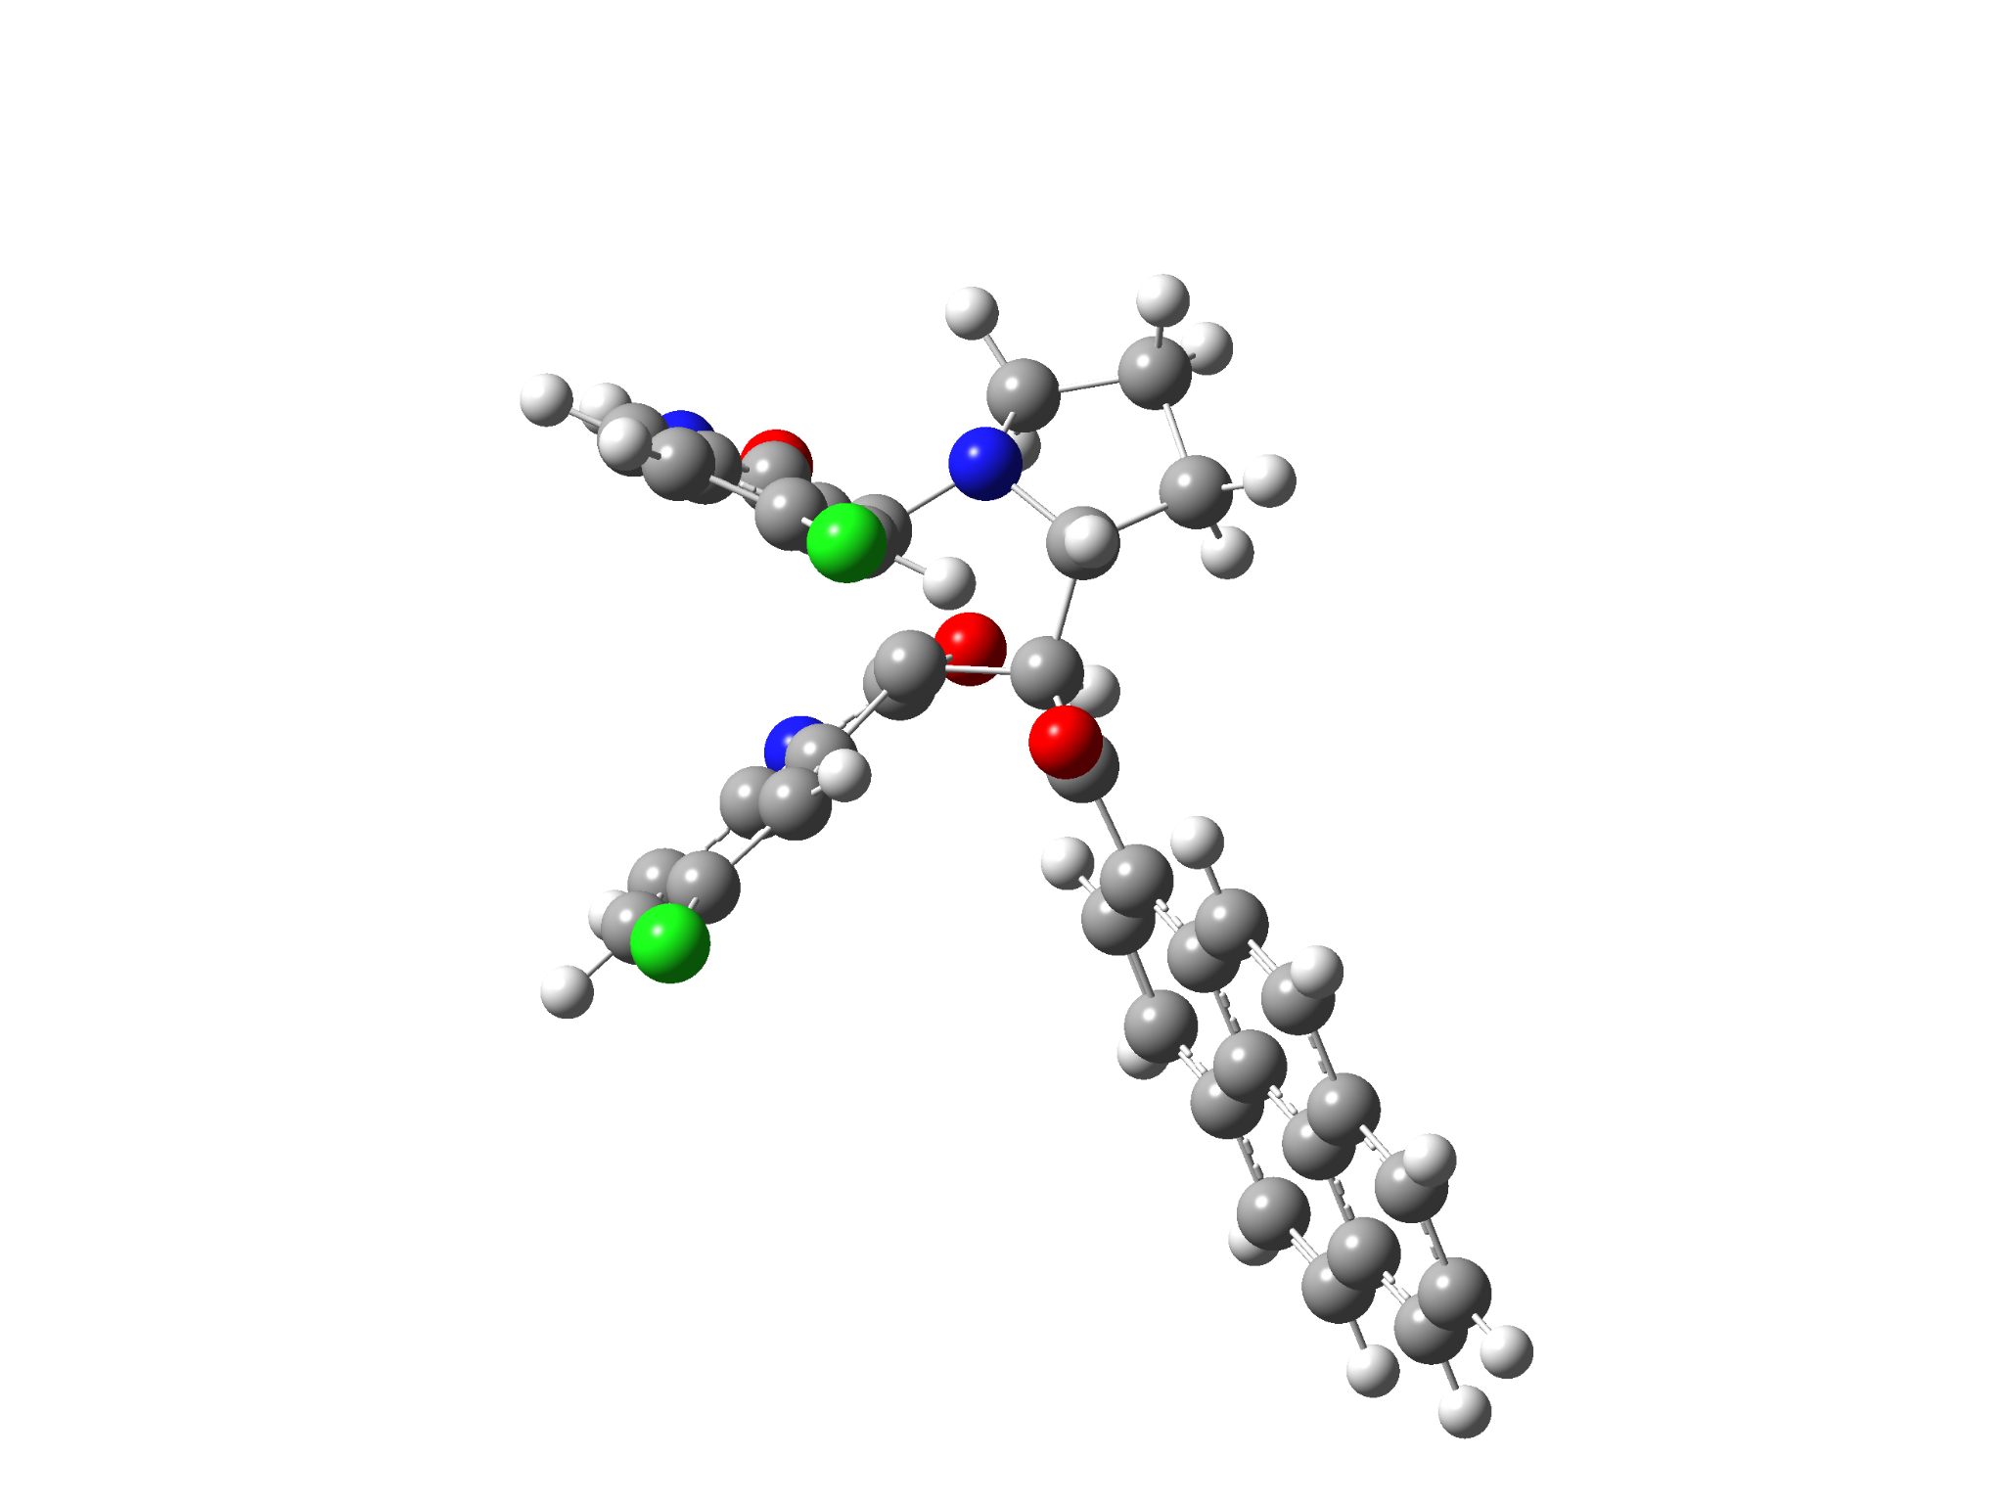

5g-1’R
Standard orientation:
---------------------------------------------------------------------
Center Atomic Atomic Coordinates (Angstroms)
Number Number Type X Y Z
---------------------------------------------------------------------
1 6 0 -4.692350 0.758617 -0.030821
2 6 0 -5.340397 1.987108 -0.037146
3 6 0 -4.700976 3.064845 -0.660897
4 6 0 -3.453847 2.876520 -1.254072
5 6 0 -2.802646 1.636218 -1.239250
6 6 0 -3.429496 0.566205 -0.609848
7 6 0 -3.046963 -0.918812 -0.496196
8 7 0 -5.158132 -0.456936 0.487563
9 6 0 -1.661279 -1.202133 0.320048
10 6 0 -0.605535 -1.352352 -0.838573
11 6 0 -1.429484 -1.303985 -2.177516
12 7 0 -2.844739 -1.490252 -1.812985
13 6 0 -4.301303 -1.500720 0.244260
14 8 0 -4.497577 -2.658051 0.567910
15 6 0 0.540512 -0.331833 -0.829688
16 8 0 0.322363 0.795338 -1.274984
17 6 0 6.765166 1.975055 -1.513540
18 6 0 5.551461 1.322743 -1.230210
19 6 0 5.543902 0.210198 -0.338192
20 6 0 6.772897 -0.222598 0.251101
21 6 0 7.962355 0.458624 -0.058650
22 6 0 7.957419 1.546481 -0.932743
23 6 0 4.317711 -0.464390 -0.038710
24 6 0 4.344798 -1.581854 0.853754
25 6 0 5.591895 -1.995374 1.433679
26 6 0 6.754341 -1.345437 1.146365
27 6 0 4.307696 1.731229 -1.810045
28 6 0 3.133097 1.098349 -1.522763
29 6 0 3.081018 -0.024000 -0.621129
30 6 0 1.878940 -0.736203 -0.306649
31 6 0 1.954378 -1.844772 0.559506
32 6 0 3.145665 -2.253828 1.137230
33 6 0 -1.445748 -0.261385 1.501540
34 6 0 -1.640402 -0.982331 2.696201
35 7 0 -1.861976 -2.331063 2.398256
36 6 0 -1.147909 1.096788 1.576151
37 6 0 -1.067402 1.699528 2.838267
38 6 0 -1.284338 0.982811 4.013625
39 6 0 -1.575094 -0.385047 3.948991
40 6 0 -1.732356 -2.587032 1.053293
41 8 0 -1.606717 -3.692157 0.557332
42 6 0 -1.122440 -2.431195 -3.192765
43 6 0 -3.267644 -2.863115 -2.177910
44 6 0 -2.497287 -3.070724 -3.484863
45 1 0 -1.287231 -0.317378 -2.626423
46 1 0 -0.635066 -2.049975 -4.094576
47 1 0 -0.201369 -2.359621 -0.753804
48 1 0 -0.451605 -3.172409 -2.745613
49 1 0 -6.317754 2.115256 0.417857
50 1 0 -5.172654 4.040677 -0.687291
51 1 0 -1.819720 1.538061 -1.682927
52 1 0 -6.048806 -0.601369 0.941929
53 1 0 6.762637 2.822383 -2.193952
54 1 0 8.893480 0.127336 0.393373
55 1 0 8.886213 2.060894 -1.160587
56 1 0 5.587731 -2.845409 2.110473
57 1 0 7.691102 -1.669603 1.592036
58 1 0 4.308795 2.574061 -2.496517
59 1 0 2.212686 1.448013 -1.965210
60 1 0 1.056842 -2.396976 0.808724
61 1 0 3.156108 -3.104436 1.812775
62 1 0 -1.902826 -3.081228 3.073650
63 1 0 -0.963224 1.686081 0.688847
64 1 0 -1.219283 1.483393 4.973233
65 1 0 -1.733003 -0.958077 4.857400
66 1 0 -2.986740 -3.611971 -1.429952
67 1 0 -4.351805 -2.896550 -2.315635
68 1 0 -2.998384 -2.542402 -4.303428
69 1 0 -2.420666 -4.127711 -3.756199
70 17 0 -2.667265 4.240043 -2.044313
71 17 0 -0.678982 3.413631 2.938365
---------------------------------------------------------------------

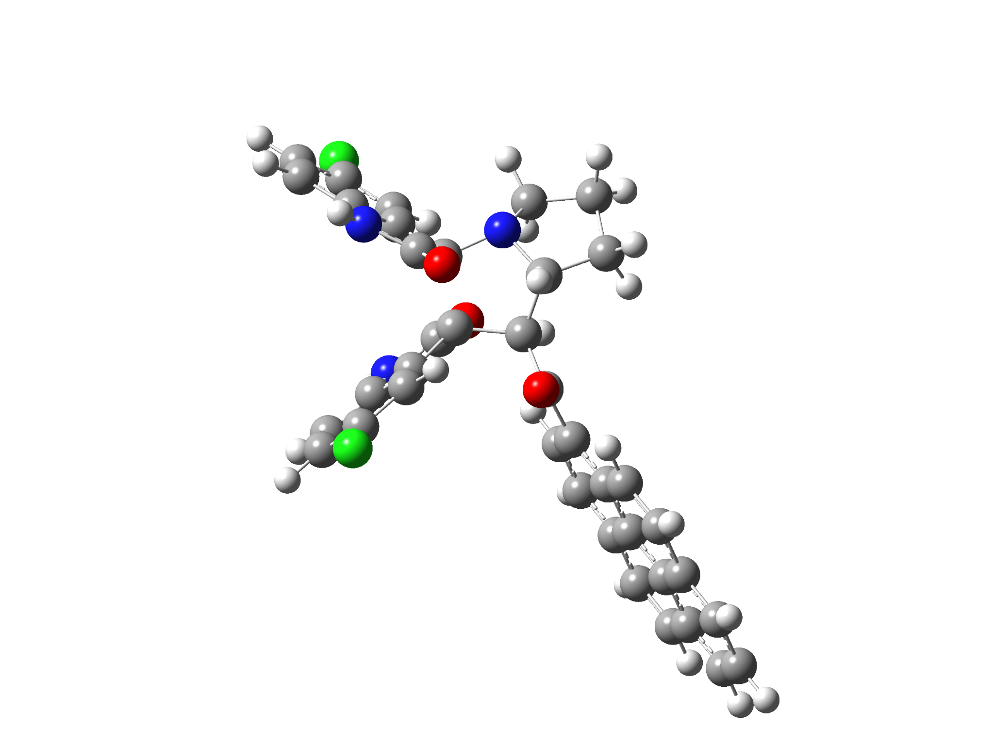

5g-1’S
Standard orientation:
---------------------------------------------------------------------
Center Atomic Atomic Coordinates (Angstroms)
Number Number Type X Y Z
---------------------------------------------------------------------
1 6 0 -4.947541 0.757122 -0.485835
2 6 0 -6.236396 0.813102 0.031777
3 6 0 -6.713919 -0.296456 0.738350
4 6 0 -5.898440 -1.414599 0.903857
5 6 0 -4.597909 -1.465920 0.386469
6 6 0 -4.114363 -0.363361 -0.313565
7 6 0 -2.776196 -0.096629 -0.998436
8 7 0 -4.285018 1.727431 -1.240353
9 6 0 -1.442513 -0.012943 -0.014108
10 6 0 -0.343214 -0.692813 -0.903546
11 6 0 -0.971701 -0.811315 -2.332534
12 7 0 -2.413820 -0.981294 -2.087277
13 6 0 -3.040703 1.308570 -1.654042
14 8 0 -2.320747 1.917163 -2.421740
15 6 0 1.027093 0.000001 -0.942735
16 8 0 1.144271 1.003513 -1.640639
17 6 0 7.666526 0.649441 -1.156255
18 6 0 6.308231 0.361192 -0.930487
19 6 0 5.943095 -0.504149 0.142635
20 6 0 6.967058 -1.064404 0.969099
21 6 0 8.311419 -0.748794 0.708890
22 6 0 8.656658 0.099803 -0.343902
23 6 0 4.565629 -0.807522 0.386250
24 6 0 4.233056 -1.685194 1.465659
25 6 0 5.280225 -2.233446 2.281905
26 6 0 6.588662 -1.936741 2.045660
27 6 0 5.263232 0.903075 -1.745645
28 6 0 3.947173 0.624855 -1.514845
29 6 0 3.535344 -0.237913 -0.436648
30 6 0 2.169981 -0.576588 -0.166898
31 6 0 1.888840 -1.462542 0.891647
32 6 0 2.884418 -1.995444 1.696320
33 6 0 -1.206806 1.356094 0.616866
34 6 0 -1.462076 1.267832 1.997772
35 7 0 -1.774941 -0.058904 2.327208
36 6 0 -0.814495 2.579899 0.078423
37 6 0 -0.713183 3.681942 0.936891
38 6 0 -0.988798 3.589619 2.300570
39 6 0 -1.368760 2.359506 2.850467
40 6 0 -1.678586 -0.890646 1.243647
41 8 0 -1.749756 -2.112672 1.285548
42 6 0 -0.546095 -2.066739 -3.128110
43 6 0 -2.689929 -2.431239 -2.040121
44 6 0 -1.822638 -2.944563 -3.195517
45 1 0 -0.788168 0.120181 -2.868663
46 1 0 -0.180849 -1.805022 -4.124457
47 1 0 -0.241206 -1.710305 -0.523969
48 1 0 0.267048 -2.591695 -2.615258
49 1 0 -6.864467 1.686985 -0.109910
50 1 0 -7.715732 -0.290255 1.153204
51 1 0 -3.988893 -2.344880 0.549146
52 1 0 -4.698975 2.578401 -1.595022
53 1 0 7.936629 1.309906 -1.975900
54 1 0 9.085723 -1.175450 1.340990
55 1 0 9.700882 0.332467 -0.530316
56 1 0 5.003166 -2.896428 3.097044
57 1 0 7.370909 -2.359217 2.670882
58 1 0 5.536414 1.557116 -2.569844
59 1 0 3.185989 1.066952 -2.139610
60 1 0 0.865213 -1.739996 1.109832
61 1 0 2.620946 -2.664349 2.510837
62 1 0 -1.904216 -0.417108 3.263181
63 1 0 -0.586885 2.680335 -0.973799
64 1 0 -0.900071 4.466598 2.931970
65 1 0 -1.572503 2.269274 3.912915
66 1 0 -2.382063 -2.892775 -1.090357
67 1 0 -3.755573 -2.620680 -2.191297
68 1 0 -2.342092 -2.781865 -4.145226
69 1 0 -1.609594 -4.013663 -3.105488
70 17 0 -6.516984 -2.806030 1.789215
71 17 0 -0.217698 5.234752 0.270619
---------------------------------------------------------------------

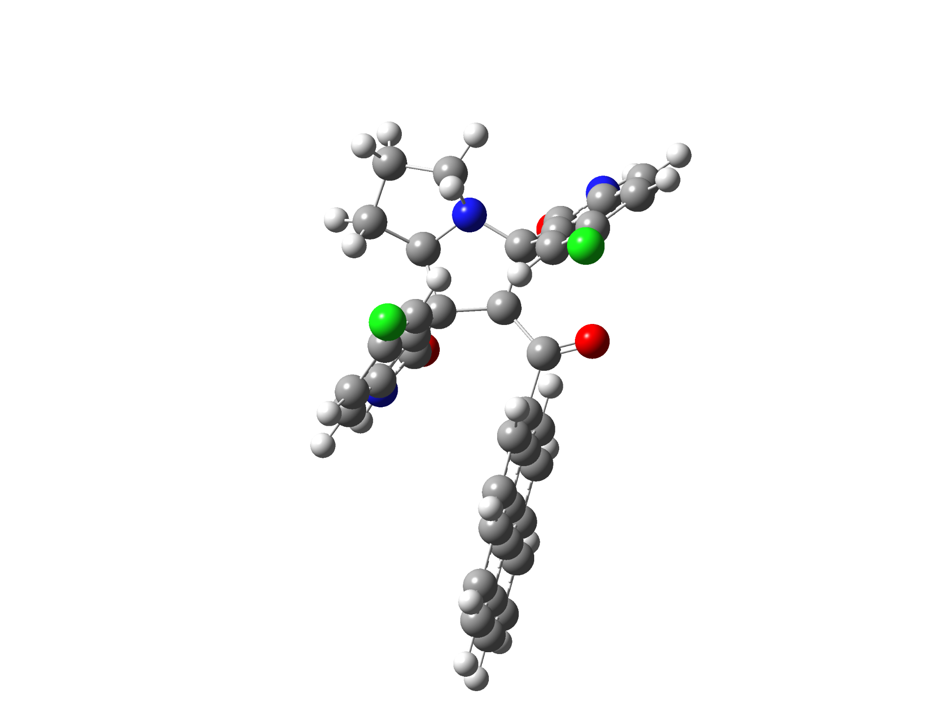

6g-2’R
Standard orientation:
---------------------------------------------------------------------
Center Atomic Atomic Coordinates (Angstroms)
Number Number Type X Y Z
---------------------------------------------------------------------
1 7 0 -2.686279 -1.206501 1.777540
2 6 0 -2.165006 -1.647759 0.484179
3 6 0 -0.665857 -1.166464 0.515872
4 6 0 -0.537197 -0.090510 1.648359
5 6 0 -1.637313 -0.653152 2.636598
6 7 0 -3.165874 -3.631648 -0.366485
7 6 0 -3.670526 -2.565858 -1.122838
8 6 0 -3.082994 -1.358026 -0.705925
9 6 0 -4.591110 -2.625470 -2.161266
10 6 0 -4.930275 -1.436126 -2.817428
11 6 0 -4.337638 -0.238738 -2.424122
12 6 0 -3.413103 -0.186012 -1.372866
13 6 0 -2.174444 -3.221735 0.492621
14 8 0 -1.458524 -3.943628 1.161370
15 6 0 -0.011358 -1.002801 -0.854151
16 8 0 -0.485639 -1.587313 -1.814648
17 6 0 1.252354 -0.192611 -1.027601
18 6 0 2.525750 -0.723774 -0.716422
19 6 0 3.685210 0.079425 -0.968437
20 6 0 3.548190 1.383997 -1.535955
21 6 0 2.264943 1.854065 -1.858607
22 6 0 1.139637 1.073838 -1.613743
23 6 0 4.987200 -0.424686 -0.662409
24 6 0 6.144842 0.379198 -0.903982
25 6 0 5.969523 1.691293 -1.465640
26 6 0 4.730227 2.169134 -1.770573
27 6 0 2.717192 -2.048410 -0.184782
28 6 0 3.960006 -2.527197 0.100465
29 6 0 5.138666 -1.736377 -0.117751
30 6 0 6.427957 -2.211261 0.178914
31 6 0 7.551267 -1.417574 -0.053614
32 6 0 7.413984 -0.136821 -0.589945
33 7 0 1.410223 1.060568 2.341786
34 6 0 0.567998 2.014473 1.766735
35 6 0 -0.614721 1.390812 1.322953
36 6 0 0.855768 -0.200084 2.320106
37 8 0 1.364105 -1.210927 2.771517
38 6 0 0.780634 3.382325 1.644282
39 6 0 -0.231033 4.162881 1.072879
40 6 0 -1.419423 3.560978 0.662593
41 6 0 -1.627270 2.181126 0.790784
42 6 0 -3.980483 -0.566377 2.006253
43 6 0 -2.373668 0.296126 3.601117
44 6 0 -3.854919 -0.126463 3.472350
45 1 0 -1.136719 -1.460409 3.186413
46 1 0 -0.130530 -2.029128 0.950044
47 1 0 -3.332731 -4.609253 -0.560483
48 1 0 -5.031673 -3.567832 -2.471743
49 1 0 -5.642382 -1.445760 -3.634946
50 1 0 -2.953219 0.761119 -1.127066
51 1 0 2.153170 2.837152 -2.307539
52 1 0 0.158091 1.453310 -1.880054
53 1 0 6.852750 2.297280 -1.650318
54 1 0 4.613413 3.159297 -2.203289
55 1 0 1.855255 -2.682389 -0.008172
56 1 0 4.074389 -3.528296 0.506647
57 1 0 6.541357 -3.209425 0.593201
58 1 0 8.540034 -1.800203 0.181941
59 1 0 8.293750 0.474683 -0.772405
60 1 0 2.332146 1.235158 2.716210
61 1 0 1.703309 3.842685 1.983483
62 1 0 -0.099370 5.233278 0.961072
63 1 0 -2.581648 1.762109 0.502003
64 1 0 -4.165907 0.301180 1.351228
65 1 0 -4.803138 -1.272580 1.849973
66 1 0 -2.254348 1.338655 3.293556
67 1 0 -1.999037 0.207846 4.624404
68 1 0 -4.067183 -0.975586 4.130571
69 1 0 -4.547758 0.681529 3.724981
70 17 0 -2.702791 4.555795 -0.016623
71 17 0 -4.749920 1.248987 -3.270996
---------------------------------------------------------------------

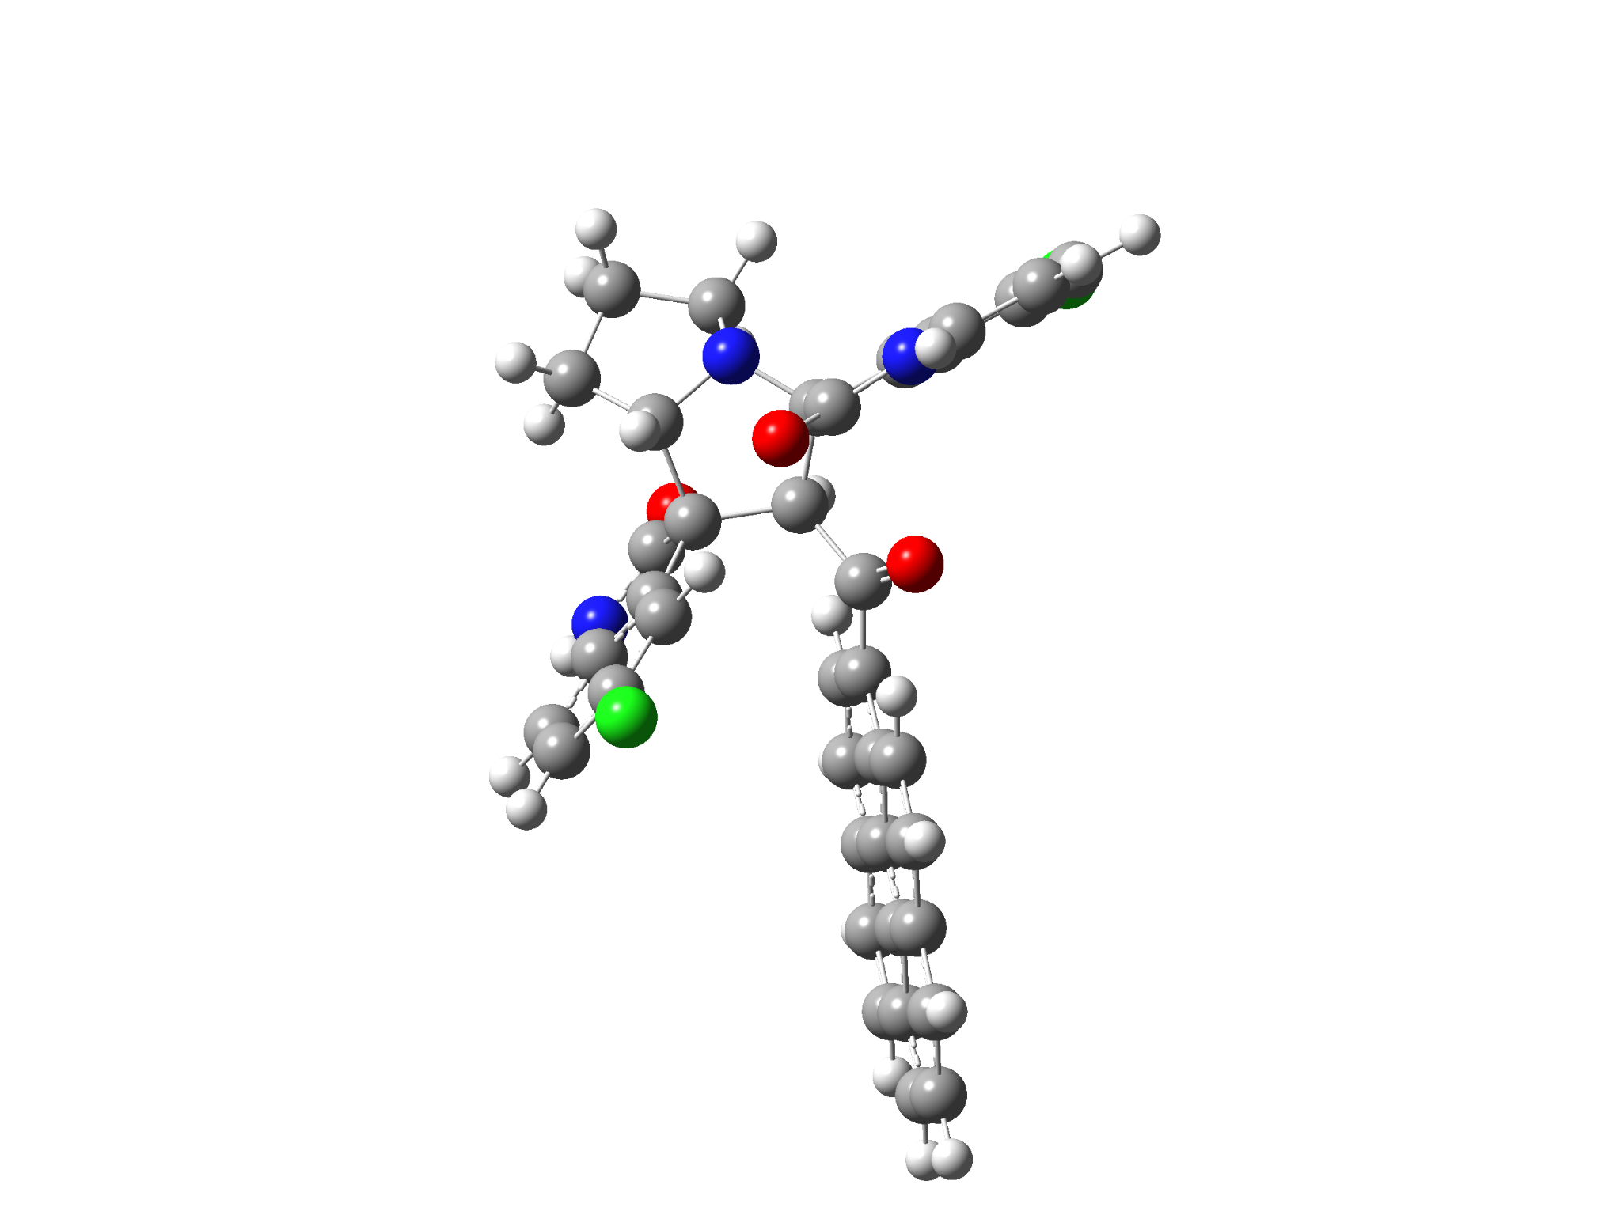

6g-2’S
Standard orientation:
---------------------------------------------------------------------
Center Atomic Atomic Coordinates (Angstroms)
Number Number Type X Y Z
---------------------------------------------------------------------
1 7 0 3.473248 -1.450313 0.078829
2 6 0 2.765889 -0.339123 -0.574104
3 6 0 1.462353 -0.148297 0.269301
4 6 0 1.139752 -1.548070 0.900506
5 6 0 2.456159 -2.404604 0.531692
6 7 0 3.275078 0.038100 -2.860156
7 6 0 3.849122 1.089699 -2.144479
8 6 0 3.582520 0.925583 -0.774954
9 6 0 4.572886 2.174932 -2.625322
10 6 0 5.034102 3.123553 -1.703644
11 6 0 4.758372 2.969678 -0.345771
12 6 0 4.027347 1.875256 0.135170
13 6 0 2.538838 -0.801259 -2.054673
14 8 0 1.920450 -1.778632 -2.439969
15 6 0 0.330679 0.579747 -0.465318
16 8 0 0.465450 0.831980 -1.657706
17 6 0 -0.882750 1.003172 0.299011
18 6 0 -2.167780 1.092320 -0.316834
19 6 0 -3.275564 1.560003 0.464682
20 6 0 -3.087853 1.955506 1.826508
21 6 0 -1.807360 1.857668 2.392180
22 6 0 -0.738790 1.378246 1.646853
23 6 0 -4.583161 1.643872 -0.109902
24 6 0 -5.684808 2.124098 0.664868
25 6 0 -5.452831 2.520178 2.026464
26 6 0 -4.210971 2.439450 2.581064
27 6 0 -2.425525 0.694884 -1.676743
28 6 0 -3.676687 0.766243 -2.214924
29 6 0 -4.798081 1.247136 -1.463107
30 6 0 -6.090452 1.334924 -2.011033
31 6 0 -7.158095 1.805385 -1.248025
32 6 0 -6.958838 2.197242 0.076475
33 7 0 -0.194868 -2.059114 2.780326
34 6 0 -0.869113 -2.576166 1.663137
35 6 0 -0.133358 -2.276999 0.504218
36 6 0 0.945062 -1.380521 2.425983
37 8 0 1.661632 -0.752697 3.195449
38 6 0 -2.062079 -3.285501 1.623294
39 6 0 -2.530476 -3.710322 0.372995
40 6 0 -1.796482 -3.425461 -0.777932
41 6 0 -0.589249 -2.715453 -0.734460
42 6 0 4.383167 -1.185406 1.211086
43 6 0 3.142292 -3.232624 1.645196
44 6 0 4.540071 -2.583586 1.818306
45 1 0 2.152070 -3.030753 -0.308202
46 1 0 1.766081 0.481114 1.113036
47 1 0 3.260000 -0.047929 -3.866345
48 1 0 4.774045 2.297872 -3.684827
49 1 0 5.600635 3.982937 -2.044650
50 1 0 3.826369 1.786754 1.197114
51 1 0 -1.652605 2.163615 3.423108
52 1 0 0.232419 1.325996 2.125068
53 1 0 -6.293035 2.887775 2.609799
54 1 0 -4.046739 2.741567 3.611918
55 1 0 -1.602601 0.342341 -2.281523
56 1 0 -3.838864 0.450980 -3.242283
57 1 0 -6.248543 1.030075 -3.042032
58 1 0 -8.149743 1.867935 -1.686274
59 1 0 -7.793497 2.565297 0.667247
60 1 0 -0.544740 -2.055579 3.728191
61 1 0 -2.623240 -3.508485 2.525460
62 1 0 -3.460520 -4.262586 0.298283
63 1 0 -0.022935 -2.515316 -1.637461
64 1 0 5.325902 -0.768825 0.848131
65 1 0 3.953094 -0.498498 1.954893
66 1 0 3.218222 -4.283079 1.352631
67 1 0 2.580853 -3.201237 2.581582
68 1 0 4.856165 -2.541697 2.864223
69 1 0 5.291742 -3.147520 1.257020
70 17 0 5.337725 4.178395 0.796608
71 17 0 -2.402715 -3.980805 -2.335778
---------------------------------------------------------------------

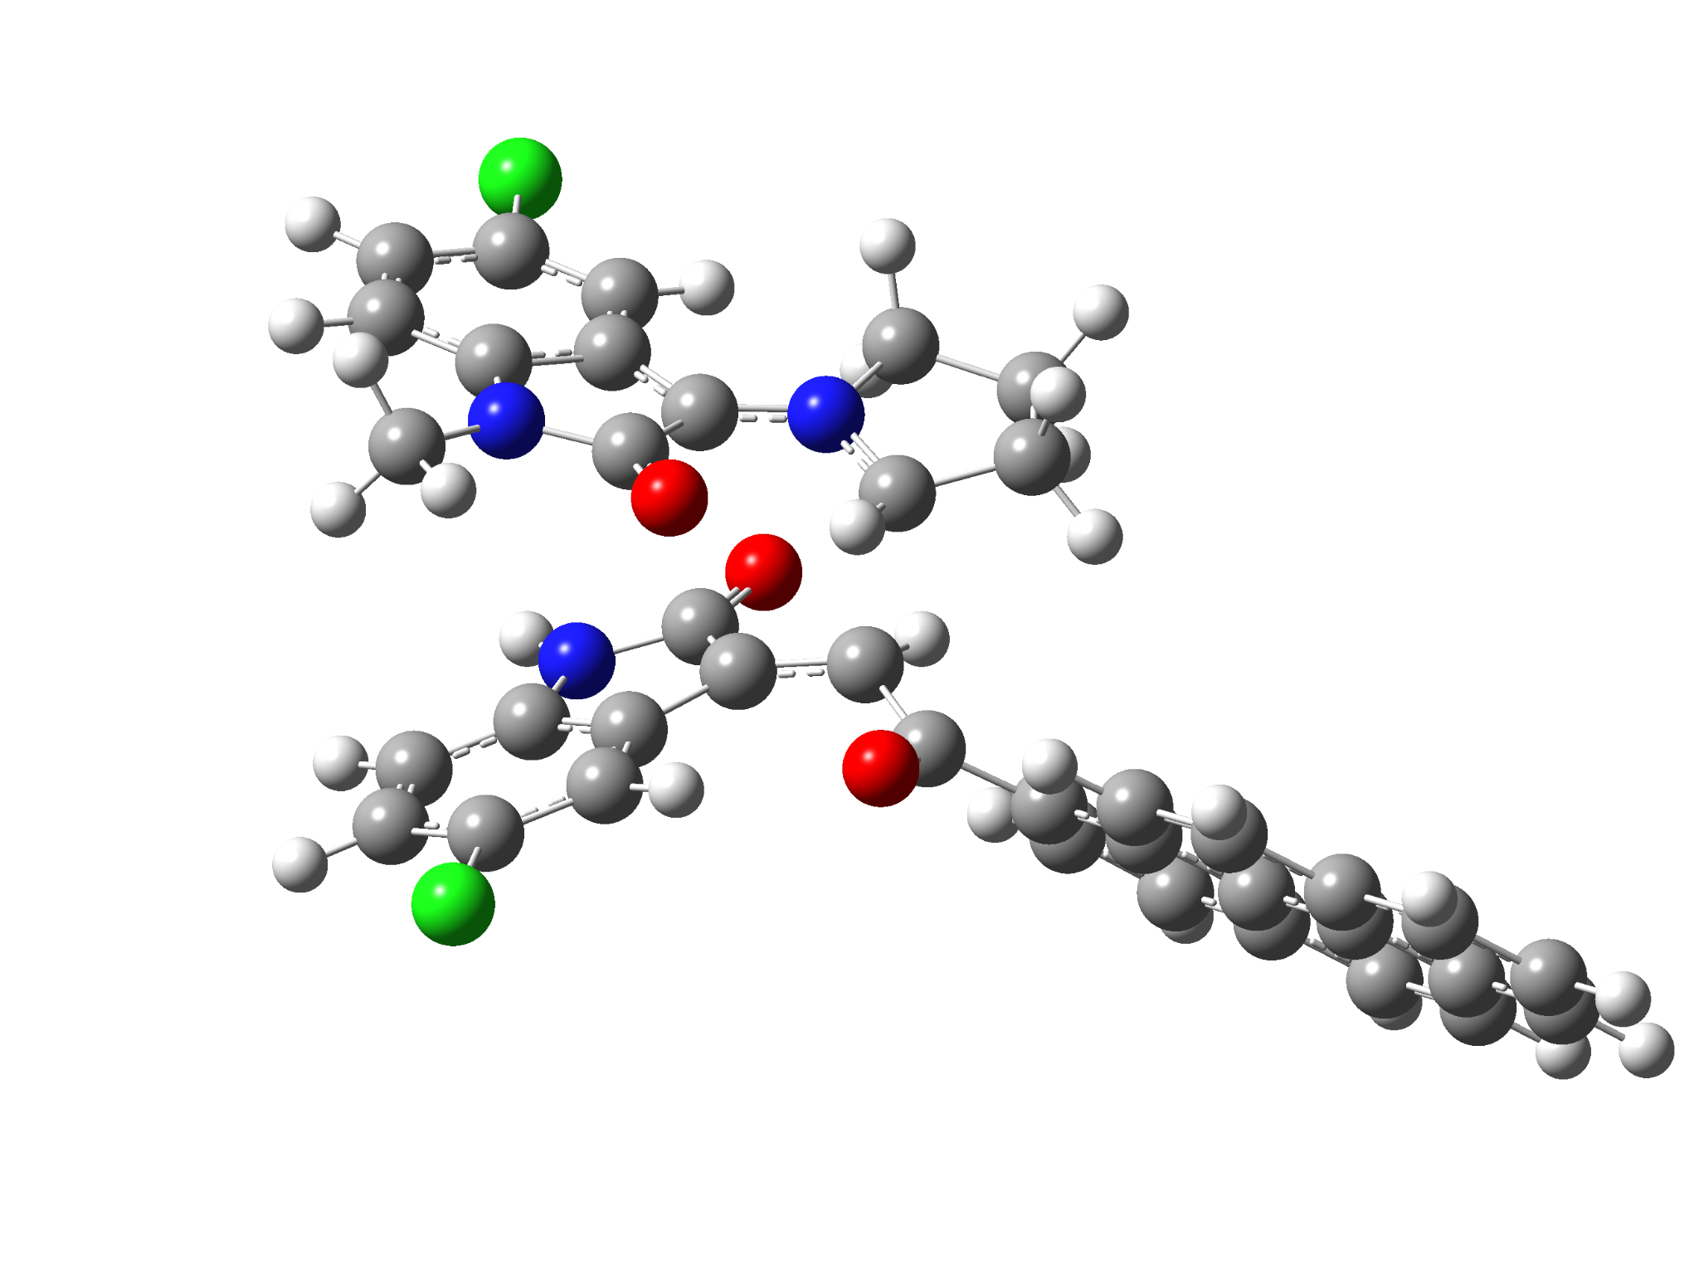

5k-exo-TS
Standard orientation:
---------------------------------------------------------------------
Center Atomic Atomic Coordinates (Angstroms)
Number Number Type X Y Z
---------------------------------------------------------------------
1 6 0 -4.785622 -0.097124 -1.069629
2 6 0 -6.135823 -0.128378 -0.744537
3 6 0 -6.664403 -1.303242 -0.191774
4 6 0 -5.831136 -2.400928 0.028823
5 6 0 -4.469756 -2.379911 -0.284954
6 6 0 -3.929724 -1.216027 -0.849151
7 6 0 -2.607876 -0.793107 -1.256817
8 7 0 -4.058718 0.947431 -1.627990
9 6 0 -1.048656 0.267359 0.925335
10 6 0 0.136141 -0.302716 0.428125
11 6 0 -0.236698 -0.978692 -1.550506
12 7 0 -1.474995 -1.524932 -1.413839
13 6 0 -2.726357 0.581185 -1.801671
14 8 0 -1.871802 1.286470 -2.339211
15 6 0 1.381724 0.481677 0.148908
16 8 0 1.341205 1.537063 -0.481328
17 6 0 7.693260 0.627404 -1.972396
18 6 0 6.446858 0.466422 -1.341277
19 6 0 6.371740 -0.255345 -0.112902
20 6 0 7.565099 -0.802031 0.454454
21 6 0 8.789494 -0.616659 -0.210135
22 6 0 8.851234 0.090600 -1.411372
23 6 0 5.112253 -0.429642 0.543320
24 6 0 5.063567 -1.160040 1.772086
25 6 0 6.278245 -1.694863 2.322426
26 6 0 7.474562 -1.524730 1.692857
27 6 0 5.234934 1.003381 -1.887122
28 6 0 4.031985 0.848836 -1.262651
29 6 0 3.915891 0.127544 -0.020390
30 6 0 2.675514 -0.090641 0.650488
31 6 0 2.662839 -0.826370 1.849722
32 6 0 3.825194 -1.337823 2.409326
33 6 0 -1.574047 1.617260 1.053216
34 6 0 -2.725437 1.538815 1.886928
35 7 0 -2.924221 0.210317 2.261501
36 6 0 -1.192803 2.860110 0.530001
37 6 0 -1.951952 3.980611 0.875358
38 6 0 -3.072723 3.900130 1.705026
39 6 0 -3.474023 2.658491 2.219476
40 6 0 -1.959218 -0.616834 1.709741
41 8 0 -1.885214 -1.836442 1.880016
42 6 0 0.743228 -2.068032 -1.902638
43 6 0 -1.418087 -3.002306 -1.229514
44 6 0 0.082165 -3.340572 -1.327410
45 1 0 -0.187829 0.023273 -1.960794
46 1 0 0.848161 -2.123703 -2.995014
47 1 0 0.294628 -1.305108 0.815198
48 1 0 1.741037 -1.886687 -1.495756
49 1 0 -6.775859 0.730320 -0.916769
50 1 0 -7.716546 -1.362771 0.062698
51 1 0 -3.868239 -3.252087 -0.073862
52 1 0 7.744693 1.179469 -2.907043
53 1 0 9.694868 -1.031407 0.225021
54 1 0 9.806282 0.224641 -1.910602
55 1 0 6.221319 -2.243178 3.258849
56 1 0 8.384981 -1.935834 2.121085
57 1 0 5.288582 1.554069 -2.822776
58 1 0 3.143332 1.292963 -1.688464
59 1 0 1.725040 -0.972753 2.374820
60 1 0 3.781075 -1.881853 3.348685
61 1 0 -3.688831 -0.143922 2.816730
62 1 0 -0.340982 2.939808 -0.130930
63 1 0 -3.630871 4.797487 1.948044
64 1 0 -4.345967 2.586127 2.862513
65 1 0 -1.828390 -3.258367 -0.253730
66 1 0 -2.021171 -3.464154 -2.017881
67 1 0 0.257687 -4.220535 -1.950220
68 1 0 0.477090 -3.556736 -0.331336
69 17 0 -1.486190 5.556165 0.231360
70 17 0 -6.515419 -3.868589 0.726858
71 6 0 -4.585413 2.243780 -2.006015
72 1 0 -3.764366 2.817075 -2.437928
73 1 0 -5.383361 2.137122 -2.749431
74 1 0 -4.974022 2.775937 -1.130858
---------------------------------------------------------------------

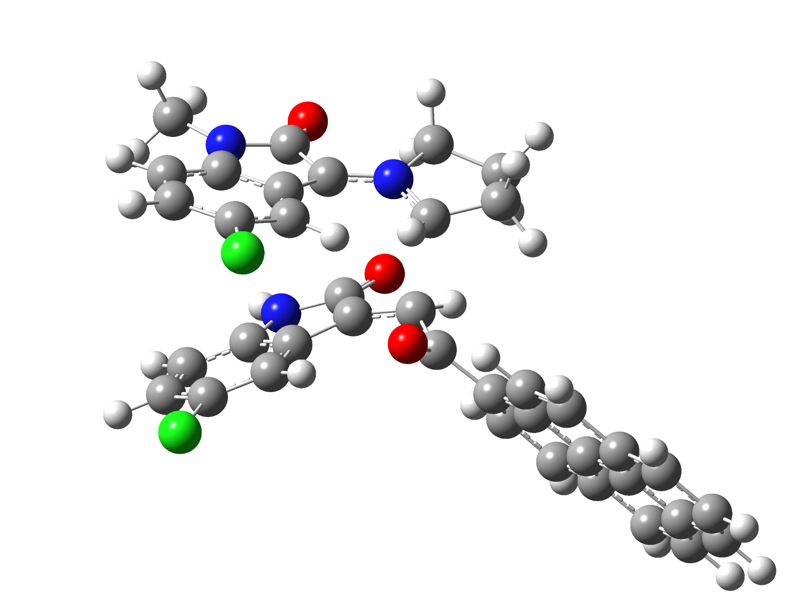

5k-endo-TS
Standard orientation:
---------------------------------------------------------------------
Center Atomic Atomic Coordinates (Angstroms)
Number Number Type X Y Z
---------------------------------------------------------------------
1 6 0 -4.666536 0.092398 -1.034993
2 6 0 -5.346064 1.300512 -1.096848
3 6 0 -4.644480 2.443427 -1.505689
4 6 0 -3.291815 2.344172 -1.826787
5 6 0 -2.590298 1.137139 -1.741709
6 6 0 -3.284125 -0.019174 -1.358431
7 6 0 -2.951284 -1.424711 -1.225477
8 7 0 -5.174745 -1.161274 -0.706682
9 6 0 -1.155868 -0.942790 1.116030
10 6 0 -0.024328 -1.194950 0.322061
11 6 0 -0.588604 -1.511710 -1.679588
12 7 0 -1.822135 -2.077825 -1.589842
13 6 0 -4.199259 -2.144167 -0.851896
14 8 0 -4.397259 -3.348024 -0.689729
15 6 0 1.033684 -0.153727 0.085621
16 8 0 0.737574 0.913979 -0.455968
17 6 0 7.115478 1.770546 -1.858121
18 6 0 5.947933 1.231467 -1.288540
19 6 0 6.056844 0.318669 -0.197816
20 6 0 7.351985 -0.031875 0.296585
21 6 0 8.492105 0.530839 -0.302259
22 6 0 8.373650 1.422481 -1.369061
23 6 0 4.879750 -0.239594 0.393954
24 6 0 5.018521 -1.154516 1.484693
25 6 0 6.331060 -1.486828 1.964285
26 6 0 7.447714 -0.950876 1.396360
27 6 0 4.637972 1.564614 -1.763917
28 6 0 3.510700 1.042480 -1.199493
29 6 0 3.579007 0.119062 -0.095870
30 6 0 2.430382 -0.478943 0.508008
31 6 0 2.607102 -1.385128 1.571428
32 6 0 3.863582 -1.708618 2.060169
33 6 0 -1.775479 0.238747 1.687356
34 6 0 -2.789601 -0.211946 2.580698
35 7 0 -2.824805 -1.604513 2.561579
36 6 0 -1.562130 1.616619 1.539893
37 6 0 -2.344152 2.492871 2.295241
38 6 0 -3.333870 2.043735 3.172784
39 6 0 -3.566543 0.669263 3.319347
40 6 0 -1.847835 -2.118017 1.716733
41 8 0 -1.602349 -3.312630 1.551042
42 6 0 0.373477 -2.508584 -2.278310
43 6 0 -1.759506 -3.567465 -1.776382
44 6 0 -0.256831 -3.858639 -1.880801
45 1 0 -0.527808 -0.459004 -1.913990
46 1 0 0.410485 -2.384371 -3.369861
47 1 0 0.334615 -2.213676 0.440781
48 1 0 1.393871 -2.382374 -1.905573
49 1 0 -6.399472 1.367595 -0.846775
50 1 0 -5.146974 3.401913 -1.567230
51 1 0 -1.530077 1.141290 -1.952075
52 1 0 7.025556 2.466576 -2.687827
53 1 0 9.474568 0.263553 0.077697
54 1 0 9.265673 1.847973 -1.819023
55 1 0 6.414496 -2.181198 2.795860
56 1 0 8.434404 -1.212431 1.769510
57 1 0 4.550578 2.259961 -2.594855
58 1 0 2.538567 1.338661 -1.565974
59 1 0 1.736375 -1.822407 2.047166
60 1 0 3.960130 -2.396541 2.895339
61 1 0 -3.428004 -2.195020 3.114235
62 1 0 -0.811185 1.994466 0.858926
63 1 0 -3.919588 2.759912 3.738098
64 1 0 -4.332741 0.312426 4.001125
65 1 0 -2.254200 -4.062898 -0.946019
66 1 0 -2.305285 -3.798512 -2.697190
67 1 0 -0.048446 -4.650848 -2.603692
68 1 0 0.119698 -4.183191 -0.907057
69 6 0 -6.549834 -1.452401 -0.359203
70 1 0 -6.846234 -0.908438 0.544468
71 1 0 -7.227330 -1.180007 -1.177076
72 1 0 -6.621401 -2.525502 -0.176748
73 17 0 -2.425971 3.787588 -2.344440
74 17 0 -2.076807 4.228558 2.134398
---------------------------------------------------------------------

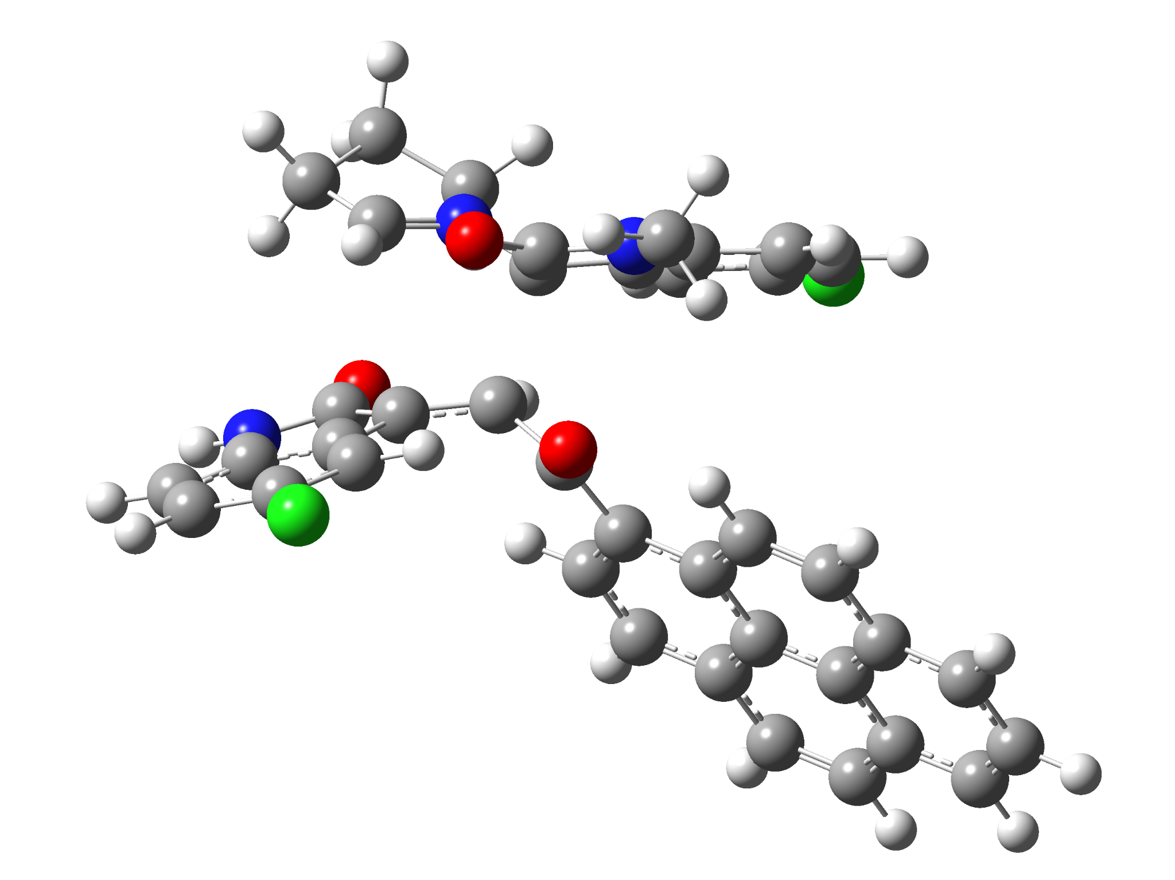

6k-exo-TS
Standard orientation:
---------------------------------------------------------------------
Center Atomic Atomic Coordinates (Angstroms)
Number Number Type X Y Z
---------------------------------------------------------------------
1 7 0 -2.838693 2.238472 0.012407
2 6 0 -1.692981 1.747117 0.656857
3 6 0 -1.258242 0.177597 -0.630533
4 6 0 -2.441616 -0.483675 -1.026374
5 6 0 -3.982791 1.580960 -0.038631
6 7 0 -0.834575 1.481837 2.799002
7 6 0 0.061787 2.276137 2.085314
8 6 0 -0.448532 2.529859 0.789083
9 6 0 1.288316 2.782356 2.500934
10 6 0 2.023322 3.570089 1.604594
11 6 0 1.527035 3.814461 0.324803
12 6 0 0.302038 3.291143 -0.106464
13 6 0 -1.937601 1.160967 2.024008
14 8 0 -2.934801 0.566760 2.420540
15 6 0 -0.147253 -0.584428 0.053622
16 8 0 -0.322081 -1.067869 1.170582
17 6 0 1.138978 -0.740688 -0.699836
18 6 0 2.383304 -1.016923 -0.053461
19 6 0 3.562749 -1.165061 -0.858533
20 6 0 3.486762 -1.067541 -2.283142
21 6 0 2.242171 -0.816003 -2.881167
22 6 0 1.106123 -0.646772 -2.104645
23 6 0 4.832295 -1.419336 -0.248526
24 6 0 6.005268 -1.571861 -1.052329
25 6 0 5.884915 -1.467768 -2.479950
26 6 0 4.679394 -1.227835 -3.067481
27 6 0 2.533759 -1.130295 1.374919
28 6 0 3.747566 -1.369172 1.950089
29 6 0 4.939042 -1.524854 1.169944
30 6 0 6.194137 -1.775955 1.752858
31 6 0 7.331860 -1.921533 0.960623
32 6 0 7.239516 -1.821174 -0.428064
33 7 0 -4.071289 -1.040264 -2.542907
34 6 0 -4.101569 -2.016050 -1.544100
35 6 0 -3.114628 -1.700008 -0.573074
36 6 0 -3.079690 -0.095260 -2.299317
37 8 0 -2.825168 0.857758 -3.052245
38 6 0 -4.929335 -3.124806 -1.428378
39 6 0 -4.775858 -3.952322 -0.308022
40 6 0 -3.815018 -3.638532 0.655963
41 6 0 -2.982990 -2.521514 0.552525
42 6 0 -2.822669 3.384952 -0.943272
43 6 0 -4.976132 2.261305 -0.923235
44 6 0 -4.315247 3.630075 -1.207926
45 1 0 -4.151764 0.741671 0.619935
46 1 0 -0.911412 0.863526 -1.399141
47 1 0 1.676436 2.579730 3.493279
48 1 0 2.980369 3.984225 1.900885
49 1 0 -0.029250 3.477628 -1.120868
50 1 0 2.172403 -0.751758 -3.963375
51 1 0 0.163117 -0.464682 -2.607144
52 1 0 6.779378 -1.585274 -3.086070
53 1 0 4.598151 -1.151015 -4.148323
54 1 0 1.651553 -1.043979 1.991356
55 1 0 3.824170 -1.452344 3.031445
56 1 0 6.267588 -1.857238 2.834146
57 1 0 8.293947 -2.115540 1.425519
58 1 0 8.128080 -1.937540 -1.042907
59 1 0 -4.602436 -1.053804 -3.400831
60 1 0 -5.677916 -3.353691 -2.181255
61 1 0 -5.402306 -4.828386 -0.184241
62 1 0 -2.261778 -2.291229 1.325267
63 1 0 -2.308135 4.230463 -0.485746
64 1 0 -2.296969 3.064040 -1.846913
65 1 0 -5.959889 2.339604 -0.449938
66 1 0 -5.100650 1.678018 -1.845418
67 1 0 -4.488296 3.976714 -2.228355
68 1 0 -4.700495 4.386844 -0.517278
69 6 0 -0.646202 0.999137 4.152104
70 1 0 -1.529873 0.418555 4.418983
71 1 0 0.239146 0.356984 4.214513
72 1 0 -0.536982 1.835812 4.850917
73 17 0 2.467187 4.800865 -0.791317
74 17 0 -3.655410 -4.689193 2.066632
---------------------------------------------------------------------

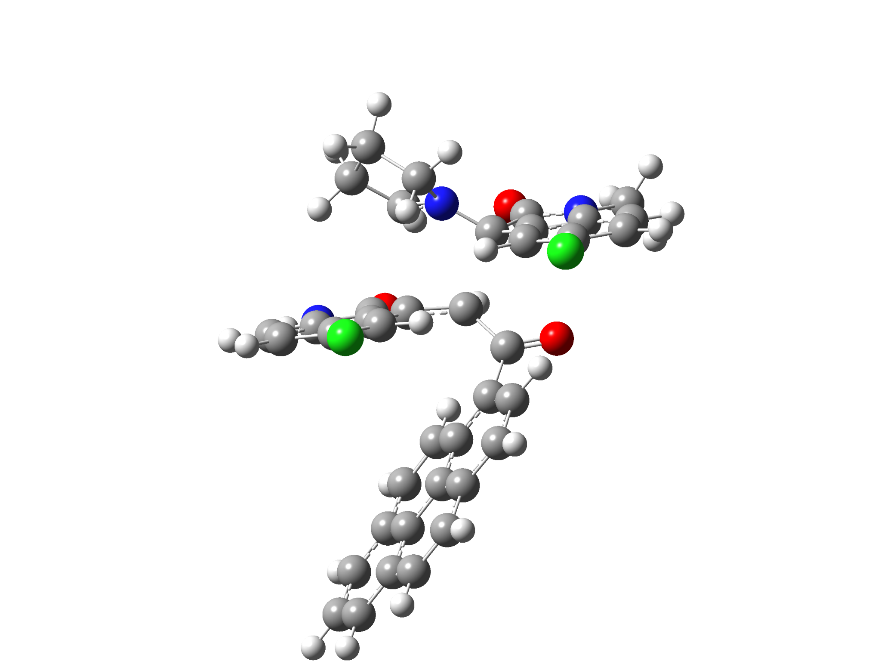

6k-endo-TS
Standard orientation:
---------------------------------------------------------------------
Center Atomic Atomic Coordinates (Angstroms)
Number Number Type X Y Z
---------------------------------------------------------------------
1 7 0 -2.970317 -1.597392 0.532669
2 6 0 -2.882802 -0.659838 -0.517097
3 6 0 -0.950310 -0.956526 -1.158735
4 6 0 -0.252446 -1.776152 -0.225132
5 6 0 -2.536225 -2.839839 0.396752
6 7 0 -4.281399 0.068757 -2.240941
7 6 0 -4.070518 1.150338 -1.386118
8 6 0 -3.277062 0.750002 -0.288114
9 6 0 -4.542962 2.451119 -1.515357
10 6 0 -4.224869 3.376812 -0.513524
11 6 0 -3.442830 2.985985 0.572855
12 6 0 -2.949559 1.681227 0.695166
13 6 0 -3.650843 -1.065490 -1.766992
14 8 0 -3.725590 -2.184227 -2.258717
15 6 0 -0.526358 0.415709 -1.633700
16 8 0 -1.248178 1.018663 -2.421271
17 6 0 0.758490 1.056730 -1.185028
18 6 0 2.034570 0.469923 -1.366421
19 6 0 3.188340 1.172190 -0.888918
20 6 0 3.046084 2.443946 -0.251988
21 6 0 1.765763 3.011521 -0.143084
22 6 0 0.649188 2.336223 -0.620414
23 6 0 4.492396 0.608463 -1.051010
24 6 0 5.641647 1.297113 -0.552058
25 6 0 5.458202 2.564133 0.101788
26 6 0 4.218862 3.113261 0.240623
27 6 0 2.239992 -0.772652 -2.065919
28 6 0 3.485846 -1.300872 -2.229805
29 6 0 4.655278 -0.643649 -1.717710
30 6 0 5.945659 -1.181441 -1.865369
31 6 0 7.060341 -0.507086 -1.366777
32 6 0 6.912198 0.718860 -0.717440
33 7 0 0.868032 -3.645229 0.506892
34 6 0 1.053660 -2.664782 1.474748
35 6 0 0.375428 -1.486375 1.054231
36 6 0 0.109066 -3.165509 -0.569044
37 8 0 -0.160245 -3.826308 -1.574722
38 6 0 1.746255 -2.729948 2.678476
39 6 0 1.769337 -1.594385 3.499530
40 6 0 1.102243 -0.435712 3.094618
41 6 0 0.407550 -0.359484 1.885007
42 6 0 -3.226504 -1.262896 1.963585
43 6 0 -2.591706 -3.593003 1.685952
44 6 0 -3.393731 -2.646630 2.610242
45 1 0 -2.386325 -3.265864 -0.586576
46 1 0 -1.232306 -1.548129 -2.033430
47 1 0 -5.141411 2.754092 -2.367482
48 1 0 -4.581240 4.398504 -0.581732
49 1 0 -2.322341 1.427782 1.541334
50 1 0 1.652292 3.987838 0.319983
51 1 0 -0.333425 2.790258 -0.541268
52 1 0 6.334851 3.082540 0.481393
53 1 0 4.094755 4.075301 0.730550
54 1 0 1.388515 -1.295326 -2.485744
55 1 0 3.608867 -2.238096 -2.766077
56 1 0 6.066745 -2.132655 -2.376944
57 1 0 8.050288 -0.937247 -1.487818
58 1 0 7.784677 1.241118 -0.333668
59 1 0 1.321909 -4.546198 0.478930
60 1 0 2.265433 -3.634291 2.981932
61 1 0 2.303012 -1.610714 4.442907
62 1 0 -0.065443 0.570467 1.594131
63 1 0 -2.363342 -0.727438 2.365921
64 1 0 -4.108829 -0.626148 2.037133
65 1 0 -1.567554 -3.759035 2.049920
66 1 0 -3.050246 -4.578973 1.564679
67 1 0 -4.449759 -2.933410 2.612718
68 1 0 -3.036925 -2.654814 3.642147
69 17 0 -3.052820 4.162578 1.824348
70 17 0 1.137164 0.982556 4.145970
71 6 0 -4.995486 0.119175 -3.501827
72 1 0 -6.033182 0.434622 -3.347607
73 1 0 -4.503349 0.812777 -4.192352
74 1 0 -4.984727 -0.885010 -3.927005
---------------------------------------------------------------------

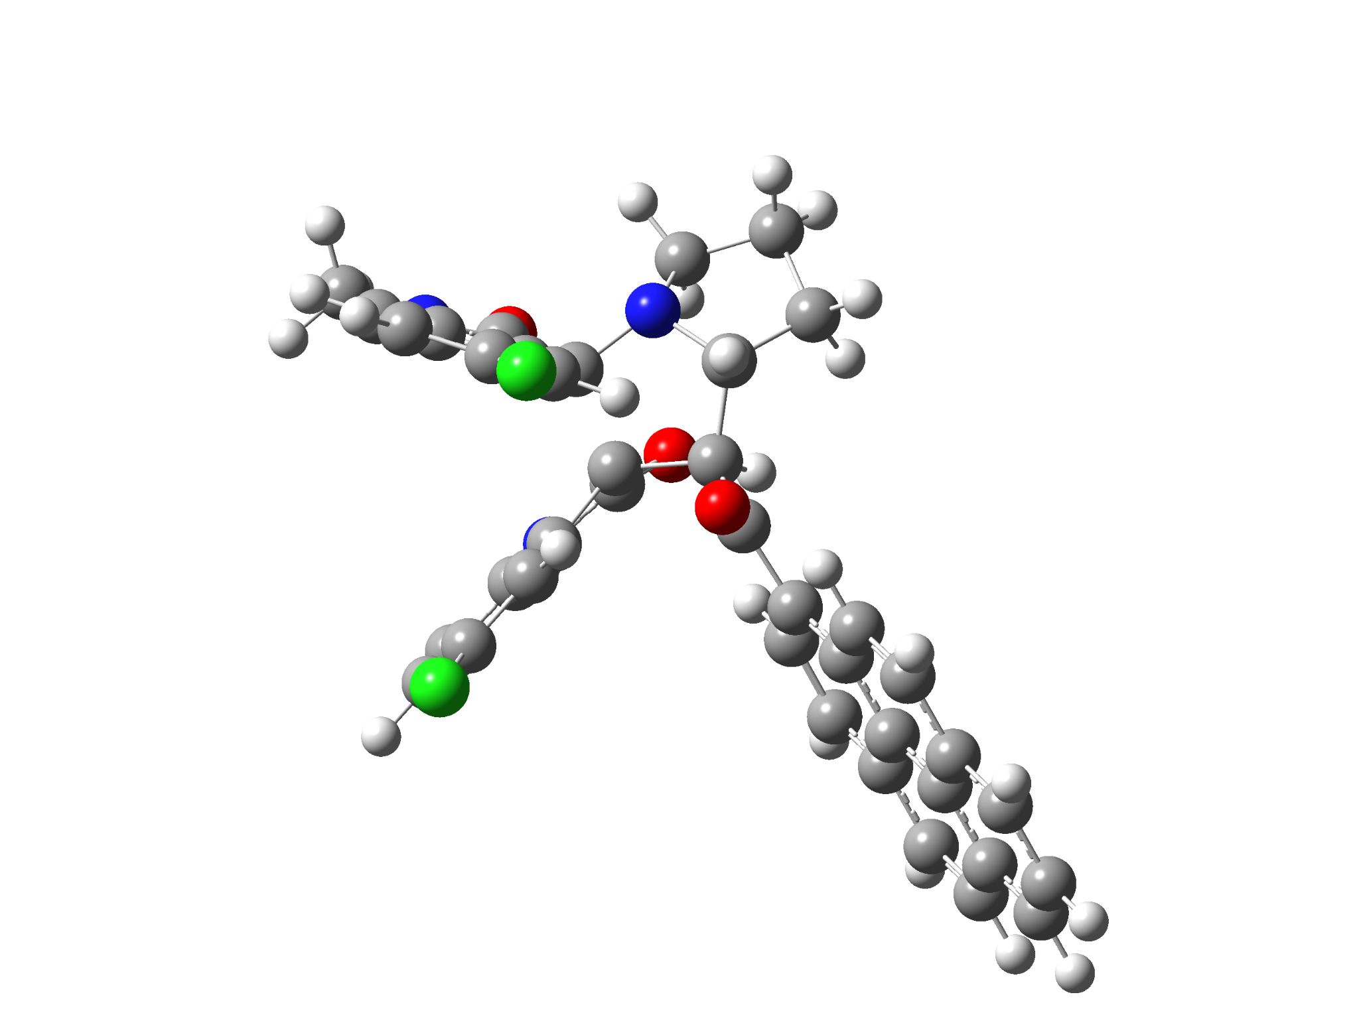

5k-1’R
Standard orientation:
---------------------------------------------------------------------
Center Atomic Atomic Coordinates (Angstroms)
Number Number Type X Y Z
---------------------------------------------------------------------
1 6 0 -4.530198 0.808255 -0.124447
2 6 0 -5.168500 2.043206 -0.123290
3 6 0 -4.509480 3.126880 -0.718042
4 6 0 -3.254008 2.939544 -1.290778
5 6 0 -2.611488 1.693557 -1.283502
6 6 0 -3.257355 0.619570 -0.683720
7 6 0 -2.890479 -0.867235 -0.585013
8 7 0 -5.027290 -0.407255 0.370151
9 6 0 -1.520592 -1.175614 0.248663
10 6 0 -0.447413 -1.315927 -0.895048
11 6 0 -1.249608 -1.238451 -2.246112
12 7 0 -2.671438 -1.420891 -1.907330
13 6 0 -4.158869 -1.444738 0.124508
14 8 0 -4.358119 -2.609523 0.429379
15 6 0 0.707572 -0.306670 -0.851197
16 8 0 0.507594 0.829713 -1.281172
17 6 0 6.964137 1.949405 -1.401985
18 6 0 5.739988 1.304632 -1.147884
19 6 0 5.707876 0.178342 -0.273819
20 6 0 6.923339 -0.275680 0.327466
21 6 0 8.123949 0.398623 0.046978
22 6 0 8.143033 1.500093 -0.809696
23 6 0 4.470740 -0.488757 -0.004000
24 6 0 4.473189 -1.620308 0.870943
25 6 0 5.707116 -2.055135 1.463385
26 6 0 6.880074 -1.412244 1.204394
27 6 0 4.509352 1.734390 -1.740279
28 6 0 3.324438 1.108630 -1.481252
29 6 0 3.247537 -0.027166 -0.598367
30 6 0 2.033984 -0.732387 -0.313898
31 6 0 2.085204 -1.854971 0.535676
32 6 0 3.263407 -2.284775 1.125164
33 6 0 -1.317135 -0.255461 1.448444
34 6 0 -1.536682 -0.993657 2.628269
35 7 0 -1.763139 -2.335659 2.305540
36 6 0 -1.010436 1.098984 1.549697
37 6 0 -0.946211 1.681149 2.822399
38 6 0 -1.187832 0.947806 3.982542
39 6 0 -1.487731 -0.416625 3.891322
40 6 0 -1.613064 -2.571440 0.958742
41 8 0 -1.483346 -3.669757 0.448871
42 6 0 -0.933661 -2.350368 -3.275478
43 6 0 -3.095518 -2.786149 -2.297819
44 6 0 -2.307215 -2.979046 -3.596337
45 1 0 -1.093346 -0.245332 -2.675516
46 1 0 -0.432804 -1.956595 -4.164430
47 1 0 -0.053494 -2.328076 -0.820606
48 1 0 -0.271714 -3.101591 -2.831790
49 1 0 -6.151962 2.175076 0.314974
50 1 0 -4.973940 4.106392 -0.736750
51 1 0 -1.620991 1.595688 -1.710014
52 1 0 6.980325 2.807331 -2.068798
53 1 0 9.044698 0.051156 0.508027
54 1 0 9.080141 2.008916 -1.014965
55 1 0 5.684247 -2.915645 2.126439
56 1 0 7.806638 -1.752574 1.659248
57 1 0 4.529237 2.587863 -2.413187
58 1 0 2.414398 1.474174 -1.932247
59 1 0 1.178629 -2.402214 0.762016
60 1 0 3.255140 -3.145977 1.787194
61 1 0 -1.816555 -3.096369 2.968114
62 1 0 -0.807128 1.700730 0.674953
63 1 0 -1.134589 1.432648 4.950932
64 1 0 -1.664318 -1.002833 4.787842
65 1 0 -2.829607 -3.547003 -1.556578
66 1 0 -4.177727 -2.812182 -2.451653
67 1 0 -2.793832 -2.436617 -4.414434
68 1 0 -2.231614 -4.032424 -3.881726
69 6 0 -6.317206 -0.581975 1.008395
70 1 0 -7.128036 -0.303428 0.325824
71 1 0 -6.415022 -1.634937 1.274603
72 1 0 -6.385413 0.032101 1.912943
73 17 0 -2.442291 4.309211 -2.044613
74 17 0 -0.546701 3.390505 2.956042
---------------------------------------------------------------------

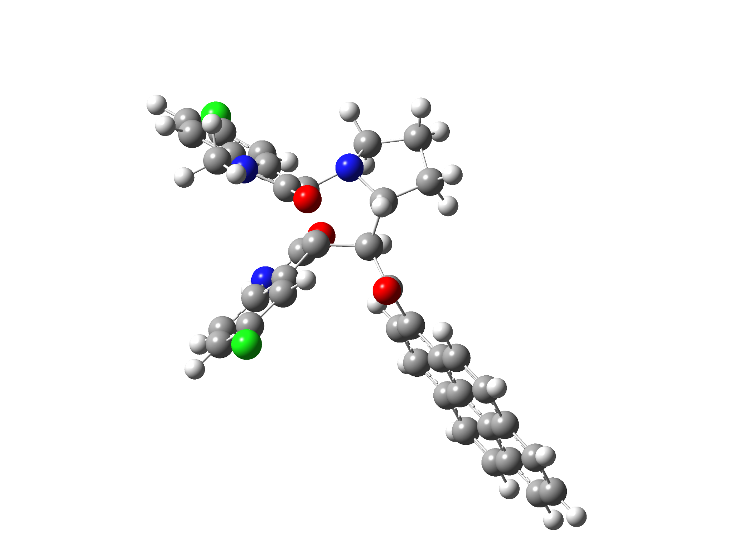

5k-1’S
Standard orientation:
---------------------------------------------------------------------
Center Atomic Atomic Coordinates (Angstroms)
Number Number Type X Y Z
---------------------------------------------------------------------
1 6 0 4.850933 0.559511 0.371122
2 6 0 6.138655 0.538486 -0.155245
3 6 0 6.574622 -0.628932 -0.794406
4 6 0 5.723205 -1.727155 -0.885272
5 6 0 4.424302 -1.702726 -0.358969
6 6 0 3.982519 -0.543703 0.271064
7 6 0 2.661043 -0.187722 0.940977
8 7 0 4.239233 1.602558 1.072466
9 6 0 1.325772 -0.120052 -0.044497
10 6 0 0.206952 -0.702426 0.888406
11 6 0 0.837225 -0.752562 2.321184
12 7 0 2.271079 -0.988743 2.084254
13 6 0 2.978155 1.242925 1.500153
14 8 0 2.270357 1.922474 2.222441
15 6 0 -1.138782 0.036999 0.888643
16 8 0 -1.217202 1.092632 1.510856
17 6 0 -7.756018 0.845938 1.190395
18 6 0 -6.409061 0.514953 0.955701
19 6 0 -6.084555 -0.419214 -0.071873
20 6 0 -7.136824 -1.003522 -0.844339
21 6 0 -8.468607 -0.643448 -0.577127
22 6 0 -8.774025 0.272267 0.430770
23 6 0 -4.719169 -0.767094 -0.323716
24 6 0 -4.427079 -1.713379 -1.355827
25 6 0 -5.502158 -2.284251 -2.118590
26 6 0 -6.798919 -1.945051 -1.875174
27 6 0 -5.336245 1.079827 1.717601
28 6 0 -4.031484 0.759419 1.477945
29 6 0 -3.660605 -0.173744 0.444437
30 6 0 -2.309019 -0.558971 0.169977
31 6 0 -2.067603 -1.511644 -0.838993
32 6 0 -3.090289 -2.067277 -1.592893
33 6 0 1.136509 1.212598 -0.762932
34 6 0 1.383702 1.026002 -2.135635
35 7 0 1.647672 -0.329391 -2.378724
36 6 0 0.788943 2.482008 -0.305325
37 6 0 0.723721 3.528673 -1.233753
38 6 0 0.991627 3.338604 -2.588772
39 6 0 1.326219 2.062568 -3.057586
40 6 0 1.524829 -1.085271 -1.243224
41 8 0 1.550114 -2.309198 -1.206931
42 6 0 0.370456 -1.939379 3.195089
43 6 0 2.494803 -2.447823 2.127049
44 6 0 1.614856 -2.856885 3.314113
45 1 0 0.689004 0.217162 2.796929
46 1 0 0.019812 -1.602687 4.174062
47 1 0 0.067623 -1.737740 0.574365
48 1 0 -0.463633 -2.465556 2.718407
49 1 0 6.798761 1.394921 -0.071703
50 1 0 7.573386 -0.681417 -1.213470
51 1 0 3.786163 -2.569883 -0.462786
52 1 0 -7.995262 1.558677 1.975100
53 1 0 -9.264618 -1.088643 -1.168142
54 1 0 -9.809044 0.538561 0.623448
55 1 0 -5.255996 -2.999485 -2.898727
56 1 0 -7.602512 -2.385471 -2.459614
57 1 0 -5.578608 1.786524 2.507249
58 1 0 -3.248276 1.220356 2.060623
59 1 0 -1.054303 -1.824199 -1.058496
60 1 0 -2.857661 -2.788203 -2.371640
61 1 0 1.761059 -0.751965 -3.289561
62 1 0 0.568813 2.657967 0.738420
63 1 0 0.931608 4.175233 -3.275872
64 1 0 1.523023 1.896059 -4.112105
65 1 0 2.166560 -2.956333 1.208618
66 1 0 3.553657 -2.665600 2.287270
67 1 0 2.144035 -2.654390 4.250740
68 1 0 1.363171 -3.921136 3.291283
69 17 0 0.285766 5.138537 -0.669049
70 17 0 6.289079 -3.192134 -1.683503
71 6 0 4.880808 2.850100 1.441453
72 1 0 4.157995 3.435682 2.010368
73 1 0 5.764907 2.664001 2.062104
74 1 0 5.179416 3.408609 0.548054
---------------------------------------------------------------------

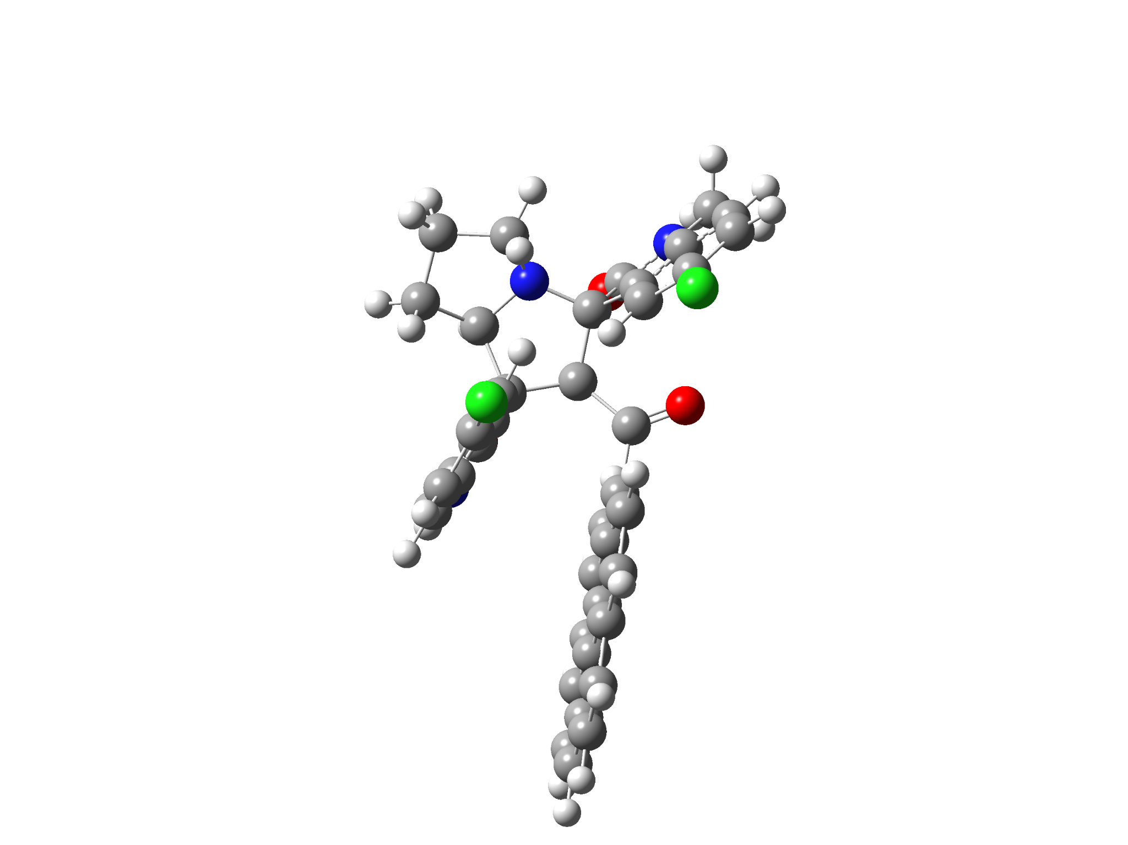

6k-2’R
Standard orientation:
---------------------------------------------------------------------
Center Atomic Atomic Coordinates (Angstroms)
Number Number Type X Y Z
---------------------------------------------------------------------
1 7 0 -2.742840 -0.870709 1.786489
2 6 0 -2.297751 -1.348265 0.478253
3 6 0 -0.734897 -1.116065 0.515679
4 6 0 -0.432686 -0.132702 1.697341
5 6 0 -1.618234 -0.542603 2.663806
6 7 0 -3.569682 -3.133202 -0.475797
7 6 0 -3.898681 -1.963588 -1.173735
8 6 0 -3.148036 -0.872538 -0.697616
9 6 0 -4.804294 -1.836828 -2.221021
10 6 0 -4.959349 -0.579144 -2.819121
11 6 0 -4.206170 0.498702 -2.364126
12 6 0 -3.296245 0.365037 -1.305679
13 6 0 -2.559113 -2.895216 0.427865
14 8 0 -1.986787 -3.737954 1.097913
15 6 0 -0.085602 -0.987623 -0.862471
16 8 0 -0.624155 -1.529711 -1.814575
17 6 0 1.216523 -0.251588 -1.074280
18 6 0 2.468713 -0.823509 -0.752014
19 6 0 3.659338 -0.081787 -1.046076
20 6 0 3.572827 1.203955 -1.663553
21 6 0 2.307724 1.714554 -1.996921
22 6 0 1.153470 0.992421 -1.714732
23 6 0 4.941573 -0.629515 -0.731493
24 6 0 6.130169 0.114074 -1.013287
25 6 0 6.005493 1.410174 -1.623354
26 6 0 4.784667 1.928334 -1.937091
27 6 0 2.609202 -2.135019 -0.173885
28 6 0 3.833230 -2.656052 0.118982
29 6 0 5.042498 -1.925217 -0.138436
30 6 0 6.313234 -2.443641 0.165512
31 6 0 7.467038 -1.708173 -0.106312
32 6 0 7.379183 -0.443889 -0.689933
33 7 0 1.677980 0.632312 2.444398
34 6 0 1.020104 1.741468 1.907641
35 6 0 -0.250102 1.352450 1.438683
36 6 0 0.913331 -0.510175 2.367431
37 8 0 1.233934 -1.611919 2.777452
38 6 0 1.469976 3.054519 1.840147
39 6 0 0.614118 4.022266 1.301497
40 6 0 -0.658274 3.654232 0.867809
41 6 0 -1.104897 2.328168 0.939029
42 6 0 -3.900326 -0.012608 2.035134
43 6 0 -2.182943 0.477616 3.671246
44 6 0 -3.714683 0.336298 3.518961
45 1 0 -1.265075 -1.447101 3.174823
46 1 0 -0.346404 -2.076260 0.896307
47 1 0 -5.373075 -2.686061 -2.583811
48 1 0 -5.654969 -0.446250 -3.640162
49 1 0 -2.711115 1.223862 -1.006631
50 1 0 2.233474 2.682948 -2.483895
51 1 0 0.186466 1.399958 -1.992379
52 1 0 6.911829 1.970457 -1.837904
53 1 0 4.705769 2.905447 -2.406425
54 1 0 1.722706 -2.723574 0.034693
55 1 0 3.908300 -3.645368 0.561518
56 1 0 6.388042 -3.429805 0.615777
57 1 0 8.440912 -2.123935 0.135104
58 1 0 8.282395 0.121824 -0.902990
59 1 0 2.613132 0.627764 2.826601
60 1 0 2.456957 3.332253 2.196576
61 1 0 0.931946 5.056559 1.232460
62 1 0 -2.114703 2.093674 0.630537
63 1 0 -3.915713 0.900910 1.417671
64 1 0 -4.836234 -0.548531 1.843947
65 1 0 -1.874011 1.494720 3.414777
66 1 0 -1.841877 0.275141 4.690026
67 1 0 -4.084703 -0.486785 4.139383
68 1 0 -4.252746 1.245444 3.803060
69 17 0 -4.388910 2.071410 -3.135457
70 17 0 -1.742773 4.884499 0.227861
71 6 0 -4.082767 -4.455672 -0.777241
72 1 0 -5.168922 -4.489554 -0.639655
73 1 0 -3.842048 -4.740395 -1.807973
74 1 0 -3.608015 -5.157032 -0.090108
---------------------------------------------------------------------

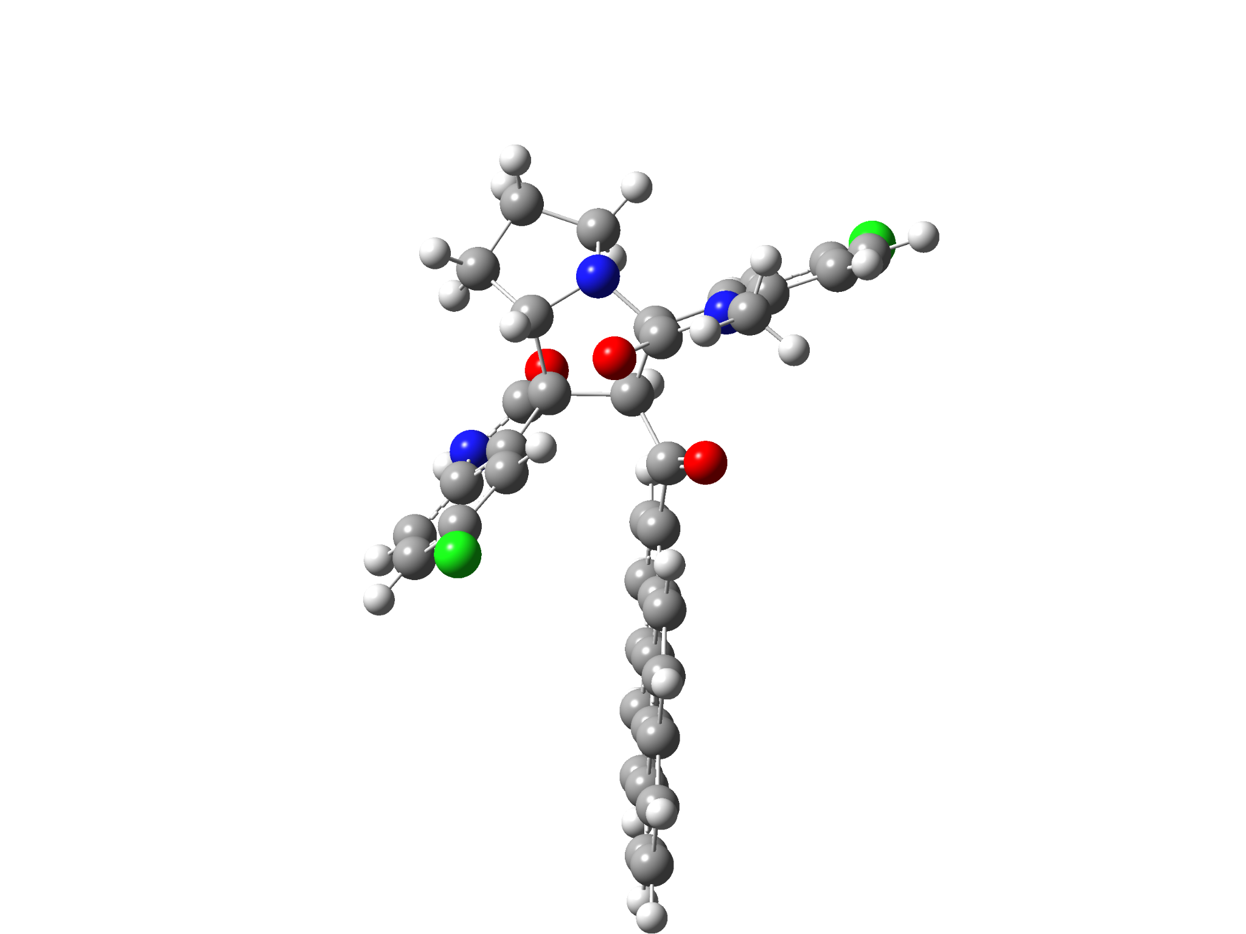

6k-2’S
Standard orientation:
---------------------------------------------------------------------
Center Atomic Atomic Coordinates (Angstroms)
Number Number Type X Y Z
---------------------------------------------------------------------
1 7 0 -3.388076 -1.441809 -0.335317
2 6 0 -2.707806 -0.342355 0.365278
3 6 0 -1.371343 -0.138484 -0.423107
4 6 0 -1.023351 -1.528151 -1.063700
5 6 0 -2.354081 -2.389325 -0.763505
6 7 0 -3.284622 0.009066 2.650495
7 6 0 -3.834219 1.063625 1.917292
8 6 0 -3.528313 0.918870 0.553422
9 6 0 -4.571307 2.145247 2.389325
10 6 0 -5.004498 3.106272 1.465263
11 6 0 -4.688312 2.969616 0.115544
12 6 0 -3.943388 1.879550 -0.357171
13 6 0 -2.538430 -0.823146 1.842885
14 8 0 -1.939485 -1.816375 2.226760
15 6 0 -0.266183 0.576340 0.363036
16 8 0 -0.438323 0.806353 1.555021
17 6 0 0.971983 1.013615 -0.353463
18 6 0 2.236807 1.086880 0.304796
19 6 0 3.369689 1.569020 -0.430595
20 6 0 3.226188 1.993868 -1.788967
21 6 0 1.964339 1.910923 -2.397130
22 6 0 0.871711 1.418081 -1.696715
23 6 0 4.658307 1.638160 0.187273
24 6 0 5.784837 2.132643 -0.541406
25 6 0 5.597158 2.557816 -1.901090
26 6 0 4.373631 2.491310 -2.496747
27 6 0 2.450490 0.659799 1.663393
28 6 0 3.683730 0.717498 2.242919
29 6 0 4.829226 1.212413 1.537952
30 6 0 6.103418 1.286278 2.128816
31 6 0 7.195545 1.770851 1.410604
32 6 0 7.039391 2.190971 0.088986
33 7 0 0.388799 -2.007195 -2.894827
34 6 0 1.016304 -2.543170 -1.759621
35 6 0 0.232526 -2.264033 -0.627460
36 6 0 -0.765914 -1.335327 -2.576793
37 8 0 -1.450816 -0.695710 -3.365105
38 6 0 2.207326 -3.252734 -1.682182
39 6 0 2.623486 -3.699055 -0.420918
40 6 0 1.841678 -3.434123 0.702915
41 6 0 0.636811 -2.723562 0.621444
42 6 0 -4.251401 -1.156667 -1.498641
43 6 0 -2.994808 -3.196867 -1.918348
44 6 0 -4.384617 -2.544100 -2.135397
45 1 0 -2.084501 -3.030015 0.077006
46 1 0 -1.642535 0.503670 -1.268158
47 1 0 -4.804355 2.258144 3.442529
48 1 0 -5.580348 3.961947 1.800088
49 1 0 -3.710395 1.804417 -1.413584
50 1 0 1.843067 2.238985 -3.425738
51 1 0 -0.083749 1.378087 -2.206642
52 1 0 6.456118 2.935990 -2.449298
53 1 0 4.242940 2.815480 -3.525702
54 1 0 1.608238 0.295389 2.233519
55 1 0 3.812589 0.379881 3.267900
56 1 0 6.227995 0.959361 3.157652
57 1 0 8.172679 1.822337 1.881678
58 1 0 7.893016 2.569918 -0.466770
59 1 0 0.777571 -1.987841 -3.827209
60 1 0 2.805955 -3.459861 -2.563814
61 1 0 3.550143 -4.252272 -0.316893
62 1 0 0.032611 -2.538726 1.502904
63 1 0 -5.207773 -0.745024 -1.167083
64 1 0 -3.791789 -0.457830 -2.213202
65 1 0 -3.081975 -4.252460 -1.648158
66 1 0 -2.396647 -3.148626 -2.830978
67 1 0 -4.659281 -2.484199 -3.192095
68 1 0 -5.157913 -3.116923 -1.613820
69 6 0 -3.362420 -0.135794 4.090189
70 1 0 -4.405954 -0.208792 4.415153
71 1 0 -2.835441 -1.052361 4.357385
72 1 0 -2.886013 0.714432 4.591928
73 17 0 -5.231385 4.192799 -1.029687
74 17 0 2.382966 -4.015988 2.275294
---------------------------------------------------------------------

