Identification of Novel HDAC8 selective inhibitors through ligand and structure based studies: Exploiting the Acetate Release Channel Differences Among Class I isoforms
Aparna Vema^{1†*}, Sudan Debnath^{2†*}, Arunasree M Kalle^{1†*}

1. Department of Animal Biology, School of Life Sciences, University of Hyderabad, Hyderabad 500046, India
2. ªDepartment of Chemistry, MBB College, Agartala, Tripura, 799 004, India
^{b}Department of Chemistry, Netaji Subhash Mahavidyalaya, Udaipur, Tripura, 799114, India

*Corresponding author:
Aparna Vema: vemaaparna@uohyd.ac.in
Sudan Debnath: bcsdebnath@gmail.com
Arunasree M Kalle: arunasreemk@uohyd.ac.in

Supporting Information

Contents
- Table S1. Metrics of Phase Hypothesis obtained from Pharmacophore studies
- Figure S1: Bar graphs showing the Enzyme inhibitory kinetics of compounds 1-3
- Figure S2: Side chain placement of Trp 141 to accommodate inhibitor, in x-ray structures of HDAC8: 1T64 (blue) and 3SFF (green) shown in circle
- Figure S3: Overlay of binding poses of Compounds 1 (yellow), 2 (pink) and 3 (orange) within HDAC8 active site
- Figure S4: H-Bond interaction between Ser138 and Trp 141 throughout the simulation
- Figure S5: Sequence Alignment of HDAC isoforms
- Characterization of Purchased Compounds

Table S1. Metrics of Phase Hypothesis obtained from Pharmacophore studies
ID | Survival | Survival -inactive | Post-hoc | Site | Vector | Volume | Selectivity | Activity | Inactive
AADRR.2 | 3.382 | 1.817 | 3.382 | 1 | 1 | 0.387 | 1.386 | 7.638 | 1.565
AAADR.13 | 2.499 | 0.869 | 2.499 | 0.3 | 0.9 | 0.294 | 1.268 | 7.538 | 1.63
AAADR.14 | 2.499 | 1.223 | 2.499 | 0.3 | 0.9 | 0.294 | 1.325 | 7.638 | 1.276
AAADR.18 | 2.499 | 1.223 | 2.499 | 0.3 | 0.9 | 0.294 | 1.325 | 7.638 | 1.276

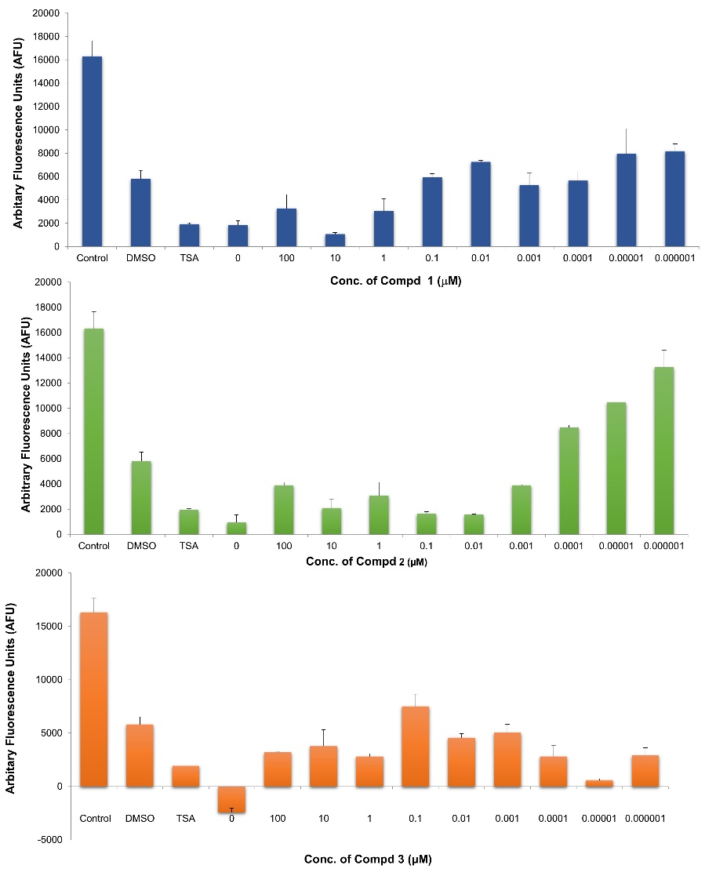
Figure S1: Bar graphs showing the Enzyme inhibitory kinetics of compounds 1-3.

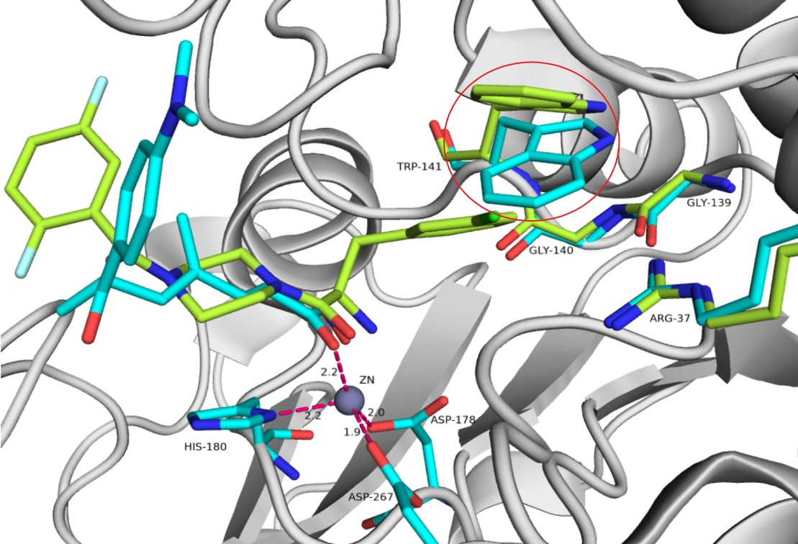

Figure S2: Side chain placement of Trp 141 to accommodate inhibitor, in x-ray structures of HDAC8: 1T64 (blue) and 3SFF (green) shown in circle
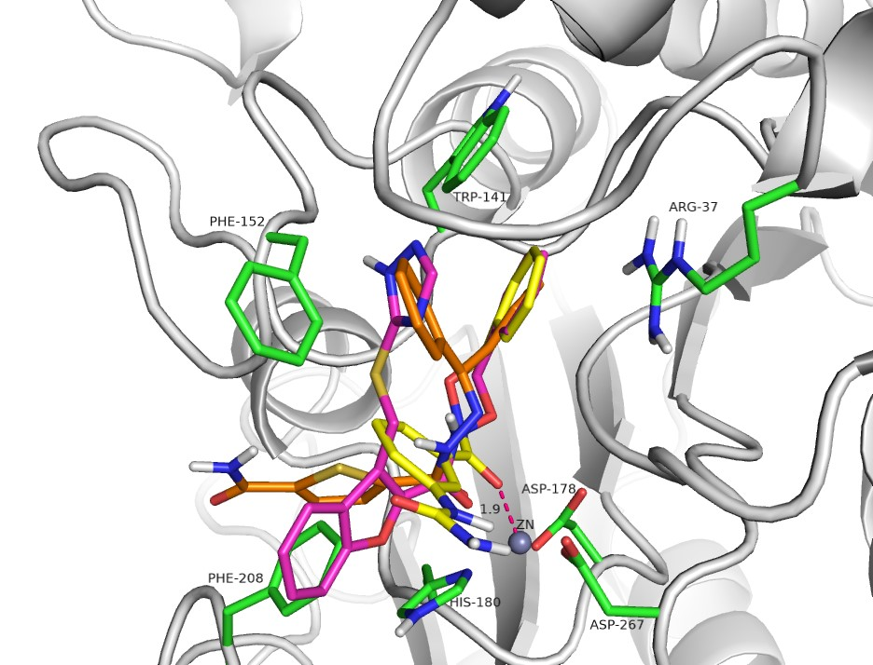
Figure S3: Overlay of binding poses of Compounds 1 (yellow), 2 (pink) and 3 (orange) within HDAC8 active site

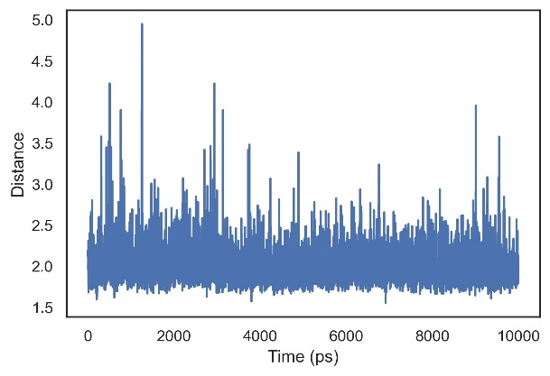 | 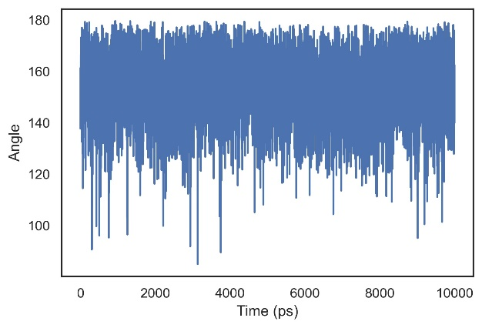

Figure S4: Distance and Angle between Ser138 backbone O-atom and Trp 141 sidechain NH atoms
Figure S5: Sequence Alignment of Class I HDAC isoforms. Red boxes show the variants in the AR Channel
Characterization of Purchased Compounds
A Bruker Ascend 400 MHz spectrometer was used to record ¹H and ¹³C NMR spectra at room temperature (400 MHz for ¹H and 100 MHz for ¹³C). Chemical shifts were recorded in ppm using TMS as internal standard and coupling constants were recorded in Hertz. Proton multiplicities were used to indicate as s (singlet), d (doublet), dd (double doublet), t (triplet), q (quartet), and m (many).
Compound 1
C₁₅H₁₅N₃O₃: ¹H-NMR (400 MHz, DMSO-d₆) δ ppm: 11.71 (1H, brs), 8.74 (1H, brs), 7.78 (1H, brs), 7.57-7.23 (8H, m). 5.94 (2H, brs), 4.92 (2H, brs). ¹³C-NMR (400 MHz, DMSO-d₆), δ ppm: 165.2, 156.4, 141.3, 136.4, 133.4, 129.3 (2C), 129.1, 128.8 (2C), 121.1, 119.9, 117.0, 77.4. m/z 285.3 [M]⁺
Compound 2
C₁₉H₁₆N₄O₃S: ¹H-NMR (400 MHz, DMSO-d₆) δ ppm: 14.13 (1H, brs) 12.28 (1H, brs), 8.48 (1H, brs), 7.77 (1H, d, 8.0), 7.61 (1H, d, 8.4), 7.45-7.47 (3H, m), 7.43-7.31 (4H, m), 4.97 (2H, s), 4.85 (2H, s). ¹³C-NMR (400 MHz, DMSO-d₆), δ ppm: 165.2, 157.3, 153.3, 148.6, 142.9, 136.2, 129.3 (2C), 128.8 (2C), 127.9, 127.4, 124.0, 122.6, 122.1, 77.8, 25.3. m/z 381.2 [M+H]⁺
Compound 3
C₁₉H₁₅N₃O₂S: ¹H-NMR (400 MHz, DMSO-d₆), δ ppm: 10.15 (1H, brs), 8.17 (1H, brs), 8.00 ((1H, brs), 7.62-7.53 (7H, m), 7.46 (3H, brs), 7.38 (2H, d, 6.0). ¹³C-NMR (400 MHz, DMSO-d₆), δ ppm: 163.2, 162.8, 161.4, 152.9, 147.5, 137.9, 137.7, 136.5, 135.6, 132.5, 130.3, 130.2, 129.8, 129.3, 129.0, 128.8, 128.6, 128.3, 128.0. m/z 350.3 [M+H]⁺
Compound 4
C₁₈H₁₇N₃O₃: ¹H-NMR (400 MHz, DMSO-d₆) δ ppm: 7.45-7.52 (3H, m), 7.36-7.44 (3H, m), 5.02 (2H, s), 2.43 (3H, s), 2.22 (1H, m), 1.15 (2H, m), 1.05 (2H, m). ¹³C-NMR (400 MHz, DMSO-d₆), δ ppm: 170.5, 161.5, 155.8, 138.6, 136.2, 129.4 (2C), 128.9, 128.8 (2C), 117.3, 107.5, 77.6, 17.7, 12.84, 12.31 (2C). m/z 323.3 [M]⁺
Compound 5
C₂₅H₂₂N₂O₄S: ¹H-NMR (400 MHz, DMSO-d₆), δ ppm: 10.54 (1H, s), 8.06 (1H, s), 7.90 (d, J=12, 3H), 7.78 (s, 1H), 7.67-7.40 (m, 10H), 3.81-3.75 (m, 1H), 3.67-3.62 (m, 1H), 3.57-3.51 (m, 1H), 2.78 (brs, 2H), 1.87-1.71 (m, 3H), 1.55-1.48) (m, 1H). ¹³C-NMR (100 MHz, DMSO-d₆), δ ppm: δ_{C} 162.9, 141.6, 137.8, 135.2, 131.3, 130.2, 129.7, 129.2, 128.9, 128.3, 77.4, 67.7, 46.9, 28.7, 25.5. m/z 464.2 [M+H]⁺

