**One-pot Synthesis of Chromium Incorporated SBA-16 under acid medium-Application in the selective oxidation of benzyl alcohol derivatives**

Z. A. AlDhawi 1.2, N.A. Alomair1.2, C. G Revathy2 and H. Kochkar1*

1 Department of Chemistry, College of Science, Imam Abdulrahman Bin Faisal University, P.O. Box 1982, 31441, Dammam, Saudi Arabia.

2 Basic & Applied Scientific Research Center, Imam Abdulrahman Bin Faisal University, P.O. Box 1982, 31441, Dammam, Saudi Arabia.

*\*Corresponding author Dr. Hafedh Kochkar: (*[*hbkochkar@iau.edu.sa*](mailto:hbkochkar@iau.edu.sa)*)*



**Figure S1**: FT-IR spectra of SBA-16, Cr-SBA-16(x) and reused Cr-SBA-16(7) catalysts.



**Figure S2.** TGA plot of SBA-16 and Cr-SBA-16(x) materials.

**Figure S3.** Arrhenius plot of benzyl alcohol oxidation over Cr-SBA-16(7).

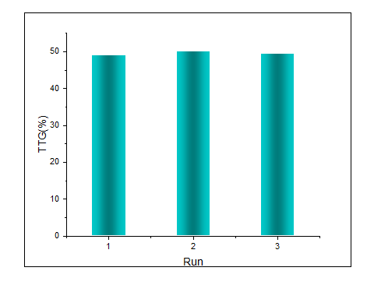

**Figure S4**: The recyclability tests of Cr-SBA-16 (7) catalyst.

**Figure S5**: SEM image of the reused Cr-SBA-16 (7) catalyst after 3 runs.